BEFORE THE FLORIDA PUBLIC SERVICE COMMISSION

In re: Petition for approval of safety, access, and facility enhancement program true-up and 2026 cost recovery factors, by Florida City Gas. | DOCKET NO. 20250111-GU  ORDER NO. PSC-2025-0458-TRF-GU  ISSUED: December 17, 2025

The following Commissioners participated in the disposition of this matter:

MIKE LA ROSA, Chairman
ART GRAHAM
GARY F. CLARK
ANDREW GILES FAY
GABRIELLA PASSIDOMO SMITH

ORDER APPROVING SAFETY, ACCESS, AND
FACILITY ENHANCEMENT TRUE-UP AND
2026 COST RECOVERY FACTORS

BY THE COMMISSION:

Background
On September 3, 2025, Florida City Gas (FCG or utility) filed a petition for approval of its safety, access, and facility enhancement (SAFE) program true-up and 2026 cost recovery factors. The SAFE program was originally approved by us in Order No. PSC-15-0390-TRF-GU (2015 Order) to recover the cost of relocating on an expedited basis certain existing gas mains and associated facilities from rear lot easements to the street front. In the 2015 Order, we found that the relocation of mains and services to the street front provides for more direct access to the facilities and will enhance the level of service provided to all customers through improved safety and reliability. The SAFE factor is a fixed surcharge on customers' bills.

In the 2015 Order, we required the utility to file an annual petition, beginning in 2016, for review and resetting of the SAFE factors to true-up any prior over-or under-recovery and to set the surcharge for the coming year. The SAFE program was originally approved as a 10-year program and was planned to finish in 2025.

During the utility’s 2022 rate case, we approved the continuation and expansion of the SAFE program beyond its 2025 expiration date to include the relocation of an additional approximately 150 miles of mains and services and the replacement of approximately 160 miles of orange pipe.
In 2024, we approved FCG’s petition to modify its SAFE program to include replacing span pipes, burying shallow and exposed pipeline, and replacing obsolete pipe and related facilities. The total estimated cost for the program modifications is $49.8 million over a ten year period. The additional program modifications are included in this proceeding for recalculation of the SAFE surcharges. The current 2025 SAFE factors were approved by Order No. PSC-2025-0033-TRF-GU.
By Order No. PSC-2025-0396-PCO-GU, issued October 23, 2025, we suspended the proposed tariffs to allow our staff sufficient time to analyze the utility’s filing, pursuant to Section 366.06(3), Florida Statutes (F.S.). Our staff issued its first data request to FCG on September 22, 2025, for which FCG provided a response on October 3, 2025.
FCG’s annual progress in the SAFE program is shown in Attachment A to this Order. The proposed 2026 SAFE factors are shown in Attachment B to this Order on Eighth Revised Sheet No. 79. We have jurisdiction over the matter pursuant to Sections 366.04, 366.041, 366.05, and 366.06, F.S.

Decision
As required by the 2015 Order, the utility’s calculations for the 2026 revenue requirement and SAFE factors include a final true-up for 2024, an estimated/actual true-up for 2025, and projected costs for 2026. During 2025, the utility replaced 31.7 miles of mains and 1,244 services as shown in Attachment A to its petition. FCG also replaced 18 miles of mains and 1,185 services associated with orange pipe in 2025.
In Attachment B to its petition, the utility provided a description of the SAFE program projects undertaken in 2024 and 2025 and forecast for 2026. In response to our staff’s data request, FCG explained that it prioritizes its replacement projects based on a risk assessment and to complete all projects in a cost-effective manner the utility uses a competitively bidding process. Work is awarded based on lowest bid, capacity to complete the work, and historical performance. FCG further explained that due to limited internal resources it utilizes contract labor the complete the replacement work.

Final True-ups for 2024
FCG stated that the revenues collected for 2024 were $4,728,363 compared to a revenue requirement of $3,691,675 resulting in an over-recovery of $1,036,688. Adding the 2023 final under-recovery of $1,852,753 and the $1,036,688 over-recovery of 2024, including interest, results in a final 2024 under-recovery of $865,219.

Actual/Estimated 2025 True-up
FCG provided actual revenues for January through June and forecasted revenues for July through December 2025, totaling $8,308,405 as compared to a projected revenue requirement of $8,547,138, resulting in an under-recovery of $238,733. Adding the 2024 under-recovery of $865,219 to the 2025 under-recovery of $238,733, the resulting total 2025 true-up, including interest, is an under-recovery of $1,106,822.

Projected 2026 Costs
The utility’s projected investment for 2026 is $107,960,202 for its SAFE program. The revenue requirement, which includes a return on investment, depreciation, and taxes is $12,315,423. The return on investment calculation includes federal income taxes, regulatory assessment fees, and bad debt. After adding the 2025 under-recovery of $1,106,822, the total 2026 revenue requirement is $13,422,245. Table 1 displays the projected 2026 SAFE program revenue requirement calculation.

Table 1
2026 SAFE Program Revenue Requirements Calculation
2026 Projected Investment | $107,960,202
Return on Investment | $8,719,408
Depreciation Expense | $1,921,817
Property Tax Expense | $1,674,198
2026 Revenue Requirement | $12,315,423
Plus 2025 Under-recovery | $1,106,822
Total 2026 Revenue Requirement | $13,422,245

Proposed 2026 SAFE Factors
The SAFE factors are fixed monthly charges. FCG’s cost allocation methodology was approved in the 2015 Order and was used in the instant filing. The approved methodology allocates the current cost of a 2-inch pipe to all customers on a per customer basis and allocates the incremental cost of replacing a 4-inch pipe to customers who use over 6,000 therms per year. For customers who require 4-inch pipes, the cost takes into account that the minimum pipe is insufficient to serve their demand, and therefore, allocates an incremental per foot cost in addition to the all-customer cost. The resulting allocation factors are applied to the 2026 total revenue requirement to develop the monthly SAFE factors.

The proposed fixed monthly SAFE factor is $8.70 for customers using less than 6,000 therms per year (current factor is $4.66). The proposed fixed monthly SAFE factor for customers using more than 6,000 therms per year is $11.01 (current factor is $7.77). FCG stated that it will provide notice to customers of the approved 2026 SAFE factors through a customer bill message and update rate schedule posted online.

Conclusion

We approve FCG’s proposed SAFE tariff for the period January through December 2026. After reviewing FCG’s filings and supporting documentation, the calculations of the 2026 SAFE factors appear consistent with the methodology approved in the 2015 Order and are reasonable and accurate.

Based on the foregoing, it is

ORDERED by the Florida Public Service Commission that Florida City Gas’s proposed Safety, Access, and Facility Enhancement tariff for the period January through December 2026 is approved as set forth herein. It is further

ORDERED that Florida City Gas’s proposed modification to Eighth Revised Sheet No. 79 as shown in Attachment B to this order is approved. It is further

ORDERED that if a protest is filed within 21 days of issuance of the Order, the tariff shall remain in effect with any revenues held subject to refund pending resolution of the protest. It is further

ORDERED that if no timely protest is filed, this docket shall be closed upon the issuance of a Consummating Order.

By ORDER of the Florida Public Service Commission this 17th day of December, 2025.

/s/ Adam J. Teitzman
ADAM J. TEITZMAN
Commission Clerk
Florida Public Service Commission
2540 Shumard Oak Boulevard
Tallahassee, Florida 32399
(850) 413-6770
www.floridapsc.com

Copies furnished: A copy of this document is provided to the parties of record at the time of issuance and, if applicable, interested persons.

RPS

NOTICE OF FURTHER PROCEEDINGS

The Florida Public Service Commission is required by Section 120.569(1), Florida Statutes, to notify parties of any administrative hearing or judicial review of Commission orders that is available under Sections 120.57 or 120.68, Florida Statutes, as well as the procedures and time limits that apply. This notice should not be construed to mean all requests for an administrative hearing or judicial review will be granted or result in the relief sought.

Mediation may be available on a case-by-case basis. If mediation is conducted, it does not affect a substantially interested person's right to a hearing.

The Commission's decision on this tariff is interim in nature and will become final, unless a person whose substantial interests are affected by the proposed action files a petition for a formal proceeding, in the form provided by Rule 28-106.201, Florida Administrative Code. This petition must be received by the Office of Commission Clerk, 2540 Shumard Oak Boulevard, Tallahassee, Florida 32399-0850, by the close of business on January 7, 2026.

In the absence of such a petition, this Order shall become final and effective upon the issuance of a Consummating Order.

Any objection or protest filed in this docket before the issuance date of this order is considered abandoned unless it satisfies the foregoing conditions and is renewed within the specified protest period.

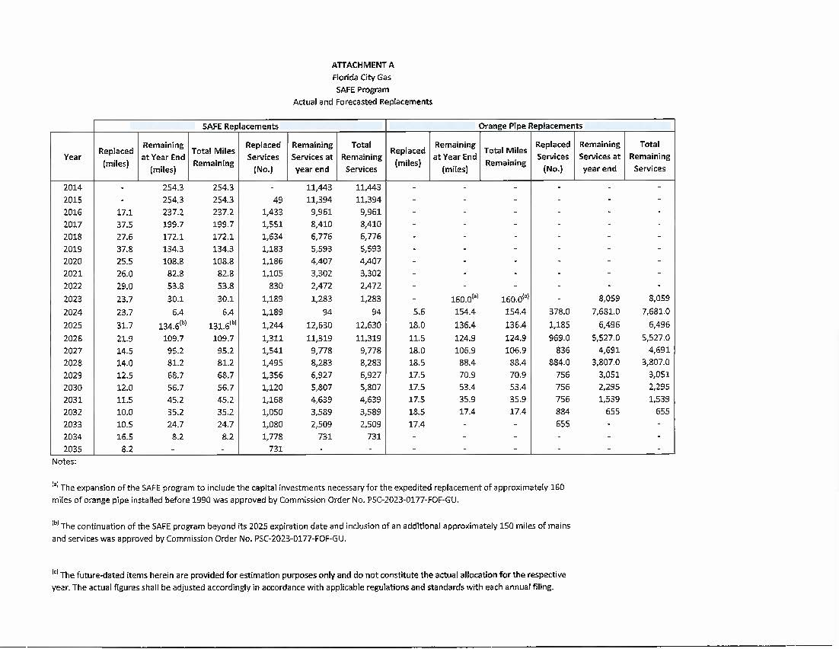

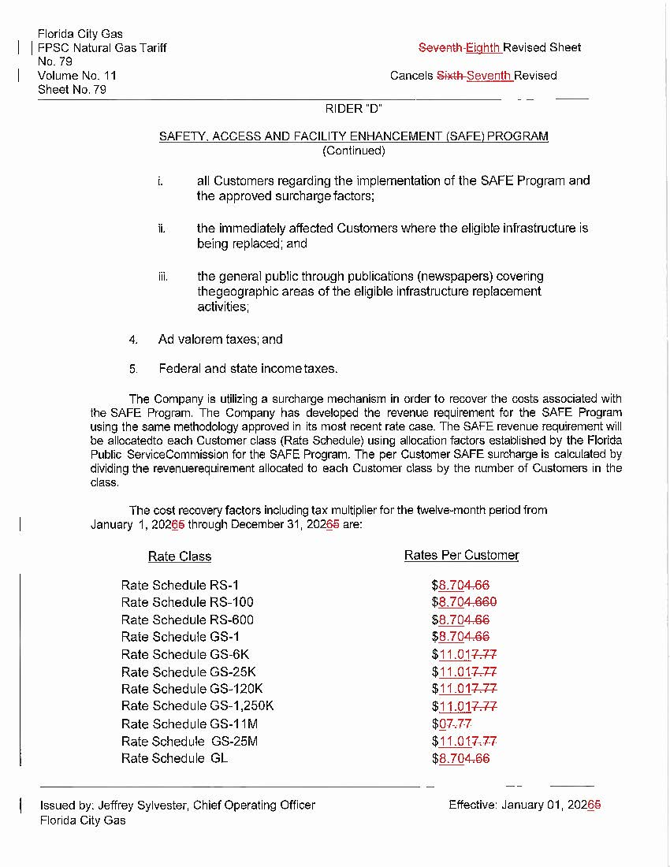

Order No. PSC-15-0390-TRF-GU, issued September 15, 2015, in Docket No. 20150116-GU, In re: Petition for approval of safety, access, and facility enhancement program and associated cost recovery methodology, by Florida City Gas.
Order No. PSC-2023-0177-FOF-GU, issued June 9, 2023, in Docket No. 20220069-GU, In re: Petition for rate increase by Florida City Gas.
Order No. PSC-2024-0438-PAA-GU, issued October 2, 2024, in Docket No. 20240071-GU, In re: Petition for approval of safety, access, and facility enhancement program modifications, by Florida City Gas.
Order No. PSC-2024-0438-PAA-GU, page 4.
Order No. PSC-2025-0033-TRF-GU, issued January 28, 2025, in Docket No. 20240134-GU, In re: Petition for approval of safety, access, and facility enhancement program true-up and 2024 cost recovery factors, by Florida City Gas.

