BEFORE THE FLORIDA PUBLIC SERVICE COMMISSION

In re: Petition for approval of second amendment to transportation service agreement between Peninsula Pipeline Company, Inc. and Florida Public Utilities Company, for the New Smyrna Beach project. | DOCKET NO. 20250132-GU  ORDER NO. PSC-2026-0021-PAA-GU  ISSUED: January 14, 2026

The following Commissioners participated in the disposition of this matter:

GABRIELLA PASSIDOMO SMITH, Chairman
GARY F. CLARK
MIKE LA ROSA
BOBBY PAYNE
ANA ORTEGA

NOTICE OF PROPOSED AGENCY ACTION
ORDER APPROVING AMENDMENT TO
TRANSPORTATION SERVICE AGREEMENT

BY THE COMMISSION:

NOTICE is hereby given by the Florida Public Service Commission that the action discussed herein is preliminary in nature and will become final unless a person whose interests are substantially affected files a petition for a formal proceeding, pursuant to Rule 25-22.029, Florida Administrative Code (F.A.C.).

Background
On October 29, 2025, Peninsula Pipeline Company, Inc. (Peninsula), filed a petition seeking approval of a second amendment to firm transportation service agreement between Peninsula and Florida Public Utilities Company (FPUC), collectively the Parties. The proposed second amendment to the agreement is included as Attachment A to this order.

Peninsula and FPUC are both wholly owned subsidiaries of Chesapeake Utilities Corporation (Chesapeake). Peninsula operates as an intrastate natural gas transmission company as defined by Section 368.103(4), Florida Statutes (F.S.). FPUC operates as a local distribution company subject to our regulatory jurisdiction pursuant to Chapter 366, F.S.
By Order No. PSC-07-1012-TRF-GP, Peninsula received approval of an intrastate gas pipeline tariff that allows it to construct and operate intrastate pipeline facilities and to actively pursue agreements with natural gas customers. The Parties are subsidiaries of Chesapeake, and agreements between affiliated companies must be approved by us pursuant to Section 368.105, F.S.

By Order No. PSC-2017-0498-PAA-GU, we approved the initial transportation service agreement between Peninsula and FPUC (2017 Order). Pursuant to the 2017 Order, Peninsula would construct and own a new pipeline in New Smyrna Beach and relocate an existing gate station. The purpose of this construction project was to eliminate pressure issues FPUC was facing at the time as well as to provide the opportunity for growth in the New Smyrna Beach area.

By Order No. PSC-2024-0072-PAA-GU, we approved Peninsula’s amended agreement to include an additional source of gas, an additional interconnect, and four new delivery points. Peninsula stated the addition to the project was needed to ensure sufficient additional gas supply and provide operational support to FPUC’s system. In response to our staff’s data request, Peninsula stated that the construction of this project is anticipated to be complete in 2026. This petition for a second amendment arises out of the need for an additional delivery point.

During the evaluation of the petition, our staff issued one data request to the Parties for which responses were received on December 2, 2025. We have jurisdiction over this matter pursuant to Sections 368.104, and 368.105, F.S.

Decision
The purpose of this amendment is to revise certain provisions of the currently approved firm transportation service agreement to reflect the construction of an additional point of delivery. In response to our staff’s data request, Peninsula stated that the additional delivery point is necessary to enhance reliability and to meet FPUC’s supply capacity design-day demand due to additional growth in the New Smyrna Beach area. Currently, FPUC is using compressed natural gas to supplement supply in the area during high demand months to ensure adequate supply. The additional delivery point would be located at or near the intersection of Pioneer Trail and Junonia Boulevard in Volusia County. In response to our staff’s data request, Peninsula stated that the expected completion date of the new delivery point would be March 31, 2026.

In response to our staff’s data request, Peninsula stated that there would be no change in the monthly reservation charge. The monthly reservation charge has been previously approved in Order No. PSC-2024-0072-PAA-GU. The reservation charge to FPUC allows Peninsula to recover the pipeline construction costs. Furthermore, Peninsula explained that it would be able to construct the additional delivery point within the existing anticipated capital cost for the original project.

Conclusion
Based on the petition and the Parties’ responses to our staff’s data request, we approve the proposed second amendment to the firm transportation service agreement dated October 27, 2025, between Peninsula and FPUC. The proposed second amendment to the firm transportation service agreement is reasonable and meets the requirements of Section 368.105, F.S.

Based on the foregoing, it is

ORDERED by the Florida Public Service Commission that the proposed second amendment to the firm transportation service agreement dated October 27, 2025, between Peninsula Pipeline Company, Inc. and Florida Public Utilities Company, attached hereto, is approved. It is further

ORDERED that the provisions of this Order, issued as proposed agency action, shall become final and effective upon the issuance of a Consummating Order unless an appropriate petition, in the form provided by Rule 28-106.201, Florida Administrative Code, is received by the Commission Clerk, 2540 Shumard Oak Boulevard, Tallahassee, Florida 32399-0850, by the close of business on the date set forth in the “Notice of Further Proceedings” attached hereto. It is further

ORDERED that in the event this Order becomes final, this docket shall be closed.

By ORDER of the Florida Public Service Commission this 14th day of January, 2026.

/s/ Adam J. Teitzman
ADAM TEITZMAN
Commission Clerk
Florida Public Service Commission
2540 Shumard Oak Boulevard
Tallahassee, Florida 32399
(850) 413-6770
www.floridapsc.com

Copies furnished: A copy of this document is provided to the parties of record at the time of issuance and, if applicable, interested persons.

DD

NOTICE OF FURTHER PROCEEDINGS OR JUDICIAL REVIEW

The Florida Public Service Commission is required by Section 120.569(1), Florida Statutes, to notify parties of any administrative hearing that is available under Section 120.57, Florida Statutes, as well as the procedures and time limits that apply. This notice should not be construed to mean all requests for an administrative hearing will be granted or result in the relief sought.

Mediation may be available on a case-by-case basis. If mediation is conducted, it does not affect a substantially interested person's right to a hearing.

The action proposed herein is preliminary in nature. Any person whose substantial interests are affected by the action proposed by this order may file a petition for a formal proceeding, in the form provided by Rule 28-106.201, Florida Administrative Code. This petition must be received by the Office of Commission Clerk, 2540 Shumard Oak Boulevard, Tallahassee, Florida 32399-0850, by the close of business on February 4, 2026.

In the absence of such a petition, this order shall become final and effective upon the issuance of a Consummating Order.

Any objection or protest filed in this/these docket(s) before the issuance date of this order is considered abandoned unless it satisfies the foregoing conditions and is renewed within the specified protest period.

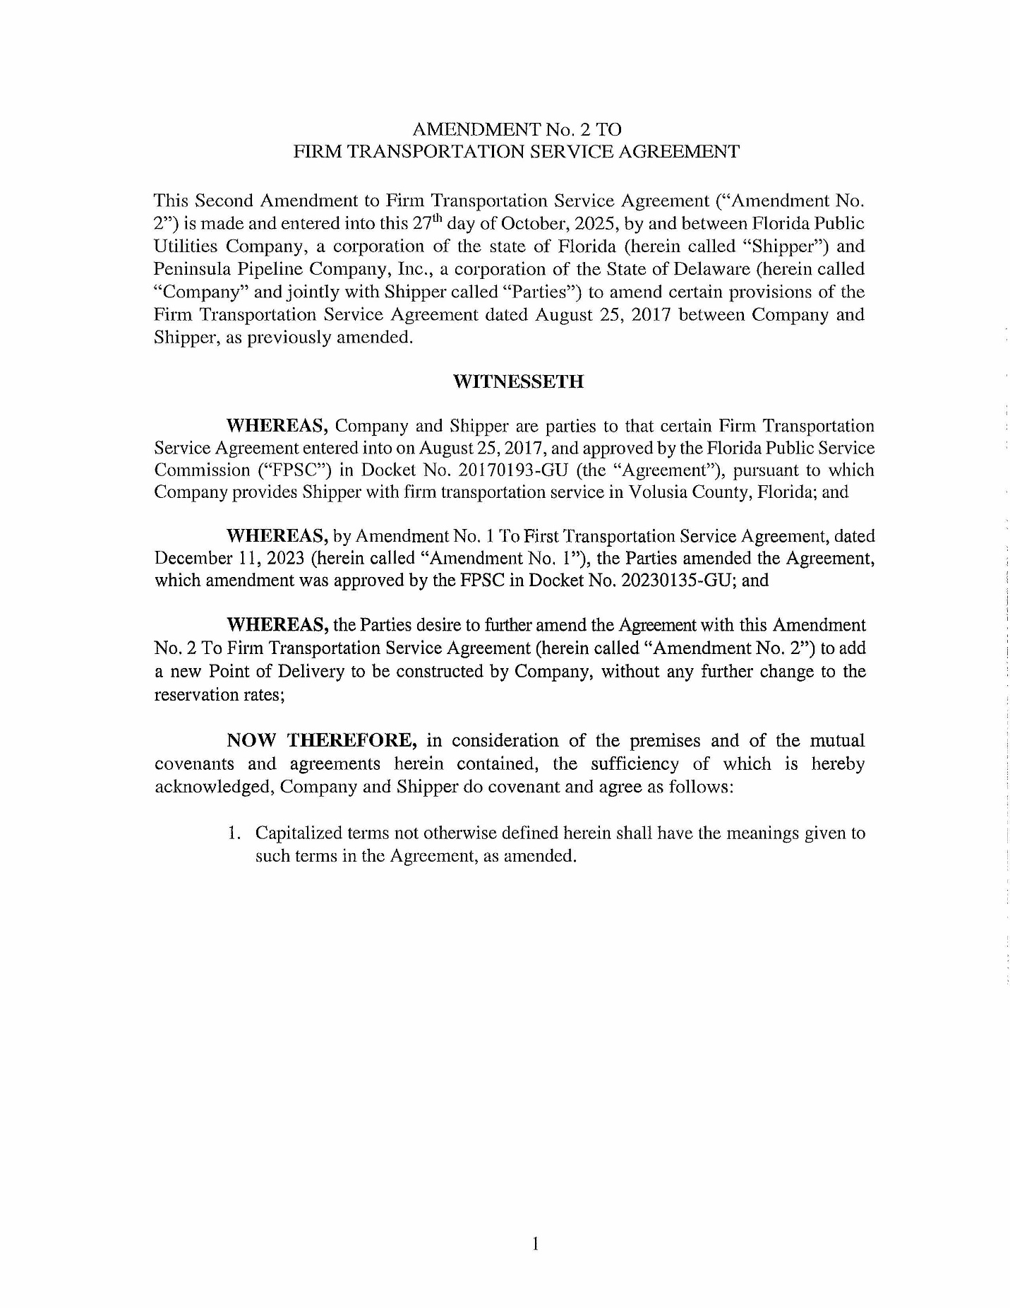
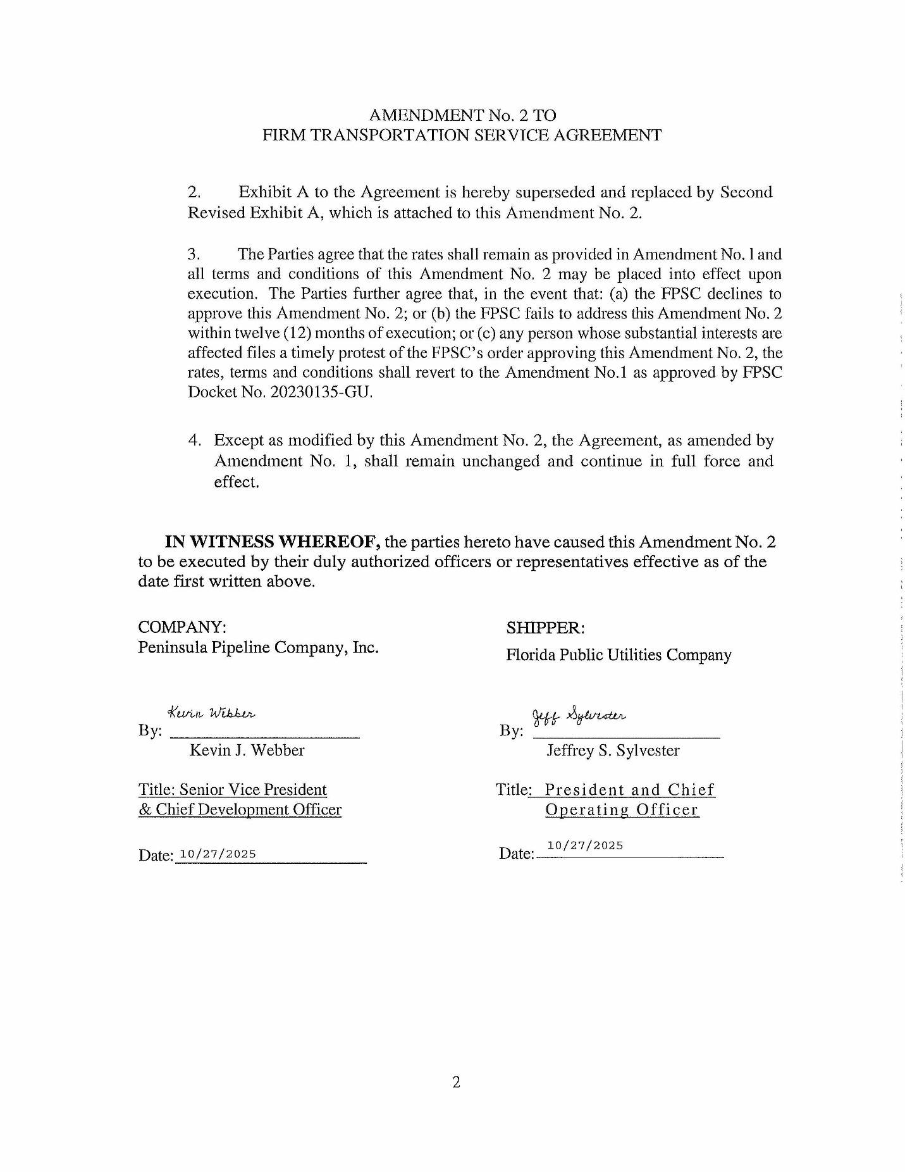
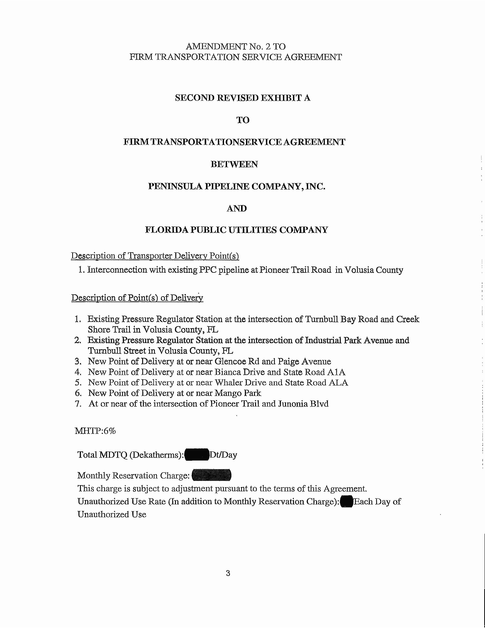

Order No. PSC-06-0023-DS-GP, issued January 9, 2006, in Docket No. 050584-GP, In re: Petition for declaratory statement by Peninsula Pipeline Company, Inc. concerning recognition as a natural gas transmission company under Section 368.101, F.S., et seq.
Order No. PSC-07-1012-TRF-GP, issued December 21, 2007, in Docket No. 20070570-GP, In re: Petition for approval of natural gas transmission pipeline tariff by Peninsula Pipeline Company, Inc.
Order No. PSC-2017-0498-PAA-GU, issued December 29, 2017, in Docket No. 20170193-GU, In re: Petition for approval of transportation service agreement with Florida Public Utilities Company, by Peninsula Pipeline Company, Inc.
Document No. 07483-2017, filed September 1, 2017.
Order No. PSC-2024-0072-PAA-GU, issued March 20, 2024, in Docket No. 20230135-GU, In re: Petition for approval of transportation service agreement with Florida Public Utilities Company by Peninsula Pipeline Company, Inc.
Document No. 06598-2023, filed December 14, 2023.
Document No. 15299-2025, filed December 2, 2025.
Id.
Document No. 15299-2025, filed December 2, 2025.
Document No. 15299-2025, filed December 2, 2025.

