BEFORE THE FLORIDA PUBLIC SERVICE COMMISSION

In re: Joint motion requesting Commission approval of settlement agreement by the Office of Public Counsel and Leighton Estates Utilities, LLC. | DOCKET NO. 20260015-WU  ORDER NO. PSC-2026-0073-PAA-WU  ISSUED: March 23, 2026

The following Commissioners participated in the disposition of this matter:

GABRIELLA PASSIDOMO SMITH, Chairman
GARY F. CLARK
MIKE LA ROSA
BOBBY PAYNE
ANA ORTEGA

NOTICE OF PROPOSED AGENCY ACTION
ORDER APPROVING SETTLEMENT FOR POSSIBLE OVEREARNINGS BY
LEIGHTON ESTATES UTILITIES, LLC

BY THE COMMISSION:

NOTICE is hereby given by the Florida Public Service Commission (Commission) that the action discussed herein is preliminary in nature and will become final unless a person whose interests are substantially affected files a petition for a formal proceeding, pursuant to Rule 25-22.029, Florida Administrative Code (F.A.C.).

Background
Leighton Estates Utilities, LLC (Leighton Estates or Utility) is a Class C water utility serving approximately 86 customers in Marion County, Florida. On December 22, 2022, we authorized a 10.45 percent return on equity (ROE) with an authorized range of 9.45 percent to 11.45 percent and a rate of return of 6.83 percent, as codified by Order No. PSC-2022-0435-PAA-WU. Based on the review of Leighton Estates’ 2024 Annual Report, our staff identified potential overearnings with a reported rate of return of 7.82 percent and an achieved ROE of 20.03 percent.
On November 21, 2025, the Office of Public Counsel (OPC) filed a letter with us outlining concerns of potential water and wastewater utilities overearning, with Leighton Estates being the only utility requiring a reduction. On December 12, 2025, OPC and Commission staff held a conference call to discuss the possible overearnings of Leighton Estates and other utilities. On December 22, 2025, the owner of Leighton Estates, Mike Smallridge, reached out to staff and inquired about a voluntary rate reduction and a refund to customers. Leighton Estates and OPC (collectively known as the Parties) conducted informal meetings to analyze the financial data provided by Leighton Estates and to determine the appropriate disposition of the potential overearnings. On January 29, 2026, the Parties filed their Joint Motion Requesting Commission Approval of Settlement Agreement (Joint Motion) to resolve the potential overearnings and to avert future overearnings.
This Order grants the Parties’ motion and approves the Parties’ Settlement Agreement. The Joint Motion and Settlement Agreement are attached as Attachment A. We have jurisdiction pursuant to Sections 367.081, 367.082, and 367.121, Florida Statutes.

Decision
As previously stated, our staff identified possible overearnings based upon a review of Leighton Estates’ 2024 Annual Report. On January 29, 2026, the Parties filed the Joint Motion to resolve the disposition of ongoing overearnings. Leighton Estates agreed to reduce its rates by 11.60 percent to ensure it will remain within range of its ROE. Furthermore, Leighton Estates agreed to refund customers 11.60 percent of water revenues billed from January 1, 2026, until the effective date of the rate reduction. The refund credit will be based upon each individual customer’s billed amounts from January 1, 2026, until the effective date of the rate reduction, and will be made pursuant to Rule 25-30.360, F.A.C.
In keeping with the our long-standing policy and practice of encouraging parties to settle issues whenever possible, we hereby grant the Joint Motion and approve the Settlement Agreement by the Parties. The settlement provides protections for Leighton Estates’ customers for possible overearnings in subsequent years. We note that this is consistent with our past decisions regarding possible overearnings. Schedule No. 1 reflects the Utility’s existing rates and our approved rates per the Utility’s settlement proposal. Commission staff will continue to monitor the earnings of the Utility, and if any subsequent overearnings are identified, our staff may open a formal earnings investigation.
The proposed Settlement Agreement adequately addresses the potential overearnings staff identified during its ongoing earnings surveillance activities. As outlined in the proposed Settlement Agreement, Leighton Estates shall reduce its rates by 11.60 percent. Additionally, Leighton Estates shall refund customers 11.60 percent of water revenues billed from January 1, 2026, until the effective date of the rate reduction. The refund shall be made pursuant to Rule 25-30.360, F.A.C. The Utility shall file a proposed customer notice reflecting our decision within 15 days of our vote. The approved rates shall be effective for service rendered on or after the stamped approval date of the tariff sheets pursuant to Rule 25-30.475(1), F.A.C. In addition, the approved rates shall not be implemented until our staff has approved the proposed customer notice and the notice has been received by the customers. The Utility shall provide proof of the date notice was given within 10 days of the date of the notice.

Based on the foregoing, it is
ORDERED by the Florida Public Service Commission that the Joint Motion Requesting Commission Approval of Settlement Agreement is hereby granted and the proposed Settlement Agreement is hereby approved. It is further

ORDERED that Leighton Estates Utility, LLC, shall reduce its rates by 11.60 percent. The approved rates shall be effective for service rendered on or after the stamped approval date of the tariff sheets pursuant to Rule 25-30.475(1), F.A.C. It is further

ORDERED that Leighton Estates Utility, LLC, shall refund customers 11.60 percent of water revenues billed from January 1, 2026, until the effective date of the rate reduction. The refund shall be made pursuant to Rule 25-30.360, F.A.C. It is further

ORDERED that the Utility shall provide Commission staff with a proposed customer notice of the approved rates by March 18, 2026, and shall provide proof of the date that notice was given within 10 days of the date of the notice. It is further

ORDERED that the provisions of this Order, issued as proposed agency action, shall become final and effective upon the issuance of a Consummating Order unless an appropriate petition, in the form provided by Rule 28-106.201, Florida Administrative Code, is received by the Commission Clerk, 2540 Shumard Oak Boulevard, Tallahassee, Florida 32399-0850, by the close of business on the date set forth in the “Notice of Further Proceedings” attached hereto. It is further

ORDERED that this docket shall remain open to allow staff to verify completion of the refunds ordered above. Once Commission staff has verified that the refunds have been made in accordance with Rule 25-30.360, F.A.C., the docket shall be closed administratively.

By ORDER of the Florida Public Service Commission this 23rd day of March, 2026.

/s/ Adam J. Teitzman
ADAM TEITZMAN
Commission Clerk
Florida Public Service Commission
2540 Shumard Oak Boulevard
Tallahassee, Florida 32399
(850) 413-6770
www.floridapsc.com

Copies furnished: A copy of this document is provided to the parties of record at the time of issuance and, if applicable, interested persons.

MRT

NOTICE OF FURTHER PROCEEDINGS OR JUDICIAL REVIEW

The Florida Public Service Commission is required by Section 120.569(1), Florida Statutes, to notify parties of any administrative hearing that is available under Section 120.57, Florida Statutes, as well as the procedures and time limits that apply. This notice should not be construed to mean all requests for an administrative hearing will be granted or result in the relief sought.

Mediation may be available on a case-by-case basis. If mediation is conducted, it does not affect a substantially interested person's right to a hearing.

The action proposed herein is preliminary in nature. Any person whose substantial interests are affected by the action proposed by this order may file a petition for a formal proceeding, in the form provided by Rule 28-106.201, Florida Administrative Code. This petition must be received by the Office of Commission Clerk, 2540 Shumard Oak Boulevard, Tallahassee, Florida 32399-0850, by the close of business on April 13, 2026.

In the absence of such a petition, this order shall become final and effective upon the issuance of a Consummating Order.

Any objection or protest filed in this/these docket(s) before the issuance date of this order is considered abandoned unless it satisfies the foregoing conditions and is renewed within the specified protest period.

 | LEIGHTON ESTATES UTILITIES, LLC |  | SCHEDULE NO. 1
 | MONTHLY WATER RATES | DOCKET NO. 20260015-WU
 |  | UTILITY | COMMISSION
 |  | CURRENT | APPROVED
 |  | RATES | RATES
 | Residential and General Service
 | Base Facility Charge by Meter Size
 | 5/8"X 3/4" | $24.27 | $21.45
 | 3/4" | $36.41 | $32.18
 | 1" | $60.68 | $53.63
 | 1-1/2" | $121.35 | $107.25
 | 2" | $194.16 | $171.60
 | 3" | $388.32 | $343.20
 | 4" | $606.75 | $536.25
 | 6" | $1,213.50 | $1,072.50
 | Charge per 1,000 gallons - Residential Service
 | 0 - 4,000 gallons | $11.03 | $9.75
 | Over 4,000 gallons | $13.79 | $12.19
 | Charge per 1,000 gallons - General Service | $11.28 | $9.97
 | Typical Residential 5/8" x 3/4" Meter Bill Comparison
 | 5,000 Gallons | $82.18 | $72.64
 | 10,000 Gallons | $151.13 | $133.59
 | 15,000 Gallons | $220.08 | $194.54

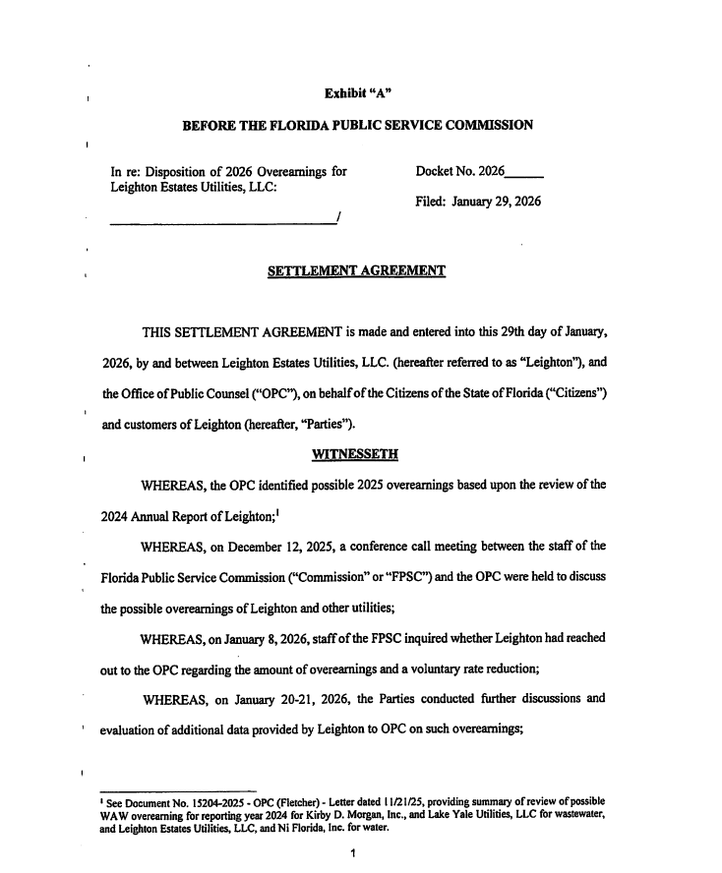

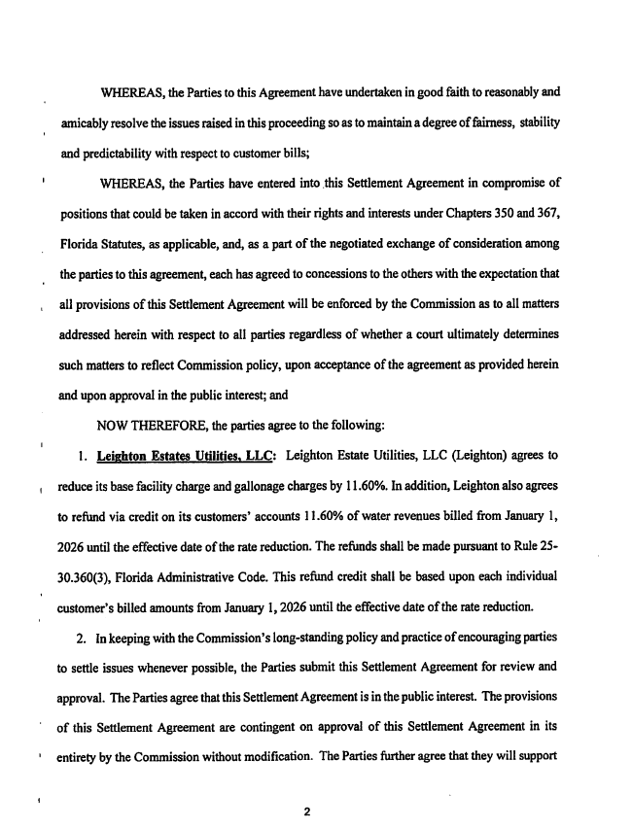

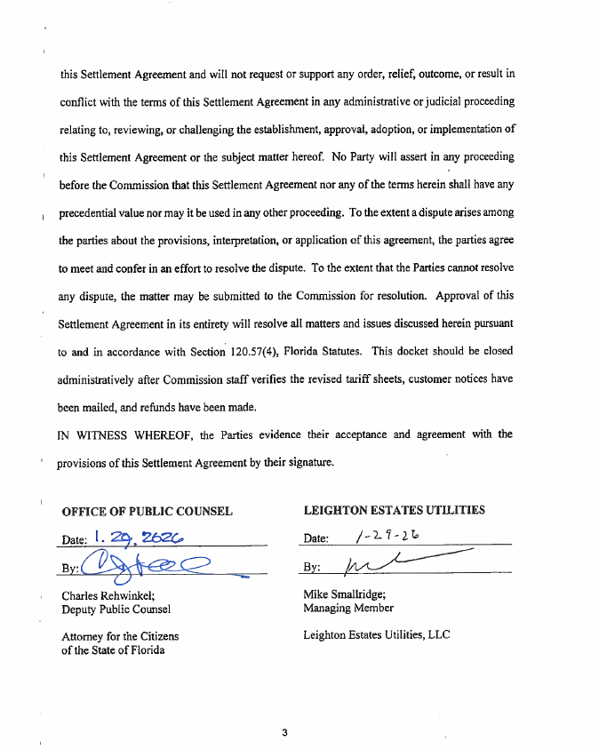

Order No. PSC-15-0173-PAA-WS, issued May 5, 2015, in Docket No. 20150069-WS, In re: Settlement proposal for possible overearnings by Southlake Utilities, Inc. in Lake County.

