BEFORE THE FLORIDA PUBLIC SERVICE COMMISSION

In re: Fuel and purchased power cost recovery clause with generating performance incentive factor. | DOCKET NO. 20260001-EI
In re: Review of the 2024-2025 outage of Tampa Electric Company's Bayside Steam Turbine Unit 2. | DOCKET NO. 20260053-EI
In re: Petition for approval of revised depreciation rates for Bayside Power Station assets, by Tampa Electric Company. | DOCKET NO. 20260062-EI  ORDER NO. PSC-2026-0243-PCO-EI  ISSUED: July 8, 2026

ORDER ESTABLISHING PROCEDURE

I. Case Background

Two replacement power issues associated with Tampa Electric Company’s (TECO) Bayside Unit 2 were raised in the 2026 Fuel Clause docket, Docket 20260001-EI: replacement power costs associated with an outage of TECO’s Bayside Steam Turbine 2 lasting from October 1, 2024 to August 15, 2025, and replacement power costs associated with a forced outage of Bayside Combustion Turbine 2D from January 22, 2025 to June 12, 2025. TECO and the Office of Public Counsel (OPC) filed a Joint Motion to spin-off the Bayside Steam Turbine 2 outage into a separate docket on March 23, 2026, due to the complexity of the outage and the volume of confidential utility and third-party documents that would have to be reviewed. This request was granted by Order No. PSC-2026-0081-PCO-EI and Docket No. 20260053-EI, In re: Review of the 2024-2025 outage of Tampa Electric Company’s Bayside Steam Turbine Unit 2, was established on April 6, 2026.

The January 22, 2025 to June 12, 2025 Bayside Combustion Turbine 2D outage was not moved to the new docket, but remained at issue in Docket No. 2026001-EI.

On April 15, 2026, TECO filed a petition seeking approval of revised depreciation rates for its Bayside Power Station assets to be effective January 1, 2027. Docket No. 20260062-EI was assigned to the depreciation rate change petition.

On June 16, 2026, TECO filed a Motion to Approve 2026 Bayside Agreement (Stipulation and Settlement Agreement dated June 12, 2026, or “2026 Bayside Agreement”) which proposed to resolve both Bayside Steam Turbine 2 and Bayside Combustion Turbine 2D outage issues and the depreciation rate changes for the Bayside Power Station assets. The signatories to the 2026 Bayside Agreement are TECO and OPC. There are no other parties to Docket Nos. 20260053-EI or Docket No. 20260062-EI. The Fuel Clause docket, Docket 20260001-EI, has seven parties in addition to TECO and OPC: Florida Public Utilities Company; Duke Energy Florida, LLC; Florida Power & Light Company; Florida Industrial Power Users Group; Southern Alliance for Clean Energy; PCS Phosphate; and Nucor Steel Florida. All of these parties have stated that they take no position on the 2026 Bayside Agreement. That being the case, the 2026 Bayside Agreement is an unopposed settlement.

A hearing will be held on August 4, 2026, to address the 2026 Bayside Agreement and thereby resolve both the Bayside Steam Unit 2 and Bayside Combustion Turbine 2D replacement power issues, as well as the proposed change to Bayside Power Station asset depreciation rates.

This Order sets forth the procedural requirements for all parties to these dockets with respect to the hearing. Jurisdiction over these matters is vested in the Commission through several provisions of Chapter 366, Florida Statutes (F.S.), including Sections 366.04, 366.05, and 366.06, F.S. This Order is issued pursuant to the authority granted by Rule 28-106.211, Florida Administrative Code (F.A.C.), which provides that the presiding officer before whom a case is pending may issue any orders necessary to effectuate discovery, prevent delay, and promote the just, speedy, and inexpensive determination of all aspects of the case.

II. Settlement Orders

The Commission has a long history of considering settlements as a means of resolving litigated matters. In particular, the complex nature of litigated matters before the Commission incentivizes parties to work together, in the spirit of compromise, towards a resolution that can be offered for consideration. TECO and OPC have agreed on the following major elements: base rate freeze; replacement power issues for Bayside Steam Turbine 2 and Bayside Combustion Turbine 2D; and Bayside Power Station depreciation rate revisions. These major elements will be considered by the Commission in determining whether the 2026 Bayside Agreement is in the public interest.

III. Testimony and Exhibits

The parties have agreed to stipulate the direct testimony of Jeff Chronister, Kris Stryker, and Ned Allis into the record. The parties have also agreed to stipulate the following into the record:
Docket No. 20260062-EI
Staff’s First Data Request Nos. 1-13, dated June 8, 2026;

Staff’s Second Data Request Nos. 1-2, dated June 10, 2026;

Exhibit No. (JC-1) – Document No. 1, Forecasted Bayside Station plant balances by account and subaccount for the years ended 2025; Document No. 2, Forecasted Bayside Station plant balances by account and subaccount for the years ended 2026; Document No. 3, Forecasted Bayside Station plant depreciation reserve balances by account and sub-account for the years ended 2025; and Document No. 4, Forecasted Bayside Station plant depreciation reserve balances by account and subaccount for the years ended 2026 ;

Exhibit No. (NA-1) – Document No. 1, 2026 Bayside Study and Document No. 2, List of cases in which Ned Allis submitted testimony;

Exhibit (KS-1) – Document No. 1, Bayside Unit 1 diagram and Document No. 2, Bayside Combustion Turbine Run-hour forecast.

Docket No. 20260053-EI
OPC’s Third Set of Interrogatories Nos. 3-6 (Bates Nos. 173053-173067), ST2;

Staff’s First Data Request Nos. 1-6 (Bates Nos. 173069-17077), ST2;

Supplemental response to Staff’s First Data Request No. 5, dated June 11, 2026 (Bates No. 173078) ST2.

Docket No. 20250001-EI
Second Supplemental response to OPC’s First Request for Production of Documents No. 1, dated October 8, 2025 (Bates Nos. 70-132) ST2;

Staff’s First Set of Interrogatories No. 1, GE Vernova Root Cause Analysis, dated May 2, 2025 (Bates Nos. 4-42) ST2.

Docket No. 20260001-EI
Revised response to OPC’s Second Set of Interrogatories No. 2, dated June 11, 2026 (Bates Nos. 30-31) CT2D;

Revised response to Staff’s First Set of Interrogatories Nos. 1b, 4a, and 4d, dated June 11, 2026 (Bates Nos. 1-18 and 23-24) ST2 and CT2D.

IV. Hearing Procedures

A. Attendance at Hearing

Unless excused by the Prehearing Officer for good cause shown, each party shall personally appear at the hearing. Failure of a party, or that party’s representative, to appear shall constitute waiver of that party’s issues, and that party may be dismissed from the proceeding.

B. Witness Panel

TECO will produce witnesses at the final hearing, sitting as a panel, who will address the major elements in the 2026 Bayside Agreement and why it is in the public interest.

C. Cross-Examination

The parties shall avoid duplicative or repetitious cross-examination.

V. Post-Hearing Procedures

If the Commission does not render a bench decision at the hearing, it may allow each party to file a post-hearing statement of issues and positions pursuant to the schedule set forth in Section VI of this Order. In such event, a summary of each position, set off with asterisks, shall be included in that statement. If a post-hearing statement is required and a party fails to file in conformance with Rule 28-106.215, F.A.C., that party shall have waived all issues and may be dismissed from the proceeding.

Further, pursuant to Rule 28-106.215, F.A.C., a party’s proposed findings of fact and conclusions of law, if any, statement of issues and positions, and brief, shall together total no more than 40 pages and shall be filed at the same time, unless modified by the Presiding Officer.

VI. Controlling Dates

The following dates are established for Commission consideration of the 2026 Bayside Agreement:

Hearing August 4, 2026

Post-Hearing Briefs, if any August 14, 2026

Based on the foregoing, it is

ORDERED by Commissioner Gary F. Clark, as Prehearing Officer, that the provisions of this Order shall govern this proceeding unless modified by the Commission.

By ORDER of Commissioner Gary F. Clark, as Prehearing Officer, this 8th day of July, 2026.

/s/ Gary F. Clark
GARY F. CLARK
Commissioner and Prehearing Officer
Florida Public Service Commission
2540 Shumard Oak Boulevard
Tallahassee, Florida 32399
(850) 413-6770
www.floridapsc.com

Copies furnished: A copy of this document is provided to the parties of record at the time of issuance and, if applicable, interested persons.

SBr

NOTICE OF FURTHER PROCEEDINGS OR JUDICIAL REVIEW

The Florida Public Service Commission is required by Section 120.569(1), Florida Statutes, to notify parties of any administrative hearing or judicial review of Commission orders that is available under Sections 120.57 or 120.68, Florida Statutes, as well as the procedures and time limits that apply. This notice should not be construed to mean all requests for an administrative hearing or judicial review will be granted or result in the relief sought.

Mediation may be available on a case-by-case basis. If mediation is conducted, it does not affect a substantially interested person's right to a hearing.

Any party adversely affected by this order, which is preliminary, procedural or intermediate in nature, may request: (1) reconsideration within 10 days pursuant to Rule 25-22.0376, Florida Administrative Code; or (2) judicial review by the Florida Supreme Court, in the case of an electric, gas or telephone utility, or the First District Court of Appeal, in the case of a water or wastewater utility. A motion for reconsideration shall be filed with the Office of Commission Clerk, in the form prescribed by Rule 25-22.0376, Florida Administrative Code. Judicial review of a preliminary, procedural or intermediate ruling or order is available if review of the final action will not provide an adequate remedy. Such review may be requested from the appropriate court, as described above, pursuant to Rule 9.100, Florida Rules of Appellate Procedure.

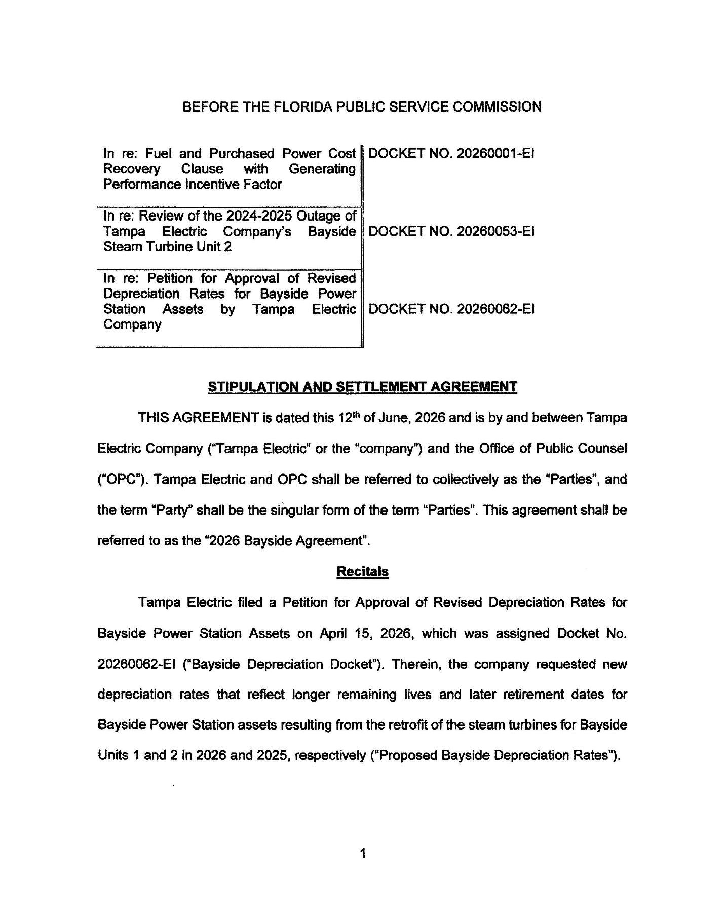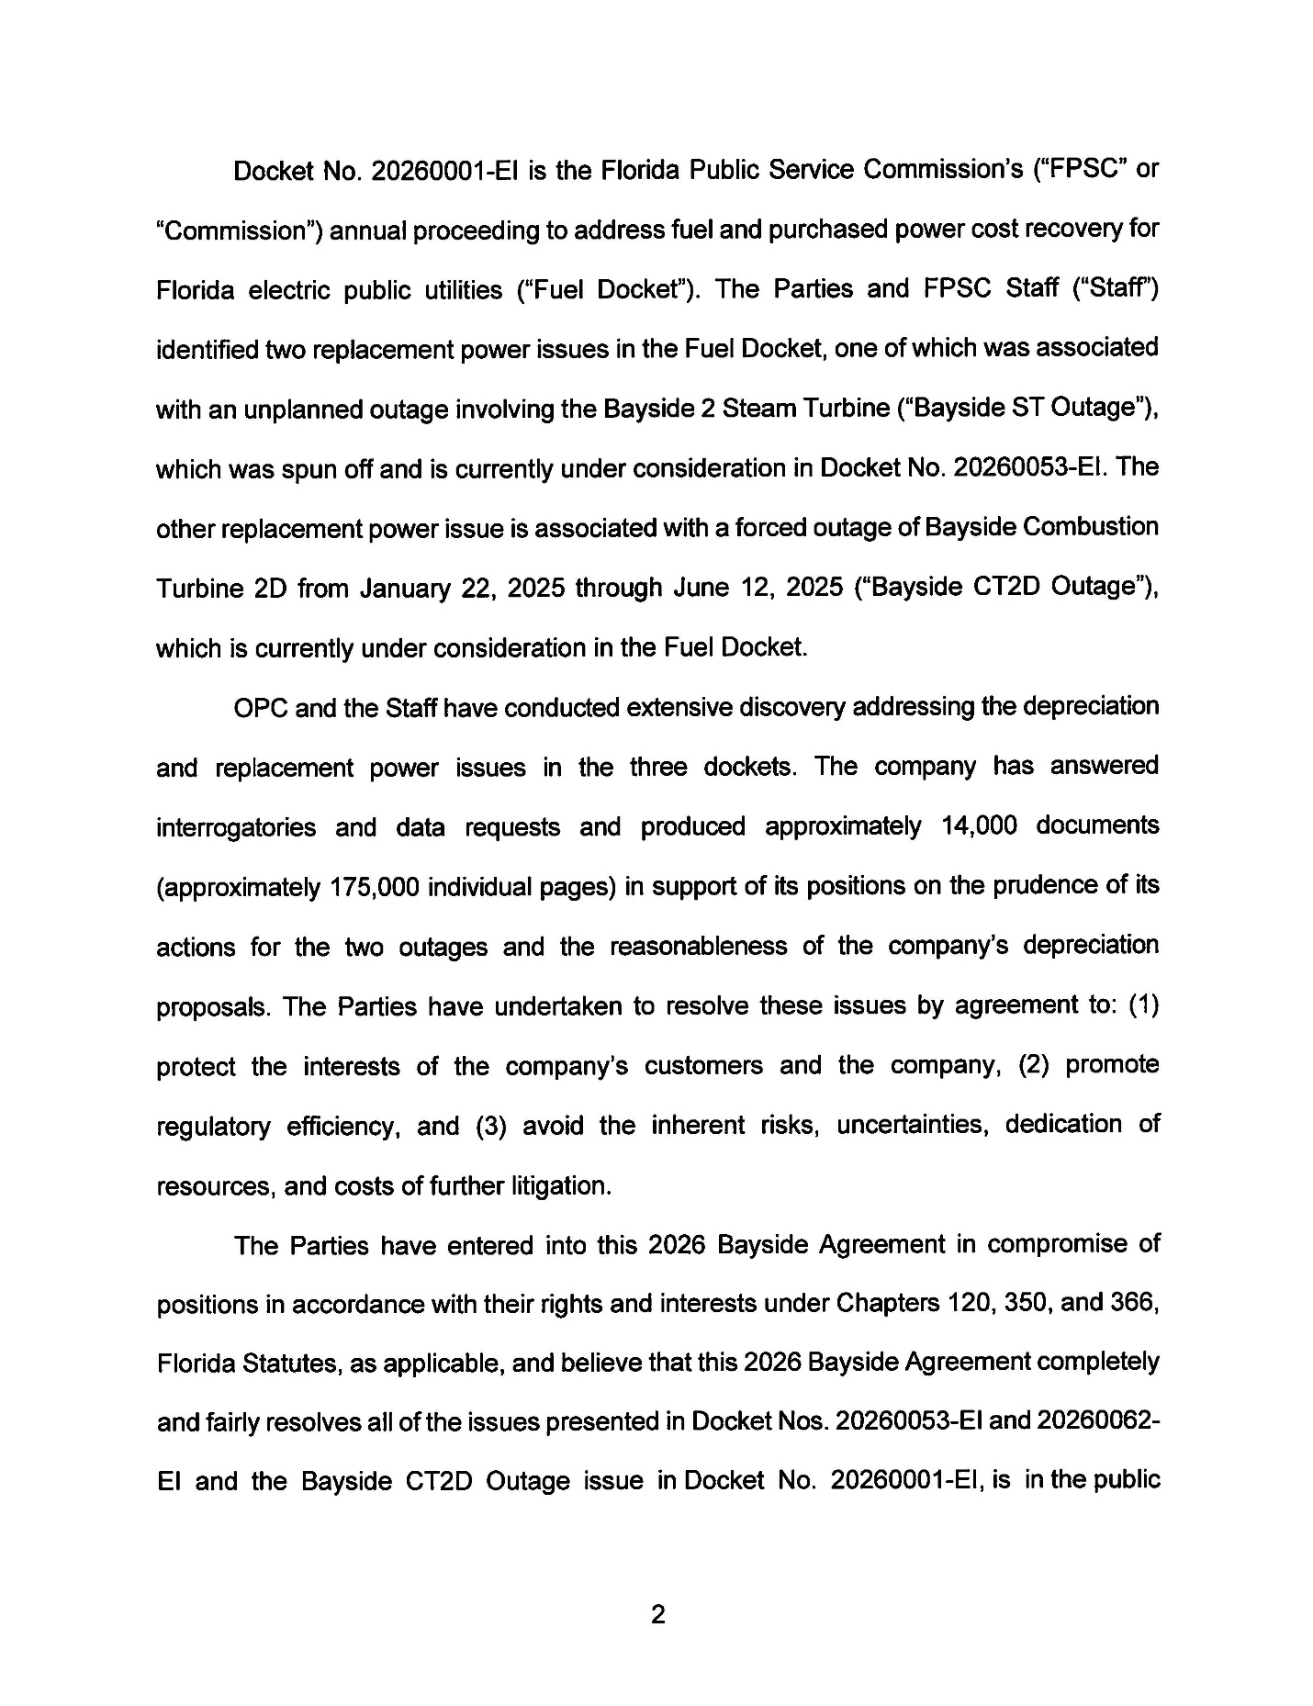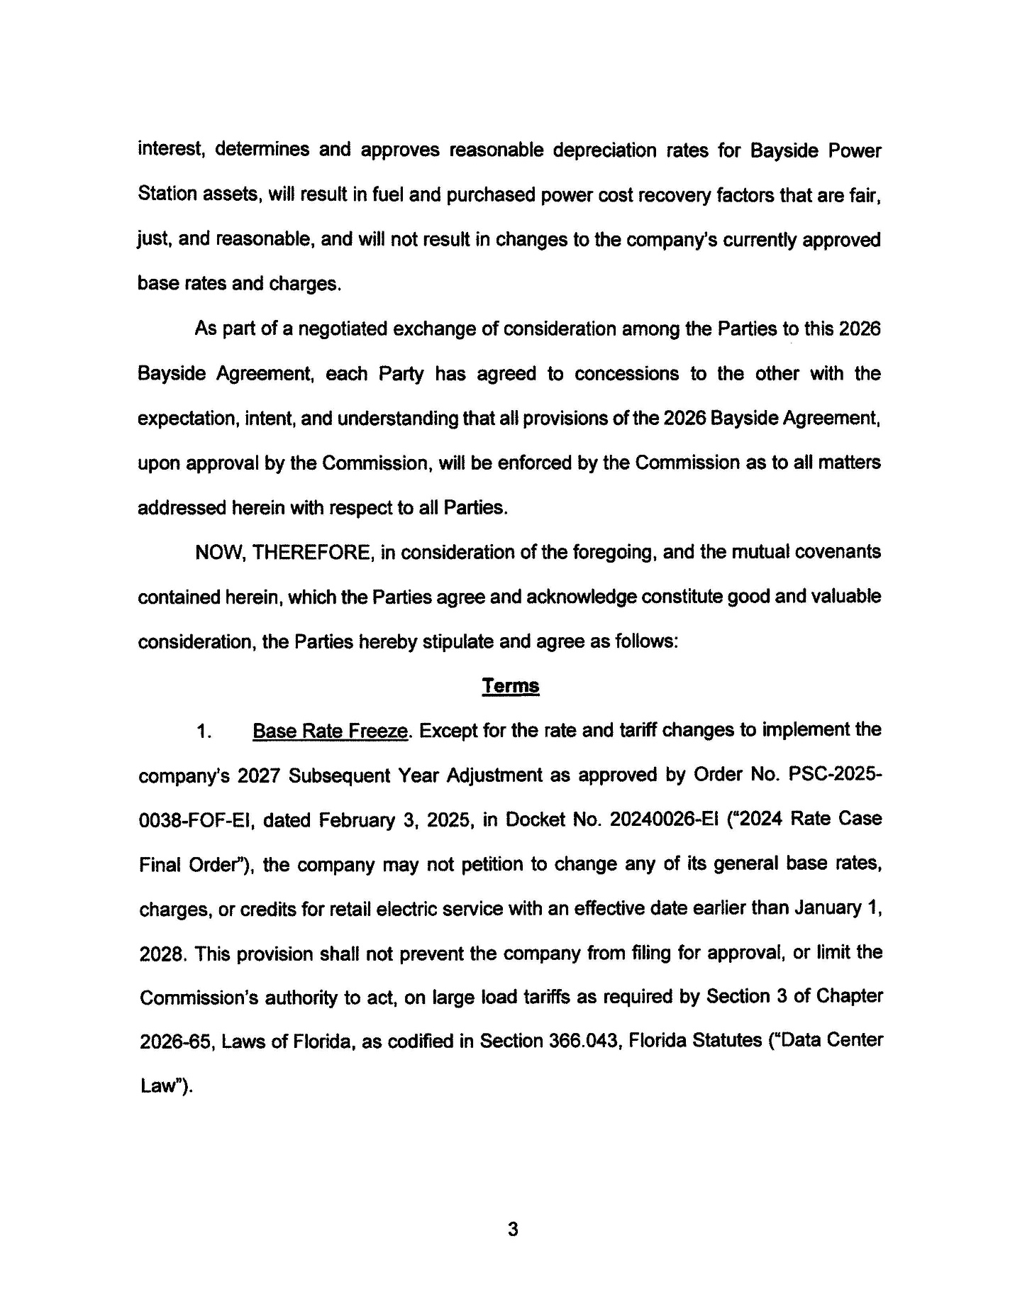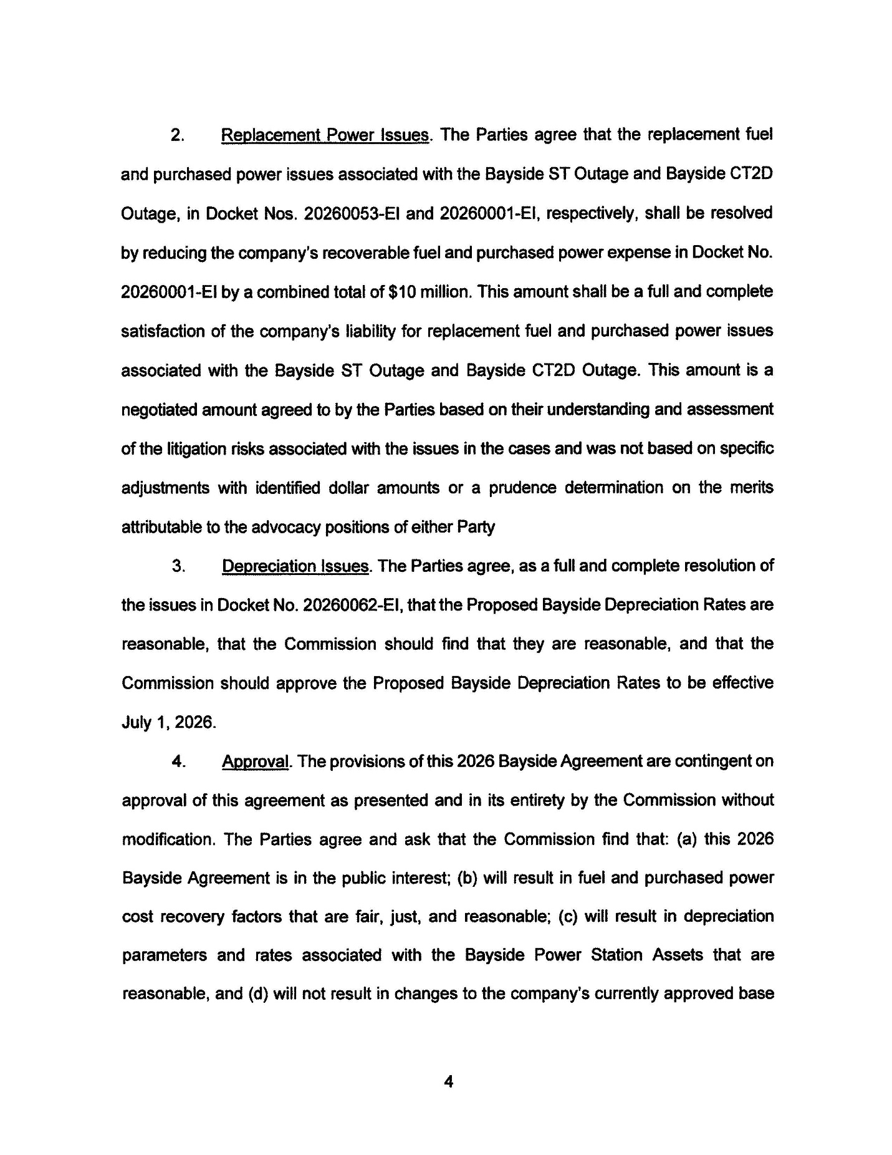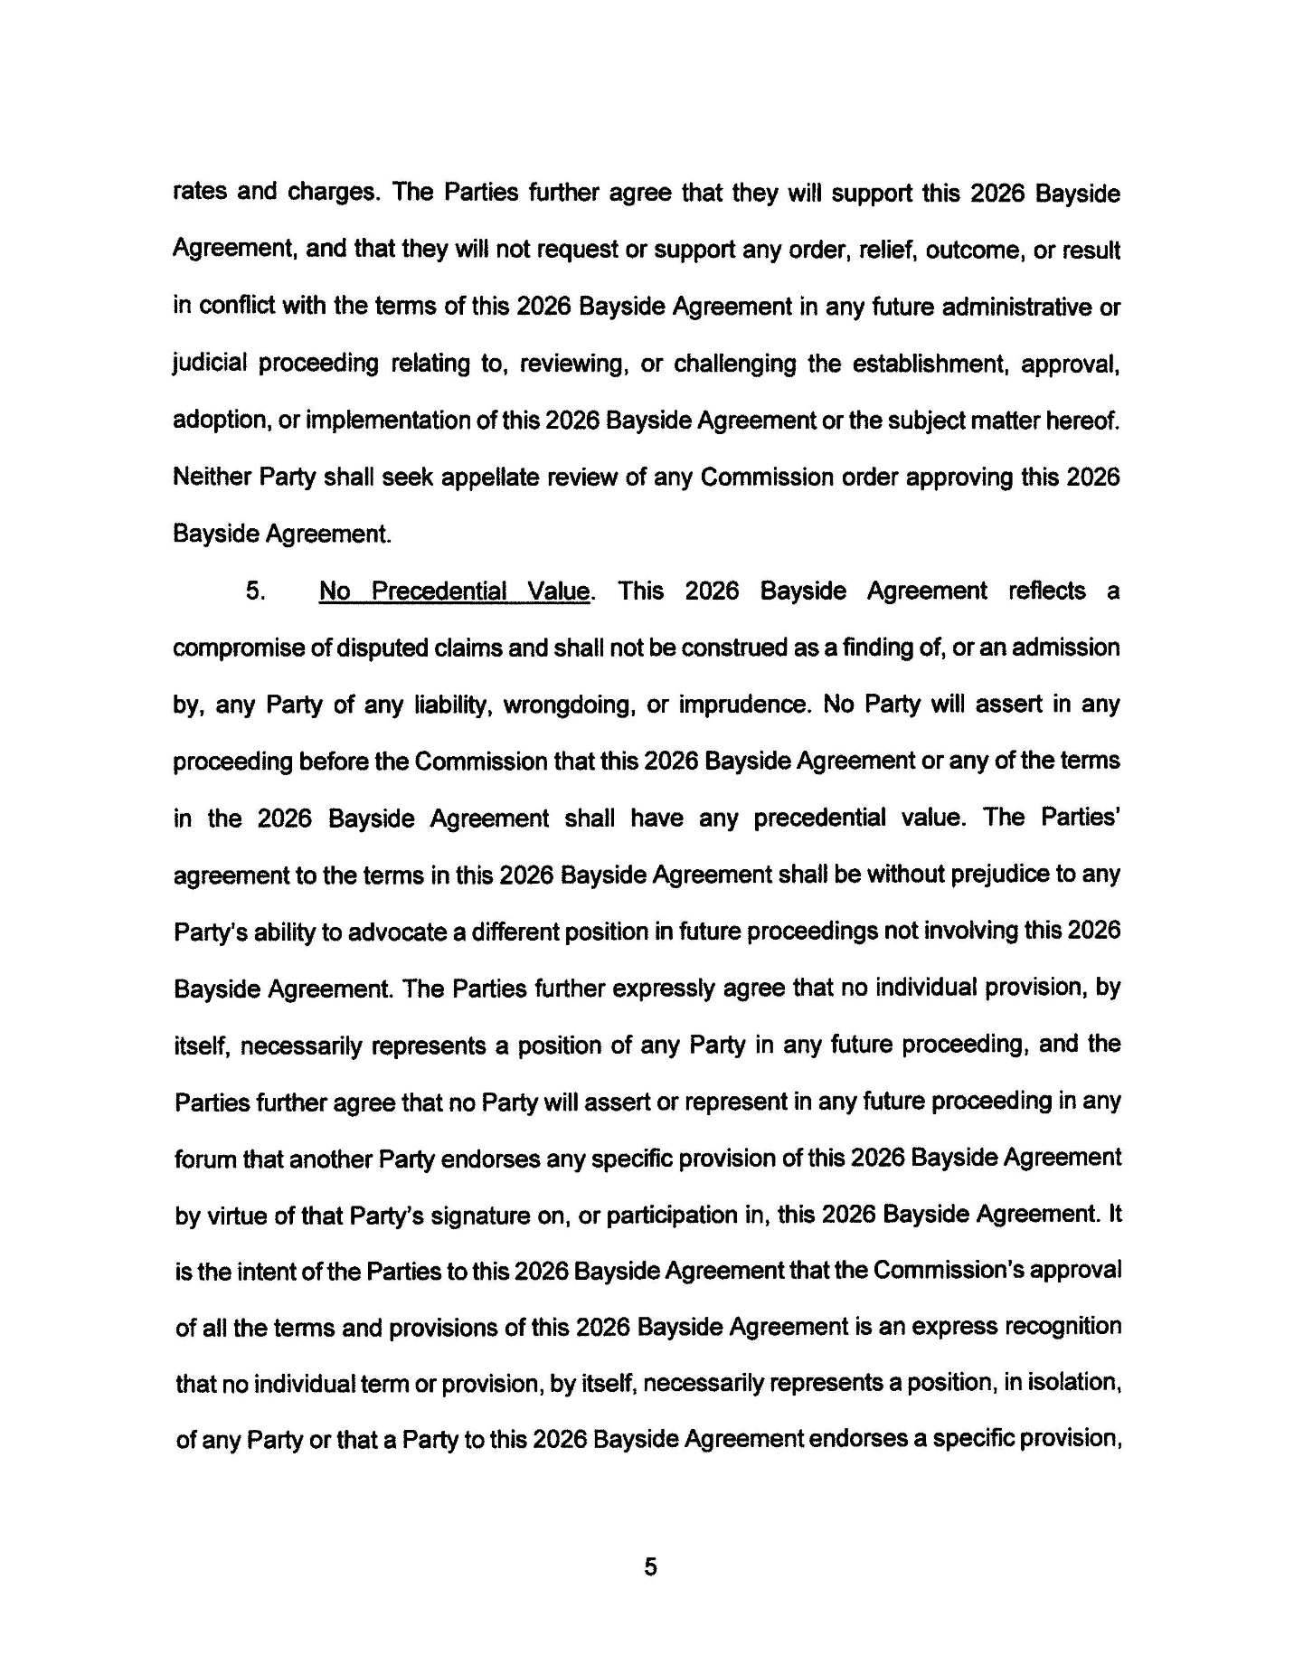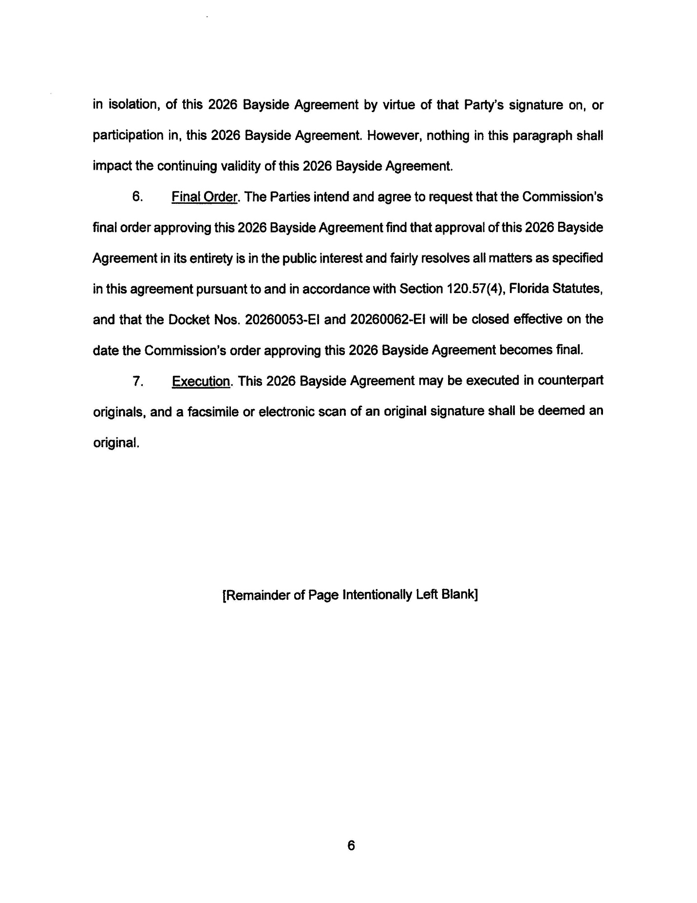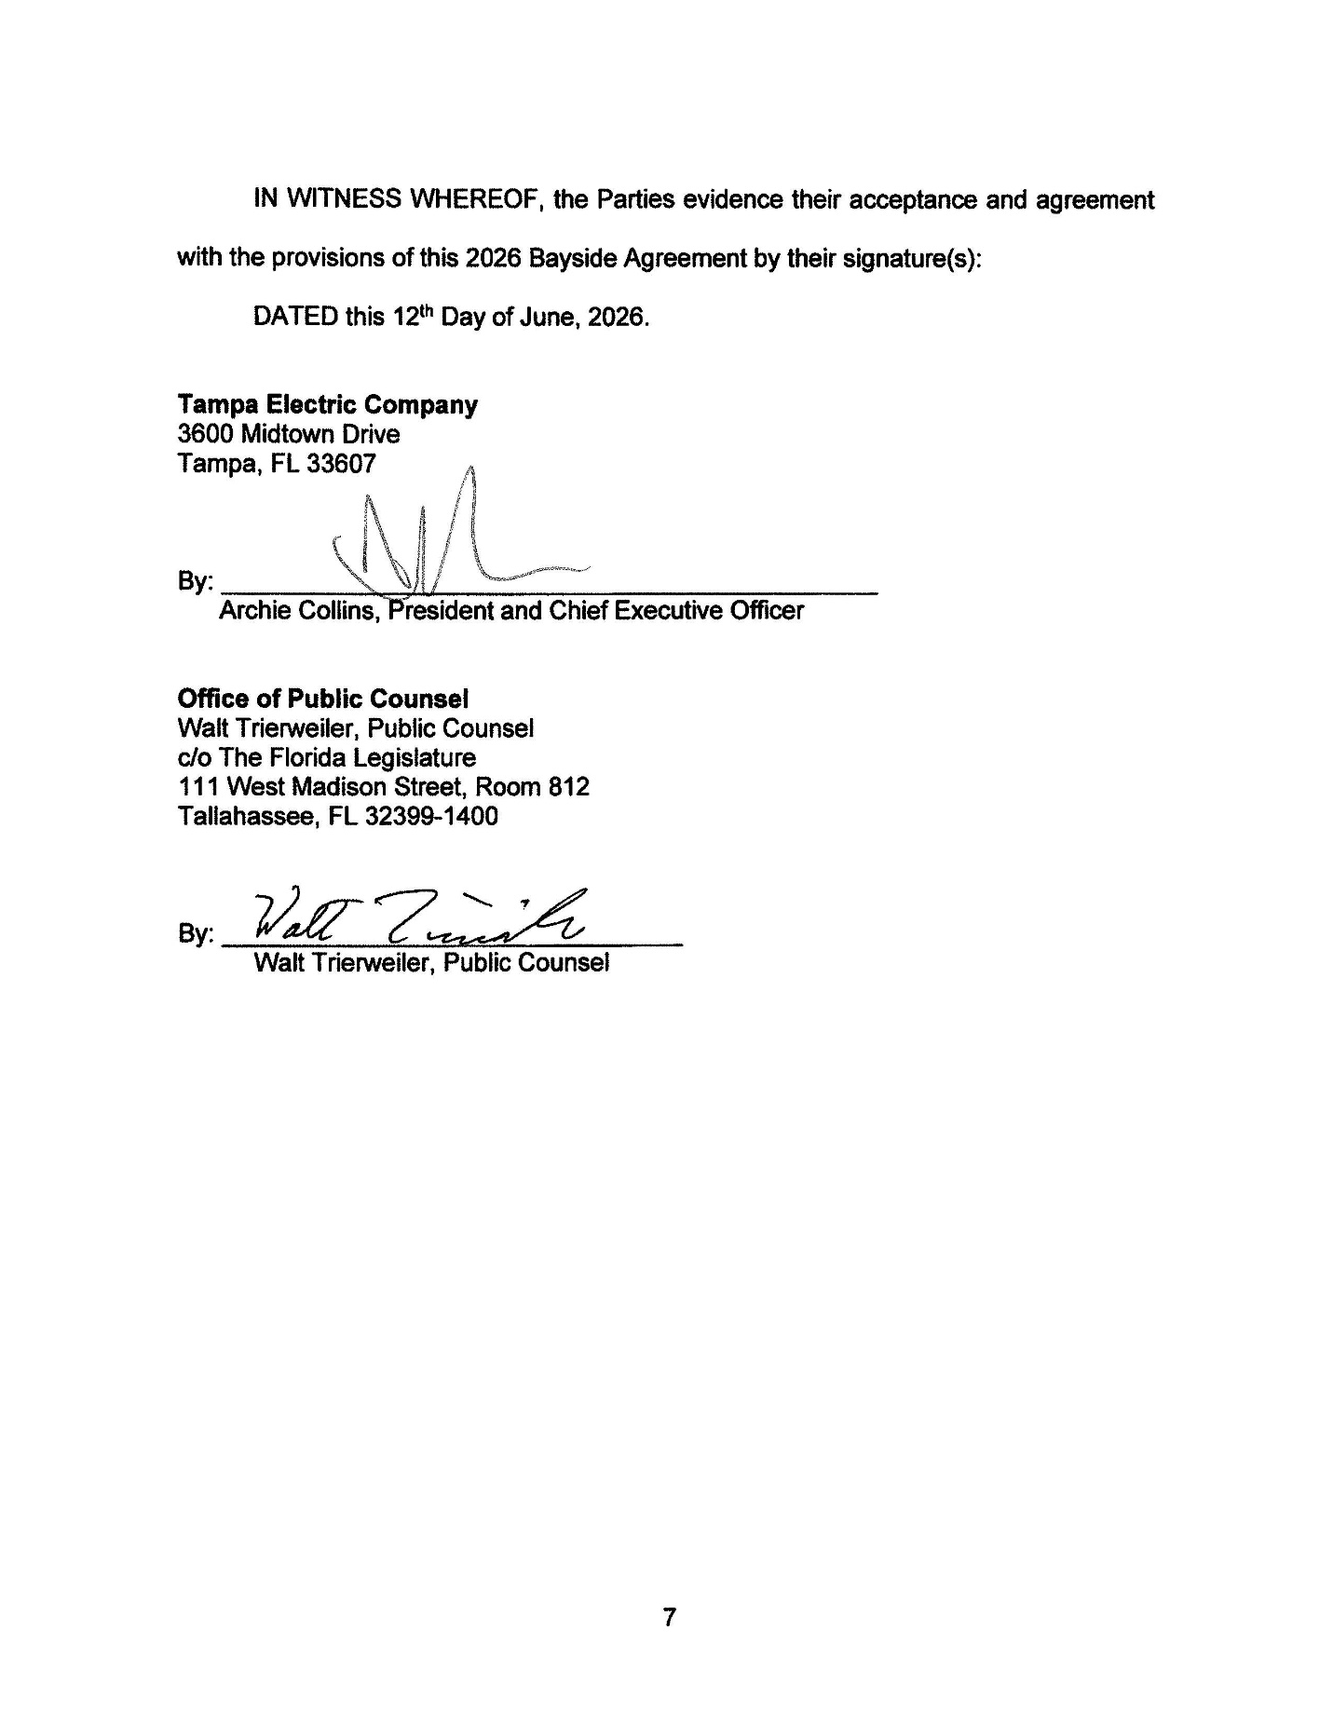

Docket No. 20260001-EI, In re: Fuel and purchased power cost recovery clause with generating performance incentive factor.
Order No. PSC-2026-0081-PCO-EI, issued April 1, 2026, in Docket No. 20260001-EI, In re: Fuel and purchased power cost recovery clause with generating performance incentive factor.
“[W]hile the Commission need not resolve every issue independently in its final order when it is reviewing a settlement agreement, it must nonetheless discuss the major elements of the settlement agreement and explain why it is in the public interest.” Floridians Against Increased Rates v. Clark, 371 So.3d 905, 912 (Fla. 2023) (internal quotations marks and citations omitted).

