BEFORE THE FLORIDA PUBLIC SERVICE COMMISSION

In re: Fuel and purchased power cost recovery clause with generating performance incentive factor. | DOCKET NO. 20260001-EI
In re: Review of the 2024-2025 outage of Tampa Electric Company's Bayside Steam Turbine Unit 2. | DOCKET NO. 20260053-EI
In re: Petition for approval of revised depreciation rates for Bayside Power Station assets, by Tampa Electric Company. | DOCKET NO. 20260062-EI  ORDER NO. PSC-2026-0297-FOF-EI  ISSUED: August 24, 2026

The following Commissioners participated in the disposition of this matter:

GABRIELLA PASSIDOMO SMITH, Chairman
GARY F. CLARK
MIKE LA ROSA
BOBBY PAYNE
ANA ORTEGA

ORDER APPROVING TAMPA ELECTRIC COMPANY’S
2026 BAYSIDE AGREEMENT

BY THE COMMISSION:
BACKGROUND

Two replacement power issues associated with Tampa Electric Company’s (TECO or Company) Bayside Unit 2 were raised in the 2026 Fuel Clause docket, Docket 20260001-EI: replacement power costs associated with an outage of TECO’s Bayside Steam Turbine 2 lasting from October 1, 2024 to August 15, 2025, and replacement power costs associated with a forced outage of Bayside Combustion Turbine 2D from January 22, 2025 to June 12, 2025. TECO and the Office of Public Counsel (OPC) filed a Joint Motion to spin-off the Bayside Steam Turbine 2 outage into a separate docket on March 23, 2026, due to the complexity of the outage and the volume of confidential utility and third-party documents that would have to be reviewed. This request was granted by Order No. PSC-2026-0081-PCO-EI and Docket No. 20260053-EI, In re: Review of the 2024-2025 outage of Tampa Electric Company’s Bayside Steam Turbine Unit 2, was established on April 6, 2026.
The January 22, 2025 to June 12, 2025 Bayside Combustion Turbine 2D outage was not moved to the new docket, but remained at issue in Docket No. 2026001-EI.

On April 15, 2026, TECO filed a petition seeking approval of revised depreciation rates for its Bayside Power Station assets to be effective January 1, 2027. Docket No. 20260062-EI was assigned to the depreciation rate change petition. The Company retrofitted the steam turbines of its Bayside Units 1 & 2; and placed them back in service in August 2025 and June 2026. The retrofit materially extends the remaining lives and anticipated retirement dates for these units; consequently, it also impacts the depreciation rates of various depreciation accounts for Bayside Station. TECO requested to approve its proposed new depreciation rates for the affected accounts, with an implementation date of January 1, 2027. The revised depreciation rates result in a reduction to depreciation expense of approximately $19.5 million.

On June 16, 2026, TECO filed a Motion to Approve 2026 Bayside Agreement (Stipulation and Settlement Agreement dated June 12, 2026, or "2026 Bayside Agreement") which proposed to resolve both Bayside Steam Turbine 2 and Bayside Combustion Turbine 2D outage issues and the depreciation rate changes for the Bayside Power Station assets. The signatories to the 2026 Bayside Agreement are TECO and OPC. There are no other parties to Docket No. 20260053-EI or Docket No. 20260062-EI. The 2026 Bayside Agreement is Attachment A to this order.

The Fuel Clause docket, Docket 20260001-EI, has seven parties in addition to TECO and OPC: Florida Public Utilities Company; Duke Energy Florida, LLC; Florida Power & Light Company; Florida Industrial Power Users Group; Southern Alliance for Clean Energy; White Springs Agricultural Chemicals, Inc. d/b/a/ PCS Phosphate – White Springs; and Nucor Steel Florida, Inc. All of these parties took no position on the 2026 Bayside Agreement and were excused from the attending the final hearing conducted on August 4, 2026. At the final hearing, the pre-filed testimony of TECO witnesses Ned Allis, Jeff Chronister and Kris Stryker and Exhibits Nos. 1-15 were admitted into the record. The parties waived briefs and a vote was taken after our staff gave an oral recommendation.

We have jurisdiction over this subject matter by the provisions of Chapter 366, Florida Statutes (F.S.).
DECISION

The legal standard for approval of a settlement agreement is whether, when taken as a whole, the agreement is in the public interest and results in fair, just and reasonable rates. In order to do this, we must identify the major elements of the settlement and provide an explanation of how those elements affect our decision on public interest.

There are three major elements in the 2026 Bayside Agreement: a base rate freeze; Bayside outage-related replacement power costs; and modifications of depreciation rates for Bayside Unit 1 and 2 assets.

Base Rate Freeze

The 2026 Bayside Agreement states that the Company may not petition to change any of its general base rates, charges, or credits for retail electric service with an effective date earlier than January 1, 2028. The 2026 Bayside Agreement further states that this "freeze" is with the exception for rate and tariff changes necessary to implement the Company's 2027 Subsequent Year Adjustment as approved by this Commission in TECO' s last rate case; and the exception for filing for approval of large load tariffs required by 366.043, F.S. This base rate freeze provision forecloses the possibility that TECO might seek base rate relief to be effective in 2027 to address the earnings pressure discussed in the Company's public and confidential Commission staff data request responses.

Bayside Outage-Related Replacement Power Costs

The 2026 Bayside Agreement states that the replacement fuel and purchased power issues associated with the Bayside Steam Turbine Unit 2 Outage in Docket Nos. 20260053-EI and Bayside Combustion Turbine 2D Outage shall be resolved by reducing the Company's 2027 recoverable fuel and purchased power expense by a combined total of $10 million.

Depreciation Rates

OPC and TECO agree that the Bayside depreciation rates proposed in Docket No. 20260062 are reasonable and should be approved effective July 1, 2026.

Public Interest

In the Company's responses to Commission staff’s data requests, TECO stated that, compared to its originally requested effective date of January 1, 2027, the new effective date will reduce its 2026 depreciation expense by approximately $9.6 million. TECO also confirmed that if the 2026 Bayside Agreement is approved, the Company still intends to proceed with the installation of "solar assets or other projects excluded from 2027 subsequent year adjustment revenues approved in its last rate case" without increasing customers' bills in 2027. TECO has stated that it expects three solar projects representing 166.5 MW to go into service by December 2026, but would not impact rates due to the proposed base rate freeze through 2027. The revenue requirement of such plants is estimated to be $22. 7M.

The 2026 Bayside Agreement would result in a $10 million reduction in the 2027 recoverable fuel costs. Further, the Agreement would provide stability in current base rates until at least December 31, 2027, in part through the deferral of new solar project cost recovery in 2027. Additionally, the 2026 Bayside Agreement would serve to reduce earnings pressure for TECO and supports the decision to forego seeking additional rate relief during this same period in 2027.

Based on the record of the three associated dockets, we find that the 2026 Bayside Agreement, and its major elements, are in the public interest when taken as a whole and results in rates that are fair, just and reasonable.

Based on the foregoing, it is

ORDERED by the Florida Public Service Commission that Tampa Electric Company’s Motion to Approve 2026 Bayside Agreement, titled Stipulation and Settlement Agreement, dated June 12, 2026, Attachment A hereto, is hereby approved.

ORDERED that Docket No. 20260053-EI, in re: Review of the 2024-2025 outage of Tampa Electric Company’s Bayside Steam Turbine Unit 2 and Docket No. 20260062-EI, In re: Petition for approval of revised depreciation rates for Bayside Power Station assets, by Tampa Electric Company, shall be closed. Docket No. 20260001-EI shall remain open.

By ORDER of the Florida Public Service Commission this 24th day of August, 2026.

/s/ Adam J. Teitzman
ADAM TEITZMAN
Commission Clerk
Florida Public Service Commission
2540 Shumard Oak Boulevard
Tallahassee, Florida 32399
(850) 413-6770
www.floridapsc.com

Copies furnished: A copy of this document is provided to the parties of record at the time of issuance and, if applicable, interested persons.

SBr

NOTICE OF FURTHER PROCEEDINGS OR JUDICIAL REVIEW

The Florida Public Service Commission is required by Section 120.569(1), Florida Statutes, to notify parties of any administrative hearing or judicial review of Commission orders that is available under Sections 120.57 or 120.68, Florida Statutes, as well as the procedures and time limits that apply. This notice should not be construed to mean all requests for an administrative hearing or judicial review will be granted or result in the relief sought.

Any party adversely affected by the Commission's final action in this matter may request: 1) reconsideration of the decision by filing a motion for reconsideration with the Office of Commission Clerk, 2540 Shumard Oak Boulevard, Tallahassee, Florida 32399-0850, within fifteen (15) days of the issuance of this order in the form prescribed by Rule 25-22.060, Florida Administrative Code; or 2) judicial review by the Florida Supreme Court in the case of an electric, gas or telephone utility or the First District Court of Appeal in the case of a water and/or wastewater utility by filing a notice of appeal with the Office of Commission Clerk, and filing a copy of the notice of appeal and the filing fee with the appropriate court. This filing must be completed within thirty (30) days after the issuance of this order, pursuant to Rule 9.110, Florida Rules of Appellate Procedure. The notice of appeal must be in the form specified in Rule 9.900(a), Florida Rules of Appellate Procedure.

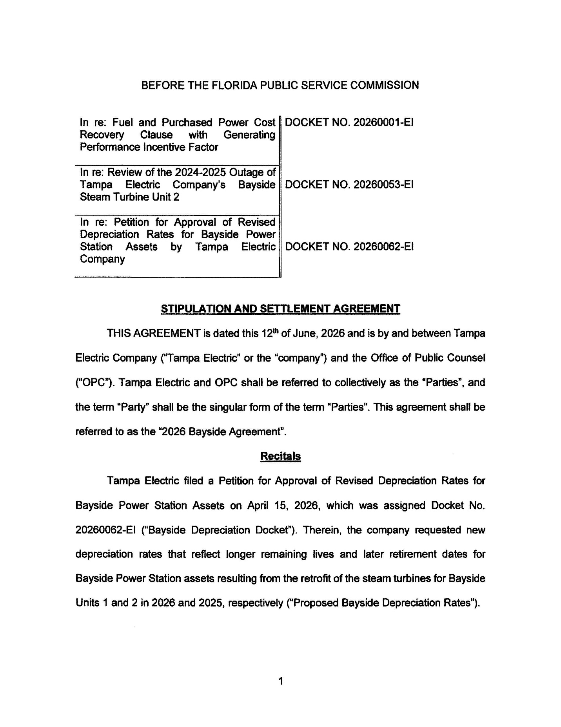
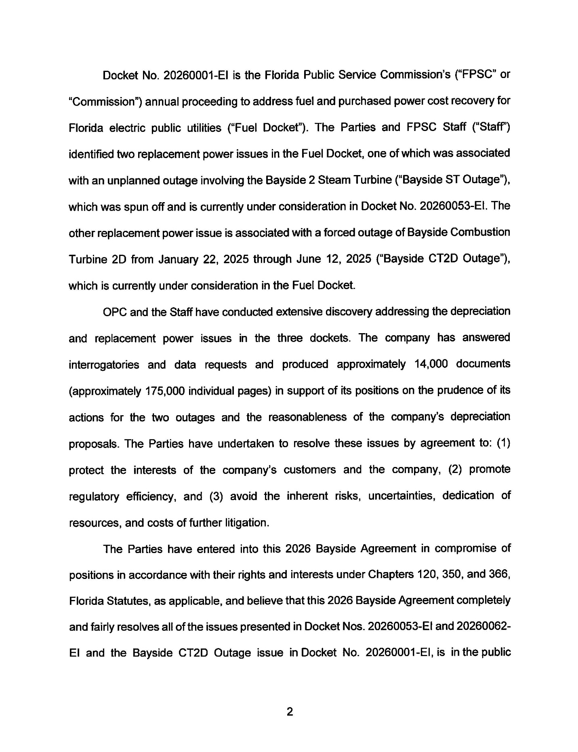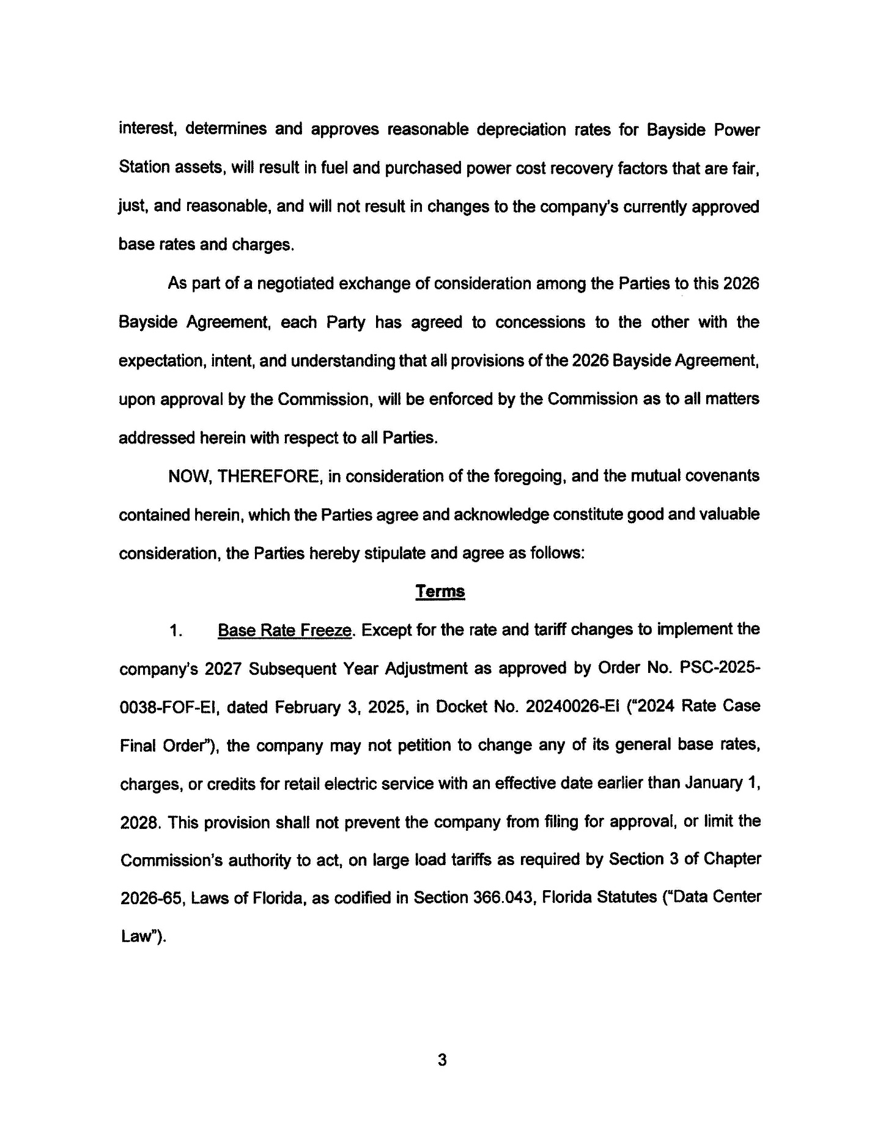
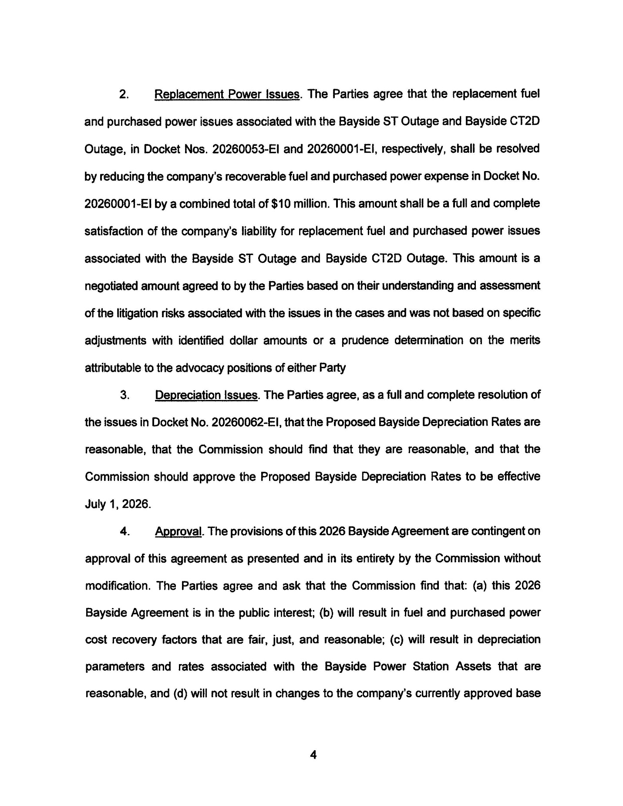
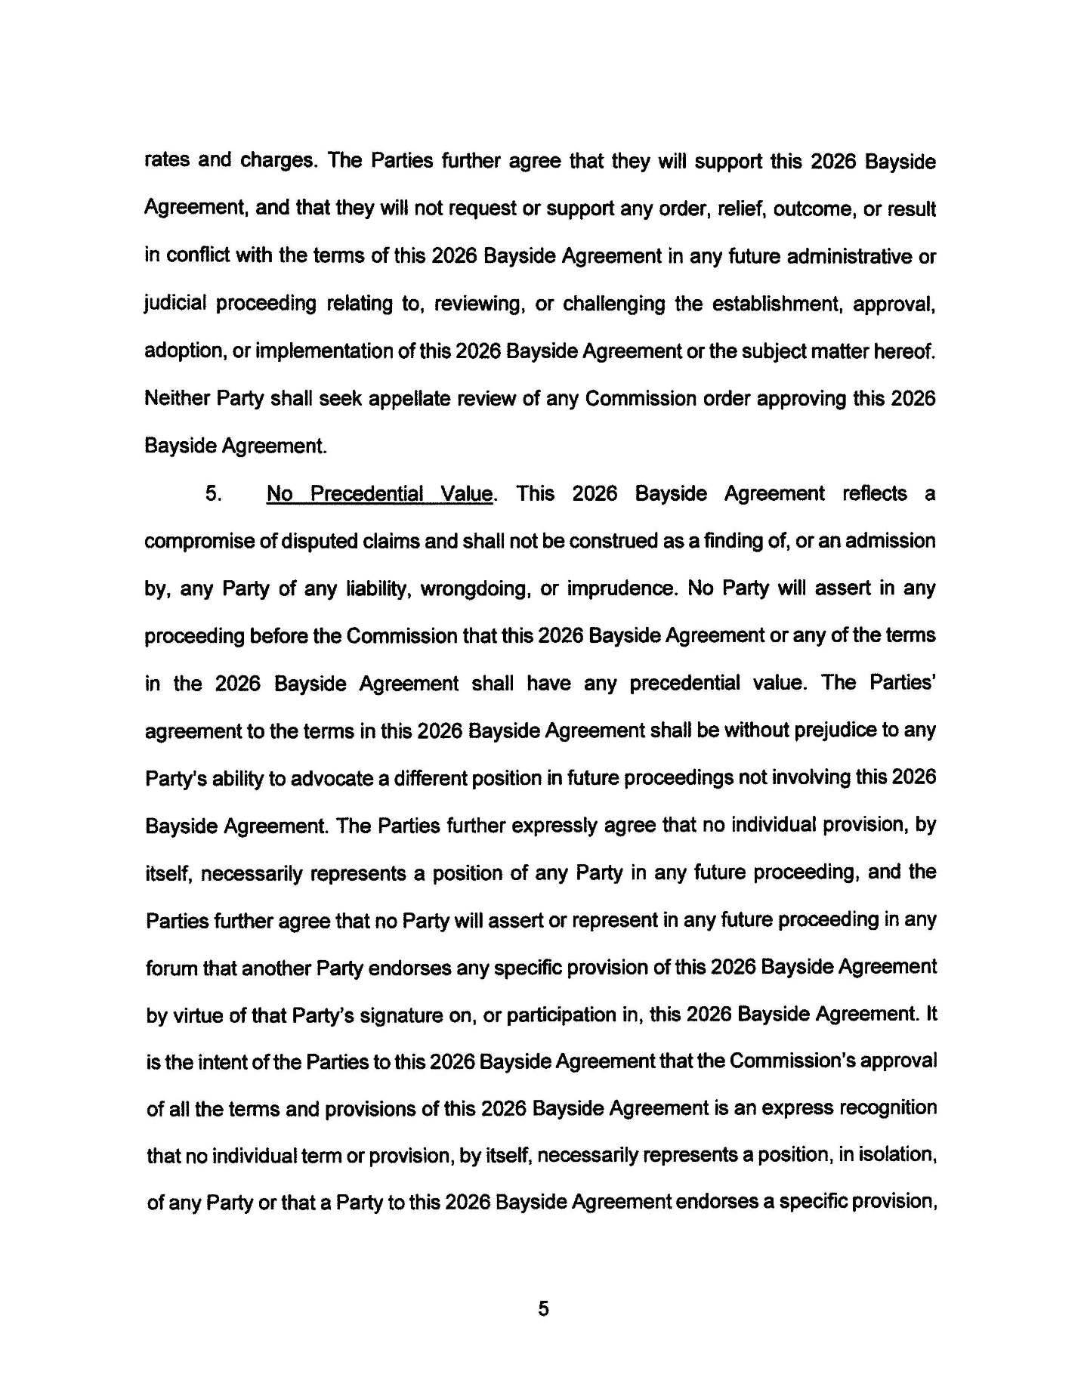
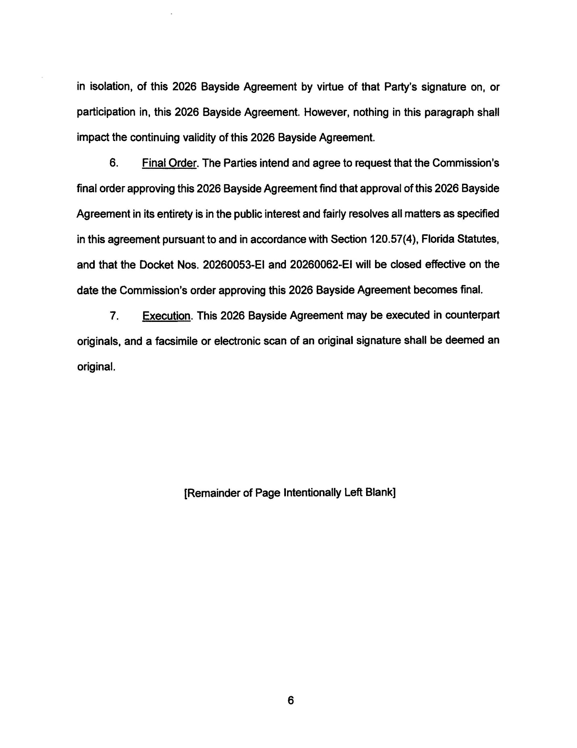
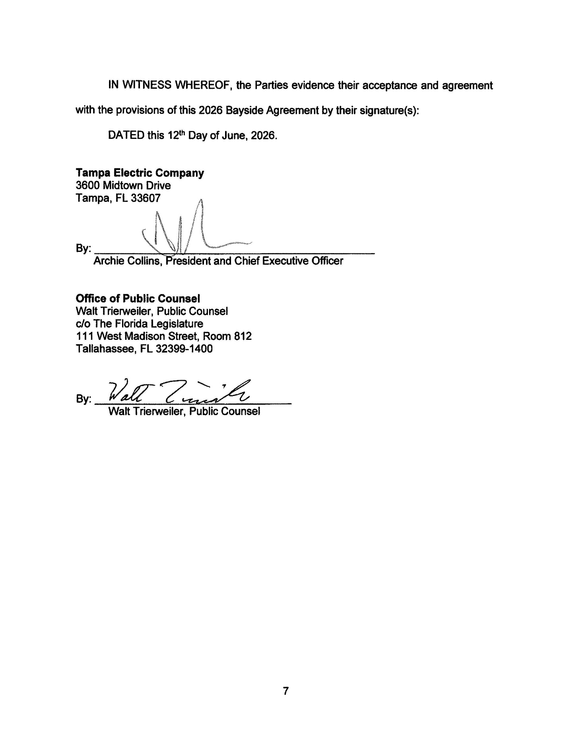

Docket No. 20260001-EI, In re: Fuel and purchased power cost recovery clause with generating performance incentive factor.
Order No. PSC-2026-0081-PCO-EI, issued April 1, 2026, in Docket No. 20260001-EI, In re: Fuel and purchased power cost recovery clause with generating performance incentive factor.
Floridians Against Increased Rates, Inc. v. Clark (FAIR), 371 So. 3d 905, 910 (Fla. 2023).
Order No. PSC-2024-0078-FOF-EI, issued March 25, 2024, in Docket No. 20210015-EI, In re: Petition for rate increase by Florida Power & Light Company.

