BEFORE THE FLORIDA PUBLIC SERVICE COMMISSION

In re: Petition for approval of firm service agreement with Peoples Gas System, Inc. in Lee and Collier Counties, by SeaCoast Gas Transmission, LLC. | DOCKET NO. 20260088-GU  ORDER NO. PSC-2026-0350-PAA-GU  ISSUED: September 30, 2026

The following Commissioners participated in the disposition of this matter:

GABRIELLA PASSIDOMO SMITH, Chairman
GARY F. CLARK
MIKE LA ROSA
BOBBY PAYNE
ANA ORTEGA

NOTICE OF PROPOSED AGENCY ACTION
ORDER APPROVING FIRM SERVICES AGREEMENT BETWEEN
PEOPLES GAS SYSTEM, INC. AND SEACOAST GAS TRANSMISSION, LLC

BY THE COMMISSION:

NOTICE is hereby given by the Florida Public Service Commission that the action discussed herein is preliminary in nature and will become final unless a person whose interests are substantially affected files a petition for a formal proceeding, pursuant to Rule 25-22.029, Florida Administrative Code (F.A.C.).

BACKGROUND

On June 5, 2026, SeaCoast Gas Transmission, LLC (SeaCoast) filed a petition seeking approval of a firm service agreement with Peoples Gas System, Inc. (Peoples, collectively, the Parties) dated May 20, 2026. SeaCoast operates as an intrastate natural gas transmission company as defined in Section 368.103, Florida Statutes (F.S.), and only transports natural gas. Peoples is a local distribution company which owns and operates natural gas distribution facilities to serve retail customers and is subject to our regulatory jurisdiction under Chapter 366.

By Order No. PSC-08-0747-TRF-GP, SeaCoast received approval of an intrastate gas pipeline tariff that allows it to construct and operate intrastate pipeline facilities and to actively pursue agreements with natural gas customers. SeaCoast provides transportation service only; it does not engage in the sale of natural gas. Pursuant to Order No. PSC-08-0747-TRF-GP, SeaCoast is allowed to enter into certain gas transmission agreements without our prior approval. However, SeaCoast is requesting our approval of this proposed agreement as it does not fit any of the criteria enumerated in the tariff for which our approval would not be required. The Parties are subsidiaries of TECO Gas Operations, Inc., and agreements between affiliated companies must be approved by us pursuant to Section 368.105, F.S., and Order No. PSC-08-0747-TRF-GP. In 2015, 2019, and 2021 we approved similar transportation agreements between Peoples and SeaCoast.

The proposed Agreement is contained in Attachment A to this order. Attachment B to this order contains the project map. During the evaluation of the instant petition, two Data Requests to the Parties were issued for which responses were received on July 8, 2026, and July 28, 2026. We have jurisdiction over this matter pursuant to Sections 366.05(1), 366.06, and 368.105, F.S.

DECISION

Peoples has entered into the proposed Agreement with SeaCoast to expand gas flow into Fort Myers, Naples, and the surrounding areas in Lee and Collier Counties to serve growth and safeguard system reliability for existing and new customers. To provide intrastate transportation of gas to Peoples, SeaCoast would construct an interconnection with an existing Florida Gas Transmission Company, LLC (FGT) pipeline serving Lee and Collier Counties. SeaCoast would also construct an approximately 24 mile, eight-inch steel high-pressure transmission pipeline originating at the new FGT and SeaCoast interconnection and continuing south to the intersection of Corkscrew Road and State Road 41. SeaCoast would also construct two interconnections between SeaCoast and Peoples along the new pipeline, the first at Palm Beach Boulevard and the second at Corkscrew Road and State Road 41. The planned pipeline extension would resolve existing capacity constraints by boosting system pressure, increasing delivery capacity, and ensuring long-term operational reliability.

In paragraph 10 of the Petition, SeaCoast explained that it estimates the permitting process would take approximately 10 months, with construction anticipated to begin in September 2027. SeaCoast estimated that the proposed transmission pipeline would be completed by the third quarter of 2028. SeaCoast stated that it projects approximately 37,961 existing customers, including 34,396 residential and 3,589 commercial/industrial customers, would benefit from the expansion project through increased resiliency and reliability. In addition, SeaCoast stated that the proposed project would support additional customer growth and customer growth that has already occurred.

The negotiated reservation charge (confidential) included in the proposed Agreement is designed to allow SeaCoast to recover its operational and maintenance costs, depreciation, taxes, and return on investment associated with the new transmission pipeline. SeaCoast stated in paragraph 12 of its Petition that the rate set forth in the Agreement is a market-based rate reflecting the costs expected to be incurred under prevailing market conditions. SeaCoast asserted that the agreement is just, reasonable and not unreasonably preferential or unduly discriminatory, and therefore, consistent with Section 368.105(3)(b), F.S. While specific circumstances vary by projects due to pipe sizing, construction conditions, permitting, etc., we find that the information provided by SeaCoast for the proposed pipeline appears reasonable and comparable to similar agreements.

Consideration of Potential Alternatives to the SeaCoast Extension

In response to Staff’s First Data Request, SeaCoast stated that Peoples did not issue a formal request for proposals for the construction of the proposed pipeline facilities. SeaCoast explained that Peoples evaluated other options to meet demand and improve delivery of gas to customers in Lee and Collier Counties. Such alternatives included compression, additional pipeline facilities, a larger diameter pipeline, and an interstate pipeline solution. Installing a compressor station was rejected due to cost limitations and maximum allowable operating pressure (MAOP) safety boundaries and it also failed to resolve the single-gate-station vulnerability; constructing a pipeline across Corkscrew Boulevard lacked the required pressure to support the system; a larger pipe size failed to provide a meaningful capacity increase because the core backbone system is restricted by an existing 8-inch pipeline diameter; and, expanding the single existing gate station was deemed technically unfeasible because it cannot push enough gas to the farthest southern reaches of the system. Seacoast explained that FGT provided a proposal to expand its system to meet the project requirement. However, FGT’s proposal was not cost-effective in comparison to the proposal from SeaCoast and could not be completed within Peoples’ time requirements.

The Parties further explained, in response to Staff’s Data Request, that Peoples selected the SeaCoast project because it provides Peoples with the best option to achieve long-term system supply, reliability, pressure support, and cost effectiveness for the customers in Lee and Collier Counties.

Peoples’ Cost Recovery of Payments to SeaCoast

Peoples' payments to SeaCoast would be included in the calculation of the Purchased Gas Adjustment (PGA) clause factor. Consistent with the methodology approved by us in Docket No. 20000810-GU, a portion of the costs would be paid by transportation customers taking service under Peoples' Natural Choice Transportation Service program via the swing service charge mechanism. Swing service charge revenues collected from transportation customers would then be credited back to the PGA. Sales customers purchase their gas from Peoples and are subject to Peoples' PGA charge.

Based on the Petition and the Parties' responses to Staff’s Data Requests, the Parties have supported the importance of the need for pipeline extensions to service customers in Lee and Collier Counties. Therefore, we find that the proposed Agreement, dated May 20, 2026, is approved because it is cost-effective, reasonable, meets the requirements of Section 368.105, F.S., and benefits Peoples’ customers.

Based on the foregoing, is

ORDERED by the Florida Public Service Commission that the Petition for Approval of Firm Service Agreement with Peoples Gas System, Inc. by SeaCoast Gas Transmission, LLC filed on June 5, 2026, is hereby granted. It is further

ORDERED that the Firm Service Agreement, dated May 20, 2026, contained in Attachment A to this order, is hereby approved. It is further

ORDERED that the service map contained in Attachment B to this order is hereby approved. It is further

ORDERED that the provisions of this Order, issued as proposed agency action, shall become final and effective upon the issuance of a Consummating Order unless an appropriate petition, in the form provided by Rule 28-106.201, Florida Administrative Code, is received by the Commission Clerk, 2540 Shumard Oak Boulevard, Tallahassee, Florida 32399-0850, by the close of business on the date set forth in the “Notice of Further Proceedings” attached hereto. It is further

ORDERED that if no protest is filed by a person whose substantial interests are affected within 21 days of the issuance of the Order, this docket should be closed upon the issuance of a Consummating Order.
By ORDER of the Florida Public Service Commission this 30th day of September, 2026.

/s/ Adam J. Teitzman
ADAM TEITZMAN
Commission Clerk
Florida Public Service Commission
2540 Shumard Oak Boulevard
Tallahassee, Florida 32399
(850) 413-6770
www.floridapsc.com

Copies furnished: A copy of this document is provided to the parties of record at the time of issuance and, if applicable, interested persons.

SBr

NOTICE OF FURTHER PROCEEDINGS OR JUDICIAL REVIEW

The Florida Public Service Commission is required by Section 120.569(1), Florida Statutes, to notify parties of any administrative hearing that is available under Section 120.57, Florida Statutes, as well as the procedures and time limits that apply. This notice should not be construed to mean all requests for an administrative hearing will be granted or result in the relief sought.

Mediation may be available on a case-by-case basis. If mediation is conducted, it does not affect a substantially interested person's right to a hearing.

The action proposed herein is preliminary in nature. Any person whose substantial interests are affected by the action proposed by this order may file a petition for a formal proceeding, in the form provided by Rule 28-106.201, Florida Administrative Code. This petition must be received by the Office of Commission Clerk, 2540 Shumard Oak Boulevard, Tallahassee, Florida 32399-0850, by the close of business on October 21, 2026.

In the absence of such a petition, this order shall become final and effective upon the issuance of a Consummating Order.

Any objection or protest filed in this/these docket(s) before the issuance date of this order is considered abandoned unless it satisfies the foregoing conditions and is renewed within the specified protest period.

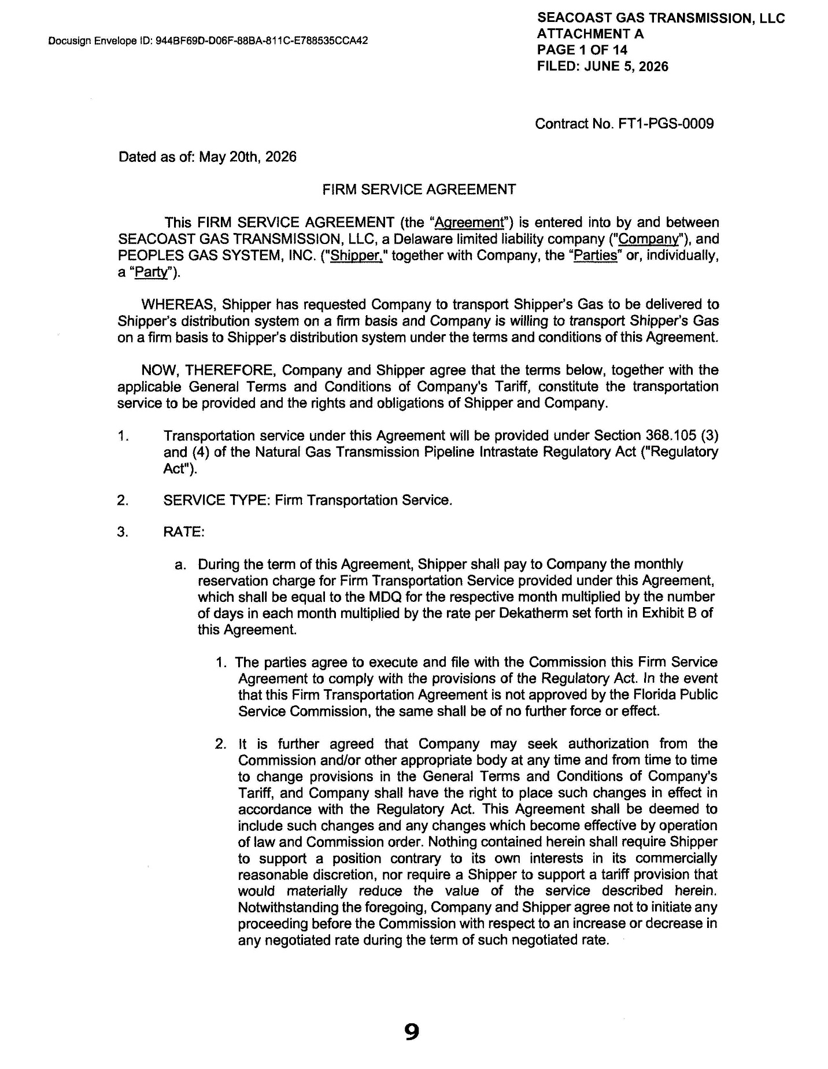
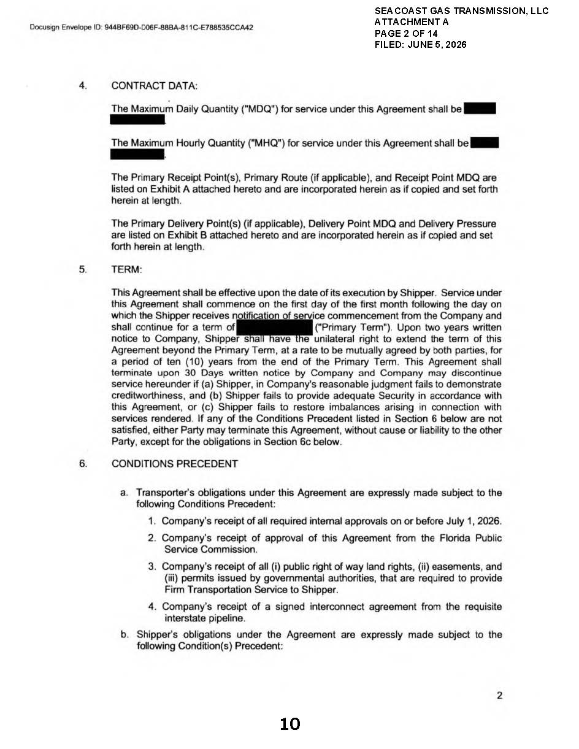

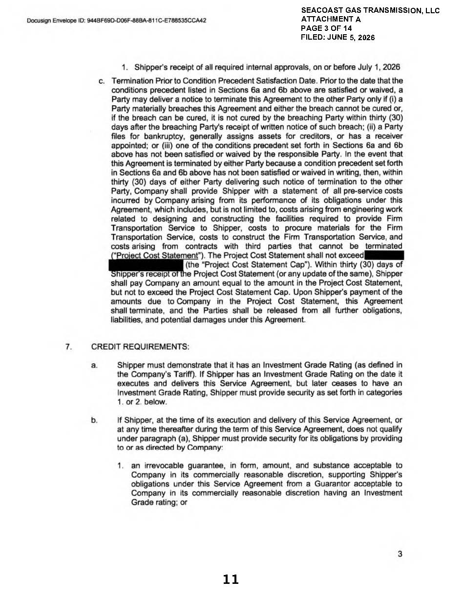

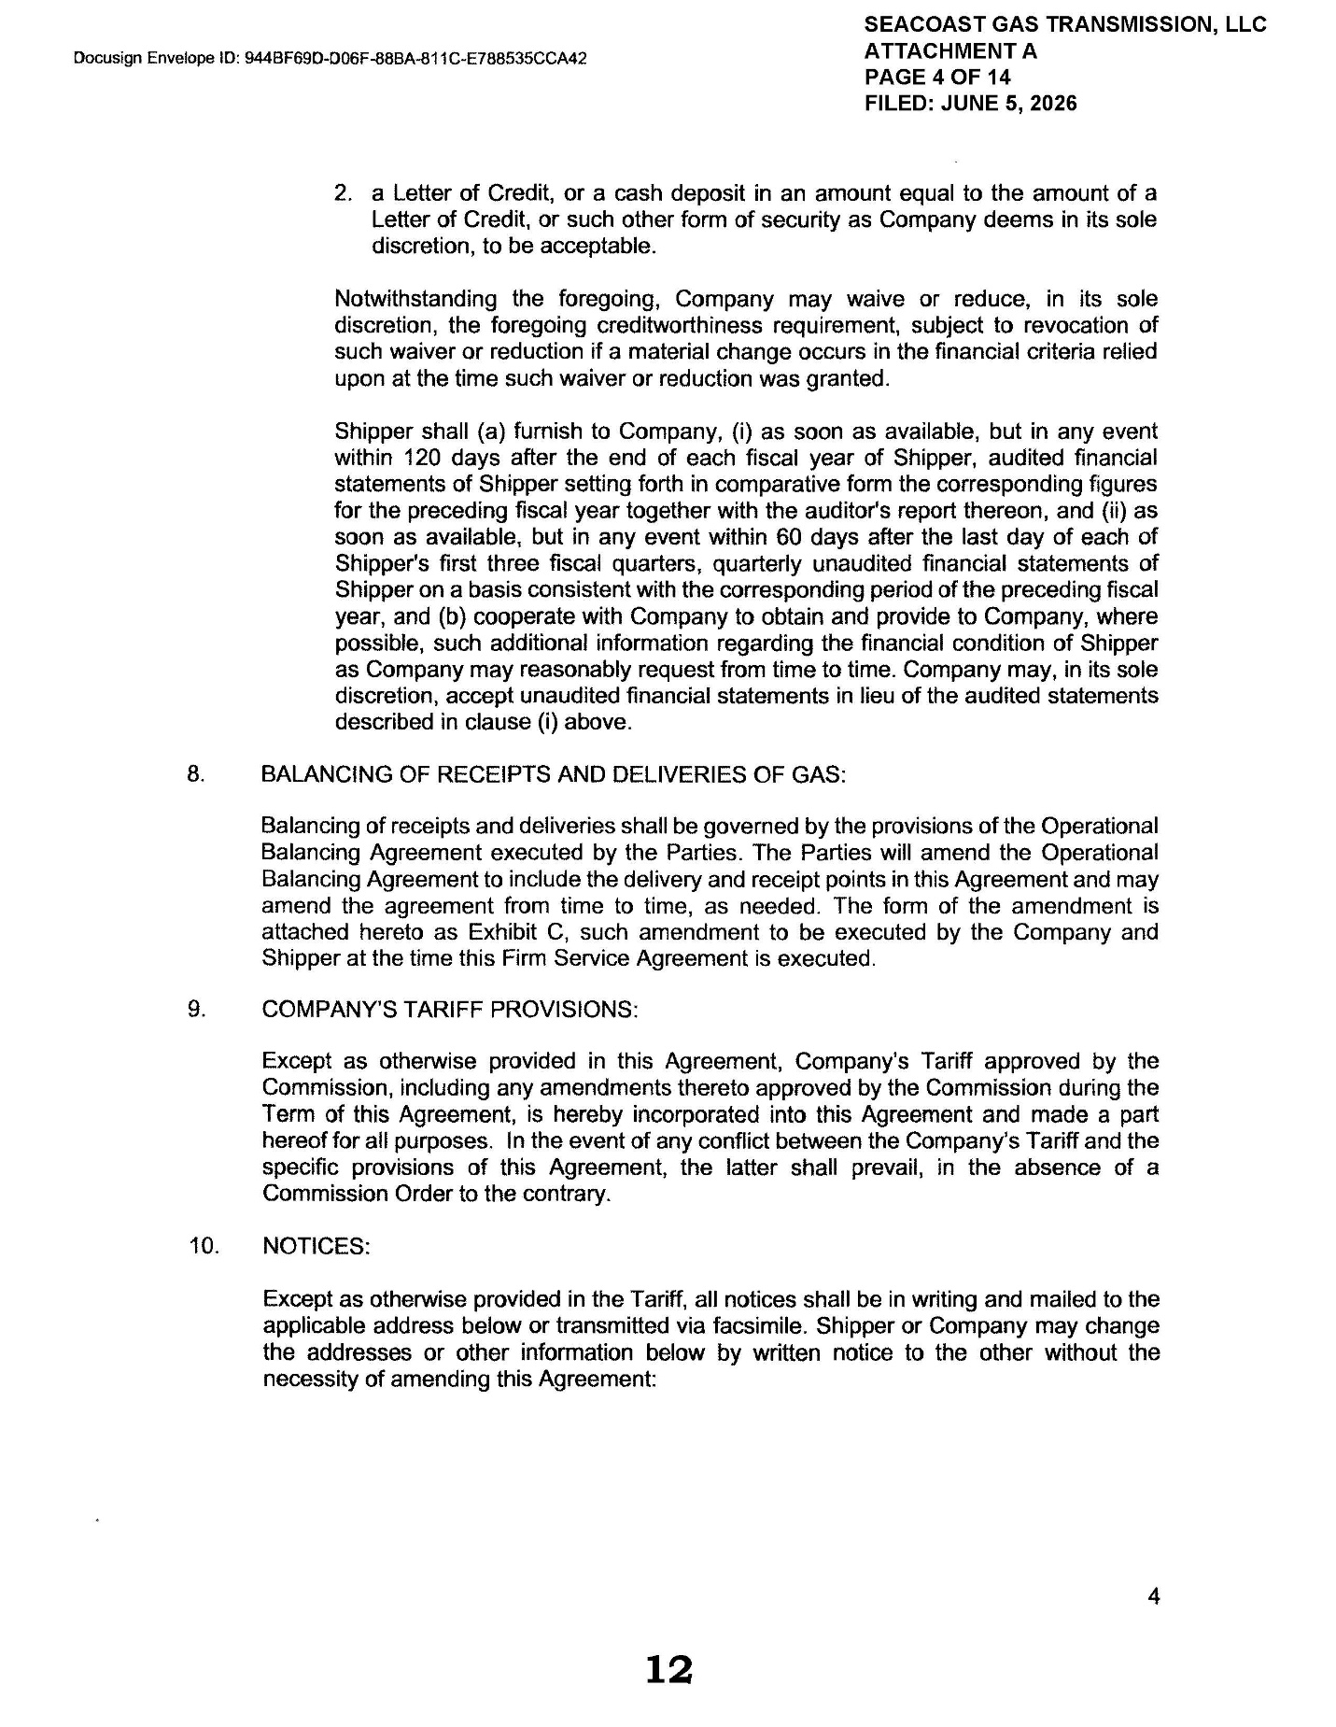

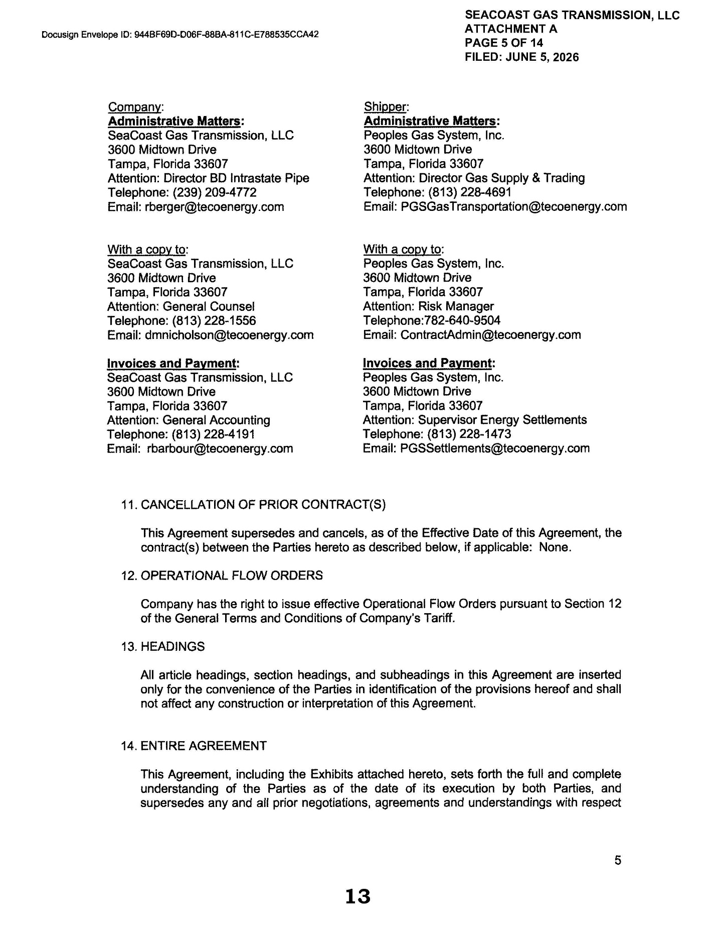

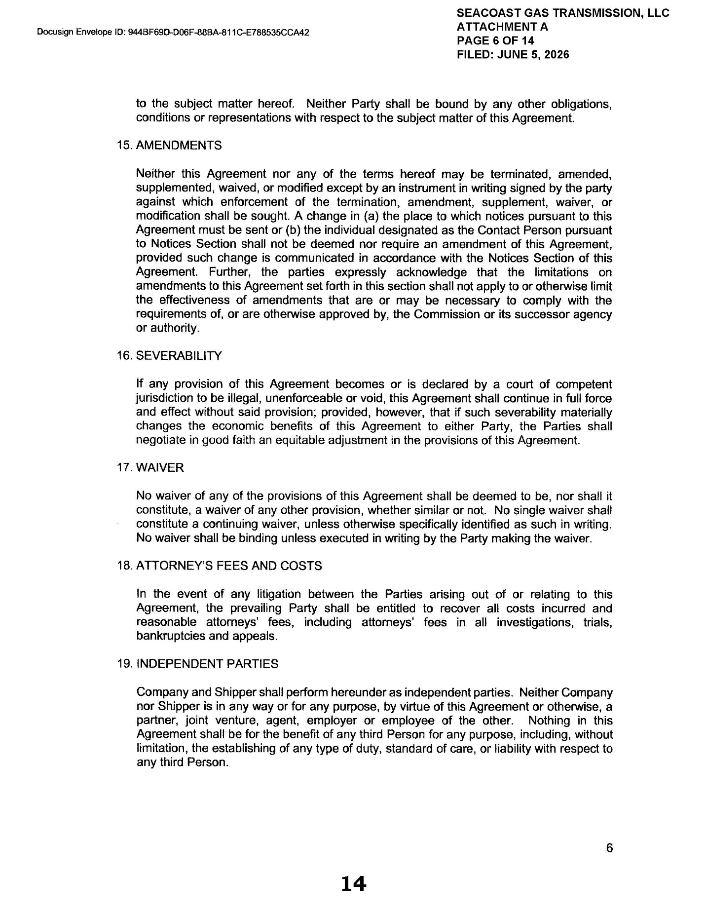

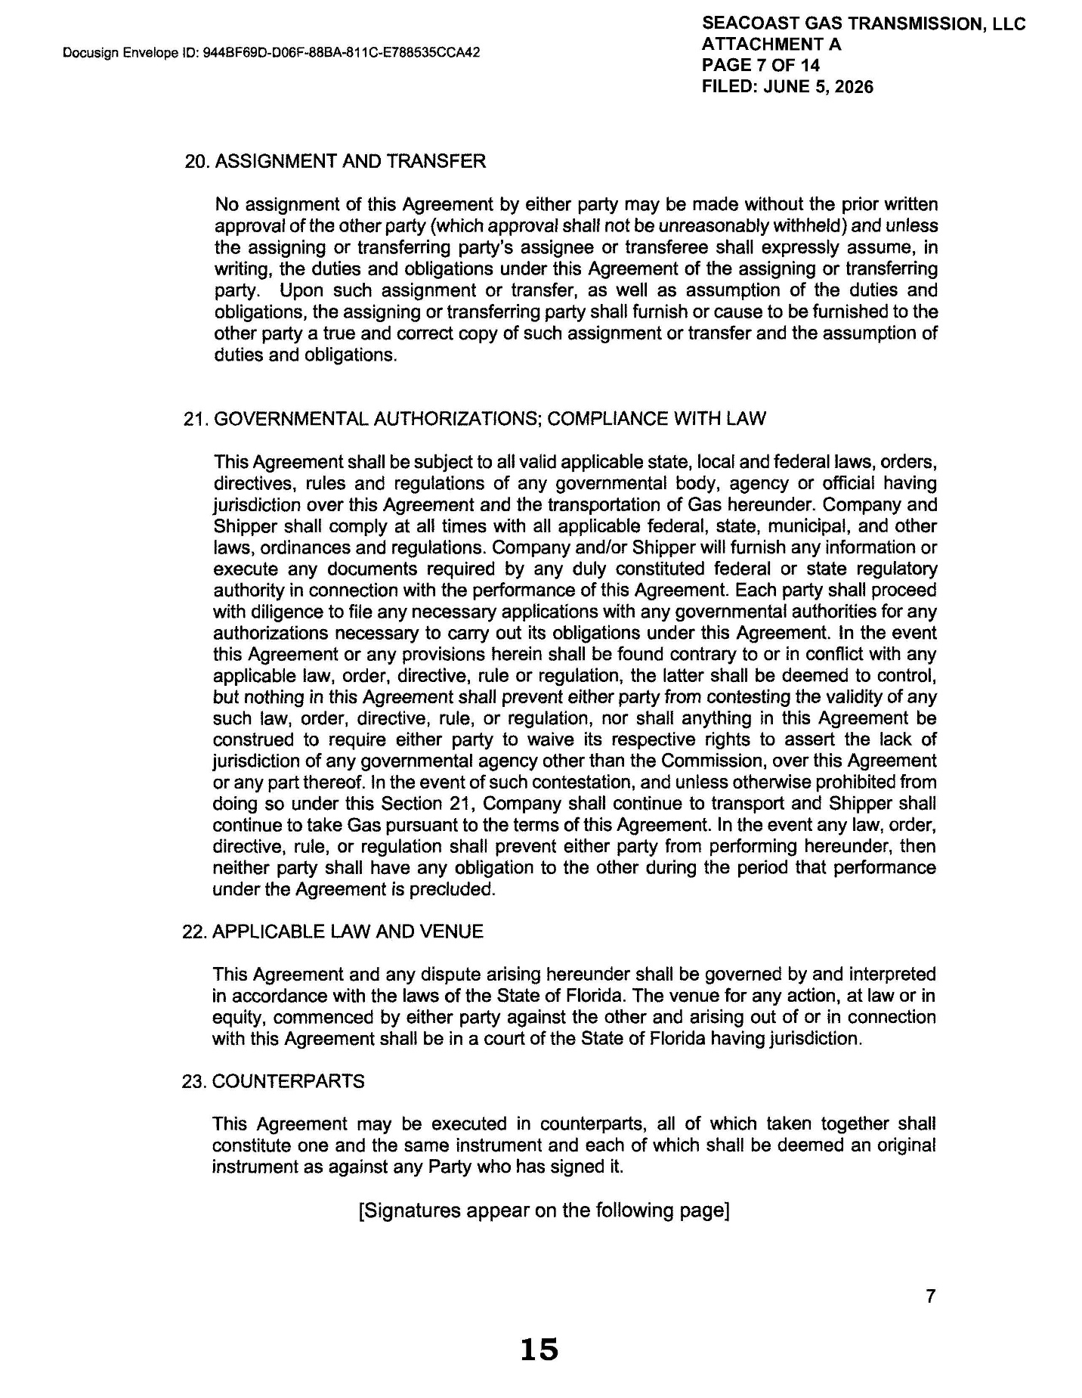

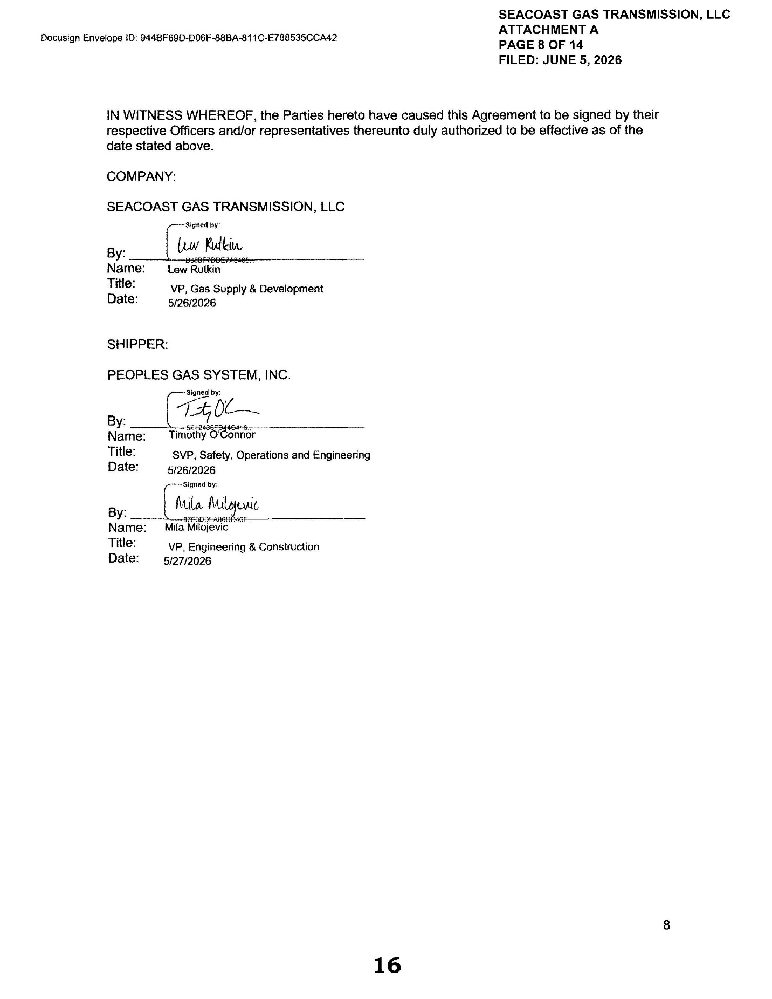

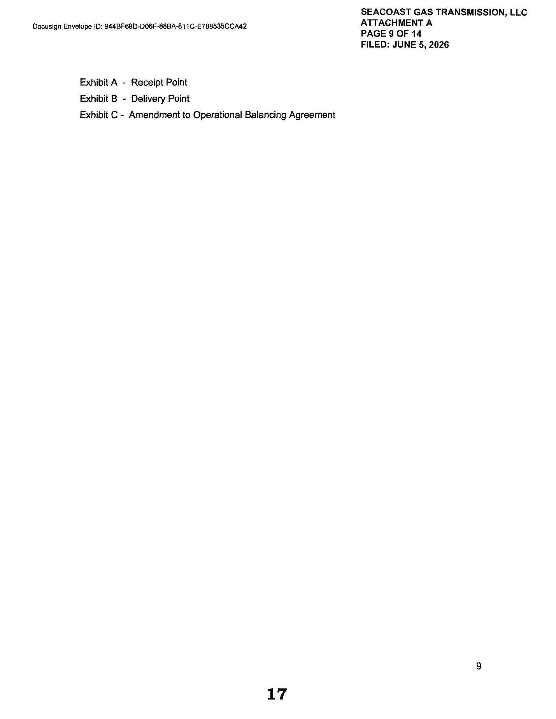

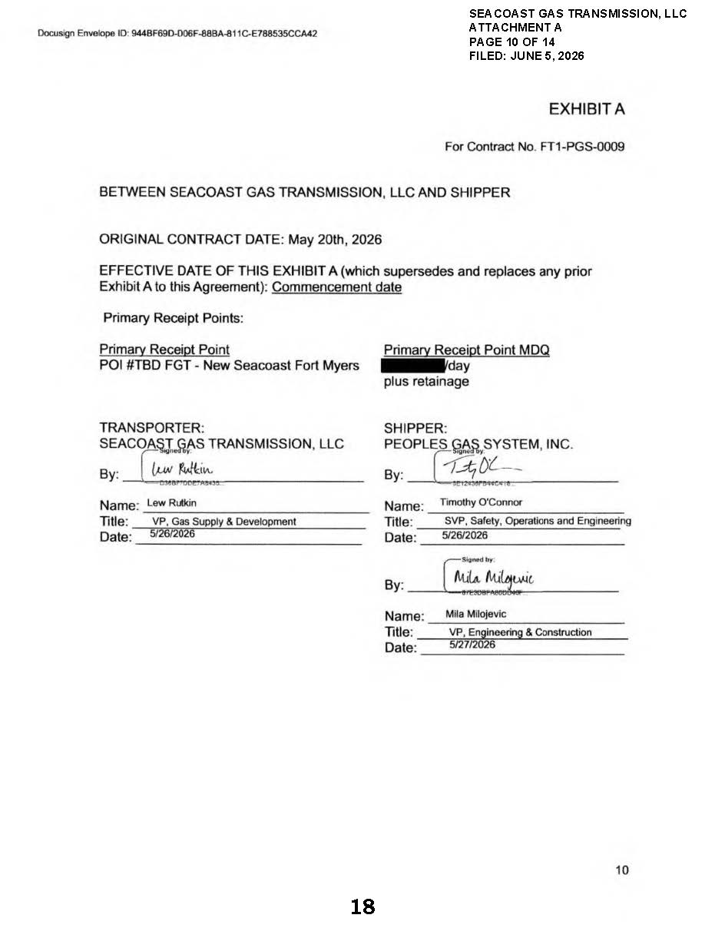

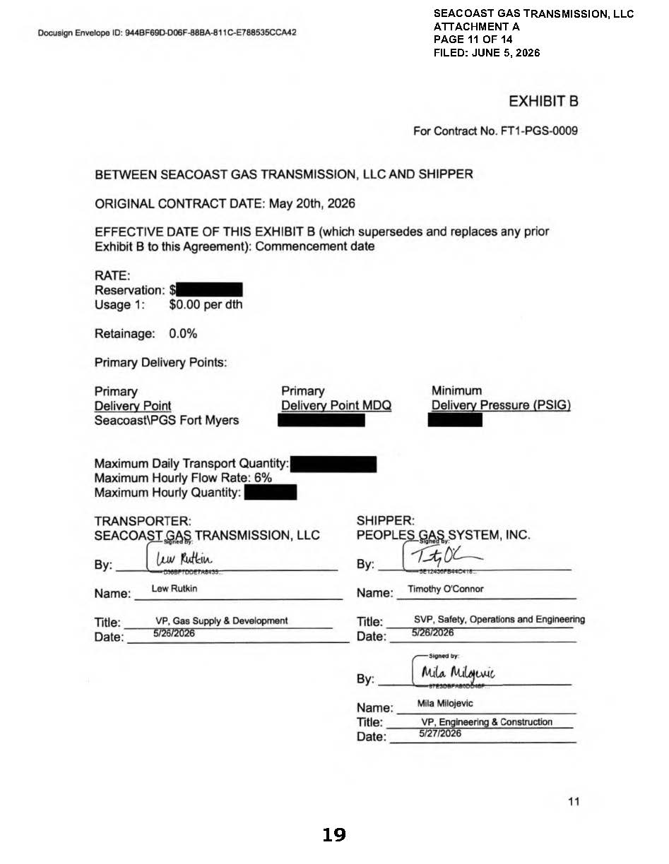

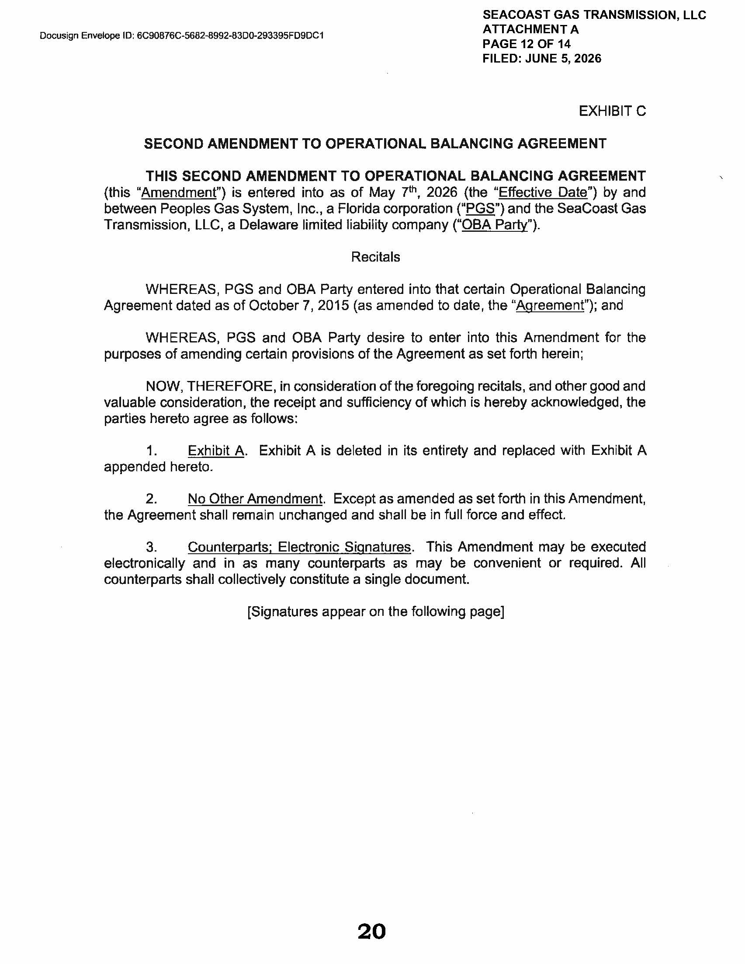

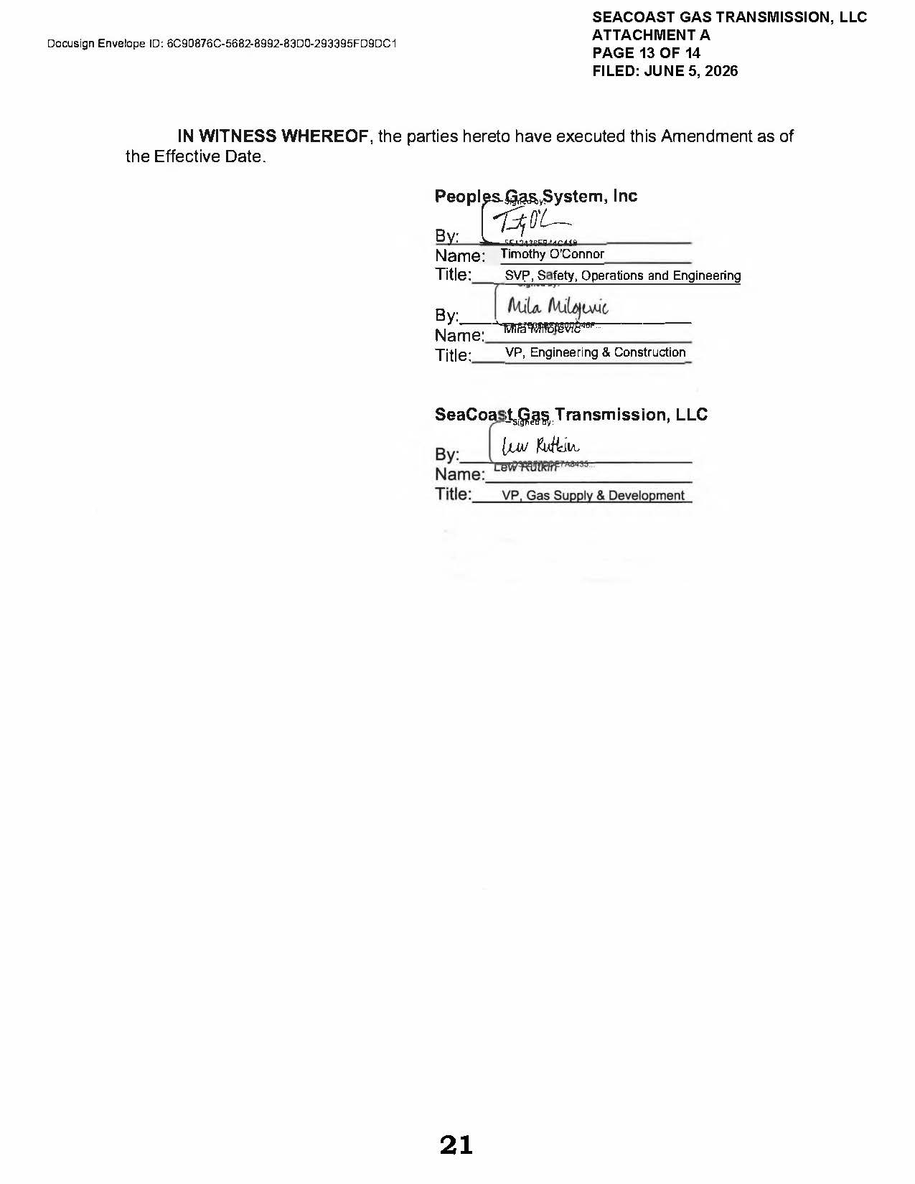

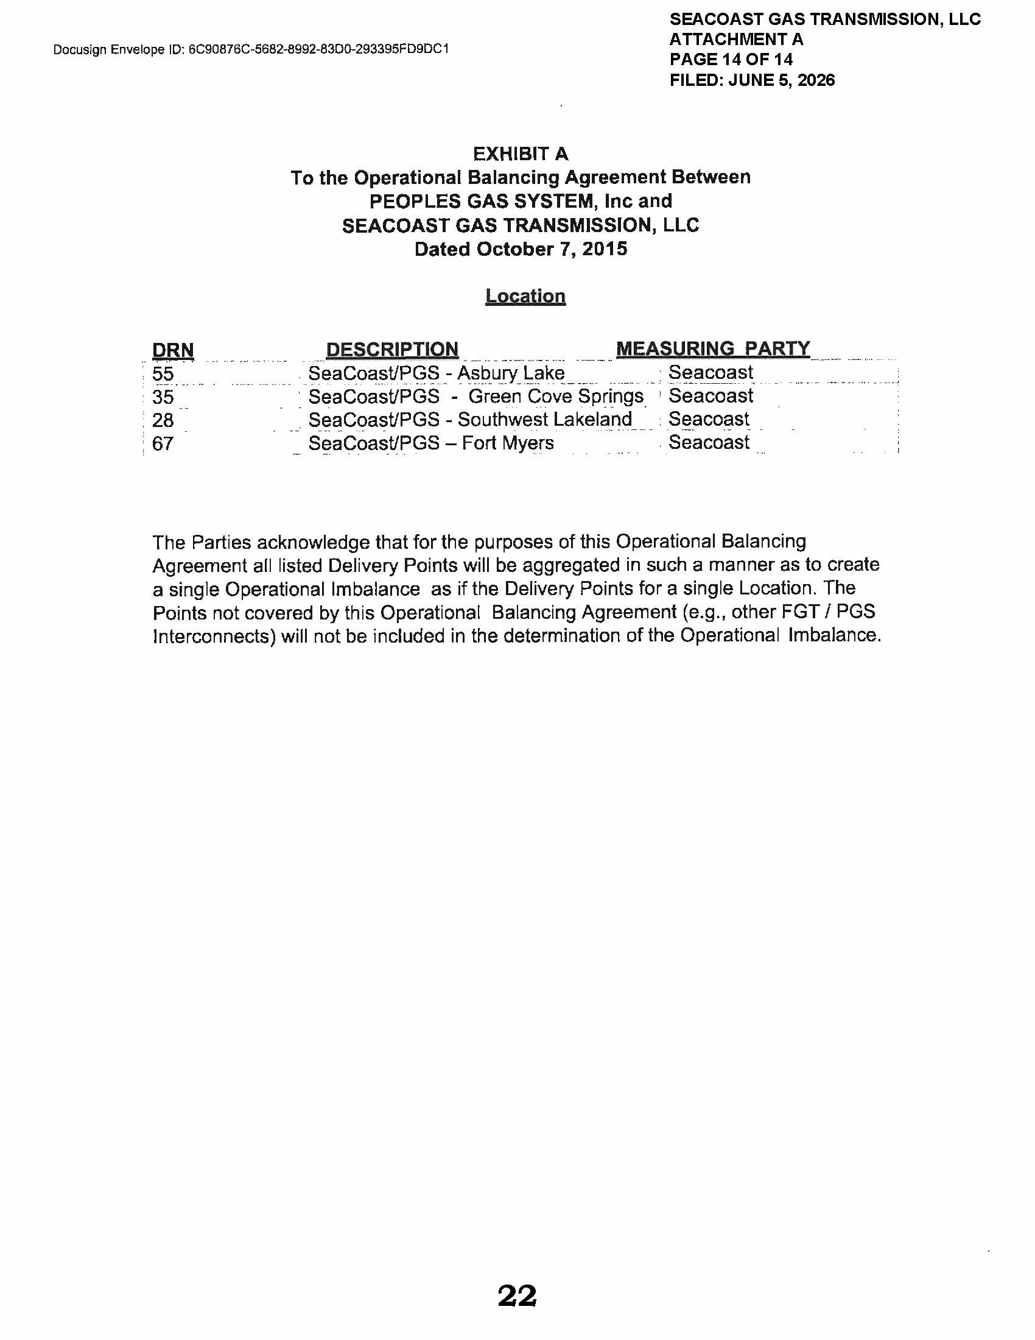

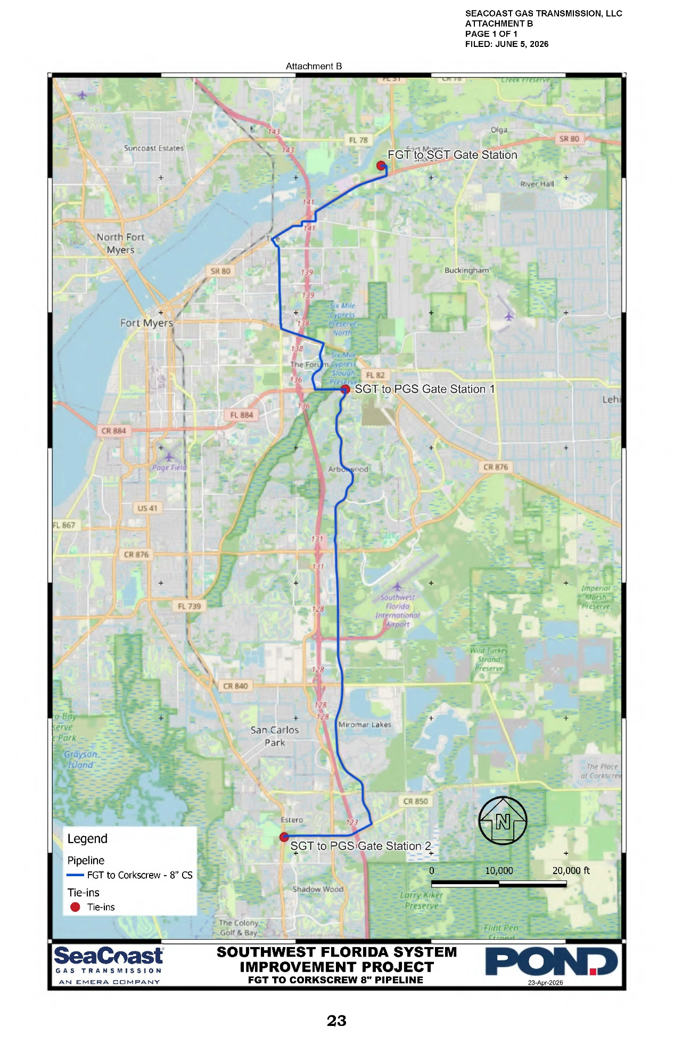

Order No. PSC-08-0747-TRF-GP, issued November 12, 2008, in Docket No. 20080561-GP, In re: Petition for approval of natural gas transmission pipeline tariff by SeaCoast Gas Transmission, LLC.
Order No. PSC-15-0574-PAA-GU, issued December 18, 2015, in Docket No. 20150221-GU, In re: Petition for approval of firm service agreement with Peoples Gas System for an extension in Clay County, by SeaCoast Gas Transmission, LLC.
Order No. PSC-2019-0545-PAA-GU, issued December 20, 2019, in Docket No. 20190145-GU, In re: Joint petition for approval of restructures Nassau County agreements to reflect Callahan expansion, by Peoples Gas System, Florida Public Utilities Company, SeaCoast Gas Transmission, and Peninsula Pipeline Company, Inc.
Order No. PSC-2021-0187-PAA-GU, issued May 24, 2021, in Docket No. 20210042-GU, In re: Petition for approval of firm service agreement with Peoples Gas System, by SeaCoast Gas Transmission, L.L.C.
SeaCoast’s response to Staff’s First Data Request, Document No. 03981-2026 and SeaCoast’s response to Staff’s Second Data Request, Document No. 04717-2026.
SeaCoast’s response to Staff’s Second Data Request, Question No. 1a.
SeaCoast’s response to Staff’s First Data Request, Question No. 8.
SeaCoast’s response to Staff’s First Data Request, Question No. 5.
SeaCoast’s response to Staff’s First Data Request, Question No. 7.
SeaCoast’s response to Staff’s Second Data Request, Question No. 3e.
SeaCoast’s response to Staff’s First Data Request, Question No. 7.
The swing service charge mechanism is designed to recover the estimated costs incurred by the Company to provide swing service (i.e., manage the level of gas and interstate pipeline capacity nominated for delivery to Peoples' system) to transportation customers. The revenue derived from the charge is credited to the Purchased Gas Adjustment clause.

