BEFORE THE FLORIDA PUBLIC SERVICE COMMISSION

In re: Petition for approval of 2027 subsequent year adjustment, by Peoples Gas System, Inc. | DOCKET NO. 20260101-GU  ORDER NO. PSC-2026-0353-TRF-GU  ISSUED: October 13, 2026

The following Commissioners participated in the disposition of this matter:

GABRIELLA PASSIDOMO SMITH, Chairman
GARY F. CLARK
MIKE LA ROSA
BOBBY PAYNE
ANA ORTEGA

ORDER APPROVING 2027 SUBSEQUENT YEAR ADJUSTMENT

BY THE COMMISSION:

Background
On July 1, 2026, Peoples Gas System, Inc. (Peoples) filed a petition seeking approval to implement its 2027 subsequent year adjustment (SYA). We approved the 2027 SYA in our Final Order addressing the settlement to Peoples’ request for base rate increase (Rate Case Order). In the Rate Case Order, we found that the SYA approved in the settlement resulted in lower rates for customers and was reasonable when considered in the totality of the whole settlement.

Paragraph 4(b) of the settlement agreement approved by the Rate Case Order discusses the 2027 SYA, including the approved total of the 2027 SYA being $25 million, how the base rate charges will be developed, and how the cost recovery clause and rider factors will be developed using the billing determinants for 2027. Paragraph 4(b) of the settlement also discusses the requirement to file their proposed tariffs to implement the 2027 SYA no later than July 31, 2026, allowing Peoples to provide timely notice to customers and to implement the new tariffs effective the first billing cycle of January 2027.

Peoples filed revised Attachments 4 and 5 to its petition on July 15, 2026, to correct scrivener’s errors. On August 24, 2026, we suspended the proposed tariffs to allow our staff sufficient time to analyze the utility's filing. Commission staff issued one data request during the evaluation of the petition, with responses filed by Peoples on August 13, 2026.
Attachment A to this Order contains the proposed legislative tariff sheets to implement the 2027 SYA. We have jurisdiction over this matter pursuant to Sections 366.05 and 366.06, Florida Statutes (F.S.).

Decision
Peoples’ petition included the proposed tariff sheets, the allocation of the revenue increase to the various rate classes, and calculations showing the revenue by rate schedule under current and proposed rates. We have reviewed Peoples’ calculations of the SYA and find that they are consistent with the Rate Case Order. The base rates and charges associated with the $25 million were developed using the cost recovery revenue allocation and the billing determinants for 2027 that Peoples will use to develop its cost recovery clause and rider factors for 2027. We compared the therm sales by rate class to Peoples’ facilities relocation clause filing in Docket No. 20260011-GU and confirmed that Peoples’ calculations relied on the same therm sales.
As a result, we hereby approve and authorize Peoples’ proposed rates and associated tariffs to implement its 2027 SYA, effective with the first billing cycle of January 2027. The rates and associated tariffs are consistent with our prior decision in the Rate Case Order. The rates have been calculated to recover a 2027 SYA annual revenue increase of $25 million, as we previously approved and as presented in Attachment Three of Peoples’ petition. The revised tariffs implementing the 2027 SYA are included as Attachment A to this Order.

Based on the foregoing, it is

ORDERED by the Florida Public Service Commission that Peoples Gas System, Inc.’s proposed rates and associated tariffs to implement its 2027 subsequent year adjustment are hereby approved. It is further
ORDERED that if a protest is filed within 21 days of the issuance of this Order by a person whose substantial interests are affected, the tariff shall remain in effect, with any incremental revenues held subject to refund, pending resolution of the protest. If no timely protest is filed, this docket shall be closed upon the issuance of a Consummating Order.

By ORDER of the Florida Public Service Commission this 13th day of October, 2026.

/s/ Adam J. Teitzman
ADAM TEITZMAN
Commission Clerk
Florida Public Service Commission
2540 Shumard Oak Boulevard
Tallahassee, Florida 32399
(850) 413-6770
www.floridapsc.com

Copies furnished: A copy of this document is provided to the parties of record at the time of issuance and, if applicable, interested persons.

MRT

NOTICE OF FURTHER PROCEEDINGS

The Florida Public Service Commission is required by Section 120.569(1), Florida Statutes, to notify parties of any administrative hearing or judicial review of Commission orders that is available under Sections 120.57 or 120.68, Florida Statutes, as well as the procedures and time limits that apply. This notice should not be construed to mean all requests for an administrative hearing or judicial review will be granted or result in the relief sought.

Mediation may be available on a case-by-case basis. If mediation is conducted, it does not affect a substantially interested person's right to a hearing.

The Commission's decision on this tariff is interim in nature and will become final, unless a person whose substantial interests are affected by the proposed action files a petition for a formal proceeding, in the form provided by Rule 28-106.201, Florida Administrative Code. This petition must be received by the Office of Commission Clerk, 2540 Shumard Oak Boulevard, Tallahassee, Florida 32399-0850, by the close of business on November 3, 2026.

In the absence of such a petition, this Order shall become final and effective upon the issuance of a Consummating Order.

Any objection or protest filed in this docket before the issuance date of this order is considered abandoned unless it satisfies the foregoing conditions and is renewed within the specified protest period.

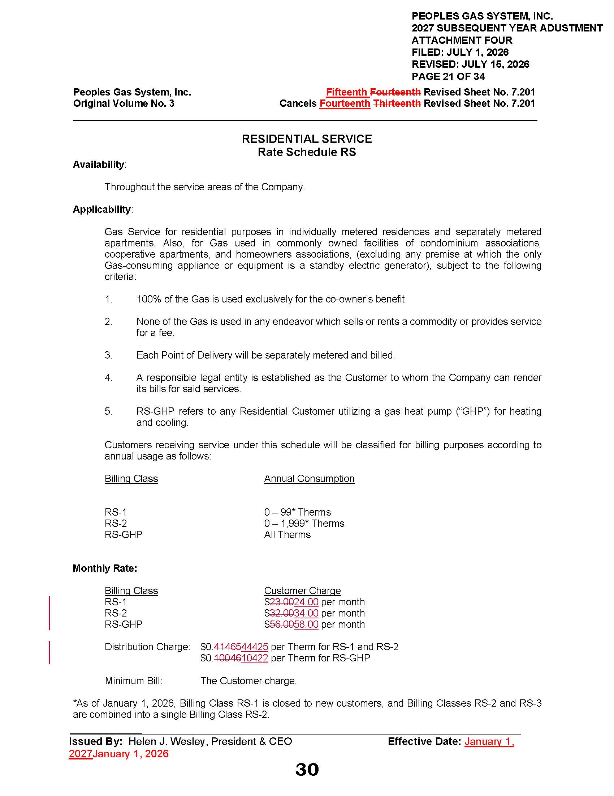

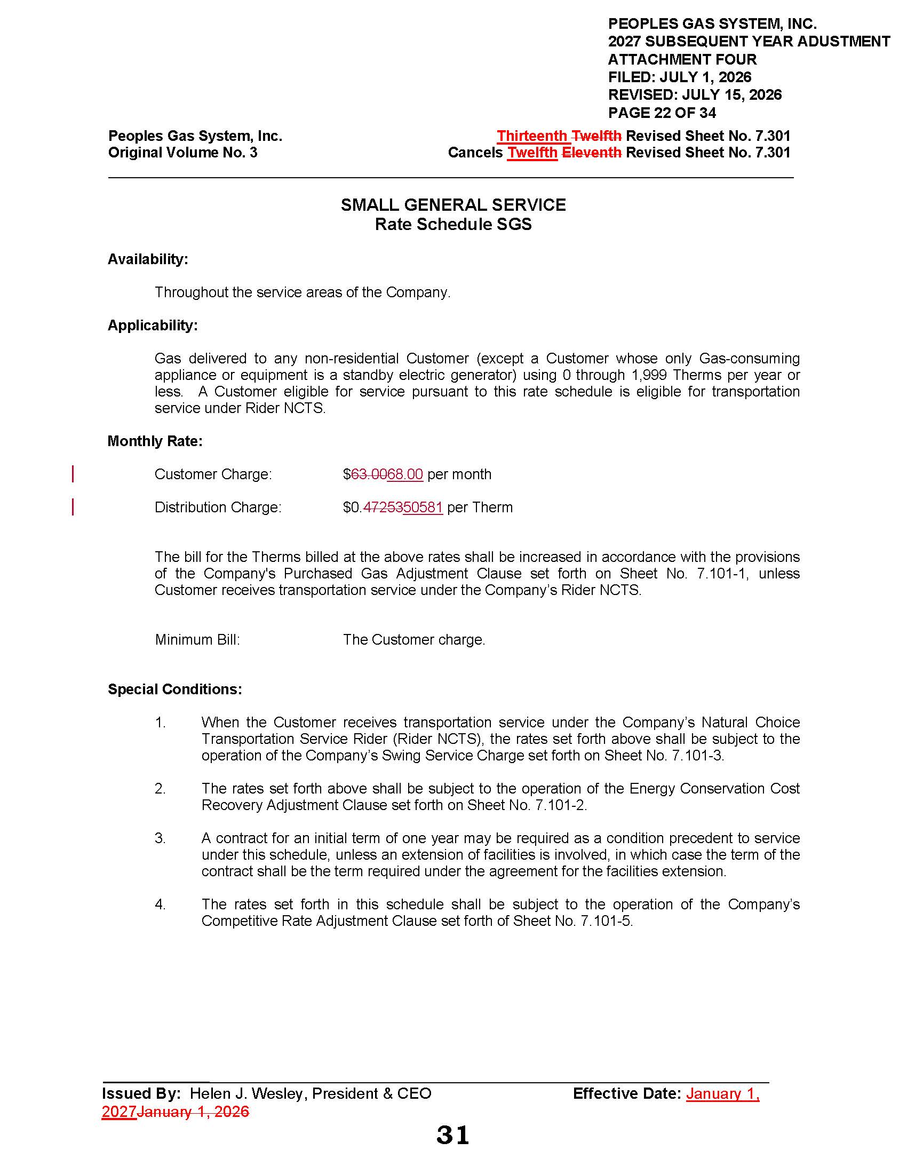

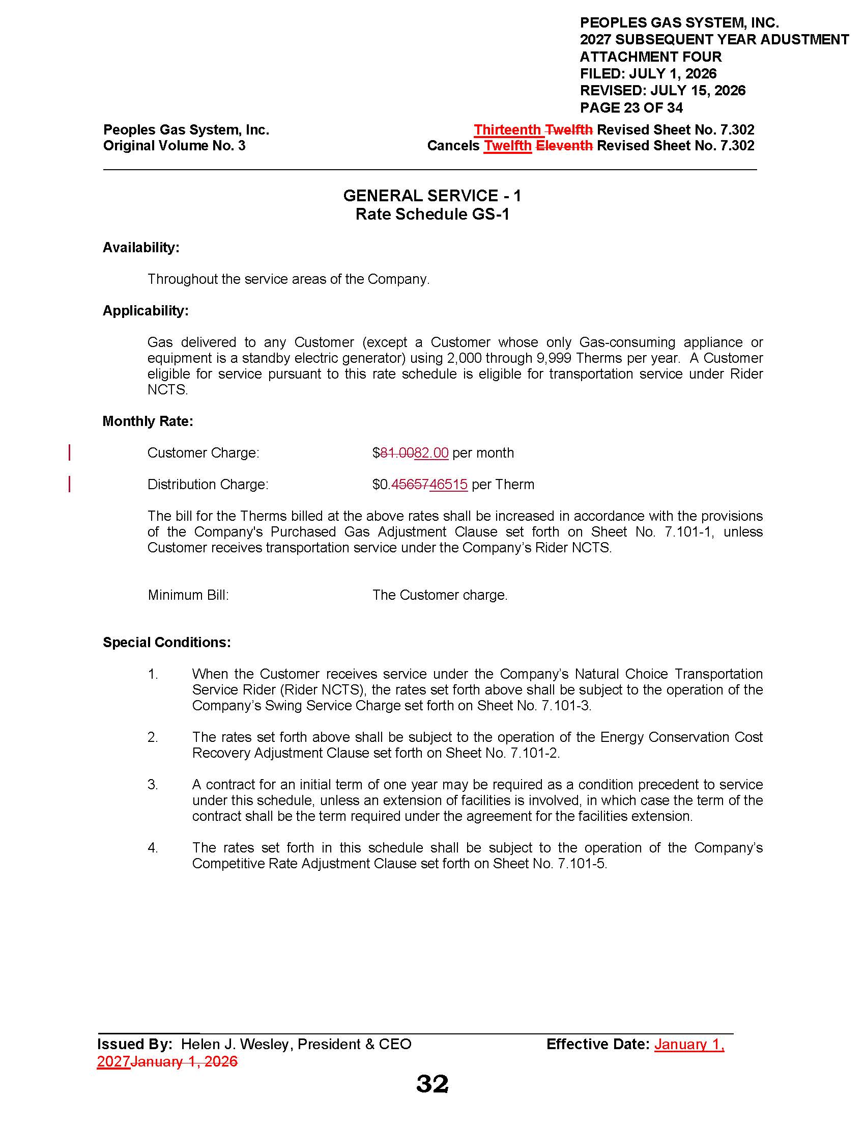

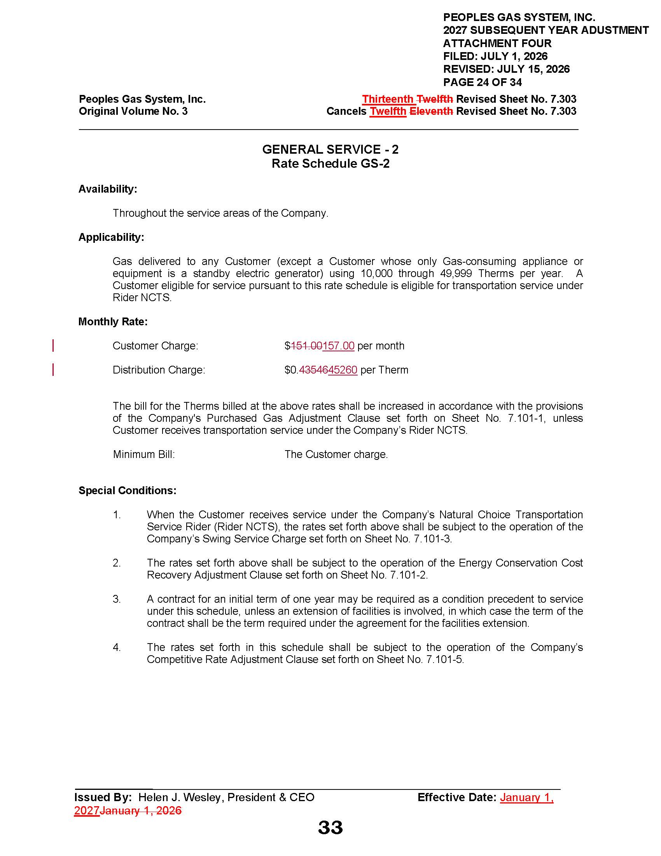

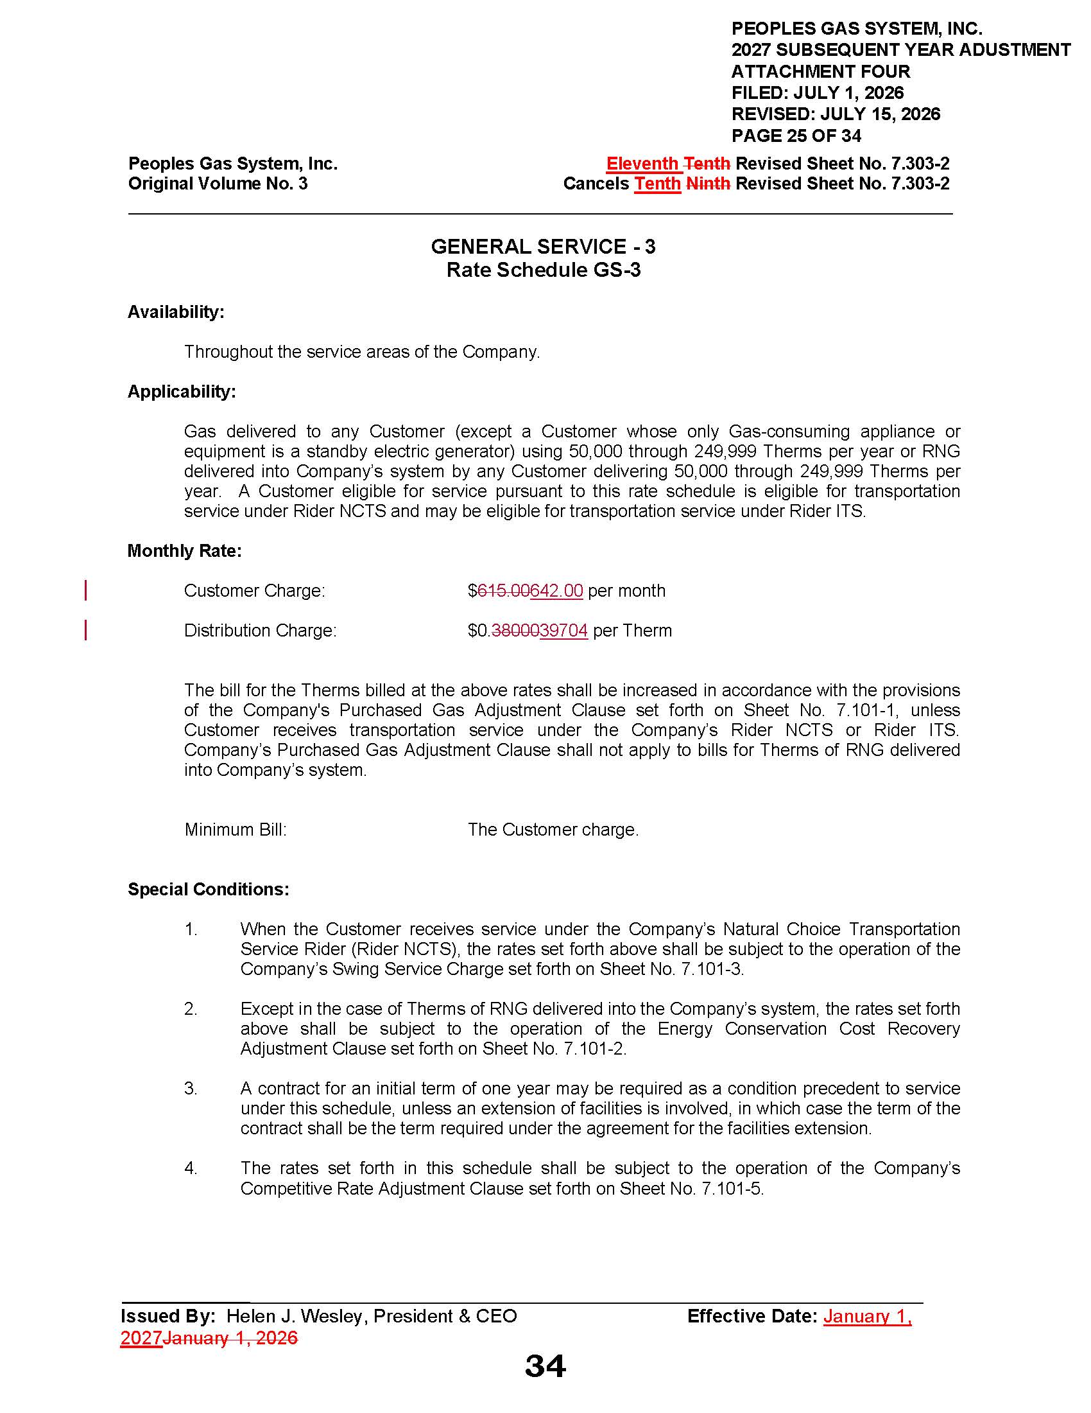

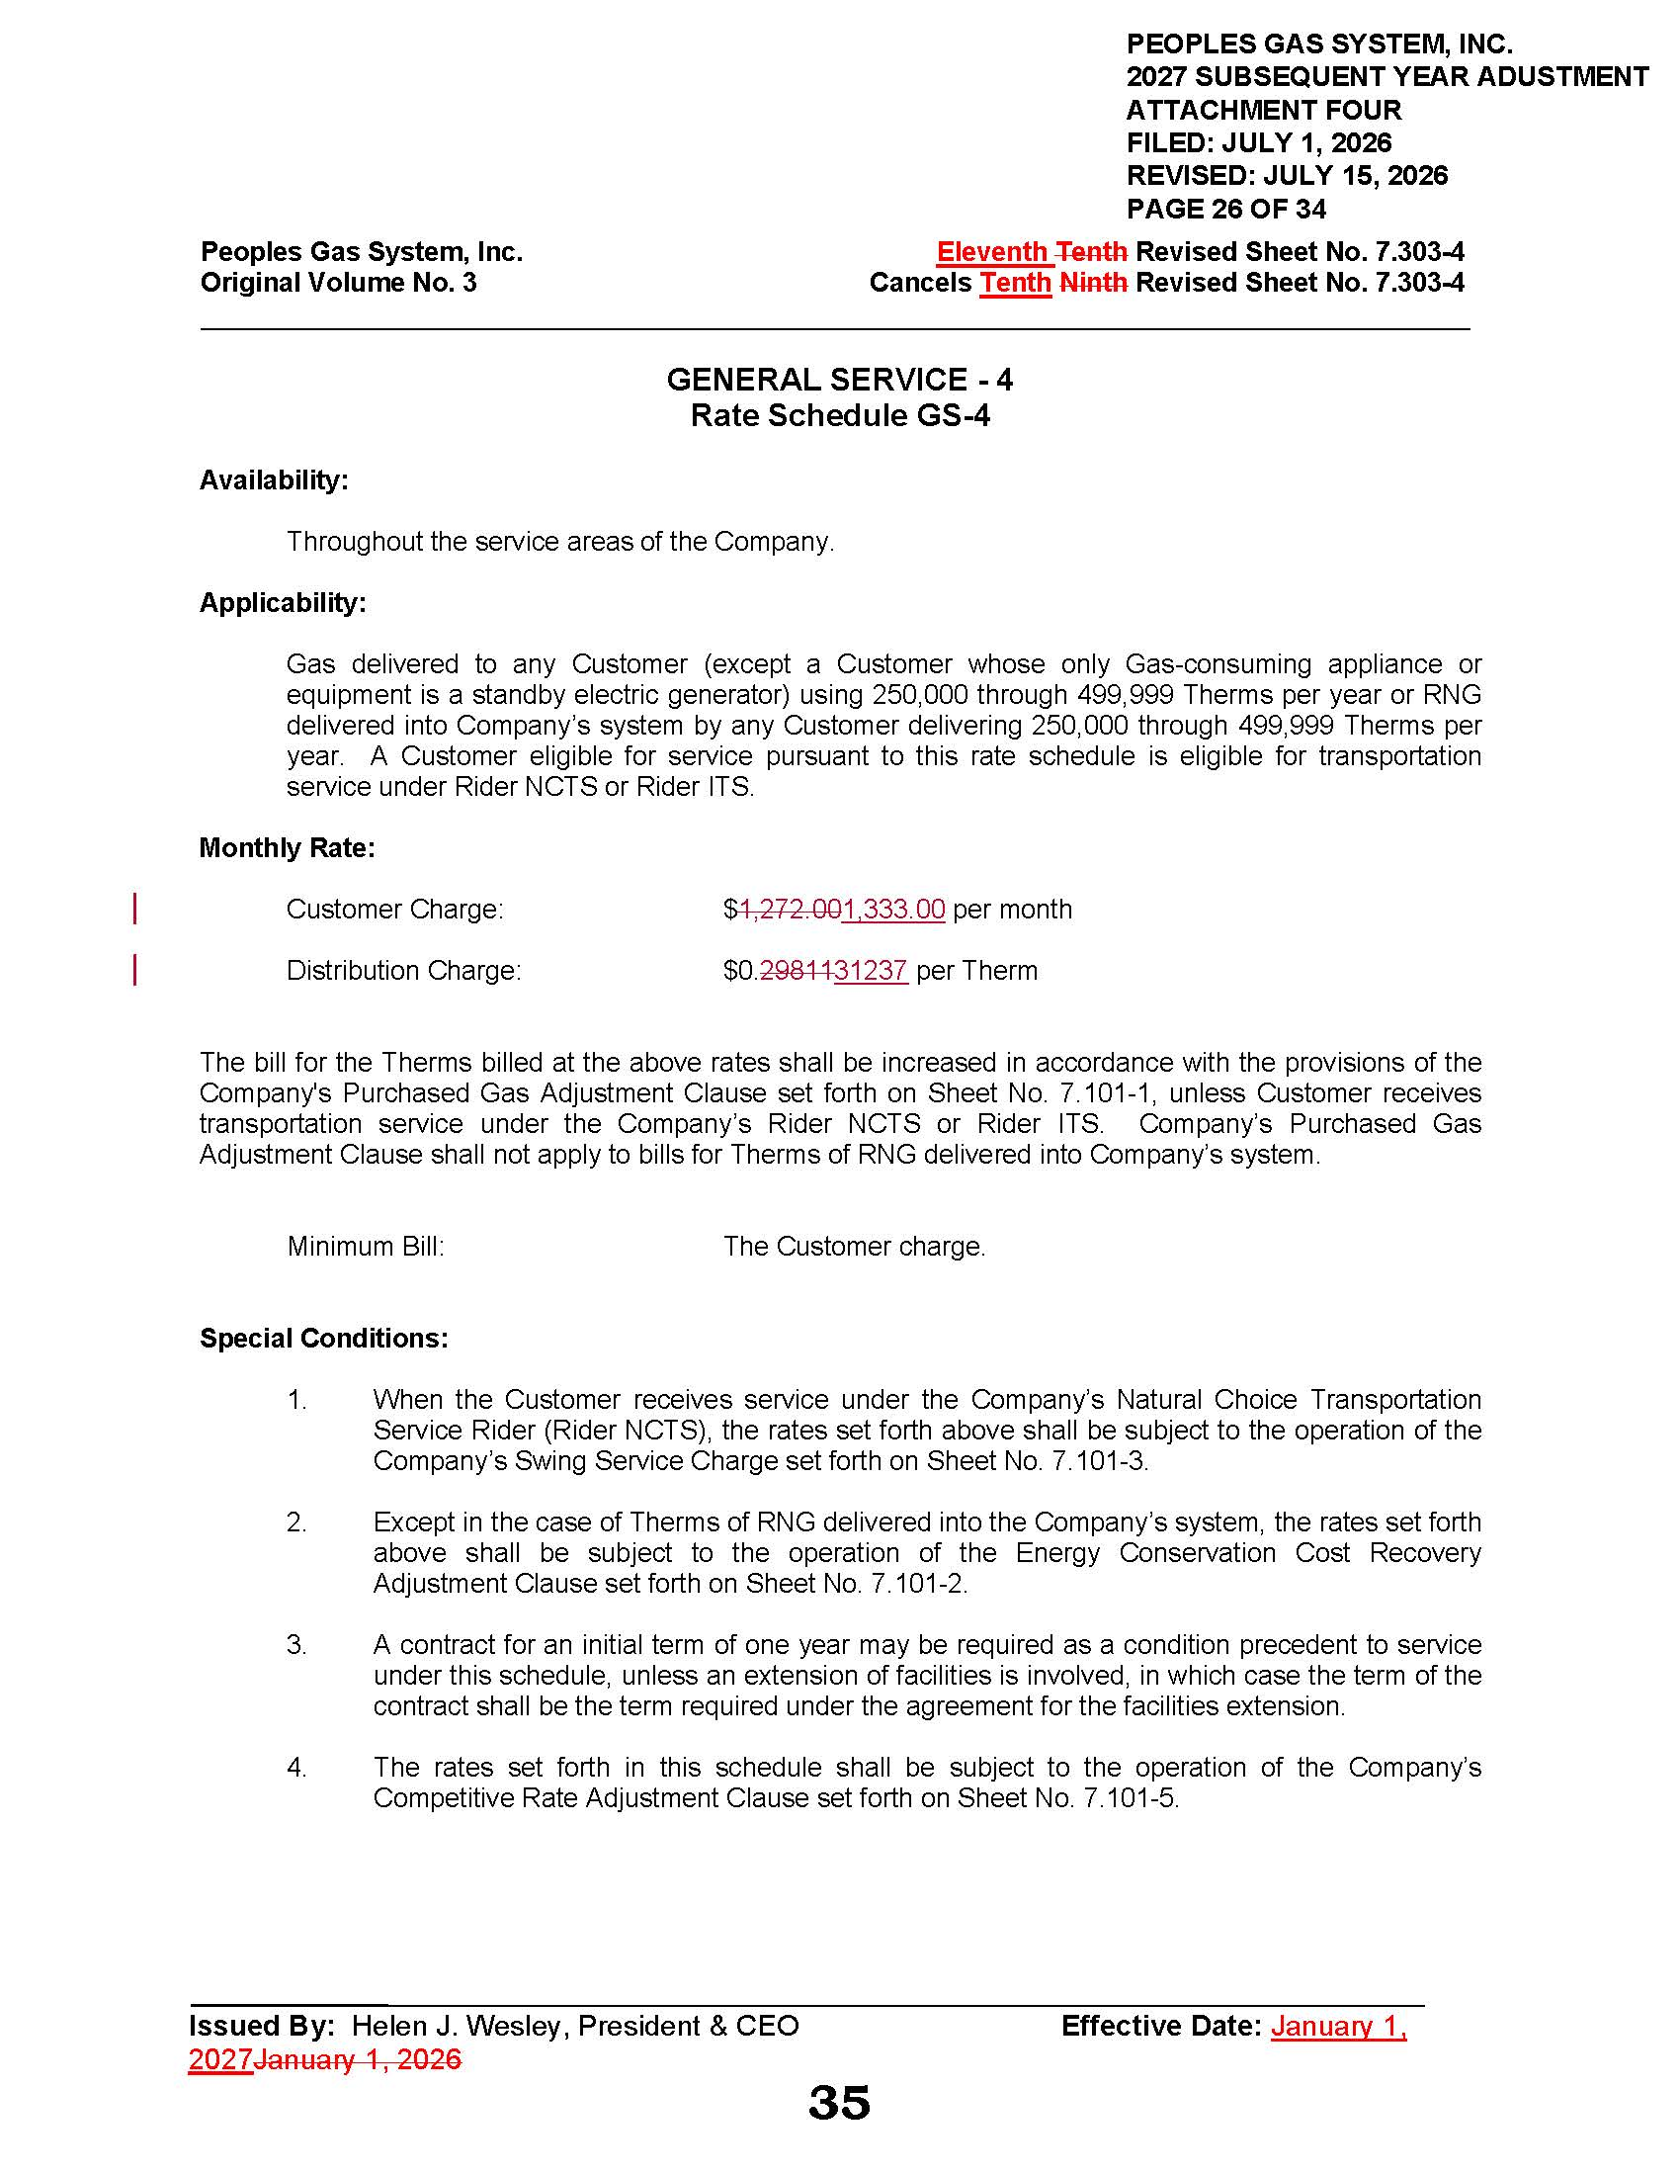

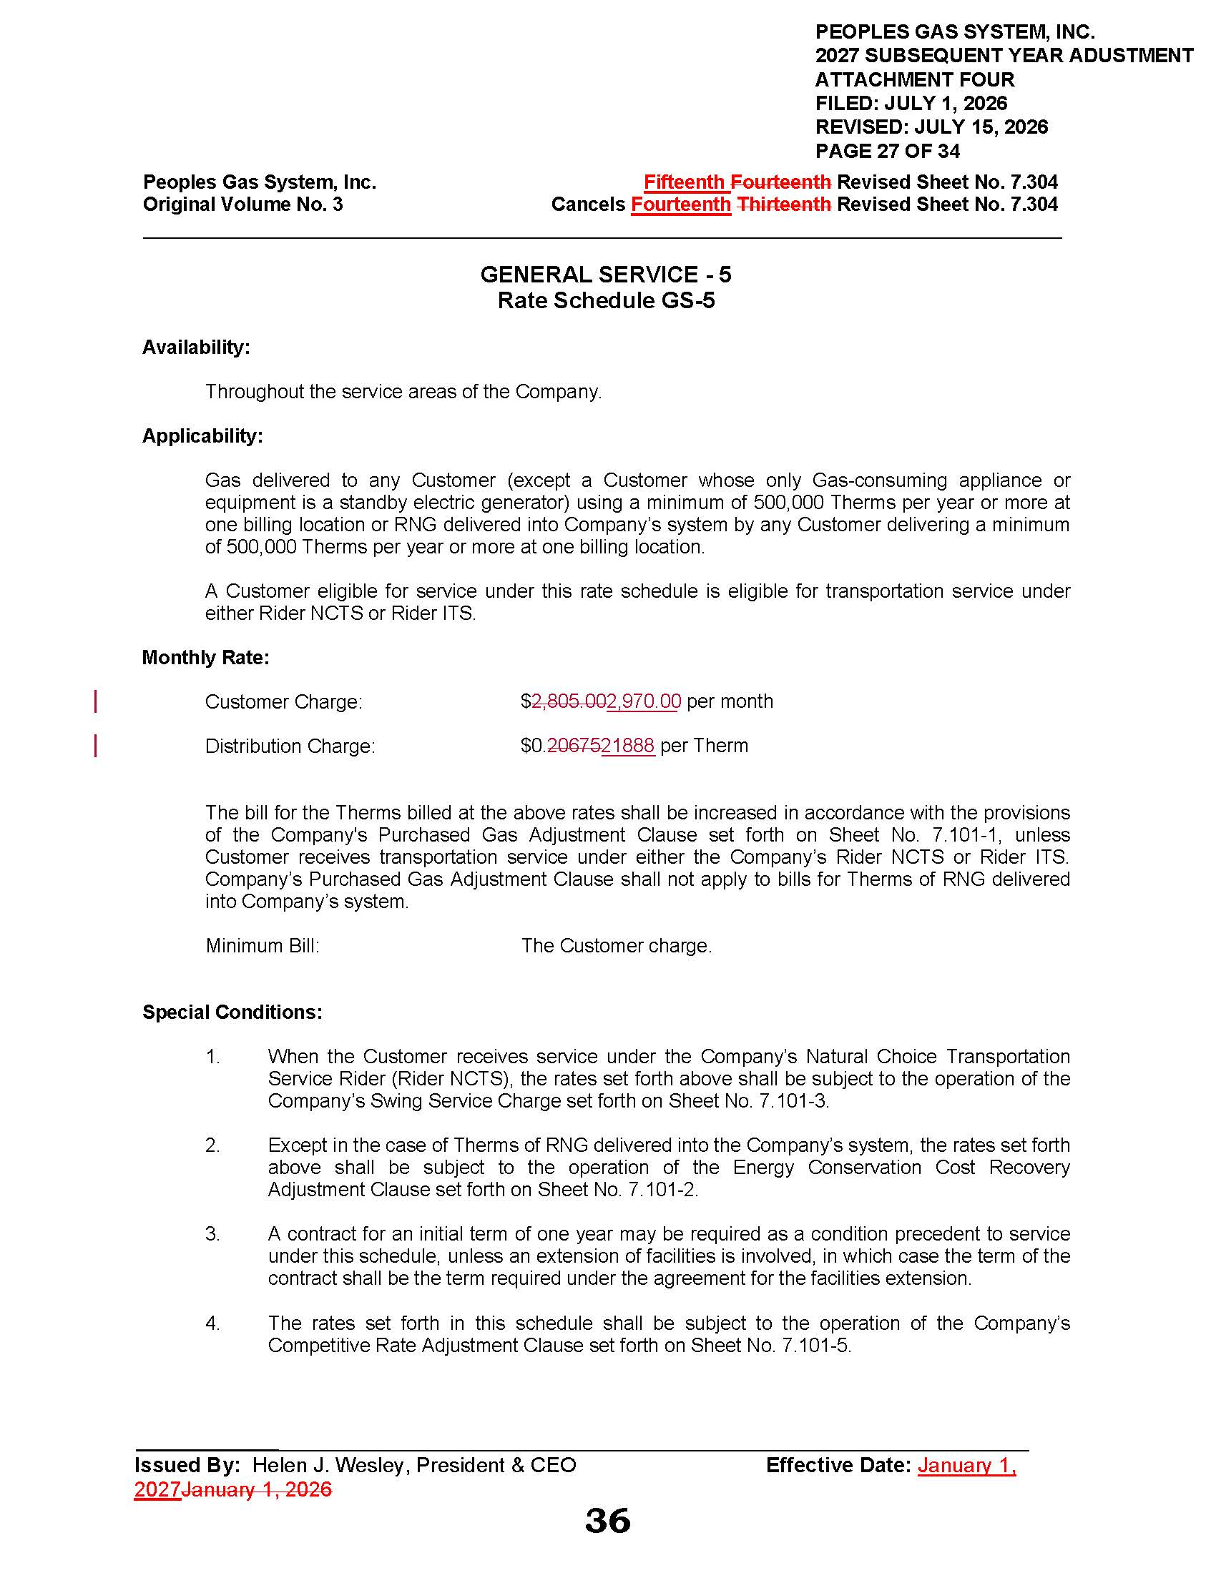

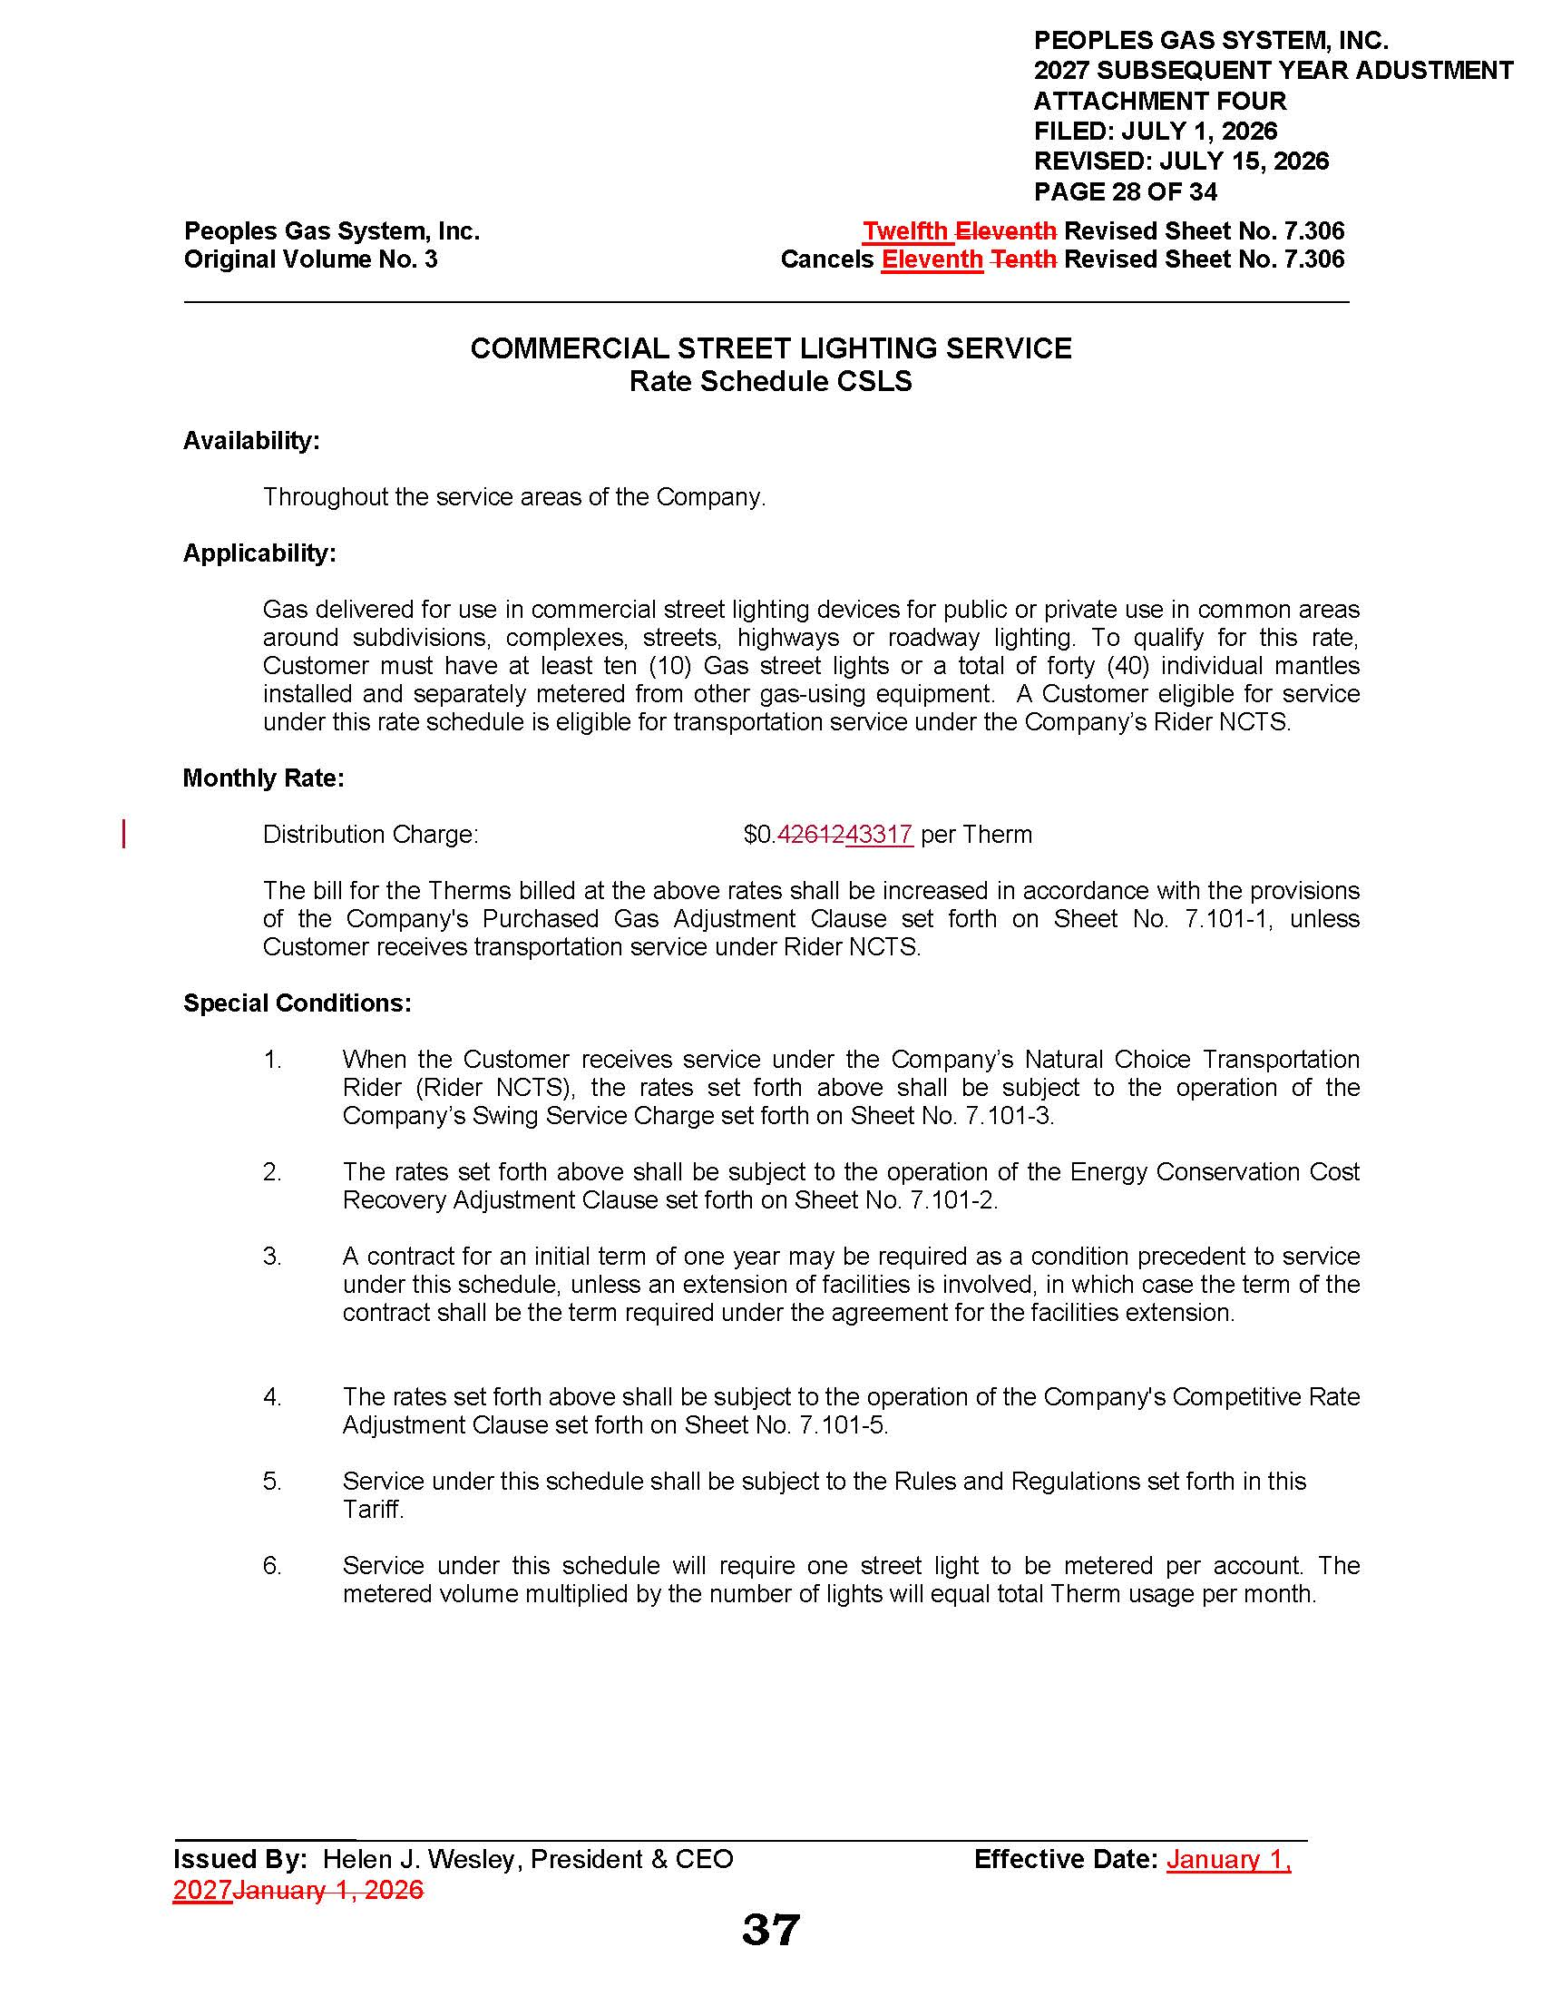

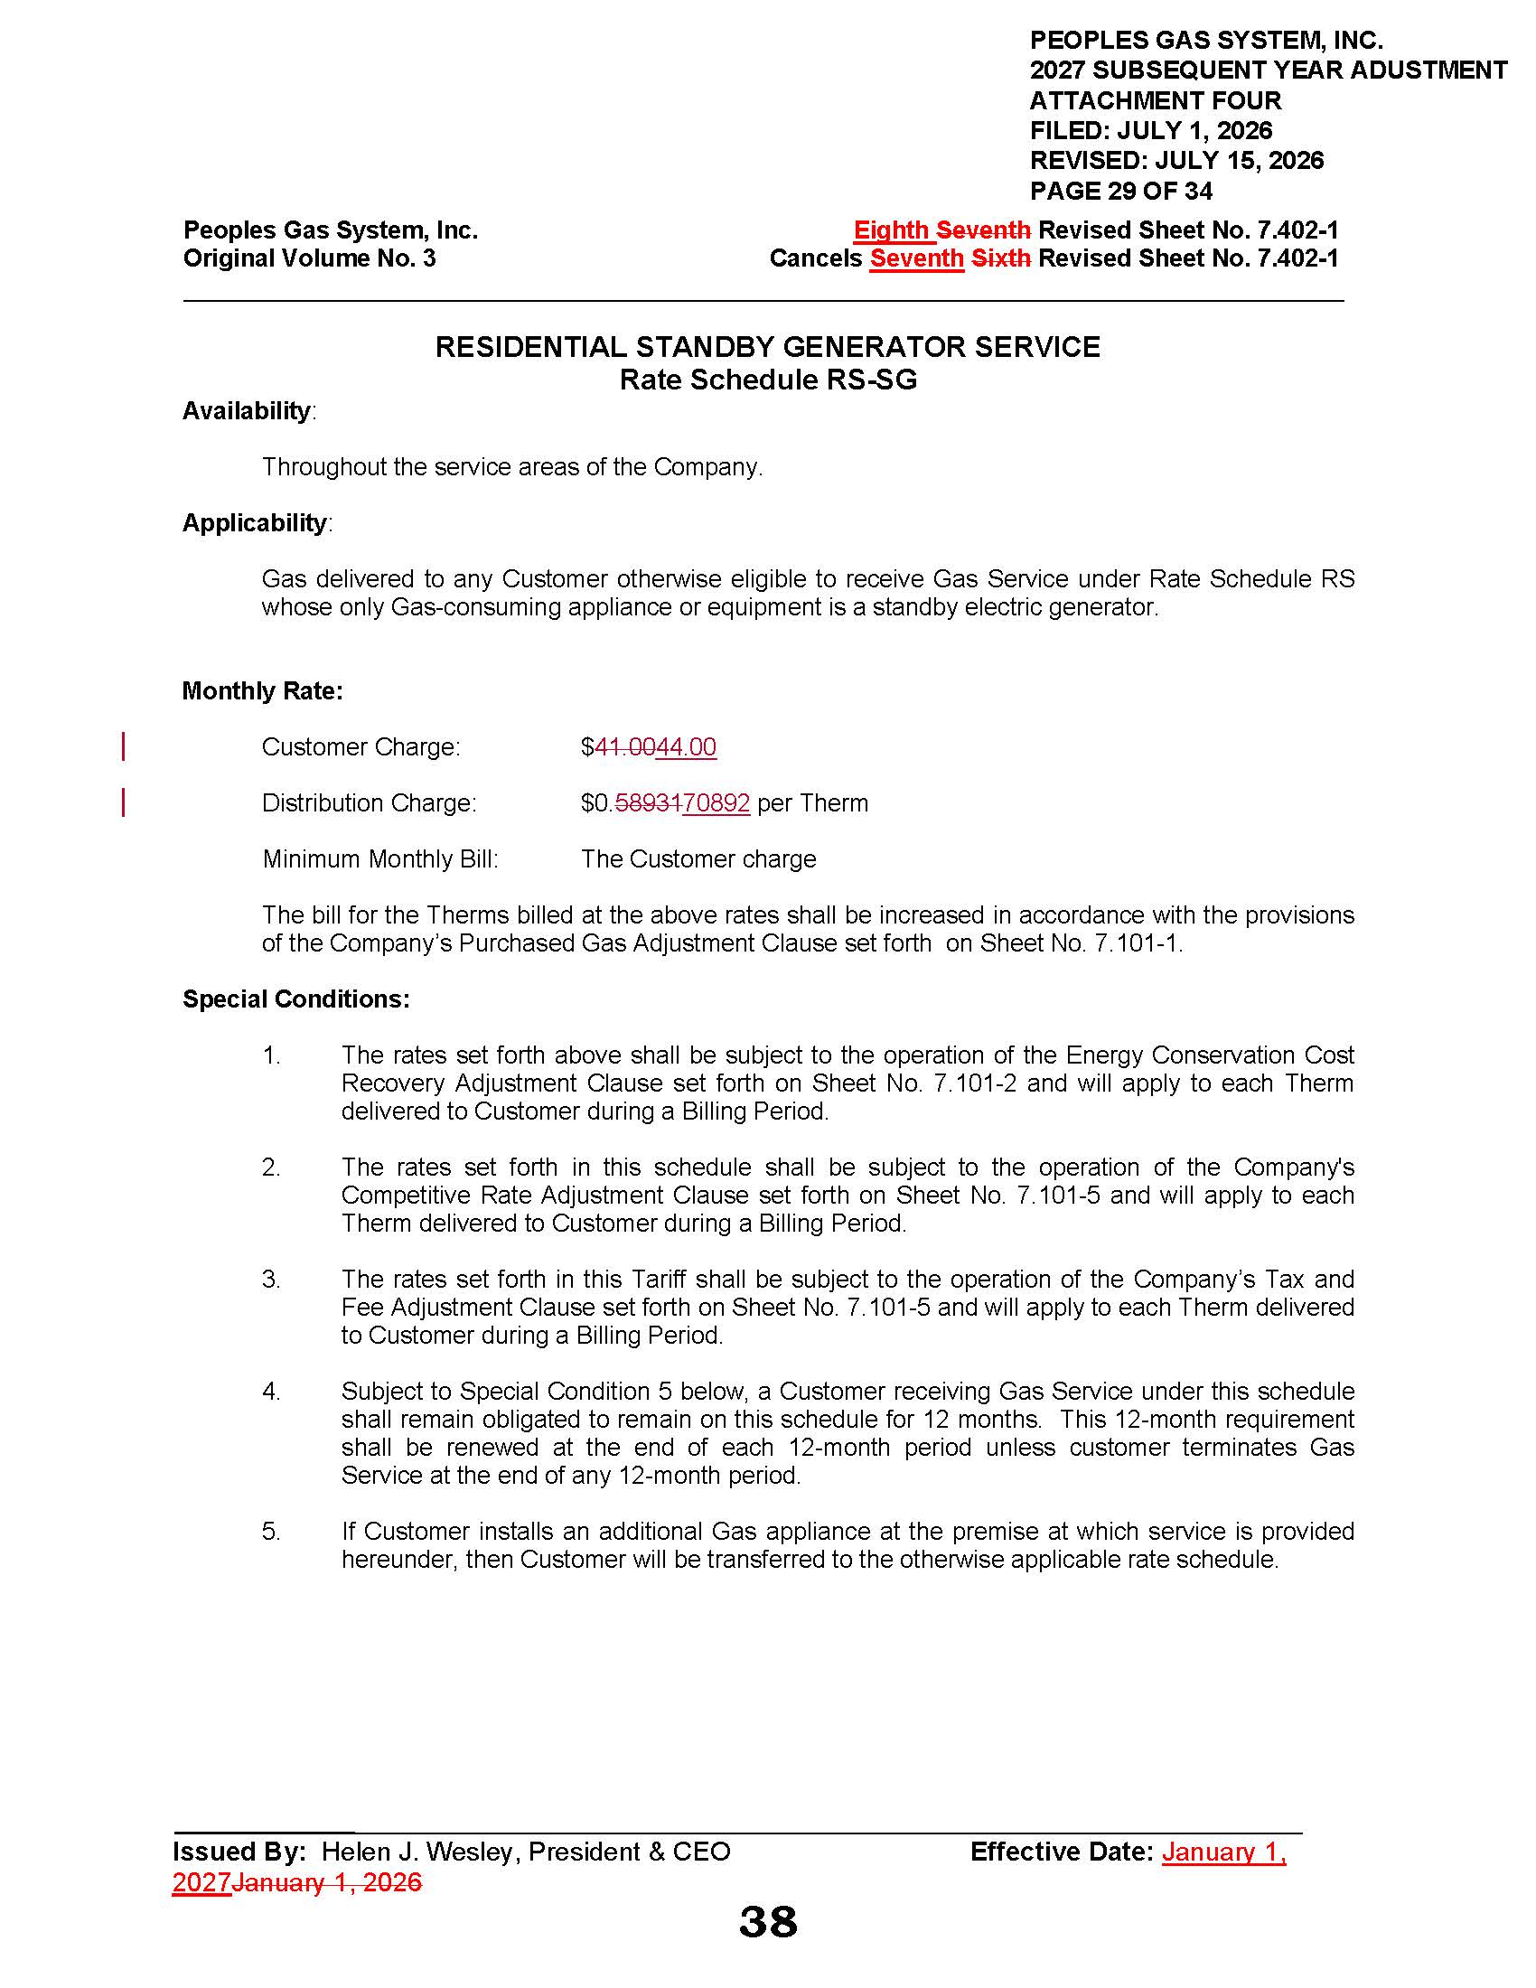

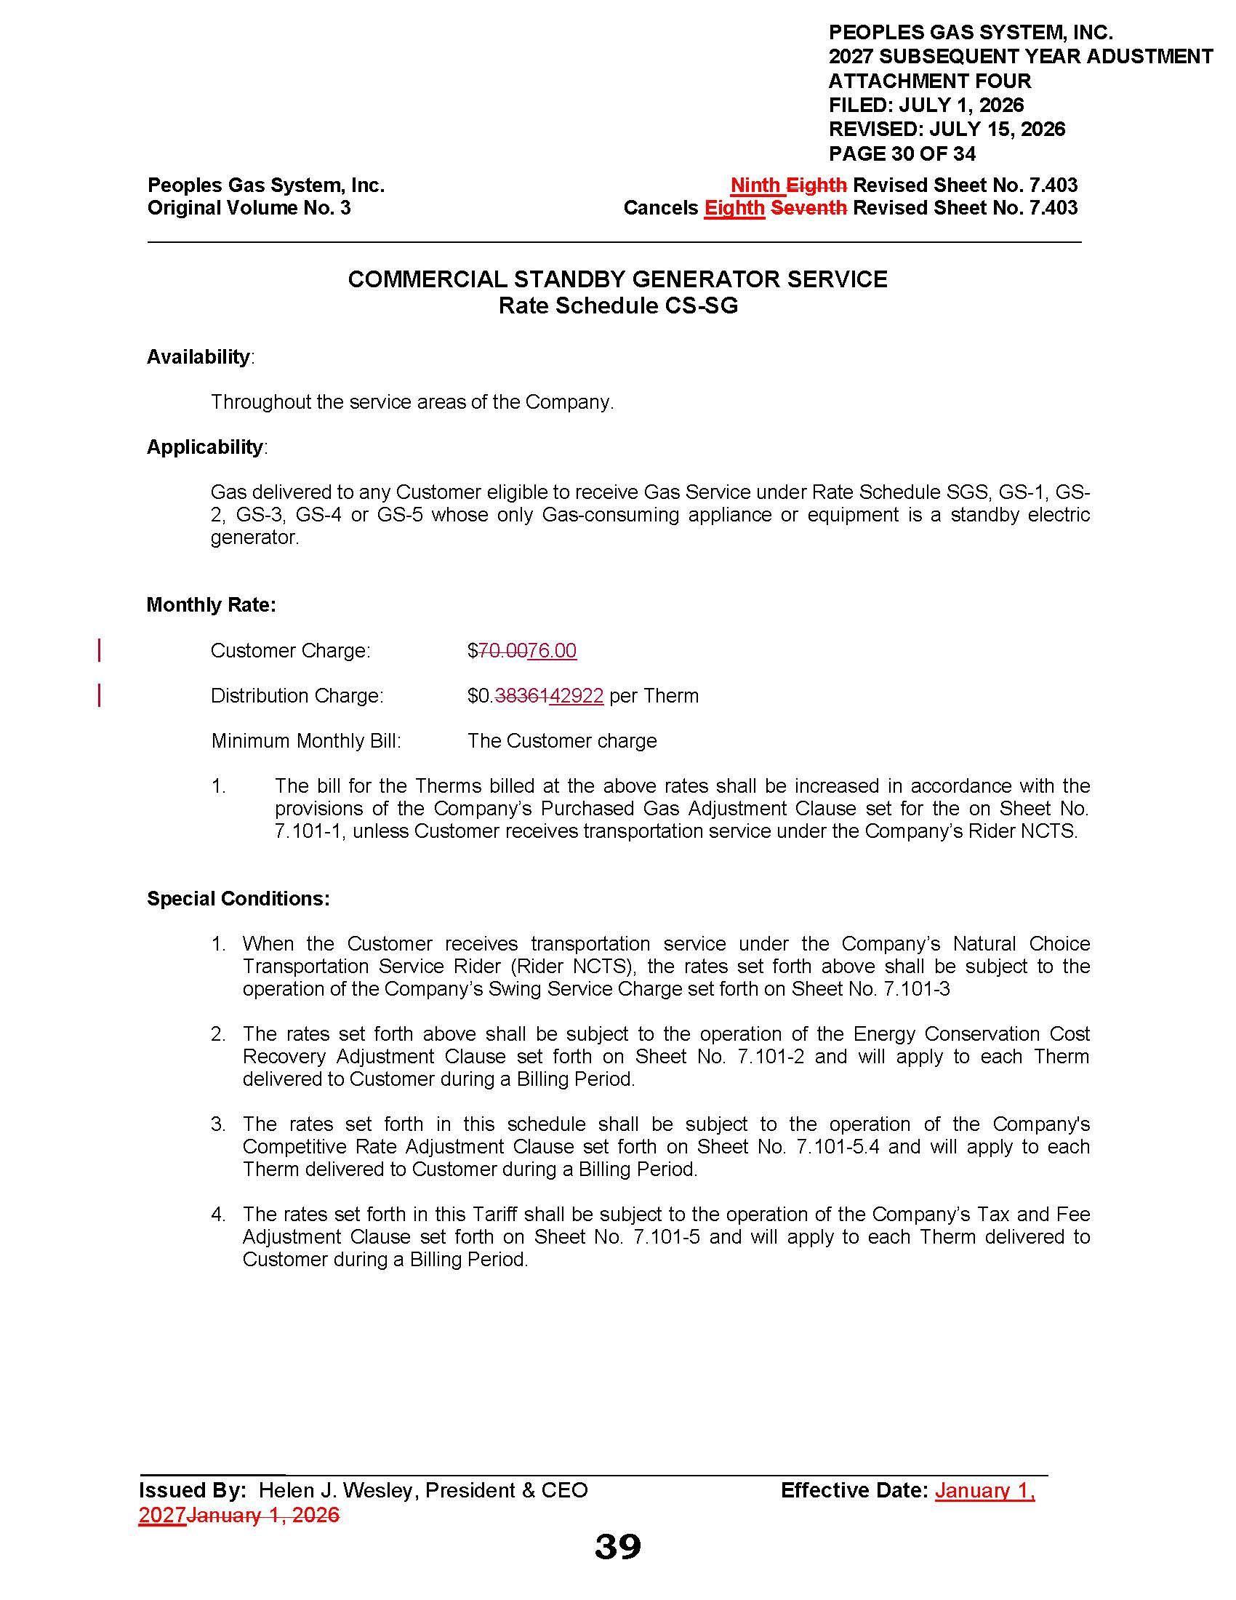

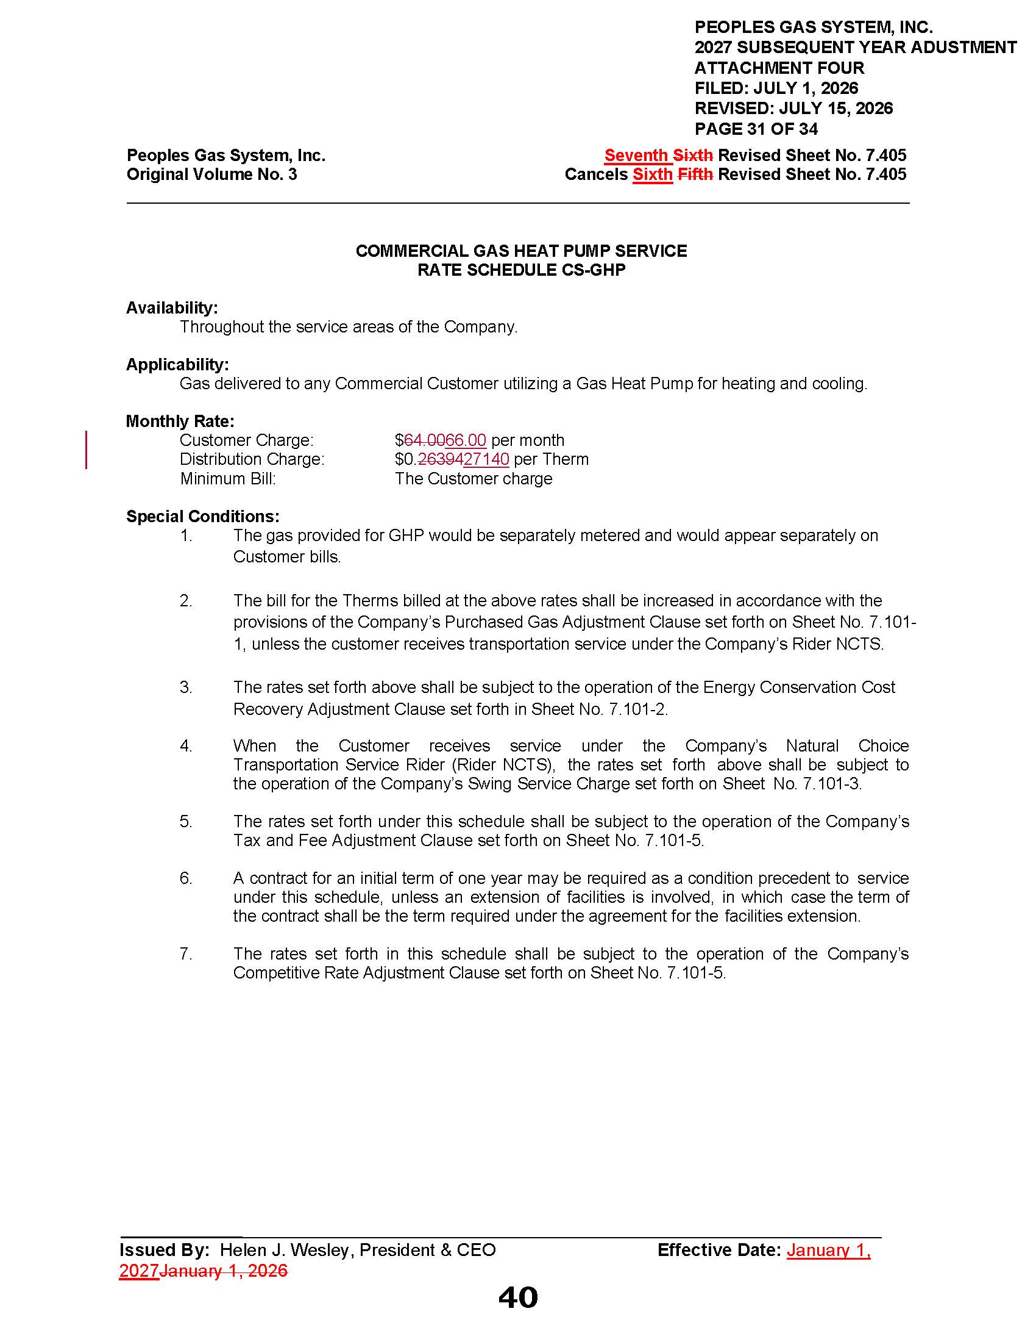

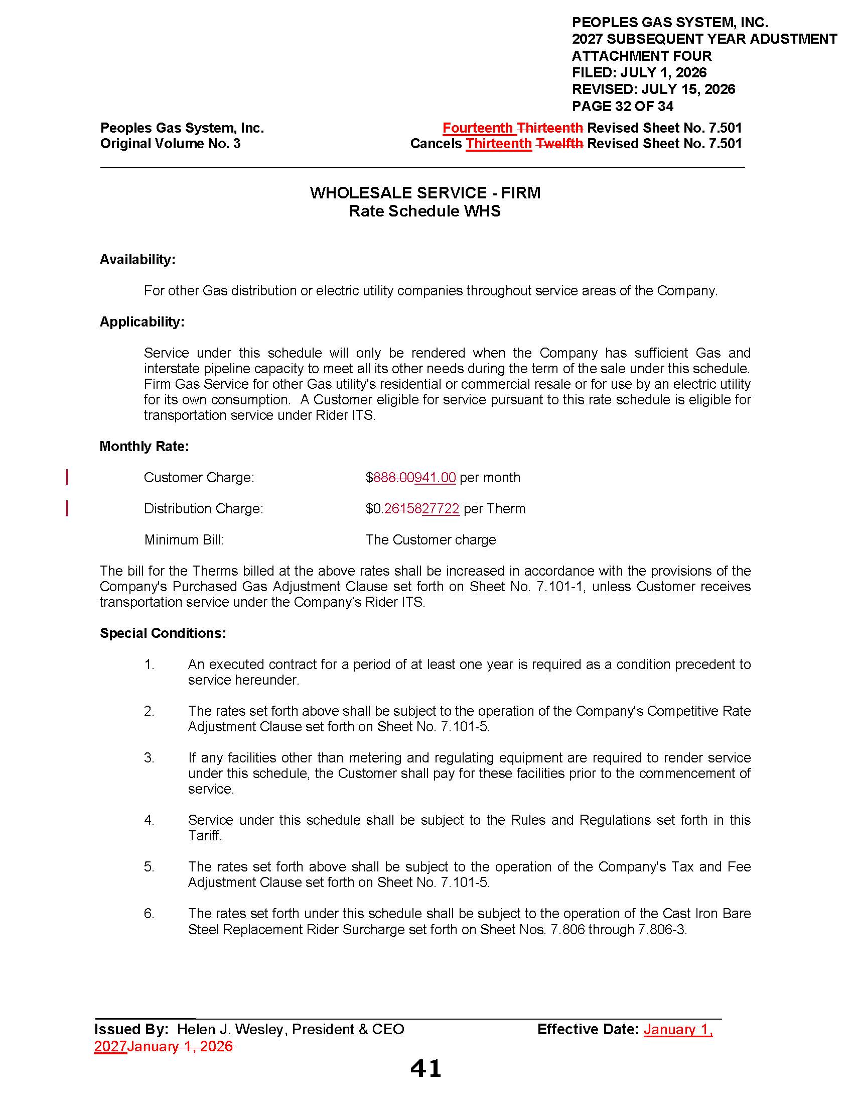

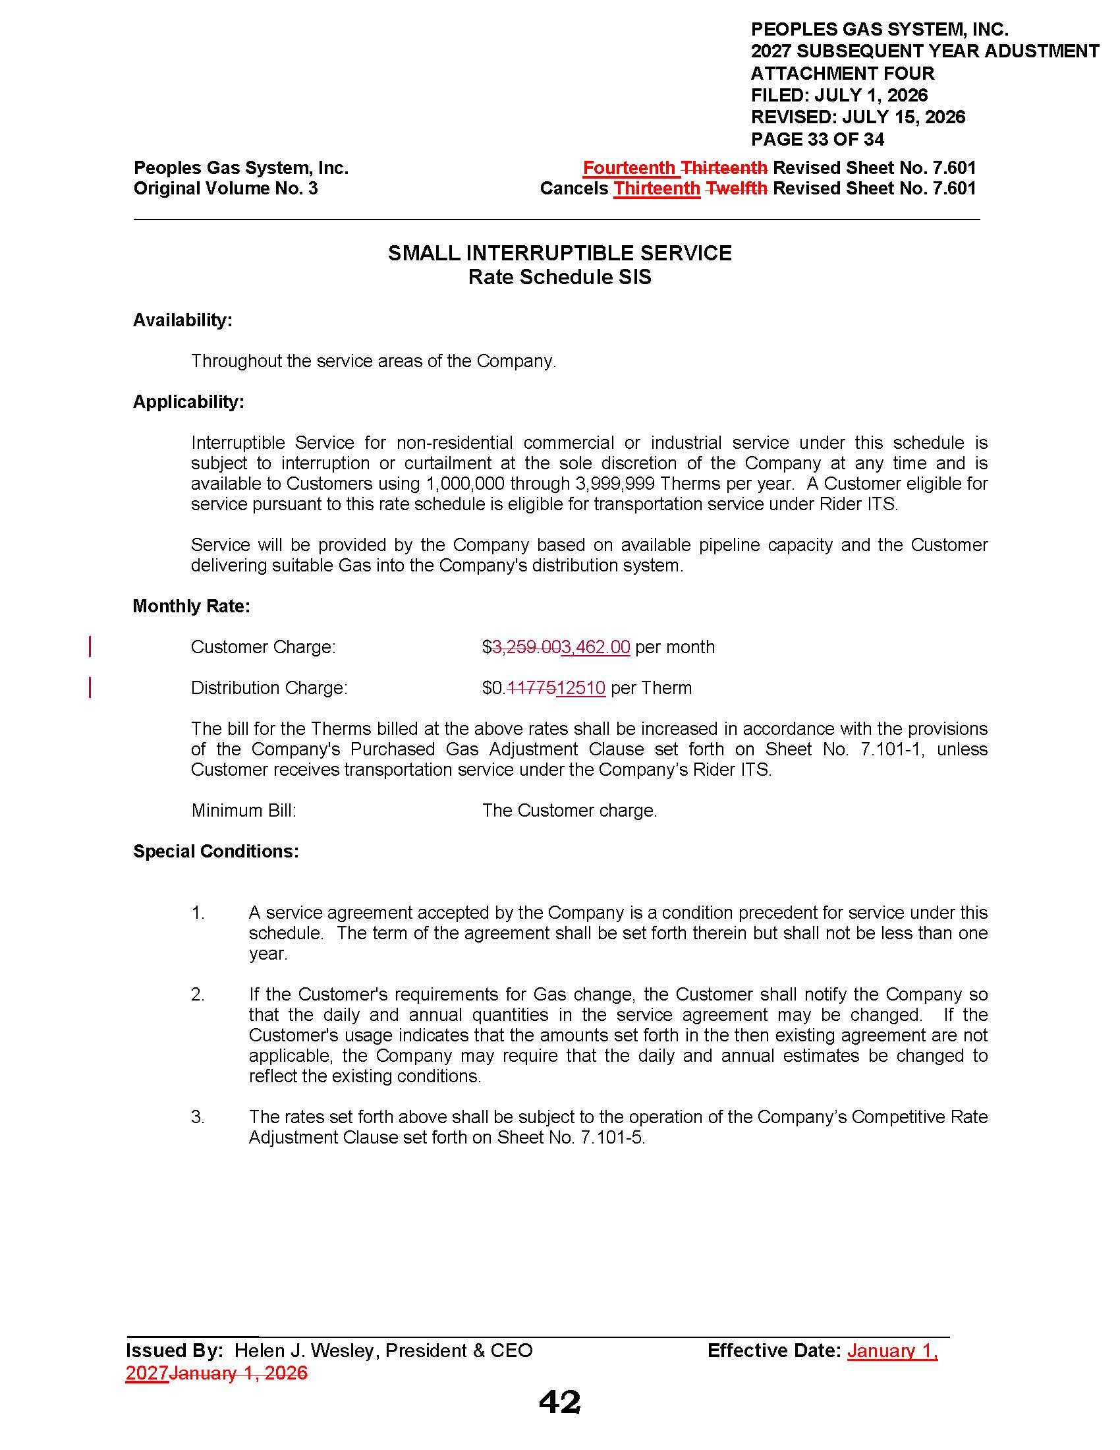

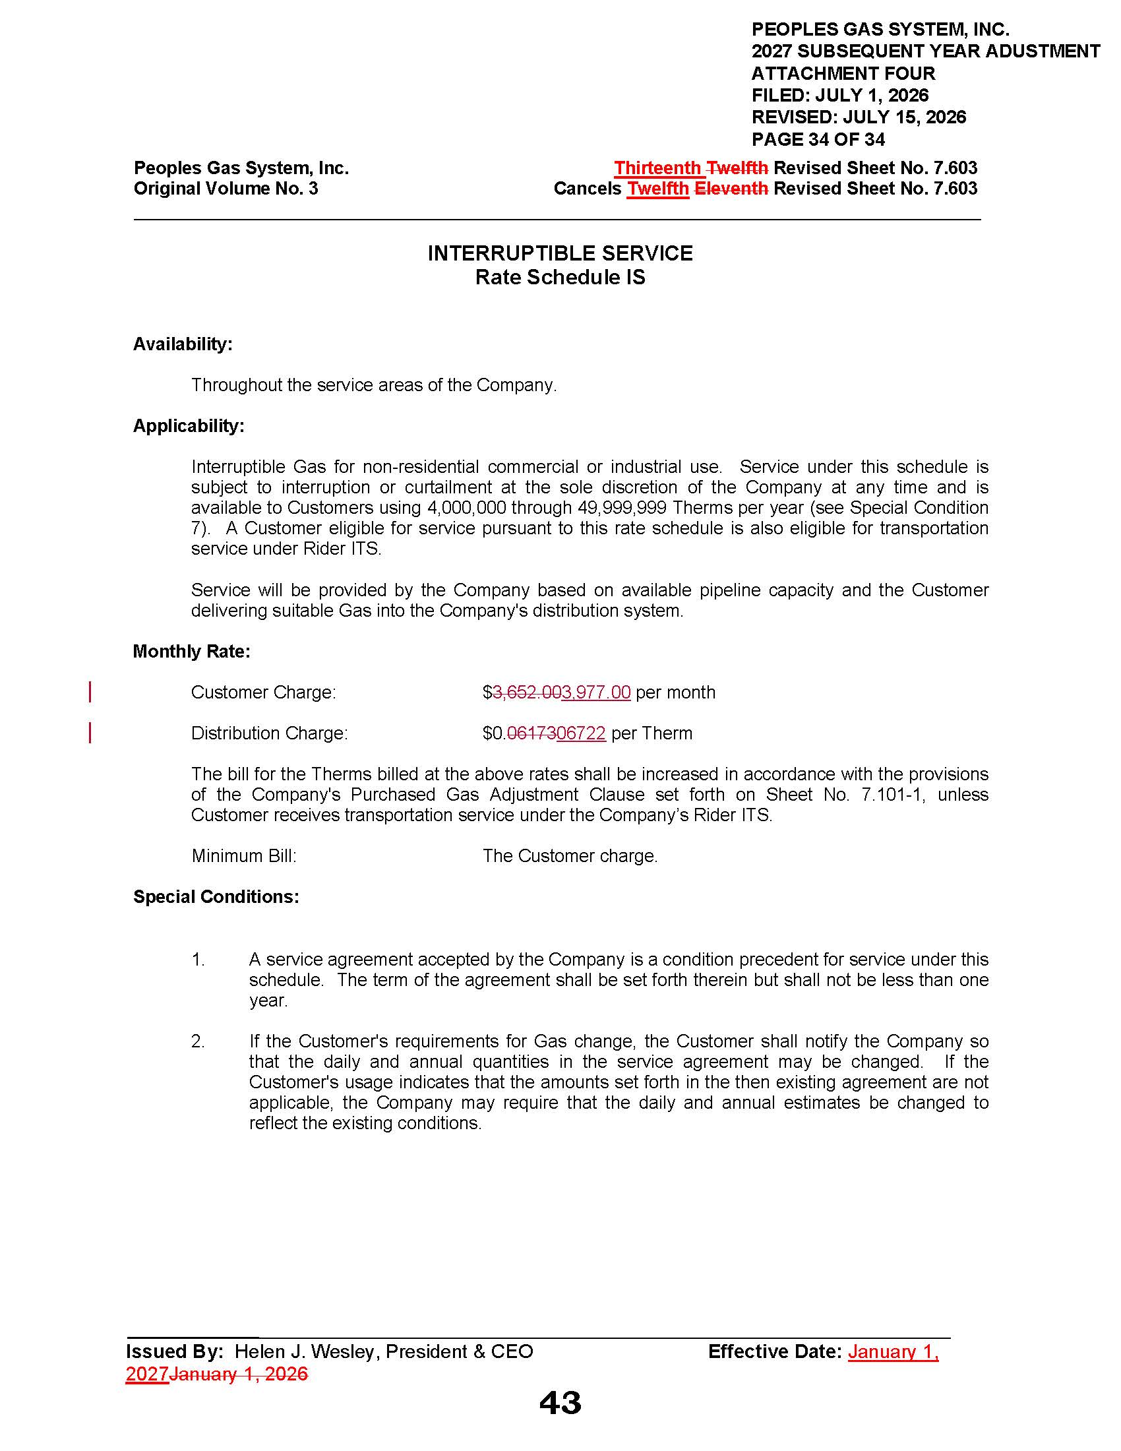

Order No. PSC-2025-0413-S-GU, issued October 31, 2025, in Docket No. 20250029-GU, In re: Petition for rate increase by Peoples Gas System, Inc.
Order No. PSC-2025-0413-S-GU, page 8.
Order No. PSC-2026-0302-PCO-GU, issued August 24, 2026, in Docket No. 20260101-GU, In re: Petition for approval of 2027 subsequent year adjustment, by Peoples Gas System, Inc.
Peoples’ Response to Staff’s First Data Request, Document No. 05147-2026.
Second Revised Document No. 9 (Form 3P) of Exhibit MEE-2, Document No. 03957-2026.

