BEFORE THE FLORIDA PUBLIC SERVICE COMMISSION

In re: Petition of Coastal Connect Services, LLC for approval of natural gas pipeline transmission company tariff and firm transportation service agreement. | DOCKET NO. 20260094-GU  ORDER NO. PSC-2026-0383-TRF-GU  ISSUED: October 26, 2026

The following Commissioners participated in the disposition of this matter:

GABRIELLA PASSIDOMO SMITH, Chairman
GARY F. CLARK
MIKE LA ROSA
BOBBY PAYNE
ANA ORTEGA

ORDER APPROVING NATURAL GAS TRANSMISSION PIPELINE TARIFF

BY THE COMMISSION:

Background

Natural gas is delivered to Florida through four Federal Energy Regulatory Commission (FERC) regulated interstate transmission pipelines: Florida Gas Transmission (FGT), Gulfstream Natural Gas System, Southern Natural Gas, and Gulf South Pipeline. The gas entering Florida is delivered to new or repowered electric generating facilities, large industrial customers, municipally operated systems, and investor-owned local distribution companies (LDCs). Pipeline laterals connect the transmission pipelines to the gas consumers.

The Natural Gas Transmission Pipeline Intrastate Regulatory Act (Act), codified at Sections 368.101–368.112, Florida Statutes (F.S.), was adopted by the Florida Legislature in 1992 in conjunction with the Natural Gas Transmission Pipeline Siting Act (Pipeline Siting Act), codified at Sections 403.9401–403.9425, F.S. At the time of enactment, these laws contemplated the filing of a proposal for a major gas pipeline (Sunshine Pipeline Partners) that would serve LDCs and major electric power generators in Florida and would be regulated by this Florida Public Service Commission (Commission) rather than FERC. The U.S. Natural Gas Act enables an intrastate pipeline company to be exempt from FERC jurisdiction under what is known as the “Hinshaw Amendment.” The Hinshaw Amendment, contained in Section 1(c) of the U.S. Natural Gas Act, codified at 15 U.S.C. § 717(c), exempts from FERC regulation intrastate pipelines that operate exclusively in one state and with rates and services regulated by the state. Payment of regulatory assessment fees to cover the cost of regulation and jurisdiction over pipeline safety is also provided for in Chapter 368, F.S.

On June 8, 2026, Coastal Connect Services, LLC (CCS), filed a petition for approval of a natural gas pipeline transmission tariff and a firm transportation service agreement. On September 3, 2026, CCS refiled its petition to ensure confidential information in the transportation service agreement was properly redacted. CCS is a limited liability company formed under Texas law and registered to do business in Florida in accordance with Section 607.1505, F.S. Consistent with the definition of “natural gas transmission company” in Section 368.103(4), F.S., CCS does not own or operate any facilities used primarily for the local distribution of natural gas or that are subject to the jurisdiction of FERC under the U.S. Natural Gas Act, 15 U.S.C. §§ 717 et seq. Additionally, CCS is not a municipality or any agency thereof or a special district created by special act to distribute natural gas.

In its petition, CCS stated that the reason it is requesting approval of a natural gas pipeline transmission tariff is to fill a specific need for the safe, timely, and efficient delivery of natural gas. Specifically, CCS seeks to provide firm transmission service to Space Exploration Technologies Company (SpaceX). CCS is a subsidiary of SpaceX. SpaceX operates facilities on Cape Canaveral in Brevard County where it launches a variety of materials and humans into space for multiple customers, including the U.S. Department of Defense. CCS stated in its petition that as SpaceX’s operations continue to grow, it has a growing need for significant supplies of natural gas, which it liquifies for use as rocket fuel. In response to Commission staff’s First Data Request, CCS stated that SpaceX currently receives its natural gas shipments by truck, and that hundreds of truckloads of liquified natural gas are required per launch. A nearby pipeline operated by Florida City Gas (FCG) was initially identified by SpaceX as a potential option for service. In response to Commission staff’s First Data Request, however, CCS stated that this pipeline does not connect to the required delivery points for SpaceX, and is inadequate for the volumes, variability, reliability, and timing needed. Additionally, the terms, timing, and costs for FCG construction of improvements did not meet the needs and specifications required by SpaceX.

There are three earlier instances of our approving intrastate pipeline tariffs for the following operators: Five Flags Pipeline Company, Peninsula Pipeline Company, Inc. (Peninsula), and SeaCoast Gas Transmission, LLC. If CCS’s petition is approved, CCS would own the anticipated pipeline facilities and serve as the transportation service provider. CCS’s capacity is presently contemplated to be fully obligated. This means that CCS’s first customer, SpaceX, would contract for all of the contemplated capacity on the new pipeline facilities. In accordance with Section 368.105(6), F.S., CCS is not required to provide other entities access to the facilities if all capacity is used.

On July 2, 2026, FCG requested that the Commission Clerk add FCG to the docket as an interested person. In its letter, FCG alleged that it has a substantial interest in this docket. Specifically, FCG stated that it has a substantial interest in ensuring our actions in this docket do not: harm FCG, its ratepayers, and the competitive market for natural gas in Florida; lead to “cherry picking” of FCG’s customers; lead to uneconomic duplication of FCG’s facilities and other territorial disputes; impede FCG’s ability to serve its customers; or foster potential risks that threaten the integrity and safety of FCG’s distribution system in the area. On August 28, 2026, FCG filed a motion for leave to intervene. CCS filed a response in opposition on September 4, 2026. Then on September 14, 2026, FCG filed a motion for leave to file a reply. On September 18, 2026, CCS filed a response in opposition to FCG’s motion for leave to file a reply.

By Order No. PSC-2026-0290-PCO-GU, we suspended CCS’s proposed tariff pending our decision on CCS’s petition. Commission staff issued four data requests for which responses were received on July 10, 2026, July 27, 2026, August 17, 2026, and September 22, 2026, respectively. We have jurisdiction over this matter pursuant to Sections 368.104 and 368.105, F.S.

Decision

- Natural Gas Transmission Pipeline Tariff

CCS proposes to construct and maintain pipeline facilities that will provide firm transportation service of customer-owned gas from the FGT interstate transmission pipeline to customers. The proposed pipeline is a 32.4 mile, 16-inch steel natural gas transmission pipeline, to be located entirely within Brevard County. CCS will not engage in the sale of gas, and title of the gas transported on CCS’s pipelines will not at any point transfer to CCS. A customer who chooses CCS to transport its gas is required to enter into a Transportation Service Agreement with CCS.

In response to Commission staff’s First Data Request, CCS stated that SpaceX contacted Chesapeake Utilities Corporation to explore different options for pipeline expansion by FCG or Peninsula. Additionally, in a confidential process, SpaceX contacted several different pipeline companies regarding the potential construction of an appropriate natural gas transportation pipeline. After exploring multiple options, based on the location, cost, timeliness, route, safety, operational, tax, and service issues, SpaceX made the business decision to utilize a newly created affiliate—CCS.

Currently, pipeline laterals can be constructed by the customer itself, an interstate pipeline, or an LDC. Customers will continue to be able to choose their pipeline provider. CCS will simply be available to operate as an additional transmission pipeline provider. In addition to constructing and maintaining the pipeline facilities, CCS will be responsible for providing administrative services related to the transportation of gas from the interconnection with the transmission pipeline to the point(s) of delivery (interconnection between CCS and the customer).

- Regulatory Authority

The Act provides us with a different level of regulatory authority than we exercise over LDCs or investor-owned electric utilities under Chapter 366, F.S. Section 368.105(3), F.S., allows rates charged by a natural gas transmission company to be deemed just and reasonable without our explicit approval if the rates meet certain conditions, as listed below. Section 368.105(3), F.S., states:

Rates charged or offered to be charged by any natural gas transmission company for transactions with other natural gas transmission companies, transportation customers, and industrial, power plant, and other similar large-volume contract customers, but excluding direct sales-for-resale to gas distribution utilities at city gates, unless suspended and modified pursuant to this subsection, are deemed to be just and reasonable and approved by the [C]ommission, if both the natural gas transmission company and the customer file an affidavit with the [C]ommission that:

- Neither the natural gas transmission company nor the customer had an unfair advantage during the negotiations;

- The rates are substantially the same as rates between the natural gas transmission company and two or more of those customers under the same or similar conditions of service; or

- Competition does or did exist either with another natural gas transmission company, another supplier of natural gas, or with supplier of an alternative form of energy.

Section 368.105(3), F.S., thus contemplates that gas transportation service provided by an intrastate pipeline is based on negotiated agreements that reflect market conditions and the specific needs of the customer. The agreement negotiated between SpaceX and CCS is discussed below in Section II.

CCS will only provide transportation service and will not engage in the retail sale of natural gas. Title of the gas transported on CCS’s facilities will belong to the customer. The customer is responsible for purchasing their own gas supplies. Section 368.105(6), F.S., further requires that rates must not be unduly discriminatory, and they must be compensatory. The statute also requires us to resolve any disputes between the natural gas transmission company and a person desiring transmission access.
In Order No. PSC-06-0023-DS-GP, we discussed certain policy considerations whereby a transmission pipeline’s projects should not lead to:

- less investment in the LDC’s facilities or stranded costs;
- “cherry picking” of the LDC’s large industrial customers;
- territorial disputes; or
- unfair competition with other transmission providers.

We find those policy considerations are persuasive here because they were primarily intended to ensure that a transmission pipeline, such as CCS, would not serve a customer within the existing service territory of an LDC, without first obtaining our approval, in order to protect the general body of LDC ratepayers. If an LDC loses a large customer to CCS, this could potentially shift costs to the LDC’s remaining ratepayers. CCS’s proposed tariff, included as Attachment A of this Order, addresses the concerns set out in Order No. PSC-06-0023-DS-GP. Under its tariff, CCS can construct facilities to provide transportation service to industrial, electric generation, or other large-volume customers if: the customer is not currently being served with gas service by another entity; and, the location of the facilities to be served is greater than one mile from existing gas facilities operated by an investor-owned gas utility, a gas municipality, or gas district. “Existing gas facilities” is defined as a City Gate Station or gas main actively providing service or substantially under construction at the date of the execution of a Transportation Service Agreement with the customer. We find that a one-mile buffer zone appears reasonably calculated to reduce the likelihood of territorial disputes. Additionally, by preventing CCS from serving current customers in the existing service territory of an LDC, without our prior approval, the likelihood of “cherry picking” customers or stranded costs is also reduced. Finally, natural gas transportation service companies are permitted to connect with other FERC-regulated interstate pipelines or Commission-regulated intrastate pipelines to provide transportation service to an LDC.

- Proposed Tariff

CCS’s proposed tariff allows CCS to construct and own natural gas transmission pipelines and engage in the business of transporting gas in Florida. The proposed tariff generally follows the template of the other natural gas transmission companies in Florida. CCS’s proposed tariff includes the rules and standard forms necessary to operate a natural gas transmission pipeline system. The tariff contemplates that CCS will operate consistent with the North American Energy Standards Board standards as it pertains to nominations, scheduling, operational order notices and requirements, Delivery Point measurement data, and gas quality standards, among other items. A customer who chooses CCS to transport its gas is required to enter into a Transportation Service Agreement. Although the tariff does not include rates and charges, those will be negotiated individually with each customer pursuant to Section 368.105(3), F.S.
- Conclusion

CCS’s proposed tariff, included as Attachment A of this Order, is reasonable and meets the requirements of Chapter 368, F.S. Within 30 days after executing a Transportation Service Agreement, CCS and the customer shall file an affidavit with this Commission as required by Section 368.105(3), F.S. Upon the issuance of the consummating order in this docket, CCS shall pay regulatory assessment fees as required by Rule 25-7.101, F.A.C. The Rule currently states that the regulatory assessment fee for natural gas transmission companies shall be 0.25 percent annually of the company’s gross operating revenue. CCS shall also file annual reports as required by Rule 25-7.100, F.A.C. Upon request of this Commission, CCS shall make available its negotiated Transportation Service Agreements; however, we envision that obtaining copies of the agreements will only be necessary in the event of a customer complaint.

- Transportation Service Agreement

Pursuant to Section 368.105(3), F.S., rates charged or offered to be charged by a natural gas transmission company for transactions with large-volume contract customers may be deemed just and reasonable without our explicit approval. Specifically, Section 368.105(3), F.S., provides that such rates “are deemed to be just and reasonable and approved by the [C]ommission, if both the natural gas transmission company and the customer file an affidavit” affirming that at least one of the conditions in Subsections (a)–(c) is met. Those conditions are that:
- Neither the natural gas transmission company nor the customer had an unfair advantage during the negotiations;

- The rates are substantially the same as rates between the natural gas transmission company and two or more of those customers under the same or similar conditions of service; or

- Competition does or did exist either with another natural gas transmission company, another supplier of natural gas, or with supplier of an alternative form of energy.

In this case, CCS submitted a proposed Firm Transportation Service Agreement with SpaceX for our approval. The definition of the word “rate” in Section 368.103(6), F.S., includes any terms and conditions, or contracts related to the transmission or sales service of a natural gas transmission company. Thus, the contractual terms contained in the Firm Transportation Service Agreement fall under the applicable definition of “rate.” In response to Commission staff’s Third Data Request, CCS and SpaceX produced affidavits affirming that (1) neither CCS nor SpaceX had an unfair advantage during the negotiations, and (2) there is no other natural gas transmission company, supplier of natural gas, or supplier of an alternative form of energy presently able to serve the SpaceX facilities at Cape Canaveral. We find these attestations satisfy the criteria contained in Section 368.105(3)(a) and (c), F.S., respectively. Thus, the Firm Transportation Service Agreement is deemed to be just and reasonable by operation of law and no action by this Commission is needed.

Because CCS and SpaceX filed affidavits that satisfy the requirements of Section 368.105(3), F.S., the rates contained in the Firm Transportation Service Agreement are deemed to be just and reasonable and approved by this Commission by operation of law. Therefore, no action by us is needed at this time.

- Intervention

- Motions

FCG filed a Motion for Leave to Intervene on August 28, 2026. FCG asserts that it is a natural gas LDC subject to our public utility jurisdiction under Chapter 366, F.S., providing gas to the Cape Canaveral area in the immediate vicinity of where CCS proposes to locate and operate its pipeline. FCG alleges that it anticipates further expansion in the Cape Canaveral area, including additional delivery points that could be used to serve SpaceX. FCG argues that if CCS’s petition is granted, the investment FCG has already made in the Cape Canaveral spaceport area could be at risk of being stranded.

On September 4, 2026, CCS filed a Response in Opposition to FCG’s Motion to Intervene. In it, CCS argues that FCG does not satisfy the two-prong standing test set forth in Agrico Chemical Co. v. Department of Environmental Regulation, 406 So. 2d 478, 481–82 (Fla. 2d DCA 1981). Agrico requires an intervenor to show that (1) they will suffer injury in fact that is of sufficient immediacy to entitle them to a Section 120.57, F.S., hearing; and (2) the substantial injury is of a type or nature that the proceeding is designed to protect.

On September 14, 2026, FCG filed a Motion for Leave to File a Reply to CCS’s Response in Opposition to FCG’s Motion to Intervene. On September 18, 2026, CCS filed a Response in Opposition to FCG’s Motion for Leave to File a Reply to CCS’s Response in Opposition to the Motion for Leave to Intervene.

- Analysis and Conclusion

This docket involves a tariff and, accordingly, its procedural posture is akin to a proposed agency action docket. There is currently no decision which could determine a person’s substantial interests within the meaning of Section 120.569(1), F.S. No hearing is scheduled. We are engaged in free-form agency action in making a preliminary decision based on the information and documentation available. Only after our vote and an order is rendered can a substantially affected person file a petition requesting an administrative hearing regarding that proposed agency action. And until and unless the proposed agency action order is protested, there is no pending administrative proceeding in which a substantially affected person may intervene. Our order will provide notice of the point of entry for persons whose substantial interests are affected to protest. If a timely and legally sufficient protest is received, then other substantially affected persons may file to intervene.

FCG’s motion and CCS’s response address the merits of whether FCG has standing to intervene and, ultimately, challenge proposed agency action by this Commission. However, because we had not yet proposed agency action and there is no pending proceeding, we find that FCG’s Motion for Leave to Intervene is premature and not ripe for review. To the extent it may be considered a Petition for Hearing or Protest, the Motion for Leave to Intervene is deemed abandoned upon issuance of this Proposed Agency Action Order.

Based on the foregoing, it is

ORDERED by the Florida Public Service Commission that Coastal Connect Services, LLC’s proposed natural gas transmission pipeline tariff, included as Attachment A of this Order, is approved. It is further

ORDERED that this Commission need not take action on Coastal Connect Services, LLC’s proposed Firm Transportation Service Agreement because the rates contained therein are deemed to be just and reasonable and approved by this Commission by operation of law since the filed affidavits from Coastal Connect Services, LLC and Space Exploration Technologies Company satisfy the requirements of Section 368.105(3), Florida Statutes. It is further

ORDERED that within 30 days of executing a transportation service agreement, Coastal Connect Services, LLC and the customer shall file an affidavit with this Commission, pursuant to Section 368.105(3), Florida Statutes. It is further

ORDERED that upon request by this Commission, Coastal Connect Services, LLC shall make available its negotiated transportation service agreements. It is further

ORDERED that Coastal Connect Services, LLC shall file Annual Reports as required by Rule 25-7.100, Florida Administrative Code. It is further

ORDERED that upon the issuance of a consummating order, Coastal Connect Services, LLC shall begin to pay regulatory assessment fees, pursuant to Rule 25-7.101, Florida Administrative Code. It is further
ORDERED that if a protest is filed within 21 days of the issuance of this Order by a person whose substantial interests are affected, the tariff shall remain in effect, with any revenues held subject to refund, pending resolution of the protest. It is further

ORDERED that if no timely protest is filed, this docket shall be closed upon the issuance of a consummating order.

By ORDER of the Florida Public Service Commission this 26th day of October, 2026.

/s/ Adam J. Teitzman
ADAM TEITZMAN
Commission Clerk
Florida Public Service Commission
2540 Shumard Oak Boulevard
Tallahassee, Florida 32399
(850) 413-6770
www.floridapsc.com

Copies furnished: A copy of this document is provided to the parties of record at the time of issuance and, if applicable, interested persons.

CMM

NOTICE OF FURTHER PROCEEDINGS

The Florida Public Service Commission (Commission) is required by Section 120.569(1), Florida Statutes, to notify parties of any administrative hearing or judicial review of Commission orders that is available under Sections 120.57 or 120.68, Florida Statutes, as well as the procedures and time limits that apply. This notice should not be construed to mean all requests for an administrative hearing or judicial review will be granted or result in the relief sought.

Mediation may be available on a case-by-case basis. If mediation is conducted, it does not affect a substantially interested person’s right to a hearing.

The Commission’s decision on this tariff is interim in nature and will become final, unless a person whose substantial interests are affected by the proposed action files a petition for a formal proceeding, in the form provided by Rule 28-106.201, Florida Administrative Code. This petition must be received by the Office of Commission Clerk, 2540 Shumard Oak Boulevard, Tallahassee, Florida 32399-0850, by the close of business on November 16, 2026.

In the absence of such a petition, this Order shall become final and effective upon the issuance of a Consummating Order.

Any objection or protest filed in this docket before the issuance date of this Order is considered abandoned unless it satisfies the foregoing conditions and is renewed within the specified protest period.

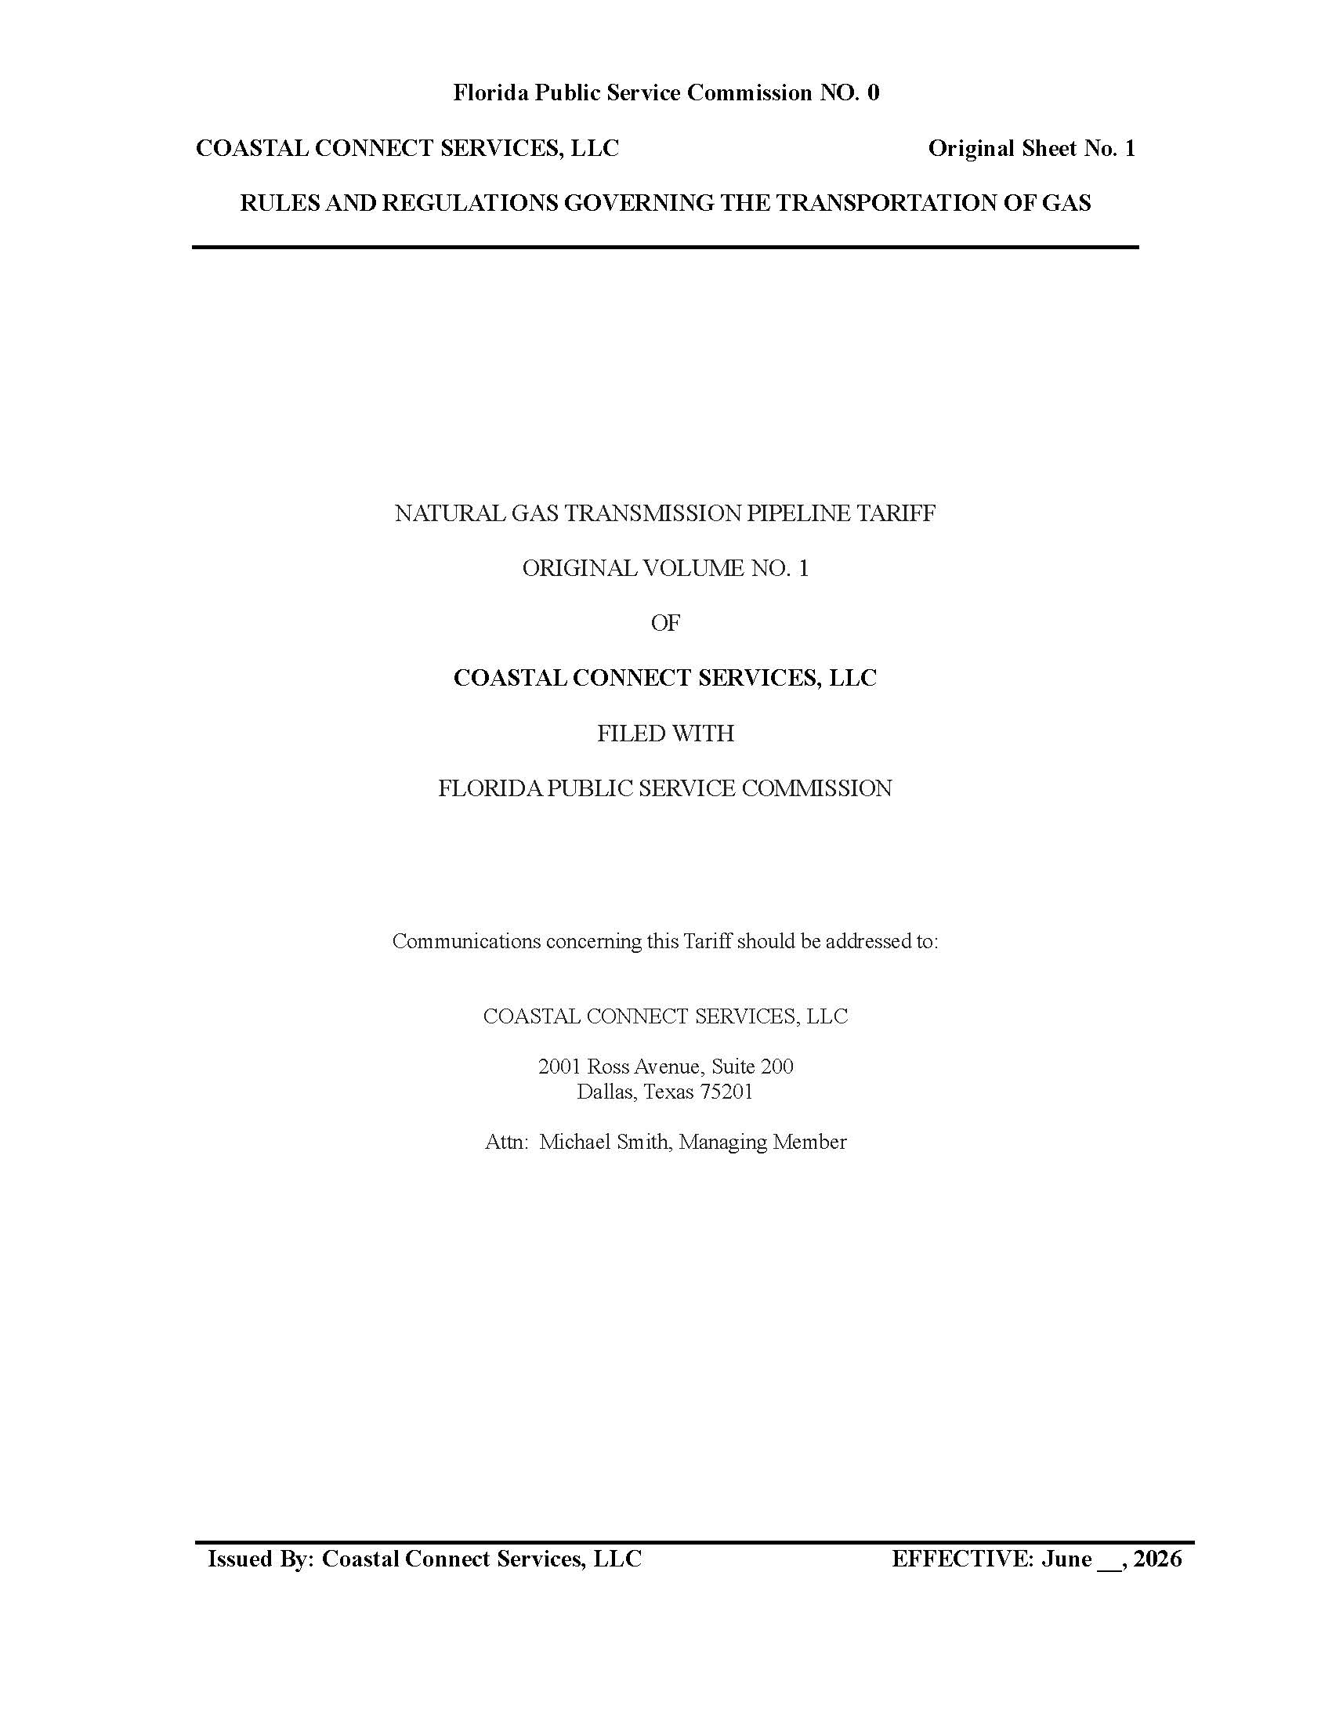

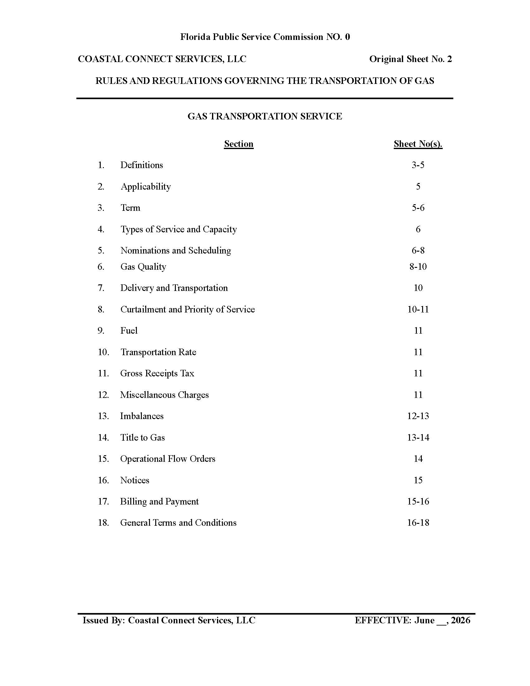

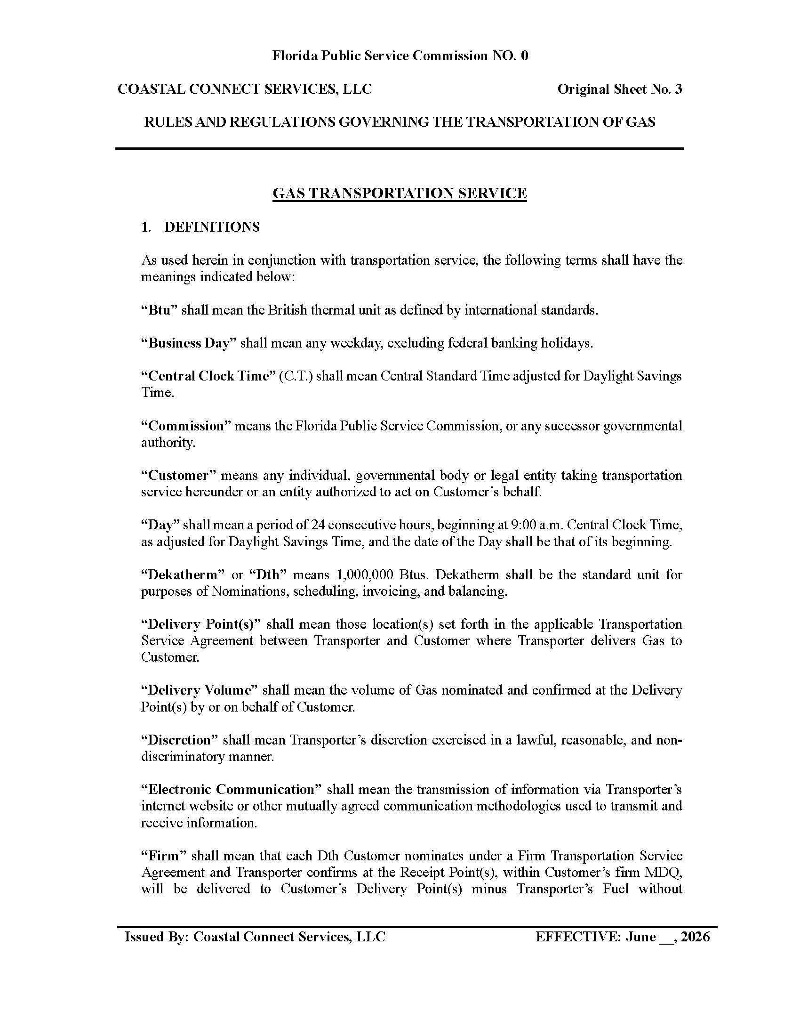

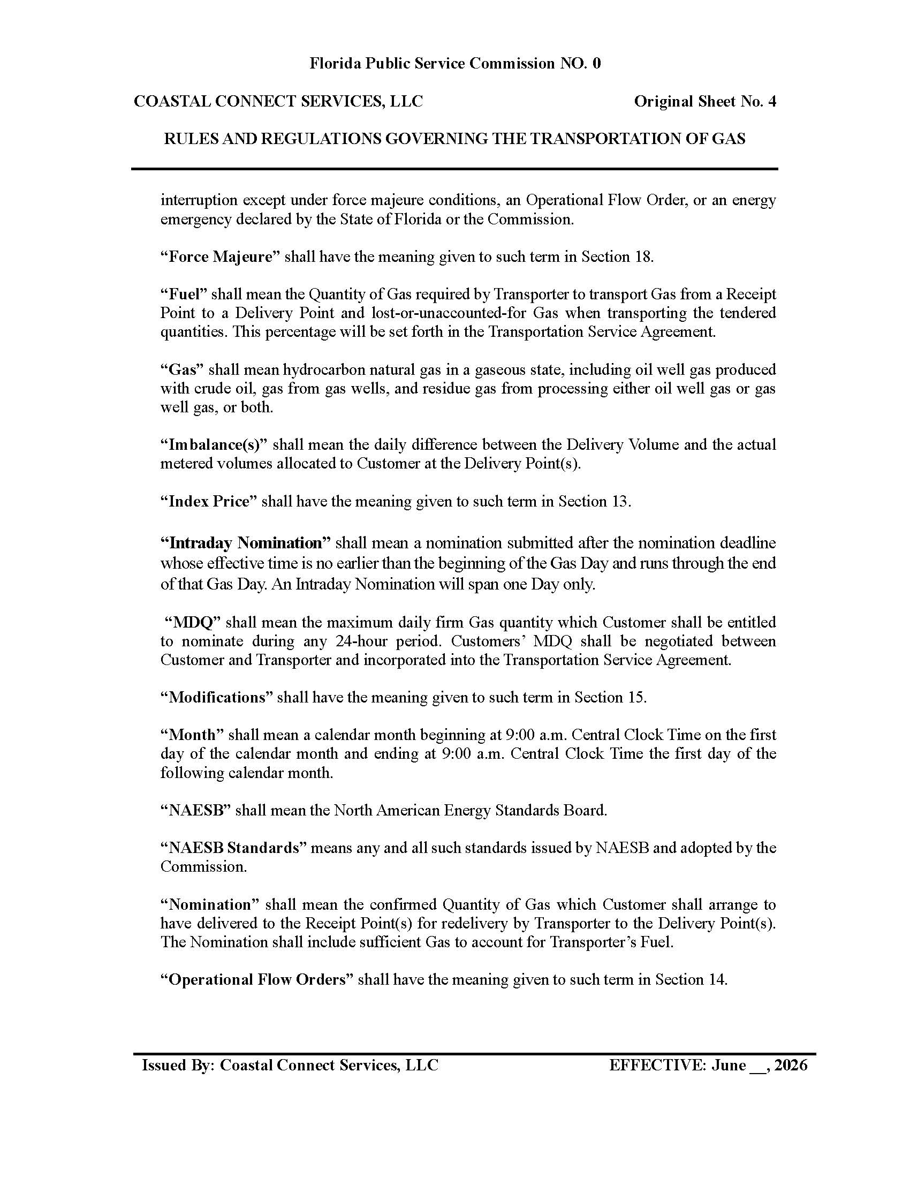

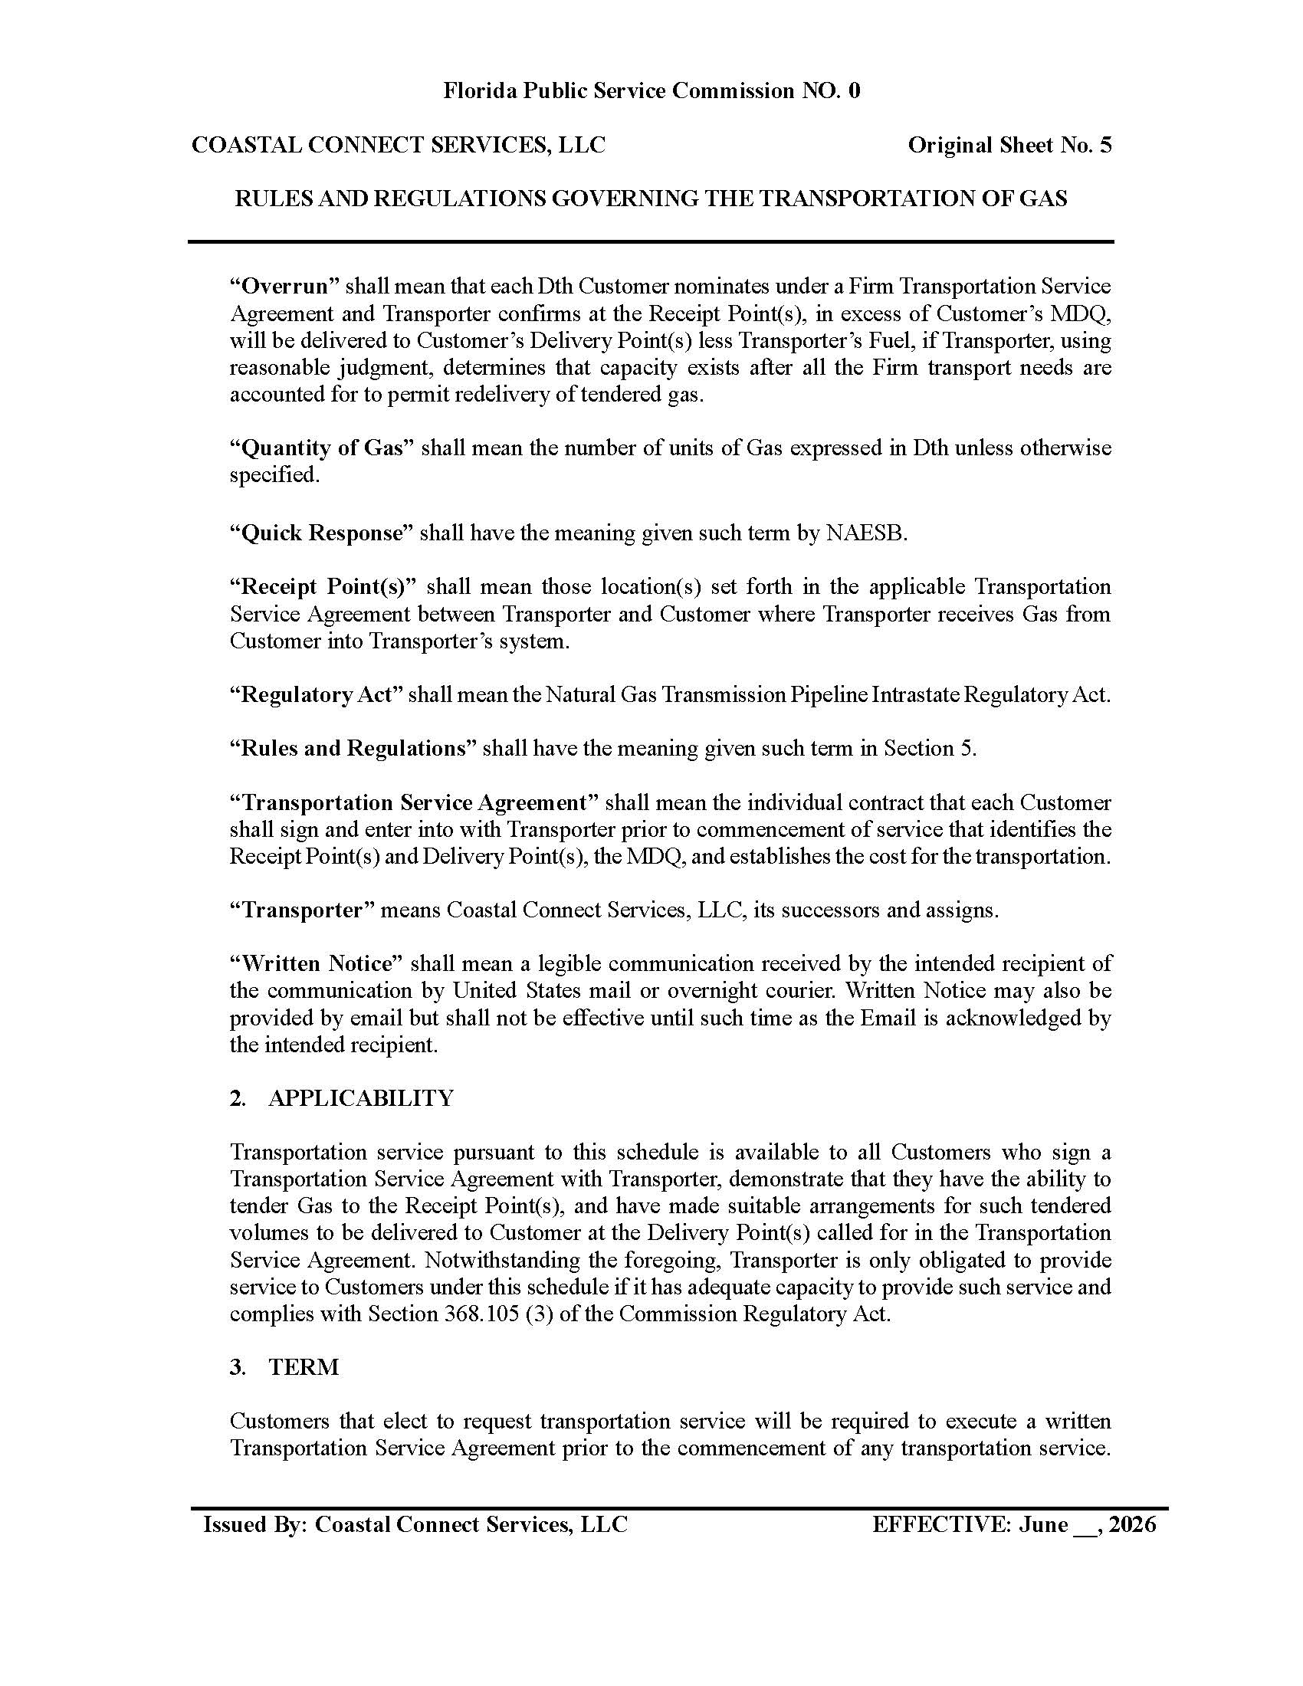

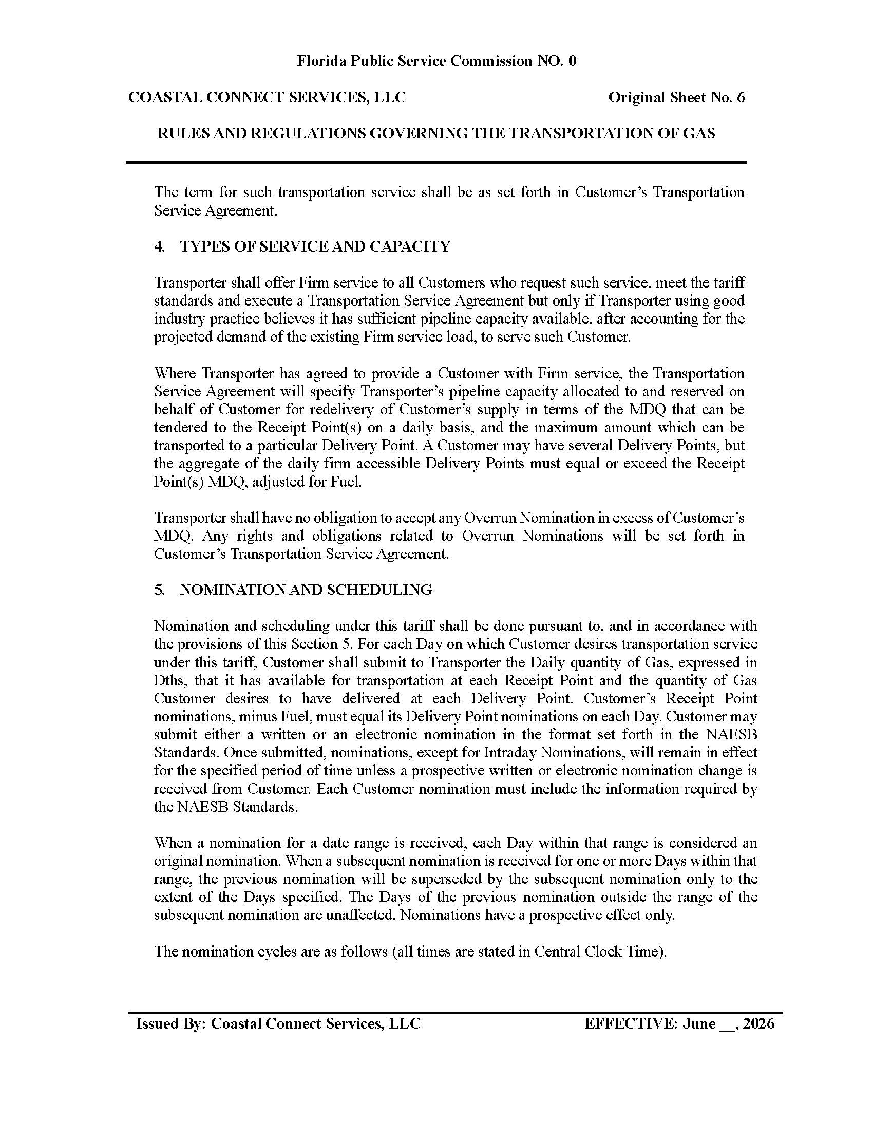

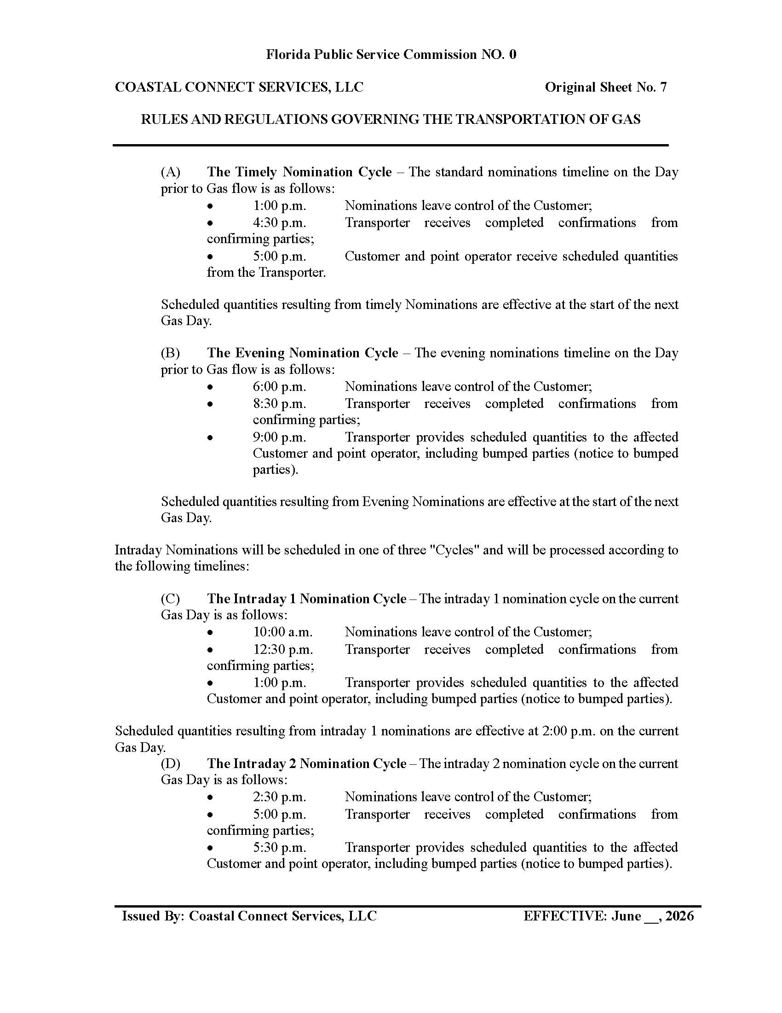

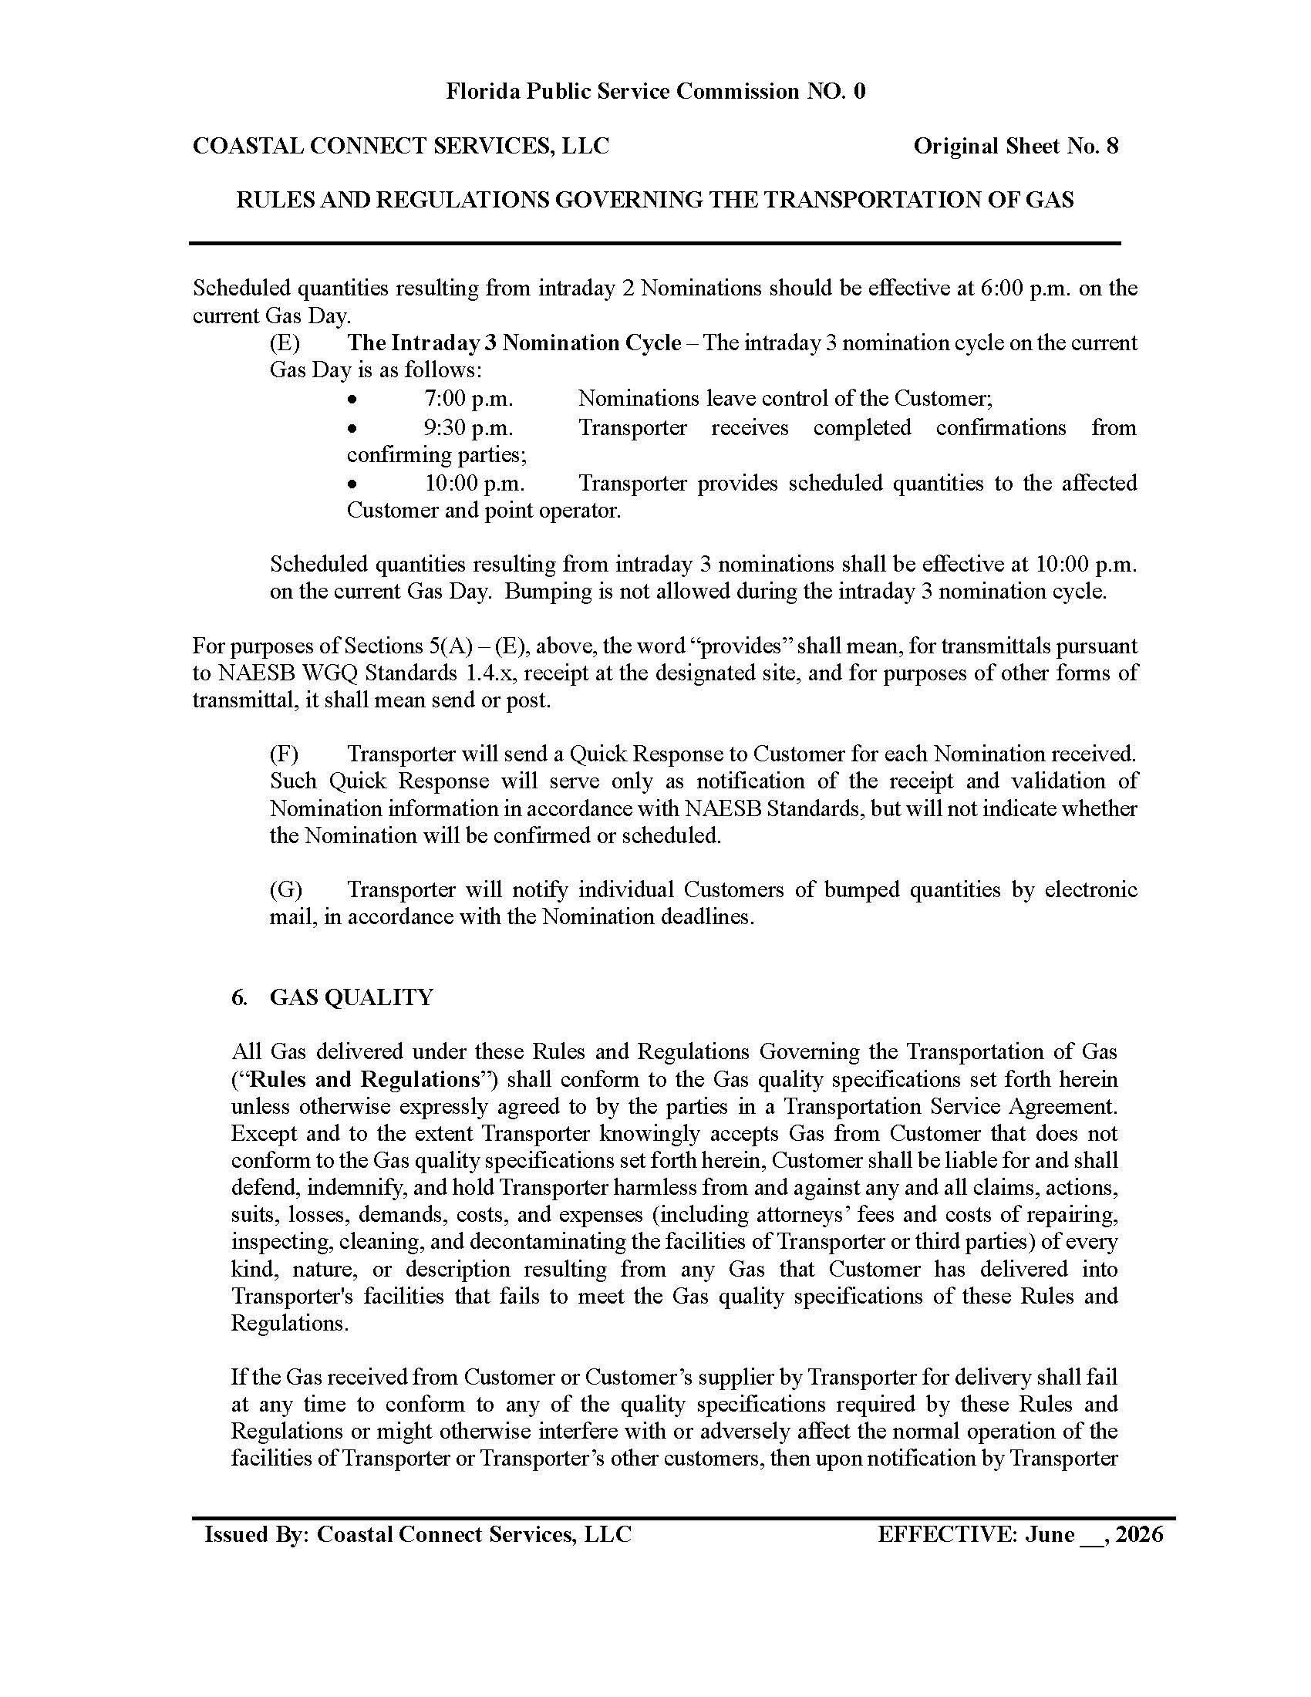

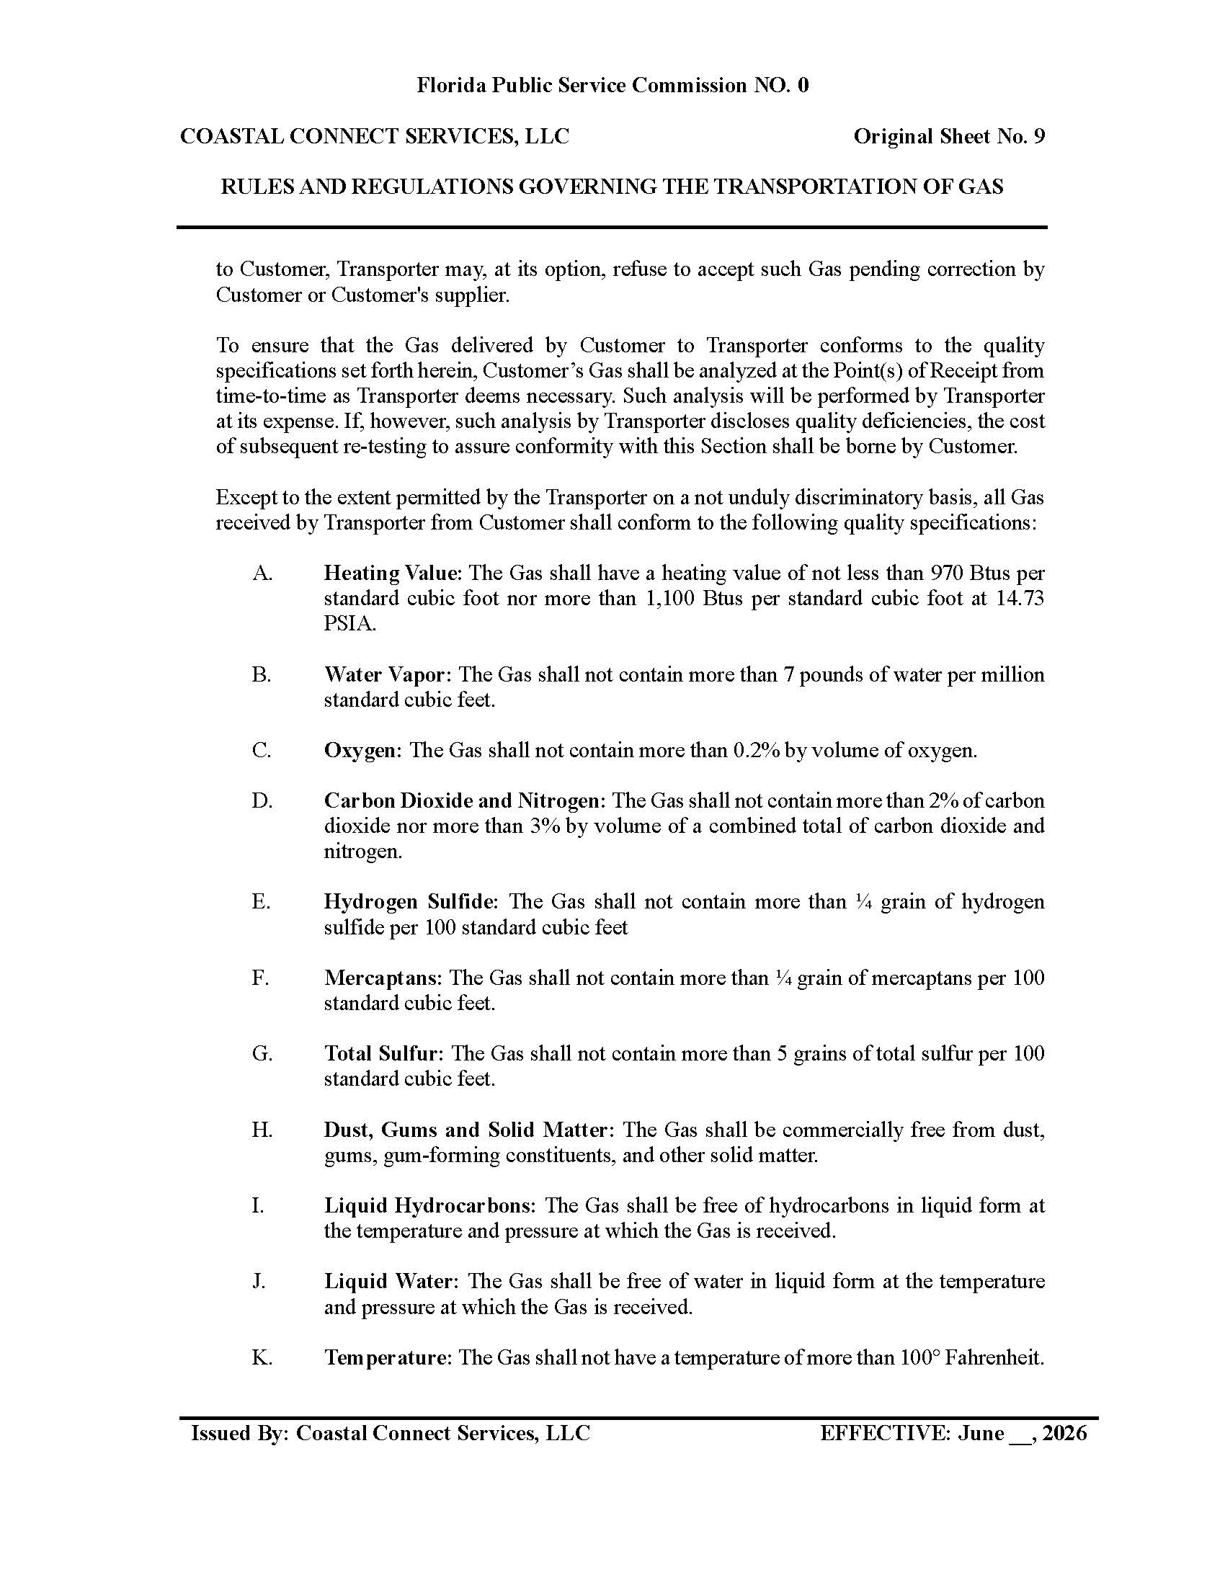

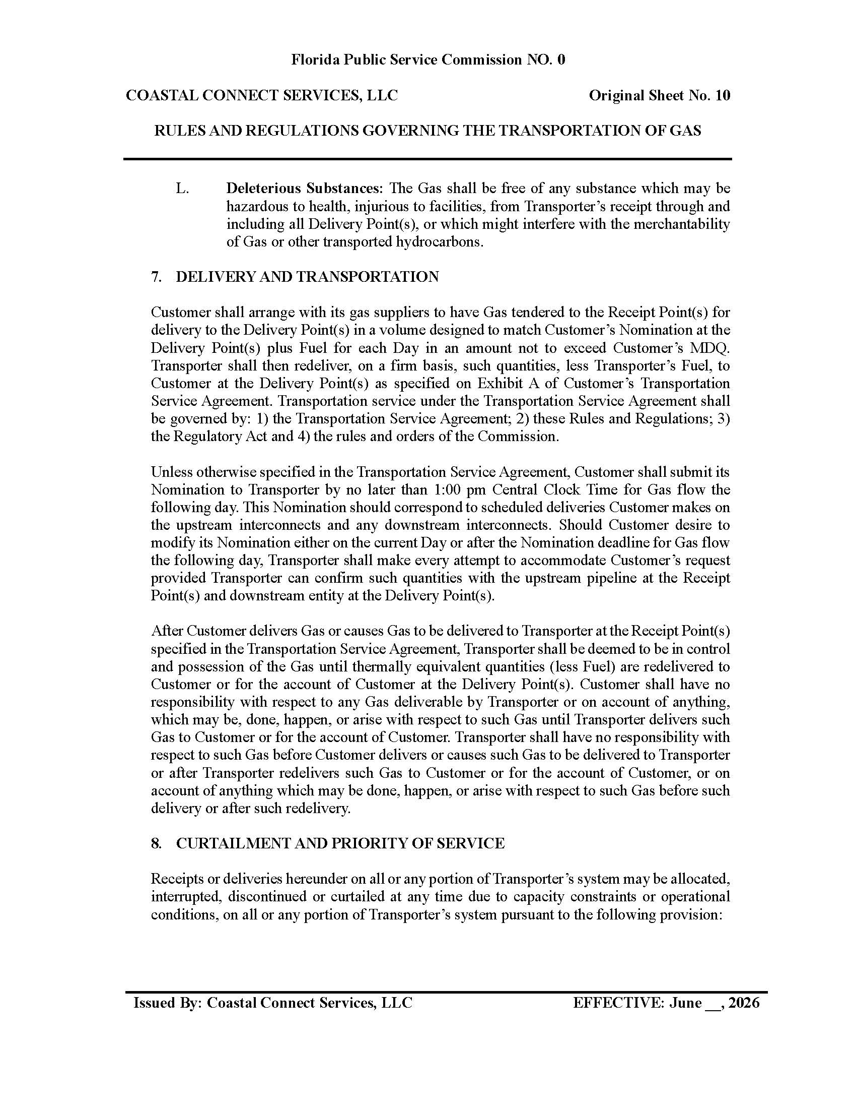

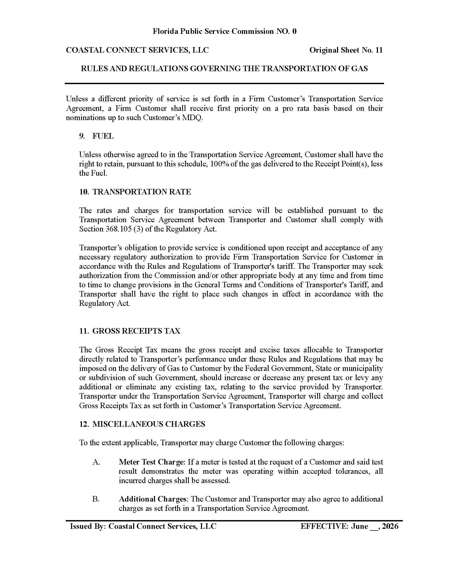

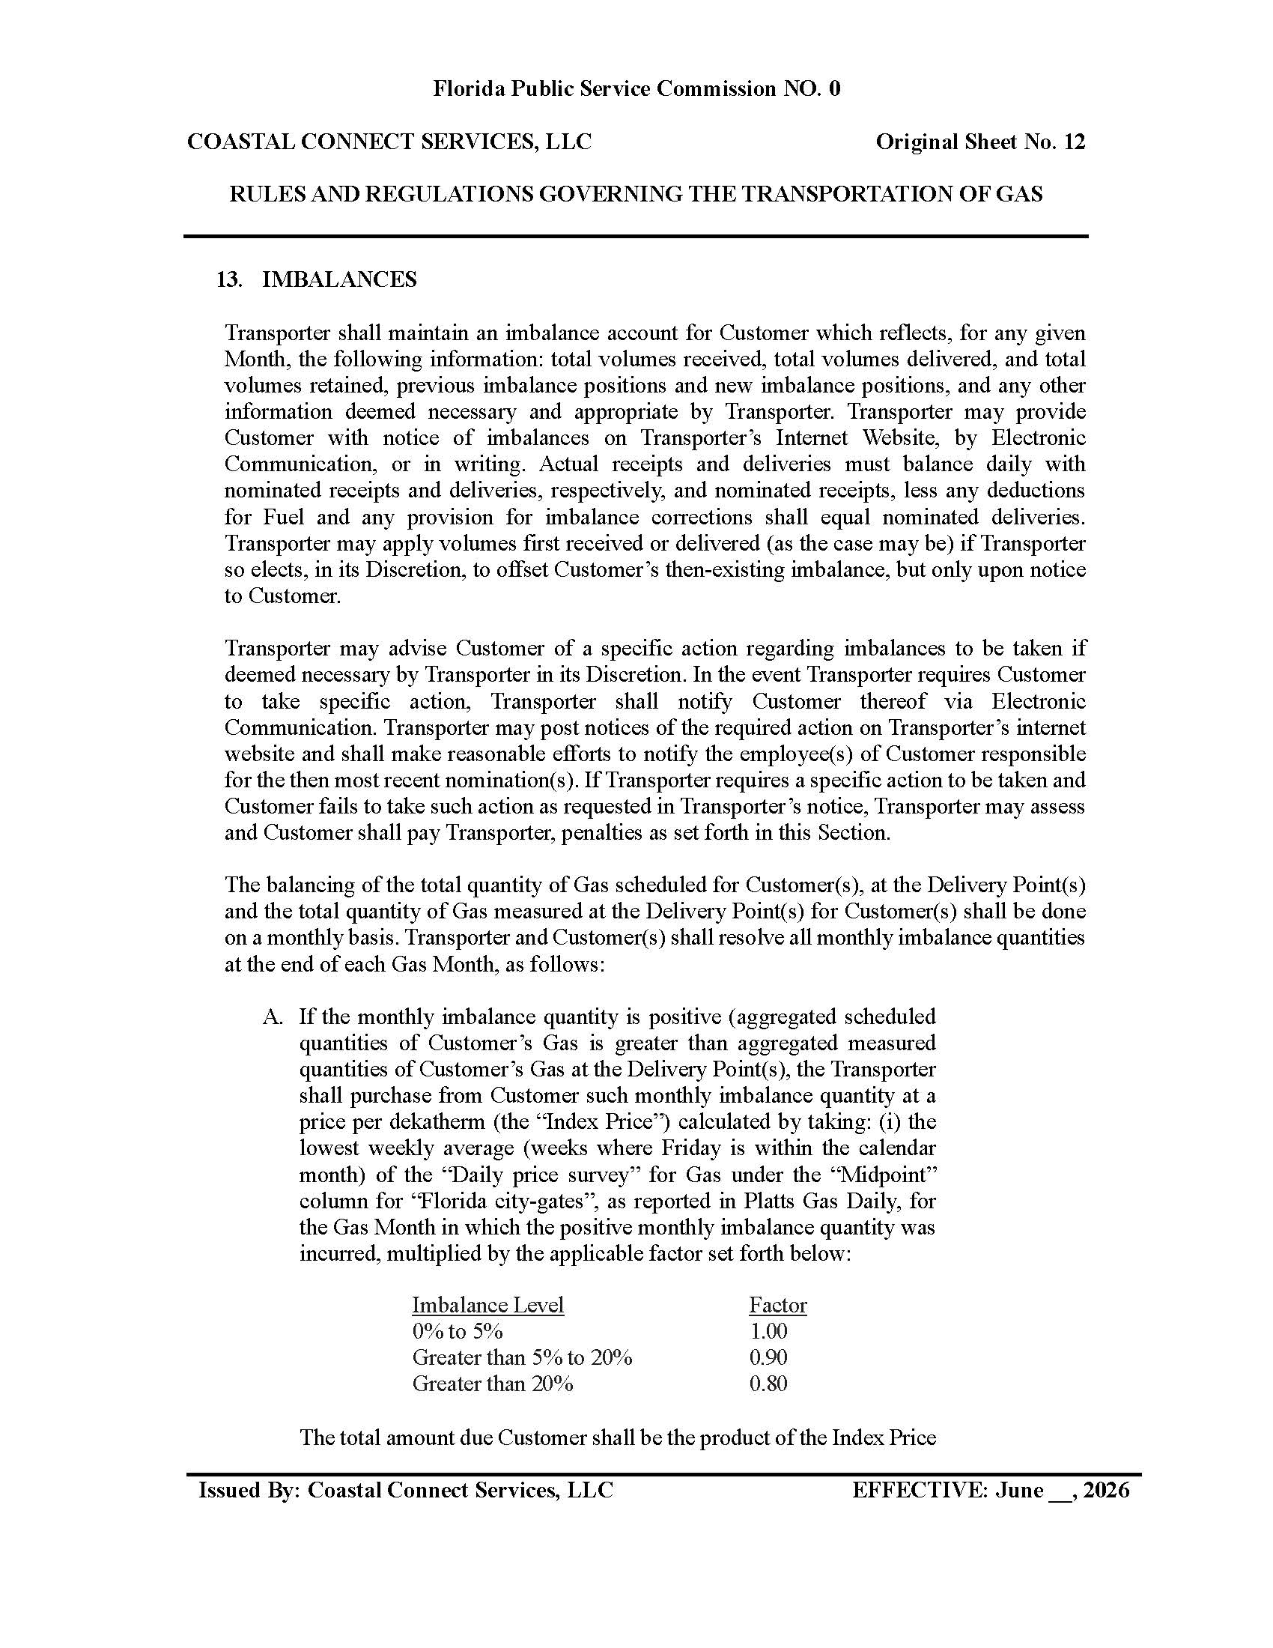

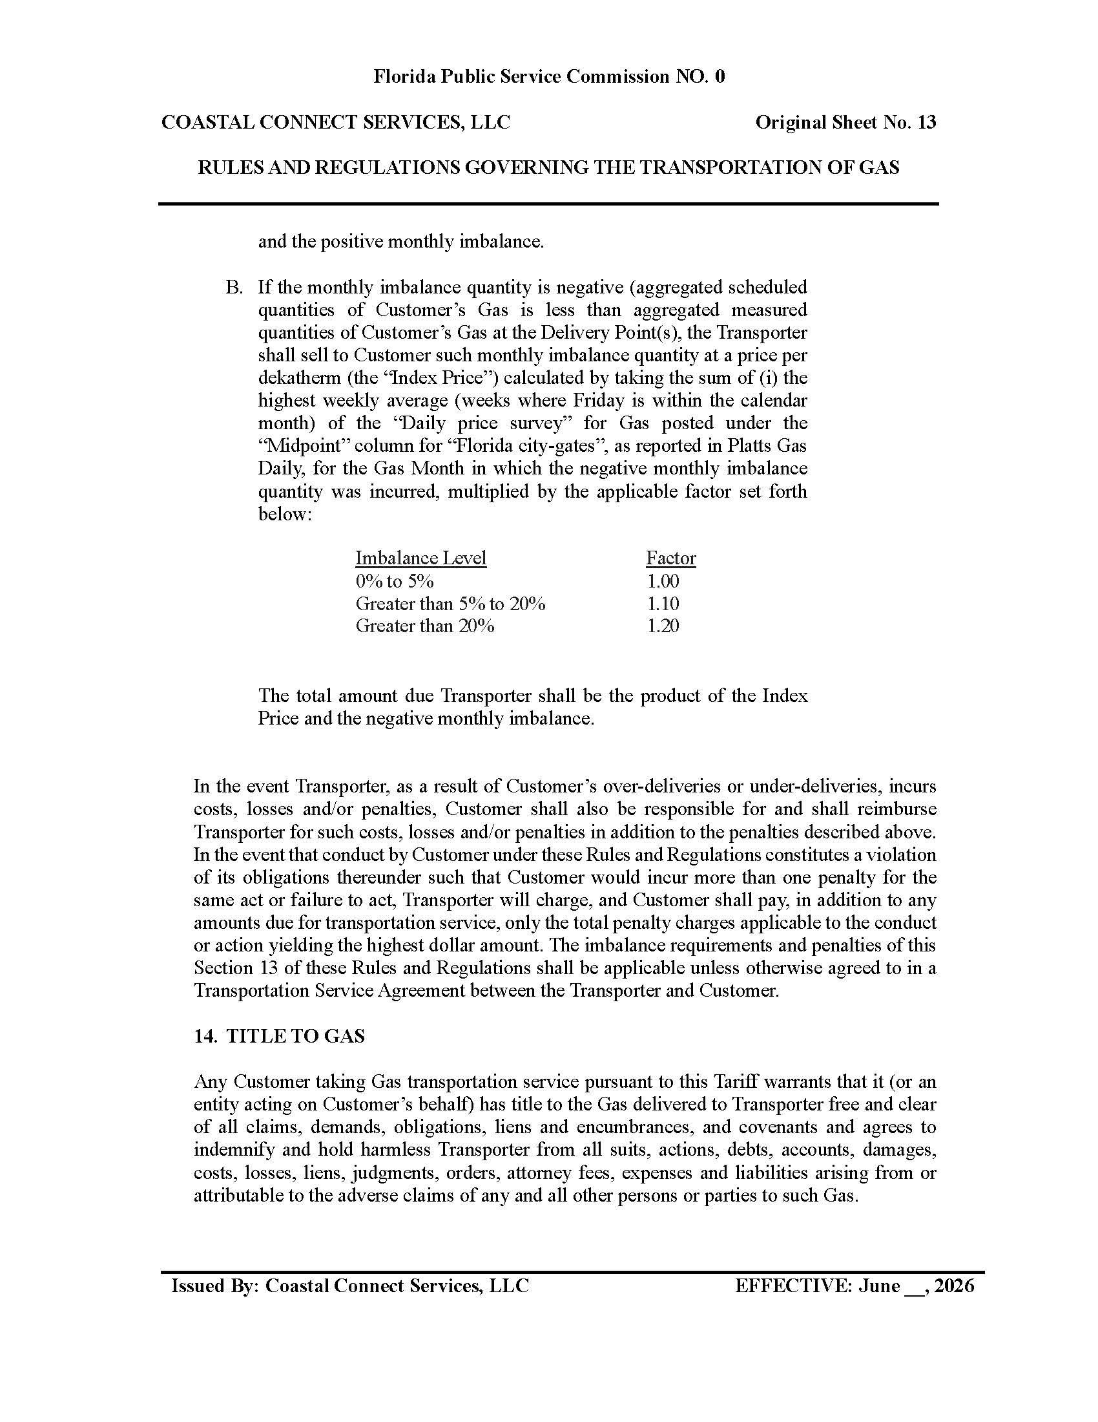

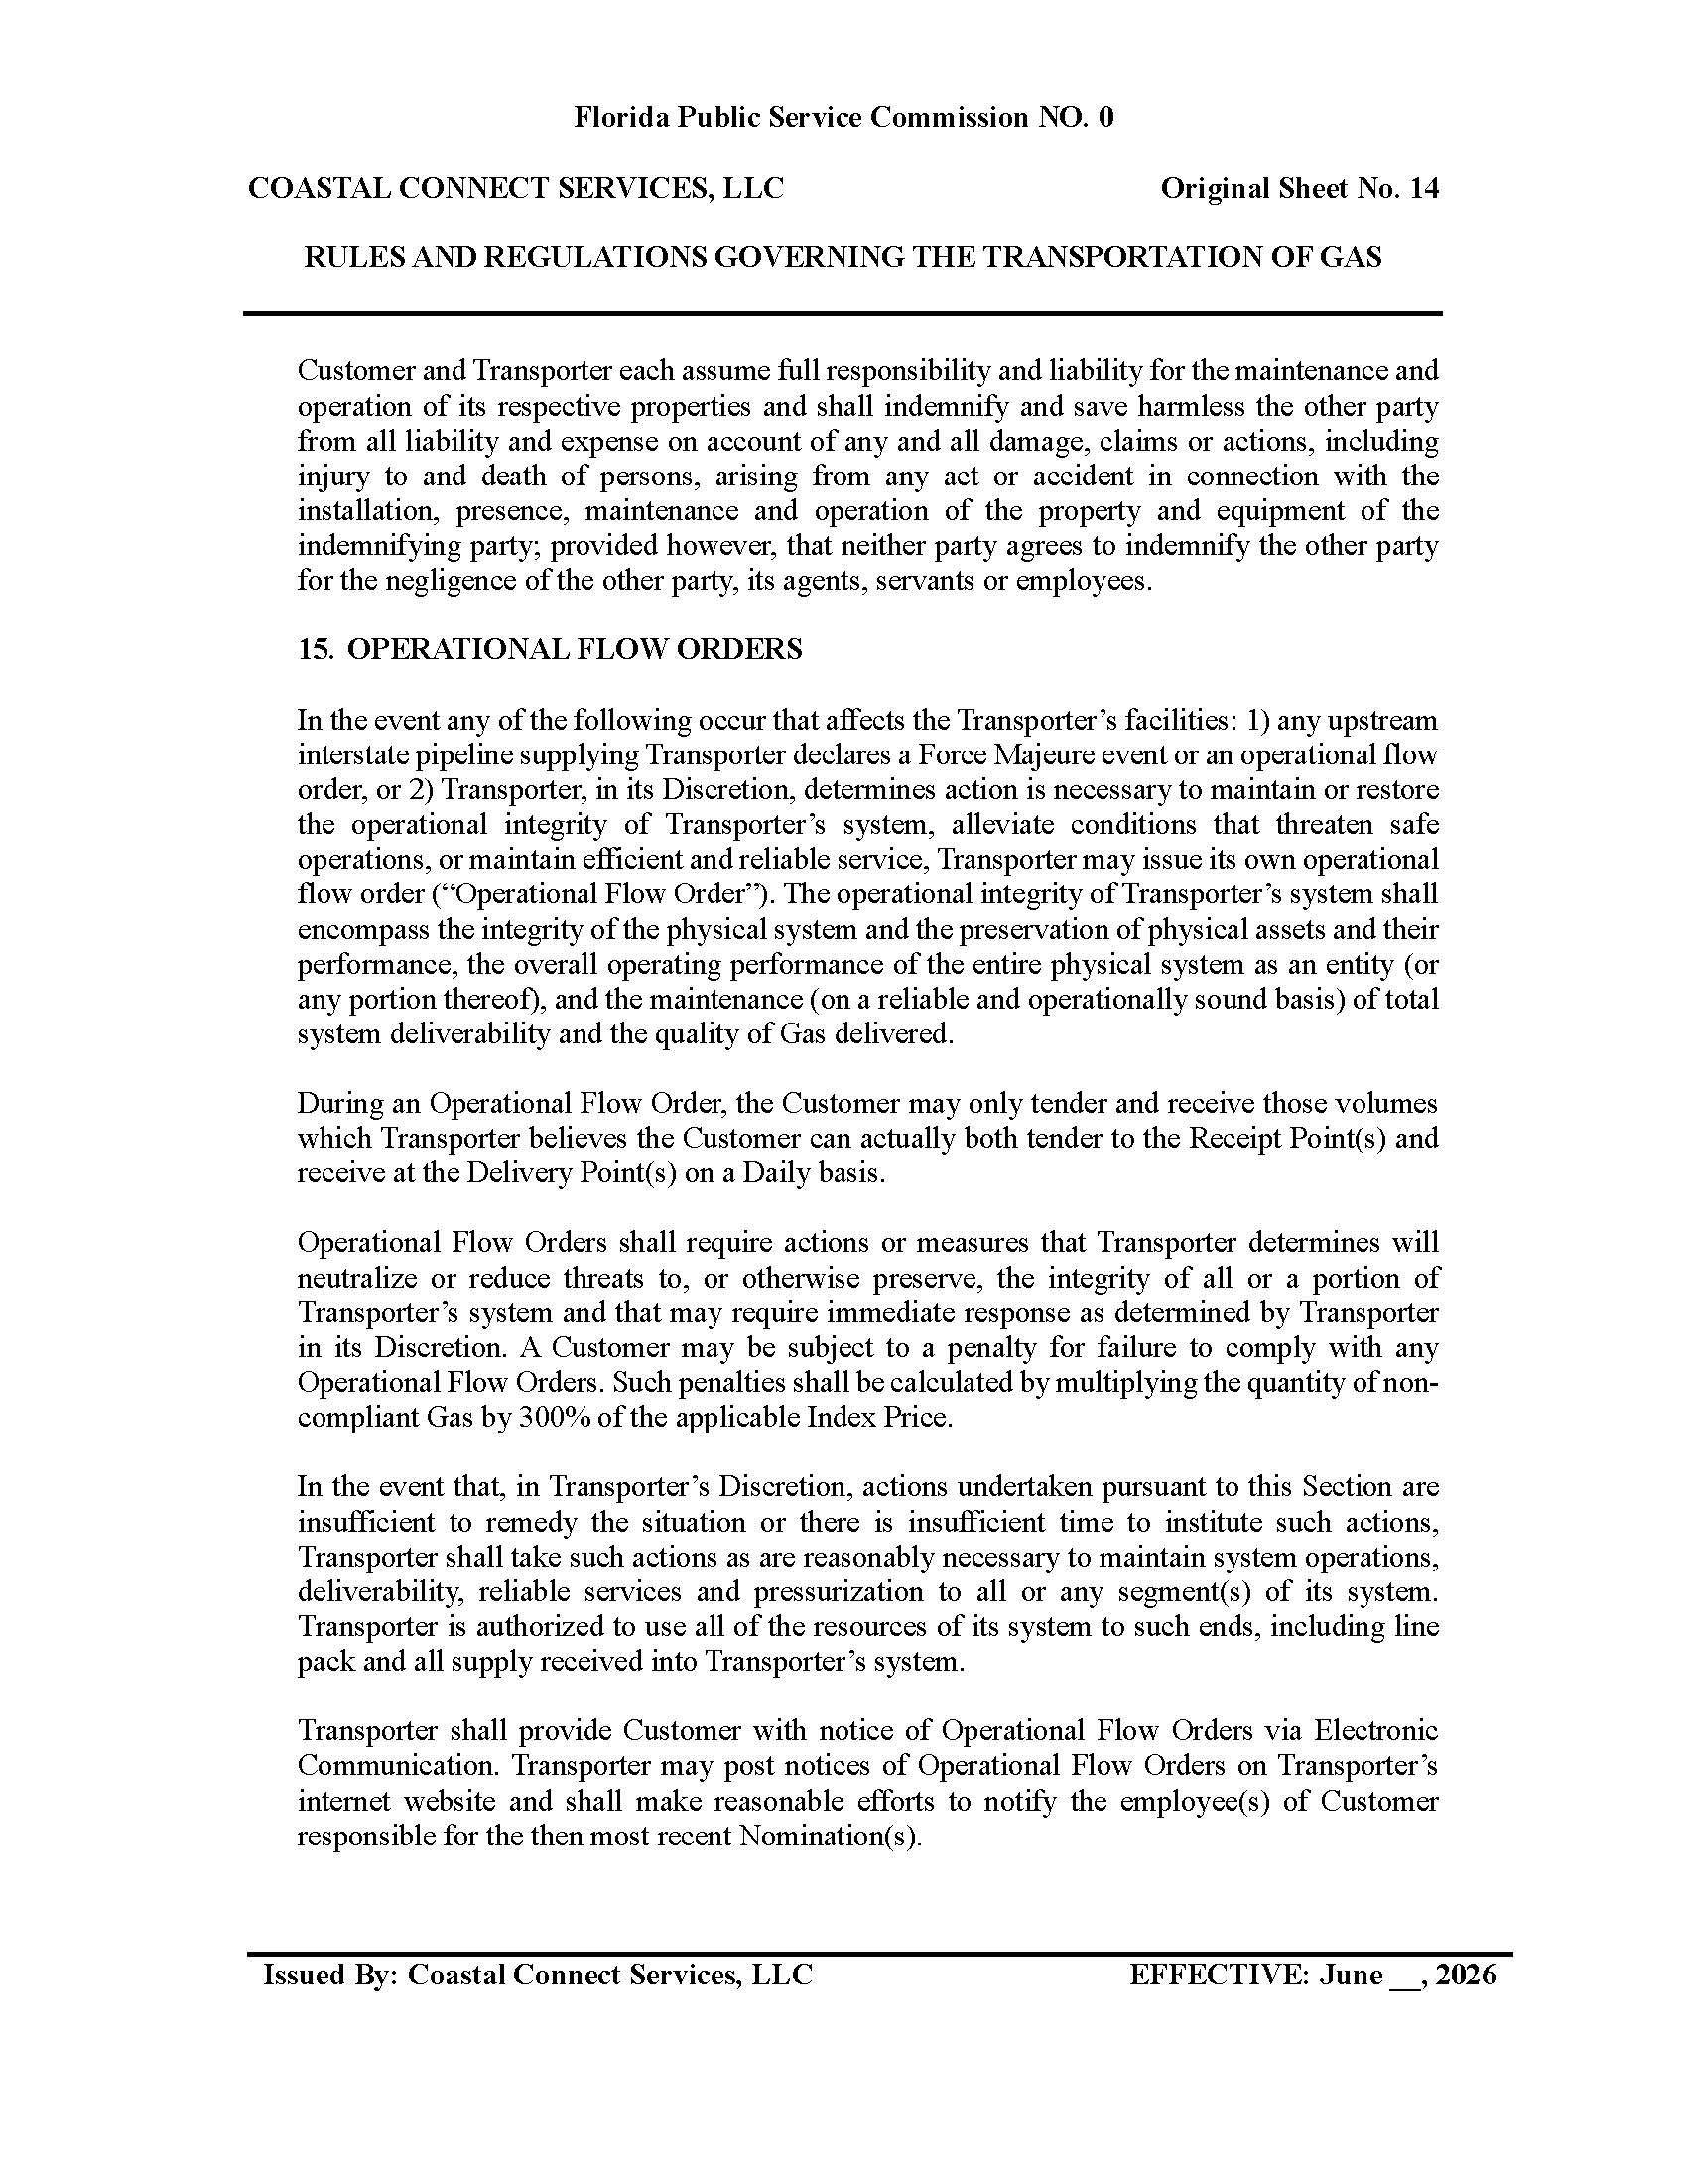

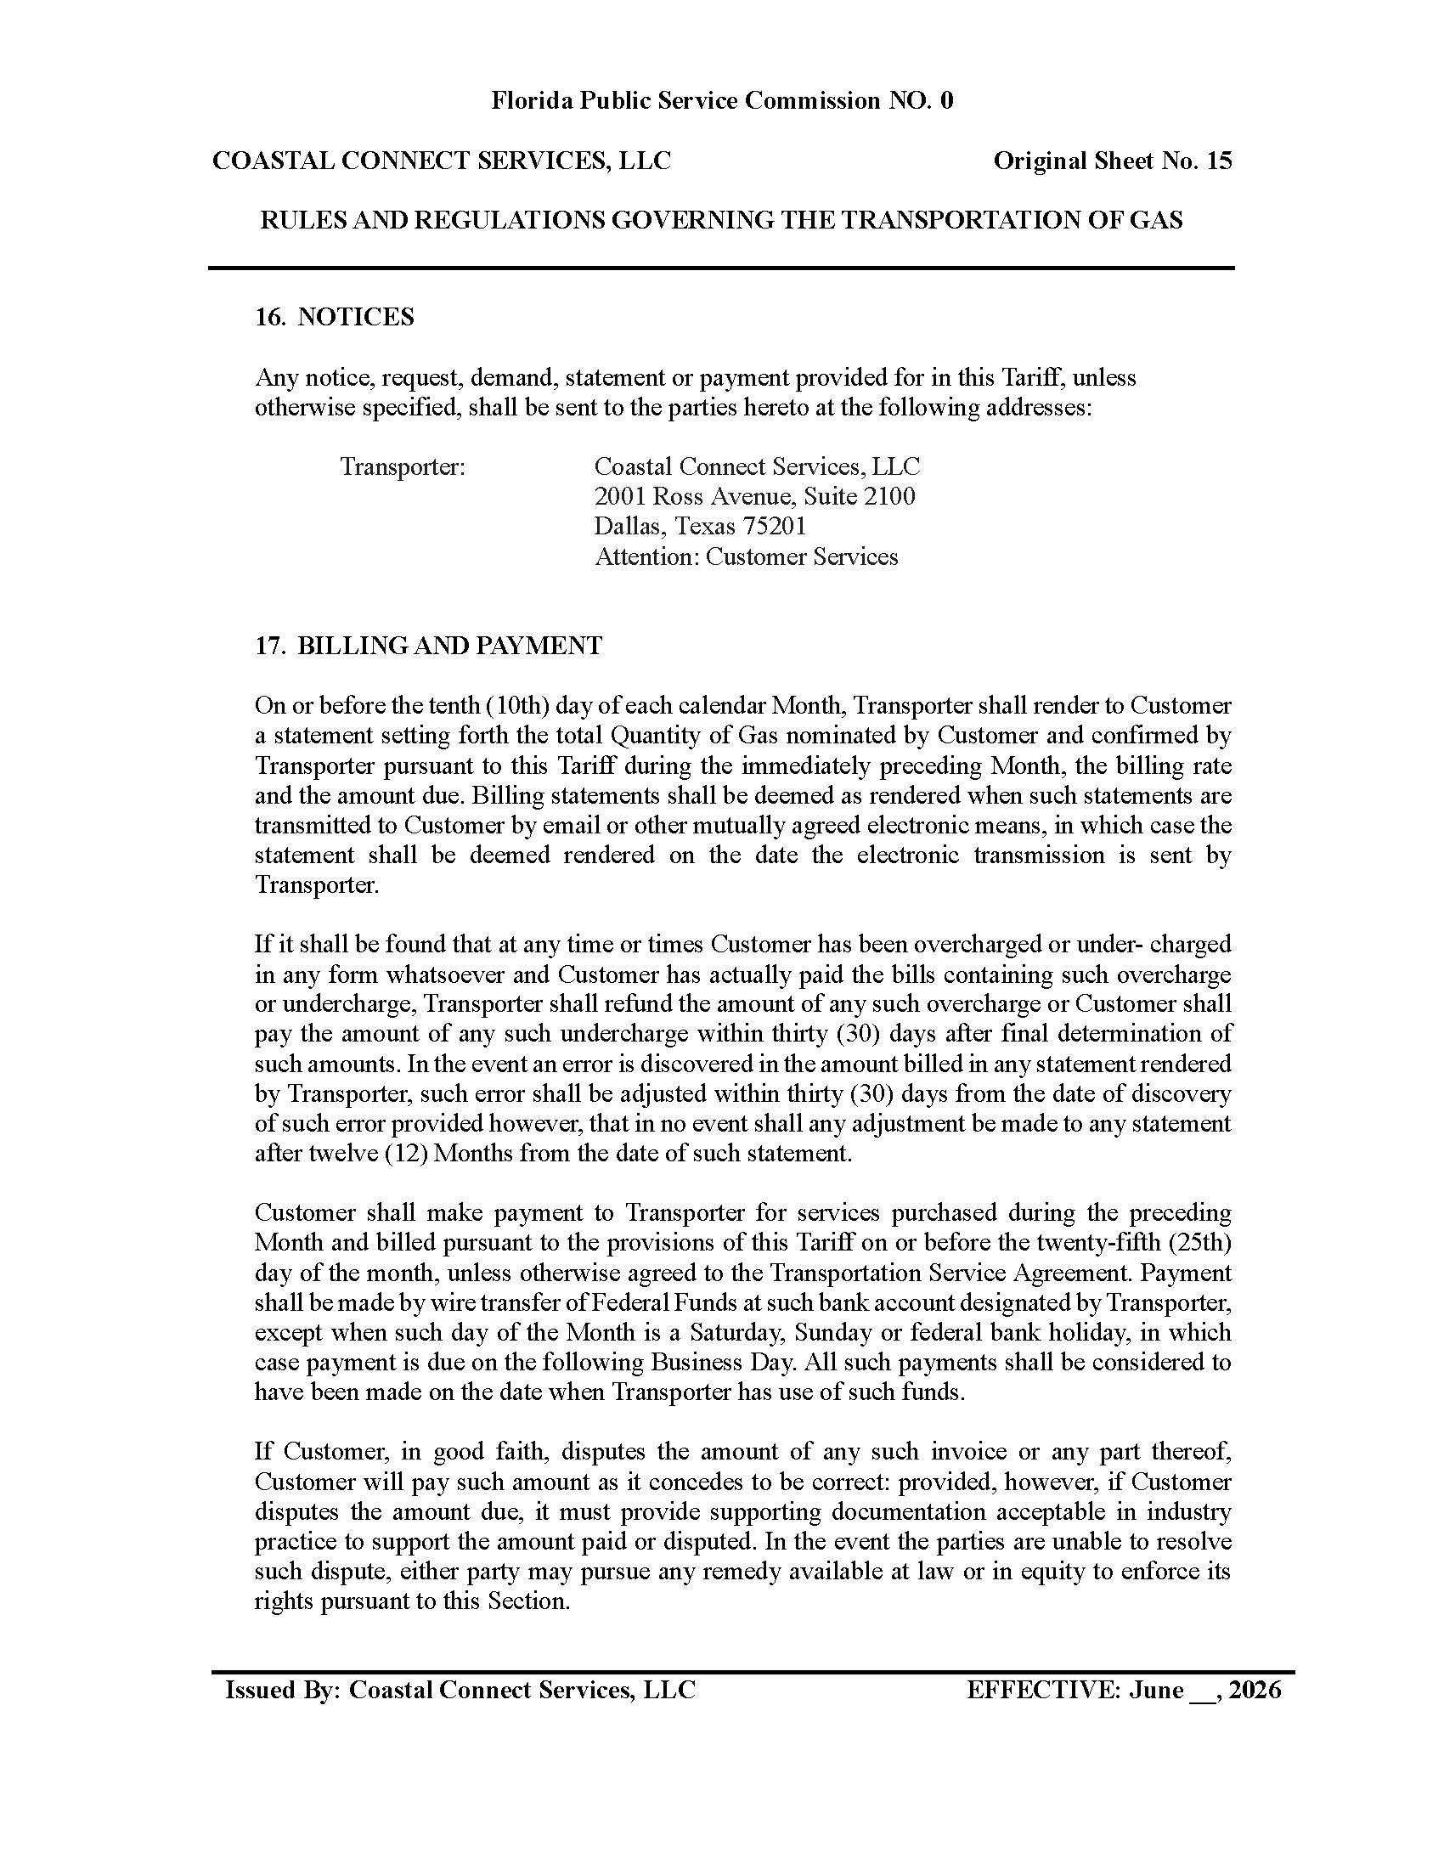

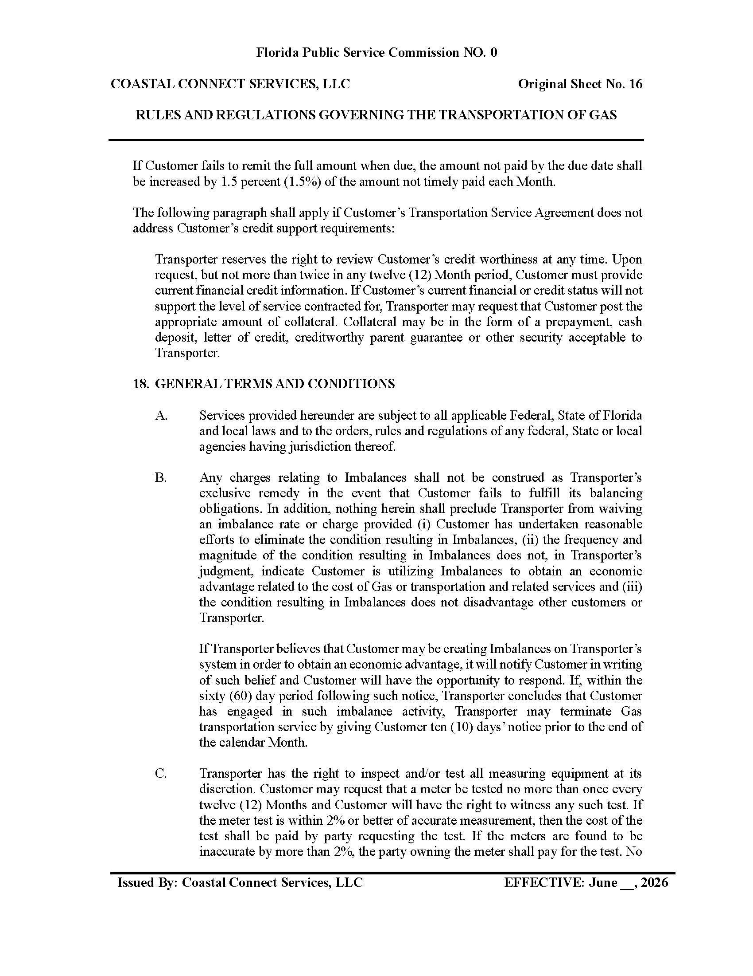

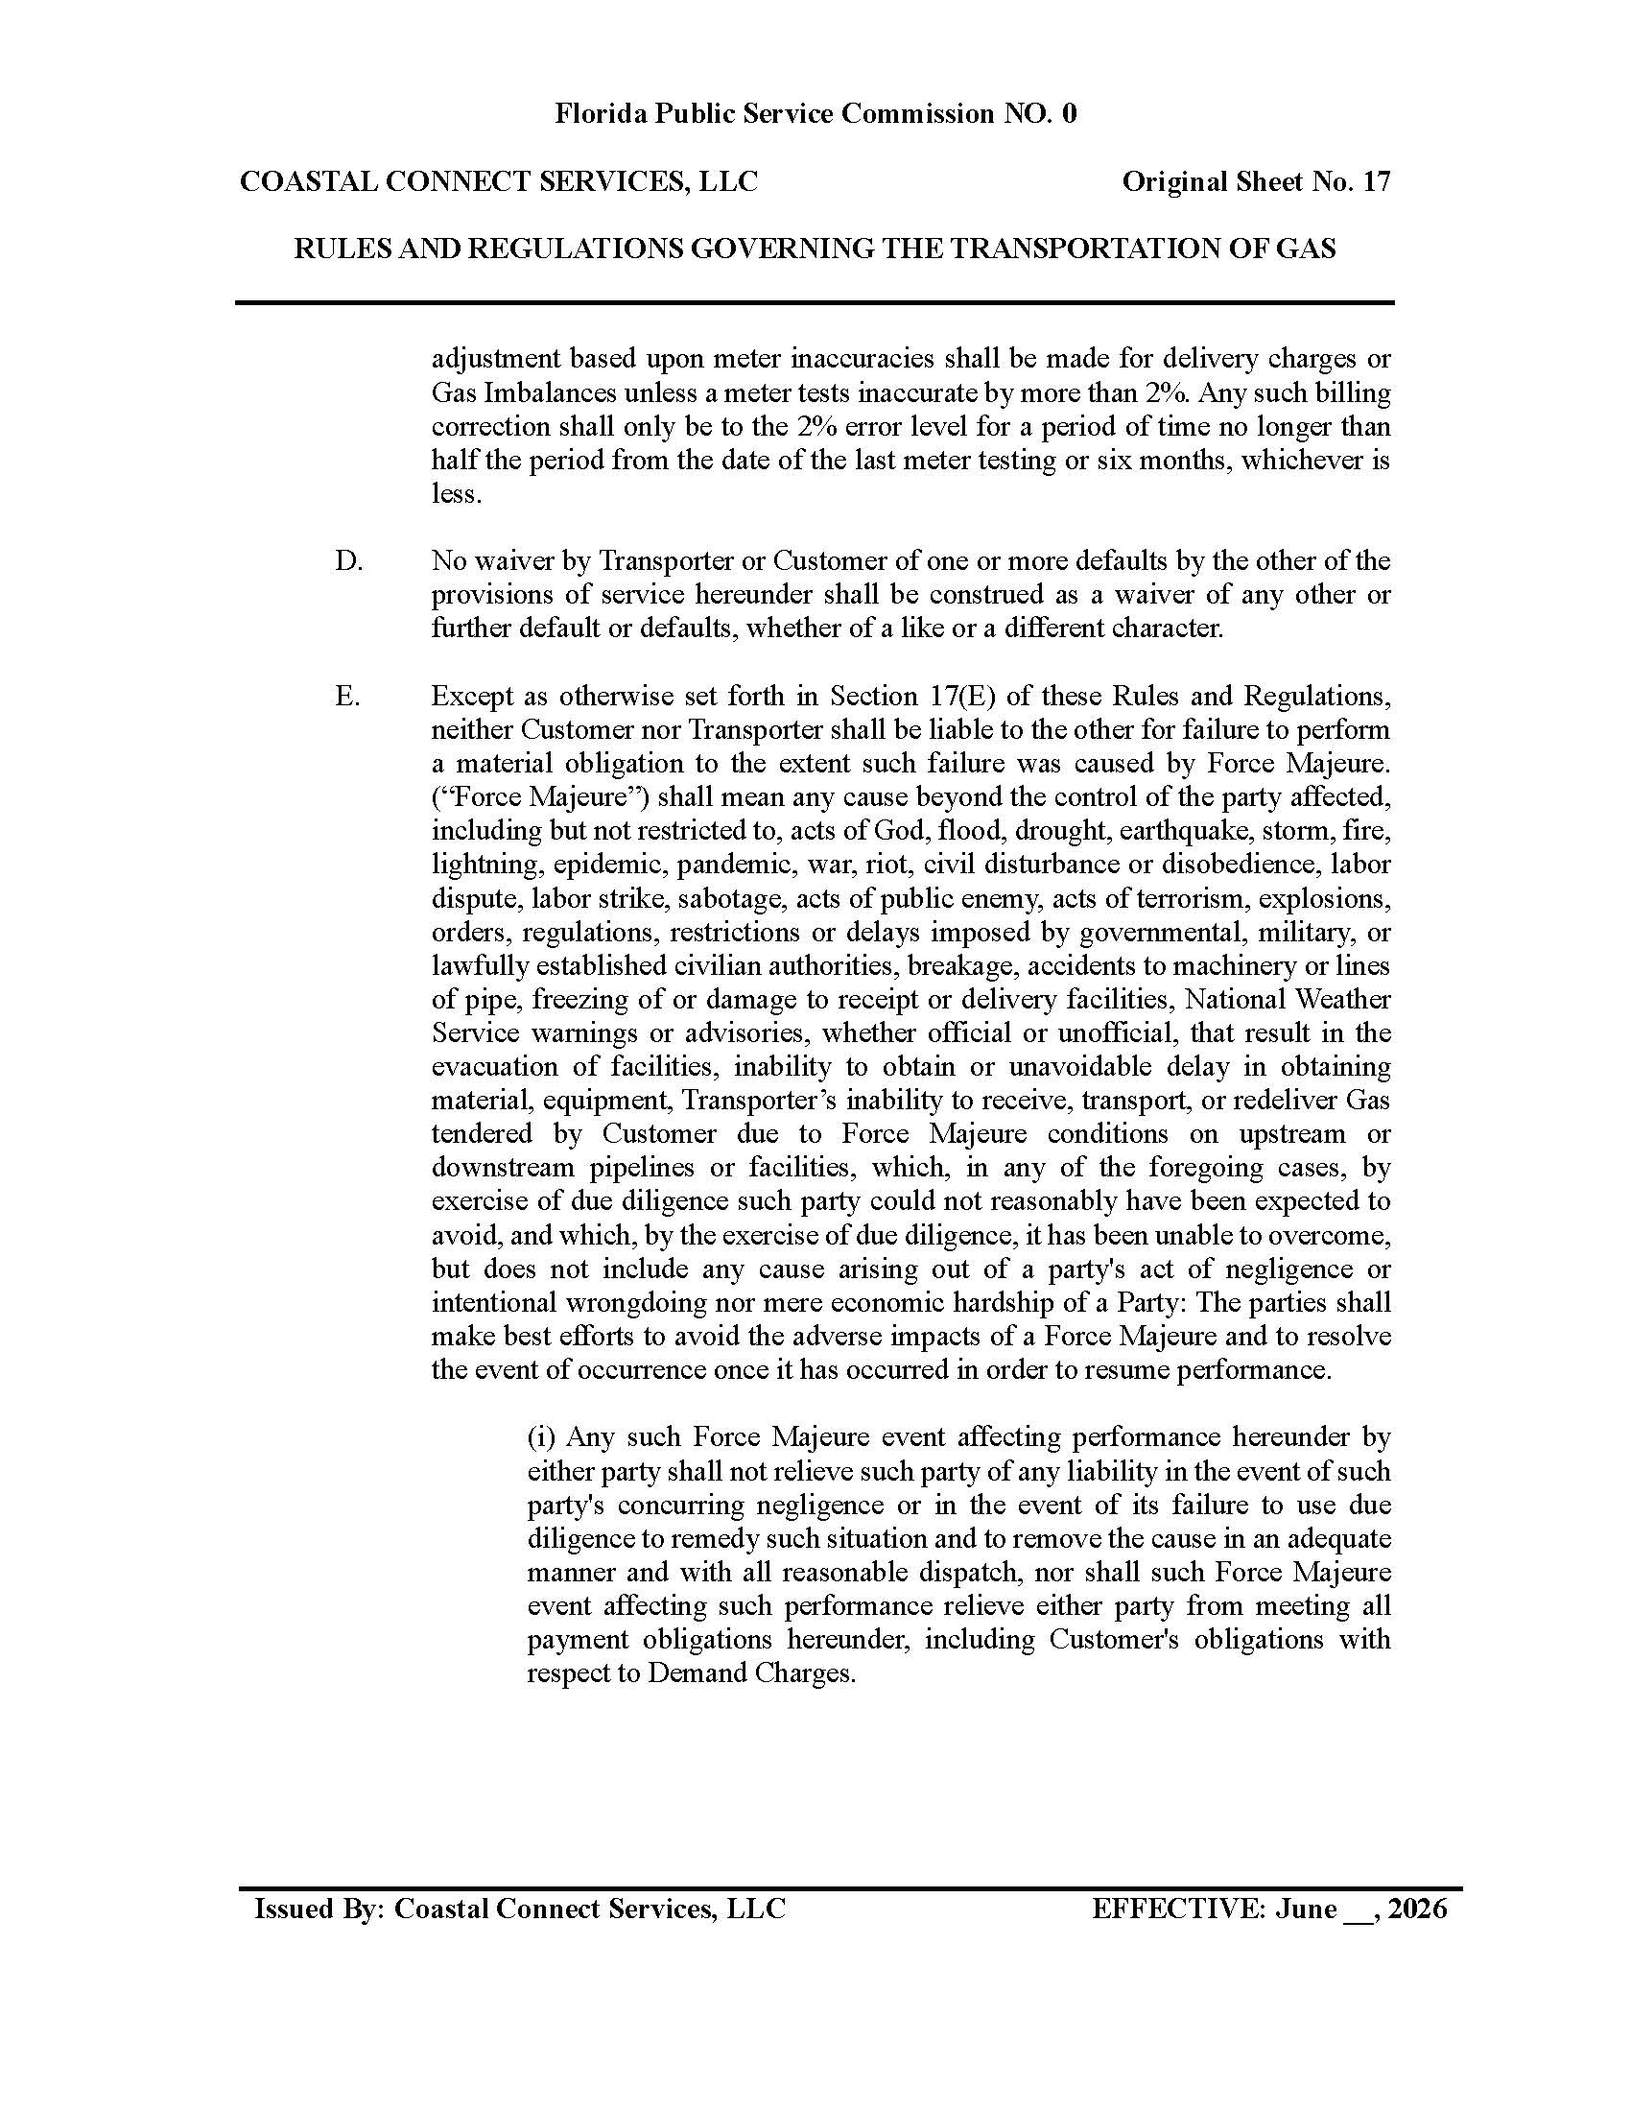

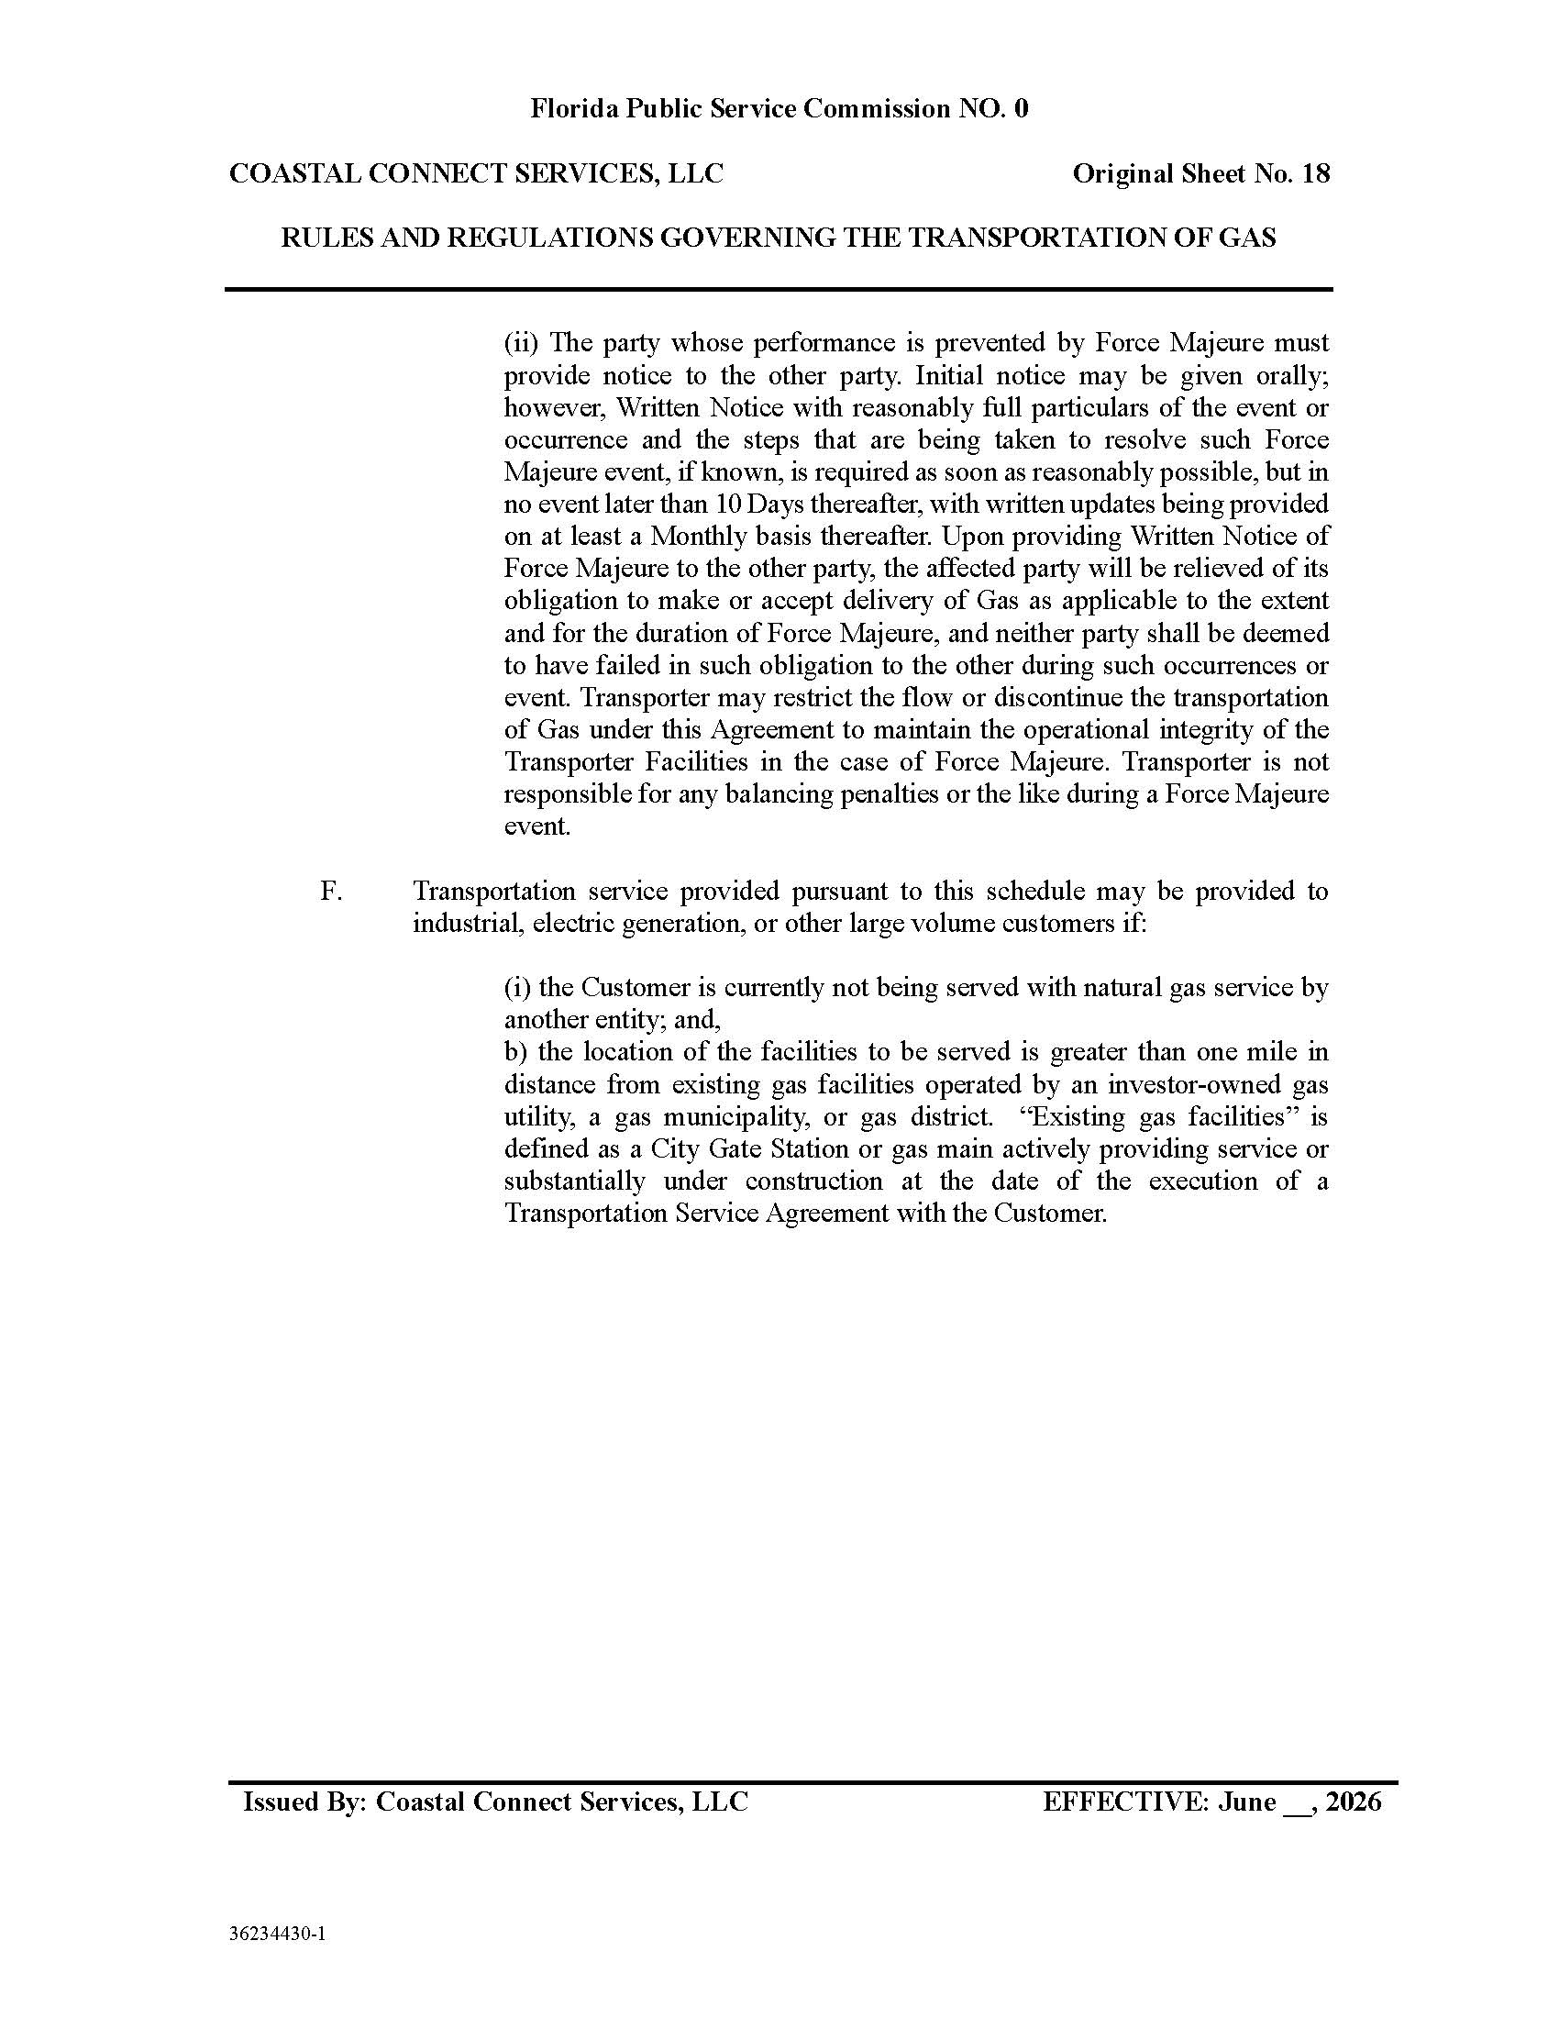

Order No. PSC-97-0609-FOF-GP, issued May 28, 1997, in Docket No. 970361-GP, In re: Five Flags Pipeline Company – Petition for approval of existing firm and interruptible system transportation rates.
Order No. PSC-07-1012-TRF-GP, issued December 21, 2007, in Docket No. 070570-GP, In re: Petition for approval of natural gas transmission pipeline tariff by Peninsula Pipeline Company, Inc.
Order No. PSC-08-0747-TRF-GP, issued November 12, 2008, in Docket No. 080561-GP, In re: Petition for approval of natural gas transmission pipeline tariff by SeaCoast Gas Transmission, LLC.
Order No. PSC-2026-0290-PCO-GU, issued August 24, 2026, in Docket No. 20260094-GU, In re: Petition of Coastal Connect Services, LLC for approval of natural gas pipeline transmission company tariff and firm transportation service agreement.
“Natural gas transmission pipelines which are less than 100 miles in length or which do not cross a county line” are exempt from the Pipeline Siting Act’s certification process, pursuant to Section 403.9405(2)(a), F.S. Therefore, a Section 403.9422, F.S., determination of need by this Commission is not required for CCS’s proposed pipeline.
Order No. PSC-06-0023-DS-GP, issued January 9, 2006, in Docket No. 050584-GP, In re: Petition for declaratory statement by Peninsula Pipeline Company, Inc. concerning recognition as a natural gas transmission pipeline company under Section 368.101, F.S, et. seq., p. 4.
Document No. 05248-2026, filed on August 17, 2026.
The first aspect of the test deals with the degree of injury. Agrico, 406 So. 2d at 482. The second deals with the nature of the injury. Id. The “injury in fact” must be both real and immediate and not speculative or conjectural. Int’l Jai-Alai Players Ass’n v. Fla. Pari-Mutuel Comm’n, 561 So. 2d 1224, 1225–26 (Fla. 3d DCA 1990); see also Vill. Park Mobile Home Ass’n, Inc. v. State Dep’t of Bus. Regulation, 506 So. 2d 426, 434 (Fla. 1st DCA 1987), rev. den., 513 So. 2d 1063 (Fla. 1987) (noting speculation on the possible occurrence of injurious events is too remote).
The exception to this general rule involves the Office of Public Counsel (OPC). OPC is statutorily conferred with legal standing, pursuant to Section 350.0611(1), F.S., to appear “in any proceeding or action before the [C]ommission.” In interpreting that statute, the Commission has found that the plain meaning of that phrase is broad and gives OPC the ability to intervene in proposed agency action matters. See Order No. PSC-15-0381-DS-PU, issued Sept. 14, 2015, in Docket No. 140107-PU, In re: Petition for declaratory statement regarding discovery in dockets or proceedings affecting rates or cost of service processed with the Commission’s proposed agency action procedure, pp. 9–10.

