BEFORE THE FLORIDA PUBLIC SERVICE COMMISSION

In re: Request for establishment of a backflow testing charge, meter tampering charge and investigation of meter tampering charge, by North Florida Community Water Systems. | DOCKET NO. 20260130-WU  ORDER NO. PSC-2026-0387-TRF-WU  ISSUED: October 27, 2026

The following Commissioners participated in the disposition of this matter:

GABRIELLA PASSIDOMO SMITH, Chairman
GARY F. CLARK
MIKE LA ROSA
BOBBY PAYNE
ANA ORTEGA

ORDER APPROVING ESTABLISHMENT OF A BACKFLOW TESTING CHARGE, METER TAMPERING CHARGE, AND INVESTIGATION OF METER TAMPERING CHARGE BY NORTH FLORIDA COMMUNITY WATER SERVICES

BY THE COMMISSION:

Background
North Florida Community Water Services (NFCWS or Utility) is a Class B water and wastewater utility serving in Alachua, Duval, Franklin, Leon, Okaloosa, and Washington Counties. According to the Utility’s 2025 annual report the Utility provides water service to 2,337 residential and 56 general service customers. NFCWS’ rates were last amended by a price index in 2026.

On August 31, 2026, NFCWS filed an application for approval of a tariff amendment to implement a backflow prevention device test charge, meter tampering charge, and investigation of meter tampering charge. In response to our request, on September 16, 2026, the Utility filed its cost justification.

This order addresses NFCWS’s request to charge for testing backflow prevention devices, establish an investigation of meter tampering charge, and meter tampering charge, which includes tariff sheets reflecting the requested charges. Furthermore, NFCWS provided a proposed tariff reflecting the Department Environmental Protection (DEP) annual backflow prevention testing requirements. We have jurisdiction over this matter pursuant to Sections 367.081 and 367.091, Florida Statutes (F.S.).

Decision
Backflow Testing Charge

In its original application, the Utility included proposed tariffs Original Sheet No. 16.5 to include DEP’s requirement for annual inspection of backflow prevention devices and Original Sheet No 16.6 to indicate the backflow prevention assembly test charge. Section 367.091, F.S., authorizes us to change miscellaneous service charges. The Utility’s request for a charge was accompanied by its reason for requesting the charge, as well as cost justification required by Section 367.091(6), F.S. The Utility states that the purpose of its request is to comply with DEP Rules 62-555.330 and 62-555.360, Florida Administrative Code (F.A.C.), which include the required language regarding backflow prevention device testing.

The Utility’s Cross-Connection Control Program mandates that a backflow prevention device be installed on all connections, which may represent a source of contamination due to a lawn irrigation system. On May 20, 2025, the Utility was cited with a deficiency by DEP stating that 77 residential connections with backflow assemblies had not been tested within the past two years. However, during inspection, the Utility discovered that only 50 connections required assemblies in Sunny Hills. The deficiency also stated that the residential assemblies be tested biennially.

The customers are responsible for piping and appurtenances beyond the Utility’s water meter toward the dwelling. Rule 25-30.231, F.A.C., requires each utility to operate and maintain safe and proper condition of all the facilities and equipment used in connection with the distribution, regulation, measurement, and delivery of water service to the customer up to and the point of delivery into the piping owned by the customer. In addition, Rule 25-30.210(7), F.A.C., states that the point of delivery for a water system is the outlet connection with the customer’s piping. Due to the location of the backflow devices, which is past the meter, the cost of inspection will be borne by the customer. The Utility sends out a notice on an annual basis advising of the testing requirement per DEP’s rule. Customers will have 30 days from the date of the notice to complete the testing and provide documentation to the Utility. Per the Utility’s request, if a customer fails to have the annual inspection performed and provide documentation of the test to the Utility within 30 days of the notice, water service will be disconnected. Rule 25-30.320(2), F.A.C., states that service may be discontinued for noncompliance with any state regulation governing such utility service.

The Utility’s proposed tariff indicates a backflow testing charge of $68.46. The charge will allow the Utility to conduct the required backflow prevention assembly testing on behalf of customers that choose the Utility to perform the test or customers that failed to have the test performed within a 30-day noticing period. The Utility requested that the proposed charge be equivalent to the Utility’s premises visit charge. The costs will be the same as a premises visit and performed by the same personnel. If a compliance inspection is needed, it falls within the confines of Rule 25-30.460, F.A.C, which is an assessment of a service issue that is the customer’s responsibility. Therefore, we find the cost of the premises visit charge is appropriate for the backflow prevention charge.
Conclusion

We find that NFCWS’ proposed tariff sheets, Original Sheet No. 16.5 and Original Sheet No. 16.6, shown on Attachment A are appropriate and shall be approved. The charges shall be effective on or after the stamped approval date on the tariff pursuant to Rule 25-30.475, F.A.C. In addition, the approved charges shall not be implemented until Commission staff has approved the proposed customer notice and the notice has been received by the customers. The Utility shall provide proof of the date notice was given within 10 days of the date of the notice.

Meter Tampering and Investigation Charge

In its application, the Utility proposed to implement a meter tampering charge at actual cost. Rule 25-30.320(2)(j), F.A.C., provides that a utility may refuse or discontinue service without notice in the event of unauthorized or fraudulent use of service. Whenever service is discontinued for fraudulent use of such service, the Utility, before restoring service, may require the customer to make, at their own expense, all changes in piping or equipment necessary to eliminate illegal use and to pay an amount reasonably estimated as the deficiency in revenue resulting from the customer’s fraudulent use before restoring service.

Additionally, the Utility requested an investigation of meter tampering charge. In the Utility’s original filing, NFCWS proposed a meter tampering charge of $50.00. However, on September 16, 2026, in response to Commission staff’s request for cost justification, the Utility filed supplemental documents revising the requested investigation of meter tampering charge from $50.00 to $68.46. This charge is the same as the Utility’s existing premises visits charge. The Utility stated that the task would incur the same cost as a premises visit. NFCWS also explained that the language of its existing premises visit charge would allow a meter investigation charge to fall within the definition of its tariff.

Conclusion

Based on the above, we find that NFCWS’ proposed tariff, Original Sheet No. 16.7, shown on Attachment B indicating a meter a tampering charge at actual cost and the investigation of meter tampering charge of $68.46 shall be approved. The Utility shall be required to file a proposed notice to reflect our approved charges. Approved charges shall be effective for service rendered or connections made on or after the stamped approval date on the tariff pursuant to Rule 25-30.475, F.A.C. In addition, the tariff sheets shall be approved upon Commission staff’s verification that the tariffs are consistent with our decision, and the proposed customer is adequate.

Based on the foregoing, it is

ORDERED by the Florida Public Service Commission that North Florida Community Water Services’ proposed tariff sheets, Original Sheet No. 16.5 and Original Sheet No. 16.6, shown on Attachment A, are appropriate and shall be approved. The charge shall be effective on or after the stamped approval date on the tariff pursuant to Rule 25-30.475, F.A.C. In addition, the approved charge shall not be implemented until Commission staff has approved the proposed customer notice, and the notice has been received by the customers. The Utility shall provide proof of the date notice was given within 10 days of the date of the notice. It is further

ORDERED that NFCWS’ proposed tariff, Original Sheet No. 16.7, shown on Attachment B indicating a meter a tampering charge at actual cost and the investigation of meter tampering charge of $68.46, shall be approved. The Utility shall be required to file a proposed notice to reflect the Commission-approved charges. The approved charges shall be effective for service rendered or connections made on or after the stamped approval date on the tariff pursuant to Rule 25-30.475, F.A.C. In addition, the tariff sheets shall be approved upon Commission staff’s verification that the tariffs are consistent with our decision, and the proposed customer is adequate. It is further

ORDERED that i
f a timely protest is filed, the tariff shall not be implemented while the protest is pending. If no protest is filed by a person whose substantial interests are affected within 21 days of the issuance of the Order, this docket shall be closed upon the issuance of a Consummating Order.

By ORDER of the Florida Public Service Commission this 27th day of October, 2026.

/s/ Adam J. Teitzman
ADAM TEITZMAN
Commission Clerk
Florida Public Service Commission
2540 Shumard Oak Boulevard
Tallahassee, Florida 32399
(850) 413-6770
www.floridapsc.com

Copies furnished: A copy of this document is provided to the parties of record at the time of issuance and, if applicable, interested persons.

BR

NOTICE OF FURTHER PROCEEDINGS

The Florida Public Service Commission is required by Section 120.569(1), Florida Statutes, to notify parties of any administrative hearing or judicial review of Commission orders that is available under Sections 120.57 or 120.68, Florida Statutes, as well as the procedures and time limits that apply. This notice should not be construed to mean all requests for an administrative hearing or judicial review will be granted or result in the relief sought.

Mediation may be available on a case-by-case basis. If mediation is conducted, it does not affect a substantially interested person's right to a hearing.

The Commission's decision on this tariff is interim in nature and will become final, unless a person whose substantial interests are affected by the proposed action files a petition for a formal proceeding, in the form provided by Rule 28-106.201, Florida Administrative Code. This petition must be received by the Office of Commission Clerk, 2540 Shumard Oak Boulevard, Tallahassee, Florida 32399-0850, by the close of business on November 17, 2026.

In the absence of such a petition, this Order shall become final and effective upon the issuance of a Consummating Order.

Any objection or protest filed in this docket before the issuance date of this order is considered abandoned unless it satisfies the foregoing conditions and is renewed within the specified protest period.

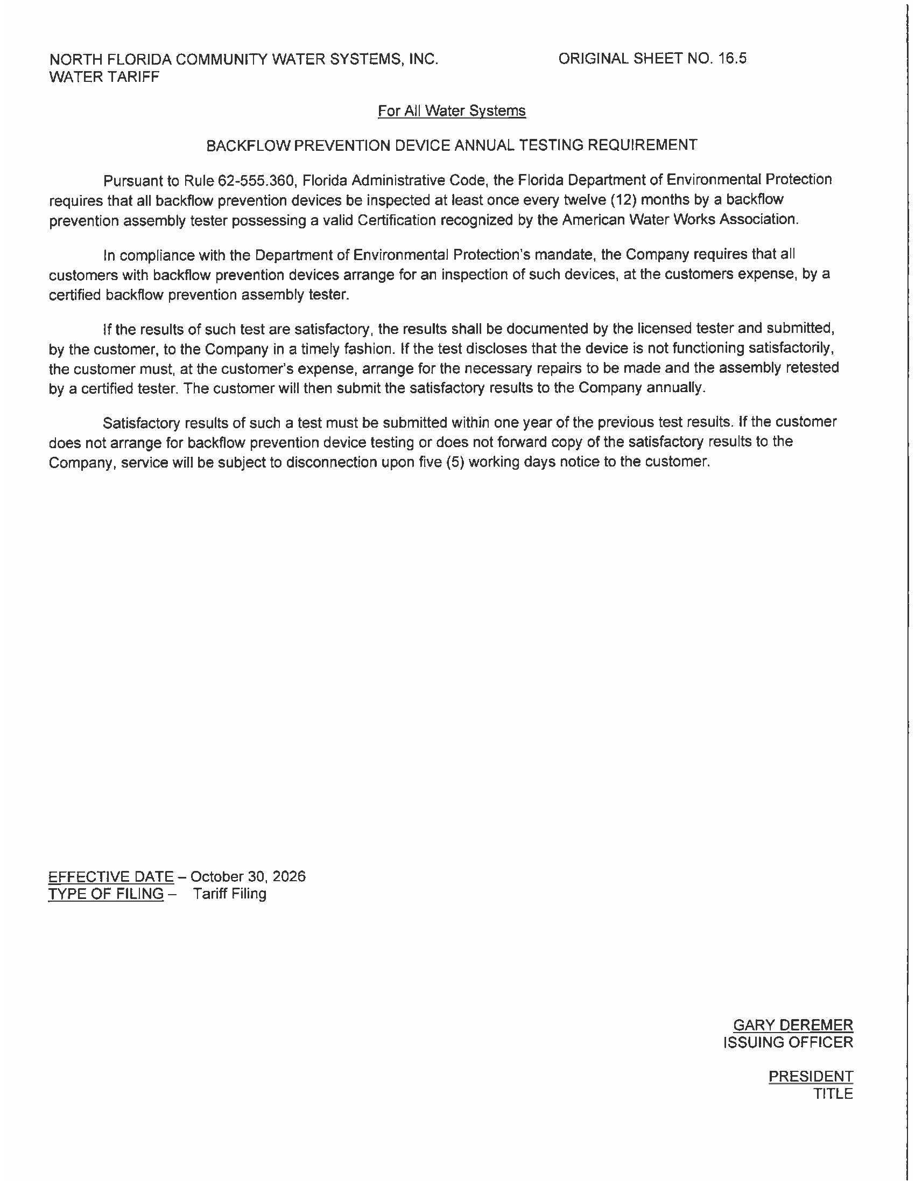
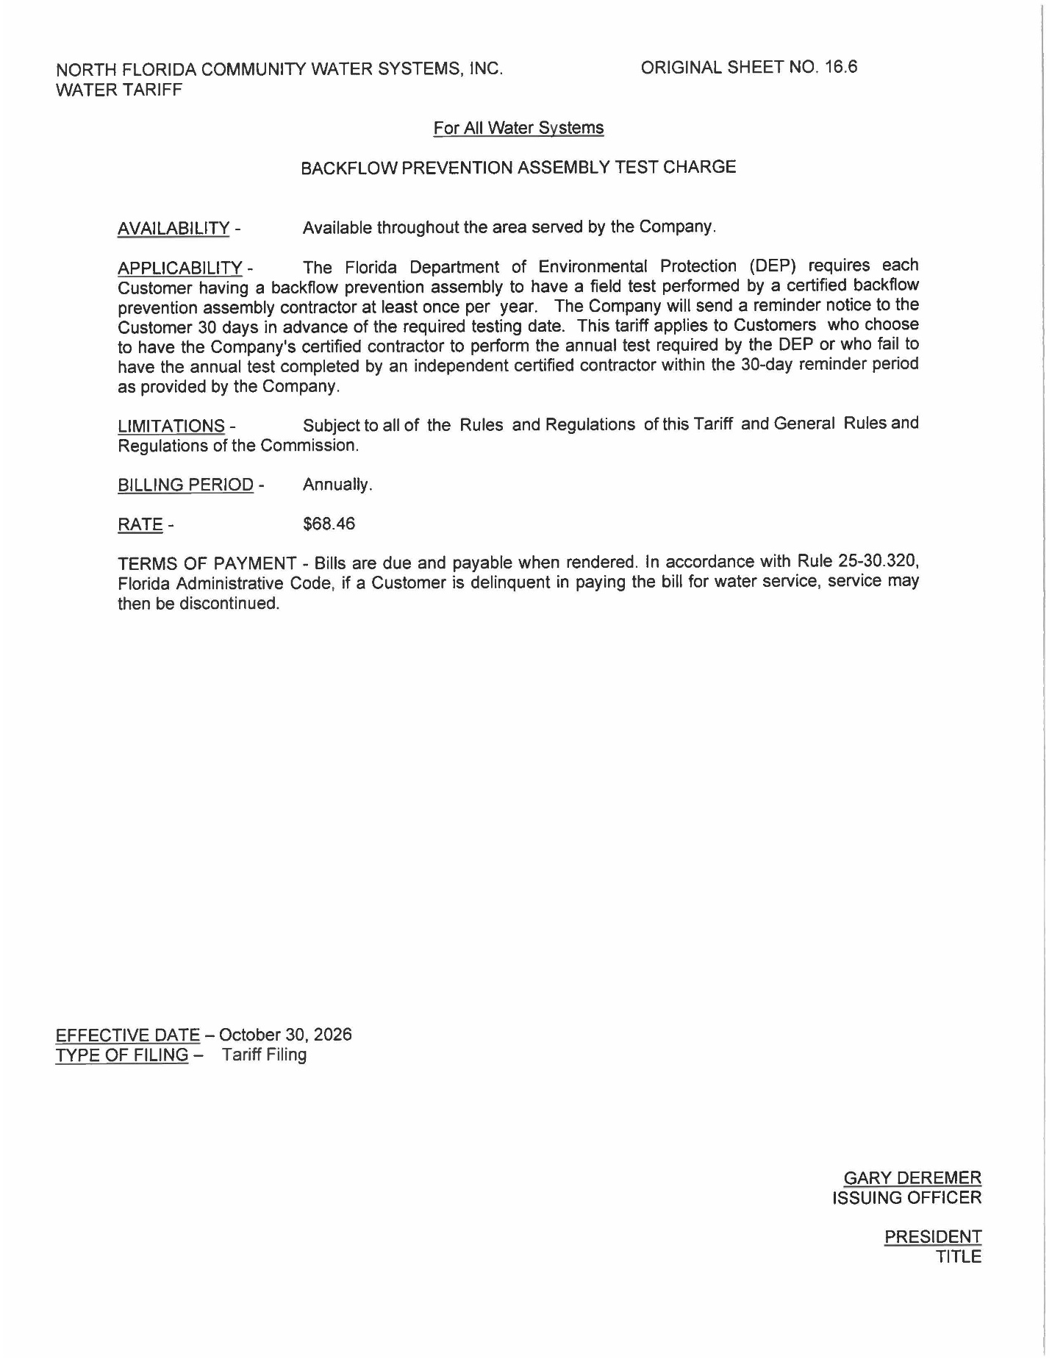
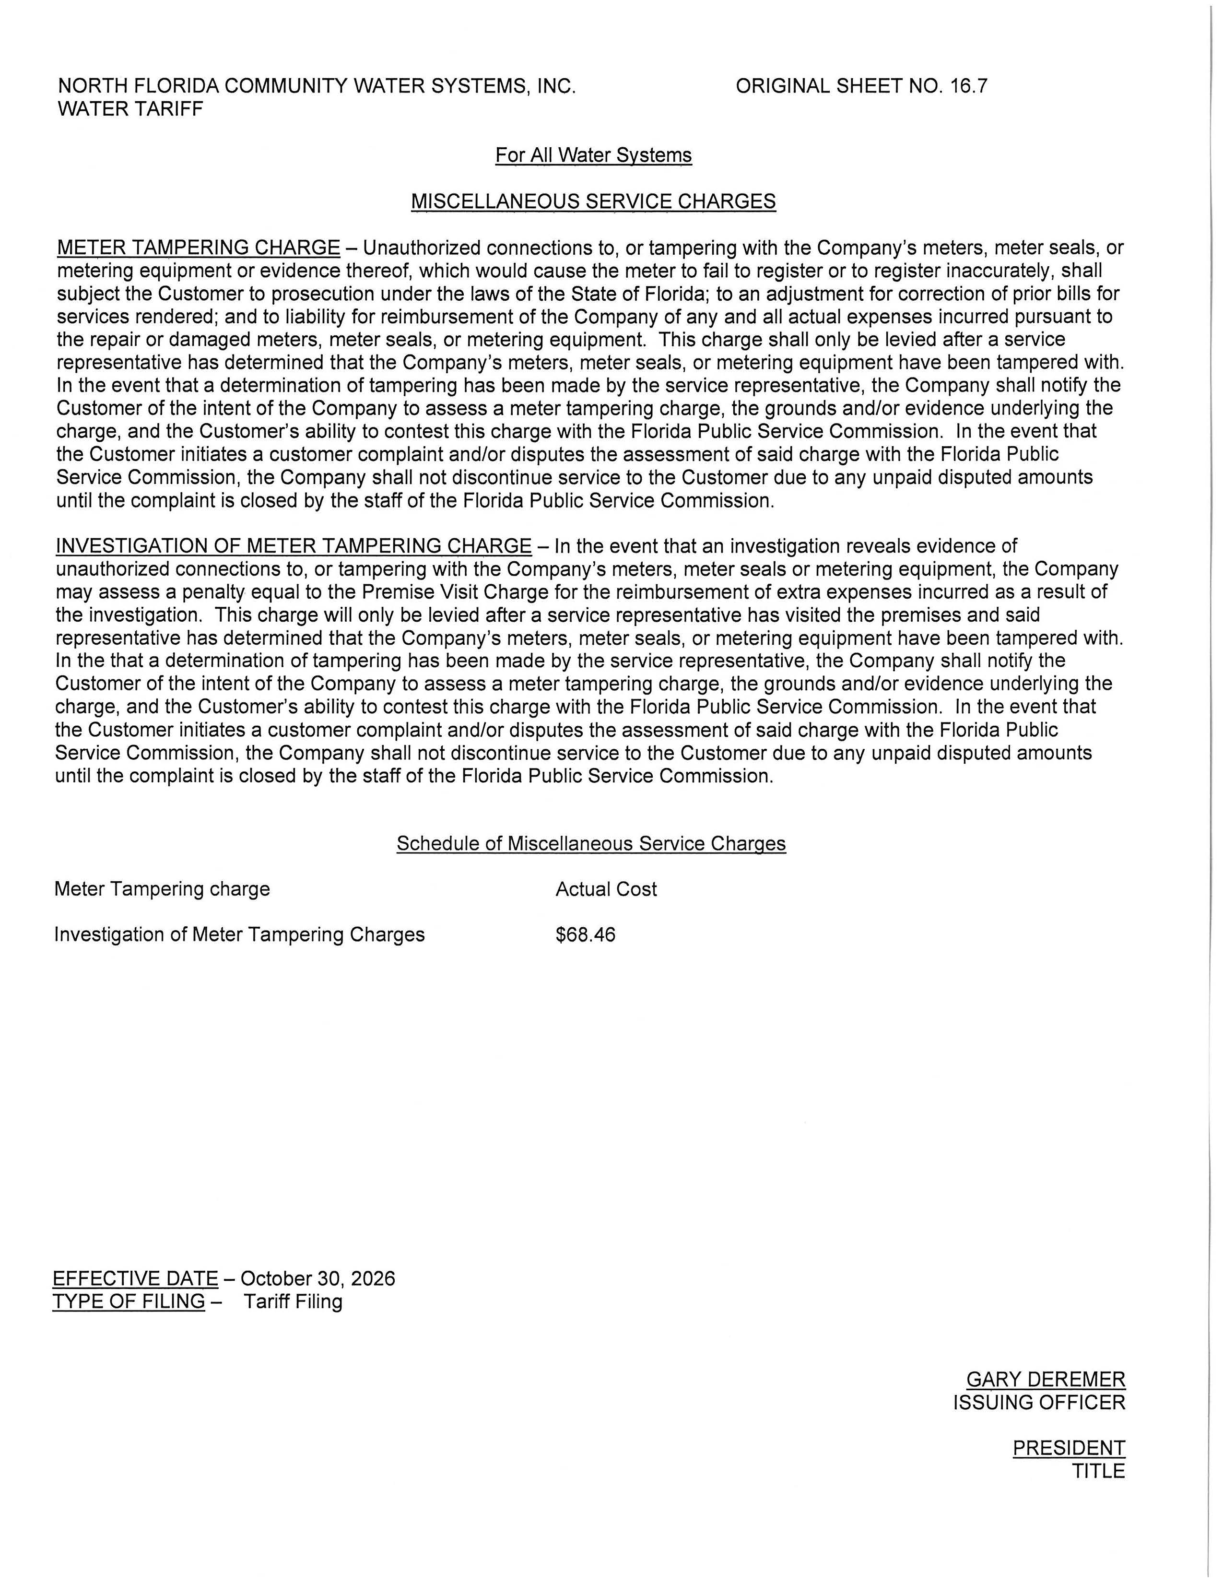

Number of customers as reported in 2025 Annual Report ending December 31, 2025.
Document No. 06726-2026

