BEFORE THE FLORIDA PUBLIC SERVICE COMMISSION

In re: Request for tariff filing revisions for backflow preventor devices testing requirements, by Florida Community Water Systems. | DOCKET NO. 20260132-WU  ORDER NO. PSC-2026-0388-TRF-WU  ISSUED: October 27, 2026

The following Commissioners participated in the disposition of this matter:

GABRIELLA PASSIDOMO SMITH, Chairman
GARY F. CLARK
MIKE LA ROSA
BOBBY PAYNE
ANA ORTEGA

ORDER APPROVING REVISIONS TO BACKFLOW PREVENTION DEVICE
ANNUAL TESTING REQUIREMENT TARIFF SHEET
BY FLORIDA COMMUNITY WATER SERVICES

BY THE COMMISSION:

Background
Florida Community Water Services (FCWS or Utility) is a Class A water and wastewater utility providing service in Brevard, Lake, and Sumter Counties. According to the Utility’s 2025 annual report, the Utility provides water service to 2,093 residential and 50 general service customers. FCWS’ rates were last amended in a price index in 2026.

The Utility’s existing backflow prevention charge was approved for its Black Bear water system located in Lake County. On May 7, 2026, FCWS filed a request to have its miscellaneous service charges be consolidated because the same operations were conducting the services and to be consistent with the consolidated rates of the Utility. The consolidated miscellaneous service charge request was approved administratively, effective June 23, 2026. On August 31, 2026, FCWS filed an application for approval of a new tariff page to include a provision that service is subject to disconnection if the customer does not comply with backflow prevention device annual testing requirements.

This order addresses the Utility’s request for a proposed tariff reflecting compliance language with Department of Environmental Protection (DEP) rules. Proposed tariff sheet No. 13.15 is included as Attachment A to the recommendation. We have jurisdiction over this matter pursuant to Sections 367.081 and 367.091, Florida Statutes (F.S.).

Decision

The Utility is proposing to implement Original Sheet 13.15 to include a provision that service is subject to disconnect if the customer does not comply with backflow prevention device annual testing requirements. The Utility states that the purpose of the tariff is to comply pursuant to DEP Rules 62-555.330 and 62-555.360, Florida Administrative Code (F.A.C.), which includes the required language regarding backflow prevention device testing.

The Utility’s Cross-Connection Control Program mandates that a backflow prevention device be installed on all connections, which may represent a source of contamination due to a lawn irrigation system. The customers are responsible for piping and appurtenances beyond the Utility’s water meter toward the dwelling. Rule 25-30.231, F.A.C., requires each Utility to operate and maintain safe and proper condition of all the facilities and equipment used in connection with the distribution, regulation, measurement and delivery of water service to the customer up to and the point of delivery into the piping owned by the customer. In addition, Rule 25-30.210(7), F.A.C., states that the point of delivery for a water system is the outlet connection with the customer’s piping. Due to the location of the backflow devices, which is past the meter, the cost of inspection will be borne by the customer. The Utility sends out a notice on an annual basis advising of the biennial testing requirement per DEP’s rule. Customers will have 30 days from the date of the notice to complete the testing and provide documentation to the Utility.

Per the Utility’s request, if a customer fails to have the annual inspection performed and provide documentation of the test to the Utility within 30 days of the notice, water service will be disconnected. Rule 25-30.320(2)(a), F.A.C., states that service may be discontinued for noncompliance with any state regulation governing such utility service.

We find that FCWS’ proposed tariff sheet shown on Attachment A shall be approved. The approved tariff shall be effective for service rendered on or after the stamped approval date on the tariff pursuant to Rule 25-30.475, F.A.C. In addition, the approved tariff shall not be implemented until Commission staff has approved the proposed customer notice and the notice has been received by the customers. The Utility shall provide proof of the date notice was given within 10 days of the date of the notice.

Based on the foregoing, it is

ORDERED by the Florida Public Service Commission that Florida Community Water Services’ proposed tariff sheet, shown on Attachment A, shall be approved. The approved tariff shall be effective for service rendered on or after the stamped approval date on the tariff pursuant to Rule 25-30.475, F.A.C. In addition, the approved tariff shall not be implemented until Commission staff has approved the proposed customer notice, and the notice has been received by the customers. The Utility shall provide proof of the date notice was given within 10 days of the date of the notice. It is further

ORDERED that if a timely protest is filed, the tariff shall not be implemented while the protest is pending. If no protest is filed by a person whose substantial interests are affected within 21 days of the issuance of the Order, this docket shall be closed upon the issuance of a Consummating Order.

By ORDER of the Florida Public Service Commission this 27th day of October, 2026.

/s/ Adam J. Teitzman
ADAM TEITZMAN
Commission Clerk
Florida Public Service Commission
2540 Shumard Oak Boulevard
Tallahassee, Florida 32399
(850) 413-6770
www.floridapsc.com

Copies furnished: A copy of this document is provided to the parties of record at the time of issuance and, if applicable, interested persons.

BR

NOTICE OF FURTHER PROCEEDINGS

The Florida Public Service Commission is required by Section 120.569(1), Florida Statutes, to notify parties of any administrative hearing or judicial review of Commission orders that is available under Sections 120.57 or 120.68, Florida Statutes, as well as the procedures and time limits that apply. This notice should not be construed to mean all requests for an administrative hearing or judicial review will be granted or result in the relief sought.

Mediation may be available on a case-by-case basis. If mediation is conducted, it does not affect a substantially interested person's right to a hearing.

The Commission's decision on this tariff is interim in nature and will become final, unless a person whose substantial interests are affected by the proposed action files a petition for a formal proceeding, in the form provided by Rule 28-106.201, Florida Administrative Code. This petition must be received by the Office of Commission Clerk, 2540 Shumard Oak Boulevard, Tallahassee, Florida 32399-0850, by the close of business on November 17, 2026.

In the absence of such a petition, this Order shall become final and effective upon the issuance of a Consummating Order.

Any objection or protest filed in this docket before the issuance date of this order is considered abandoned unless it satisfies the foregoing conditions and is renewed within the specified protest period.

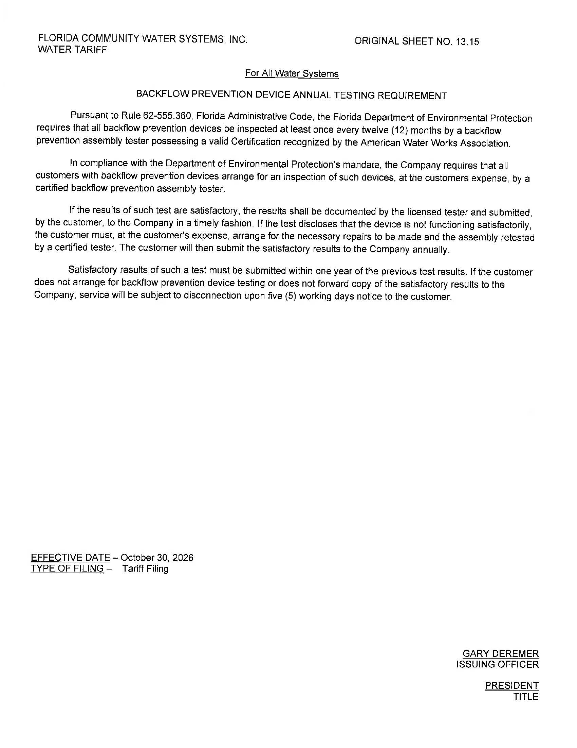

Number of customers as reported in 2025 Annual Report ending December 31, 2025.
Order No. PSC-2011-0478-PAA-WU, issued October 24, 2011, in Docket No. 20100085-WU, In re: Application for certificate to operate water utility in Lake County by Black Bear Reserve Corporation.
WS File Number – WS-2026-0067

