BEFORE THE FLORIDA PUBLIC SERVICE COMMISSION

In re: Application for staff-assisted rate case in Highlands County, by Sun Communities Acquisitions, LLC d/b/a Buttonwood Bay Utilities. | DOCKET NO. 20250122-WS  ORDER NO. PSC-2026-0390-PAA-WS  ISSUED: October 29, 2026

The following Commissioners participated in the disposition of this matter:

GABRIELLA PASSIDOMO SMITH, Chairman
GARY F. CLARK
MIKE LA ROSA
BOBBY PAYNE
ANA ORTEGA

NOTICE OF PROPOSED AGENCY ACTION ORDER
APPROVING RATE INCREASE FOR SUN COMMUNITIES ACQUISITIONS, LLC D/B/A BUTTONWOOD BAY UTILITIES

BY THE COMMISSION:

NOTICE is hereby given by the Florida Public Service Commission (Commission) that the action discussed herein is preliminary in nature-except with regard to (1) the reduction of rates after four years based upon the recovery of rate case expense, (2) the granting of temporary rates in the event of protest, and (3) the requirement for proof of adjustment of books and records - and will become final unless a person whose interests are substantially affected files a petition for a formal proceeding, pursuant to Rule 25-22.029, Florida Administrative Code (F.A.C.). The reduction of rates after four years, the granting of temporary rates in the event of protest, and the requirement for proof of adjustment of books and records are procedural agency actions and subject to reconsideration and appeal as described in the “Notice of Further Proceedings or Judicial Review.”

Background
Sun Communities Acquisitions, LLC d/b/a Buttonwood Bay Utilities (Buttonwood Bay or Utility) is a Class C utility providing service to approximately 955 water customers and 939 wastewater customers in Highlands County. The Utility is a wholly-owned subsidiary of Asset Investors Operating Partnership, LP. On March 22, 2000, the Utility transferred its control and certificates to Buttonwood Bay Utilities, Inc. In Order No. PSC-03-0759-PAA-WS, issued June 23, 2003, the Commission established the Utility’s rate base as of January 1, 2002. The Utility changed the name on its certificate to its current name, Sun Communities Acquisitions, LLC d/b/a Buttonwood Bay Utilities, in that same docket.

On October 16, 2023, the Utility filed an application for a staff-assisted rate case (SARC) which was assigned Docket No. 20230117-WS. This application was withdrawn on June 5, 2024.

On October 3, 2025, the Utility filed the current application for a SARC. Staff selected the test year ended December 31, 2024. According to the Utility’s 2025 Annual Report, total gross revenues were $162,277 for water and $140,275 for wastewater and its operating expenses were $275,100 for water and $228,550 for wastewater.

We have jurisdiction pursuant to Sections 367.011, 367.081, 367.0812, 367.0814, 367.091, and 367.121, Florida Statutes (F.S.).

Review and Decision

- Quality of Service

Pursuant to Section 367.081(2)(a)(l), F.S., and Rule 25-30.433(1), F.A.C., in water and wastewater rate cases, we shall determine the overall quality of service provided by the Utility. This determination is made from an evaluation of the quality of the Utility’s product (water) and the Utility’s attempt to address customer satisfaction (water and wastewater). The rule further states that the most recent chemical analyses for the water system, outstanding citations, violations, and consent orders on file with the DEP and the county health department, and any DEP and county health department officials’ testimony concerning quality of service shall be considered. In addition, any customer testimony, comments, or complaints we received are also reviewed. The operating conditions of the water and wastewater systems is addressed in Section II.

- Quality of the Utility’s Product

In evaluating Buttonwood Bay’s water product quality, Commission staff reviewed the Utility’s compliance with the DEP’s primary and secondary drinking water standards. Primary standards protect public health while secondary standards regulate contaminants that may impact the taste, odor, and color of drinking water. Commission staff reviewed the DEP’s triennial Safe Drinking Water chemical analyses of samples taken on March 27, 2024, and the Utility was determined to be in-compliance with DEP standards except for the secondary standard of color, which exhibited a color level of 31 color units (CU). The Maximum Contaminant Level (MCL) for color is 15 CU. As a result, the DEP ordered the Utility to conduct additional quarterly testing and also initiated an investigation to determine the possible source(s) of discoloration. The investigation identified several potential sources, including the filters and a galvanized steel/cast iron pipe used for chlorine injection. The Utility recently replaced the filters in January 2024 but had been operating them for four years past their replacement schedule. Its next quarterly test, conducted on May 23, 2024, had a CU of 16, still exceeding the MCL, but improved from the prior test results. Subsequently, the Utility indicated that it adjusted operations and switched the filter types in an attempt to address the issue. The next testing on August 18, 2024, resulted in a CU sample of 5, which is below DEP’s MCL. The subsequent tests in November 2024 and January 2025 also resulted in CU samples of 5.

Commission staff also reviewed the DEP’s last Sanitary Survey Report dated December 30, 2024, in which there were no chemical or bacteriological exceedances noted for the previous 12 months, except the previously noted secondary standard for color. In the Utility's last Consumer Confidence Report dated June 24, 2024, no violations of contaminant levels were noted for the testing period.

- The Utility’s Attempt to Address Customer Satisfaction

Commission staff reviewed the complaints filed in the Commission’s Consumer Activity Tracking System (CATS), received by the Utility, and filed with the DEP for the test year and four years prior. There were no complaints filed in CATS or with the Utility during this period. The DEP recorded six complaints during this analyzed time period, all of which pertained to water color and/or odor, with one in 2020 and five in 2024. The first complaint, dated September 9, 2020, reported black, rusty water. The DEP investigated the complaint but found no violation. The DEP reported receiving four complaints regarding color and odor in February, March, and June 2024, which coincides with the CU MCLs discussed above. An additional complaint was filed on September 11, 2024, regarding color and odor, following the compliant CU results discussed above. The DEP issued Compliance Assistance Letters, one dated May 20, 2024, for color, and another on September 18, 2024, for odor. In its response, the Utility states it resolved these issues with the filter media replacement for both the color and odor concerns. There appears to be no further DEP action regarding these complaints.

A Customer Meeting was held on July 16, 2026, where eleven customers provided comments. The comments included the frequency of boil water notices (BWNs), water line breaks, and service interruptions, missing or inadequate communication from the Utility regarding these events, the state of the water infrastructure, and concerns regarding the impact of the proposed rate increase. Customers also voiced concerns regarding the amount of unaccounted for water calculated in the Staff Report. In addition, as of September 1, 2026, 262 written comments were filed in the docket. For reference, the Utility serves approximately 955 water customers and 939 wastewater customers.

Table 1 shows a total of 668 comments (provided verbally at the customer meeting and written via the docket file) over six main categories. A single customer comment was counted in multiple categories if it addressed multiple issues. The majority of the comments expressed concern with the overall rate increase and quality of service. The quality of service comments identified issues with water discoloration, foul odor, and unpleasant taste. However, there were a number of comments expressing concerns regarding the frequency of outages and lack of communications to the customers from the Utility. The Other category captured all other concerns, such as low or no water pressure, required irrigation and pressure washing by the associated development, unmetered water use, and damaged property such as fixtures or appliances.
Table 1
Number of Comments Received, Organized by Category and Source
Comment Category | Verbal Comments | Written Comments | Total*
Quality of Service | 8 | 206 | 214
Outages and/or BWNs | 4 | 62 | 66
Improper Billing | 7 | 21 | 28
Meter Concerns | 4 | 6 | 10
Rate Increase Concerns | 11 | 221 | 232
Other | 8 | 110 | 118
Total | 42 | 626 | 668
*A single customer comment could be counted multiple times if it is associated with multiple categories.
As discussed above, the quality of service category in Table 1 is primarily associated with water product quality, due to a combination of color, odor, or taste concerns. The Utility attempted to address the concerns regarding color and odor by adjusting its operations and changing the type of filters used. The Utility also proposed a pro forma project as part of the instant docket to again replace the filters (discussed further in Section IV), but the project was delayed until 2027 and therefore not recommended by staff for cost recovery as part of this rate case. Regarding the wastewater system, customers also complained about odor associated with lift stations and the central sewer plant. As discussed in Section IV, the Utility requested several pro forma projects associated with its wastewater facilities, some of which concern odor.

Commission staff further investigated the Utility’s service interruptions due to the customers’ concerns identified above. Pursuant to Rule 25-30.251, F.A.C., the Utility is required to maintain a record of all interruptions in service which affect 10 percent or more of its customers and to notify us of the interruptions. The rule further states the Utility must provide the cause of the interruption, the date, time, duration, remedy, and steps taken to prevent reoccurrence. In response to Commission staff’s eighth data request, the Utility provided service interruption data for the period 2020 through 2025. According to the Utility’s data, complete system outages impacting all the customers happened once in 2021 and 2022, five times in 2023, twice in 2024, and once in 2025. Events classified as community-wide or system-wide, including planned system shutdowns and power or electrical failures at water treatment plants, would exceed the Rule’s designated threshold. Localized line breaks affecting a single street or a restricted number of lots and residences do not meet the Rule’s criteria and would not need to be reported. Overall, there were at least 15 instances between 2020 and 2025 that the Utility should have informed us of, but did not do so. Subsequent to Commission staff’s data request, the Utility stated it has now established a protocol to comply with Rule 25-30.251(2), F.A.C.

Commission Staff also investigated the reported customer concerns regarding the Utility’s communication with its customers. Customer comments suggested that customers were directed to the associated community’s main office, rather than the Utility directly. The Utility indicated that it handles after-hours emergencies through a 24-hour on-call service operated by its contractor, U.S. Water. Standard business-hour inquiries are logged by the main office and systematically routed through the Utility’s management and operational chain of command including the Office Administrator, Water System Manager, Water Treatment Plant Operator, and Maintenance Staff. As noted above, the Utility stated it had received no complaints during the test year or four prior years. However, customers reported difficulties reaching the Utility to relay concerns, indicating a potential communication breakdown. Rule 25-30.130, F.A.C., requires the Utility to maintain records of all complaints for a minimum of five years. Pursuant to Rule 25-30.355, F.A.C., a complaint is defined as an objection made to a Utility by a customer. We find that the Utility record information required by Rule 25-30.130 F.A.C., for all customer complaints regardless of whether the complaints were received from the end-use customer directly or indirectly through the associated community or system operators.

As shown in Table 1, meter accuracy concerns were also raised by some customers. Rule 25-30.265, F.A.C., outlines the intervals that utilities must inspect and test their customer meters, with a maximum interval of 8 to 10 years between tests for commonly used residential meter sizes. In response to Commission staff’s data request asking for information regarding customer meter testing, the Utility responded only with meter testing information regarding its own Utility flow meters that are associated with the wells and effluent and used only for reporting to DEP and the water management district, not any customer meters used for billing referenced by the Rules in the data request. The Utility also stated it received no requests for customer meter testing during the period 2020 through 2025. The Utility shall begin conducting regular customer meter testing at the required intervals stated in Rule 25-30.265, F.A.C., and maintain records as required by Rule 25-30.267, F.A.C.

- Managerial Concerns

In response to a Commission staff data request addressing the customer comments made at the customer meeting and the 257 comments filed in the docket as of the July 16, 2026, the Utility stated that no customers appeared to offer comments at the customer meeting and the Utility was unaware of any customer comments filed in the docket, and therefore no action was required on behalf of the Utility. The Utility did note that it engaged in capital investments regarding its filters in 2024 to resolve DEP complaints, and stated it was committed to address customer concerns promptly. However, we note that the Utility did include expenses associated with both attending the customer meeting, along with follow-up discussions, and reviewing customer complaints in its requested rate case expenses. While representatives may have indeed attended the virtual customer meeting, the Utility’s inaccurate recordkeeping of no customers comments at the meeting indicates there is room for improvement as there were customer comments, as discussed above, from both the customer meeting and docket file.

Overall, our review of the Utility’s attempt to address customer satisfaction demonstrates that while the Utility did respond to formal DEP complaints regarding color and odor, there were DEP deficiencies related to poor recordkeeping and reporting by Utility management. For example, on December 30, 2024, the Utility received a Compliance Assistance Letter from the DEP based on its December 12, 2024 sanitary survey, which among other factors included deficiencies for failure to provide records for its flow meter calibration, to update the Utility’s Lead and Copper sampling plan, and to maintain an emergency plan on site. While these and other noted deficiencies were resolved by January 22, 2025, and the water treatment plant returned to compliance, it is indicative of the type of recordkeeping discrepancies seen above regarding service interruptions, complaints, and meter testing records. Additionally, in Section III, we address the Utility’s recordkeeping as it relates to Excessive Unaccounted for Water (EUW), as it appears the Utility is not keeping full record of water used for other purposes. Such actions can negatively impact the customer service provided by Buttonwood Bay. Therefore, we find that Buttonwood Bay’s quality of service to be unsatisfactory, and the return on equity shall be reduced by 50 basis points as a penalty until the Utility demonstrates its quality of service has improved in a future proceeding.

In addition, the Utility should be required to submit, within 30 days of this Order becoming final, a plan describing how it will accomplish the following to remedy some of the recordkeeping and communication issues addressed above:

- Regarding service interruptions, the Utility must report service interruptions of more than ten percent of connections, both for the initial filing that an interruption has occurred and the supplemental filing with complete details after service has been restored, pursuant to Rule 25-30.251, F.A.C. As required by the Rule, the Utility must also record the required supplemental details for each, including the cause, remedy, and steps taken to prevent recurrence of service interruptions.

- Regarding customer communications, the Utility must document and maintain records of all customer complaints whether received directly from the customer or indirectly through any other source, including the associated community, pursuant to Rule 25-30.130, F.A.C. In addition, when the Utility provides acknowledgement and responses to a complaint pursuant to Rule 25-30.355, F.A.C., it should do so to the original customer who provided the complaint, even if it was indirectly provided to the Utility by any other source.

- Regarding meter testing, the Utility must begin conducting regular meter testing at the required intervals pursuant to Rule 25-30.265, F.A.C. Additionally, the Utility must perform meter tests upon customer request and keep and maintain records of all tests performed. As part of this requirement, the Utility shall submit information within 30 days of our final order in this docket regarding the meter testing program, including the representative sample size and timing for each class of meter.

- Regarding recordkeeping of the Utility’s water uses, the Utility is responsible for maintaining its records with respect to water uses and also accurately reporting this information in its Annual Report pursuant to Rule 25-30.110, F.A.C. As discussed in Issue 3, the Utility was unable to accurately present the amounts of water used for flushing to be considered in the EUW calculation, when prompted by staff. Therefore, as part of this requirement, the Utility shall explain how it intends to improve its recordkeeping practices with respect to measuring water for flushing to ensure that such uses are accurately documented and reported in its annual reports and other filings.

- Conclusion

While Buttonwood Bay’s water product is in compliance with the rules and regulations of the DEP, we find that the Utility’s attempts to address customer satisfaction have not been adequate based on the recordkeeping, reporting, and communications of the Utility. We find the quality of service to be unsatisfactory. Accordingly, the return on equity shall be reduced by 50 basis points and the Utility shall file a plan outlining how it will improve its recordkeeping and customer communications within 30 days of this Order becoming final.

- Infrastructure and Operating Conditions

Rule 25-30.225(2), F.A.C., requires each water and wastewater Utility to maintain and operate its plant and facilities by employing qualified operators in accordance with the rules of the DEP. Rule 25-30.433(2), F.A.C., requires consideration of whether the infrastructure and operating conditions of the plant and facilities are in compliance with Rule 25-30.225, F.A.C. In making this determination, we must consider testimony of the DEP and county health department officials, sanitary surveys for water and compliance evaluations for wastewater systems, citations, violations and consent orders issued to the Utility, customer testimony, comments, complaints, and Utility testimony and responses to the aforementioned items.

- Water System Operating Conditions

Buttonwood Bay’s water system has a permitted capacity of 542,000 gallons per day. The system consists of two 8-inch diameter wells, two 15,000-gallon hydropneumatic storage tanks, and one 107,000-gallon above-ground water storage tank. The pumping capacity of both Well No. 1 and No. 2 are 450 gallons per minute (gpm). Groundwater is treated through hypochlorination prior to distribution. The DEP conducted an inspection of Buttonwood Bay’s water treatment plant (WTP) on December 12, 2024. The resulting Sanitary Survey Report indicated seven issues classified as minor, including missing documentation for flow meter calibration and emergency response plans and leaks from one of the pumps and ground storage tank, all of which were corrected by February 24, 2025. Consequently, the WTP is in compliance with the DEP’s rules and regulations.

- Wastewater System Operating Conditions

The Buttonwood Bay wastewater treatment facility operates with an existing permitted capacity of 0.098 million gallons per day. Commission staff reviewed the Utility’s last DEP Compliance Evaluation Inspection report, dated April 18, 2024. The DEP noted fifteen deficiencies, including permitting and documentation concerns, wastewater treatment plant (WWTP) operational issues, and effluent quality concerns. The DEP determined that all non-compliance items identified at the time of the inspection have been corrected and deemed the Utility to be in compliance as of July 24, 2024.

Regarding effluent quality, on October 3, 2024, the DEP attached Administrative Order AO-014348-018-SD to the facility's approved operating permit, citing a lack of compliance with the Lake Okeechobee Basin's Total Nitrogen and Total Phosphorus discharge standards. To resolve these deficiencies, the Utility has partnered with third-party engineering firm Kimley Horn to design and execute the necessary physical upgrades to the facility to meet the Total Nitrogen and Total Phosphorus discharge standards. While foundational steps like effluent sampling and securing a licensed engineer have been completed, critical engineering actions remain in progress. Ultimately, the Utility anticipates a total capital investment of approximately $250,000 to finalize the upgrades and achieve full regulatory compliance by the final March 1, 2027 operational deadline. As discussed in Section IV, the Utility requested pro forma projects associated these upgrades, but we are not approving of these projects at this time as they are outside of the pro forma time period and minimal cost data was provided.

- Conclusion

Buttonwood Bay’s water and wastewater systems are in compliance with DEP regulations, with the exception of the wastewater system’s permit which is currently subject to a DEP Administrative Order until the plant achieves full compliance with the DEP’s standards for effluent quality related to nitrogen and phosphorus by March 1, 2027.

- Used and Useful

As stated in Section II, Buttonwood Bay’s water system is served by two 8-inch diameter wells. The pumping capacity of both Well No. 1 and No. 2 is 450 gpm. The Utility is permitted by the DEP to treat 542,000 gallons per day. The water distribution system is composed of approximately 35,676 feet of 2-inch to 8-inch polyvinyl chloride pipe.

- Excessive Unaccounted for Water

Rule 25-30.4325, F.A.C., provides factors to be considered in determining whether adjustments to operating expenses are necessary for EUW. EUW is defined as “unaccounted for water in excess of 10 percent of the amount produced.” Unaccounted for water is all water that is not sold, metered, or accounted for in the records of the Utility.

EUW is calculated by subtracting both the gallons sold to customers and the gallons used for other services such as line flushing, from the total gallons pumped and purchased for the test year, and dividing by the sum of the gallons pumped and purchased. The amount in excess of 10 percent, if any, is the EUW percentage.

A review of Buttonwood Bay’s 2024 monthly operating reports on file with the DEP shows the Utility produced 74,350,000 gallons of water during the test year. In response to Commission staff’s data requests, the Utility indicated that it purchased no water from other utilities. While the Utility reported no Utility usage in its annual reports, in response to Commission staff’s data requests the Utility identified Utility usage for backwashing of 1,837,000 gallons, and known water loss from line breaks estimated at 36,930 gallons during the test year. However, the Utility reported various amounts of water for flushing, ranging from 57,960 gallons based on metering, 463,014 gallons based on quarterly hydrant and flushing logs, and 4,508,928 gallons based on estimated flushing durations. We included the 463,014 gallon value for flushing because the Utility provided supporting documentation for that amount. An examination of the Utility’s billing records indicated 51,174,962 gallons of treated water were sold to its customers. The calculation (74,350,000 + 0 – 51,174,962 – 1,837,000 – 36,930 – 463,014)/(74,350,000 + 0) results in 28.03 percent unaccounted for water. The Rule allows a 10 percent margin; therefore, there is 18.03 percent EUW.

We find that the Utility’s EUW may be attributable, at least in part, to deficiencies in the Utility’s recordkeeping regarding water flushing. Accordingly, as stated in Section I, the Utility shall file, within 30 days of this Order becoming final, a plan explaining how it intends to improve its recordkeeping practices with respect to flushing, including measures to ensure that such uses are accurately documented and reported in its annual reports and other filings.

- Infiltration and Inflow

Rule 25-30.432, F.A.C., provides that in determining the amount of U&U plant, we will consider infiltration and inflow (I&I). Excessive I&I is a calculation that is based on a comparison of the allowable wastewater treated to the actual amount of wastewater treated. Allowable treated wastewater was calculated as 50,155,719 gallons, and the actual amount of the wastewater treated was 14,253,000 gallons. The actual amount does not exceed the allowable amount, therefore there is no excessive I&I and no adjustment to operating expenses is necessary.
- Used and Useful Percentages

Rules 25-30.432 and 25-30.4325, F.A.C., address the method by which the U&U percentage of water and wastewater systems are determined. We have not previously established the used and useful percentages for the Utility. Rule 25-30.4325(4), F.A.C., states that a water treatment system is considered 100 percent U&U if the service territory the system is designed to serve is built out and there is no apparent potential for expansion of the service territory. Based on Commission staff’s investigation, the Utility’s service area appears to be built out, therefore the WTP, water storage, water distribution system should be considered 100 percent U&U.

Similarly, Rule 25-30.432, F.A.C., for wastewater systems allows us to consider other factors, including the extent to which the area served is built out. As noted above, the Utility’s service area appears to be built out, therefore the WWTP and wastewater collection system should be considered 100 percent U&U.

- Conclusion

Buttonwood Bay’s WTP, water storage, water distribution system, WWTP, and wastewater collection system shall all be considered 100 percent used and useful. An 18.03 percent adjustment shall be made to reduce the operating expenses for chemicals and purchased power for EUW. Consistent with Section I, the Utility shall file a plan, within 30 days of this Order becoming final, outlining how it will improve its recordkeeping as it relates to flushing and EUW.

IV. Average Test Year Rate Base

The appropriate components of the Utility’s rate base include Utility plant in service (UPIS), land and land rights, accumulated depreciation, contributions-in-aid of construction (CIAC), accumulated amortization of CIAC, capital recovery, accumulated amortization of capital recovery, and working capital. Our staff selected the test year ended December 31, 2024, for this rate case. A summary of each component and the recommended adjustments are discussed below.
- Pro Forma Plant Additions

When evaluating a utility’s request for pro forma plant additions, we request the Utility provide, among other things the: (1) need; (2) reasonableness; (3) cost; (4) in-service date(s); and (5) alternatives, as each item relates to each project. Additionally, it is Commission practice for our staff to evaluate whether a minimum of three bids were solicited for each project or the Utility’s reasoning as to why three could not be obtained. During the course of the rate case, the Utility proposed a total of 13 pro forma projects.
Based on a review of the information provided by the Utility for each project, we approve of the five pro forma projects listed in Table 2. Each projected is described in more detail below. The Utility classified all five as emergencies, and therefore, did not seek three bids in each instance.

Table 2
Commission Approved Pro Forma Projects
# | Project Name | In-Service Date | Account  Number | Installed  Cost | Retirement
1 | Diffuser in Stillwell | 10/07/2025 | 380 | $1,983 | $1,487
2 | New Triplex Skimmer | 09/29/2025 | 380 | 11,643 | 8,732
3 | New Surface Aerator Motor | 09/26/2025 | 380 | 9,371 | 7,028
4 | New Surge Tank Air Line and Diffuser | 01/30/2026 | 380 | 18,606 | 13,955
5 | Surge Tank Electrical Control Panel | 12/24/2025 | 380 | 6,280 | 4,710
 | Total |  |  | $47,883 | $35,912
Source: Utility’s responses to Commission staff’s data requests.

Project 1: Install Diffuser in Stillwell

Project 1 is the replacement of a diffuser in the bottom of the stillwell in the wastewater plant. The new diffuser was installed on the waterline to accelerate waste breakdown and control odor. In response to staff’s data requests, the Utility labeled this project an emergency because its failure would impede operation of the WWTP. However, even with this classification, two bids were provided, one dated July 2024 and the other undated. Of the two bids provided, the Utility selected the lowest bid. We agree that without the diffuser, the Utility’s ability to control odor and operate the WWTP efficiently would be impacted, and emergency replacement was prudent. An invoice dated October 31, 2025, was provided for $1,983 for work completed on October 7, 2025. Based on this review, we approve the pro forma project.

Project 2: Install New Triplex Skimmer

Project 2 is the replacement of a skimmer to assist with removing debris from the WWTP that will not settle. The Utility reported it was necessary as the existing equipment was approaching failure due to mechanical wear and corrosion. In response to Commission staff’s data requests, the Utility labeled this project an emergency because its failure would impede operation of the WWTP. However, even with this classification, two bids were provided, one dated July 2024 and the other undated. Of the two bids provided, the Utility selected the lowest bid. We agree that without a skimmer, the WWTP would experience a buildup of floating material that would impact its efficiency, and emergency replacement was prudent. An invoice was provided for $11,643 for work completed on September 29, 2025. Based on this review, we approve the pro forma project.

Project 3: Install New Surface Aerator Motor

Project 3 is the replacement of the surface aerator motor. The Utility reported it was necessary as the existing surface aerator motor failed. In response to staff’s data requests, the Utility labeled this project an emergency, as the component is necessary for proper operation of the WWTP, and provided a single estimate, dated July 29, 2025. We agree that without surface aeration, the WWTP would not function properly, and emergency replacement was prudent. An invoice was provided for $9,371 for work completed on September 26, 2025. Based on this review, we approve the pro forma project.

Project 4: Install New Surge Tank Air Line and Diffuser

Project 4 is the replacement of a surge tank air line and diffuser. The Utility reported it was necessary as the existing diffuser was not operating properly and experiencing fouling and clogging. In response to Commission staff’s data requests, the Utility labeled this project an emergency, as it is necessary for proper operation of the WWTP. We agree that without aeration from the air line, the WWTP would not function properly, and emergency replacement was prudent. An invoice was provided for $18,606 for work completed on January 30, 2026. Based on this review, we approve the pro forma project.

Project 5: Install New Surge Tank Electrical Control Panel

Project 5 is replacing the electrical control panel for the surge tank. The replacement was driven by environmental degradation, mechanical failure, and regulatory obsolescence. In response to Commission staff’s data requests, the Utility labeled this project an emergency, as it was necessary to operate the associated equipment. We agree that without a control panel, the associated equipment would not function as needed for proper operation of the WWTP, and emergency replacement was prudent. An invoice for $6,280 was provided for work completed on December 24, 2025. Based on this review, we approve the pro forma project.

- Excluded Pro Forma Projects

Of the 13 pro forma projects proposed by the Utility, we are rejecting the remaining eight projects due to withdrawal, untimeliness, or lack of supporting cost data. The Utility voluntarily withdrew one project, WTP electrical upgrades estimated at $80,000, as it was no longer necessary. We did not consider three additional projects as they were outside of the 24 month period following the end of the test year, no longer period was requested under 367.081(2)(a)2., F.S., and minimal cost data was provided. These projects were: (1) a new generator for the WTP estimated at $180,000 to $300,000; (2) new filter media for the WTP estimated at $80,000 to $90,000; and, (3) environmental upgrades for the WWTP estimated at $250,000. The remaining four projects are discussed in more detail below. While we recognize there may be a need for the following four projects, the Utility failed to provide the appropriate supporting information when provided the opportunity and, therefore, we do not believe it is appropriate to include them in rate base at this time.

- High Service Pump (WTP)

In the Utility’s response to Commission staff’s first data request, filed on January 9, 2026, the Utility requested cost recovery estimated at $12,000 for replacing the existing high service pump at the WTP because the current high service pump is failing. In a subsequent response, dated July 17, 2026, the Utility provided a revised estimate of $13,000, a statement they were still gathering bids, and an estimated in-service date of October 1, 2026. While we agree that there is a need to timely replace failing equipment, the Utility did not provide adequate information regarding the project to demonstrate it could meet the given in-service date, nor any documentation supporting the costs to be included in rate base. Therefore, we are not approving this project at this time.

- New Control Room (WTP)

Requested as part of the Utility’s application filed October 3, 2025, this project involves replacing the old control room containing the high service pumps which the Utility indicated was necessary due to leaks, wood rot, and collapsing floors, with an estimated cost of $62,319. In a subsequent data request response dated July 17, 2026, the Utility provided a revised estimated cost of $61,407, and stated they sought bids from four vendors but only received one bid, which was ultimately selected, with an estimated in-service date of November 20, 2025. While we agree that there is a need for the project based upon the described conditions of the original facility, the Utility did not provide any supporting documentation for the costs to be included in rate base, such as an invoice. Therefore, we do not approve this project at this time.

- Install New Blower (WWTP)

Requested as part of the Utility’s application filed October 3, 2025, this project involves replacement of the blower at the wastewater treatment plant due to the failure of the original blower, and was estimated to cost $9,251. The Utility provided multiple in-service dates for the project, including both August 29, 2025, and October 9, 2025. The Utility classified it as an emergency, and states it only sought a single bidder, and provided an estimate to our staff, dated August 8, 2025. While we agree that there is a need to timely replace failing equipment, the Utility did not provide adequate information regarding the project to demonstrate the in-service date, nor any documentation supporting the costs to be included in rate base, such as an invoice. Therefore, we do not approve this project at this time.
- Install RAS WAS Splitter Box (WWTP)

Requested as part of the Utility’s application filed October 3, 2025, this project involves replacement of the splitter box at the wastewater treatment plant due to the failure of the existing splitter box, estimated at $10,070. The Utility provided multiple in-service dates for the project, including both October 9, 2025, and November 10, 2025. While the Utility classified it as an emergency, it stated that it sought two bids and selected the lowest one, and provided only one bid to staff, dated July 23, 2025. While we agree that there is a need to timely replace failing equipment, the Utility did not provide adequate information regarding the project to demonstrate the in-service date, nor any documentation supporting the costs to be included in rate base, such as an invoice. Therefore, we do not approve this project at this time.
- Utility Plant in Service

The Utility recorded UPIS of $2,264,116 for water and $1,804,226 for wastewater. The Utility could not provide a ledger or invoices from December 31, 2002, to December 31, 2016. Commission staff determined Buttonwood Bay’s UPIS by using the Utility’s last Commission order and by reviewing available invoices and annual reports. Several discrepancies were noted, thus audit staff decreased UPIS for water by $290,048 and wastewater by $90,331 to adjust for improper classification of additions.

The Utility only made six retirements from December 31, 2003, to December 31, 2024. We decreased UPIS by $107,071 for water and $86,126 for wastewater to reflect the appropriate retirement of assets. In addition, we increased UPIS for water by $7,119 and wastewater by $199 to reflect averaging adjustments. Lastly, we increased wastewater UPIS by $47,883 to reflect pro forma additions, but further decreased this amount by $35,912 to reflect pro forma retirements.

Our adjustments to UPIS result in a net decrease of $390,000 for water and a net decrease of $164,288 for wastewater. Therefore, we find a water UPIS balance of $1,874,116 and a wastewater UPIS balance of $1,639,938.

- Capped Retirement

In general, it is our practice to use the 75 percent of plant addition methodology to estimate the retirement amount of assets being replaced when the original cost is unknown. In this case, the Utility did not record retirements for certain accounts in prior years. As a result, application of the 75 percent retirement methodology would result in an overall negative plant balance. Therefore, we have capped the retirement amount at the plant balance for one account in the relevant years. This methodology was utilized in Docket No. 20160101-WS and was approved by Order No. PSC-2017-0361-FOF-WS. In that order, we found that: “the amount of retirement to plant in service and accumulated depreciation reflected in the adjusted test year shall be calculated based on either the 75 percent methodology . . . or on the actual balance in the impacted plant in service account . . . if that balance would be negative as a result of the 75 percent methodology.”

Due to the capped retirement, we identified Account 311 – Pumping Equipment, as having a total of $2,756 of remaining undepreciated plant balance. We find that this remaining balance should be recovered as amortization expense over a seven-year period. Although Rule 25-30.433(10), F.A.C., outlines the formula for determining the appropriate amortization period for forced abandonment or the prudent retirement of plant assets prior to the end of their depreciable life, an alternate amortization period is permitted under the rule. Thus, we find an amortization period of seven years is appropriate. This seven-year period results in an annual amortization expense of $394. Therefore, we approve capital recovery of $2,756 over a seven-year amortization period. The associated annual amortization expense is $394.

- Land and Land Rights

The Utility recorded a test year land and land rights balances of $4,600 for water and $31,000 for wastewater. We made no adjustments to this amount and, therefore, approve land and land rights balances of $4,600 for water and $31,000 for wastewater.

- Used and Useful

As discussed in Section III, the Utility’s systems are considered 100 percent U&U. Therefore, no U&U adjustment is necessary.
- Accumulated Depreciation

The Utility recorded $1,439,238 of accumulated depreciation for water and $1,481,086 for wastewater. We decreased these amounts by $169,628 for water and $191,127 for wastewater to reflect corrections to UPIS and the application of the correct depreciation rates per Rule 25-30.140, F.A.C. We further decreased these amounts by $190,363 for water and $107,734 for wastewater to reflect the appropriate retirement of assets and updated depreciation expense associated with plant retirements recognized outside the test year. We increased accumulated depreciation for water by $53,280, and decreased wastewater by $91,673 resulting from its recalculation of depreciation activity. Additionally, we increased these amounts by $28,692 for water and $88,127 for wastewater to reflect averaging adjustments. Lastly, we decreased this amount by $35,114 for wastewater to reflect pro forma additions and retirements.

Our adjustments to accumulated depreciation result in a net decrease of $278,019 for water and $337,522 for wastewater. Therefore, we approve an average accumulated depreciation balance of $1,161,219 for water and $1,143,564 for wastewater.

- Contributions in Aid of Construction (CIAC)

The Utility recorded a CIAC balance of $216,940 for water and $227,500 for wastewater. We made no adjustments to CIAC for water or wastewater. Therefore, we approve a CIAC balance of $216,940 for water and $227,500 for wastewater.

- Accumulated Amortization of CIAC

The Utility recorded an accumulated amortization of CIAC balance of $216,940 for water and $227,500 for wastewater. We made no adjustments to accumulated amortization of CIAC for water or wastewater. Therefore, we approve an accumulated amortization of CIAC balance of $216,940 for water and $227,500 for wastewater.

- Accumulated Amortization of Capital Recovery

As a result of capped retirement, we increased accumulated amortization of capital recovery by $197 to reflect an averaging adjustment. Therefore, we approve an accumulated amortization balance of $197.

- Working Capital Allowance

Working capital is defined as the short-term investor-supplied funds that are necessary to meet operating expenses. Consistent with Rule 25-30.433(3), F.A.C., and Commission practice, we used the one-eighth operation and maintenance (O&M) expense (less rate case expense) formula for calculating the working capital allowance. As such, we removed the rate case expense of $2,234 for water and $2,201 for wastewater. This resulted in an adjusted O&M expense balance of $138,551 for water and $109,761 for wastewater. Applying this formula, we approve a working capital allowance of $17,319 for water and $13,720 for wastewater.

- Conclusion and Rate Base Summary

Based on the foregoing, we approve an appropriate average test year rate base of $737,375 for water and $541,094 for wastewater. Rate base is shown in Schedule Nos. 1-A and 1-B. The related adjustments are shown on Schedule No. 1-C. Plant, depreciation, and CIAC balances are shown in Schedule Nos. 5-A and 5-B.

V. Rate of Return

The Utility’s capital structure consists entirely of common equity. The Utility’s capital structure has been reconciled with our approved rate base. We found a 50-basis-point penalty be assessed to Buttonwood Bay’s ROE as discussed in Section I. The appropriate ROE is 8.08 percent based on our leverage formula currently in effect and inclusive of the 50-basis-point penalty. We approve an ROE of 8.08 percent with a range of 7.08 percent to 9.08 percent, and an overall rate of return of 8.08 percent. The ROE and overall rate of return are equal, as shown on Schedule No. 2.

VI. Test Year Revenues

The Utility recorded test year operating revenues of $154,284 for water and $133,036 for wastewater. The Utility did not record any miscellaneous revenues during the test year. Our review of the Commission audit indicated that the Utility’s billing register contained several inaccuracies during the test year. For water and wastewater, the Utility incorrectly undercharged its customers base facility charges of $10.28 for water service and $10.61 for wastewater service. The Utility’s general ledger included duplicate bills for its residential wastewater customers. Our staff removed 36 duplicate bills and adjusted the billing determinants. Furthermore, the Utility did not account for any of its general service customers. However, based on our staff’s investigation, the Utility’s site map indicated several amenities (pool, rec hall, community center, etc.) which appeared to be general service customers within the service territory. Therefore, per our request, the Utility submitted additional billing determinants for the general service customers.

Buttonwood Bay’s service territory contains a mobile home area and RV park. The RV park consists of vacant sites for rental, vacation rentals of preexisting structure, and permanently affixed park models owned by the resort. According to the Utility, the majority of the RV sites are occupied on an annual or seasonal basis and a portion are transient in nature. The transient sites are occupied for brief periods by customers who rotate on a regular basis. The billing analysis prepared by the staff auditor included customers of the RV park. The billing analysis is used to determine what residential usage would be affected by an increase in price and subject to repression. Due to the transient nature of the RV park, we find that a rate increase would have no impact on usage. As a result, the occupants of the RV park should be treated as general service customers and not be included in the residential billing analysis.

After the customer meeting, our staff determined that all of the billing information may not have been provided for the RV park. Commission staff sent a data request regarding the RV park. In response, the Utility provided billing determinants for approximately 530 RV sites, which includes the park model, transient customers, and vacation rentals billing determinants. The Utility’s revised consumption for the RV park was presented as total consumption, on a per site basis, for the test year. A review of the audit indicated that although some of the RV sites were vacant during the year, we find it is appropriate to annualize the bills for RV customers. According to the Utility, a majority of the sites were either occupied most of the time or there are customers who are considered rolling annual. Because water is available on demand, we find that the RV bills be annualized to reflect the appropriate number of bills during the test year. This results in a total of 6,360 bills (530 x 12) for RV water and wastewater.

Finally, the Utility was approved for a price index rate adjustment outside of the test year effective June 16, 2025. Therefore, we annualized test year operating revenues by applying the adjusted number of billing determinants to the rates effective June 16, 2025. As a result, we determined test year service revenues shall be $183,124, which is an increase of $28,840 ($183,124 - $154,284) and $157,265 for wastewater, which is an increase of $24,229 ($157,265 - $133,036).

Based on the above, the appropriate and approved test year operating revenues for Buttonwood Bay are $183,124 for the water system and $157,265 for the wastewater system.

VII. Operating Expenses

The Utility recorded an operating expense of $247,983 for water and $200,766 for wastewater. The test year expenses have been reviewed, including invoices and other supporting documentation, and we have made several adjustments to the Utility’s operating expenses as described below.

- Operation and Maintenance Expenses

- Sludge Removal Expense (711)

The Utility recorded sludge removal expense of $22,341. We reclassified $3,435 of these expenses to Account 736 – Contractual Services – Other, $453 to Account 718 – Chemicals Expense, and $504 to Account 742 – Rental of Equipment. Our adjustments result in a net decrease of $4,391. Therefore, we approve a sludge removal expense of $17,950.
- Purchased Power (615/715)

The Utility recorded a purchased power expense of $22,339 for water and $22,339 for wastewater. During the audit, the Utility could only provide power bills for 2023. We increased the water expense by $4,499 and decreased the wastewater expense by $2,694 to reflect the proper purchased power expense allocations using the 2023 bills that were provided. However, in response to a data request, the Utility provided its 2024 purchased power expenses. Based on the documentation, we increased the water expense by $212 and increased the wastewater expense by $2,462 to reflect the 2024 amounts.

As discussed in Section III, EUW is 18.03 percent. Based on our calculations, the application of EUW decreases purchased power expense for water by $4,877.
Our adjustments result in a net decrease of $166 to water and a net decrease of $232 for wastewater. Therefore, we approve a purchased power expense of $22,173 for water and $22,107 for wastewater.

- Chemicals Expense (618/718)

The Utility recorded a chemicals expense of $27,488 for water and $0 for wastewater. We decreased the water expense by $1,951 and increased the wastewater expense by $1,951 to reflect the proper allocation of costs. We also reclassified $12,410 from Account 735 – Contractual Services – Testing, resulting in an increase of $2,396 for water and $10,014 for wastewater. In addition, we increased wastewater chemicals expense by $453 to reflect the reclassification of expenses from Account 711 – Sludge Removal expense.

As discussed in Section III, EUW is 18.03 percent. Based on our calculations, the application of EUW decreases water chemicals expense by $5,036.

Our adjustments result in a net decrease of $4,591 to water and a net increase of $12,418 to wastewater. Therefore, we approve a chemicals expense of $22,897 for water and $12,418 for wastewater.

- Contractual Services – Billing (630/730)

The Utility recorded contractual services – billing expense of $7,178 for water and $7,178 for wastewater. We made no adjustments and therefore, we approve contractual services – billing expense of $7,178 for water and $7,178 for wastewater.

- Contractual Services – Professional (631/731)

The Utility recorded contractual services – professional expense of $91,211 for water and $58,065 for wastewater. We adjusted this expense to reflect several reclassifications. For water, we reclassified $2,853 to Account 635 – Contractual Services – Testing. For water and wastewater, we reclassified $13,660 to Accounts 633 – Contractual Services – Legal and 733 – Contractual Services – Legal, and $12,825 to Accounts 634 – Contractual Services – Management Fees and 734 – Contractual Services – Management Fees. We also reclassified $3,799 from Account 636 – Contractual Services – Other to the water expense. For wastewater, we reclassified $2,186 to Account 736 – Contractual Services – Other.

We further increased this account by $498 for both water and wastewater to reflect pro forma operator costs. In addition, the wastewater expense was increased by $2,508 to reflect a pro forma expense for the amortization of Hurricane Milton storm costs over a five-year period. Our staff reviewed supporting documentation provided in response to our staff’s second data request and confirmed these costs.

Our adjustments result in a net decrease of $25,041 to water and $25,665 to wastewater. Therefore, we approve a contractual services – professional expense of $66,170 for water and $32,400 for wastewater.

- Contractual Services – Accounting (632/732)

The Utility did not record any expense for contractual services – accounting. We increased the expense for both water and wastewater by $615 to reflect pro forma expenses for Milian, Swain, & Associates, Inc. accounting services to assist with National Association of Regulatory Utility Commissioners Uniform System of Accounts (NARUC USOA) compliance matters. Our staff reviewed invoices provided in response to a data request and confirmed these expenses. Therefore, we approve contractual services – accounting expense of $615 for both water and wastewater.

- Contractual Services – Legal (633/733)

The Utility did not record any expense for contractual services – legal. We reclassified $13,660 from Accounts 631 – Contractual Services – Professional and 731 – Contractual Services – Professional, resulting in an increase of $6,830 for both water and wastewater. Additionally, we decreased the expense for both water and wastewater by $4,182 to reflect the removal of legal expenses related to the Utility’s 2023 SARC, based on supporting documentation provided in response to a data request. Therefore, we approve a contractual services – legal expense of $2,648 for both water and wastewater.

- Contractual Services – Management Fees (634/734)

The Utility did not record any expense for contractual services – management fees. We increased the expense for both water and wastewater by $6,412 to reflect reclassification of $12,825 in expense from Accounts 631 – Contractual Services – Professional and 731 – Contractual Services – Professional. Therefore, we approve a contractual services – management fees expense of $6,412 for both water and wastewater.

- Contractual Services – Testing (635/735)

The Utility recorded contractual services – testing expense of $5,195 for water and $12,466 for wastewater. We increased the water expense by $2,853 after reclassifying expense from Account 631 – Contractual Services – Professional. We also increased the water expense by $125 after reclassifying expense from Account 636 – Contractual Services – Other. We decreased the wastewater expense by $12,410 after reclassifying $2,396 to Account 618 and $10,014 to Account 718 – Chemicals Expense. We decreased wastewater expense by $55 after reclassifying an expense to Account 736 – Contractual Services – Other. Our adjustments result in a net increase of $2,978 for water and a net decrease of $12,466 for wastewater. Therefore, we approve a contractual services – testing expense of $8,173 for water and zero expense for wastewater.

- Contractual Services – Other (636/736)

The Utility recorded contractual services – other expense of $6,209 for water and $1,853 for wastewater. We decreased the water expense by $3,799 and $125, and reclassified these expenses to Account 631 – Contractual Services – Professional and Account 635 – Contractual Services – Testing, respectively. We increased the wastewater expense by $3,435 and $2,240 after reclassifying from Account 711 – Sludge Removal Expense and Account 731 – Contractual Services – Professional, respectively. Our adjustments result in a net decrease of $3,924 for water and a net increase of $5,675 for wastewater. Therefore, we approve a contractual services – other expense of $2,285 for water and $7,528 for wastewater.

- Rental of Equipment (742)

The Utility did not record any expense for rental of equipment. We increased this amount by $504 to reflect the reclassification of expense from Account 711 – Sludge Removal Expense. Therefore, we approve a rental of equipment expense of $504 for wastewater.

- Rate Case Expense (665/765)

The Utility did not record any rate case expense for this docket. The Utility is required by Rule 25-22.0407, F.A.C., to mail notices of the rate case overview, final rates, and four-year rate reduction. We calculated noticing costs to be $3,448. We calculated the distance from the Utility representative’s office in Sebring, Florida, to Tallahassee as 325 miles. Based on the 2026 Internal Revenue Service (IRS) business mileage rate of $0.76, we calculated round trip travel and lodging expense to the Commission Conference of $694. Additionally, the Utility paid a filing fee, of $1,000 for water and $1,000 for wastewater.

Under Section 367.0814(3), F.S., we may grant rate case expense for attorney fees or fees of other outside consultants after the initial staff report. On September 1, 2026, the Utility provided documentation to support additional rate case expenses, including legal expenses and consulting fees incurred to date and estimated through the end of the PAA process.
We reviewed the supporting documentation and found that the requested attorney hourly rate of $695 is approximately 24 percent higher than the $560 hourly rate recently approved for Jones Walker-associated legal fees in the GCP Plantation, Gulfstream, Water Oak, and Sunlake SARC proceedings involving Sun Communities.
We are not aware of this Commission approving a $695 hourly rate for attorneys in any SARC proceeding. We find the most appropriate comparison is the $560 hourly rate recently approved for Jones Walker in the GCP Plantation, Gulfstream, Water Oak, and Sunlake SARC proceedings involving Sun Communities. Therefore, we find appropriate limiting the recoverable attorney hourly rate for the Buttonwood Bay SARC to $560 as to maintain consistency with the Commission’s previously approved rates for proceedings involving Sun Communities. This results in a reduction of $2,363.
This results in a total rate case expense, consisting of noticing costs, consulting fees, travel, lodging expenses, and filing fees of $8,937 for water and $8,804 for wastewater, which amortized over four years is $2,234 for water and $2,201 for wastewater. Therefore, we approve total annual rate case expense of $2,234 for water and $2,201 for wastewater.

- Bad Debt (670/770)

The Utility did not record any bad debt for water or wastewater. In its three most recent Annual Reports (2022, 2023, 2024), the Utility reported bad debt expenses of $0 in all three years. In response to a data request, the Utility confirmed that this reporting is accurate and reflects its accounting records. Therefore, we approve a bad debt expense of zero for both water and wastewater.

- Operation and Maintenance Expense Summary

The Utility recorded test year O&M expenses of $159,620 for water and $124,242 for wastewater. Based on the above adjustments, we find that O&M expenses shall be decreased by $18,835 for water and $12,280 for wastewater. This results in a total O&M expense of $140,785 for water and $111,962 for wastewater. Our adjustments to O&M are shown on Schedule No. 3-D and Schedule No. 3-E, respectively.

- Depreciation Expense

The Utility recorded depreciation expense of $77,651 for water and $66,768 for wastewater. Based on the depreciation rates prescribed in Rule 25-30,140, F.A.C., we increased this amount by $2,048 for water and decreased it by $43,613 for wastewater to reflect changes to UPIS. We decreased this amount by $26,124 for water and decreased this amount by $3,243 for wastewater to reflect the retirements made to UPIS and the application of the appropriate depreciation rates pursuant to Rule 25-30.140, F.A.C. We increased water depreciation expense by $14,928, and wastewater by $9,751 resulting from its recalculation of depreciation activity. In addition, we increased depreciation expense by $798 for wastewater to reflect pro forma additions and retirements.

Our adjustments to depreciation expense result in a net decrease of $9,148 for water and $36,307 for wastewater. Therefore, we approve depreciation expense of $68,503 for water and $30,461 for wastewater.

- Capital Recovery Amortization Expense

As discussed in Section IV, we approved a capital recovery schedule of $2,756 for water over a seven-year amortization period. The corresponding annual amortization expense is $394 for water.

- Taxes Other Than Income (TOTI)

The Utility recorded TOTI of $10,712 for water and $9,756 for wastewater. We decreased these amounts by $133 for water and $41 for wastewater to reflect adjustments made to Regulatory Assessment Fees (RAFs) based on an audit revenue adjustment. We decreased property taxes for water by $2,739 and increased property taxes for wastewater by $3,129 to reflect 2024 property taxes as well as proper allocation between the two systems based on land percentage. We further increased TOTI by $141 for wastewater to reflect property taxes associated with pro forma plant additions.
Based on revenues discussed in Section VI, TOTI should be increased by $1,432 for water and $1,132 for wastewater to reflect a RAF rate of 4.5 percent applied to the adjustment in revenues.
As discussed in Section IX, we find revenues be increased by $99,866 for water and $44,993 for wastewater to reflect the change in revenue required to cover expenses and allow an opportunity to earn the recommended rate of return. As a result, TOTI should be increased by $4,494 for water and $2,025 for wastewater to reflect RAFs of 4.5 percent of the change in revenues. Our adjustments result in a net increase of $3,054 for water and $6,386 for wastewater. Therefore, we approve TOTI of $13,766 for water and $16,141 for wastewater.
- Conclusion and Operating Expense Summary

The Utility recorded operating expenses of $247,983 for water and $200,766 for wastewater. Our net adjustments result in a decrease of $24,536 for water and $42,201 for wastewater. The application of our adjustments to the Utility’s operating expense results in a total operating expense of $223,447 for water and $158,564 for wastewater. Operating expenses are shown on Schedule Nos. 3-A and 3-B, and the related adjustments are shown on Schedule No. 3-C.

VIII. Operating Ratio Methodology
Rule 25-30.4575(2), F.A.C., indicates that in rate cases processed under Rule 25-30.455, F.A.C., we will use the operating ratio methodology to establish the Utility’s revenue requirement when its rate base is not greater than 125 percent of O&M expenses, less regulatory Commission expense, and the use of the operating ratio methodology does not change the Utility’s qualification for a SARC.
With respect to Buttonwood Bay, we have approved a rate base of $737,375 for water and $541,094 for wastewater. After removal of rate case expense, we calculated an adjusted O&M expense of $138,551 for water and $109,761 for wastewater. Based on our approved amounts, the Utility’s water rate base is 532.21 percent of its adjusted O&M expense and its wastewater rate base is 492.98 percent of its adjusted O&M expense. Based on these results, the Utility does not qualify for application of the operating ratio methodology.

IX. Revenue Requirement
Buttonwood Bay shall be allowed an annual increase of $99,866 (54.53 percent) for water and $44,993 (28.61 percent) for wastewater. This should allow the Utility the opportunity to recover expenses and earn an 8.08 percent return on its rate base. The calculations of revenue requirement are shown on Table 3 and Table 4 below.

Table 3
Water Revenue Requirement
Water Rate Base | $737,375
Rate of Return | × 8.08%
Return On Rate Base | $59,543
Water O&M Expense | 140,785
Depreciation Expense | 68,503
Amortization | 394
Taxes Other Than Income | 13,766
Revenue Requirement | $282,990
Less Test Year Revenues | $183,124
Annual Increase / (Decrease) | $99,866
Percent Increase / (Decrease) | 54.53%

Table 4
Wastewater Revenue Requirement
Wastewater Rate Base | $541,094
Rate of Return | × 8.08%
Return on Rate Base | $43,693
Wastewater O&M Expense | 111,962
Depreciation Expense | 30,461
Taxes Other Than Income | 16,141
Revenue Requirement | $202,258
Less Test Year Revenues | $157,265
Annual Increase / (Decrease) | $44,993
Percent Increase / (Decrease) | 28.61%

X. Rate Structure

- Water Rates

Buttonwood Bay is located in Highlands County within the SWFWMD. As mentioned in Section VI, during the test year, the residential and RV billing data was commingled, which is not appropriate due to RV customers being considered general service. Therefore, we revised the residential billing analysis to reflect the removal of the RV billing determinants. Based on our revised residential billing analysis, the Utility provides service to approximately 400 residential customers. According to the billing data 8.75 percent of the residential bills during the test year had zero gallons, which signifies a non-seasonal customer base. The average water demand is 8,674 gallons per month. The Utility provided updated billing determinants for the RV park. Based on the Utility’s updated billing determinants, there are approximately 530 RV sites, which is comprised of transient customers as well as vacation rentals. The Utility’s current rate structure for the water system consists of a base facility charge (BFC) and a uniform gallonage charge for residential and general service.

Commission staff performed an analysis of the Utility’s billing data in order to evaluate the appropriate rate structure for the residential water customers. The goal of the evaluation was to select the rate design parameters that: (1) produce the recommended revenue requirement; (2) equitably distribute cost recovery among the Utility’s customers; (3) establish the appropriate discretionary usage threshold for restricting repression; and (4) implement, where appropriate, water conserving rate structures consistent with Commission practice.

The Utility’s current BFC allocation is 67 percent. We find that the BFC allocation be reduced from 67 percent to 40 percent. Our approved BFC allocation of 40 percent will allow the Utility to maintain revenue stability and target customers that are using a higher level of usage, while minimizing the rate impact at non-discretionary levels of consumption. The average people per household served by the water system is 2.16; therefore, based on the number of people per household, 50 gallons per day per person, and the number of days per month, the non-discretionary usage threshold should be 4,000 gallons per month. Our review of the billing data indicates that discretionary usage above 4,000 gallons represents approximately 66 percent of the bills, which accounts for approximately 64 percent of water demand. This indicates that there is high discretionary usage above 4,000 gallons.

Due to the high discretionary usage in this case, we approve a BFC and a three-tier inclining block rate structure, which includes separate gallonage charges for non-discretionary and discretionary usage for residential water customers. The rate blocks are: (1) 0 – 4,000 gallons; 2) 4,000 – 10,000 gallons; and 3) over 10,000 gallons per month. Our approved rate structure sends the appropriate pricing signals because it targets customers with high consumption levels and also minimizes price increases for customers at non-discretionary levels. Furthermore, the third tier provides an additional pricing signal to customers using in excess of 10,000 gallons per month. General service customers should be billed a BFC and a gallonage charge.

Based on our approved revenue increase of 54.53 percent, which excludes miscellaneous revenues, the residential consumption can be expected to decline by 11,899,000 gallons, resulting in anticipated average residential demand of 6,195 gallons per month. We approve a 28.6 percent reduction in test year residential gallons for rate setting purposes. As a result, the corresponding reductions are $5,155 for purchased power expense, $5,324 for chemical expense, and $494 for RAFs to reflect the anticipated repression, which results in a post-repression revenue requirement of $272,017.

B. Wastewater Rates

As mentioned in Section VI, during the test year the residential and RV billing were commingled. We removed all RV billing determinants from the residential billing analysis and reclassified the RV customers as general service. Based on our revised residential billing analysis, the Utility provides wastewater service to approximately 400 residential customers, 530 RV sites which include transient customers as well as vacation rentals, and 9 general service customers. Currently, the wastewater rate structure for residential customers consists of a monthly uniform BFC for all meter sizes and gallonage charge with an 6,000 gallonage cap. The general service customers are billed a BFC and a gallonage charge.

Commission staff performed an analysis of the Utility’s billing data in order to evaluate various BFC cost recovery percentages and gallonage caps for the residential wastewater customers. The goal of the evaluation was to select the rate design parameters that: 1) produce the recommended revenue requirement; 2) equitably distribute cost recovery among the Utility’s customers; and 3) implement a gallonage cap that considers approximately the amount of water that may return to the wastewater system.
Currently the Utility’s BFC allocation is approximately 79 percent of the wastewater revenue. Consistent with Commission practice, we approve 50 percent of the wastewater revenue to the BFC due to the capital intensive nature of wastewater plants. The Utility’s current wastewater gallonage cap is set at 6,000 gallons per month, which represents 49.92 percent of the gallons. The wastewater gallonage cap recognizes that not all water used by the residential customers is returned to the wastewater system. It is our practice to set the wastewater cap at approximately 80 percent of residential water sold, which typically results in gallonage caps of 6,000, 8,000, or 10,000. Based on our review of the billing analysis, 80.89 percent of the gallons are captured at the 13,000 consumption level. This is higher than what we have set for wastewater gallonage caps in the past. Therefore, we find that the wastewater gallonage cap should be changed to 10,000 gallons. We also find that the general service gallonage charge should be changed to be 1.2 times greater than the residential gallonage charge, which is consistent with our practice.
In addition, based on the expected reduction in water demand described above, we find that a repression adjustment also be made for wastewater. Because wastewater rates are calculated based on customers’ water demand, if those customers’ water demand is expected to decline, then the billing determinants used to calculate wastewater rates should also be adjusted. Based on the billing analysis for the wastewater system, we find that a repression adjustment of 4,234,315 gallons to reflect the anticipated reduction in water demand shall be used to calculate wastewater rates. We therefore approve a 14.06 percent reduction in total residential consumption and corresponding reductions of $2,525 for sludge removal, $3,109 for purchased power, $1,747 for chemicals and $332 for RAFs to reflect the anticipated repression, which results in a post repression revenue requirement of $194,545.

- Conclusion

The approved rate structures and monthly water and wastewater rates are shown on Schedule Nos. 4-A and 4-B. The Utility shall file revised tariff sheets and a proposed customer notice to reflect the Commission-approved rates. The approved rates should be effective for service rendered on or after the stamped approval date on the tariff sheets pursuant to Rule 25-30.475(1), F.A.C. In addition, the approved rates should not be implemented until our staff has approved the proposed customer notice and the notice has been received by the customers. The Utility should provide proof of the date notice was given within 10 days of the date of the notice.

XI. Miscellaneous Service Charges

In its application, the Utility did not request to revise its existing miscellaneous service charges. Section 367.091, F.S., authorizes this Commission to establish, increase, or change a rate or charge other than monthly rates or service availability charges. Currently, Buttonwood Bay has an initial connection charge, a normal reconnection charge, and a violation reconnection charge of $15. The Utility also has a premises visit charge (in lieu of disconnection) of $10. Rule 25-30.460, F.A.C., does not allow for initial connection and normal reconnection charges. The definitions for initial connection charges and normal reconnection charges were subsumed into the definition of the premises visit charge. Therefore, we find that the initial and reconnection charges be removed. Since the premises visit now entails a broader range of tasks, we find the premises visit charge reflect the amount of the higher initial connection charge of $15. Therefore, the premises visit charge should be $15. We also find that the definition for the premises visit charge shall be updated to comply with Rule 25-30.460, F.A.C.

Based on the above, we find that the miscellaneous service charges be revised to comply with Rule 25-30.460, F.A.C. The Utility is hereby required to file a proposed customer notice to reflect the Commission-approved charges. The approved charge shall be effective on or after the stamped approval date on the tariff sheet pursuant to Rule 25-30.475(2), F.A.C. In addition, the approved charge should not be implemented until our staff has approved the proposed customer notice and the notice has been received by customers. The Utility should provide proof of the date notice was given by affidavit no less than 10 days after the date of notice.

XII. Service Availability Charges

The Commission approved Buttonwood Bay’s existing service availability charges in a transfer and certificate docket in 2003. The service availability charges consist of a system capacity charge of $600 and meter installation charges of $70 for a 5/8 inch X 3/4 inch meter size and actual costs for all other meter sizes. The system capacity charge for wastewater is $875. A system capacity charge is a single service availability charge that includes the cost of both plant and lines. For a Utility that receives donated lines from a developer, an individual customer connecting to those lines should only be responsible for a service availability charge that reflects plant costs. Therefore, separate charges are typically developed to reflect the customer’s share of plant costs (plant capacity charges) and the cost of lines in lieu of donated lines (main extension charges).

Rule 25-30.580, F.A.C., establishes guidelines for designing service availability charges. Pursuant to the rule, the maximum amount of CIAC, net of amortization, should not exceed 75 percent of the total original cost, net of accumulated depreciation, of the Utility’s facilities and plant when the facilities and plant are at their designed capacity. The minimum amount of CIAC should not be less than the percentage of such facilities and plant that is represented by the water transmission and distribution system and sewage collection systems. The contribution levels are zero percent for water and wastewater, respectively. In addition, Buttonwood Bay is completely built out and there is no potential for expansion of the service territory. Therefore, no main extension charge or plant capacity charge should be implemented in this case. We find Buttonwood Bay’s system capacity charge for both water and wastewater shall be discontinued. We also find that the meter installation charges remain unchanged.

- Conclusion

We find that the Utility’s existing system capacity charges for water and wastewater shall be discontinued. We find that the existing meter installation charges shall remain in effect. The Utility shall file a revised tariff sheet to reflect the Commission-approved charges. The approved charges shall be effective for connections made on or after the stamped approval date on the tariff sheet. In addition, the approved charges should not be implemented until our staff has approved the proposed customer notice and the notice has been received by property owners who requested service beginning 12 months prior to the establishment of this docket. The Utility shall provide proof of noticing within 10 days of rendering the approved notice.

XIII. Four Year Rate Reduction
Section 367.081, F.S., requires that the rates be reduced immediately following the expiration of the four-year period by the amount of the rate case expense previously included in rates. The reduction will reflect the removal of revenue associated with the amortization of rate case expense and the gross-up for RAFs. This results in a reduction of $2,340 for water and $2,305 for wastewater.
We find that the rates should be reduced, as shown on Schedule Nos. 4-A and 4-B, to remove rate case expense grossed-up for RAFs and amortized over a four-year period. Pursuant to Section 367.081(8), F.S., the decrease in rates should become effective immediately following the expiration of the rate case expense recovery period. Buttonwood Bay shall file revised tariffs and a proposed customer notice setting forth the lower rates and rationale no later than one month prior to the effective date of the new rates. If the Utility files revised tariffs reflecting this reduction in conjunction with a price index, or pass-through rate adjustment, separate data should be filed for the price index and/or pass-through increase and the reduction in the rates due to the amortized rate case expense.

XIV. Temporary Rates
This Order proposes an increase in rates. A timely protest might delay a rate increase resulting in an unrecoverable loss of revenue to the Utility. Therefore, pursuant to Section 367.0814(7), F.S., in the event of a protest filed by a party other than the Utility, we find that the approved rates be approved on a temporary basis. Buttonwood Bay shall file revised tariff sheets and a proposed customer notice reflecting the Commission-approved rates. The approved rates shall be effective for service rendered on or after the stamped approval date on the tariff sheet, pursuant to Rule 25-30.475(1), F.A.C. In addition, the temporary rates shall not be implemented until our staff has approved the proposed notice, and it has been received by the customers. The additional revenue produced by our approved rates and collected by the Utility shall be subject to the refund provisions discussed below.

Buttonwood Bay shall be authorized to initiate the temporary rates upon staff’s approval of an appropriate security for the potential refund and cost of the proposed customer notice. Security should be in the form of either a bond or letter of credit in the amount of $68,206 for water and $30,729 for wastewater. Alternatively, the Utility may establish an escrow agreement with an independent financial institution.

If the Utility chooses a bond for securing the potential refund, the bond should contain wording to the effect that it will be terminated only under the following conditions:
1. The Commission approves the rate increase; or,
2. If the Commission denies the increase, the Utility shall refund the amount collected that is attributable to the increase.
If the Utility chooses a letter of credit for securing the potential refund, the letter of credit should contain the following conditions:
1. The letter of credit is irrevocable for the period it is in effect.
2. The letter of credit will be in effect until a final Commission order is rendered, either approving or denying the rate increase.
If security is provided through an escrow agreement, the following conditions should be part of the agreement:
1. The Commission Clerk, or his or her designee, must be a signatory to the escrow agreement.
2. No monies in the escrow account may be withdrawn by the Utility without the prior written authorization of the Commission Clerk, or his or her designee.
3. The escrow account shall be an interest-bearing account.
4. If a refund to the customers is required, all interest earned by the escrow account shall be distributed to the customers.
5. If a refund to the customers is not required, the interest earned by the escrow account shall revert to the Utility.
6. All information on the escrow account shall be available from the holder of the escrow account to a Commission representative at all times.
7. The amount of revenue subject to refund shall be deposited in the escrow account within seven days of receipt.
8. This escrow account is established by the direction of the Florida Public Service Commission for the purpose(s) set forth in its order requiring such account. Pursuant to Cosentino v. Elson, 263 So. 2d 253 (Fla. 3d DCA 1972), escrow accounts are not subject to garnishments.
9. The account must specify by whom and on whose behalf such monies were paid.
In no instance should the maintenance and administrative costs associated with the refund be borne by the customers. These costs are the responsibility of, and shall be borne by, the Utility. Irrespective of the form of security chosen by the Utility, an account of all monies received as a result of the rate increase should be maintained by the Utility. If a refund is ultimately required, it shall be paid with interest calculated pursuant to Rule 25-30.360(4), F.A.C.
The Utility shall maintain a record of the amount of the bond, and the amount of revenues that are subject to refund. In addition, after the increased rates are in effect, pursuant to Rule 25-30.360(6), F.A.C., the Utility shall file reports with the Commission Clerk’s office no later than the 20th of every month indicating the monthly and total amount of money subject to refund at the end of the preceding month. The report filed should also indicate the status of the security being used to guarantee repayment of any potential refund.

XV. Adjustment to Books

Buttonwood Bay shall be required to notify the Commission, in writing, that it has adjusted its books in accordance with this decision. The Utility shall submit a letter within 90 days of the Commission’s final order in this docket, confirming that the adjustments to all applicable NARUC USOA primary accounts have been made to the Utility’s books and records. In the event the Utility needs additional time to complete the adjustments, a notice providing good cause should be filed not less than seven days prior to the deadline requesting an extension. Upon providing a notice of good cause, staff should be given administrative authority to grant an extension of up to 60 days.
Based on the foregoing, it is

ORDERED by the Florida Public Service Commission that Sun Communities Acquisitions, LLC d/b/a Buttonwood Bay Utilities quality of service is unsatisfactory. Return on equity shall be reduced by 50 basis points. It is further

ORDERED that Sun Communities Acquisitions, LLC d/b/a Buttonwood Bay Utilities is hereby required to file a plan outlining how it will improve its recordkeeping and customer communications as described herein within 30 days of this Order becoming final. It is further

ORDERED that the infrastructure and operating conditions of the Sun Communities Acquisitions, LLC d/b/a Buttonwood Bay Utilities water and wastewater systems are in compliance with DEP regulations with the exception of the wastewater system’s permit which is currently subject to a DEP Administrative Order. It is further

ORDERED that the water treatment plant, water storage, water distribution system, wastewater treatment plant, and wastewater collection system of Sun Communities Acquisitions, LLC d/b/a Buttonwood Bay Utilities shall all be considered 100 percent U&U. Additionally, an 18.03 percent adjustment to reduce the operating expenses for chemicals and purchased power for excessive unaccounted for water shall be made. It is further

ORDERED that the appropriate average test year rate base for Sun Communities Acquisitions, LLC d/b/a Buttonwood Bay Utilities is $737,375 for water and $541,094 for wastewater. It is further
ORDERED that the appropriate return on equity for Sun Communities Acquisitions, LLC d/b/a Buttonwood Bay Utilities is 8.08 percent with a range of 7.08 percent to 9.08 percent. The appropriate rate of return is 8.08 percent. It is further

ORDERED that the appropriate test year operating revenues for Sun Communities Acquisitions, LLC d/b/a Buttonwood Bay Utilities are $183,124 for the water system and $157,265 for the wastewater system. It is further

ORDERED that the appropriate amount of operating expense for Sun Communities Acquisitions, LLC d/b/a Buttonwood Bay Utilities are $223,447 for water and $158,564 for wastewater. It is further

ORDERED that Sun Communities Acquisitions, LLC d/b/a Buttonwood Bay Utilities does not meet the criteria for application of the operating ratio methodology for calculating the revenue requirement. It is further

ORDERED that the appropriate revenue requirement for Sun Communities Acquisitions, LLC d/b/a Buttonwood Bay Utilities is $282,990 for water and $202,258 for wastewater. It is further

ORDERED that the rate structure and monthly water rates shown on Schedule No. 4 are approved. Sun Communities Acquisitions, LLC d/b/a Buttonwood Bay Utilities shall file revised tariff sheets and a proposed customer notice to reflect the Commission-approved rates. The approved rates shall be effective for service rendered on or after the stamped approval date on the tariff sheets, pursuant to Rule 25-30.475(1), F.A.C. In addition, the approved rates shall not be implemented until Commission staff has approved the proposed customer notice and the notice has been received by the customers. Sun Communities Acquisitions, LLC d/b/a Buttonwood Bay Utilities shall provide proof of the date notice was given by affidavit within 10 days of the date of the notice. It is further

ORDERED that the miscellaneous service charges be revised to comply with Rule 25-30.460, F.A.C. Sun Communities Acquisitions, LLC d/b/a Buttonwood Bay Utilities is hereby required to file a proposed customer notice to reflect the Commission-approved charges. The approved charge shall be effective on or after the stamped approval date on the tariff sheet pursuant to Rule 25-30.475(2), F.A.C. In addition, the approved charge should not be implemented until our staff has approved the proposed customer notice and the notice has been received by customers. The Utility should provide proof of the date notice was given by affidavit no less than 10 days after the date of notice. It is further

ORDERED that Sun Communities Acquisitions, LLC d/b/a Buttonwood Bay Utilities’ existing system capacity charges for water and wastewater shall be discontinued. We find that the existing meter installation charges remain in effect. Sun Communities Acquisitions, LLC d/b/a Buttonwood Bay Utilities shall file a revised tariff sheet to reflect the Commission-approved charges. The approved charges shall be effective for connections made on or after the stamped approval date on the tariff sheet. In addition, the approved charges should not be implemented until our staff has approved the proposed customer notice and the notice has been received by property owners who requested service beginning 12 months prior to the establishment of this docket. Sun Communities Acquisitions, LLC d/b/a Buttonwood Bay Utilities shall provide proof of noticing within 10 days of rendering the approved notice. It is further

ORDERED that the rates shall be reduced as shown on Schedule No. 4, to remove rate case expense grossed-up for regulatory assessment fees and amortized over a four-year period. Pursuant to Section 367.081(8), F.S., the decrease in rates shall become effective immediately following the expiration of the rate case expense recovery period. Sun Communities Acquisitions, LLC d/b/a Buttonwood Bay Utilities shall file revised tariffs and a proposed customer notice setting forth the lower rates and rationale no later than one month prior to the effective date of the new rates. If Sun Communities Acquisitions, LLC d/b/a Buttonwood Bay Utilities files revised tariffs reflecting this reduction in conjunction with a price index or pass-through rate adjustment, separate data shall be filed for the price index and/or pass-through increase and the reduction in the rates due to the amortized rate case expense. It is further
ORDERED that in the event of a protest filed by a party other than Sun Communities Acquisitions, LLC d/b/a Buttonwood Bay Utilities, the proposed rates shall be approved on a temporary basis, subject to refund with interest, pursuant to Section 367.0814(7), F.S. Sun Communities Acquisitions, LLC d/b/a Buttonwood Bay Utilities shall file revised tariff sheets and a proposed customer notice reflecting the Commission-approved rates. The temporary rates shall be effective for service rendered on or after the stamped approval date on the tariff sheets, pursuant to Rule 25-30.475(1), F.A.C. In addition, the temporary rates shall not be implemented until Commission staff has approved the proposed notice and the notice has been received by the customers. Further, prior to implementation of any temporary rates, Sun Communities Acquisitions, LLC d/b/a Buttonwood Bay Utilities shall provide appropriate financial security as set forth herein. The approved temporary rates collected by Sun Communities Acquisitions, LLC d/b/a Buttonwood Bay Utilities shall be subject to refund provisions. It is further

ORDERED that after the increased temporary rates are in effect, pursuant to Rule 25-30.360(6), F.A.C., Sun Communities Acquisitions, LLC d/b/a Buttonwood Bay Utilities shall file reports with the Commission’s Office of Commission Clerk no later than the 20th of each month indicating both the current monthly and total amount of money subject to refund at the end of the preceding month. The report filed shall also indicate the status of the security being used to guarantee repayment of any potential refund. It is further

ORDERED that Sun Communities Acquisitions, LLC d/b/a Buttonwood Bay Utilities shall notify this Commission, in writing, that it has adjusted its books in accordance with our decision. Sun Communities Acquisitions, LLC d/b/a Buttonwood Bay Utilities shall submit a letter within 90 days of this Commission’s final order in this docket, confirming that the adjustments to all applicable National Association of Regulatory Commissioners Uniform System of Accounts primary accounts were made to the books and records of Sun Communities Acquisitions, LLC d/b/a Buttonwood Bay Utilities. In the event that Sun Communities Acquisitions, LLC d/b/a Buttonwood Bay Utilities needs additional time to complete the adjustments, a notice providing good cause and requesting an extension shall be filed not less than seven days prior to the deadline. Upon providing a notice of good cause, Commission staff shall have administrative authority to grant an extension of up to 60 days. It is further

ORDERED that if no person whose substantial interests are affected by the proposed agency action files a protest within 21 days of the issuance of the Proposed Agency Action Order, a consummating order shall be issued. The docket shall remain open for Commission staff’s verification that the revised tariff sheets and customer notice have been filed by Sun Communities Acquisitions, LLC d/b/a Buttonwood Bay Utilities and approved by Commission staff, and that Sun Communities Acquisitions, LLC d/b/a Buttonwood Bay Utilities submitted its letter confirming all adjustments to applicable National Association of Regulatory Utility Commissioners Uniform System of Accounts primary accounts were made. Once these actions are complete, this docket shall be closed administratively. It is further

ORDERED that all matters contained in the attachments and schedules appended hereto are incorporated by reference.

By ORDER of the Florida Public Service Commission this 29th day of October, 2026.

/s/ Adam J. Teitzman
ADAM TEITZMAN
Commission Clerk
Florida Public Service Commission
2540 Shumard Oak Boulevard
Tallahassee, Florida 32399
(850) 413-6770
www.floridapsc.com

Copies furnished: A copy of this document is provided to the parties of record at the time of issuance and, if applicable, interested persons.

TPS

NOTICE OF FURTHER PROCEEDINGS OR JUDICIAL REVIEW

The Florida Public Service Commission (Commission) is required by Section 120.569(1), Florida Statutes, to notify parties of any administrative hearing or judicial review of Commission orders that is available under Sections 120.57 or 120.68, Florida Statutes, as well as the procedures and time limits that apply. This notice should not be construed to mean all requests for an administrative hearing or judicial review will be granted or result in the relief sought.

As identified in the body of this order, our actions are preliminary in nature, except for (1) the reduction of rates after four years based upon the recovery of rate case expense, (2) the granting of temporary rates in the event of protest, and (3) the requirement for proof of adjustment of books and records. Any person whose substantial interests are affected by the action proposed by this order may file a petition for a formal proceeding, in the form provided by Rule 28-106.201, Florida Administrative Code. This petition must be received by the Office of Commission Clerk, at 2540 Shumard Oak Boulevard, Tallahassee, Florida 32399-0850, by the close of business on November 19, 2026. If such a petition is filed, mediation may be available on a case-by-case basis. If mediation is conducted, it does not affect a substantially interested person's right to a hearing. In the absence of such a petition, this order shall become effective and final upon the issuance of a Consummating Order.

Any objection or protest filed in this docket before the issuance date of this order is considered abandoned unless it satisfies the foregoing conditions and is renewed within the specified protest period.

Any party adversely affected by the Commission’s procedural action in this matter may request: (1) reconsideration of the decision by filing a motion for reconsideration with the Office of Commission Clerk, within fifteen (15) days of the issuance of this order in the form prescribed by Rule 25-22.060, Florida Administrative Code; or (2) judicial review by the First District Court of Appeal in the case of a water or wastewater utility by filing a notice of appeal with the Office of Commission Clerk and filing a copy of the notice of appeal and the filing fee with the appropriate court. This filing must be completed within thirty (30) days after the issuance of this order, pursuant to Rule 9.110, Florida Rules of Appellate Procedure. The notice of appeal must be in the form specified in Rule 9.900(a), Florida Rules of Appellate Procedure.

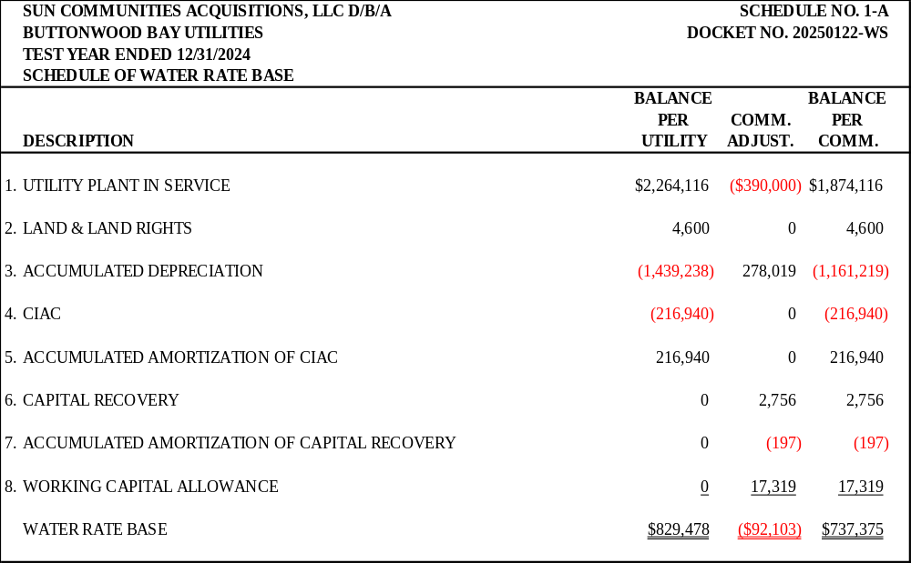

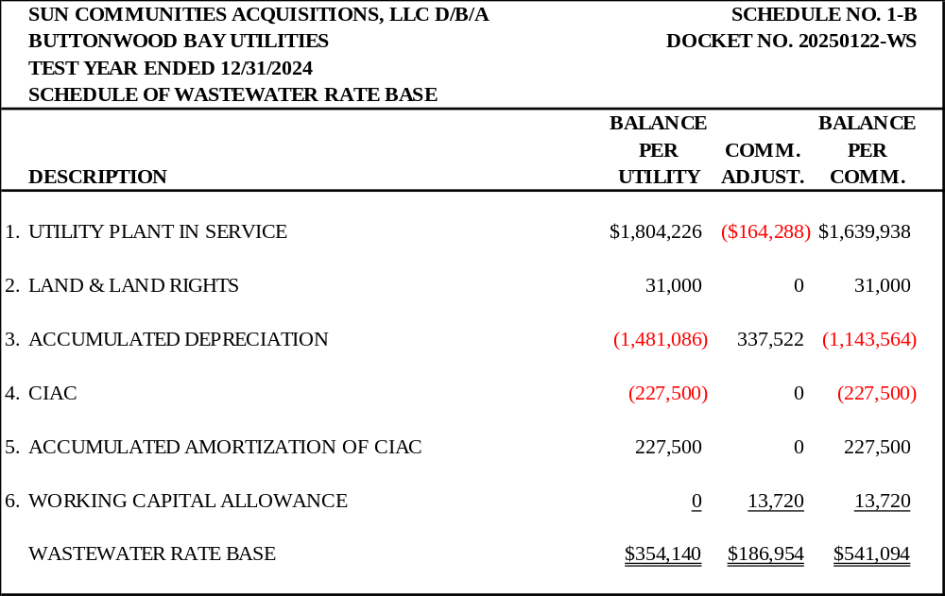

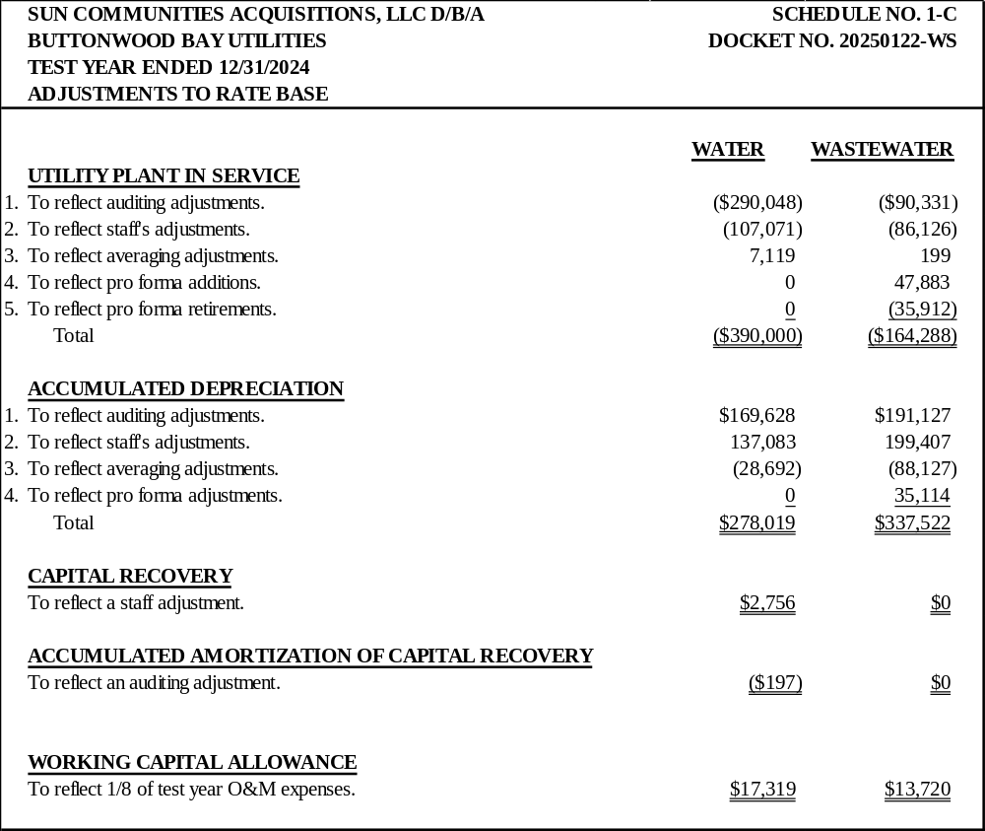

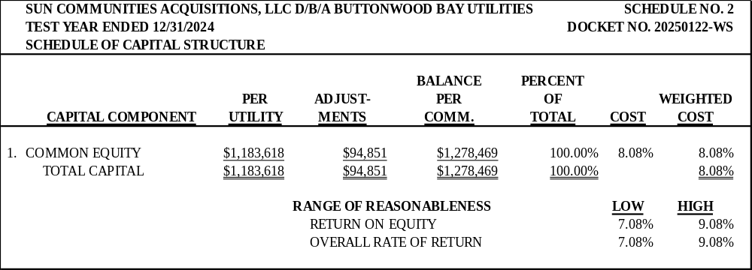

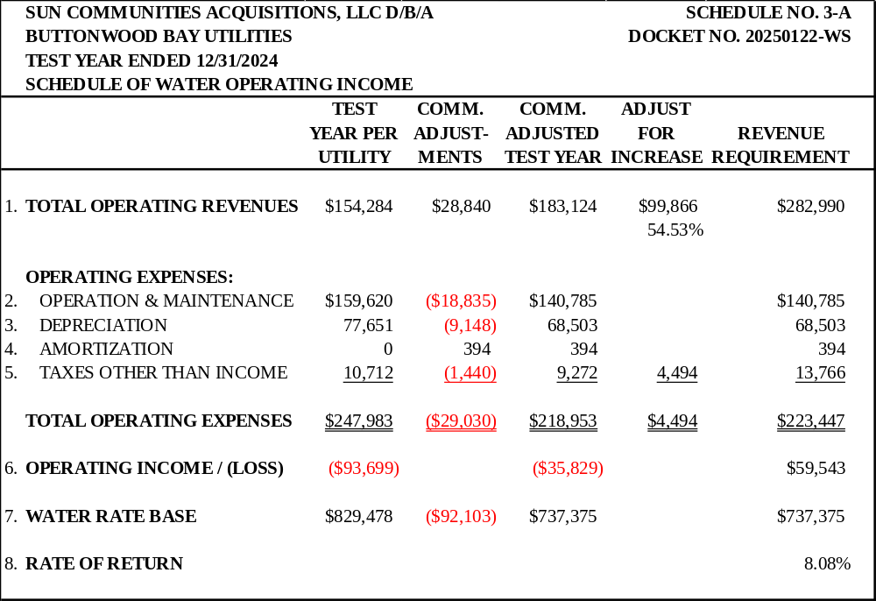

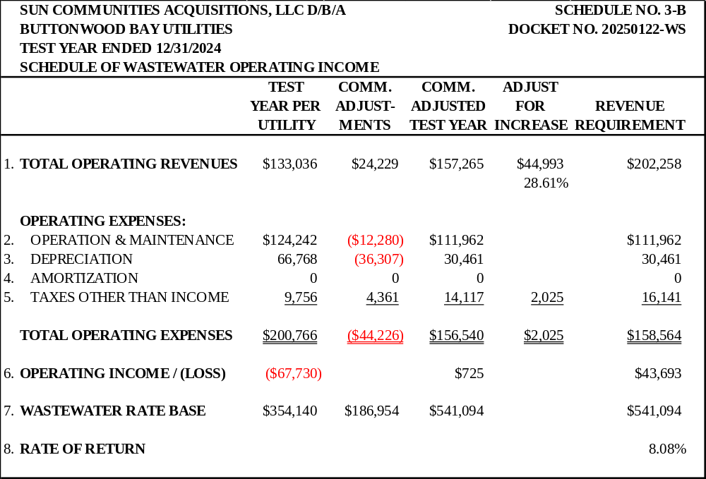

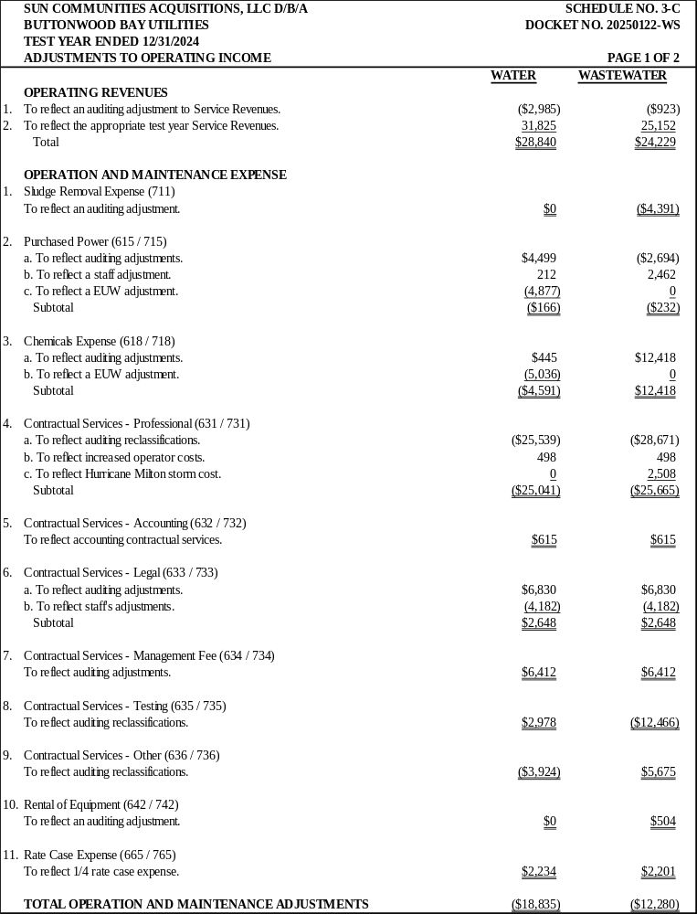

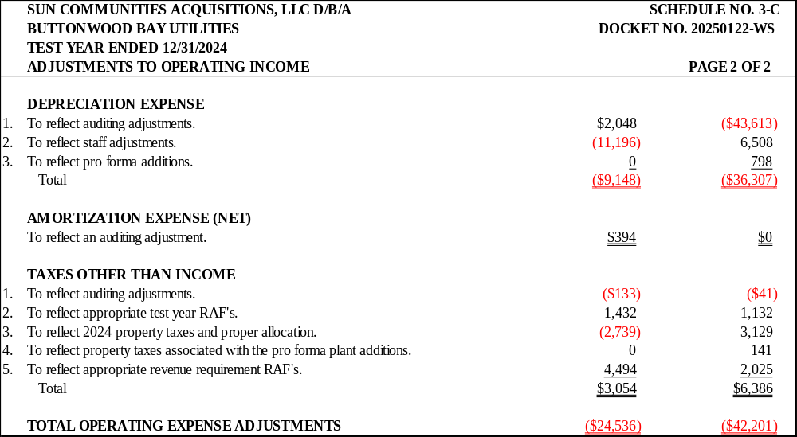

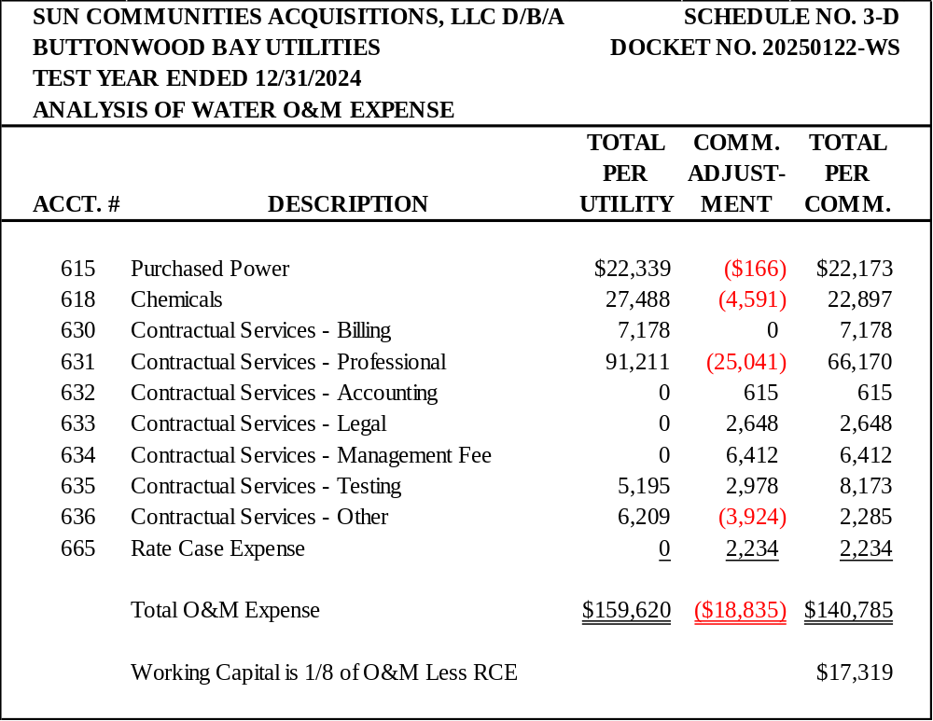

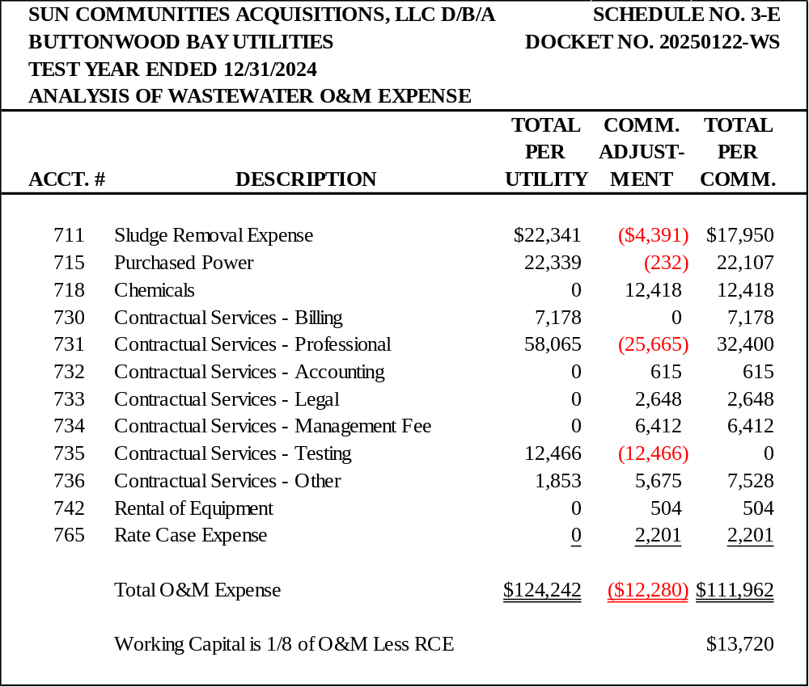

SUN COMMUNITIES ACQUISITIONS, LLC D/B/A BUTTONWOOD BAY UTILITIES |  |  | SCHEDULE NO. 4-A
TEST YEAR ENDED DECEMBER 31, 2024 |  | DOCKET NO. 20250122-WS
MONTHLY WATER RATES
 | UTILITY | COMMISSION | 4 YEAR
 | CURRENT | APPROVED | RATE
 | RATES | RATES | REDUCTION
Residential and General Service
Base Facility Charge by Meter Size
5/8" x 3/4" | $10.72 | $9.16 | $0.08
3/4" | N/A | $13.74 | $0.12
1" | $26.80 | $22.90 | $0.20
1-1/2" | $53.60 | $45.80 | $0.39
2" | $85.76 | $73.28 | $0.63
3" | $171.52 | $146.56 | $1.26
4" | $268.00 | $229.00 | $1.97
6" | $536.00 | $458.00 | $3.94
Charge per 1,000 gallons - Residential & General Service | $1.09 | N/A | N/A
0 - 4,000 gallons | N/A | $3.53 | $0.03
4,001 - 10,000 gallons | N/A | $4.41 | $0.04
Over 10,000 gallons | N/A | $5.30 | $0.05
Charge per 1,000 gallons - General Service | N/A | $4.16 | $0.04
Typical Residential 5/8" x 3/4" Meter Bill Comparison
5,000 Gallons | $16.17 | $27.69
10,000 Gallons | $21.62 | $49.74
15,000 Gallons | $27.07 | $76.24

SUN COMMUNITIES ACQUISITIONS, LLC D/B/A BUTTONWOOD BAY UTILITIES |  |  | SCHEDULE NO. 4-B
TEST YEAR ENDED DECEMBER 31, 2024 |  | DOCKET NO. 20250122-WS
MONTHLY WASTEWATER RATES
 | UTILITY | COMMISSION | 4 YEAR
 | CURRENT | APPROVED | RATE
 | RATES | RATES | REDUCTION
Residential Service
All Meter Sizes | $11.01 | $8.78 | $0.10
Charge per 1,000 gallons | $1.06 | N/A | N/A
(6,000 gallon cap)
Charge per 1,000 gallons | N/A | $2.67 | $0.03
(10,000 gallon cap)
General Service
Base Facility Charge by Meter Size
5/8" x 3/4" | $11.01 | $8.78 | $0.10
3/4" | N/A | $13.17 | $0.16
1" | $27.53 | $21.95 | $0.26
1 - 1/2" | $55.05 | $43.90 | $0.52
2" | $88.08 | $70.24 | $0.83
3" | $176.16 | $140.48 | $1.66
4" | $275.25 | $219.50 | $2.59
6" | $550.50 | $439.00 | $5.18
Charge per 1,000 gallons - General Service | $1.06 | $3.21 | $0.04
Typical Residential 5/8" x 3/4" Meter Bill Comparison
4,000 Gallons | $15.25 | $19.46
8,000 Gallons | $17.37 | $30.14
10,000 Gallons | $17.37 | $35.48

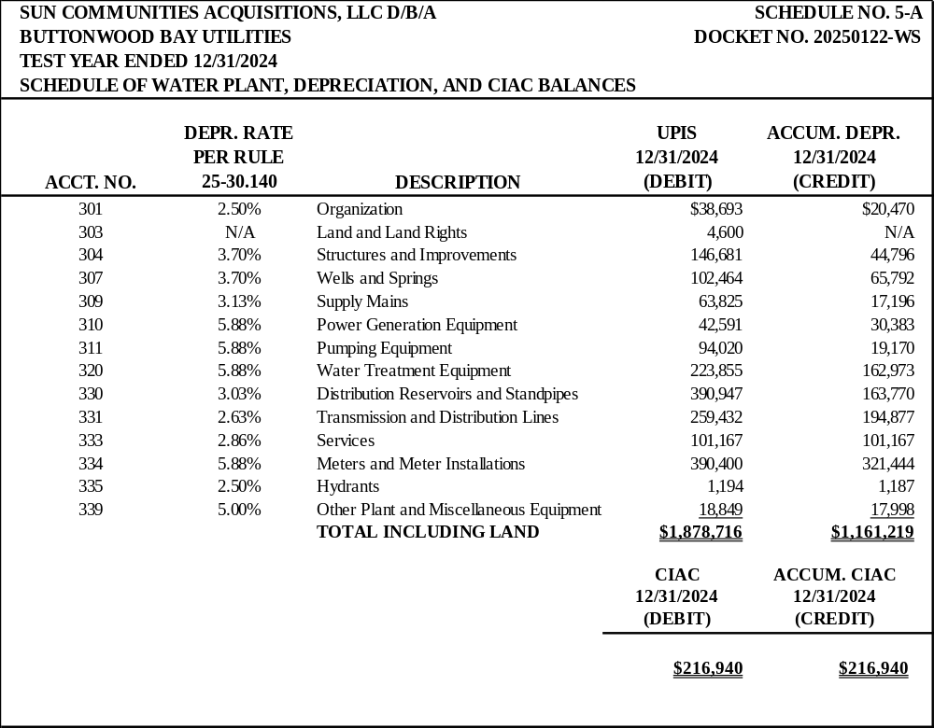

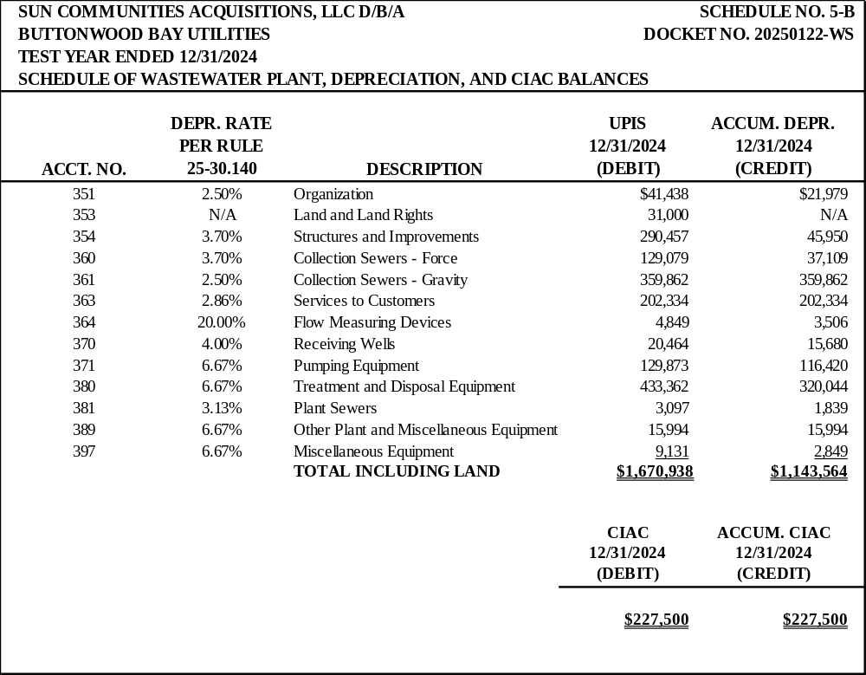

Order No. PSC-2000-0577-FOF-WS, issued on March 22, 2000, in Docket No. 19990915-WS, In re: Application by Sun Life Trailer Resorts Limited Partnership for transfer of majority organizational control of Buttonwood Bay Utilities, Inc., holder of Certificates 431-W and 364-S in Highlands County, merger into Buttonwood Bay Water & Sewer Company, LLC, and name change on certificates to Buttonwood Bay Water & Sewer Company, LLC.
Order No. PSC-2003-0759-PAA-WS, issued on June 23, 2003, in Docket No. 20020892-WS, In re: Application for transfer of facilities and Certificates Nos. 431-W and 364-S in Highlands County from Buttonwood Bay Water & Sewer Company, LLC to Sun Communities Acquisitions, LLC d/b/a Buttonwood Bay Utilities.
Document No. 02690-2023.
Document No. 04603-2024.
Document No. 14198-2025.
Document No. 05337-2026.
See Document No. 05337-2026.
Id.
Id.
See Document No. 06036-2026.
The most recent DEP Sanitary Survey Report lists the pumping capacity of the wells as unknown for Well No. 1 and 220 gpm for Well No. 2. The prior DEP Sanitary Survey, conducted on May 12, 2022, and the Utility’s 2024 and 2025 Annual Reports list the pumping capacity of both wells as 450 gpm.
See Document Nos. 03066-2026 and 03206-2026.
See Document Nos. 03066-2026, 03206-2026, and 05968-2026.
Document Nos. 03066-2026 and 03209-2026.
See Document No. 03066-2026.
Id.
Id.
Id.
Id.
See Document No. 00125-2026.
See Document No. 04396-2026.
See Document Nos. 14198-2025 and 04396-2026.
See Document No. 04396-2026.
See Document No. 14198-2026.
See Document Nos. 00125-2026 and 03066-2026.
See Document No. 03209-2062.
See Document No. 14198-2025.
See Document Nos. 00125-2026 and 03066-2026.
See Document No. 03209-2026.
Order No. PSC-03-0759-PAA-WS, issued June 23, 2003, in Docket No. 20020892, In re: Application for transfer of facilities and Certificates Nos. 431-W and 364-S in Highlands County from Buttonwood Bay Water & Sewer Company, LLC to Sun Communities Acquisitions, LLC d/b/a Buttonwood Bay Utilities.
Order No. PSC-2017-0361-FOF-WS, issued September 25, 2017, in Docket No. 20160101-WS, In re: Application for increase in water and wastewater rates in Charlotte, Highlands, Lake, Lee, Marion, Orange, Pasco, Pinellas, Polk, and Seminole Counties by Utilities, Inc. of Florida.
Id.
Order No. PSC-2025-0359-PAA-WU, issued September 24, 2025, in Docket No. 20240168-WU, In re: Application for staff-assisted rate case in Highlands County, by Country Walk Utilities, Inc.
Order No. PSC-2026-0223-PAA-WS, issued on June 22, 2026, in Docket No. 20260006-WS, In re: Water and wastewater industry annual reestablishment of authorized range of return on common equity for water and wastewater utilities pursuant to Section 367.081(4)(f), F.S.
See Document No. 00125-2026.
See Document No. 02207-2026.
Id.
See Document No. 02933-2026.
See Document No. 06036-2026.
See Order No. PSC-2026-0115-PAA-WS, issued April 27, 2026, in Docket No. 20250094-WS, In re: Application for staff-assisted rate case in Polk County, by GCP Plantation Landings, LLC.; Order No. PSC-2026-0114-PAA-SU, issued April 27, 2026, in Docket No. 20250084-SU, In re: Application for staff-assisted rate case in Orange County, by Gulfstream Utility LLC.; Order No. PSC-2026-0232-PAA-WU, issued June 22, 2026, in Docket No. 20250088-WU, In re: Application for staff-assisted rate case in Lake County by Sun Communities Finance, LLC d/b/a Water Oak Utility; and Order No. PSC-2026-0296-PAA-WS, issued August 24, 2026, in Docket No. 20250108-WS, In re: Application for staff-assisted rate case in Lake County, by Sunlake Estates Utilities, L.L.C.
See Document No. 02207-2026.
We note the calculations presented in Table 3 and Table 4 may not compute exactly due to rounding.
Average persons per household may be found by following: https://www.census.gov/quickfacts/fact/table/sebringcityflorida/PST045224
Order No. PSC-03-0759-PAA-WS, issued June 23, 2003, in Docket No. 20020892-WS, In re: Application for transfer of facilities and Certificates Nos. 431-W and 364-S in Highlands County from Buttonwood Bay Water and Sewer Company, LLC to Sun Communities Acquisitions, LLC d/b/a Buttonwood Bay Utilities.

