State of Florida   |  | Public Service Commission  Capital Circle Office Center ● 2540 Shumard Oak Boulevard  Tallahassee, Florida 32399-0850  -M-E-M-O-R-A-N-D-U-M-
DATE: | June 4, 2009
TO: | Office of Commission Clerk (Cole)
FROM: | Division of Regulatory Compliance (Polk, Casey)  Office of the General Counsel (Murphy)  Division of Service, Safety & Consumer Assistance (Moses)
RE: | Docket No. 070348-TX – Amended petition for designation as eligible telecommunications carrier (ETC) by Swiftel, LLC.
AGENDA: | 06/16/09 – Regular Agenda - Proposed Agency Action - Interested Persons May Participate
COMMISSIONERS ASSIGNED: |  |  | All Commissioners
PREHEARING OFFICER: |  |  | Skop
CRITICAL DATES: |  |  | None
SPECIAL INSTRUCTIONS: |  |  | None
FILE NAME AND LOCATION: |  |  | S:\PSC\RCP\WP\070348.RCM.DOC

Case Background
On May 30, 2007, Swiftel LLC (Swiftel) petitioned the Florida Public Service Commission (FPSC or Commission) for designation as an Eligible Telecommunications Carrier (ETC) in the State of Florida. Specifically, Swiftel is requesting that it be granted ETC status throughout the non-rural wire centers of BellSouth/AT&T (AT&T) and Verizon (Attachment B) for purposes of receiving federal universal service support. Swiftel has consummated interconnection agreements with both AT&T and Verizon. The company maintains that it will only be seeking low income support, and that it will not be requesting high-cost support from the federal Universal Service Fund (USF). Swiftel’s primary purpose in requesting ETC status in Florida is to provide Lifeline and Link-Up services.
Swiftel is a limited liability company organized under the laws of the State of Florida on August 18, 2006, under the name Swiftel, LLC. The company currently is certificated to provide telecommunication services in the State of Florida through certificate number 8682. The principal office of the company is located at 811 West Garden Street, Pensacola, Florida 32507.

Upon designation as an ETC, Swiftel indicates that it will participate in and offer Lifeline and Link-Up programs to qualified low-income consumers. Additionally, Swiftel has committed to publicize the availability of Lifeline and Link-Up services in a manner reasonably designed to reach those likely to qualify for those services.

On August 7, 2008, staff filed a recommendation to deny Swiftel ETC status for failing to be in the public interest based on the following six reasons:

- Swiftel had not paid its Florida regulatory assessment fee (RAF) for 2007.

- Swiftel did not accurately respond to staff’s data request asking Swiftel to provide its corporate structure.

- Swiftel did not accurately respond to staff’s data request asking Swiftel to provide a list of Swiftel owners or corporate officers and indicate if any are also owners or corporate officers of any other telecommunication companies.

- Swiftel did not accurately respond to staff’s data request by failing to disclose its Oregon Certificate of Authority to Provide Telecommunications Service had been cancelled.

- Swiftel did not accurately respond to staff’s data request by failing to disclose Angie M. Franco (now Angie M. Watson, President of Swiftel), as Operating Manager of Seven Bridges Communications, LLC, abandoned its Petition for ETC Status in the State of South Carolina.

- Swiftel did not accurately respond to staff’s data request by failing to disclose that its ETC Petition in the State of Montana was dismissed.

Scheduled for the August 19, 2008 Agenda, the recommendation addressing Swiftel’s petition for ETC status was postponed by a request from the company to answer and correct what Swiftel considered items that it needed to revisit. Staff arranged a meeting with the attorneys representing Swiftel and the President and Managing Partner for Swiftel, Ms. Angie Watson, on September 9, 2008, to discuss various items. In the meeting, Swiftel indicated that inaccurate information had previously been submitted on its behalf by its counsel, and that it retained Foley & Lardner LLP as new counsel for this docket.

Swiftel requested that it be allowed to file an Amended Petition for designation as an ETC in Florida. Staff agreed to the request based on Swiftel’s claims of inaccurate information that was supplied to staff’s responses by Swiftel’s original counsel, and an Amended Petition was submitted on November 18, 2008. Staff sent out additional data requests on December 12, 2008, based on the Amended Swiftel Petition. Staff postponed the filing of this recommendation twice since the Amended Petition was filed due to Swiftel’s requests for additional time to respond and provide documentation to staff’s data requests.

Swiftel stated as of January 1, 2009, it served 1,051 Florida residential customers on a prepaid basis. Swiftel has no commercial customers. Swiftel stated that if granted ETC status, it will provide local exchange and exchange access services in the requested designated service areas using a combination of resale and wholesale local platform (WLP)/unbundled network element (UNE) lines. According to FCC rules, facilities obtained as WLP/UNE lines satisfy the requirement that an ETC provide the supported services using its own facilities.

Swiftel signed an Affidavit attesting that it will follow all Florida Statutes, Florida Administrative Rules, Florida PSC Orders, FCC Rules, FCC Orders, and regulations contained in the Telecommunications Act of 1996 regarding Universal Service, ETCs, Link-Up and Lifeline, and toll limitation service. (Attachment A)

This recommendation addresses Swiftel’s Petition for ETC designation in the State of Florida. The Commission has authority under Section 364.10(2), Florida Statutes, to decide a petition by a CLEC seeking designation as an eligible telecommunications carrier pursuant to 47 C.F.R. § 54.201.

Discussion of Issues
Issue 1:1
Should Swiftel be granted eligible telecommunications carrier status in the State of Florida?
Recommendation:
No. Staff recommends that Swiftel not be granted eligible telecommunications carrier status in the State of Florida. (Polk, Casey, Moses, Murphy)
Staff Analysis:
Under FCC rules, state commissions have the primary responsibility to designate providers as ETCs. Section 364.10(2)(a), Florida Statutes, provides that “… For the purposes of this section, the term ‘eligible telecommunications carrier’ means a telecommunications company, as defined by Section 364.02, Florida Statutes, which is designated as an eligible telecommunications carrier by the commission pursuant to 47 C.F.R. §54.201.”

Designation as an ETC is required for a provider to be eligible to receive monies from the federal USF. 47 USC 254(e) of the Act provides that “only an eligible telecommunications carrier designated under Section 214(e)… shall be eligible to receive specific federal universal service support.” Pursuant to Section 214(e)(1), a common carrier designated as an ETC must offer and advertise the services supported by the federal universal service mechanisms throughout a designated service area.

ETC Certification Requirements

The Code of Federal Regulations addresses a state commission’s responsibilities related to an ETC designation:

Upon request and consistent with the public interest, convenience, and necessity, the state commission may, in the case of an area served by a rural telephone company, and shall, in the case of all other areas, designate more than one common carrier as an eligible telecommunications carrier for a service area designated by the state commission, so long as each additional requesting carrier meets the requirements of paragraph (d) of this section. Before designating an additional eligible telecommunications carrier for an area served by a rural telephone company, the state commission shall find that the designation is in the public interest.
The FCC has found that the public interest concerns existing for carriers seeking ETC designation in areas served by rural carriers also exist in study areas served by non-rural carriers and that before designating an ETC, whether the applicant seeks designation in an area served by a rural or non-rural carrier, it must make an affirmative determination that such designation is in the public interest.
To qualify as an ETC, a carrier must provide nine services identified in 47 CFR 54.101 either using its own facilities or a combination of its own facilities and resale of another carrier’s services. The services are:
- Voice grade access to the public switched network;

- Local Usage;

- Dual tone multi-frequency signaling or its functional equivalent;

- Single-party service or its functional equivalent;

(5) Access to emergency services;

(6) Access to operator services;

(7) Access to interexchange service;

(8) Access to directory assistance; and,

- Toll limitation for qualifying low-income consumers.

ETCs must also advertise the availability of such services and the associated charges using media of general distribution.

Additional ETC Certification Requirements

In addition to requiring the above services, the FCC, on March 17, 2005, issued a Report and Order that established additional criteria that all ETC applicants must satisfy in order to be granted ETC status by the FCC. In this Order, the FCC determined that an ETC applicant must also demonstrate:

- a commitment and ability to provide the supported services throughout the designated area;

- the ability to remain functional in emergency situations;

- ability to satisfy consumer protection and service quality standards;

- provision of local usage comparable to that offered by the incumbent LEC; and,

- an acknowledgement that the applicant may be required by the FCC to provide equal access if all other ETCs in the designated service area relinquish their designations pursuant to Section 214(e)(4) of the Act.

The FCC encouraged states to also adopt these criteria, and the FPSC has done so by Order No. PSC-05-0824-TL, issued August 15, 2005, in Docket No. 010977-TL.
Swiftel Compliance with ETC Requirements

Staff believes that Swiftel fails to comply with two of the requirements identified above. Staff believes Swiftel has failed to fulfill the facilities’ requirements of 47 CFR §54.201(d)(1). Additionally, staff believes it would not be in the public interest to grant Swiftel ETC status in Florida. Both of these requirements will be addressed below.

Facilities Requirement

On April 16, 2009, Swiftel filed documents with the Commission asserting that it will fulfill the facilities requirement of 47 C.F.R. §54.201(d)(1) in Florida by using Session Initiation Protocol (SIP) signaling protocol to supply at least one of the nine required services to its customers. SIP is a signaling protocol used for establishing communication sessions within an IP based network, similar to SS7 signaling protocol within the Public Switched Telephone Network. SIP is an Internet signaling protocol service, not a “physical component of the telecommunications network.”

47 CFR §54.201(d), provides that:

A common carrier designated as an eligible telecommunications carrier under this section shall be eligible to receive universal service support in accordance with section 254 of the Act and shall, throughout the service area for which the designation is received:

(1) Offer the services that are supported by federal universal service support mechanisms under subpart B of this part and section 254(c) of the Act, either using its own facilities or a combination of its own facilities and resale of another carrier’s services (including the services offered by another eligible telecommunications carrier). (emphasis added)

47 CFR §54.201(e) and (f), further defines the term “facilities:”

(e) For the purposes of this section, the term facilities means any physical components of the telecommunications network that are used in the transmission or routing of the services that are designated for support pursuant to subpart B of this part. (emphasis added)

(f) For the purposes of this section, the term ‘‘own facilities’’ includes, but is not limited to, facilities obtained as unbundled network elements (UNE) pursuant to part 51 of this chapter, provided that such facilities meet the definition of the term ‘‘facilities’’ under this subpart. (emphasis added)

A common carrier can be designated as an ETC if it has the ability to offer the services supported by federal universal service support mechanisms such as having an existing interconnection agreement with an underlying carrier. However, universal service support is only provided to the ETC upon provision of the supported services to consumers. An ETC cannot receive universal service support if it is a pure reseller. 47 CFR §54.201(i), provides that:

A state commission shall not designate as an eligible telecommunications carrier a telecommunications carrier that offers the services supported by federal universal service support mechanisms exclusively through the resale of another carrier’s services.

Swiftel filed a petition for ETC designation in Alabama in January 2008, and stated that it offers all of the supported services under section 254(c) using facilities obtained as UNEs from AT&T. The Alabama PSC Order designating Swiftel as an ETC specifically states that Swiftel will offer the ETC required services using its own facilities or a combination of its own facilities and the resale of another carrier’s services. However, Swiftel has apparently not done so. In a data request response to staff, Swiftel indicated that it had not purchased any UNEs from AT&T or CenturyTel in the State of Alabama. Swiftel has advised staff that it uses SIP IP Protocol service to fulfill the facilities requirement in Alabama. SIP is a service purchased by Swiftel, it is not a physical component of the telecommunications network. Swiftel is not fulfilling the facilities requirement by purchasing SIP service. It is therefore providing ETC services in Alabama using 100% resale services. Since a pure reseller cannot receive universal service funding, staff believes Swiftel is in violation of 47 CFR §54.201(i).

Staff further investigated how Swiftel will meet the facilities requirement in Florida. Swiftel responded that it owns facilities in Atlanta which provide at least one of the required services to customers. As evidence of meeting the facilities requirement, Swiftel filed documents showing it will provide at least one of the required nine ETC services using SIP service. SIP is a signaling protocol service of an IP-based network. It is not a physical component of the telecommunications network as required by 47 CFR §54.201(e).

The FCC requires that “facilities” must be physical components of the telecommunications network. In Order FCC 97-197, the FCC stated:

By encompassing only physical components of the telecommunications network that are used to transmit or route the supported services, this definition, in effect, excludes from eligibility a "pure" reseller that claims to satisfy the facilities requirement by providing facilities through its own billing office or through some other facility that is not a "physical component" of the network, as defined in this Order. We find that our determination to define "facilities" in this manner is consistent with congressional intent to require that at least some portion of the supported services offered by an eligible carrier be services that are not offered through "resale of another carrier's services."

Swiftel is asserting that SIP service meets the facilities requirement of the federal rules. Staff disagrees. SIP is a purchased IP protocol service. It is not a physical component of the telecommunications network. Staff believes Swiftel is attempting to stretch the FCC definition of facilities to meet its own needs. The FCC did not want states to interpret the term “own facilities” and included the following clarification in the Universal Service Order to avoid conflicting interpretations:

It is clearly appropriate for a federal agency to interpret the federal statute that it has been entrusted with implementing. Moreover, we believe it is particularly important for us to set out a federal interpretation of the "own facilities" language in section 214, particularly as it relates to the use of unbundled network elements. We note that the "own facilities" language in section 214(e)(1)(A) is very similar to language in section 271(c)(1)(A), governing Bell operating company (BOC) entry into interLATA services. While we are not interpreting the language in section 271 in this Order, given the similarity of the language in these two sections, we would find it particularly troubling to allow the states unfettered discretion in interpreting and applying the "own facilities" language in section 214(e). In order to avoid the potential for conflicting interpretations from different states, we believe it is important to set forth a single, federal interpretation, so that the "own facilities" language is consistently construed and applied.

Swiftel is interpreting the phrase “own facilities” to include SIP service. It does not. The FCC was very clear that conflicting interpretations of the “own facilities” language will not be allowed. SIP service does not meet the definition of “own facilities.”

Facilities Requirement Summary

Swiftel has not provided evidence that as an ETC, it would offer the services that are supported by federal universal service support mechanisms either using its own facilities or a combination of its own facilities and resale of another carrier’s services as required by 47 C.F.R. §54.201(d)(1). Swiftel’s Alabama petition for ETC status stated it would use UNEs and resale services to fulfill the facilities requirement. However, Swiftel subsequently elected to use a SIP signaling service instead, asserting that the SIP service fulfills the facilities requirement. Staff also determined that Swiftel is using SIP service in Kentucky, asserting that SIP service fulfills the facilities requirement.

Swiftel’s ETC petition also states it would use UNEs to fulfill the facilities requirement in Florida, but Swiftel has provided evidence in this docket that it plans to use the SIP signaling service instead. SIP is a signaling protocol used for establishing communication sessions within an IP based network. It is not a “physical component of the telecommunications network” as required by 47 CFR §54.201(e). Therefore, staff recommends that Swiftel does not meet federal and state requirements for being designated as an eligible telecommunications carrier in the State of Florida.

Public Interest Requirement
As previously mentioned, the FCC has found that before designating an ETC, it must make an affirmative determination that such designation is in the public interest, regardless of whether the applicant seeks designation in an area served by a rural or non-rural carrier. It found that the public interest concerns that exist for carriers seeking ETC designation in areas served by rural carriers also exist in study areas served by non-rural carriers. Staff believes that before designating a carrier as an ETC, the FPSC should also make an affirmative determination that such designation is in the public interest, regardless of whether the applicant seeks designation in an area served by a rural or non-rural carrier. Staff believes it would not be in the public interest to designate Swiftel as an ETC in Florida based on the following research and responses to staff’s data requests:

- Swiftel failed to pay its Florida RAF for 2007 in a timely manner;

- Swiftel has not officially requested a name change from Swiftel to LifeConnex Telecom, LLC, effective April 2, 2009;

- As of April 2, 2009, Swiftel is no longer recognized as a legal corporate name in the State of Florida by the Secretary of State, Division of Corporations;

- Seven Bridges Communications, LLC had its CLEC certificate revoked October 15, 2008 for failure to file annual reports to the South Carolina PSC. The South Carolina PSC order named Angie Watson as Operations Manager;

- Swiftel failed to disclose through staff’s data requests that Leonard I. Solt is an owner of TRUE Wireless LLC, a company seeking ETC status in the State of Texas;

- Swiftel’s ETC Petition in the State of Montana was dismissed for not complying with Montana laws;

- Swiftel’s Oregon Certificate of Authority to Provide Telecommunications Service was cancelled for failing to comply with Commission Rules and Terms of the Certificate for non-payment of regulatory assessment fees;

- Swiftel is not using its own facilities or a combination of its own facilities and resale of another carrier’s services to provide at least one of the required ETC services to Lifeline customers in Alabama or Kentucky in violation of federal rules.

Public Interest Requirement Summary

Swiftel has failed to comply with FPSC and FCC rules and regulations, made misrepresentations to the FPSC staff, and had regulatory compliance issues in other states. As a result, staff believes that the public interest would not be served by designating Swiftel as an ETC in Florida.
Conclusion
Swiftel has provided documentation in this docket, that as an ETC, it would offer the services that are supported by federal universal service support mechanisms using SIP Internet Protocol services. This does not meet the requirements of 47 C.F.R. §54.201(d)(1) which requires that ETCs must offer at least one of the nine required ETC services using its own facilities or a combination of its own facilities and resale of another carrier’s services.

Swiftel has shown a history of non-compliance with FCC and FPSC rules and regulations, and made misrepresentations to staff in this docket. Additionally, staff’s analysis has shown Swiftel’s non-compliance with other states’ rules and regulations. Therefore, staff recommends that Swiftel not be granted ETC status in the State of Florida. Declining ETC status to Swiftel will not prevent it from providing Link-Up and Lifeline services to its clients. Swiftel can purchase Link-Up and Lifeline resold services from its underlying carrier and receive the Link-Up and Lifeline USF credits from them.
Issue 2:2
2
2
Should this docket be closed?
Recommendation:
If no person whose substantial interests are affected by the proposed agency action files a protest within 21 days of the issuance of the order, this docket should be closed upon the issuance of a consummating order. (Murphy)
Staff Analysis:
At the conclusion of the protest period, if no protest is filed this docket should be closed upon the issuance of a consummating order.
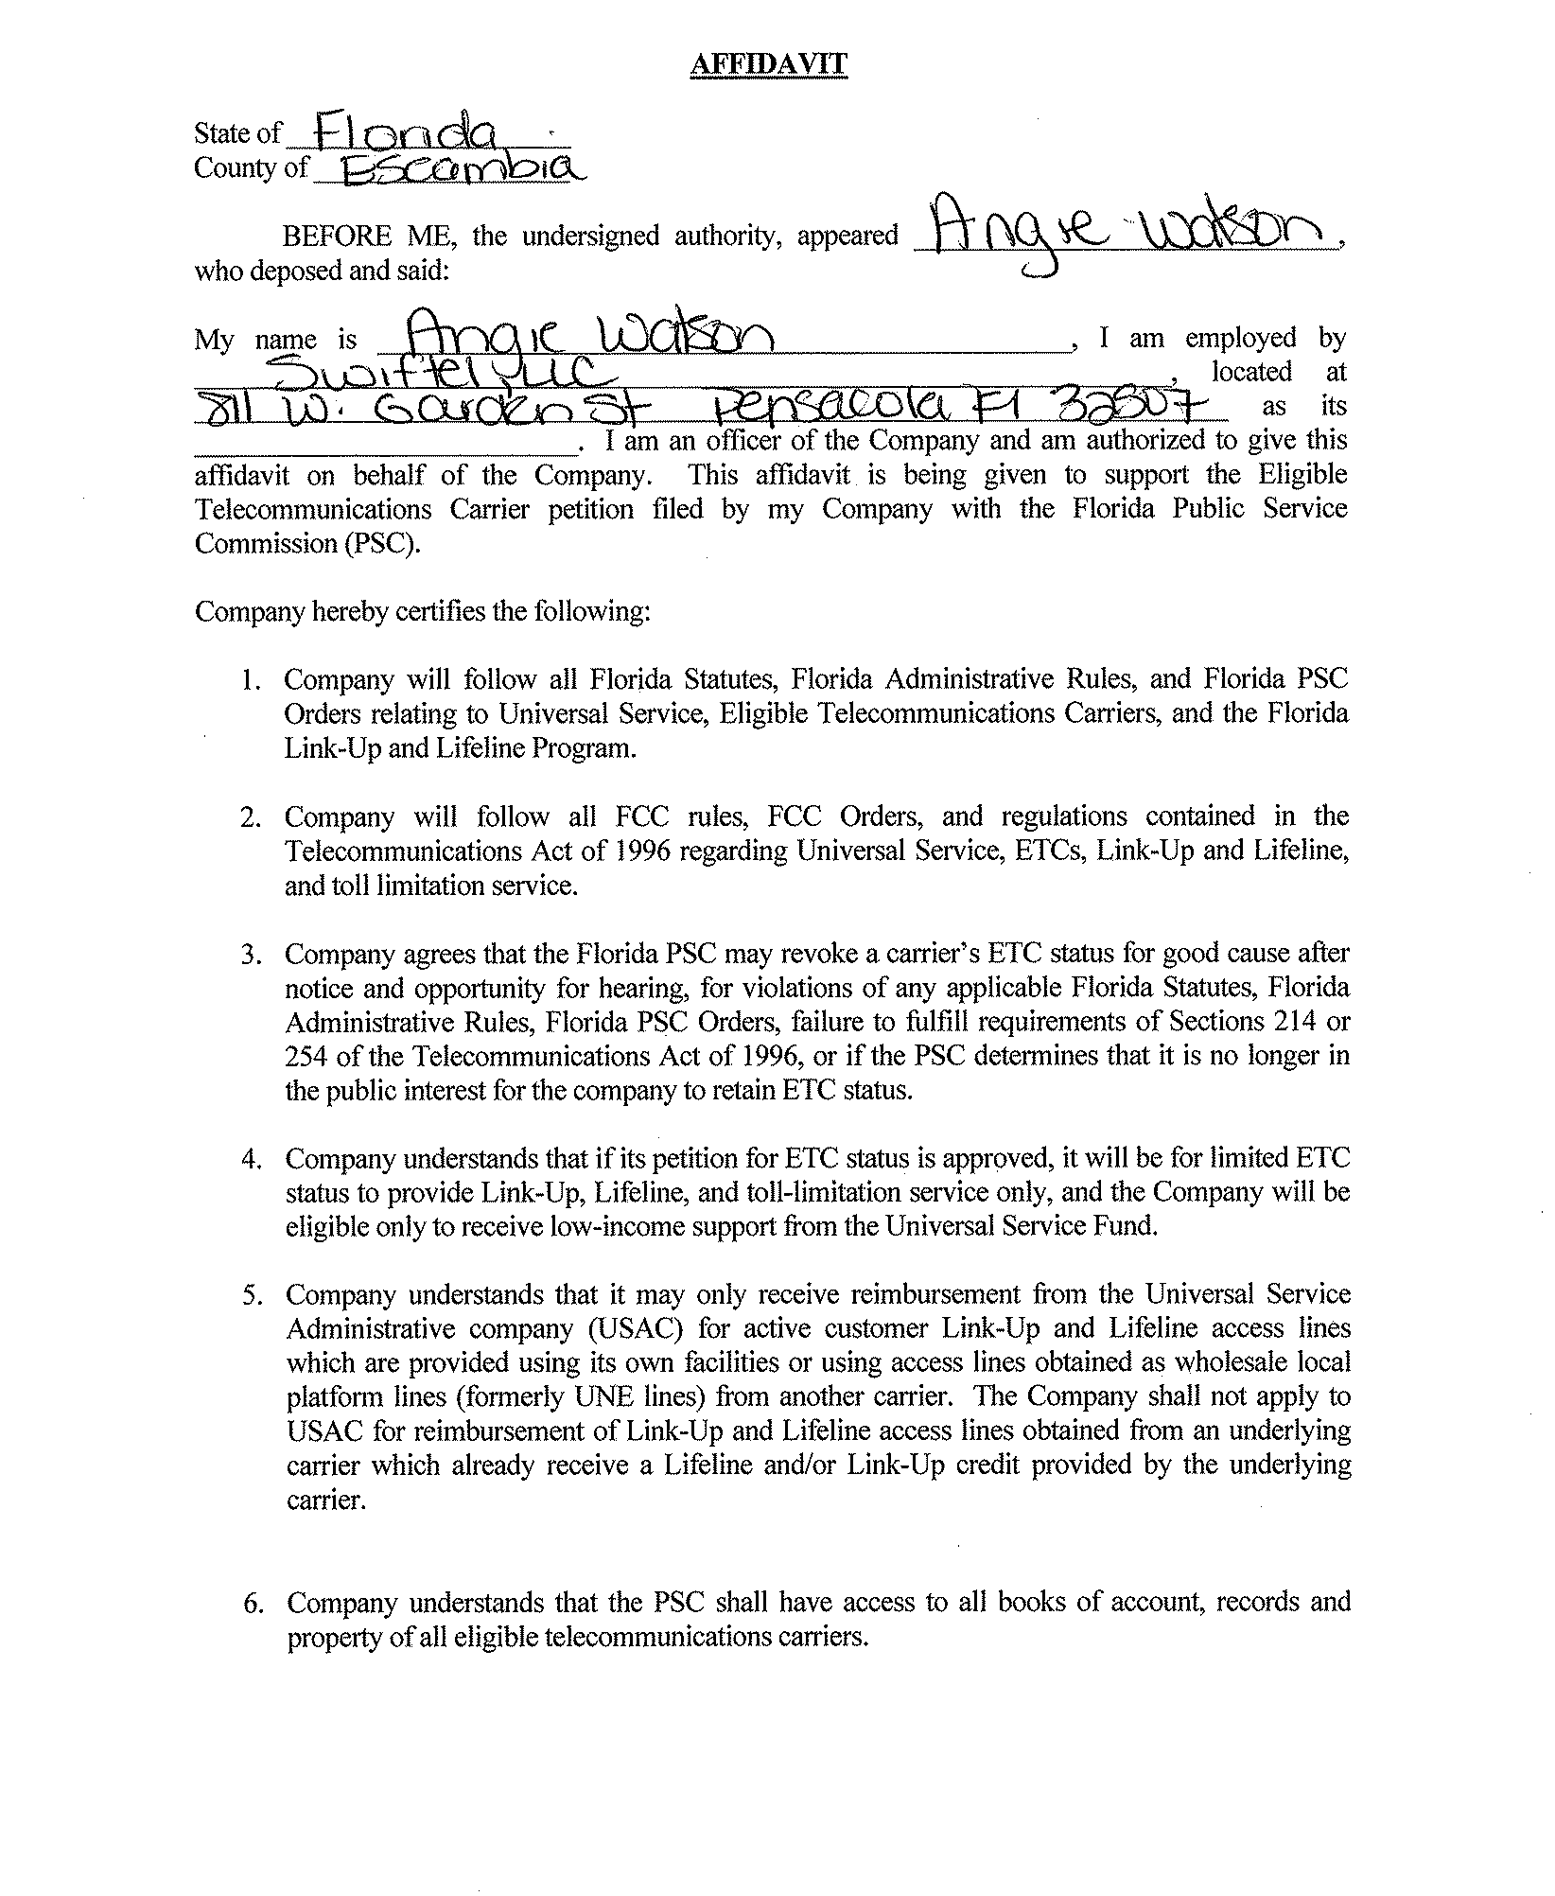

Staff’s investigation revealed that Swiftel changed its corporate name to LifeConnex Telecom, LLC on April 2, 2009, with the Florida Department of State, Division of Corporations. No request for a name change has been received by the FPSC to date.
Swiftel subsequently paid it 2007 RAF and $500 penalty on August 13, 2008.
Swiftel LLC’s request for postponement, filed August 14, 2008, Document No. 07321-08.
Although Swiftel stated that its counsel submitted inaccurate information to the Florida PSC, it continues to use his firm for filings in Florida and other states.
47 U.S.C. § 214(e)(2), 47 C.F.R. § 54.201(b).
47 C.F.R. § 54.201(c)
In the Matter of Federal-State Joint Board on Universal Service, CC Docket No. 96-45, Order FCC 05-46, ¶ 42, Released: March 17, 2005.
In the Matter of Federal-State Joint Board on Universal Service, CC Docket No. 96-45, Order FCC 05-46, Adopted: February 25, 2005, Released: March 17, 2005.
“A carrier must meet the section 214(e) criteria as a condition of its being designated an eligible carrier and then must provide the designated services to customers pursuant to the terms of Section 214(e) in order to receive support.” Universal Service Order, 12 FCC Rcd 8853, FCC 97-157, ¶ 137.
In the Matter of Federal-State Joint Board on Universal Service, Western Wireless Corporation Petition for Preemption of an Order of the South Dakota Public Utilities Commission, FCC 00-248, ¶15, Released August 10, 2000.
Universal Service Order, 12 FCC Rcd 8853, FCC 97-157, ¶ 168.
In the Matter of Federal-State Joint Board on Universal Service, CC Docket No. 96-45, Order FCC 05-46, ¶ 42, Released March 17, 2005.
Staff advised Swiftel on May 13, 2009, that companies must petition the Commission for an official name change.
Swiftel was granted ETC status in AT&T Alabama’s territory on April 15, 2008, and in AT&T’s Kentucky territory on January 6, 2009. Since that time, it has collected $2,258,941 for Alabama, and $21,410 for Kentucky from the federal universal service fund.
Swiftel stated in its original petition and amended petition for ETC status in Florida that it would offer the nine required ETC services using its own facilities or a combination of its own facilities and resale of another carrier’s services as required by 47 C.F.R. §54.201(d)(1).

