State of Florida   |  | Public Service Commission  Capital Circle Office Center ● 2540 Shumard Oak Boulevard  Tallahassee, Florida 32399-0850  -M-E-M-O-R-A-N-D-U-M-
DATE: | September 12, 2013
TO: | Office of Commission Clerk (Cole)
FROM: | Division of Economics (Roberts, Hudson)  Office of the General Counsel (Murphy)
RE: | Docket No. 130161-WS – Application for staff assistance for alternative rate setting case in Polk County by Four Points Utility Corp.
AGENDA: | 09/25/13 – Regular Agenda – Proposed Agency Action – Interested Persons May Participate
COMMISSIONERS ASSIGNED: |  |  | All Commissioners
PREHEARING OFFICER: |  |  | Brown
CRITICAL DATES: |  |  | 11/14/13 (90 day deadline pursuant to Rule 25-30.456(13), F.A.C.)
SPECIAL INSTRUCTIONS: |  |  | None
FILE NAME AND LOCATION: |  |  | S:\PSC\ECO\WP\130161.RCM.DOC

Case Background
Four Points Utility Corporation (Four Points or Utility) is a Class C water and wastewater utility located in Davenport in northeast Polk County (County). The Utility serves approximately 215 residential water and wastewater customers and a clubhouse in the Island Club West Resort and Spa townhome development (Island Club West). Four Point's 2012 annual report indicates that the Utility had combined gross operating revenues of $104,699 and a net operating loss of $92,576.

In 2007, the Utility was granted Certificate Nos. 634-W and 544-S. On April 20, 2009, Four Points applied for a staff-assisted rate case (SARC). However, the docket was closed pursuant to Rule 25-30.455(9), Florida Administrative Code (F.A.C.), because the Utility failed to pay the applicable filing fee.
In 2011, the Commission initiated a show cause proceeding against Four Points for potential violations of numerous Commission rules and statutes related to meter reading, customer billing, record keeping, delinquent accounts, annual reports, and regulatory assessment fees. Although the show cause docket remains open, on January 25, 2012, David Meadows, the Utility owner, filed notice of abandonment of the Utility effective March 23, 2012. As a result, Polk County filed a Petition to appoint a receiver, and by Order dated March 19, 2012, the Circuit Court appointed Michael Smallridge as the receiver.
On June 12, 2013, the Utility filed an application for a staff-assisted alternative rate setting (SAARS) increase, pursuant to Rule 25-30.456, F.A.C. On August 20, 2013, Four Points and the Office of Public Counsel (OPC) filed a Joint Motion Requesting Commission Approval of the Settlement Agreement (Joint Motion) and the closure of this docket. The Settlement Agreement between OPC, Four Points, and the Island Club West Homeowners Association (HOA) (collectively Parties) is incorporated in this recommendation as Attachment A. The Settlement Agreement is done in an effort to facilitate the substitution of the Florida Governmental Utility Authority (FGUA) as the receiver for the Utility.
On September 9, 2013, on behalf of all Parties, OPC filed a Motion Requesting Commission Approval of Amended Settlement Agreement and the Closure of this Docket (OPC’s Motion). The Amended Settlement Agreement, which is incorporated in this recommendation as Attachment B, removed the 7,000 gallon cap for general service wastewater customers. This recommendation addresses the Joint Motion and Settlement Agreement as modified by OPC’s Motion and Amendments to the Settlement Agreement (collectively Amended Settlement Agreement). Attachment C provides the Commission-approved rate, the modified Polk County rates, and amended rates requested in the Amended Settlement Agreement. The Commission has jurisdiction pursuant to Sections 367.081, 367.121, and 367.0814, Florida Statutes (F.S.).
Discussion of Issues
Issue 1:1
Should the Commission approve the Joint Motion requesting approval of the Settlement Agreement as modified by OPC’s Motion and Amendments to the Settlement Agreement?
Recommendation:
Yes. The Motion and Amended Settlement Agreement should be approved. The Utility should file a proposed customer notice and revised tariff sheets consistent with the Commission’s decision within 15 days of the Commission vote. The approved rates should be effective for service rendered on or after the stamped approval date of the tariff pursuant to Rule 25-30.475(1), F.A.C., after staff has verified that the proposed customer no0tice is adequate and the notice has been provided to the customers. The Utility should provide proof that the customers have received notice within 10 days of the date of the notice. (Roberts)
Staff Analysis:
The Parties have entered into an Amended Settlement Agreement resolving the Utility’s application for a SAARS filed in this docket. The Parties indicated that the Amended Settlement Agreement would avoid the time, expense, and any uncertainty associated with potential adversarial litigation. Also, the Parties indicated that the Amended Settlement Agreement would facilitate the pending substitution of FGUA as the Receiver for the Utility.
In 2012, when Michael Smallridge was appointed receiver of Four Points, the Utility was indebted to Polk County for approximately $55,000 for the purchase of bulk water and wastewater service. Since that time, the amount owed to the County has escalated by an additional $116,000. The County has requested that FGUA take over the operations of Four Points. Polk County believes that FGUA would bring more economical, efficient, and effective services to the Utility customers.
In order to facilitate the substitution of FGUA as the receiver for the Utility, the Parties are requesting approval of the modified Polk County rates and an abatement of any further proceedings in this docket. The rates are "modified" because the inclining block rate structure excludes all but the first two tiers for residential and general service water customers. The modified rates are shown on page 5 of Attachment B.
The Polk County residential and commercial rates will increase by 5 percent effective October 1, 2013. The Amended Settlement Agreement provides that the proposed rates are subject to the same 5 percent increase. Although the rate schedules attached to the Settlement Agreements reflect the rates currently in effect, the Commission’s action will not become effective until after October 1, 2013. Thus, since the parties Amended Settlement Agreement anticipates implementation of the 5 percent increase, effective October 1, 2013, staff recommends that the Commission approve rates, including the 5 percent increase, at this time. Four Points’ existing rates, the modified Polk County rates, and the modified Polk County rates with the 5 percent increase effective October 1, 2013, are shown on Attachment C.
Staff believes that the Parties’ Amended Settlement Agreement is a reasonable resolution because it addresses all issues in this docket. Further, staff believes that it is in the public interest for the Commission to approve the Amended Settlement Agreement because the settlement promotes administrative efficiency for the Utility customers. In keeping with the Commission’s long-standing practice of encouraging parties to settle contested proceedings whenever possible, staff recommends that the Commission approve the Parties’ Amended Settlement Agreement.
Based on the foregoing, staff recommends the Motion and Amended Settlement Agreement should be approved. The Utility should file a proposed customer notice and revised tariff sheets consistent with the Commission’s decision within 15 days of the Commission vote. The approved rates should be effective for service rendered on or after the stamped approval date of the tariff pursuant to Rule 25-30.475(1), F.A.C., after staff has verified that the proposed customer notice is adequate and the notice has been provided to the customers. The Utility should provide proof that the customers have received notice within 10 days of the date of the notice.

Issue 2:2
Should this docket be closed?
Recommendation:
No. If no timely protest is received from a sustainably affected person, upon expiration of the protest period, the PAA Order will become final upon the issuance of a consummating order. If the Commission approves staff’s recommendation in Issue 1, this docket should remain open for staff’s verification that the revised tariff sheets and customer notice have been filed by the Utility and approved by staff. Once these actions are complete, this docket should be closed administratively in accordance with the Parties’ Amended Settlement Agreement. (Murphy)
Staff Analysis:
If no timely protest is received from a sustainably affected person, upon expiration of the protest period, the PAA Order will become final upon the issuance of a consummating order. If the Commission approves staff’s recommendation in Issue 1, this docket should remain open for staff’s verification that the revised tariff sheets and customer notice have been filed by the Utility and approved by staff. Once these actions are complete, this docket should be closed administratively in accordance with the Parties’Amended Settlement Agreement.
Attachment A
Page 1 of 7

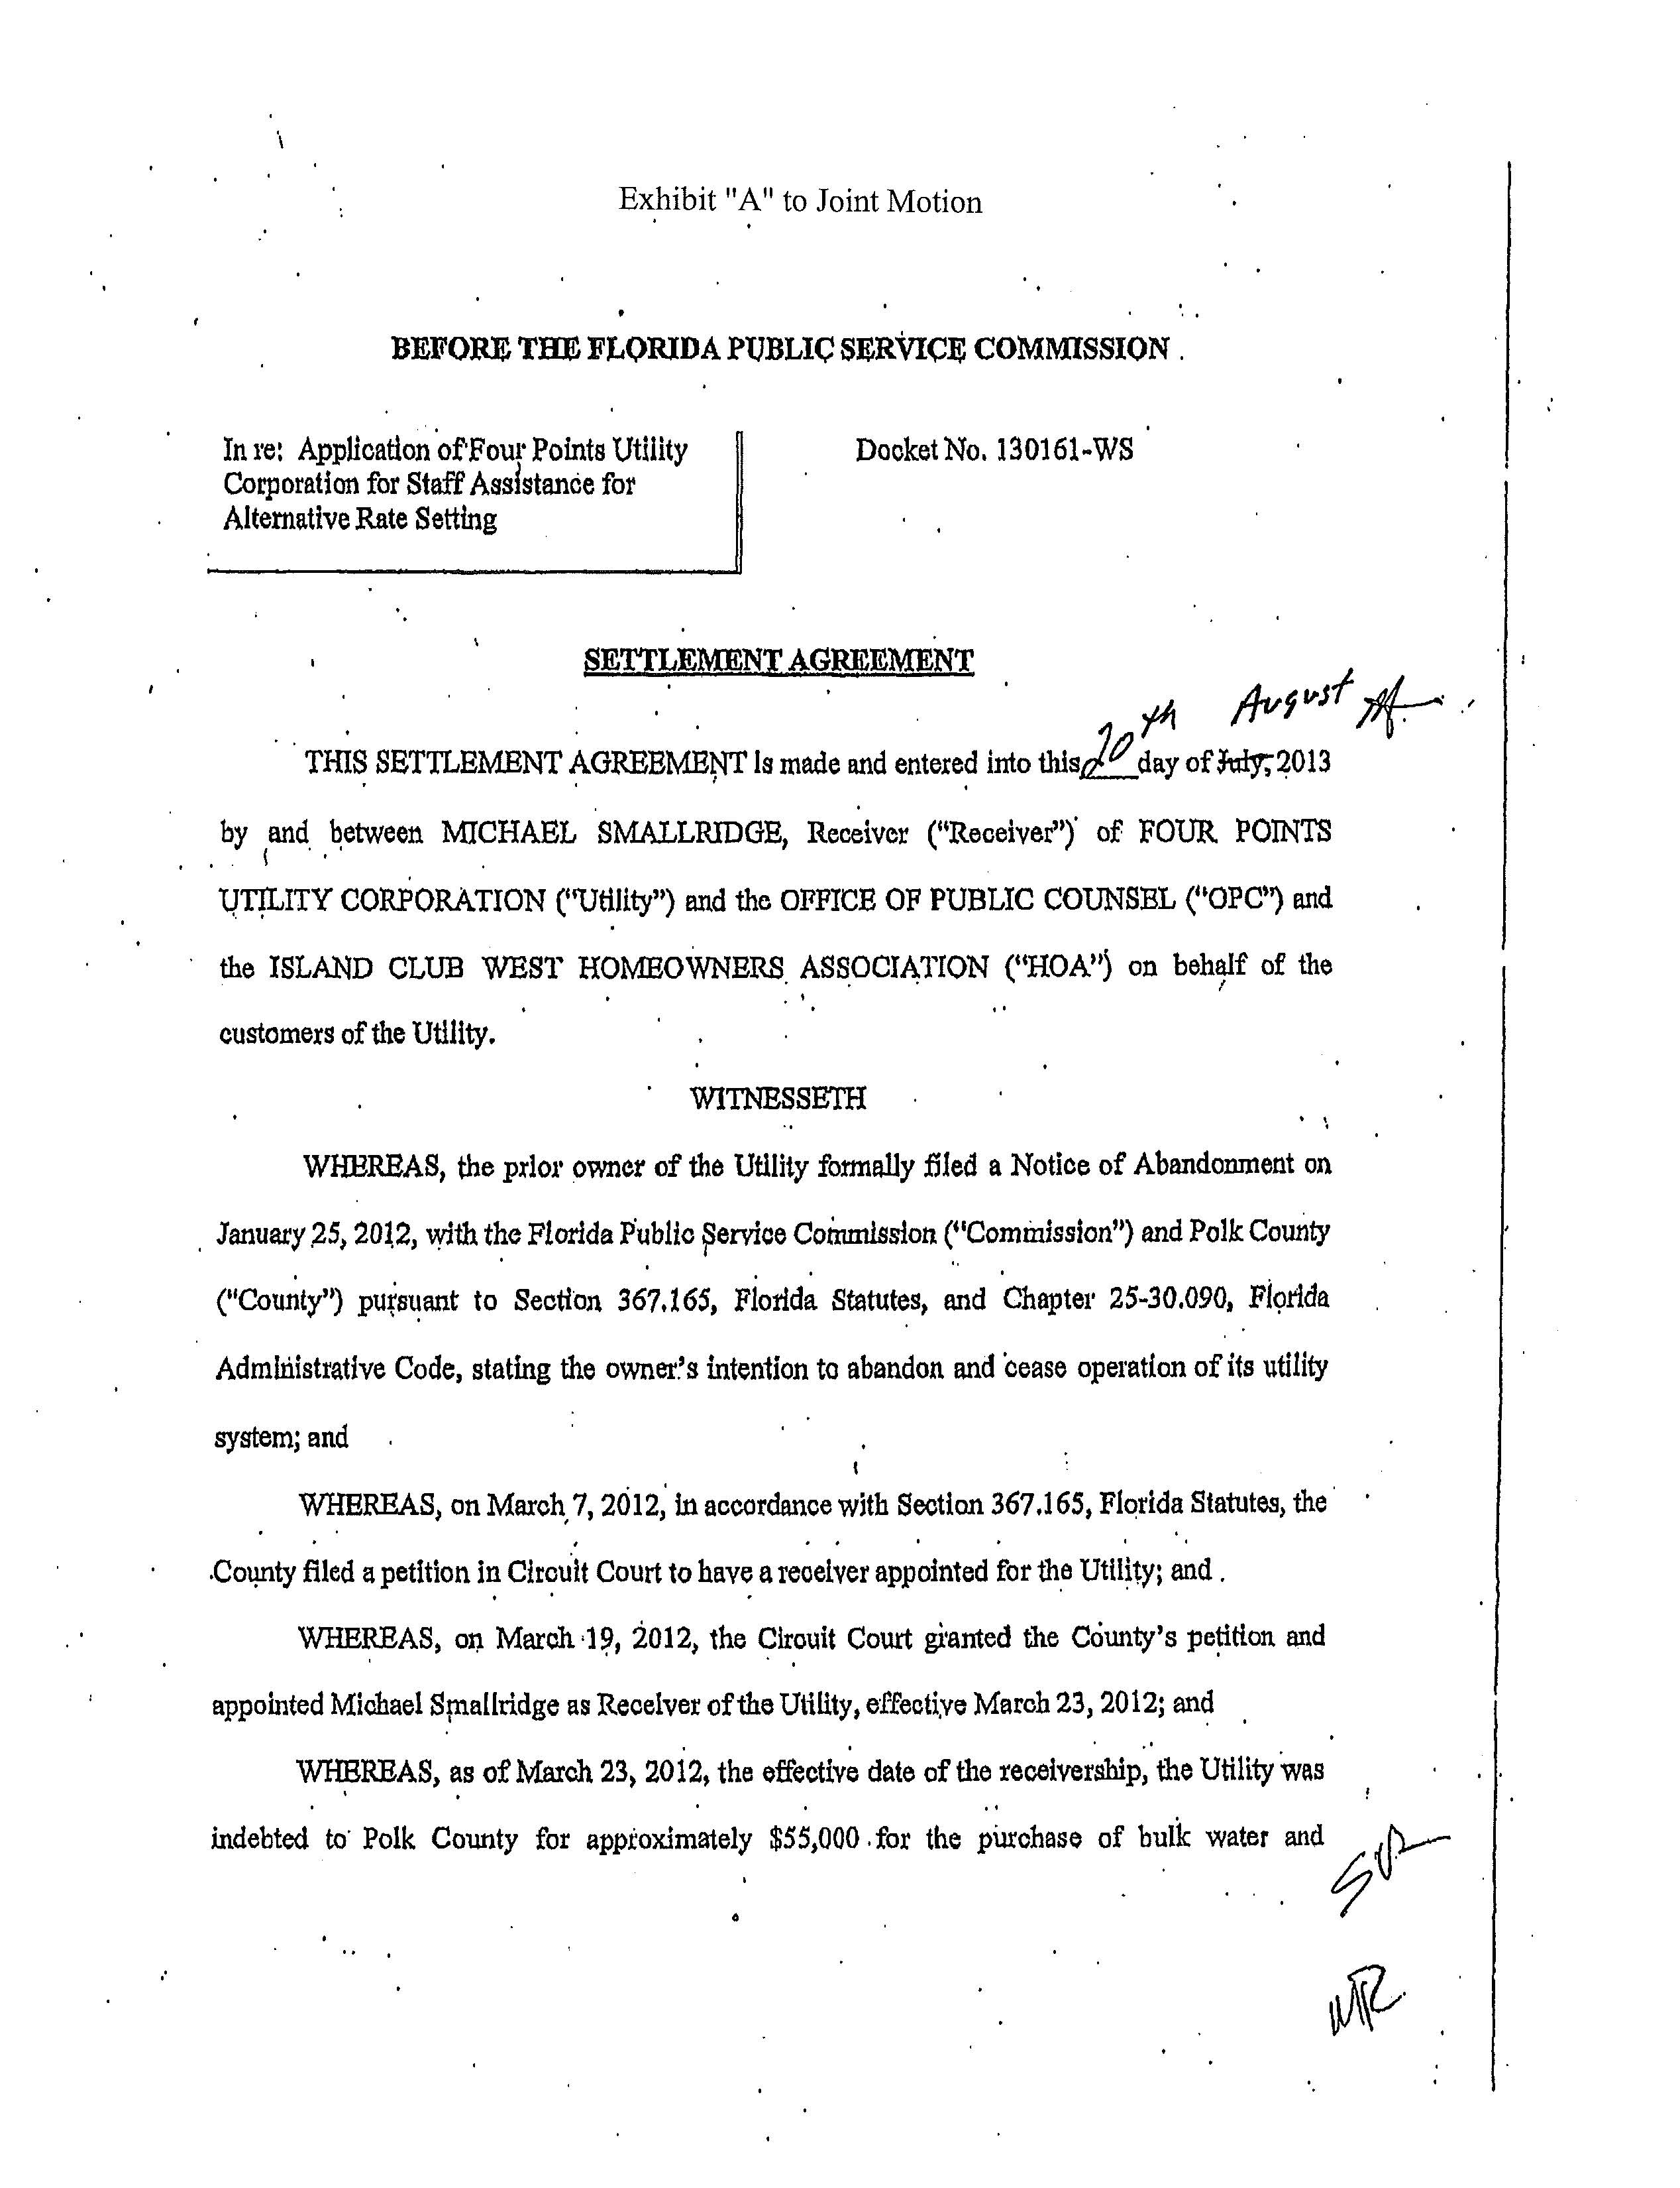
Attachment A
Page 2 of 7
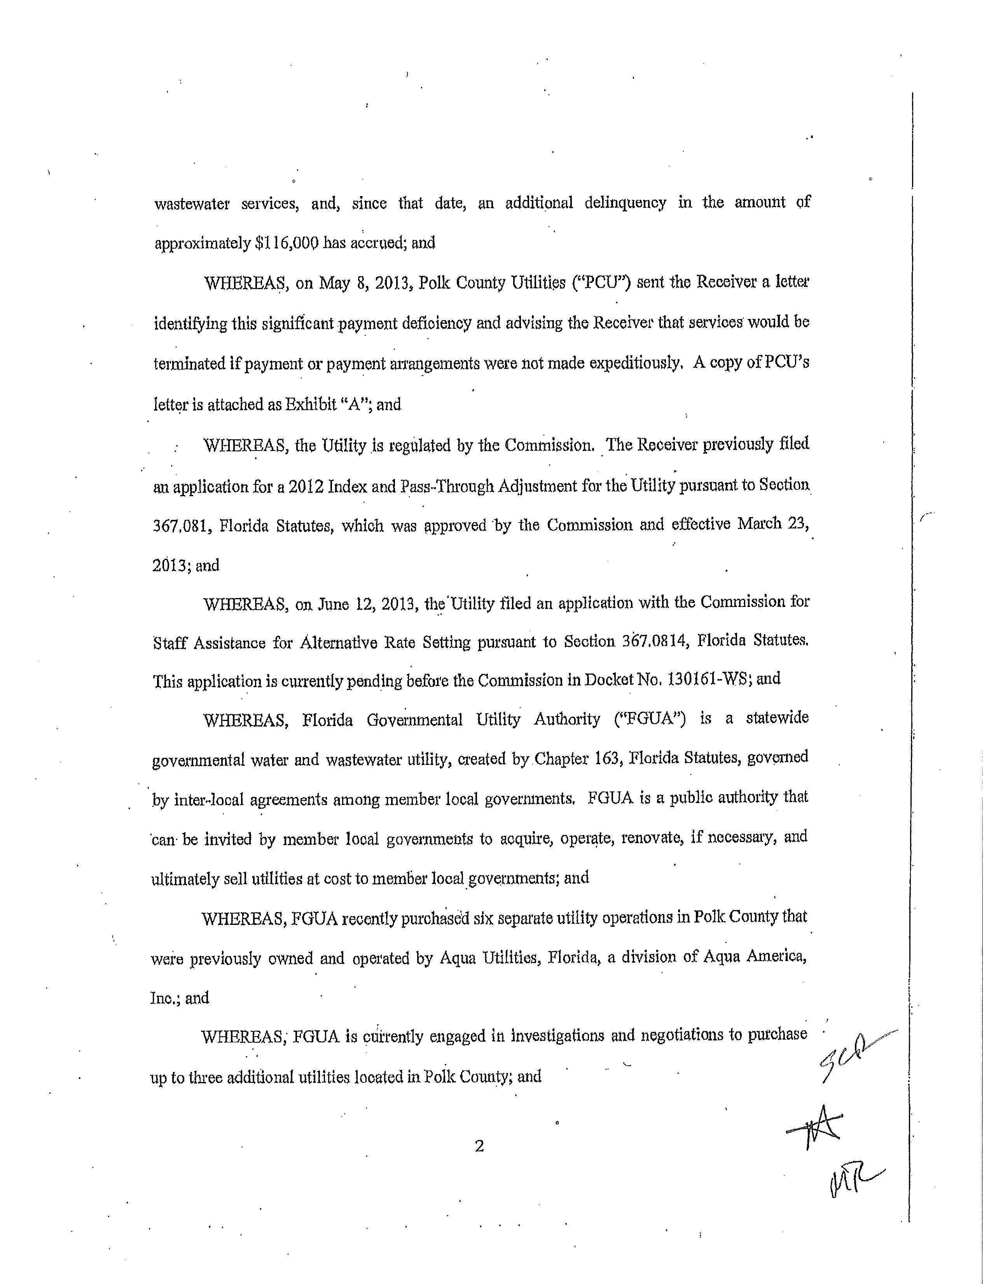
Attachment A
Page 3 of 7
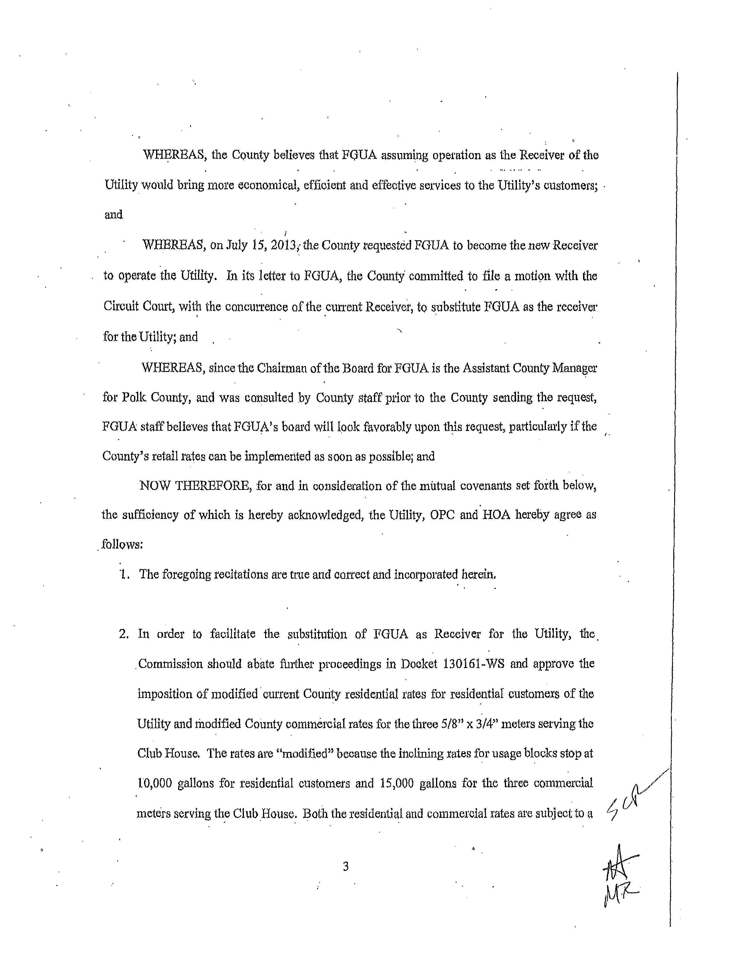
Attachment A
Page 4 of 7
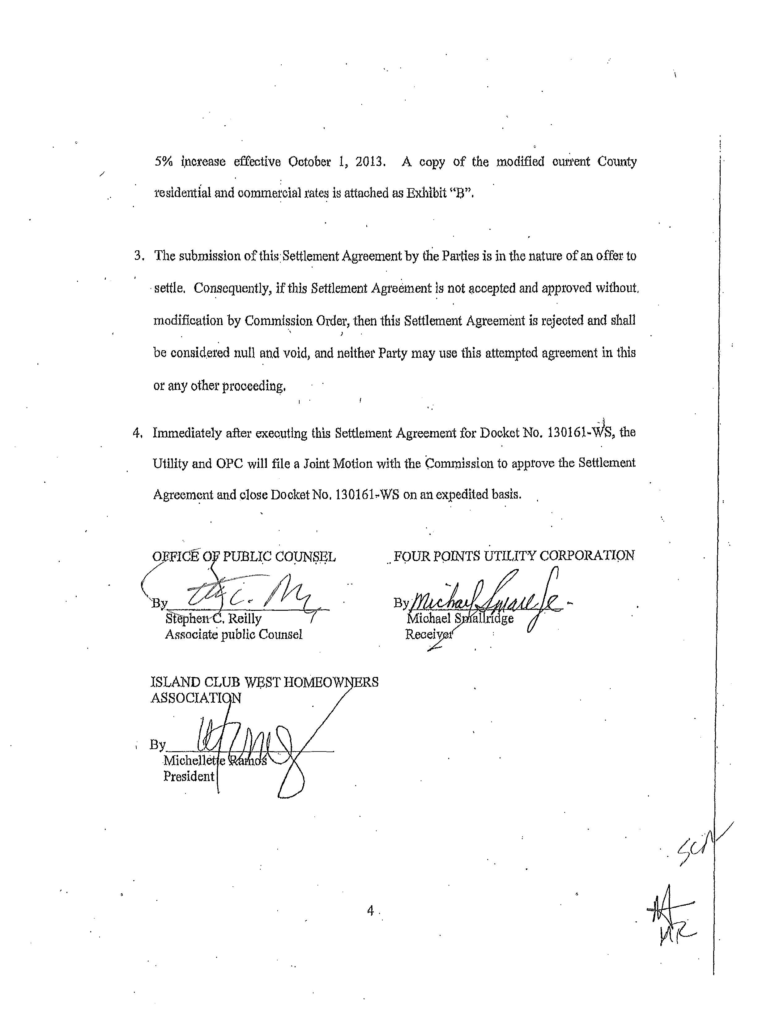
Attachment A
Page 5 of 7
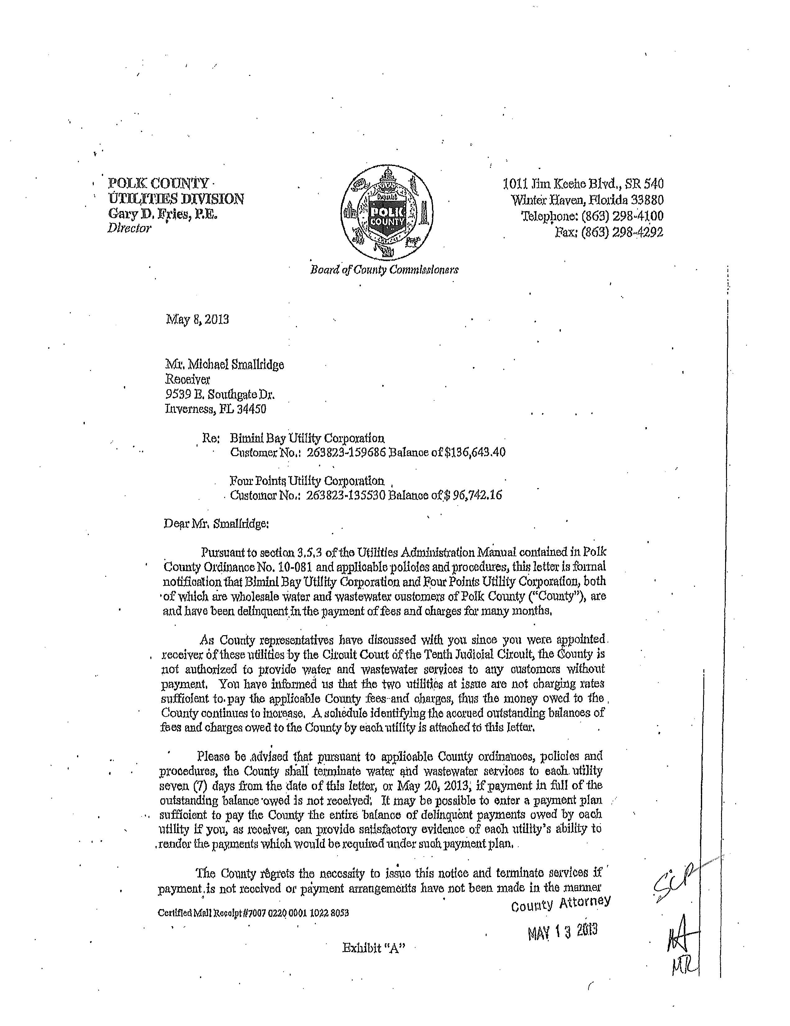
Attachment A
Page 6 of 7
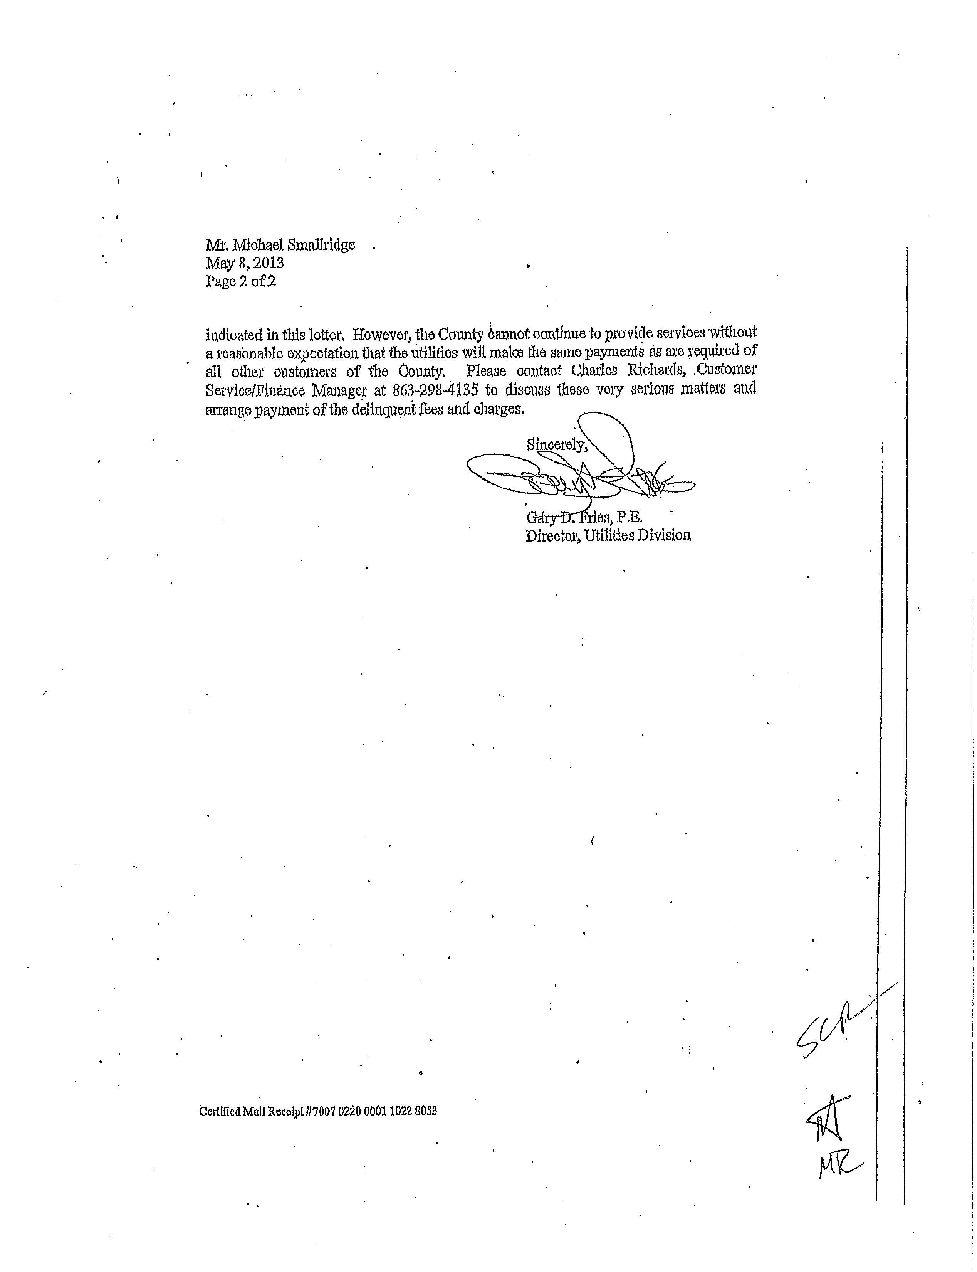
Attachment A
Page 7 of 7
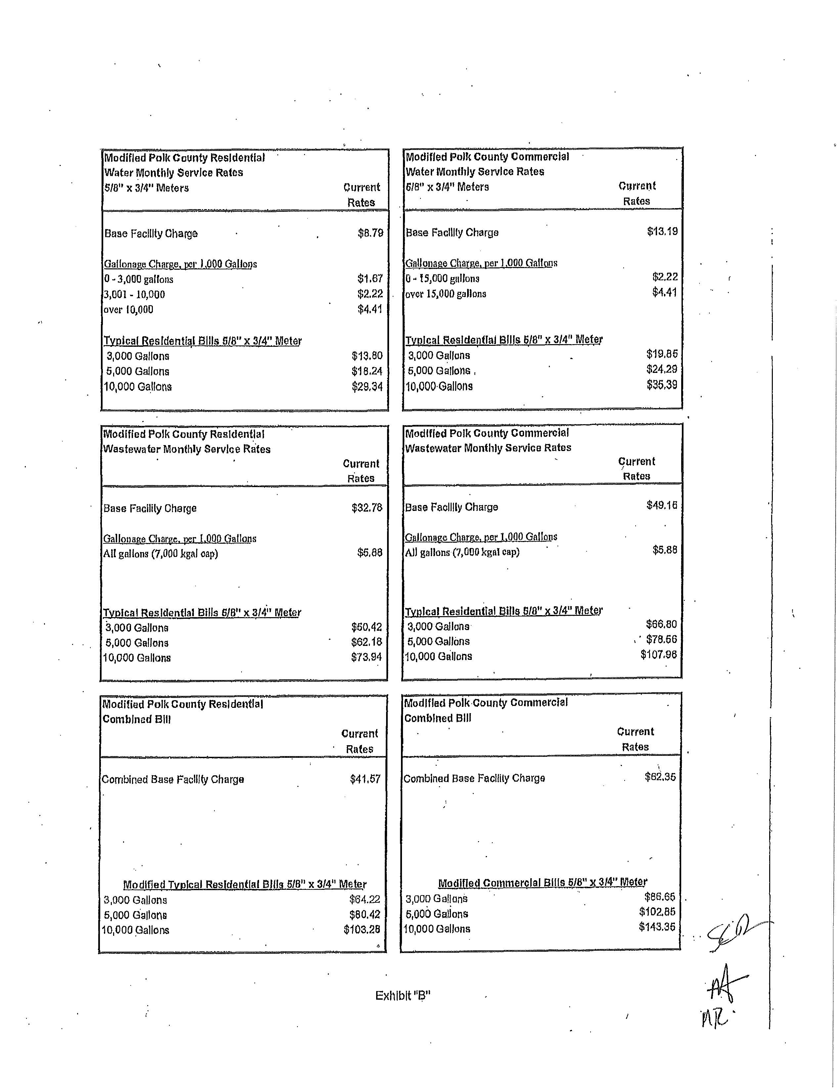
Attachment B
Page 1 of 5

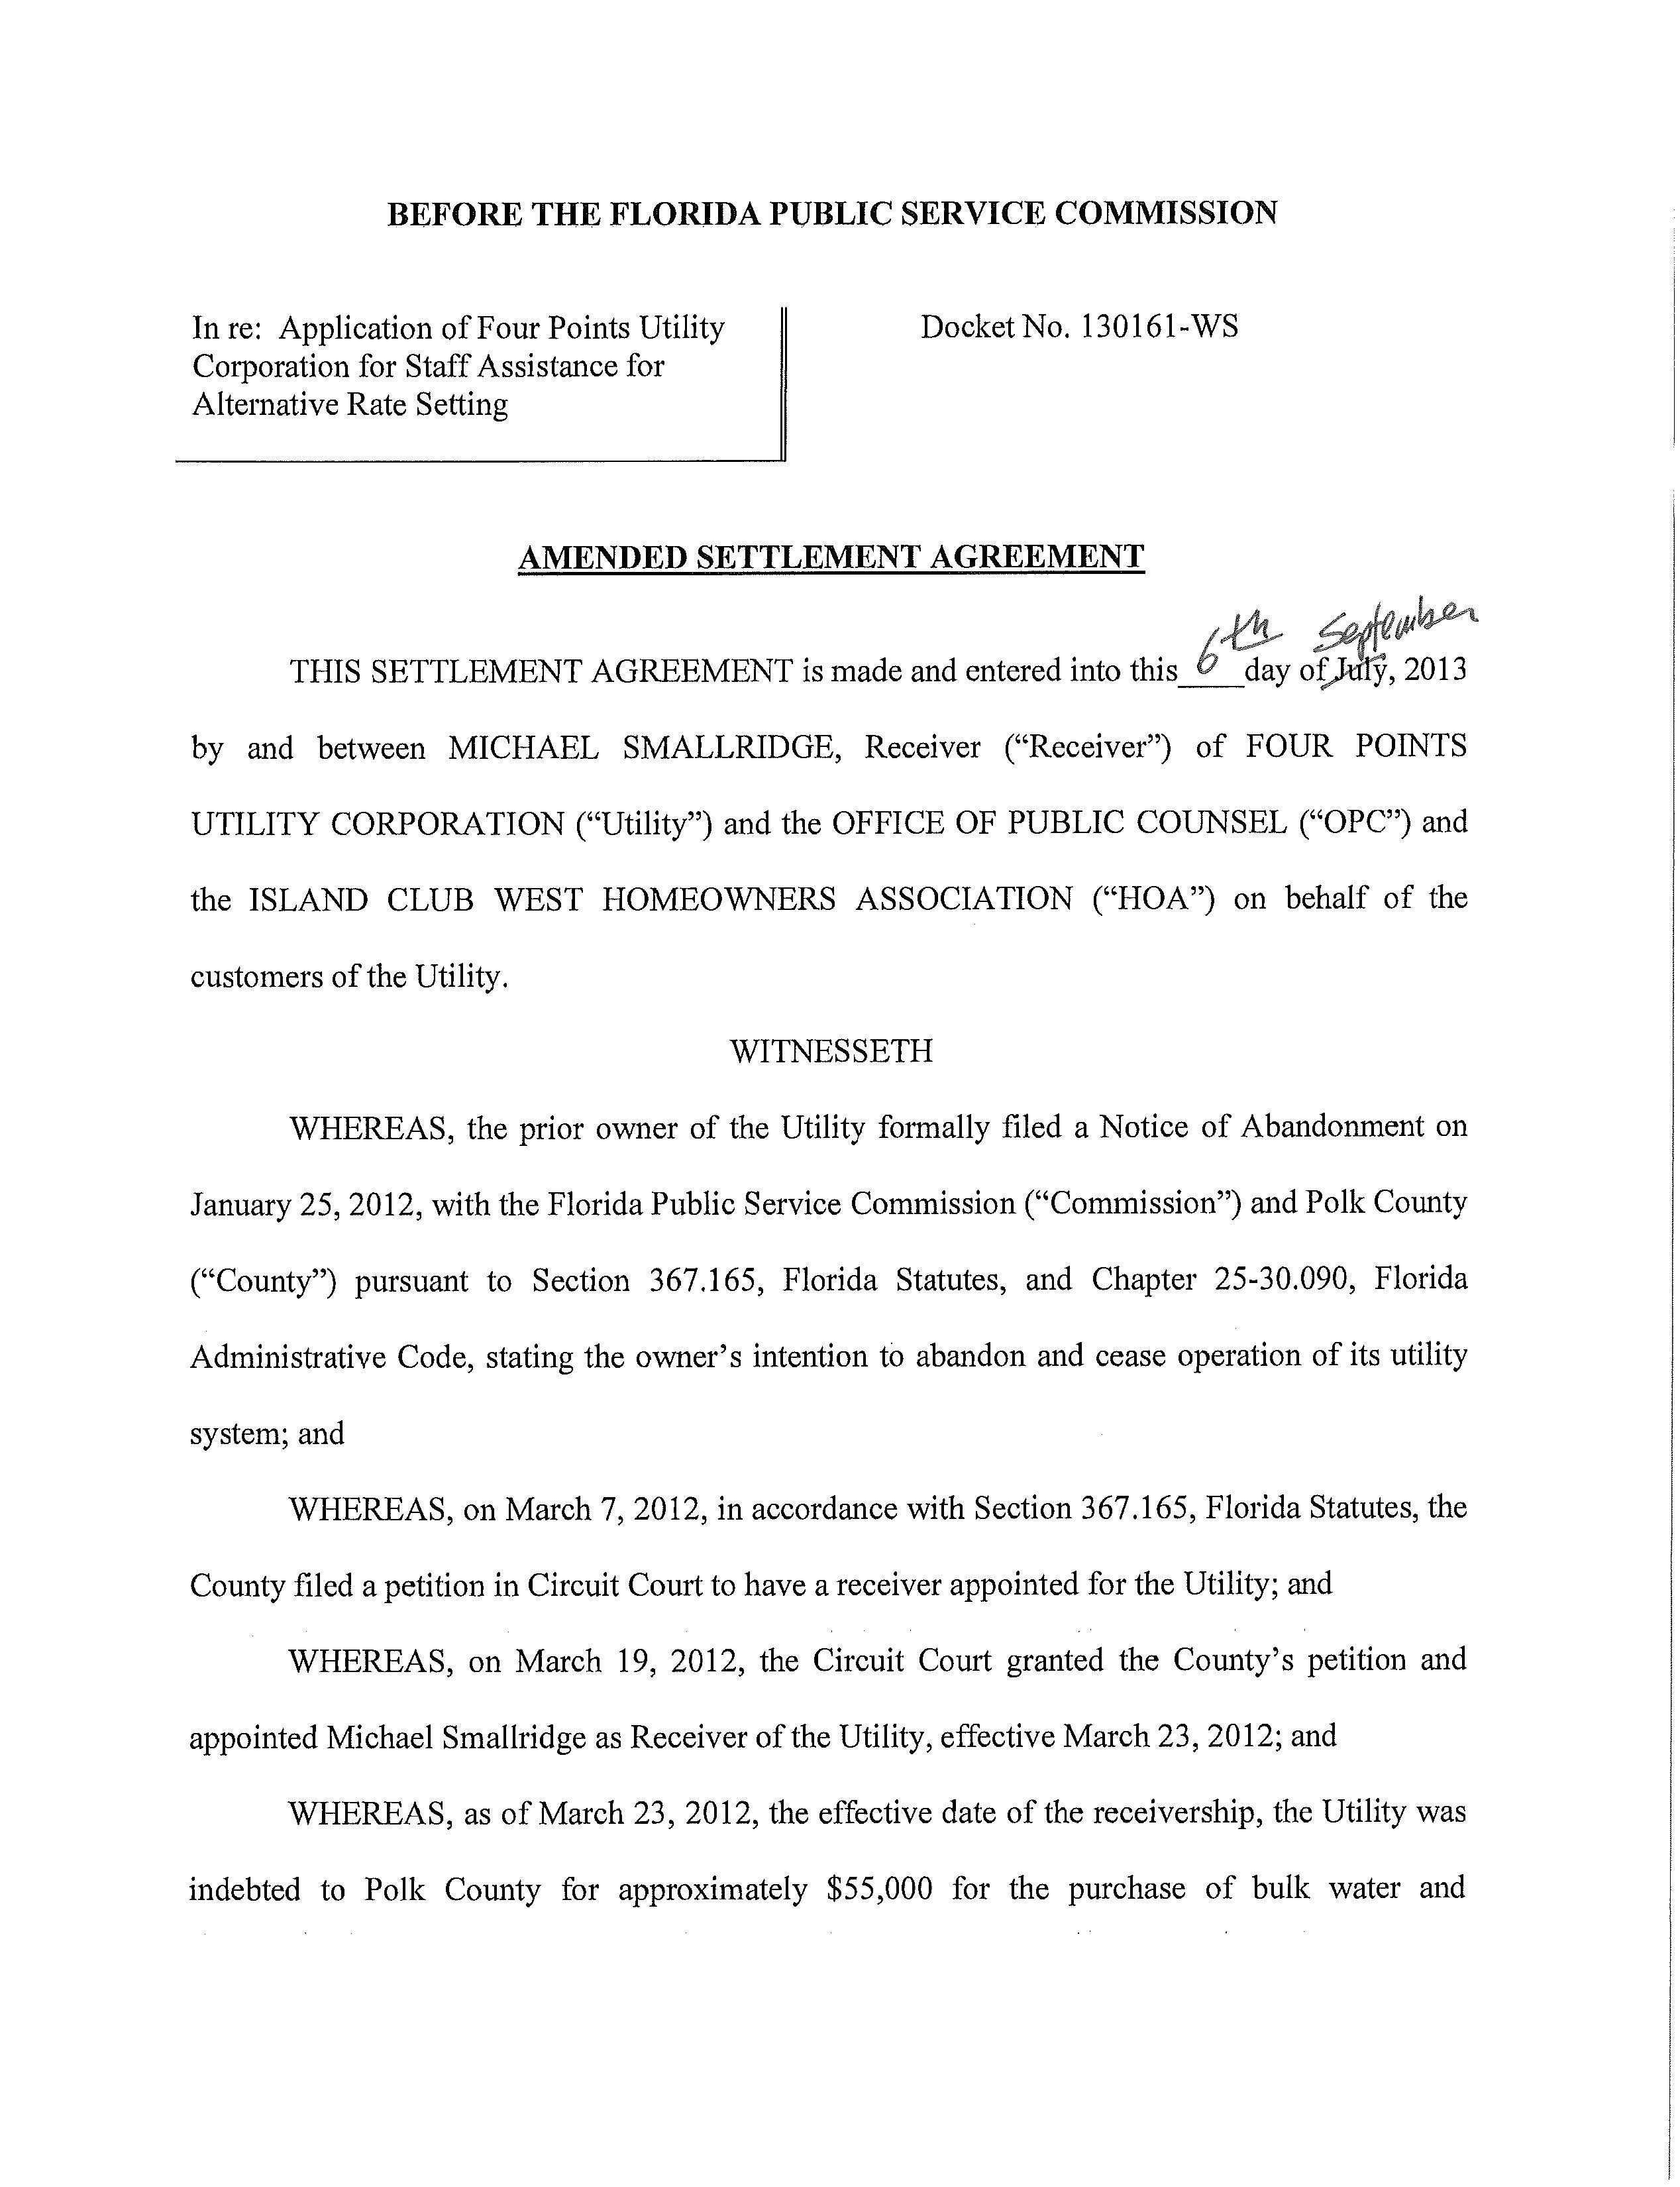
Attachment B
Page 2 of 5
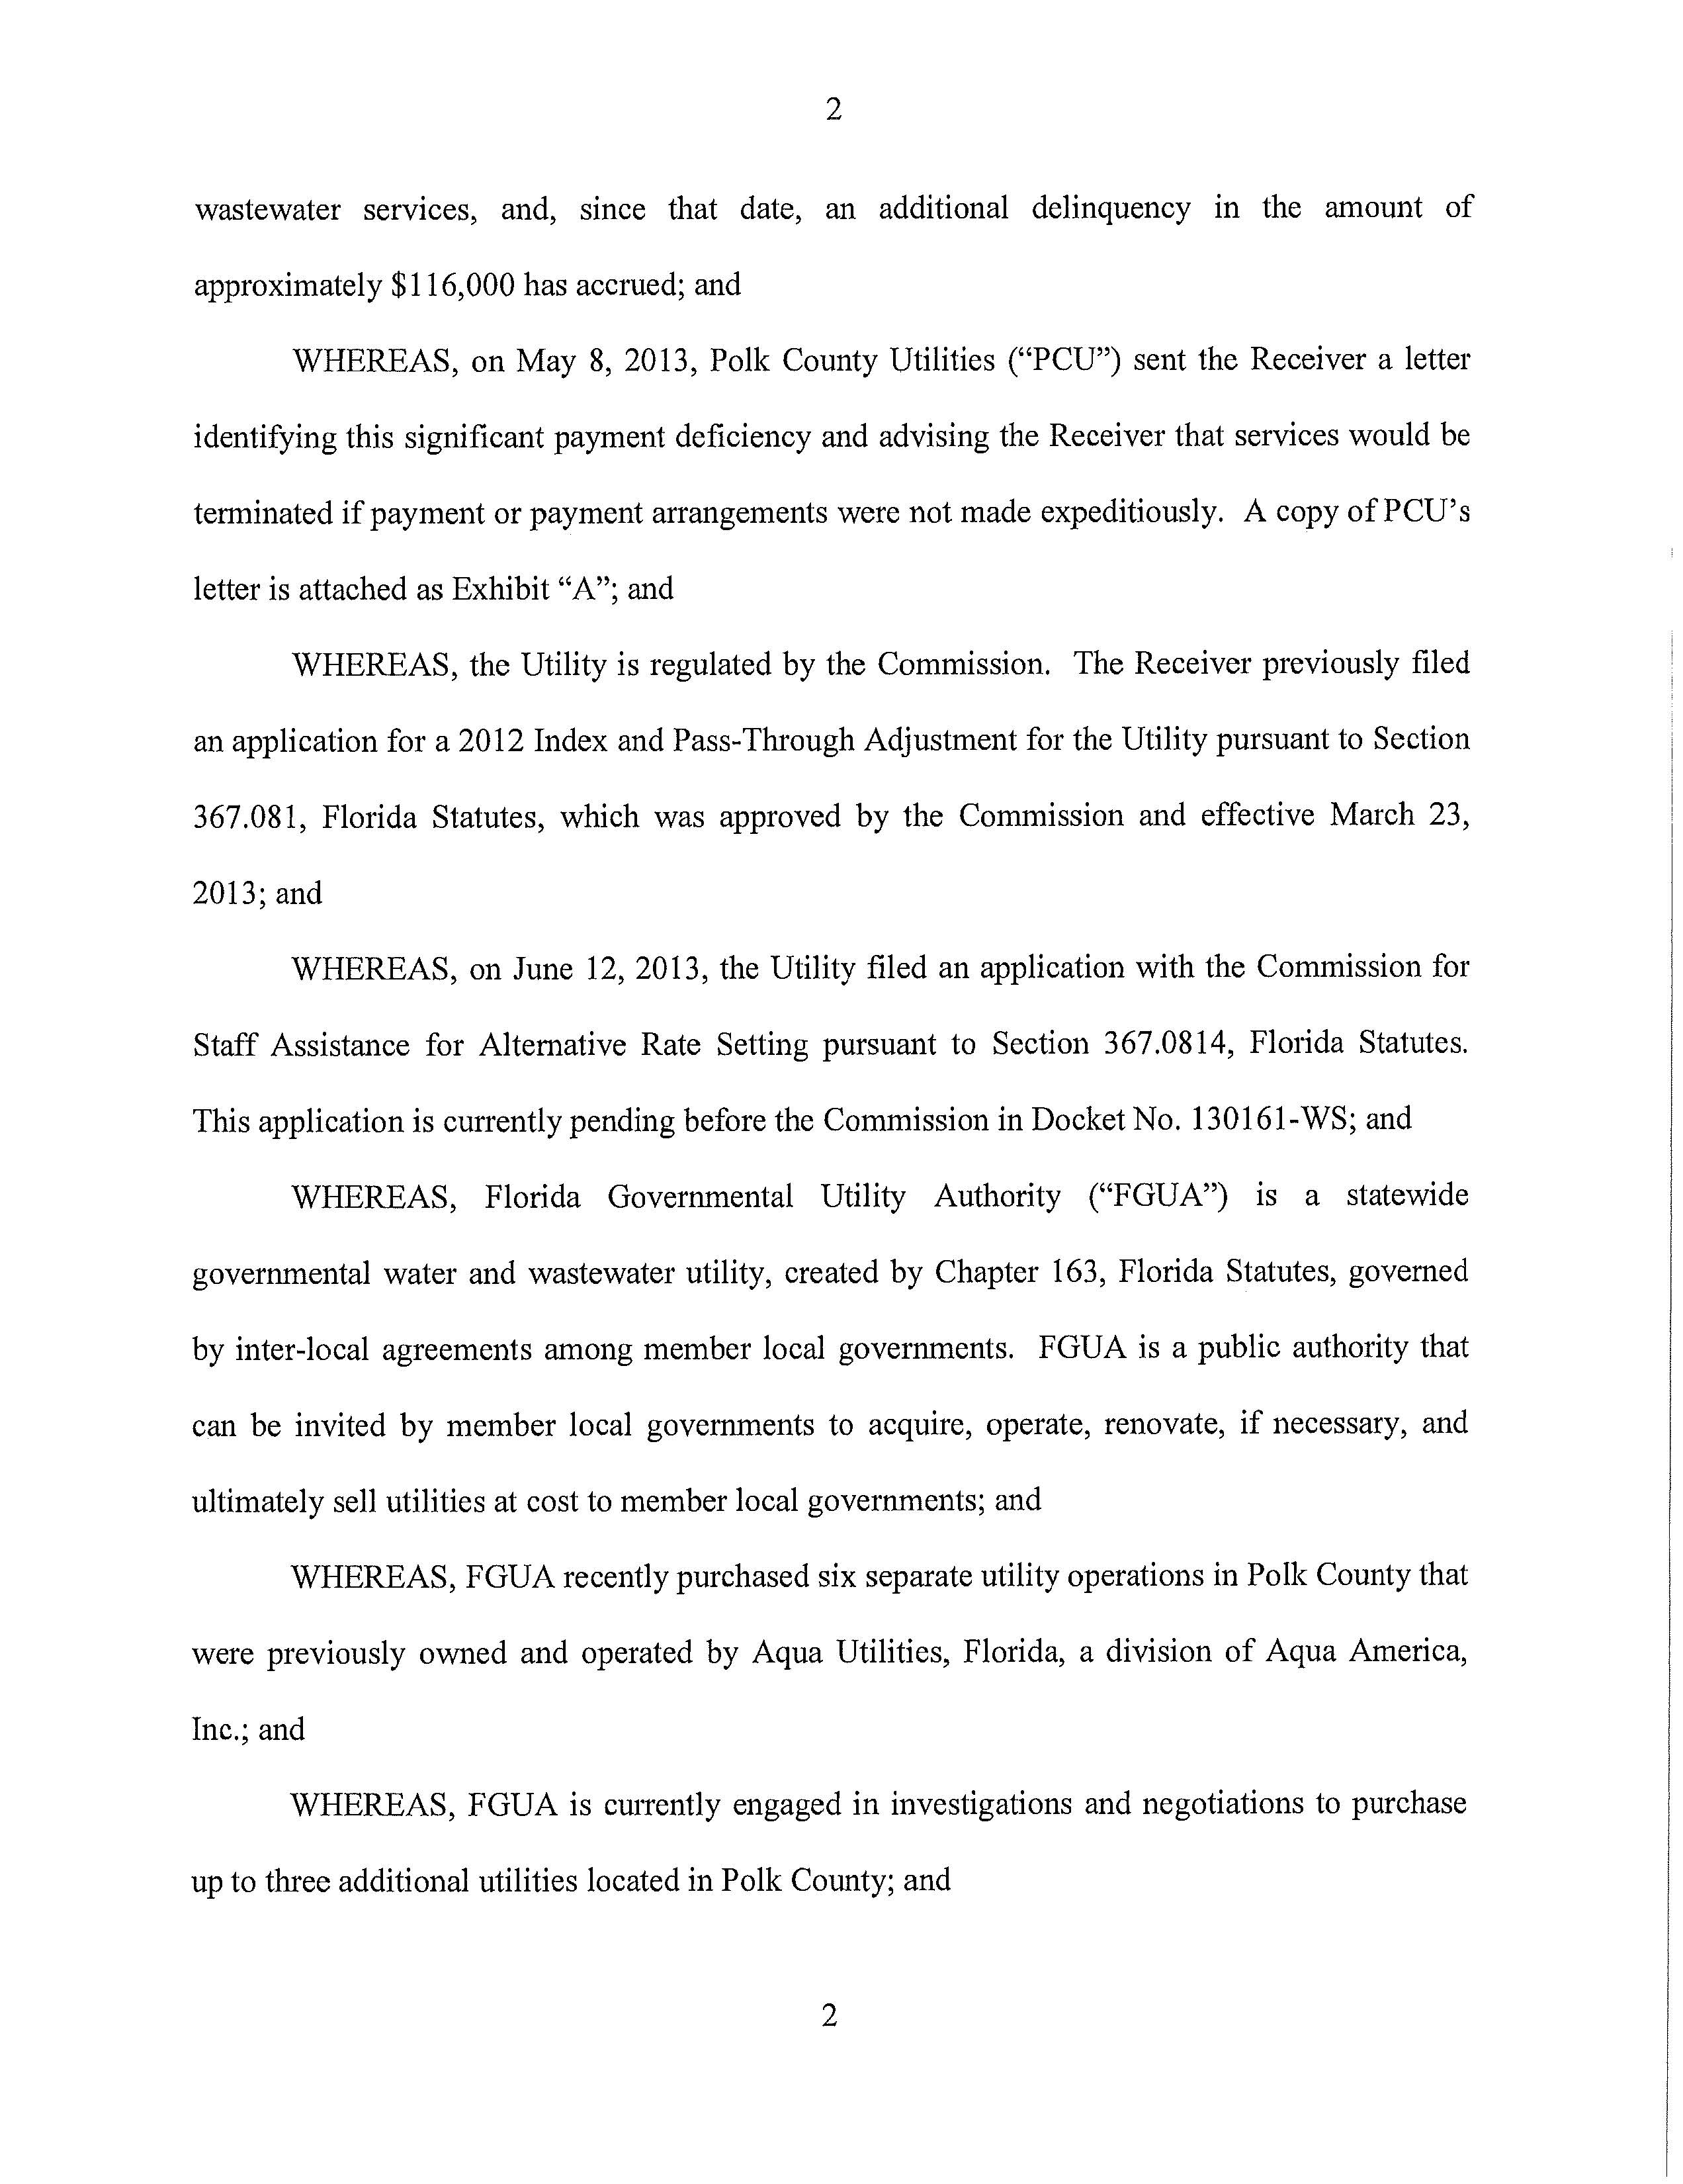
Attachment B
Page 3 of 5

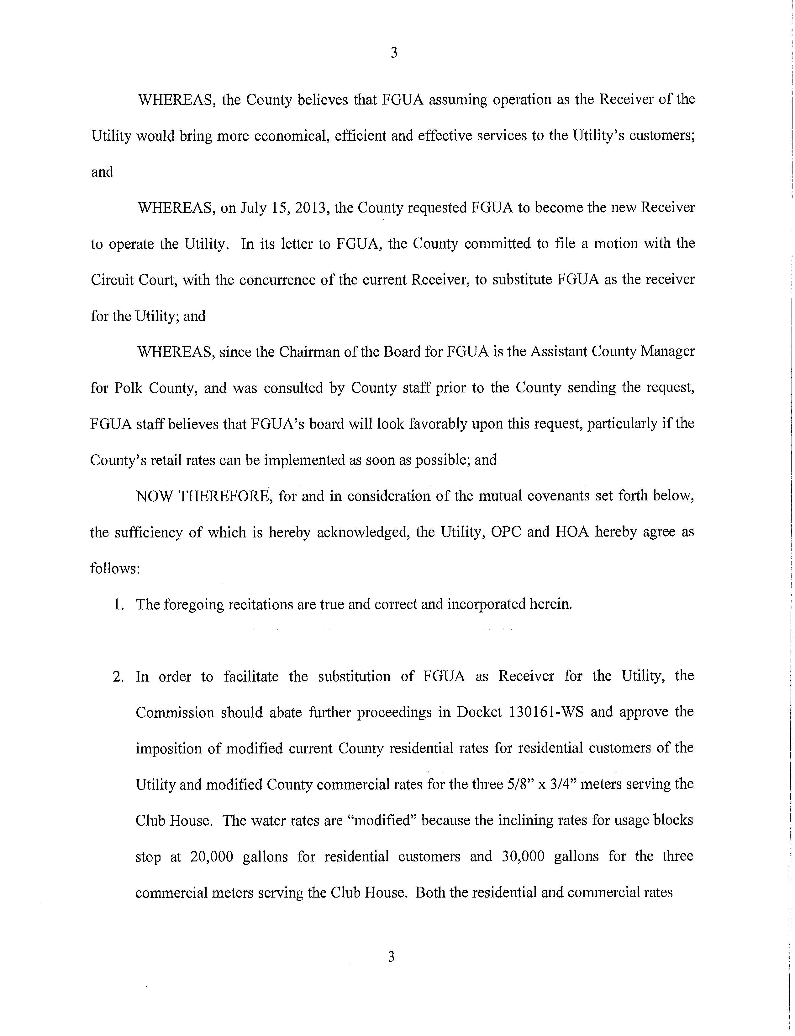
Attachment B
Page 4 of 5
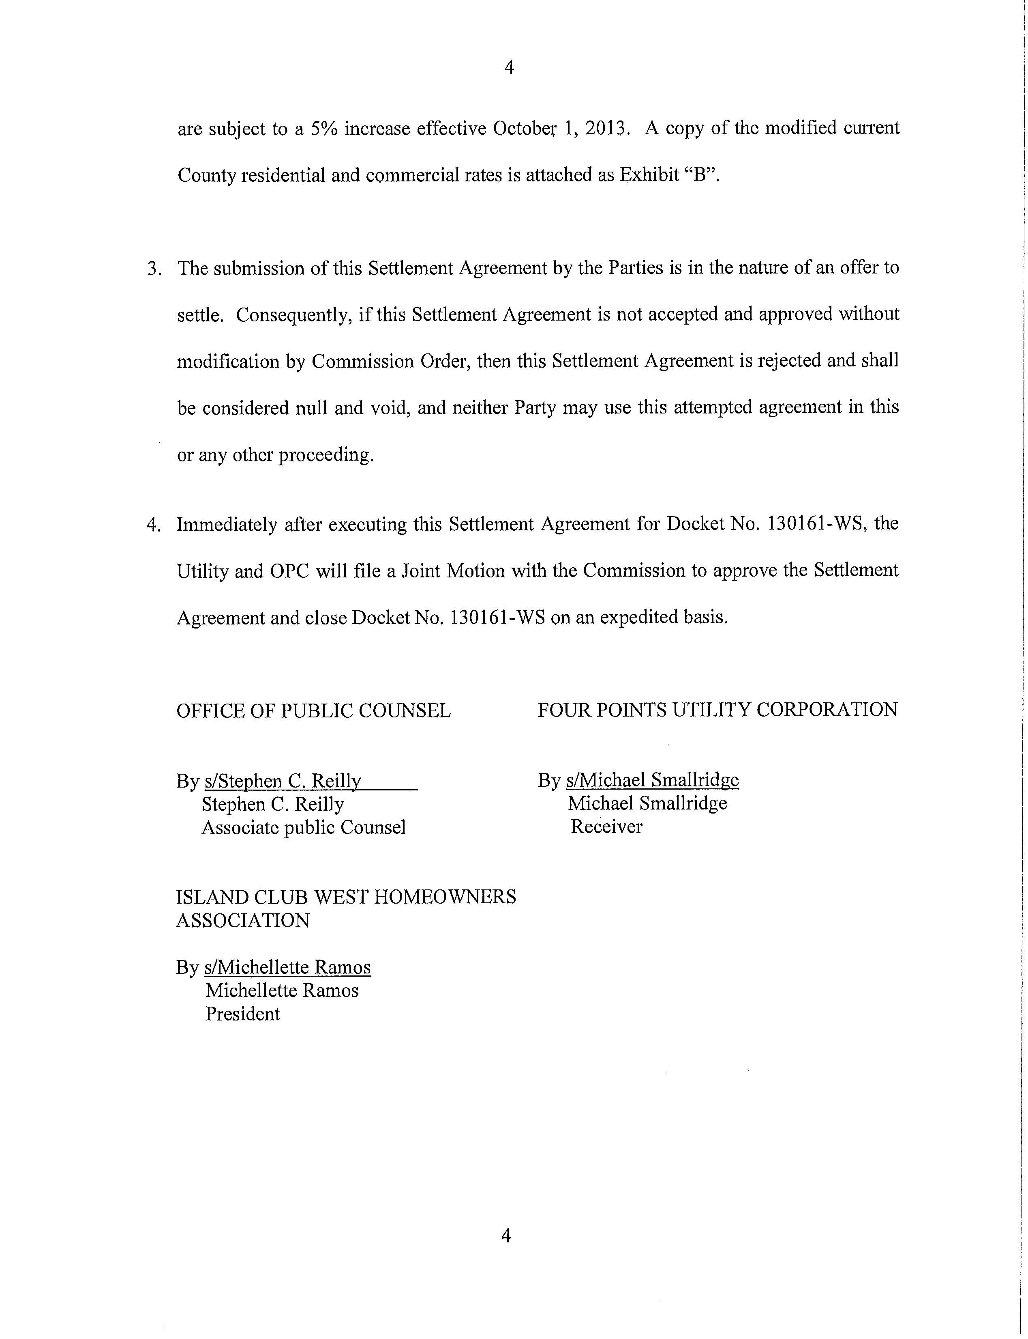
Attachment B
Page 5 of 5

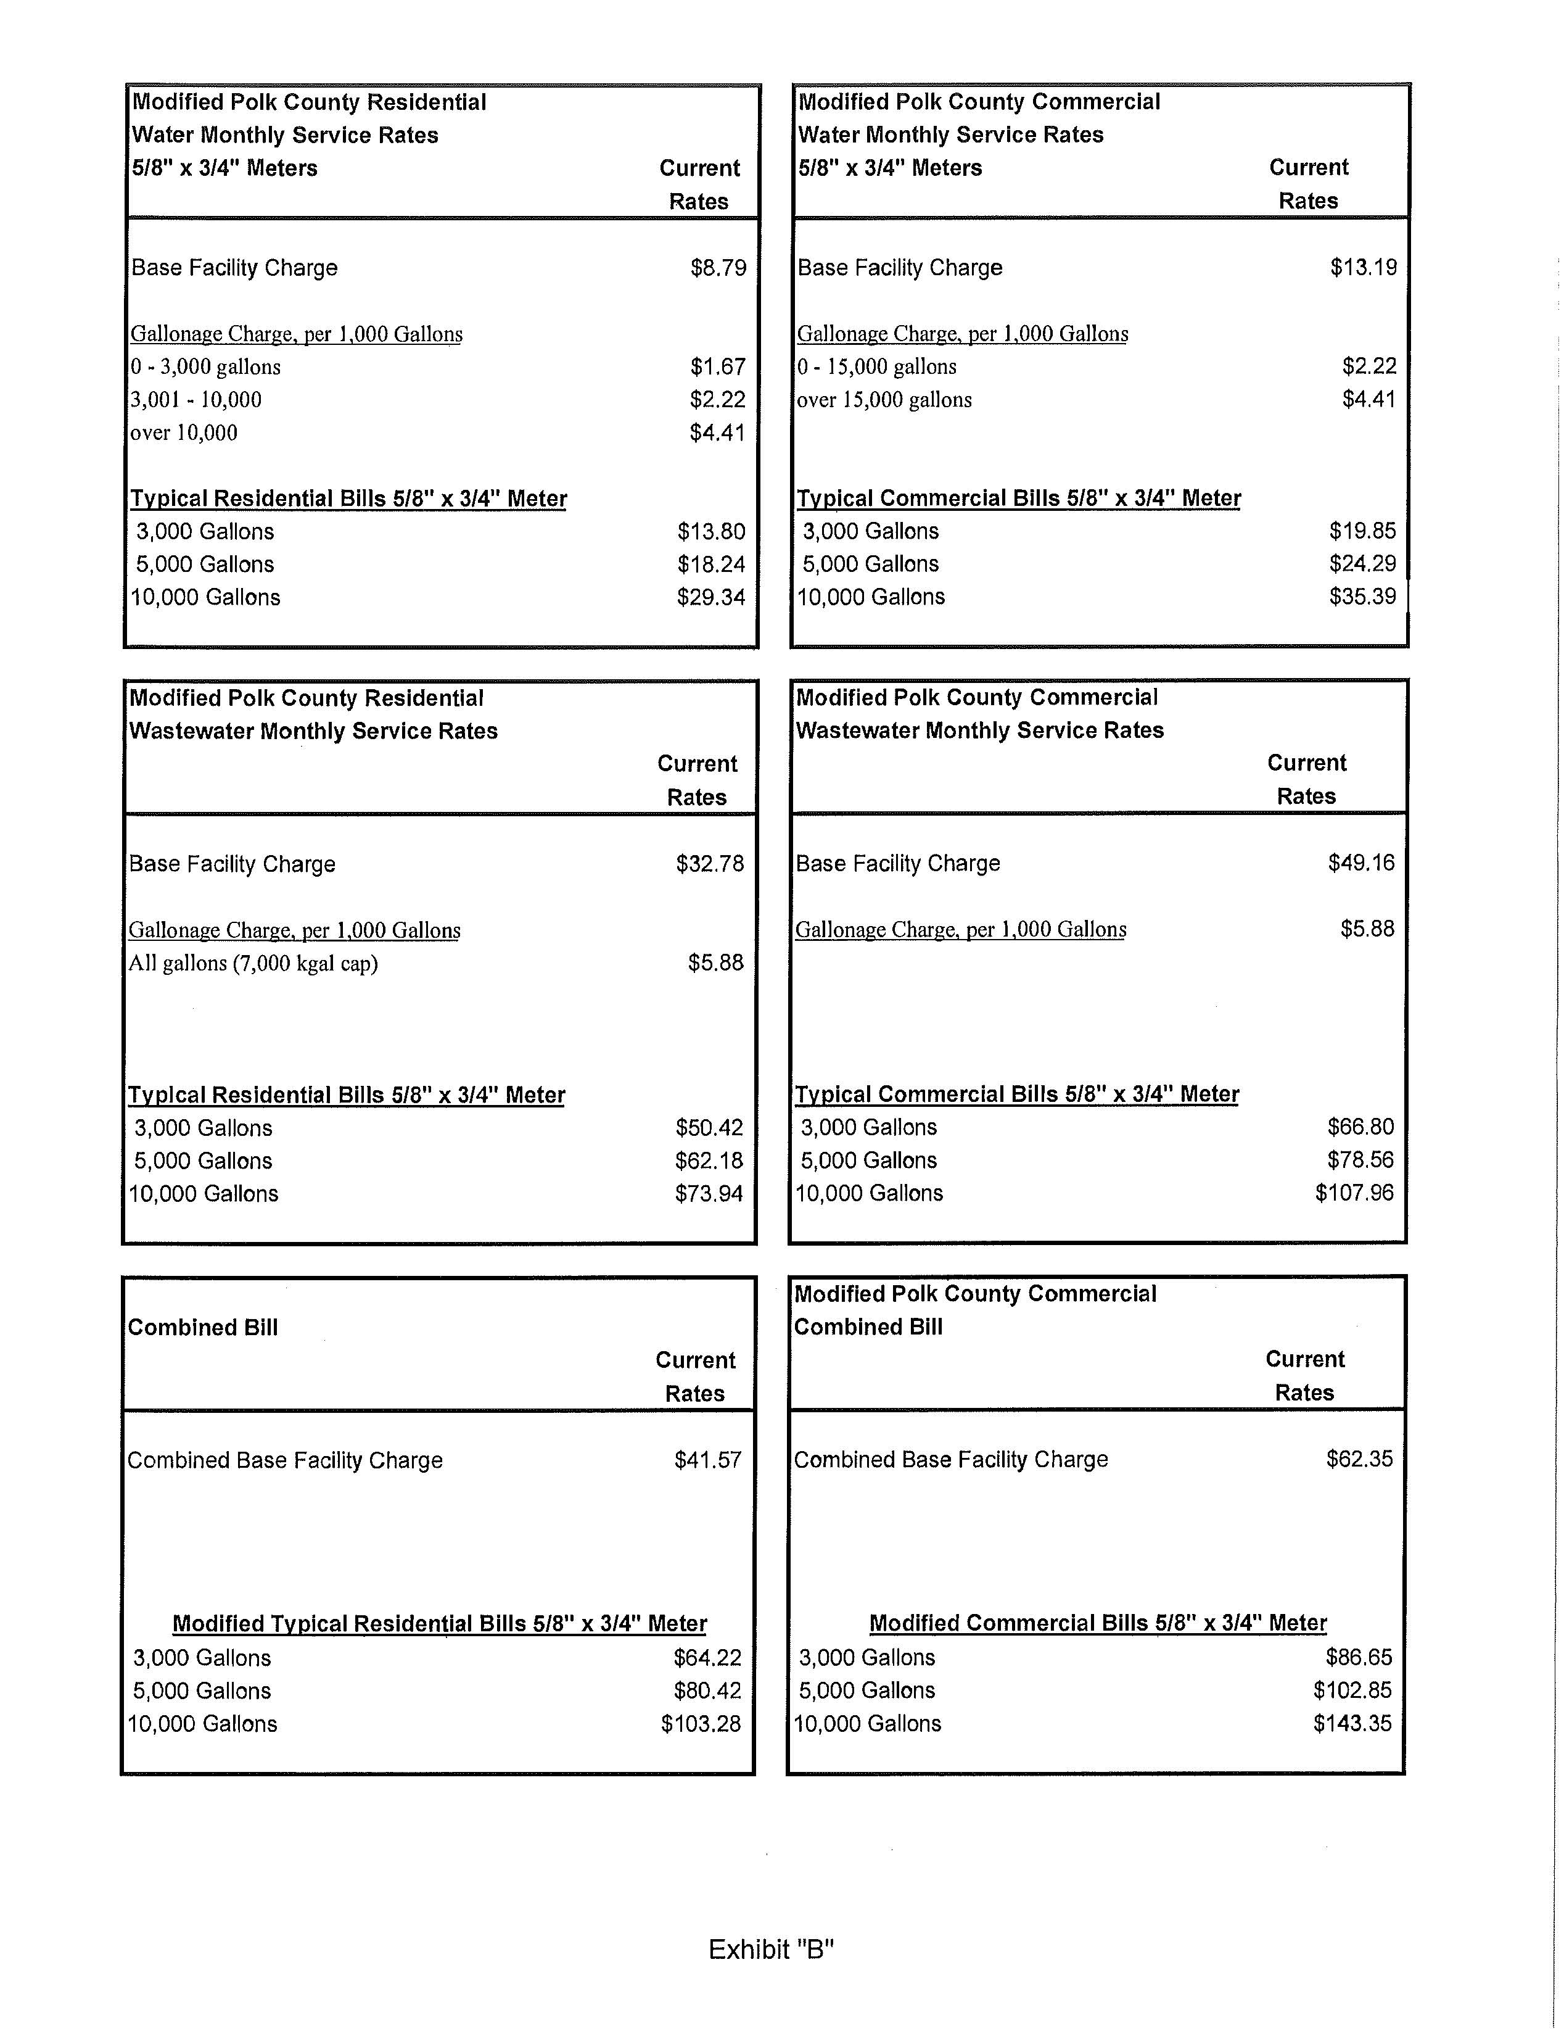
Attachment C
Page 1 of 2
Water Rates
 |  | Commission-Approved |  | Modified County |  |  | 10/1/2013 Modified County
 |  | Rates |  | Rates |  |  | Rates
 | Residential
 | Base Facility Charge – All Meter Sizes | $12.06 |  | $8.79 |  |  | $9.23
 | Charge per 1,000 Gallons - Residential
 | 0-10,000 Gallons | $2.94
 | 0- 3,000 Gallons | N/A |  | $1.67 |  |  | $1.75
 | 3,001- 10,000 Gallons | N/A |  | $2.22 |  |  | $2.33
 | Over 10,000 Gallons | $3.58 |  | $4.41 |  |  | $4.63
 | General Service
 | Base Facility Charge – All Meter Sizes | $12.06 |  | $13.19 |  |  | $13.85
 | Charge per 1,000 Gallons – General Service
 | 0- 15,000 Gallons | $2.94 |  | $2.22 |  |  | $2.33
 | Over 15,000 Gallons | $3.58 |  | $4.41 |  |  | $4.63
 | Typical Residential Bills 5/8" x 3/4" Meter
 | 3,000 Gallons | $20.88 |  | $13.80 |  |  | $14.49
 | 5,000 Gallons | $26.76 |  | $18.24 |  |  | $19.15
 | 10,000 Gallons | $41.46 |  | $29.34 |  |  | $30.81
Attachment C
Page 2 of 2
Wastewater Rates
 |  |  |  |  |  | 10/1/2013
 |  |  | Commission- |  | Modified | Modified
 |  |  | Approved |  | County | County
 |  |  | Rates |  | Rates | Rates
 | Residential
 | Base Facility Charge – All Meter Sizes |  | $19.44 |  | $32.78 | $34.42
 | Charge per 1,000 Gallons - Residential*
 | *7,000 Gallon cap |  |  |  | $5.88 | $6.17
 | *10,000 Gallon cap |  | $4.97
 | General Service
 | Base Facility Charge– All Meter Sizes |  | $19.44 |  | $49.16 | $51.62
 | Gallonage Charge per 1,000 – General Service |  | $4.97 |  | $5.88 | $6.17
 | Typical Residential Bills 5/8" x 3/4" Meter
 | 3,000 Gallons |  | $34.35 |  | $50.42 | $52.94
 | 5,000 Gallons |  | $44.29 |  | $62.18 | $65.29
 | 10,000 Gallons |  | $69.14 |  | $73.94 | $77.64

See Order No. PSC-07-0280-PAA-WS, issued April 2, 2007, in Docket No. 050595-WS, In re: Application for certificates to provide water and wastewater service in Polk County by Four Points Utility Corporation.
See Document No. 10894-09, filed October 27, 2009, in Docket No. 090213-WS.
See Order No. PSC-11-0541-SC-WS, issued November 22, 2011, in Docket No. 110254-WS, In re: Initiation of show cause proceedings against Four Points Utility Corporation in Polk County for violation of Commission rules and regulations as outlined in the Florida Public Service Commission's management audit for Four Points Utility Corporation and Bimini Bay Utilities Corporation issued June 2011.
See Document No. 00515-12, filed January 25, 2012, in Docket No. 120030-WS.

