|  |  |  |  |
| --- | --- | --- | --- |
| State of Florida  pscSEAL | | Public Service Commission  Capital Circle Office Center ● 2540 Shumard Oak Boulevard Tallahassee, Florida 32399-0850  -M-E-M-O-R-A-N-D-U-M- | |
| DATE: | July 24, 2025 | | |
| TO: | Office of Commission Clerk (Teitzman) | | |
| FROM: | Division of Economics (P. Kelley)  Office of the General Counsel (Sandy) | | |
| RE: | Docket No. 20250058-GU – Petition for approval of natural gas transportation service agreement between Florida City Gas and Miami-Dade County through Miami-Dade Water and Sewer Department. | | |
| AGENDA: | 08/05/25 – Regular Agenda – Proposed Agency Action – Interested Persons May Participate | | |
| COMMISSIONERS ASSIGNED: | | | All Commissioners |
| PREHEARING OFFICER: | | | Graham |
| CRITICAL DATES: | | | None |
| SPECIAL INSTRUCTIONS: | | | None |

Case Background

On April 8, 2025, Florida City Gas (FCG or company) filed a petition seeking approval of a proposed 2025 to natural gas transportation service agreement (TSA) between FCG and Miami-Dade County Water and Sewer Department (MDWASD) through Miami-Dade County. FCG is a public utility as defined by Section 366.02(8), Florida Statutes (F.S.). MDWASD is a water and sewer utility operating in Miami-Dade County, Florida. MDWASD’s Alexander Orr (Orr) and Hialeah Preston (Hialeah) use natural gas at plants to heat lime kilns that produce lime for the water treatment process. The natural gas is also used to power high service pumps that pump water through MDWASD’s water distribution system to customers.

Currently, FCG is providing natural gas transportation service to MDWASD’s Orr and Hialeah plants via the TSA the Commission approved by Order No. PSC-2013-0402-PAA-GU (2014 TSA).[1]

The 2014 TSA was needed in order to allow FCG to provide natural gas transportation service to the Alexander Orr and Hialeah water treatment plants after the expiration of their 2011 TSA (effective August 1, 2009 through December 31, 2013).[2] FCG explained in the petition that the 2014 TSA expired on December 31, 2023.[3]

FCG has continued to provide service to Miami-Dade County’s Orr and Hialeah plants on a month to month basis under the terms of the 2014 TSA while the parties negotiated a new contract. The purpose of the TSA is to create a new agreement between FCG and Miami-Dade County. The term of the proposed 2025 TSA would be a 10-year agreement, backdating to January 1, 2024, to be consecutive with the 2014 TSA.

Contract rate transportation service is available to certain large volume customers like MDWASD subject to Rule 25-9.034, Florida Administrative Code, and to the terms and conditions of FCG’s Commission-approved Load Enhancement Service (LES) tariff.[4] The LES tariff provides that:

1. The customer must be a commercial customer that currently receives service under contract or otherwise would take service pursuant to the Flexible Gas Service (FGS), Contract Demand Service (KDS), Transportation Supply Service (TSS), Off-System Sales Service (OSS), or GS-1250k rate schedules in FCG’s tariff.
2. The customer must have an alternative energy source or an economic natural gas bypass alternative, the availability of which shall be documented by the customer and verifiable by FCG.
3. FCG must demonstrate to the Commission that service under the proposed contract will not impose any additional costs on FCG’s other rate classes, including at a minimum, that the rate shall not be set lower than the incremental cost of service plus some additional amount as a reasonable return on investment.
4. FCG is not compelled to offer service under contract, but if offered it shall be pursuant to mutually agreeable terms and conditions.
5. In developing rates for a contract under the LES tariff, FCG is required to evaluate competitive and overall economic market conditions.
6. The agreed-upon contract must be approved by the Commission prior to execution by the parties.

Pursuant to the proposed TSA, attached hereto as Attachment A to this recommendation, FCG would continue to serve Miami-Dade County’s Orr and Hialeah plants. During the evaluation of the petition, staff issued a data request to FCG. Responses from FCG were received on June 2, 2025. The Commission has jurisdiction over this matter pursuant to Sections 366.04, 366.05, and 366.06, F.S.

Discussion of Issues

Issue 1:

 Should the Commission approve the proposed transportation service agreement dated January 1, 2024, between FCG and Miami-Dade County?

Recommendation:

 Yes, The Commission should approve the proposed transportation service agreement dated January 1, 2024, between FCG and Miami-Dade County. The 2025 TSA is based on the LES tariff rate case which provides clear specifications for contractual rates, terms, and conditions such as those negotiated by and Miami-Dade County. Based on staff’s review of the petition and responses given by FCG to data requests, staff believes the 2025 TSA complies with the LES tariff. (P. Kelley)

Staff Analysis:

Proposed Transportation Service Agreement

The 2025 TSA continues the plant-specific volumetric rate structure first established in 2011 and updated with the 2014 TSA. The 2025 TSA has updated the volumes and rates for each plant. FCG and Miami-Dade County indicate of the contract will provide for cost-based rates that recover the incremental costs of service plus some additional amount to recover some of FCG’s common costs. The LES tariff indicated the Competitive Rate Adjustment tariff may apply in this instance. The proposed term of the 2025 TSA is for ten years beginning January 1, 2024, which would backdate the term to be consecutive with the 2014 TSA.

Analysis of Bypass Alternatives Available to Miami-Dade County

The Commission has historically approved various load retention tariff schedules similar to FCG's LES tariff for gas transportation utilities which are designed to allow utilities to retain customers who have demonstrated the ability to bypass utility facilities at costs below the normal tariff rates.[5] In instances of demonstrated bypass, load retention tariffs typically encourage negotiated rates that allow the utility to cover its cost of providing service to the customer plus provide some amount of contribution to the common costs of the utility. FCG's LES Rate Schedule’s section titled “Applicability” includes the requirement that, “the Customer must provide the Company verifiable documentation of either a viable alternative fuel or of a Customer's opportunity to economically bypass the Company’s system.” In response to staff’s data request, FCG stated that the bypass assumptions today are the same as they were in the 2014 TSA, only that the bypass costs do interconnect with the Florida Gas Transmission pipeline and have been updated.[6]

To demonstrate the viability of bypass options, it is necessary to show that MDWASD's estimated cost per therm to bypass FCG’s system would be less than the cost per therm that MDWASD would be charged under the GS-1250k tariff rate. The applicable GS-1250k tariff rate is approximately $0.14073 per therm. Attachment A to the joint data request indicates that Miami-Dade County’s estimated costs to bypass FCG’s system for the Orr and Hialeah plants are $0.0233 per therm and $0.0455 per therm, respectively. Based on review of materials submitted in support in support of the petition and additional information provided in response to staff’s data request, staff believes that FCG’s demonstration that Miami-Dade County has verifiable and documented bypass alternatives to the FCG gas transportation facilities at the Orr and Hileah plants is reasonable.

Cost Recovery under the Proposed 2025 TSA

Under the terms of the LES tariff, FCG must demonstrate to the Commission that service under the proposed contract will not impose any additional costs on FCG’s other rate classes, including at the minimum, that the rate shall not be set lower that the incremental cost of service plus some additional amount as a reasonable return on investment. Staff has reviewed the cost support data for the 2025 TSA provided in the petition and in response to staff’s data request.[7]

The cost support provided by the Company indicates that FCG’s operations and maintenance expense estimates account for inflation for all years. As the previous inflationary rate was not sufficient in order for contract rates to be set at a level to allow recovery of incremental costs, the FCG and Miami-Dade County’s negotiated inflationary adjustments to the 2025 TSA rates for beginning the year after the first year of the contract term. In the 2014 TSA, from January 1, 2018 till December 31, 2023, the annual price increase relied on the Bureau of Labor Statistics Consumer Price Index for All Urban Consumer (CPI-U). If the CPI-U did not increase or even decreased in that calendar year, then the transportation rates did not increase. In this TSA, there is an inflation provision that will allow for the annual price to increase by a minimum of no less than 0.75 percent or by the result of the increase to the CPI-U, which ever number is higher for that calendar year.[8]

Staff compared the incremental cost of service to the Orr and Hialeah plants to each plant's proposed 2025 TSA rates. Staff notes that the proposed 2025 TSA rates are set higher than incremental costs for all tier levels (1-3) and all years in the contract term (2024-2033) for both the Orr and the Hialeah plants. The total marginal revenue for the contract term (total revenue less inflation-adjusted costs for the 10-year term) is relatively small, especially for volumes based on proposed Tier 3 volumes and rates. In order to help assess whether rates under the 2025 TSA provide sufficient headroom to cover specified cost risks, staff evaluated the cost impact of volumetric shortfalls.

The risk of volumetric shortfalls has been addressed, at least in part, by the take or pay provision of the 2025 TSA.[9] Under the take or pay provision, if actual volumes are less than the take or pay volumes, the 2025 TSA rates are set sufficiently high to recover the incremental costs of service and provide some level of contribution.

Conclusion

Based upon review of the petition and the additional information provided in response to staff’s data request, staff recommends that the Commission should approve the proposed transportation service agreement dated January 1, 2024, between FCG and Miami-Dade County. The 2025 TSA is based on the LES tariff which provides clear specifications for contractual rates, terms, and conditions such as those negotiated by the join petitioners. Based on staff’s review of the petition and responses provided by FCG to data requests, staff believes the 2025 TSA complies with the LES tariff.Issue 2:

 Should this docket be closed?

Recommendation:

 If no protest is filed by a person whose substantial interests are affected within 21 days of the issuance of the Order, this docket should be closed upon the issuance of a Consummating Order. (Sandy)

Staff Analysis:

 If no protest is filed by a person whose substantial interests are affected within 21 days of the issuance of the Order, this docket should be closed upon the issuance of a Consummating Order.

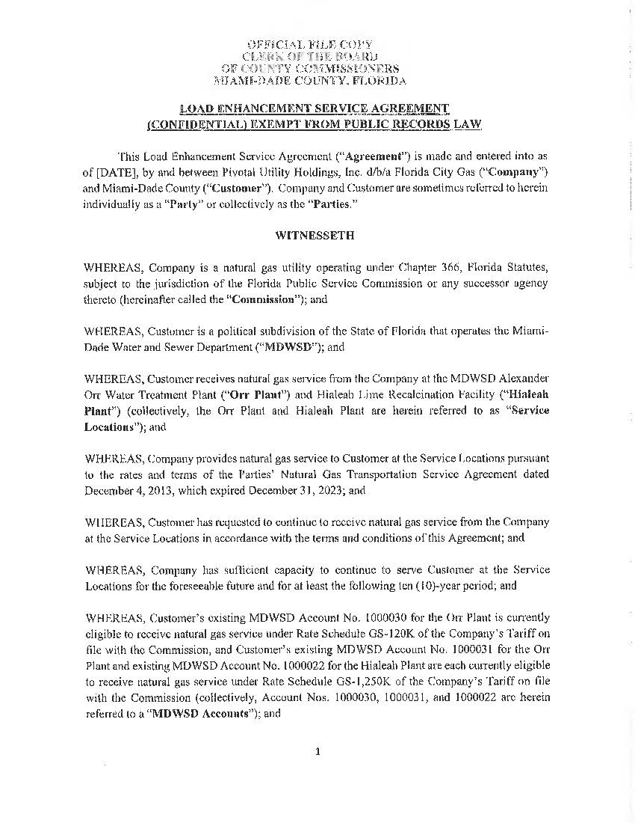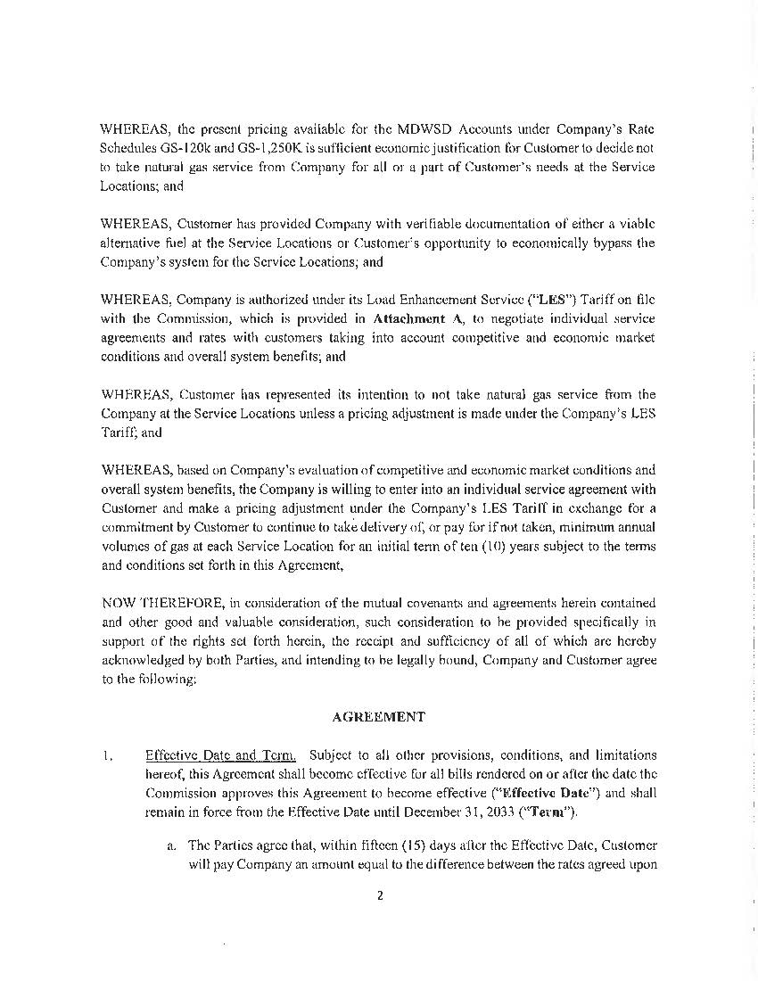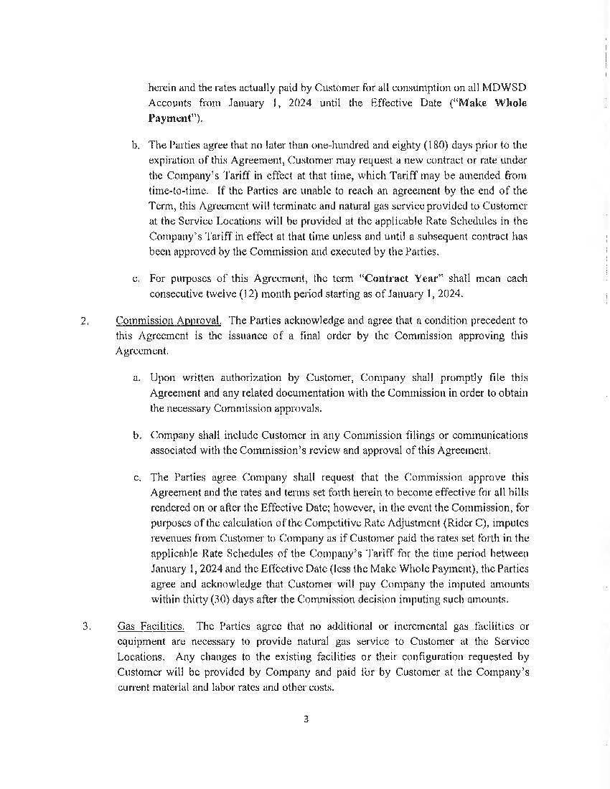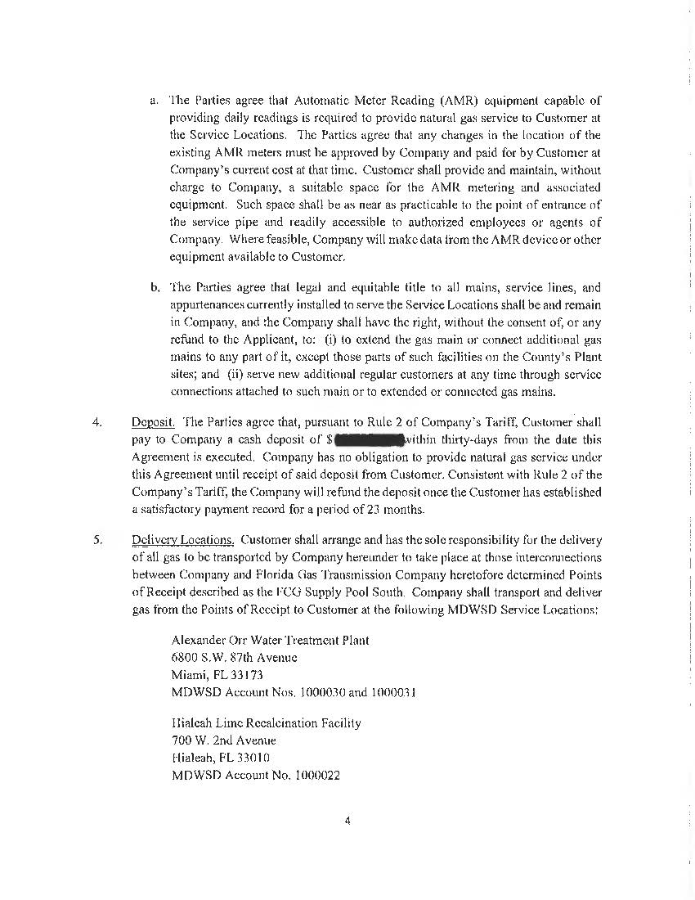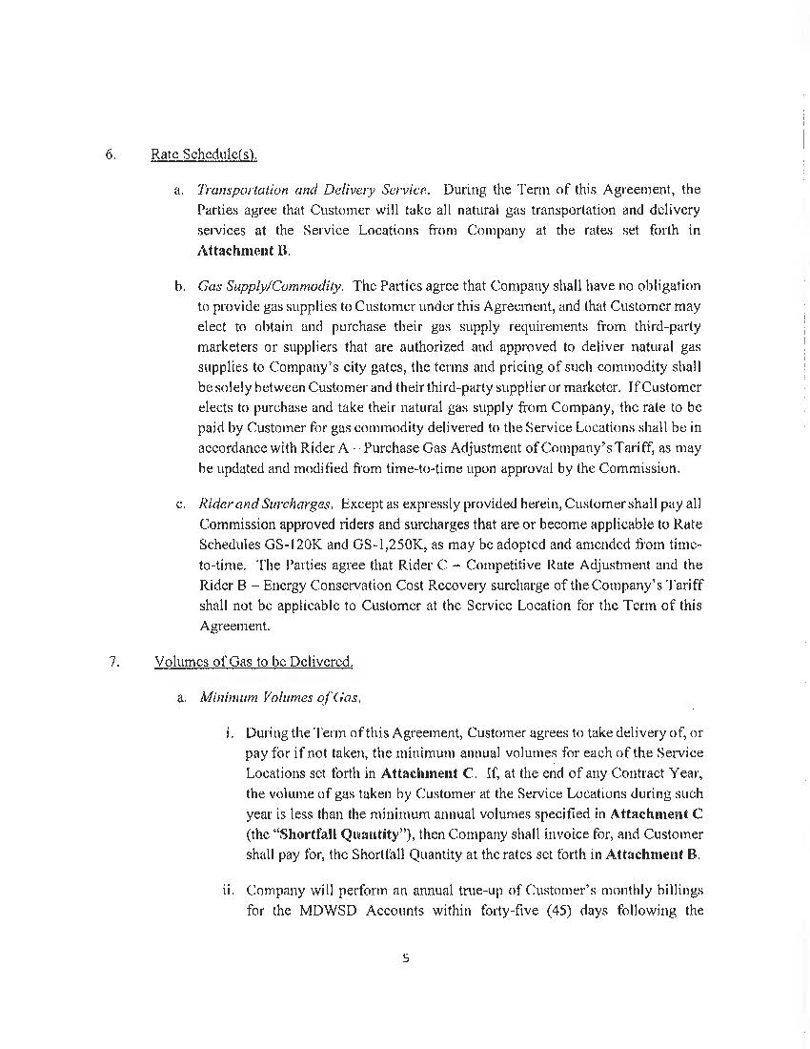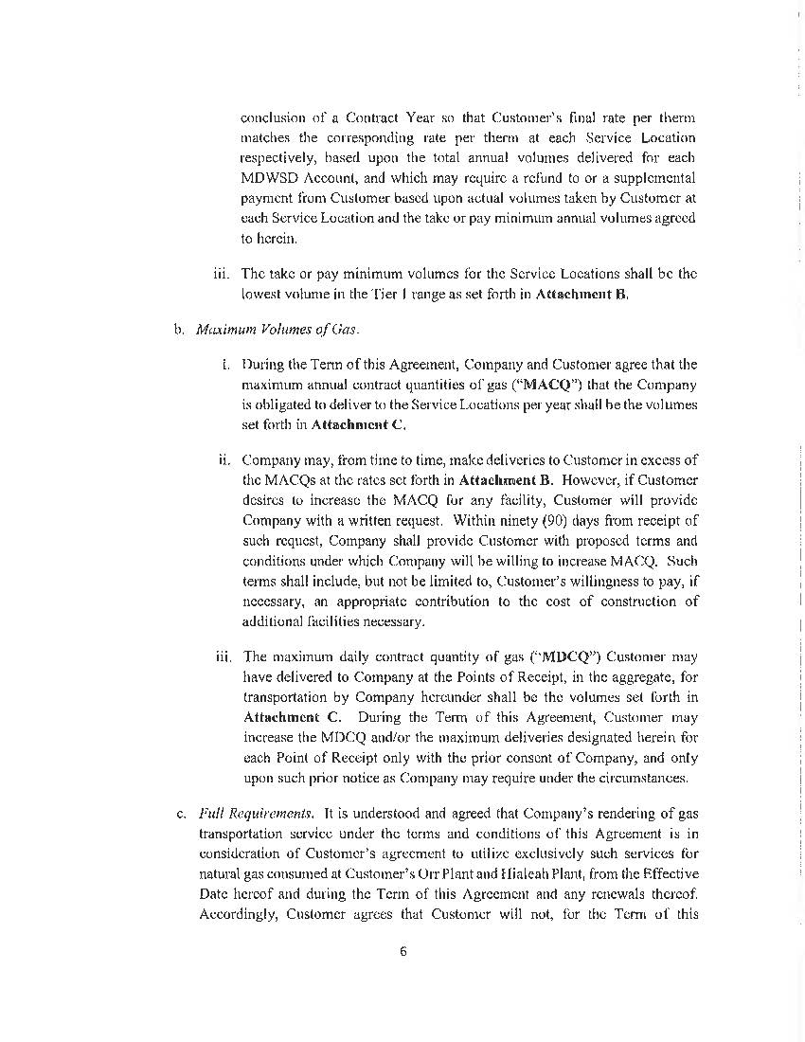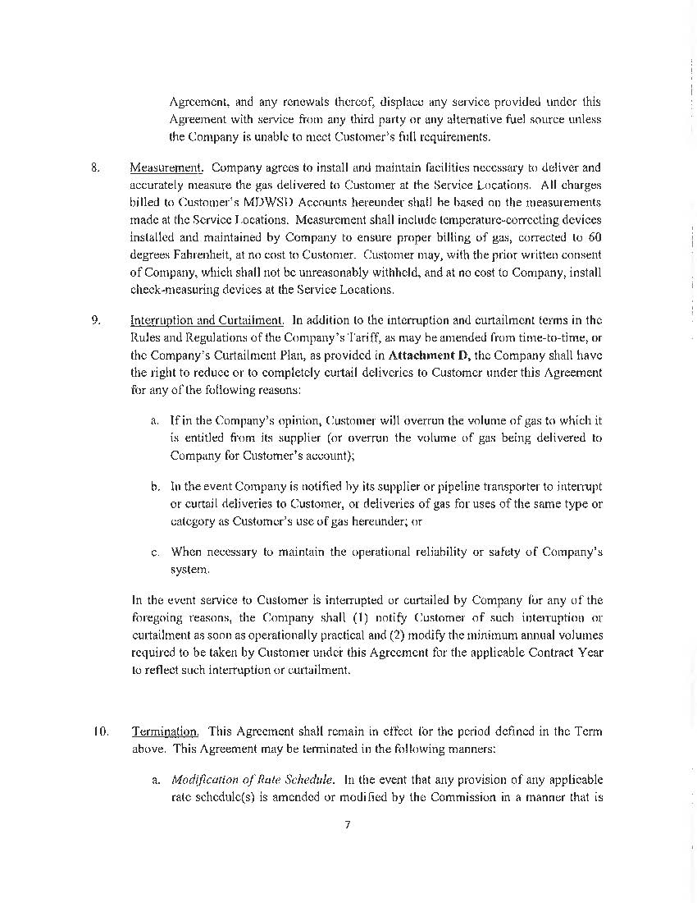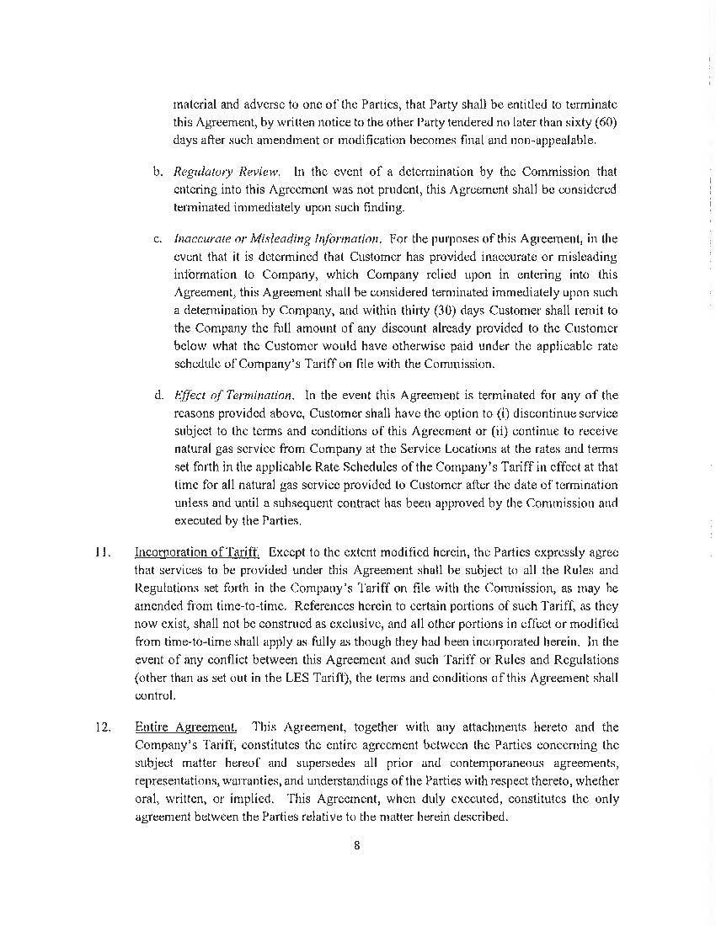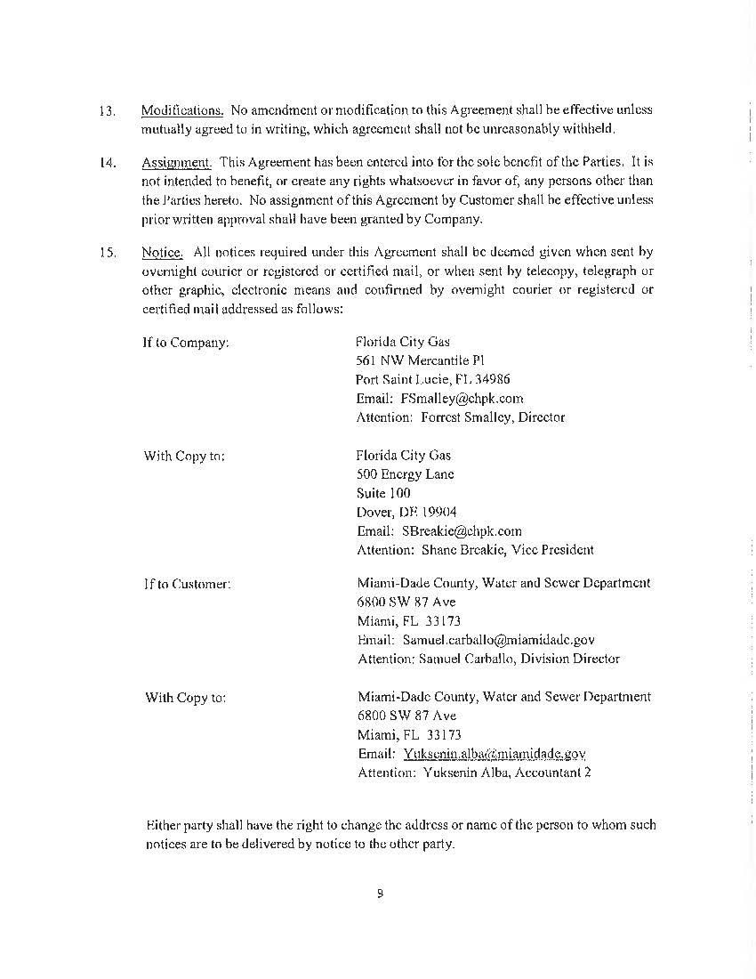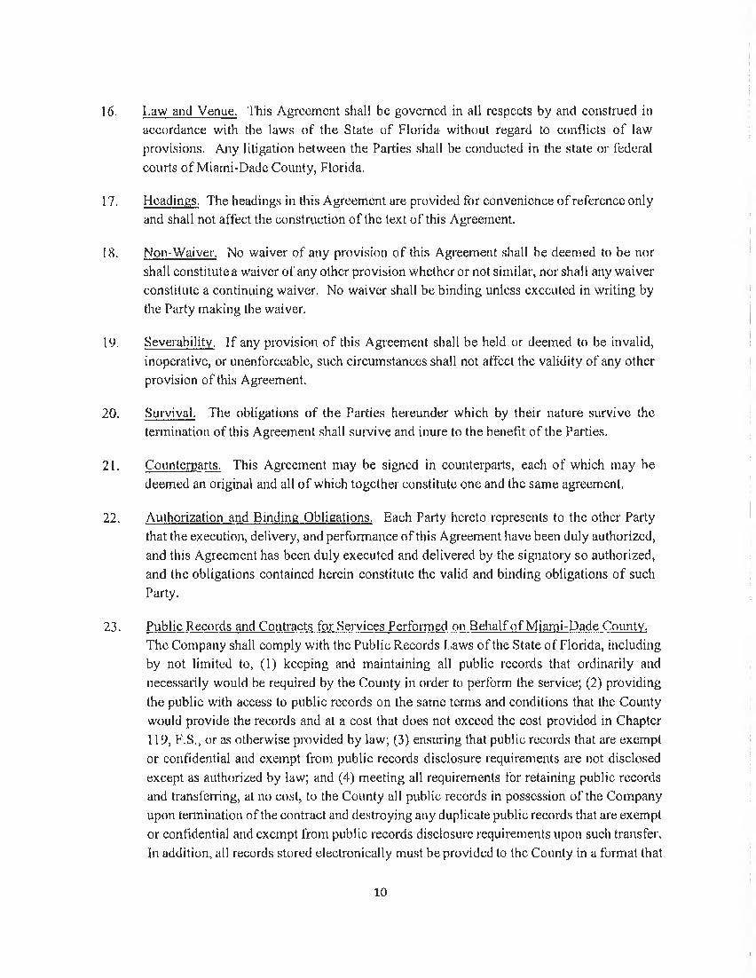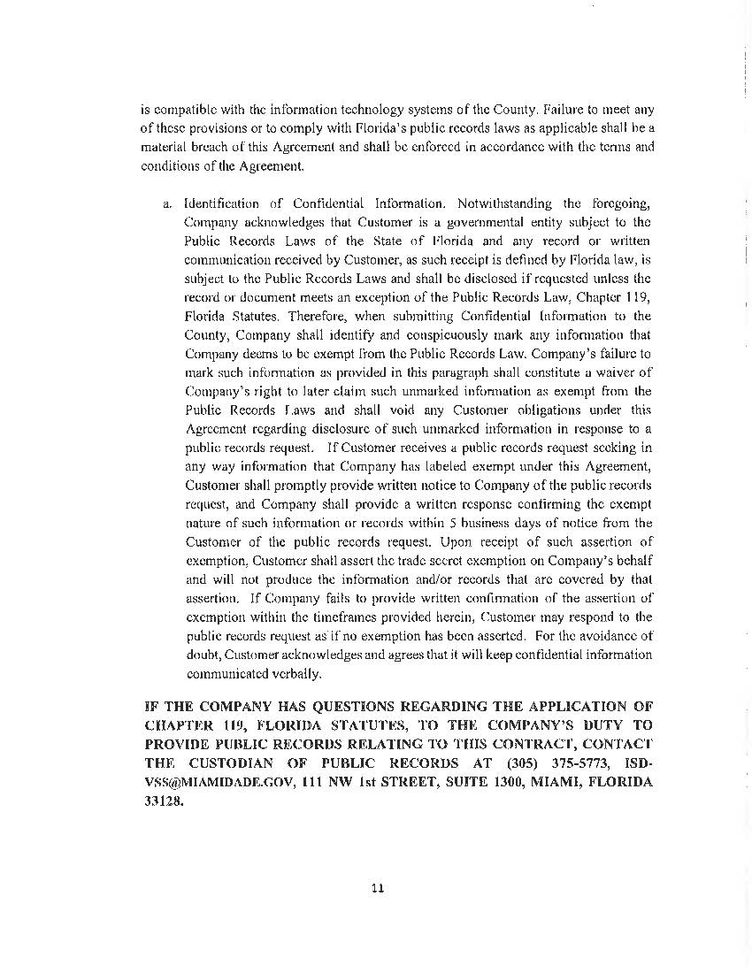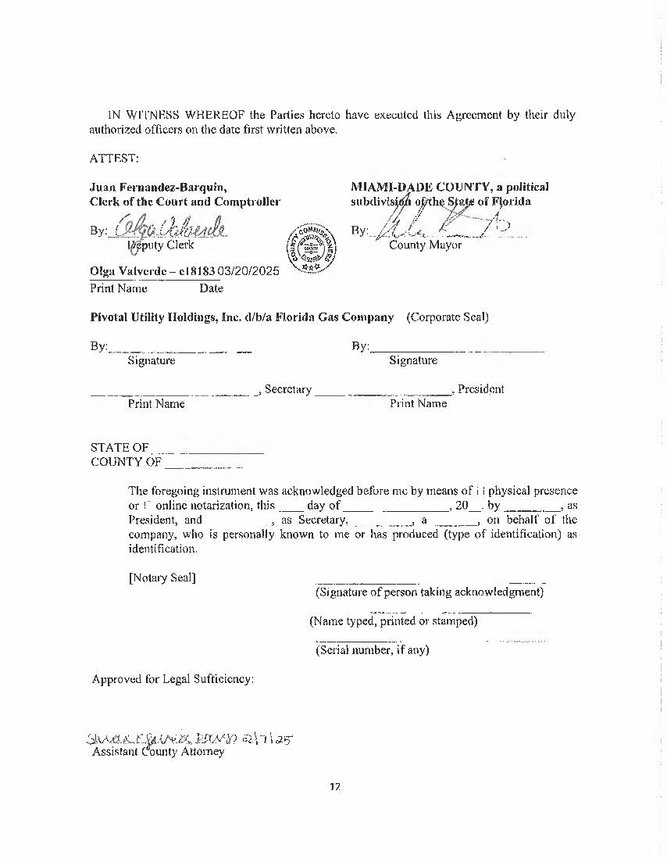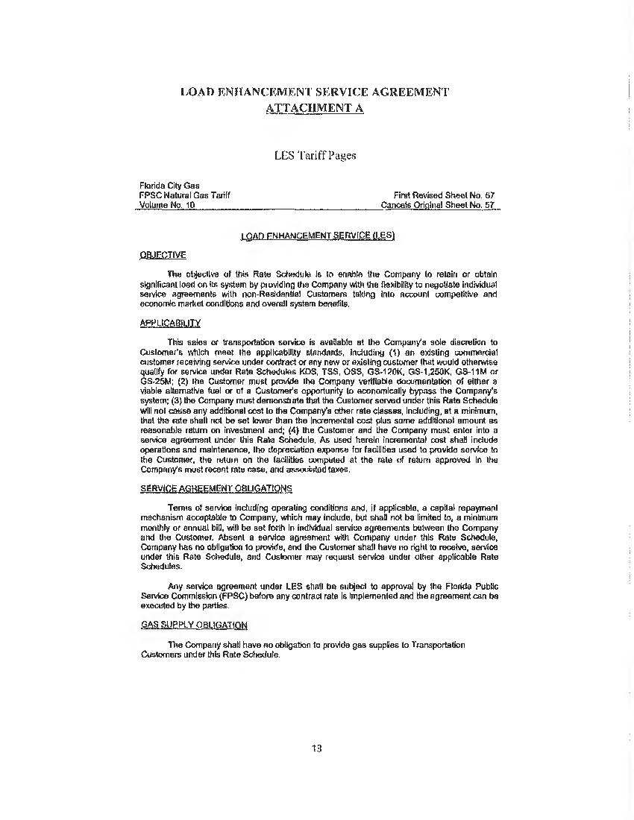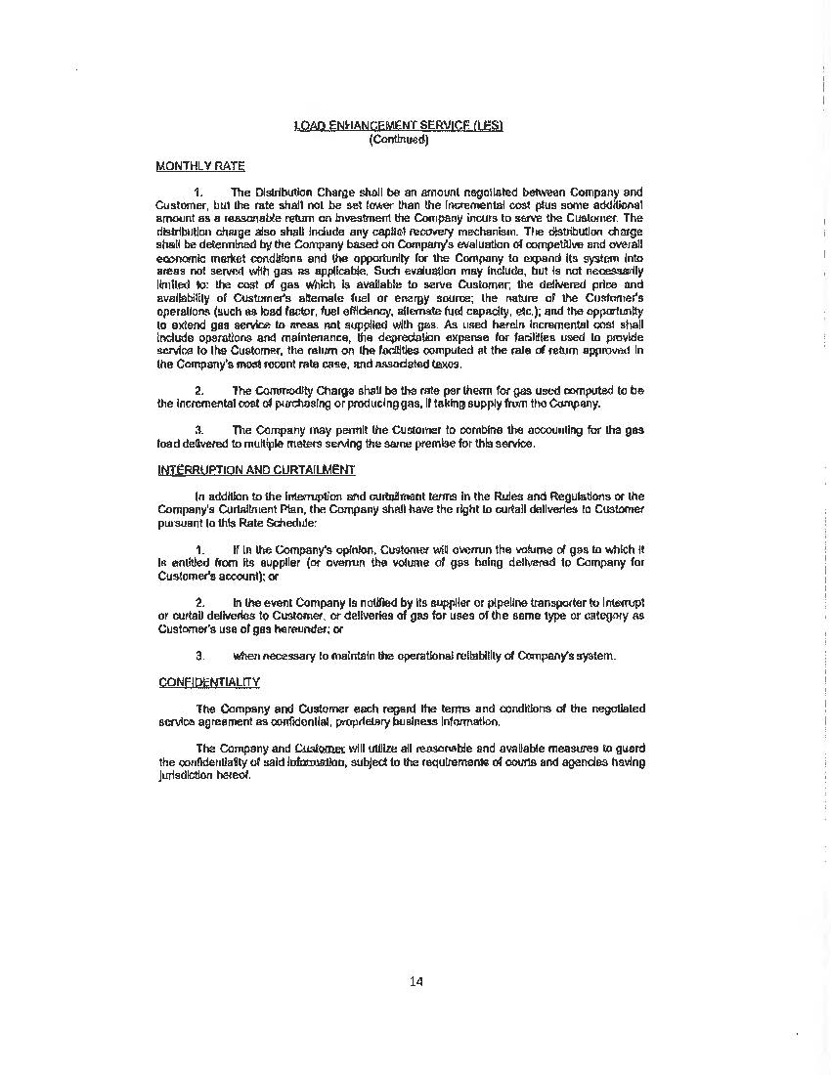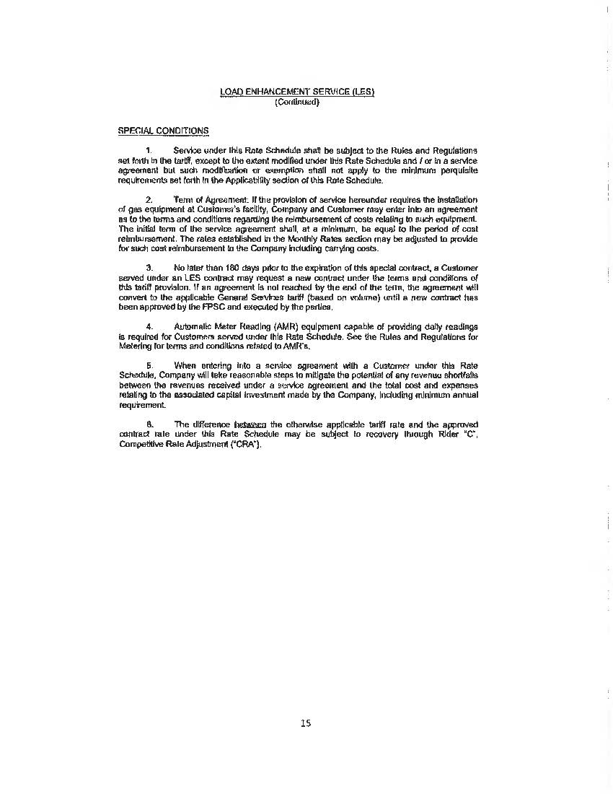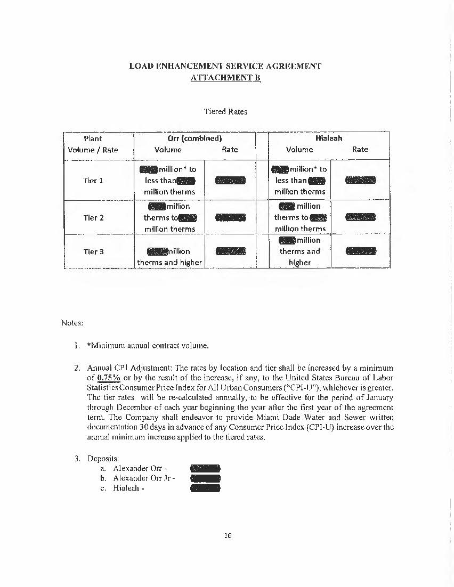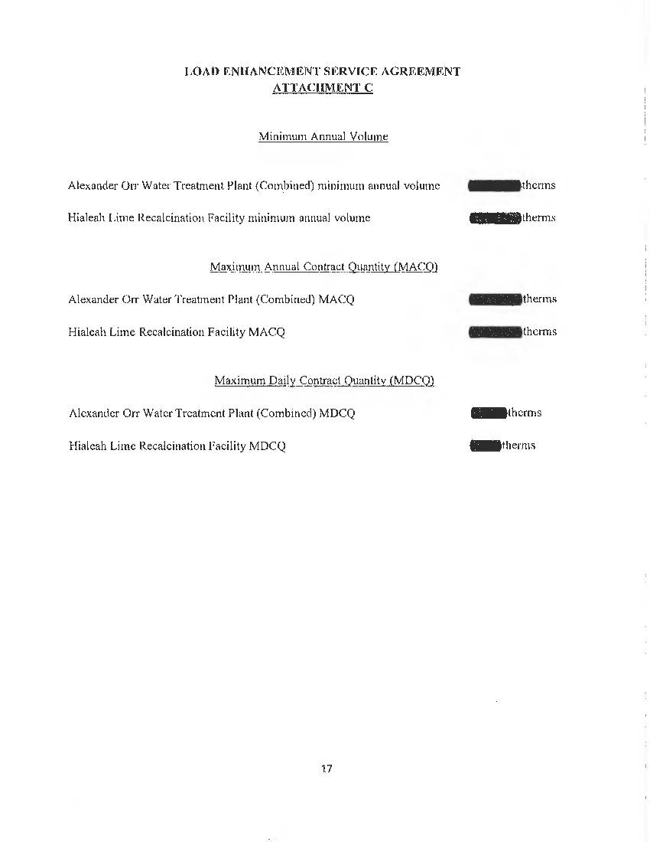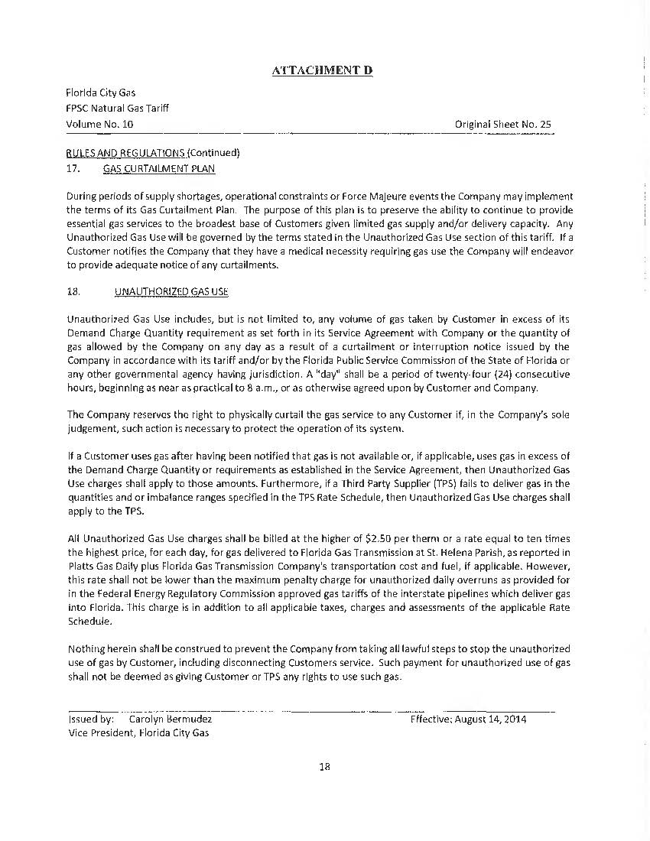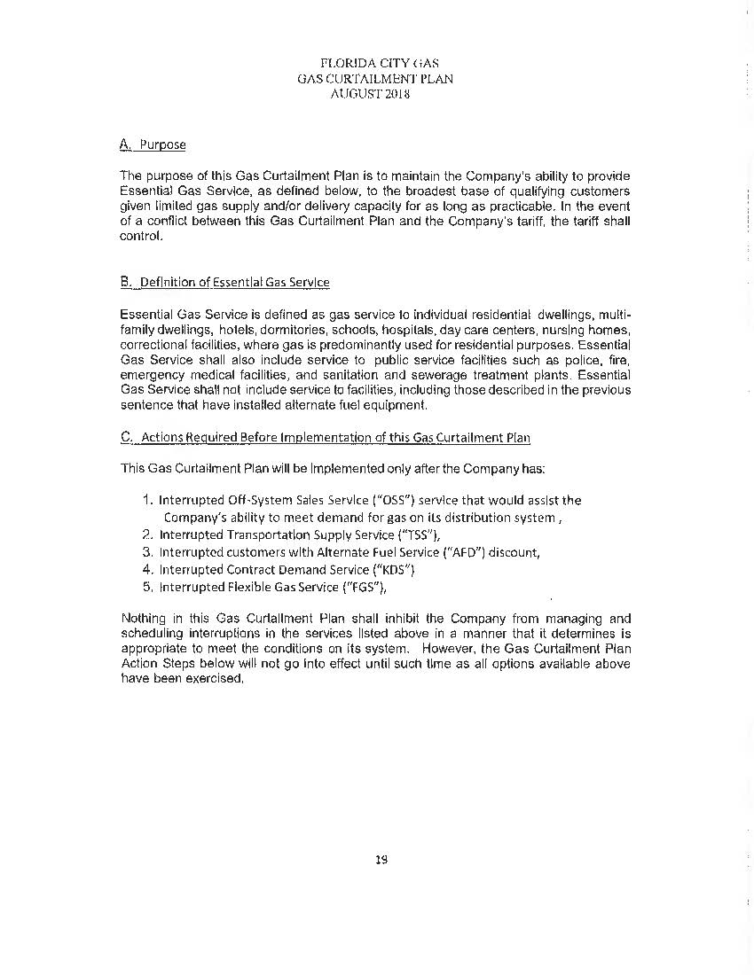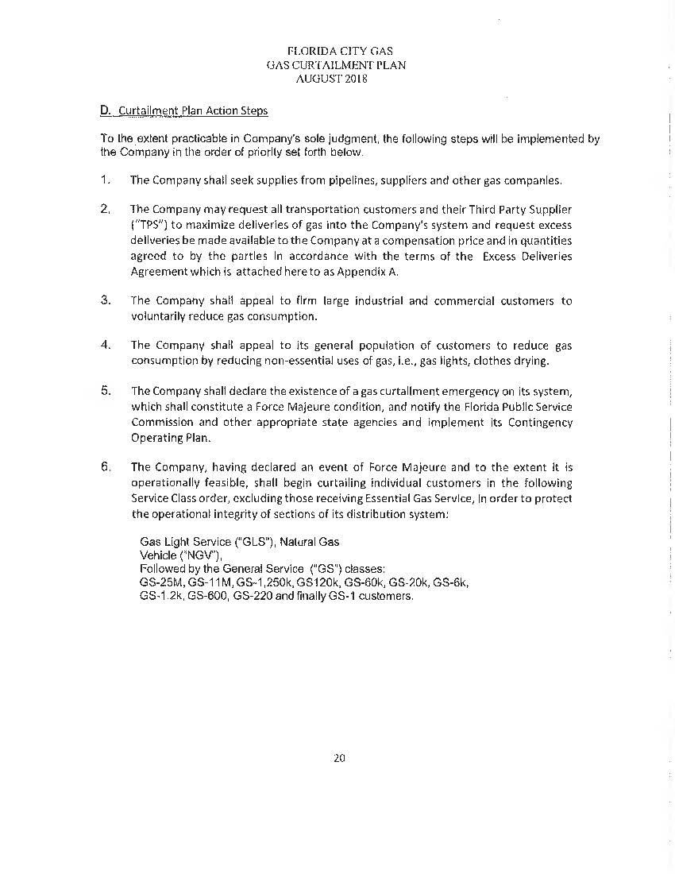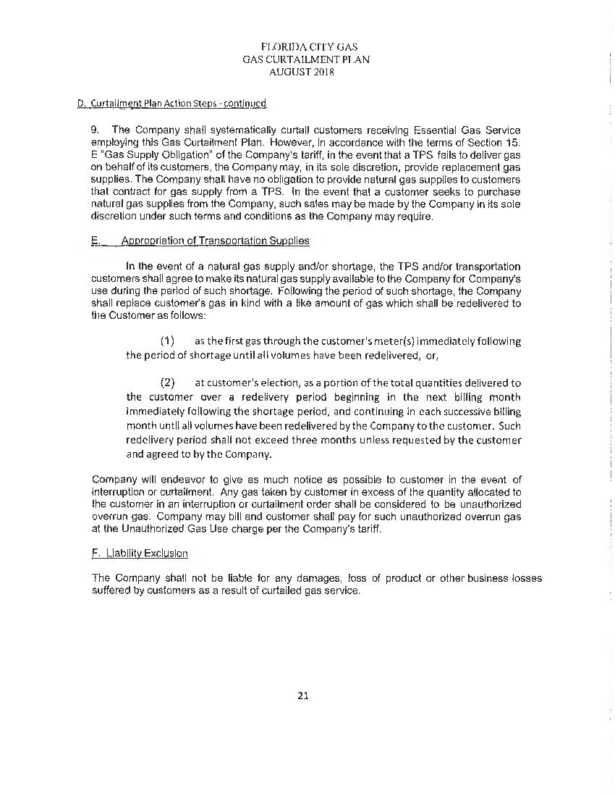

1. Order NO. PSC-13-0402-PAA-GU, Issued August 30, 2013, Docket No. 20130089-GU, *In RE: Joint petition for approval of natural gas transportation service between Florida City Gas and Miami-Dade County through Miami-Dade Water and Sewer Department.*
2. Order No. PSC-12-0171-AS-GU, issued April 2, 2012, in Docket No. 090539-GU, *In re: Petition for approval of Special Gas Transportation Service agreement with Florida City Gas by Miami-Dade County through Miami-Dade Water and Sewer Department.*
3. Order No. PSC-13-0402-PAA-GU, filed on August 30, 2013, in Docket No. 20130089-GU, *In re: Joint petition for approval of natural gas transportation service agreement between Florida City Gas and Miami-Dade County, through Miami-Dade Water and Sewer Department.*
4. Order No. PSC-2023-0177-FOF-GU, issued June 9, 2023, in Docket No. 20220069-GU, *In re: Petition for approval of rate increase and request for approval of depreciation rates by FCG.*
5. Order No. PSC-00-1592-TRF-GU, issued September 5, 2000, in Docket No. 000717-GU, *In re: Petition for authority to implement contract transportation service by City Gas Company of Florida;* Order No. PSC-96-1218-FOF-GU, issued September 24, 1996, in Docket No. 960920-GU, *In re: Petition for approval of flexible service tariff by City Gas Company of Florida*; Order No. PSC-98-1485-FOF-GU, issued November 5, 1998, in Docket No.980895-GU, *In re: Petition by Florida Division of Chesapeake Utilities Corporation for authority to implement proposed flexible gas service tariff and to revise certain tariff sheets.*
6. Joint Responses to Staff’s First Data Request, Question 1 and Attachment A. Document No. 04147-2025.
7. Joint Responses to Staff’s First Data Request, Attachment B. Document No. 04147-2025
8. See Attachment B, page 16 of the petition.
9. A take or pay clause in a contract requires the buyer to either purchase a specified quantity of goods or services, or pay for them even if they are not taken. This type of clause is typically used in long-term supply agreements, especially in industries like energy and manufacturing, to reduce risk for both the seller and the buyer.