|  |  |  |  |
| --- | --- | --- | --- |
| State of Florida  pscSEAL | | Public Service Commission  Capital Circle Office Center ● 2540 Shumard Oak Boulevard Tallahassee, Florida 32399-0850  -M-E-M-O-R-A-N-D-U-M- | |
| DATE: | September 25, 2025 | | |
| TO: | Office of Commission Clerk (Teitzman) | | |
| FROM: | Division of Economics (Nguyen, Hampson)  Office of the General Counsel (Dose) | | |
| RE: | Docket No. 20250099-GU – Joint petition for approval of amendments to transportation service agreements between Peninsula Pipeline Company, Inc. and Florida City Gas. | | |
| AGENDA: | 10/07/25 – Regular Agenda – Proposed Agency Action – Interested Persons May Participate | | |
| COMMISSIONERS ASSIGNED: | | | All Commissioners |
| PREHEARING OFFICER: | | | Clark |
| CRITICAL DATES: | | | None |
| SPECIAL INSTRUCTIONS: | | | None |

Case Background

On August 7, 2025, Peninsula Pipeline Company, Inc. (Peninsula) and Florida City Gas (FCG), collectively the Parties, filed a joint petition seeking approval of amendments to three separate Firm Transportation Service Agreements (FTSAs) that had been previously approved by the Commission. The proposed amendments to the FTSAs are included as attachments to the recommendation.

By Order No. PSC-2024-0271-PAA-GU (2024 Order), the Commission approved three FTSAs between Peninsula and FCG.[1] FCG had entered into commodity purchase agreements with three third party Renewable Natural Gas (RNG) producers. Pursuant to the 2024 FTSAs, Peninsula would construct, own, and operate new gas pipelines allowing for the delivery of the natural gas purchased by FCG from the third party producers. To support the 2024 FTSAs, the parties had stated that this would diversify and introduce additional gas supply sources, enhance transmission access, and increase system resiliency. The three RNG projects are located in Brevard, Indian River, and Miami Dade Counties. The FTSAs contain monthly reservation charges, payable from FCG to Peninsula, that reflect Peninsula’s construction costs.

The Parties state the amendments to the FTSAs pertain to the interconnection agreements (ICAs) between FCG and the RNG producers which were referenced in the 2024 Order. The interconnection agreements (ICA) between FCG and the RNG producers were entered into before FCG was acquired by Chesapeake and not subject to Commission approval. The ICAs address the construction of pipeline facilities and establishment of an interconnection point connecting the RNG facilities to FCG. In the response to staff’s fourth data request in Docket No. 20240039-GU, the Parties stated that upon acquisition of FCG by Chesapeake, it was determined that the interconnection projects would be a better fit as a Peninsula project.[2] In the same responses, the Parties explain that it would be best to use Peninsula to tie the RNG producers into the rest of the FCG distribution system because the project is more in line with the transmission activity projects that Peninsula has expertise in facilitating and building. The instant petition amends the FTSAs to reflect a subcontracting of the ICA work to Peninsula.

Peninsula and FCG are both wholly owned subsidiaries of Chesapeake Utilities Corporation (Chesapeake). Staff notes that FCG became a subsidiary of Chesapeake on December 1, 2023. Peninsula operates as an intrastate natural gas transmission company as defined by Section 368.103(4), Florida Statutes (F.S.).[3] FCG operates as a local distribution company subject to the regulatory jurisdiction of the Commission pursuant to Chapter 366, F.S.

By Order No. PSC-07-1012-TRF-GP, Peninsula received approval of an intrastate gas pipeline tariff that allows it to construct and operate intrastate pipeline facilities and to actively pursue agreements with natural gas customers.[4] The Parties are subsidiaries of Chesapeake, and agreements between affiliated companies must be approved by the Commission pursuant to Section 368.105, F.S.

During the evaluation of the petition, staff issued one data request to the Parties for which responses were received on September 5, 2025.[5] Staff also had a phone call with the Parties on September 19, 2025, after which the Parties filed supplemental responses on September 23, 2025.[6] The Commission has jurisdiction over this matter pursuant to Sections 368.104, and 368.105, F.S.

Discussion of Issues

Issue :

 Should the Commission approve the proposed Amendments to the Firm Transportation Service Agreements dated July 23, 2025, between Peninsula and FCG?

Recommendation:

 Yes, the Commission should approve the proposed Amendments to the Firm Transportation Service Agreements dated July 23, 2025, between Peninsula and FCG. The proposed amendments to the agreements are reasonable and meet the requirements of Section 368.105, F.S. (Nguyen)

Staff Analysis:

 As described in paragraph 10 of the instant petition and in response to staff’s data requests in Docket No. 20240039-GU, the Parties had contemplated that the interconnection work may also be done by Peninsula. Therefore, the Parties now propose for the FTSAs approved in the 2024 Order to be amended to add monthly reservation charges associated with the cost to construct, own, operate and maintain the interconnection facilities used to connect the RNG producers to FCG.

On page 6 of the instant petition, the Parties state the facilities previously approved in the FTSAs and the facilities mentioned in the ICAs are “inter-reliant.” Additionally, the Parties explain that it is most efficient for Peninsula to construct the pipeline facilities contemplated in the 2024 Order from each RNG site to the interconnection point with FCG, as well as the interconnection facilities addressed in the ICA. Peninsula will also construct the necessary regulator stations, pressure regulation and measuring equipment, valving, filters, and communications equipment necessary. Peninsula also agrees to install gas quality monitoring equipment and monitor at the interconnect to ensure that the natural gas meets required gas quality levels. FCG retains ownership of the meter and its agreement with each RNG producer. Furthermore, in response to staff’s first data request, the Parties state that it would not be efficient to have two different entities doing the planning, engineering, permitting work, and operation and maintenance on facilities constructed for the same projects.[7]

With the proposed amendments, a fixed, monthly reservation charge, payable from FCG to Peninsula, will be added to the existing FTSAs. This charge is equal to the monthly service charge that the RNG producer will pay to FCG under the terms of the ICA once in-service. FCG will then credit the payment from the RNG producer to its Purchased Gas Adjustment Clause costs. Further discussion of this payment structure was provided in Peninsula and FCG’s supplemental response.[8] All of the amended FTSAs include monthly reservation charges that vary dependent upon the year of the agreement. Peninsula and FCG stated that this is because of negotiating charges reflective of the development of a project over time.[9] The Parties also mention this could be used as front-loaded recovery in the first few years with reductions over time.

Peninsula and FCG assert that the rates in the amended FTSAs meet the requirements of Section 368.105(3), F.S., and are consistent with Order Nos. PSC-2006-0023-DS-GP and PSC-2007-1012-TRF-GP and with Peninsula's tariff on file with the Commission. Staff has reviewed the amended FTSAs and agrees that the monthly reservation charges associated with the ICAs are identical to the monthly reservation charges that were included in the agreements between FCG and the RNG producers, which were entered prior to FCG becoming an affiliate to Peninsula.

The Parties assert, in response No. 2 of the Parties’ supplemental response, that the costs of these projects include a metering and regulation site with regulators, remote monitoring communication and control configurations, and meters. The Parties also state the costs of these projects are comparable to those of a standard interconnect. However, the company states there is equipment specific to the RNG that other interconnects do not require. These components average approximately $550,000 per project, which the Parties state is a small portion of the cost.

In the Parties’ supplemental response, the Parties state that the interconnect facilities for the Brevard project are currently anticipated to be completed in October 2025. The interconnect facilities related to the Indian River project are constructed and in service. Finally, the interconnect facilities related to the Miami Dade project are estimated to be completed in early 2026.

Conclusion

Based on the petition and the Parties’ responses to staff’s data requests, staff recommends that the Commission should approve the proposed amendments to the FTSAs dated July 23, 2025, between Peninsula and FCG, attached to this recommendation. The proposed amendments to the agreements are reasonable and meet the requirements of Section 368.105 F.S.

Issue :

 Should this docket be closed?

Recommendation:

 If no person whose substantial interests are affected by the proposed agency action files a protest within 21 days of the issuance of the order, this docket should be closed upon the issuance of a consummating order. (Dose)

Staff Analysis:

 If no person whose substantial interests are affected by the proposed agency action files a protest within 21 days of the issuance of the order, this docket should be closed upon the issuance of a consummating order.

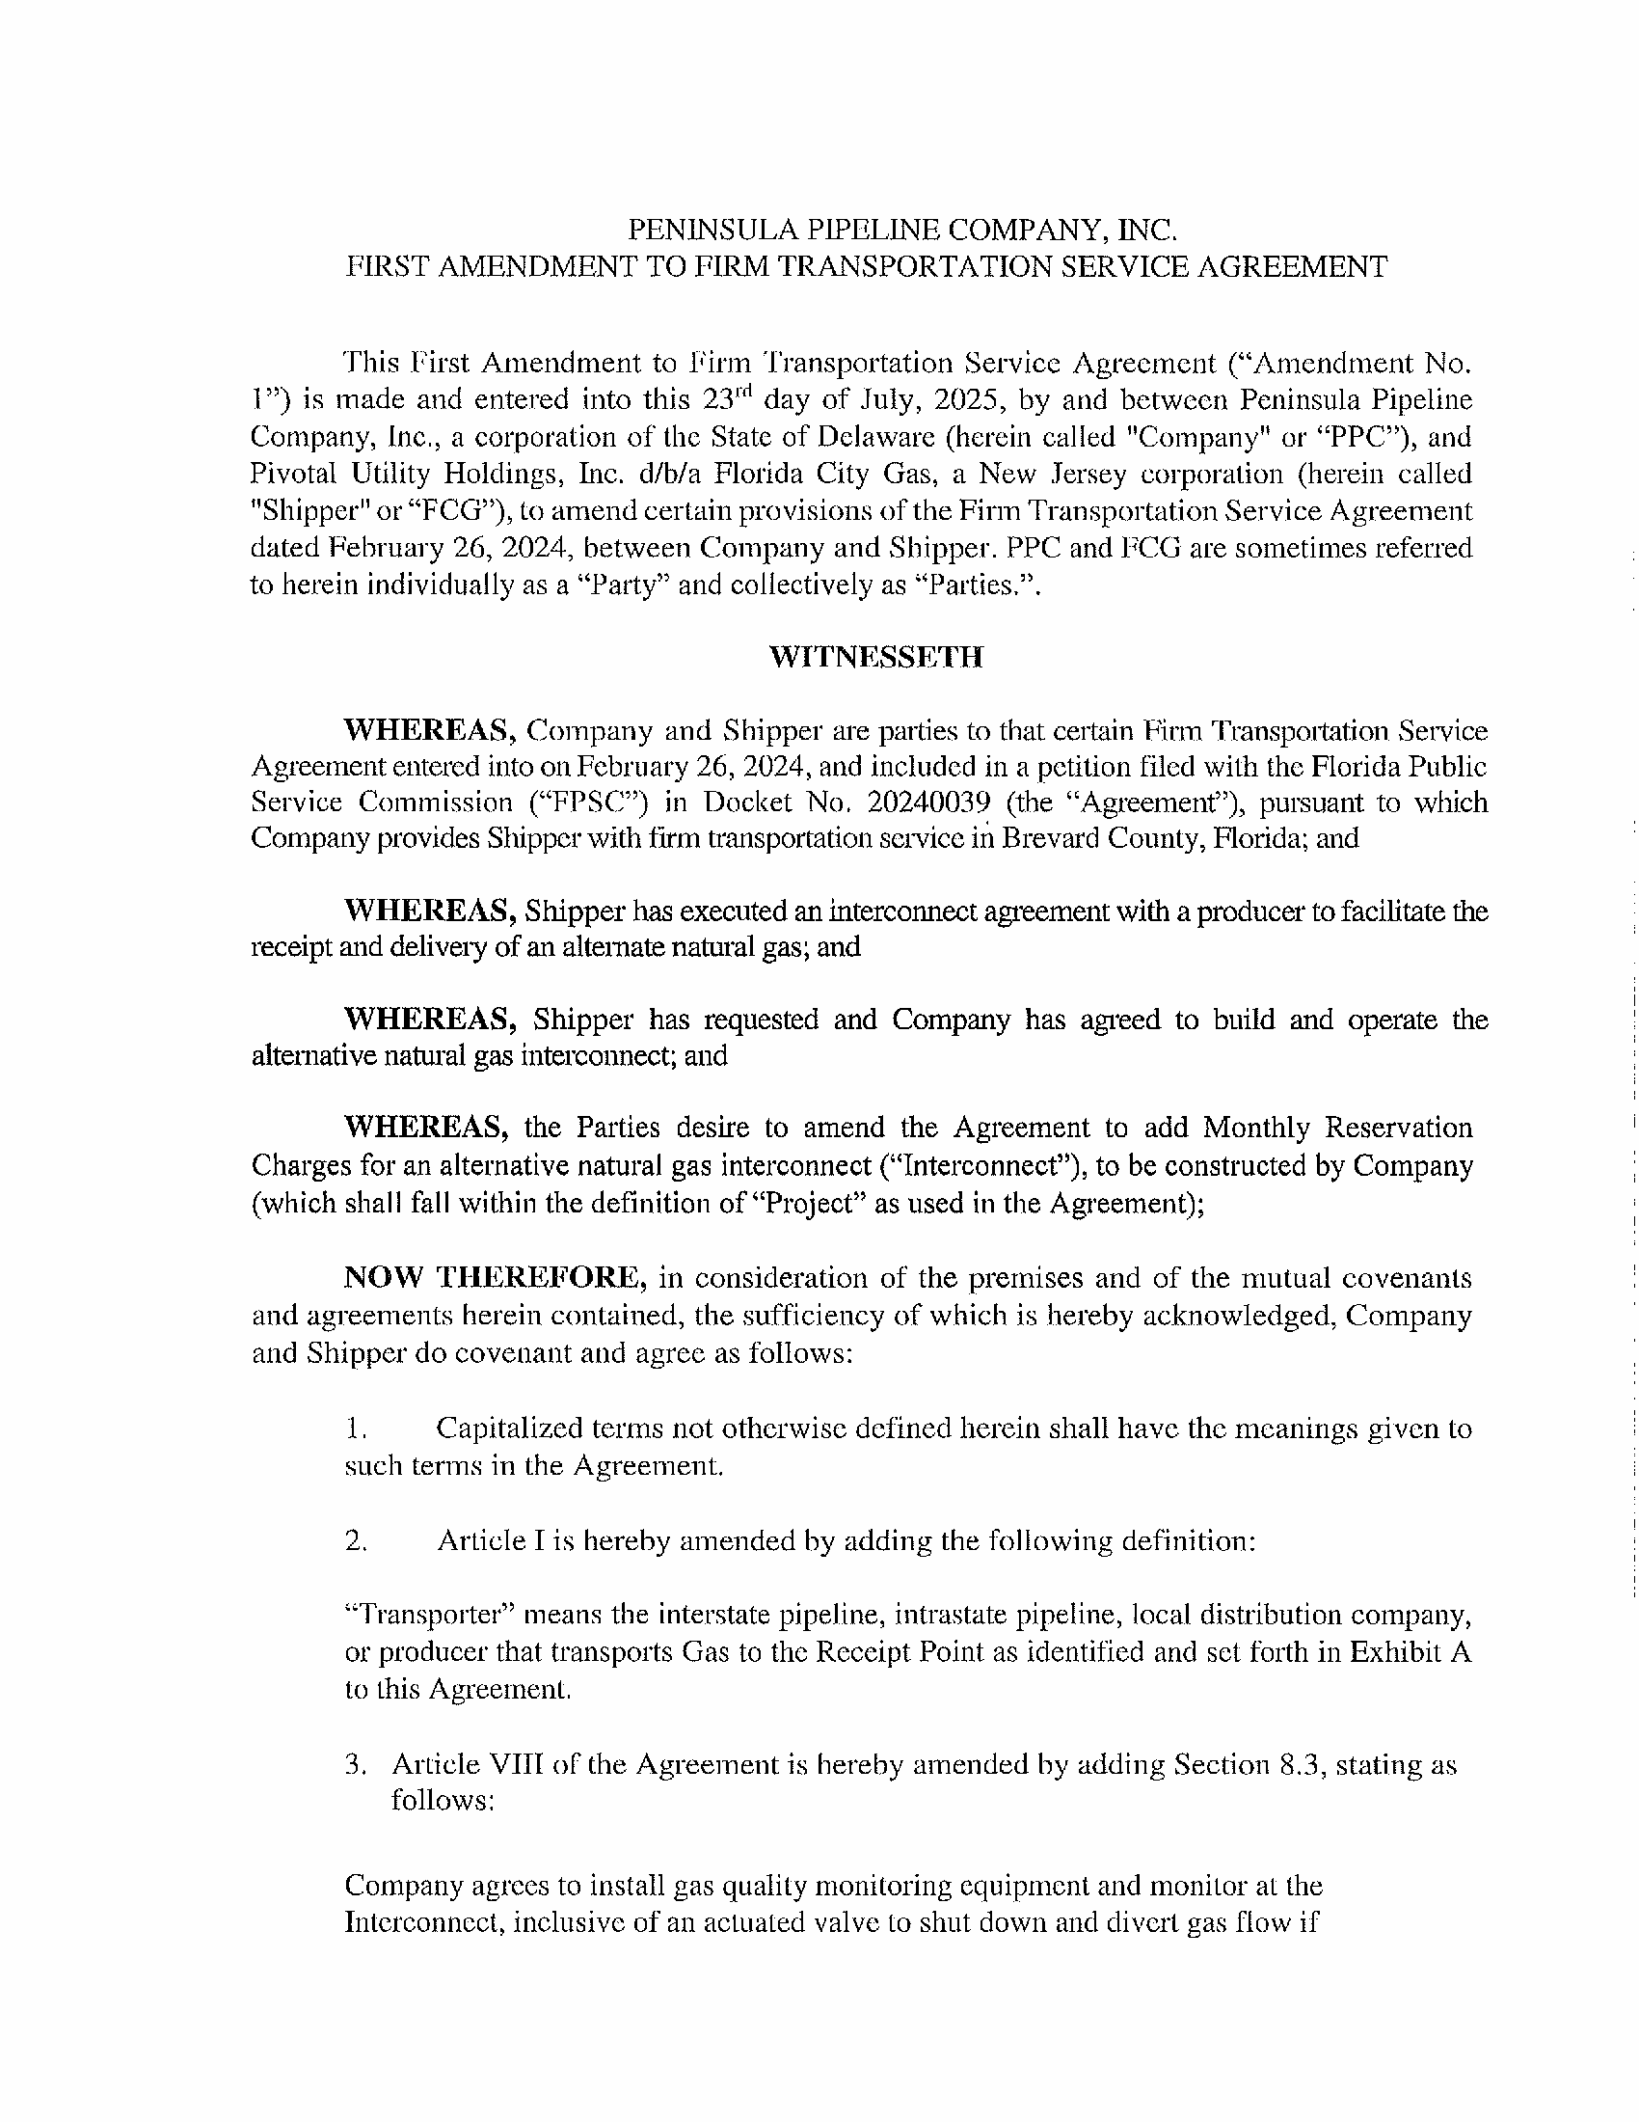

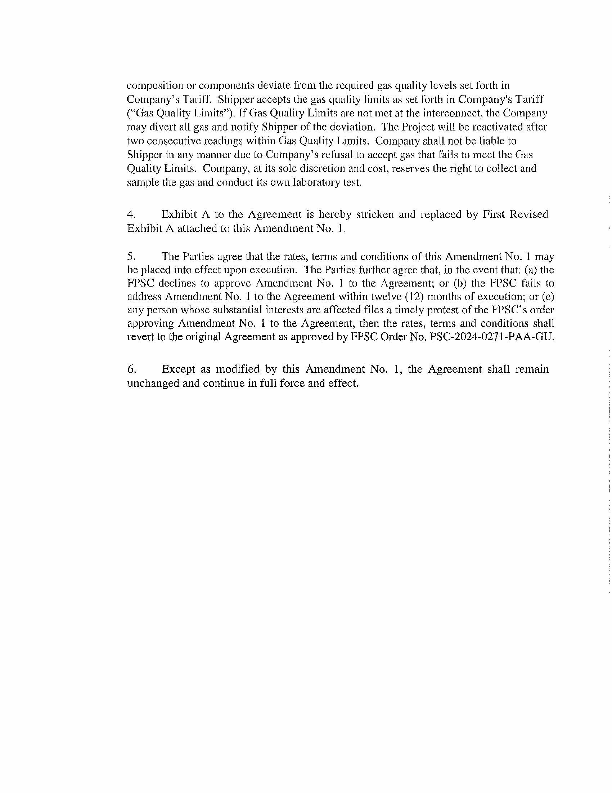

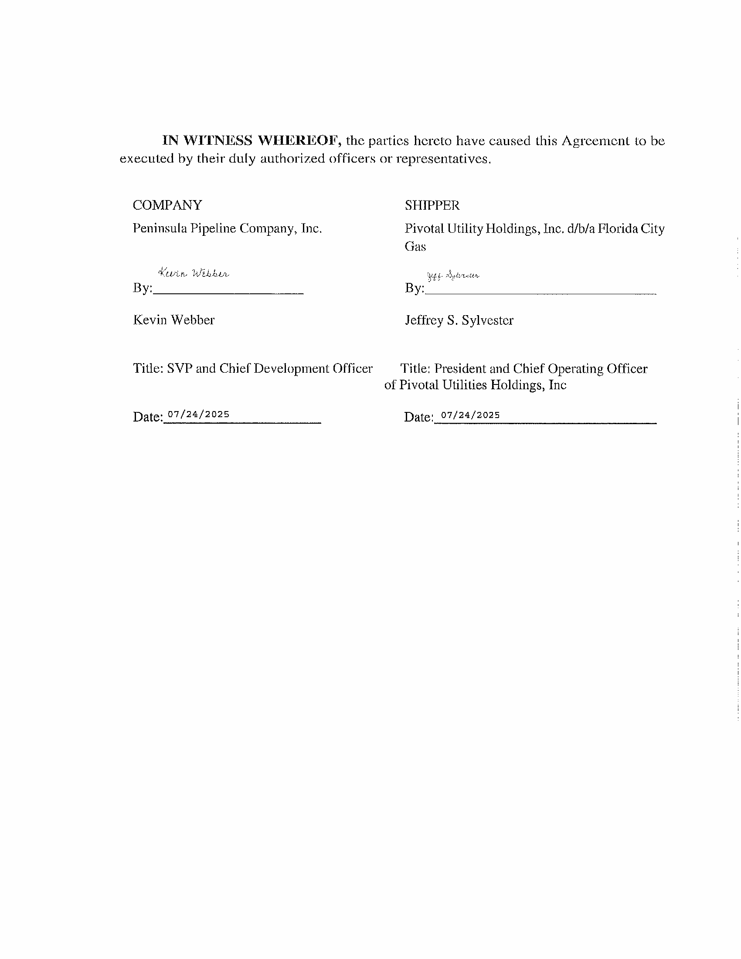

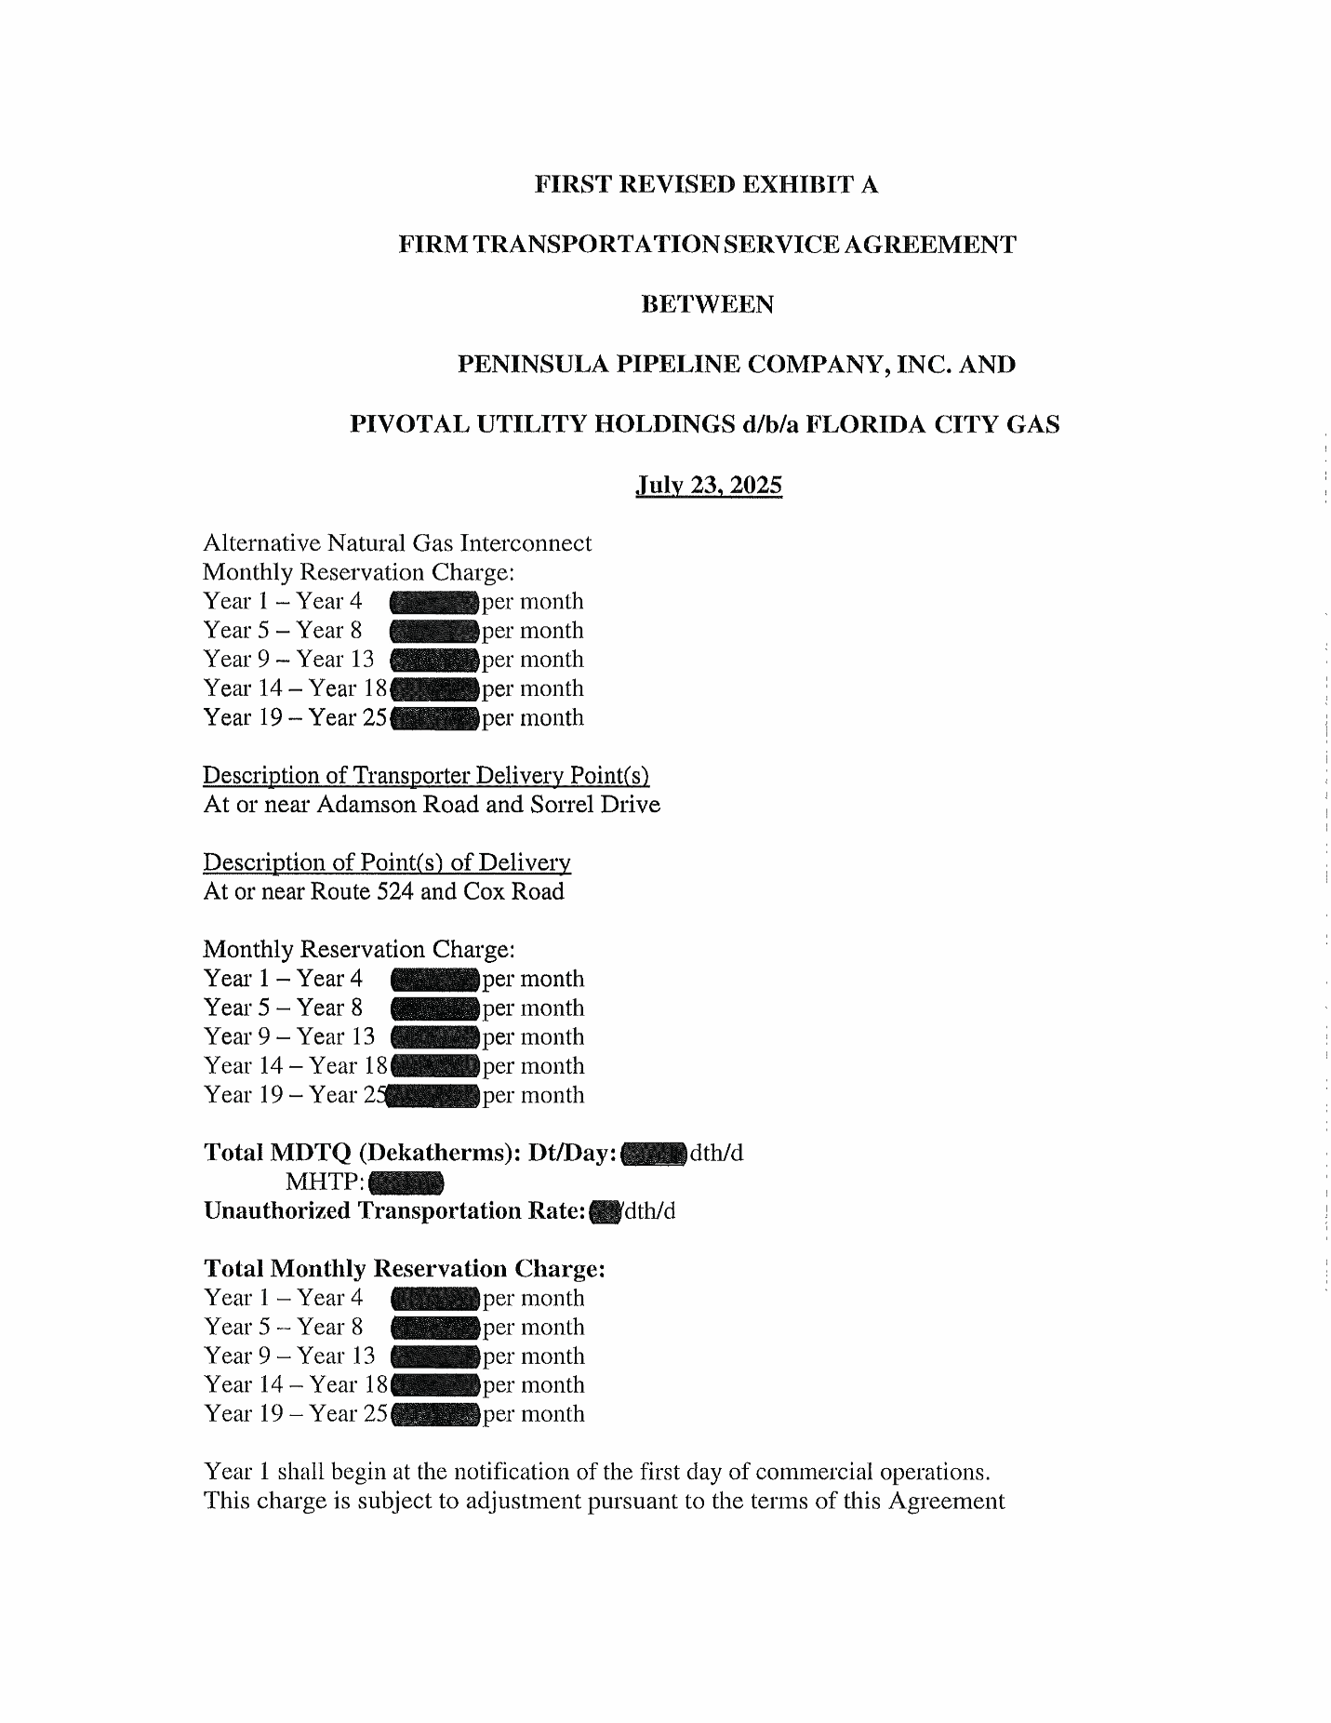

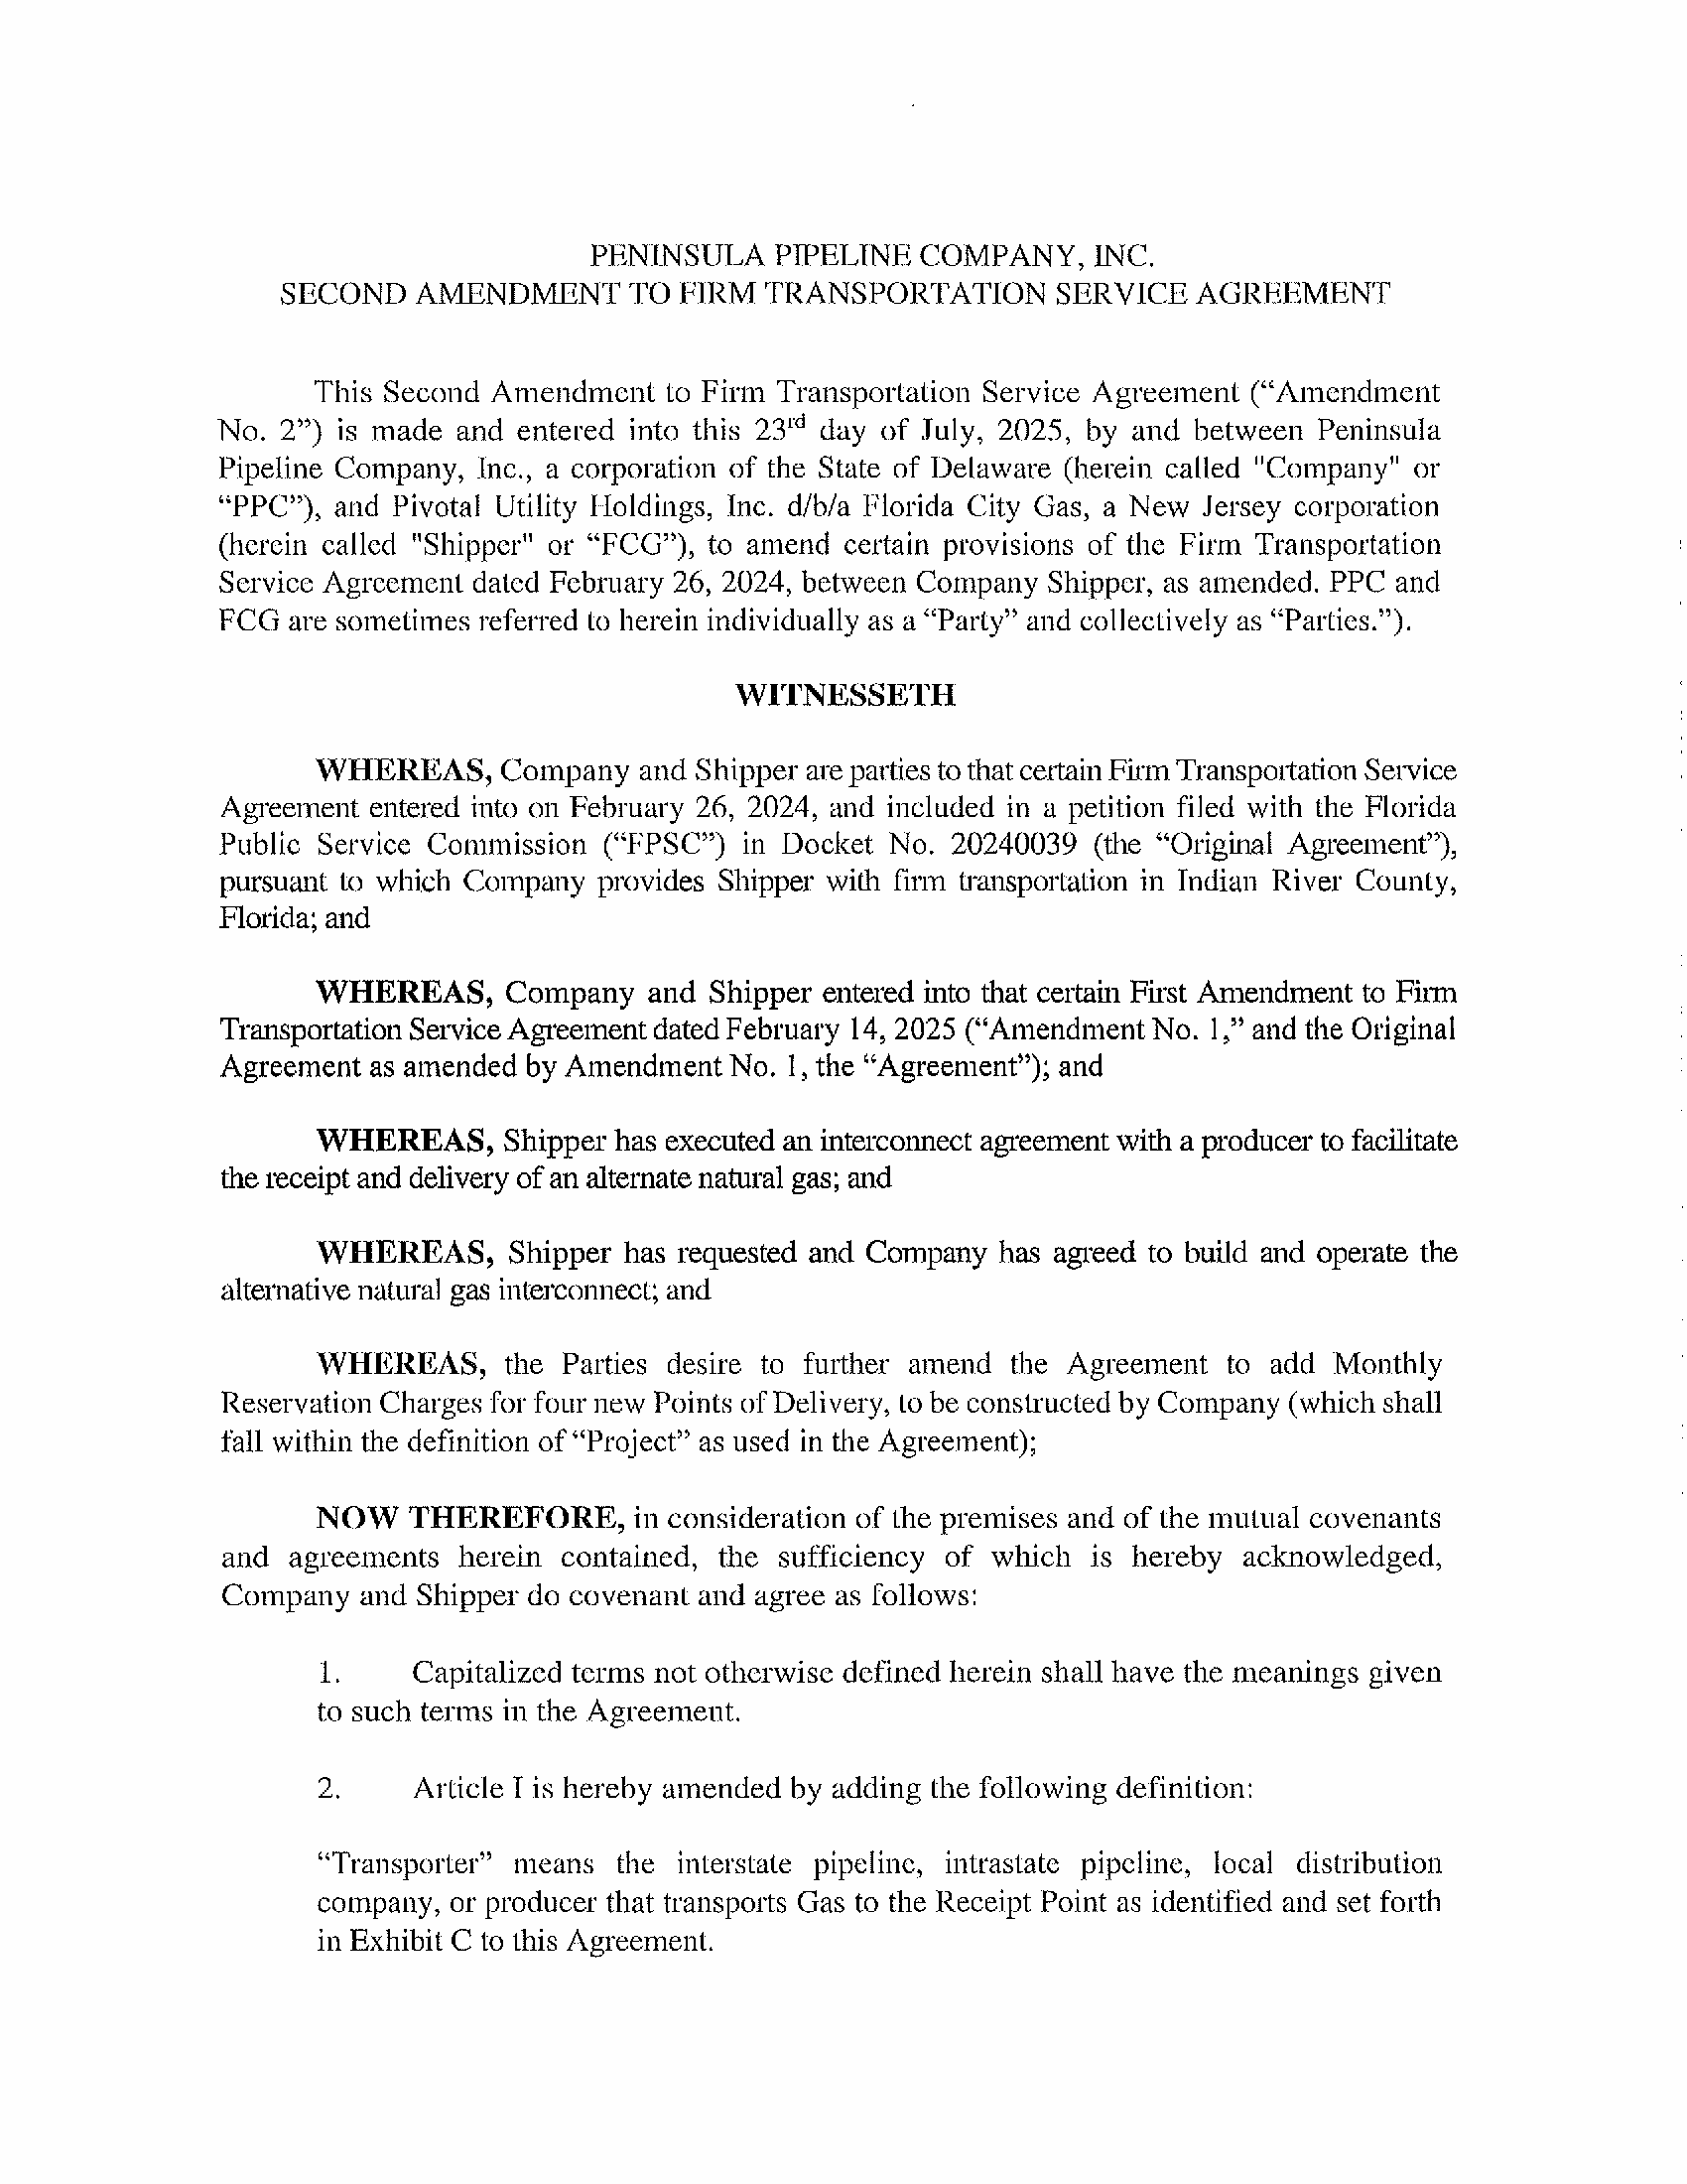

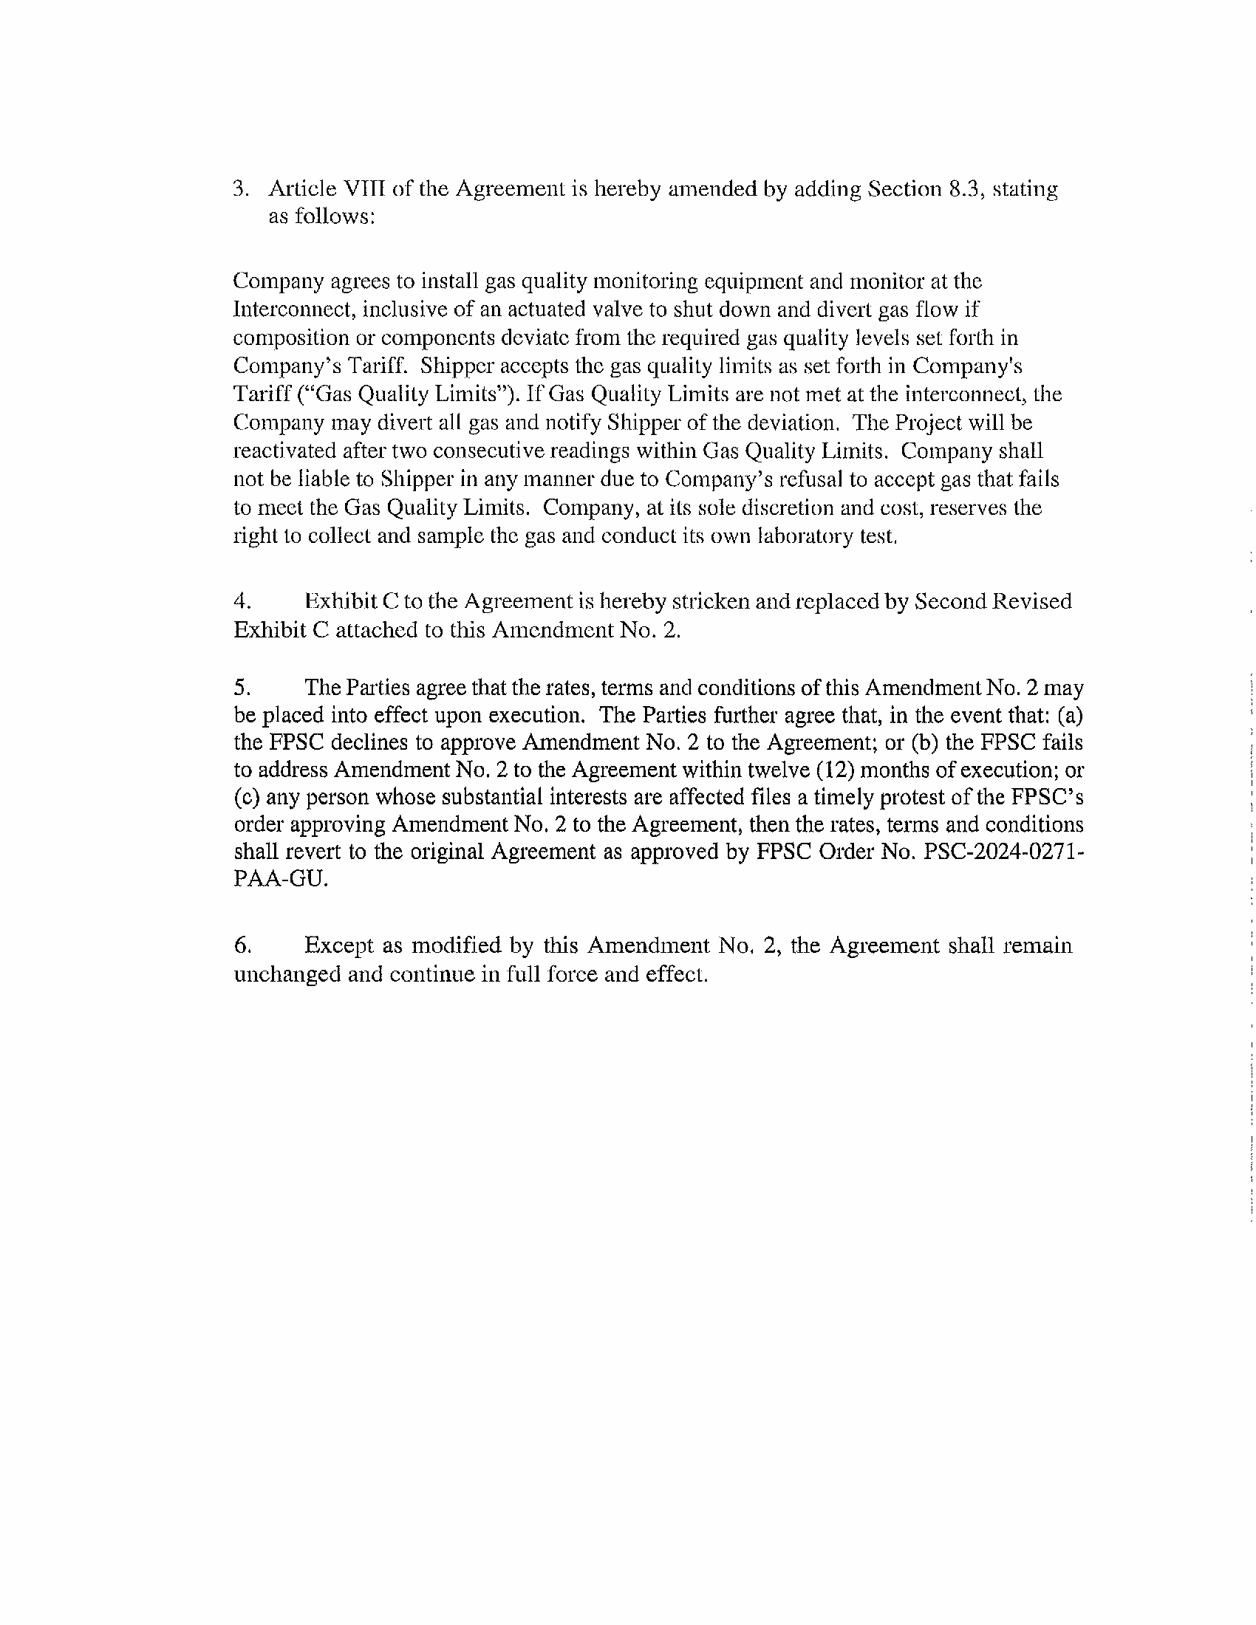

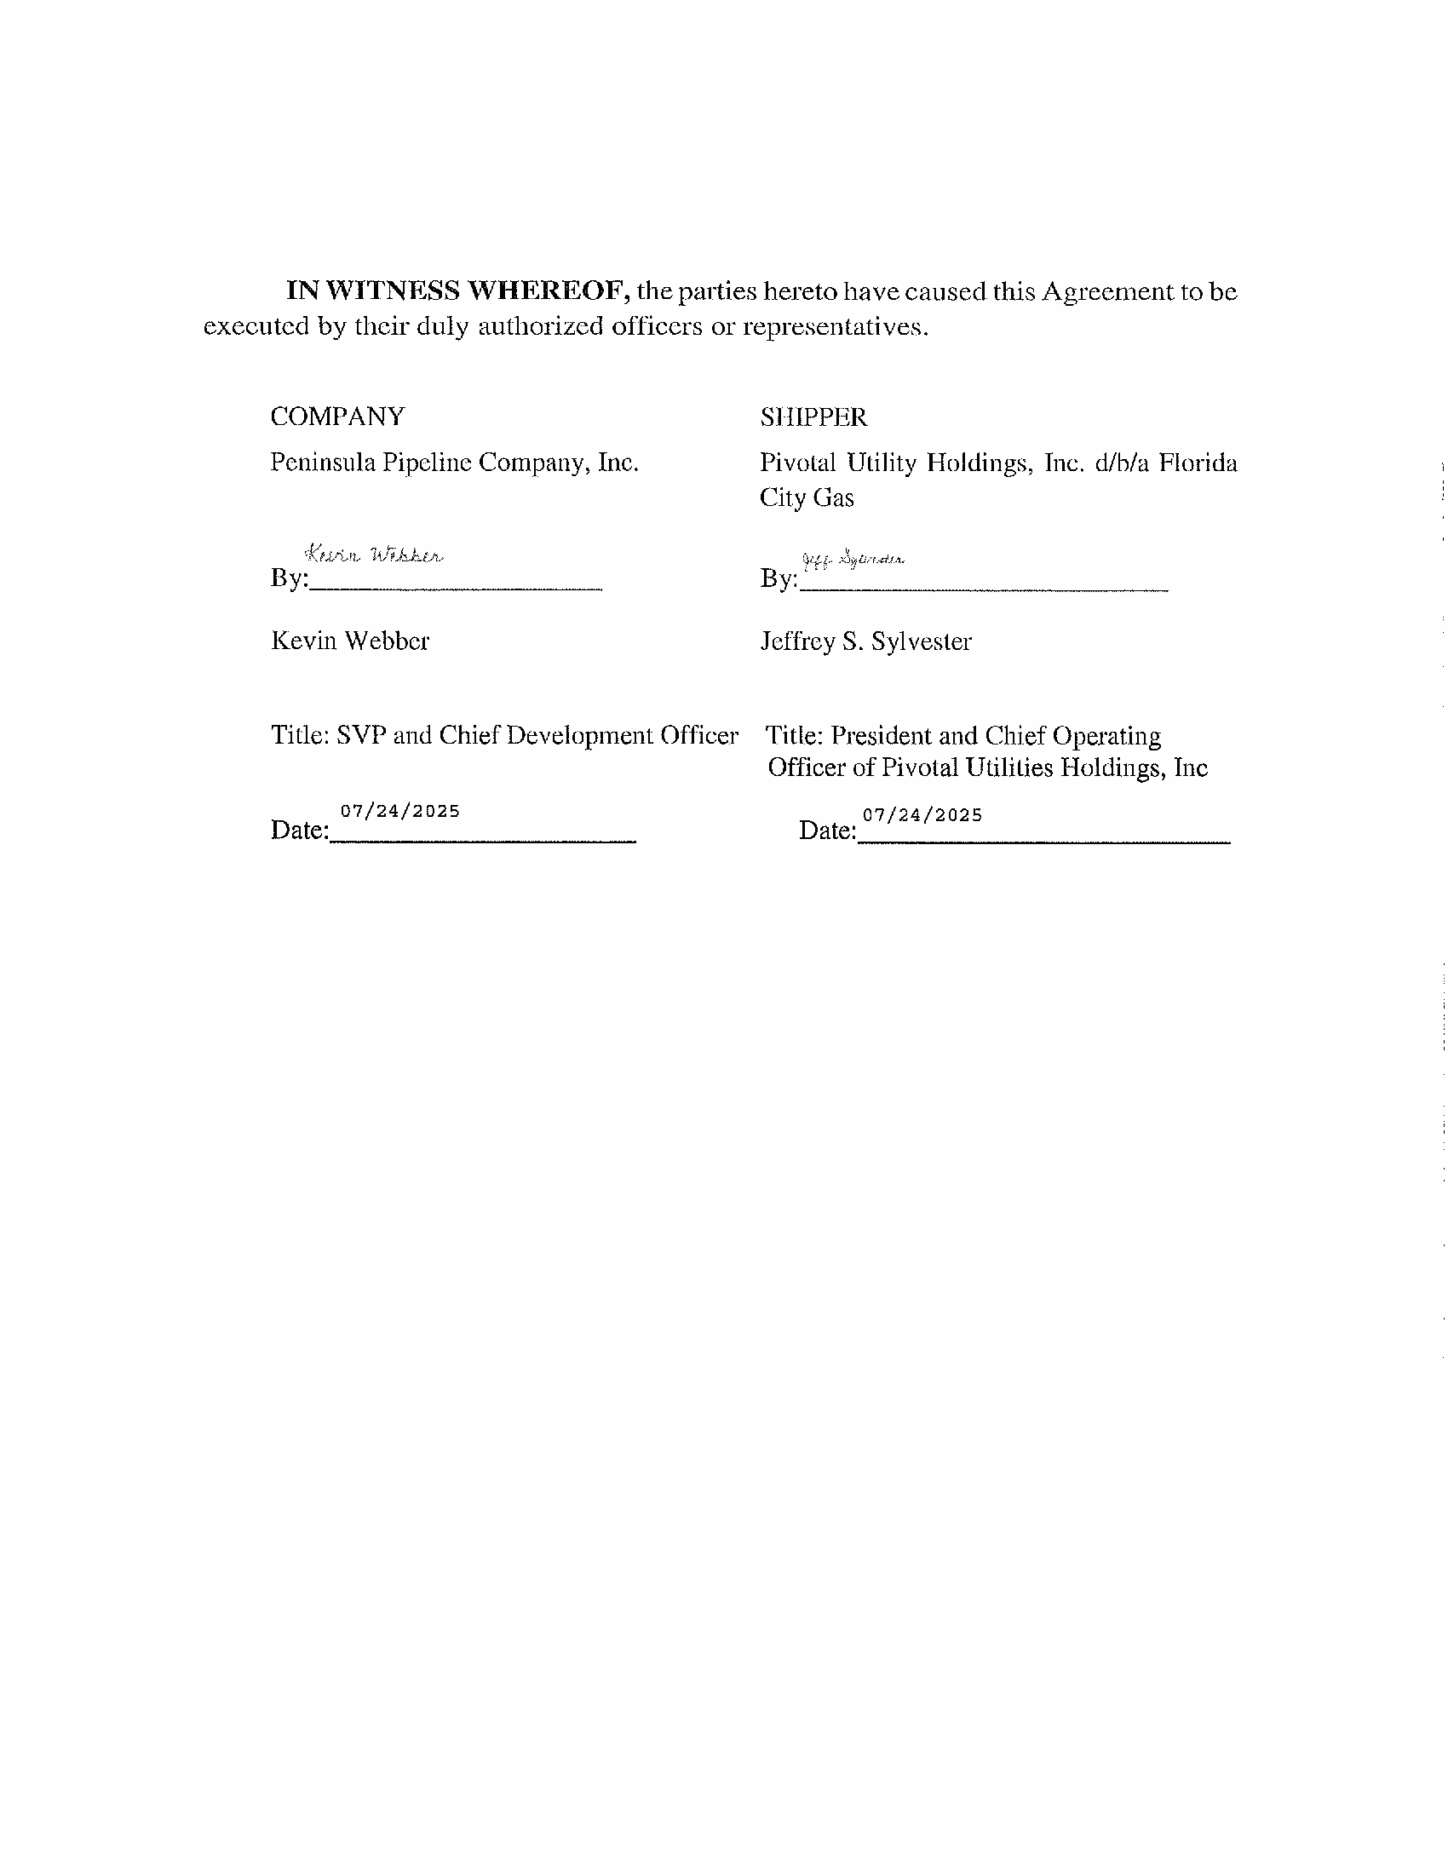

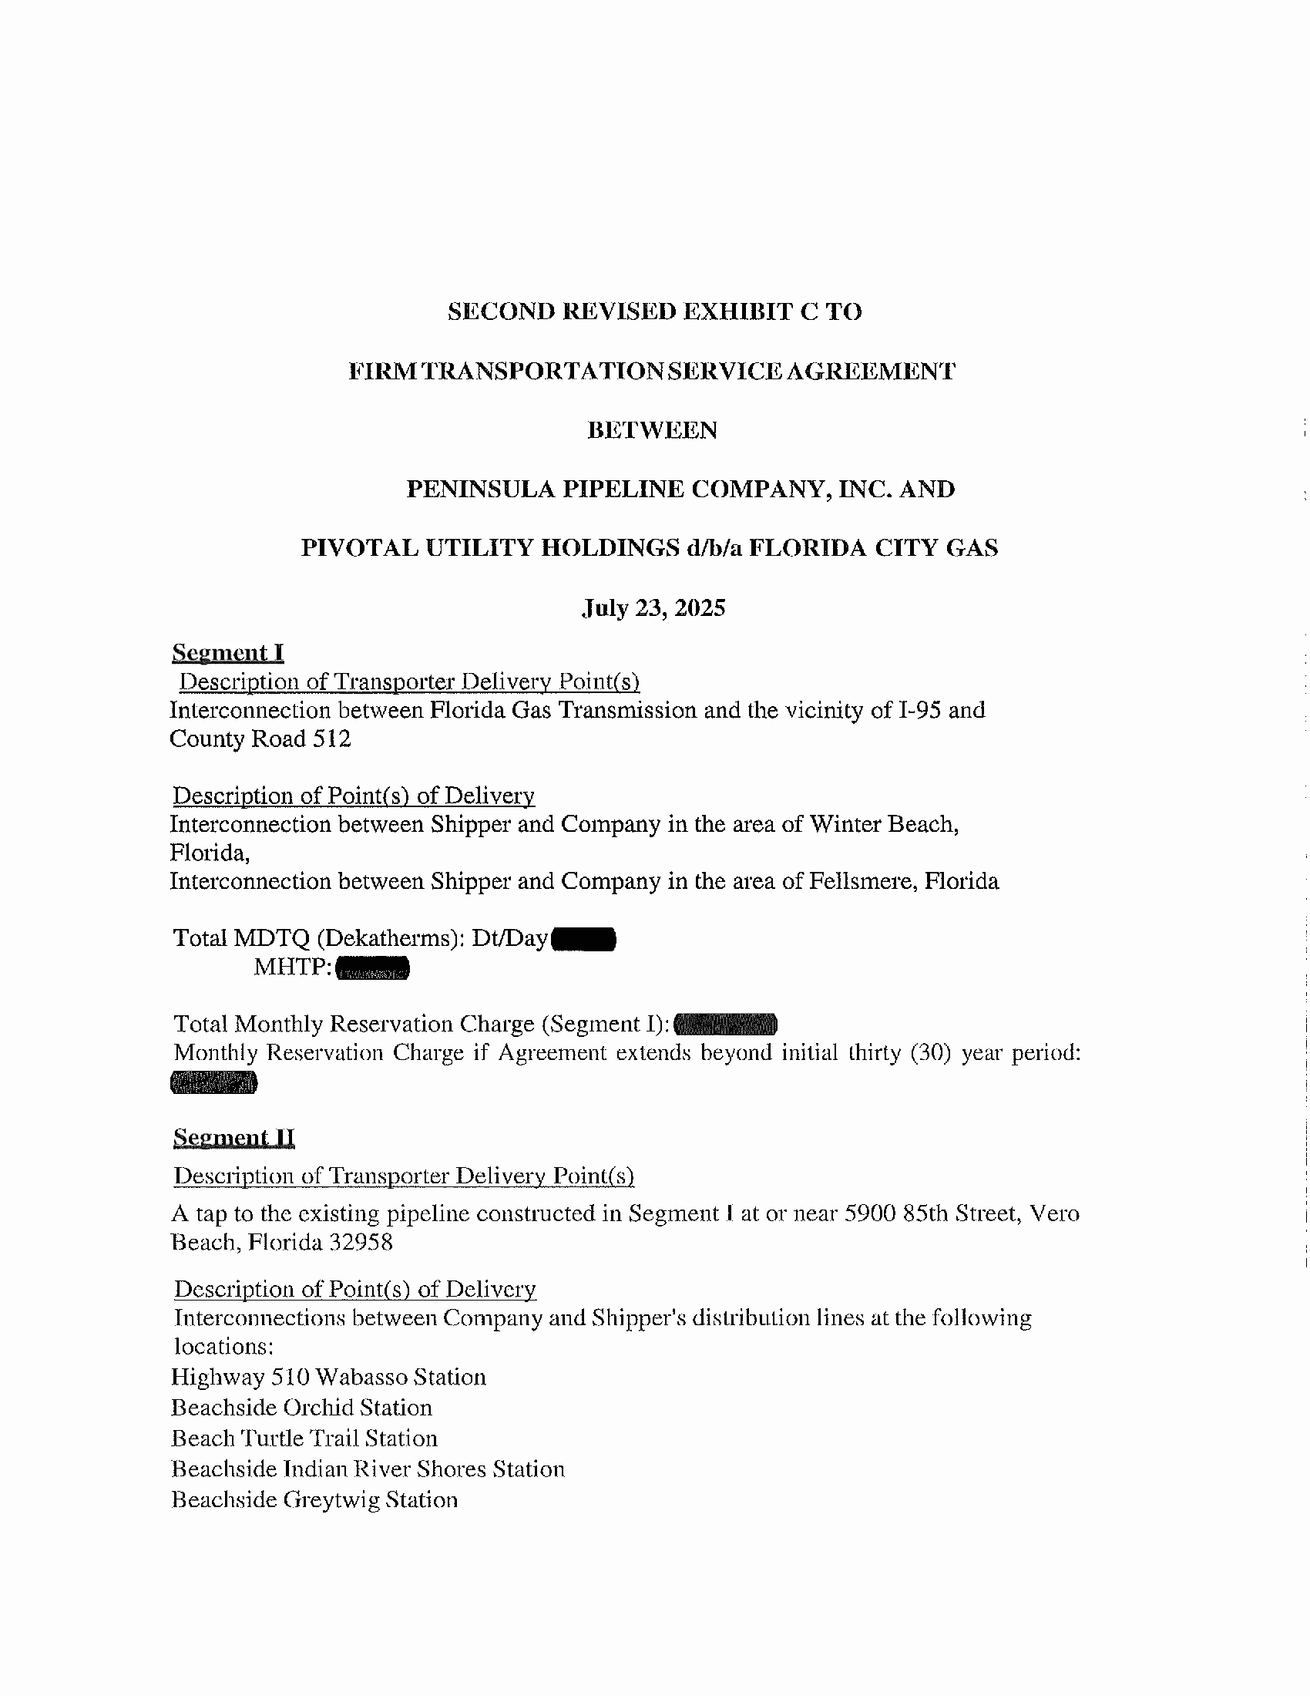

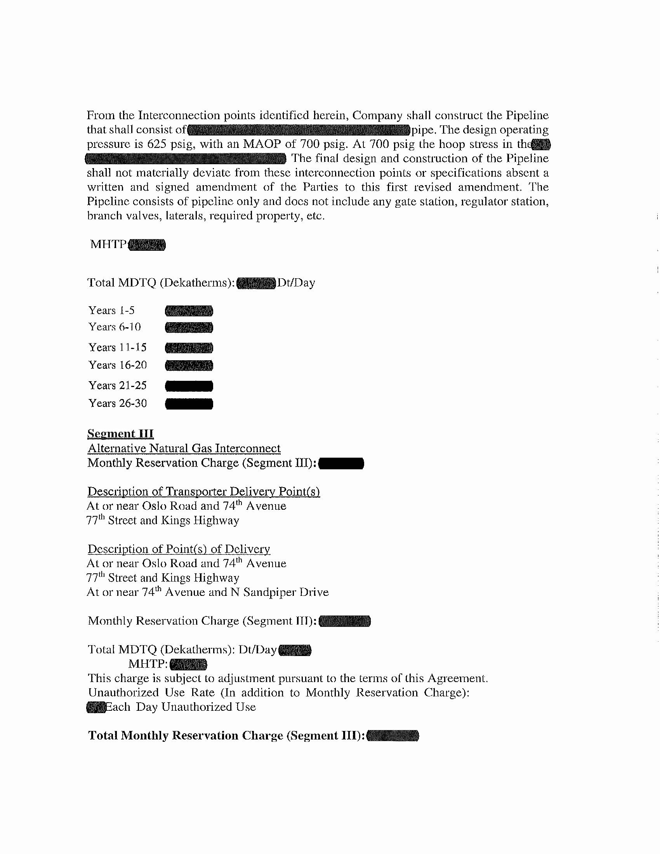



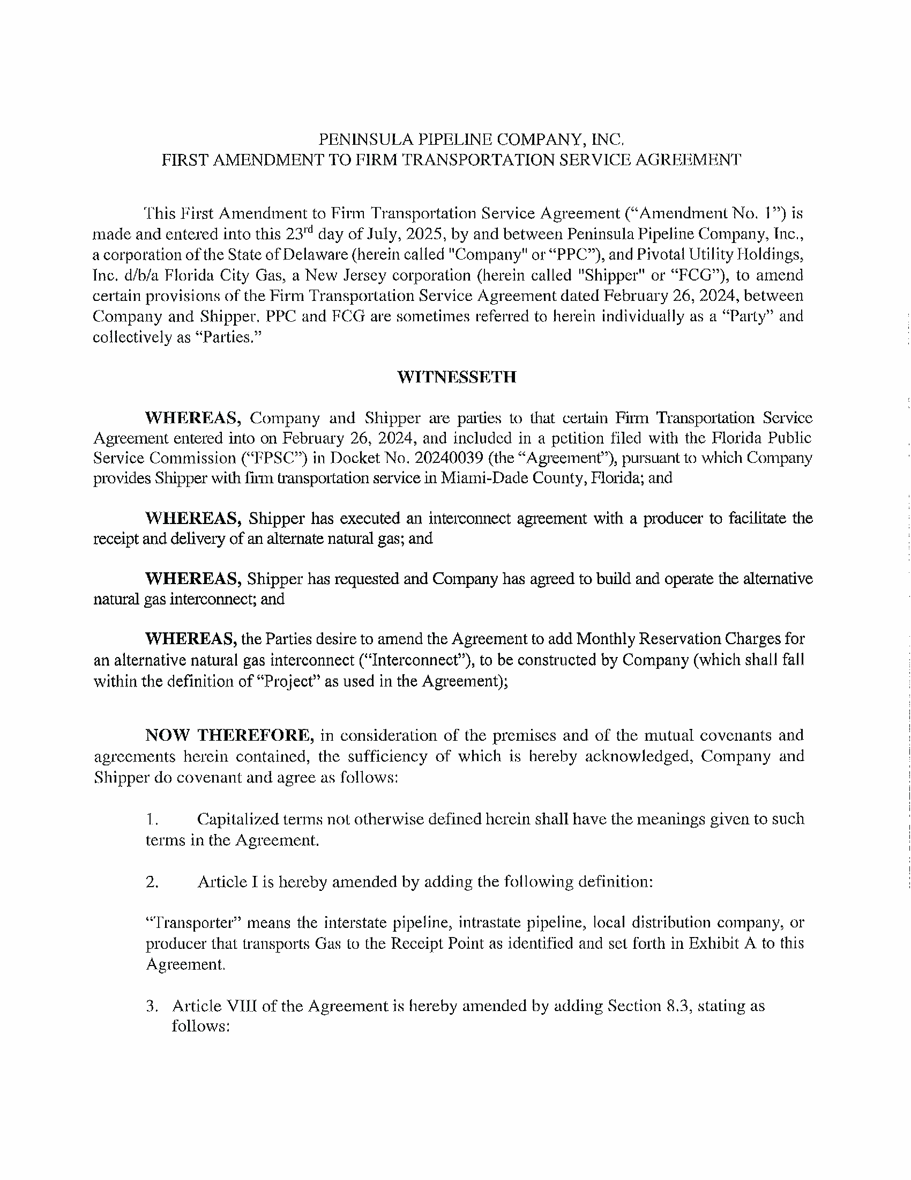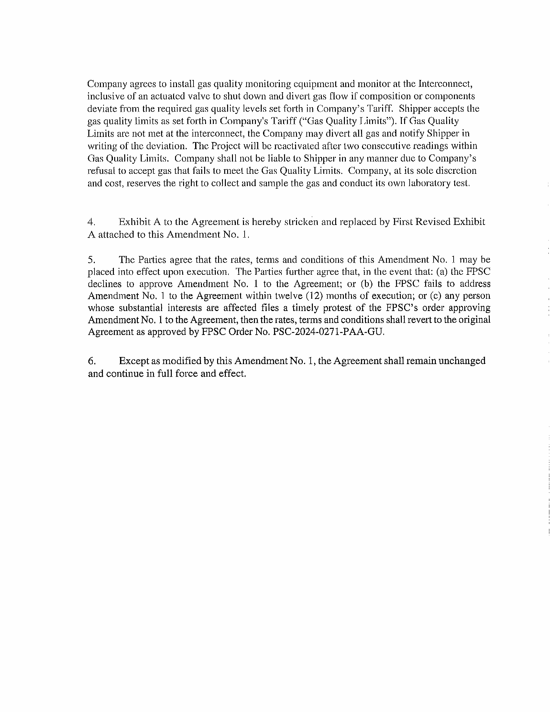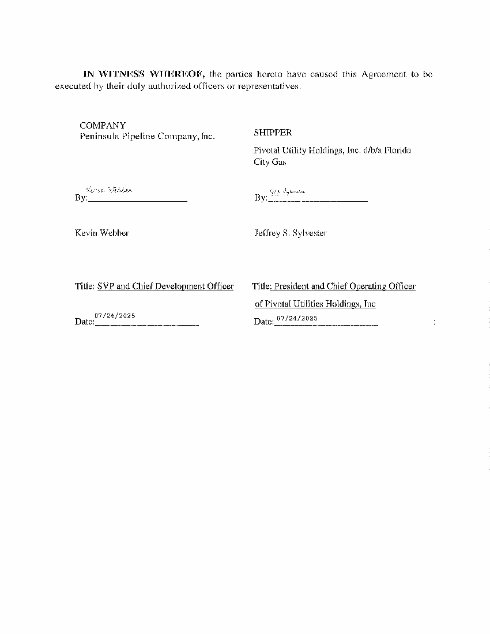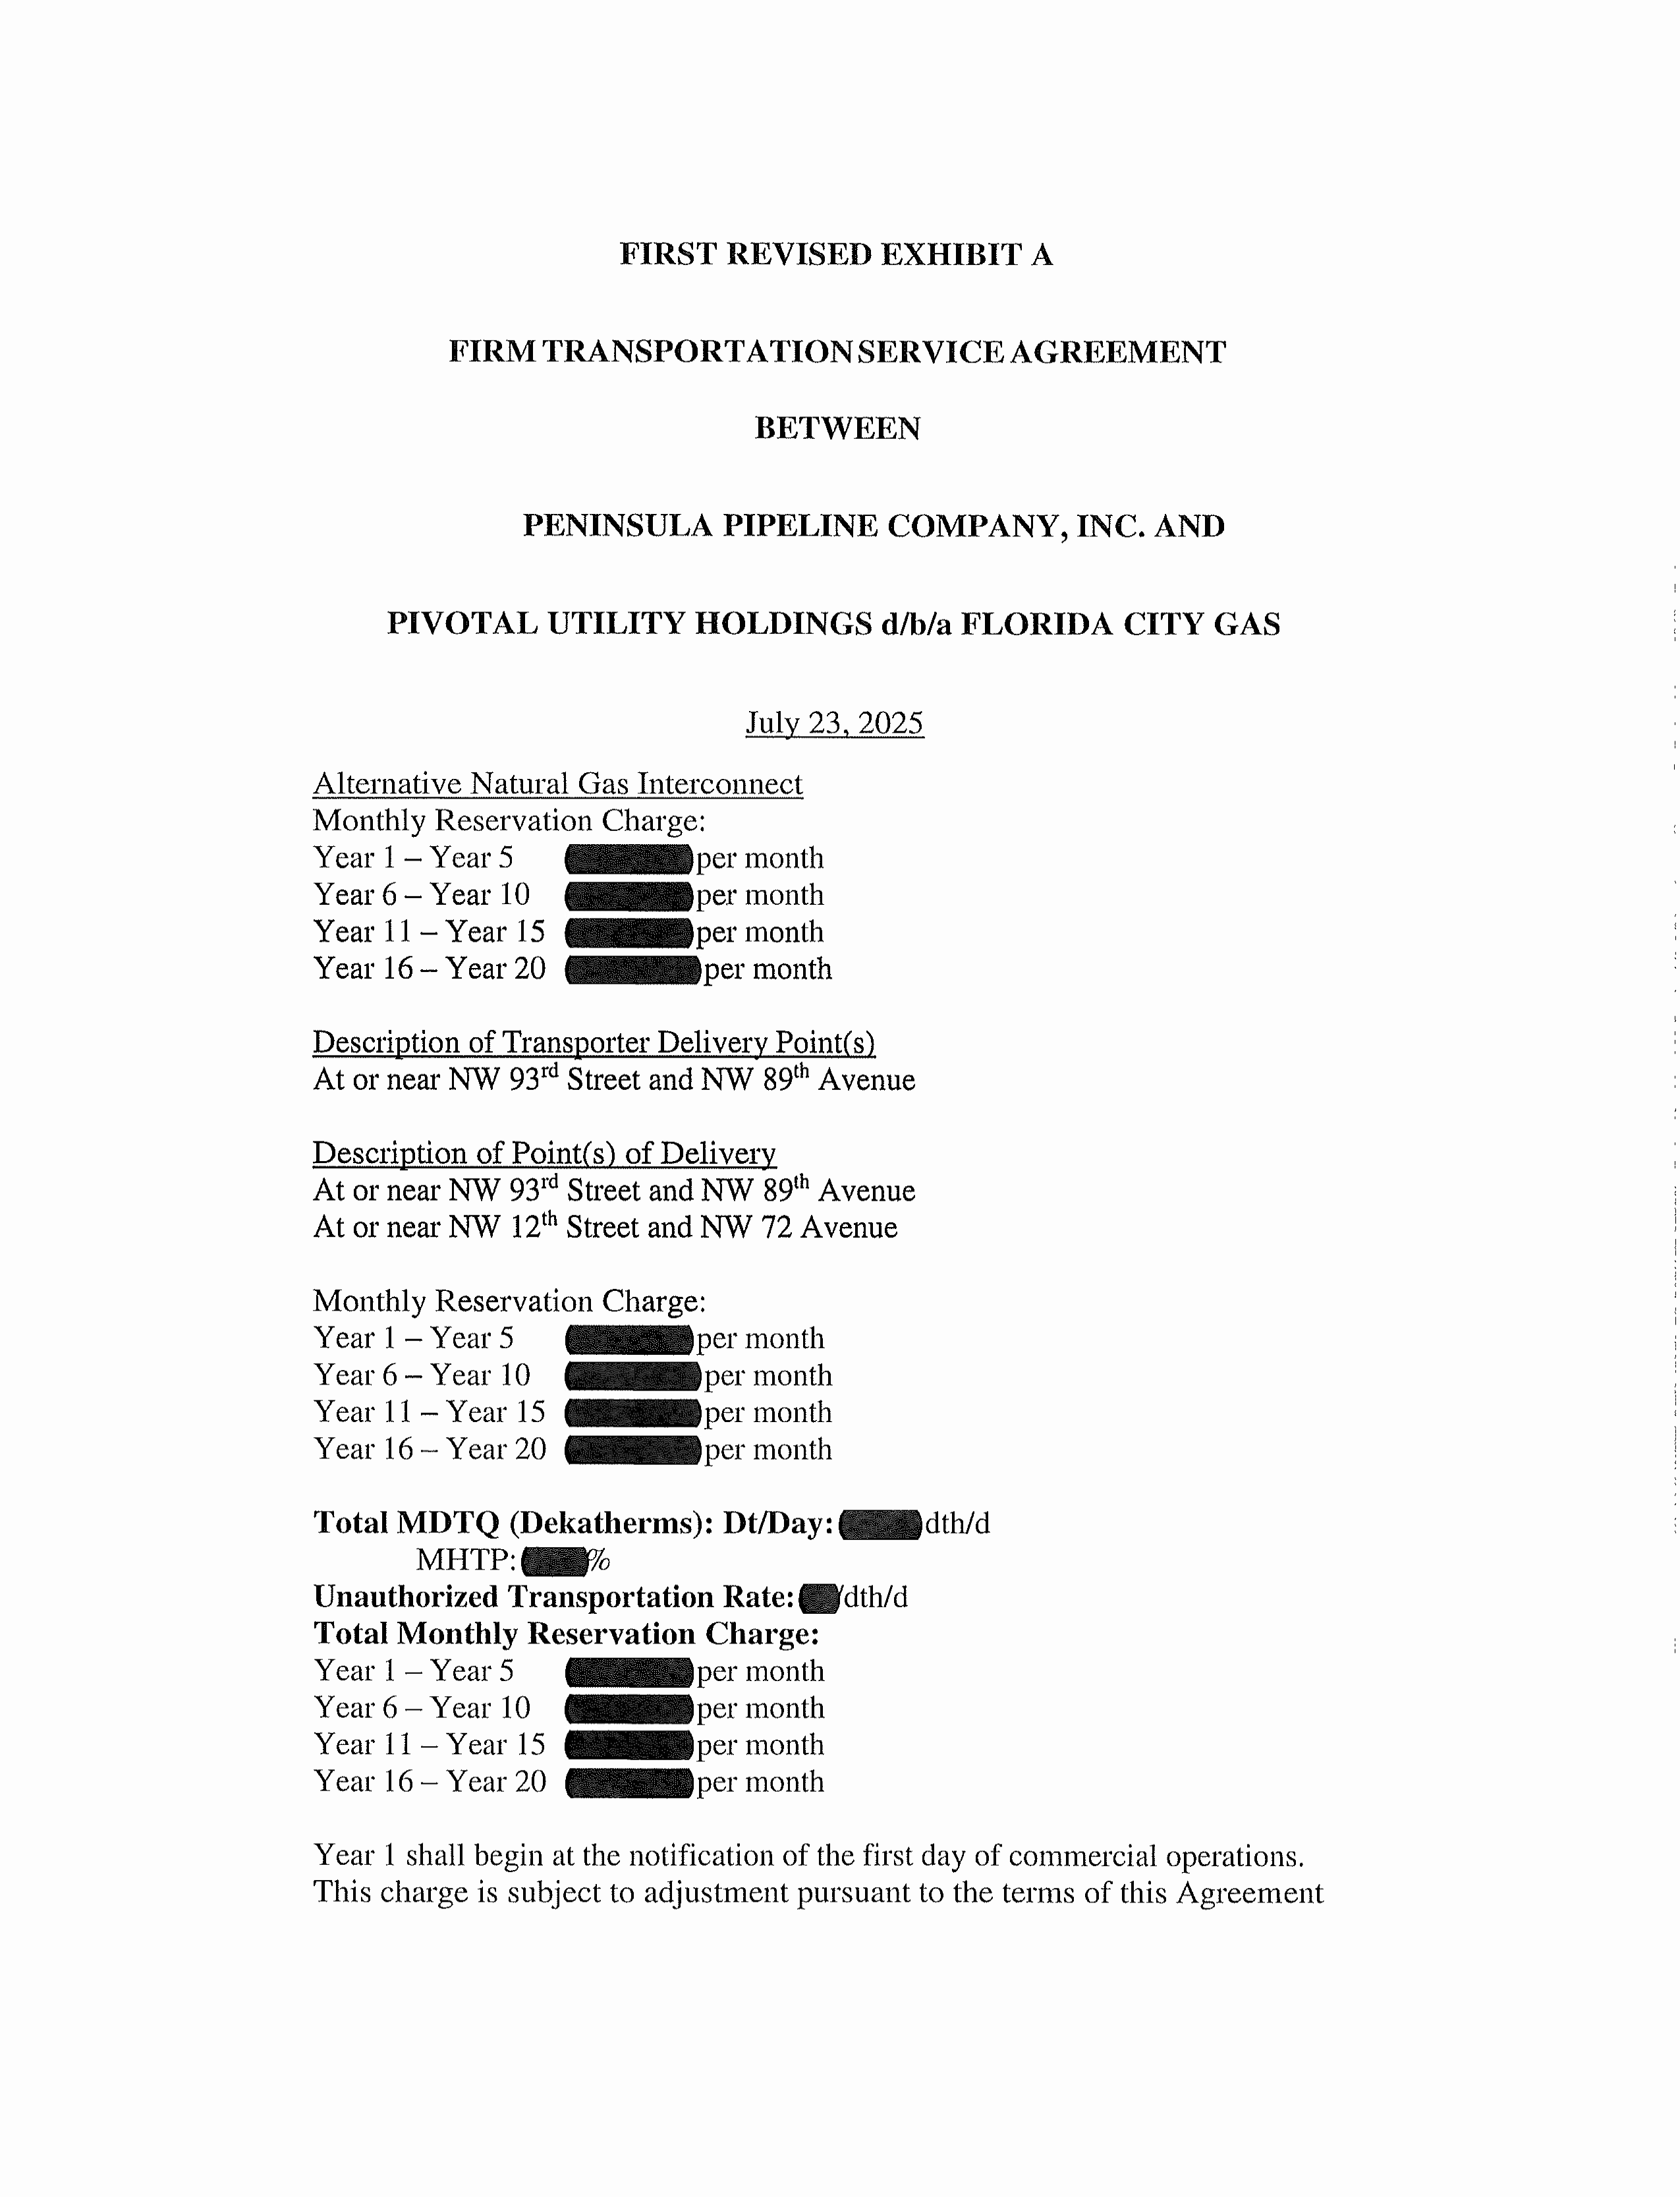

1. Order No. PSC-2024-0271-PAA-GU, issued July 26, 2024, in Docket No. 20240039-GU, *In re: Petition for approval of transportation service agreements between Peninsula Pipeline Company, Inc. and Pivotal Utility Holdings, Inc. d/b/a Florida City Gas.*
2. Document No. 05188-2024, filed June 10, 2024.
3. Order No. PSC-06-0023-DS-GP, issued January 9, 2006, in Docket No. 050584-GP, *In re: Petition for declaratory statement by Peninsula Pipeline Company, Inc. concerning recognition as a natural gas transmission company under Section 368.101, F.S., et seq.*
4. Order No. PSC-07-1012-TRF-GP, issued December 21, 2007, in Docket No. 20070570-GP, *In re: Petition for approval of natural gas transmission pipeline tariff by Peninsula Pipeline Company, Inc.*
5. Document No. 09213-2025, filed September 5, 2025.
6. Document No. 13843-2025, filed September 23, 2025.
7. Document No. 09213-2025, filed September 5, 2025.
8. Attachment A in the Parties’ Supplemental Response, Document No. 13843-2025, filed September 23, 2025.
9. Response No. 11 in Staff’s First Data Request, Document No. 09213-2025, filed September 5, 2025.