State of Florida   |  | Public Service Commission  Capital Circle Office Center ● 2540 Shumard Oak Boulevard  Tallahassee, Florida 32399-0850  -M-E-M-O-R-A-N-D-U-M-
DATE: | February 19, 2026
TO: | Office of Commission Clerk (Teitzman)
FROM: | Division of Economics (Guffey)  Office of the General Counsel (Brownless)
RE: | Docket No. 20250139-EI – Petition for approval of tariffs to implement base rate increase consistent with settlement agreement approved by Order No. PSC-2025-0287-AS-EI, by Florida Public Utilities Company.
AGENDA: | 03/03/26 – Regular Agenda – Tariff Filing – Interested Persons May Participate
COMMISSIONERS ASSIGNED: |  |  | All Commissioners
PREHEARING OFFICER: |  |  | Administrative
CRITICAL DATES: |  |  | 07/17/26 (8-Month Effective Date)
SPECIAL INSTRUCTIONS: |  |  | None

Case Background
By Order No. PSC-2025-0287-AS-EI (2025 Settlement Order), the Commission approved Florida Public Utilities Company’s (FPUC or Company) Stipulation and Settlement, a unanimous settlement which resolved all of the issues in FPUC’s 2025 rate case (2025 Settlement). Paragraph III, Revenue Requirement, sections a. and b. of the 2025 Settlement divided the base rate increase into two parts: a $7.4 million increase effective March 20, 2025, to March 19, 2026, and the final $8.4 million increase starting March 20, 2026, with a minimum term ending in September 20, 2028.
In addition to the base rate increase, the 2025 Settlement included an increase in miscellaneous fees and charges of $164,495 effective March 20, 2025. Also, the deferred $1 million would be collected over a three-year period through a one-time increase subject to an offset of the difference between the proposed Agency Action (PAA) rates collected from March 20, 2025, until July 2, 2025. The base rate increase initially approved in Order No. PSC-2025-0114-PAA-EI (PAA Order) was higher than the annual increase contained in the subsequent 2025 Settlement. A request for a hearing on the PAA Order was filed by the parties to the rate case docket who subsequently reached the 2025 Settlement.

Paragraph XV, New Rates, of the 2025 Settlement provides for FPUC to file revised tariffs reflecting the subsequent years’ revenue requirement, to be effective on March 20, 2026. Accordingly, on November 17, 2025, FPUC filed a petition seeking approval to implement a base rate increase consistent with the 2025 Settlement to be effective on March 20, 2026.

During the analysis to date, staff issued its first data request to FPUC on December 1, 2025, for which the responses were received on December 15, 2025. By Order No. PSC-2026-0020-PCO-EI, the Commission suspended the revised tariffs. The Commission has jurisdiction over this matter pursuant to Sections 366.04, 366.05, and 366.06, Florida Statutes (F.S.).

Discussion of Issues

Issue 1:
Should the Commission approve FPUC's revised tariffs to implement the base rate increase consistent with the 2025 Settlement approved in Order No. PSC-2025-0287-AS-EI?

Recommendation:
Yes. The Commission should approve FPUC's revised tariffs to implement the base rate increase consistent with the 2025 Settlement approved in Order No. PSC-2025-0287-AS-EI. The revised tariffs, Sheet Nos. 7.001, 7.004, 7.006, 7.008, 7.010, 7.013, 7.014, and 7.016 are included in Attachment A to this recommendation, and should be effective on March 20, 2026. (Guffey)

Staff Analysis:
The 2025 Settlement Order approved a base revenue increase of $8.4 million. The 2025 Settlement Order divided the base rate increase into 2 parts: a $7.4 million increase effective March 20, 2025, to March 19, 2026, and the final $8.4 million increase starting March 20, 2026 with a minimum term ending September 20, 2028.
In this petition, FPUC seeks to collect the deferred $1 million base revenue increase and 1/3 of the difference between the PAA rates collected from March 20, 2025, until July 2, 2025. Consistent with the 2025 Settlement, FPUC calculated the increase in base rates to be effective March 20, 2026 as shown in Table 1-1 below.
Table 1-1
Base Rate Increase Calculation
Base Rate Deferral | $1,000,000.00
Over Collection (3/20/2025 to 7/2/2025) | ($624,014.03)
Net Increase to be Collected Over 3 Years | $375,985.97
1/3 of the Net Increase to be Collected per Year | $125,328.66
Base Rate Increase from $7.4M to $8.4M | $1,000,000.00
Total Base Rate Increase | $1,125,328.66
Source: FPUC Petition and Responses in Staff’s First Data Request
The base rates contained in Attachment A will remain in effect until the next rate proceeding. However, the 2025 Settlement provides for a step rate increase when the acquisition and replacement of substation and transmission assets are completed. FPUC states that the additional amount shown in Table 1-1 was allocated consistent with the rate design approved in the 2025 Settlement.
With the proposed tariff revisions, the base energy charge for residential customers would increase from 2.696 cents/kWh to 2.867 cents/kWh. Currently, a residential customer using 1,000 kWh a month pays a total of $163.42, including gross receipts tax. With the revised tariffs, a residential customer’s total 1,000 kWh bill would be $165.17 a month, an increase of $1.75 (including Gross Receipts Tax).
Staff notes that the petition included tariff pages 7.002, 7.003, 7.005, 7.007, 7.009, 7.011, 7.012, 7.015, and 7.017 which did not have revisions. In response to staff’s first data request No. 7, the Company confirmed that revisions to the above listed tariff pages are not necessary. Therefore, staff has not included those tariff pages in Attachment A to this recommendation as no Commission approval is needed. Attachment A includes the revised tariffs, Sheet Nos. 7.001, 7.004, 7.006, 7.008, 7.010, 7.013, 7.014, and 7.016 which require Commission approval.

Conclusion
After review of FPUC’s petition, responses to staff’s data request, and the 2025 Settlement, staff concludes that the Company’s proposal is consistent with the 2025 Settlement Order. Therefore, the Commission should approve FPUC's revised tariff Sheet Nos. 7.001, 7.004, 7.006, 7.008, 7.010, 7.013, 7.014, and 7.016 to implement the base rate increase consistent with the 2025 Settlement approved in Order No. PSC-2025-0287-AS-EI. The revised tariffs included in Attachment A to this recommendation should be effective on March 20, 2026.

Issue 2:
Should this docket be closed?

Recommendation:
Yes. If a protest is filed within 21 days of the issuance of the order, the tariffs should remain in effect, with any revenues held subject to refund, pending resolution of the protest. If no timely protest is filed, this docket should be closed upon the issuance of a consummating order. (Brownless)

Staff Analysis:
If a protest is filed within 21 days of the issuance of the order, the tariffs should remain in effect, with any revenues held subject to refund, pending resolution of the protest. If no timely protest is filed, this docket should be closed upon the issuance of a consummating order.

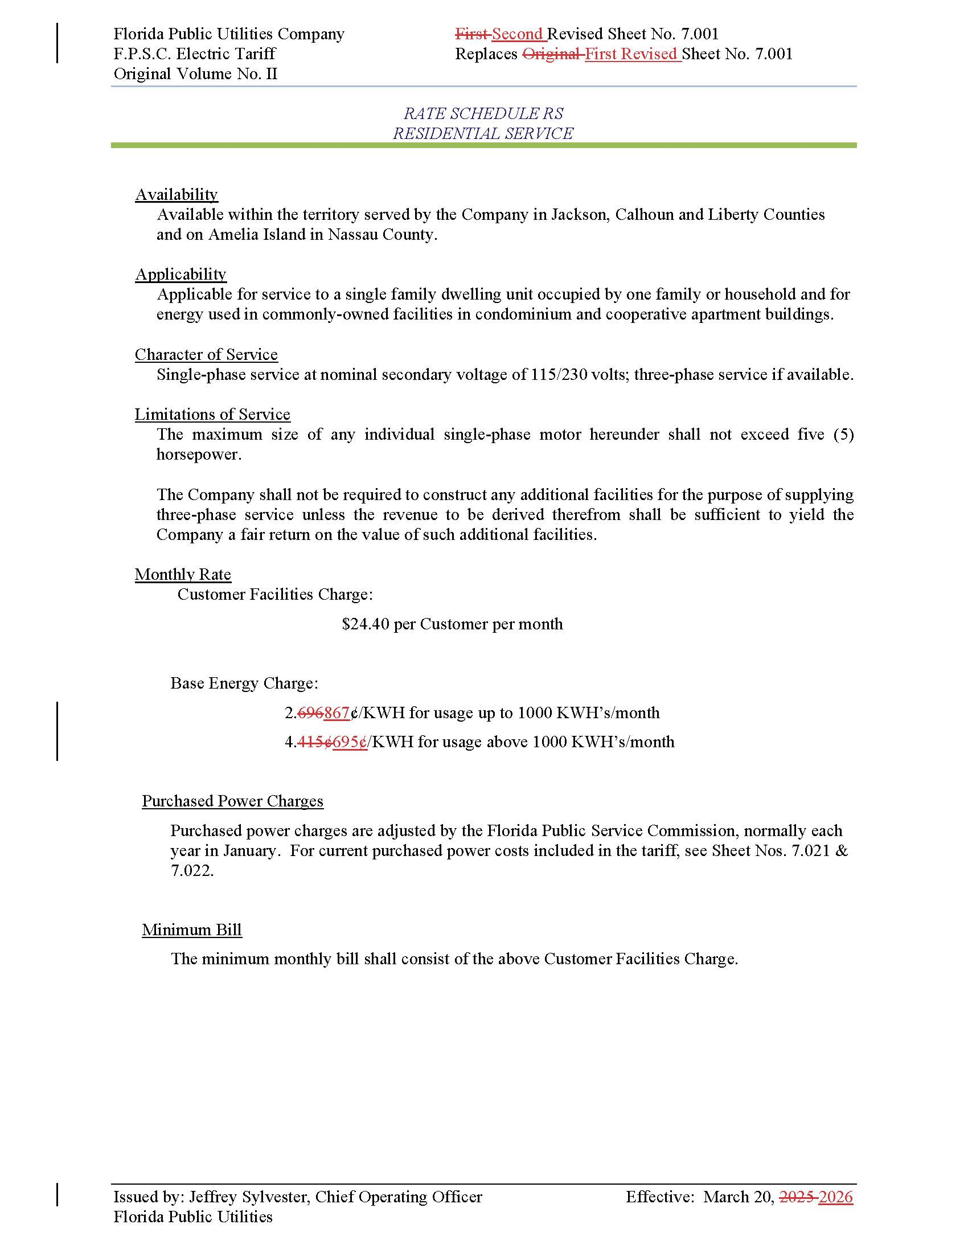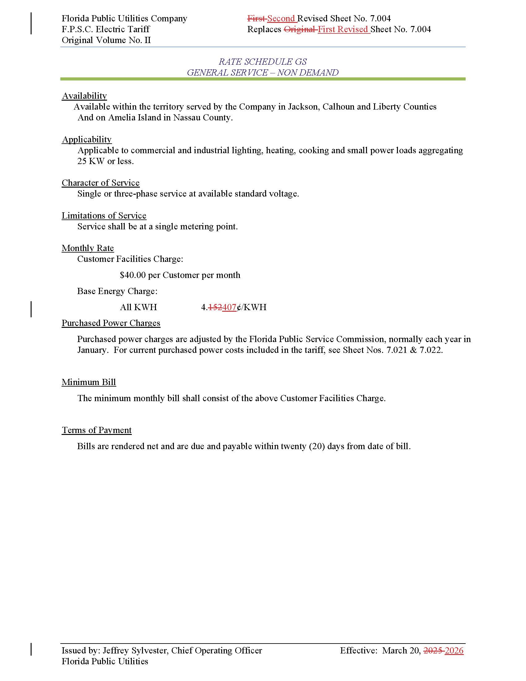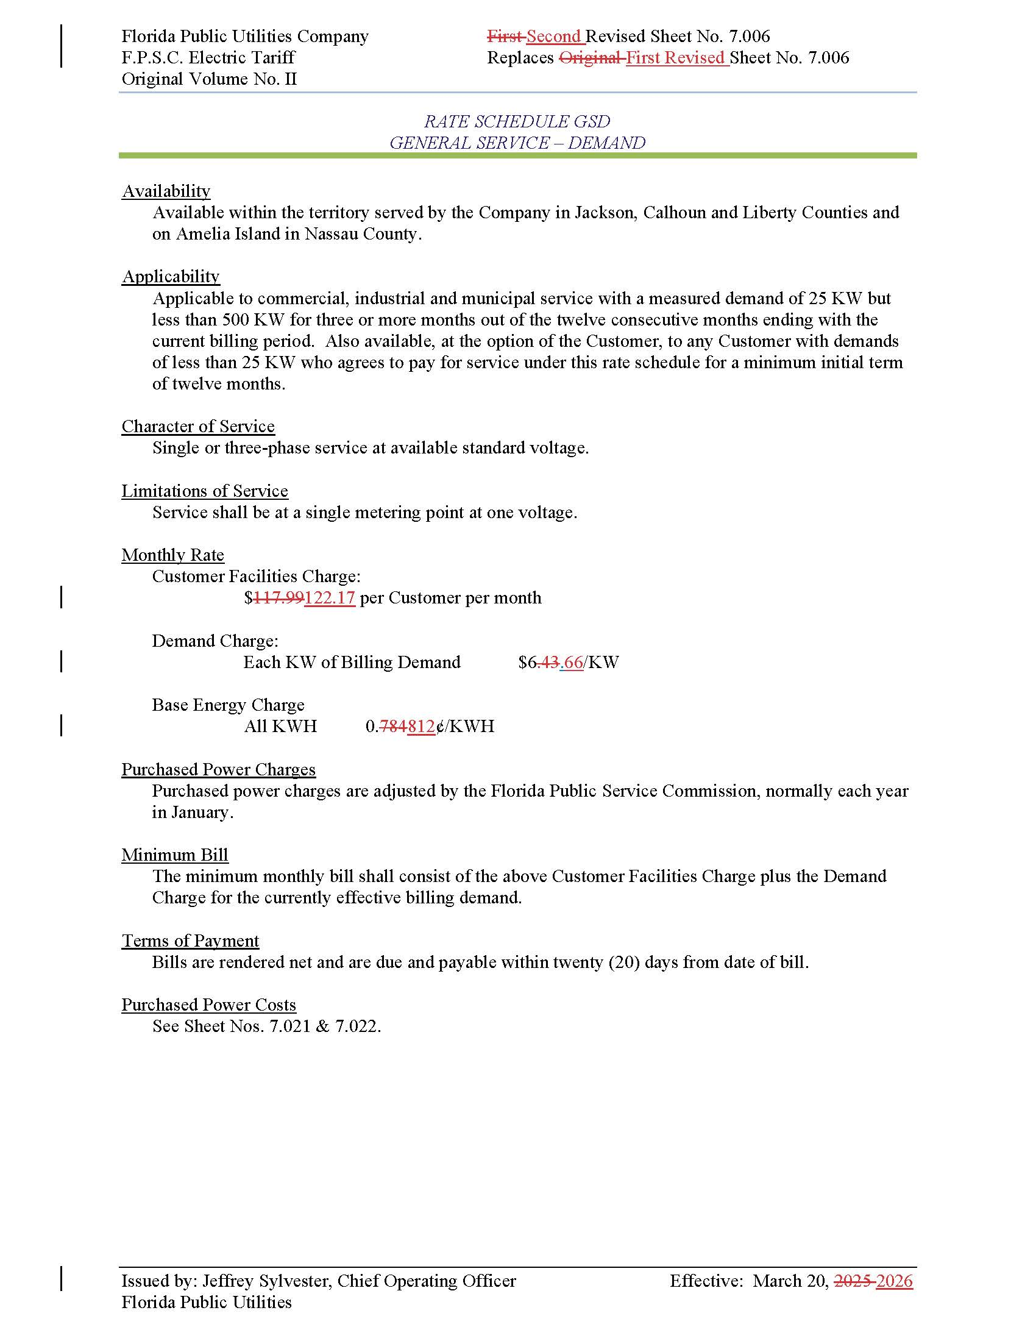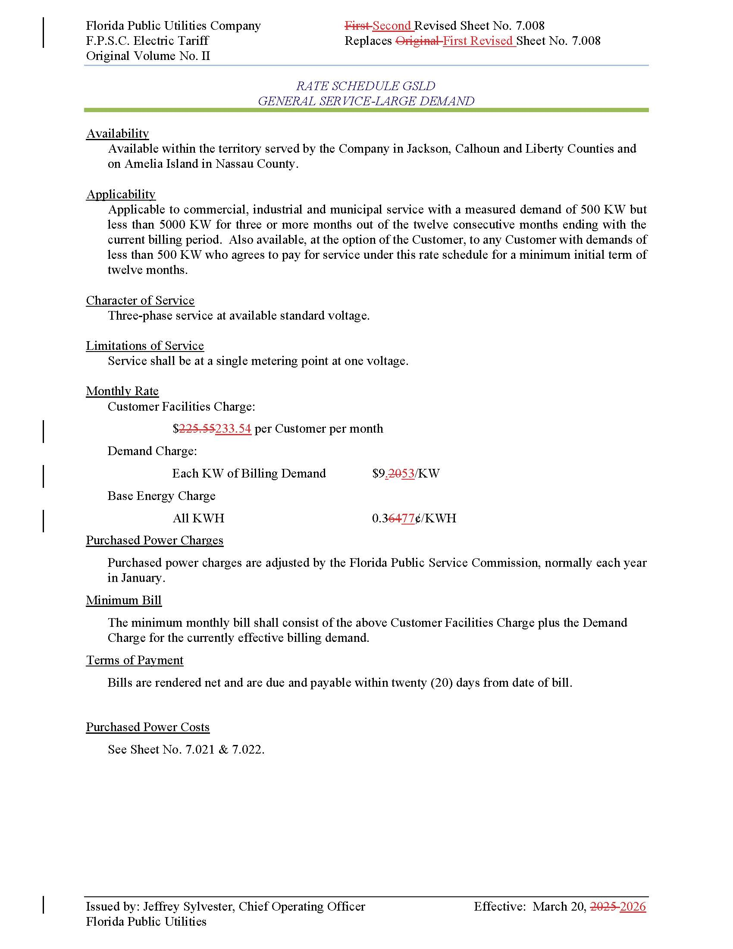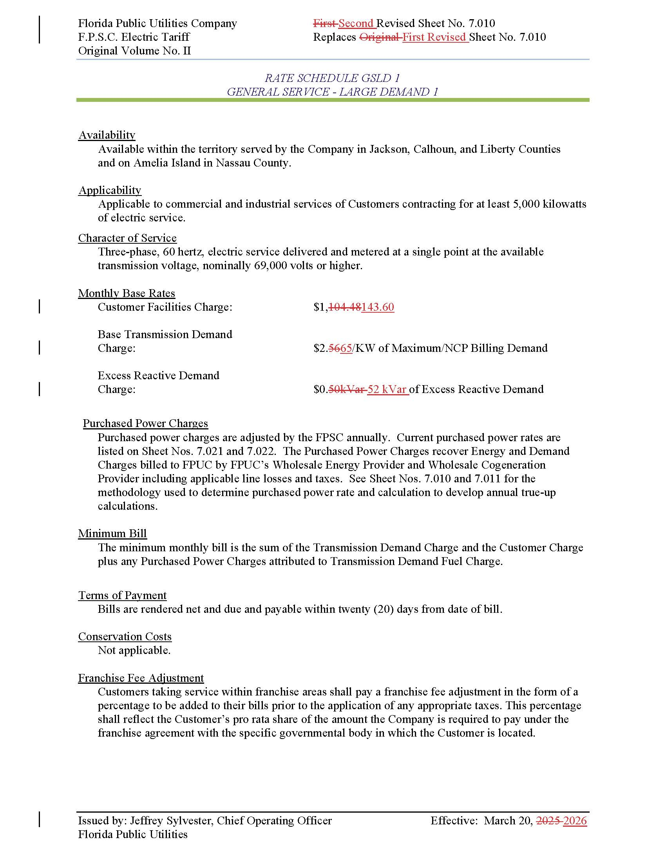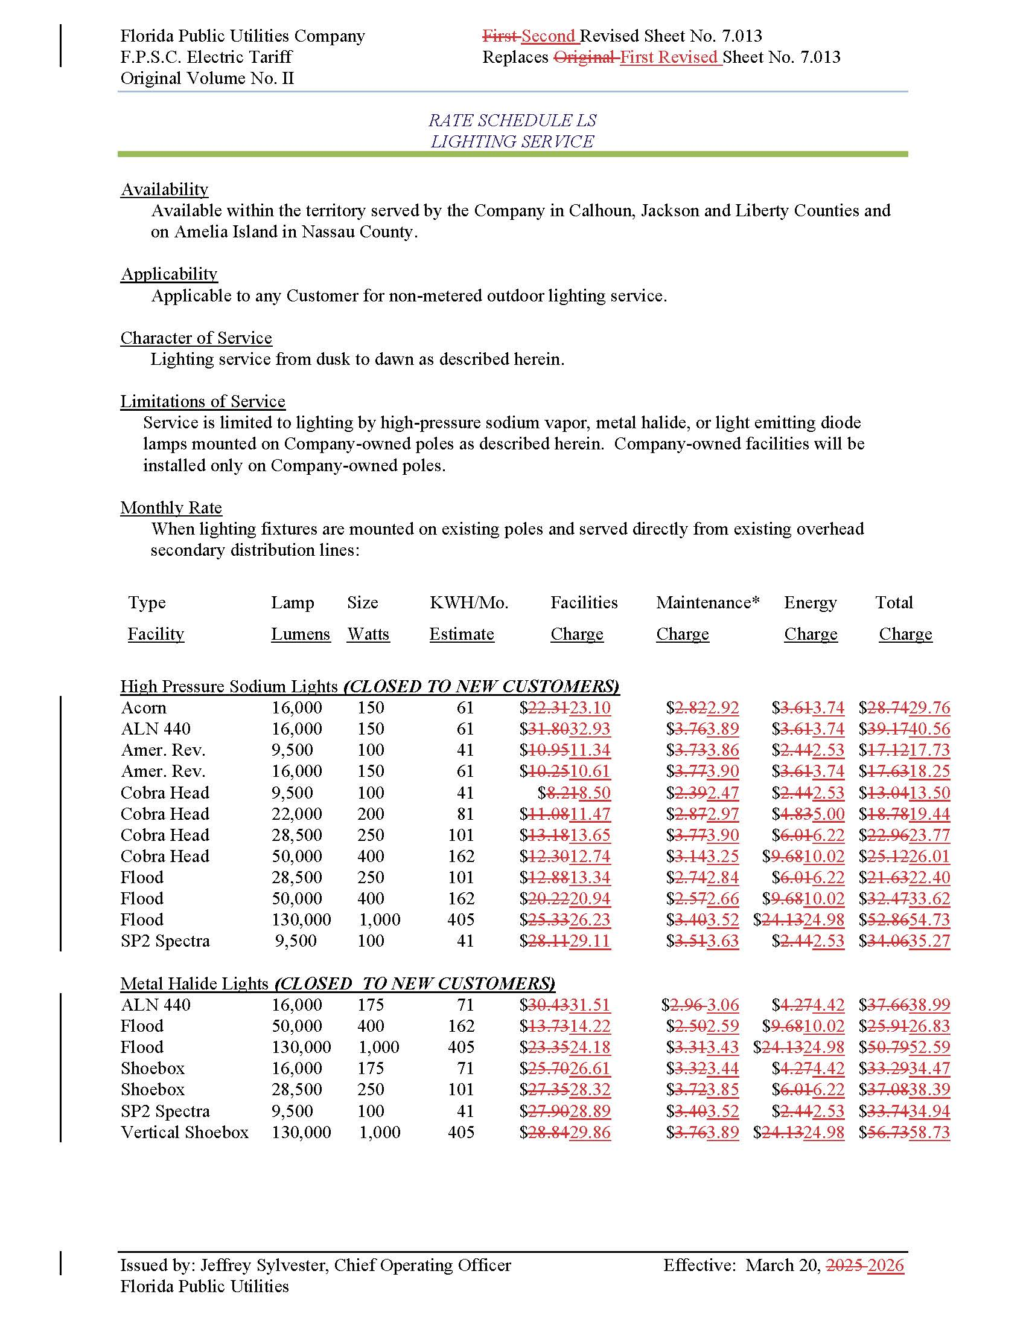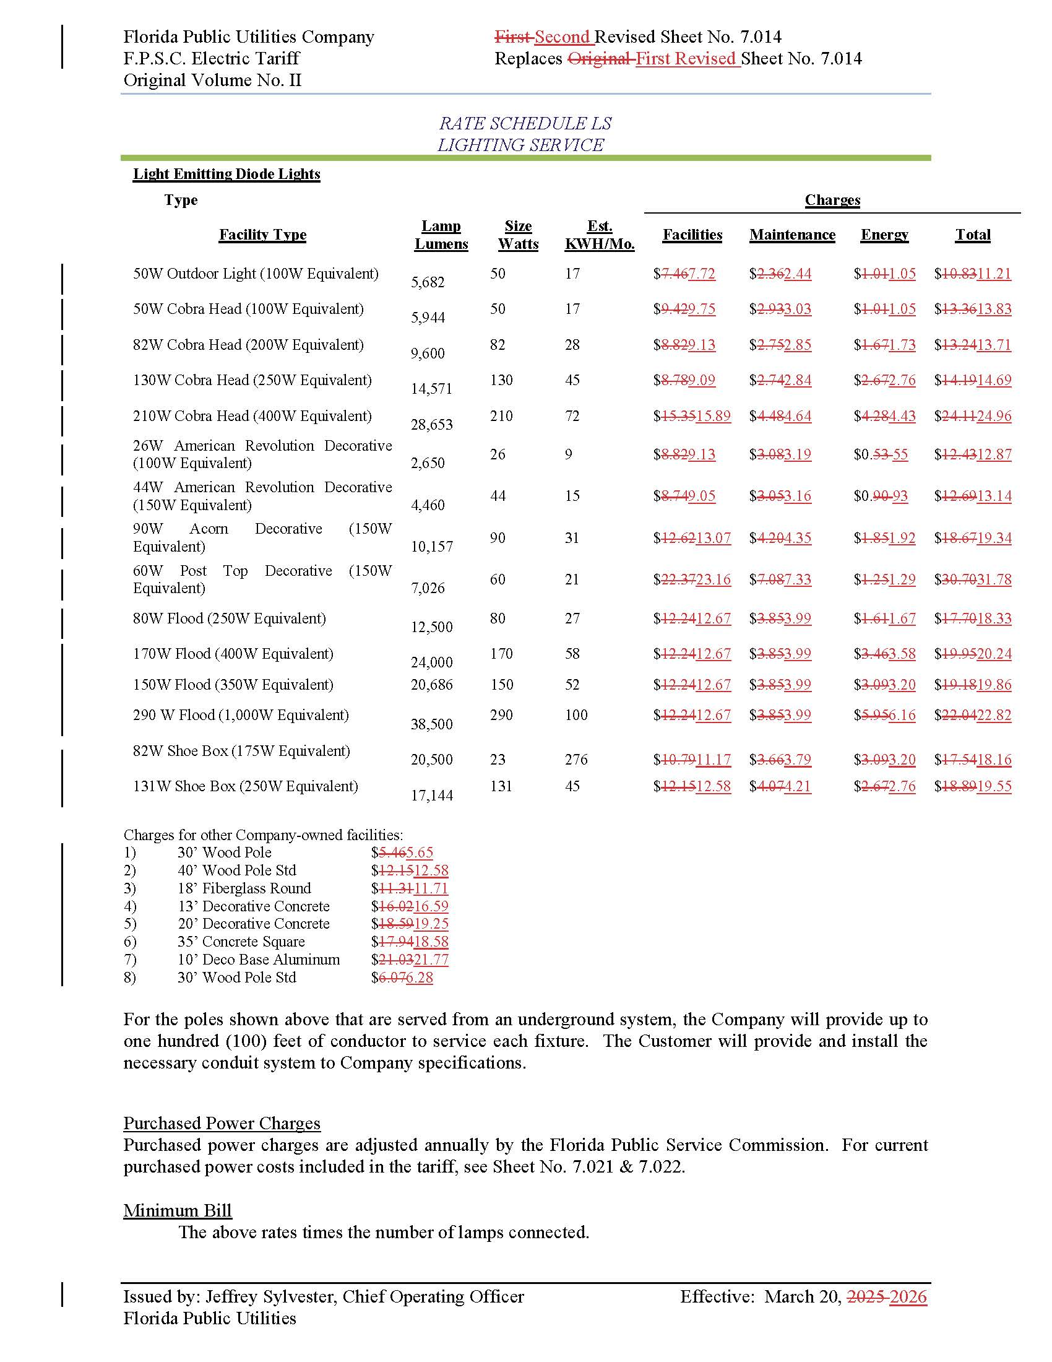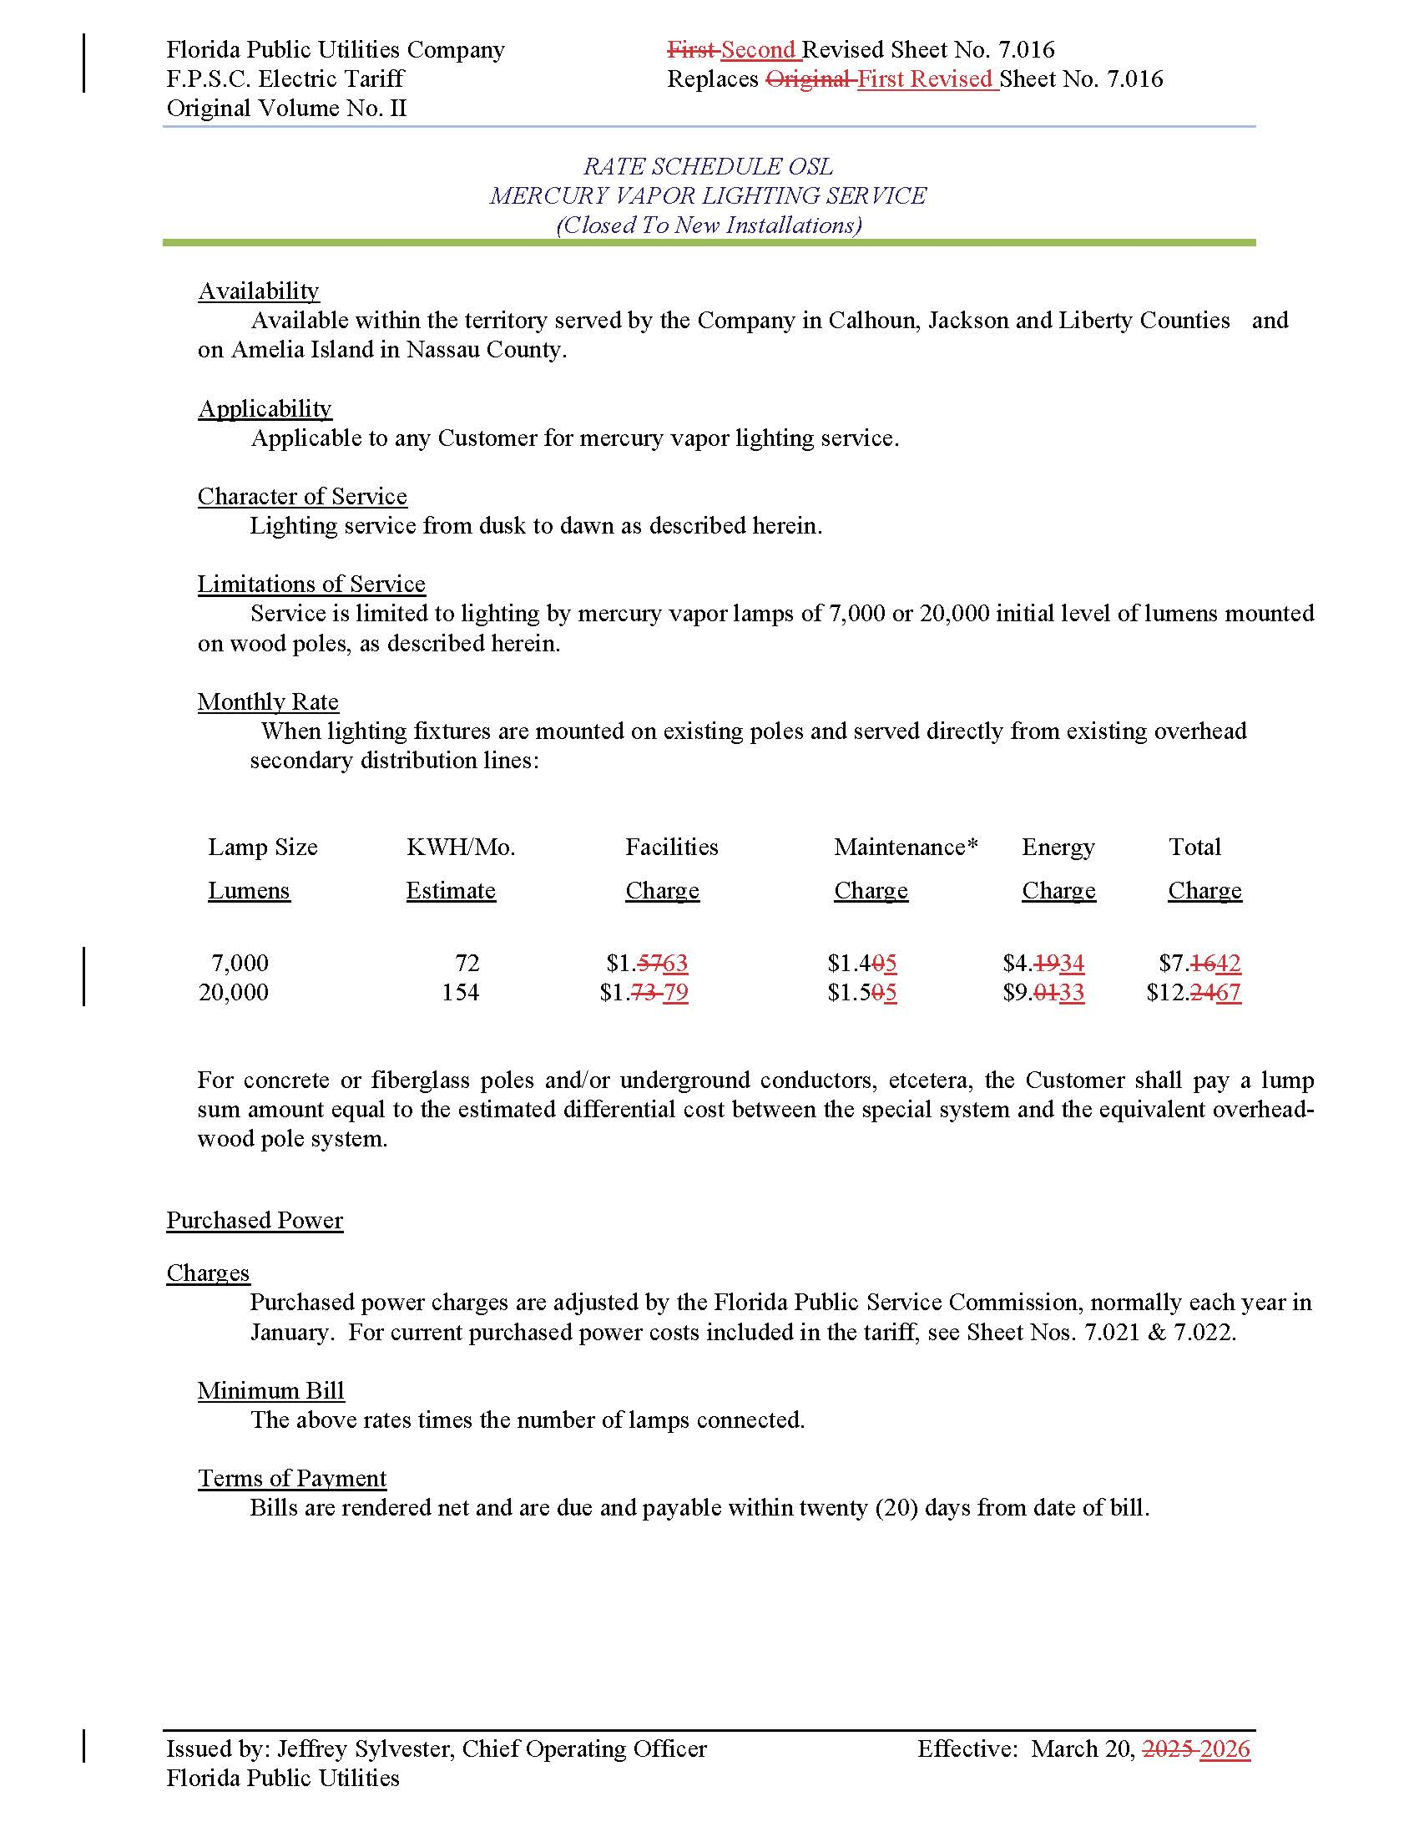

Order No. PSC-2025-0287-AS-EI, issued July 24, 2025 in Docket No. 20240099-EI, In re: Petition for rate increase by Florida Public Utilities Company.
Order No. PSC-2025-0114-PAA-EI, issued April 7, 2025, in Docket No. 20240099-EI, In re: Petition for rate increase by Florida Public Utilities Company.
Order No. PSC-2026-0020-PCO-EI, issued January 14, 2026, in Docket No. 2025139-EI, In re: Petition for approval of tariffs to implement base rate increase consistent with settlement agreement approved by Order No. PSC-2025-0287-AS-EI, by Florida Public Utilities Company.
Order No. PSC-2025-0287-AS-EI, pages 2-4.
Paragraph III.d of the 2025 Settlement.

