BEFORE THE FLORIDA PUBLIC SERVICE COMMISSION

In re: Petition for approval of tariffs to implement base rate increase consistent with settlement agreement approved by Order No. PSC-2025-0287-AS-EI, by Florida Public Utilities Company. | DOCKET NO. 20250139-EI  ORDER NO. PSC-2026-0059-TRF-EI  ISSUED: March 12, 2026

The following Commissioners participated in the disposition of this matter:

GABRIELLA PASSIDOMO SMITH, Chairman
GARY F. CLARK
MIKE LA ROSA
BOBBY PAYNE
ANA ORTEGA

ORDER APPROVING 2025 SETTLEMENT
AGREEMENT TARIFFS

BY THE COMMISSION:
BACKGROUND

By Order No. PSC-2025-0287-AS-EI (2025 Settlement Order), we approved Florida Public Utilities Company’s (FPUC or Company) Stipulation and Settlement, a unanimous settlement which resolved all of the issues in FPUC’s 2025 rate case (2025 Settlement). Paragraph III, Revenue Requirement, sections a. and b. of the 2025 Settlement divided the base rate increase into two parts: a $7.4 million increase effective March 20, 2025, to March 19, 2026, and the final $8.4 million increase starting March 20, 2026, with a minimum term ending in September 20, 2028.
In addition to the base rate increase, the 2025 Settlement included an increase in miscellaneous fees and charges of $164,495 effective March 20, 2025. Also, the deferred $1 million would be collected over a three-year period through a one-time increase subject to an offset of the difference between the proposed Agency Action (PAA) rates collected from March 20, 2025, until July 2, 2025. The base rate increase initially approved in Order No. PSC-2025-0114-PAA-EI (PAA Order) was higher than the annual increase contained in the subsequent 2025 Settlement. A request for a hearing on the PAA Order was filed by the parties to the rate case docket who subsequently reached the 2025 Settlement.
Paragraph XV, New Rates, of the 2025 Settlement provides for FPUC to file revised tariffs reflecting the subsequent years’ revenue requirement, to be effective on March 20, 2026. Accordingly, on November 17, 2025, FPUC filed a petition seeking approval to implement a base rate increase consistent with the 2025 Settlement to be effective on March 20, 2026.

During the analysis to date, staff issued its first data request to FPUC on December 1, 2025, for which the responses were received on December 15, 2025. By Order No. PSC-2026-0020-PCO-EI, we suspended the revised tariffs. We have jurisdiction over this matter pursuant to Sections 366.04, 366.05, and 366.06, Florida Statutes (F.S.).
DECISION
The 2025 Settlement Order approved a base revenue increase of $8.4 million. The 2025 Settlement Order divided the base rate increase into 2 parts: a $7.4 million increase effective March 20, 2025, to March 19, 2026, and the final $8.4 million increase starting March 20, 2026 with a minimum term ending September 20, 2028.
In this petition, FPUC seeks to collect the deferred $1 million base revenue increase and 1/3 of the difference between the PAA rates collected from March 20, 2025, until July 2, 2025. Consistent with the 2025 Settlement, FPUC calculated the increase in base rates to be effective March 20, 2026 as shown in Table 1 below.
Table 1
Base Rate Increase Calculation
Base Rate Deferral | $1,000,000.00
Over Collection (3/20/2025 to 7/2/2025) | ($624,014.03)
Net Increase to be Collected Over 3 Years | $375,985.97
1/3 of the Net Increase to be Collected per Year | $125,328.66
Base Rate Increase from $7.4M to $8.4M | $1,000,000.00
Total Base Rate Increase | $1,125,328.66
Source: FPUC Petition and Responses in Staff’s First Data Request
The base rates contained in Attachment A will remain in effect until the next rate proceeding. However, the 2025 Settlement provides for a step rate increase when the acquisition and replacement of substation and transmission assets are completed. FPUC states that the additional amount shown in Table 1 was allocated consistent with the rate design approved in the 2025 Settlement.
With the proposed tariff revisions, the base energy charge for residential customers would increase from 2.696 cents/kWh to 2.867 cents/kWh. Currently, a residential customer using 1,000 kWh a month pays a total of $163.42, including gross receipts tax. With the revised tariffs, a residential customer’s total 1,000 kWh bill would be $165.17 a month, an increase of $1.75 (including Gross Receipts Tax).
The petition included tariff pages 7.002, 7.003, 7.005, 7.007, 7.009, 7.011, 7.012, 7.015, and 7.017 which did not have revisions. The Company has confirmed that revisions to the above listed tariff pages are unnecessary. Therefore, those tariff pages have not been included in Attachment A to this order. Attachment A includes only the revised tariffs, Sheet Nos. 7.001, 7.004, 7.006, 7.008, 7.010, 7.013, 7.014, and 7.016, for which our approval is required.
After review of FPUC’s petition, responses to staff’s data request, and the 2025 Settlement, we find that the Company’s proposal is consistent with the 2025 Settlement Order. Therefore, we approve FPUC's revised tariff Sheet Nos. 7.001, 7.004, 7.006, 7.008, 7.010, 7.013, 7.014, and 7.016 implementing the base rate increase consistent with the 2025 Settlement. The revised tariffs included in Attachment A hereto shall be effective on March 20, 2026.
Based on the foregoing, it is
ORDERED by the Florida Public Service Commission that the Florida Public Utility Company’s revised tariffs to implement the base rate increase consistent with the 2025 Settlement approved in Order No. PSC-2025-0287-AS-EI are hereby approved as stated in Attachment A. It is further
ORDERED that the tariffs listed in Attachment A, Sheet Nos. 7.001, 7.004, 7.006, 7.008, 7.010, 7.013, 7.014 and 7.016, shall be effective on March 20, 2026. It is further
ORDERED that if a protest is filed within 21 days of the issuance of the order, the tariffs shall remain in effect, with any revenues held subject to refund, pending resolution of the protest. It is further
ORDERED that if no timely protest is filed, this docket shall be closed upon the issuance of a consummating order.
By ORDER of the Florida Public Service Commission this 12th day of March, 2026.

/s/ Adam J. Teitzman
ADAM TEITZMAN
Commission Clerk
Florida Public Service Commission
2540 Shumard Oak Boulevard
Tallahassee, Florida 32399
(850) 413-6770
www.floridapsc.com

Copies furnished: A copy of this document is provided to the parties of record at the time of issuance and, if applicable, interested persons.
SBr

NOTICE OF FURTHER PROCEEDINGS

The Florida Public Service Commission is required by Section 120.569(1), Florida Statutes, to notify parties of any administrative hearing or judicial review of Commission orders that is available under Sections 120.57 or 120.68, Florida Statutes, as well as the procedures and time limits that apply. This notice should not be construed to mean all requests for an administrative hearing or judicial review will be granted or result in the relief sought.

Mediation may be available on a case-by-case basis. If mediation is conducted, it does not affect a substantially interested person's right to a hearing.

The Commission's decision on this tariff is interim in nature and will become final, unless a person whose substantial interests are affected by the proposed action files a petition for a formal proceeding, in the form provided by Rule 28-106.201, Florida Administrative Code. This petition must be received by the Office of Commission Clerk, 2540 Shumard Oak Boulevard, Tallahassee, Florida 32399-0850, by the close of business on April 2, 2026.

In the absence of such a petition, this Order shall become final and effective upon the issuance of a Consummating Order.

Any objection or protest filed in this docket before the issuance date of this order is considered abandoned unless it satisfies the foregoing conditions and is renewed within the specified protest period.

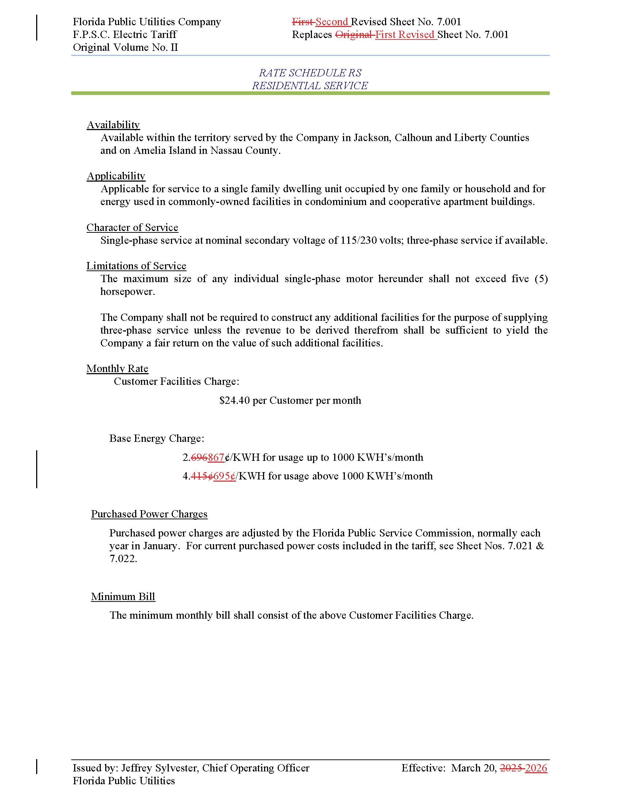

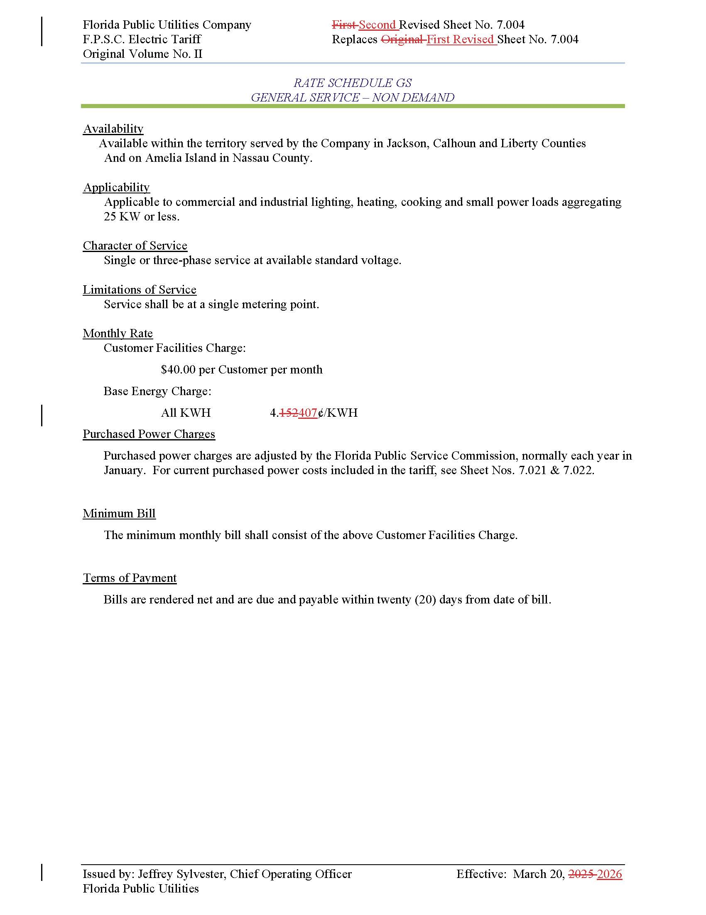
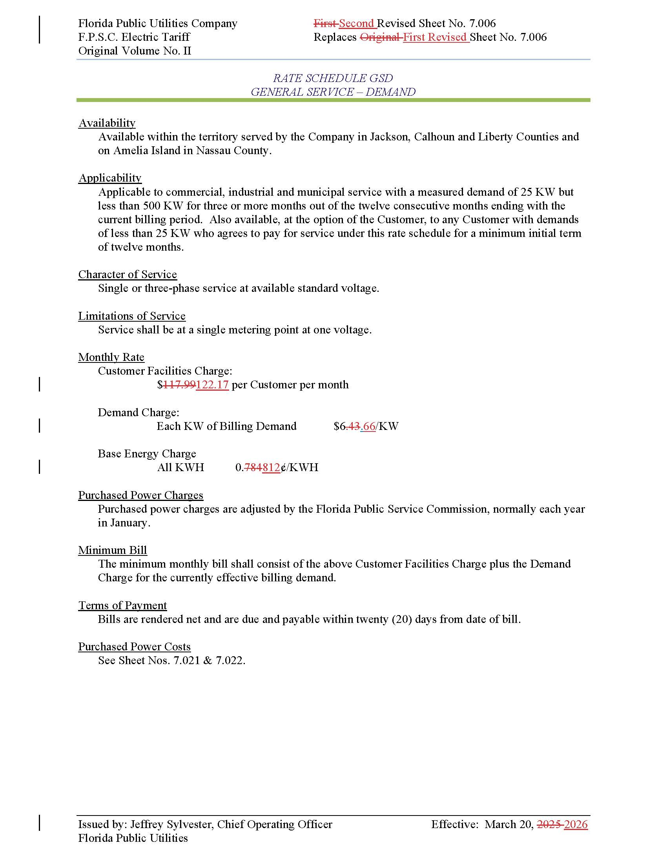

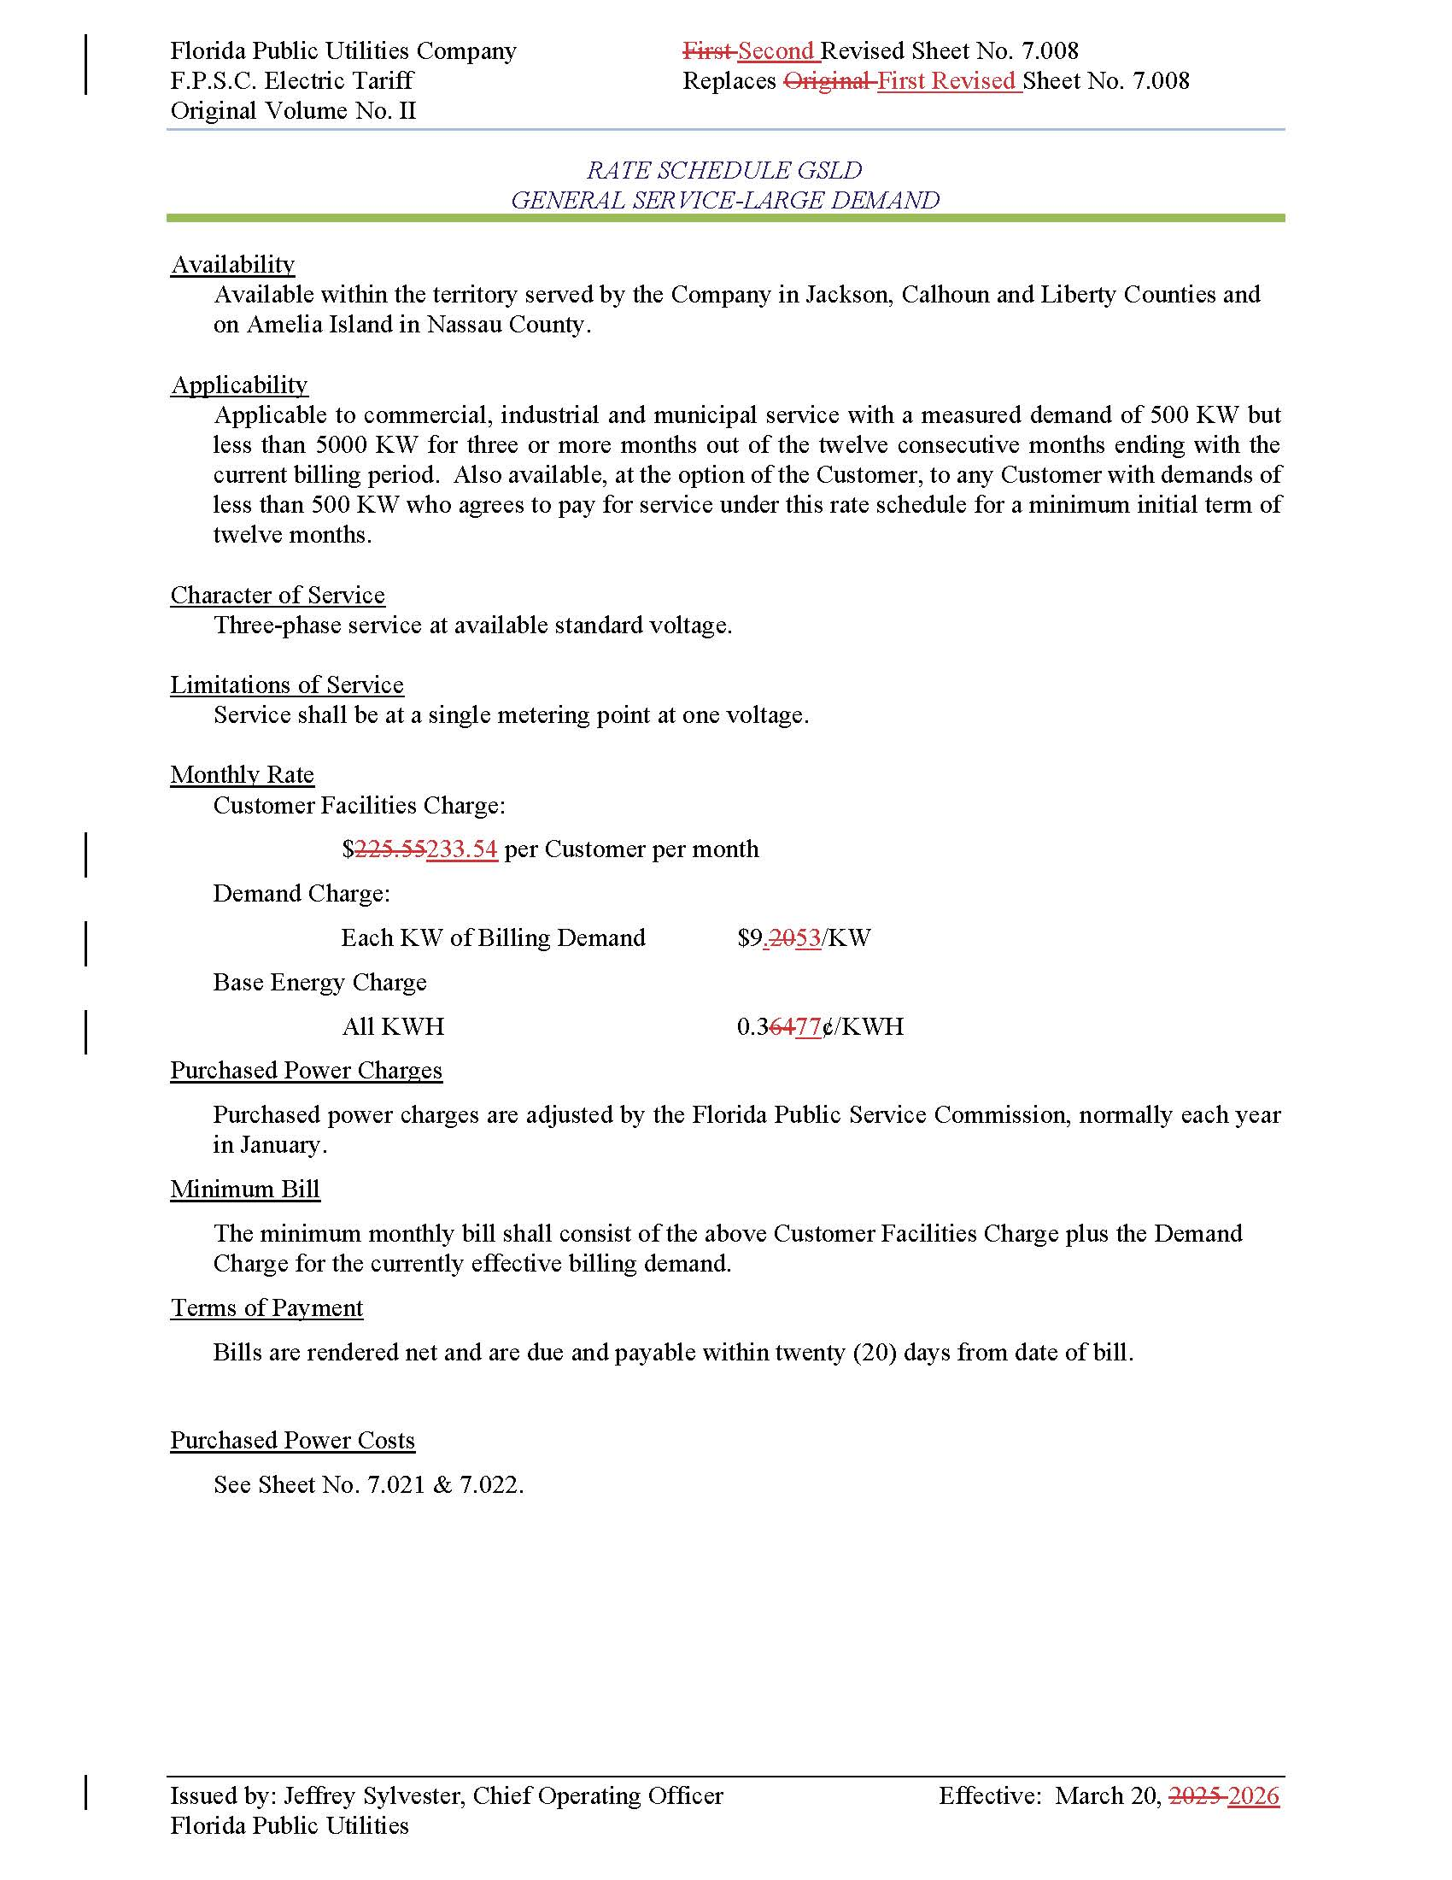

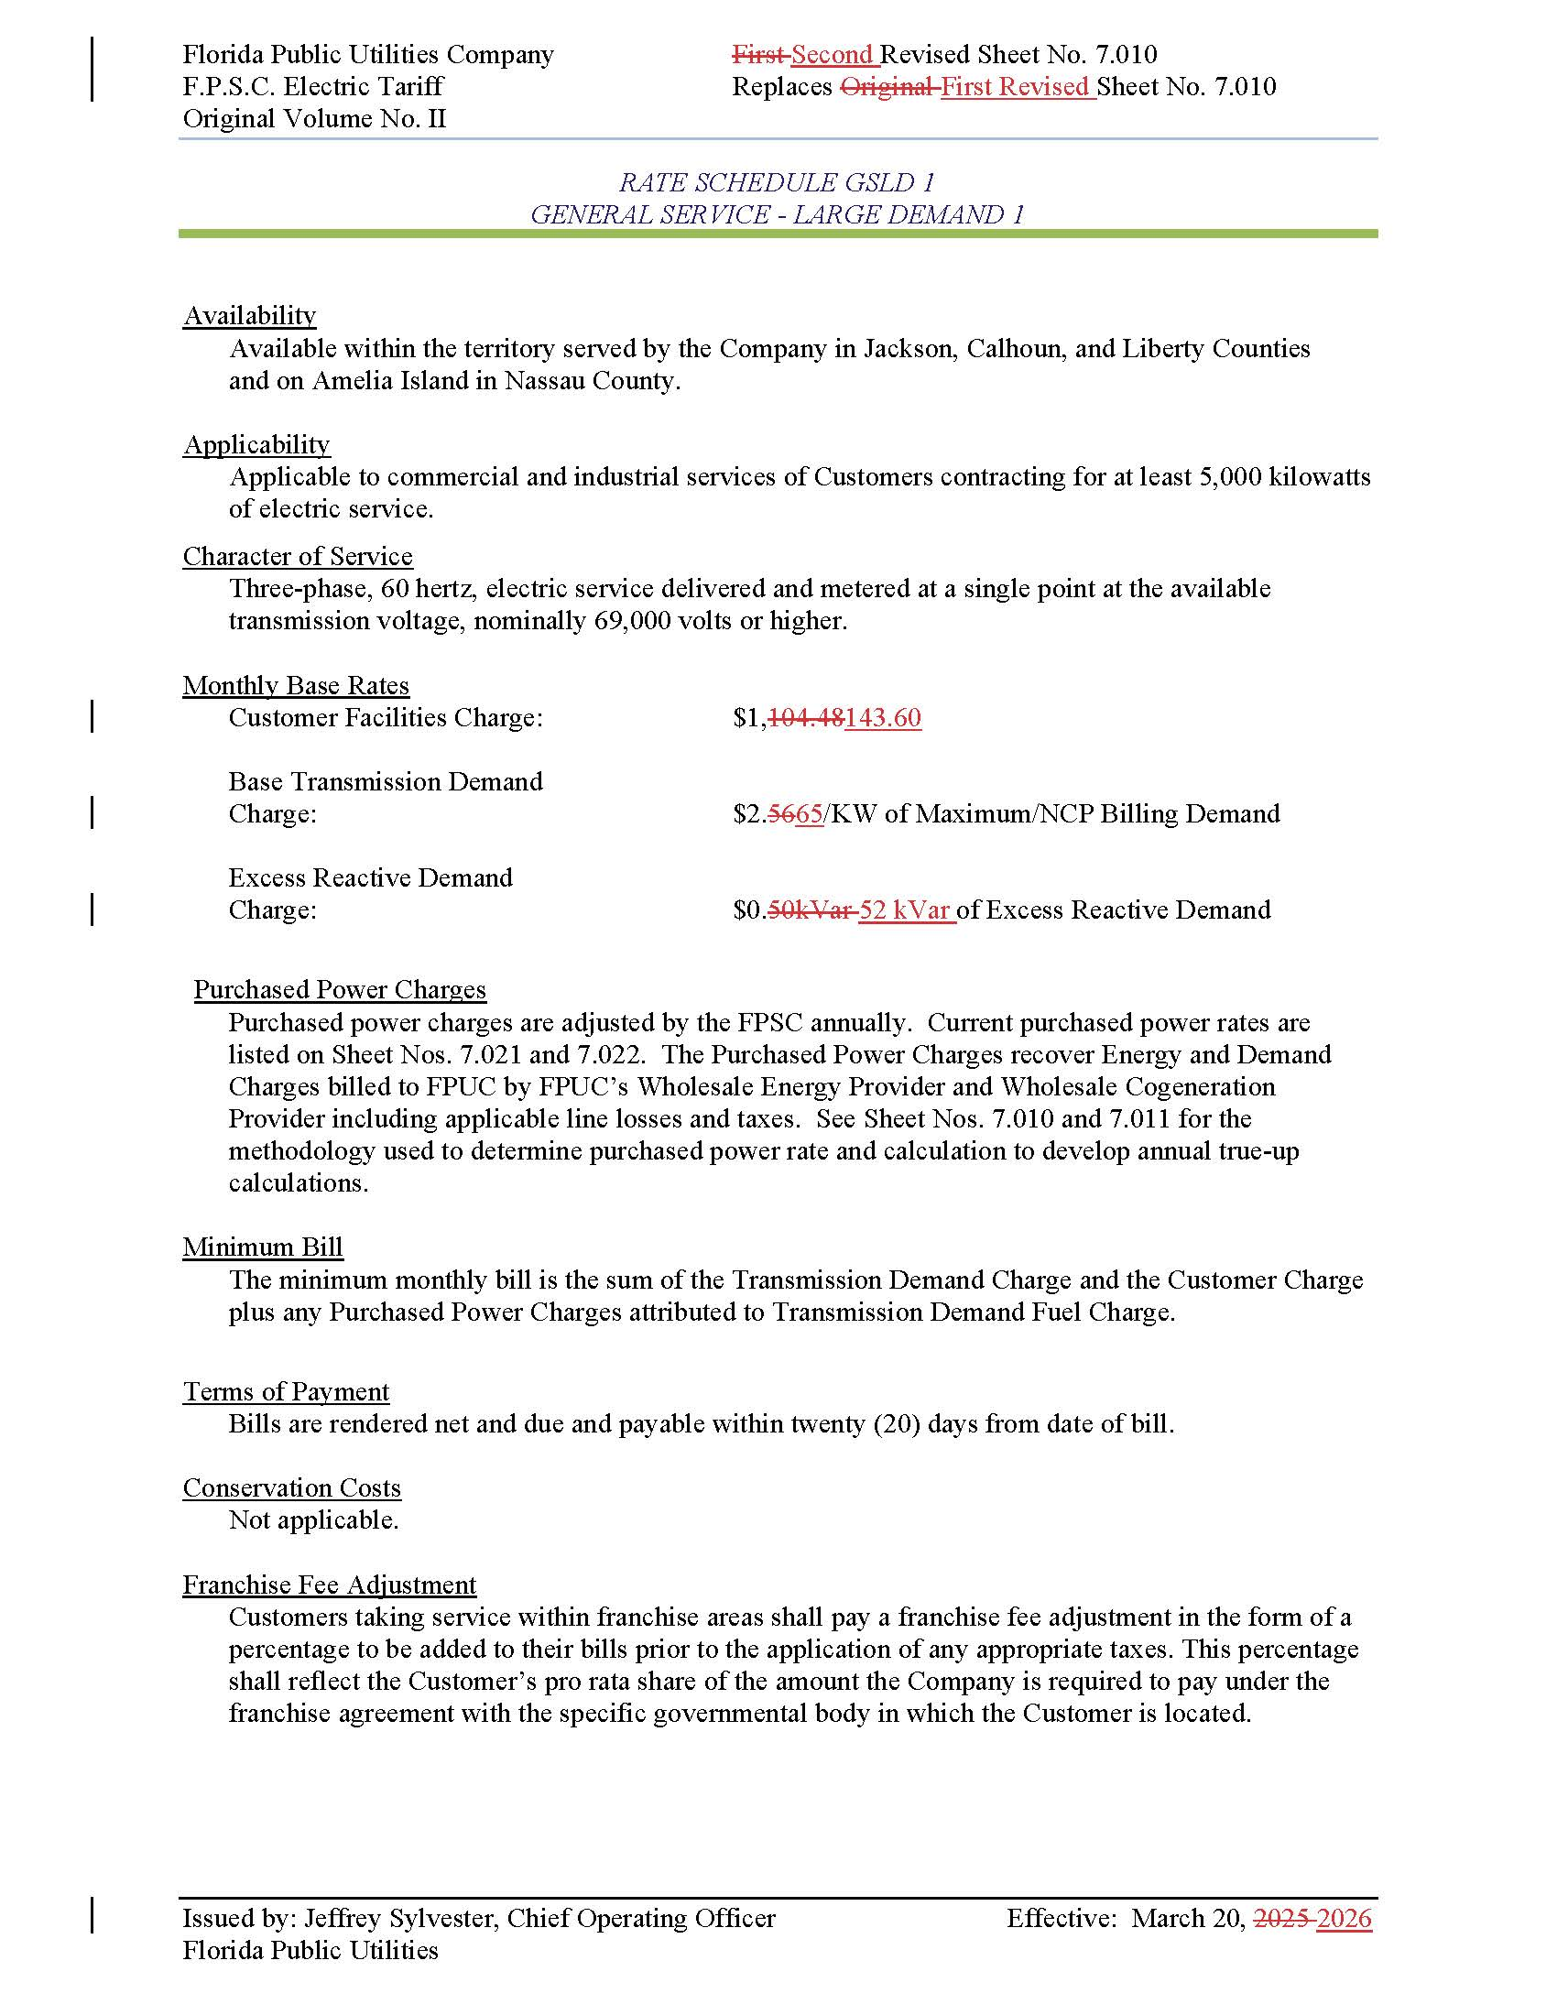

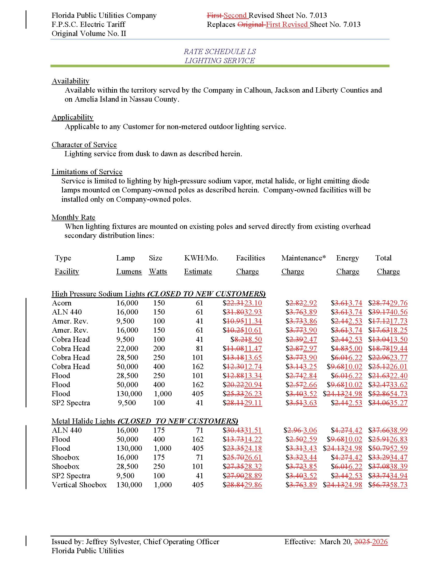

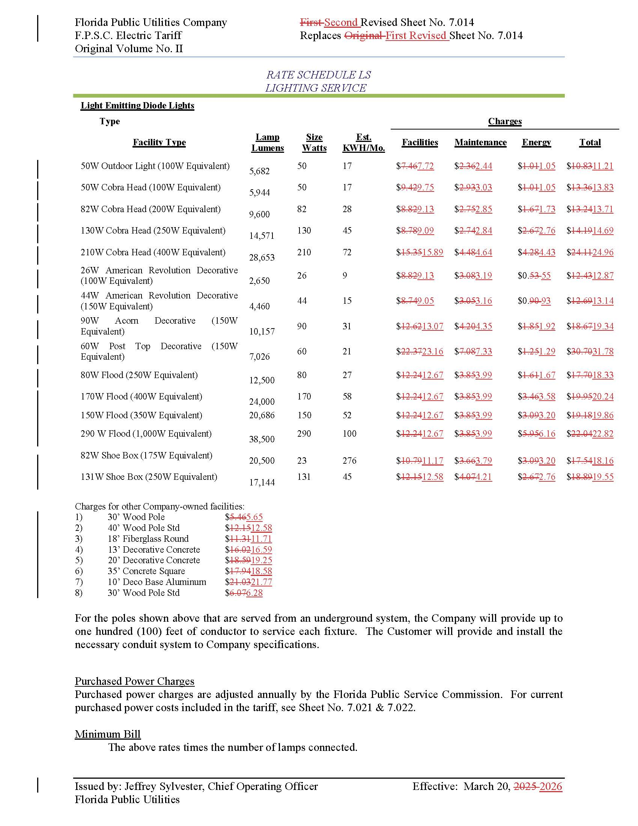

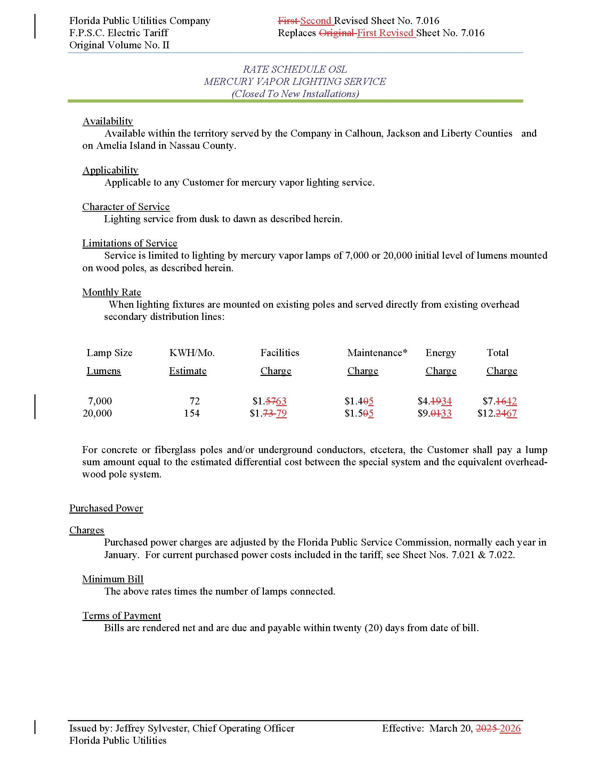

Order No. PSC-2025-0287-AS-EI, issued July 24, 2025 in Docket No. 20240099-EI, In re: Petition for rate increase by Florida Public Utilities Company; Order No. PSC-2025-0287A-AS-EI, issued February 18, 2026, In re: Petition for rate increase by Florida Public Utilities Company (correcting a scrivener’s error and reaffirming all other aspects of Order No. PSC-2025-0287-AS-EI).
Order No. PSC-2025-0114-PAA-EI, issued April 7, 2025, in Docket No. 20240099-EI, In re: Petition for rate increase by Florida Public Utilities Company.
Order No. PSC-2026-0020-PCO-EI, issued January 14, 2026, in Docket No. 2025139-EI, In re: Petition for approval of tariffs to implement base rate increase consistent with settlement agreement approved by Order No. PSC-2025-0287-AS-EI, by Florida Public Utilities Company.
Order No. PSC-2025-0287-AS-EI, pages 2-4.
Paragraph III.d of the 2025 Settlement.

