State of Florida   |  | Public Service Commission  Capital Circle Office Center ● 2540 Shumard Oak Boulevard  Tallahassee, Florida 32399-0850  -M-E-M-O-R-A-N-D-U-M-
DATE: | April 23, 2026
TO: | Office of Commission Clerk (Teitzman)
FROM: | Division of Engineering (Willis, Ellis)  Office of the General Counsel (Sparks)
RE: | Docket No. 20260048-EQ – Petition for approval of amended standard offer contract (Schedule COG-2), by Duke Energy Florida, LLC.
AGENDA: | 05/05/26 –Regular Agenda – Proposed Agency Action – Interested Persons May Participate
COMMISSIONERS ASSIGNED: |  |  | All Commissioners
PREHEARING OFFICER: |  |  | Administrative
CRITICAL DATES: |  |  | None
SPECIAL INSTRUCTIONS: |  |  | None

Case Background
Section 366.91(3), Florida Statutes (F.S.), requires each investor-owned utility (IOU) to continuously offer to purchase capacity and energy from renewable generating facilities (RF) and small qualifying facilities (QF). Rules 25-17.200 through 25-17.310, Florida Administrative Code (F.A.C.), implement the statute and require each IOU to file with the Florida Public Service Commission (Commission), by April 1 of each year, a revised standard offer contract based on the next avoidable fossil-fueled generating unit of each technology type identified in the utility’s current Ten-Year Site Plan (TYSP). On April 1, 2026, Duke Energy Florida, LLC (DEF) filed a petition for approval of its amended standard offer contract based on its 2026 TYSP. The Commission has jurisdiction over this amended standard offer contract, pursuant to Sections 366.04, 366.041, 366.05, 366.055, 366.06, and 366.91, F.S.

Discussion of Issues

Issue 1:
Should the Commission approve the renewable energy tariff and amended standard offer contract filed by Duke Energy Florida, LLC?

Recommendation:
Yes. The provisions of DEF’s renewable energy tariff and amended standard offer contract meet the requirements of Rules 25-17.200 through 25-17.310, F.A.C. The amended standard offer contract offers multiple payment options so that a developer of renewable generation may select the payment stream best suited to its financial needs. (Willis)

Staff Analysis:

Legal Standard
Section 366.91(3), F.S., and Rule 25-17.250, F.A.C., require that an IOU continuously make available a standard offer contract for the purchase of firm capacity and energy from RFs and QFs with design capacities of 100 kilowatts (kW) or less. Pursuant to Rules 25-17.250(1) and (3), F.A.C., the standard offer contract must provide a term of at least 10 years, the payment terms must be based on the utility’s next avoidable fossil-fueled generating unit identified in its most recent TYSP or, if no avoided unit is identified, its next avoidable planned purchase. Standard offer contracts are further subject to the applicable provisions of Rules 25-17.082 through 25-17.091, F.A.C. The Commission’s review of standard offer contracts is in accordance with goals to integrate nontraditional sources of power pursuant to the Florida Energy Efficiency and Conservation Act and diversify Florida’s energy generation portfolio.

Analysis
In DEF’s 2026 TYSP, the first set of potentially eligible generation units is a pair of 218 megawatt (MW) Combustion Turbines (CT) with a scheduled in-service date of June 2031. Because DEF has taken steps to begin construction of these CTs, they are not eligible for selection as the next avoidable planned generation unit pursuant to Rule 25-17.250(2)(a)2, F.A.C. Accordingly, DEF identified the second set of undesignated 400 MW natural gas-fueled CTs with a scheduled in-service date of June 2034, as the next avoidable planned generation unit. The units have a planned construction start date of January 2030.
Under DEF’s amended standard offer contract, the RF/QF operator commits to certain minimum performance requirements, based on the identified avoided unit, such as being operational and delivering an agreed upon amount of capacity by the in-service date of the avoided unit. In this way, the RF/QF thereby becomes eligible for capacity payments in addition to payments received for energy. The standard offer contract may also serve as a starting point for negotiation of contract terms by providing payment information to an RF/QF operator in a situation where one or both parties desire particular contract terms other than those established in the standard offer.
In order to promote renewable generation, the Commission requires each IOU to offer multiple options for capacity payments, including the options to receive early or levelized payments. If the RF/QF operator elects to receive capacity payments under the normal or levelized contract options, it will receive as-available energy payments only until the in-service date of the avoided unit (in this case June 1, 2034). Thereafter, they begin receiving capacity payments in addition to firm energy payments. If either the early or early levelized option is selected, then the operator will begin receiving capacity payments earlier than the in-service date of the avoided unit. However, payments made under the early capacity payment options tend to be lower in the later years of the contract term, because the net present value (NPV) of the total payments must remain equal for all contract payment options.
Table 1 contains DEF’s estimates of the annual payments for the normal and levelized capacity payment options available under the amended standard offer contract to an operator with a 50 MW facility operating at a capacity factor of 95 percent, which is the minimum capacity factor required under the contract to qualify for full capacity payments. Normal and levelized capacity payments begin with the projected in-service date of the avoided unit (June 1, 2034), and continue for 10 years, while early and early levelized capacity payments begin four (4) years prior to the in-service date, or January 2030 in this case.
Table 1
Estimated Annual Payments to a 50 MW Renewable Facility
(95% Capacity Factor)
Year | Energy Payments | Capacity Payment
Year | Energy Payments | Normal | Levelized | Early | Early Levelized
Year | $(000) | $(000) | $(000) | $(000) | $(000)
2027 | 14,490 | - | - | - | -
2028 | 13,810 | - | - | - | -
2029 | 12,606 | - | - | - | -
2030 | 11,752 | - | - | 5,477 | 6,068
2031 | 11,910 | - | - | 5,569 | 6,073
2032 | 13,893 | - | - | 5,663 | 6,078
2033 | 16,169 | - | - | 5,758 | 6,083
2034 | 18,187 | 5,314 | 5,783 | 5,855 | 6,089
2035 | 18,819 | 9,263 | 9,922 | 5,954 | 6,094
2036 | 19,743 | 9,419 | 9,931 | 6,054 | 6,100
2037 | 20,531 | 9,578 | 9,940 | 6,156 | 6,105
2038 | 20,637 | 9,739 | 9,949 | 6,259 | 6,111
2039 | 21,431 | 9,902 | 9,958 | 6,365 | 6,117
2040 | 22,737 | 10,069 | 9,968 | 6,472 | 6,124
2041 | 24,357 | 10,239 | 9,977 | 6,581 | 6,130
2042 | 23,859 | 10,411 | 9,987 | 6,691 | 6,137
2043 | 23,599 | 10,586 | 9,998 | 6,804 | 6,143
2044 | 23,173 | 10,764 | 10,008 | 6,919 | 6,150
2045 | 21,151 | 10,946 | 10,019 | 7,035 | 6,157
2046 | 21,570 | 11,130 | 10,030 | 7,154 | 6,164
Total | 374,425 | 127,360 | 125,471 | 106,766 | 103,923
Total(NPV) | 181,118 | 47,972 | 47,972 | 47,972 | 47,972
Source: DEF’s Response to Staff’s First Data Request.
DEF’s amended standard offer contract, in type-and-strike format, is included as Attachment A to this recommendation. The changes made to DEF’s tariff sheets are consistent with the updated avoided unit. Revisions include updates to calendar dates and payment information, which reflect the current economic and financial assumptions for the avoided unit.

Conclusion
The provisions of DEF’s amended standard offer contract and associated rate schedule COG-2 meet the requirements of Rules 25-17.200 through 25-17.310, F.A.C. The amended standard offer contract offers multiple payment options so that a developer of renewable generation may select the payment stream best suited to its financial needs. The Commission should approve the amended standard offer contract.

Issue 2:
Should this docket be closed?

Recommendation:
Yes. This docket should be closed upon issuance of a Consummating Order, unless a person whose substantial interests are affected by the Commission’s decision files a protest within 21 days of the issuance of the Commission’s Proposed Agency Action Order. Potential signatories should be aware that, if a timely protest is filed, DEF’s standard offer contract may subsequently be revised. (Sparks)

Staff Analysis:
This docket should be closed upon issuance of a Consummating Order, unless a person whose substantial interests are affected by the Commission’s decision files a protest within 21 days of the issuance of the Commission’s Proposed Agency Action Order. Potential signatories should be aware that, if a timely protest is filed, DEF’s standard offer contract may subsequently be revised.

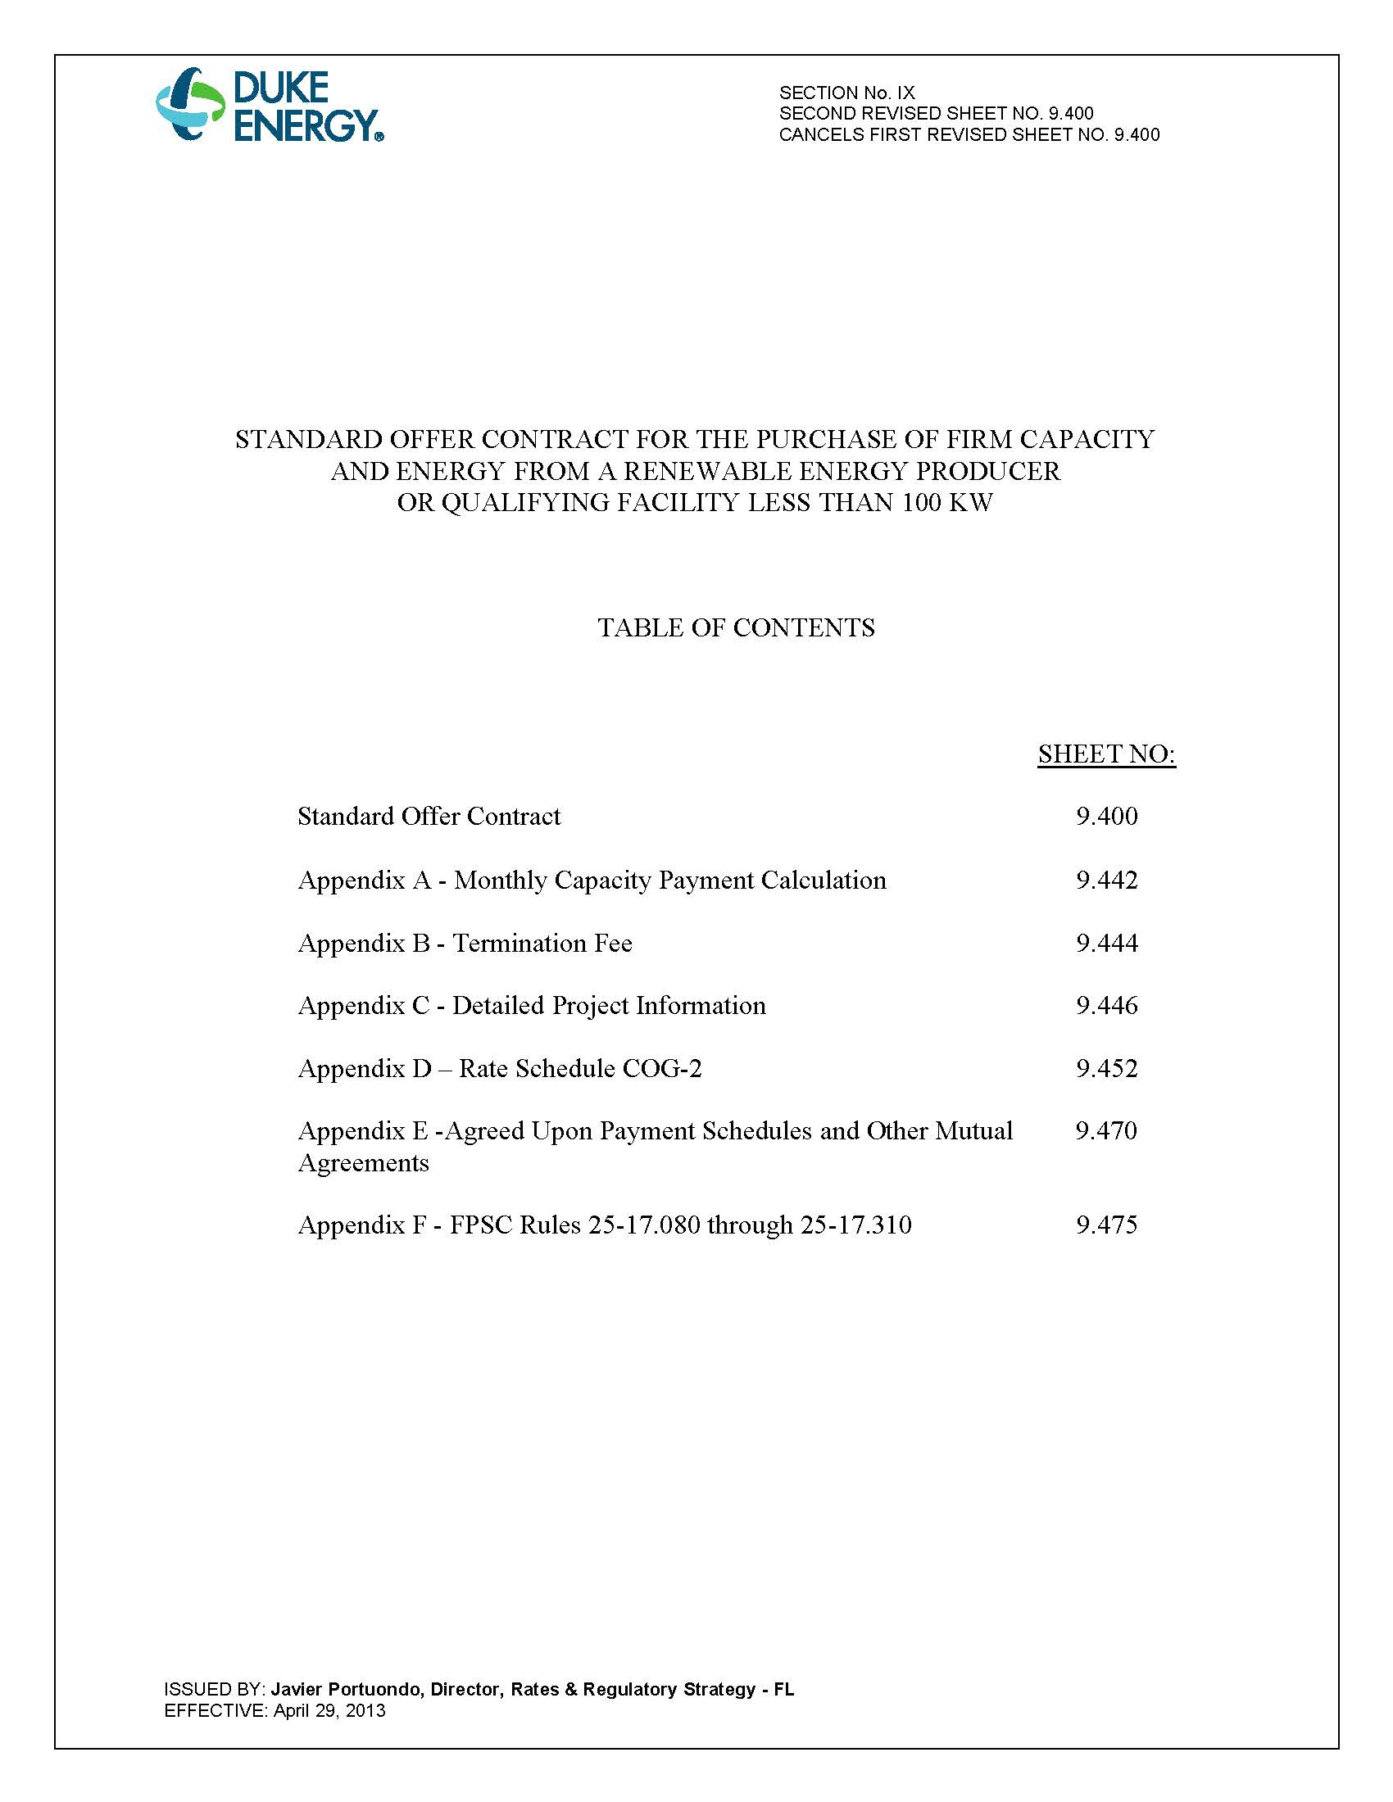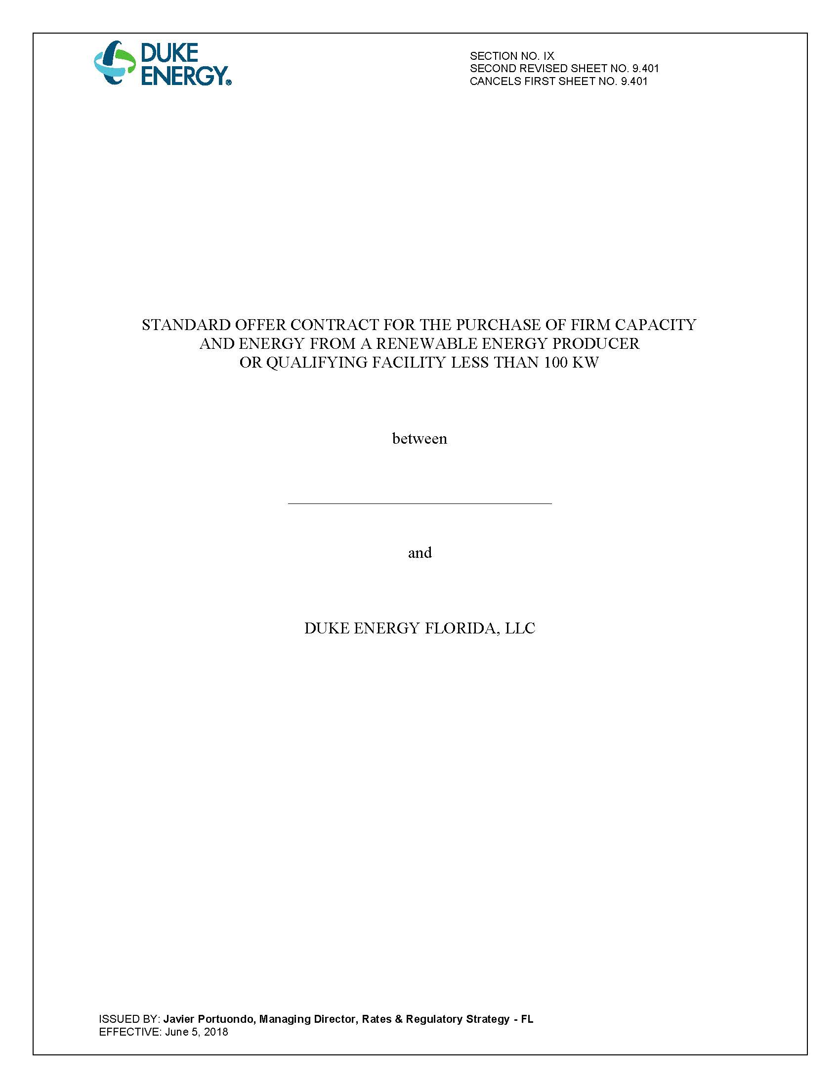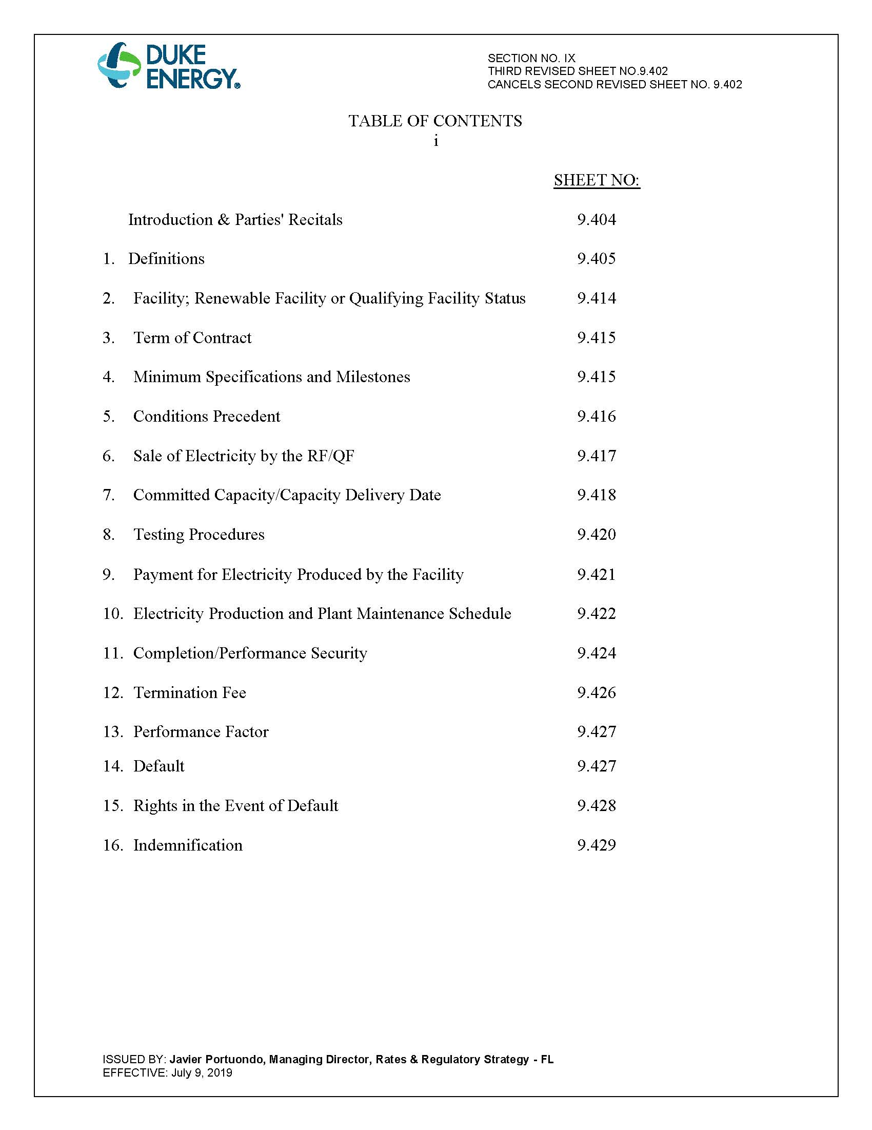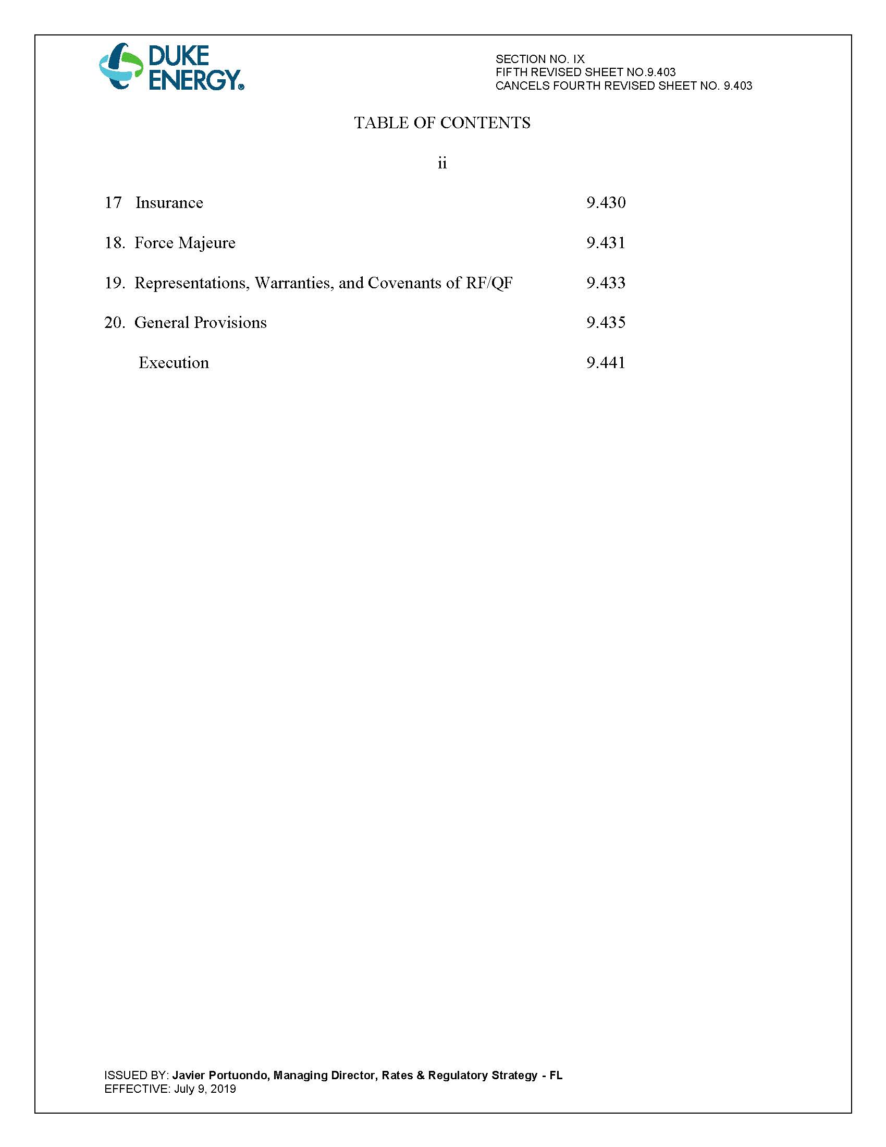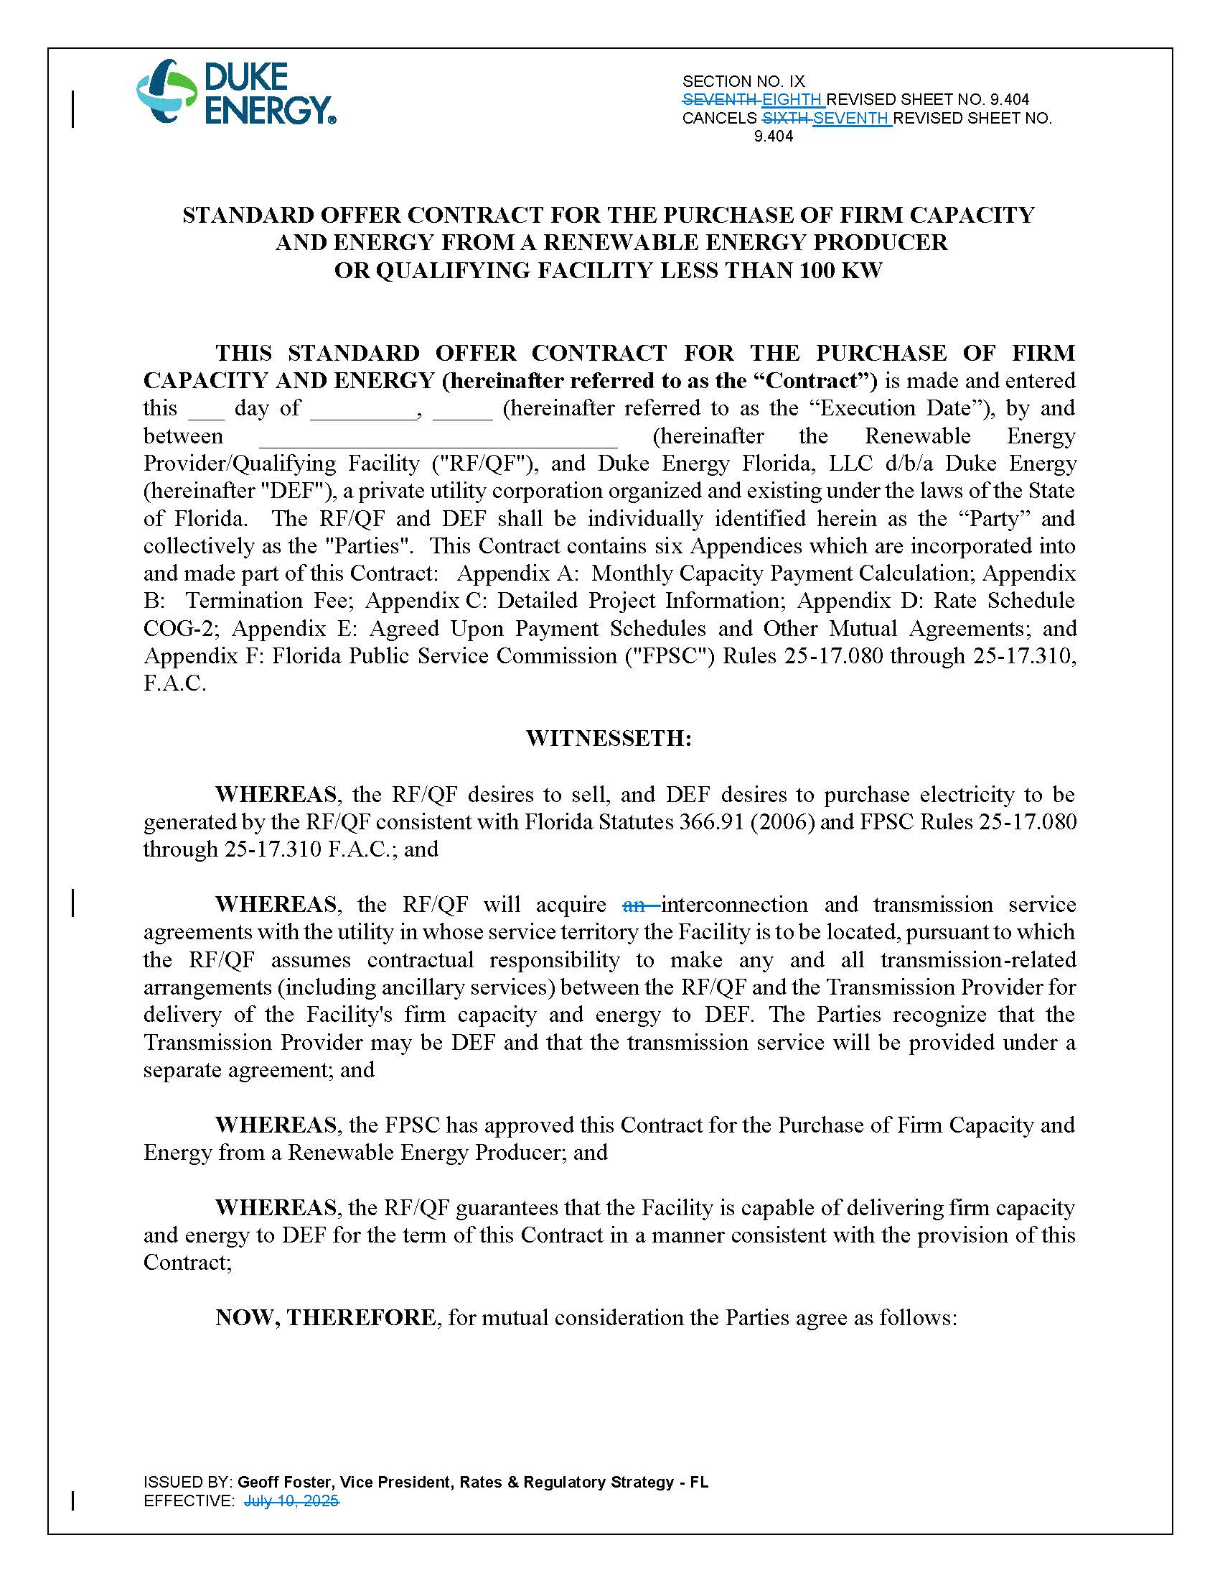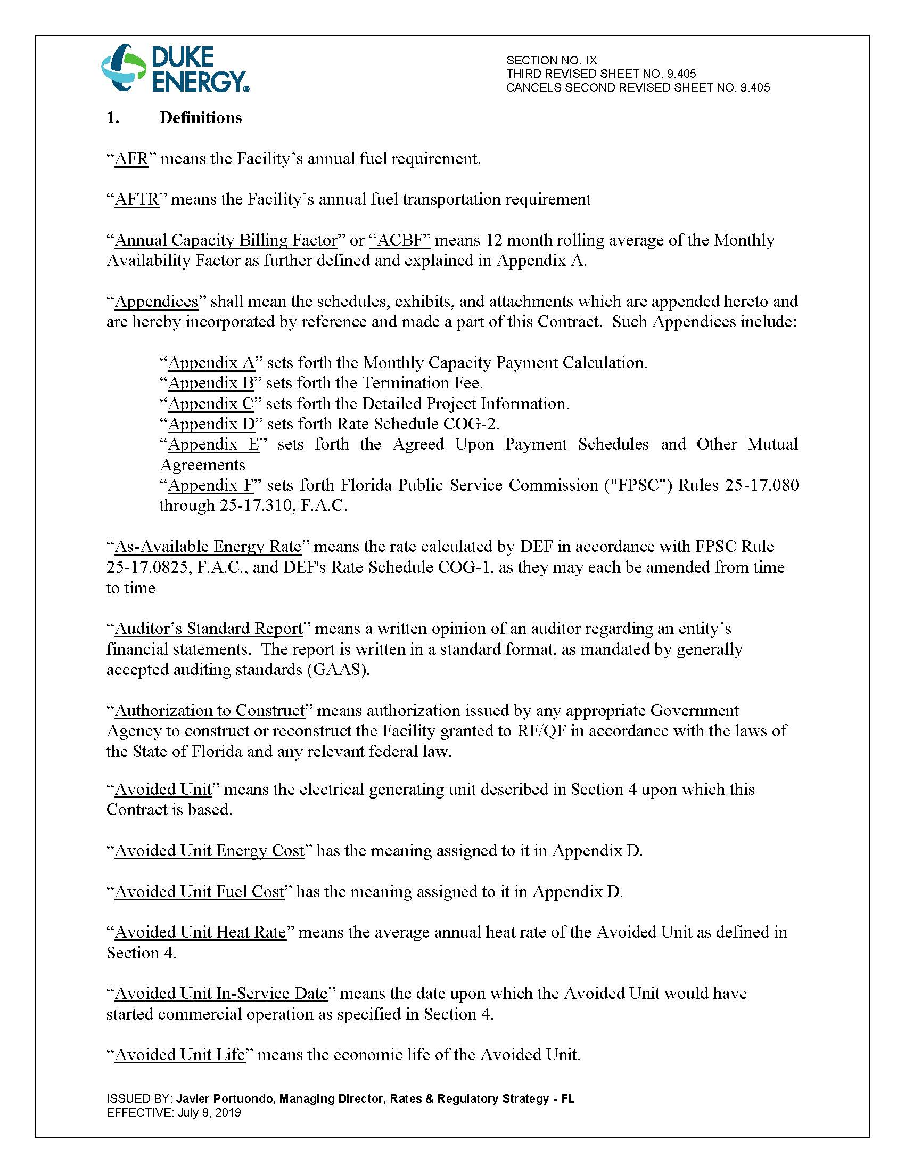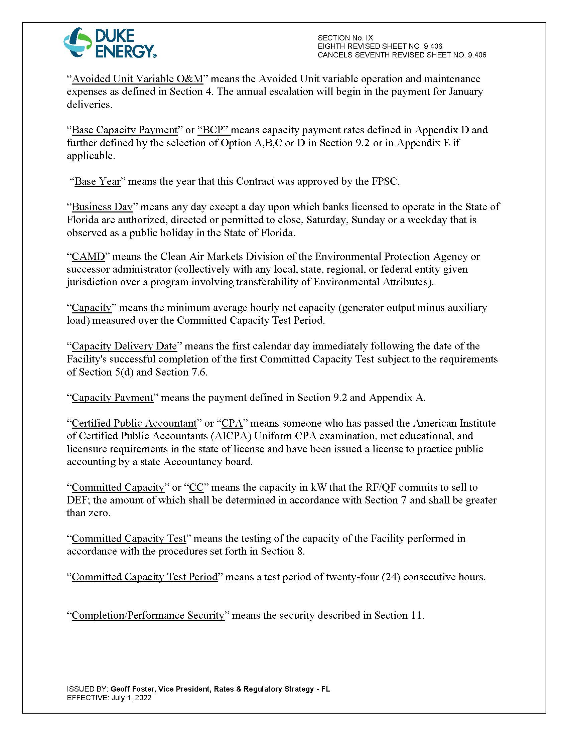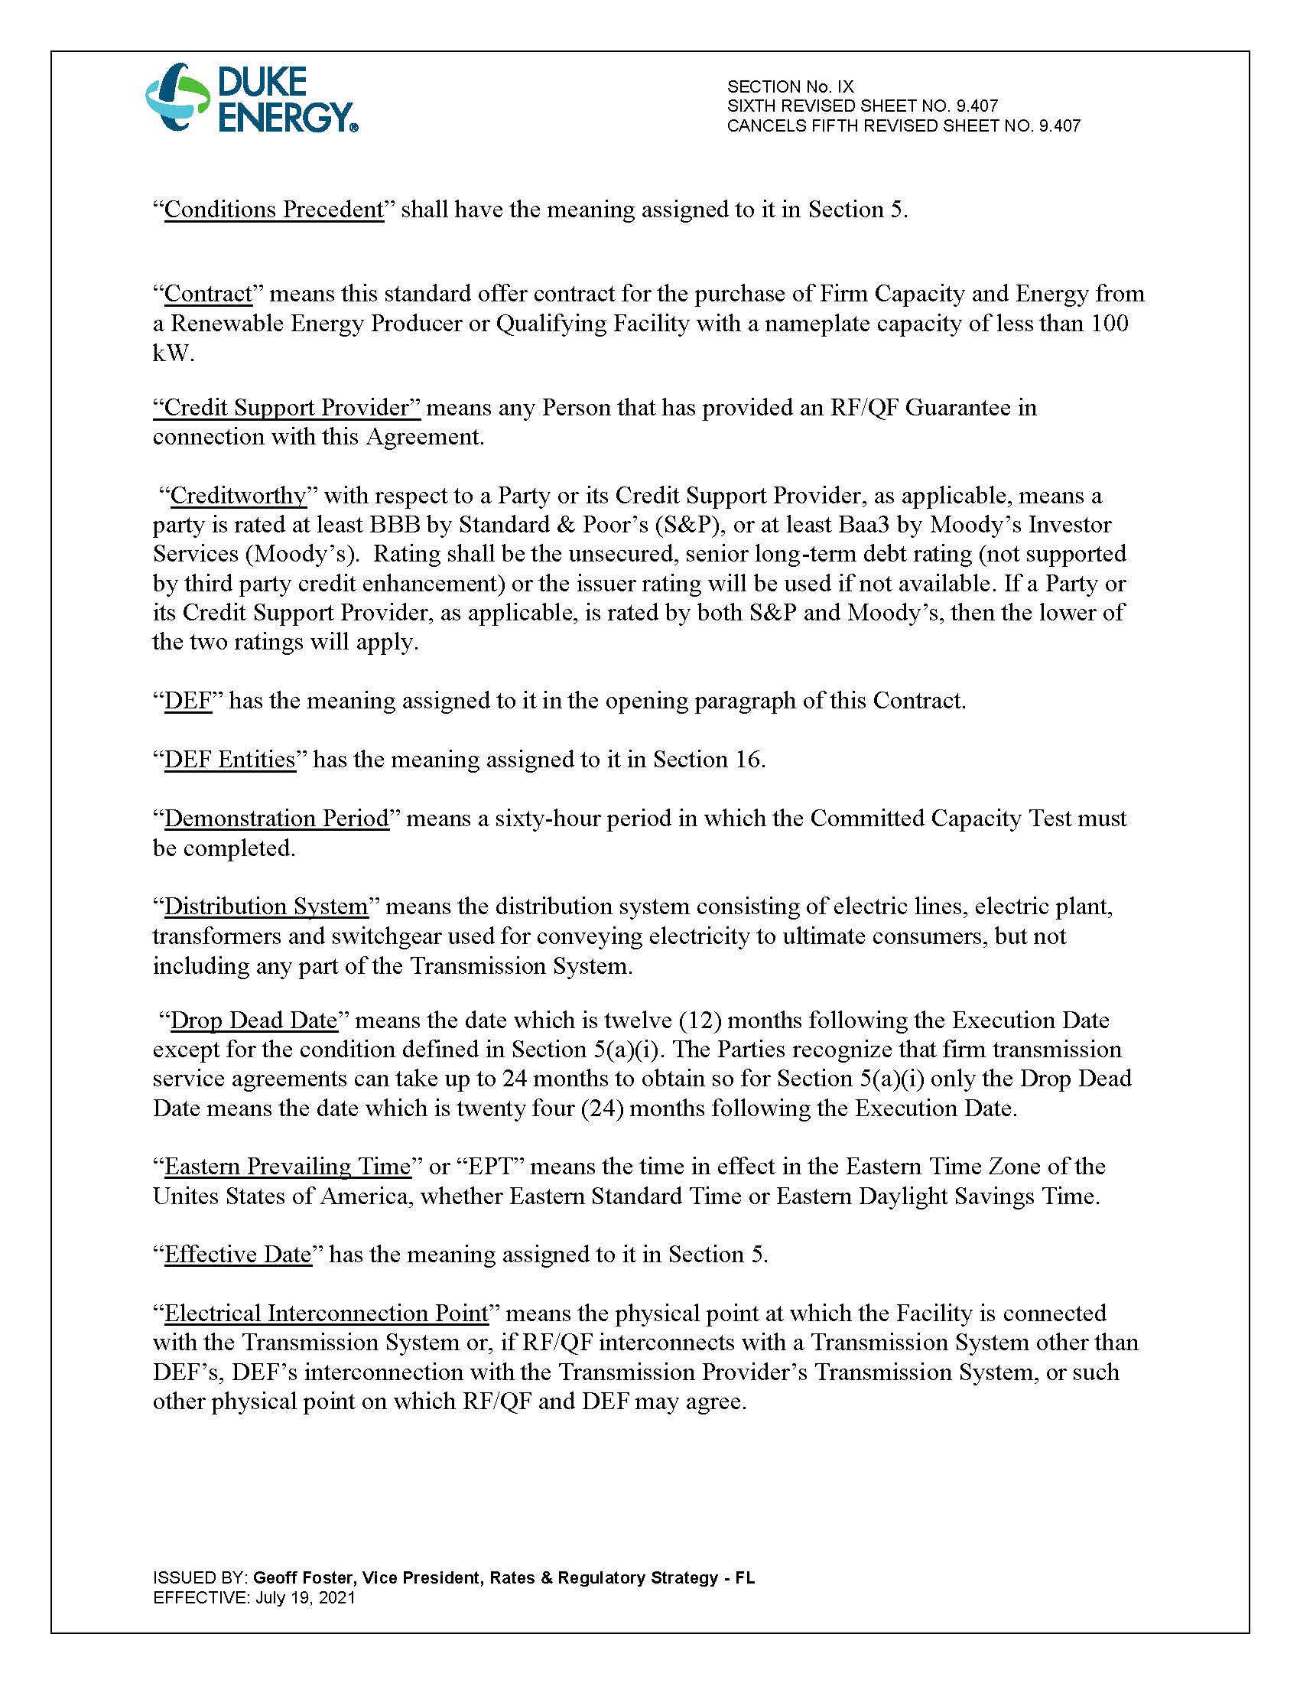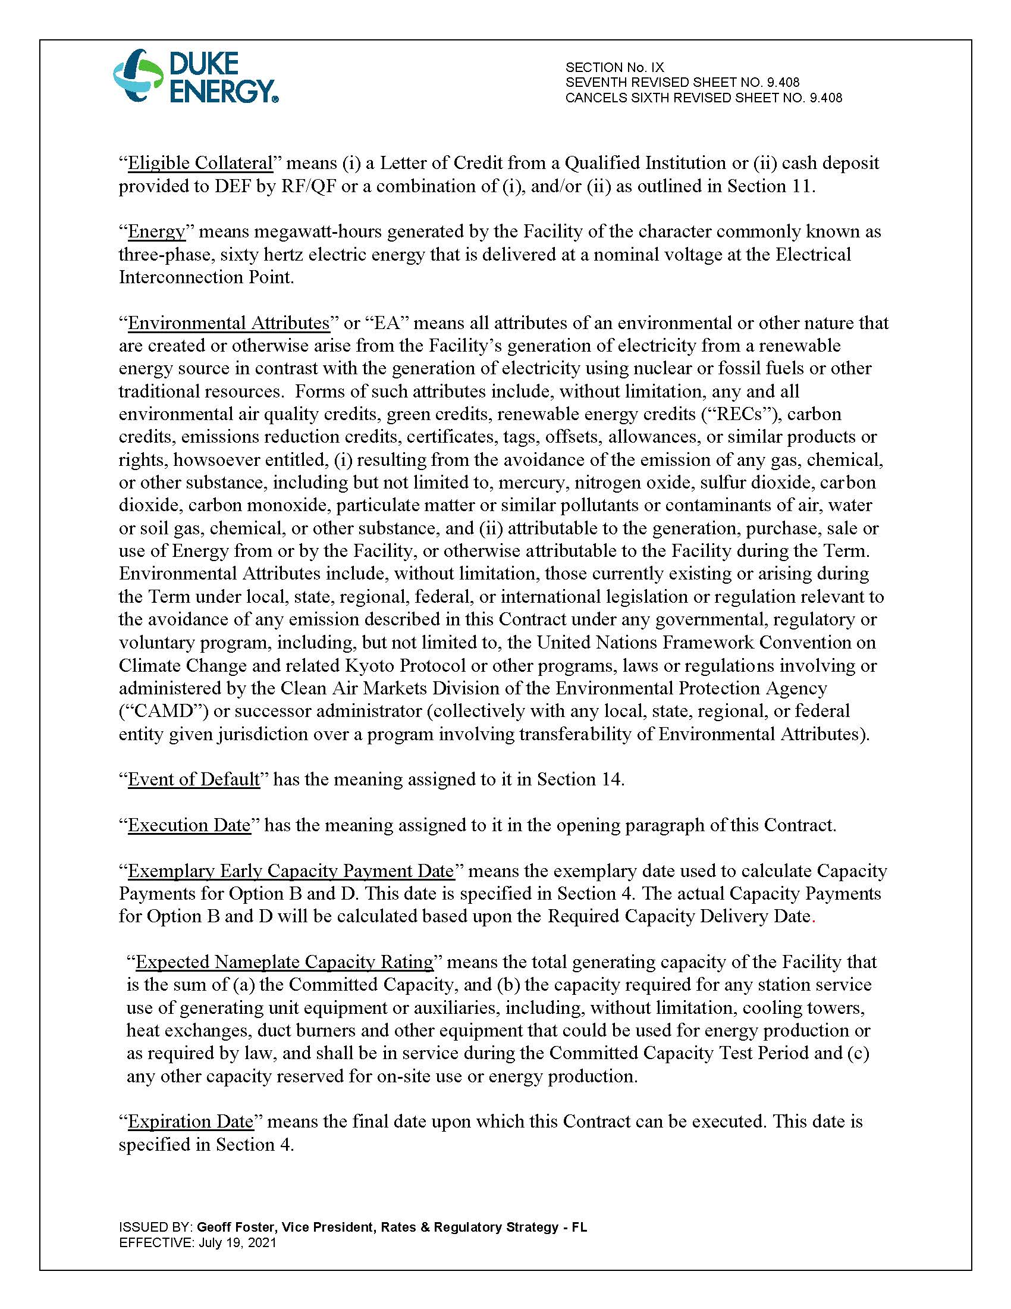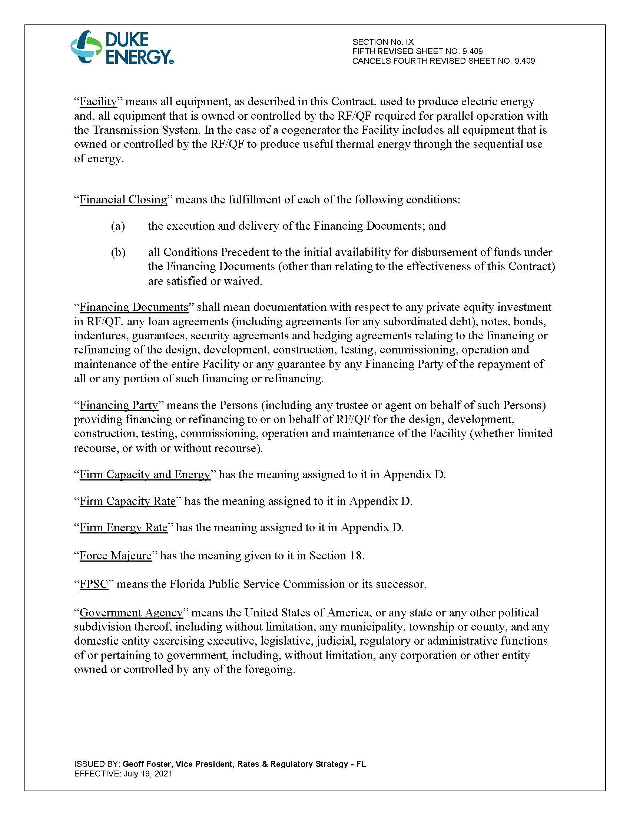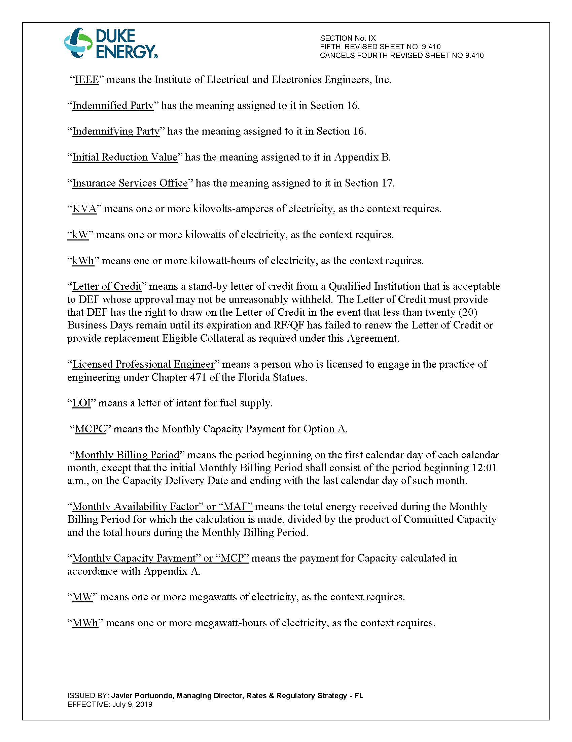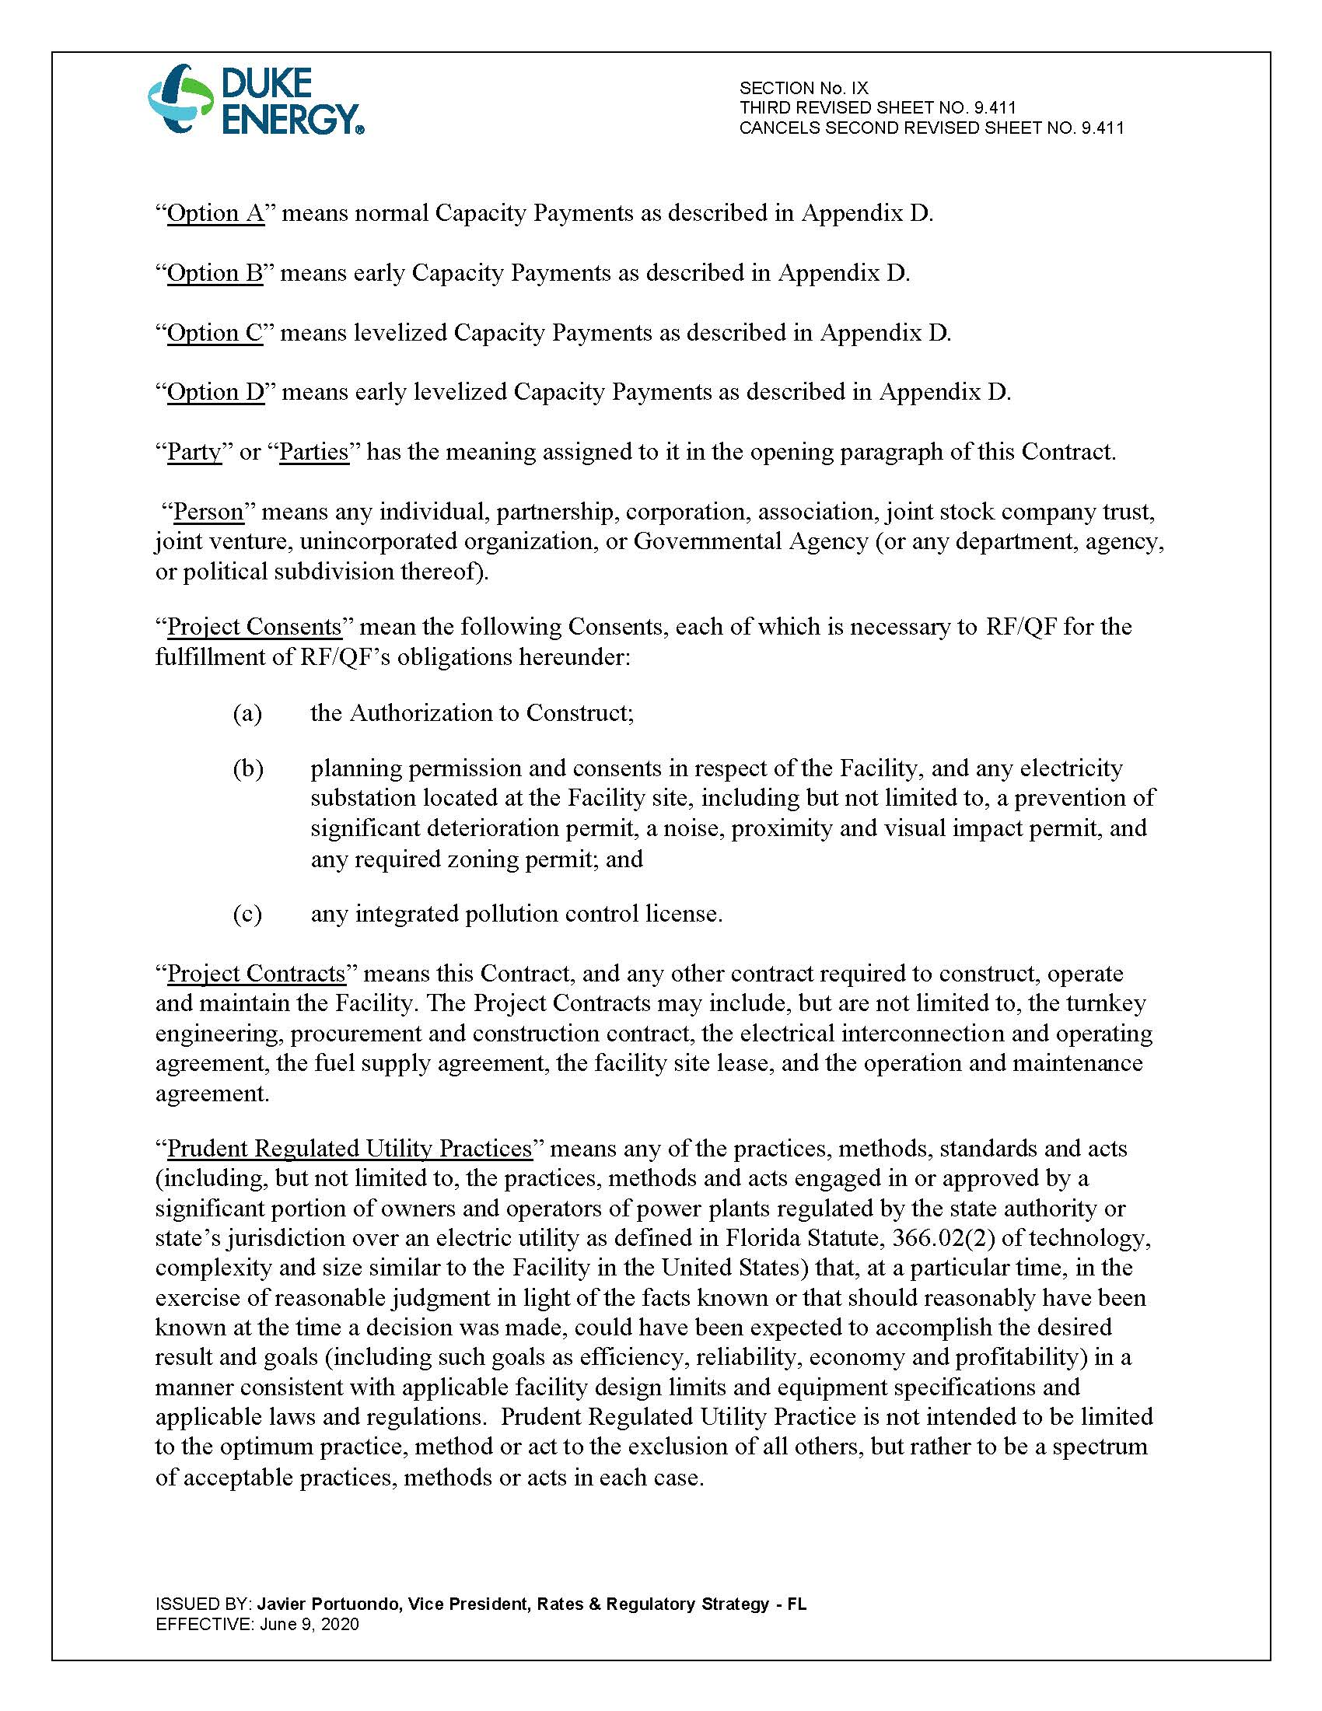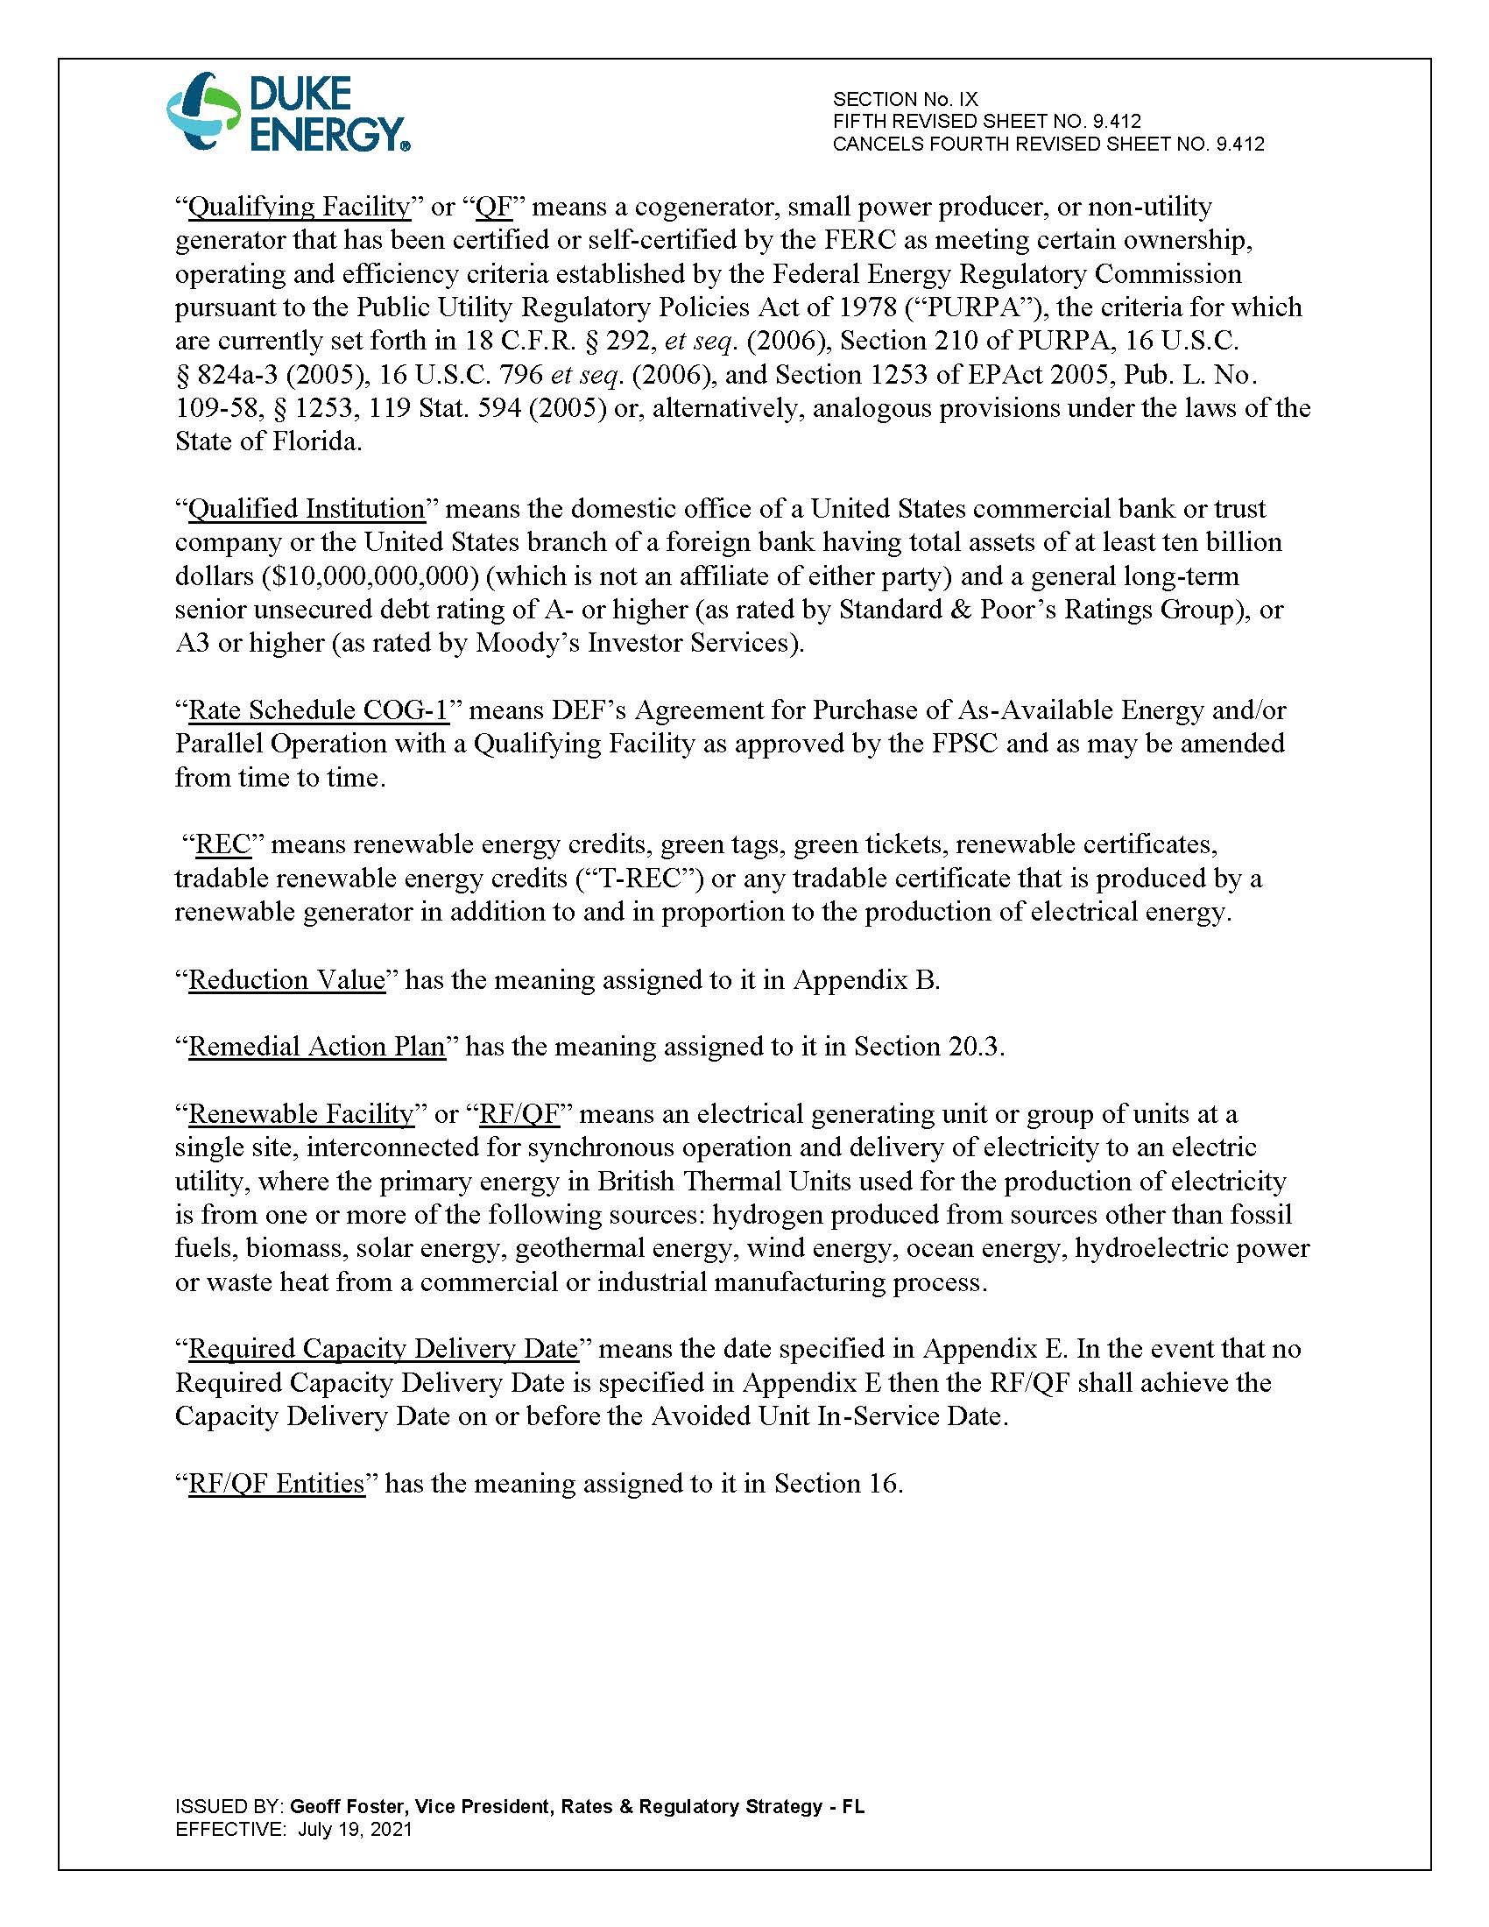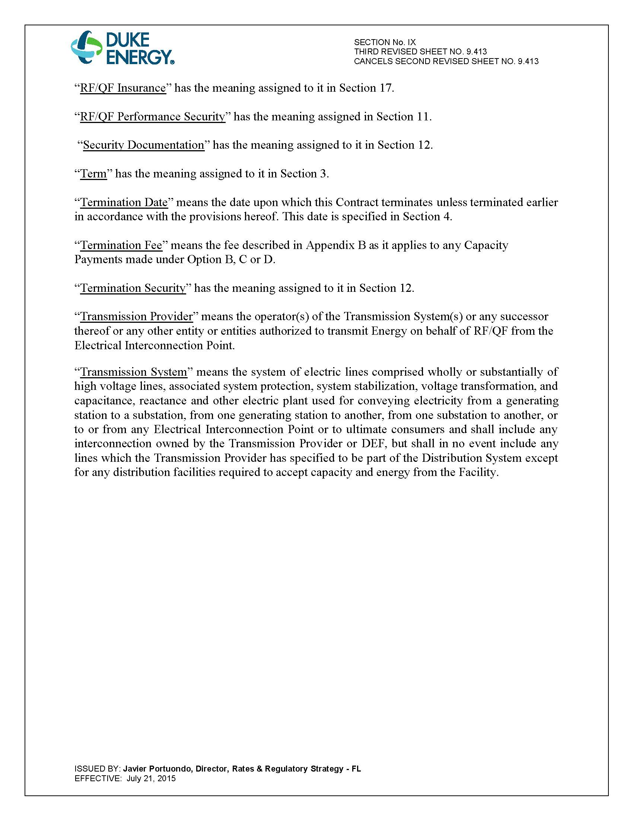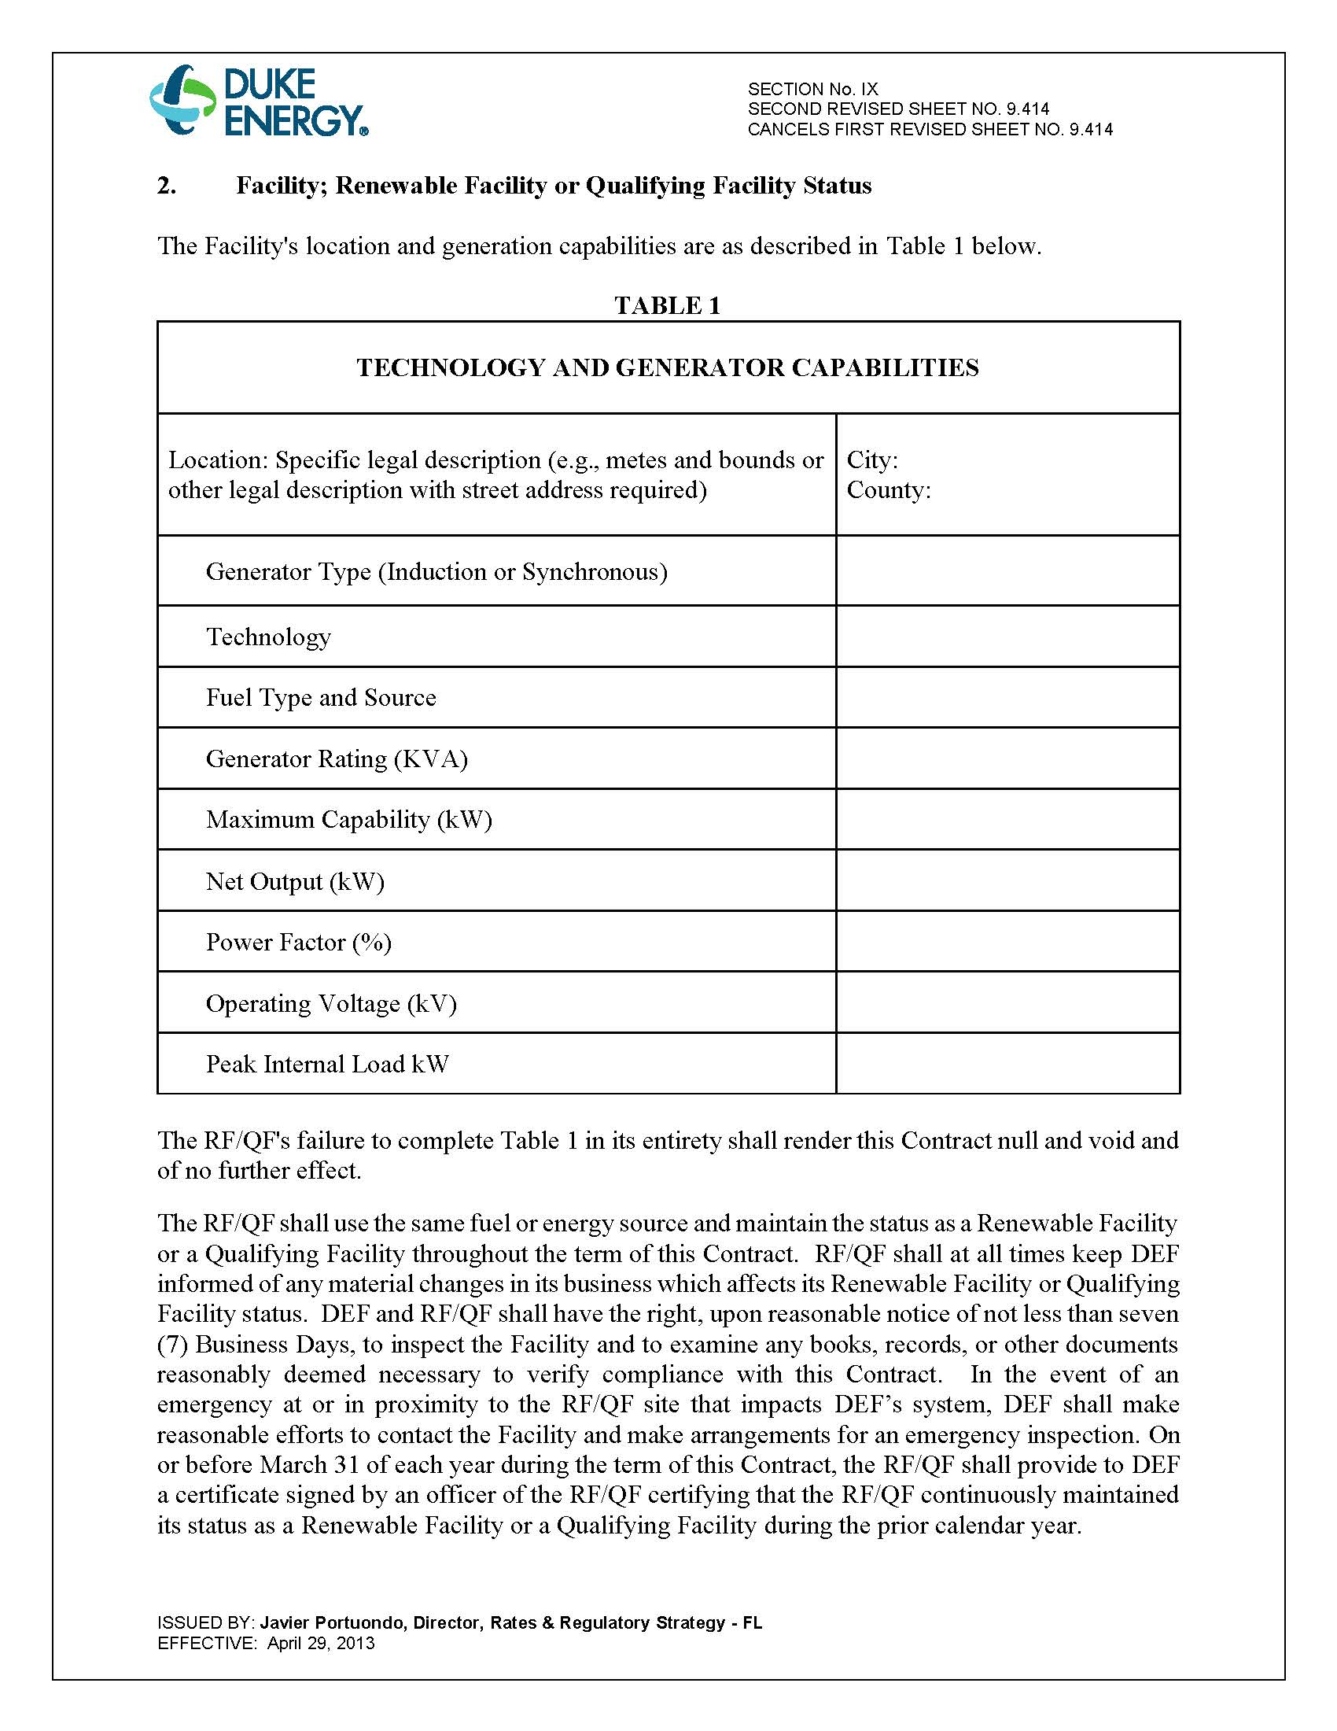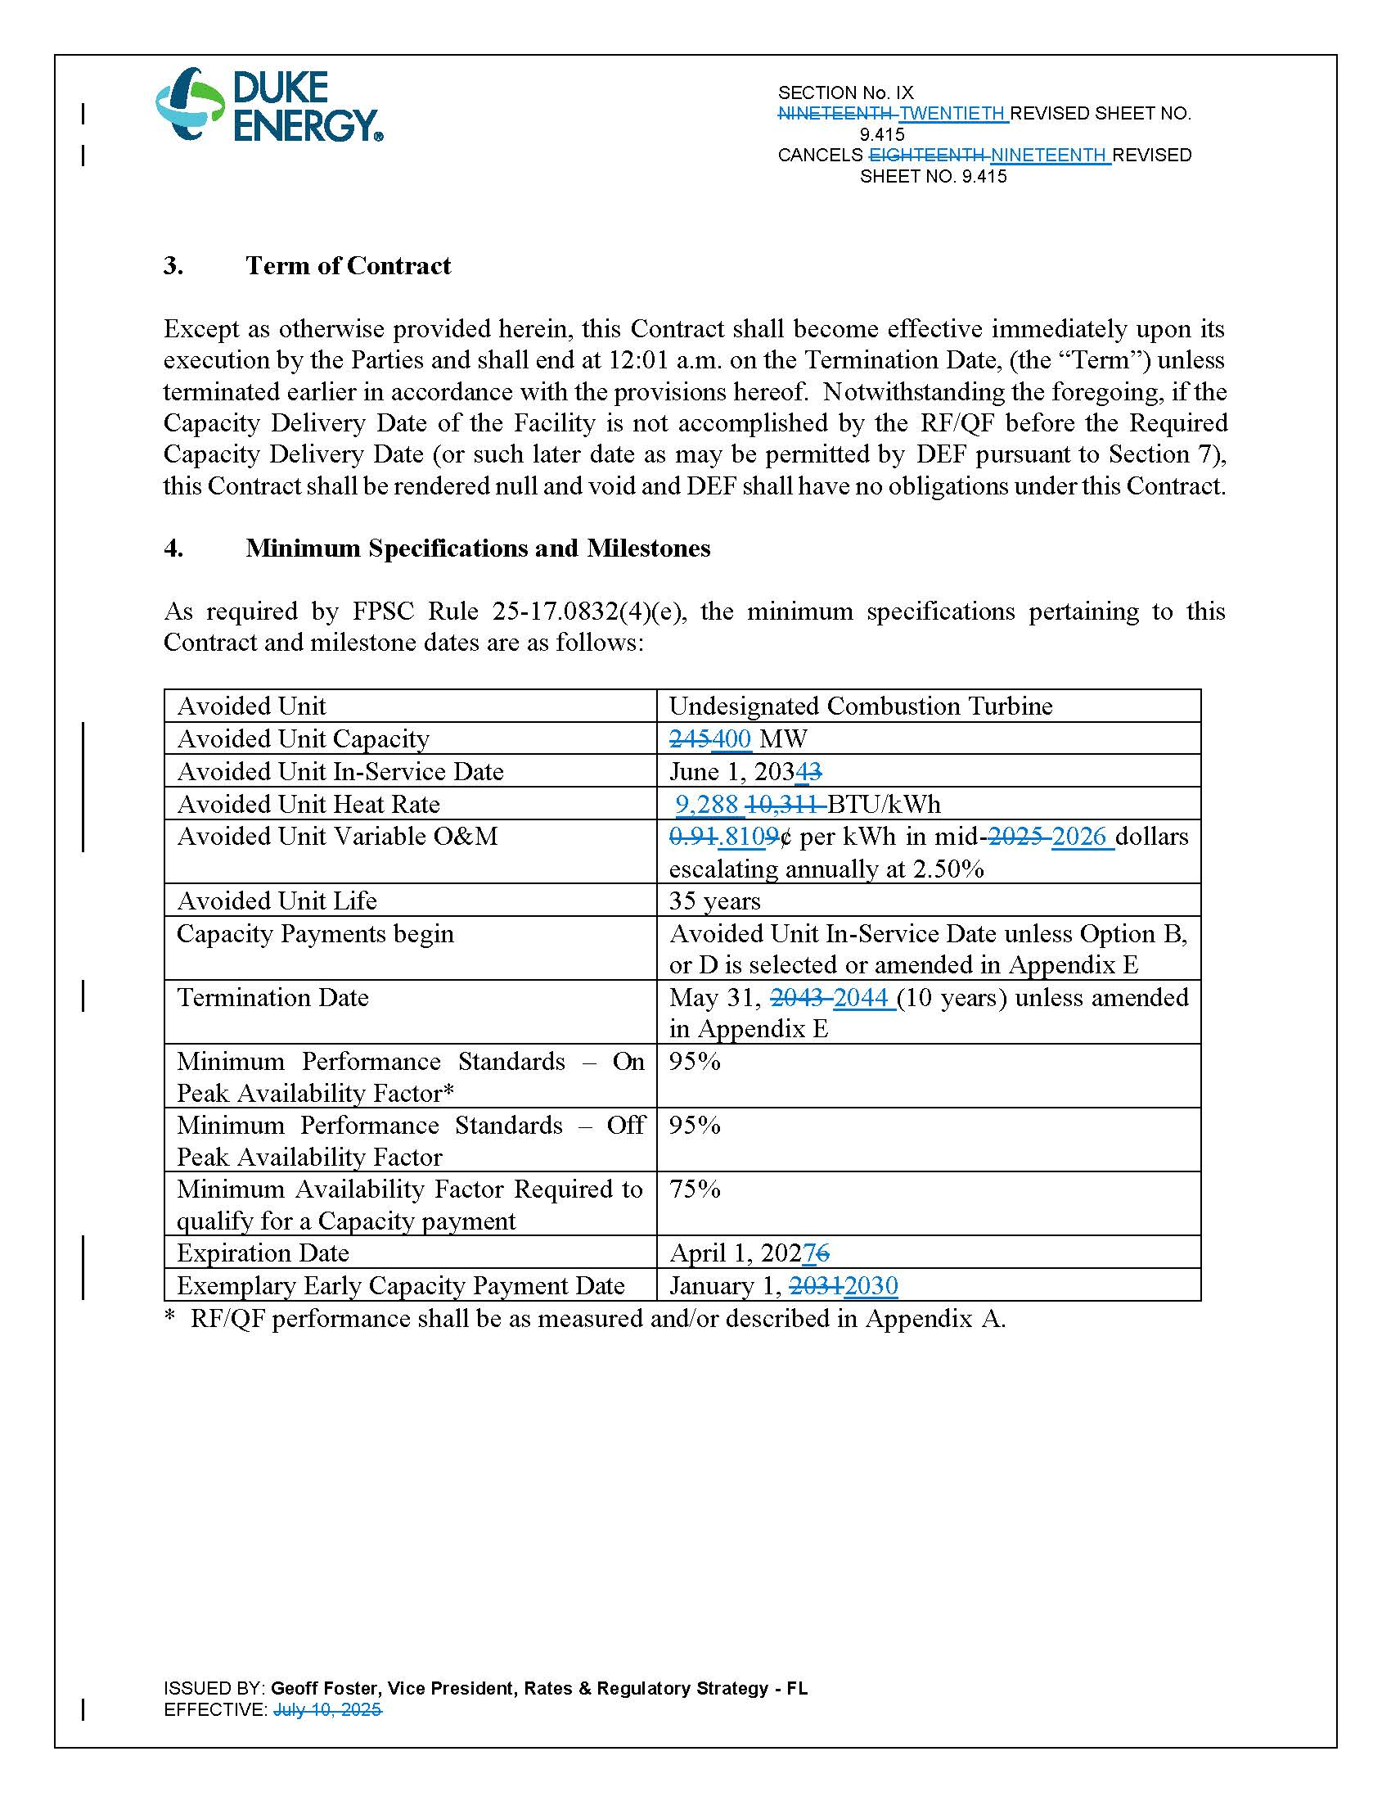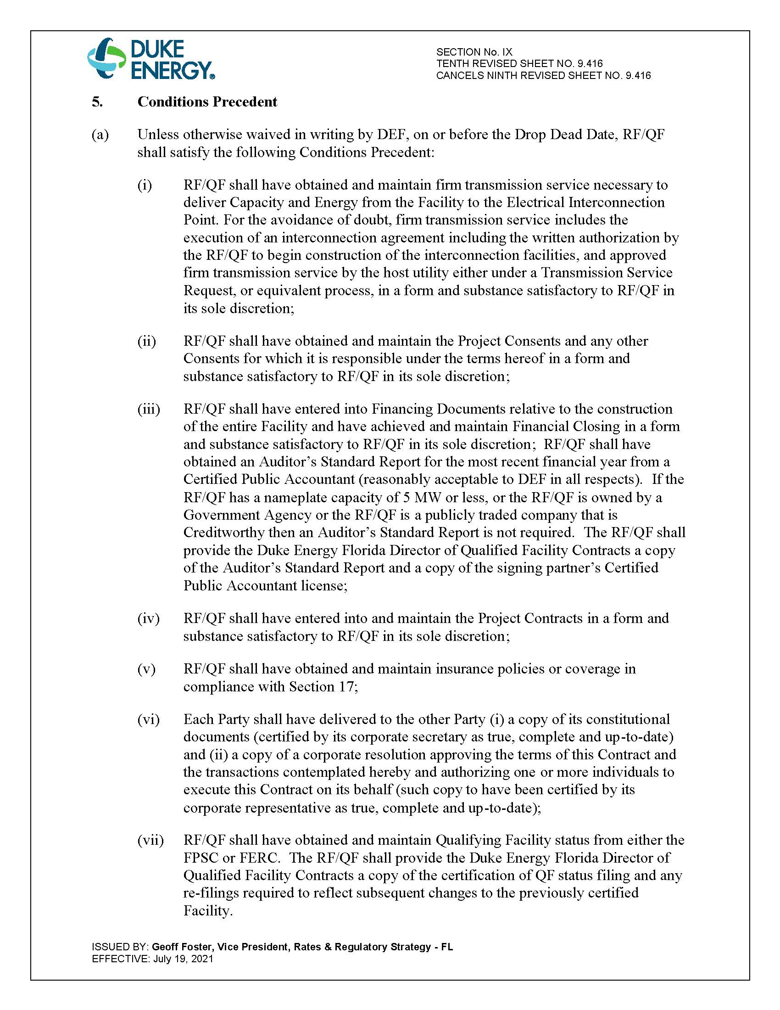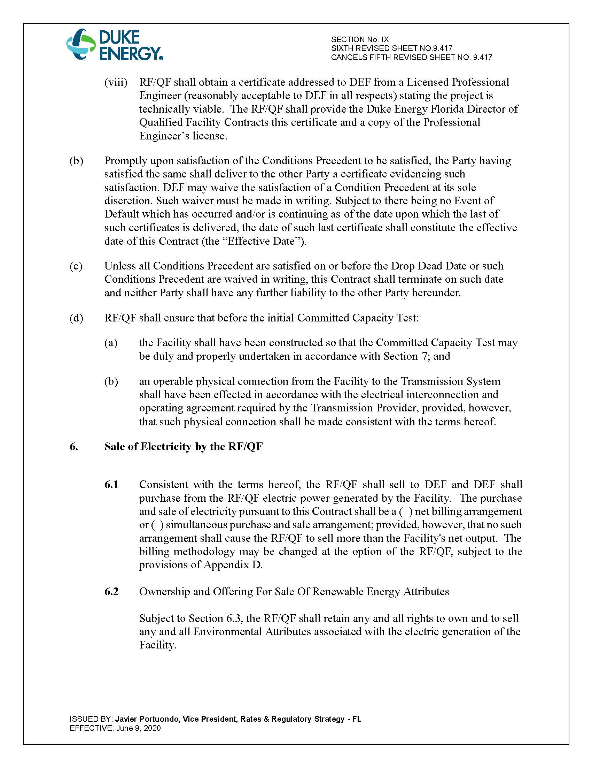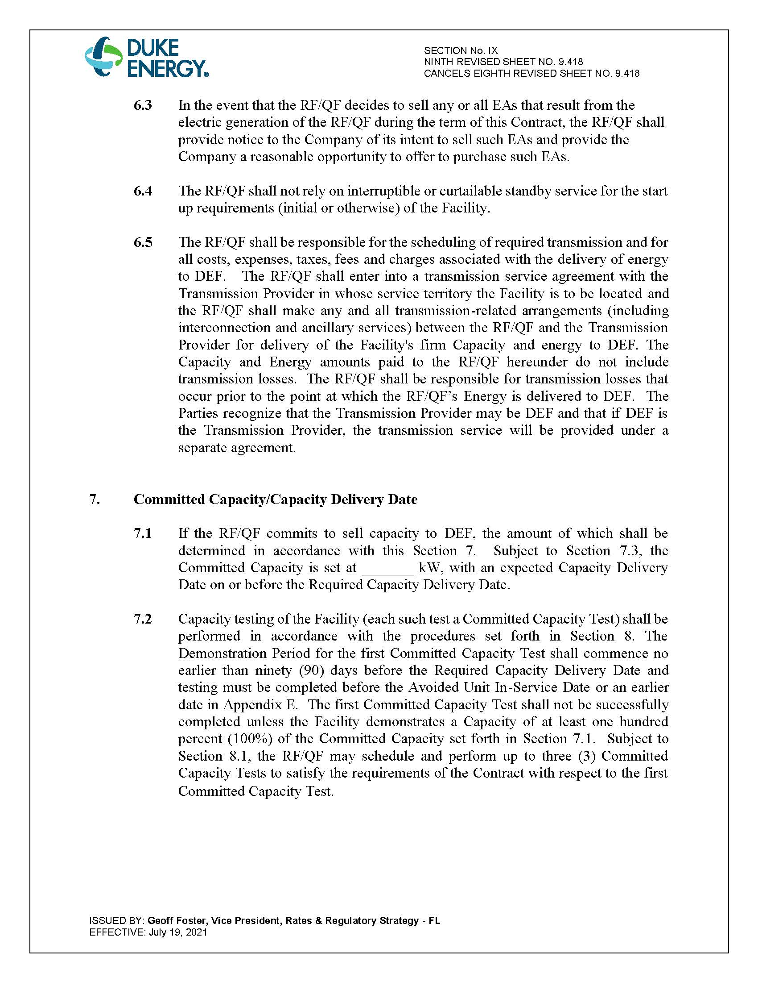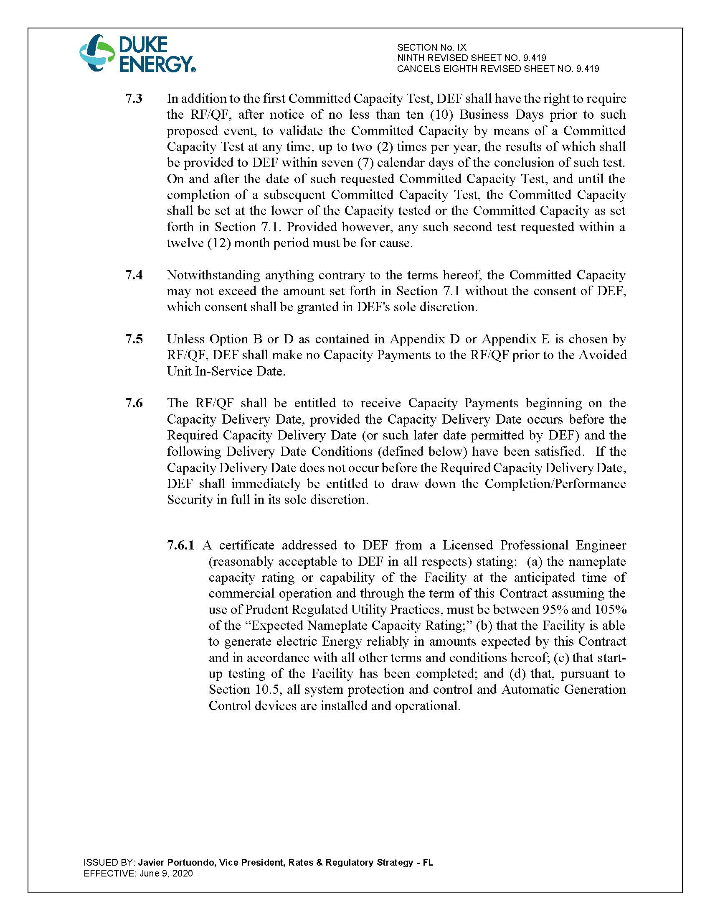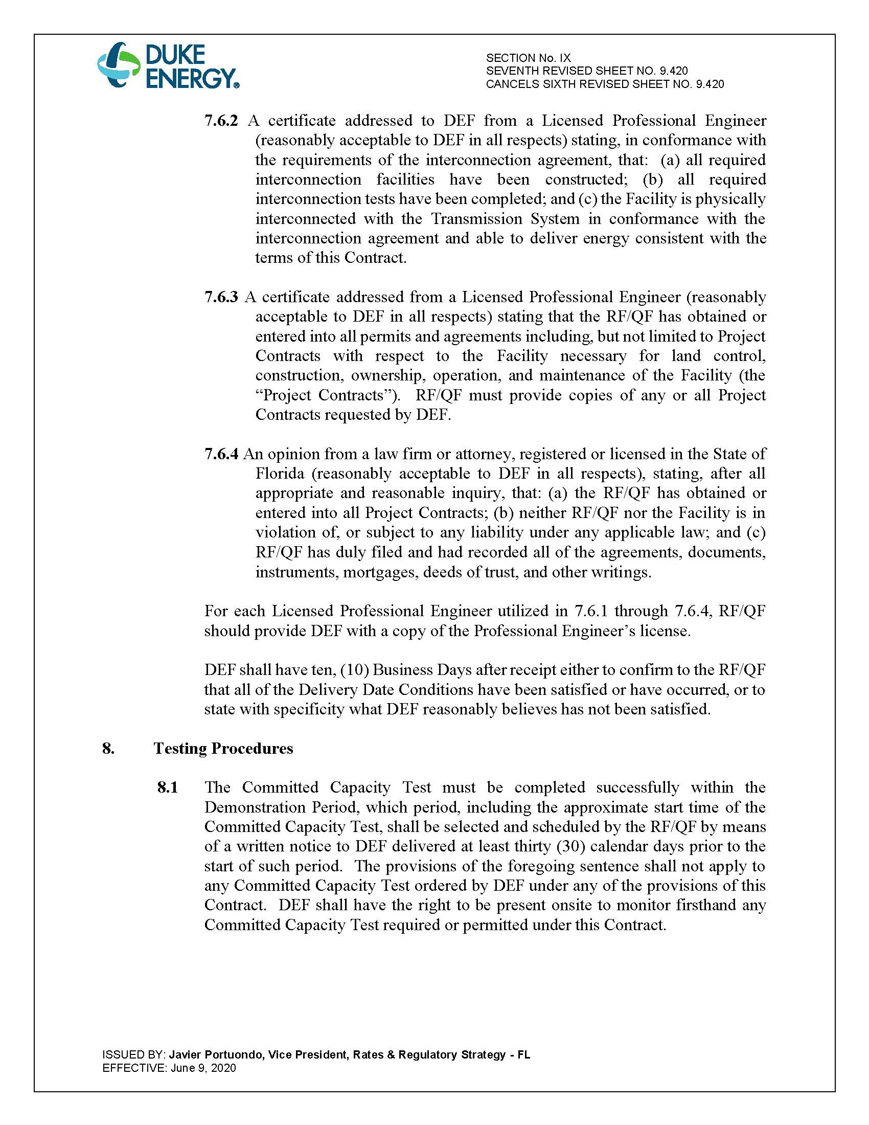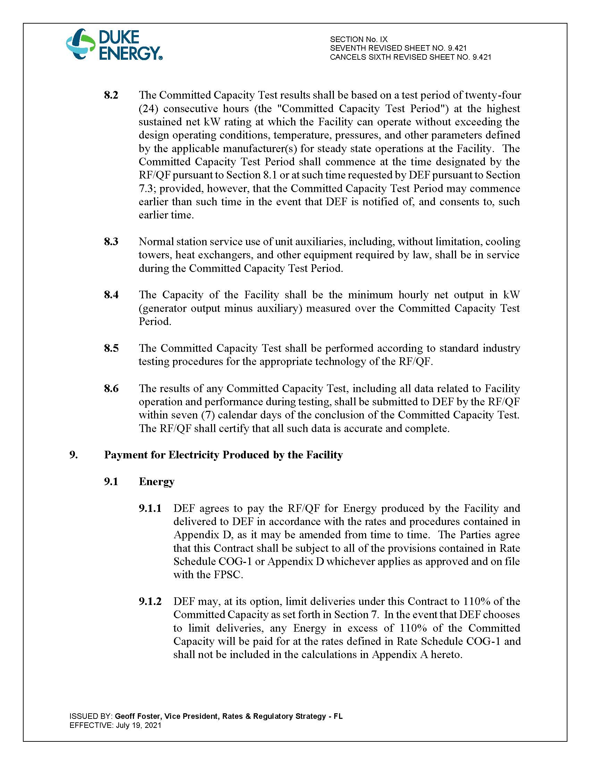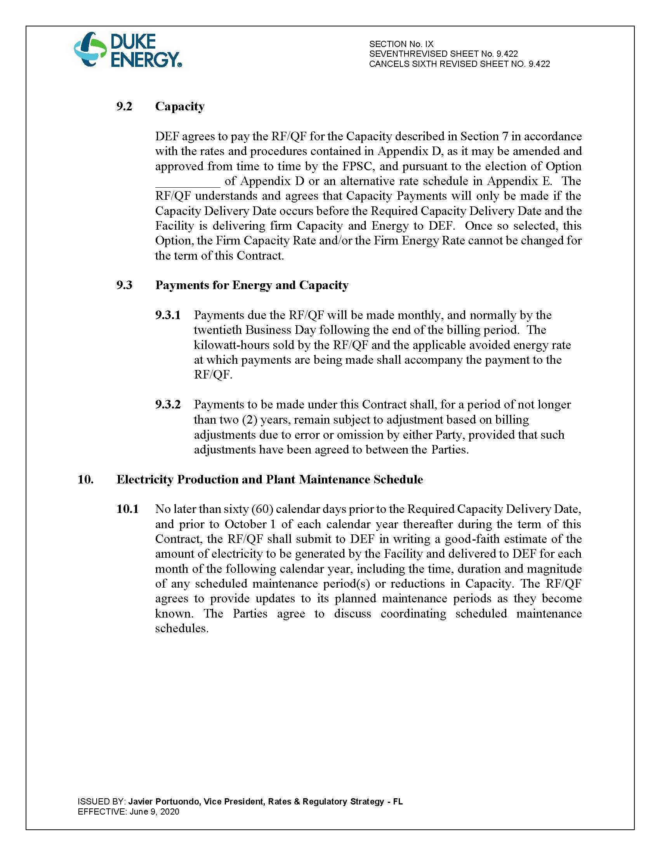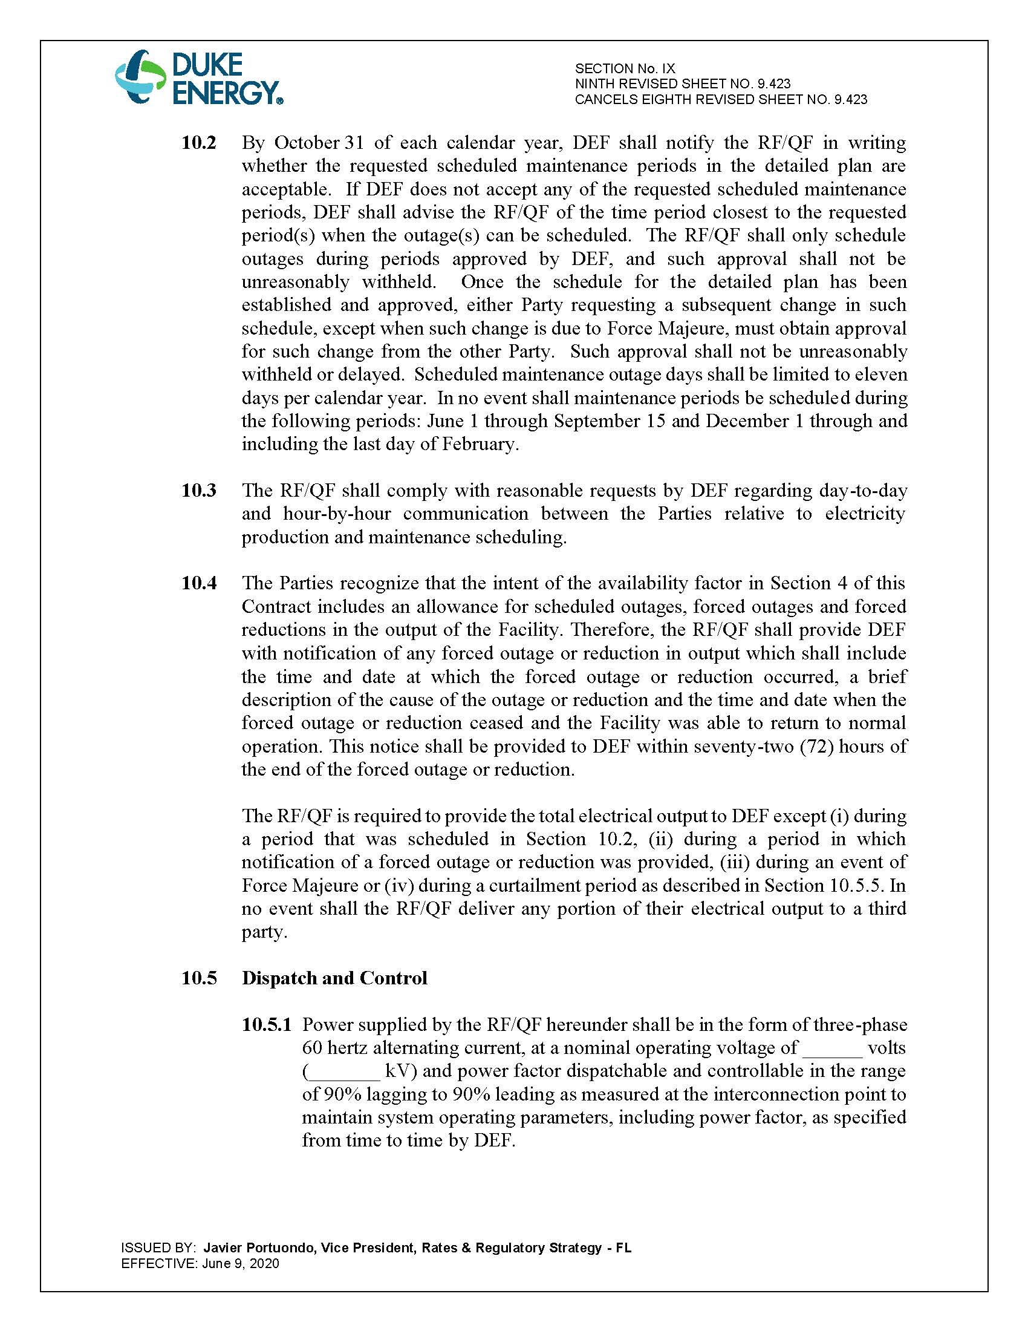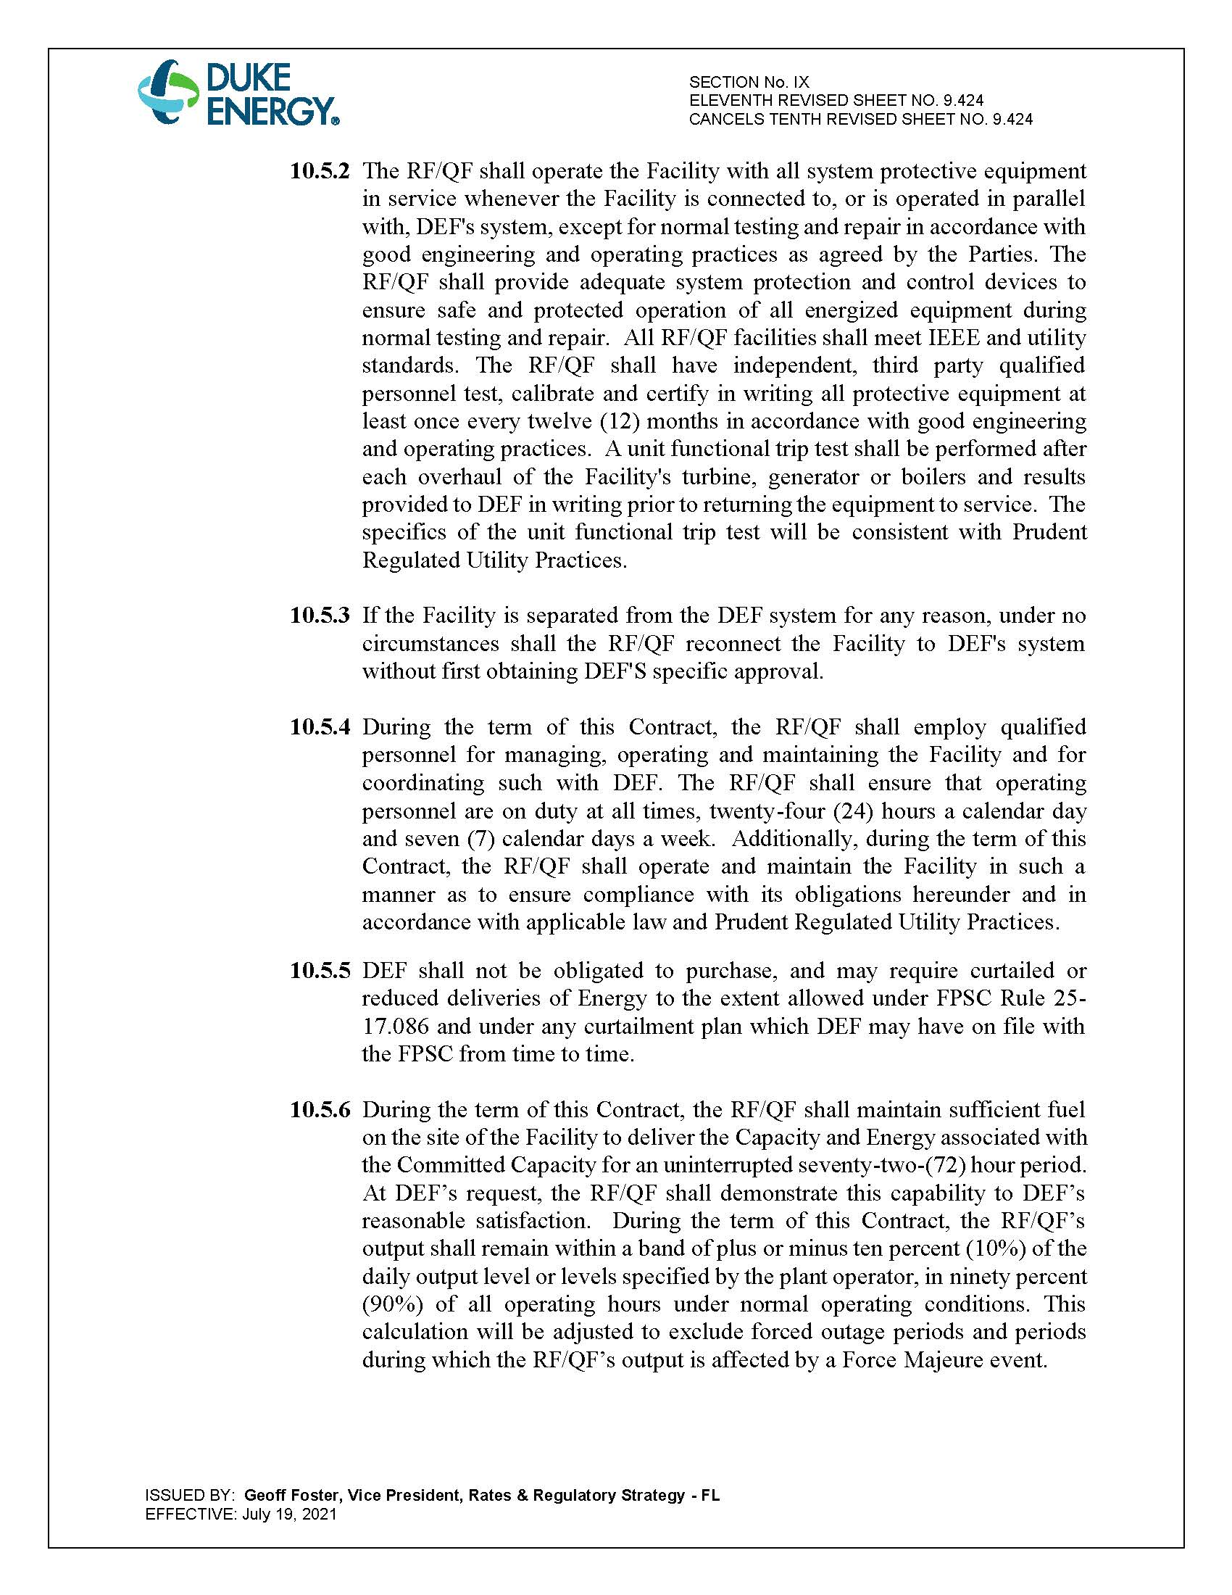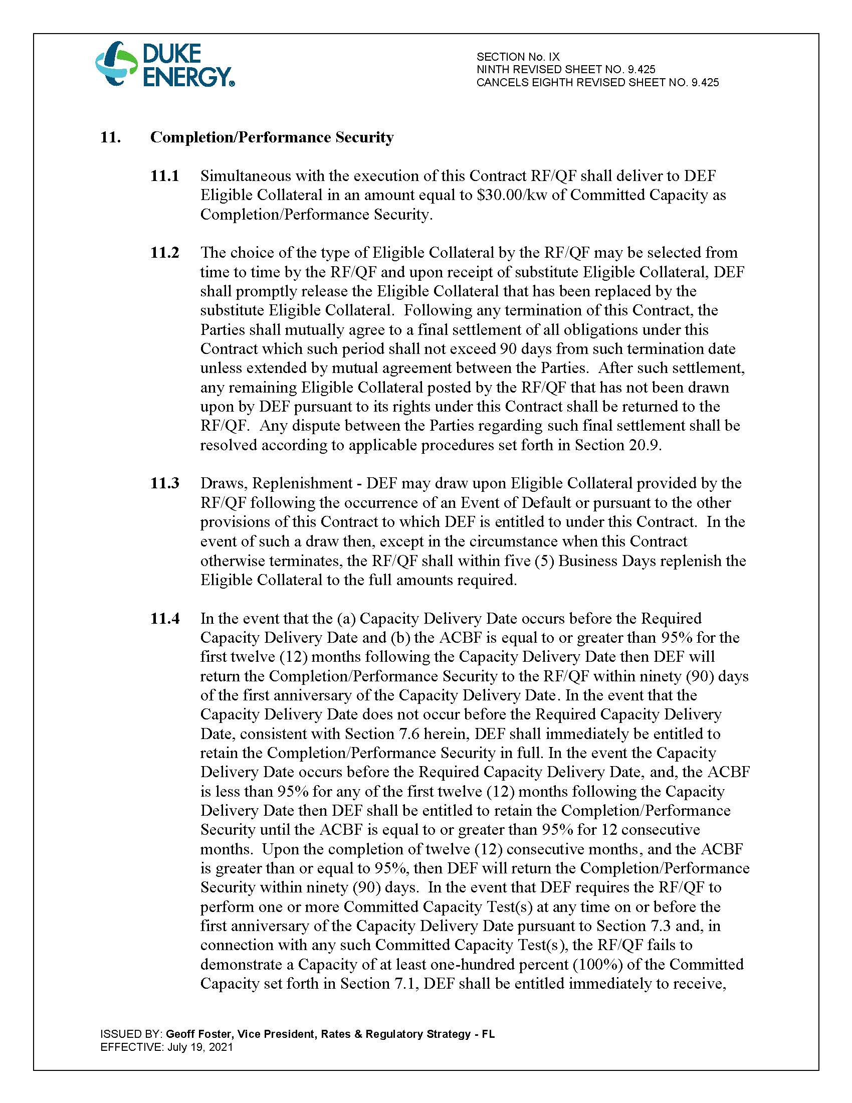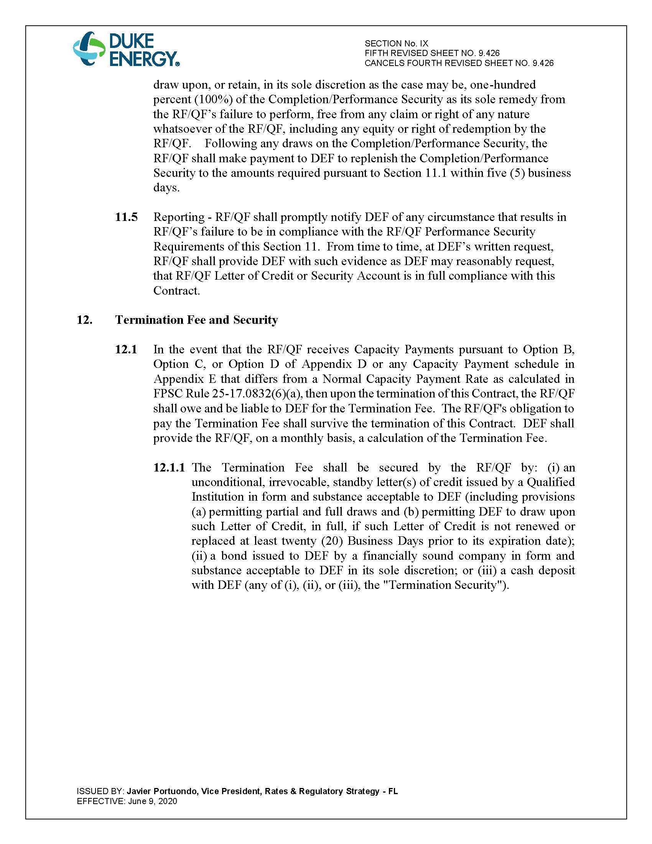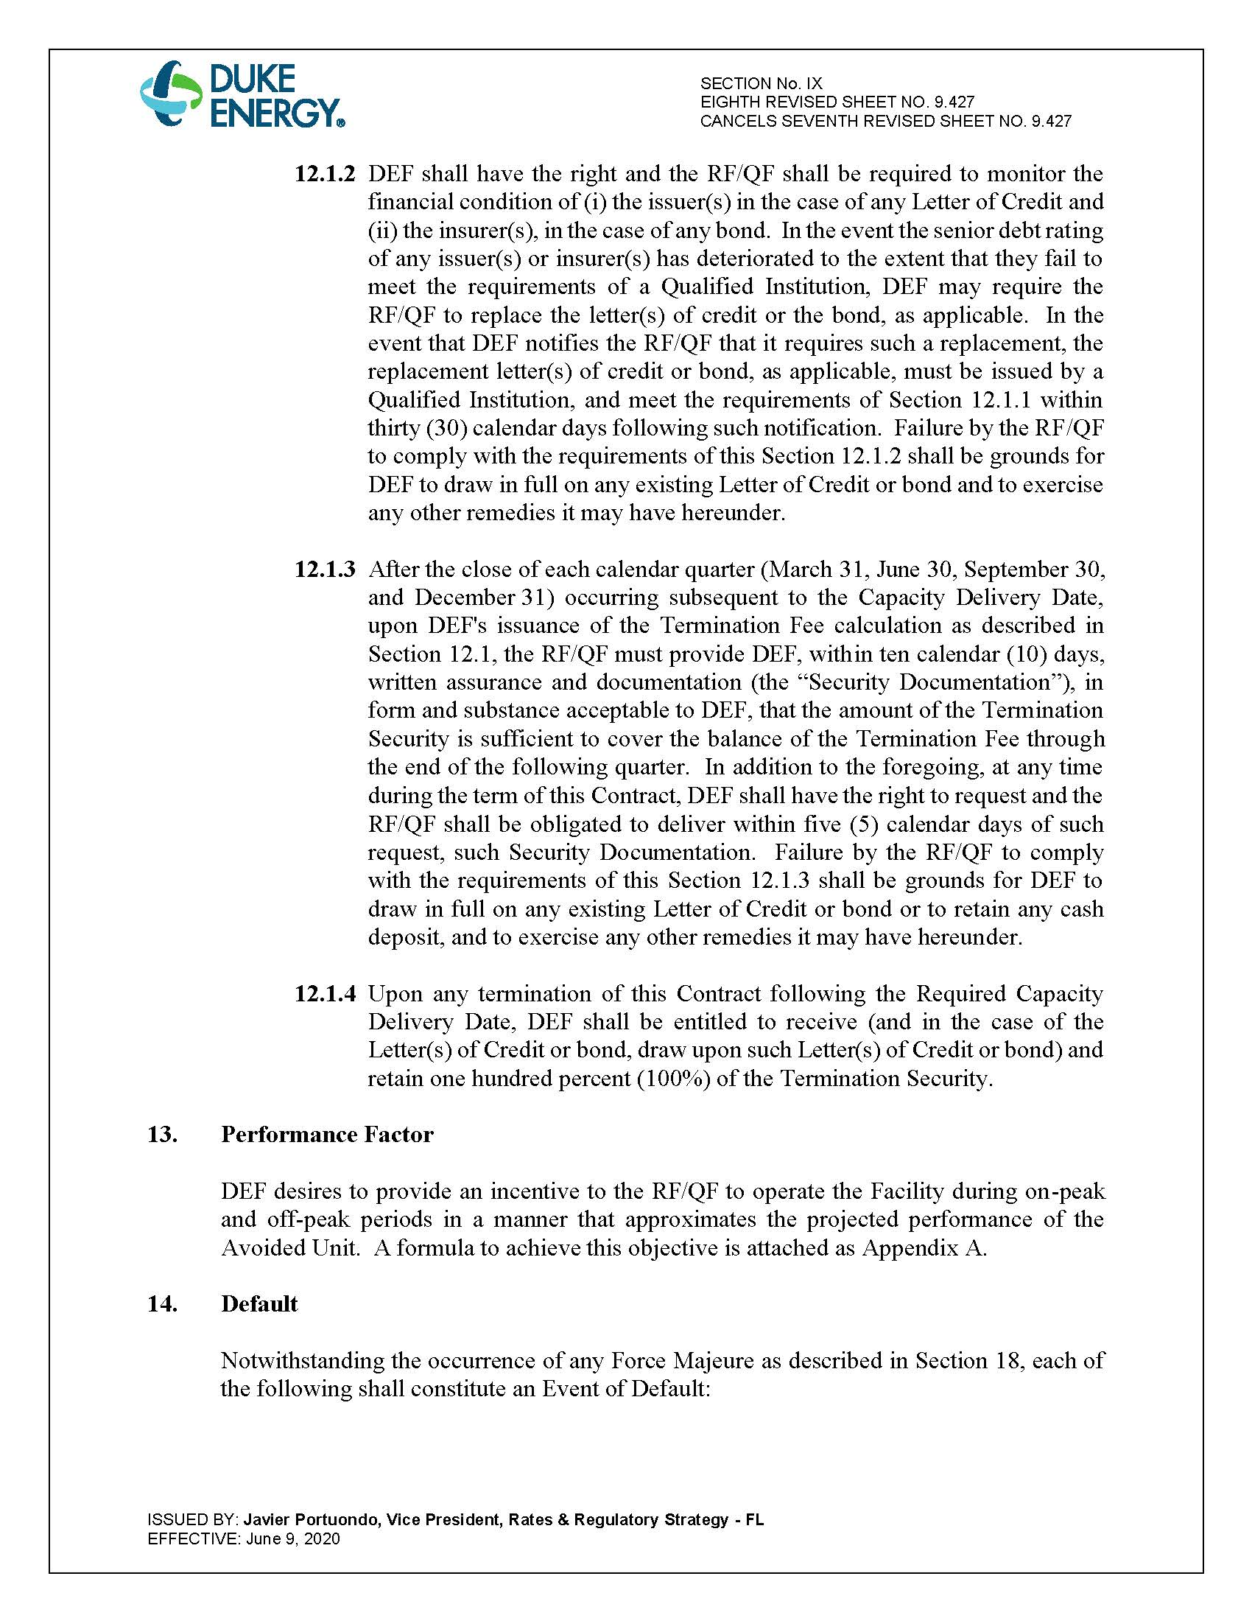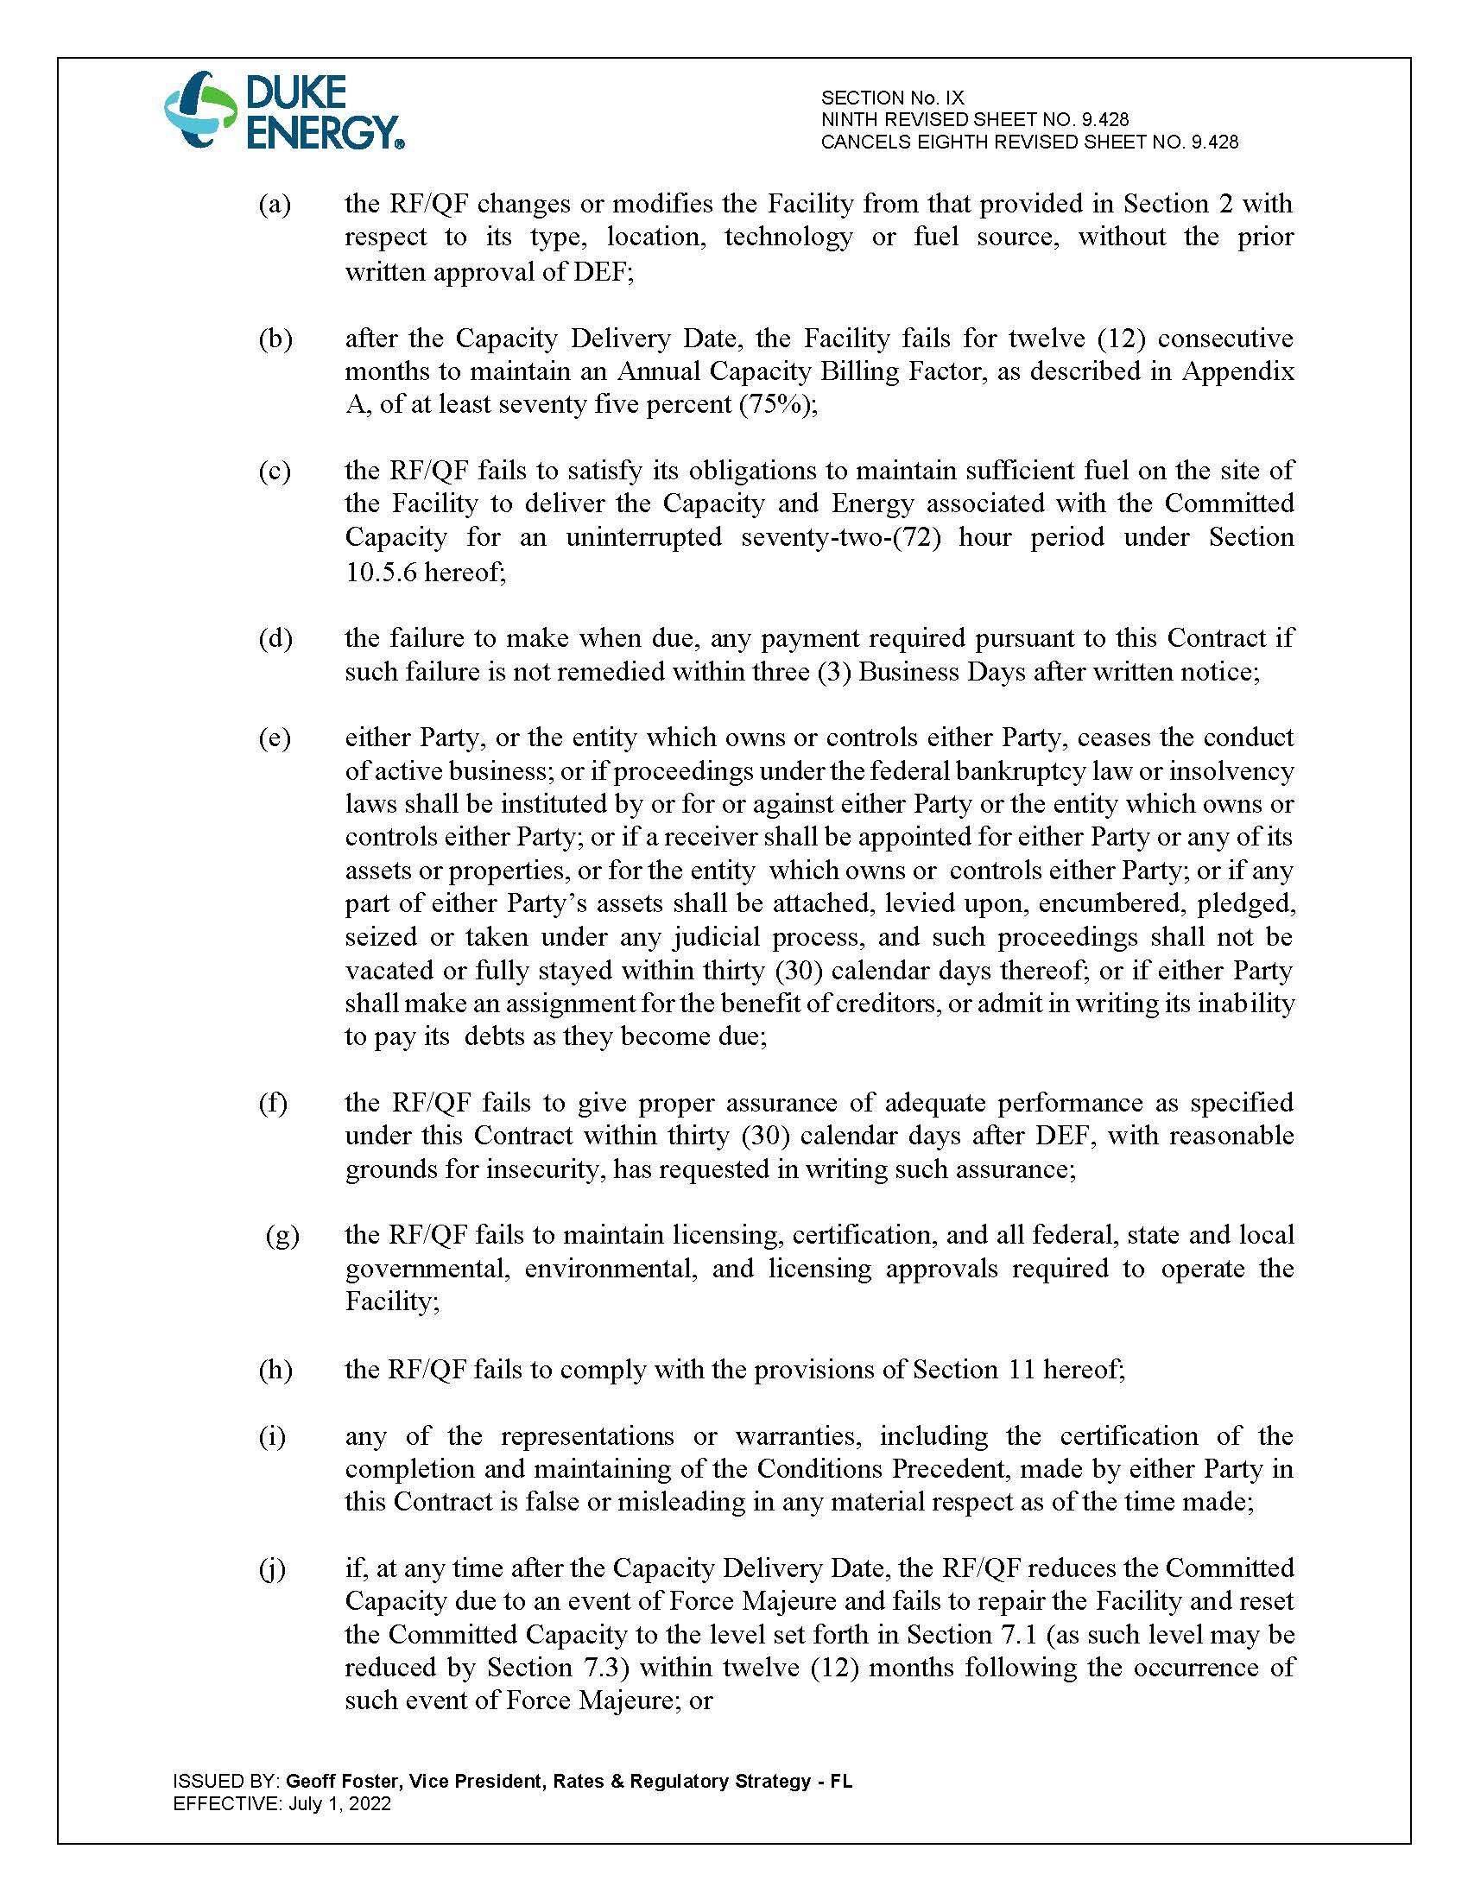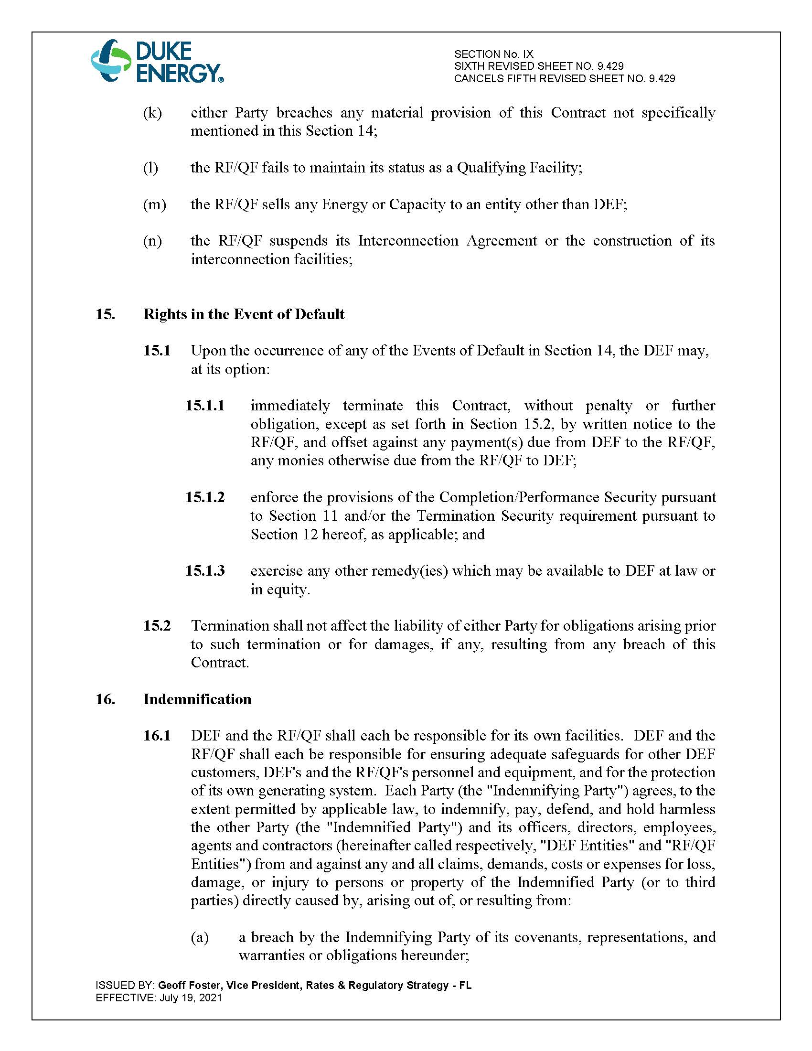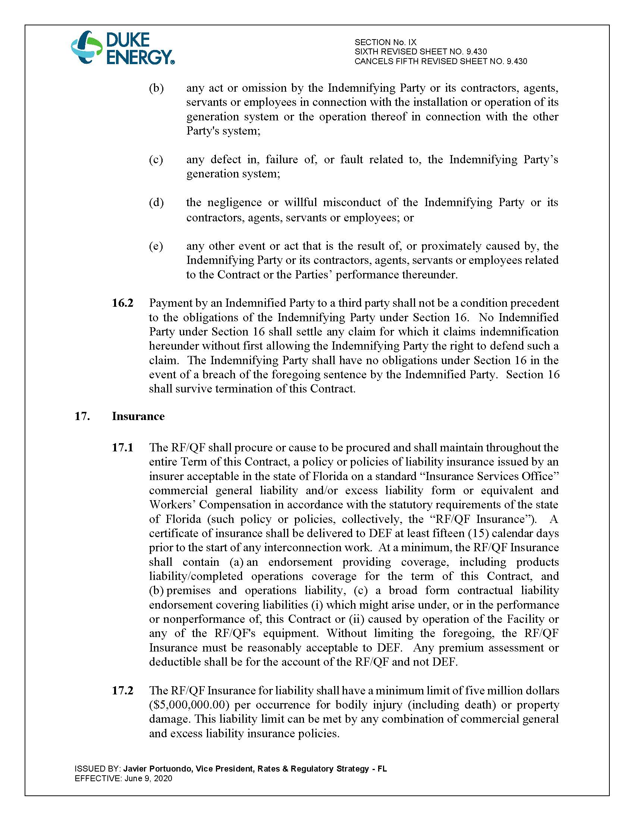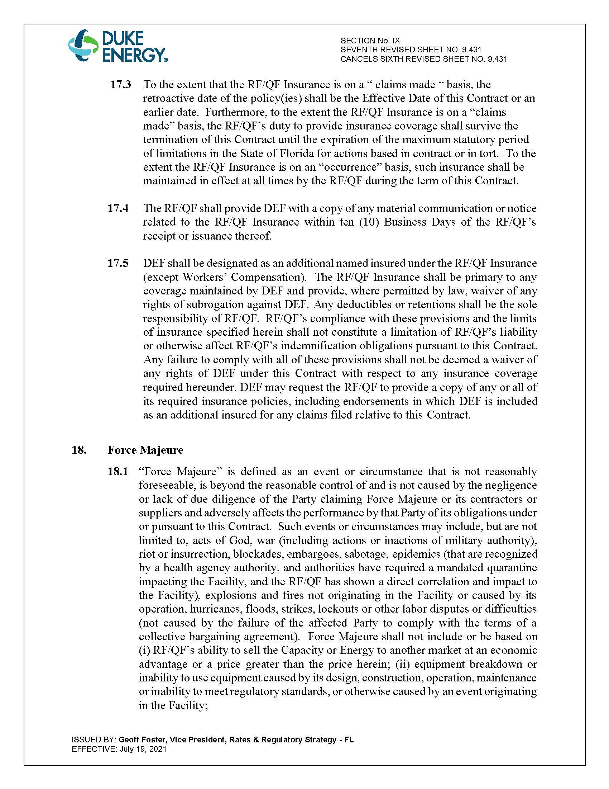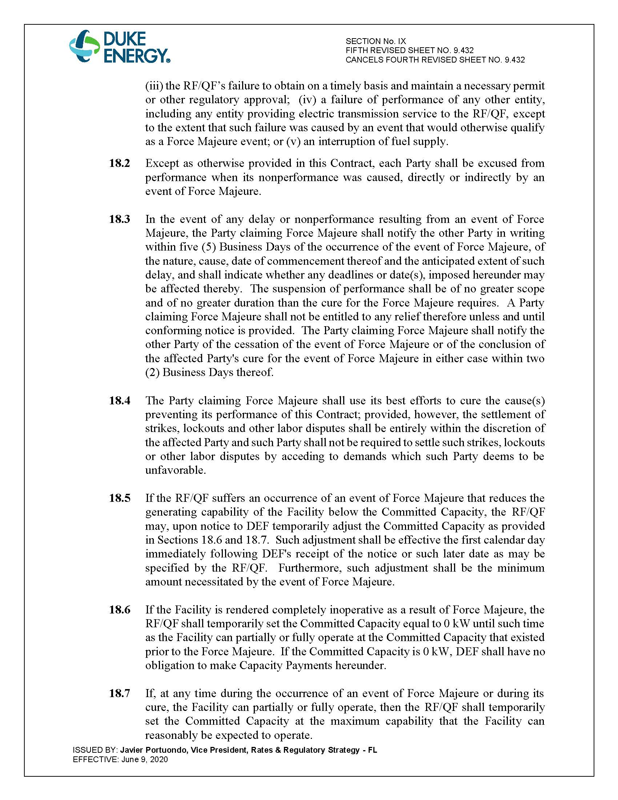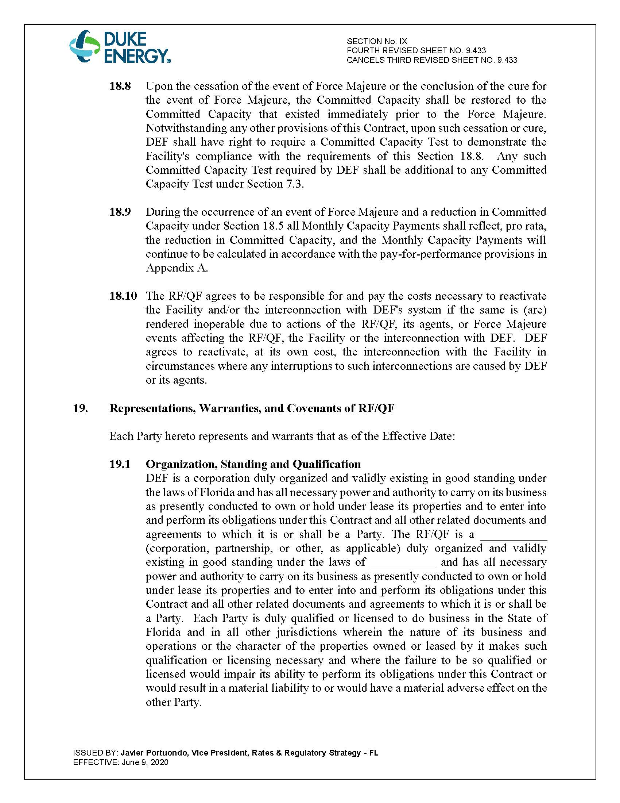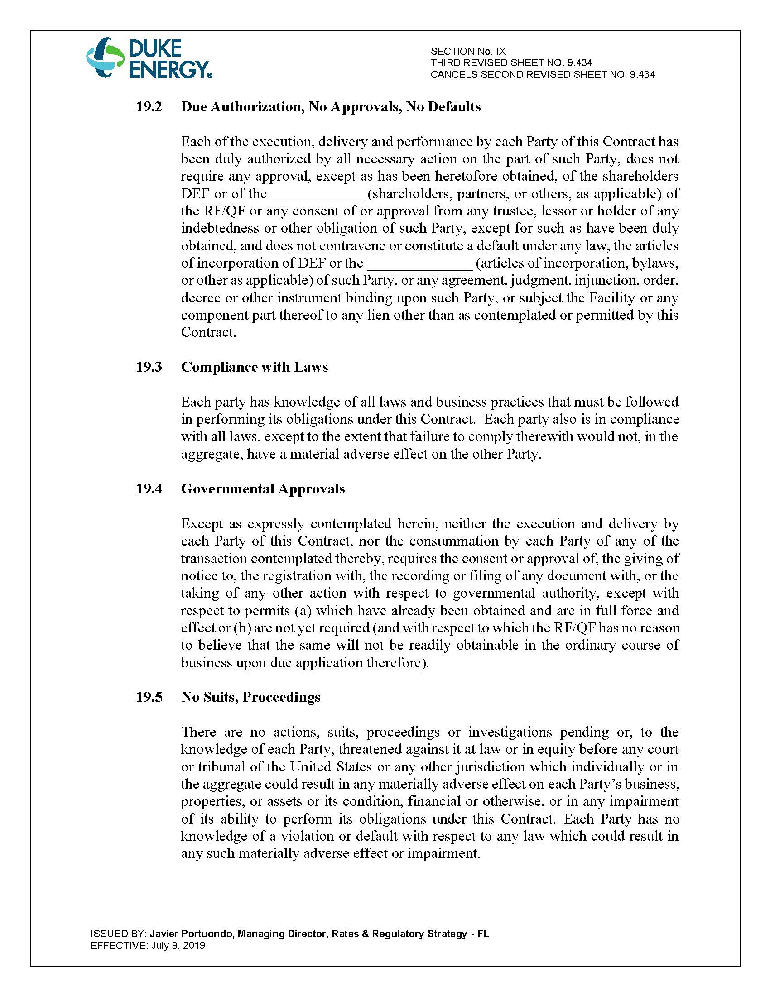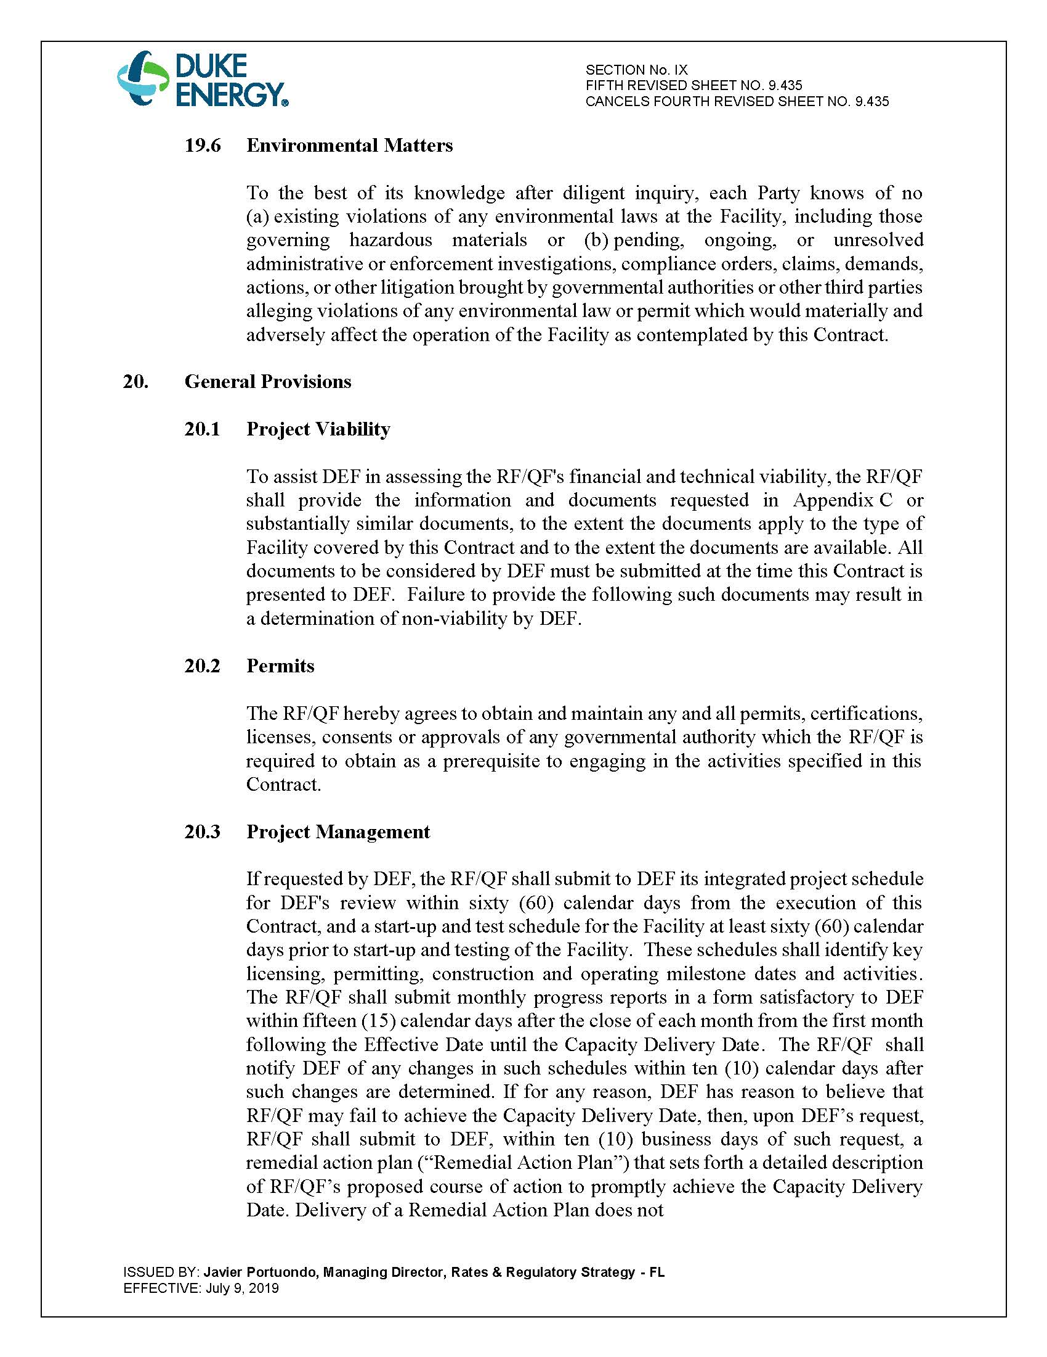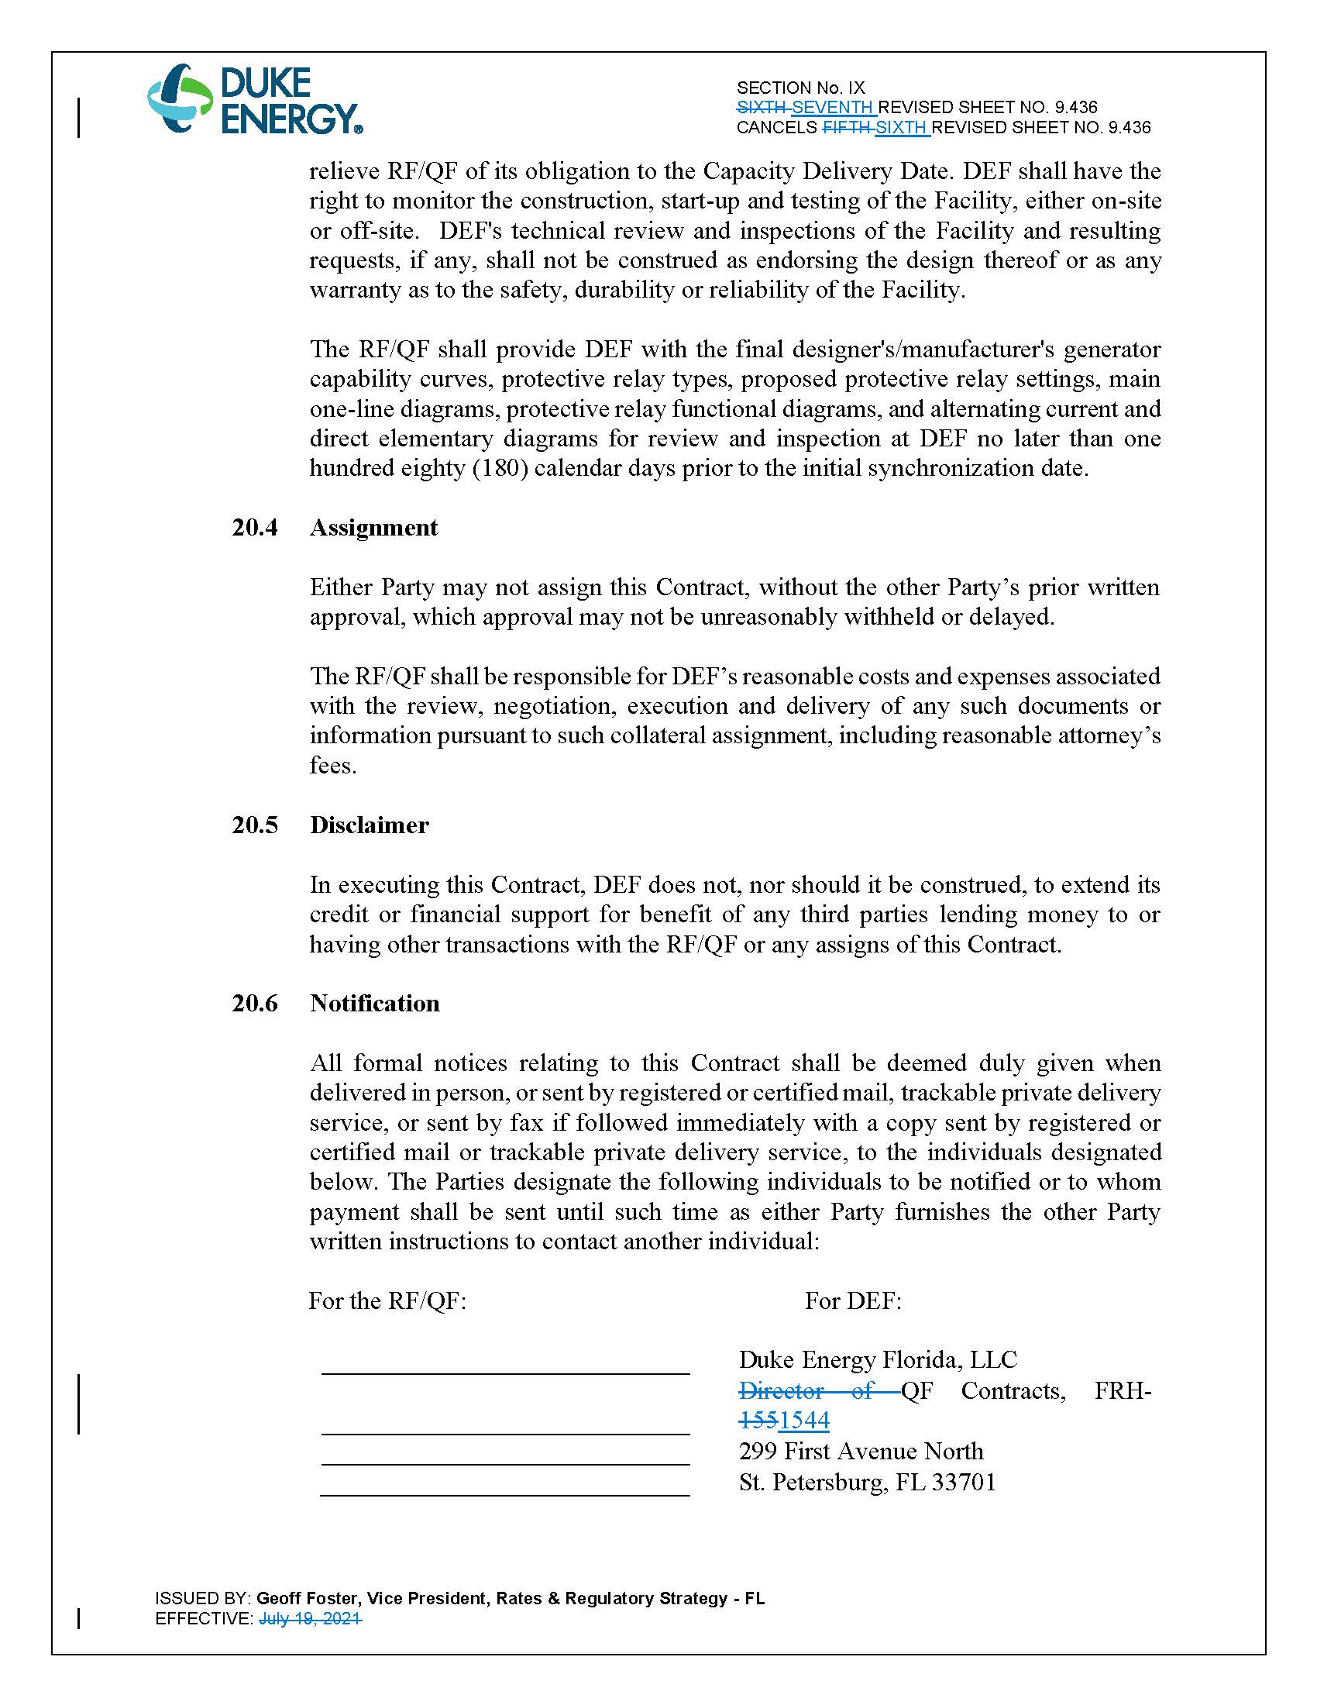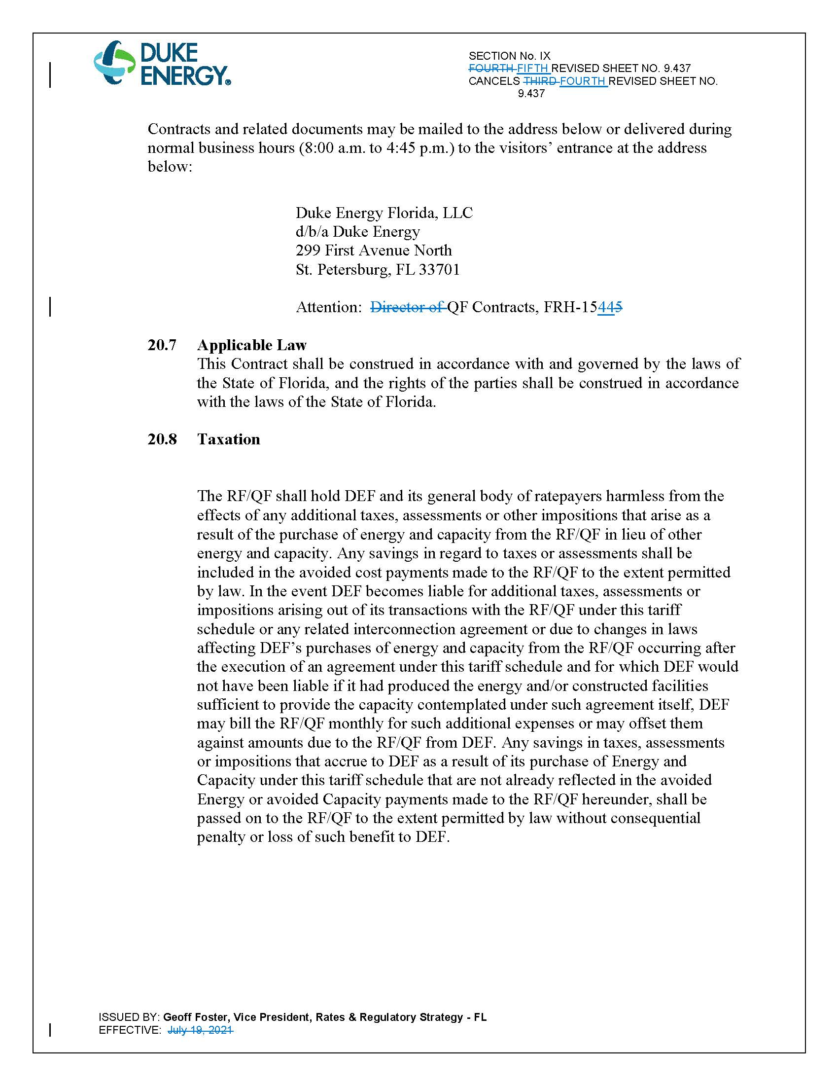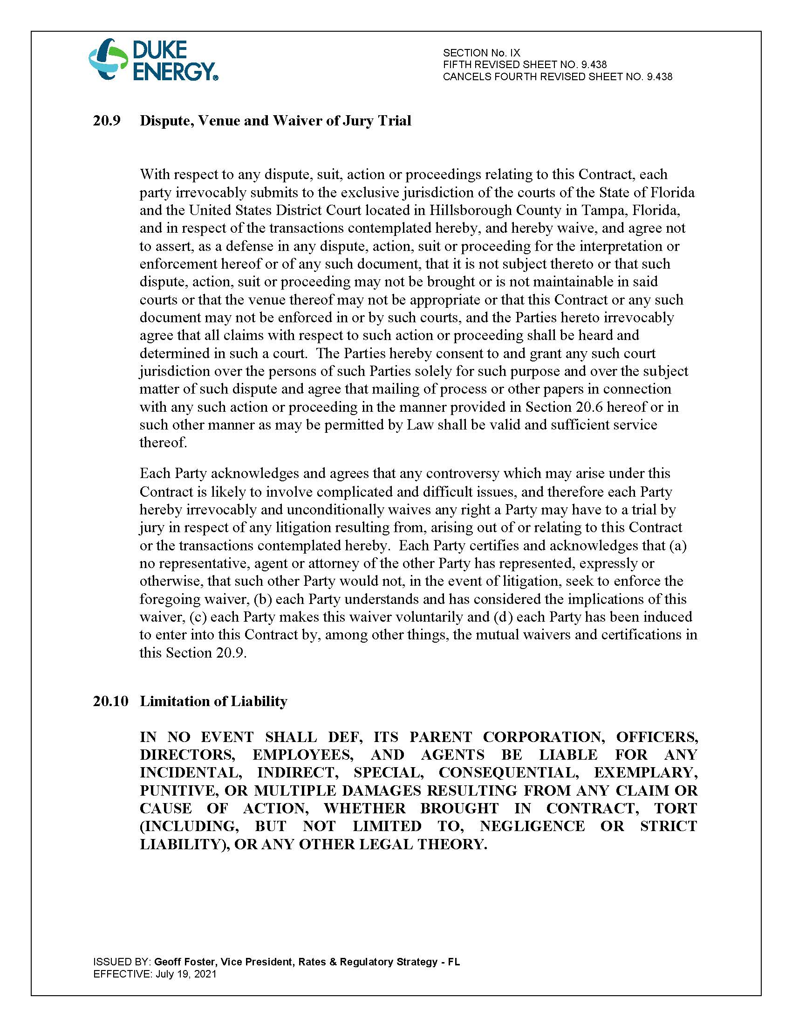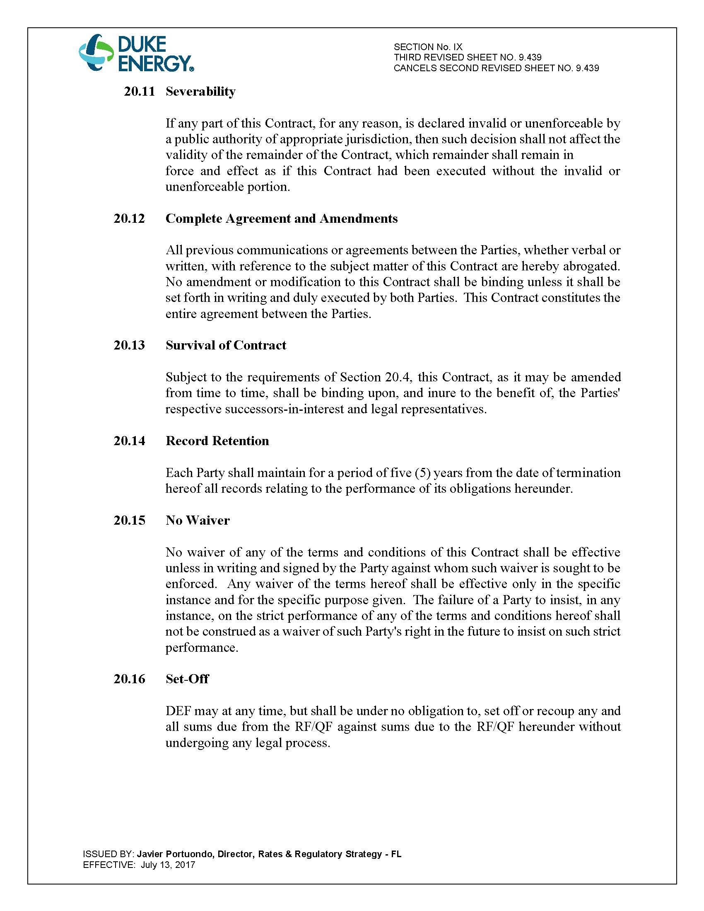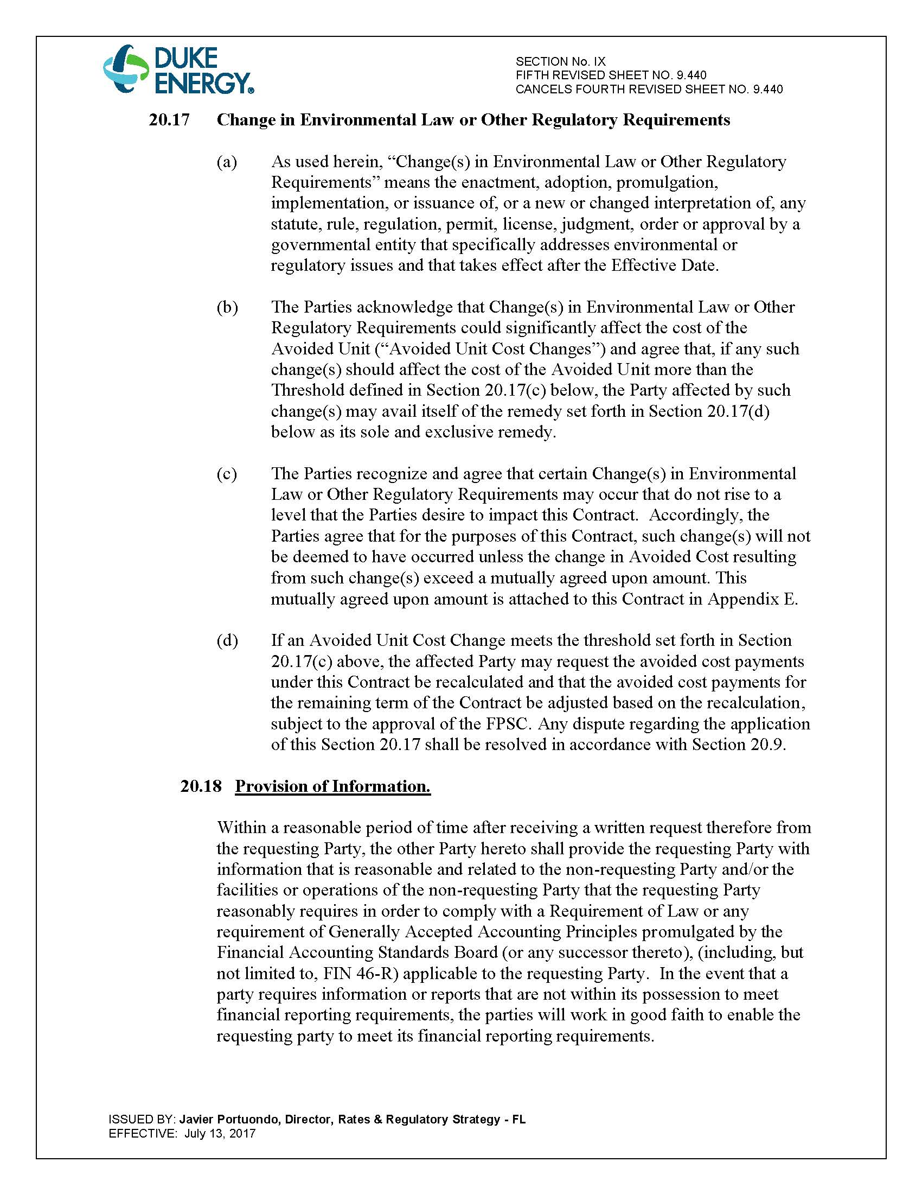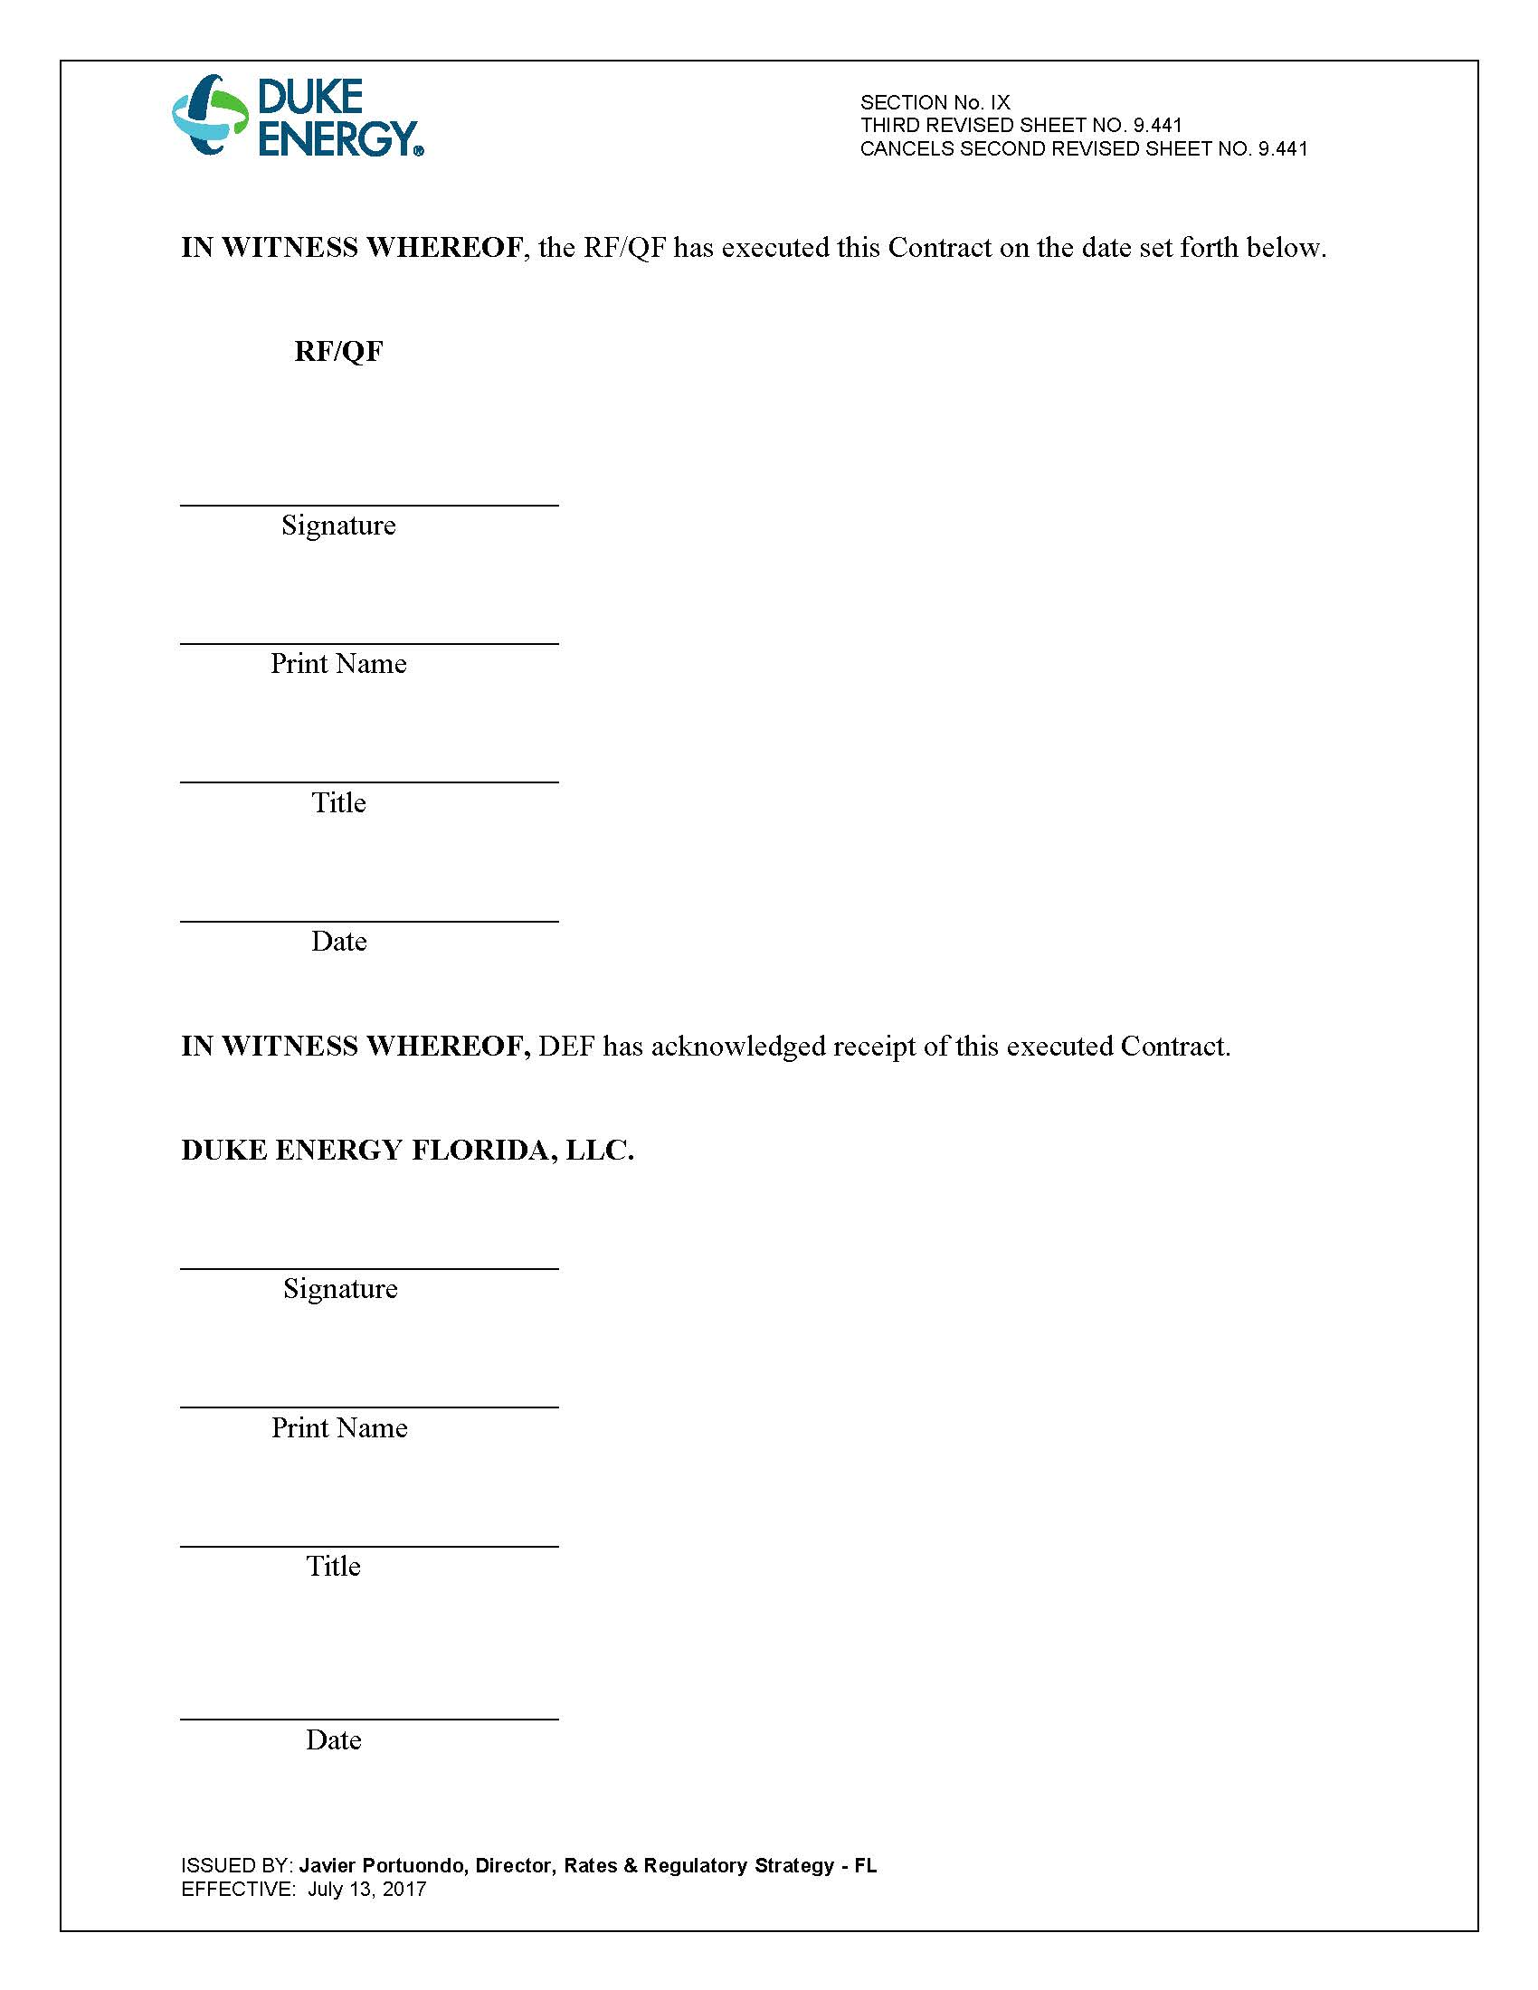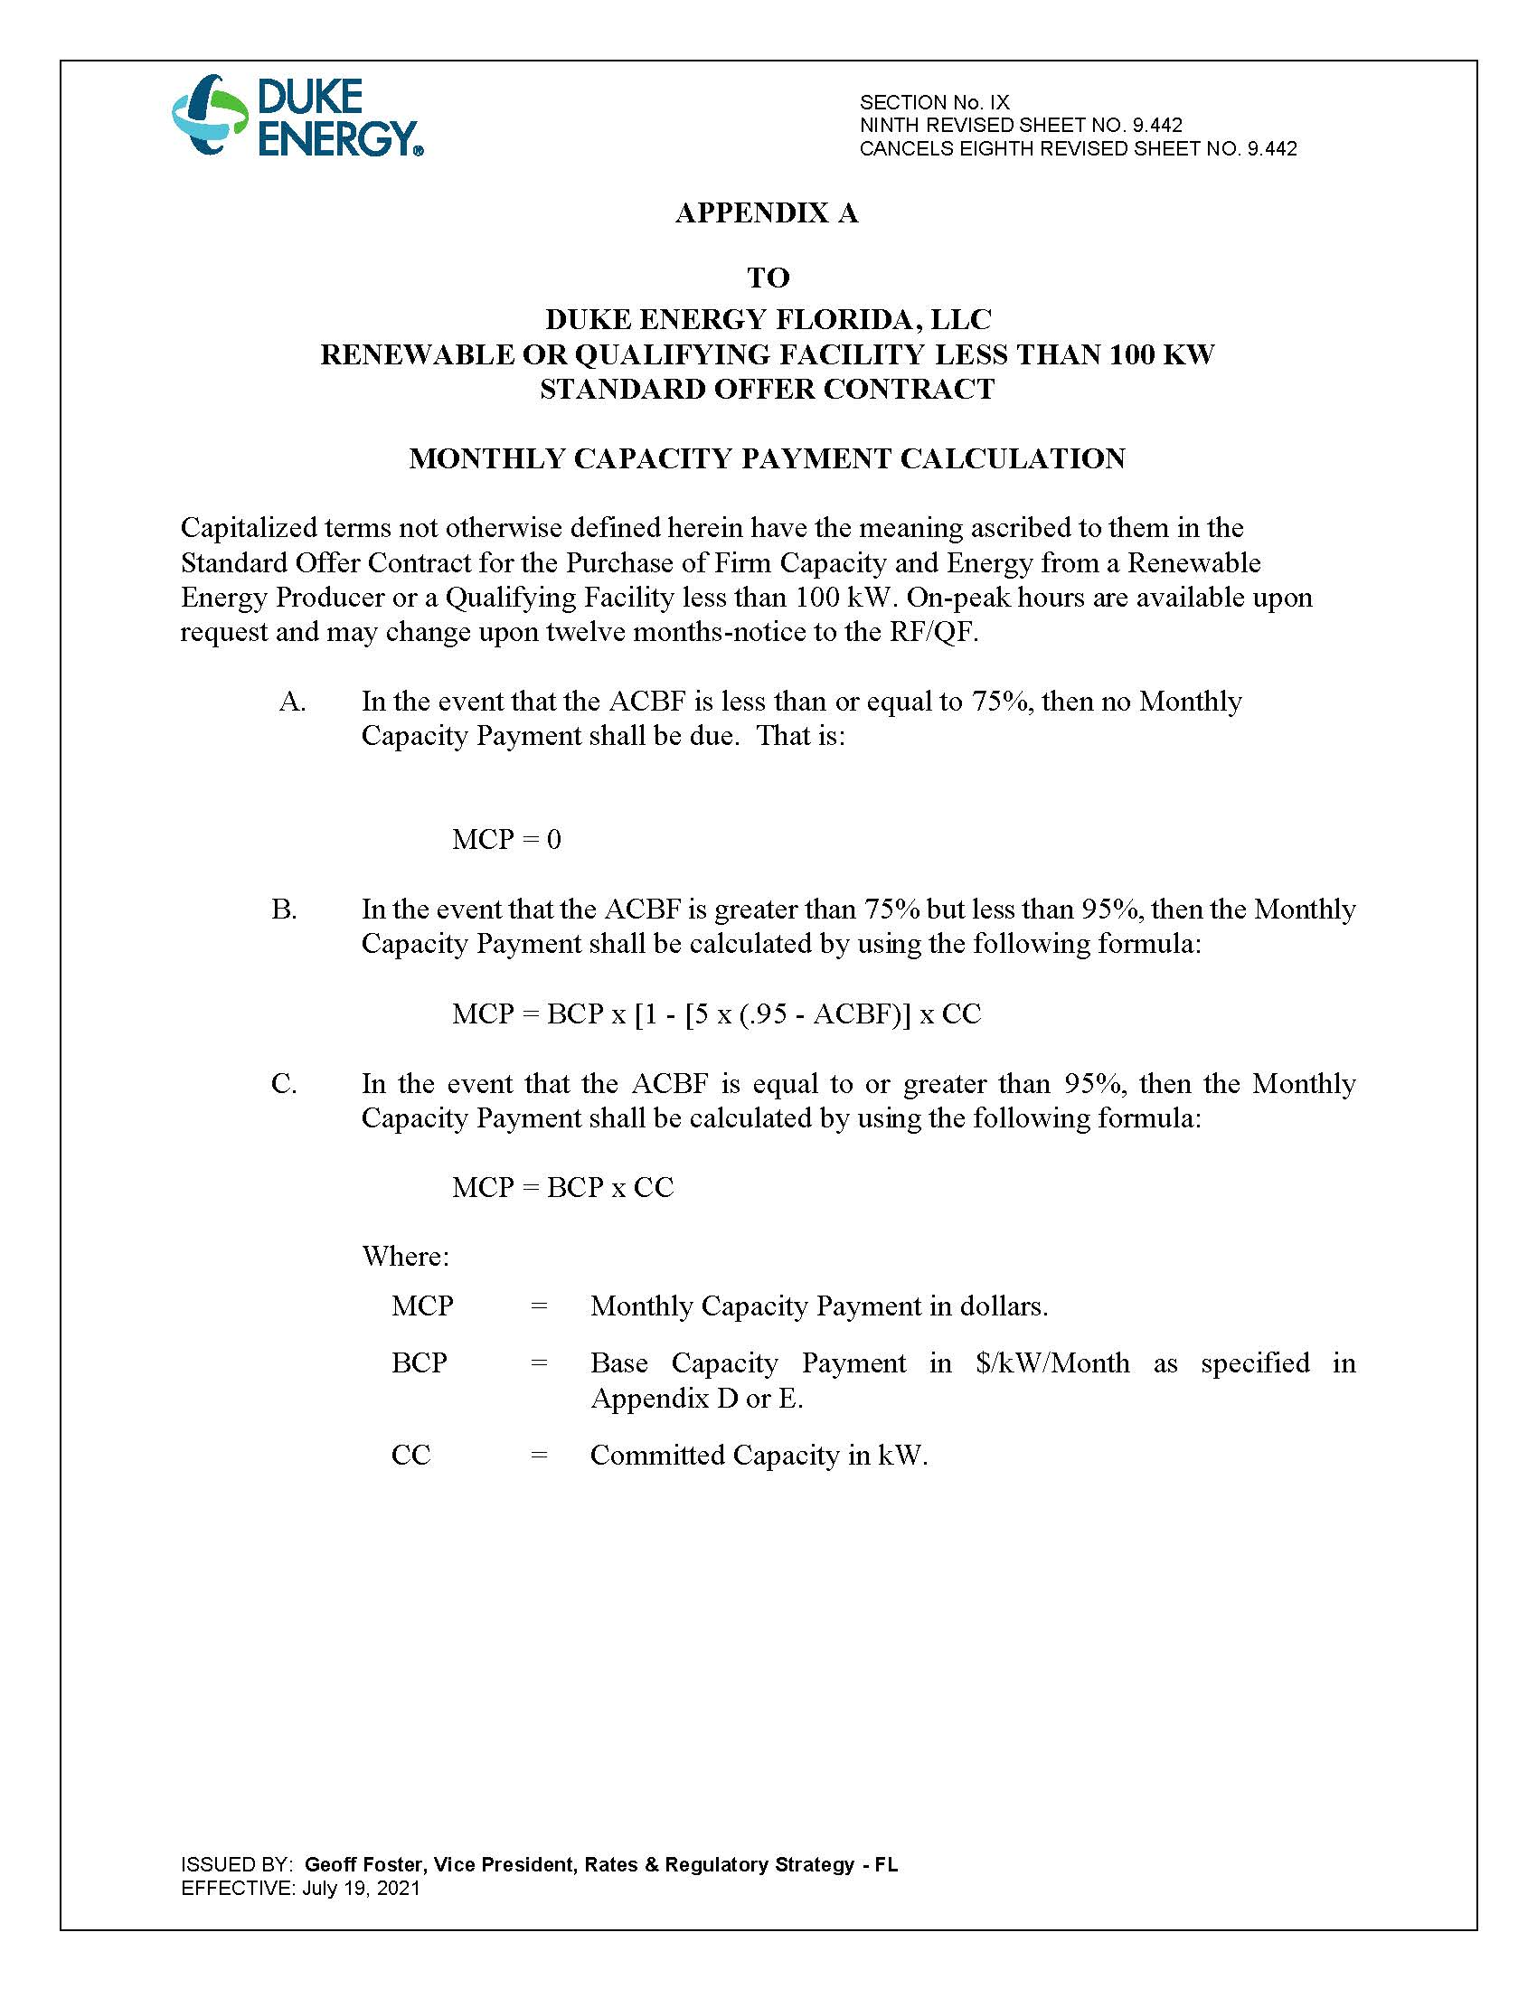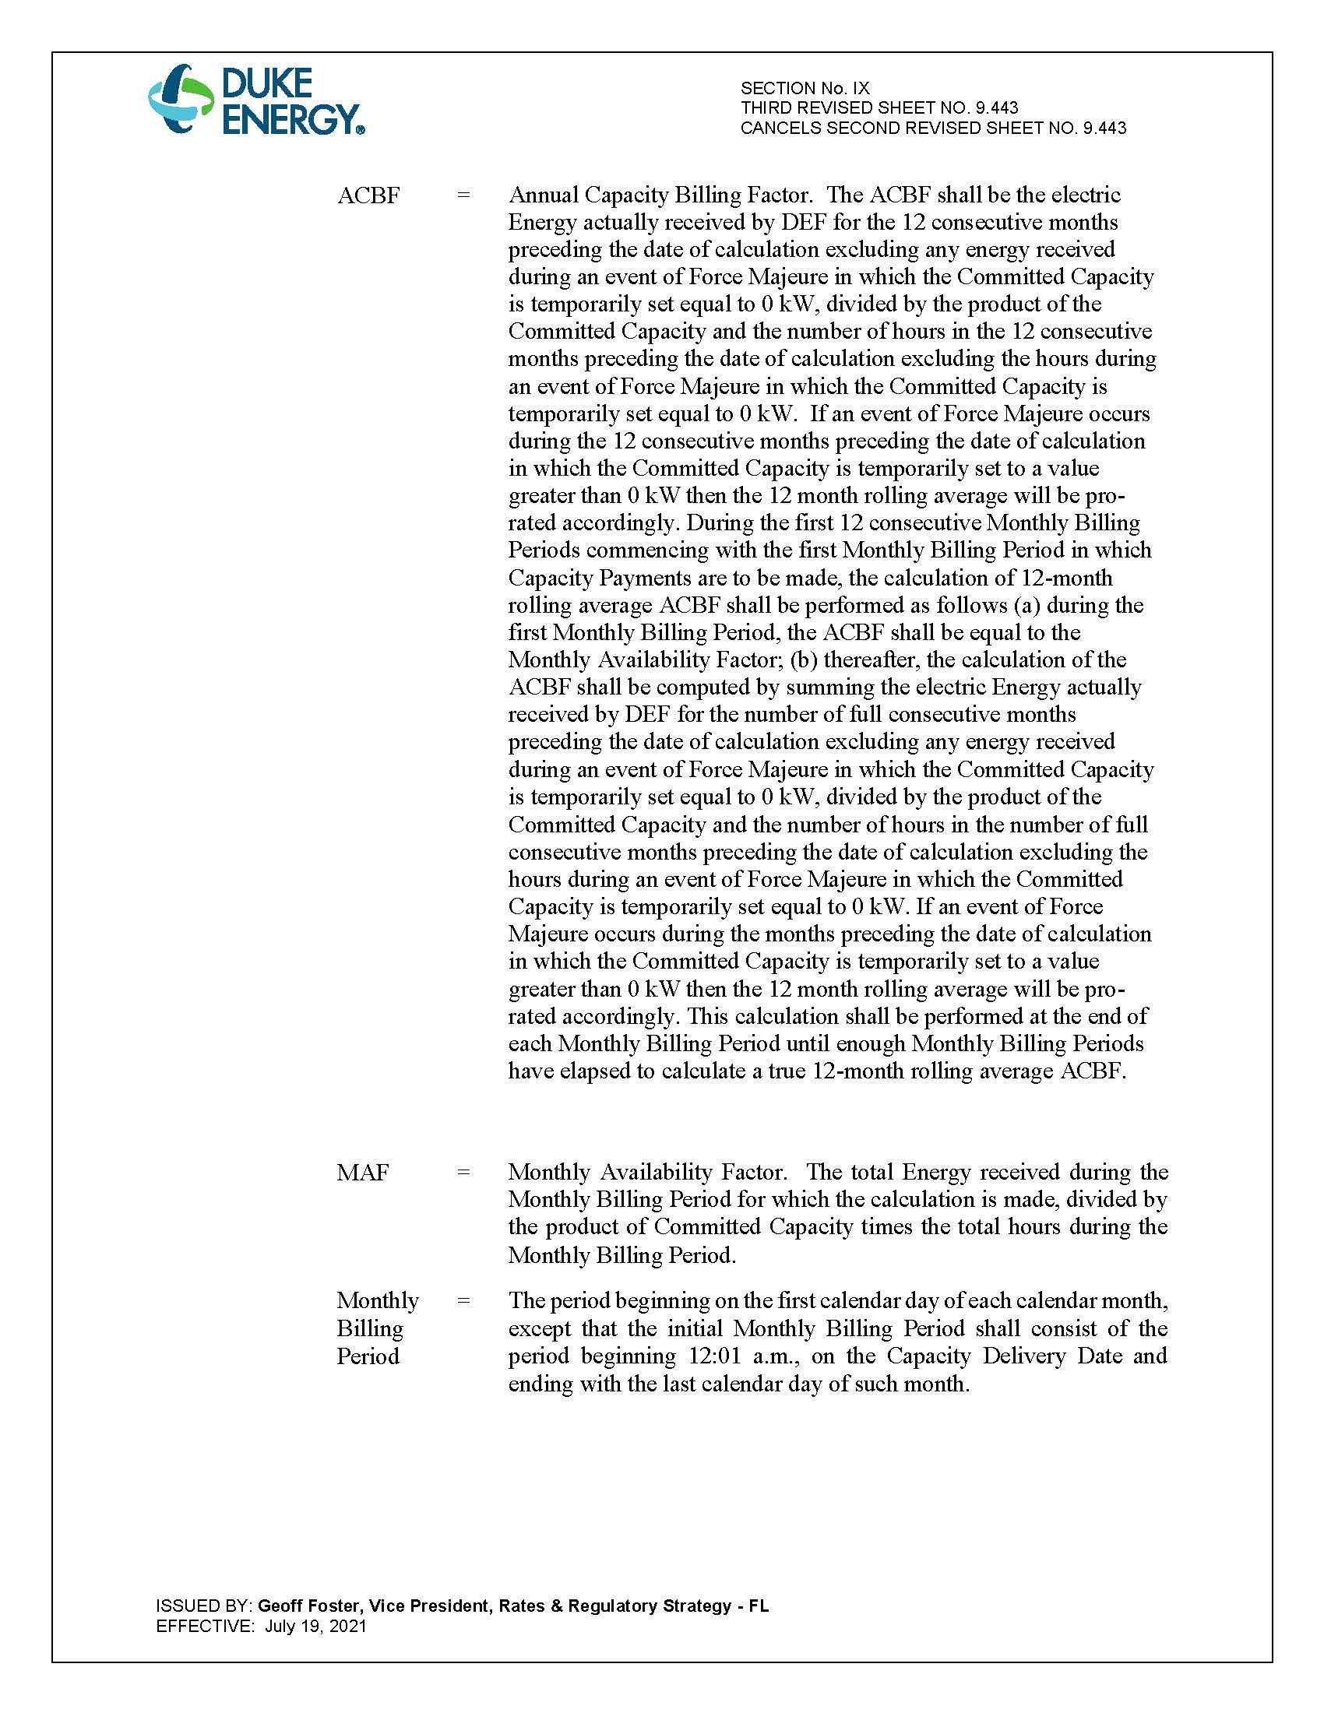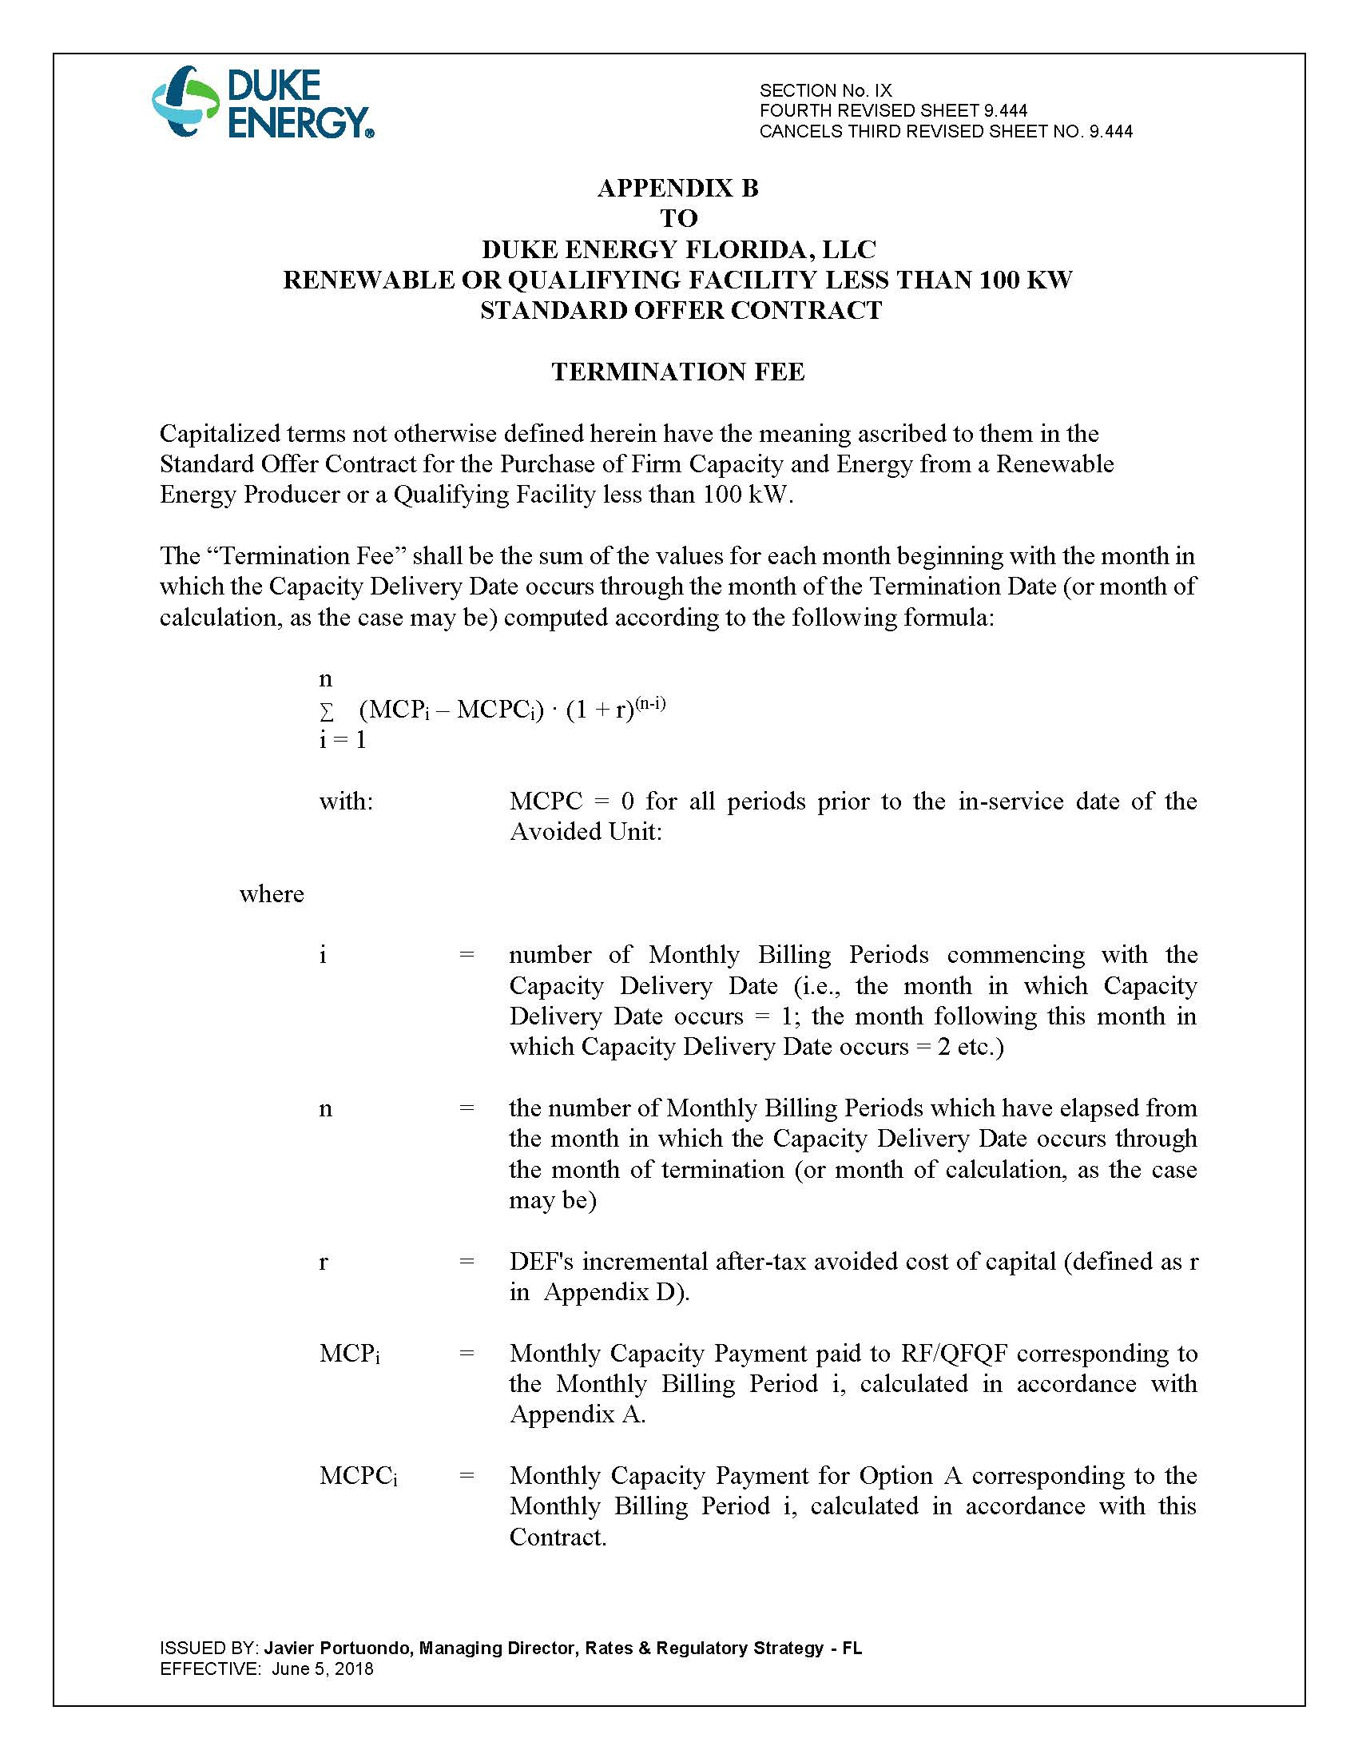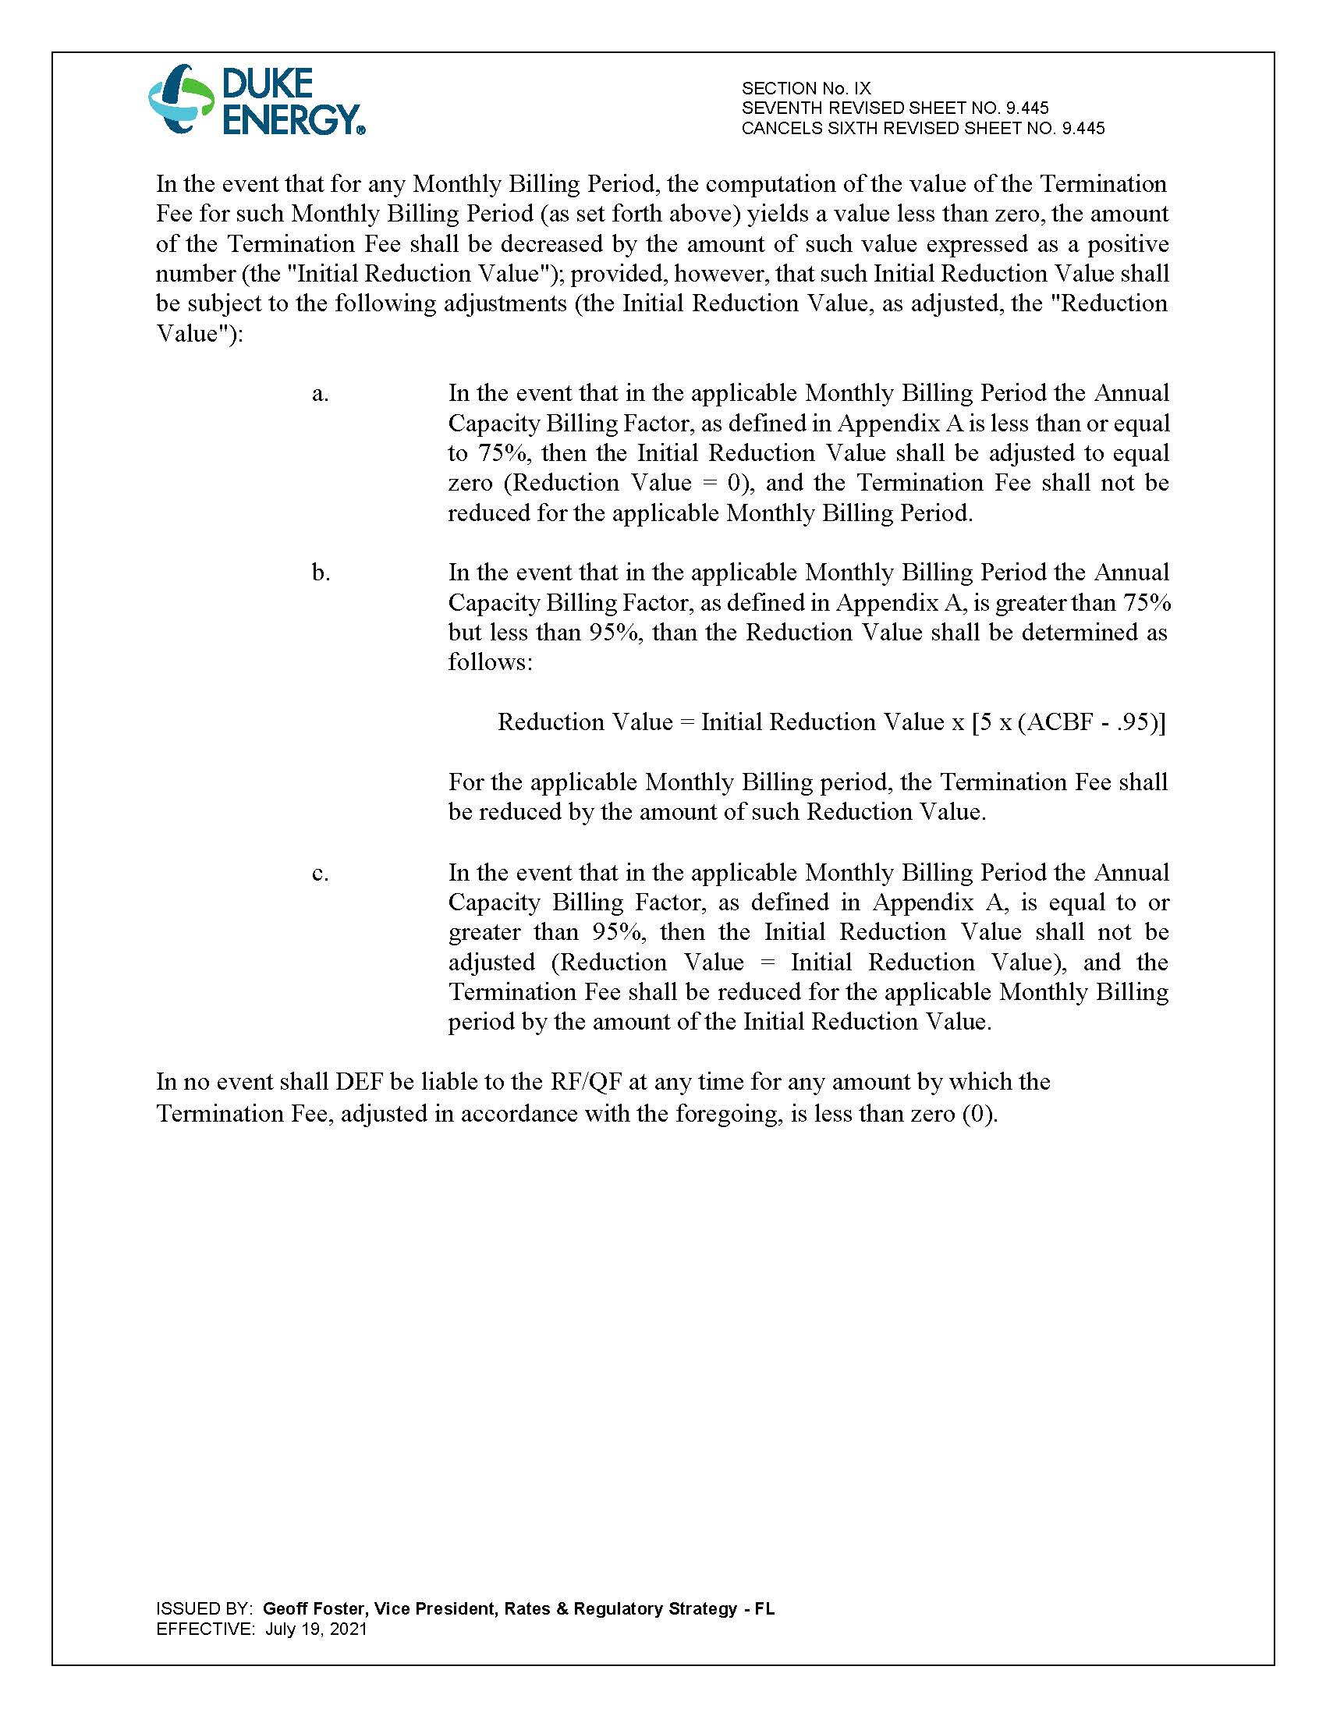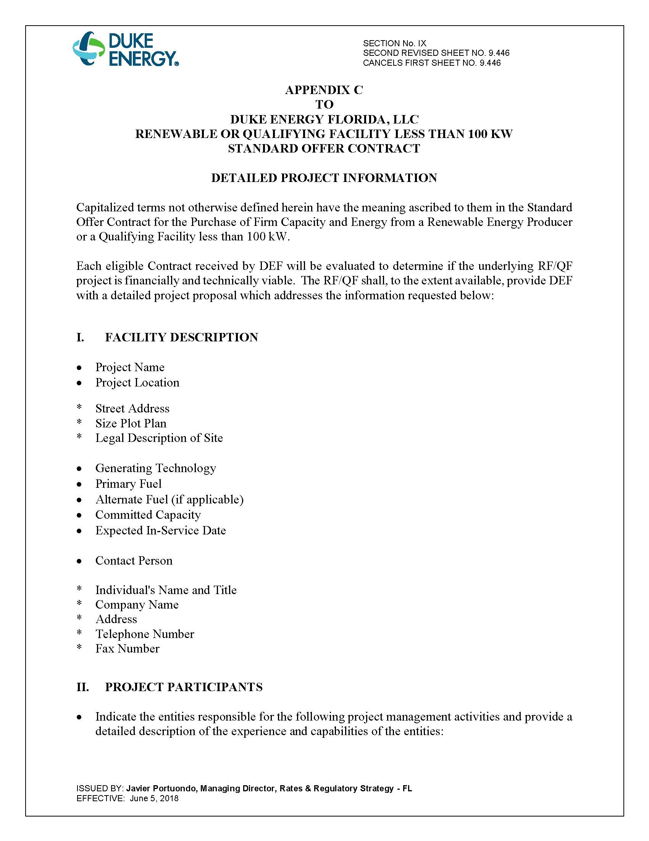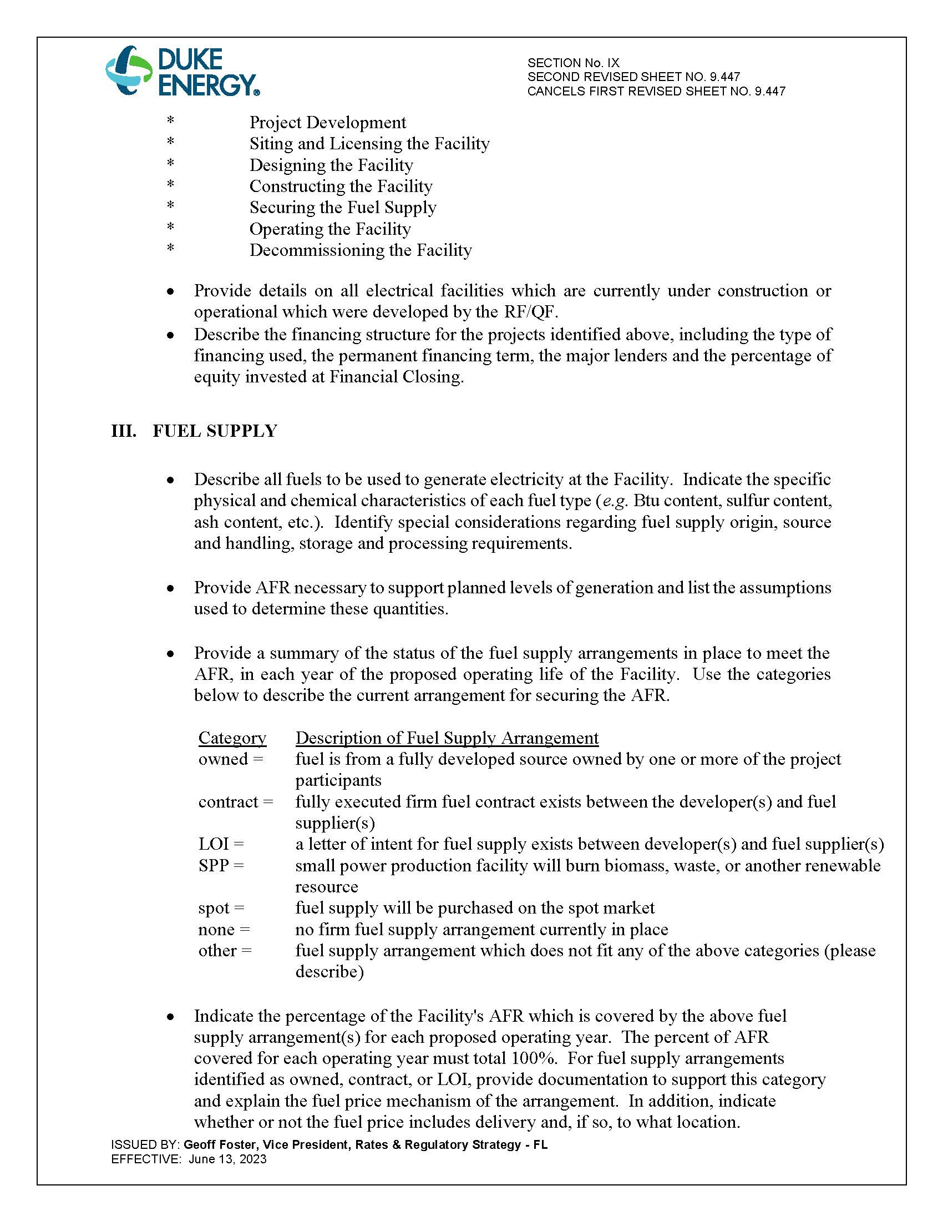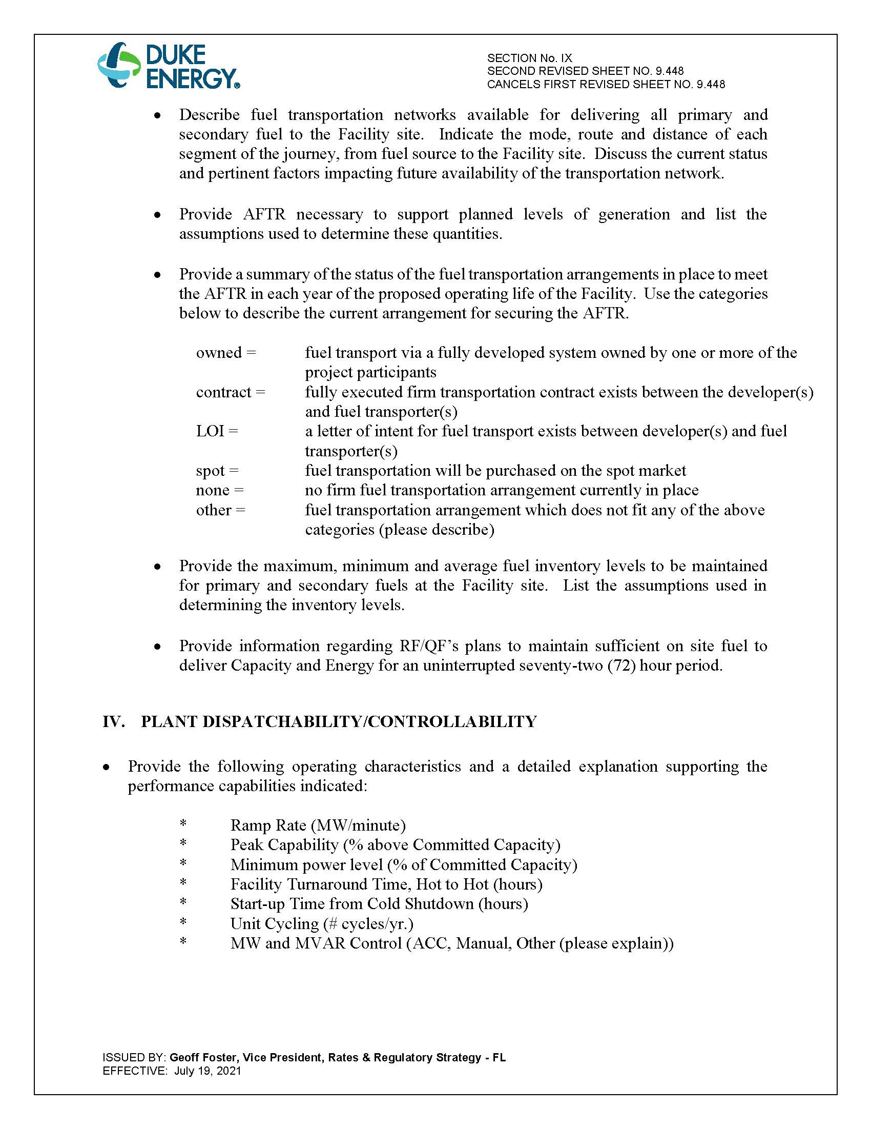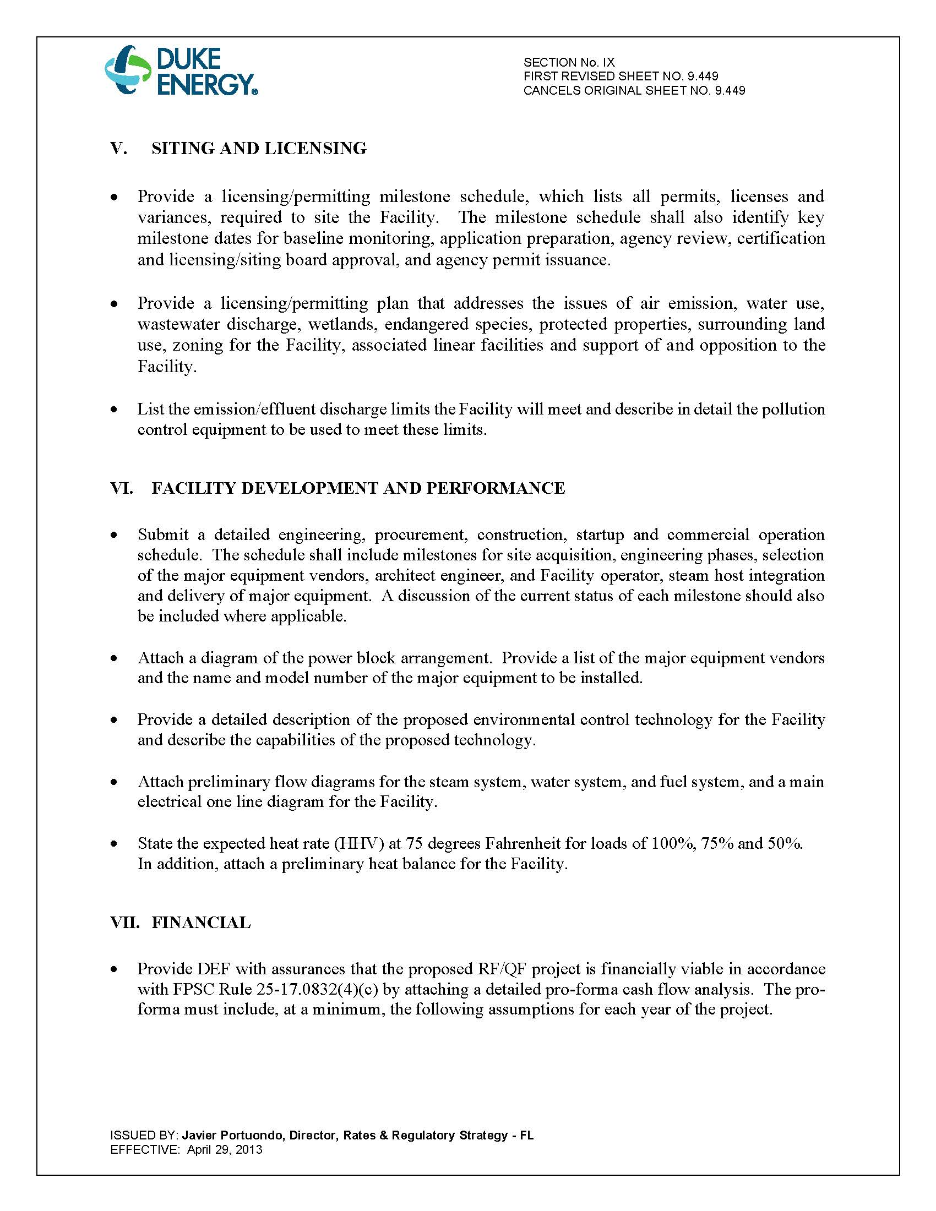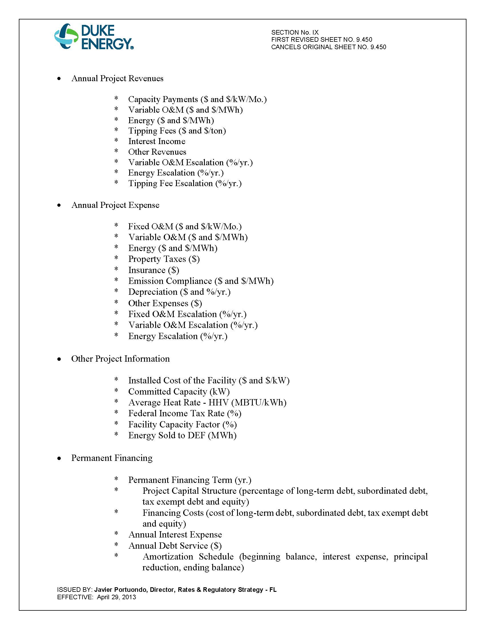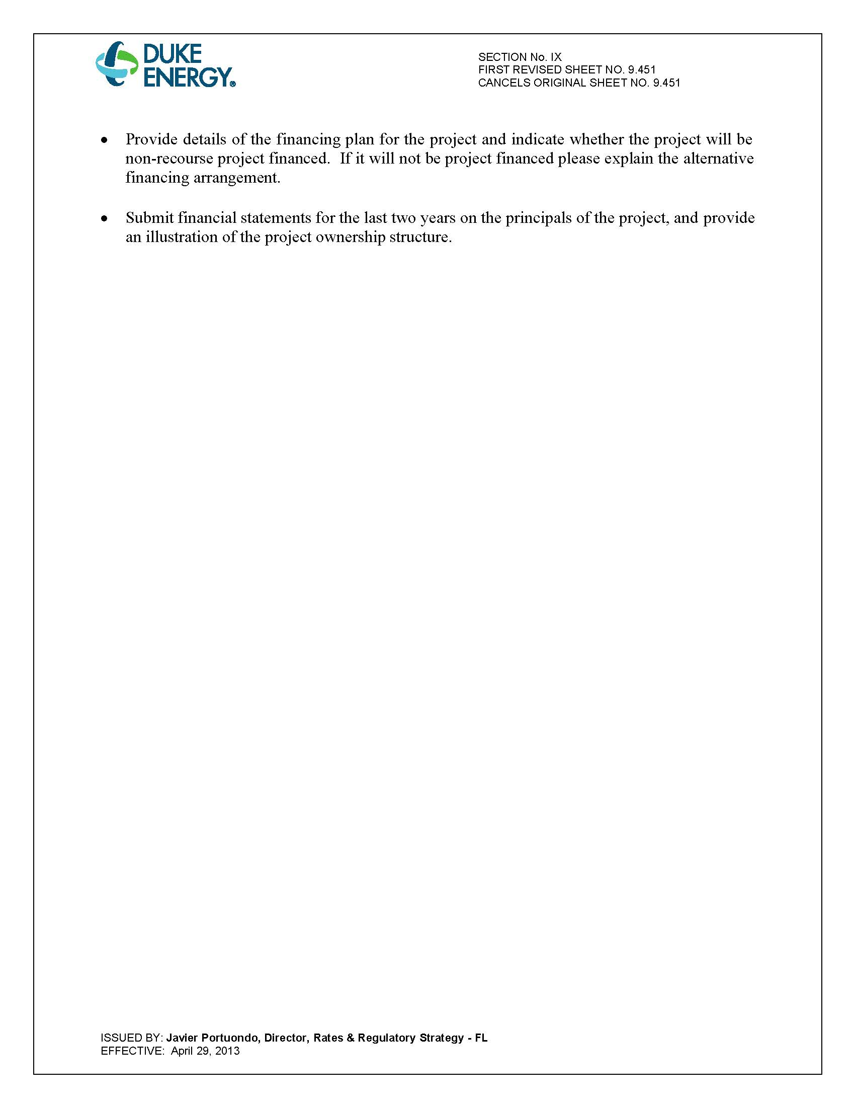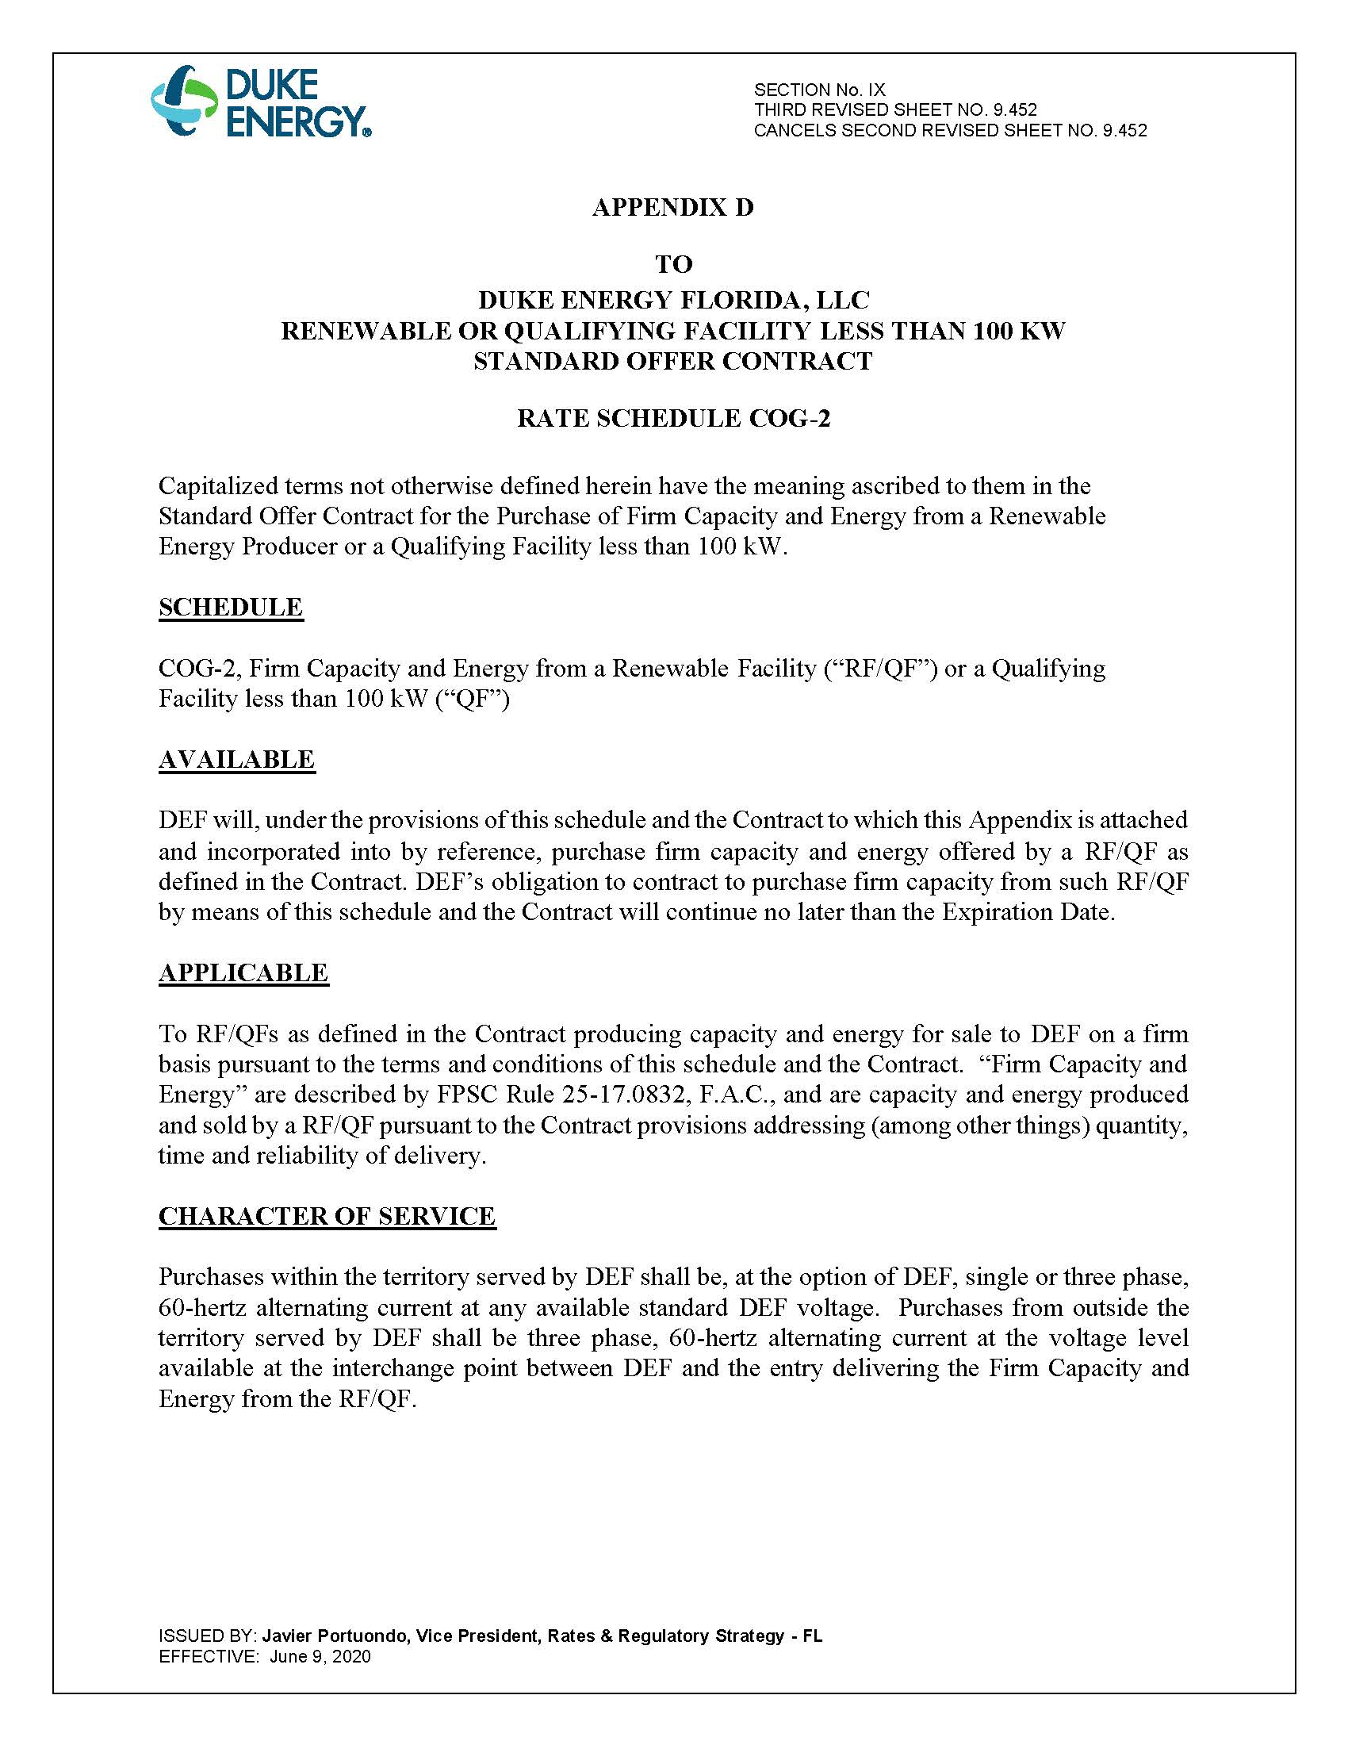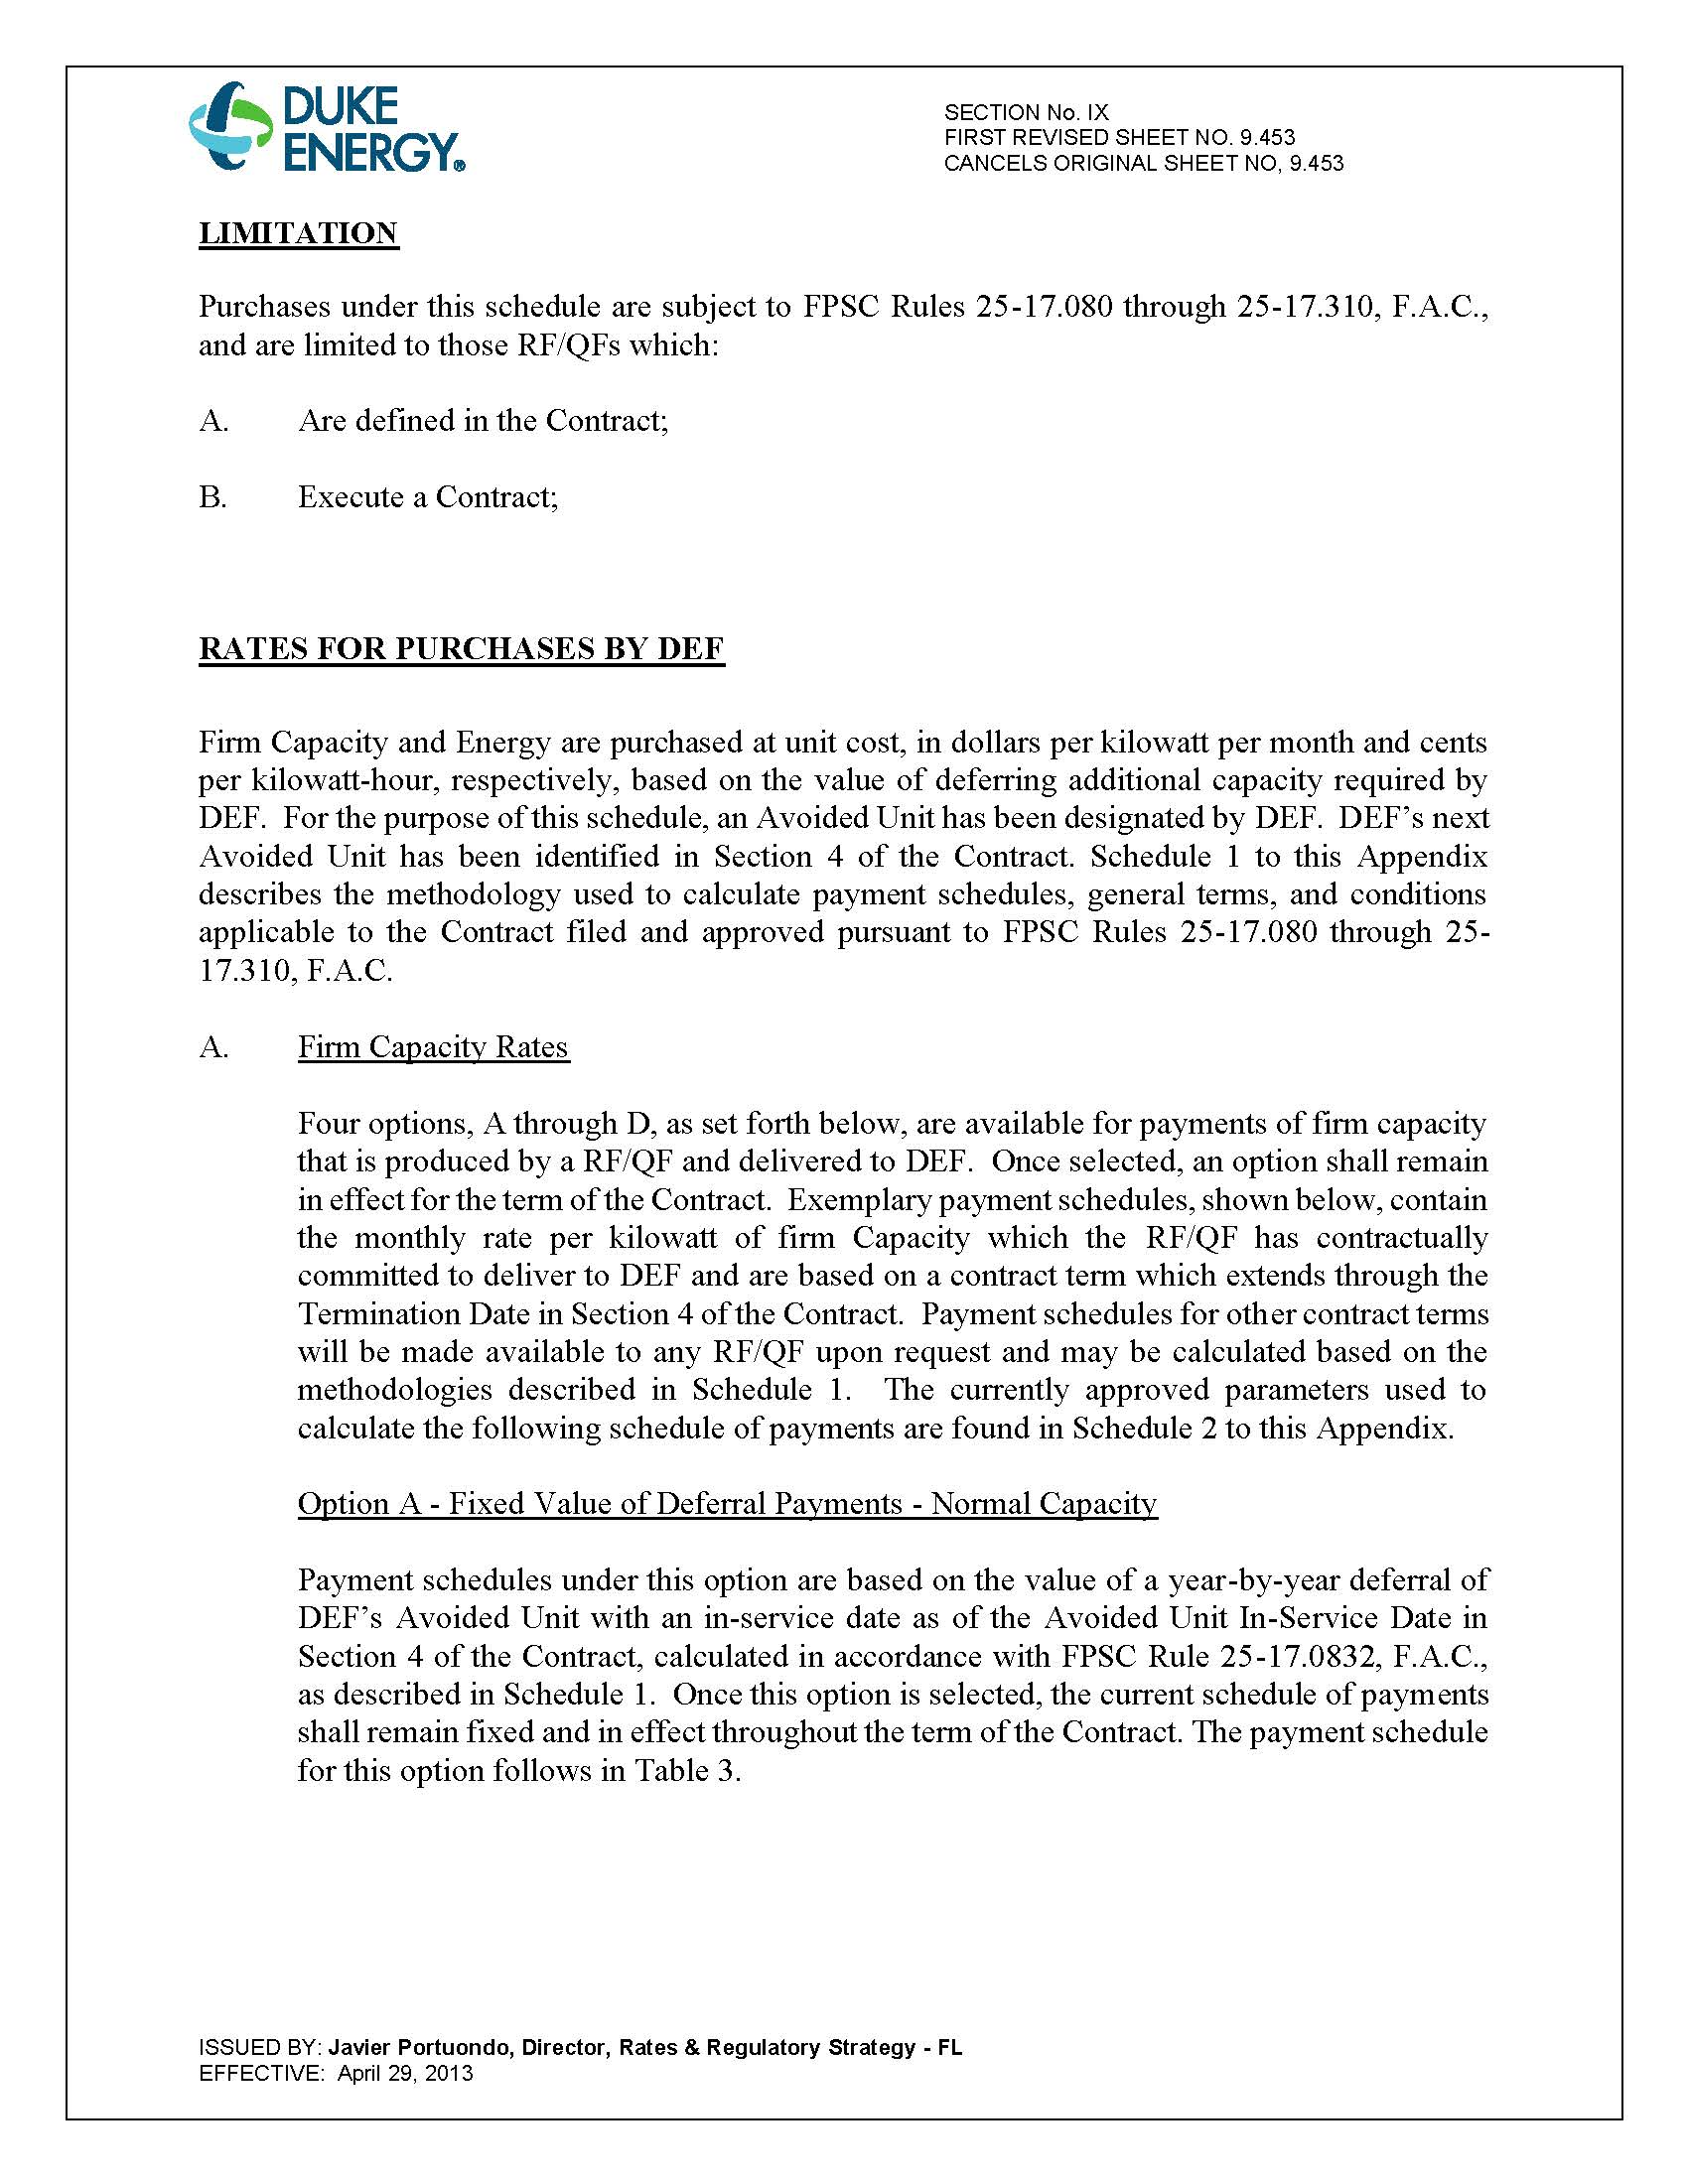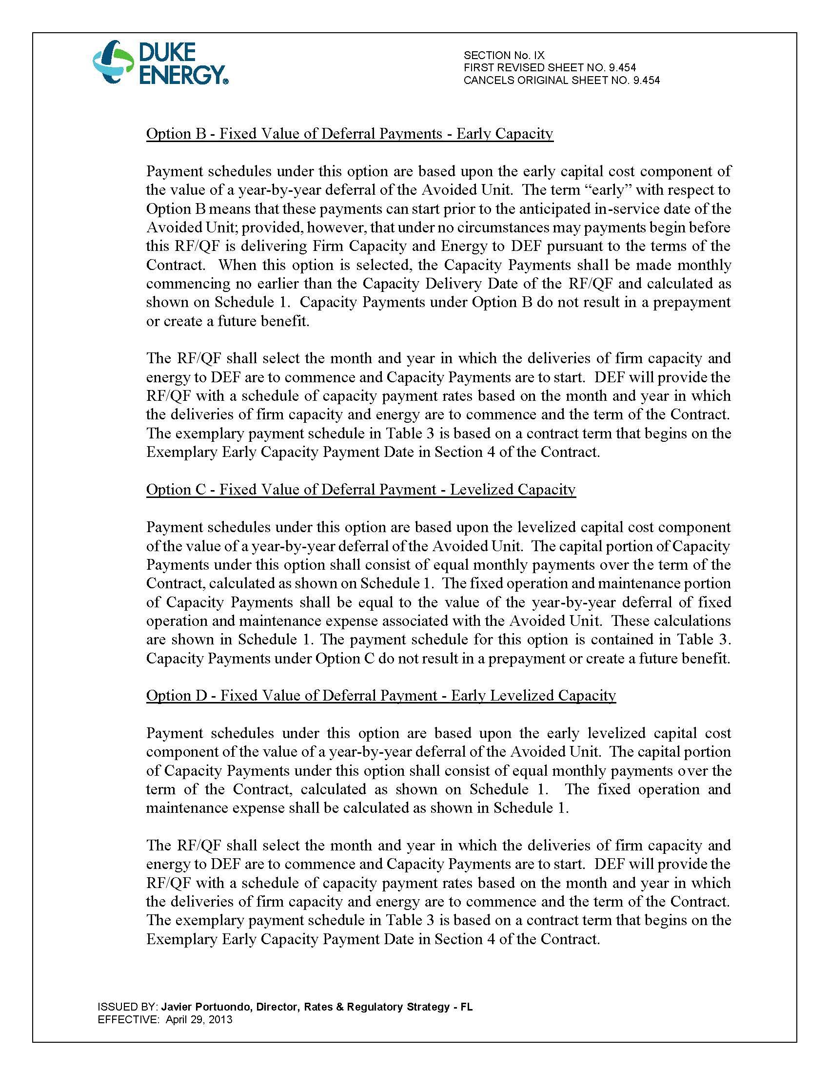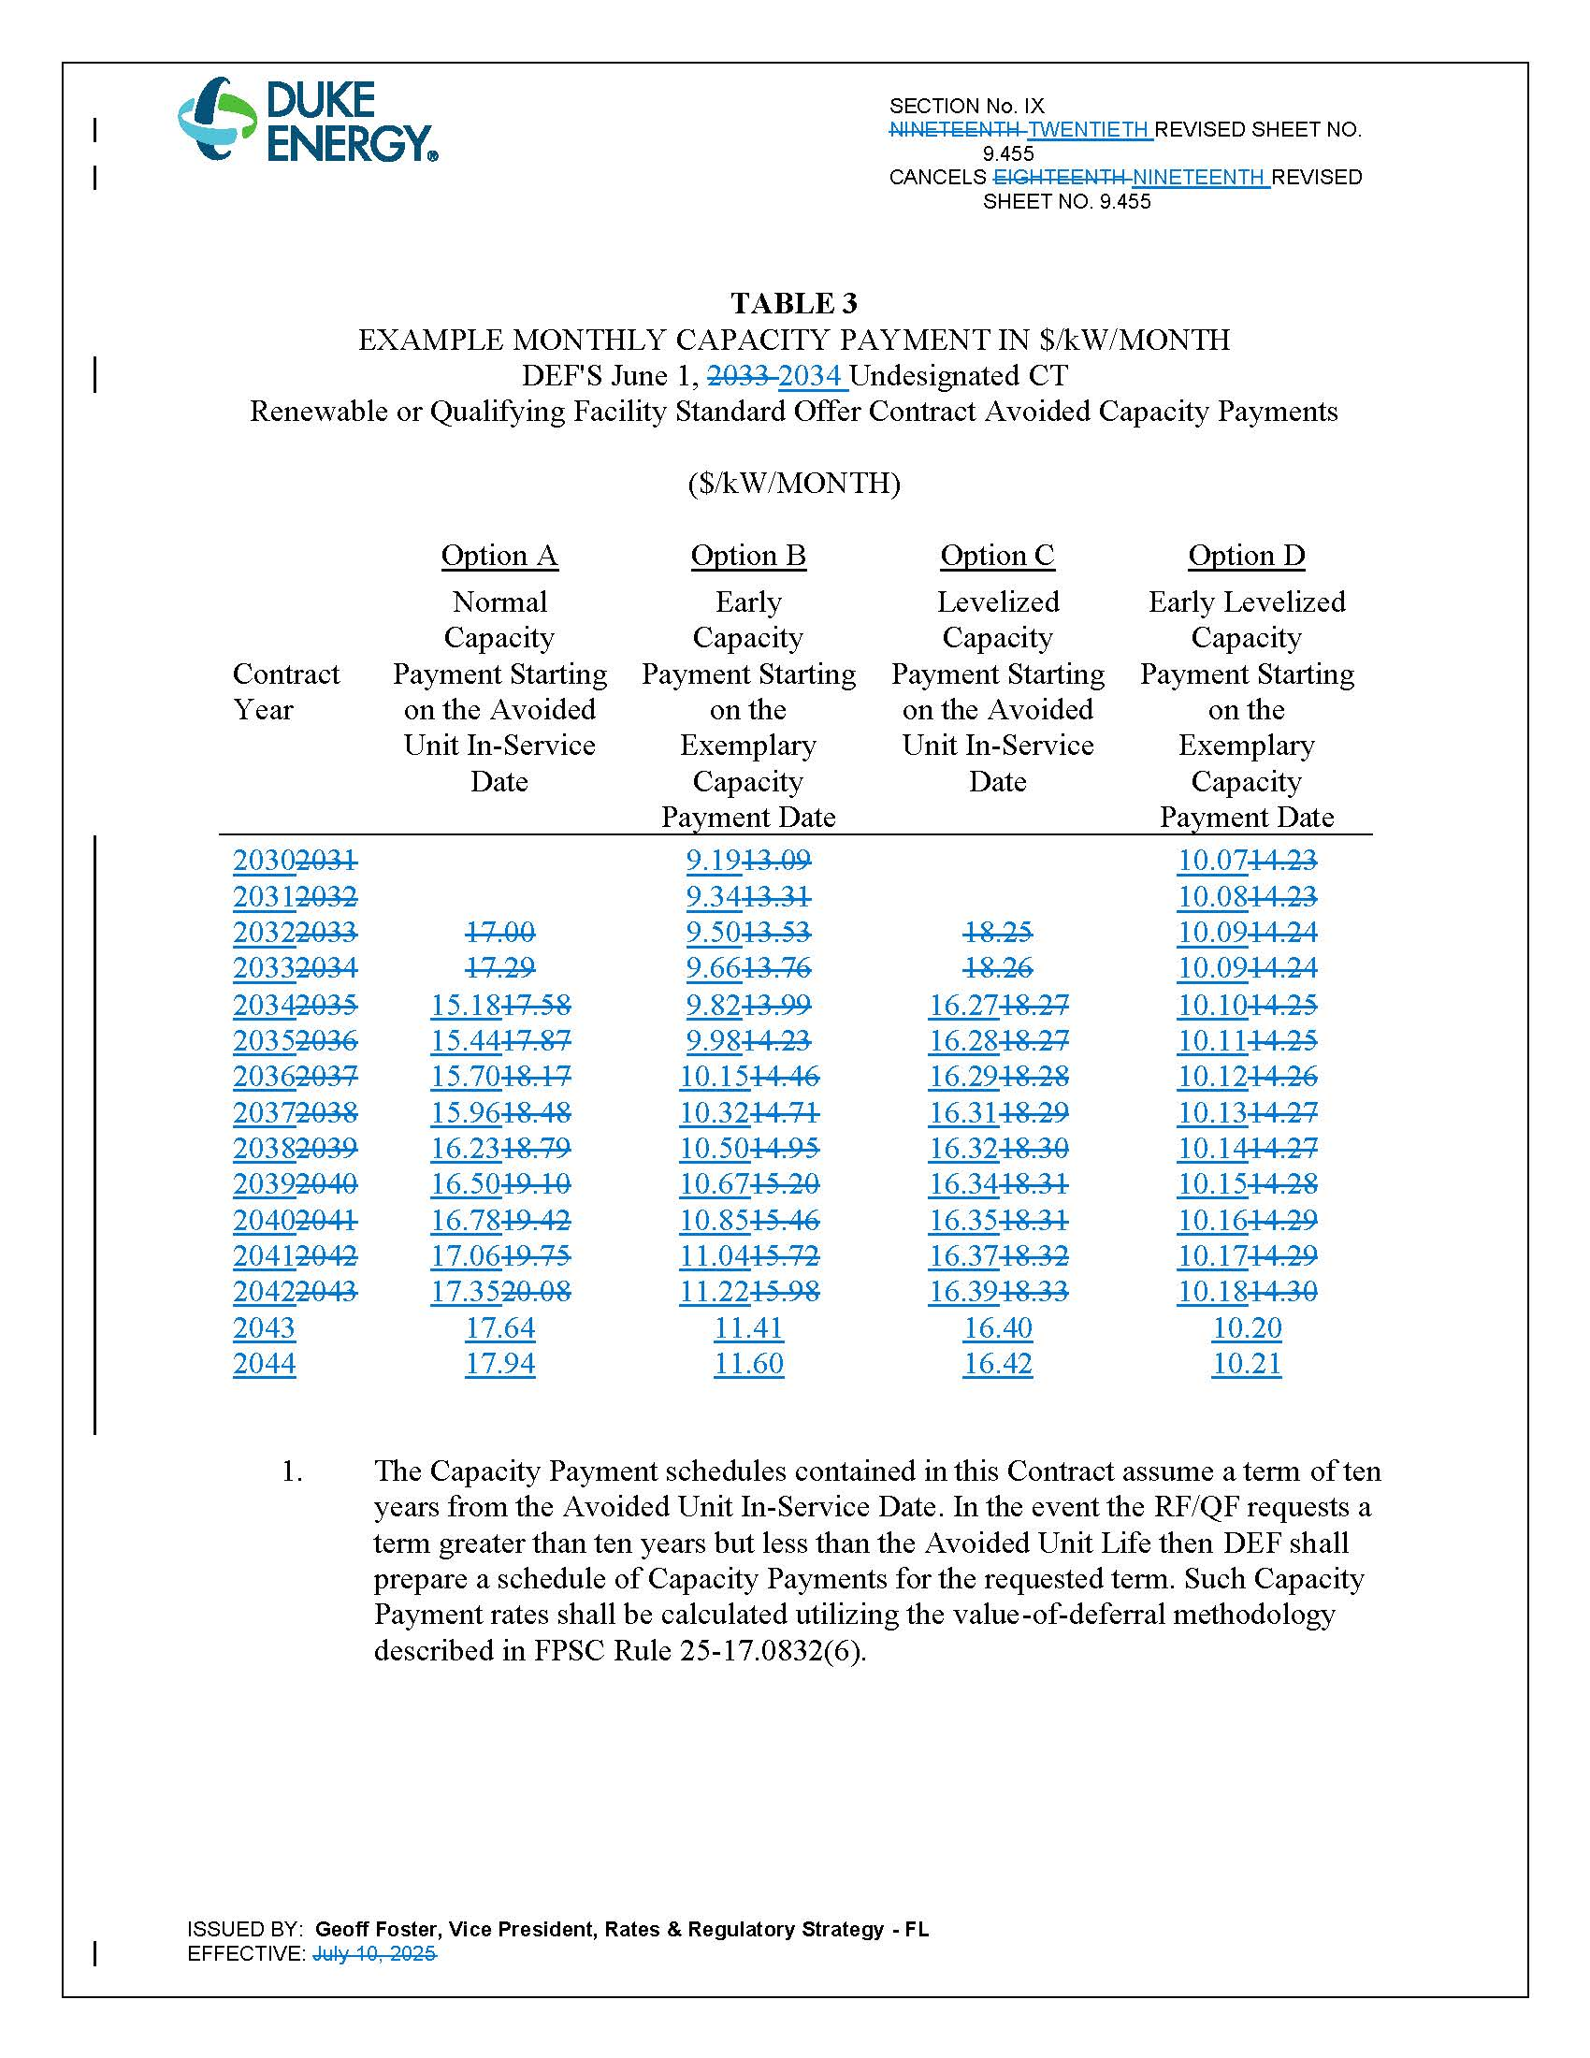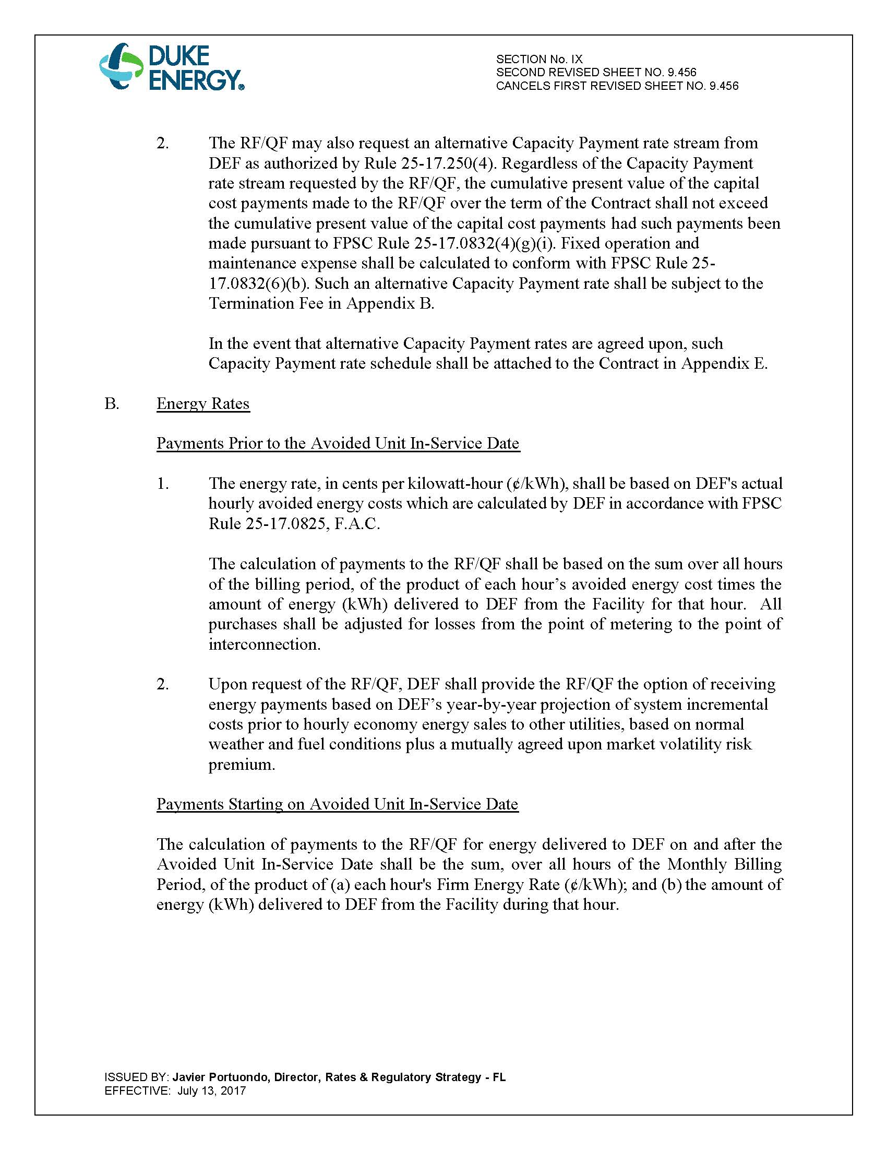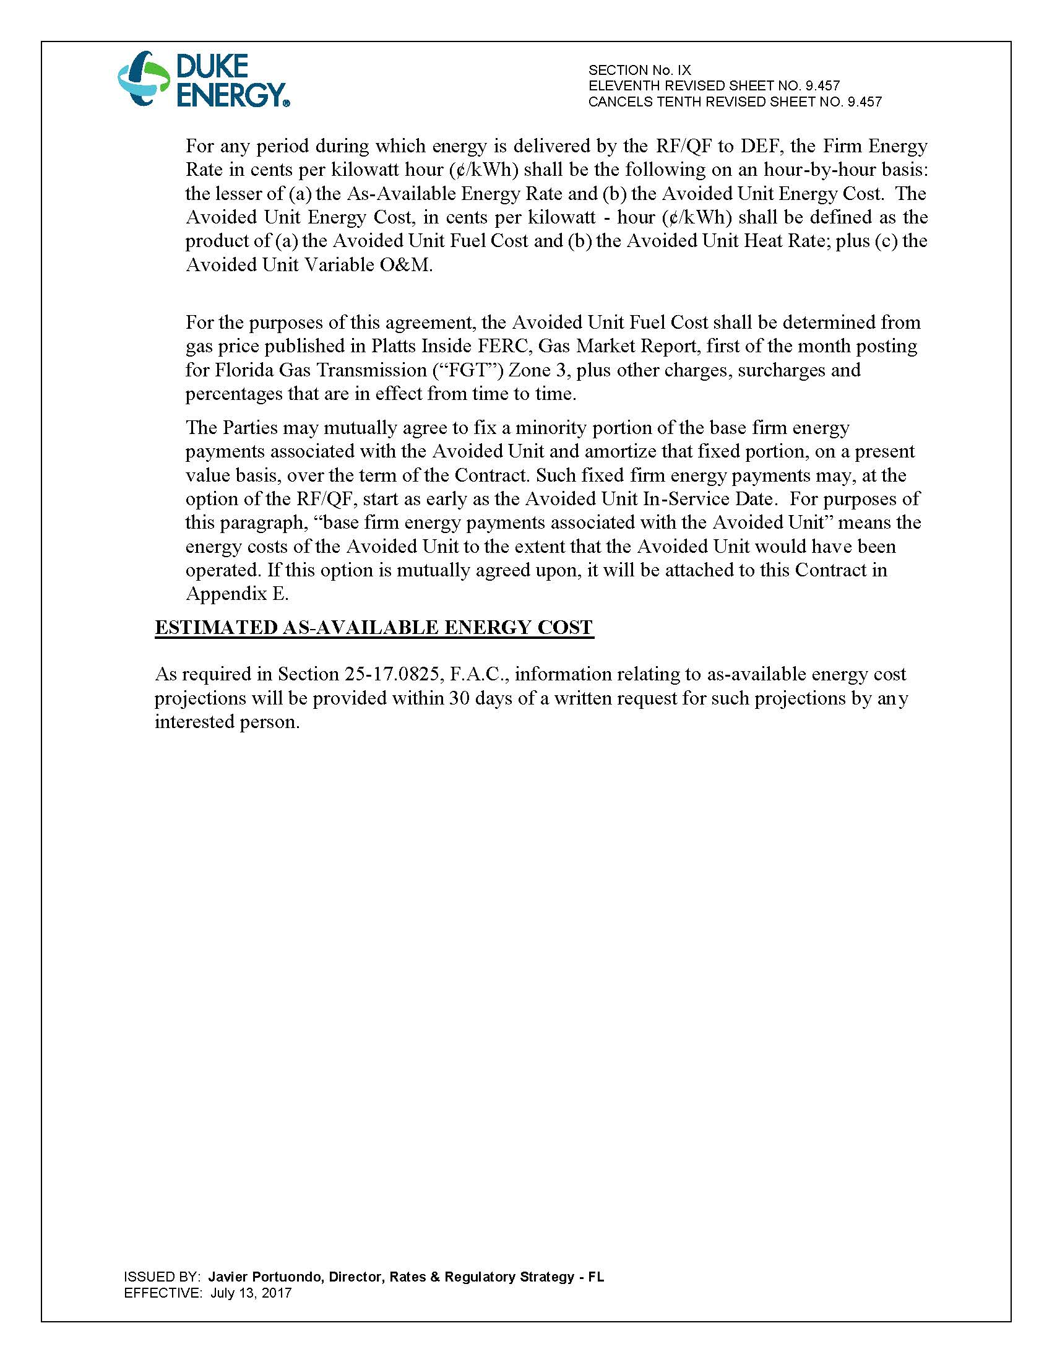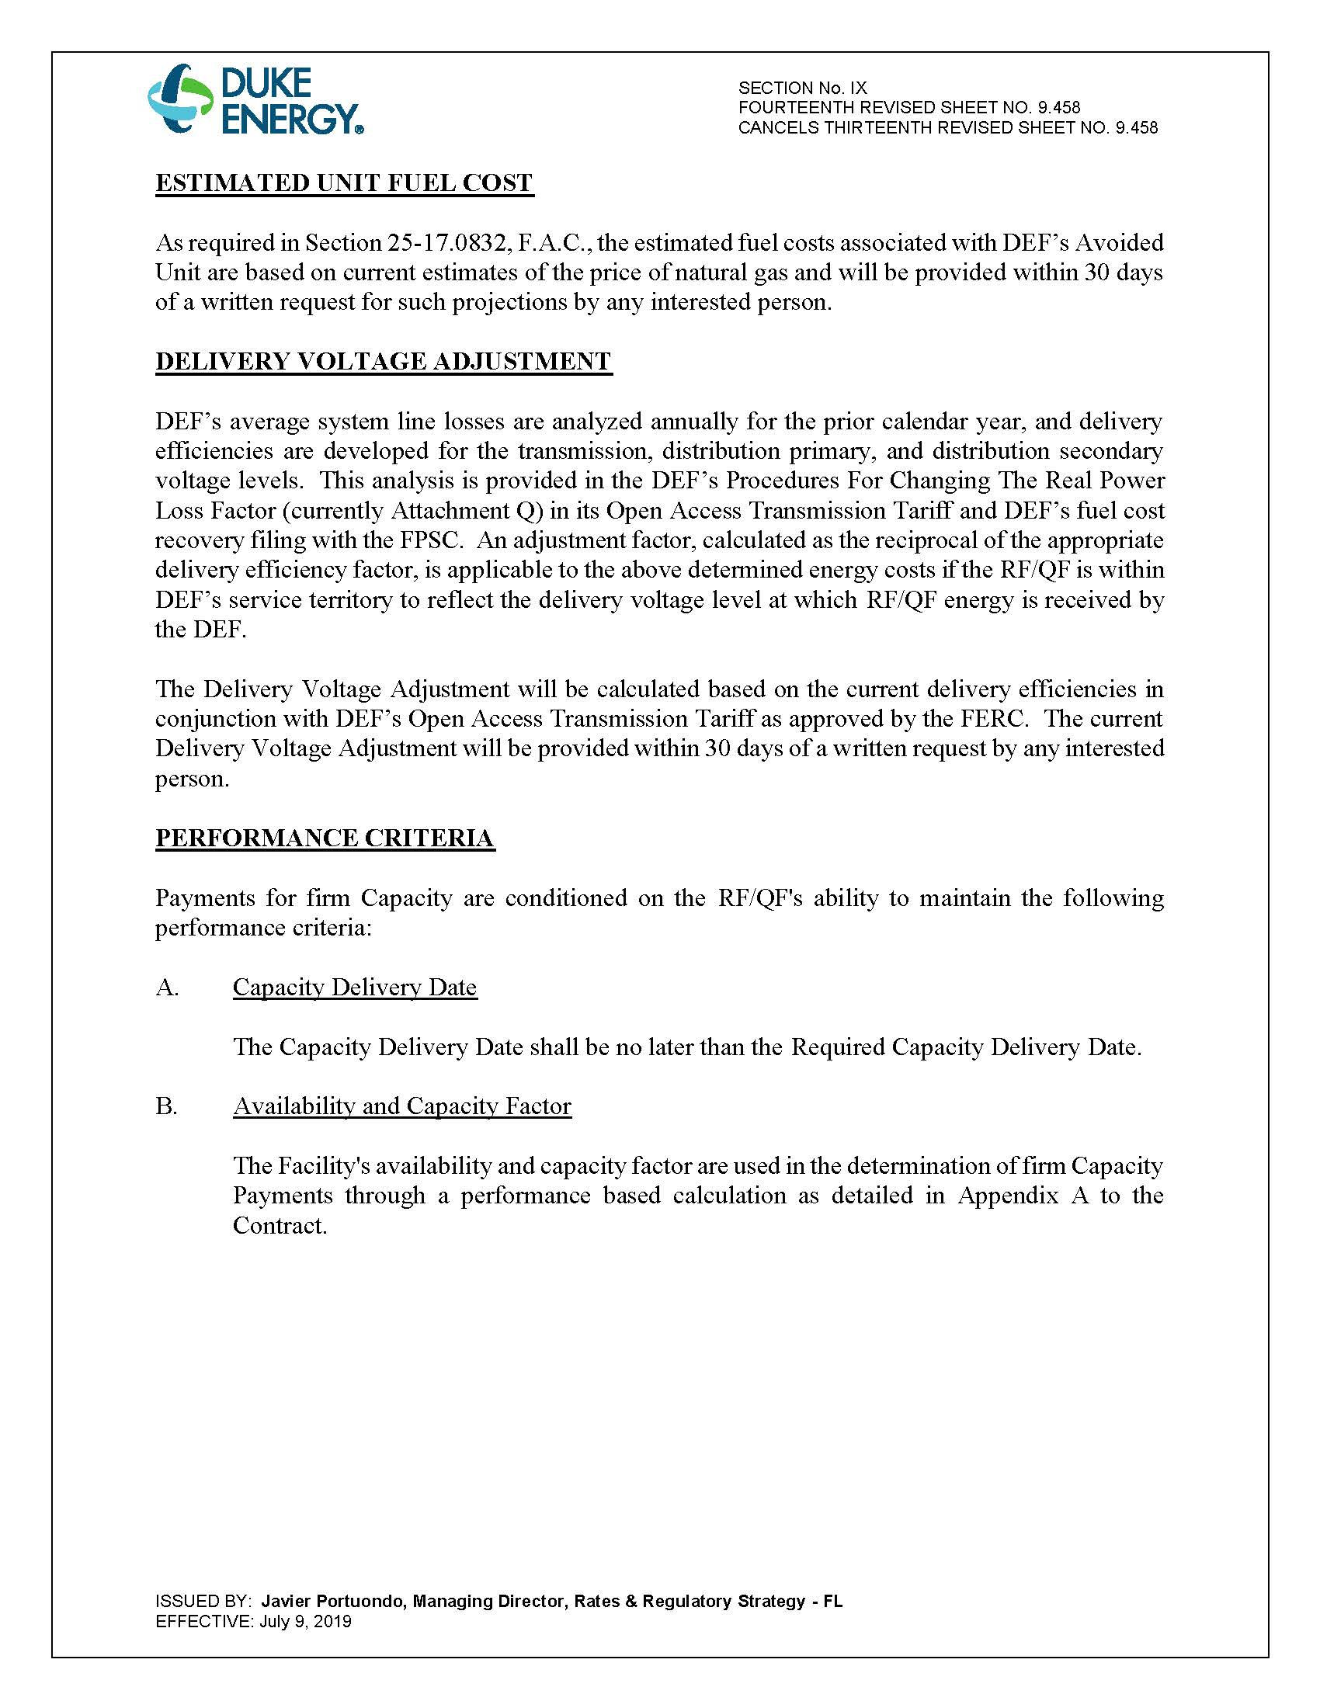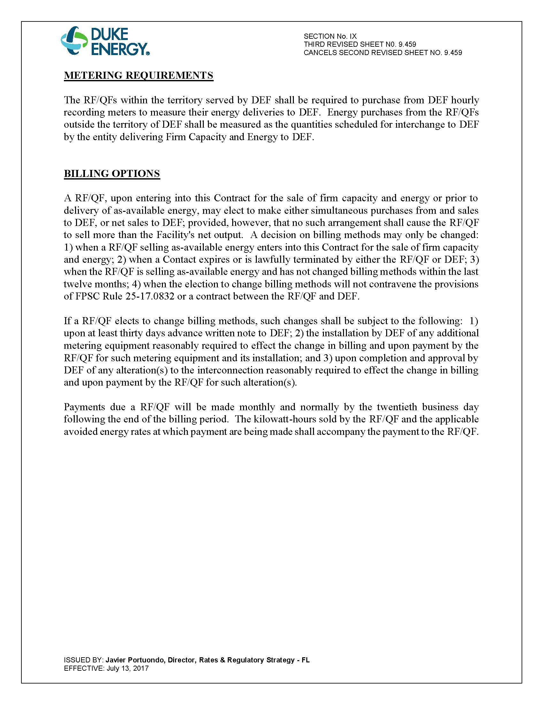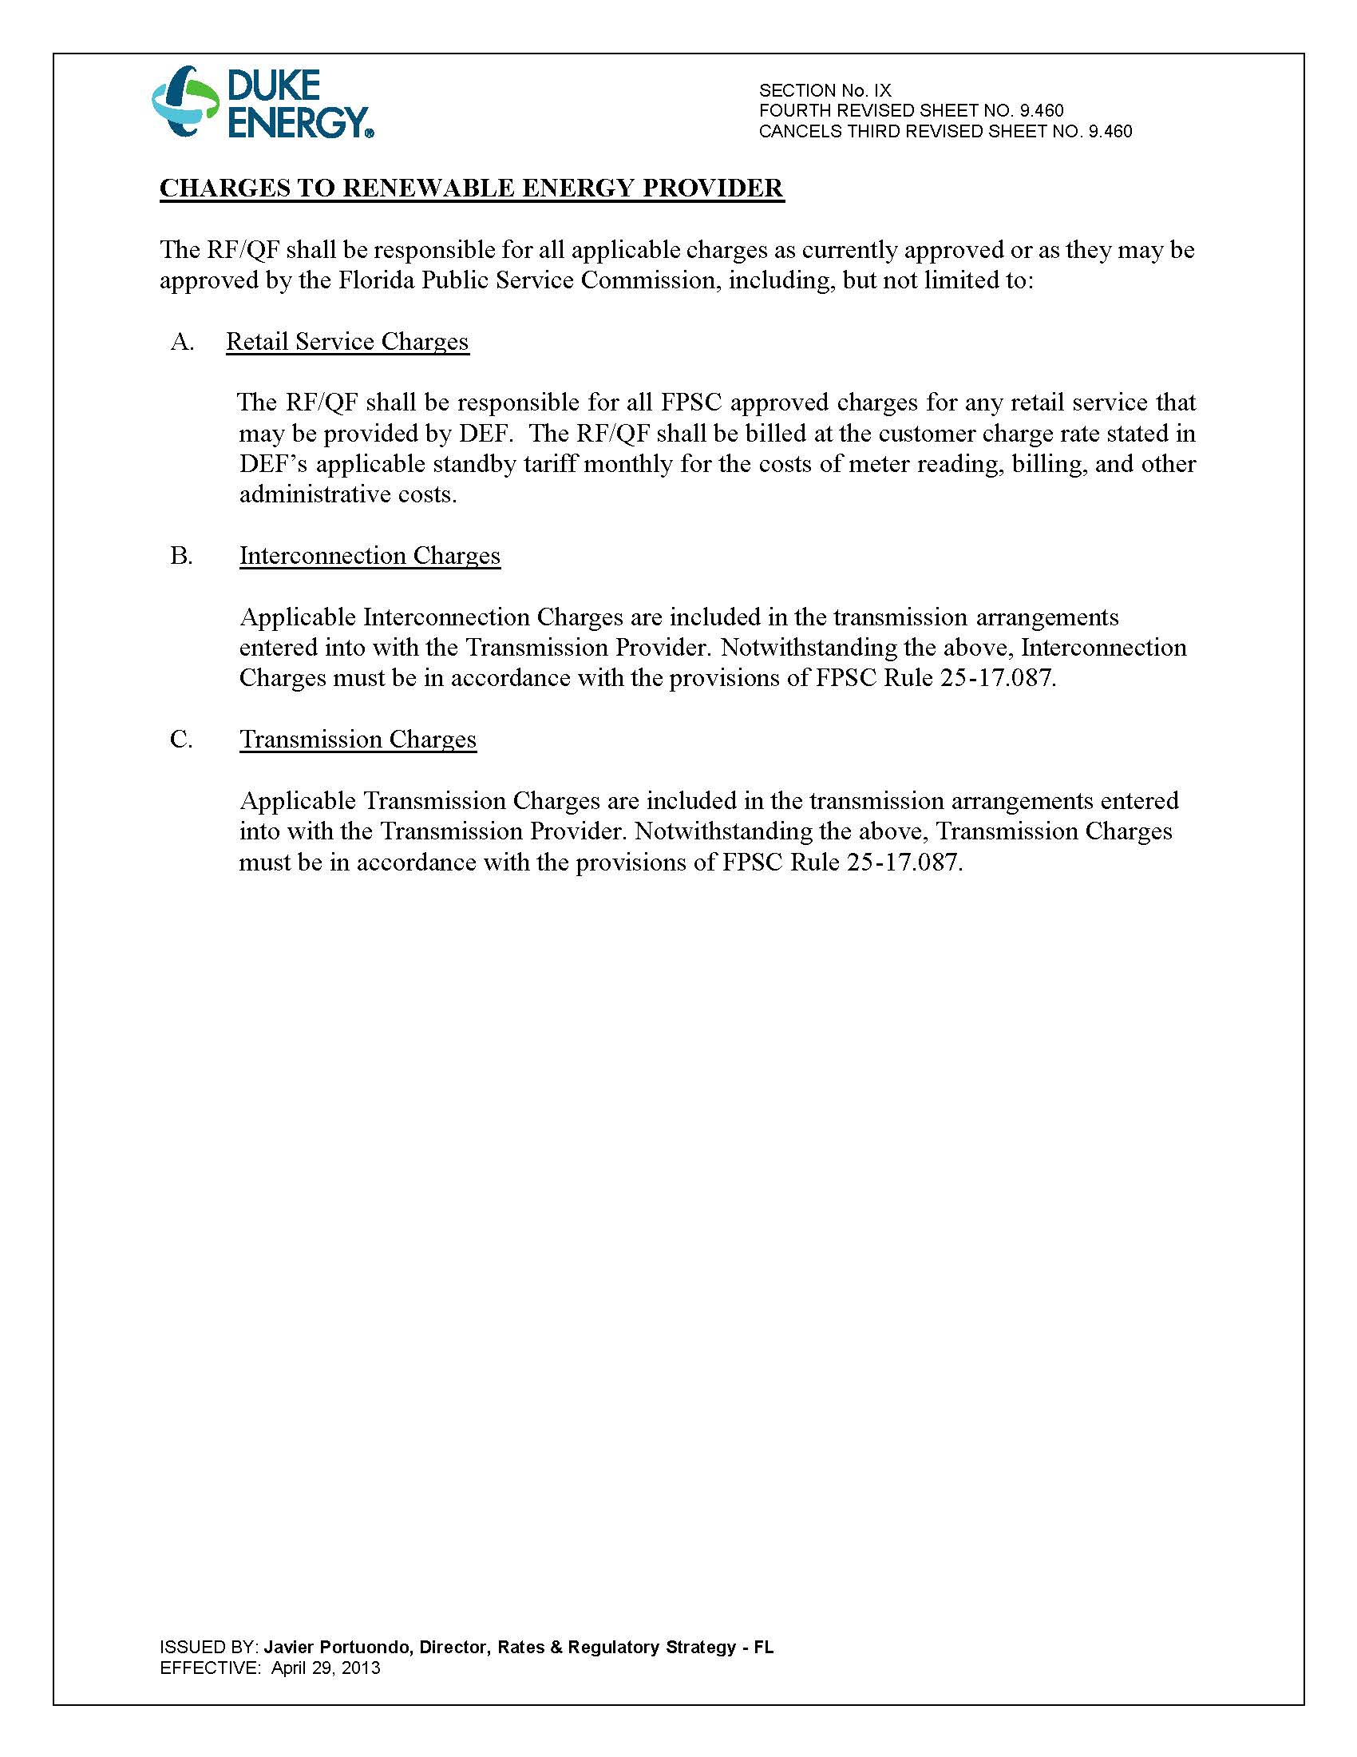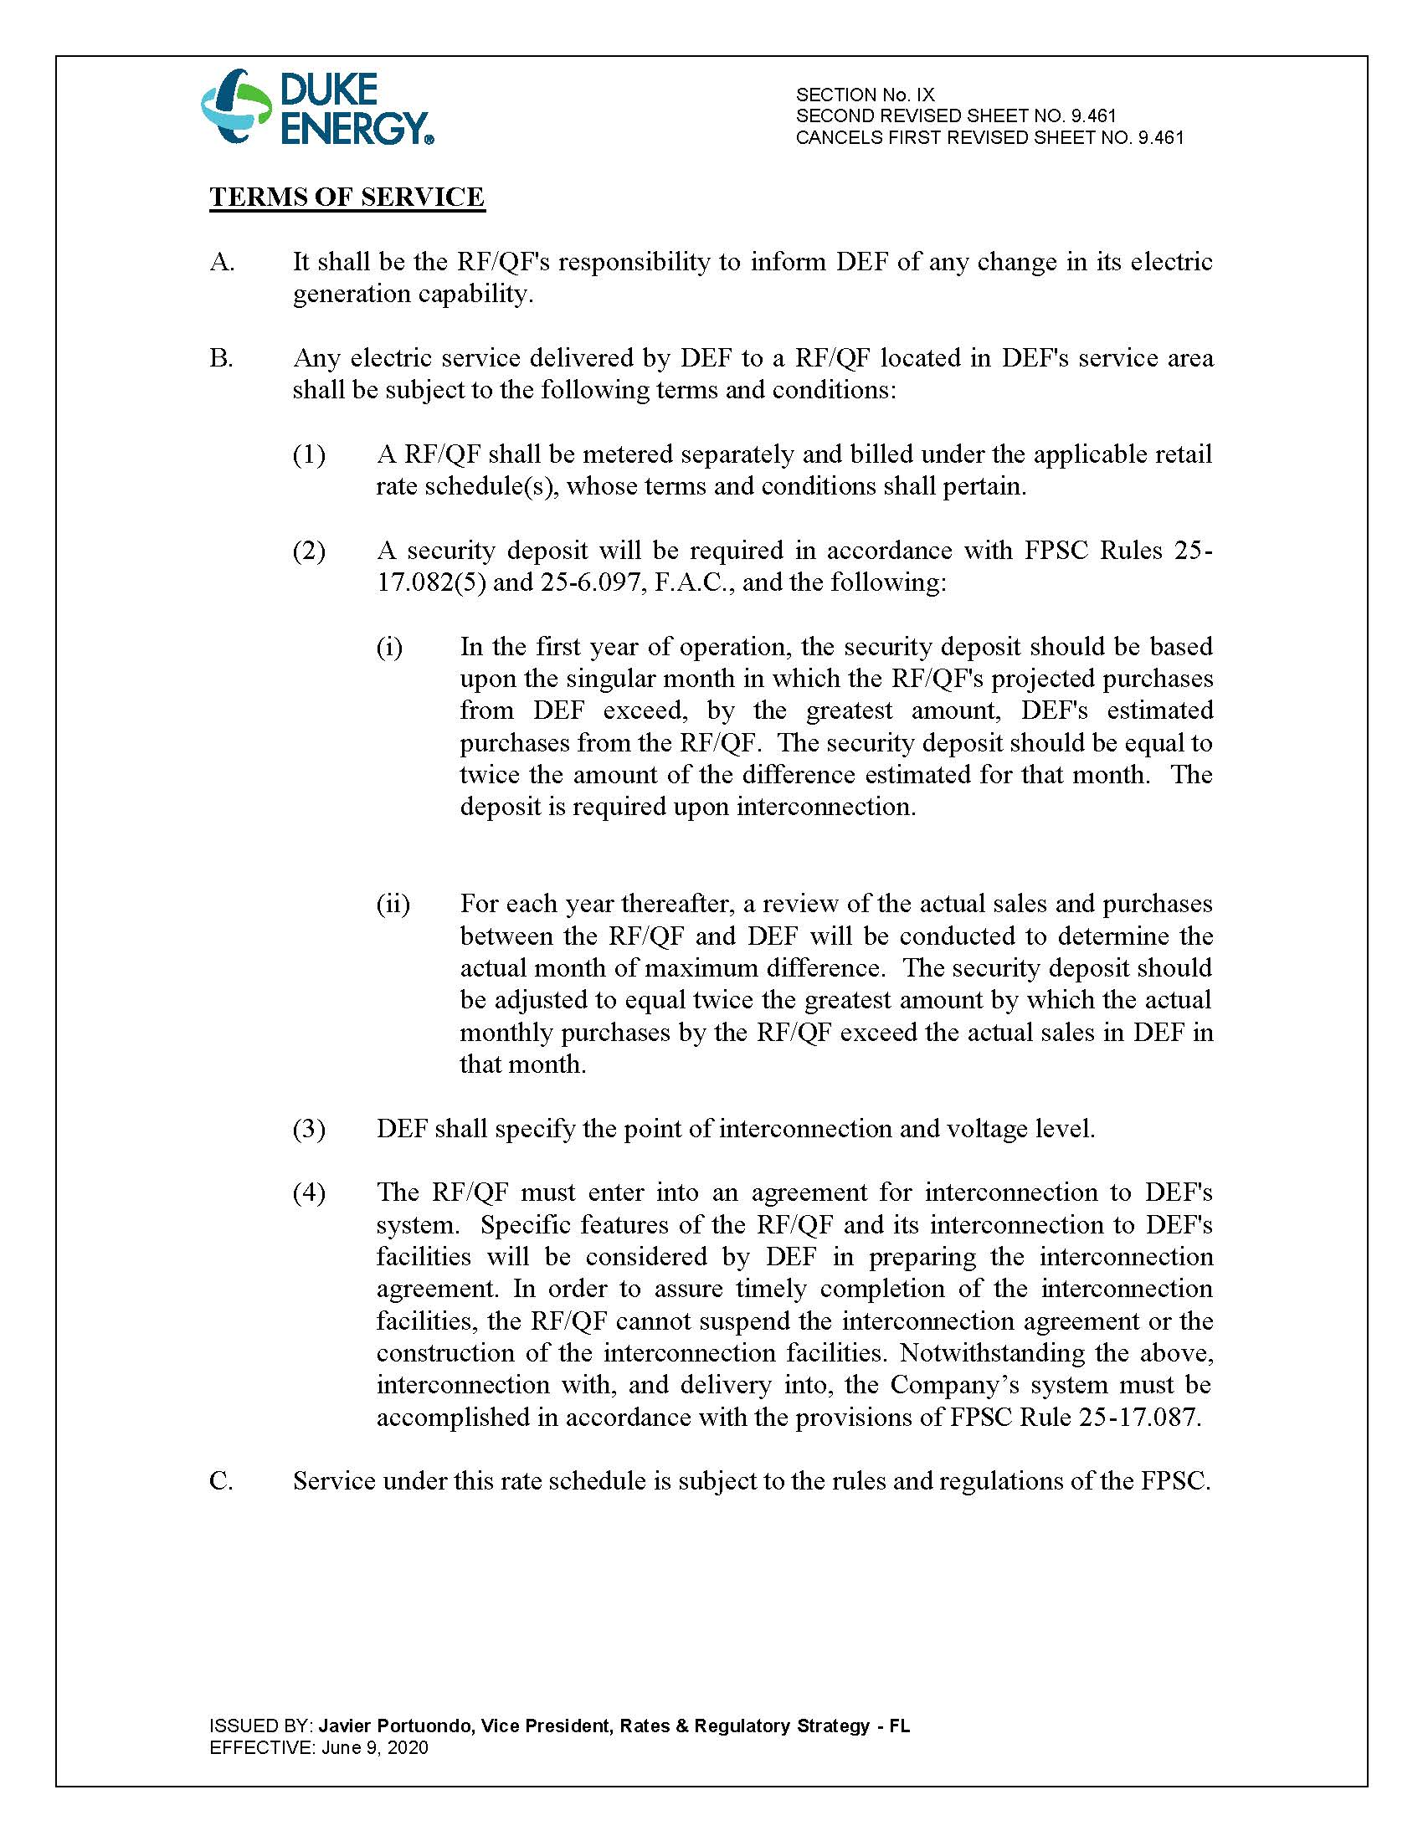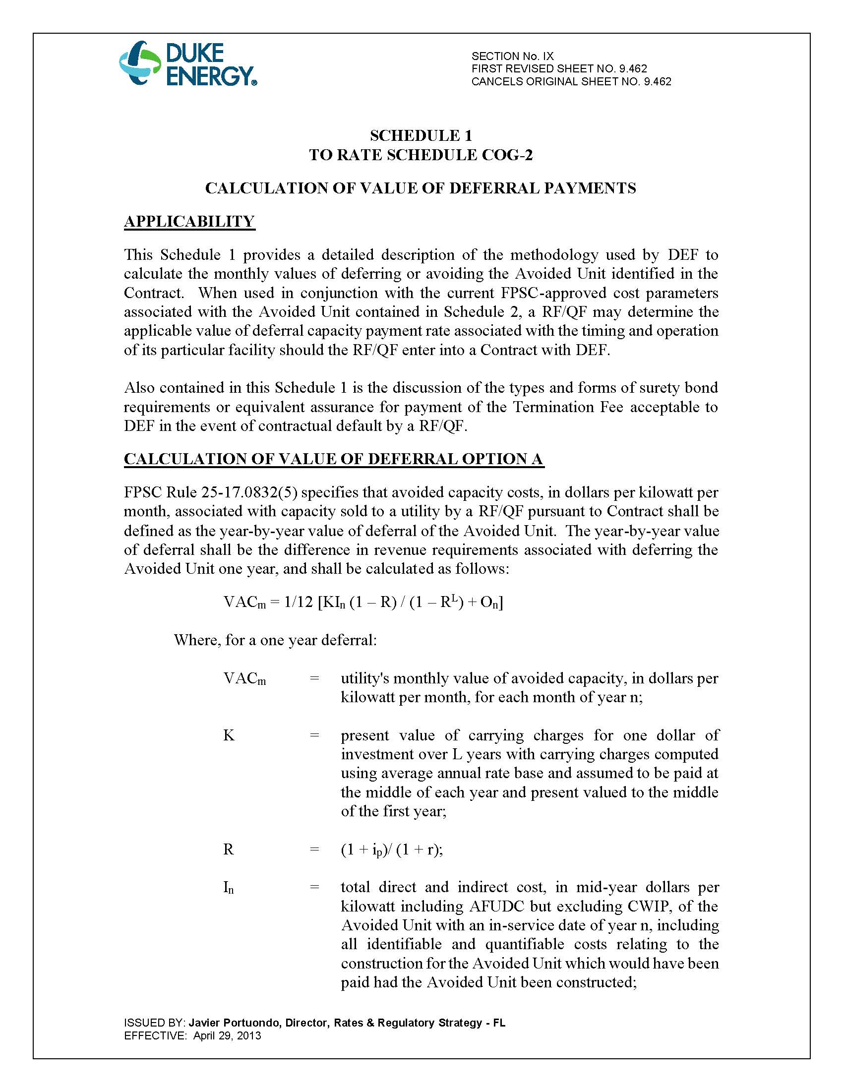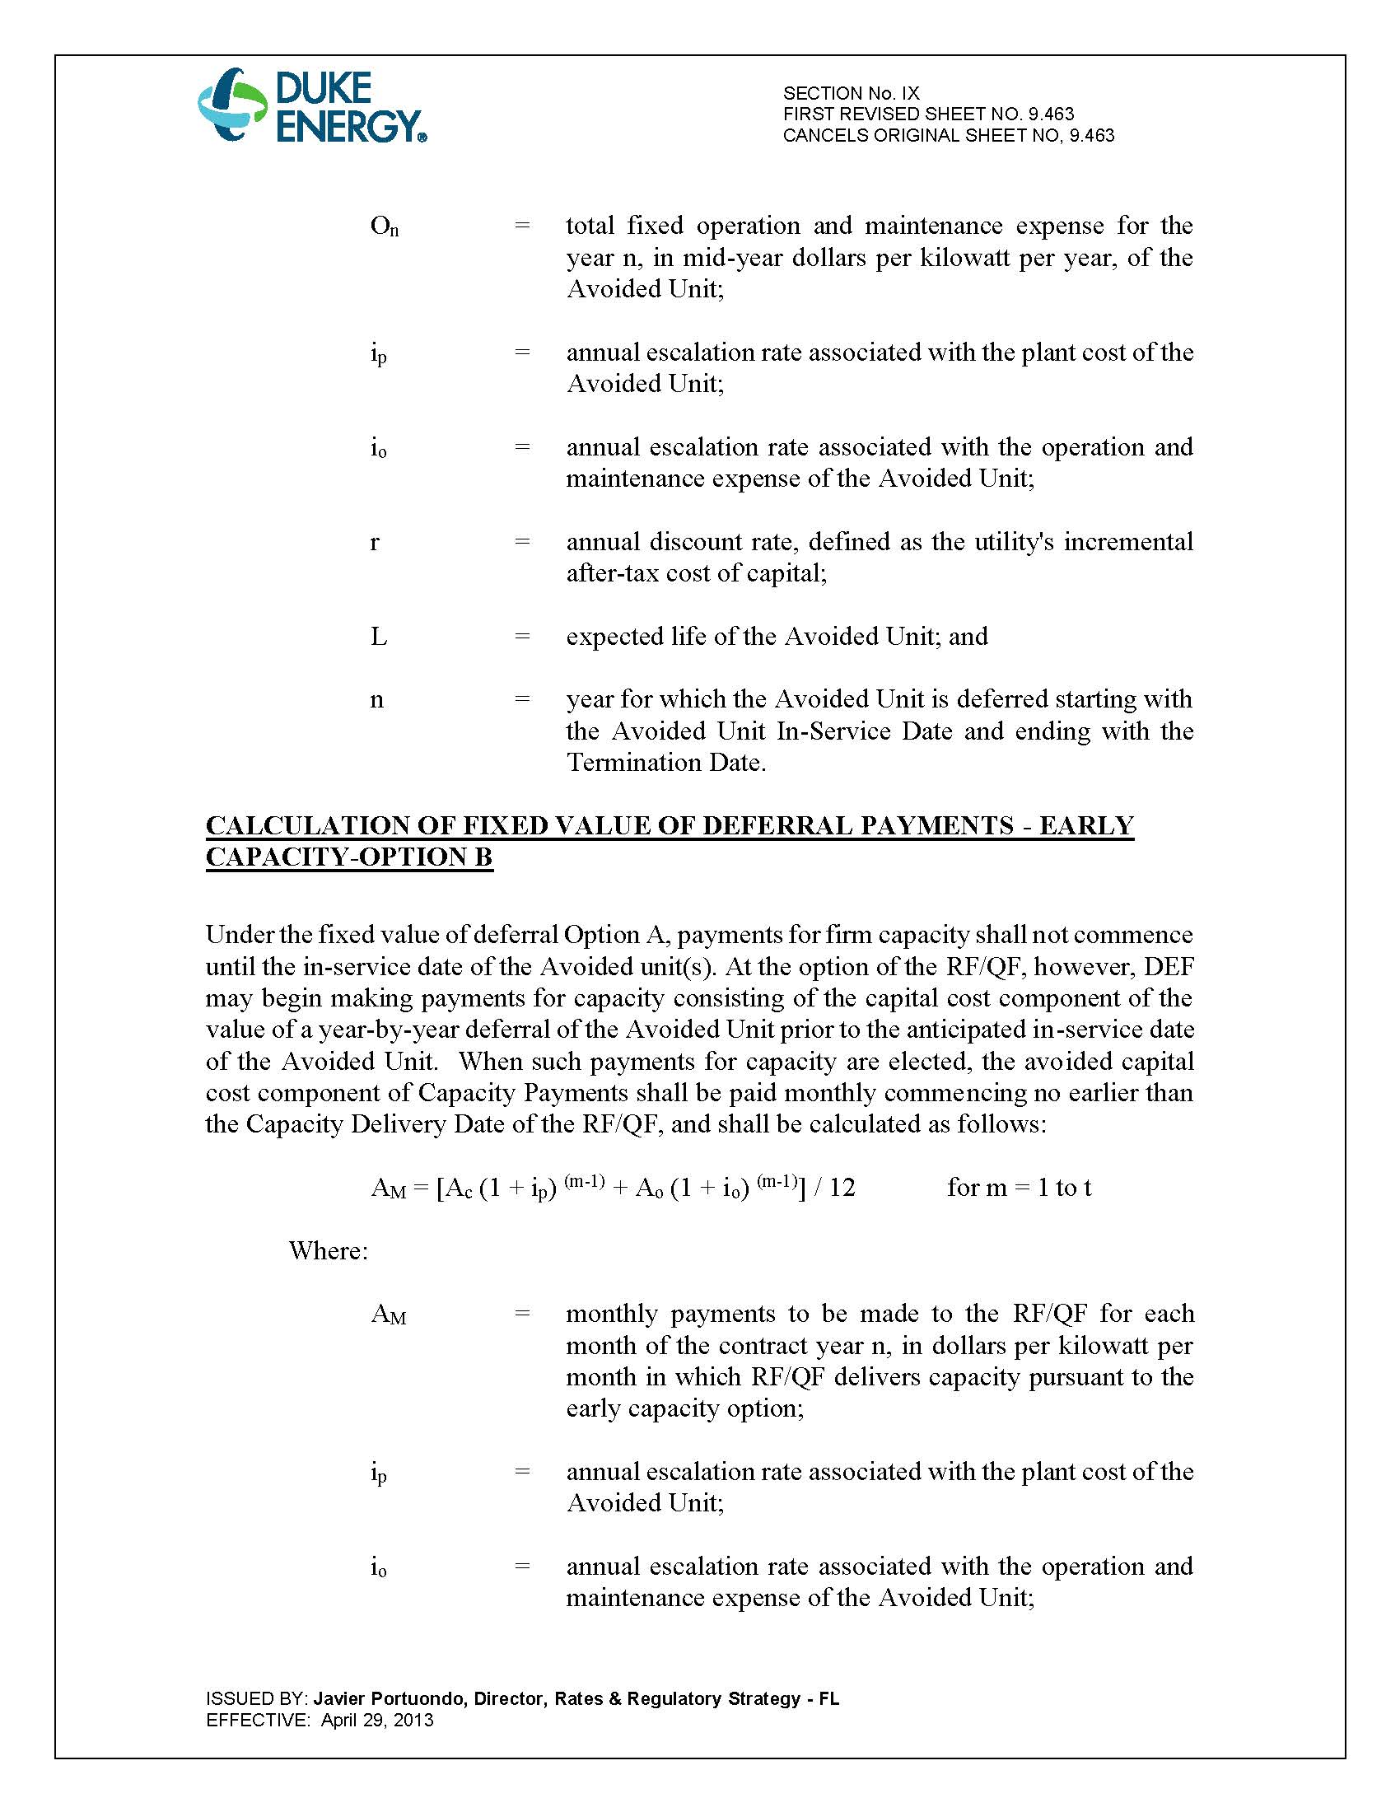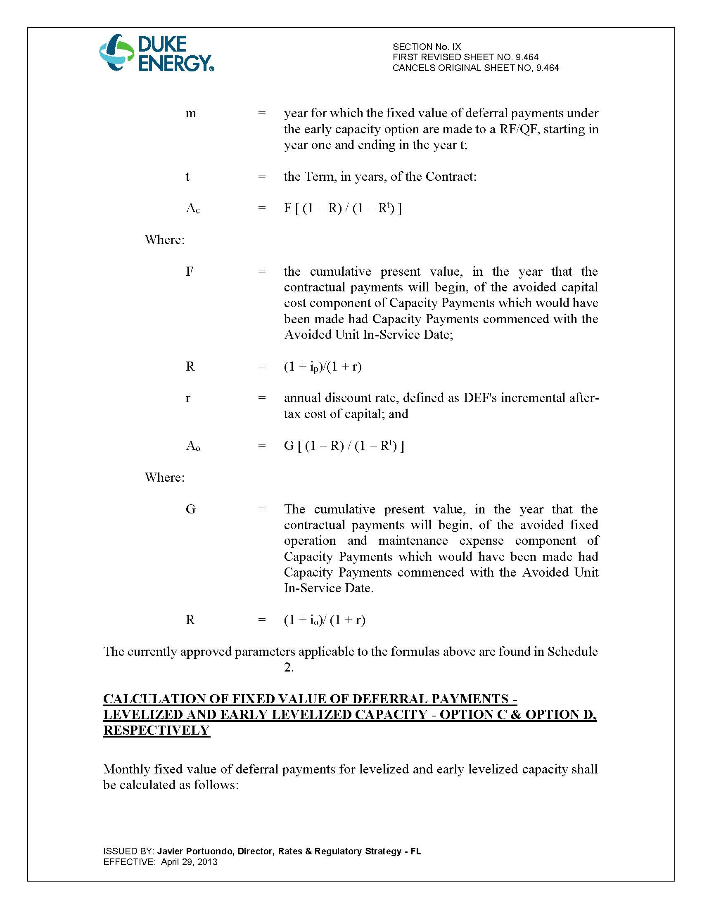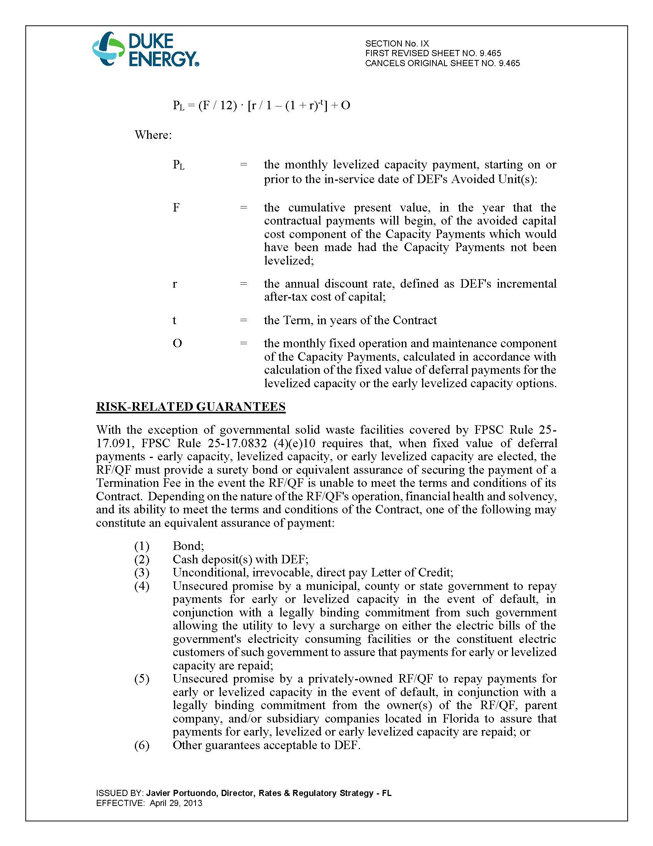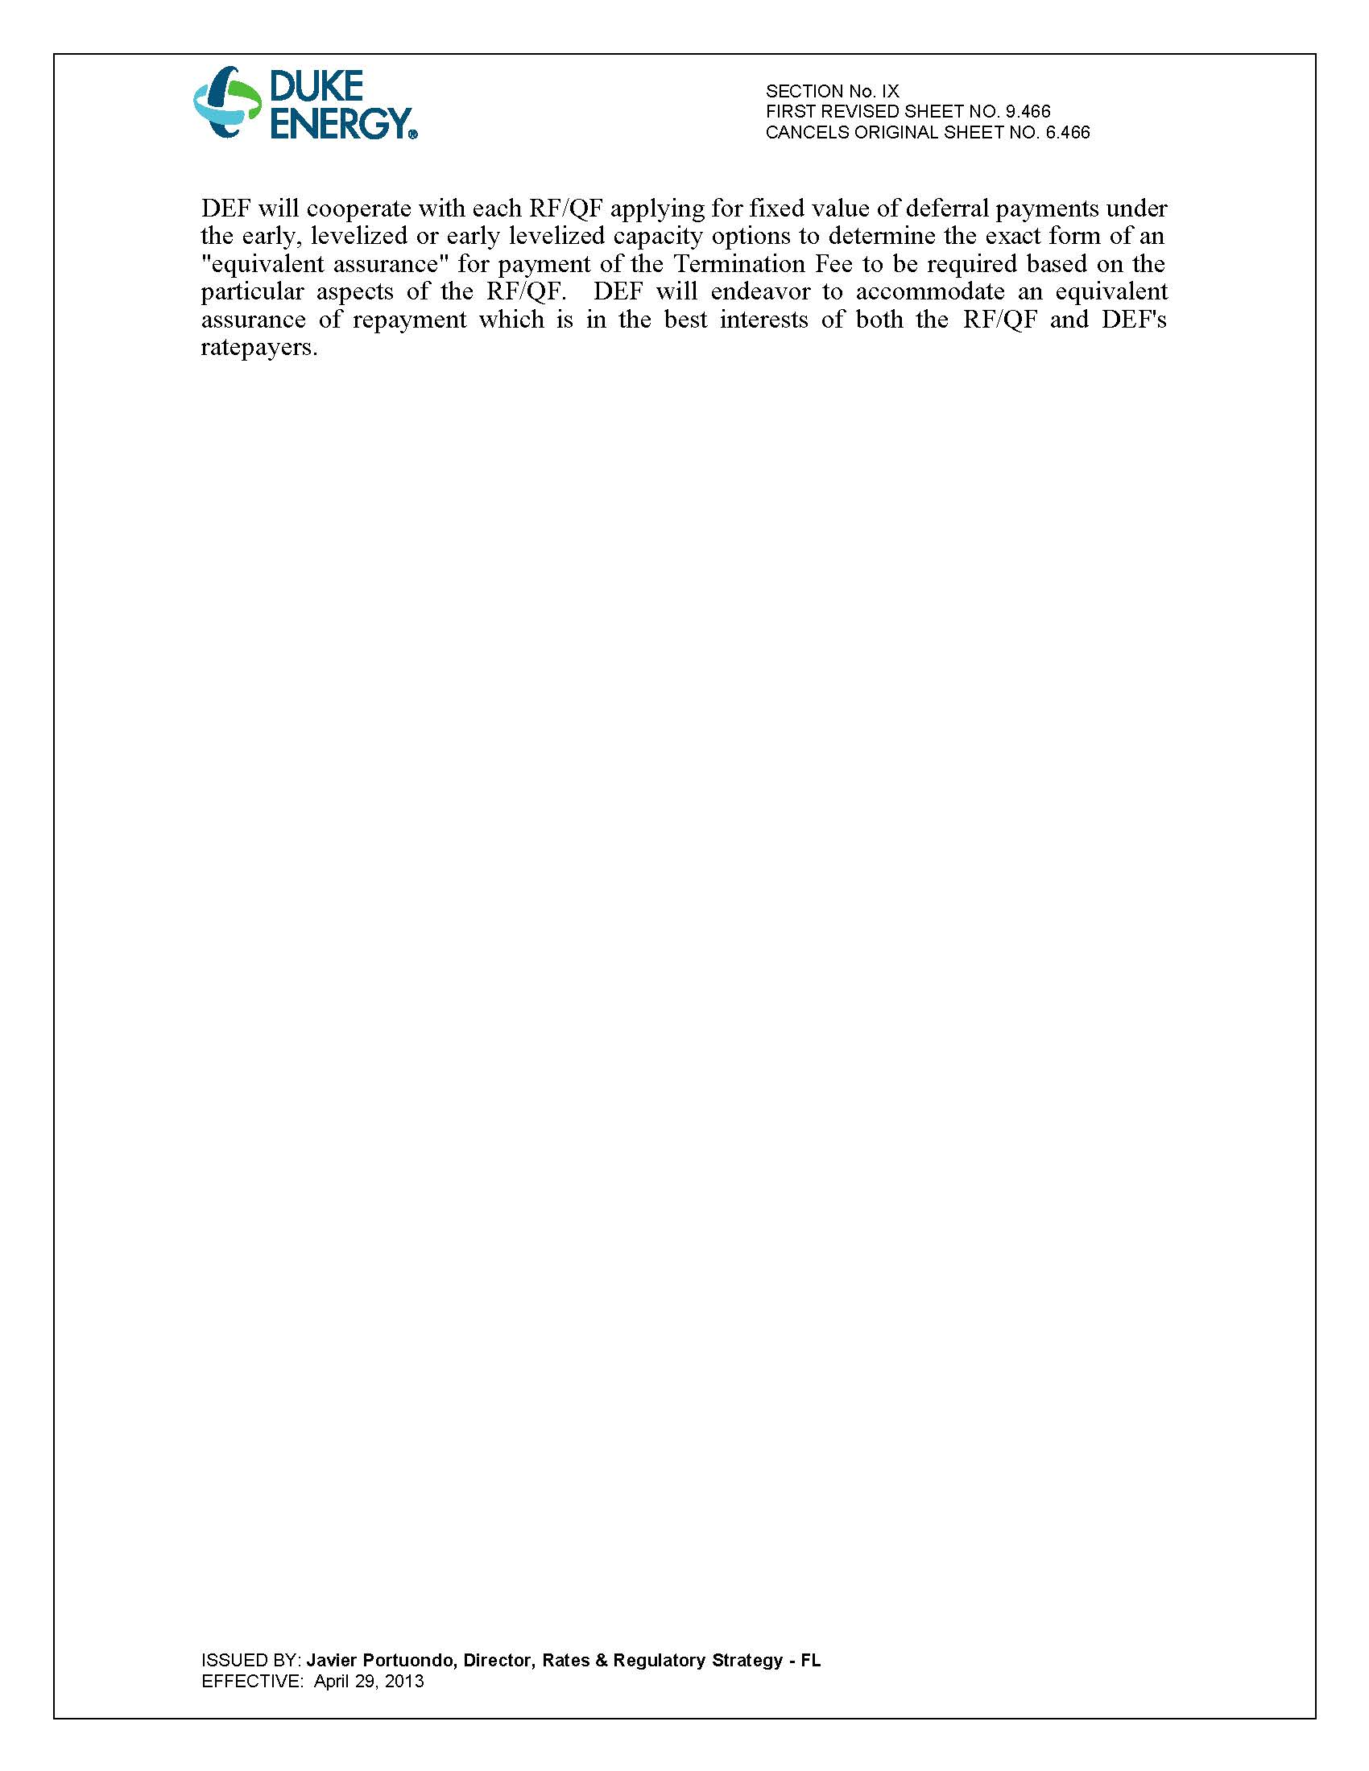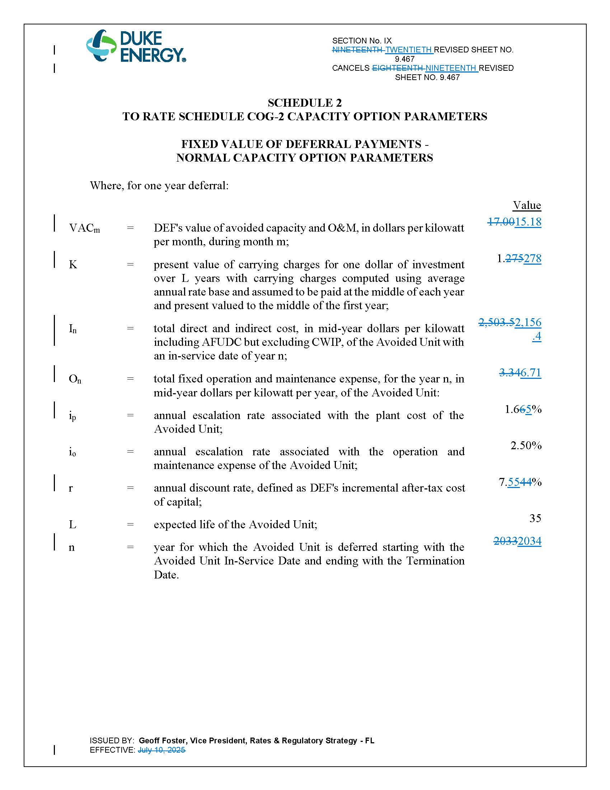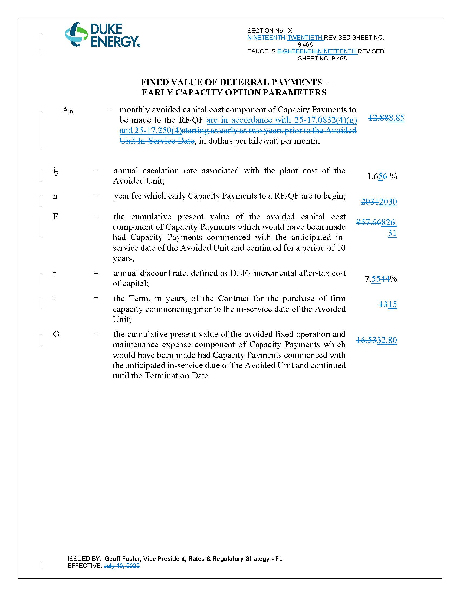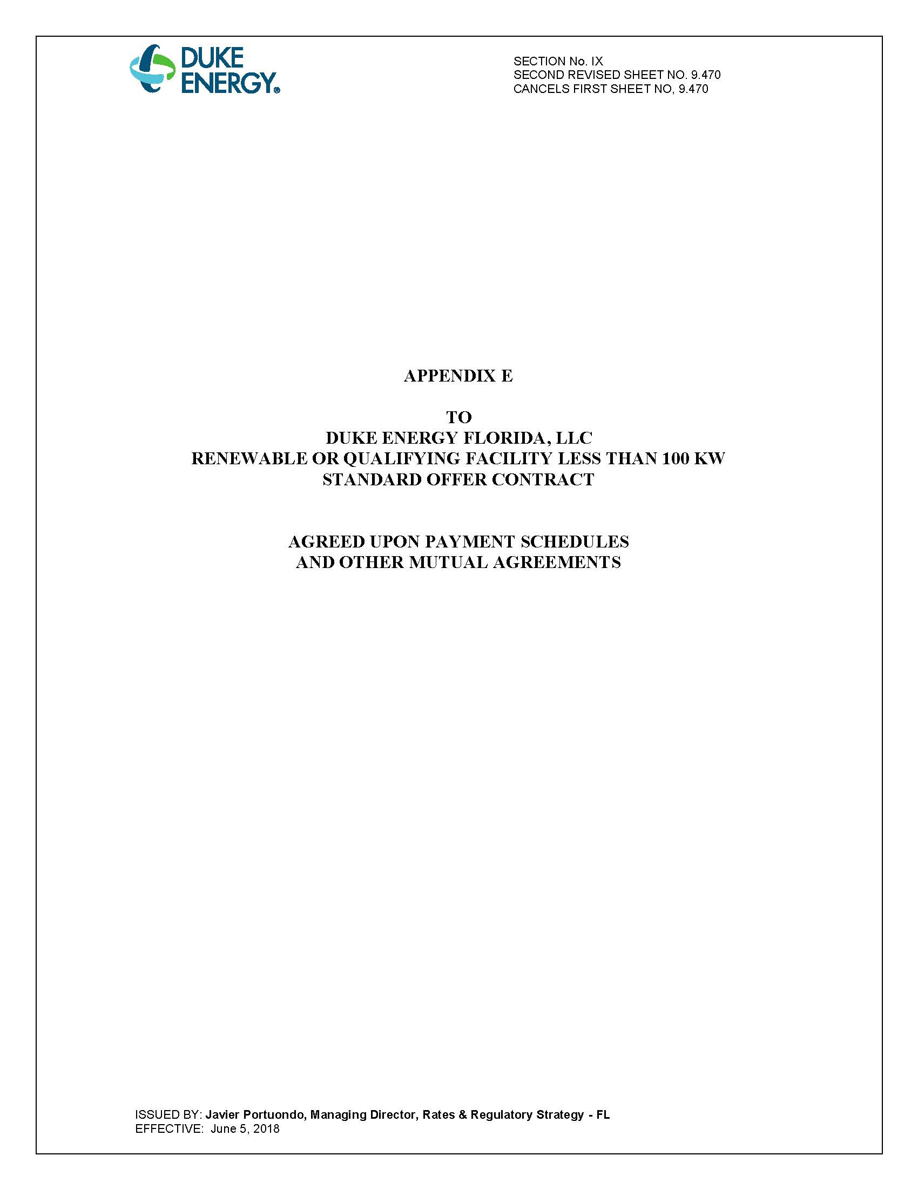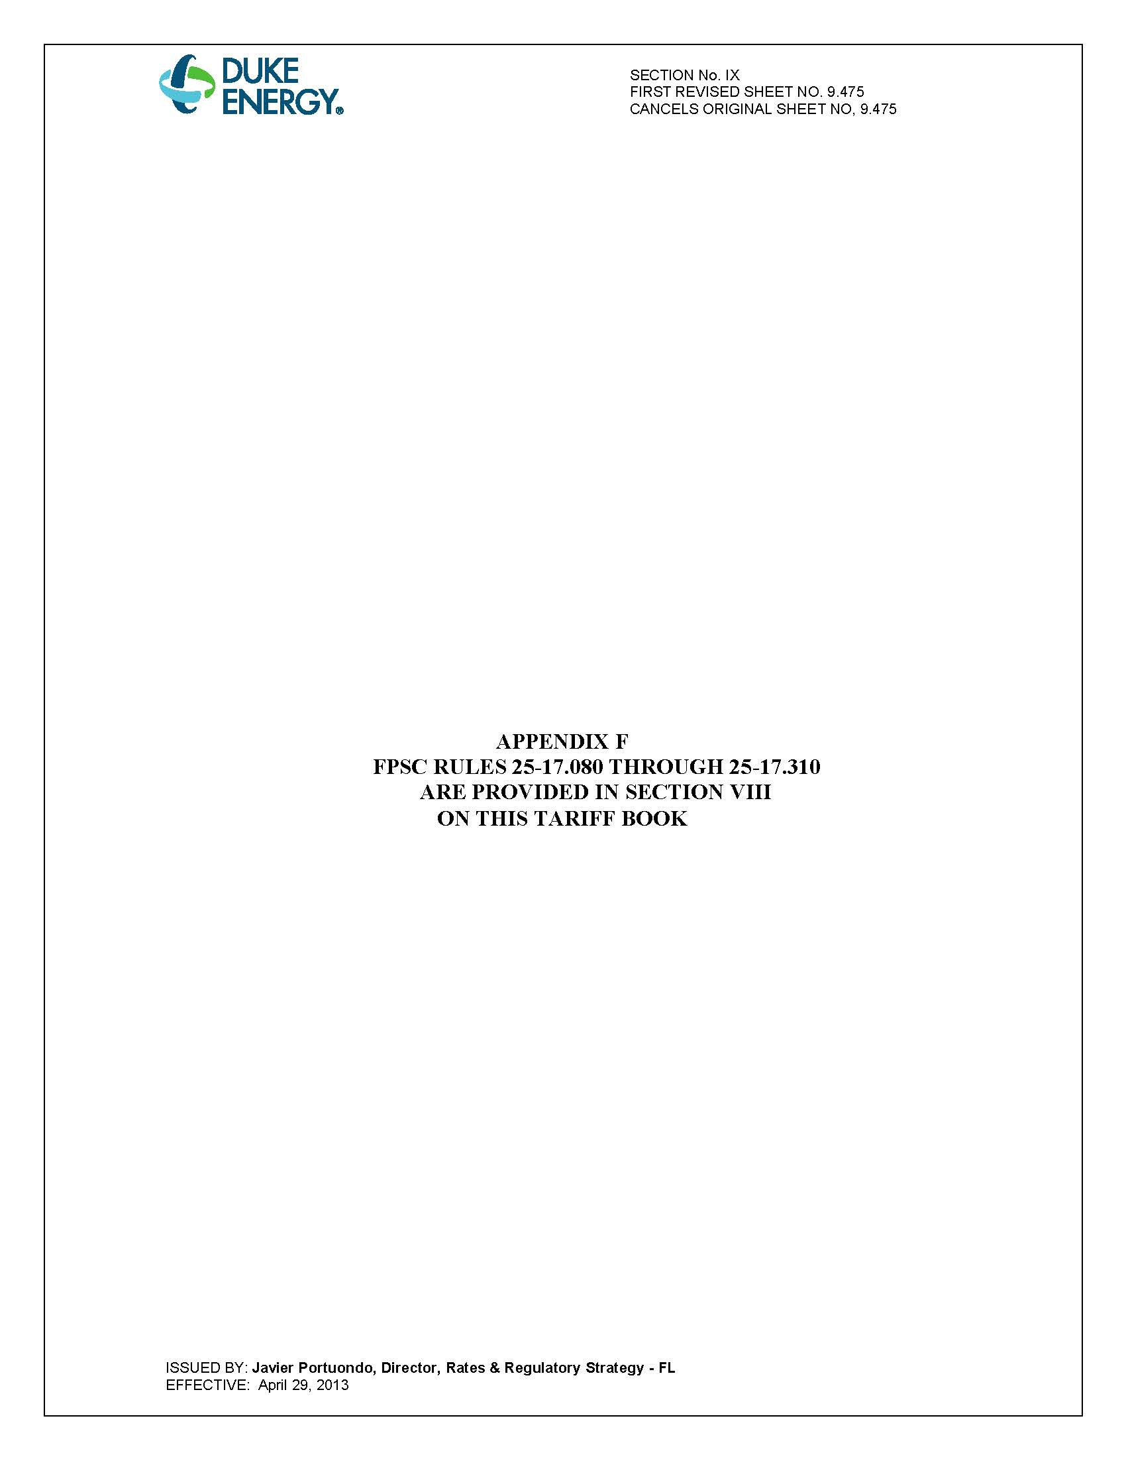

Document No. 02208-2026, filed April 16, 2026, in Docket No. 20260048-EQ, In re: Petition for approval of amended standard offer contract (Schedule COG-2), by Duke Energy Florida, LLC.
Document No. 02114-2026, filed April 10, 2026, in Docket No. 20260048-EQ, In re: Petition for approval of amended standard offer contract (Schedule COG-2), by Duke Energy Florida, LLC.

