BEFORE THE FLORIDA PUBLIC SERVICE COMMISSION

In re: Application for limited proceeding rate increase by Sunshine Water Services Company d/b/a Sunshine Water Services. | DOCKET NO. 20250137-SU  ORDER NO. PSC-2026-0119-S-SU  ISSUED: May 4, 2026

The following Commissioners participated in the disposition of this matter:

GABRIELLA PASSIDOMO SMITH, Chairman
GARY F. CLARK
MIKE LA ROSA
BOBBY PAYNE
ANA ORTEGA

FINAL ORDER APPROVING 2026
STIPULATION AND SETTLEMENT AGREEMENT

APPEARANCES:

J. JEFFRY WAHLEN, VIRGINIA PONDER and MATT J. JONES, ESQUIRES, Ausley McMullen, Post Office Box 391, Tallahassee, Florida 32302
On behalf of Sunshine Water Services Company (SWS).

WALT TRIERWEILER, OCTAVIO SIMOES-PONCE and PATRICIA A. CHRISTENSEN, ESQUIRES, Office of Public Counsel, c/o The Florida Legislature, 111 West Madison Street, Suite 812, Tallahassee, Florida 32399-1400
On behalf of Office of Public Counsel (OPC).

SAAD FAROOQI, ZACHARY BLOOM and JENNIFER CRAWFORD, ESQUIRES, Florida Public Service Commission, 2540 Shumard Oak Boulevard, Tallahassee, Florida 32399-0850
On behalf of the Florida Public Service Commission (Staff).

MARY ANNE HELTON, ESQUIRE, Deputy General Counsel, Florida Public Service Commission, 2540 Shumard Oak Boulevard, Tallahassee, Florida 32399-0850
Advisor to the Florida Public Service Commission.

ADRIA HARPER, ESQUIRE, General Counsel, Florida Public Service Commission, 2540 Shumard Oak Boulevard, Tallahassee, Florida 32399-0850 Florida Public Service Commission General Counsel.
BY THE COMMISSION:

Background

On November 10, 2025, Sunshine Water Services Company (Sunshine) filed a petition requesting a limited proceeding to seek cost recovery for its upgrades to the Mid-County Wastewater Treatment Facility (MCWWTF) and an increase in base rates. Sunshine is a Class A utility providing water and wastewater services to approximately 35,000 water and 30,000 wastewater customers in Charlotte, Highlands, Lake, Lee, Marion, Orange, Pasco, Pinellas, Polk, and Seminole Counties. Sunshine is subject to our regulatory jurisdiction under Chapter 367, Florida Statutes (F.S.). By Order No. PSC-2025-0460-PCO-SU, a final administrative hearing was scheduled for April 13-14, 2026.

Intervention by the Citizens of the State of Florida through the Office of Public Counsel (OPC) was acknowledged by Order No. PSC-2025-0461-PCO-SU, and no other parties intervened. The parties and Commission staff engaged in thorough discovery based upon the scope of the limited proceeding. We conducted three virtual customer service hearings in March of 2026. Over the course of these hearings, we heard testimony from six customers. All of these customers expressed disapproval of a rate increase, and three complained of Sunshine’s quality of service.

On March 26, 2026, Sunshine filed its Motion to Approve 2026 Stipulation and Settlement Agreement (Motion) with a copy of the 2026 Stipulation and Settlement Agreement (Settlement) appended thereto as Attachment 1. The Settlement was agreed to unanimously by Sunshine and OPC (collectively, the Parties). By Order No. PSC-2026-0080-PCO-SU, the Prehearing Officer issued a Procedural Order on April 1, 2026, and scheduled a final hearing on the Motion for April 13, 2026.

At the final hearing on April 13, 2026, we admitted the testimony of Sunshine witnesses Seán Twomey and Dante DeStefano, and Commission staff witness John F. Plescow. Sunshine witness Seán Twomey presented in-person testimony at the final hearing and was made available for questions from us. Following our questioning, the record in this proceeding was closed. The Parties waived filing post-hearing briefs, and a bench vote was taken approving the Settlement.

This Order addresses our approval of the Settlement, incorporated and attached to this Order as Attachment A. We have jurisdiction over this matter pursuant to the provisions of Sections 367.011, 367.081, 367.121, and 367.0822, F.S.

Standard of Review

In reviewing a settlement agreement, we first make factual findings based on the evidence presented by the parties. As the finder of fact, we must consider all the evidence presented, resolve conflicts, judge credibility of witnesses, draw permissible inferences from the evidence, and reach ultimate findings of fact based on competent substantial evidence. Each of those ultimate findings of fact must be supported by a preponderance of the record evidence. After making factual findings, we must decide whether the settlement agreement, in light of our findings of fact, is in the public interest and results in rates that are just, reasonable, compensatory, and not unfairly discriminatory. We review settlement agreements as a whole to determine whether approving them is in the public interest.

Executive Summary

The general terms of the Settlement are as follows:

- Sunshine shall be authorized to increase its rates effective no later than June 1, 2026, to recover an additional annual revenue requirement of $4,300,000.
- The Parties agree that the rates are fair, just, and reasonable within the meaning of Chapter 367, F.S.
- Sunshine shall defer its rate case expense associated with this proceeding to its next general rate case filing.
- The MCWWTF project and related costs are prudent and eligible for cost recovery.
- This proceeding is a limited proceeding focused solely on the prudence of the MCWWTF and whether it qualified for cost recovery and related revenue requirement and rate increases as proposed by Sunshine.
- The Parties agree that they will support the Settlement in any future proceedings, and neither party shall seek appellate review of any Commission order approving the Settlement.
- The Parties agree not to assert that the Settlement has precedential value in any proceeding before the Commission.
- The Parties agree to request we approve the Settlement, and find it is in the public interest and fairly resolves all matters in this docket.

The Supreme Court has held that while we need not resolve every issue independently in our final order when reviewing a settlement agreement, we must nonetheless discuss the major elements of the settlement agreement and explain why the Settlement is in the public interest. We reviewed the Settlement and determined that it contains the following 6 major elements: (1) the agreement that the MCWWTF is prudent; (2) authorization for related rate base additions and revenue increase; (3) the approved annual revenue requirement increase to recover the costs associated with the MCWWTF; (4) the tariffs that implement the approved revenue increase; (5) the agreement to defer rate case expenses for consideration in a future rate proceeding; and (6) the agreement to forgo further litigation. The witness testimony and evidence on those issues were admitted into the record at hearing, and as discussed below, serve as a foundational evidentiary basis for the Settlement.

Decision

We considered the Settlement as a whole in making our ultimate determination of whether to approve it as being in the public interest and establishing rates that are just, reasonable, compensatory, and not unfairly discriminatory. Consistent with the Supreme Court’s direction in FAIR, we examine the major elements of the Settlement to determine whether and how each one impacts rates, and then consider the public interest in the context of the overall settlement.

- The MCWWTF is Prudent

The Settlement details the benefits Sunshine’s customers will receive as a result of the MCWWTF, which include: (1) treating influent to permitted nutrient removal levels; (2) addressing existing process and operational deficiencies, (3) improving overall plant reliability and redundancy, (4) increasing hydraulic capacity, and (5) promoting consistent and reliable service. The MCWWTF is expected to improve compliance issues with the Florida Department of Environmental Protection, as well as overall plant reliability. The Settlement asserts that the MCWWTF improves Sunshine’s ability to provide safe, reliable, and environmentally sound wastewater treatment services to its customers. Based on the foregoing and the record, we find that Sunshine has adequately demonstrated a need for the MCWWTF and customers benefit from it and, as a result, we find that the MCWWTF is prudent.

- Authorization for Related Rate Base Additions and Revenue Increase

Chapter 367, F.S., requires that water and wastewater rates be compensatory, and utilities must have the opportunity to earn a fair rate of return on its investments. Adding the costs of upgrades to the MCWWTF to the utility’s rate base allows Sunshine to timely earn a fair rate of return on its investment in facilities placed into public service. Based on the foregoing and the record, we find that approval of the rate base additions and associated revenue increase are appropriate, allows Sunshine to continue providing safe and reliable wastewater service to its customers, and provides timely rate relief to the utility.

- Annual Revenue Requirement Increase

The Parties agreed upon a revenue increase of $4,300,000 in the Settlement, which is $246,891 lower than Sunshine’s initial request in its application for a limited proceeding. We agree that the $4,300,000 revenue increase, beginning no later than June 1, 2026, is reasonable and appropriate when considered in the context of the comprehensive Settlement. The Settlement details that the $4,300,000 amount is a result of informed negotiations with the statutory representative of the Sunshine customers, OPC. The lowered amount makes the increased and approved rates lower and mitigates the impact to customers. Based on the foregoing and the record, we find that the annual revenue requirement increase of $4,300,000 is appropriate.

- Tariffs Implementing Revenue Increase

The tariff rates were prepared by the Parties using the rate design methods and principles approved by us in Sunshine’s most recent general rate case. We have reviewed the tariff sheets included in the Settlement; based on our review and the record, we find that the tariff sheets included in the Settlement are appropriate. However, the approved rates shall not be implemented until our staff has approved a proposed customer notice, filed by Sunshine, and the notice has been received by customers. Sunshine shall provide proof of the date notice was given within 10 days of the date of the notice.

- Deferred Rate Case Expenses

In the Settlement, the Parties propose that recovery of Sunshine’s limited proceeding rate case expenses be preserved for consideration in a future rate case proceeding. The deferral of rate case expense associated with this limited proceeding means that the revenue increase approved herein is lower than it might be otherwise. Based on the foregoing and the record, we find that deferral of Sunshine’s limited proceeding rate case expenses is appropriate.

- Agreement to Forgo Further Litigation

The agreement to forgo further litigation by the Parties will not only reduce the time and expense the Parties and the Commission will spend on this limited proceeding, but will also reduce the amount of rate case expense to be considered at a future rate proceeding by Sunshine by avoiding further litigation in this docket. Based on the foregoing and the record, we find that the Parties agreement to forgo further litigation is appropriate.

The Public Interest

We now turn to our ultimate determination: whether the Settlement, in light of our findings of fact, is in the public interest and results in rates that are just, reasonable, and compensatory. We make this determination based upon review of the Settlement as a whole. By providing resolution of all outstanding issues, the Settlement promotes certainty, predictability, and regulatory efficiency, and is supported by the public policy in Florida to encourage resolution of disputes by agreement of the parties. The Settlement is the result of a collaboration between Sunshine and OPC reflecting compromises of their respective positions, and appropriately balances the need for Sunshine to have the revenues necessary to provide safe and reliable service with the requirement that the service be provided at just and reasonable rates to customers. Having found it to be in the public interest, the Settlement is therefore approved.

Based on the foregoing, it is

ORDERED by the Florida Public Service Commission that Sunshine Water Services Company d/b/a Sunshine Water Services’ Motion to Approve 2026 Stipulation and Settlement Agreement is hereby granted. It is further

ORDERED that the 2026 Stipulation and Settlement Agreement, incorporated and attached to this Order, is approved. It is further

ORDERED that the tariff sheets within the 2026 Stipulation and Settlement Agreement are complete and consistent with this Order and, therefore, approved. The utility shall file a proposed customer notice to reflect the rates approved herein. The approved rates shall be effective for service on or after the stamped approval date of the tariff sheets pursuant to Rule 25-30.475(1), F.A.C. In addition, the approved rates shall not be implemented until Commission staff has approved the proposed customer notice and the notice has been received by customers. The Utility shall provide proof of the date notice was given within 10 days of the date of the notice. It is further

ORDERED that this docket shall be closed.

By ORDER of the Florida Public Service Commission this 4th day of May, 2026.

/s/ Adam J. Teitzman
ADAM TEITZMAN
Commission Clerk
Florida Public Service Commission
2540 Shumard Oak Boulevard
Tallahassee, Florida 32399
(850) 413-6770
www.floridapsc.com

Copies furnished: A copy of this document is provided to the parties of record at the time of issuance and, if applicable, interested persons.

SF

NOTICE OF FURTHER PROCEEDINGS OR JUDICIAL REVIEW

The Florida Public Service Commission is required by Section 120.569(1), Florida Statutes, to notify parties of any administrative hearing or judicial review of Commission orders that is available under Sections 120.57 or 120.68, Florida Statutes, as well as the procedures and time limits that apply. This notice should not be construed to mean all requests for an administrative hearing or judicial review will be granted or result in the relief sought.

Any party adversely affected by the Commission's final action in this matter may request: 1) reconsideration of the decision by filing a motion for reconsideration with the Office of Commission Clerk, 2540 Shumard Oak Boulevard, Tallahassee, Florida 32399-0850, within fifteen (15) days of the issuance of this order in the form prescribed by Rule 25-22.060, Florida Administrative Code; or 2) judicial review by the Florida Supreme Court in the case of an electric, gas or telephone utility or the First District Court of Appeal in the case of a water and/or wastewater utility by filing a notice of appeal with the Office of Commission Clerk, and filing a copy of the notice of appeal and the filing fee with the appropriate court. This filing must be completed within thirty (30) days after the issuance of this order, pursuant to Rule 9.110, Florida Rules of Appellate Procedure. The notice of appeal must be in the form specified in Rule 9.900(a), Florida Rules of Appellate Procedure.

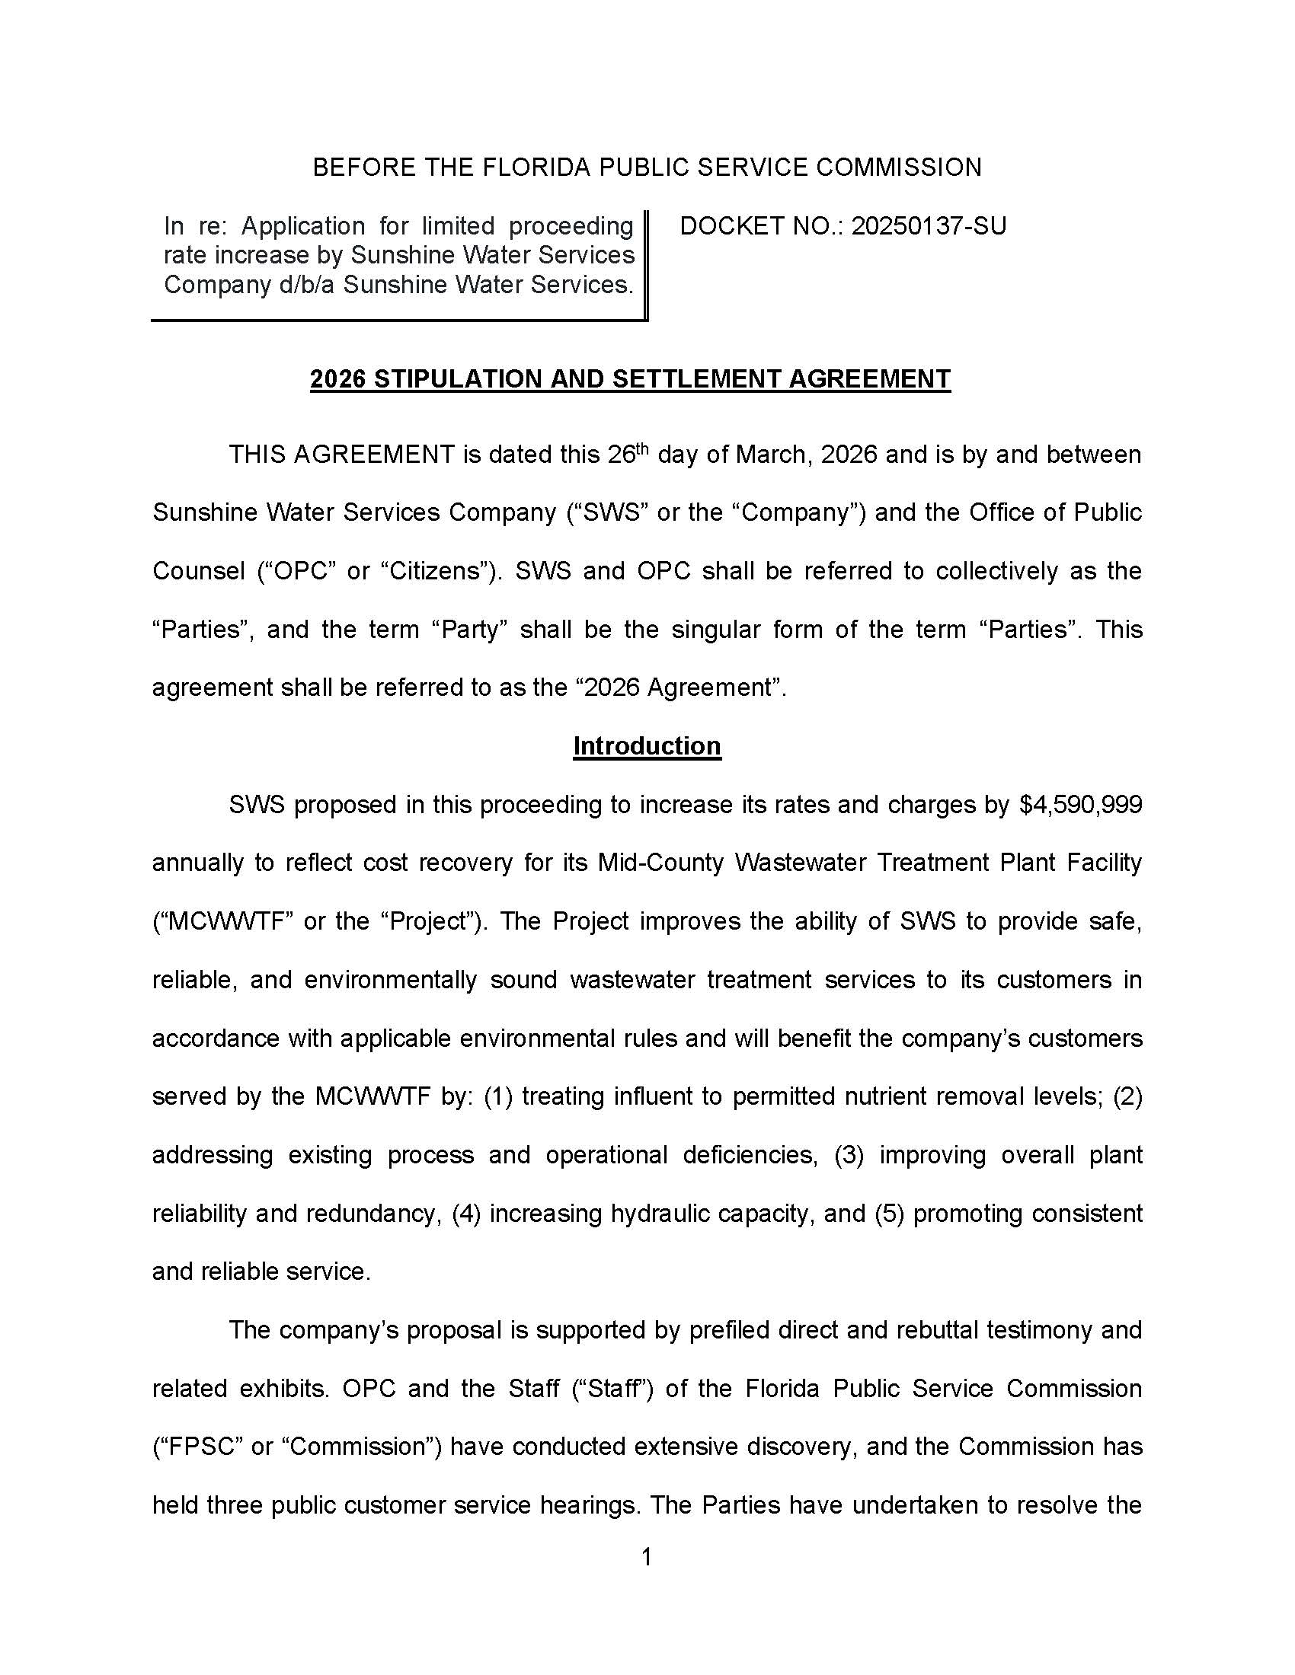

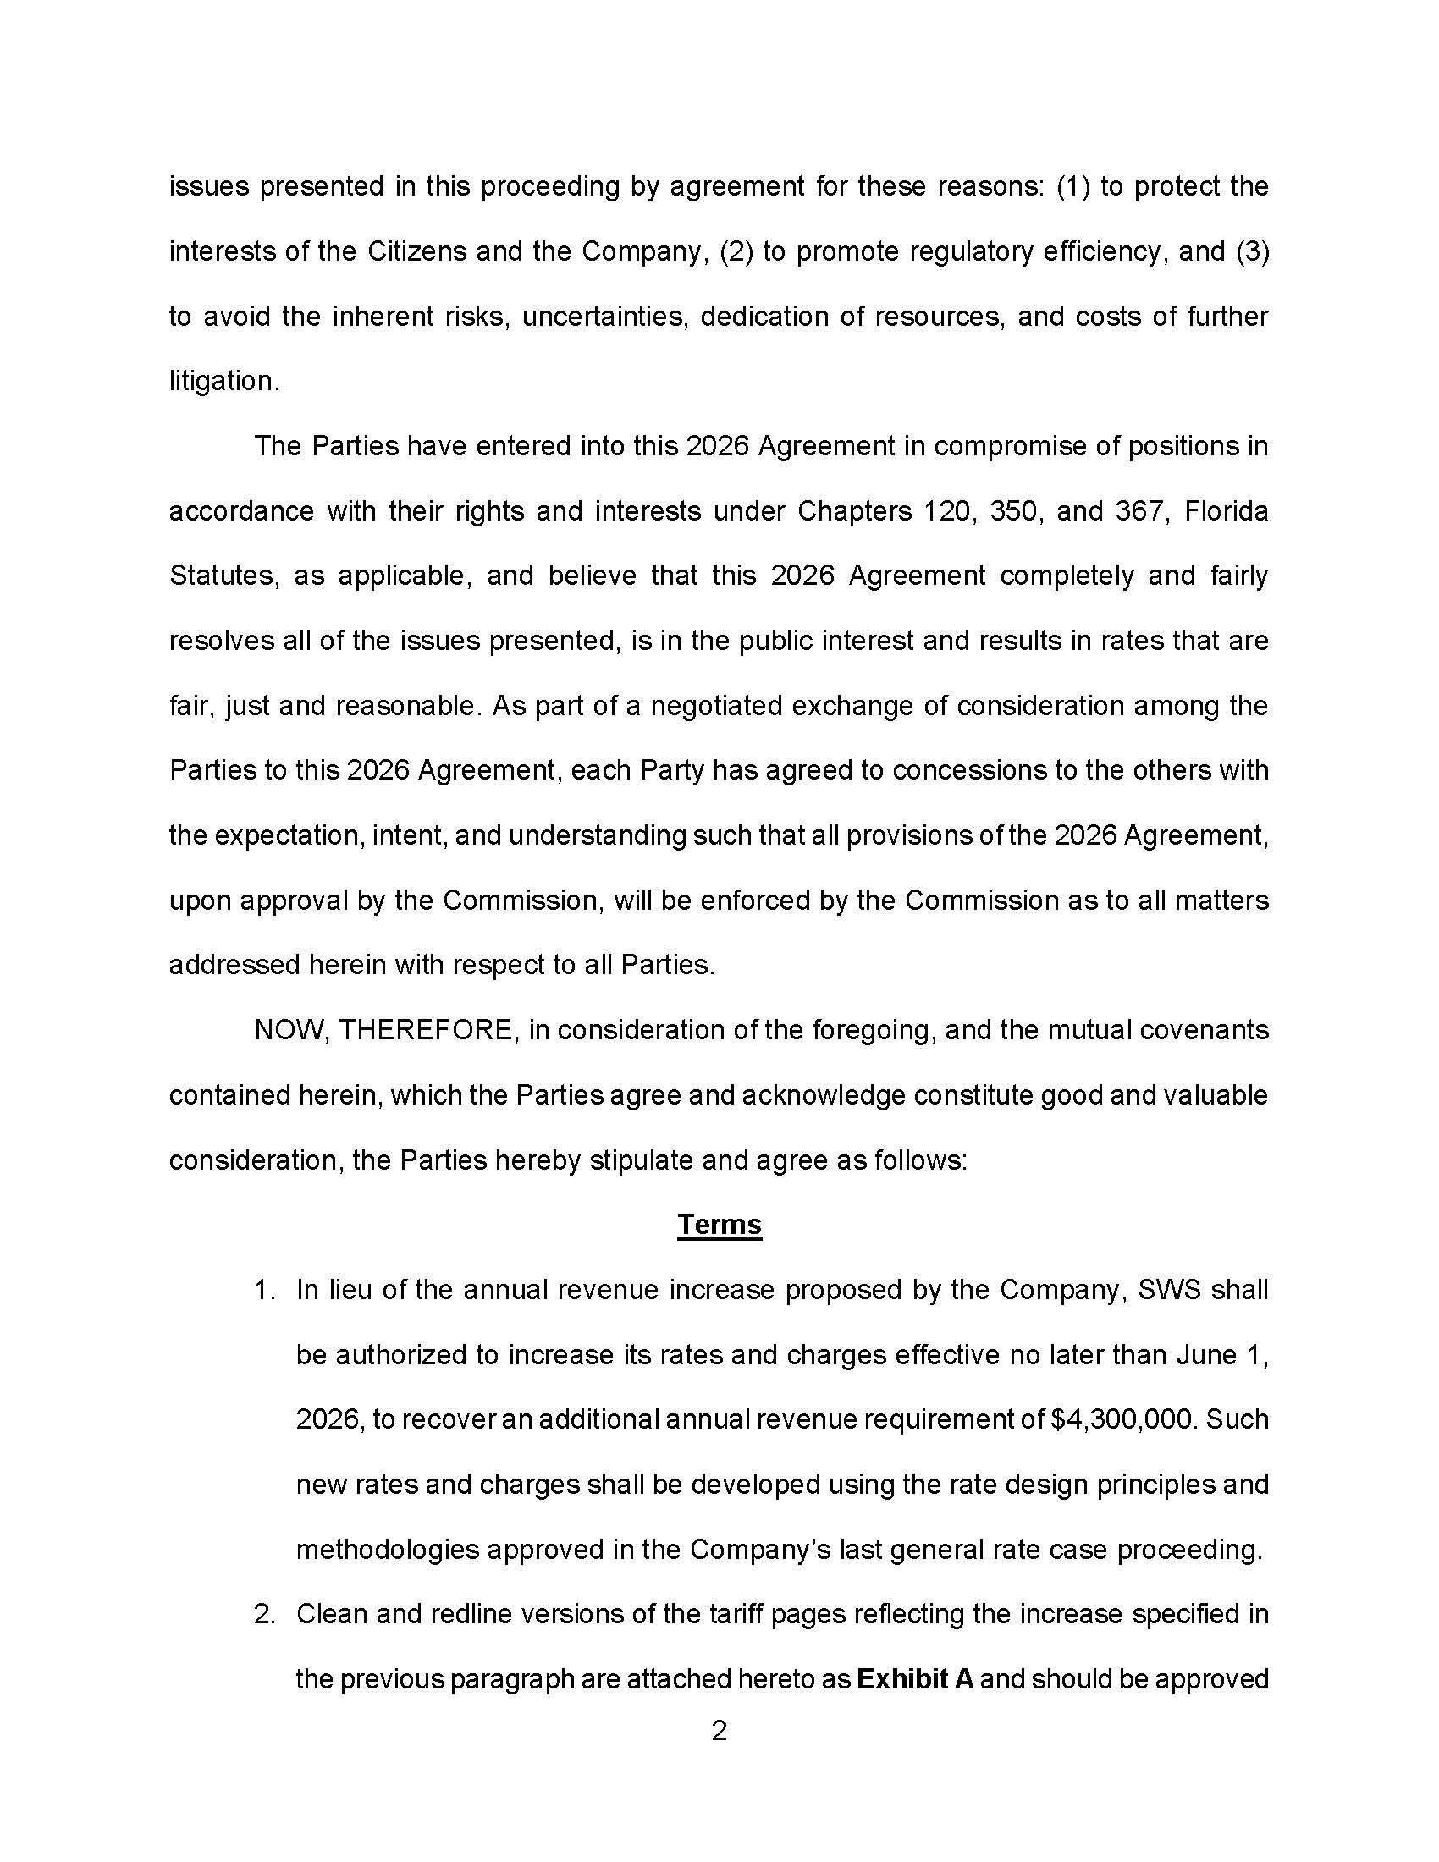

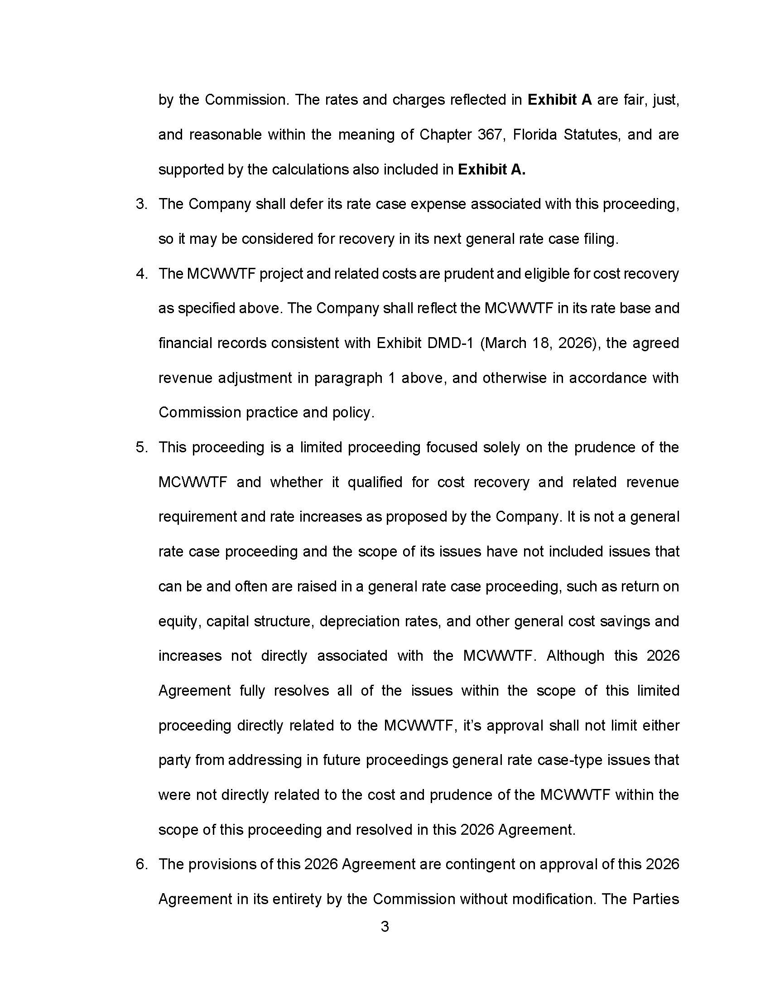

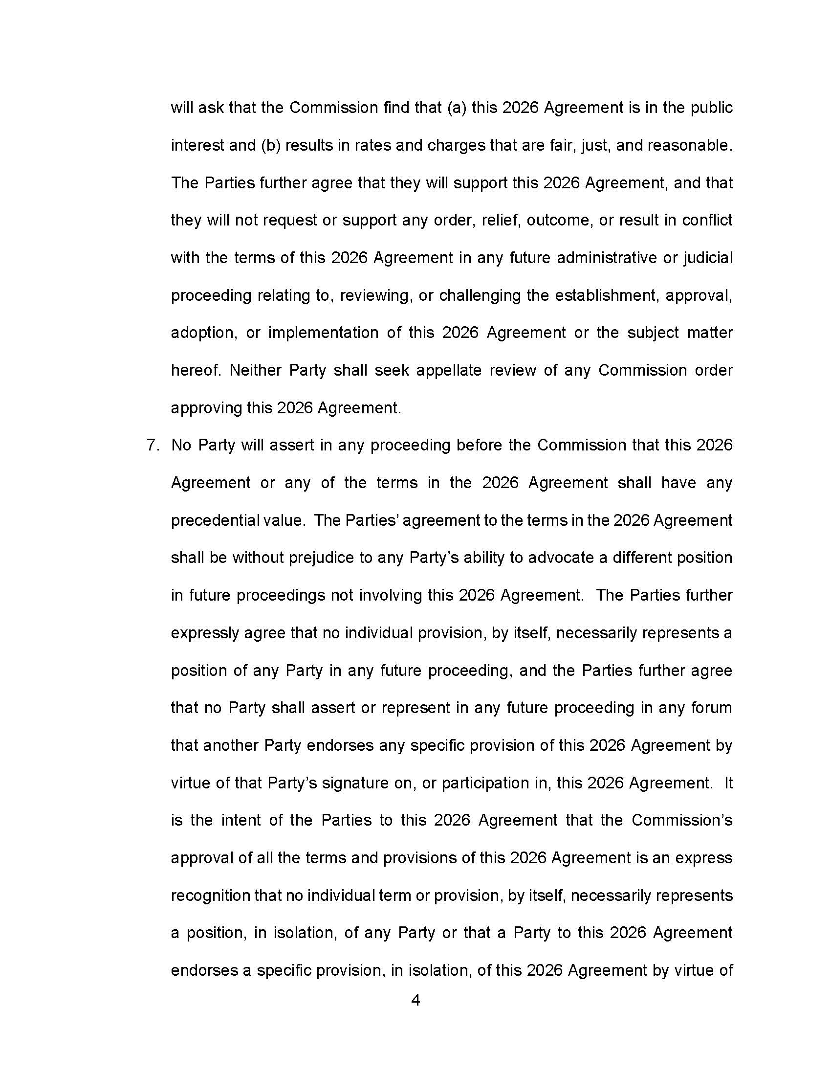

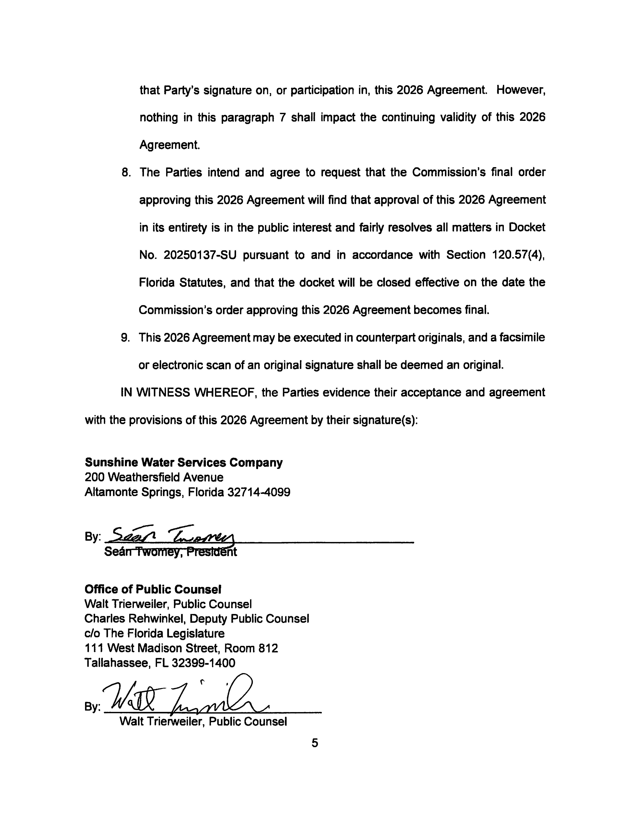

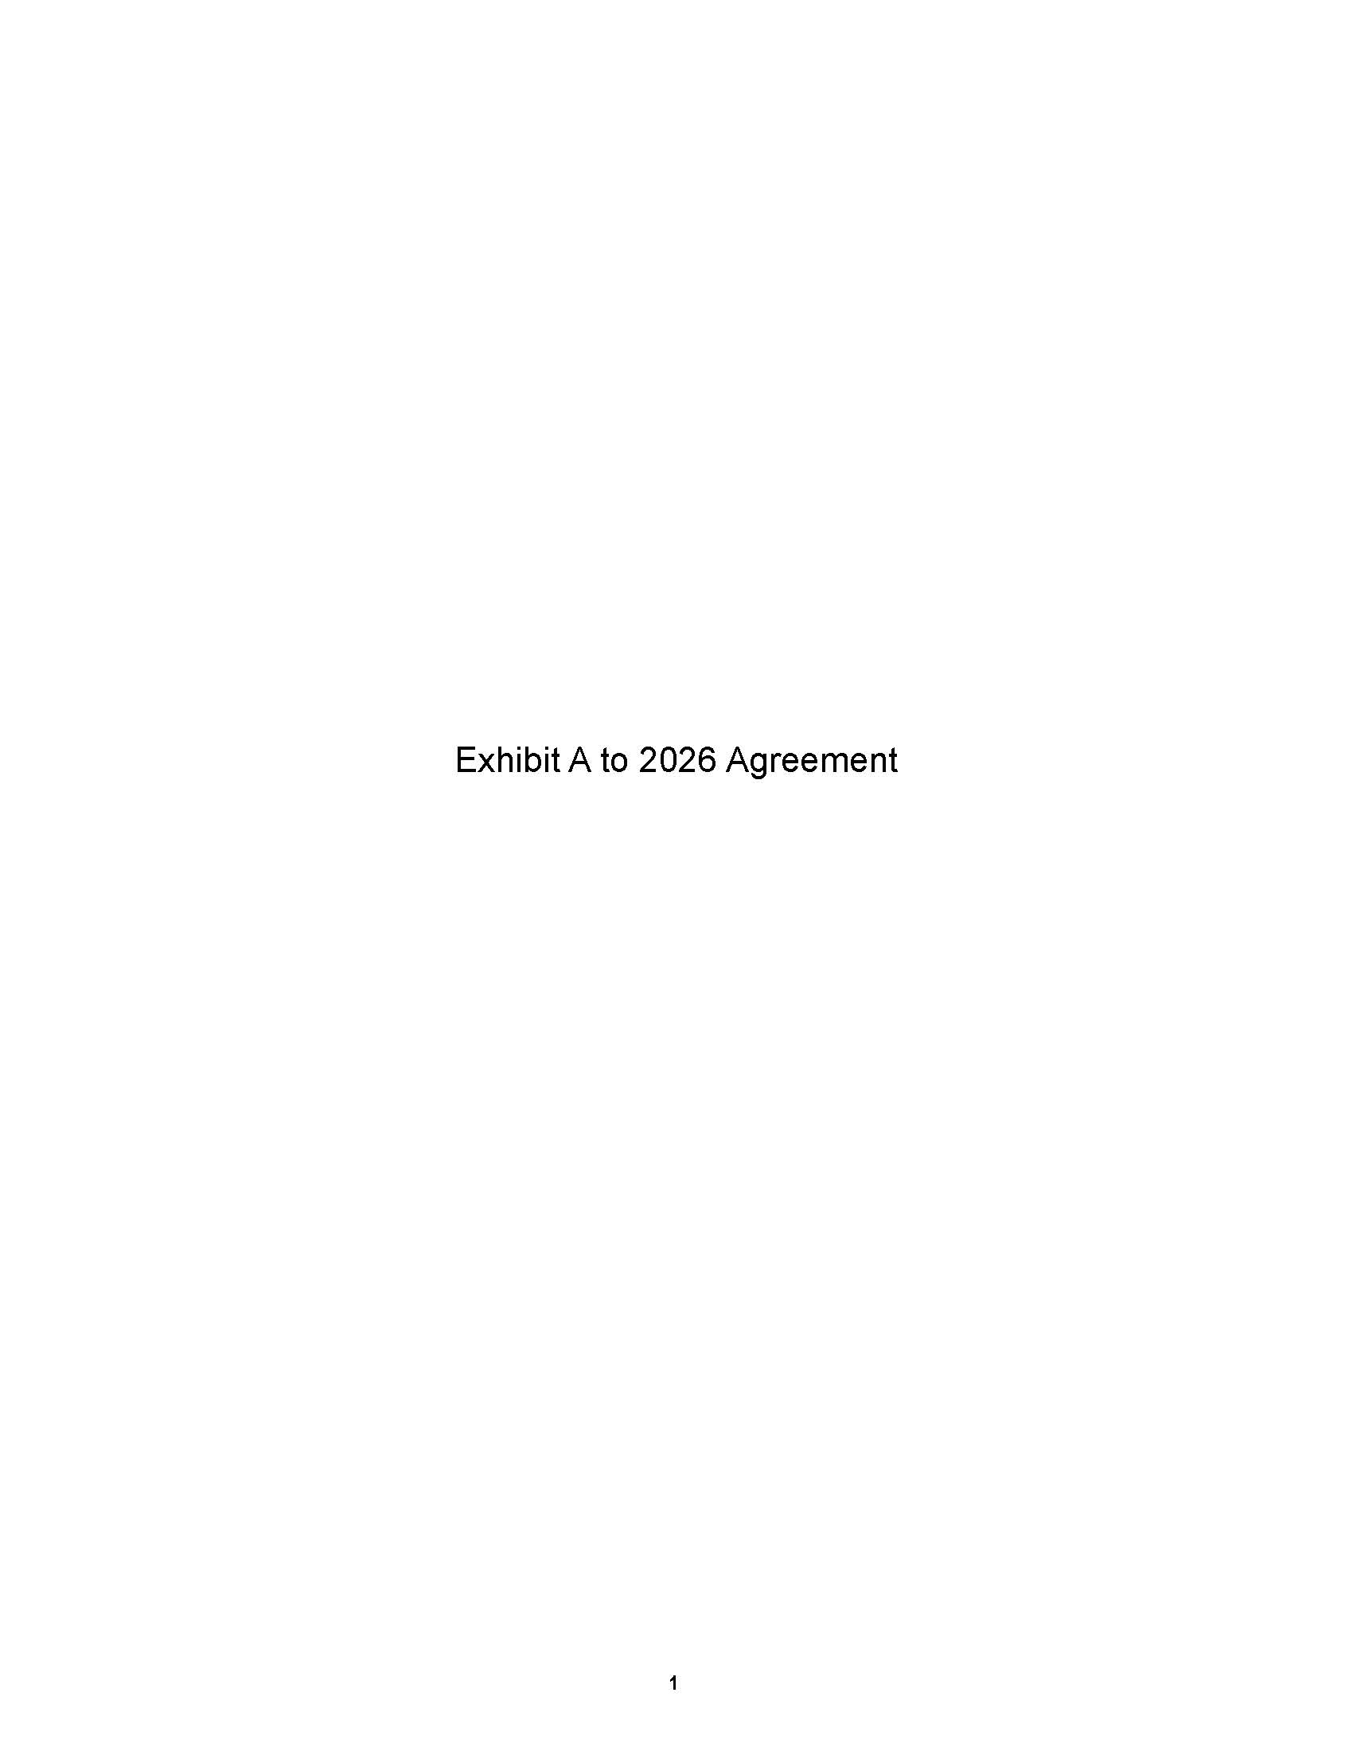

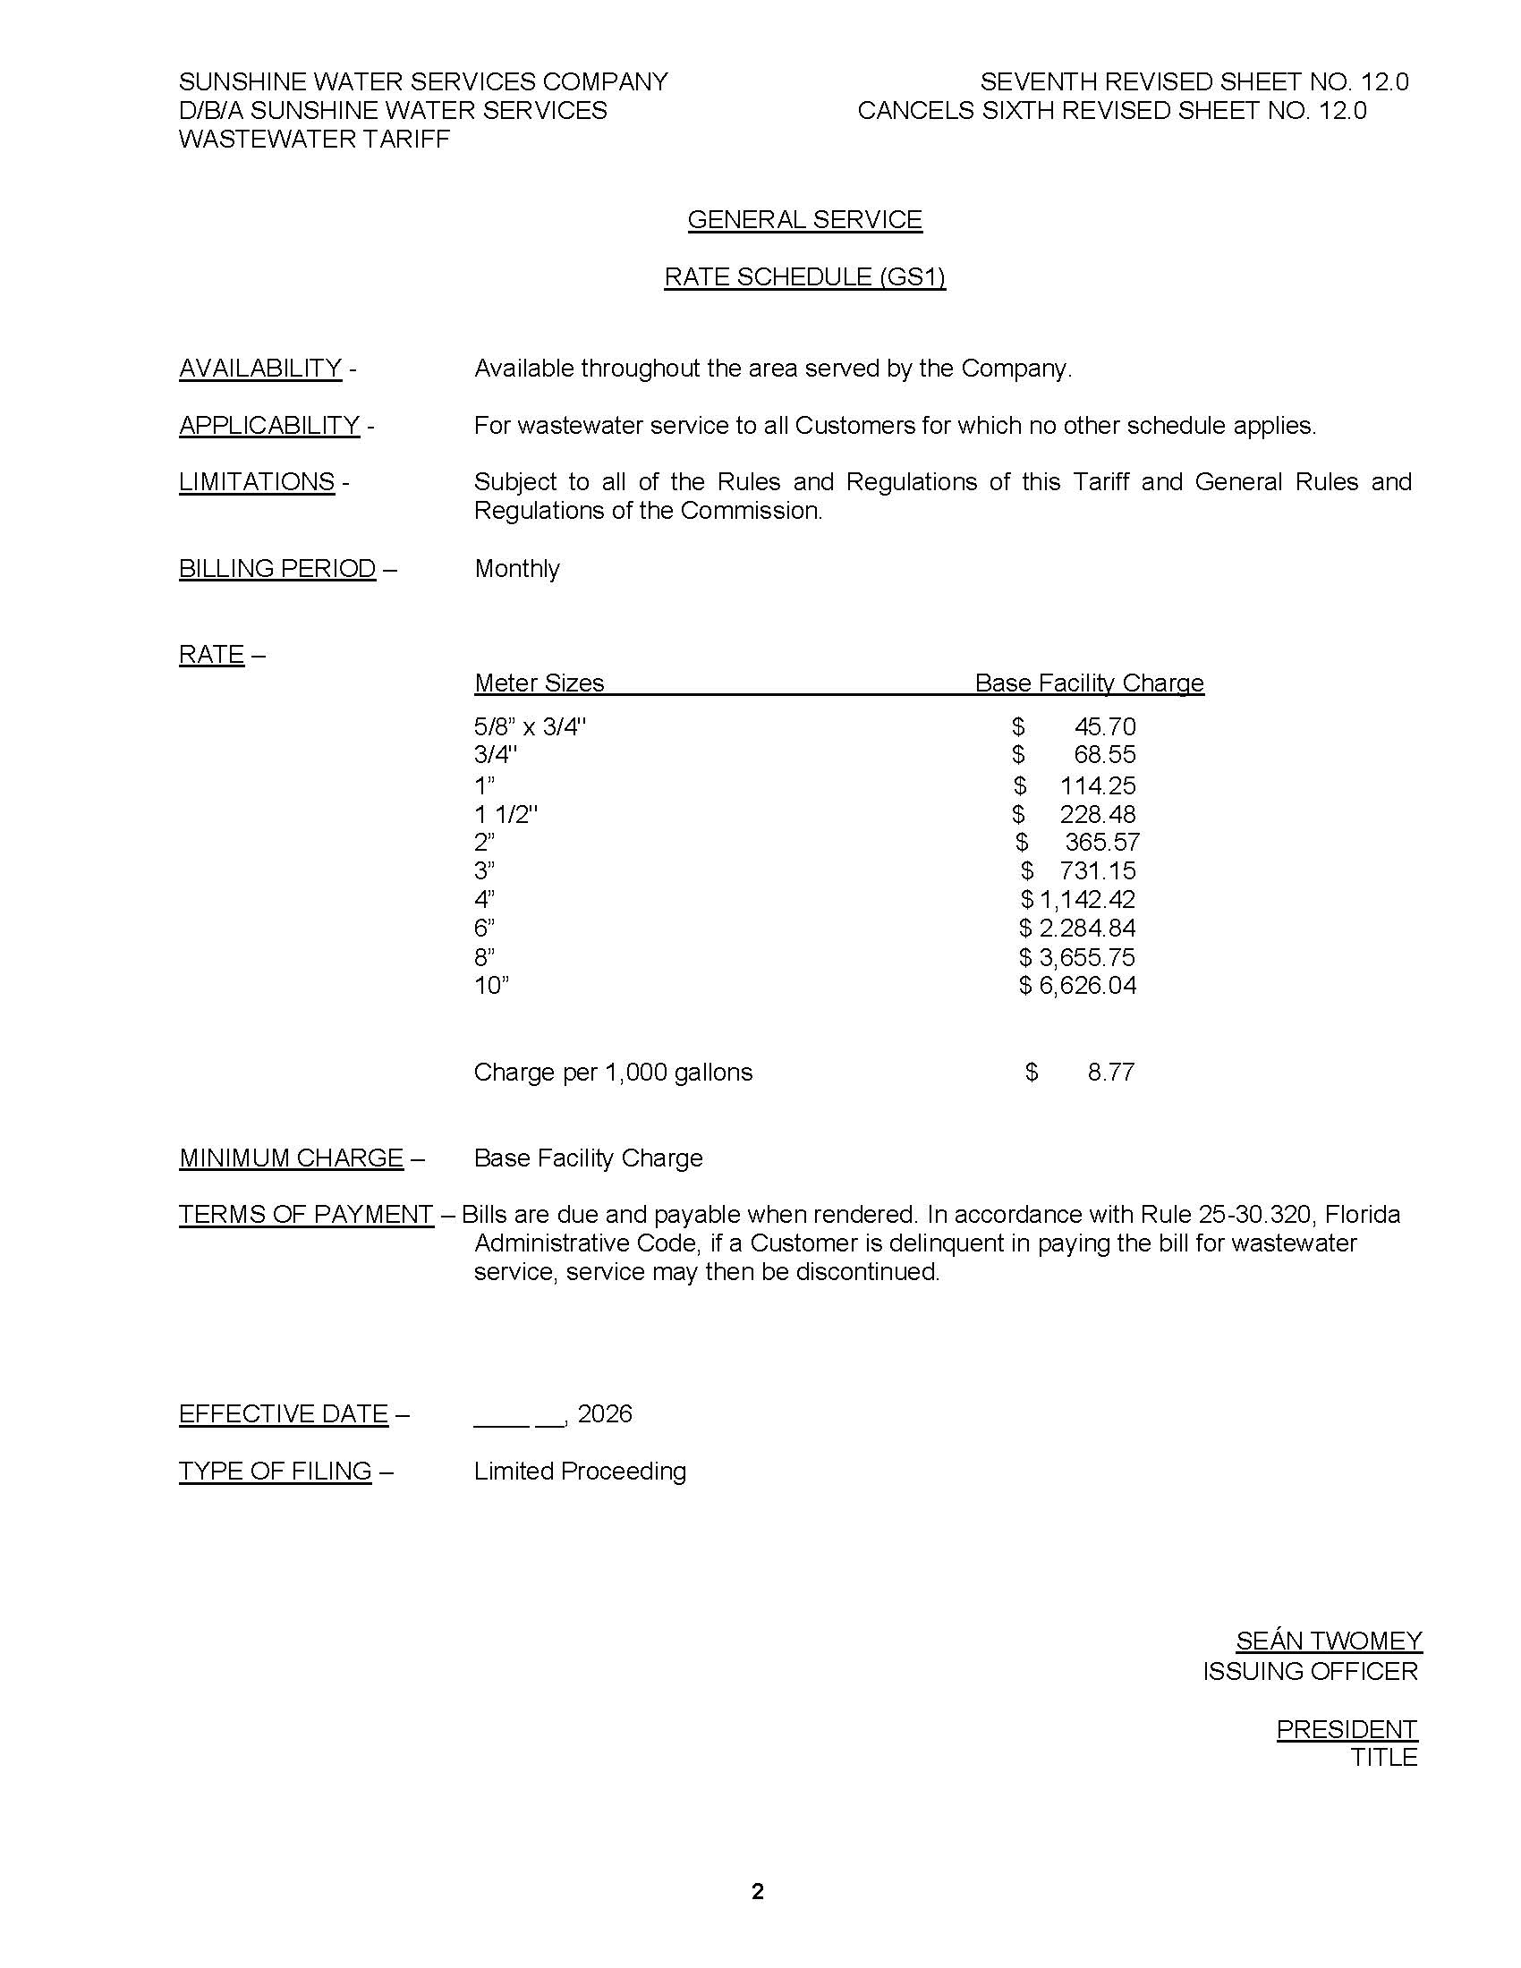

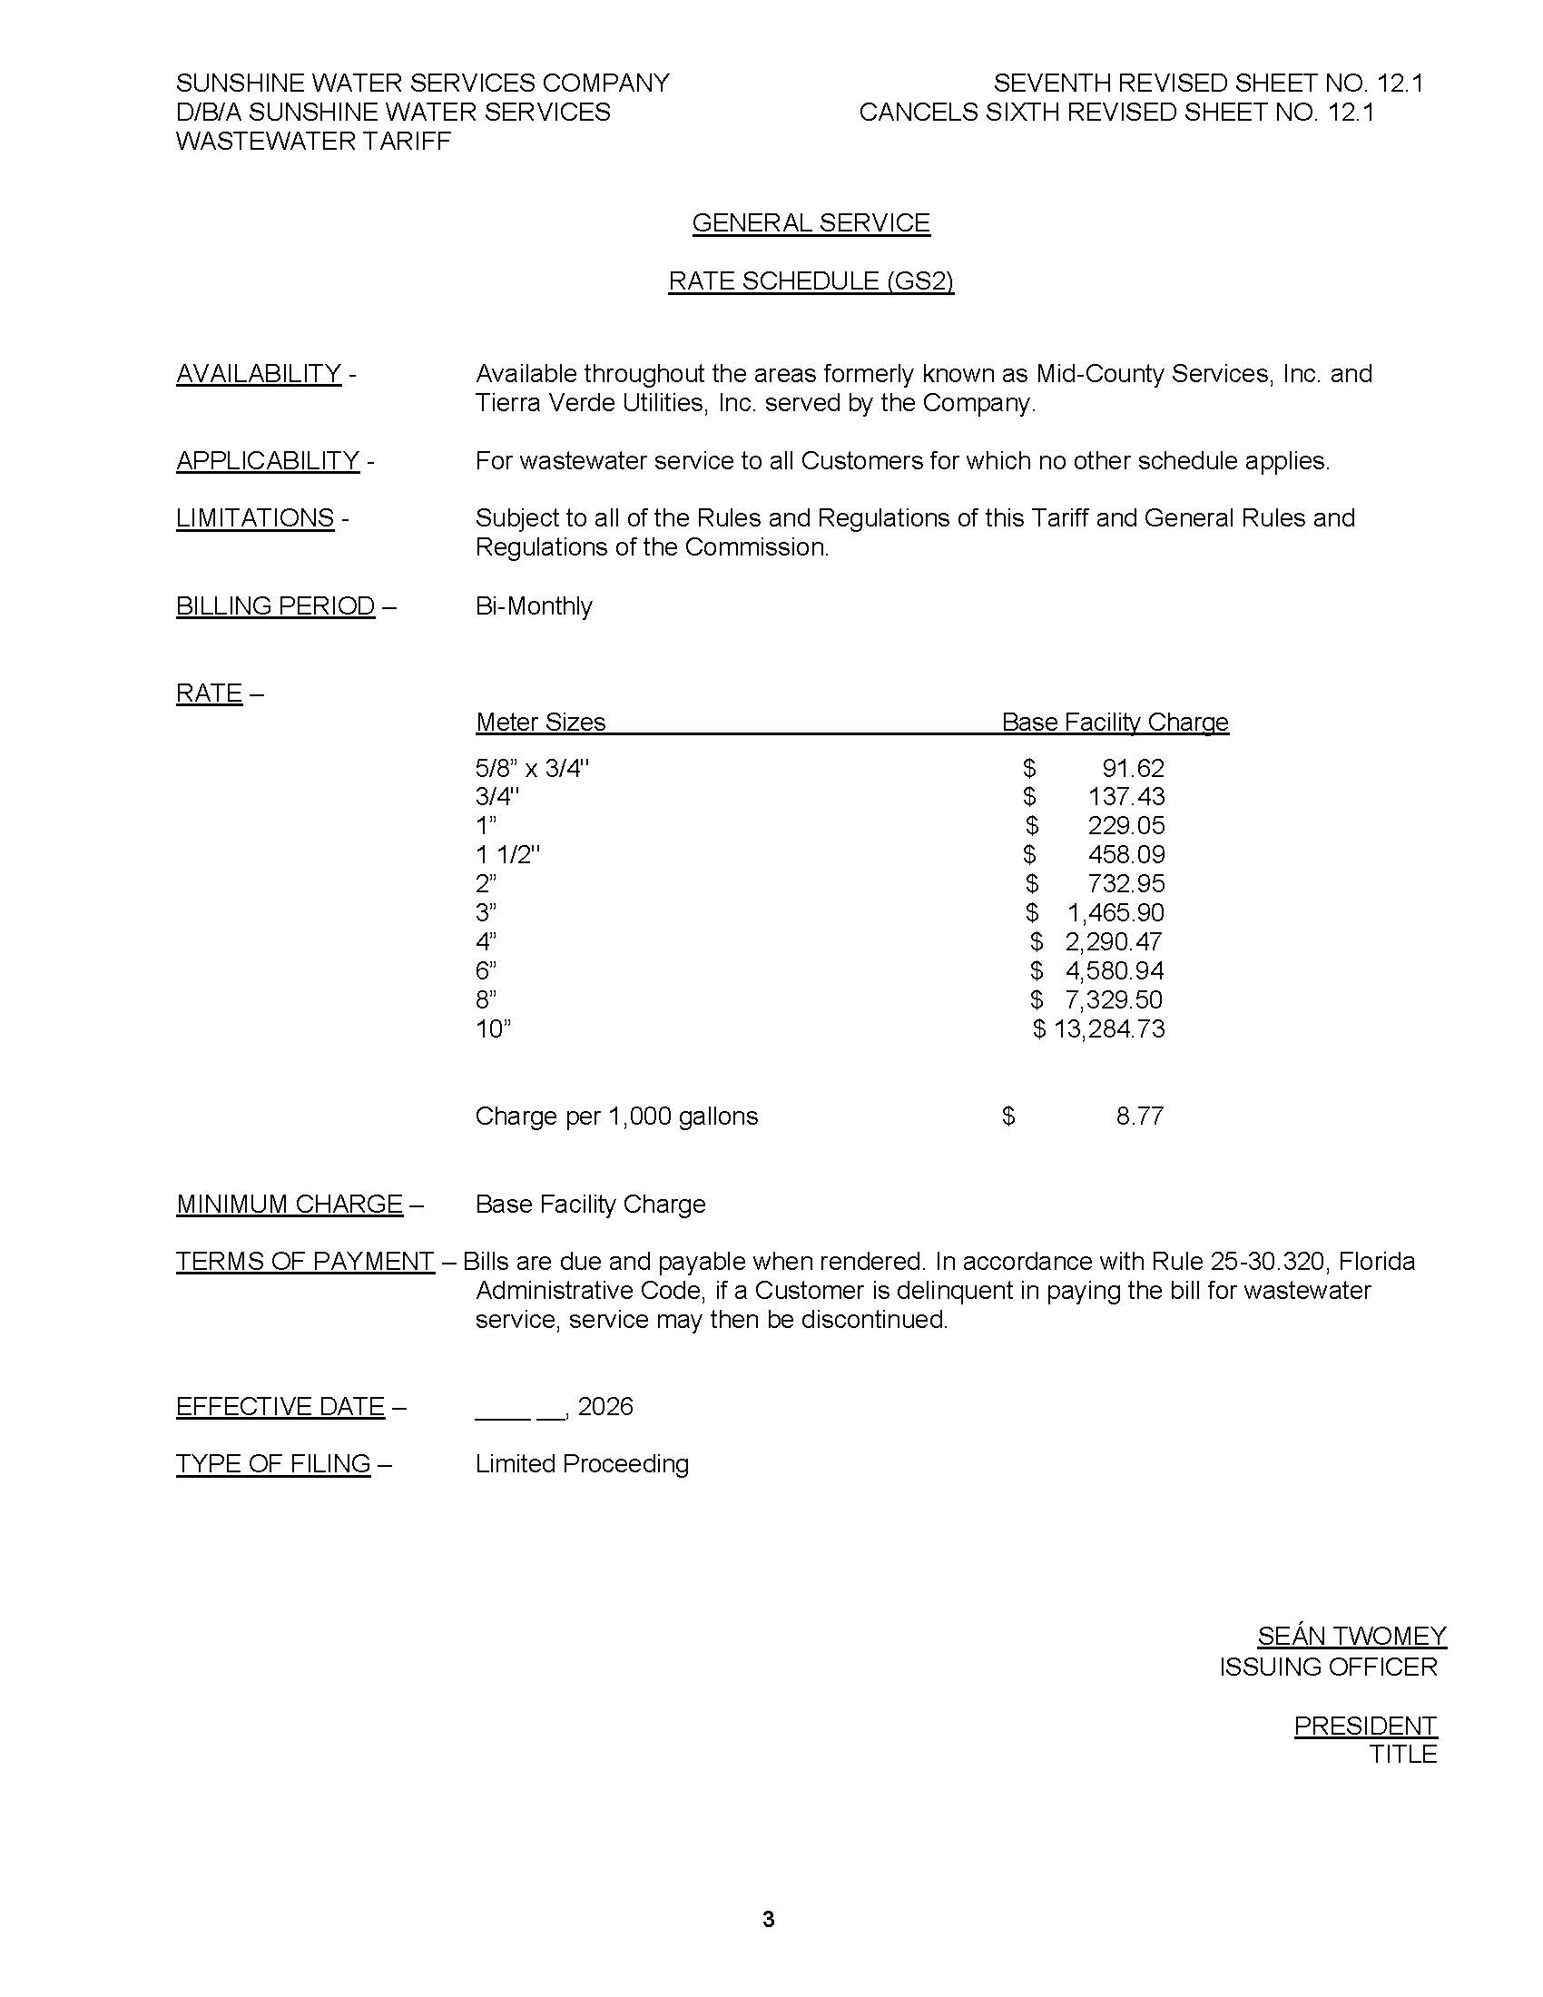

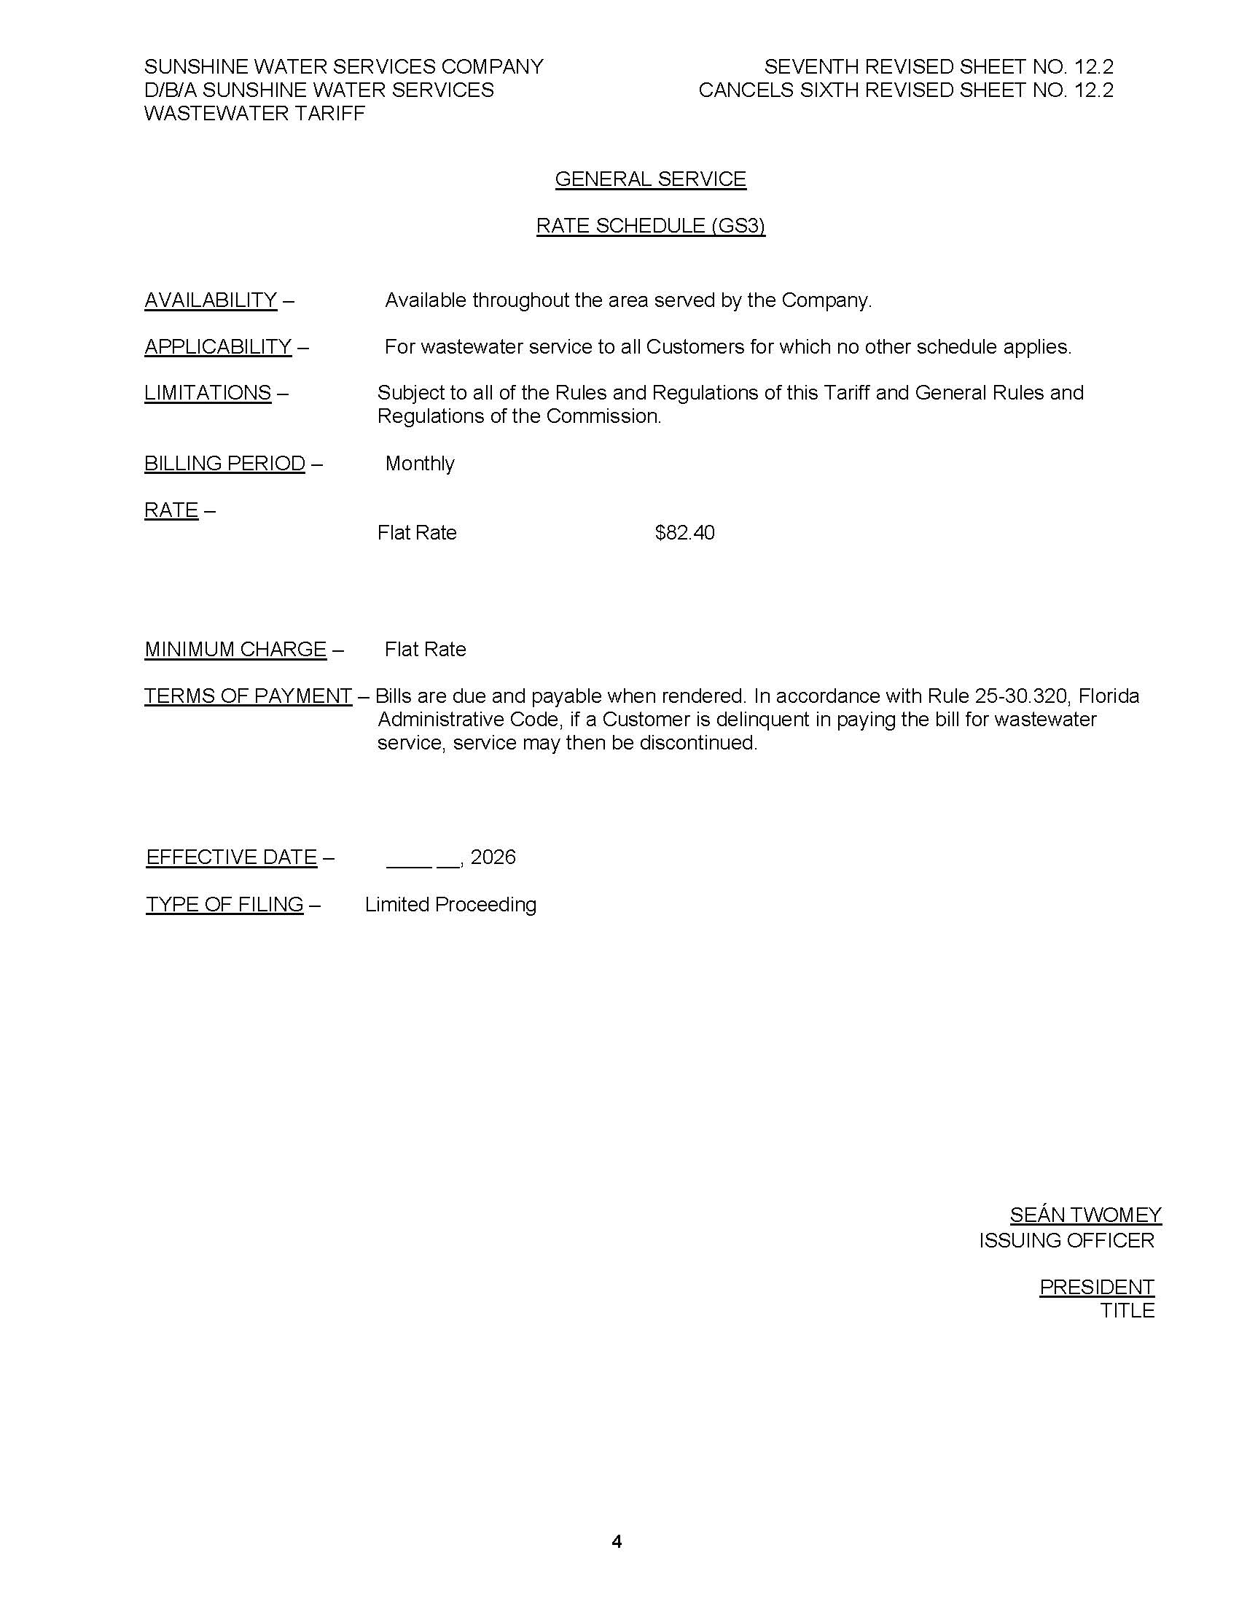

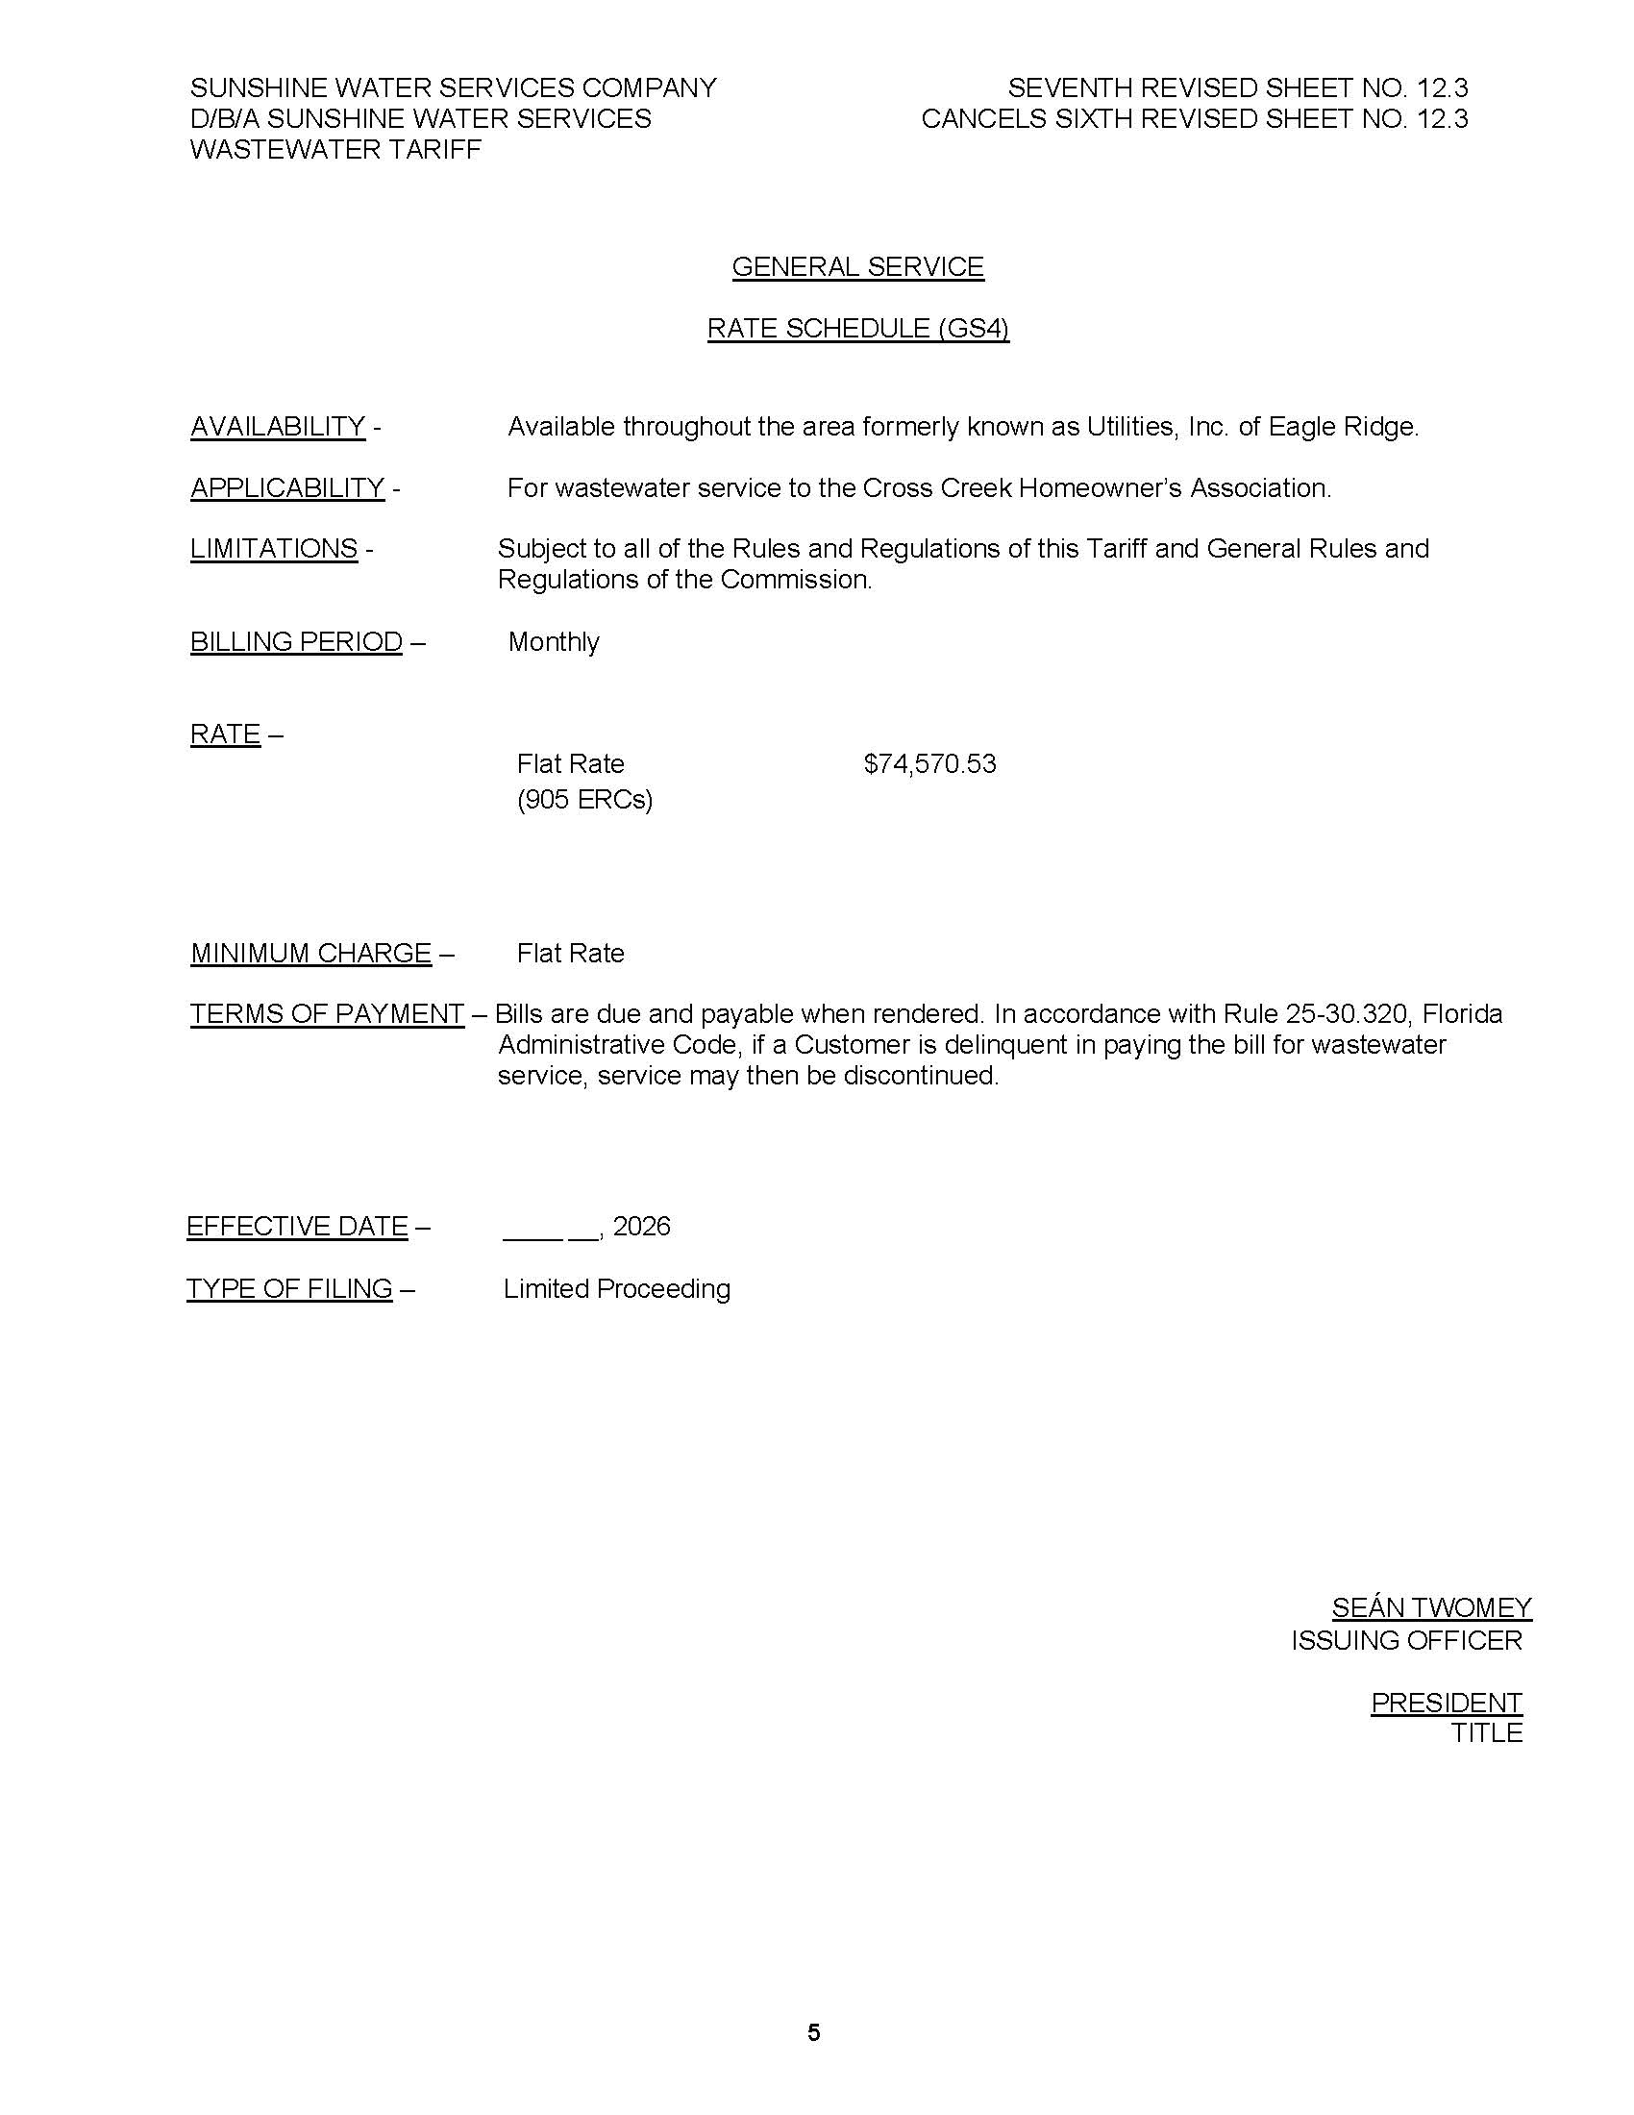

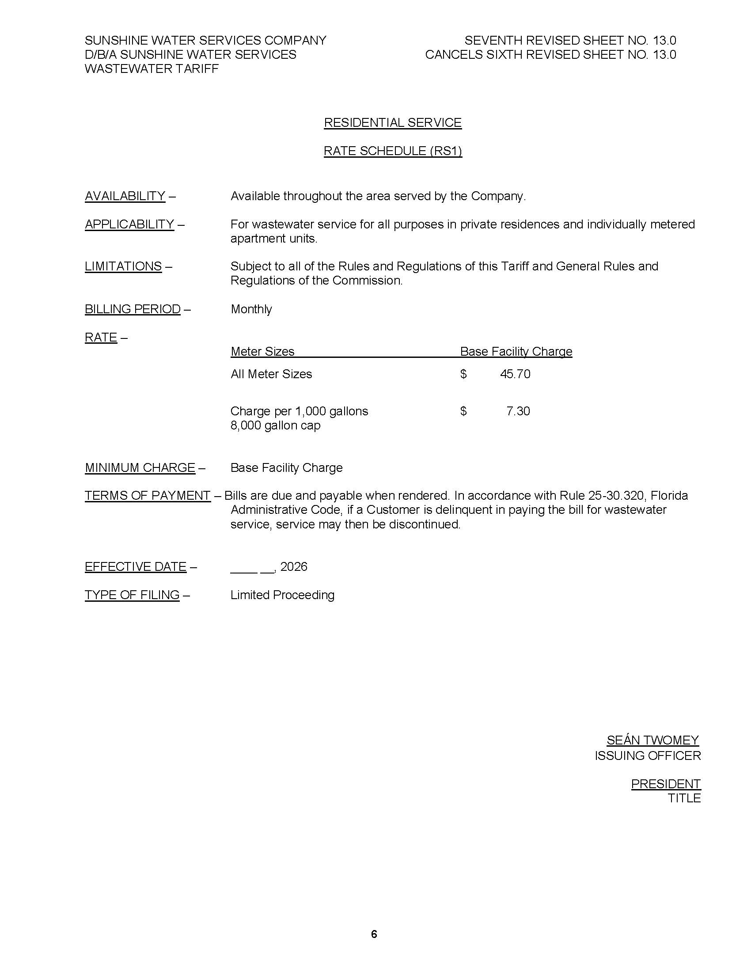

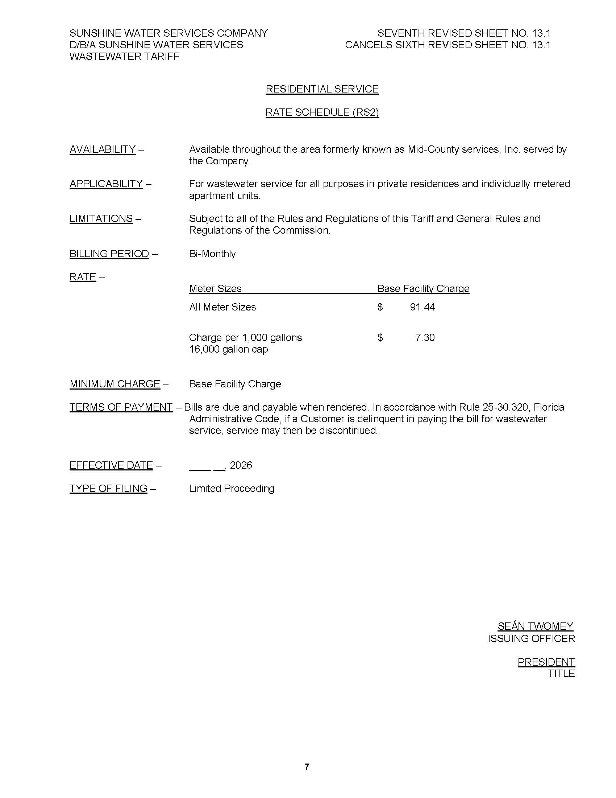

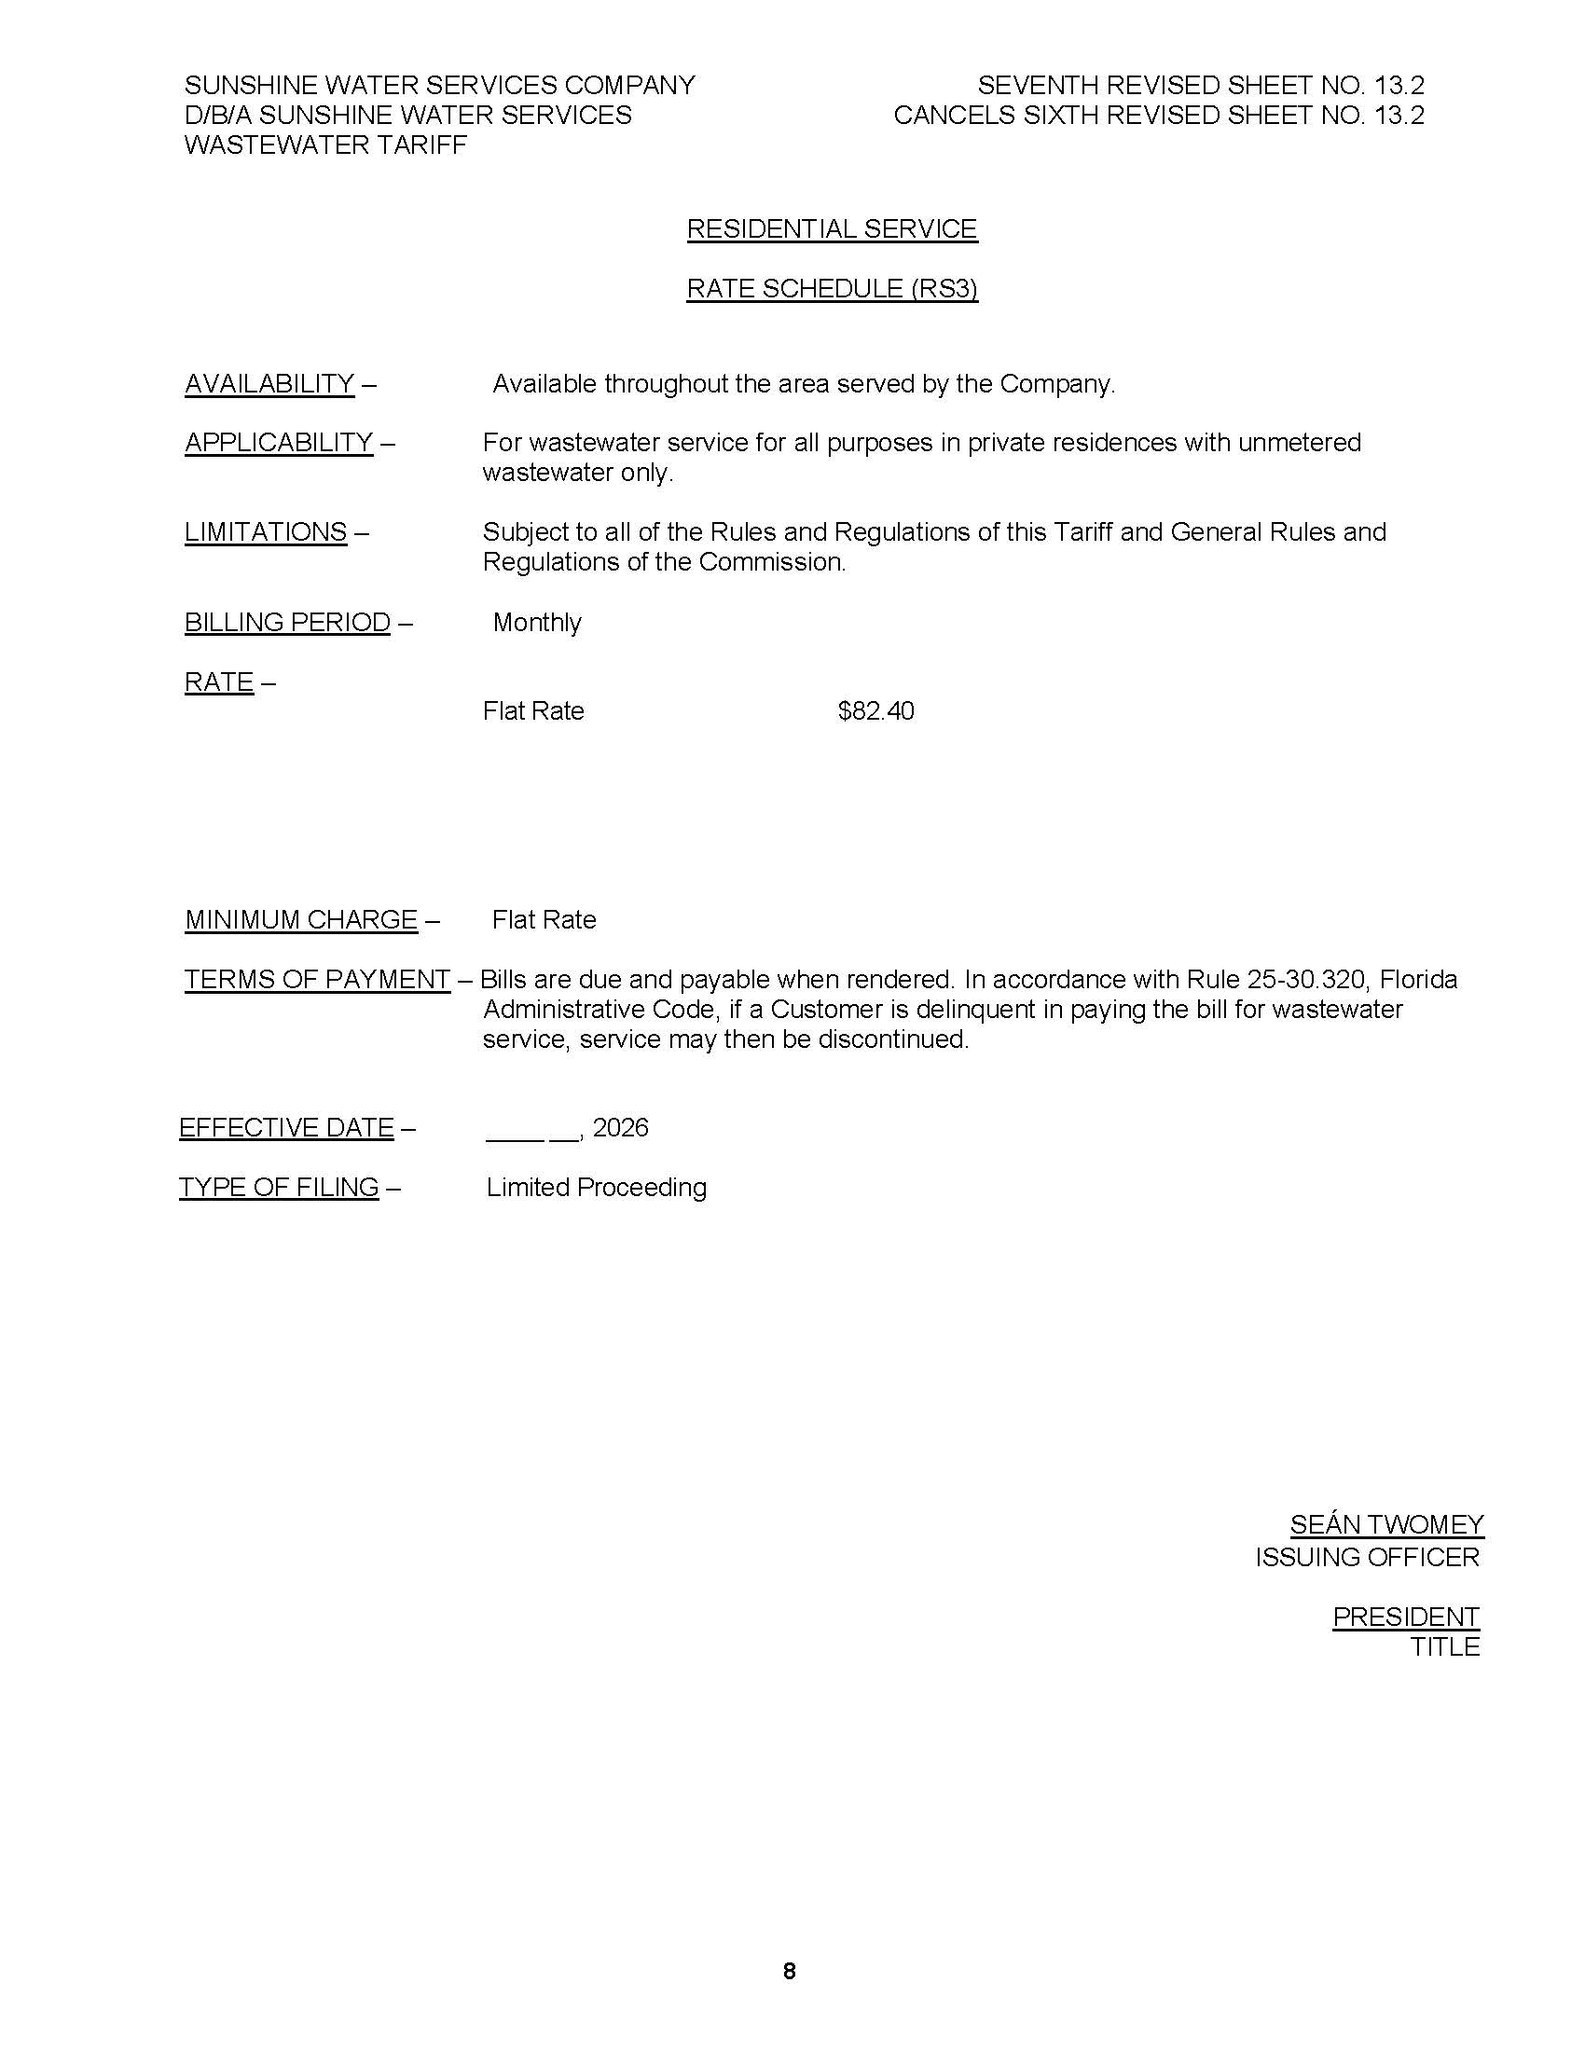

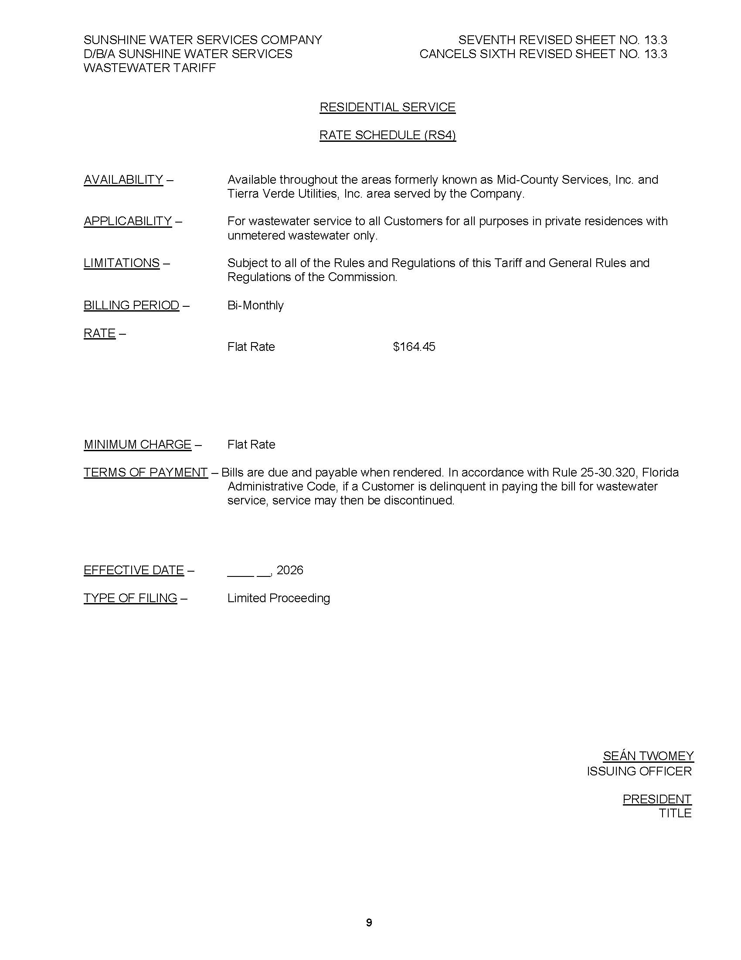

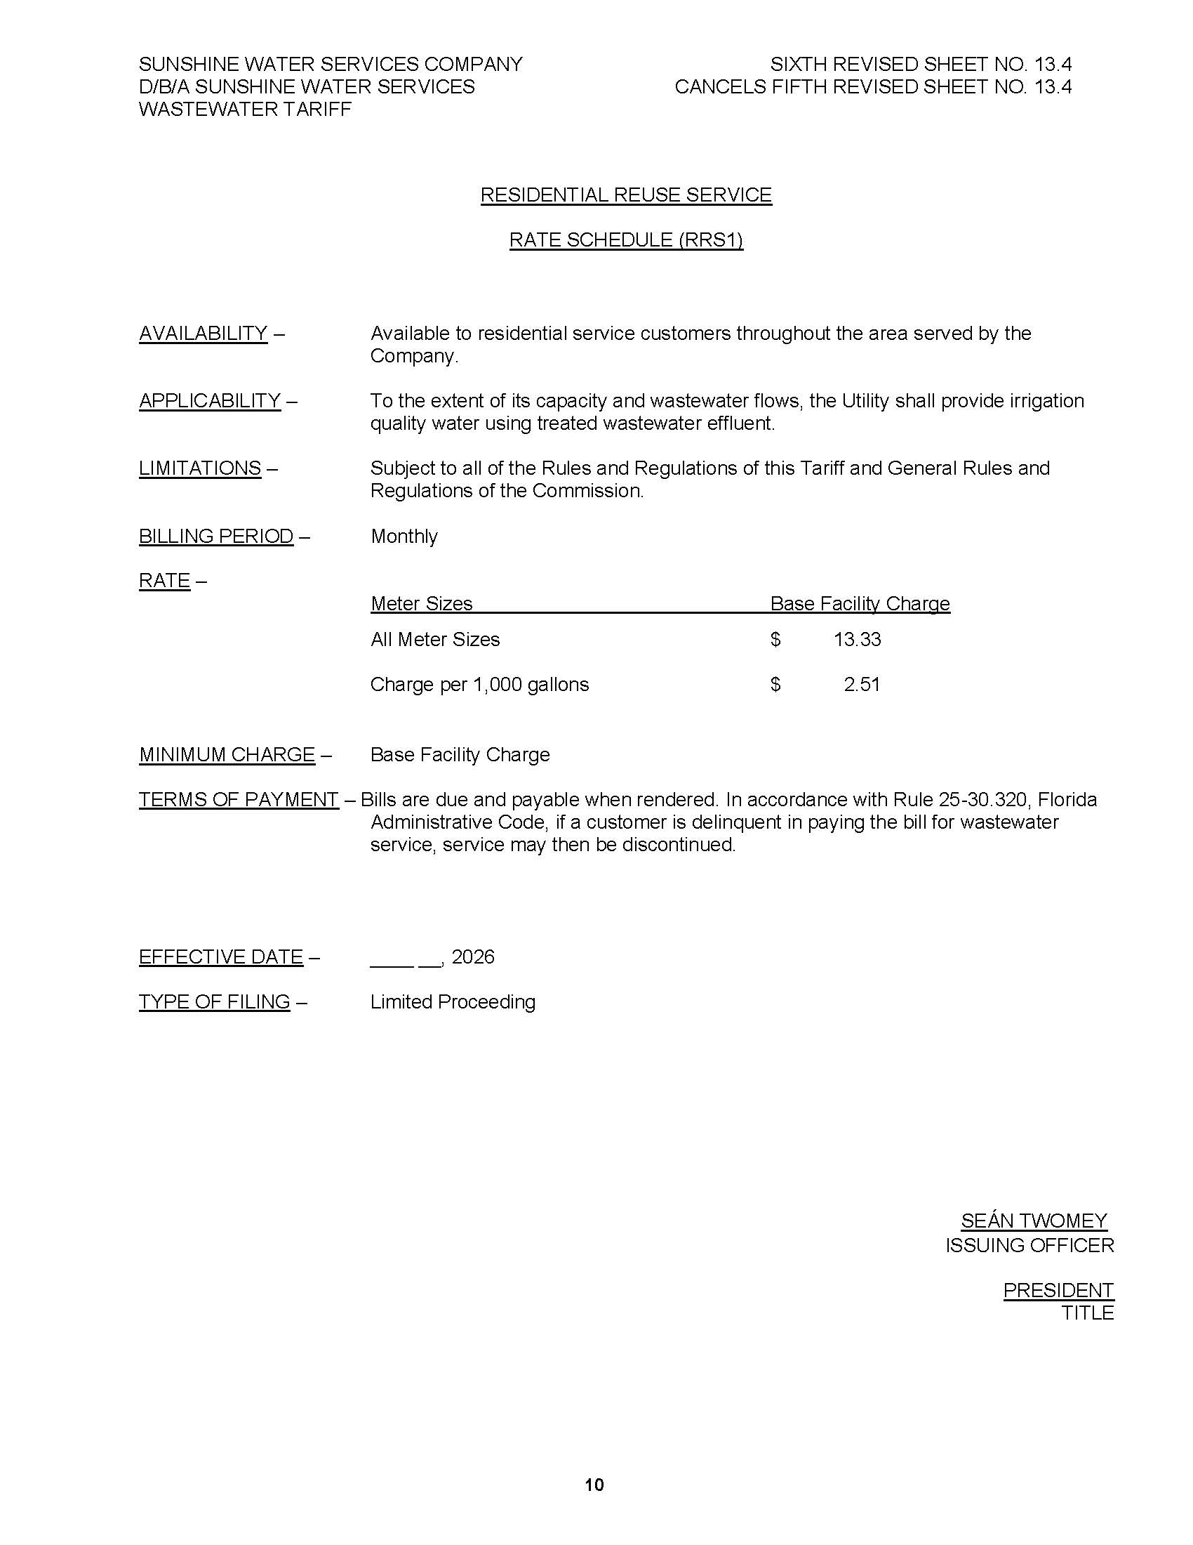

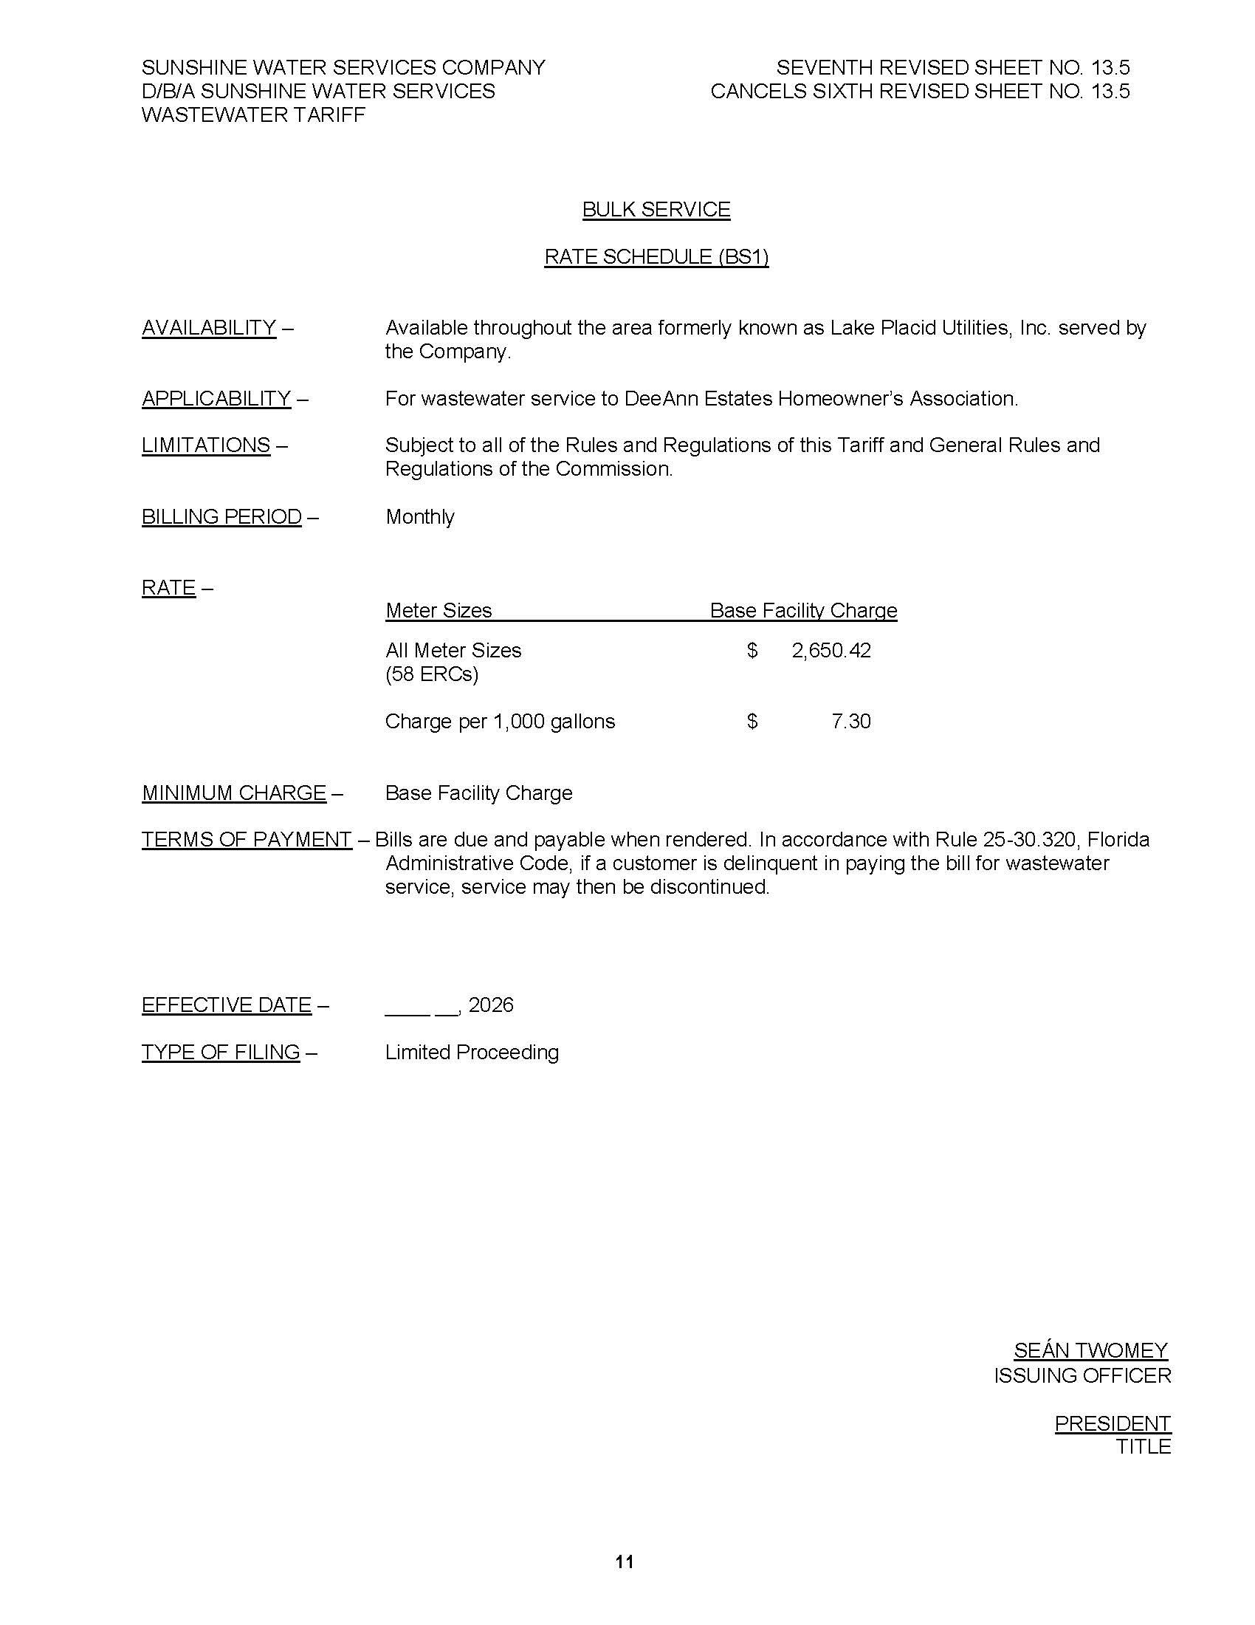

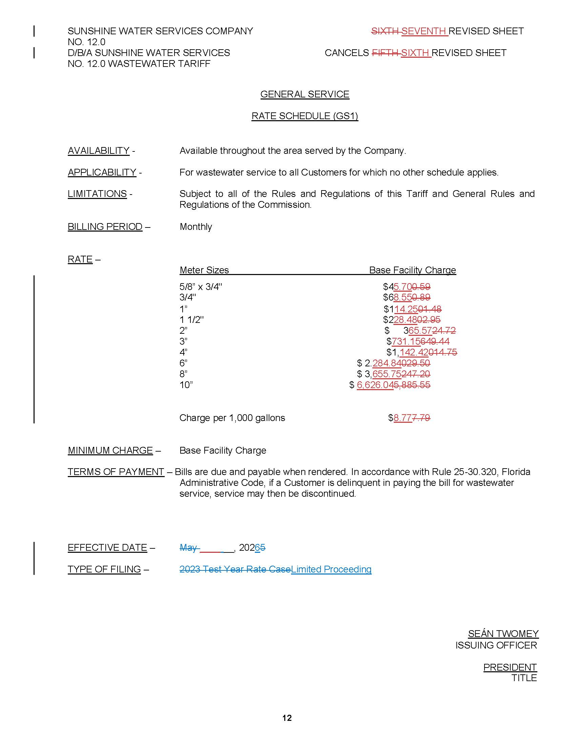

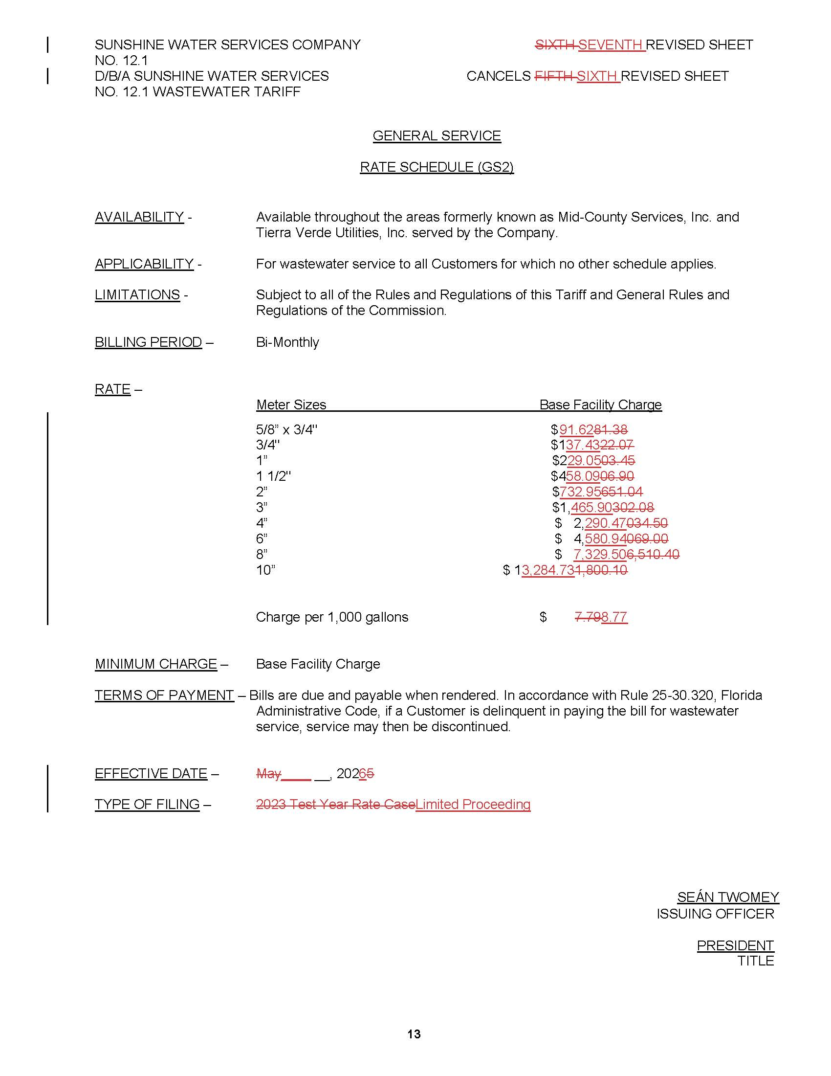

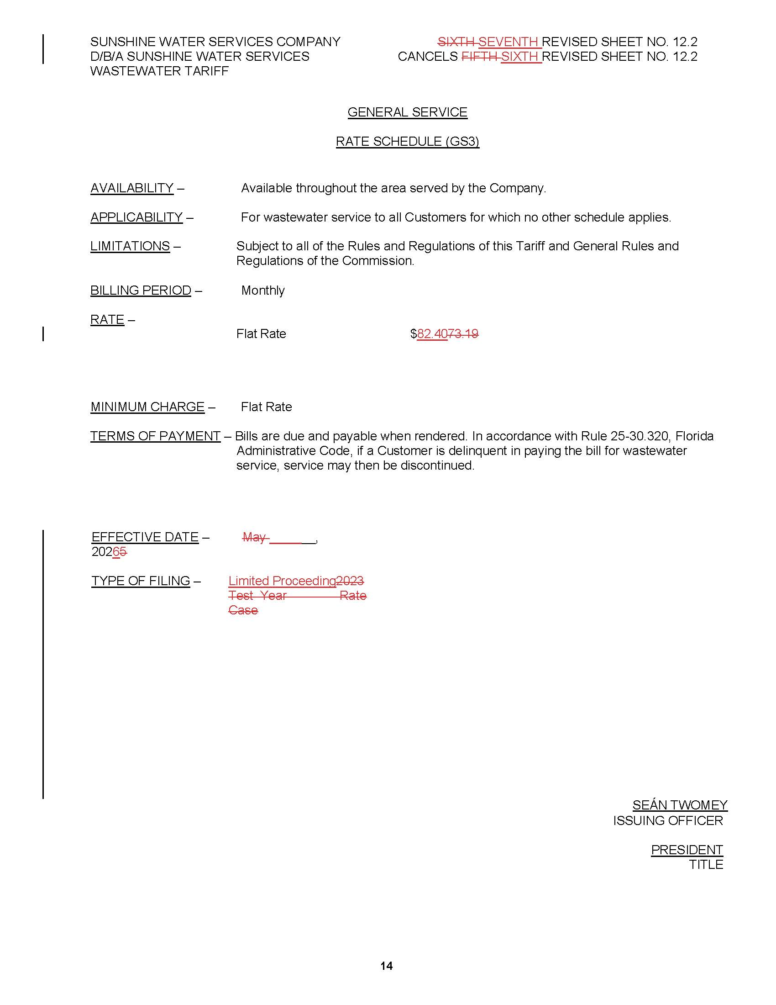

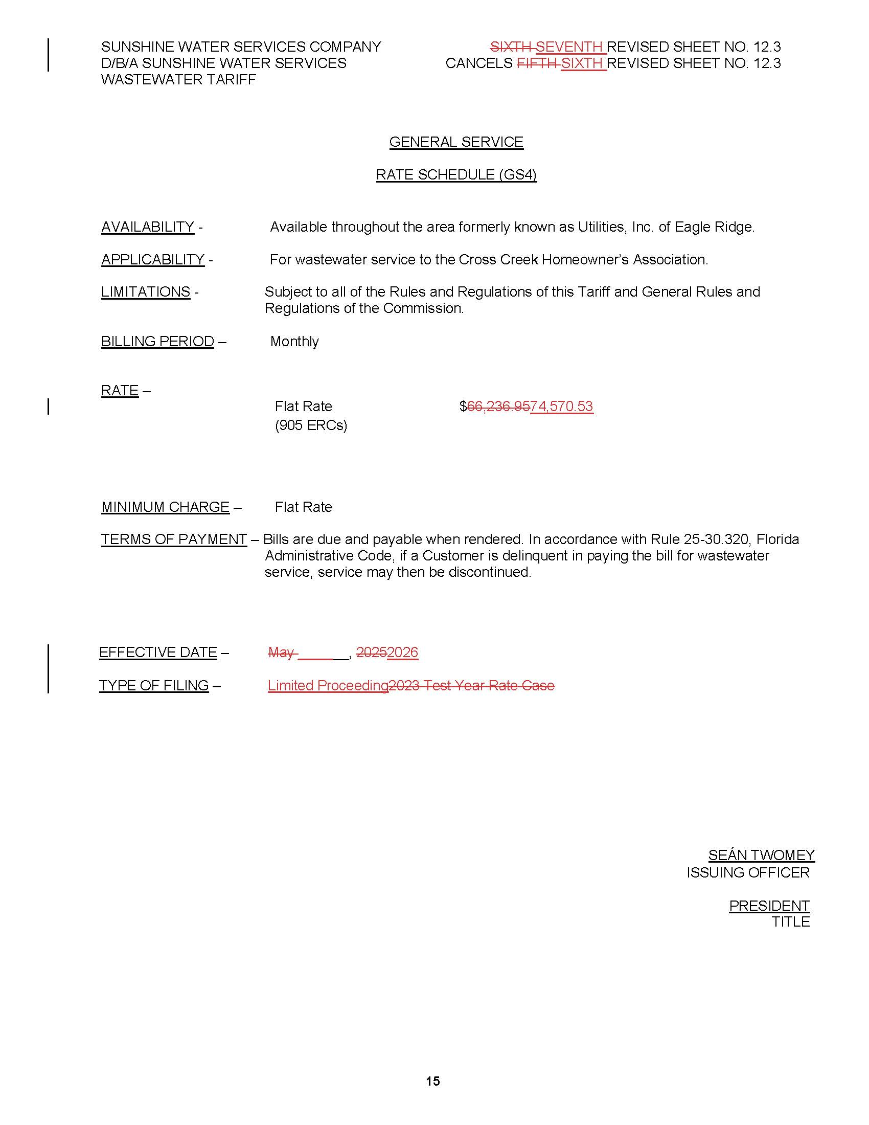

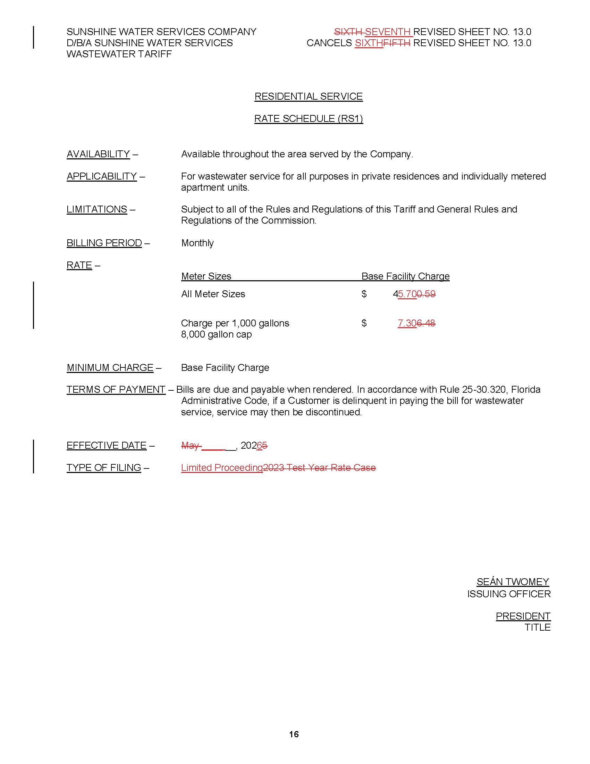

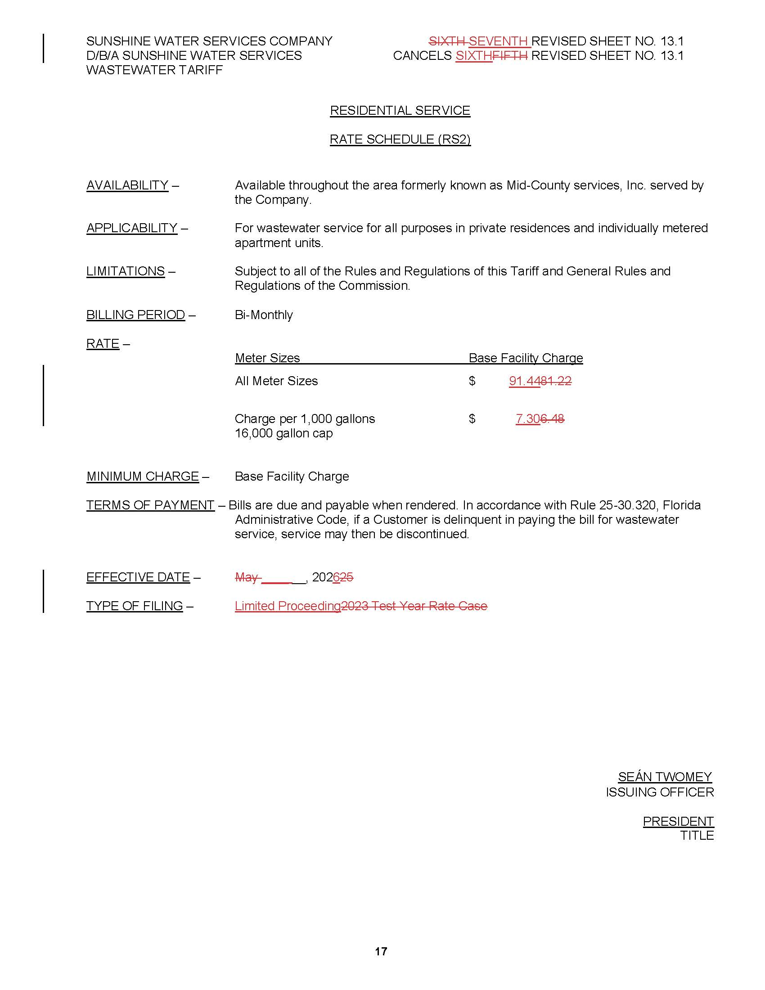

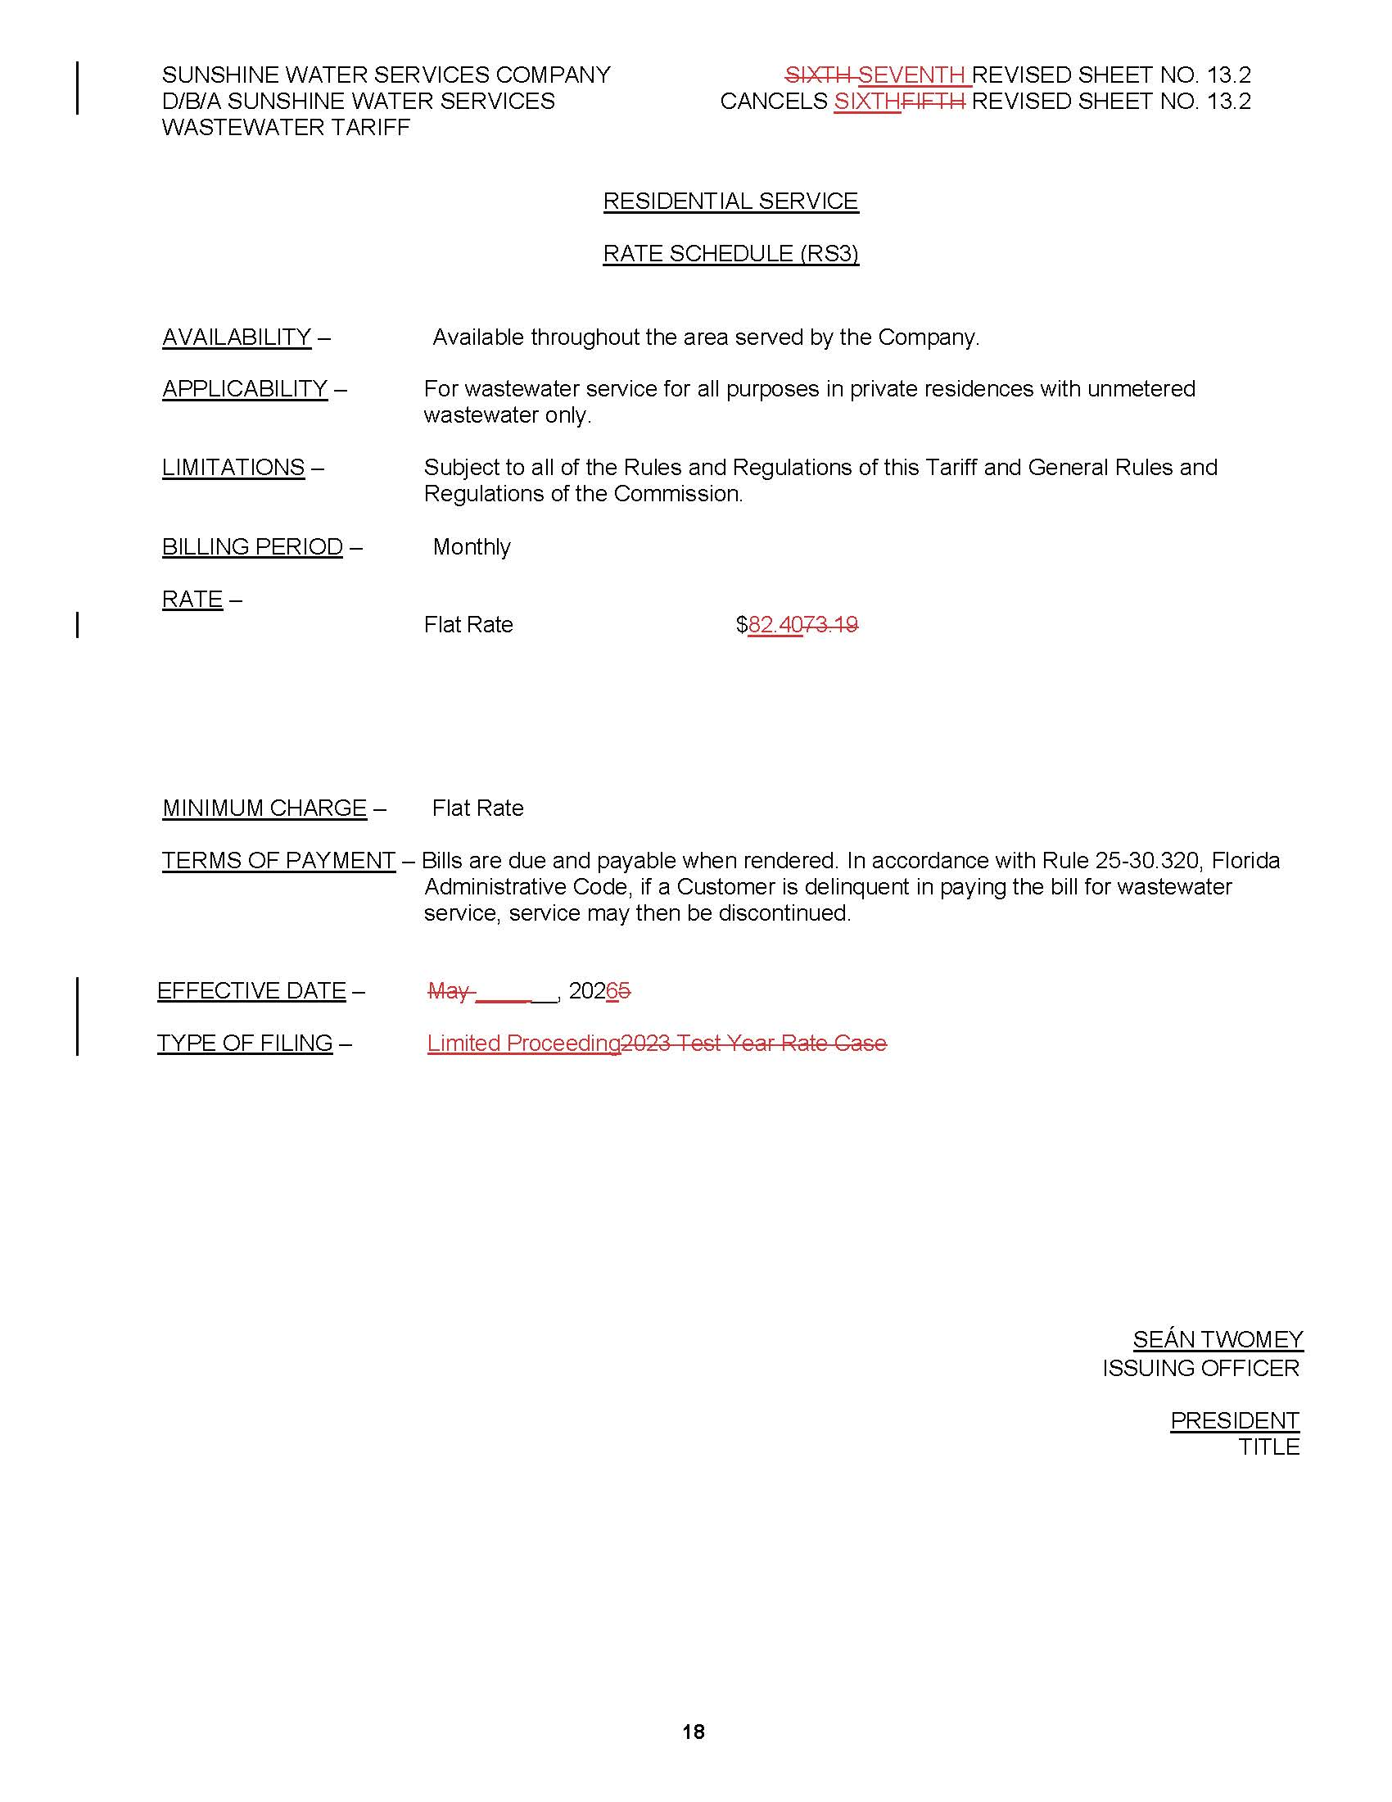

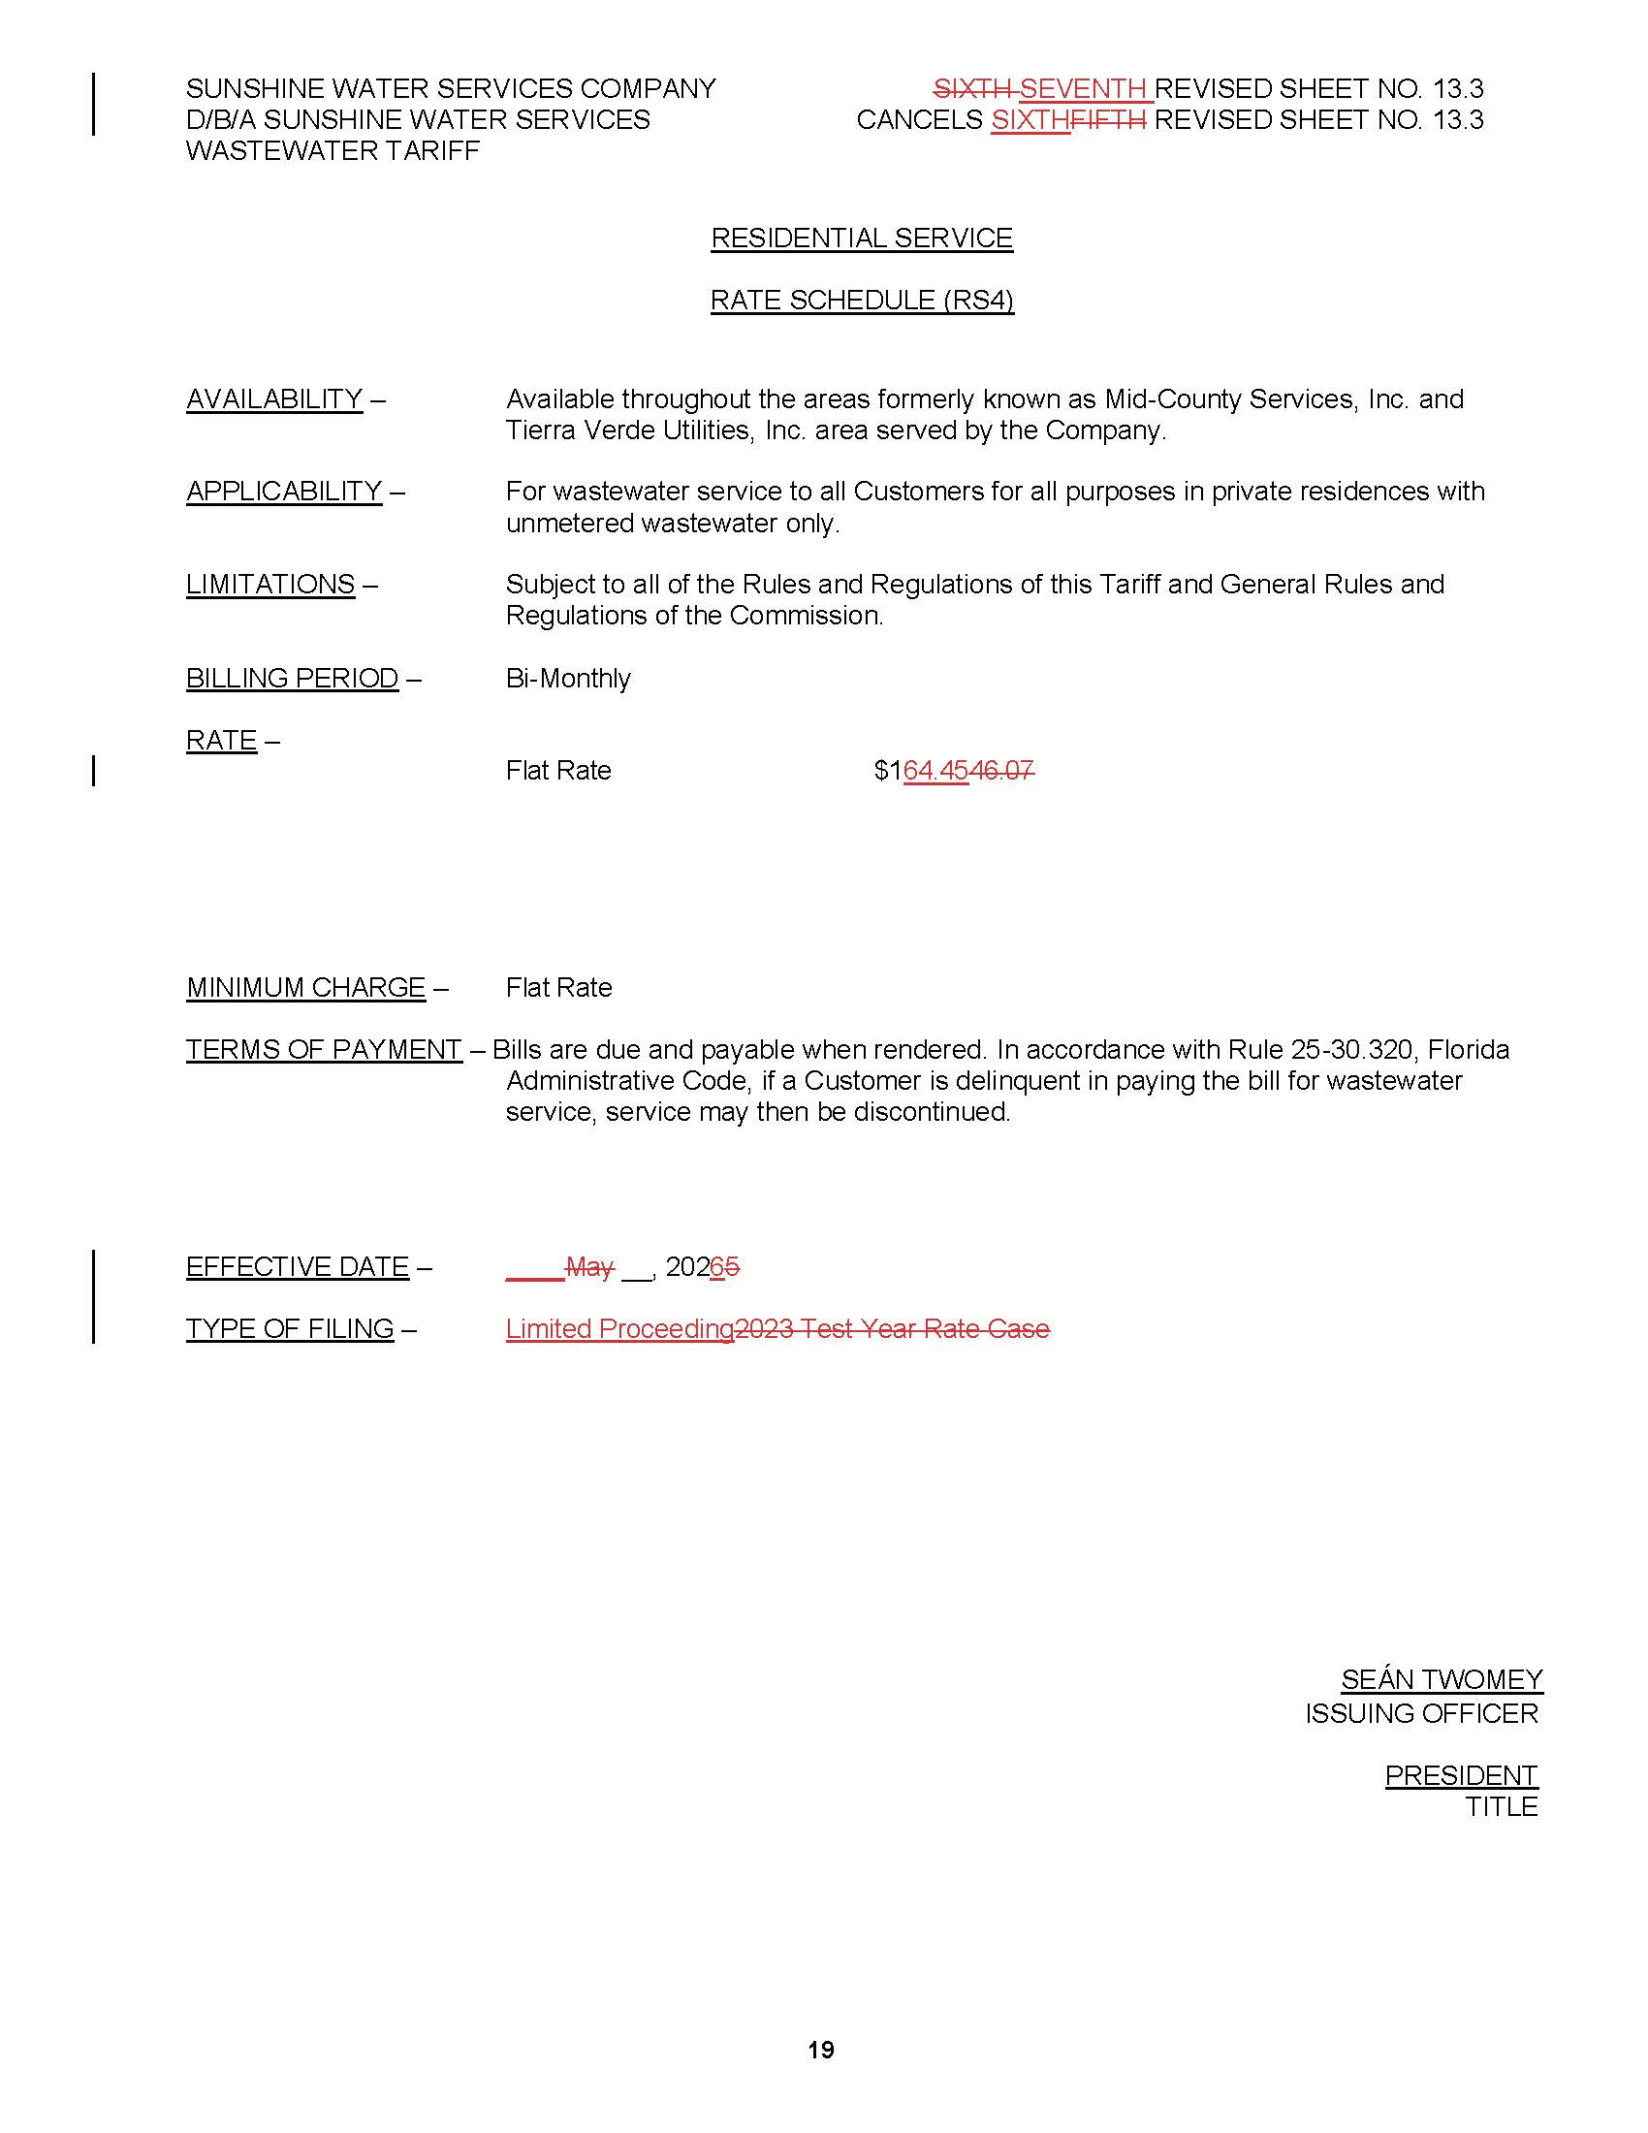

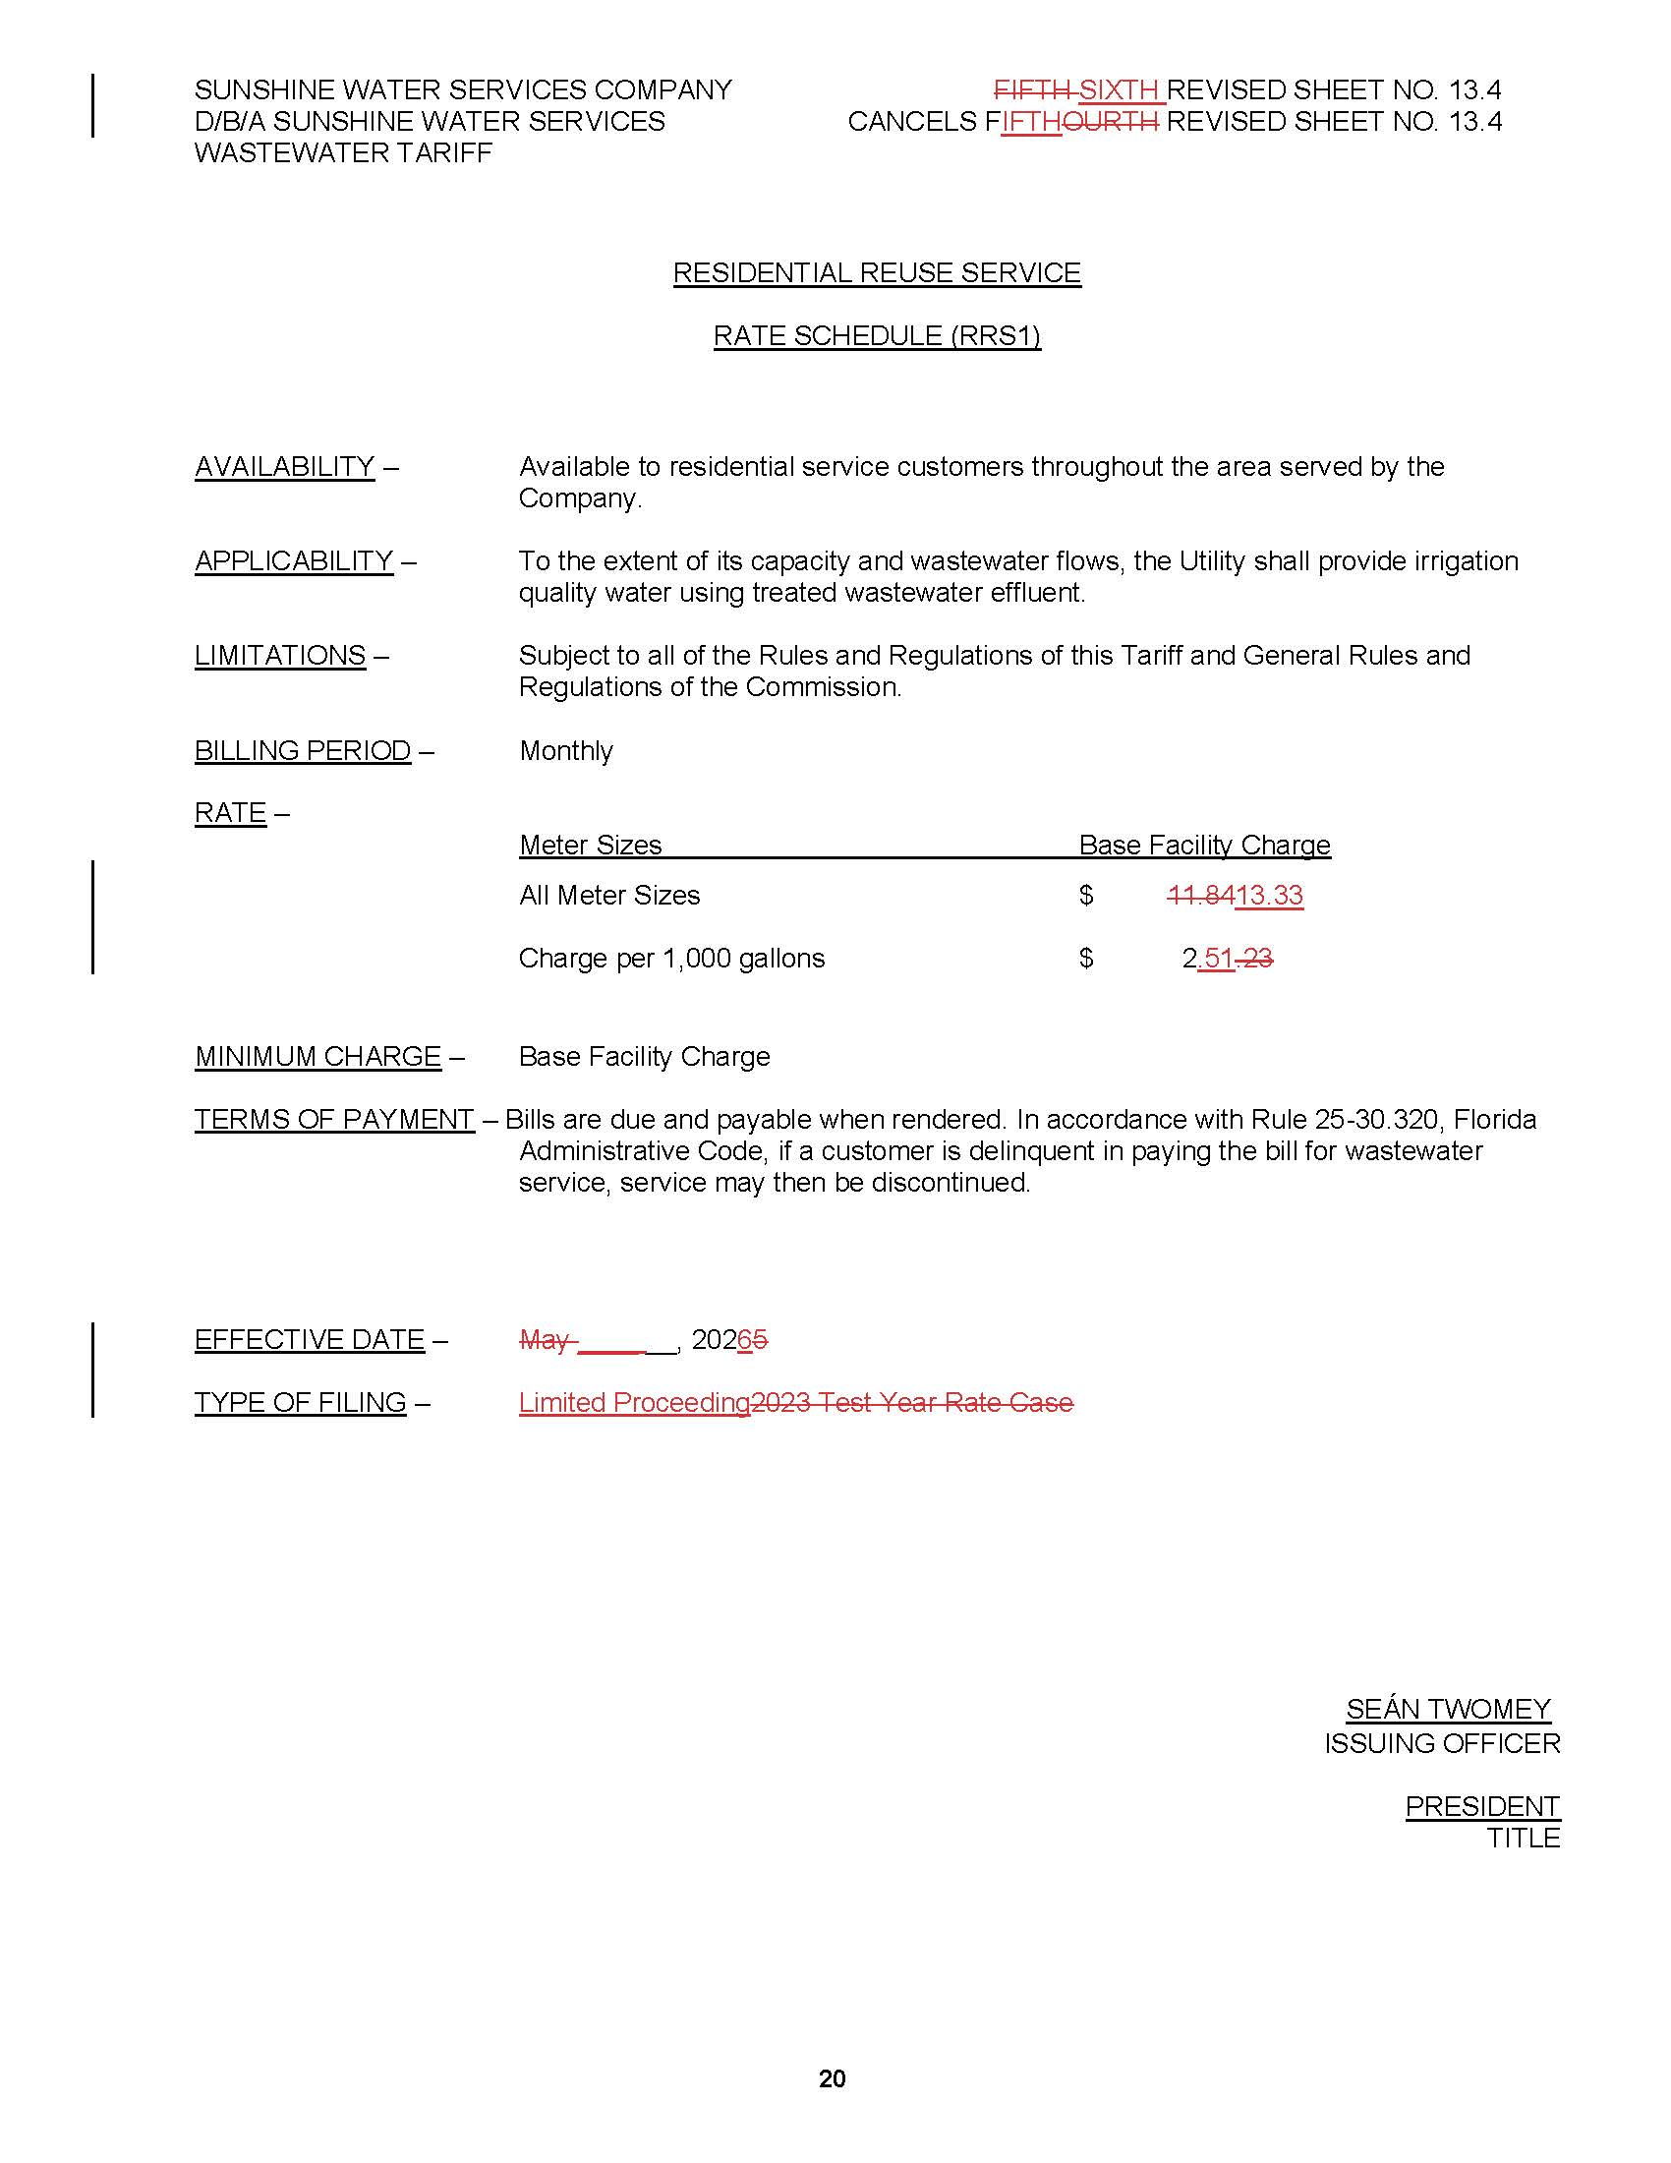

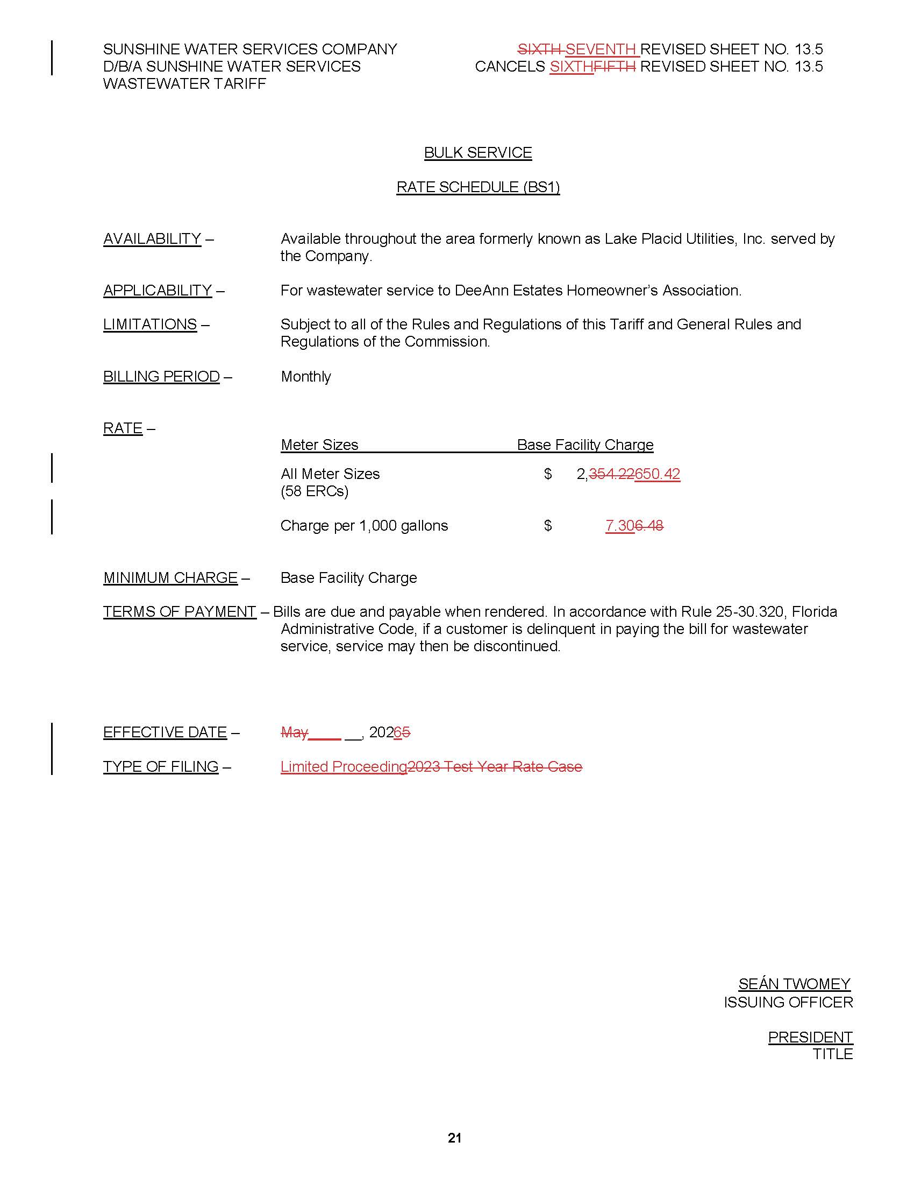

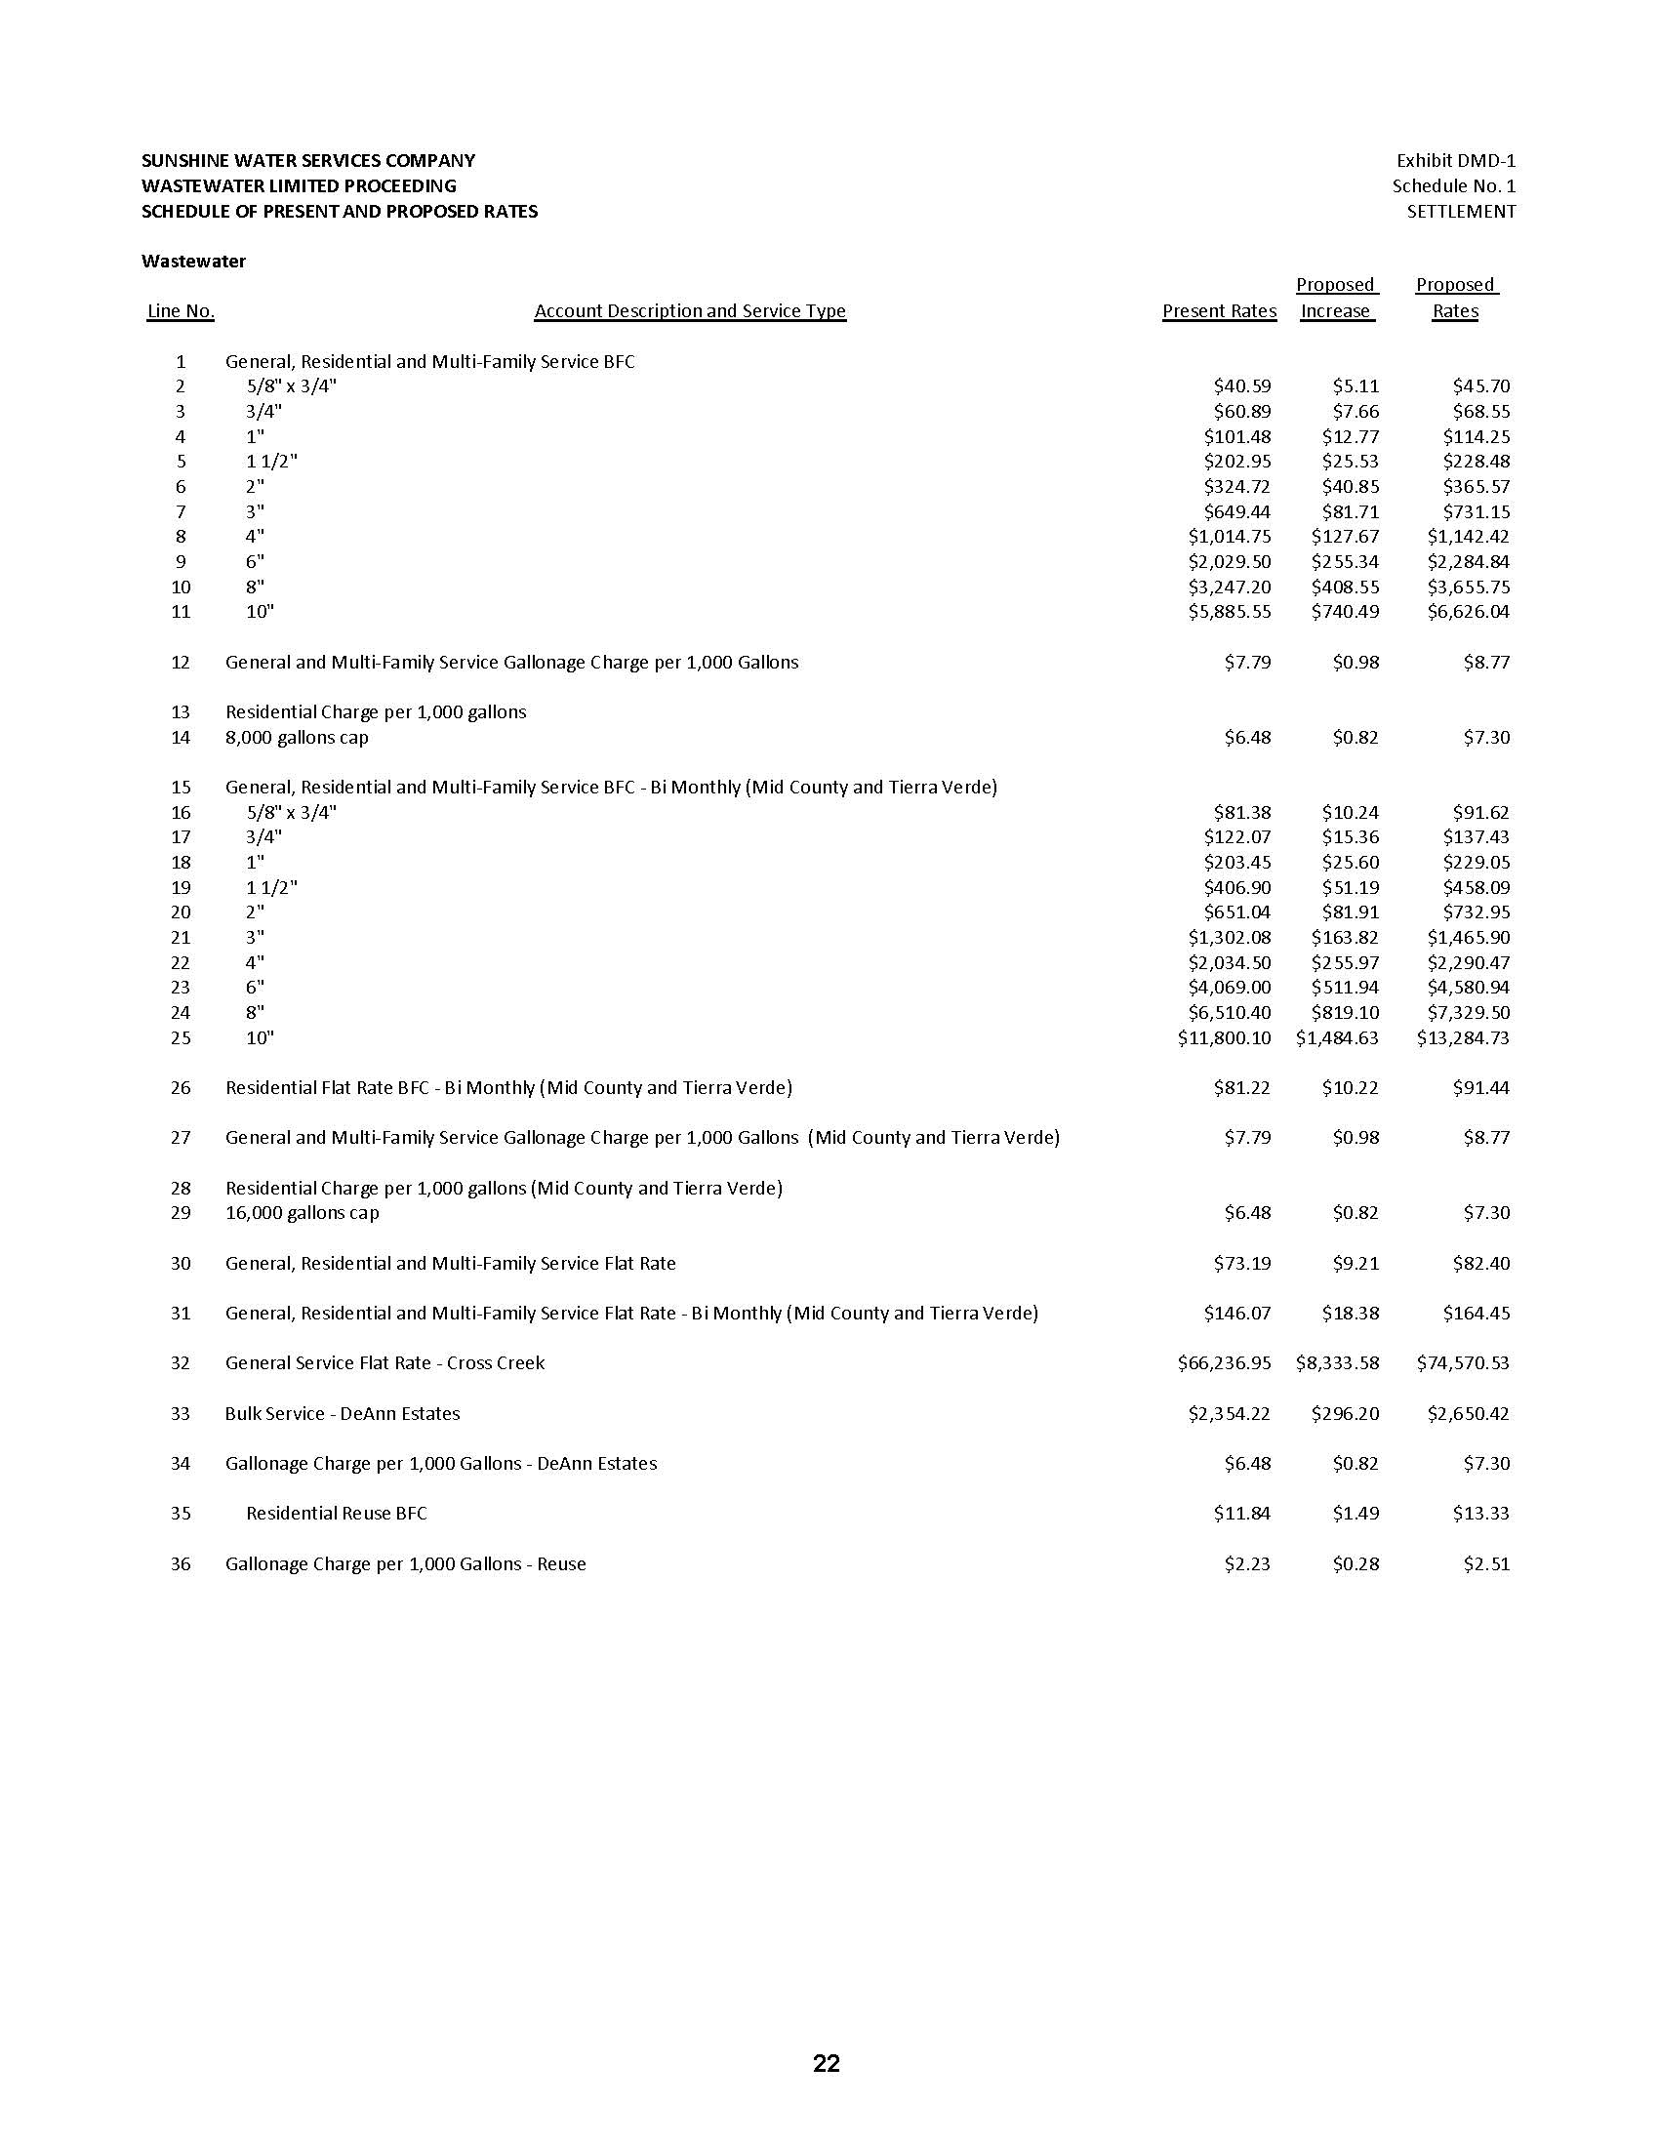

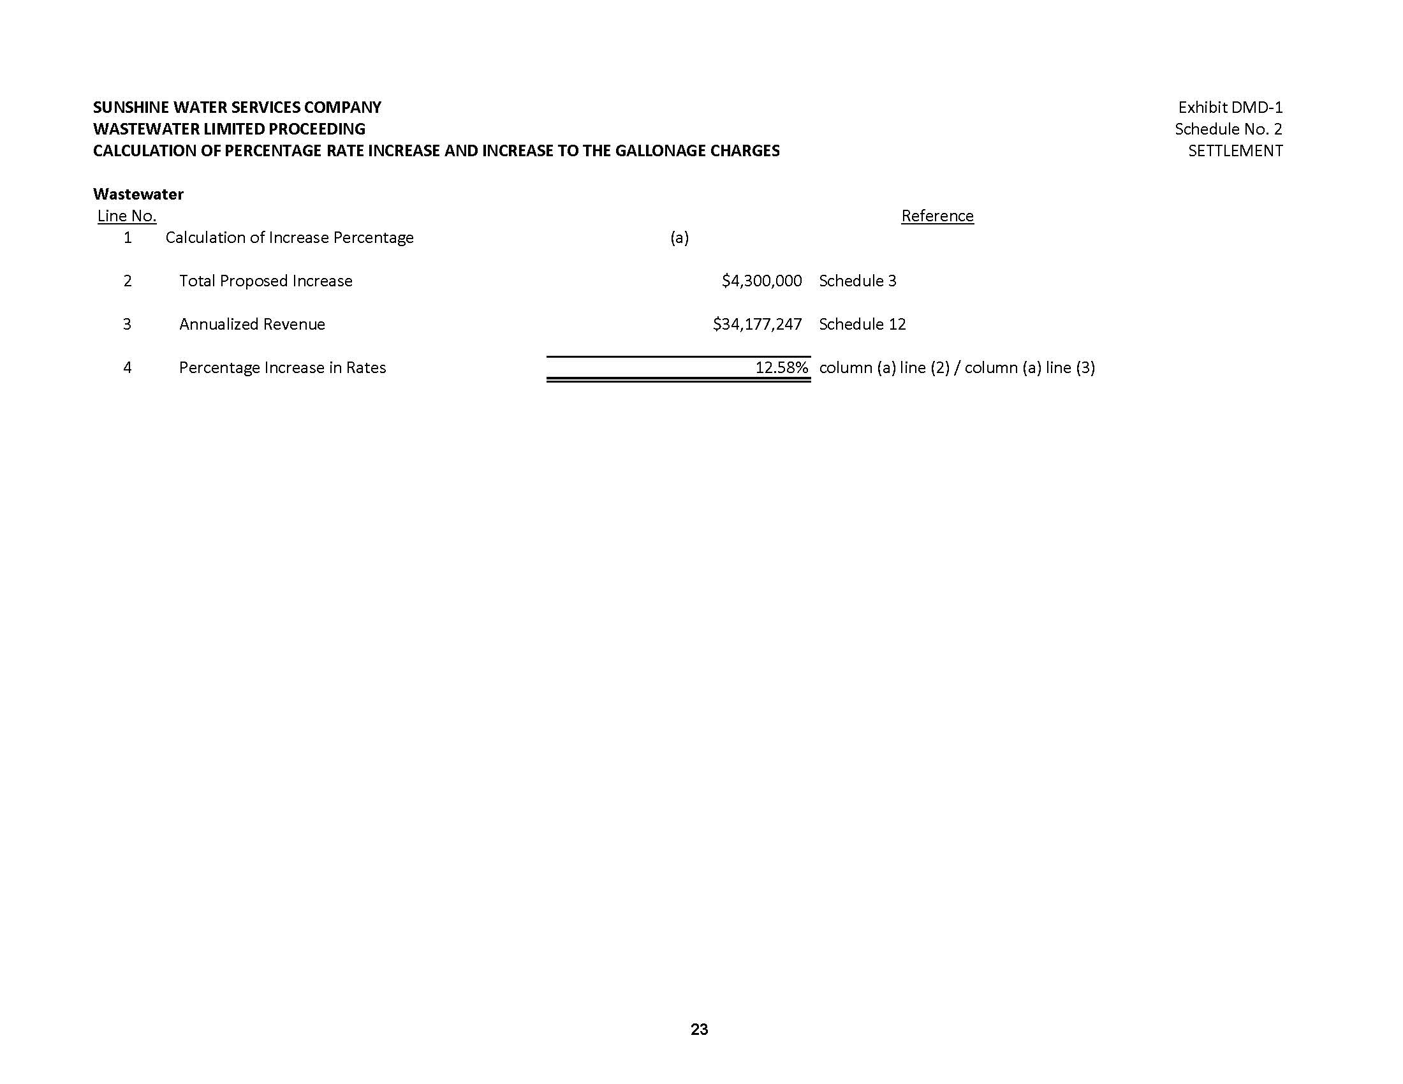

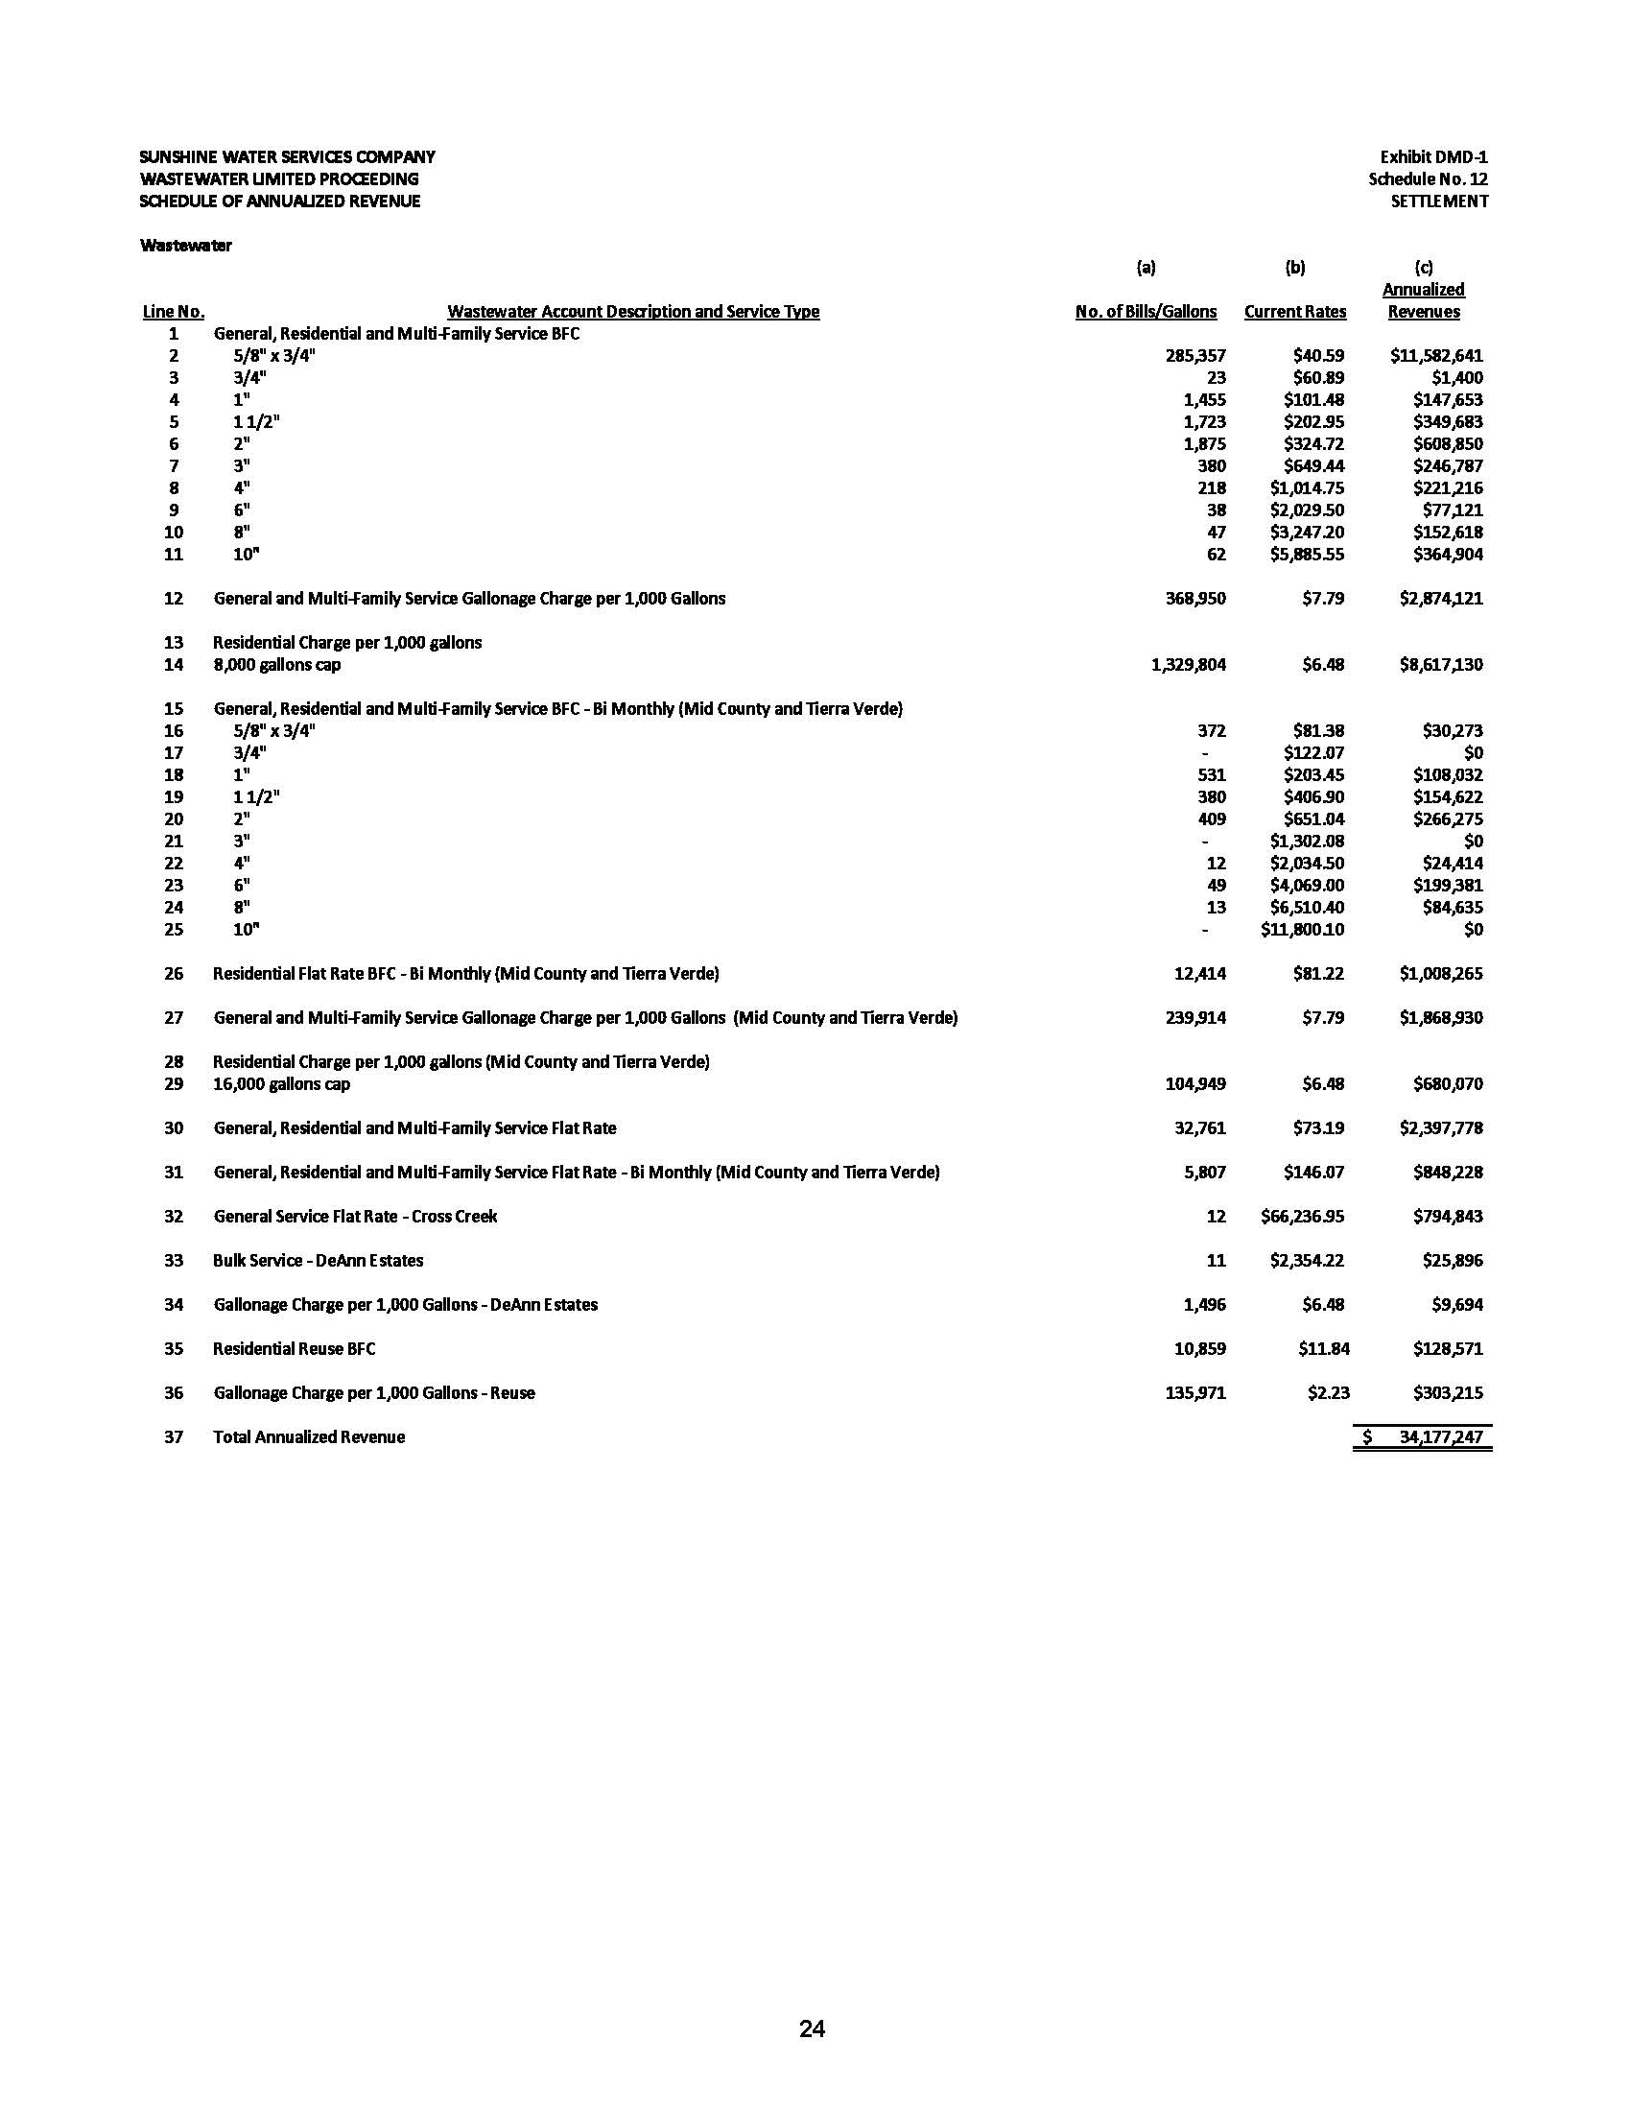

As amended by Order No. PSC-2026-0026-PCO-SU, issued January 27, 2026.
OPC and Commission staff together served 46 interrogatories and 9 document requests on Sunshine, resulting in hundreds of pages of discovery.
Floridians Against Increased Rates, Inc. v. Clark, 371 So. 3d 905, 910 (Fla. 2023) (referred to hereafter as FAIR).
Martuccio v. Dep't of Pro. Regul., Bd. of Optometry, 622 So. 2d 607, 609 (Fla. 1st DCA 1993) (citation omitted).
Section 120.57(1)(j), F.S.
Section 367.081(2)(a)1., F.S.; see also FAIR, 371 So. 3d at 910.
See Sierra Club v. Brown, 243 So. 3d 903, 909 (Fla. 2018).
FAIR, 371 So. 3d at 912.
Order No. PSC-2025-0196-FOF-WS, issued June 6, 2025, in Docket No. 20240068-WS, In re: Application for increase in water and wastewater rates in Charlotte, Highlands, Lake, Lee, Marion, Orange, Pasco, Pinellas, Polk, and Seminole Counties, by Sunshine Water Services Company.
FAIR, 371 So. 3d at 910.
See Sierra Club, 243 So.3d at 909.

