BEFORE THE FLORIDA PUBLIC SERVICE COMMISSION

In re: Application for transfer of majority organizational control of Wildwood Water Company, holder of Certificate No. 648-W in St. Johns County. | DOCKET NO. 20250144-WU  ORDER NO. PSC-2026-0157-PAA-WU  ISSUED: May 19, 2026

The following Commissioners participated in the disposition of this matter:

GARY F. CLARK
MIKE LA ROSA
BOBBY PAYNE
ANA ORTEGA

NOTICE OF PROPOSED AGENCY ACTION
ORDER REVISING MISCELLANEOUS SERVICE CHARGES
AND
FINAL ORDER DECLINING TO INITIATE SHOW CAUSE PROCEEDINGS,
GRANTING TRANSFER OF MAJORITY ORGANIZATIONAL CONTROL, AND
CONTINUING EXISTING RATES AND CHARGES

BY THE COMMISSION:

NOTICE is hereby given by the Florida Public Service Commission that the action discussed herein revising miscellaneous service charges is preliminary in nature and will become final unless a person whose interests are substantially affected files a petition for a formal proceeding, pursuant to Rule 25-22.029, Florida Administrative Code (F.A.C.).

Background

We issued a Grandfather Certificate for Wildwood Water Company (Wildwood or Utility) on June 7, 2010. At the time of issuance, Gerald E. Mills and Diane N. Mills each held a 50 percent ownership interest in the Utility.

On October 16, 2025, Wildwood filed an application for a Staff-Assisted Rate Case (SARC), with the owner identified as G. Gregory Mills (51 percent) and Holy Grail, LLC (49 percent). On November 17, 2025, Wildwood’s SARC application was denied on the basis that a change in majority ownership control had occurred and not yet approved by us as required by Section 367.071, Florida Statutes (F.S.). In its denial letter, Commission staff advised the Utility to submit an application for a transfer in accordance with Rule 25-30.037, F.A.C. On December 15, 2025, Wildwood filed an application for transfer of majority organizational control to G. Gregory Mills (Transferee).

We have jurisdiction pursuant to Sections 367.071 and 367.091, F.S.

Decision
- Show Cause

- Legal Standard

Section 367.071(1), F.S., provides that no utility shall transfer its certificate of authorization, facilities or any portion thereof, or majority organizational control without our determination and approval that the proposed transfer is in the public interest and that the buyer, assignee, or transferee will fulfill the commitments, obligations, and representations of the utility. However, a transfer of certificate of authorization, facilities or any portion thereof, or majority organizational control may occur prior to our approval if the contract for sale, assignment, or transfer is made contingent upon our approval.

Furthermore, Rule 25-30.037(1)(a), F.A.C., provides that if a transfer occurs prior to our approval, the utility shall submit an application for authority to transfer no later than 90 days after the sale closing date.

Violations of the provisions of any lawful rule or any statute administered by us may result in penalties as provided by Section 367.161, F.S. In particular, violations of the provisions of Chapter 367, F.S., or any rule adopted pursuant to the Chapter, may result in a penalty for each offense of not more than $5,000. Utilities are charged with the knowledge of our rules and statutes. Additionally, “it is a common maxim, familiar to all minds, that ‘ignorance of the law’ will not excuse any person, either civilly or criminally.” Barlow v. United States, 32 U.S. 404, 411 (1833). We consider the existence of mitigating circumstances when deciding whether to pursue show cause proceedings against utilities.

- Analysis

On December 15, 2025, Wildwood submitted an application for authority to transfer majority organizational control of the Utility and Certificate No. 648-W in St. Johns County. The Transferee has been in control of and operating Wildwood since 2020, following the death of the Transferee’s parents. Notably, there was no contract of sale or transfer as the transfer occurred by inheritance.
By failing to file its transfer application within 90 days of the transfer of majority organizational control, it appears that Wildwood violated Section 367.071(1), F.S., and Rule 25-30.037(1)(a), F.A.C. On November 17, 2025, Wildwood Water Company was emailed a letter denying the Utility’s eligibility for a SARC because the transfer of majority organizational control was not yet approved by us. Commission staff recommended that the Utility submit an application for a transfer of majority organizational control in accordance with Rule 25-30.037, F.A.C. Since learning of its violations, Wildwood has shown diligence in working with Commission staff to ensure the transfer of this system is in conformity with our laws and rules.

We find that Wildwood has made a good faith effort to effect a lawful transfer of majority organizational control of this system, and that the transfer is in the best interest of its customers. Because the Utility has been responsive in coming into compliance with the applicable rules and statutes regarding transfer of certificates, we find that the Utility’s apparent violation of Section 367.071(1), F.S., and Rule 25-30.037(1)(a), F.A.C., does not rise to the level which warrants the initiation of a show cause proceeding. Therefore, Wildwood shall not be required to show cause for failing to obtain our approval prior to closing on the sale of its facilities, and failing to submit an application to us for authority to transfer no later than 90 days after the transfer of majority organizational control. However, Wildwood shall be placed on notice that show cause proceedings may be initiated if further violations of our laws or rules regarding the transfer of certificates are identified.

- Transfer of Majority Organizational Control

- Legal Standard

Applications for the sale, assignment, or transfer of certificates of authorization, facilities, or control for water and wastewater utilities are governed by Section 367.071, F.S., and Rule 25-30.037, F.A.C. The statute provides that a utility may not sell, assign, or transfer its certificate of authorization, facilities, or any portion thereof, or majority organization control without a determination by us that the sale, assignment, or transfer is in the public interest and that the buyer will fulfill all commitments, obligations, and representations of the utility. A sale, assignment, or transfer of a certificate of authorization may occur prior to our approval if the contract for sale, assignment, or transfer is made contingent upon our approval. The rule provides all of the requirements an applicant must provide in an application for sale, assignment, or transfer of a certificate of authorization.

- Analysis

This application is for the transfer of majority organizational control of Wildwood Water Company in St. Johns County from Gerald E. Mills and Diane N. Mills to G. Gregory Mills. Based on our review, the application is in compliance with the governing statute, Section 367.071, F.S., and Rule 25-30.037(4), F.A.C., concerning applications for transfer of majority organizational control. As majority organizational control was acquired through inheritance, there is no applicable contract for sale.

- Noticing and Territory

Wildwood provided notice of its application pursuant to Section 367.071, F.S., and Rule 25-30.030, F.A.C. No objections to the transfer were filed with us, and the time for doing so has expired. The notice contains a description of the territory for Wildwood, which is appended to this Order as Attachment A.

- Technical and Financial Ability

The Transferee has experience in operating water systems since 1978, and has been operating the Wildwood system since 1988 through the present. Based upon our review, the system appears to currently be in compliance with the Department of Environmental Protection. The transfer application states that the Transferee is supported by an affiliate company, Holy Grail Holdings, LLC. We have reviewed the financial statements of the affiliate company and find that it has the financial capability to provide necessary funding and has established a line of credit to ensure continued operations. Based on the statement above, we find that the Transferee has the technical and financial capability to provide service to the existing service territory.

- Rates, Charges, and Initial Customer Deposits

Wildwood Water Company’s rates, charges, and customer deposits were last approved in a grandfather certificate in 2010. Subsequently, the rates were amended by three price index rate adjustments with the last increase approved effective September 1, 2021. Rule 25-9.044(1), F.A.C., provides that, in the case of a change of ownership or control of a Utility, the rates, classifications, and regulations of the former owner must continue unless authorized to change by us.

In regard to the Utility’s existing miscellaneous service charges, the violation reconnection, the late payment, and non-sufficient funds (NSF) charges are appropriate. However, the remaining miscellaneous service charges do not conform to Rule 25-30.460, F.A.C., and are discussed in Section III. Therefore, we find that the Utility’s existing rates, initial customer deposit, violation reconnection charge, late payment charge, NSF charge, and service availability charges shown on Schedule No. 1, shall remain in effect, until a change is authorized by us in a subsequent proceeding. The tariff sheets reflecting the transfer shall be effective on or after the stamped approval date pursuant to Rule 25-30.475(1), F.A.C.

- Conclusion

Based on the above, we find that the transfer of the majority organizational control from Gerald E. Mills and Diane N. Mills to G. Gregory Mills is in the public interest and shall be approved effective the date of our vote. This Order shall serve as the water and wastewater certificates, with the territories described in Attachment A. The Utility’s existing rates and charges shall remain in effect until a change is authorized by us in a subsequent proceeding. For the Utility, the tariff pages reflecting the transfer shall be effective on or after the stamped approval date on the tariff sheets pursuant to Rule 25-30.475(1), F.A.C.

- Miscellaneous Service Charges

The Utility did not request to revise its existing miscellaneous service charges. Section 367.091, F.S., authorizes us to establish, increase, or change rates or charges other than monthly rates or service availability charges. Rule 25-30.460, F.A.C. does not allow for initial connection and normal reconnection charges. The Utility’s initial connection and normal reconnection charges are obsolete and inconsistent with the rule. The definitions for initial connection charges and normal reconnection charges were subsumed in the definition of the premises visit charge. Based on the above, we find that the initial connection and normal reconnection charges shall be removed, and the definition for the premises visit charge be updated to comply with Rule 25-30.460, F.A.C.

We find that the appropriate revisions to miscellaneous service charges for Wildwood shall be the removal of initial connection and normal reconnection charges and update the definition of the premises visit charge to be consistent with Rule 25-30.460, F.A.C. The Utility shall be required to file a proposed customer notice to reflect the approved charges. The approved charges shall be effective on or after the stamped approval date on the tariff sheet pursuant to Rule 25-30.475(1), F.A.C. In addition, the approved charges shall not be implemented until Commission staff has approved the proposed customer notice and the notice has been received by customers. The Utility shall provide proof of the date notice was given, no less than 10 days after the date of the notice. Wildwood shall be required to charge the approved miscellaneous services charges until authorized to change them by us in a subsequent proceeding.

Based on the foregoing, it is

ORDERED by the Florida Public Service Commission that Wildwood Water Company’s apparent violation of Section 367.071(1), F.S., and rule 25-30.037(1)(a), F.A.C., does not rise to the level which warrants the initiation of a show cause proceeding. However, Wildwood Water Company shall be placed on notice that show cause proceedings may be initiated if further violations of our laws or rules regarding the transfer of certificates are identified. It is further

ORDERED that the transfer of majority organizational control from Gerald E. Mills and Diane N. Mills to G. Gregory Mills is in the public interest and shall be approved effective as of May 5, 2026. This Order shall serve as the water and wastewater certificates, with the territories described in Attachment A. Wildwood Water Company’s existing rates and charges shall remain in effect until a change is authorized by us in a subsequent proceeding. For Wildwood Water Company, the tariff pages reflecting the transfer shall be effective on or after the stamped approval date on the tariff sheets pursuant to Rule 25-30.475(1), F.A.C. It is further

ORDERED that the appropriate revisions to miscellaneous service charges for Wildwood Water Company shall be the removal of initial connection and normal reconnection charges and update the definition of the premises visit charge to be consistent with Rule 25-30.460, F.A.C. Wildwood Water Company shall be required to file a proposed customer notice to reflect the approved charges, The approved charges shall be effective on or after the stamped approval date on the tariff sheet pursuant to Rule 25-30.475(1), F.A.C. The approved charges shall not be implemented until Commission staff has approved the proposed customer notice and the notice has been received by customers. Wildwood Water Company shall provide proof of the date notice was given, no less than 10 days after the date of the notice. Wildwood Water Company shall be required to charge the approved miscellaneous service charges until authorized to change them by us in a subsequent proceeding. It is further

ORDERED that the provisions of this Order, issued as proposed agency action, shall become final and effective upon the issuance of a Consummating Order unless an appropriate petition, in the form provided by Rule 28-106.201, Florida Administrative Code, is received by the Commission Clerk, 2540 Shumard Oak Boulevard, Tallahassee, Florida 32399-0850, by the close of business on the date set forth in the “Notice of Further Proceedings” attached hereto. It is further

ORDERED that in the event this Order becomes final, this docket shall be closed administratively once Commission staff has verified that the revised tariff sheets have been filed by the utility and approved by staff, and notice has been provided to customers.

By ORDER of the Florida Public Service Commission this 19th day of May, 2026.

/s/ Adam J. Teitzman
ADAM TEITZMAN
Commission Clerk
Florida Public Service Commission
2540 Shumard Oak Boulevard
Tallahassee, Florida 32399
(850) 413-6770
www.floridapsc.com

Copies furnished: A copy of this document is provided to the parties of record at the time of issuance and, if applicable, interested persons.

DD

NOTICE OF FURTHER PROCEEDINGS OR JUDICIAL REVIEW

The Florida Public Service Commission is required by Section 120.569(1), Florida Statutes, to notify parties of any administrative hearing that is available under Section 120.57, Florida Statutes, as well as the procedures and time limits that apply. This notice should not be construed to mean all requests for an administrative hearing will be granted or result in the relief sought.

Mediation may be available on a case-by-case basis. If mediation is conducted, it does not affect a substantially interested person's right to a hearing.

The action proposed herein revising miscellaneous service charges is preliminary in nature. Any person whose substantial interests are affected by the action proposed by this order may file a petition for a formal proceeding, in the form provided by Rule 28-106.201, Florida Administrative Code. This petition must be received by the Office of Commission Clerk, 2540 Shumard Oak Boulevard, Tallahassee, Florida 32399-0850, by the close of business on June 9, 2026.

In the absence of such a petition, this order shall become final and effective upon the issuance of a Consummating Order.

Any objection or protest filed in this/these docket(s) before the issuance date of this order is considered abandoned unless it satisfies the foregoing conditions and is renewed within the specified protest period.

Any party adversely affected by the Commission's final action in this matter may request: 1) reconsideration of the decision by filing a motion for reconsideration with the Office of Commission Clerk, 2540 Shumard Oak Boulevard, Tallahassee, Florida 32399-0850, within fifteen (15) days of the issuance of this order in the form prescribed by Rule 25-22.060, Florida Administrative Code; or 2) judicial review by the Florida Supreme Court in the case of an electric, gas or telephone utility or the First District Court of Appeal in the case of a water and/or wastewater utility by filing a notice of appeal with the Office of Commission Clerk, and filing a copy of the notice of appeal and the filing fee with the appropriate court. This filing must be completed within thirty (30) days after the issuance of this order, pursuant to Rule 9.110, Florida Rules of Appellate Procedure. The notice of appeal must be in the form specified in Rule 9.900(a), Florida Rules of Appellate Procedure.

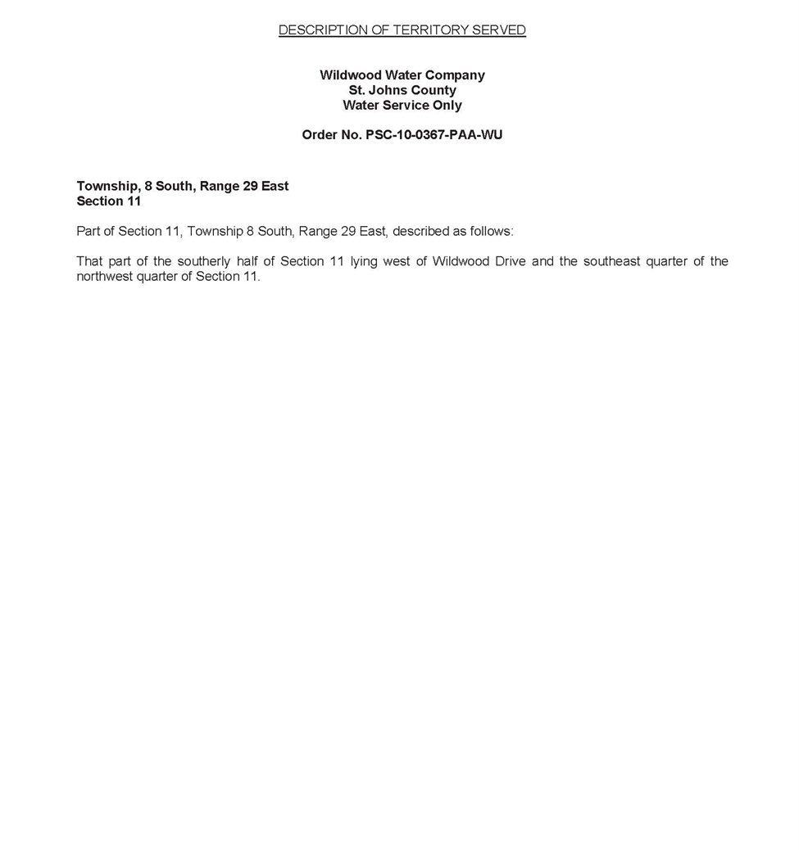
FLORIDA PUBLIC SERVICE COMMISSION
Authorizes
Wildwood Water Company
pursuant to
Certificate Number 648-W

to provide water service in St. Johns County in accordance with the provisions of Chapter 367, Florida Statutes, and the Rules, Regulations, and Orders of this Commission in the territory described by the Orders of this Commission. This authorization shall remain in force and effect until superseded, suspended, cancelled or revoked by Order of this Commission.

Order Number Date Issued Docket Number Filing Type

PSC-10-0367-PAA-WU 06/07/2010 100011-WU Grandfather Certificate

PSC-2026-0157-PAA-WU 05/19/2026 20250144-WS Transfer of Majority

WILDWOOD WATER COMPANY
Existing Monthly Water Rates

Residential and General Service
Base Facility Charge | $35.49
Charge Per 1,000 gallons
0 - 4,000 gallons | $0.00
4,001 - 10,000 gallons | $4.71
10,001 - 20,000 gallons | $5.77
Over 20,000 gallons | $7.01

Initial Customer Deposits
Meter Size |  |  | Residential Service
5/8” X 3/4” |  |  | $75.00

Miscellaneous Service Charges
 | Normal Hours | After Hours
Violation Reconnection Charge | $35.00 | $52.20
NSF Charge | Pursuant to Section 68.065, F.S.
Late Payment Charge | $5.00

Service Availability Charges
Meter Installation and Tap-In Charge
5/8” x 3/4" | $130.00
3/4” | $390.00
1" | $490.00
1 1/2” | $1,400.00
2” | $2,200.00
Connection Charge | $1,500.00

Order No. PSC-10-0367-PAA-WU, issued June 7, 2010, in Docket No. 20100011-WU, In re: Application for grandfather certificate to operate water utility in St. Johns County by Wildwood Water Company.
Document No. 15121-2025, issued November 17, 2025, in Docket No. 20250127-WU, In re: Application for staff-assisted rate case in St. Johns County, by Wildwood Water Company.
Order Nos. PSC-10-0367A-PAA-WU, issued August 27, 2010, in Docket No. 20100011-WU, In re: Application for grandfather certificate to operate water utility in St. Johns County by Wildwood Water Company. and PSC-10-0367-PAA-WU, issued June 7, 2010, in Docket No. 20100011-WU, In re: Application for grandfather certificate to operate water utility in St. Johns County by Wildwood Water Company.

