BEFORE THE FLORIDA PUBLIC SERVICE COMMISSION

In re: Joint petition for approval of territorial agreement in Hillsborough, Pasco, Pinellas, and Polk Counties, by Tampa Electric Company and Duke Energy Florida, LLC. | DOCKET NO. 20260013-EU  ORDER NO. PSC-2026-0165-PAA-EU  ISSUED: May 26, 2026

The following Commissioners participated in the disposition of this matter:

GARY F. CLARK
MIKE LA ROSA
BOBBY PAYNE
ANA ORTEGA

NOTICE OF PROPOSED AGENCY ACTION
ORDER APPROVING TERRITORIAL AGREEMENT BETWEEN
DUKE ENERGY FLORIDA, LLC AND TAMPA ELECTRIC COMPANY

BY THE COMMISSION:

NOTICE is hereby given by the Florida Public Service Commission (Commission) that the action discussed herein is preliminary in nature and will become final unless a person whose interests are substantially affected files a petition for a formal proceeding, pursuant to Rule 25-22.029, Florida Administrative Code (F.A.C.).

Background
On January 7, 2026, Duke Energy Florida, LLC (DEF) and Tampa Electric Company (TECO) (collectively the joint petitioners or Utilities), filed a petition seeking our approval of a territorial agreement in Hillsborough, Pasco, Pinellas, and Polk Counties (2026 Territorial Agreement) with a twenty-year term. The 2026 Territorial Agreement provides details on the boundary line changes and includes maps depicting the new territorial boundaries, written descriptions, and addresses of proposed customer transfers that are attached hereto as Attachment A.
Since 1991, DEF and TECO have been parties to an agreement for Hillsborough, Pasco, Pinellas, and Polk Counties, which expired in 2021 (1991 Agreement). Since the expiration of that agreement, the joint petitioners have been working on the 2026 Territorial Agreement, which is intended to replace the expired agreement in the above-referenced counties. Although the 1991 Agreement expired, the Utilities have continued to meet their obligations under that agreement while negotiations for the 2026 Territorial Agreement were underway.
The 2026 Territorial Agreement, in part, is intended by the joint petitioners to reflect sound engineering and operational decisions regarding proposed changes in the territorial boundary while also facilitating the orderly transfer of certain inadvertently served customers. Also, certain boundary line changes are proposed to allow extra-territorial customers to remain with the electric utility to which they are currently connected.
During the review process, Commission staff sent two data requests to the joint petitioners, for which responses were received on February 17, 2026 and April 2, 2026. Commission staff also held an informal teleconference with the Utilities on March 13, 2026. The 2026 Territorial Agreement establishes revised territorial boundaries for a twenty year period in the affected counties and would eliminate current extra-territorial connections.
We have jurisdiction over this matter pursuant to Section 366.04, Florida Statutes (F.S.).

Decision

Pursuant to Section 366.04(2)(d), F.S., and Rule 25-6.0440(2), F.A.C., we have jurisdiction to approve territorial agreements between and among rural electric cooperatives, municipal electric utilities, and investor-owned electric utilities. Unless we determine that a territorial agreement will cause a detriment to the public interest, the agreement should be approved. As set forth below, the 2026 Territorial Agreement is hereby approved.
Rule 25-6.0440(2), F.A.C., addresses the standards we may consider for approving territorial agreements for electric utilities. The rule states:

(2) Standards for Approval. In approving territorial agreements, the Commission may consider:
(a) The reasonableness of the purchase price of any facilities being transferred;
(b) The reasonable likelihood that the agreement, in and of itself, will not cause a decrease in the reliability of electrical service to the existing or future ratepayers of any utility party to the agreement;
(c) The reasonable likelihood that the agreement will eliminate existing or potential uneconomic duplication of facilities; and
(d) Any other factor the Commission finds relevant in reaching a determination that the territorial agreement is in the public interest.

2026 Territorial Agreement
DEF and TECO executed the 2026 Territorial Agreement addressing common boundaries over a four-county area on January 7, 2026, to replace and supersede the existing territorial agreement from 1991. The joint petitioners assert that the 2026 Territorial Agreement will accomplish three main objectives:
- Reduce or eliminate dangerous and uneconomic conditions;
- Transfer certain customers over a future 12 months to correct (reverse) inadvertent service connection errors that have taken place; and
- Make minor boundary changes to allow for sound engineering and operational decisions and to eliminate extra-territorial connections.
Collectively, these objectives are expected to aid the Utilities in eliminating circumstances that give rise to the uneconomic duplication of service facilities and hazardous conditions, such as overlapping wires and facilities that could endanger utility linemen and the public at large.
The 2026 Territorial Agreement includes 72 maps depicting the new territorial boundaries, written descriptions of the territorial areas, and comprehensive terms and conditions the joint petitioners negotiated. Among the terms the joint petitioners agreed on were terms addressing the provision of new and temporary service, methods and obligations each utility will follow for correcting inadvertent service errors, and procedures for the transfer of customers and facilities. The 2026 Territorial Agreement also includes the joint petitioners’ negotiated terms regarding the method of compensation for transferred facilities, and identifies the service addresses for the extra-territorial customers that are to be transferred. The joint petitioners’ filing also includes a sample copy of the notification letters provided to customers that are subject to transfer.
Pursuant to Section 6.1, the 2026 Territorial Agreement will remain in effect for 20 years from the date that this order approving the agreement in its entirety is no longer subject to judicial review. Upon the expiration of the initial 20-year term, the agreement will remain in effect in perpetuity unless either party provides written notice of termination at least 12 months prior to the termination of the agreement in accordance with Section 8.3.

Boundary Changes
The joint petitioners negotiated and are proposing boundary line changes, in part, as a corrective measure to address inadvertent service connections each party identified in their respective territories. While collaborating over the last several years, the joint petitioners discovered some of the inadvertent connections while analyzing the territorial service boundaries related to the instant pleading.
Some boundary line changes address approximately 340 extra-territorial customer connections (80 extra-territorial DEF customers in TECO’s territory and 259 extra-territorial TECO customers in DEF’s territory) that are not subject to transfer due to specific technical reasons or the uneconomic cost of switching utility facilities. Instead, the Utilities have agreed to modify their service territory boundaries to eliminate these extra-territorial connections.
The joint petitioners assert that the proposed boundary line changes are primarily needed to avoid duplication of services and wasteful expenditures, as well as to best protect the public health and safety from hazardous conditions.
While negotiating the 2026 Territorial Agreement, both DEF and TECO exchanged geographic information systems (GIS) files to update their respective mapping resources. Should the agreement be approved, the joint petitioners claim having agreed-upon maps will allow for better planning of distribution and transmission capital investments.
The joint petitioners assert that corrective measures and improved processes should significantly reduce inadvertent service connections going forward. Both Utilities state that modern digital mapping more clearly defines service territories, and that shared advanced GIS platforms provide greater precision for identifying boundaries and agreeing on proposed borders. Both Utilities report expanded GIS team staffing. In addition, both Utilities perform verification reviews of boundary lines in the field upon service initiation, and DEF now also conducts off-cycle verification reviews roughly every five years. Despite these improvements, the joint petitioners acknowledge connection errors may still occur. Section 2.5 of the 2026 Territorial Agreement requires correction within 12 months of discovery. In the interim, affected customers are treated as temporary service customers, and if temporary service is expected to exceed one year, the parties must jointly seek our approval.

Proposed Customer Transfers, Notifications, and Bills
Exhibit B of the 2026 Territorial Agreement identifies the service addresses of the two active DEF customer accounts that are proposed to be transferred to TECO. Both customers are neighboring parcels in a residential subdivision. The proposed customer transfers under the 2026 Territorial Agreement are a result of negotiations between the Utilities, with the intent of avoiding duplication of services and wasteful expenditures, as well as to best protect the public health and safety from potentially hazardous conditions.
The Utilities have no plans to transfer facilities. The joint petitioners state that, upon our approval of the 2026 Territorial Agreement, customer transfers will be coordinated over a 12-month period. The joint petitioners state that they will not conduct any customer transfers until we approve the joint petition.
Rule 25-6.0440(2)(d), F.A.C., also gives us the discretion to address any other relevant concerns that are case-specific. Based on the comparative bill information provided to customers by letter in November 2025, the average residential DEF bill for 1,000 kWh was $179.29 and the average residential TECO bill for 1,000 kWh was $168.01, a difference of $11.28, or about 6 percent.
The joint petitioners assert they followed the guidelines of Rule 25-6.0440(1)(d), F.A.C., which required them to provide notification to the affected customers. This notification was provided in letters dated November 10, 2025. Regarding feedback from those letters, the joint petitioners stated they have received no customer comments expressing dissatisfaction related to the proposed transfers. The joint petitioners also assert that prior to the actual transfer, the affected customers will receive a second notification of the transfer. The joint petitioners also state that no additional charges will be imposed on the customers who will be transferred.

Review
We analyzed the 2026 Territorial Agreement for compliance with each component of Rule 25-6.0440(2), F.A.C. We note that no purchase price, construction cost estimates, or detailed engineering drawings were presented for review, as the joint petitioners stated that no facilities are intended to be purchased or transferred.
We also evaluated the agreement according to Rule 25-6.0440(2)(b), F.A.C., which addresses electrical system reliability for existing or future customers. The joint petitioners contend that the reliability of service to existing or future DEF or TECO customers would not be decreased as a result of the proposed agreement. Additionally, both Utilities confirmed that the 2026 Territorial Agreement would help them gain further operational efficiencies and customer service improvements in their respective retail service areas.
Under the 2026 Territorial Agreement, the joint petitioners have proposed to minimize existing or potential uneconomic duplication of facilities, as referenced in Rule 25-6.0440(2)(c), F.A.C., and have provided a brief justification to support each boundary line change. The Utilities have also provided brief justifications to support aligning the boundary lines to eliminate all known extra-territorial customers instead of transferring them. In accordance with Rule 25-6.0440(2)(c), F.A.C., we find that the minimizing of potential uneconomic duplication of facilities represents a strong argument favoring approval of the 2026 Territorial Agreement.
We are concerned with the extent of extra-territorial customer connections reported by the Utilities (80 extra-territorial DEF customers in TECO’s territory and 259 extra-territorial TECO customers in DEF’s territory), with some extra-territorial customers being located a significant distance from the boundary line. For example, the entirety of a Polk County walled subdivision served by TECO is located inside DEF’s service area at a distance of approximately 0.4 miles from the nearest DEF/TECO territorial border. The 2026 Territorial Agreement, however, addresses these concerns by setting forth the specific obligations both Utilities are bound to regarding service provisioning and adherence to the boundary lines we previously approved.
While Article II of the 2026 Territorial Agreement includes specific terms for provisioning of new and temporary services, we note that Article II also addresses remedies the joint petitioners shall follow for correcting temporary service and inadvertent service connections. Specifically, temporary service expected to last more than one year, including inadvertent service connections, must be jointly submitted by the Utilities to us for approval (Sections 2.3 and 2.5). The joint parties, aided with their respective boundary verification protocols for establishing/auditing service connections, shall follow such protocols in order to assure compliance with this stated term of the 2026 Territorial Agreement. Doing so will assure that the Utilities are abiding by the approved boundary lines to the greatest extent possible, and should also serve to limit the Utilities’ need to seek our approval for inadvertent connections beyond a year.
DEF and TECO satisfied the notification requirements of Rule 25-6.0440(1)(d), F.A.C., for customers affected by the proposed service and rate changes. At the time the November 10, 2025 notification letters were issued, the projected bill decrease for DEF customers to be transferred to TECO did not appear significant. However, we recognize that future rate differences cannot be known with certainty and that actual rates at the time of transfer may differ from those presented in the notification letters.

Conclusion
We hereby approve the 2026 Territorial Agreement between DEF and TECO in Hillsborough, Pasco, Pinellas, and Polk Counties, as consistent with the Standards for Approval set forth in Rule 25-6.0440(2), F.A.C. The 2026 Territorial Agreement amends the respective boundary lines between the Utilities and authorizes customer transfers for two residential customers. Additionally, the terms of the agreement will allow the joint petitioners to avoid uneconomic duplication of service facilities, wasteful expenditures, and hazardous conditions. Also, the terms of the agreement require the Utilities to seek our approval of any temporary service, including inadvertent service, expected to last more than one year. The need for the Utilities to seek such approval should be limited as a result of recently deployed boundary line verification protocols for new service connections, increased boundary monitoring personnel, and improved mapping tools and technologies. The Utilities are also encouraged to communicate with Commission staff in a timely fashion when inadvertent service is discovered.

Based on the foregoing, it is

ORDERED by the Florida Public Service Commission that the 2026 Territorial Agreement between Duke Energy Florida, LLC and Tampa Electric Company in Hillsborough, Pasco, Pinellas, and Polk Counties, attached hereto as Attachment A, is hereby approved as set forth in the body of this Order. The terms of the agreement require the Utilities to seek our approval of any temporary service, including inadvertent service, expected to last more than one year. The Utilities are also encouraged to communicate with Commission staff in a timely fashion when inadvertent service is discovered. It is further

ORDERED that the provisions of this Order, issued as proposed agency action, shall become final and effective upon the issuance of a Consummating Order unless an appropriate petition, in the form provided by Rule 28-106.201, Florida Administrative Code, is received by the Commission Clerk, 2540 Shumard Oak Boulevard, Tallahassee, Florida 32399-0850, by the close of business on the date set forth in the “Notice of Further Proceedings” attached hereto. It is further

ORDERED that in the event this Order becomes final, this docket shall be closed.

By ORDER of the Florida Public Service Commission this 26th day of May, 2026.

/s/ Adam J. Teitzman
ADAM TEITZMAN
Commission Clerk
Florida Public Service Commission
2540 Shumard Oak Boulevard
Tallahassee, Florida 32399
(850) 413-6770
www.floridapsc.com

Copies furnished: A copy of this document is provided to the parties of record at the time of issuance and, if applicable, interested persons.

MRT

NOTICE OF FURTHER PROCEEDINGS OR JUDICIAL REVIEW

The Florida Public Service Commission is required by Section 120.569(1), Florida Statutes, to notify parties of any administrative hearing that is available under Section 120.57, Florida Statutes, as well as the procedures and time limits that apply. This notice should not be construed to mean all requests for an administrative hearing will be granted or result in the relief sought.

Mediation may be available on a case-by-case basis. If mediation is conducted, it does not affect a substantially interested person's right to a hearing.

The action proposed herein is preliminary in nature. Any person whose substantial interests are affected by the action proposed by this order may file a petition for a formal proceeding, in the form provided by Rule 28-106.201, Florida Administrative Code. This petition must be received by the Office of Commission Clerk, 2540 Shumard Oak Boulevard, Tallahassee, Florida 32399-0850, by the close of business on June 16, 2026.

In the absence of such a petition, this order shall become final and effective upon the issuance of a Consummating Order.

Any objection or protest filed in this/these docket(s) before the issuance date of this order is considered abandoned unless it satisfies the foregoing conditions and is renewed within the specified protest period.

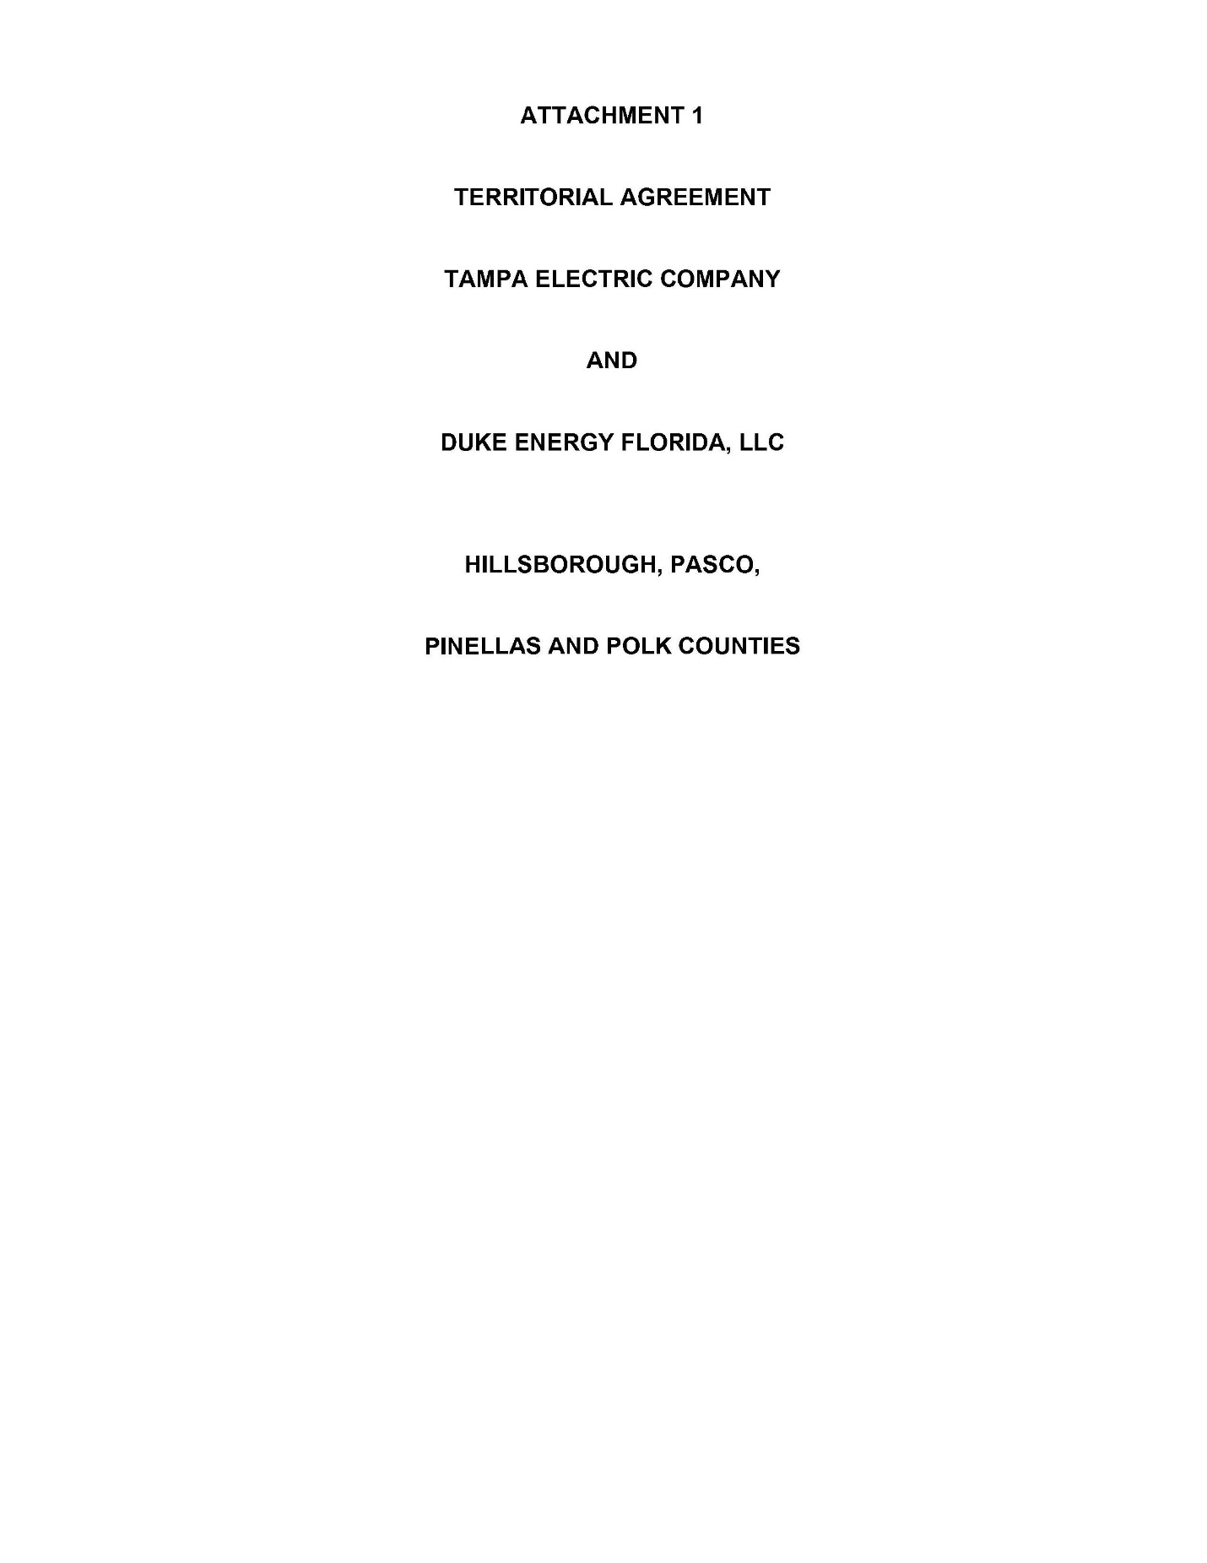

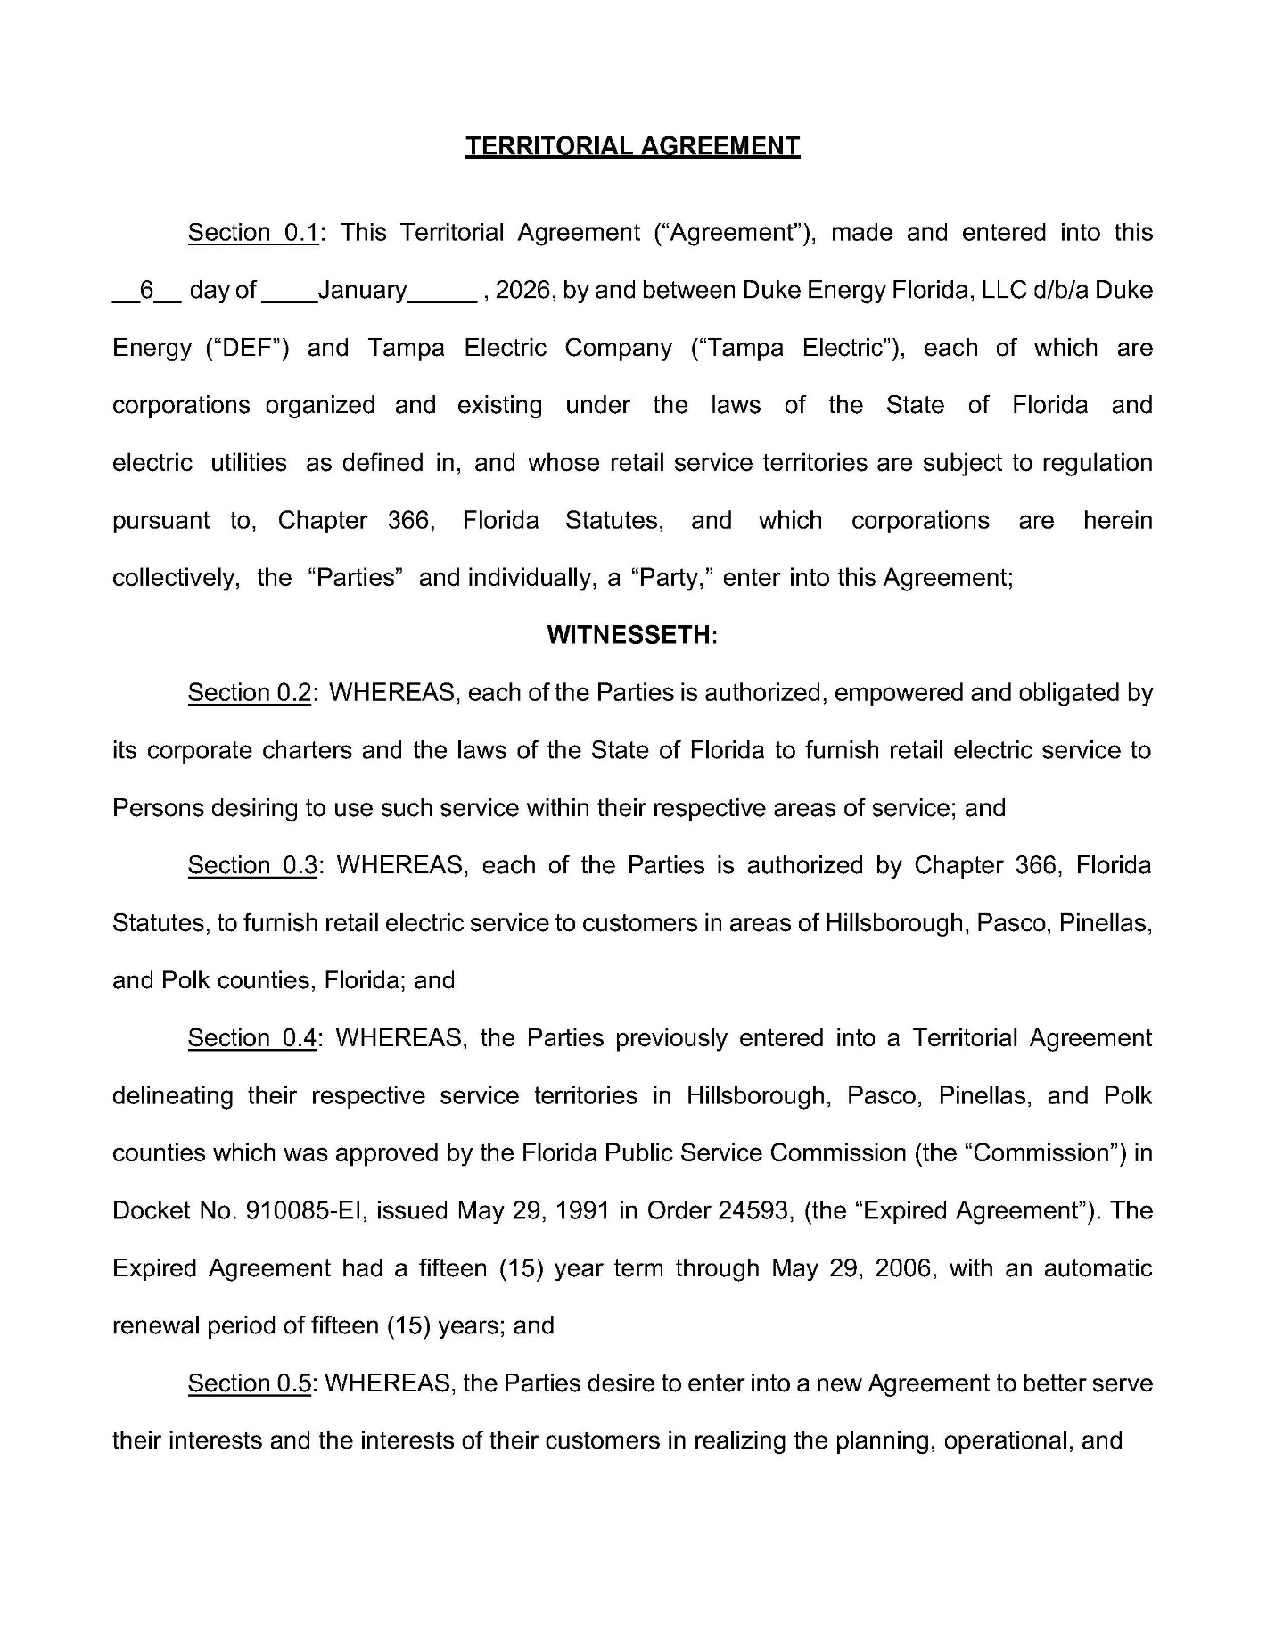

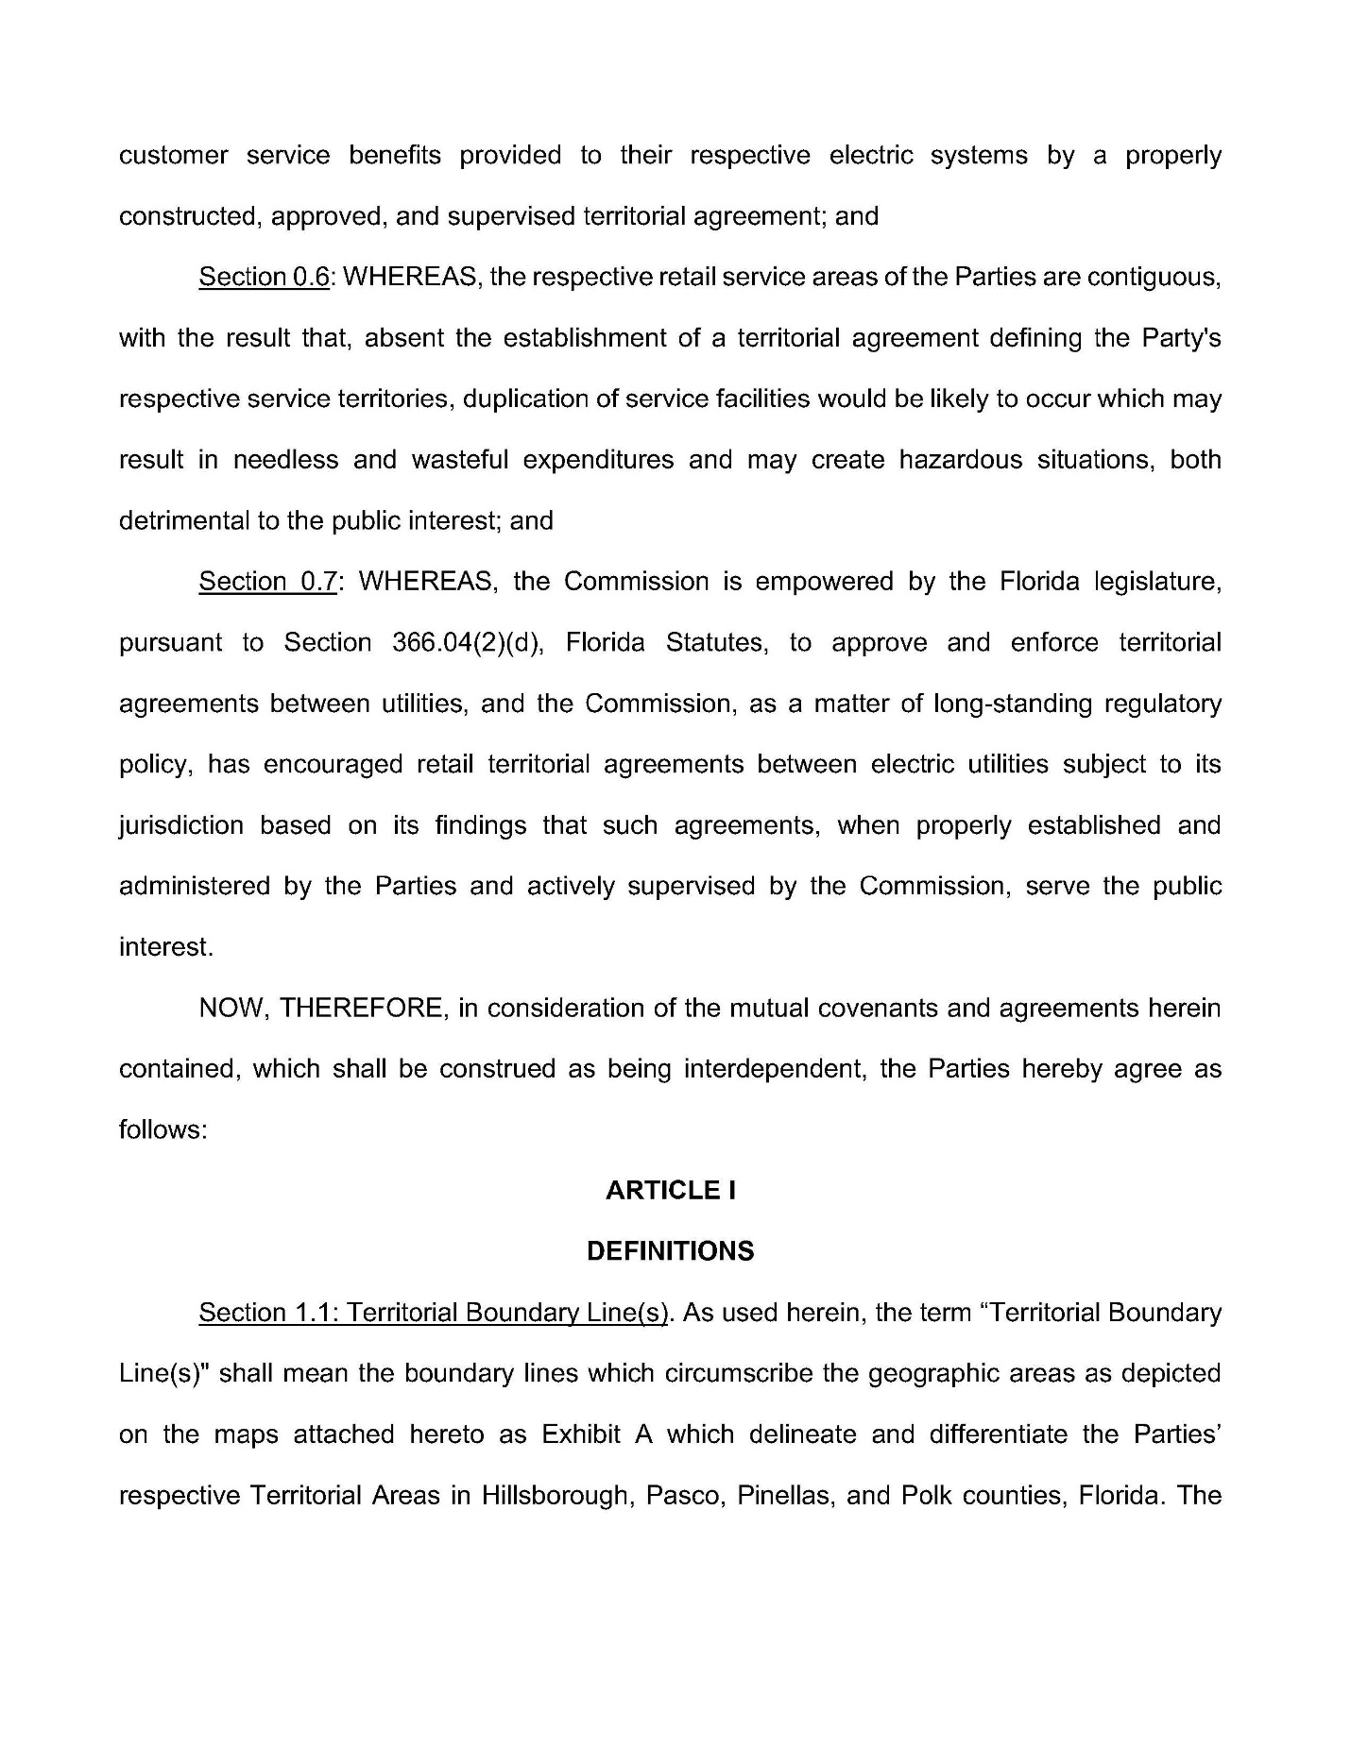

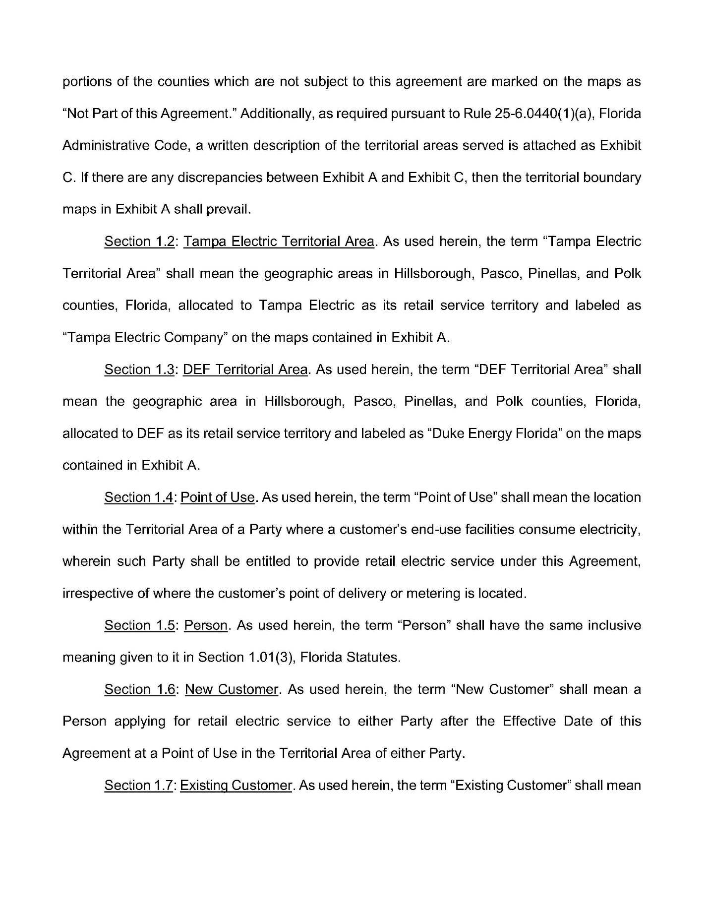

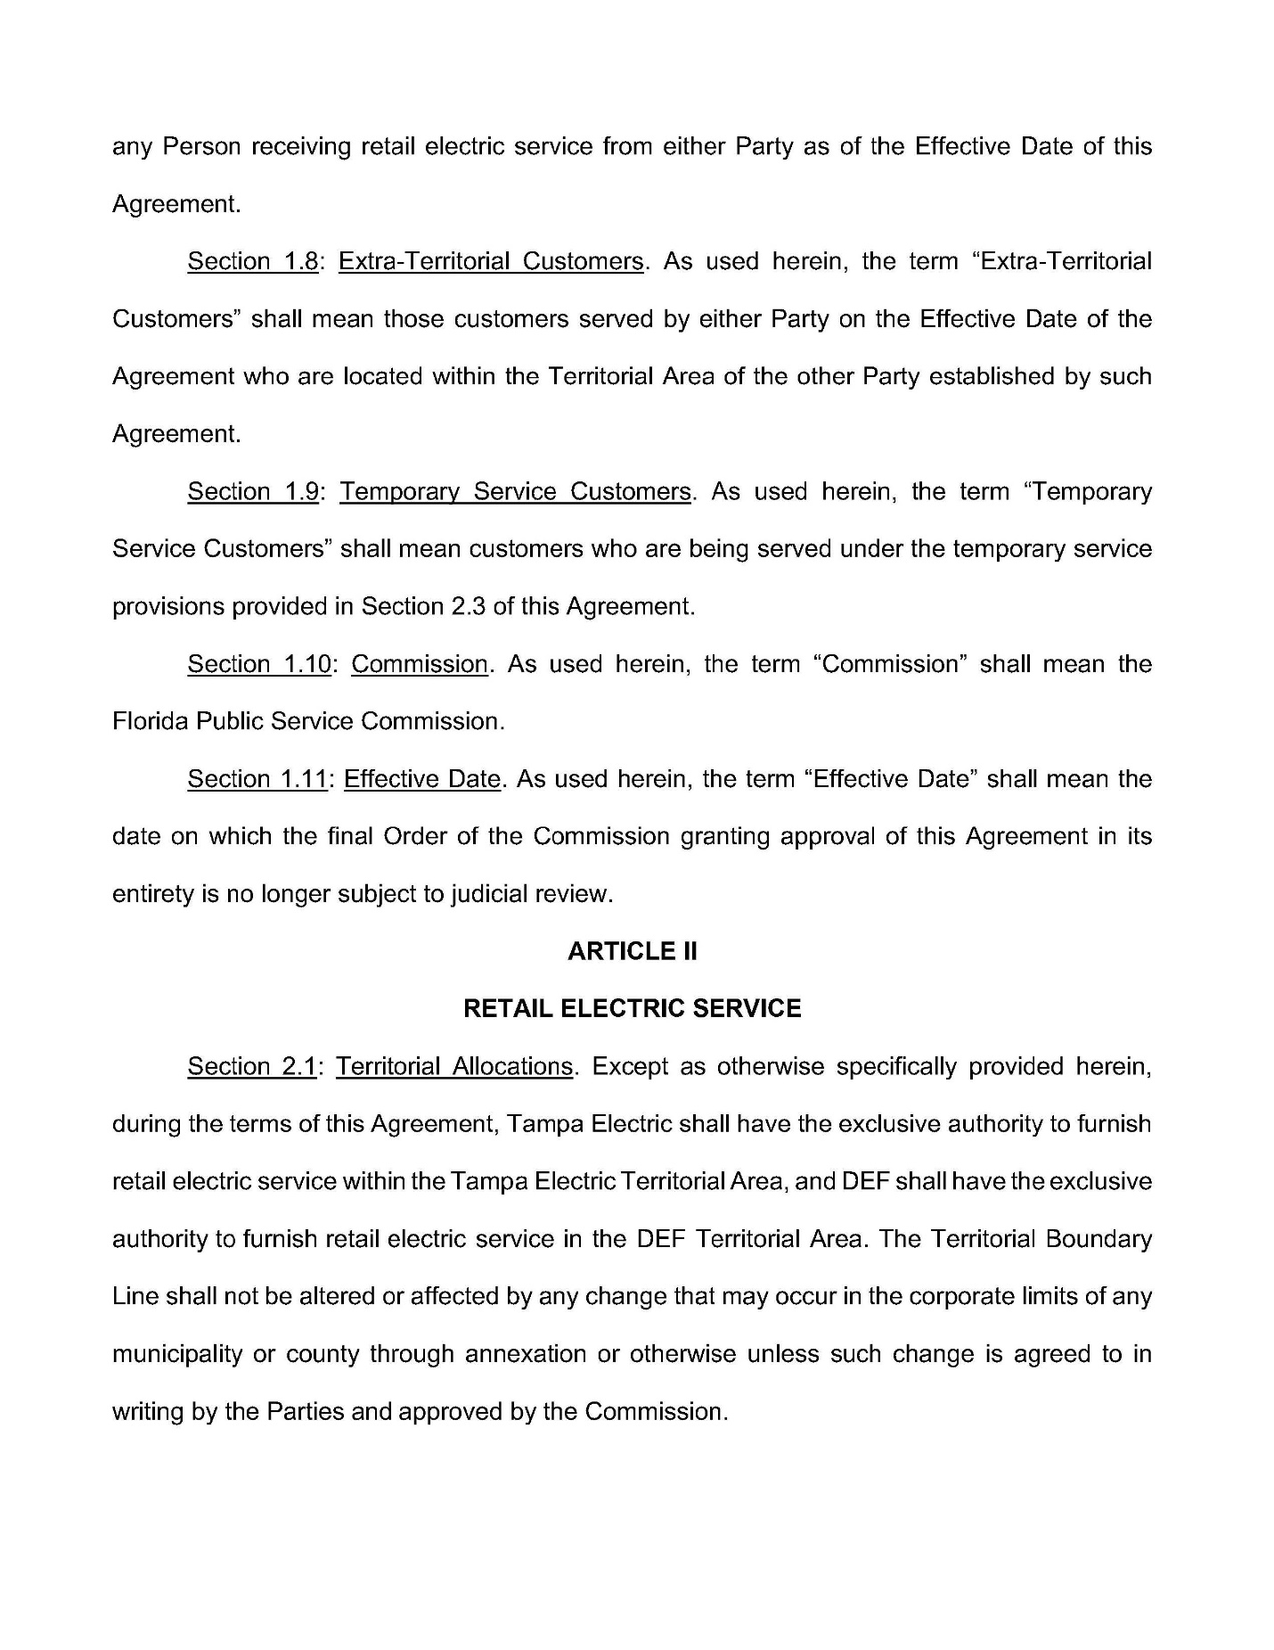

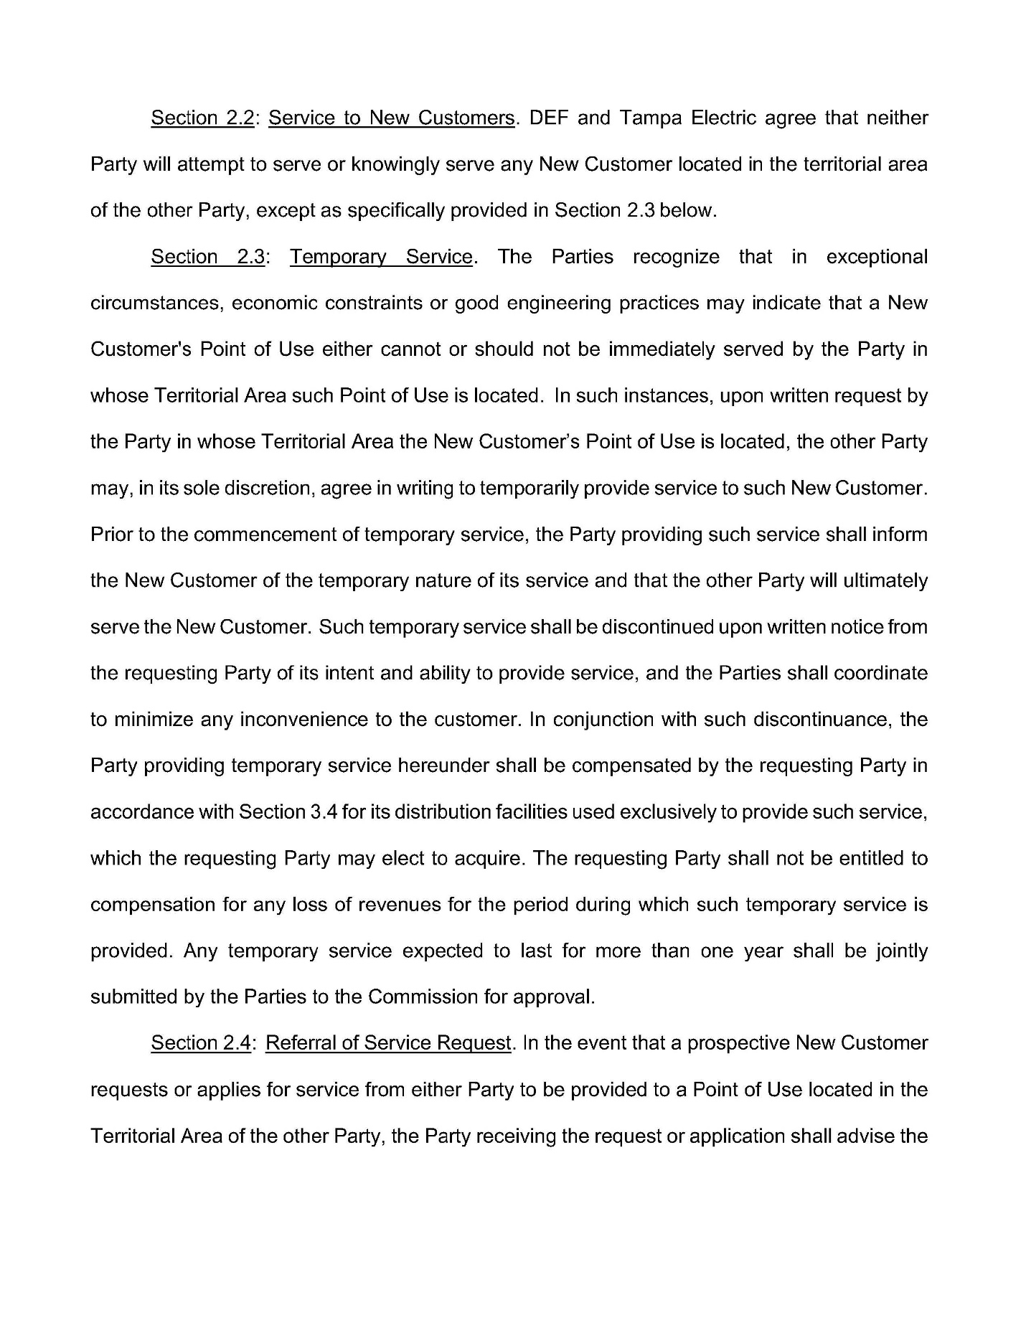

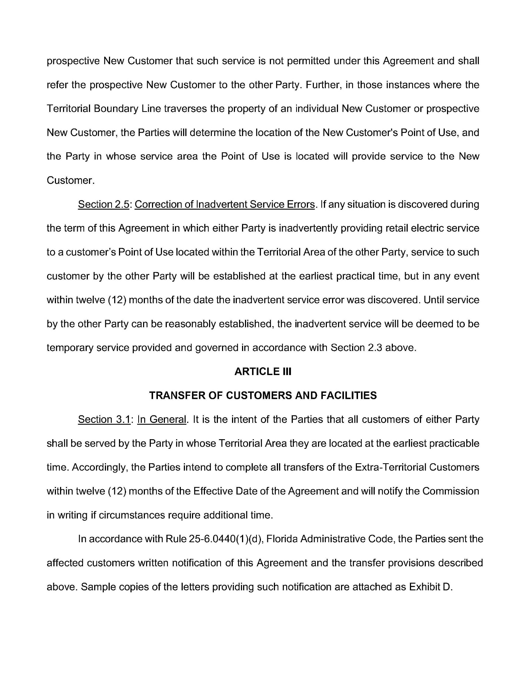

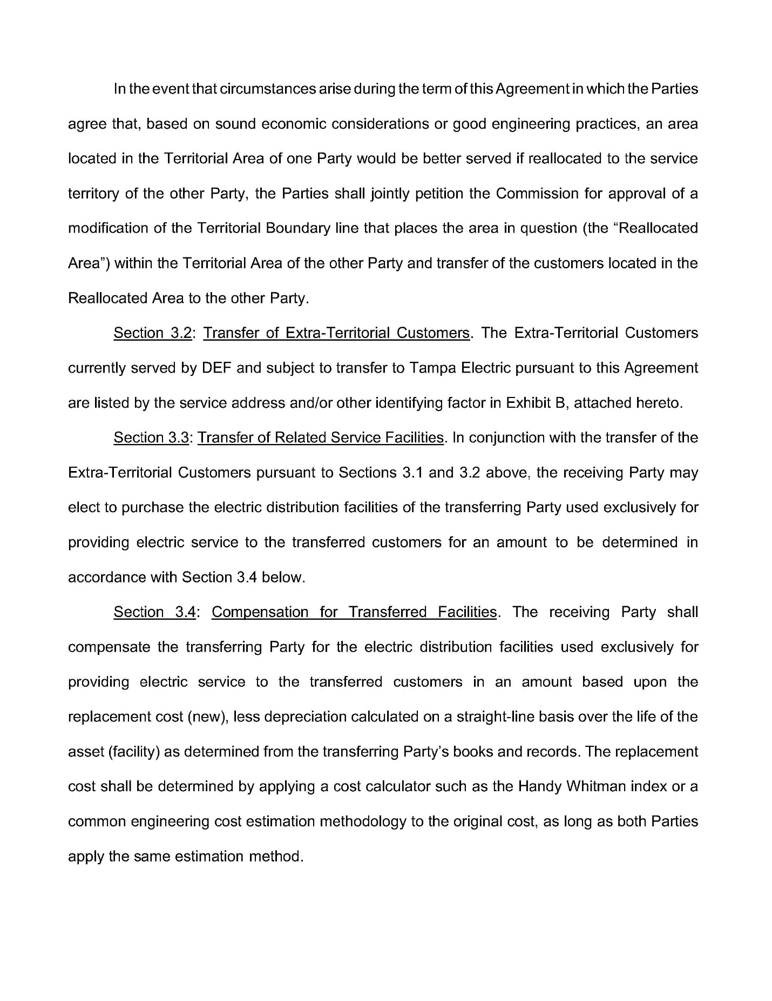

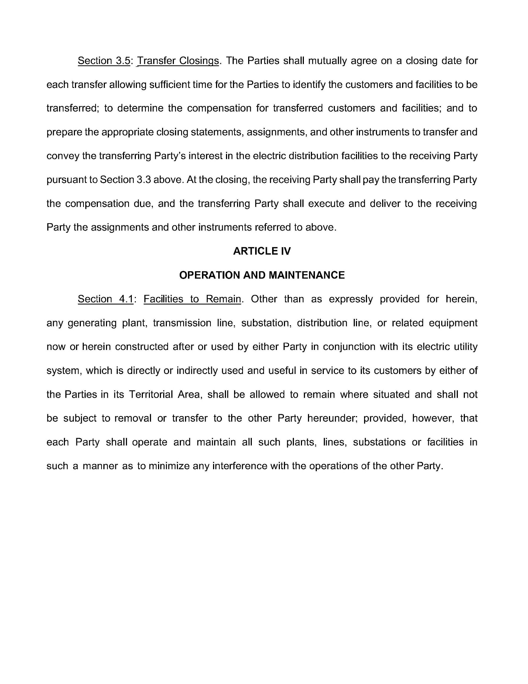

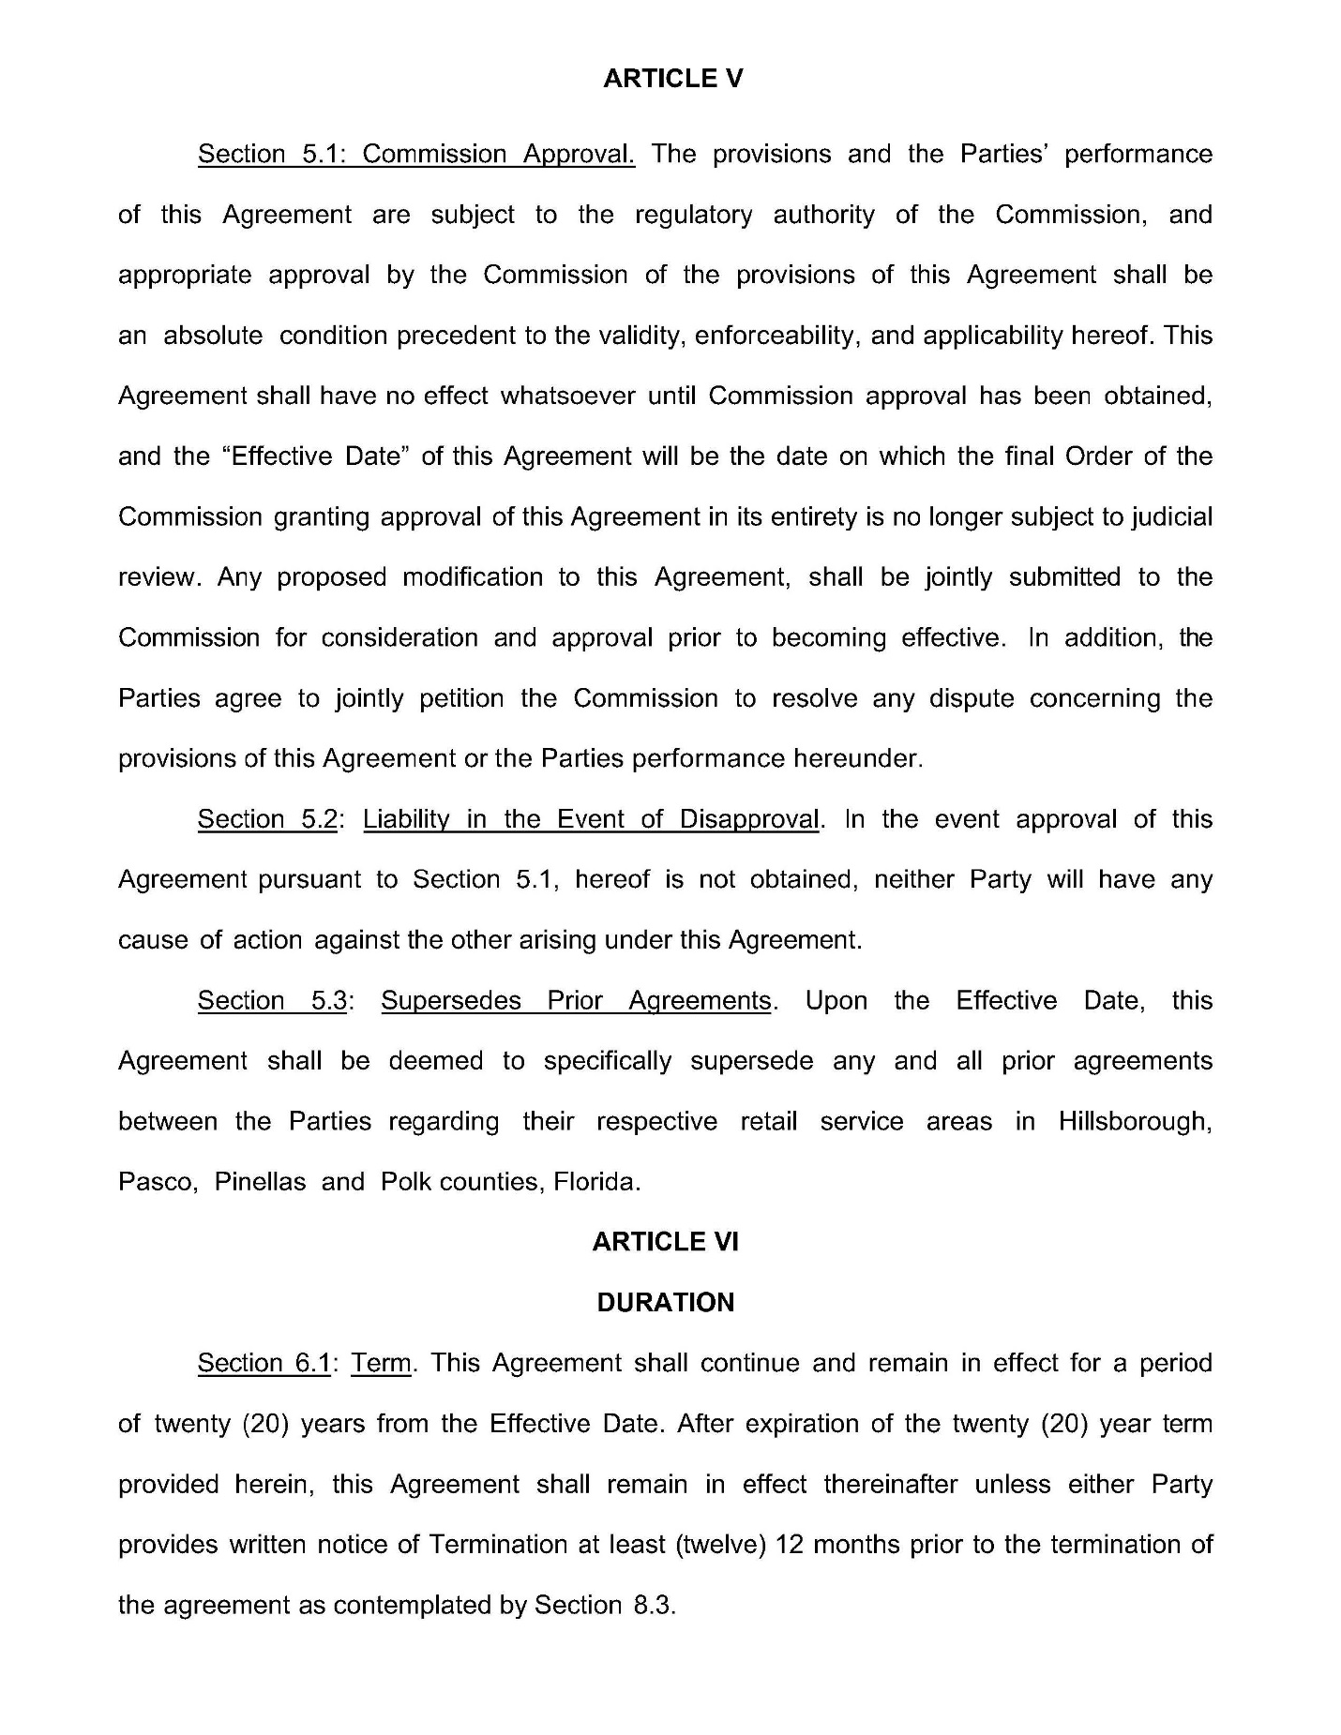

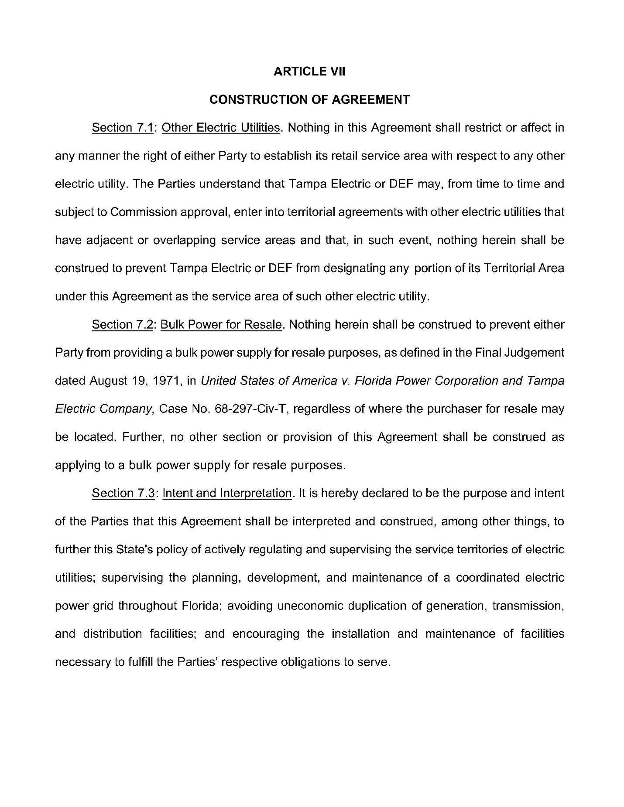

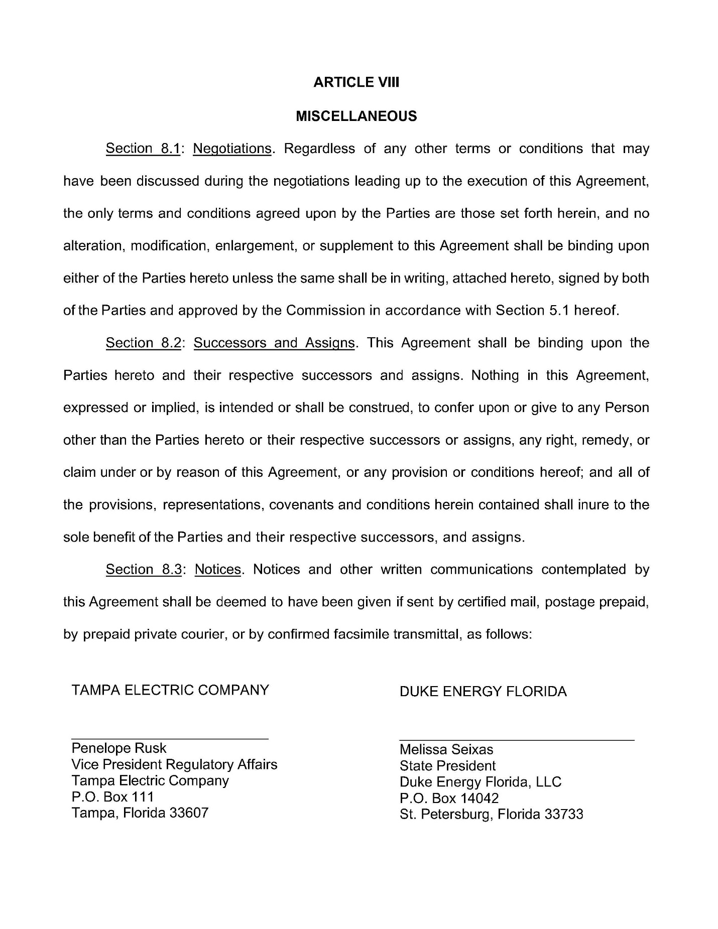

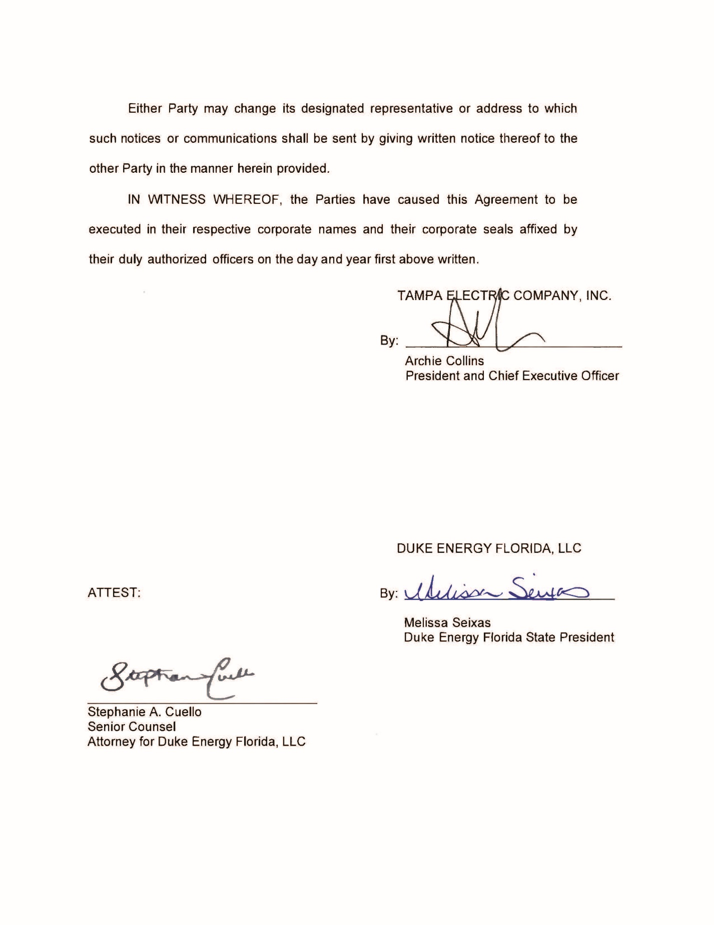

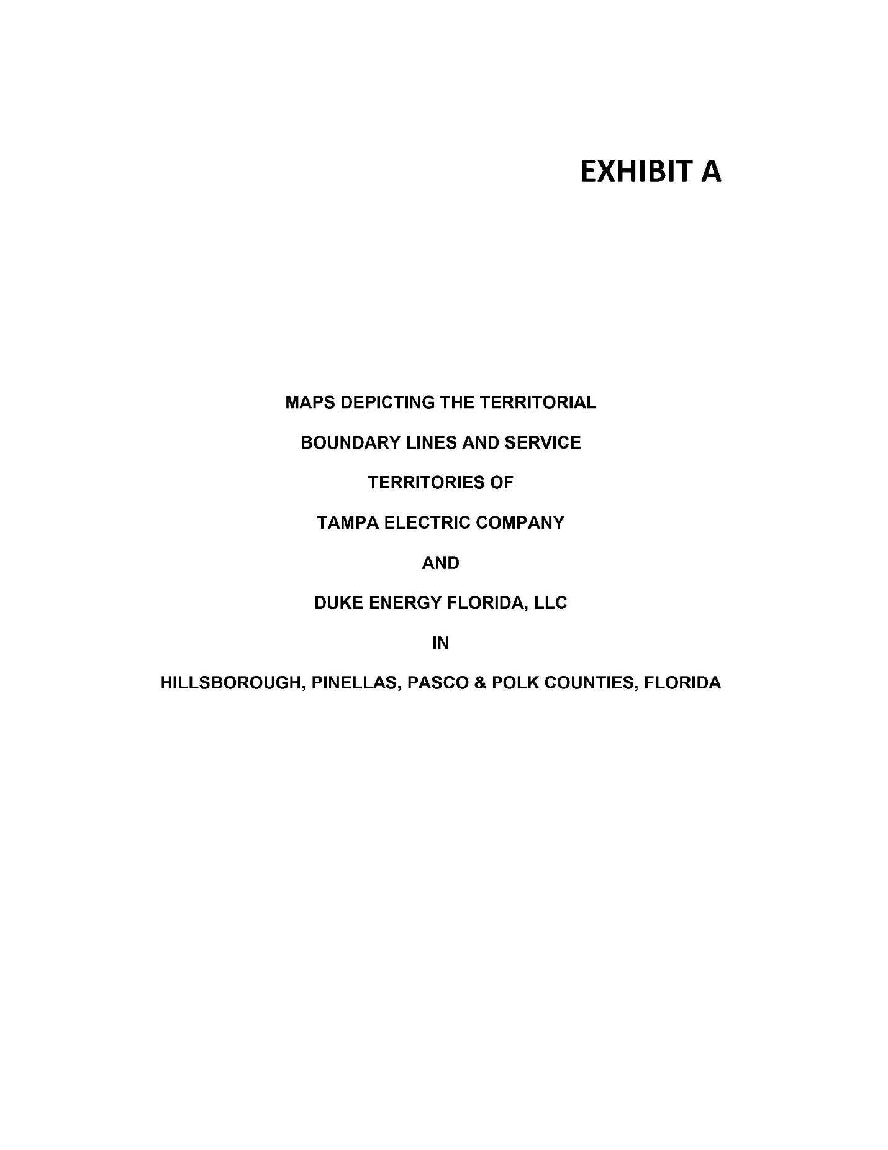

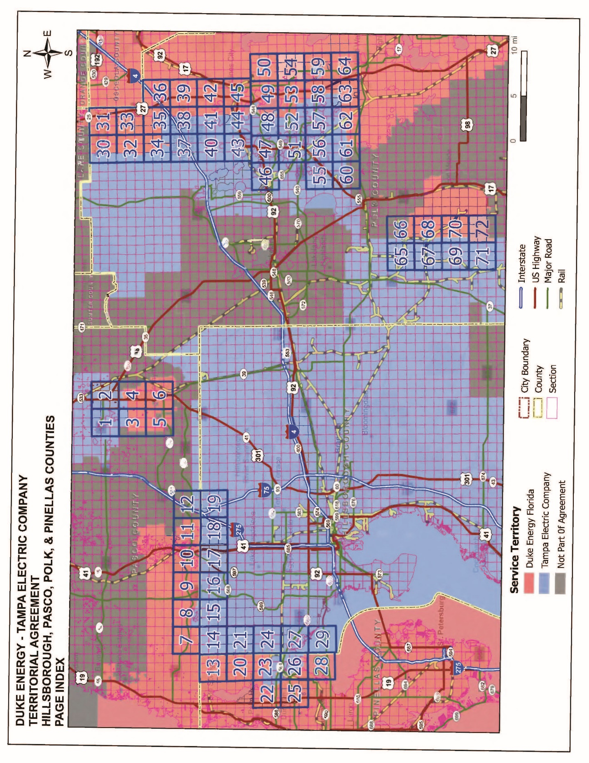

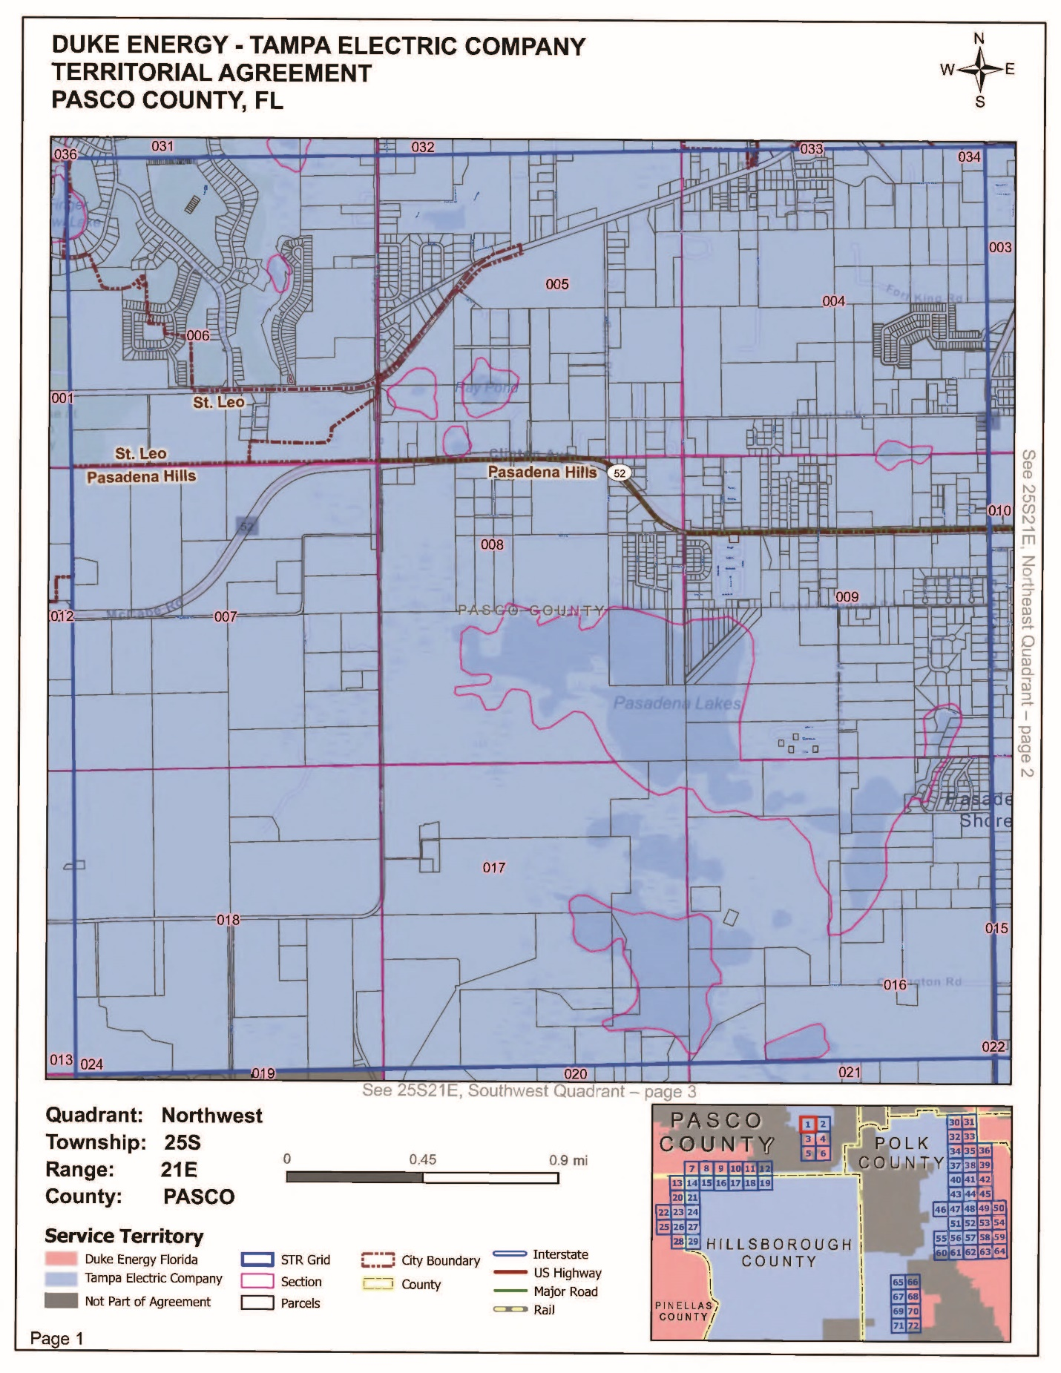

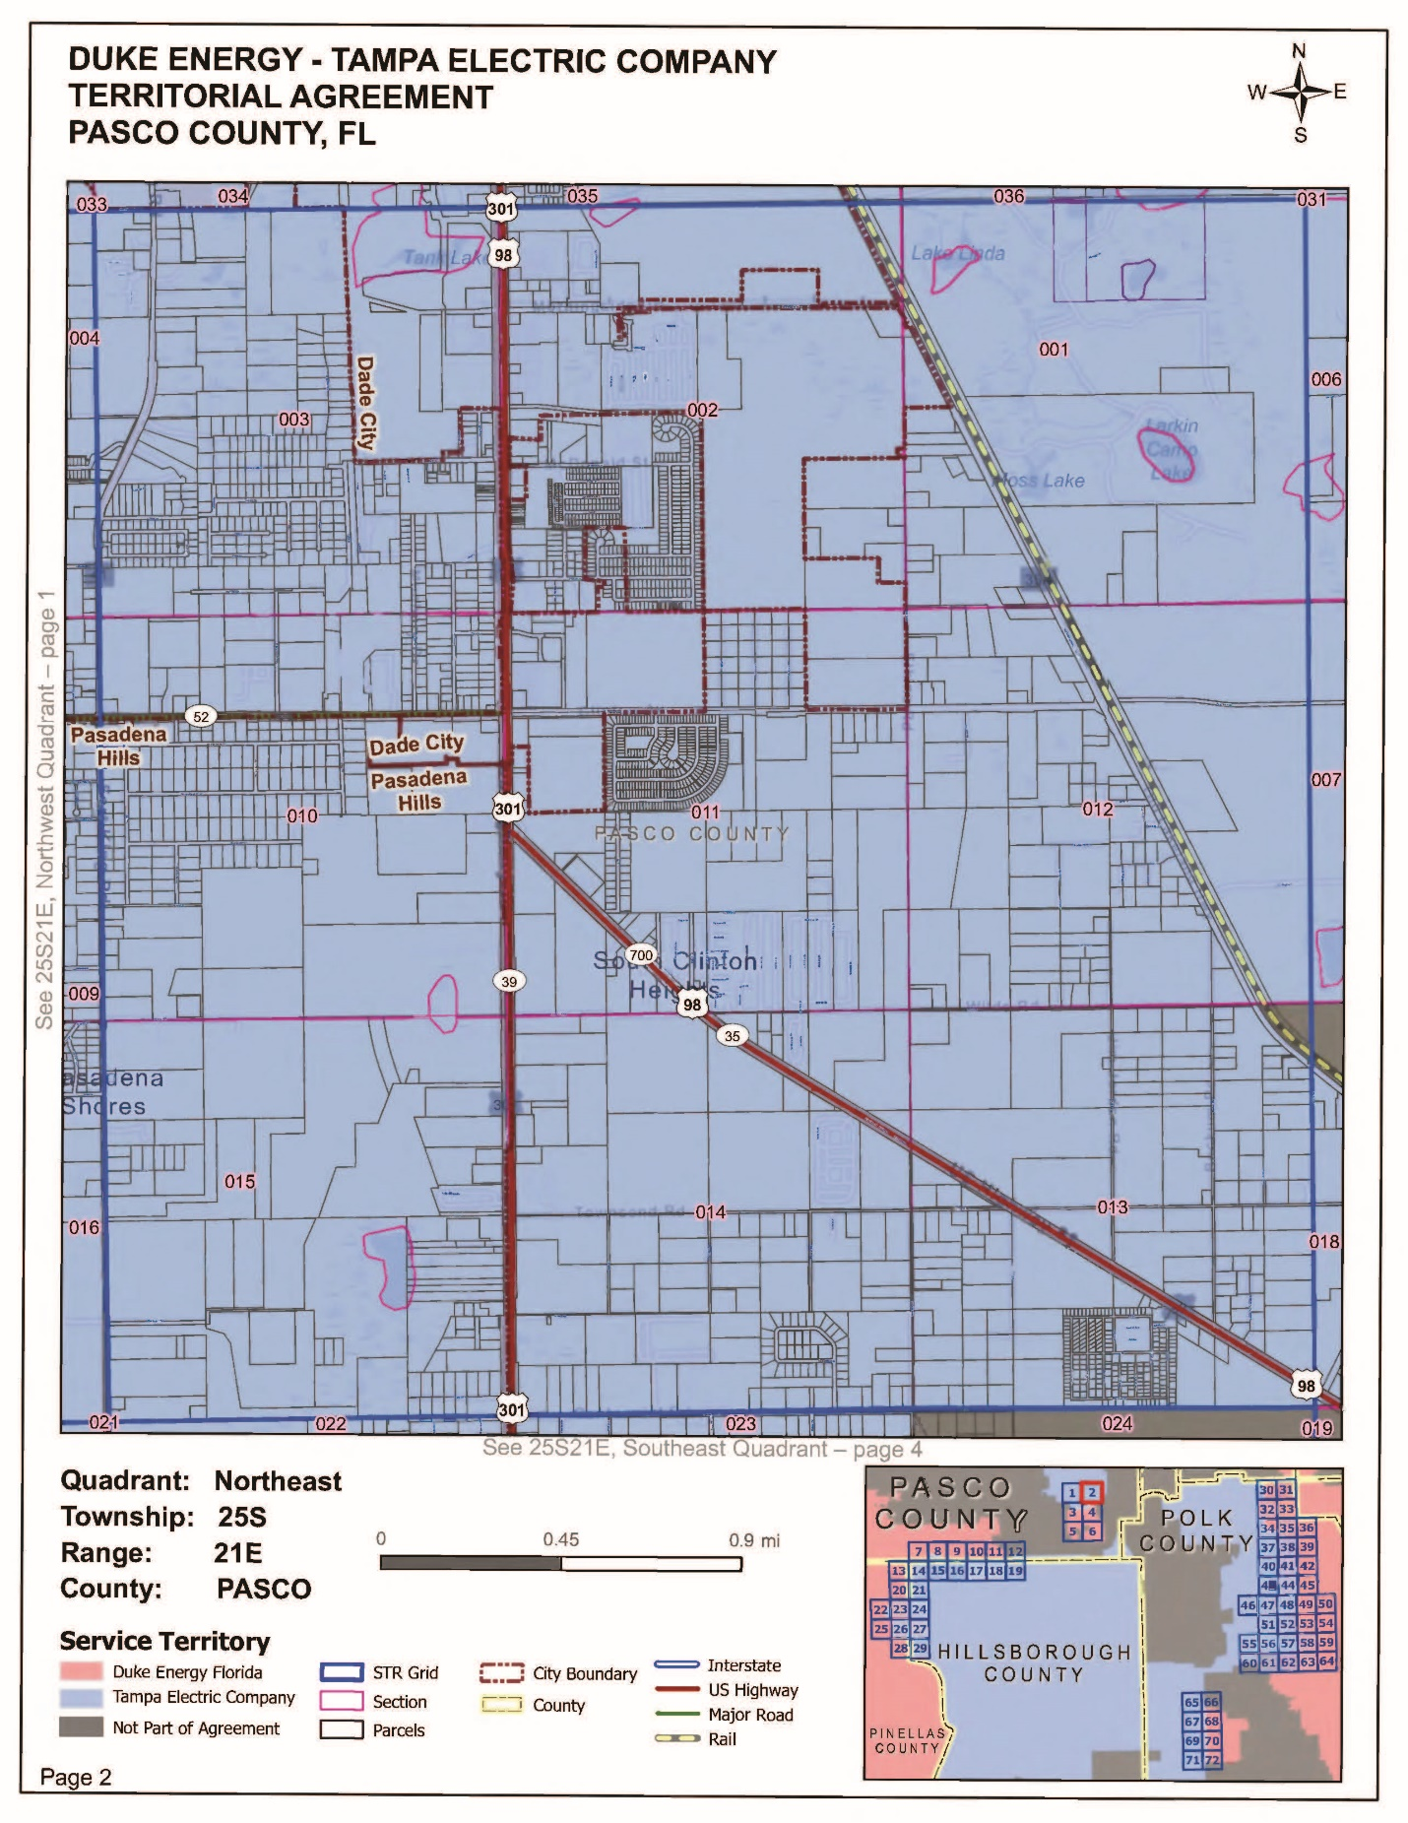

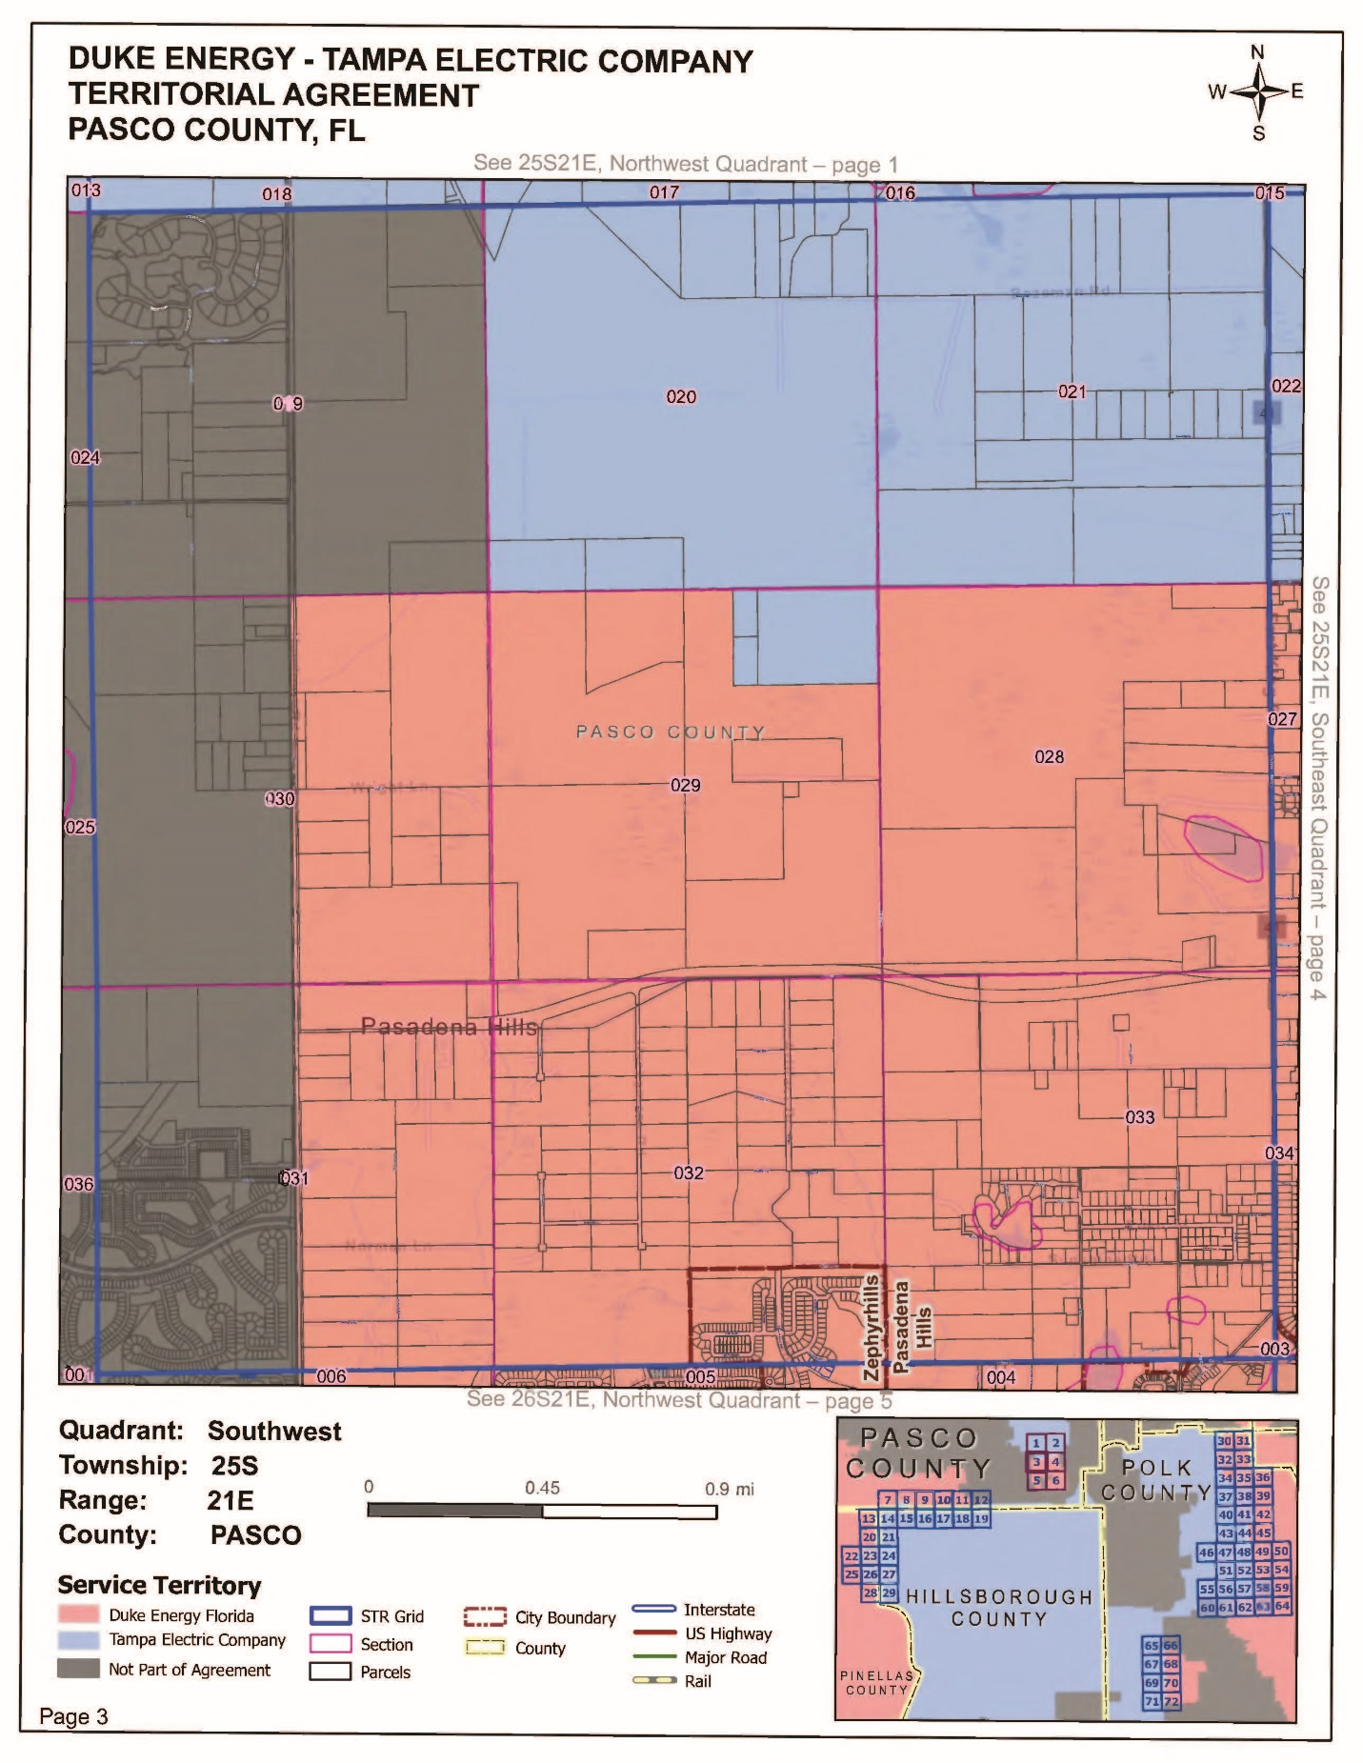

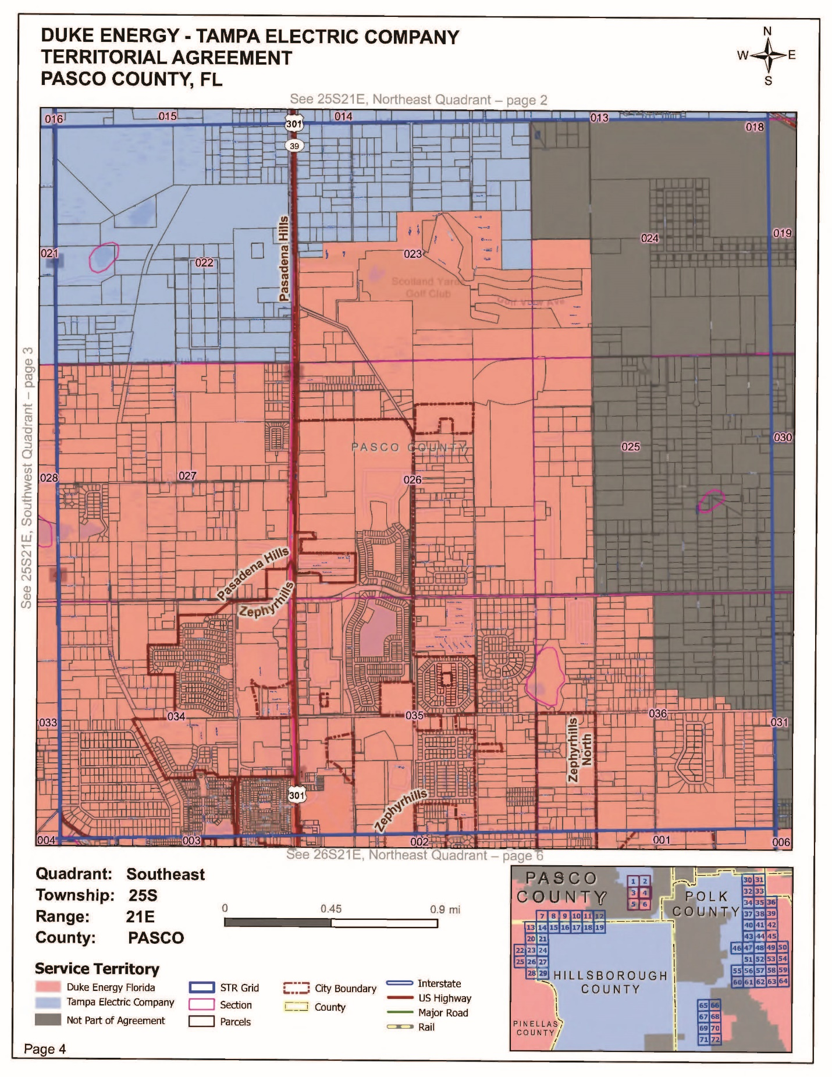

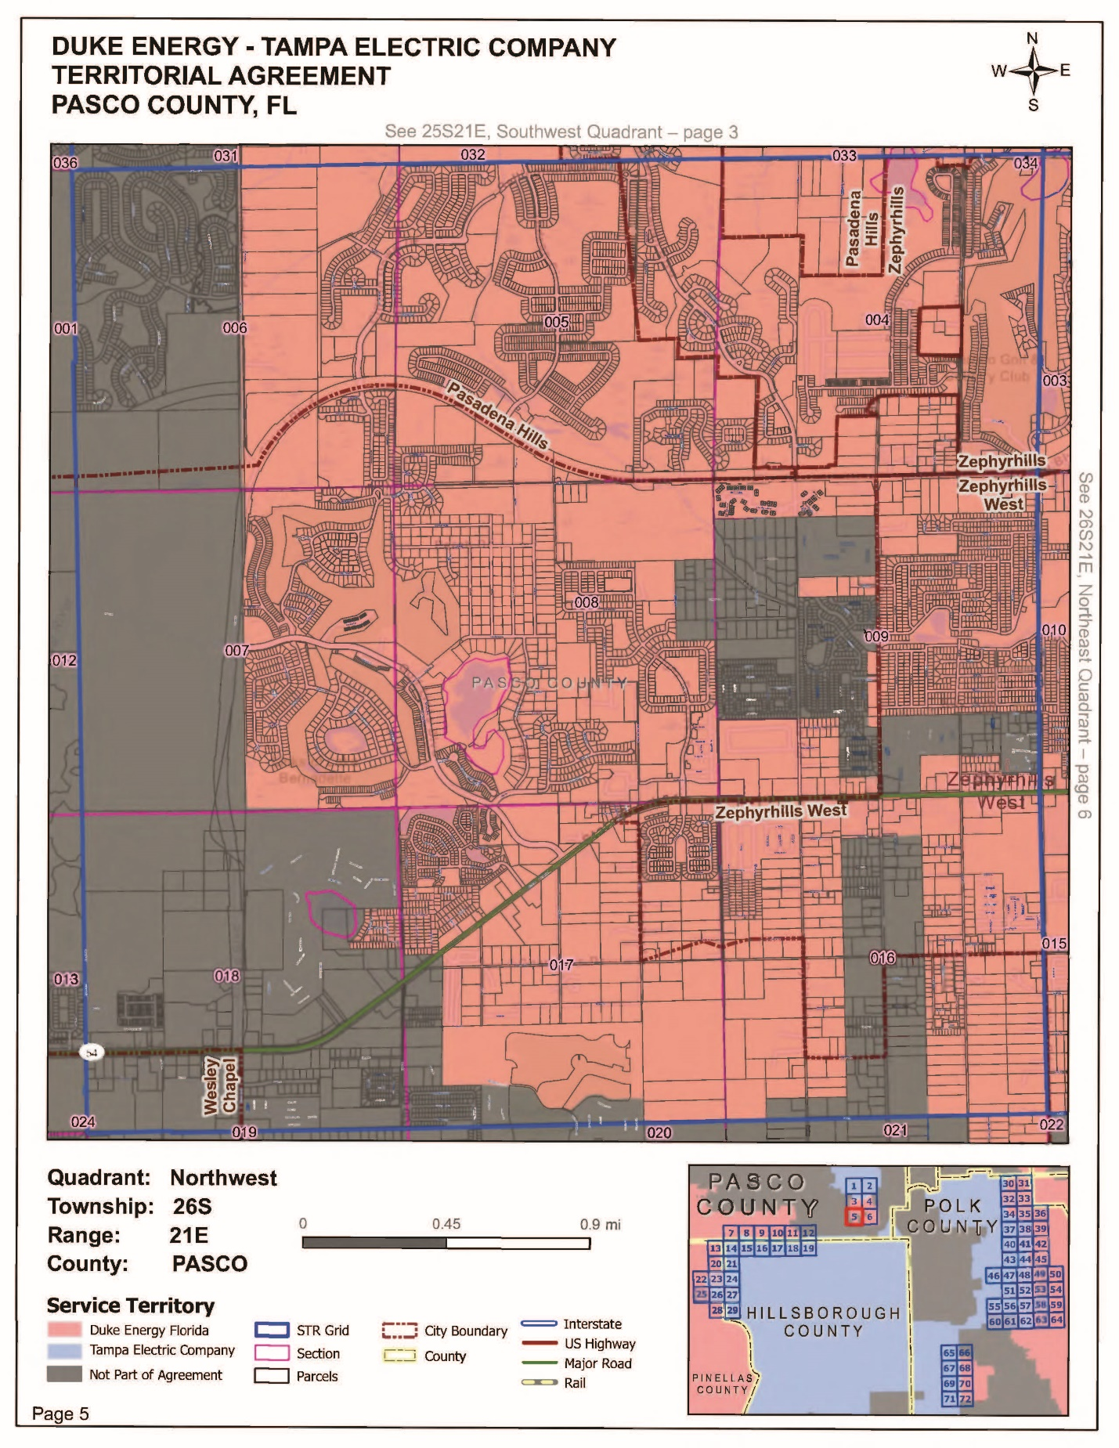

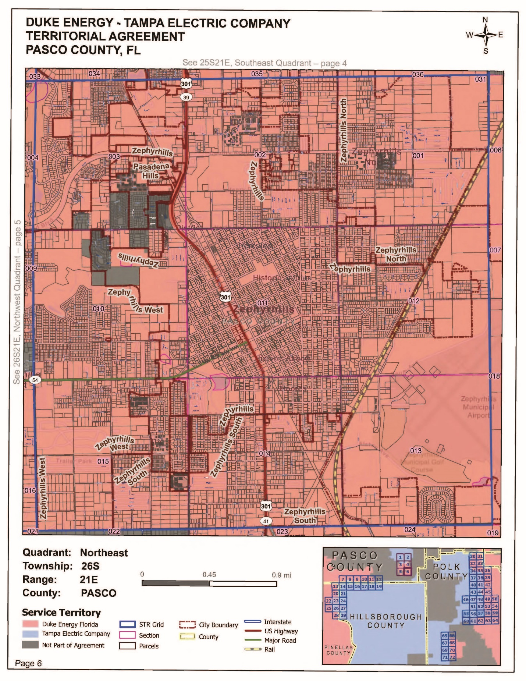

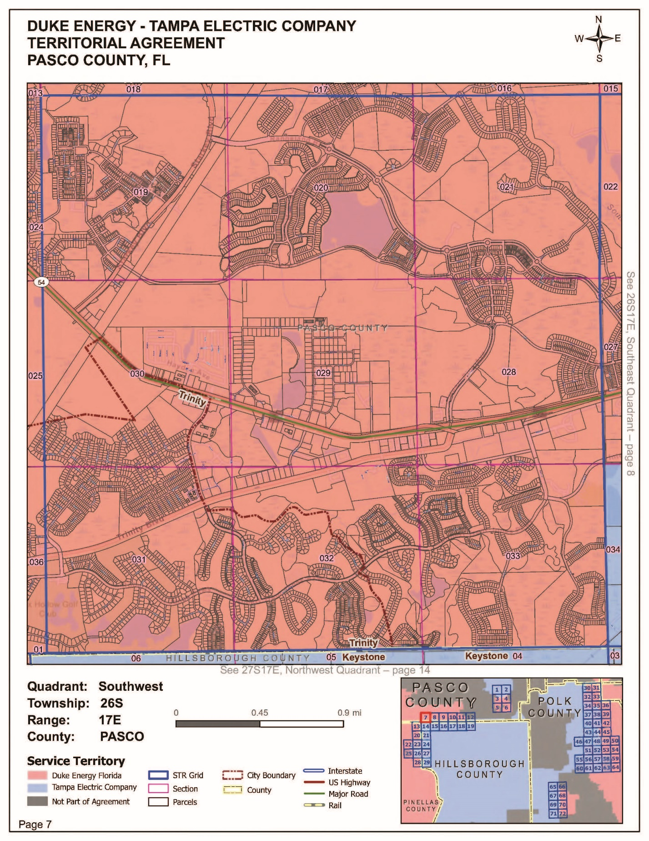

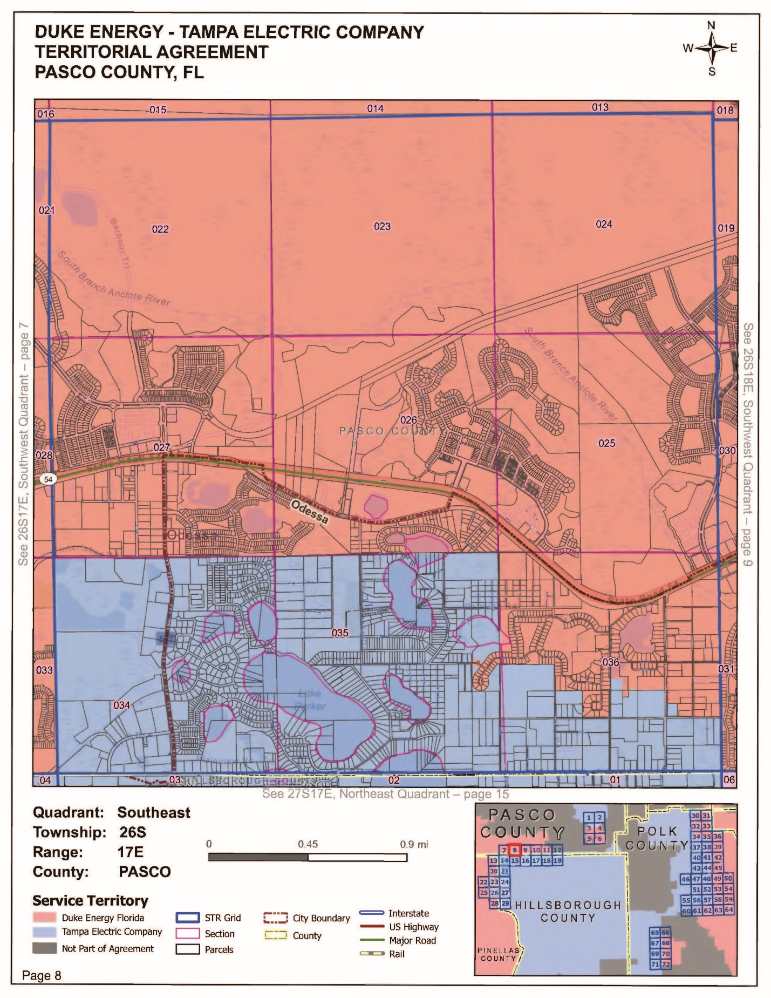

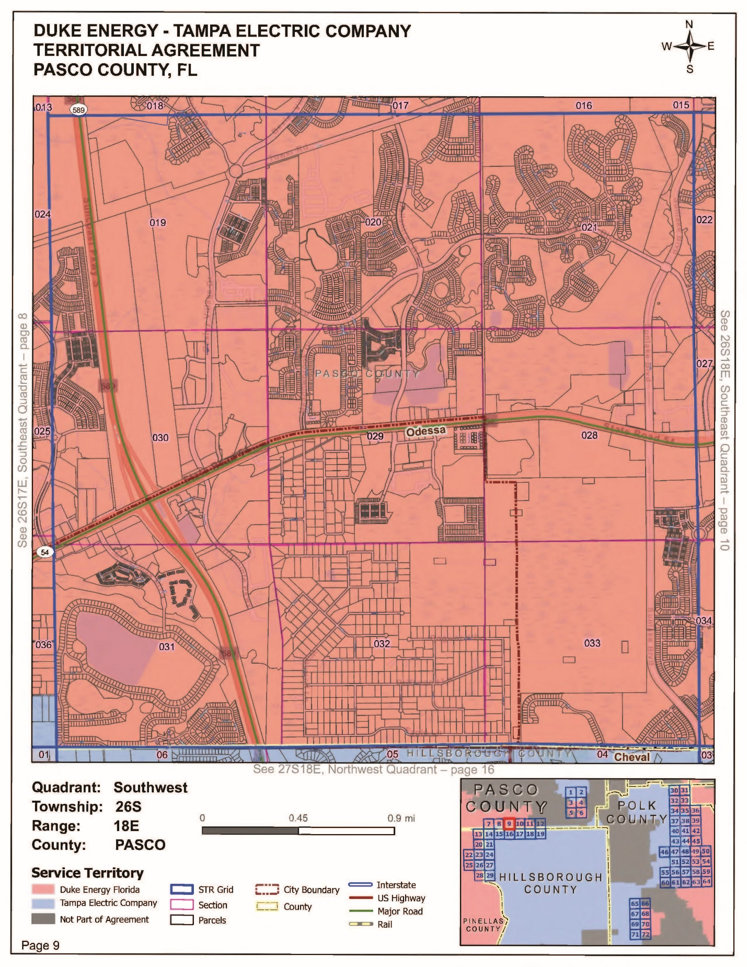

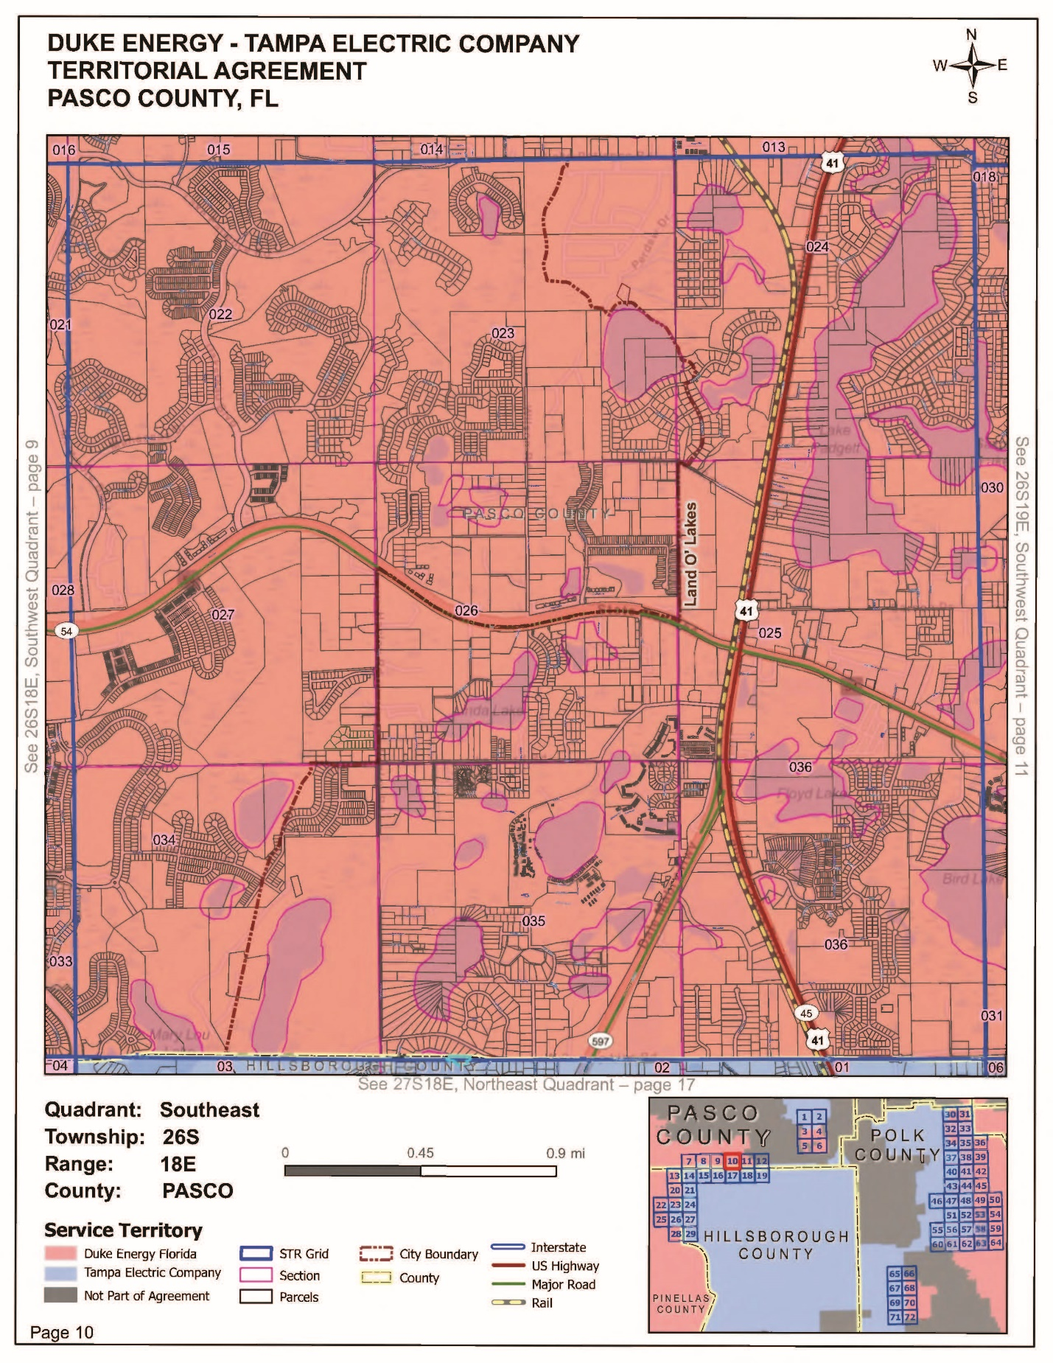

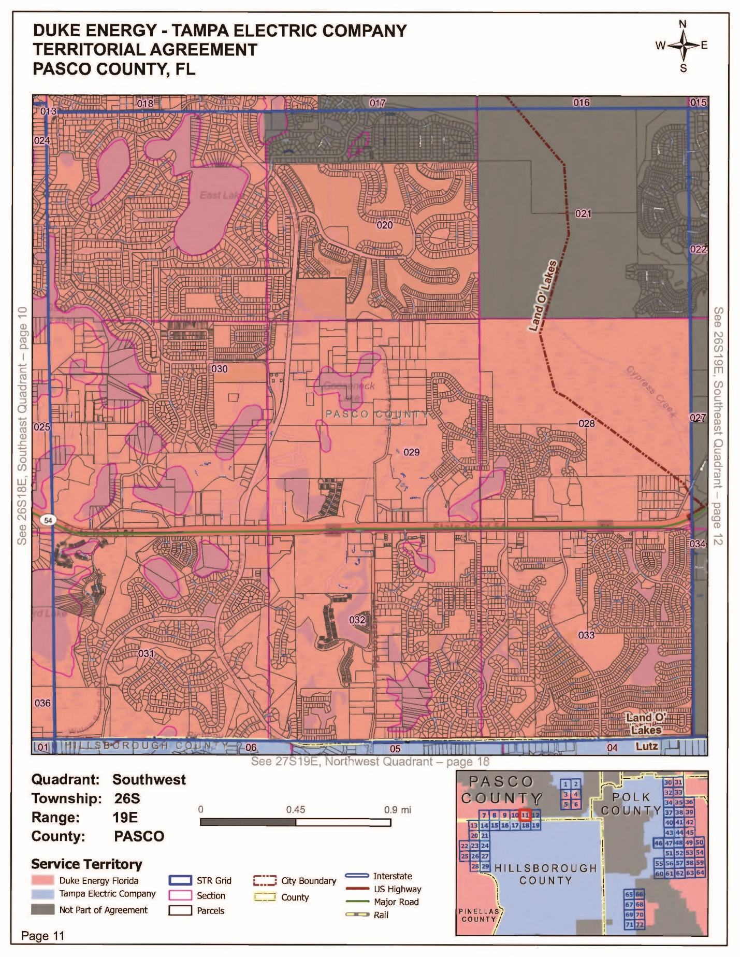

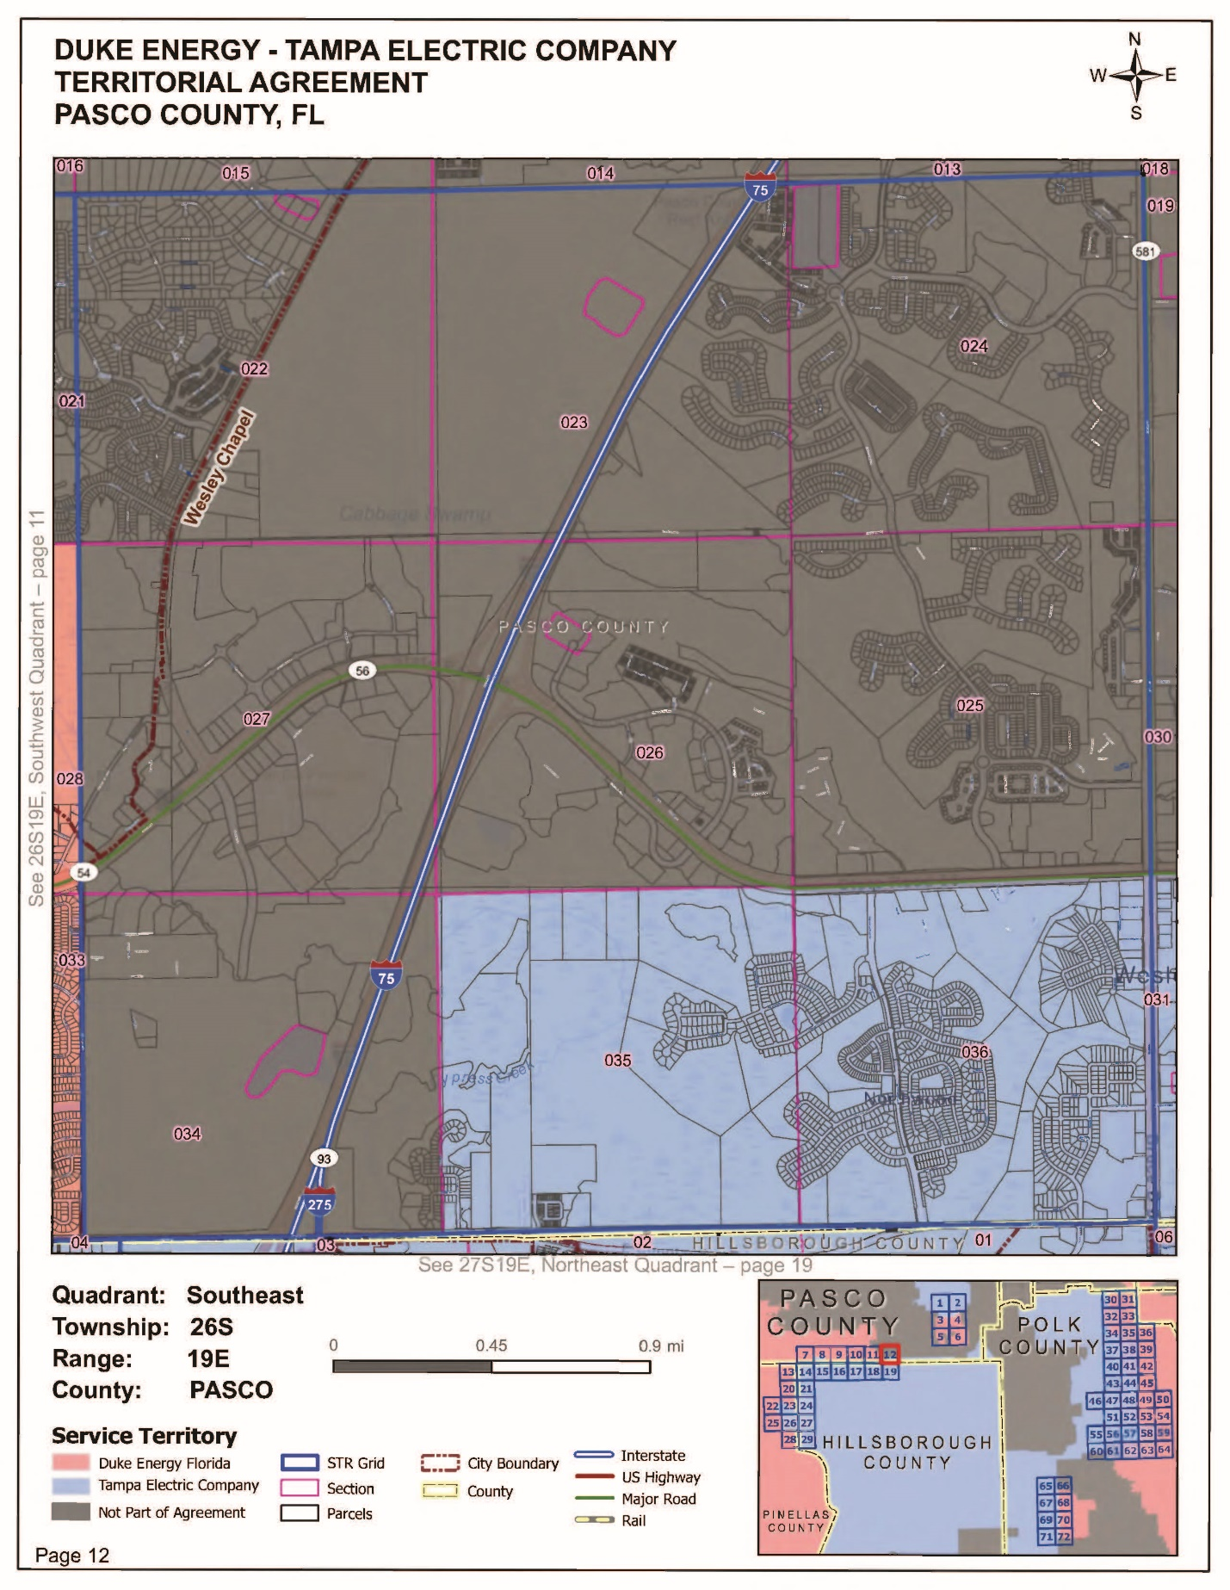

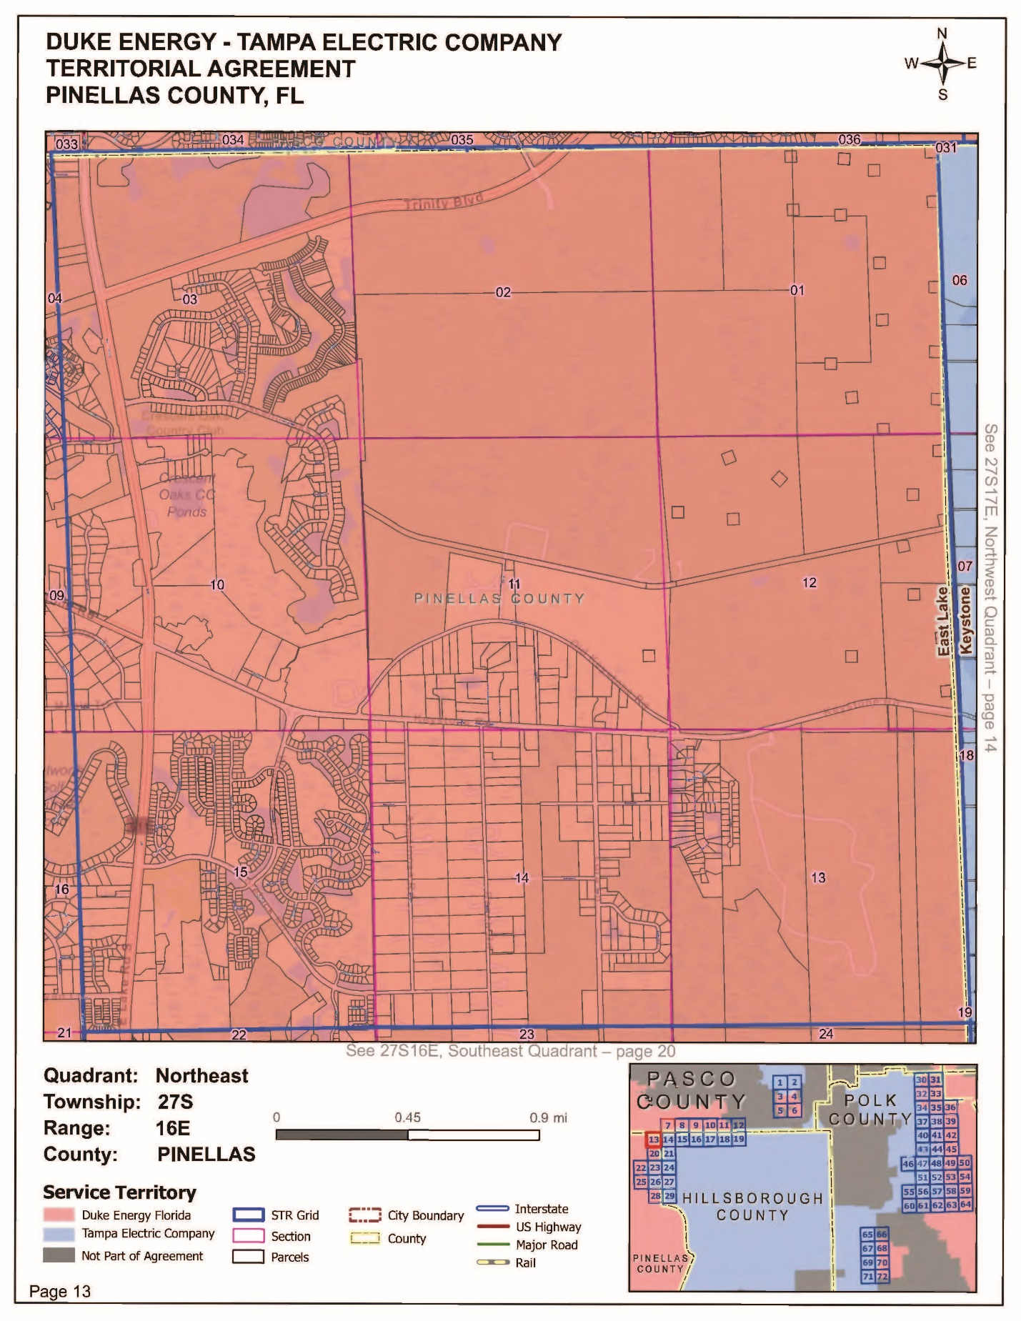

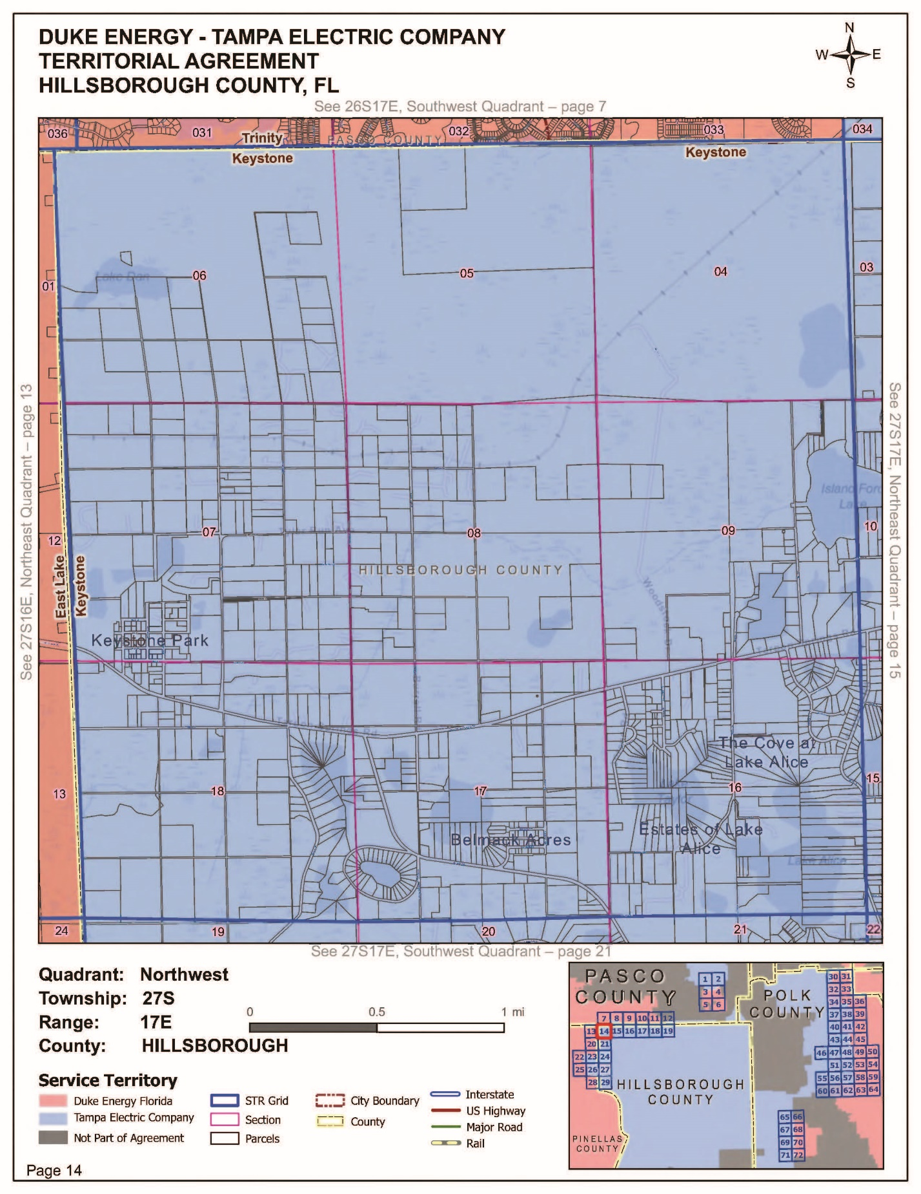

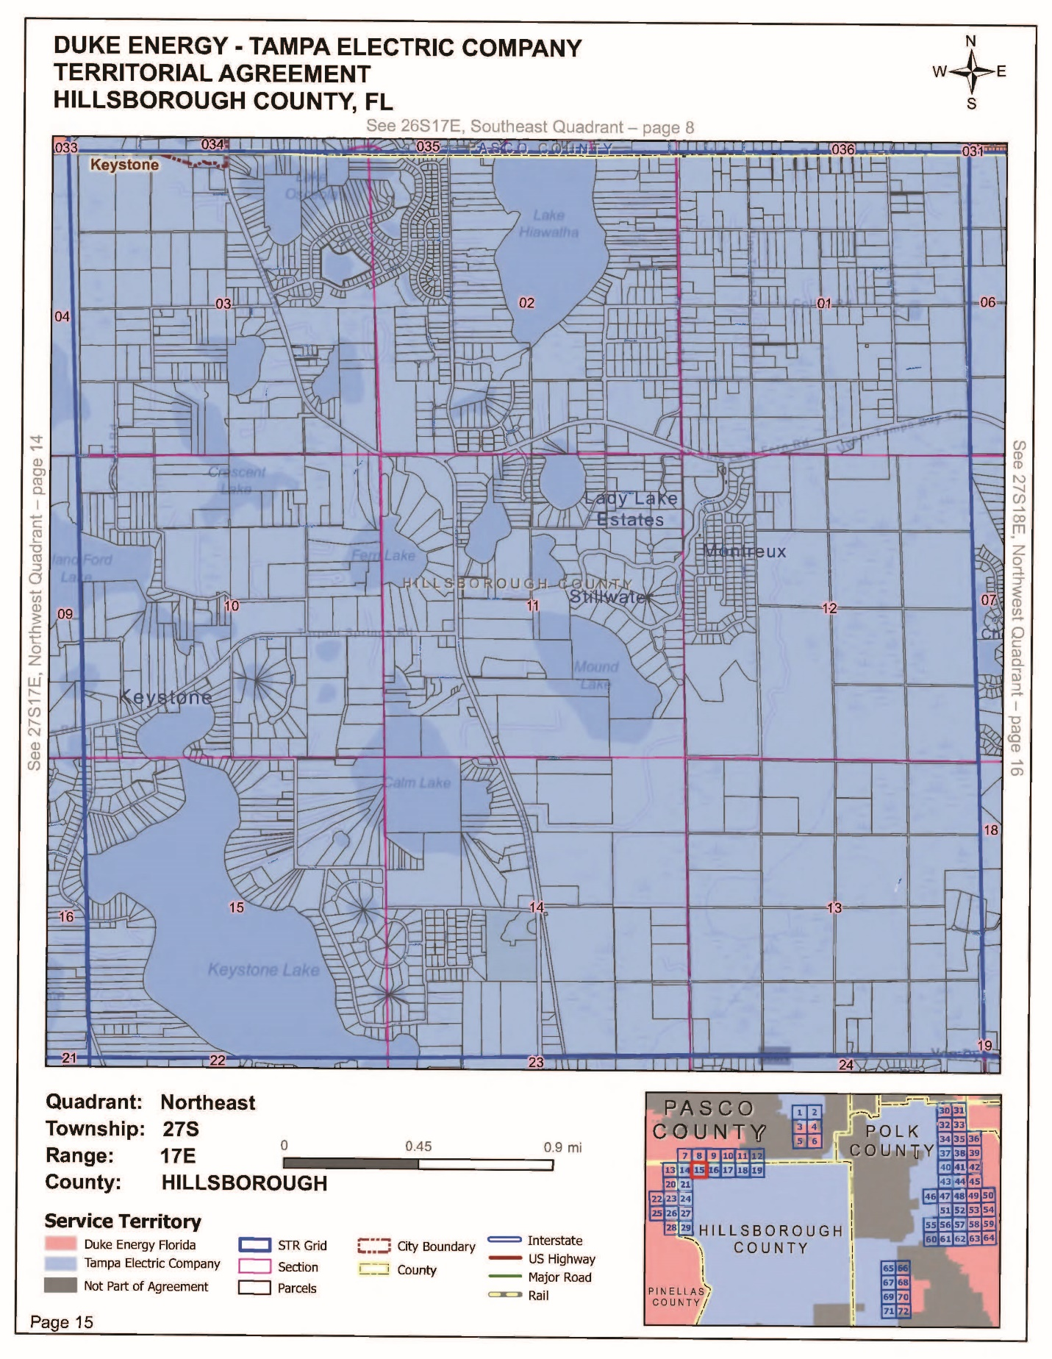

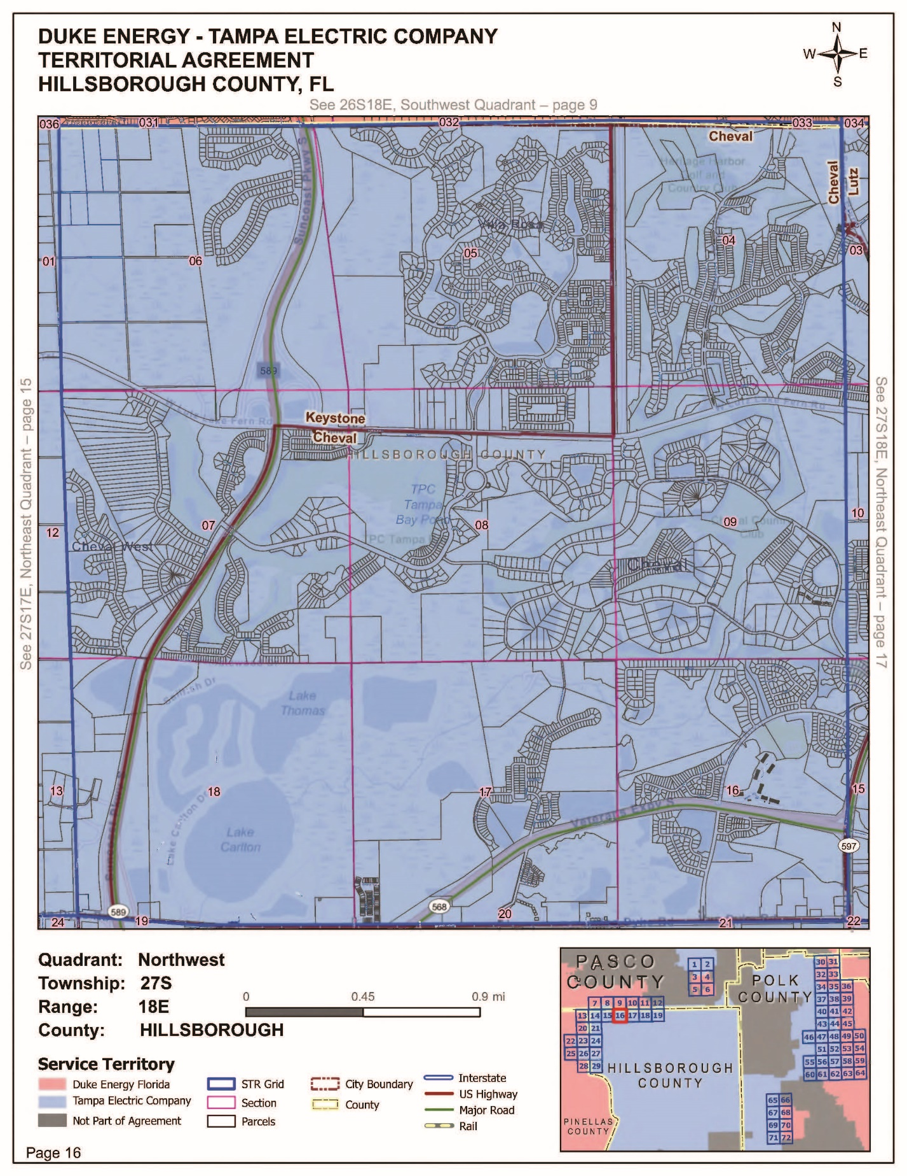

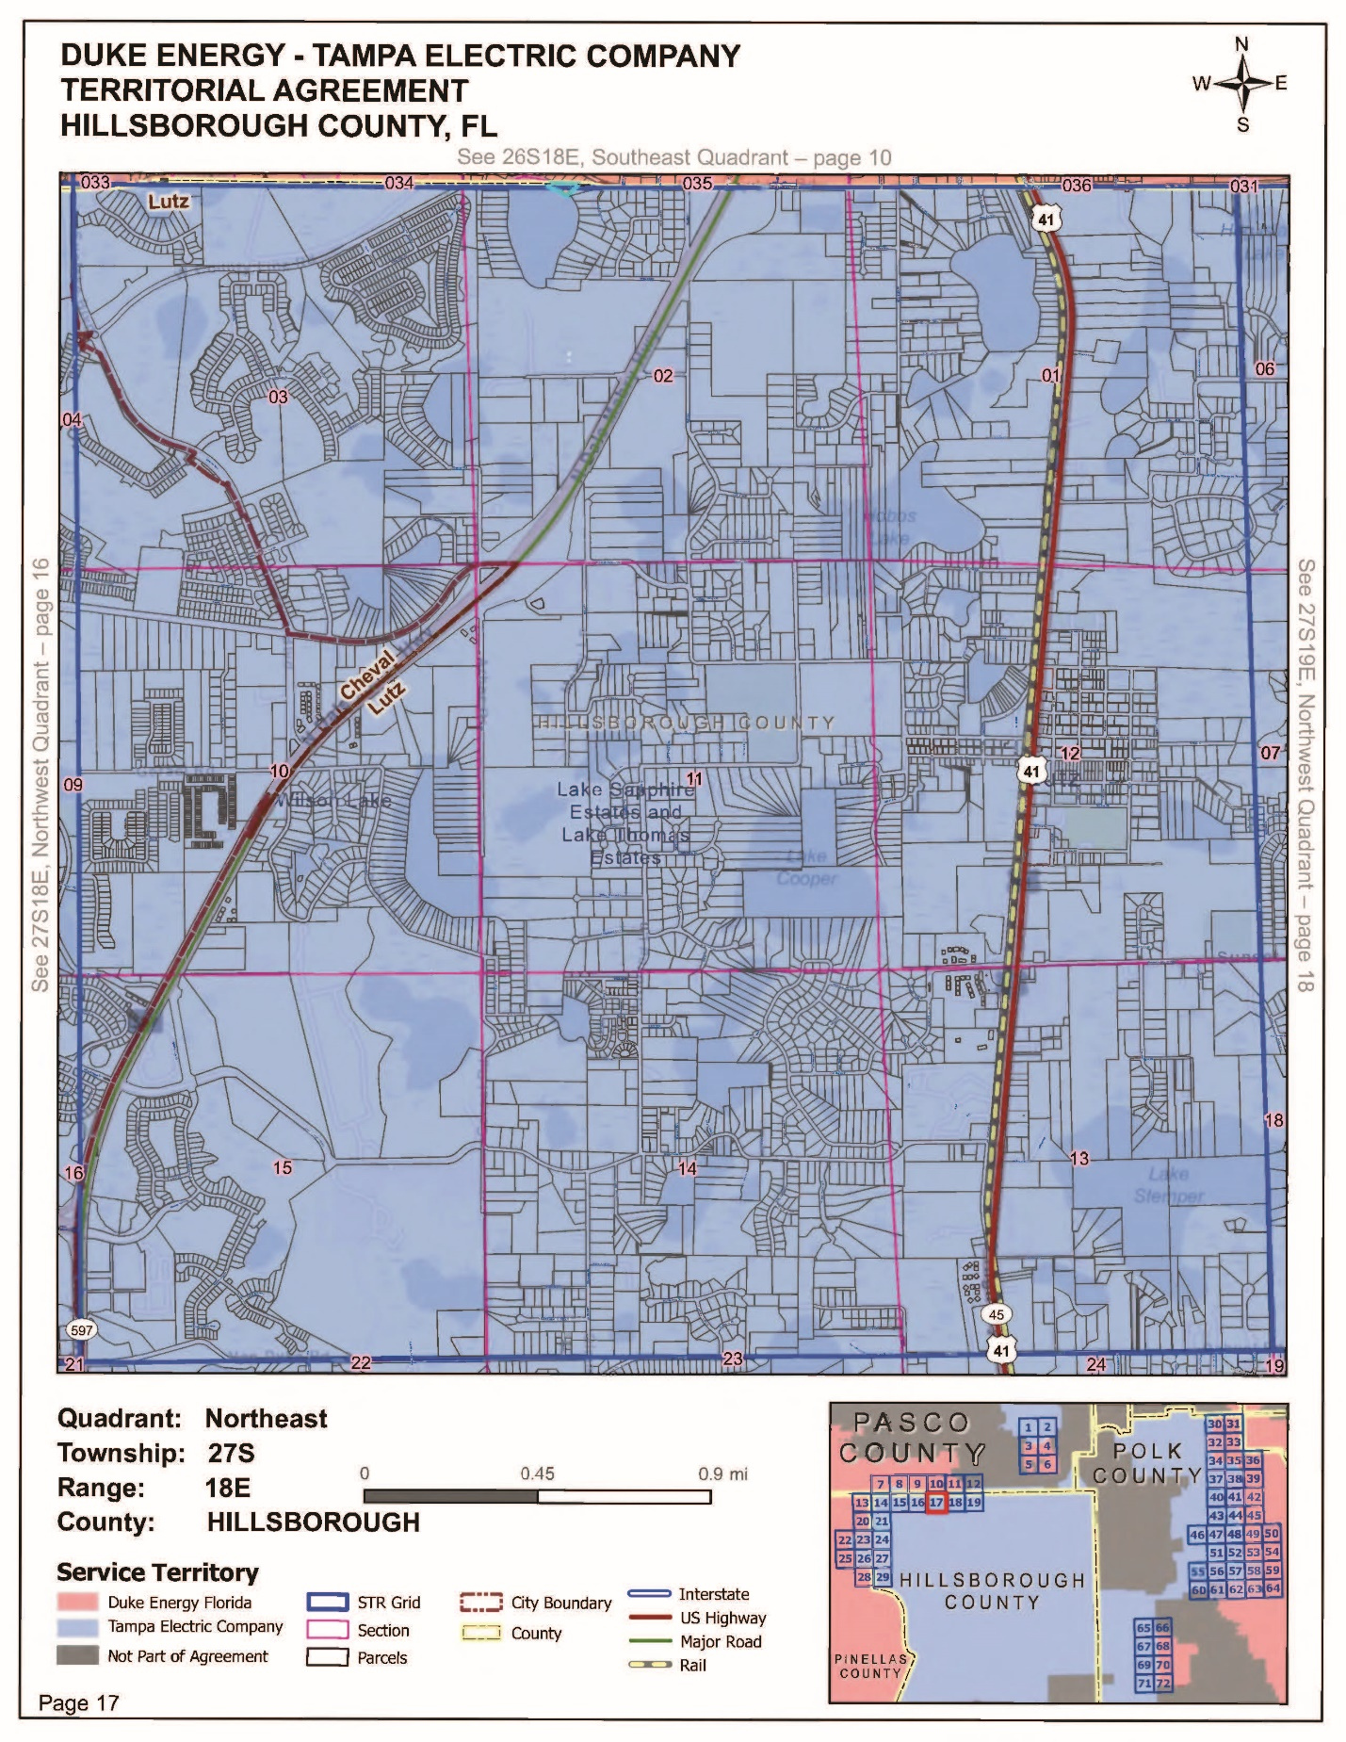

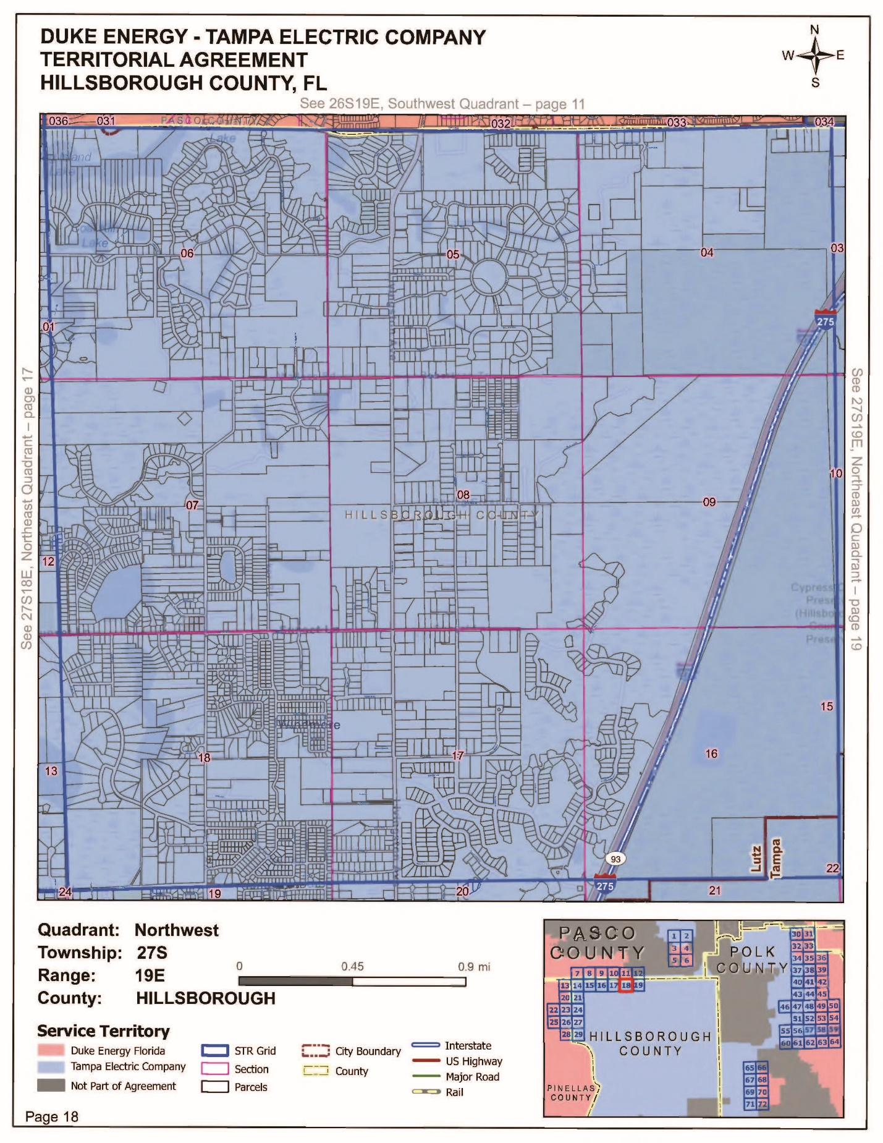

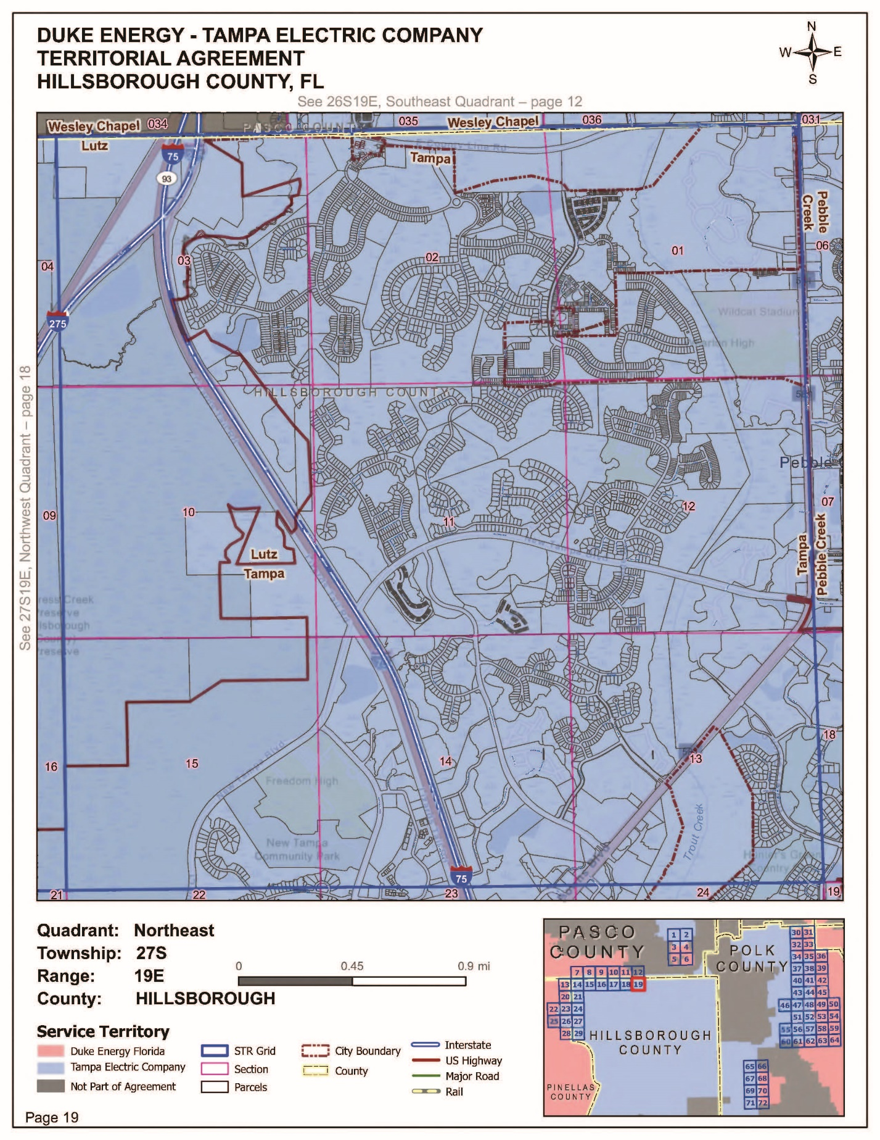

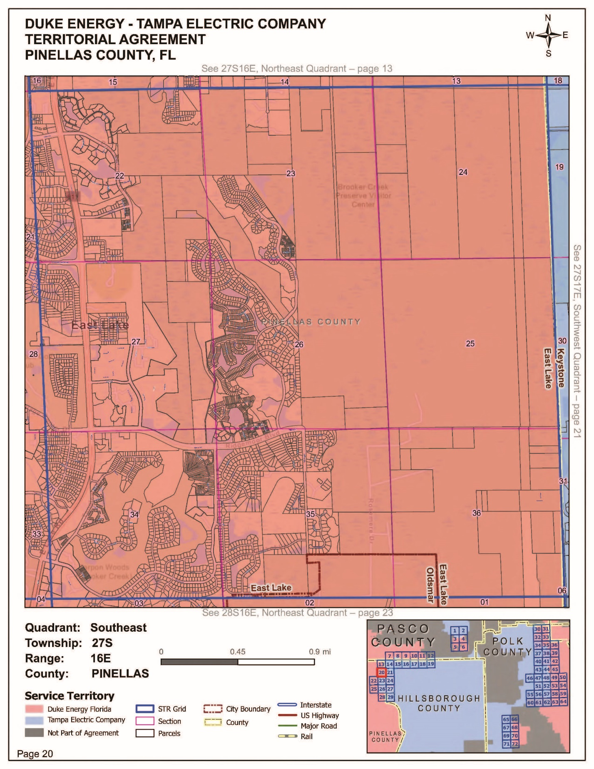

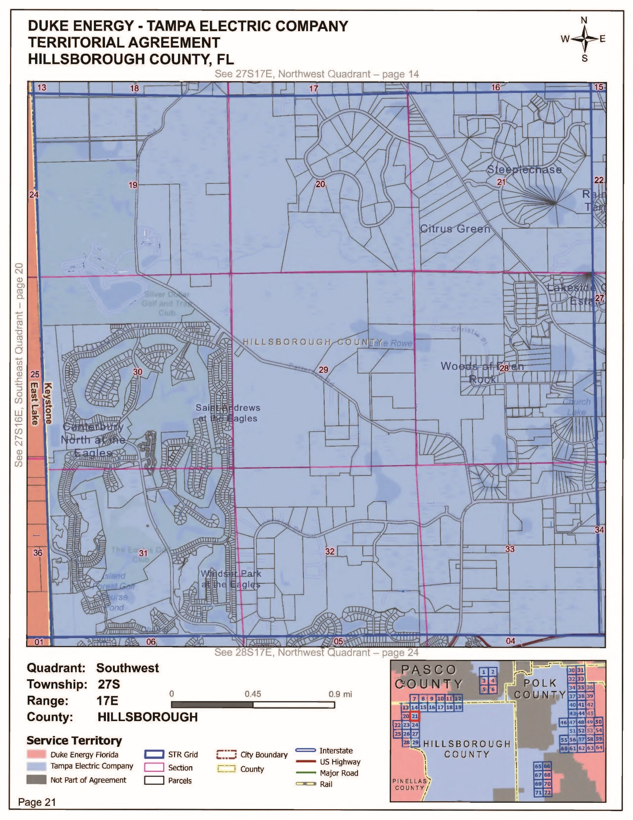

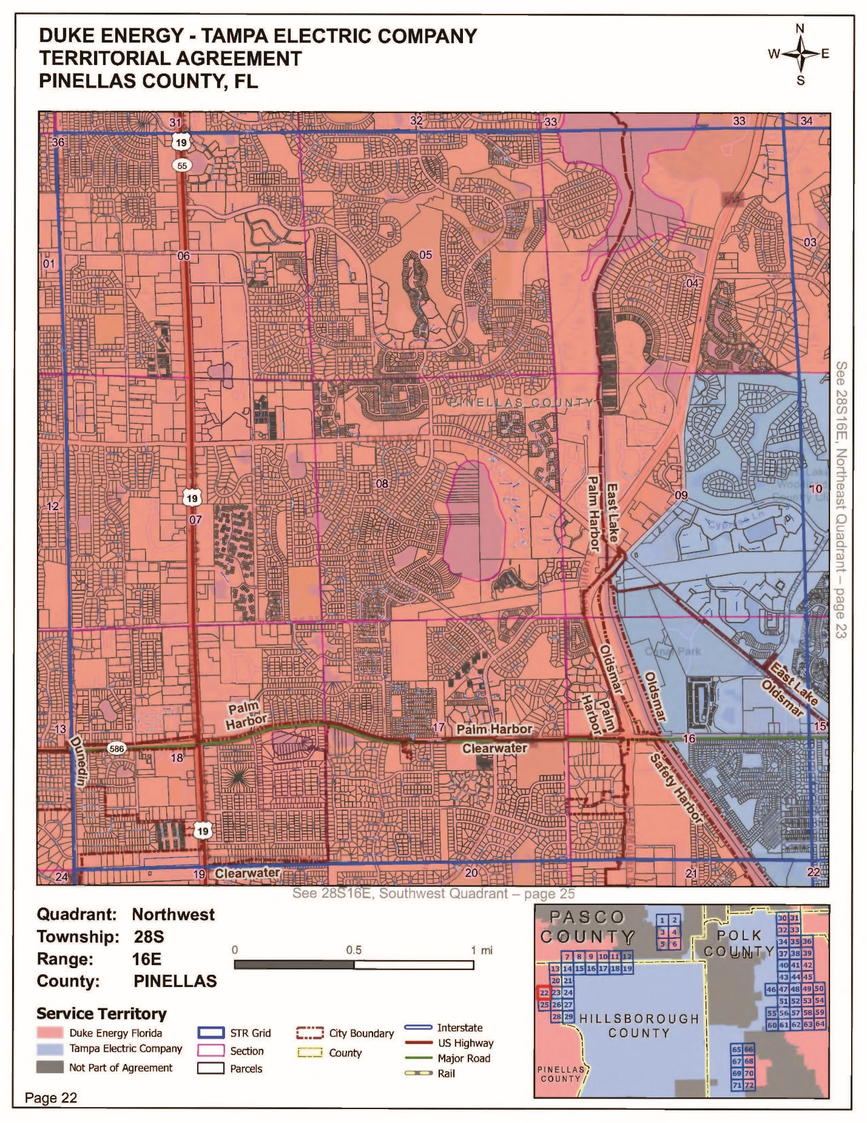

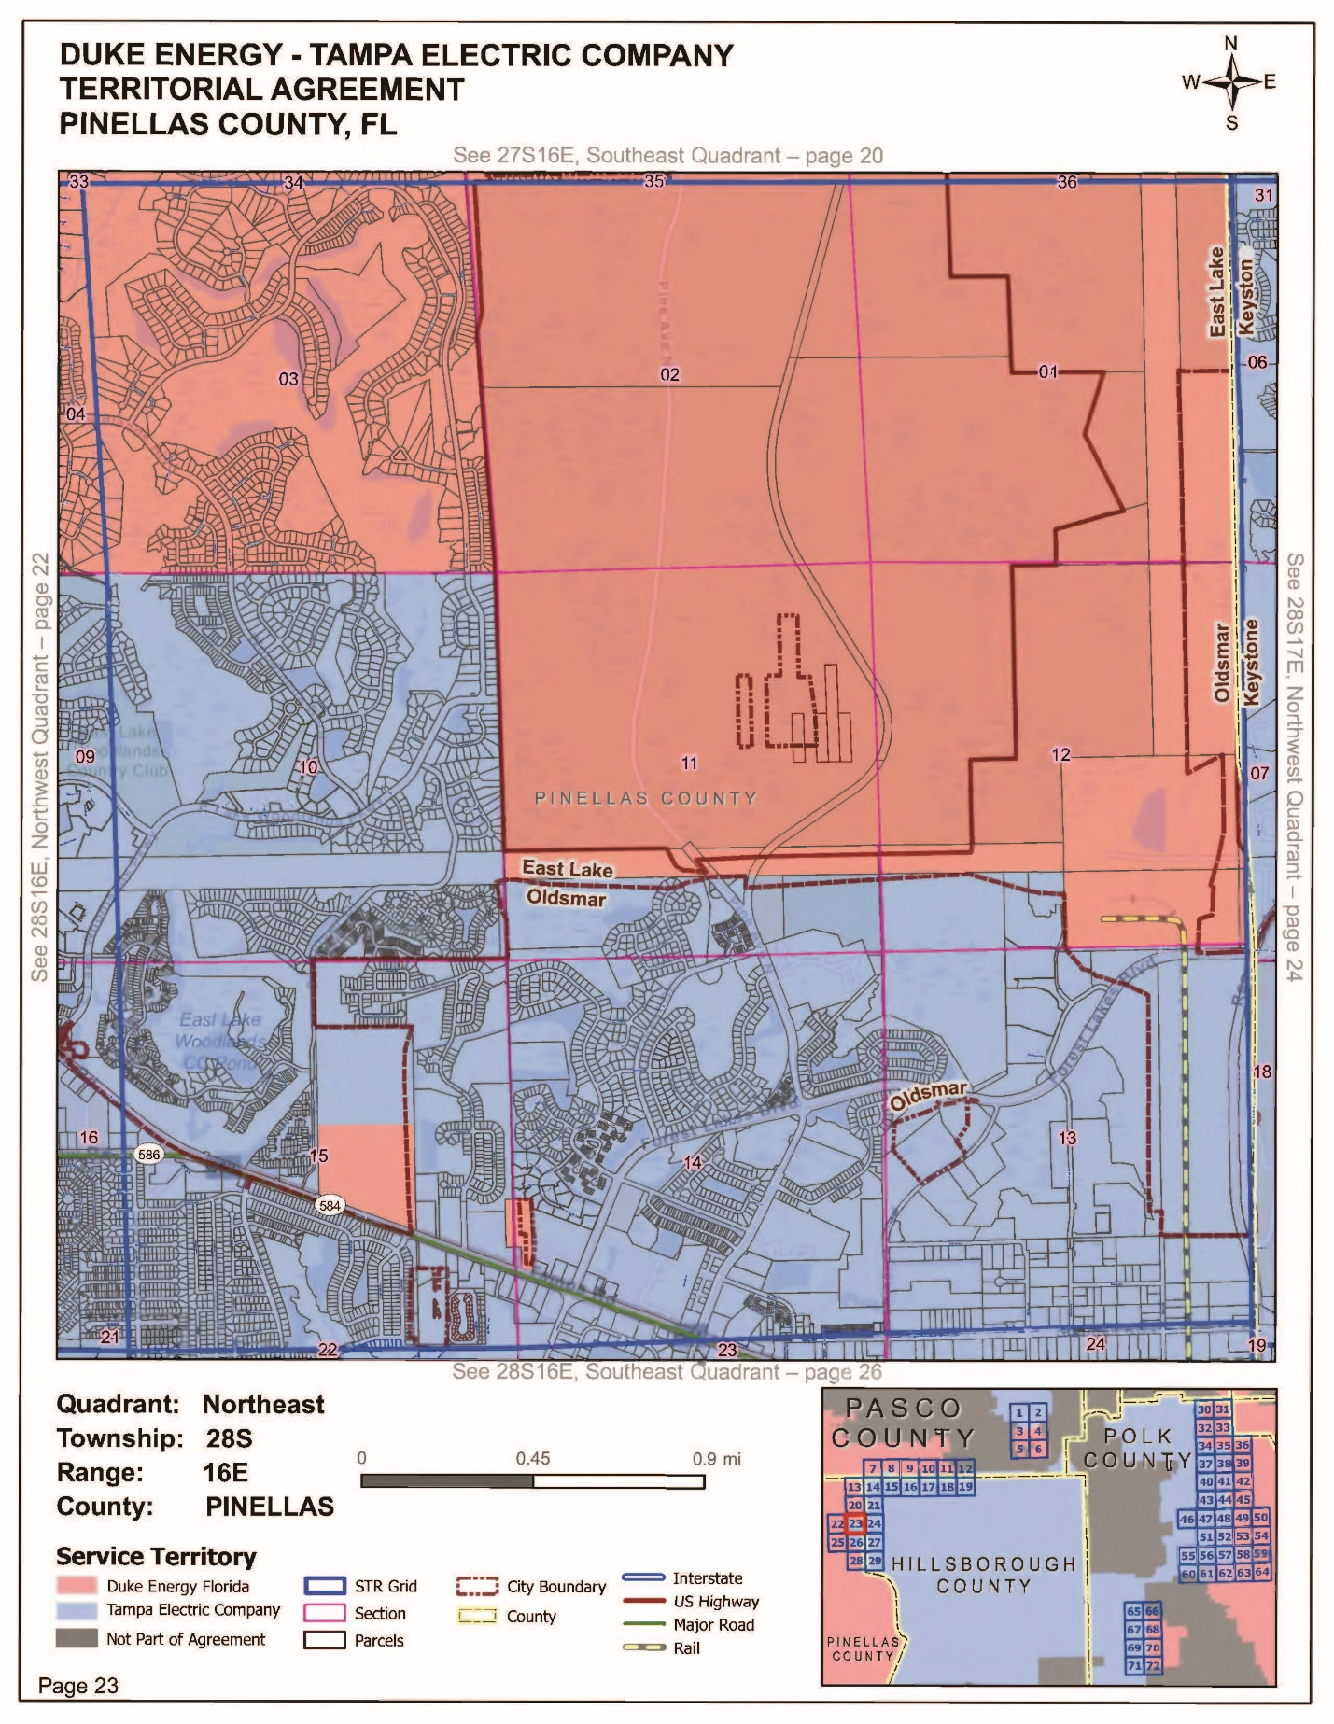

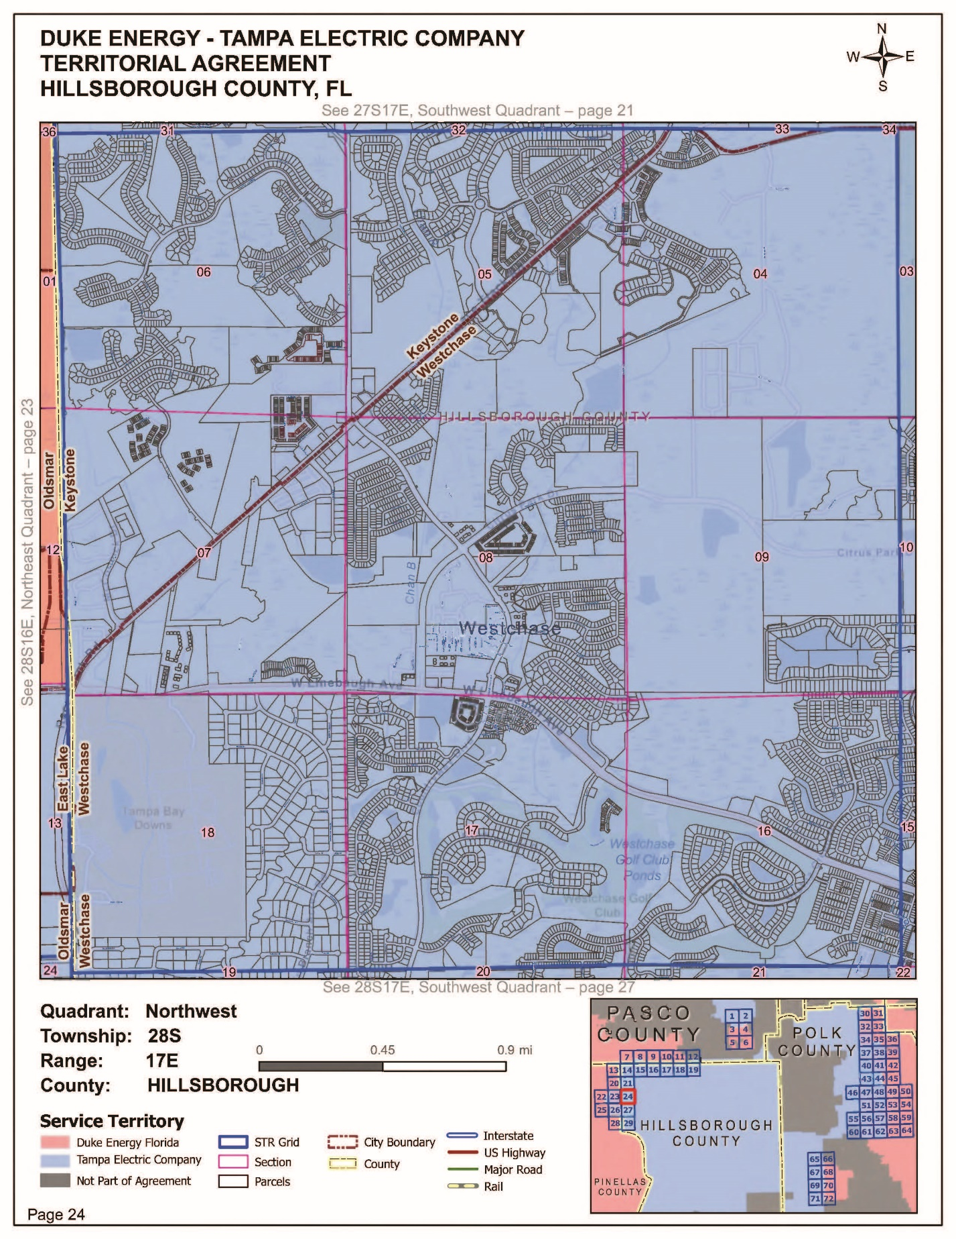

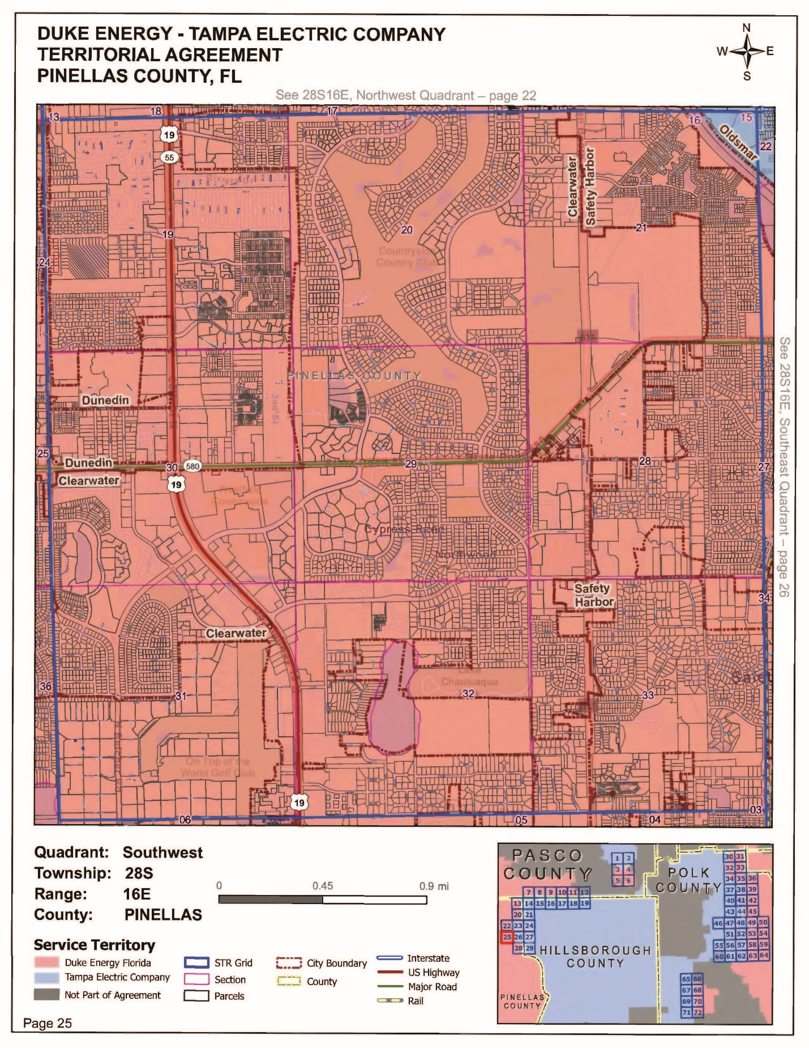

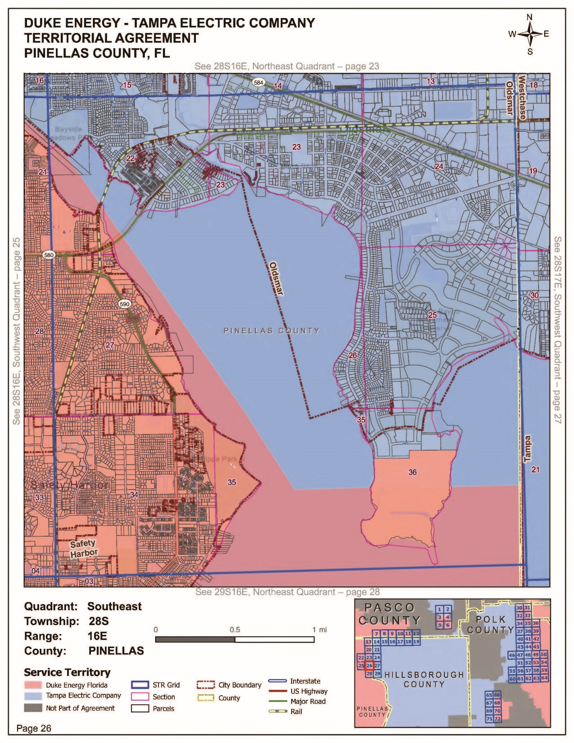

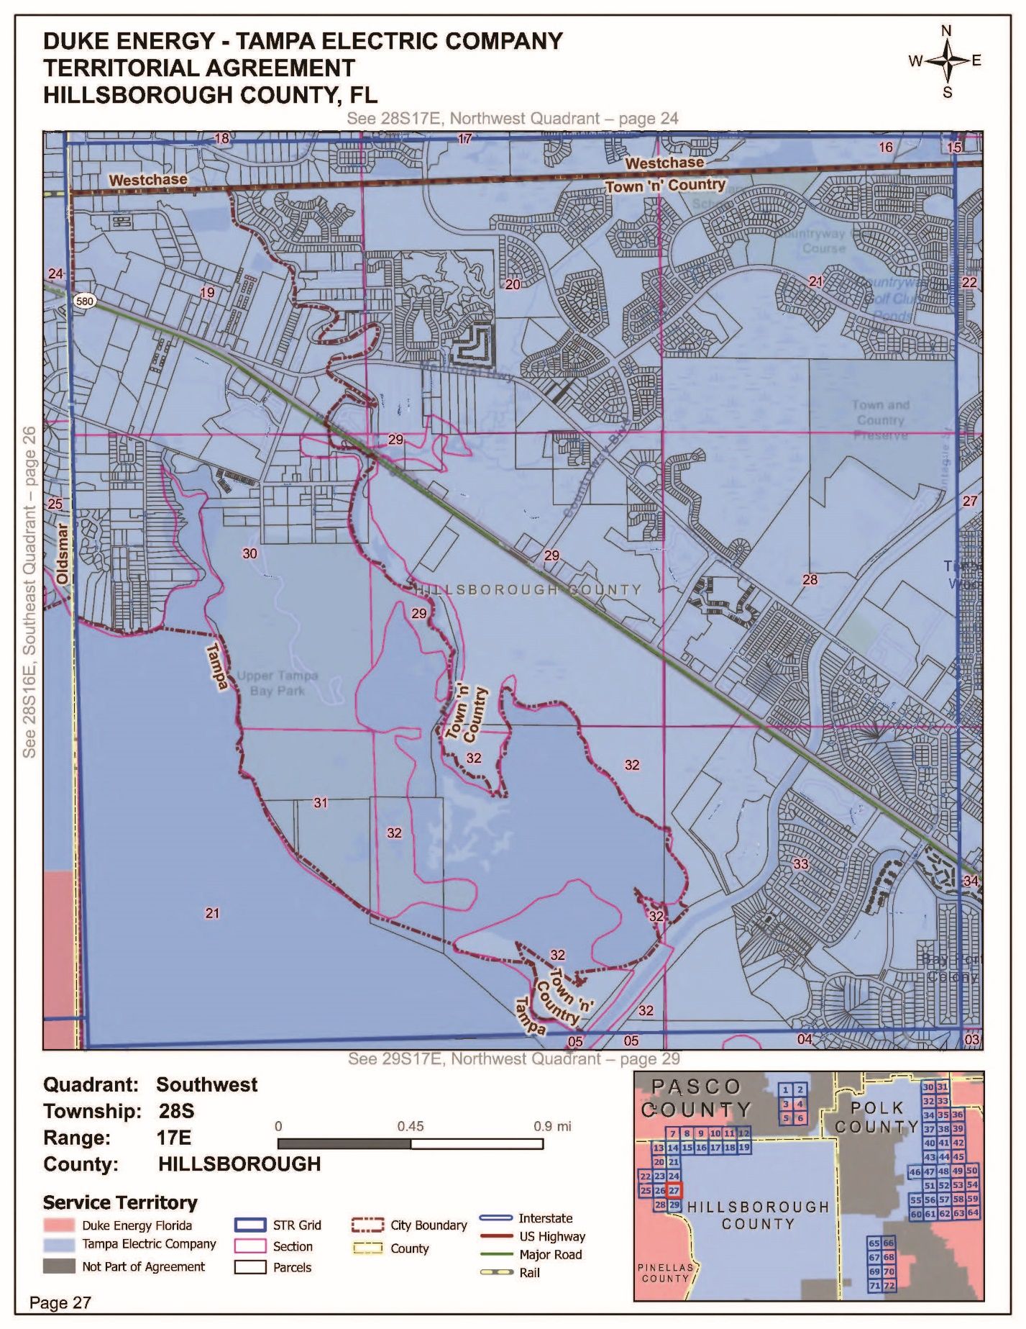

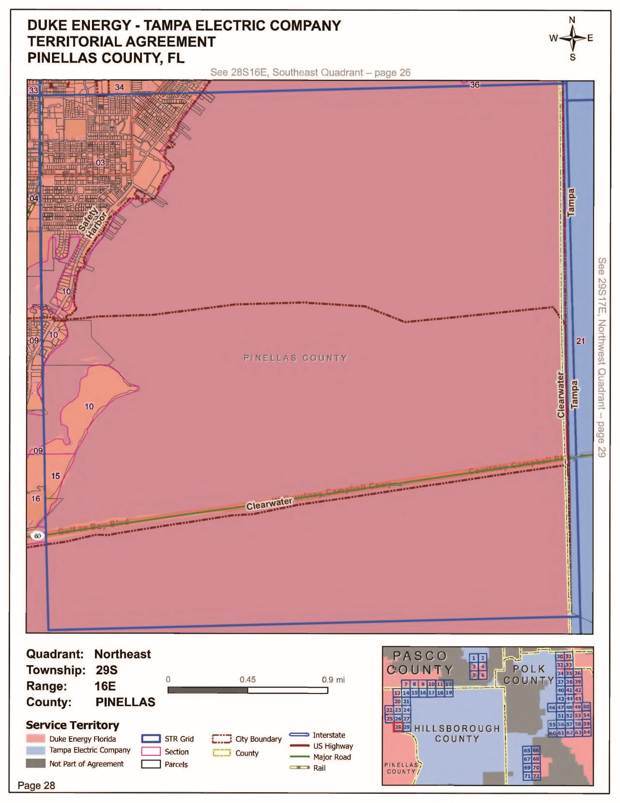

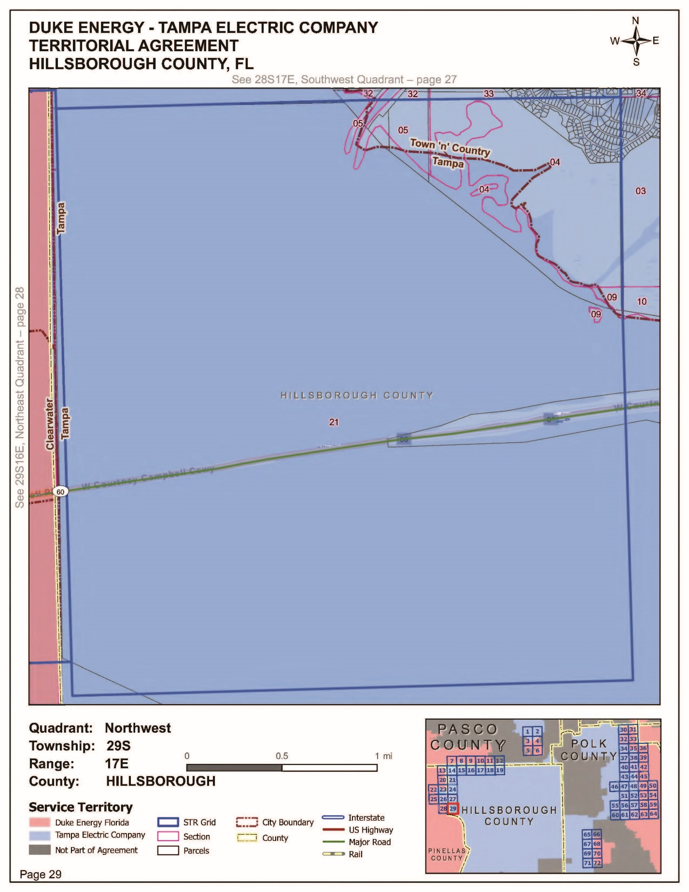

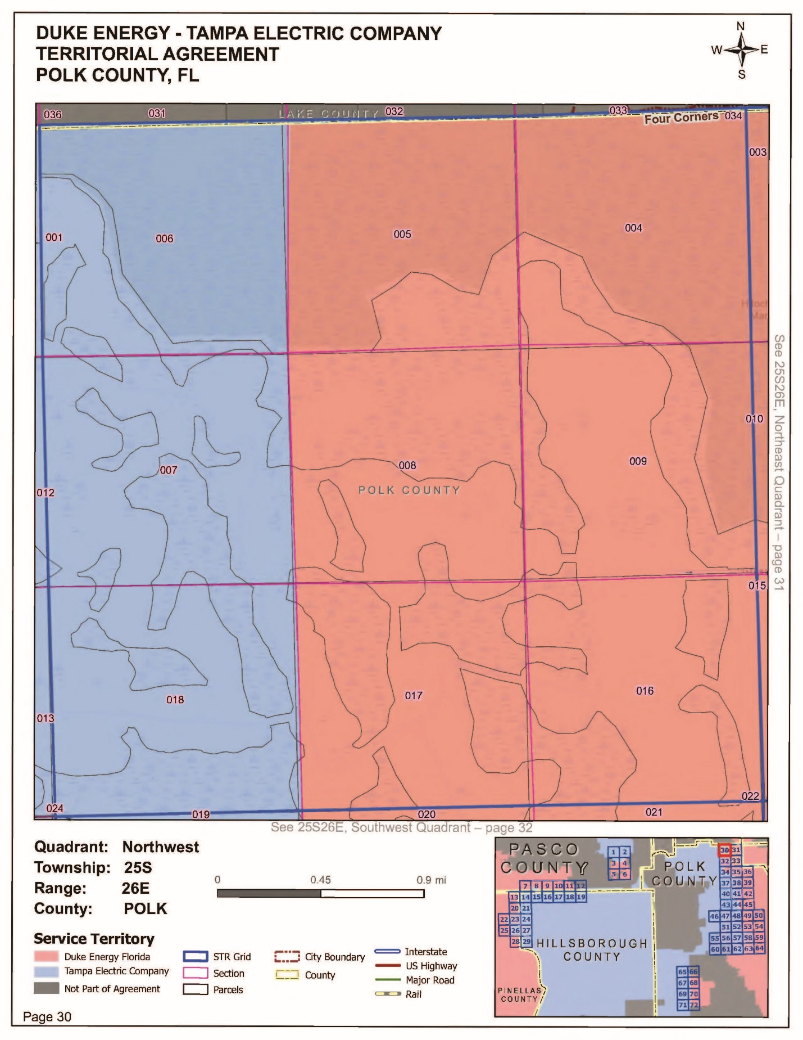

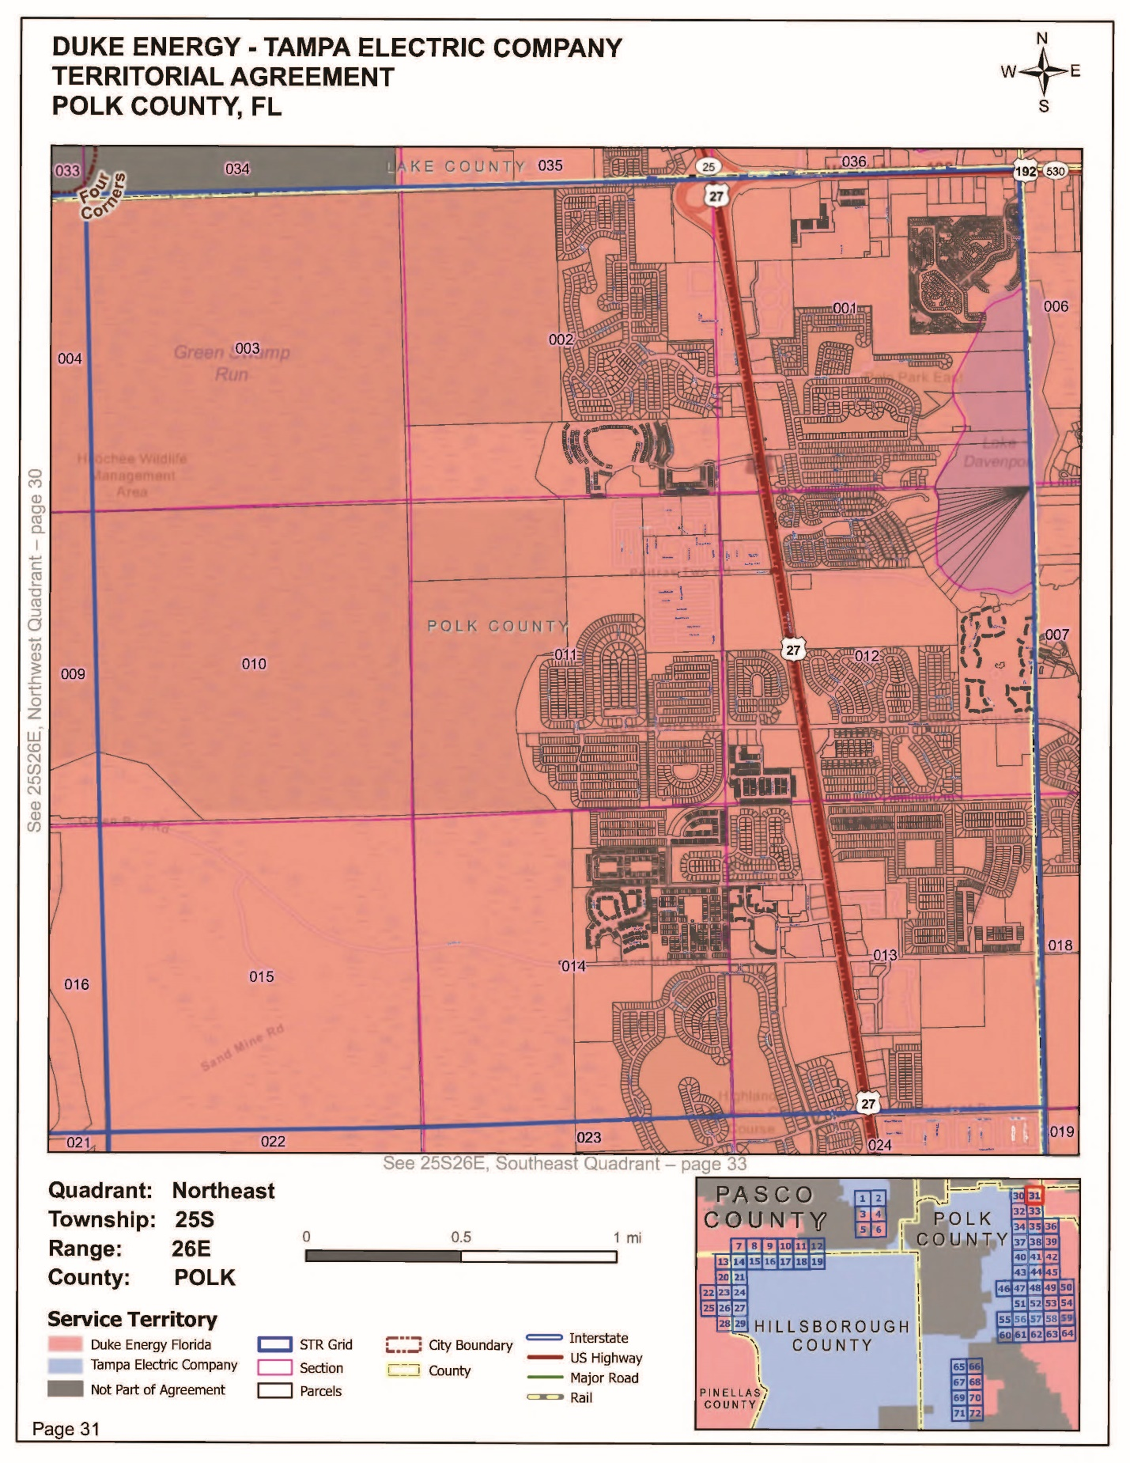

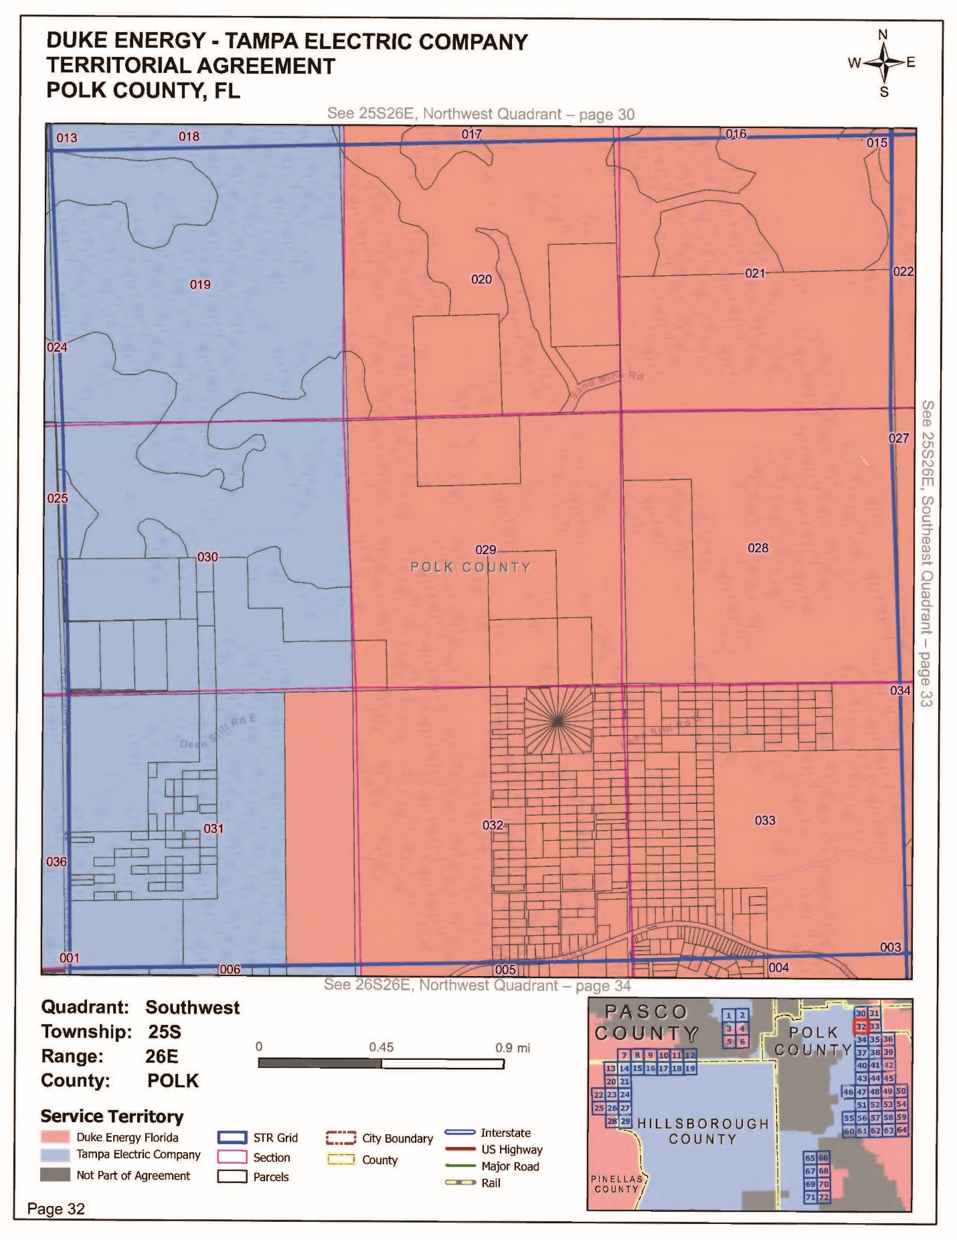

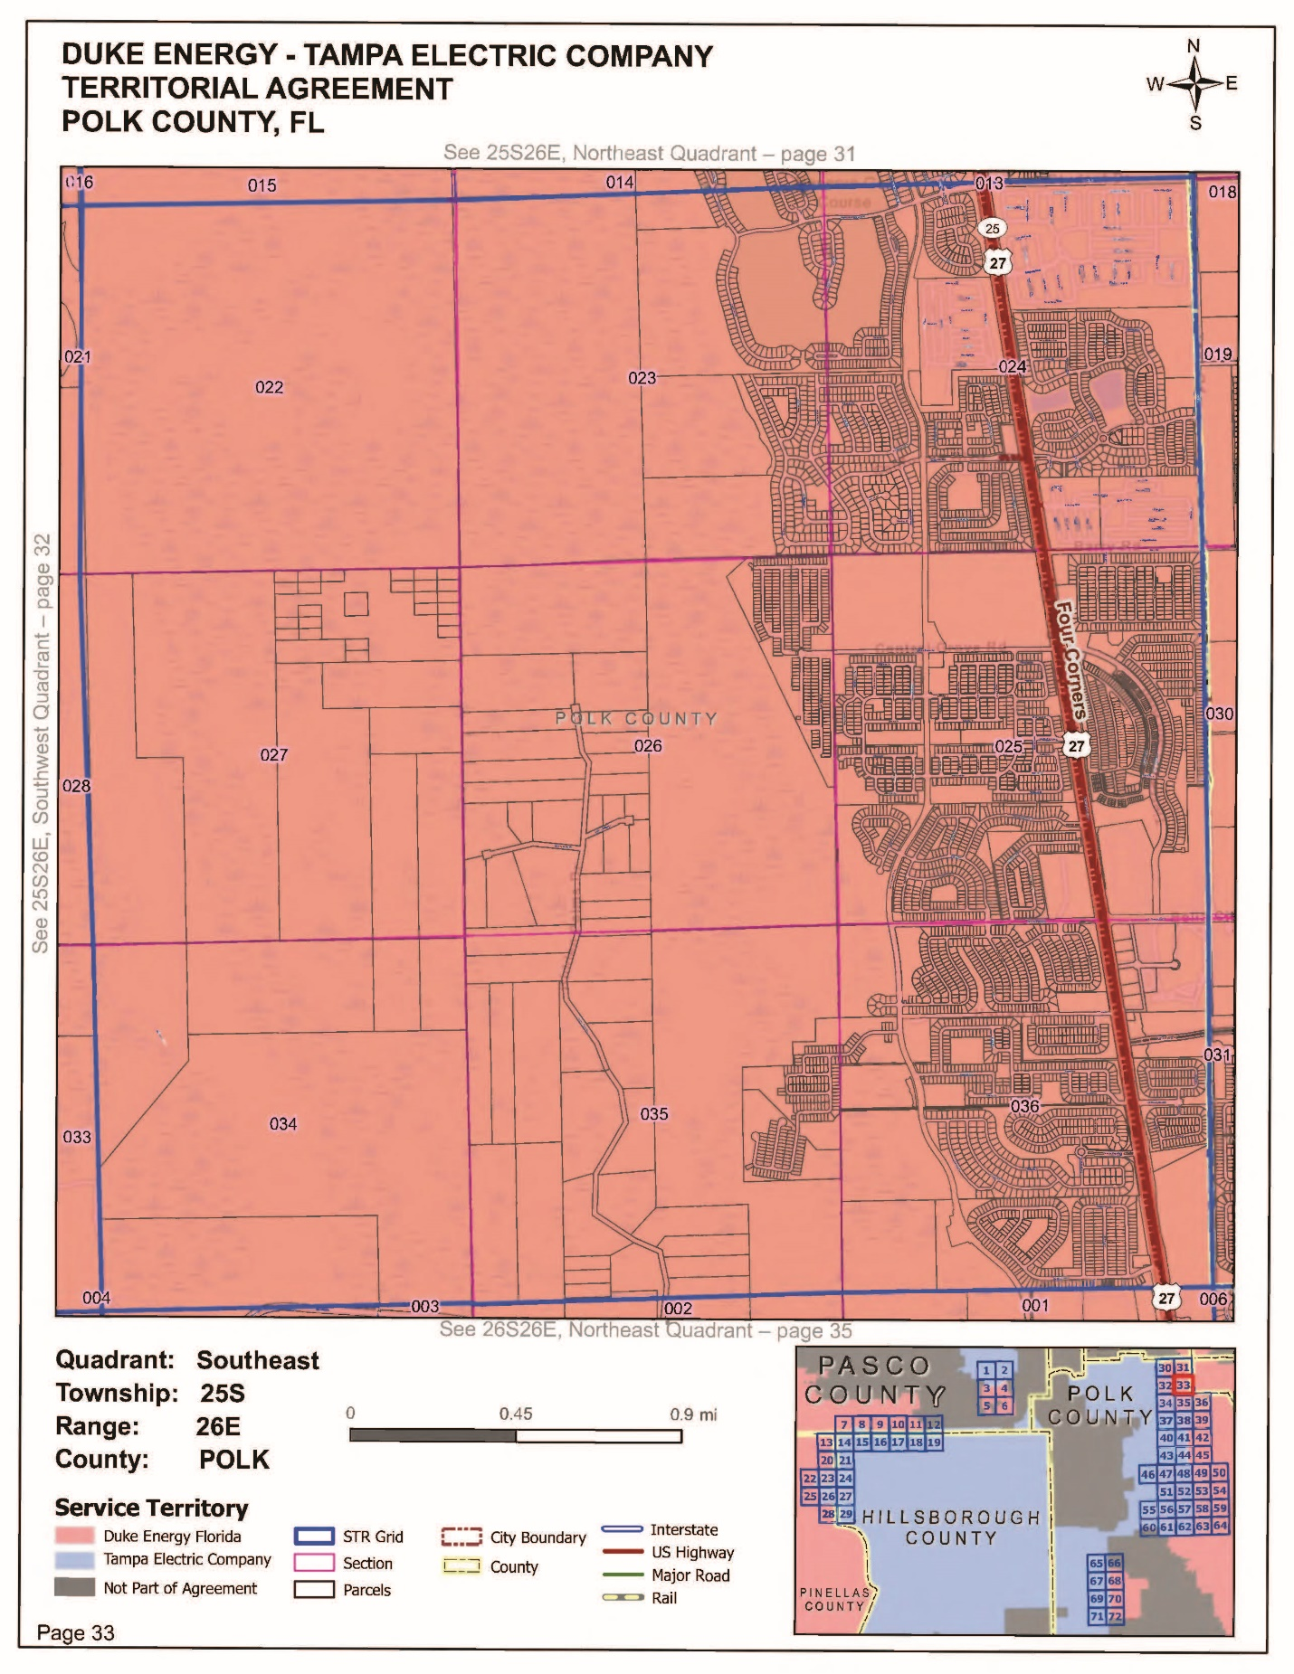

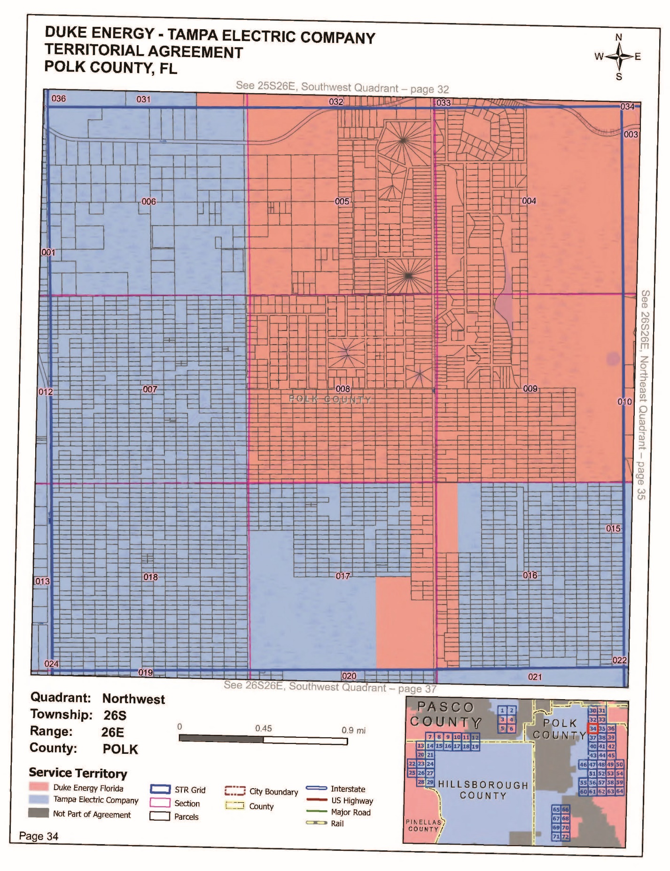

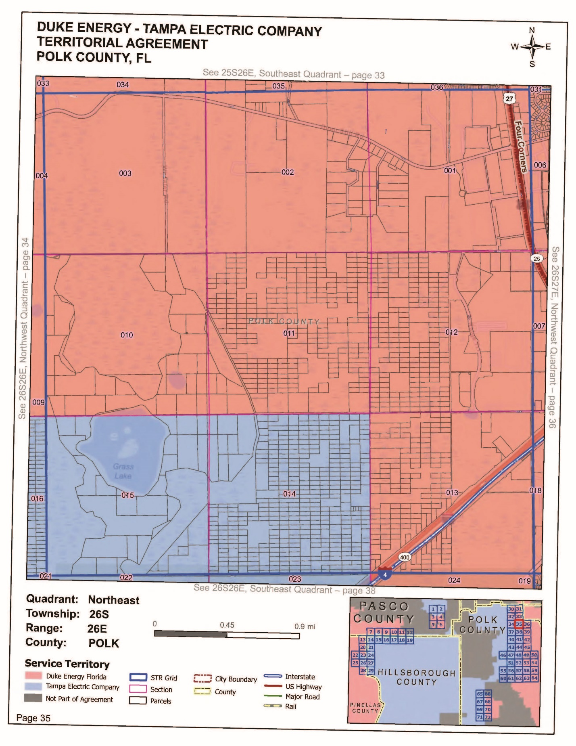

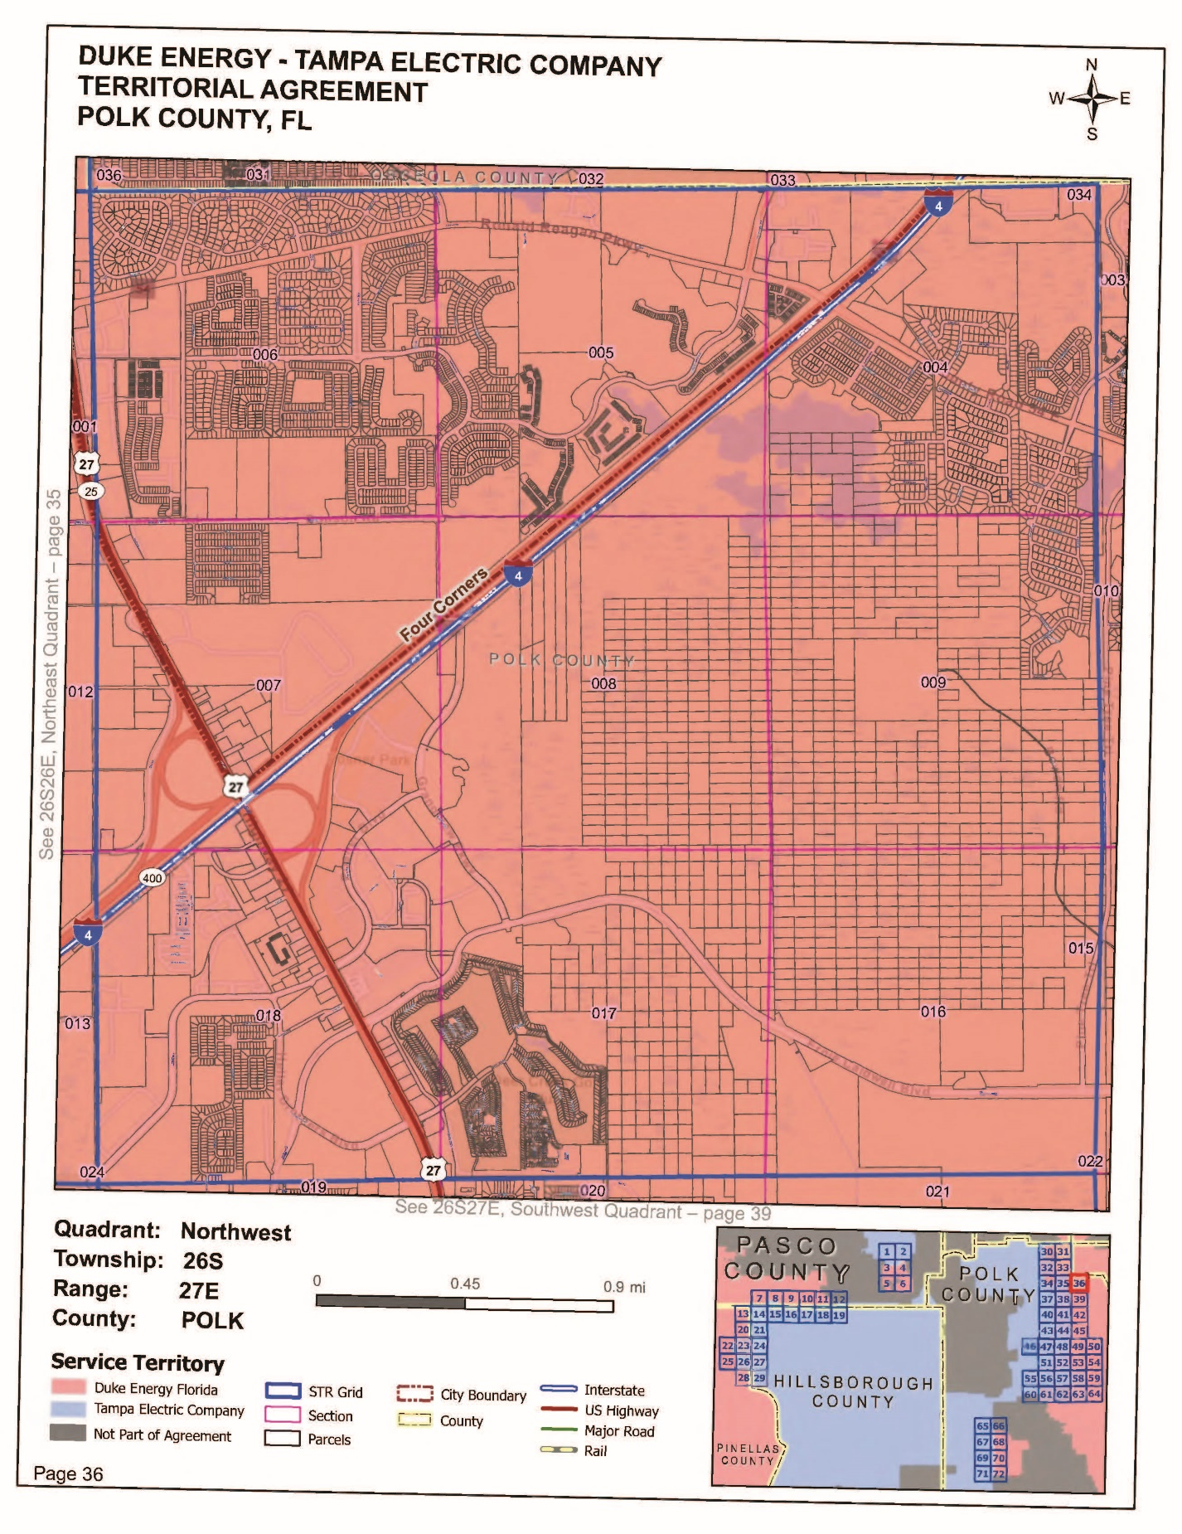

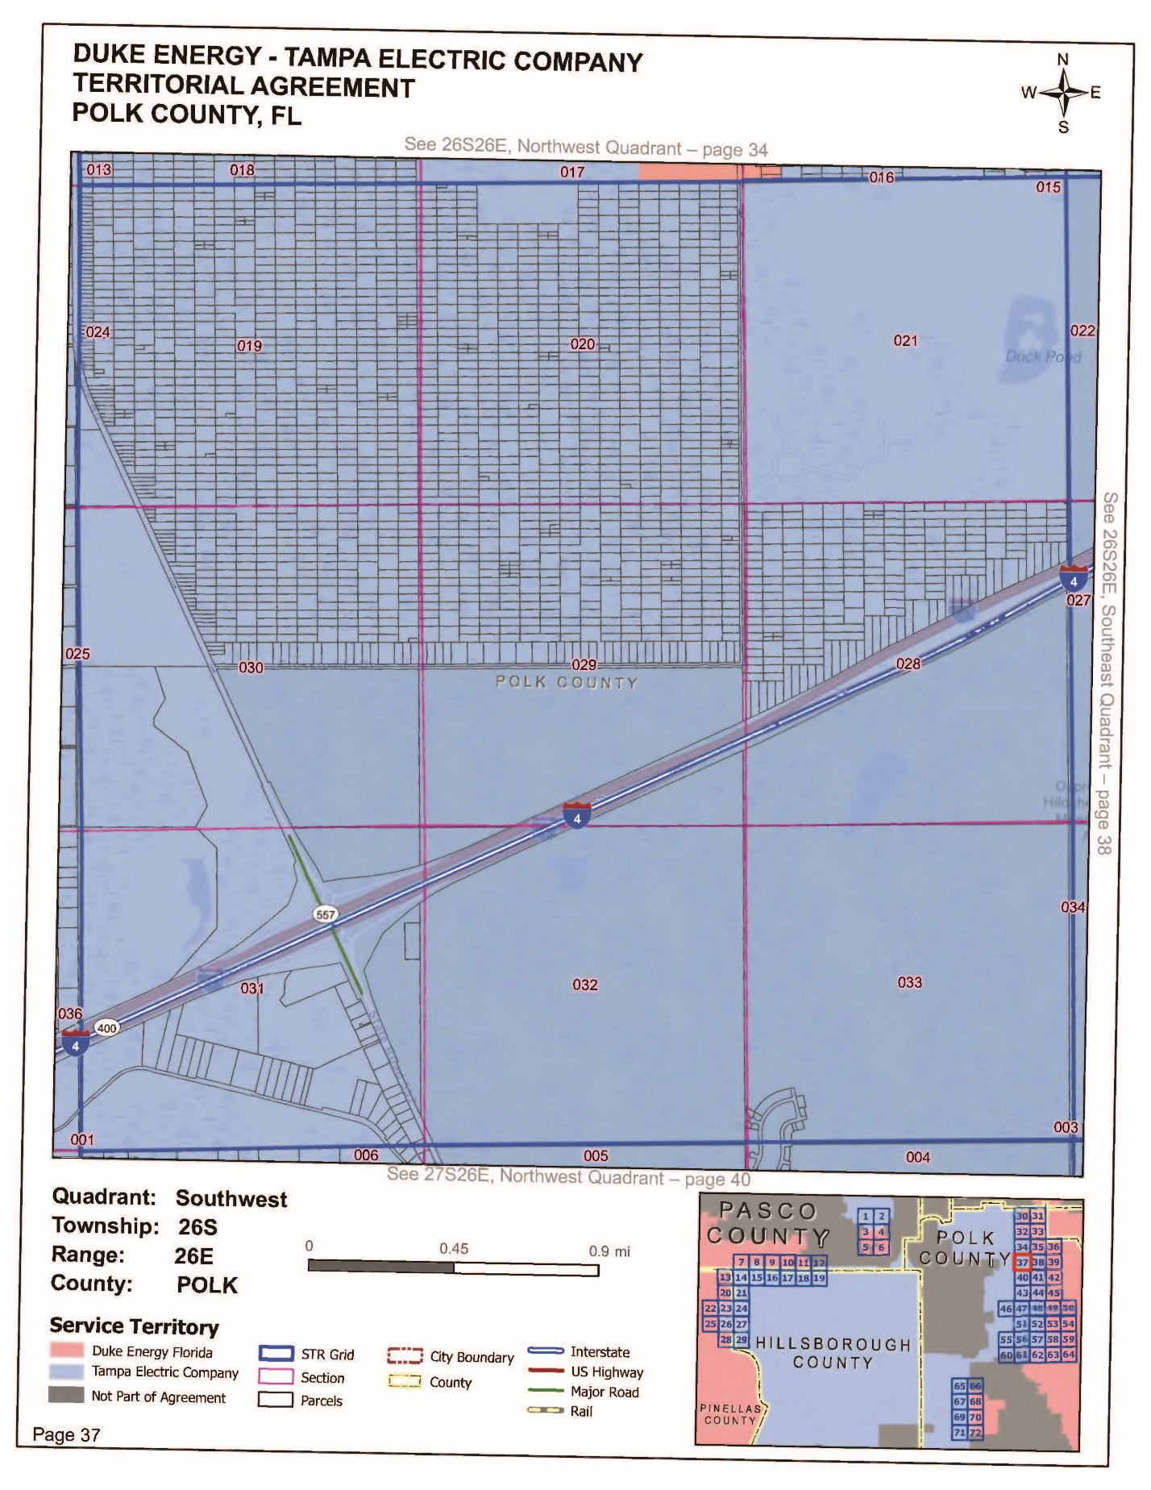

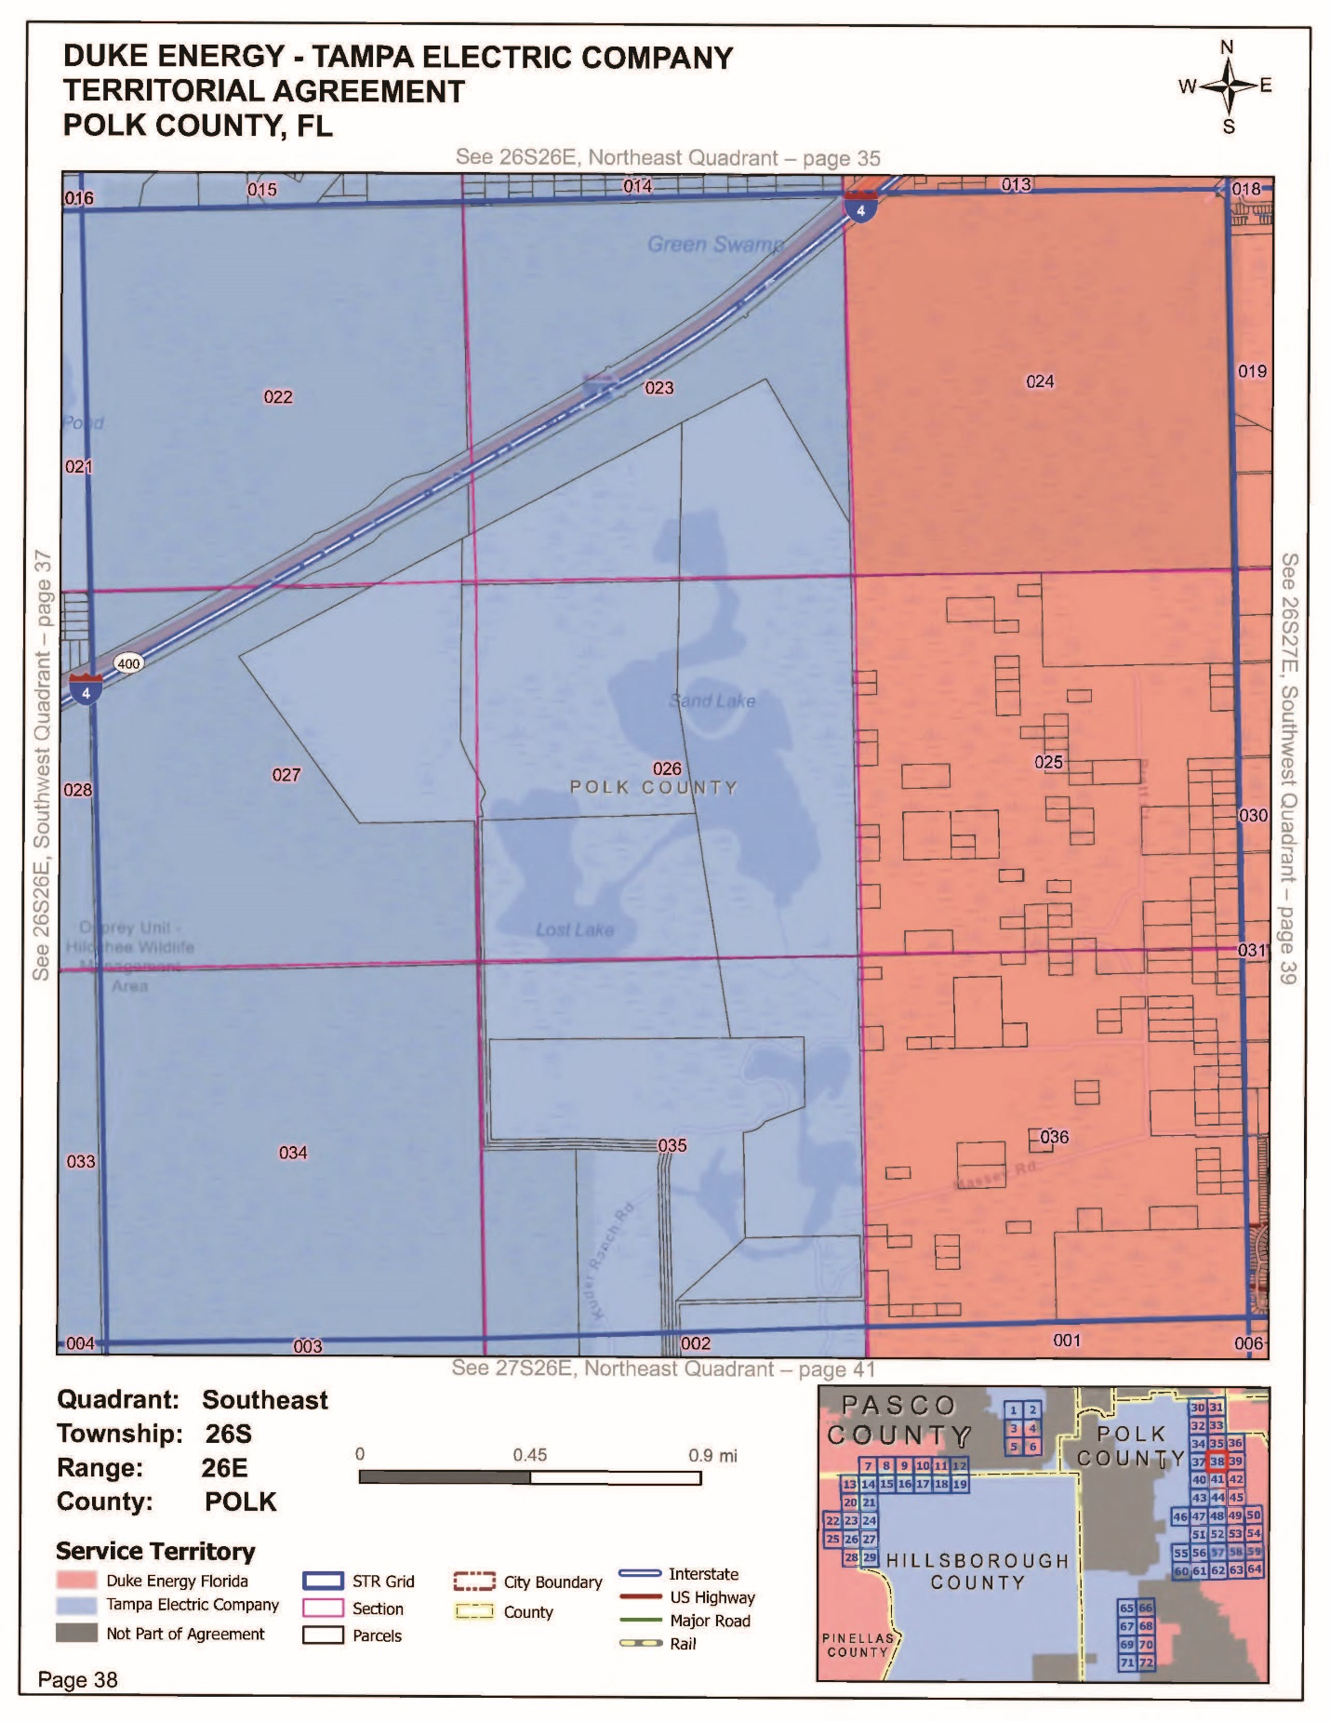

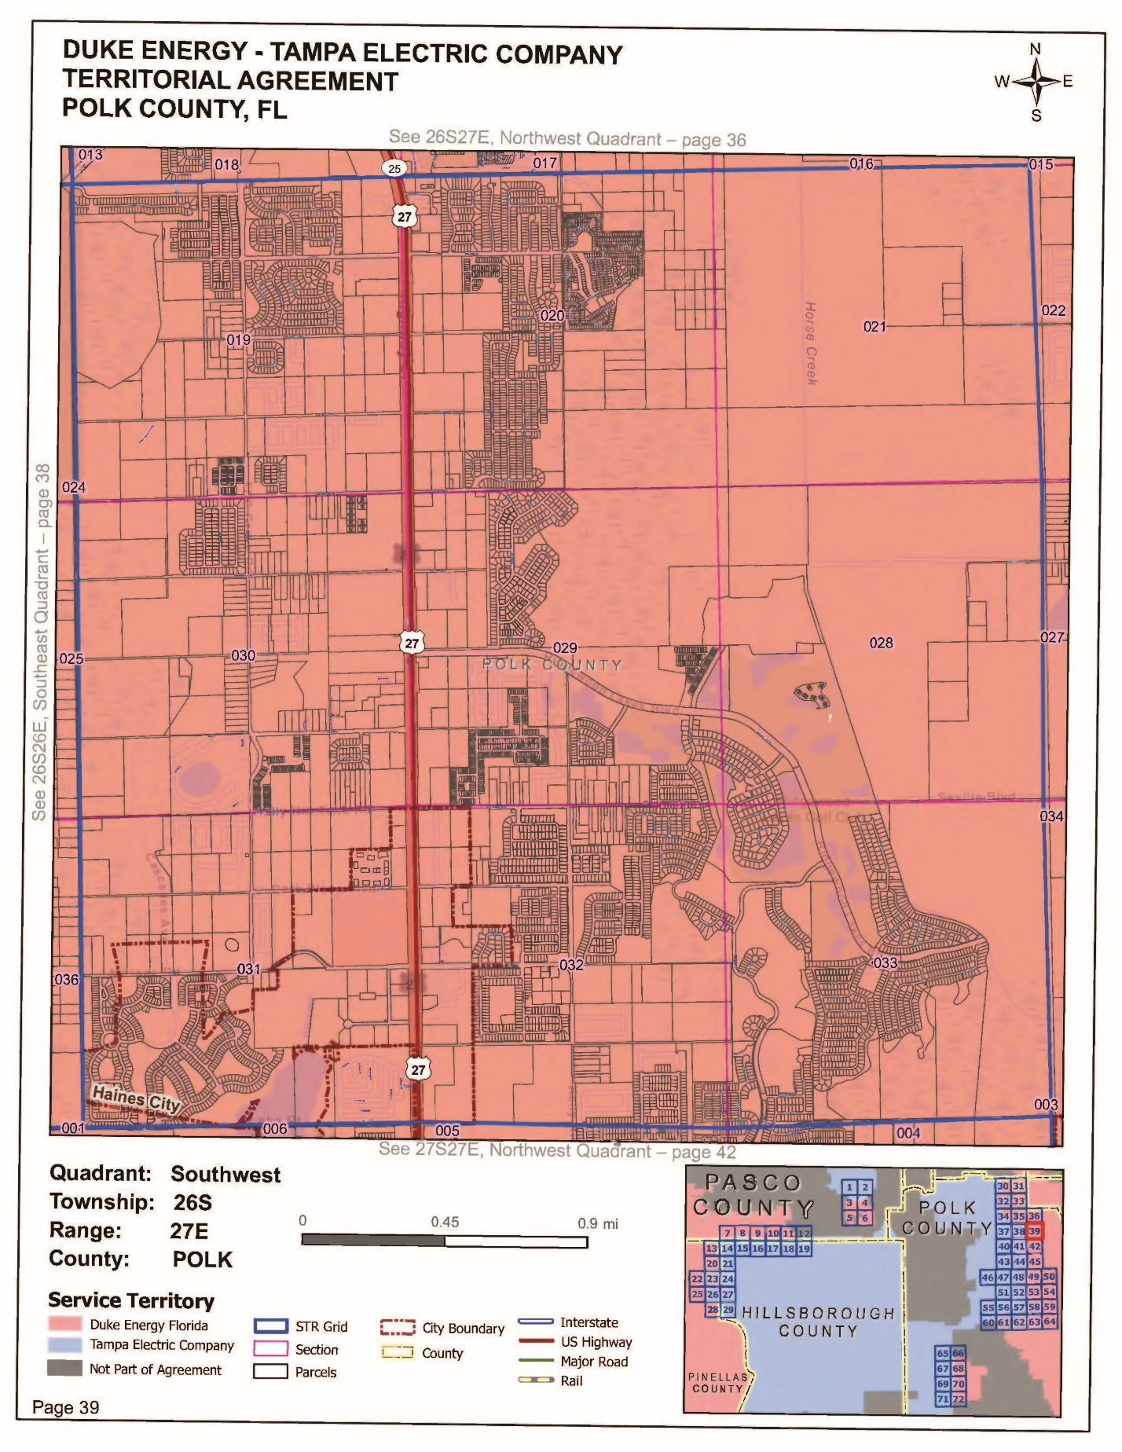

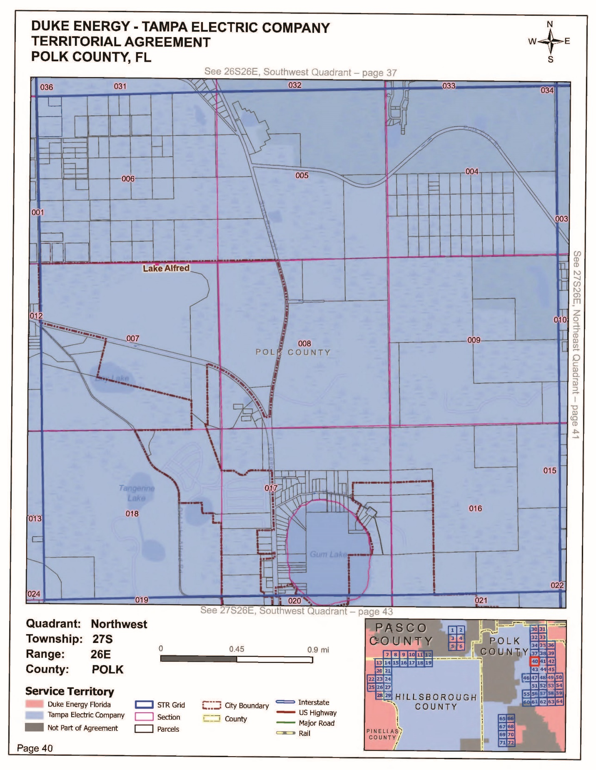

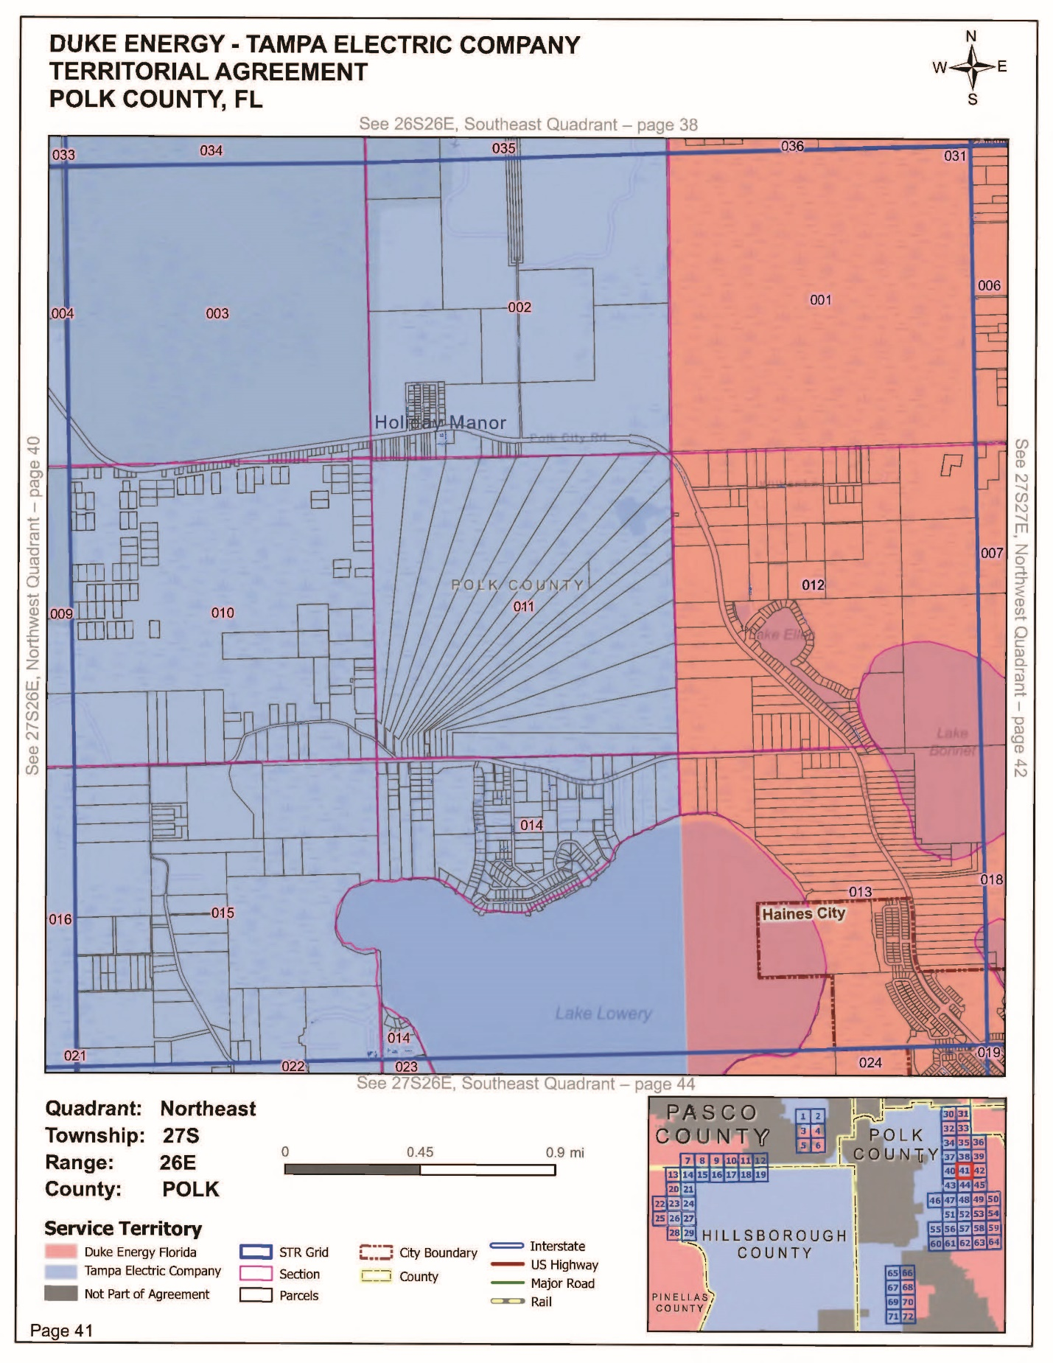

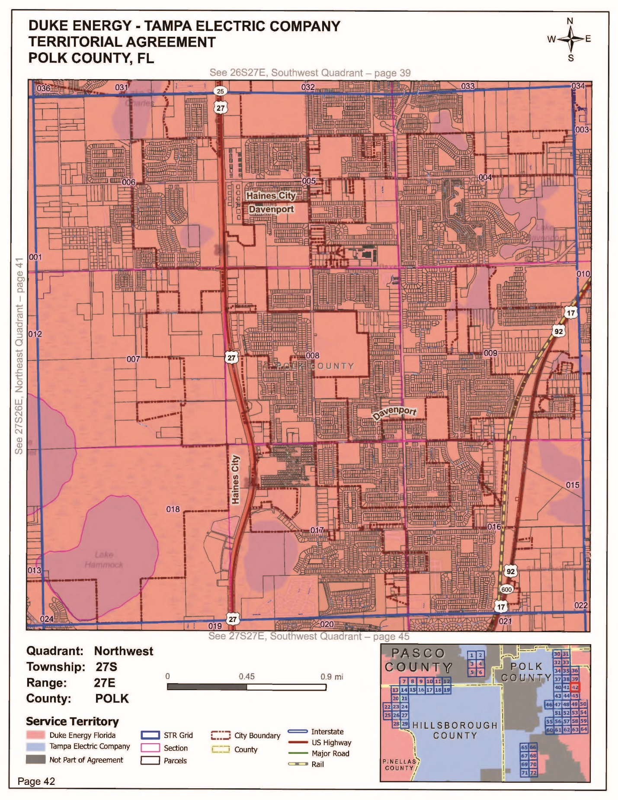

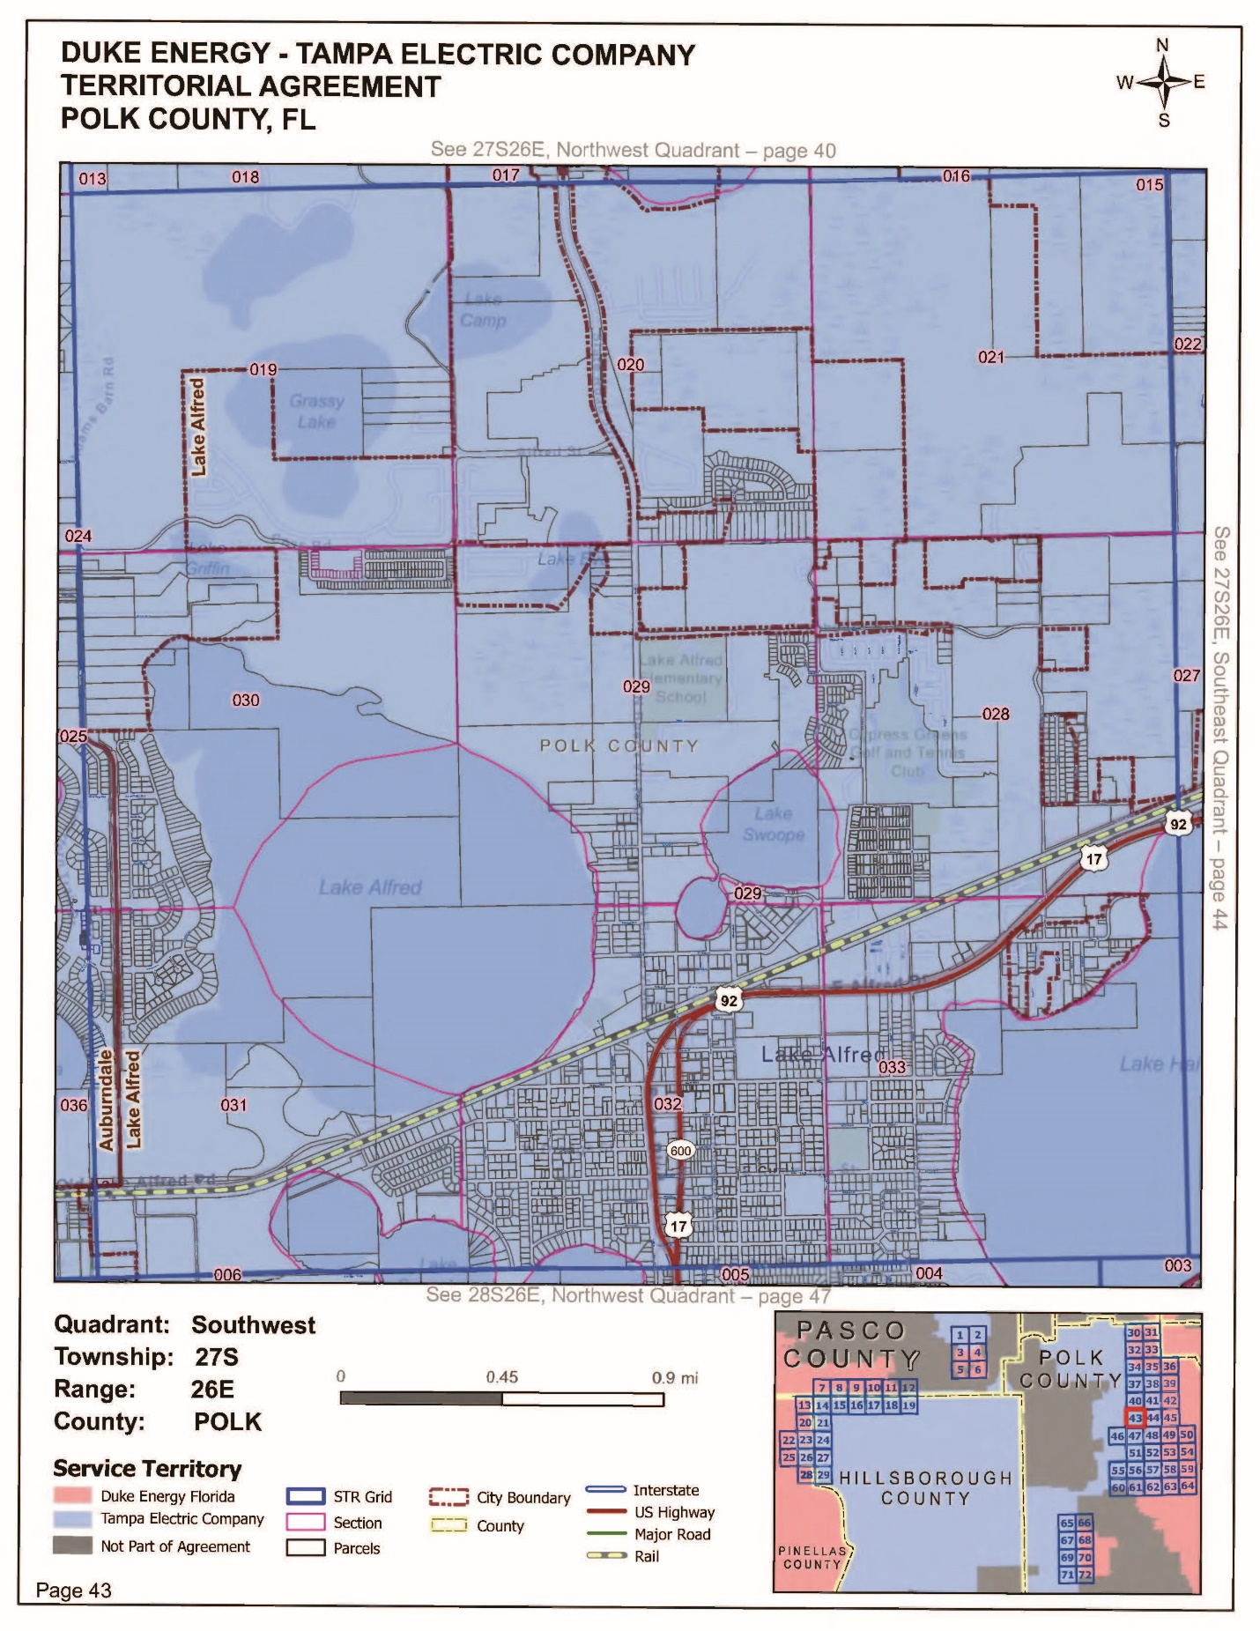

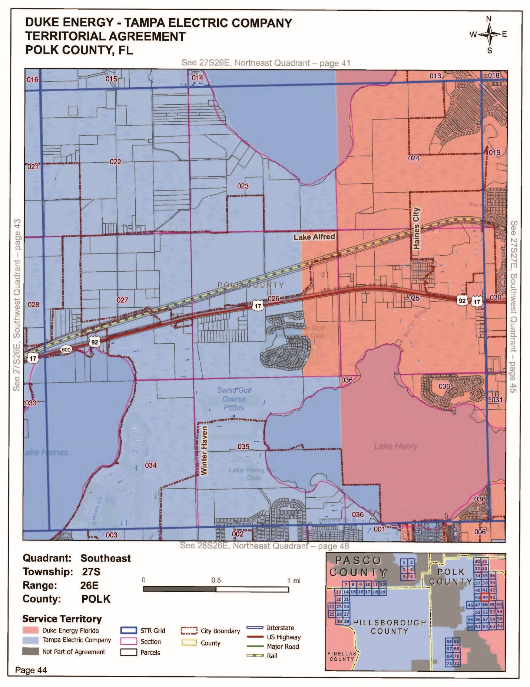

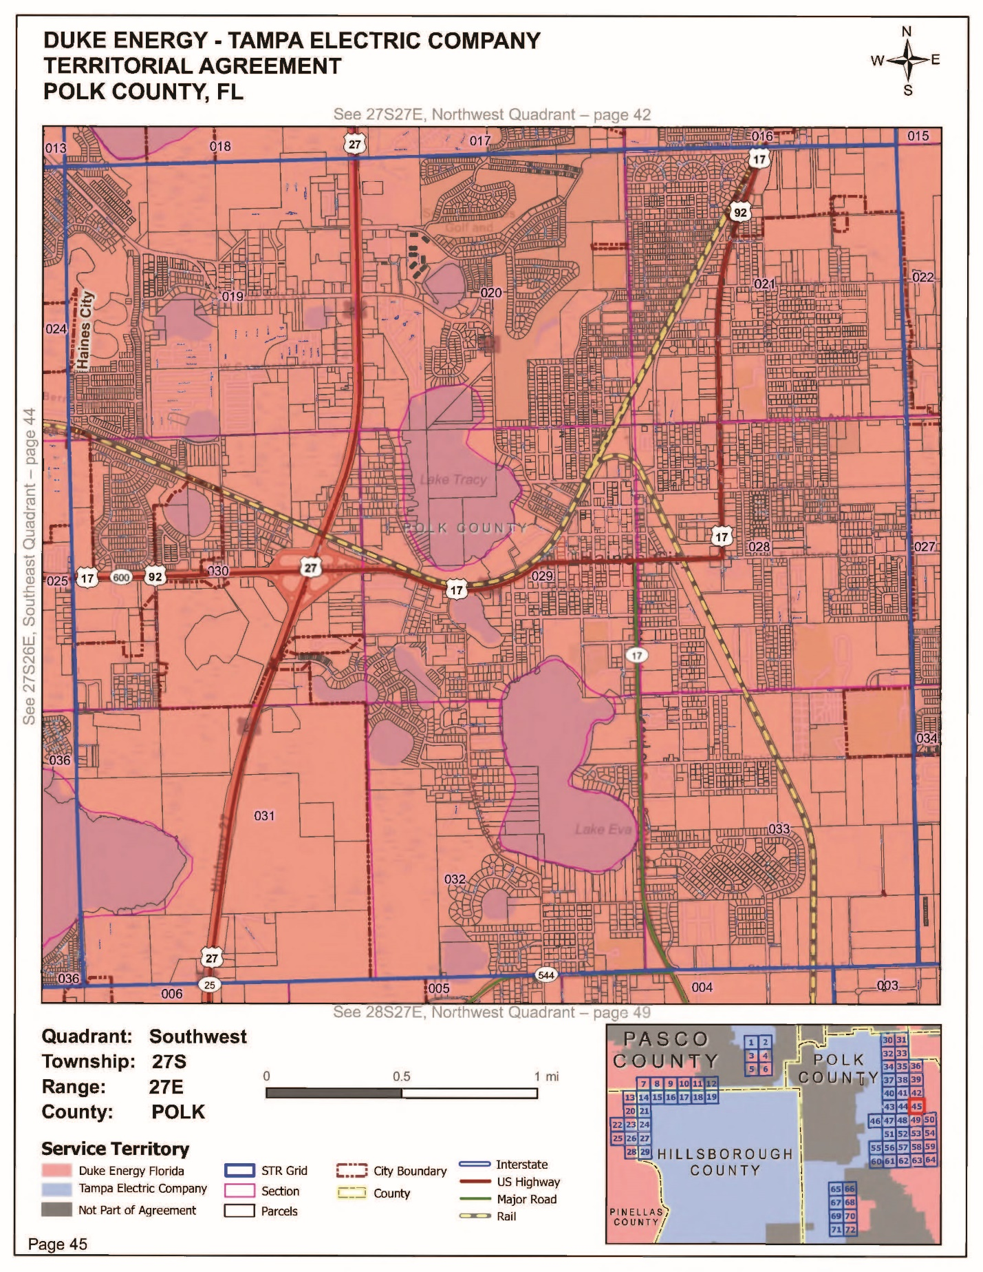

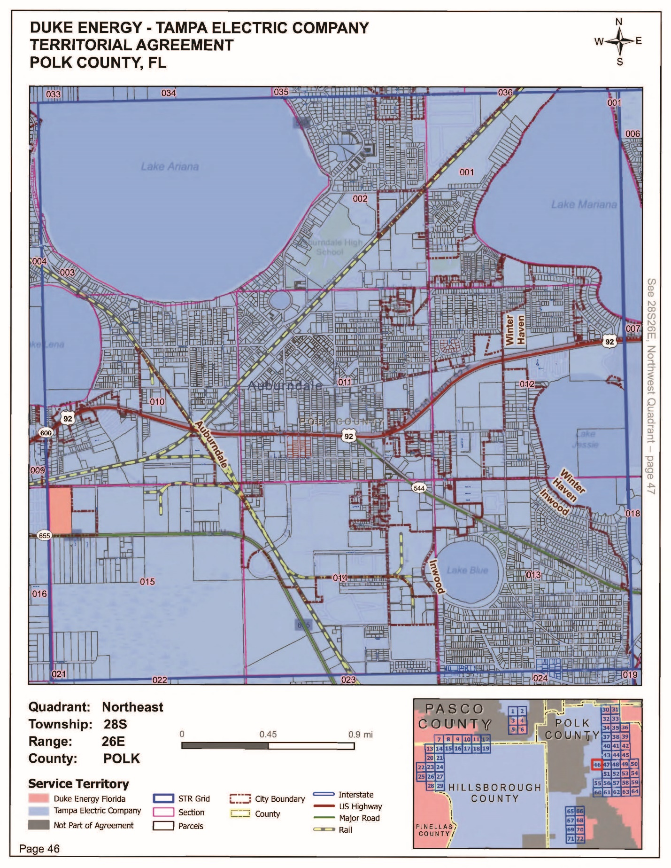

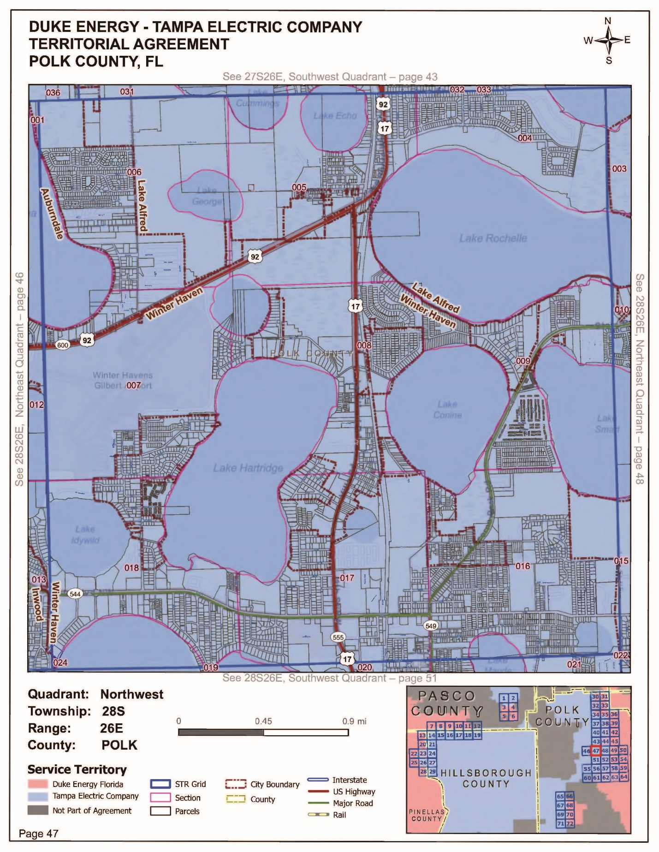

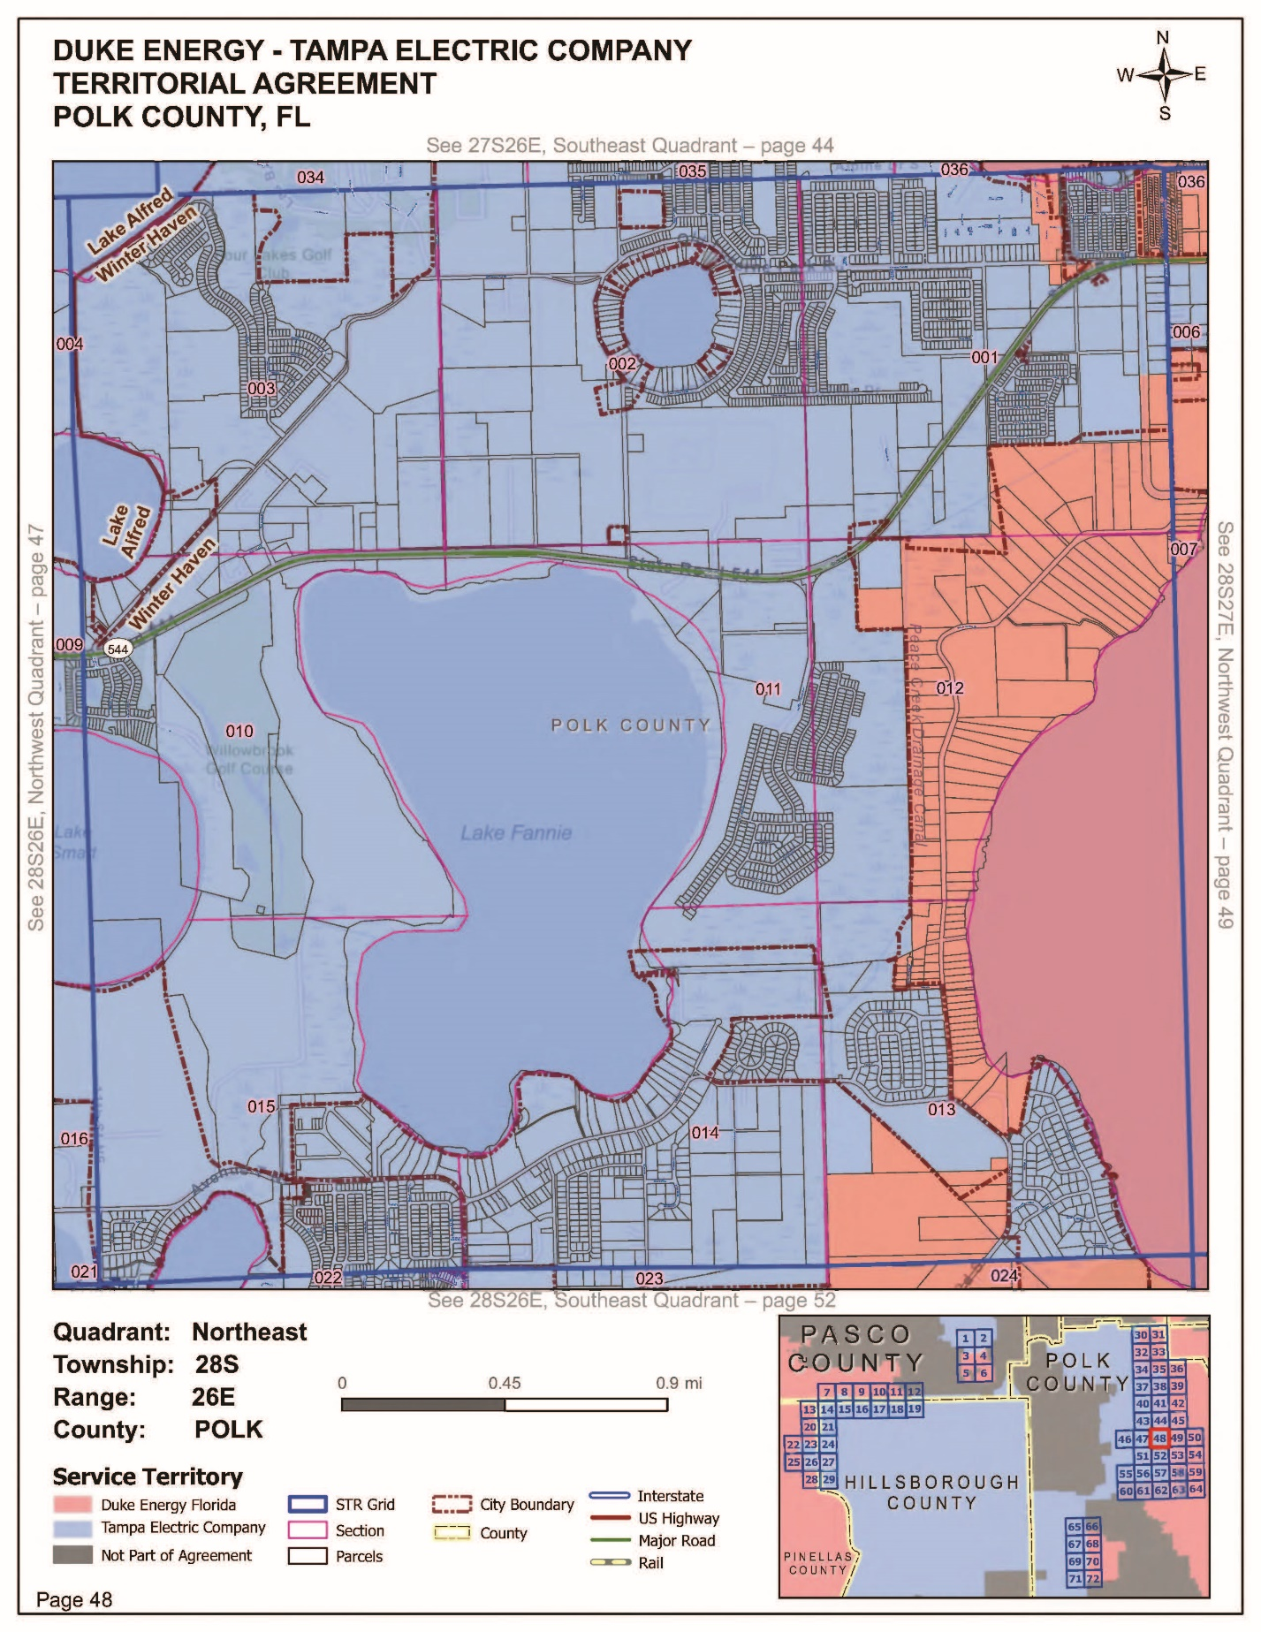

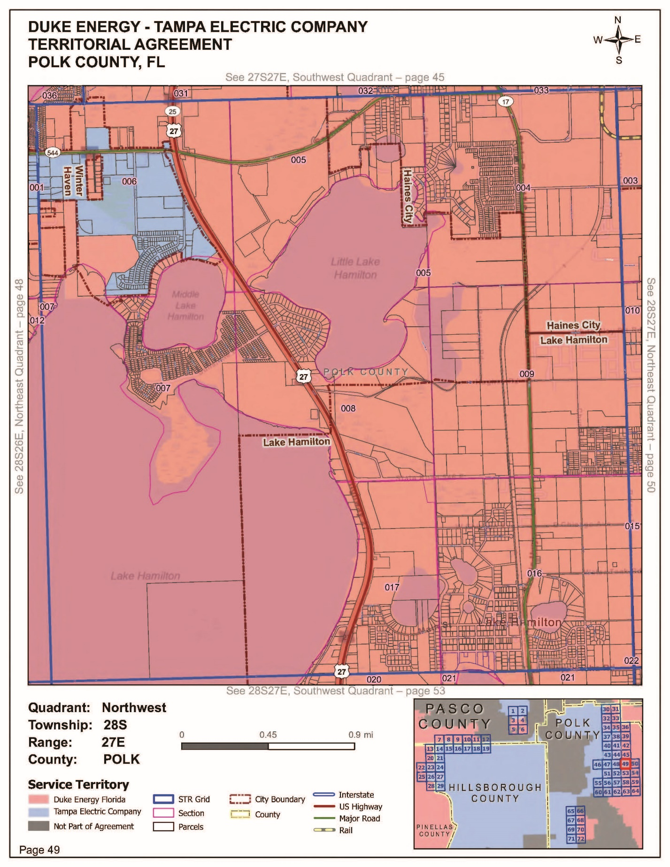

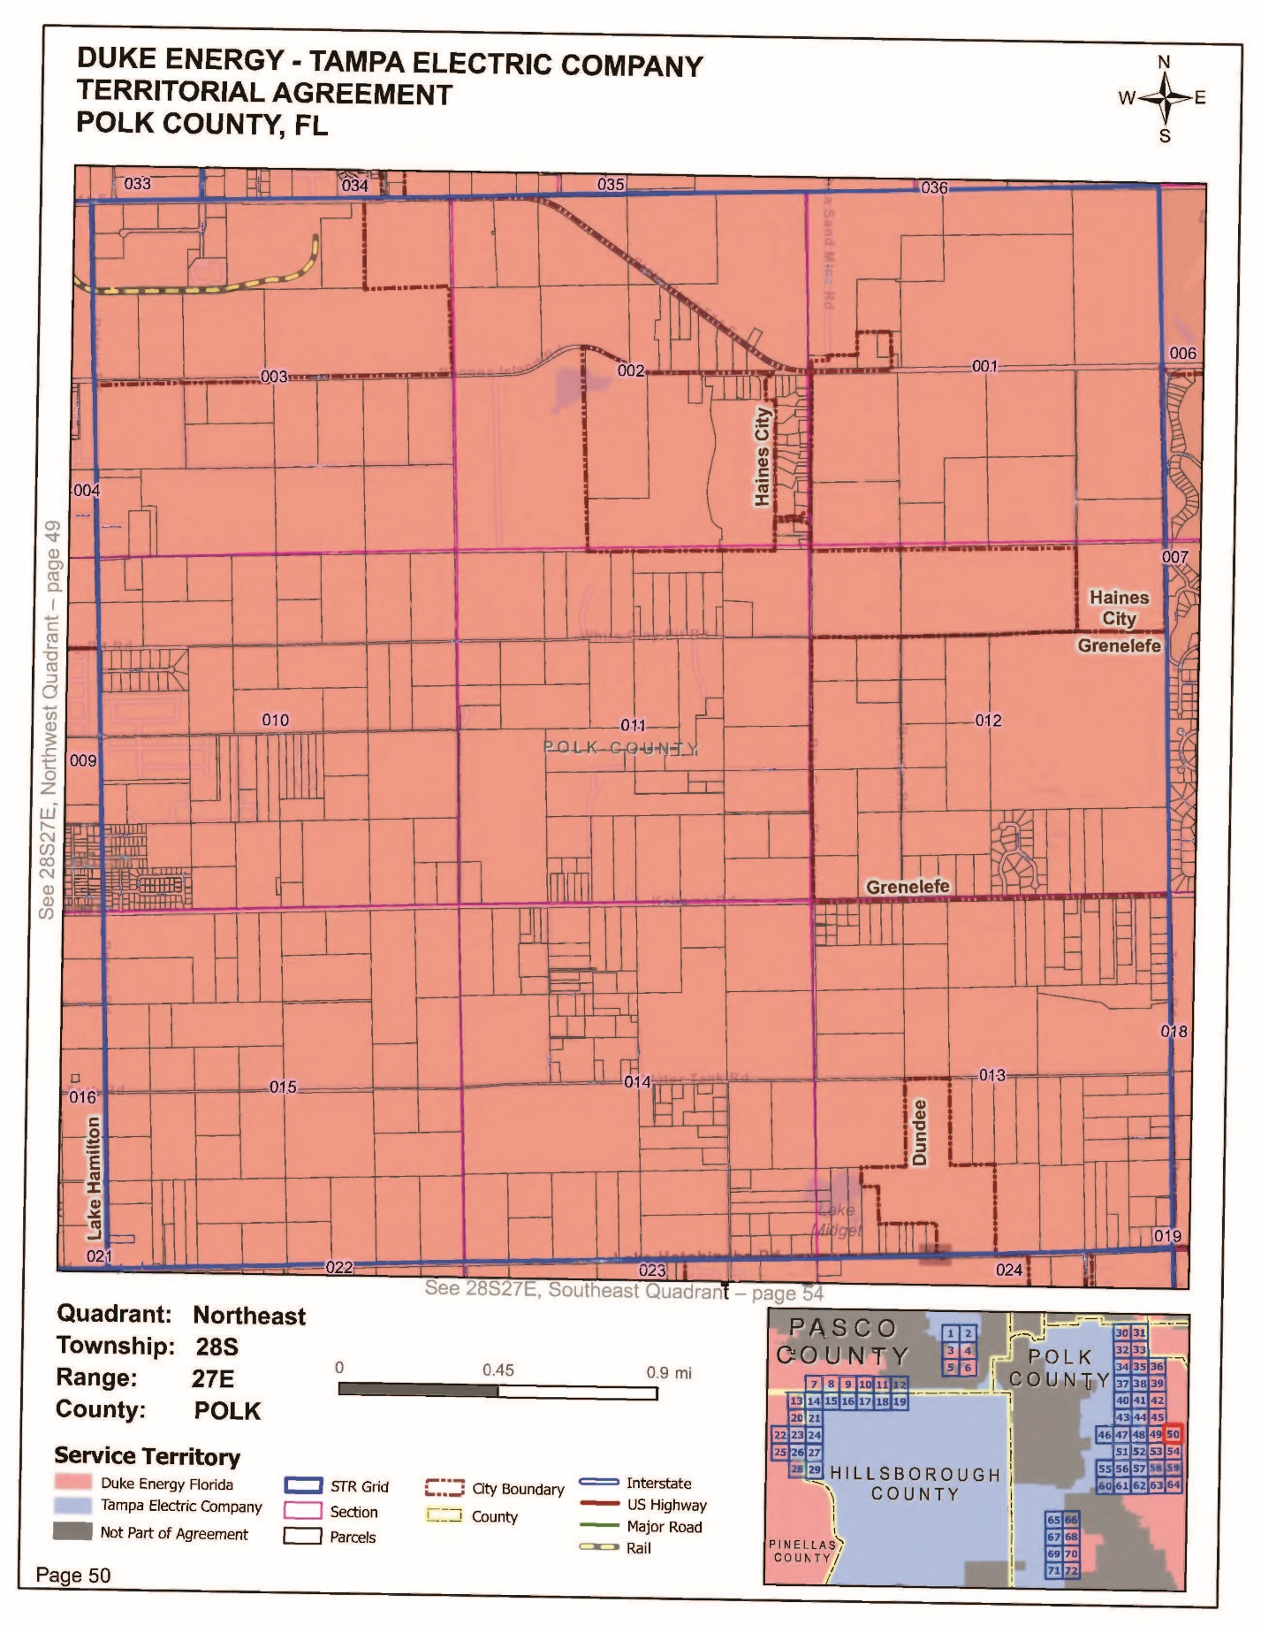

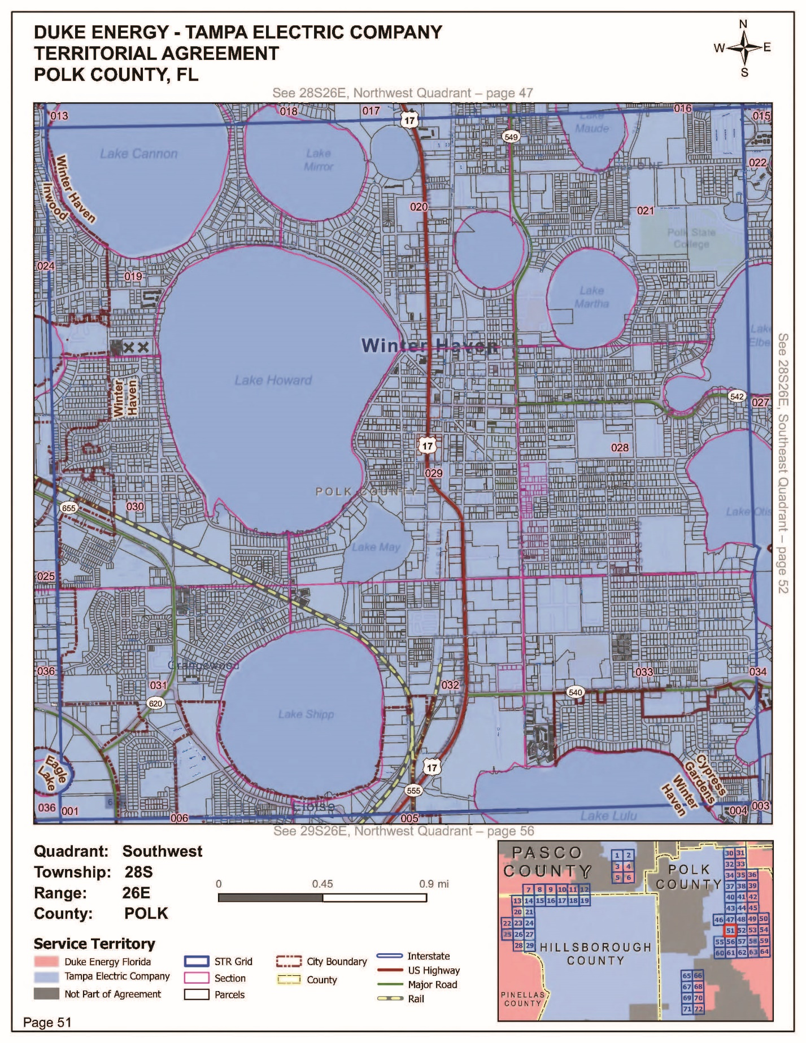

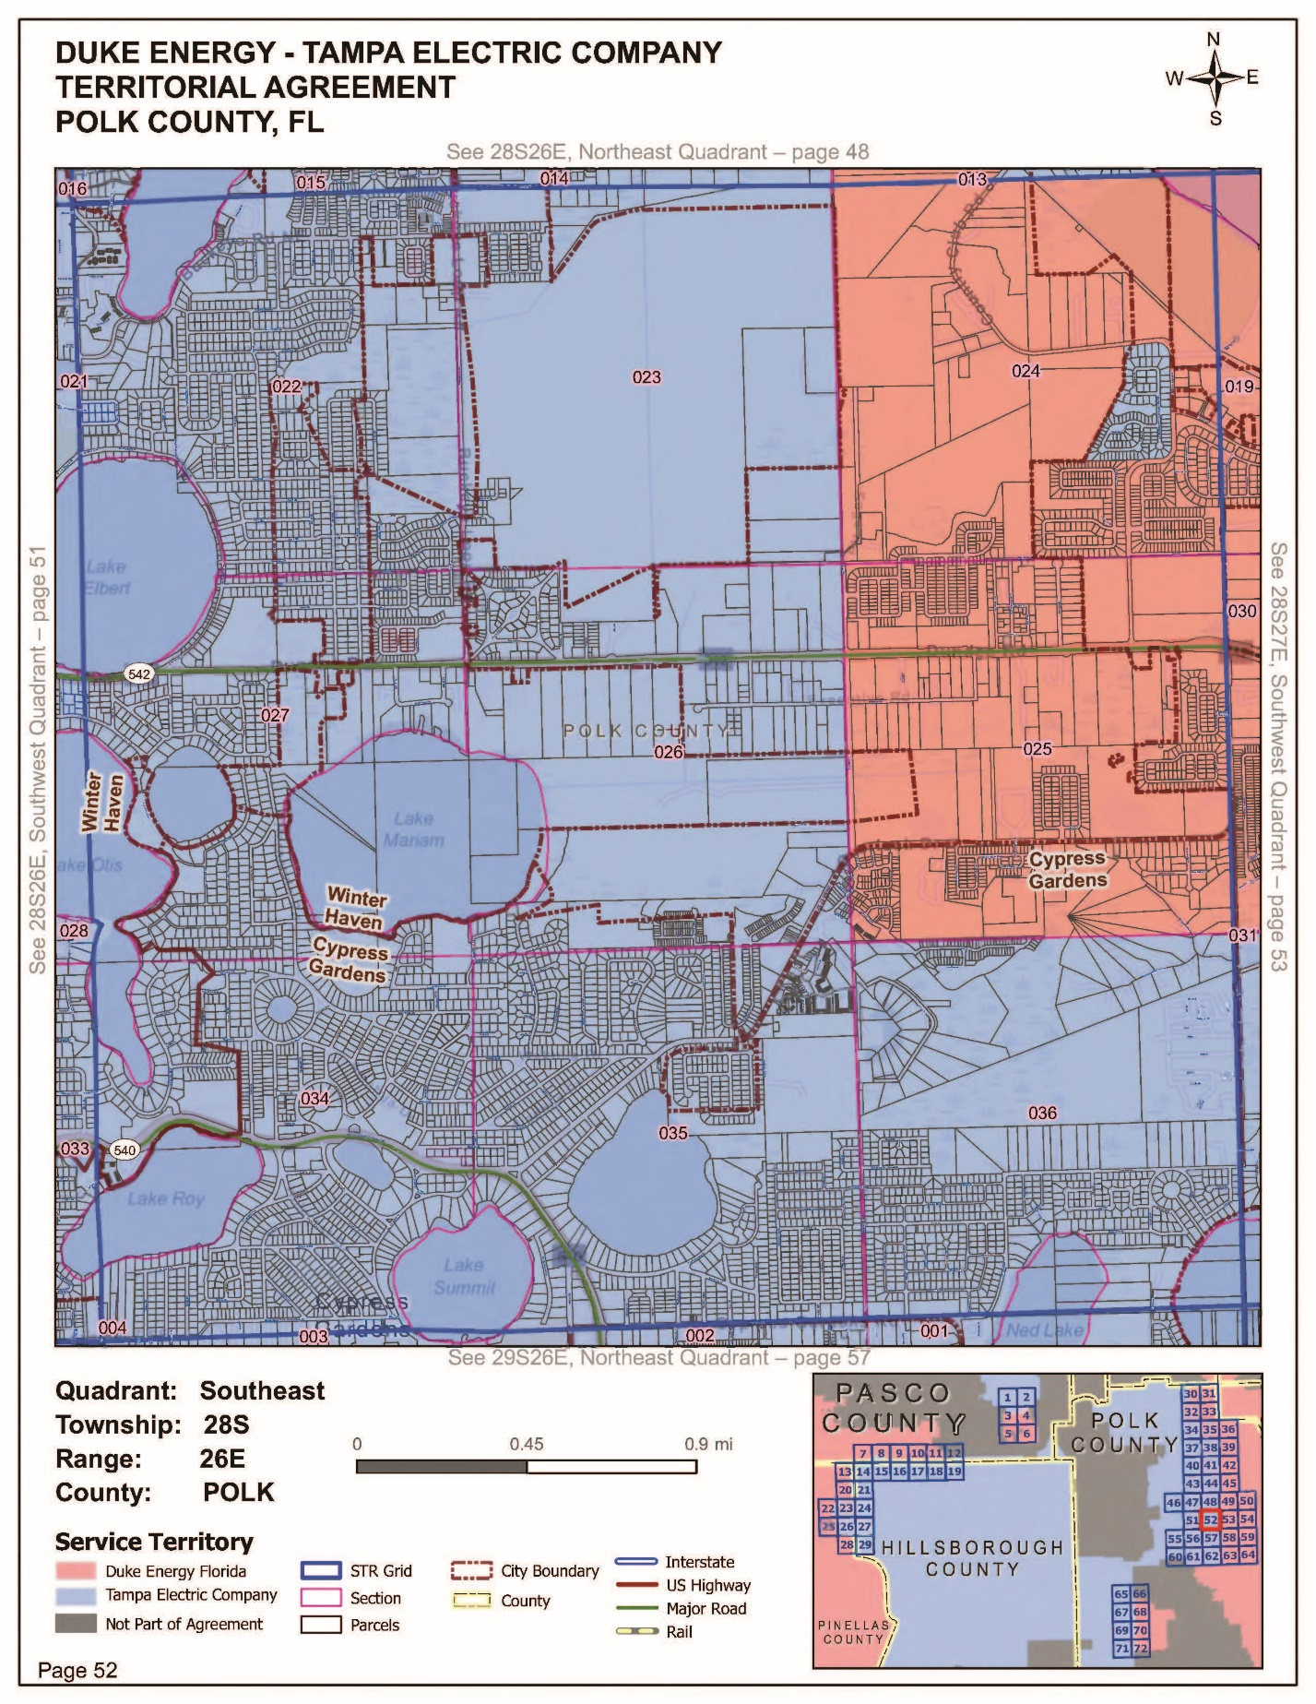

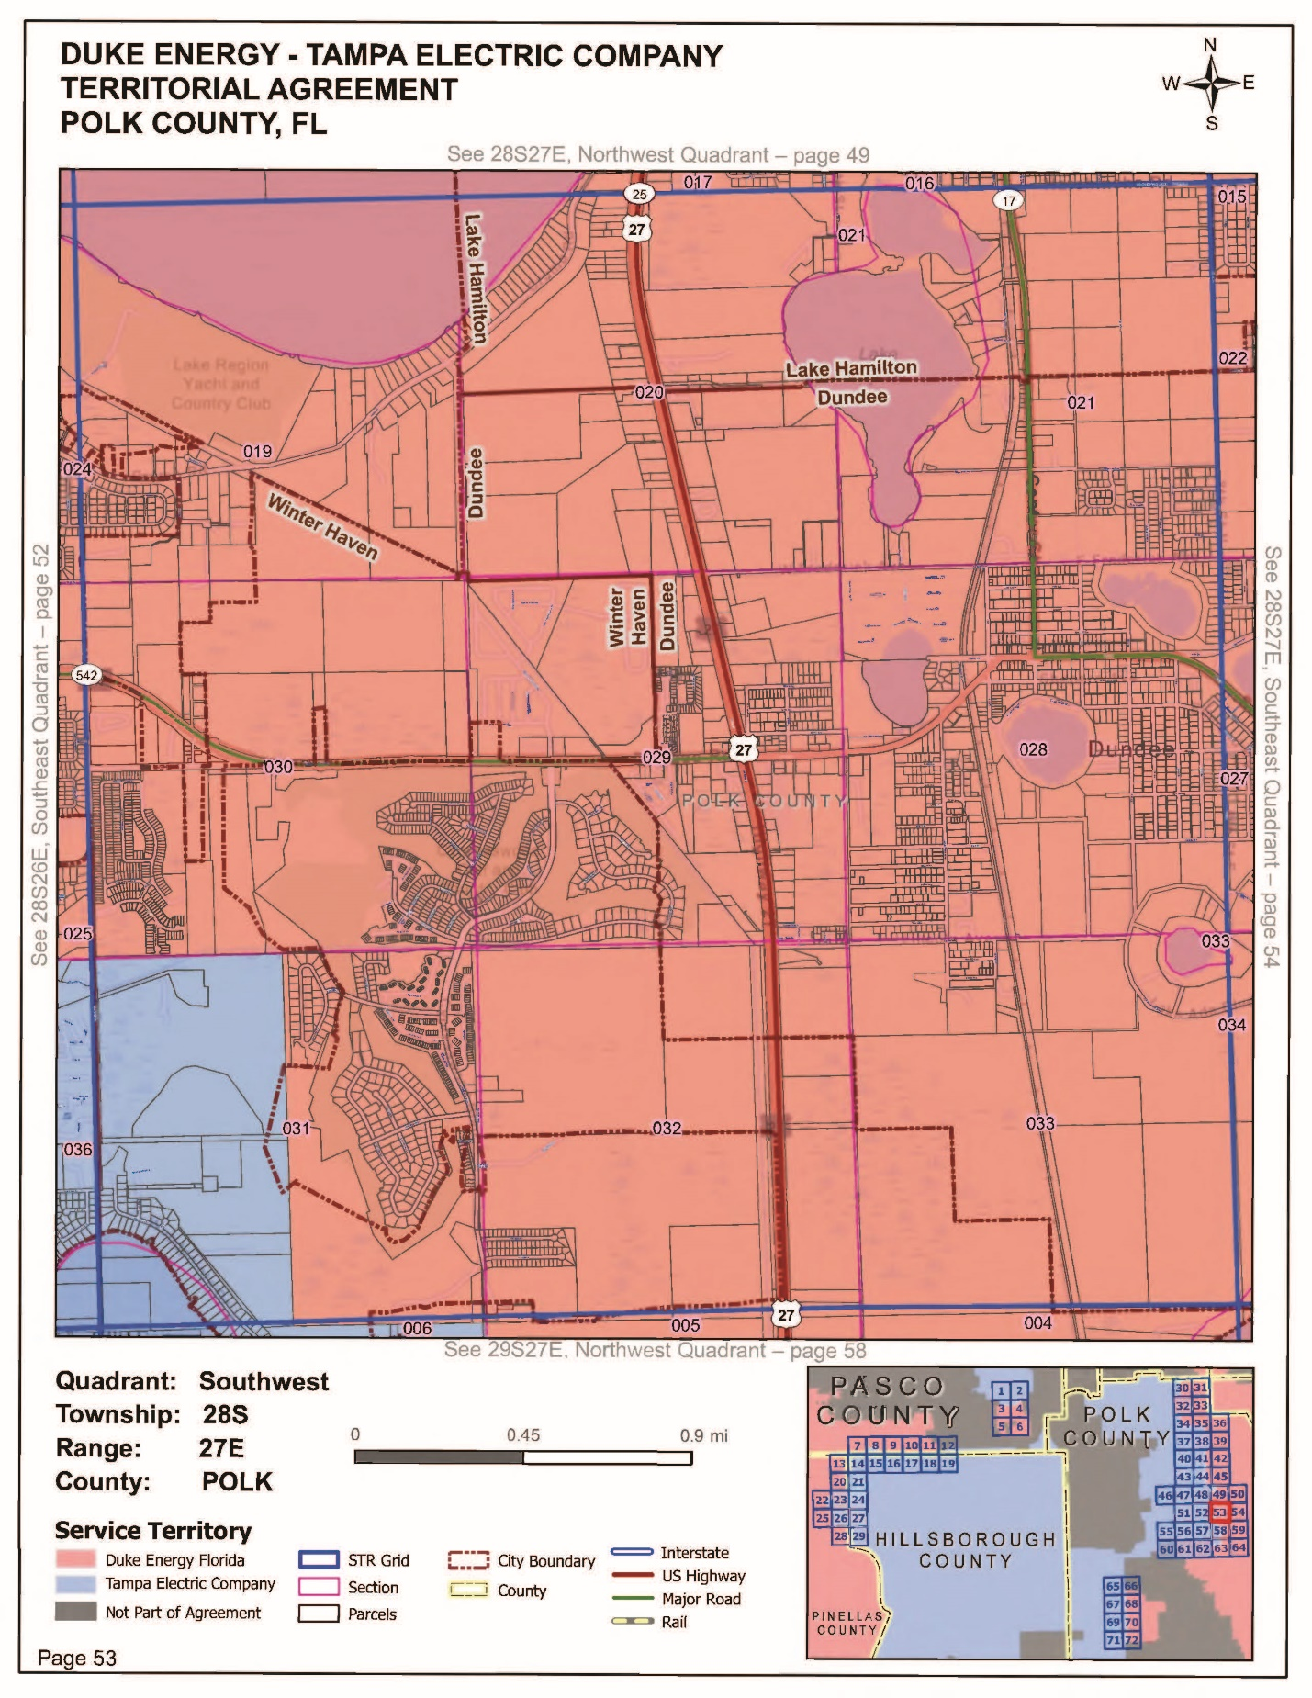

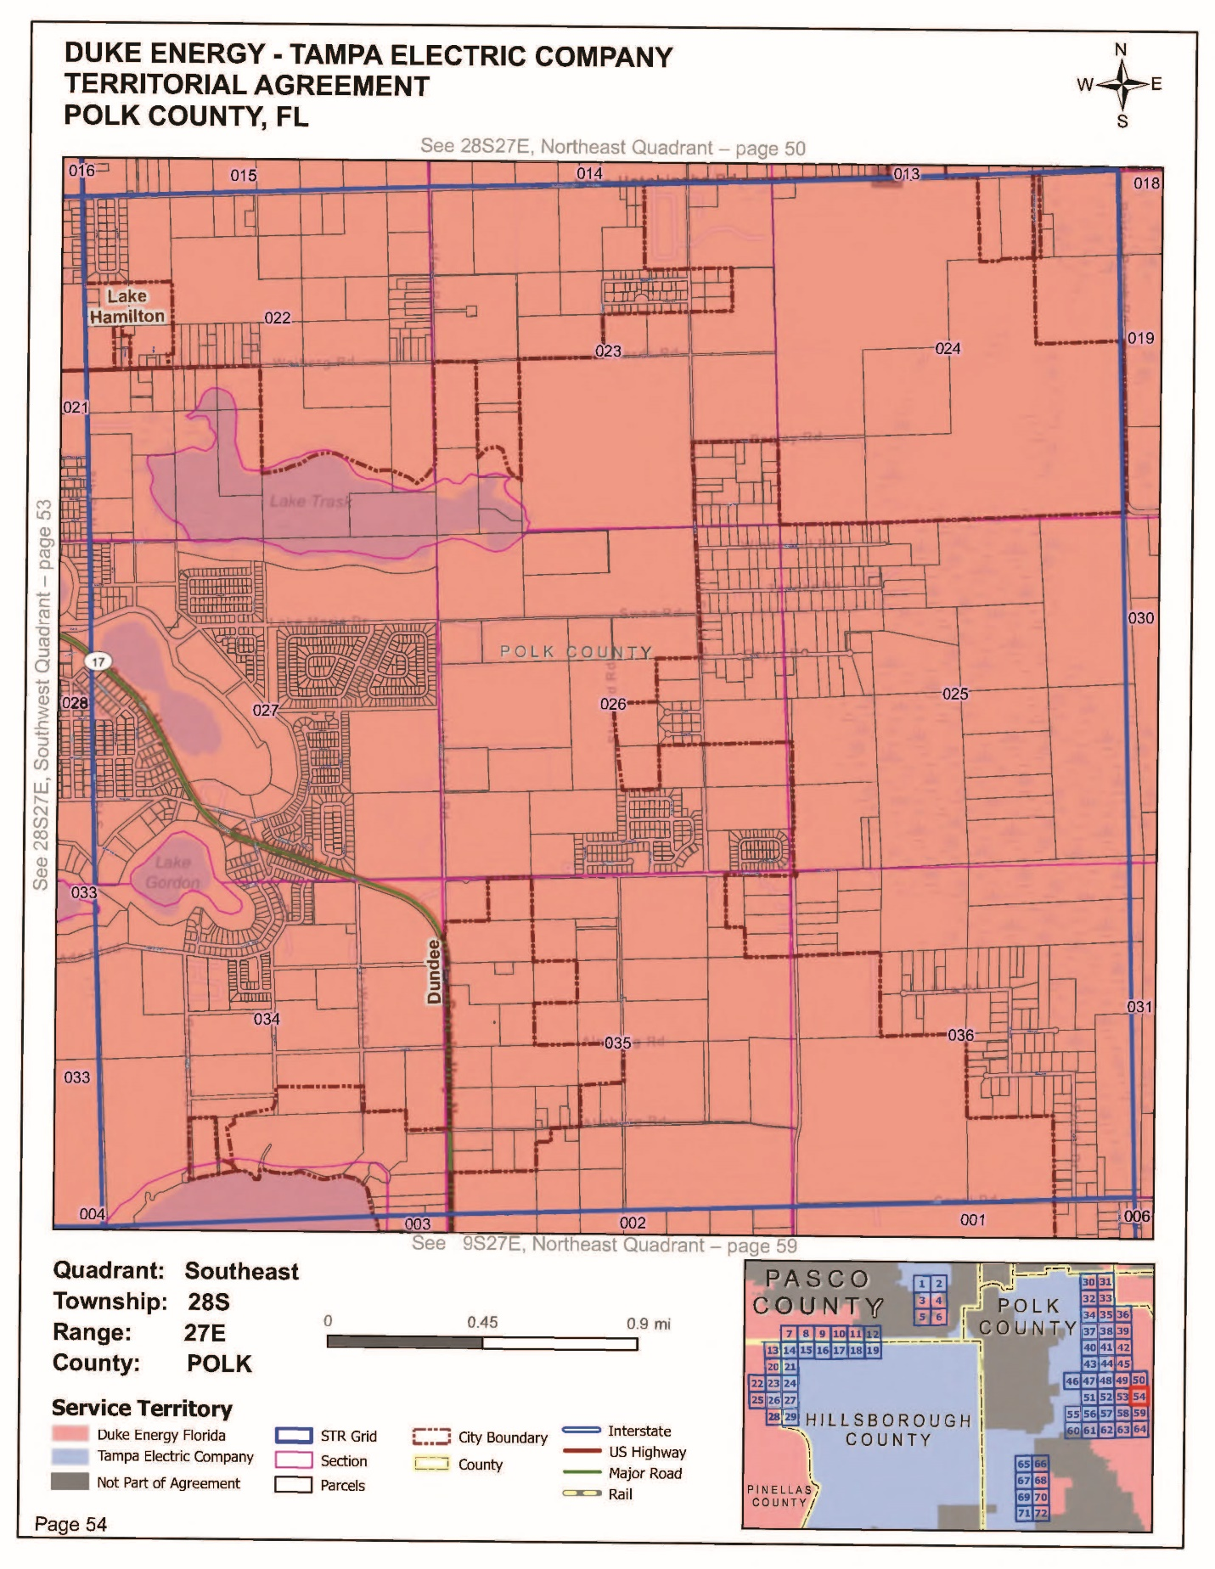

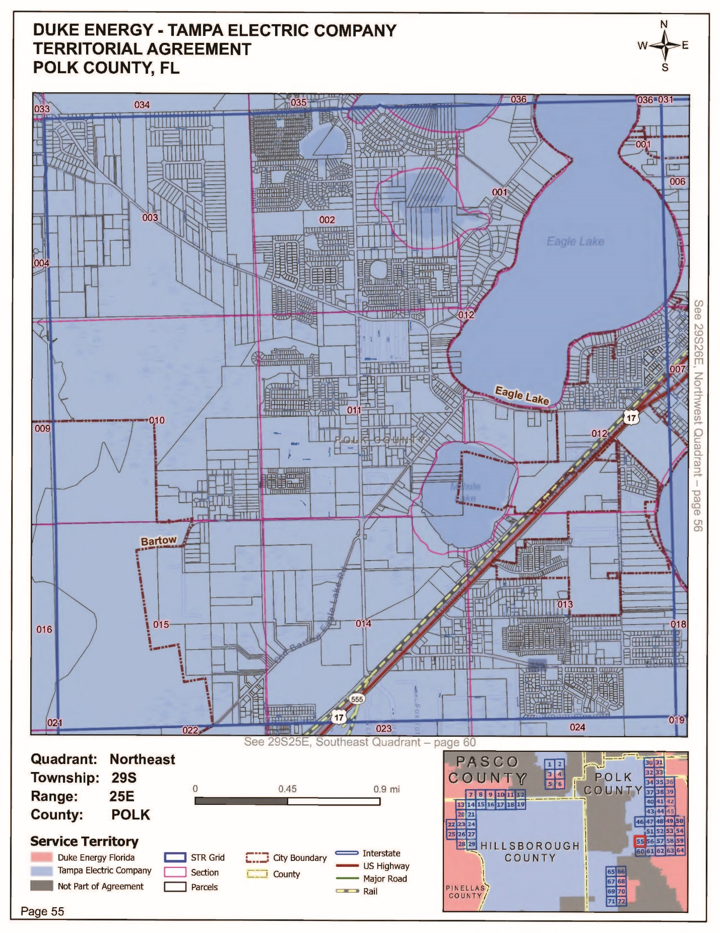

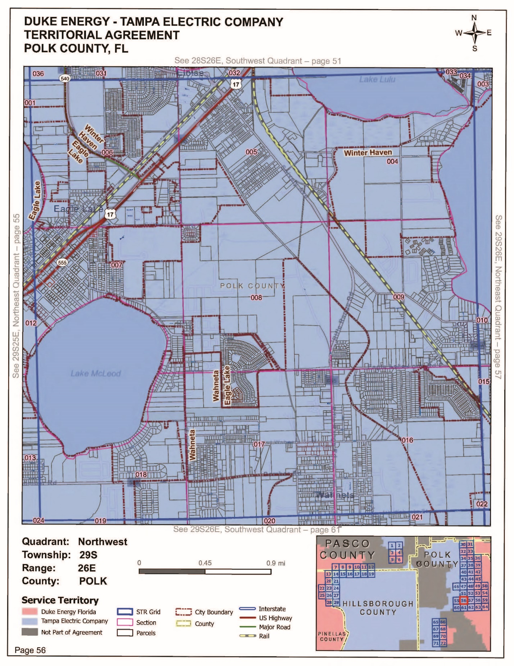

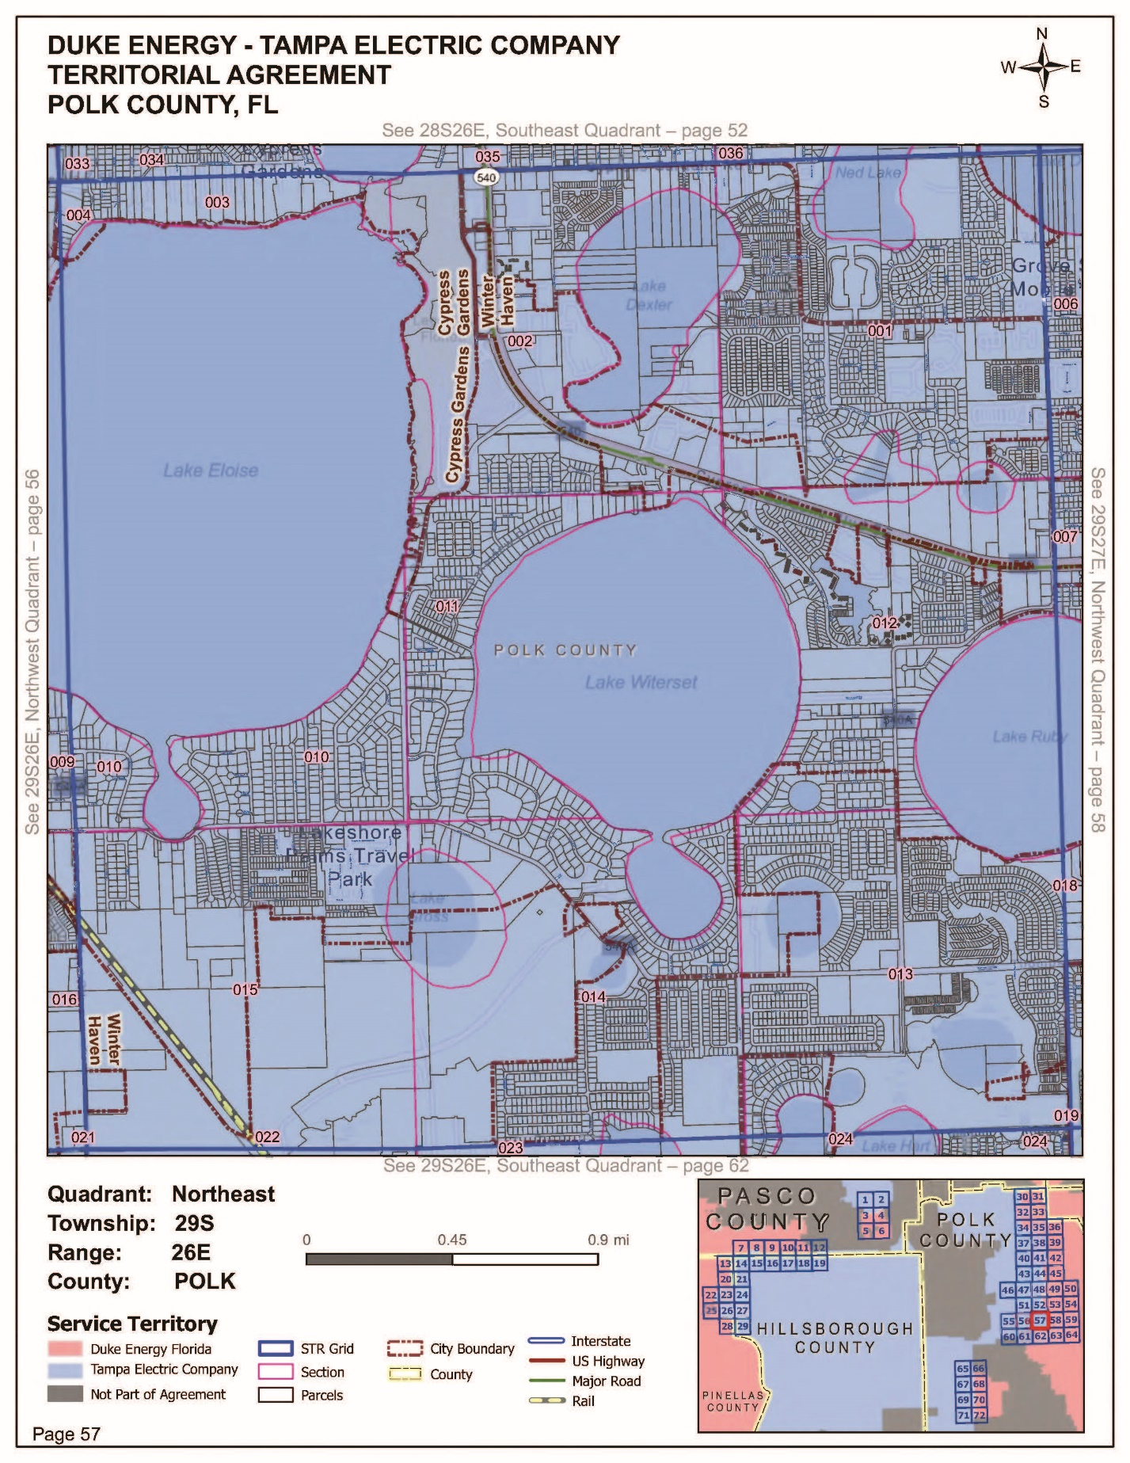

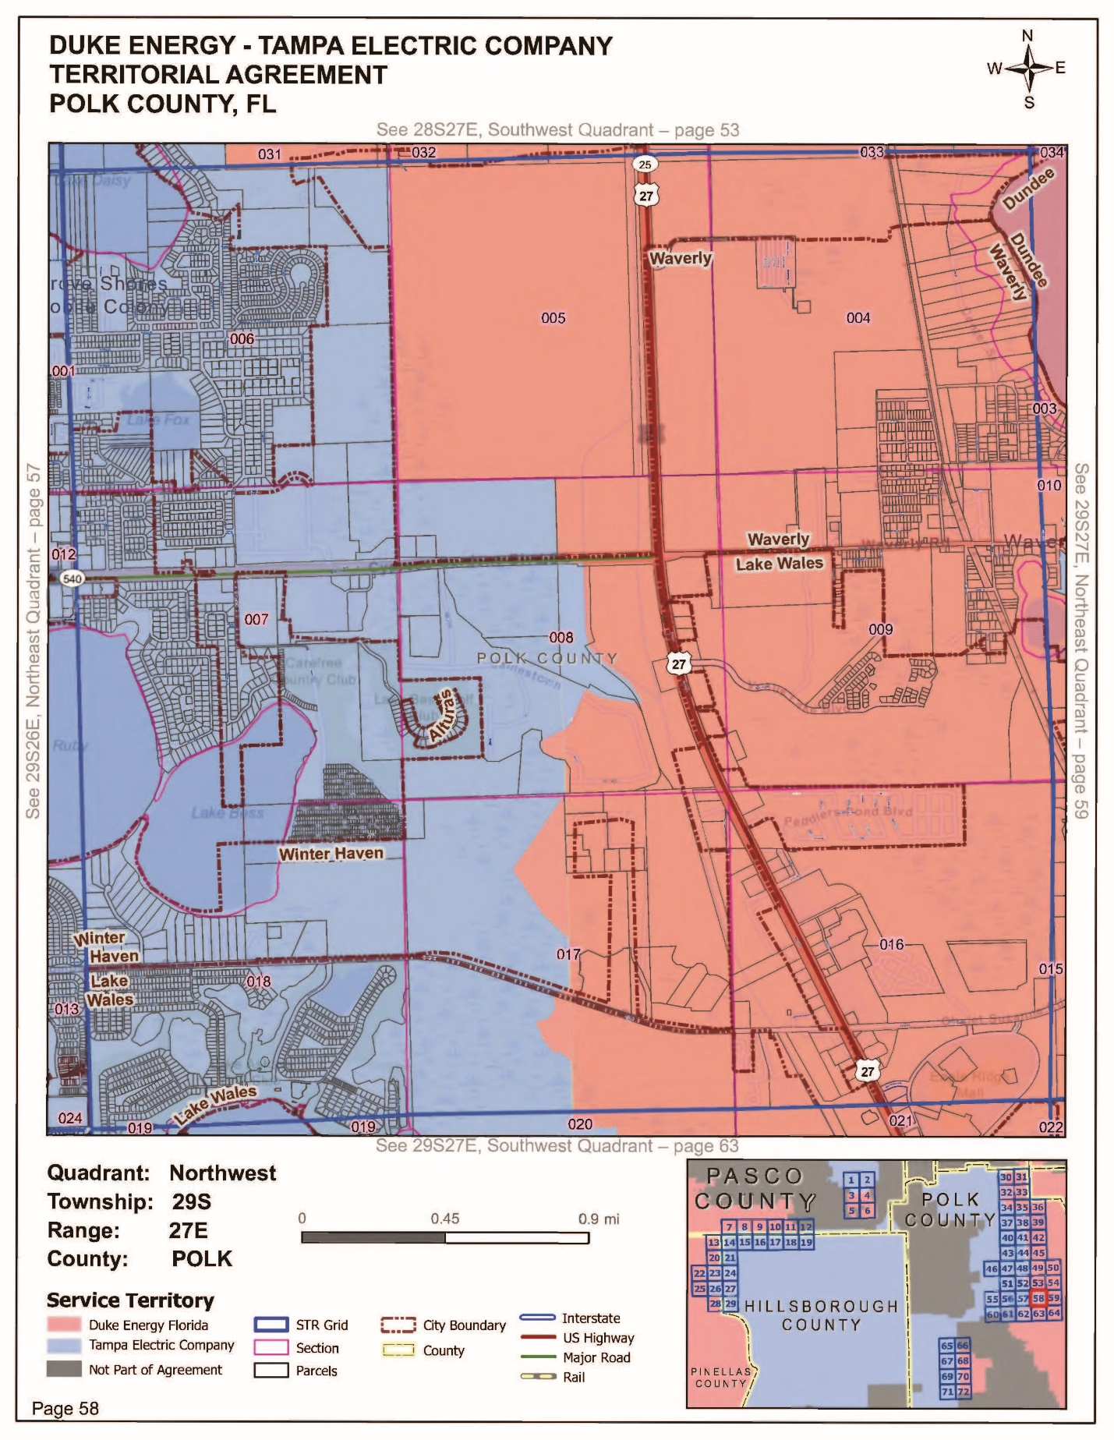

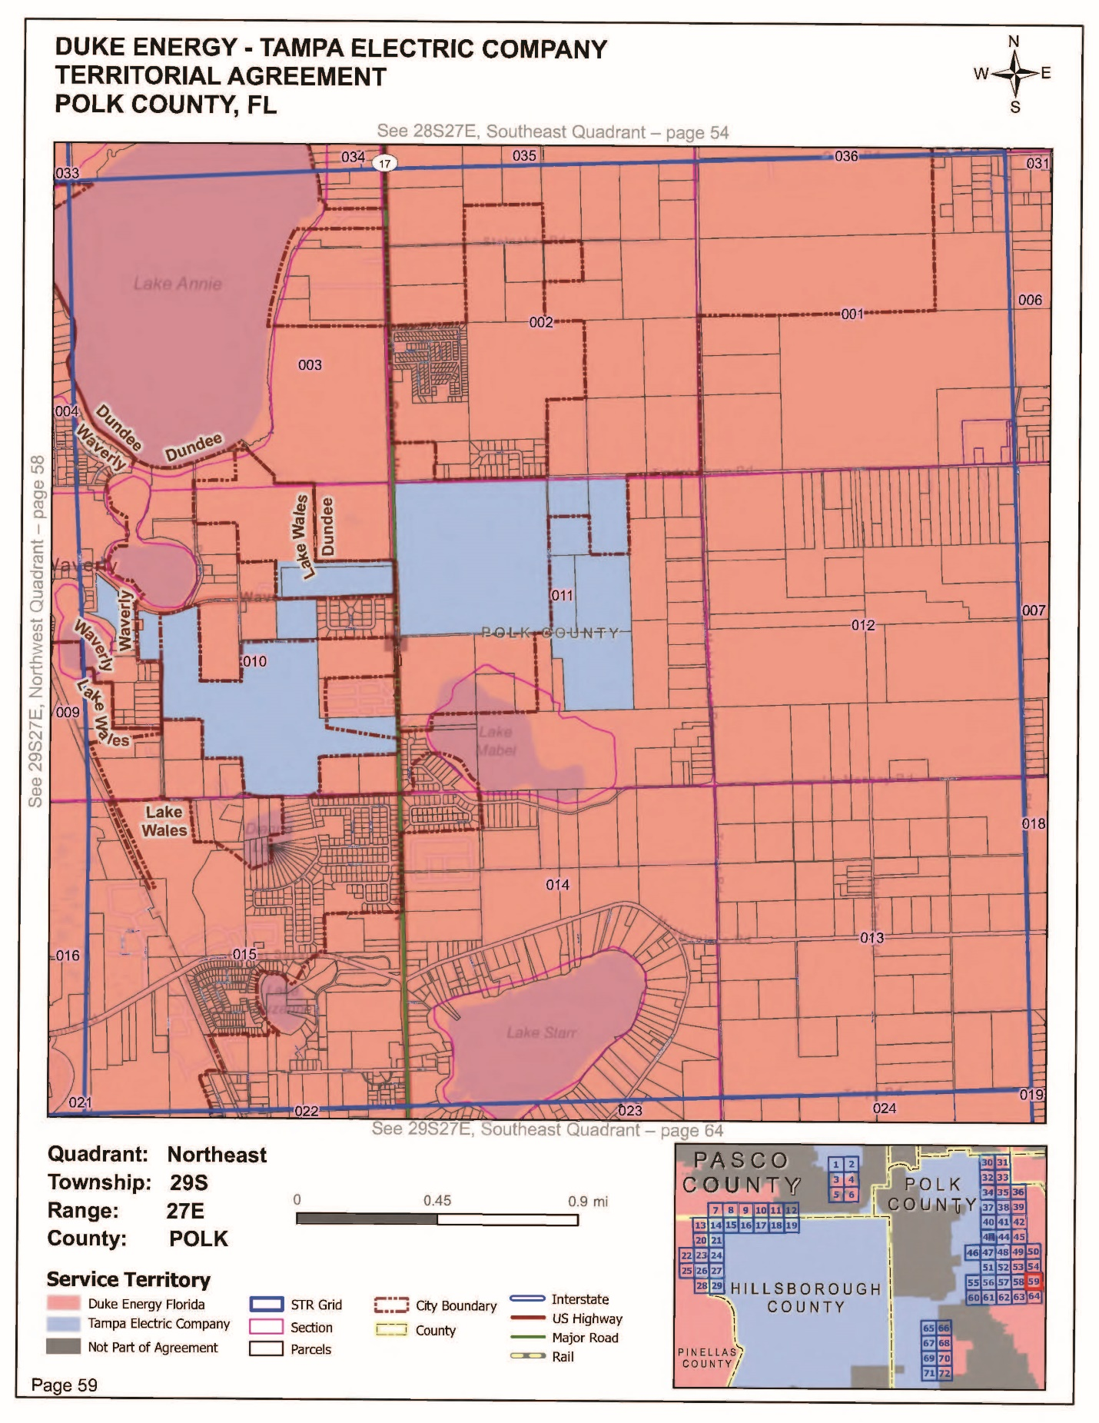

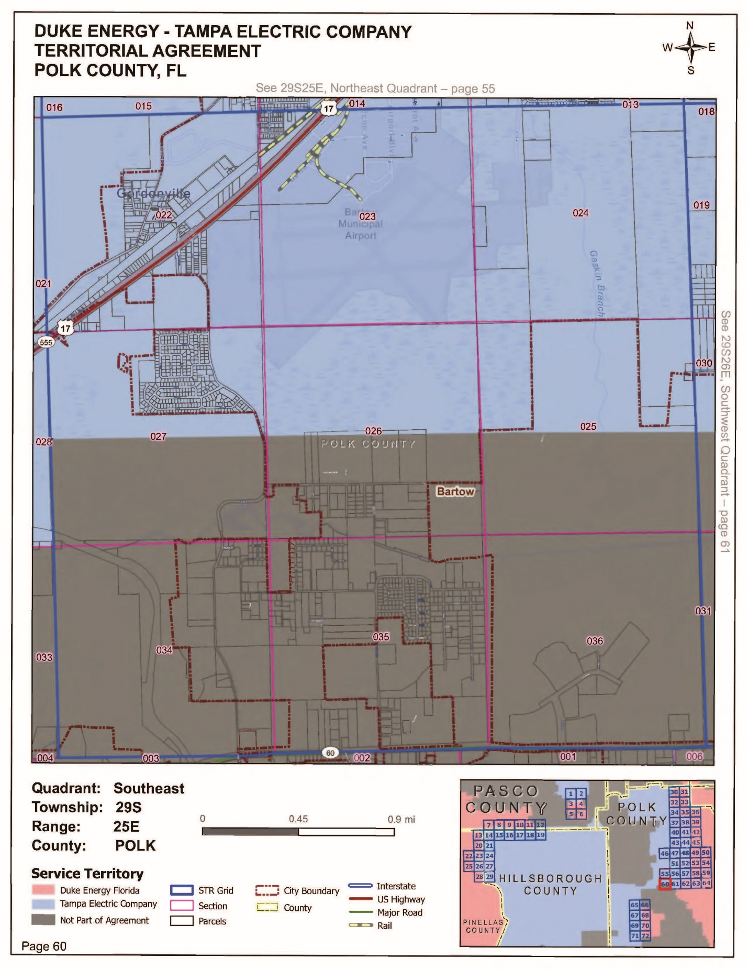

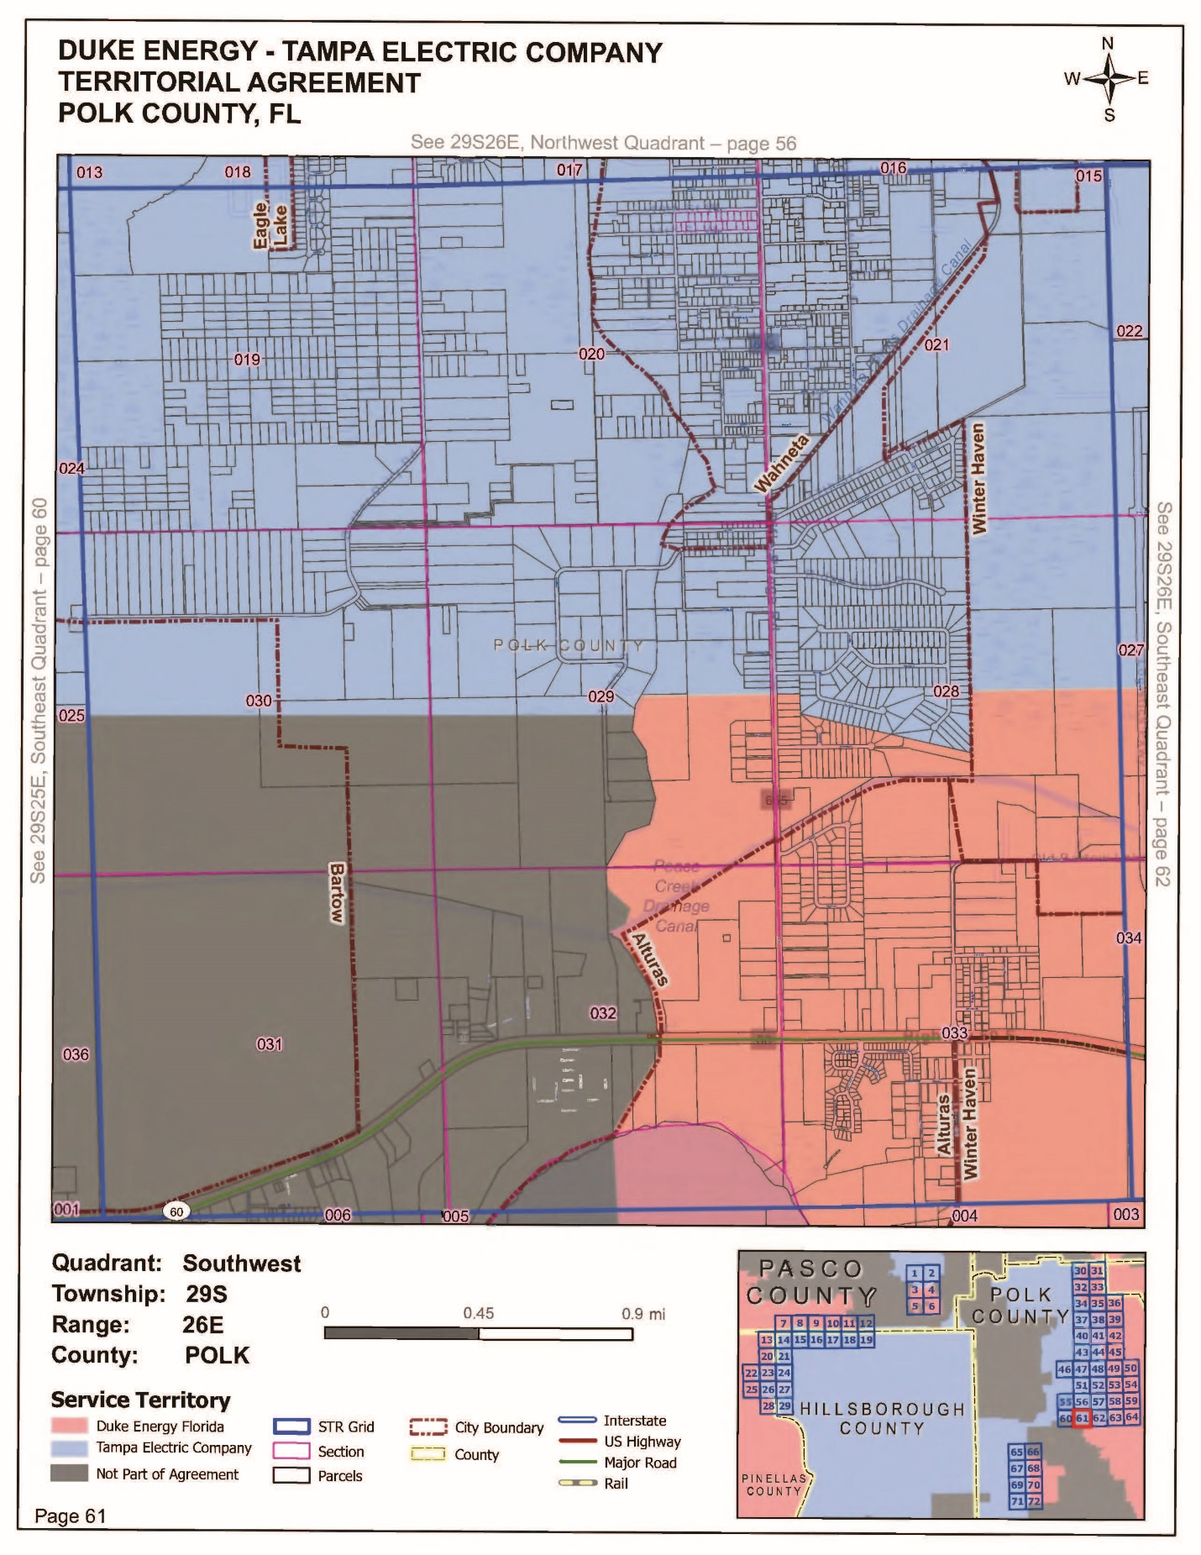

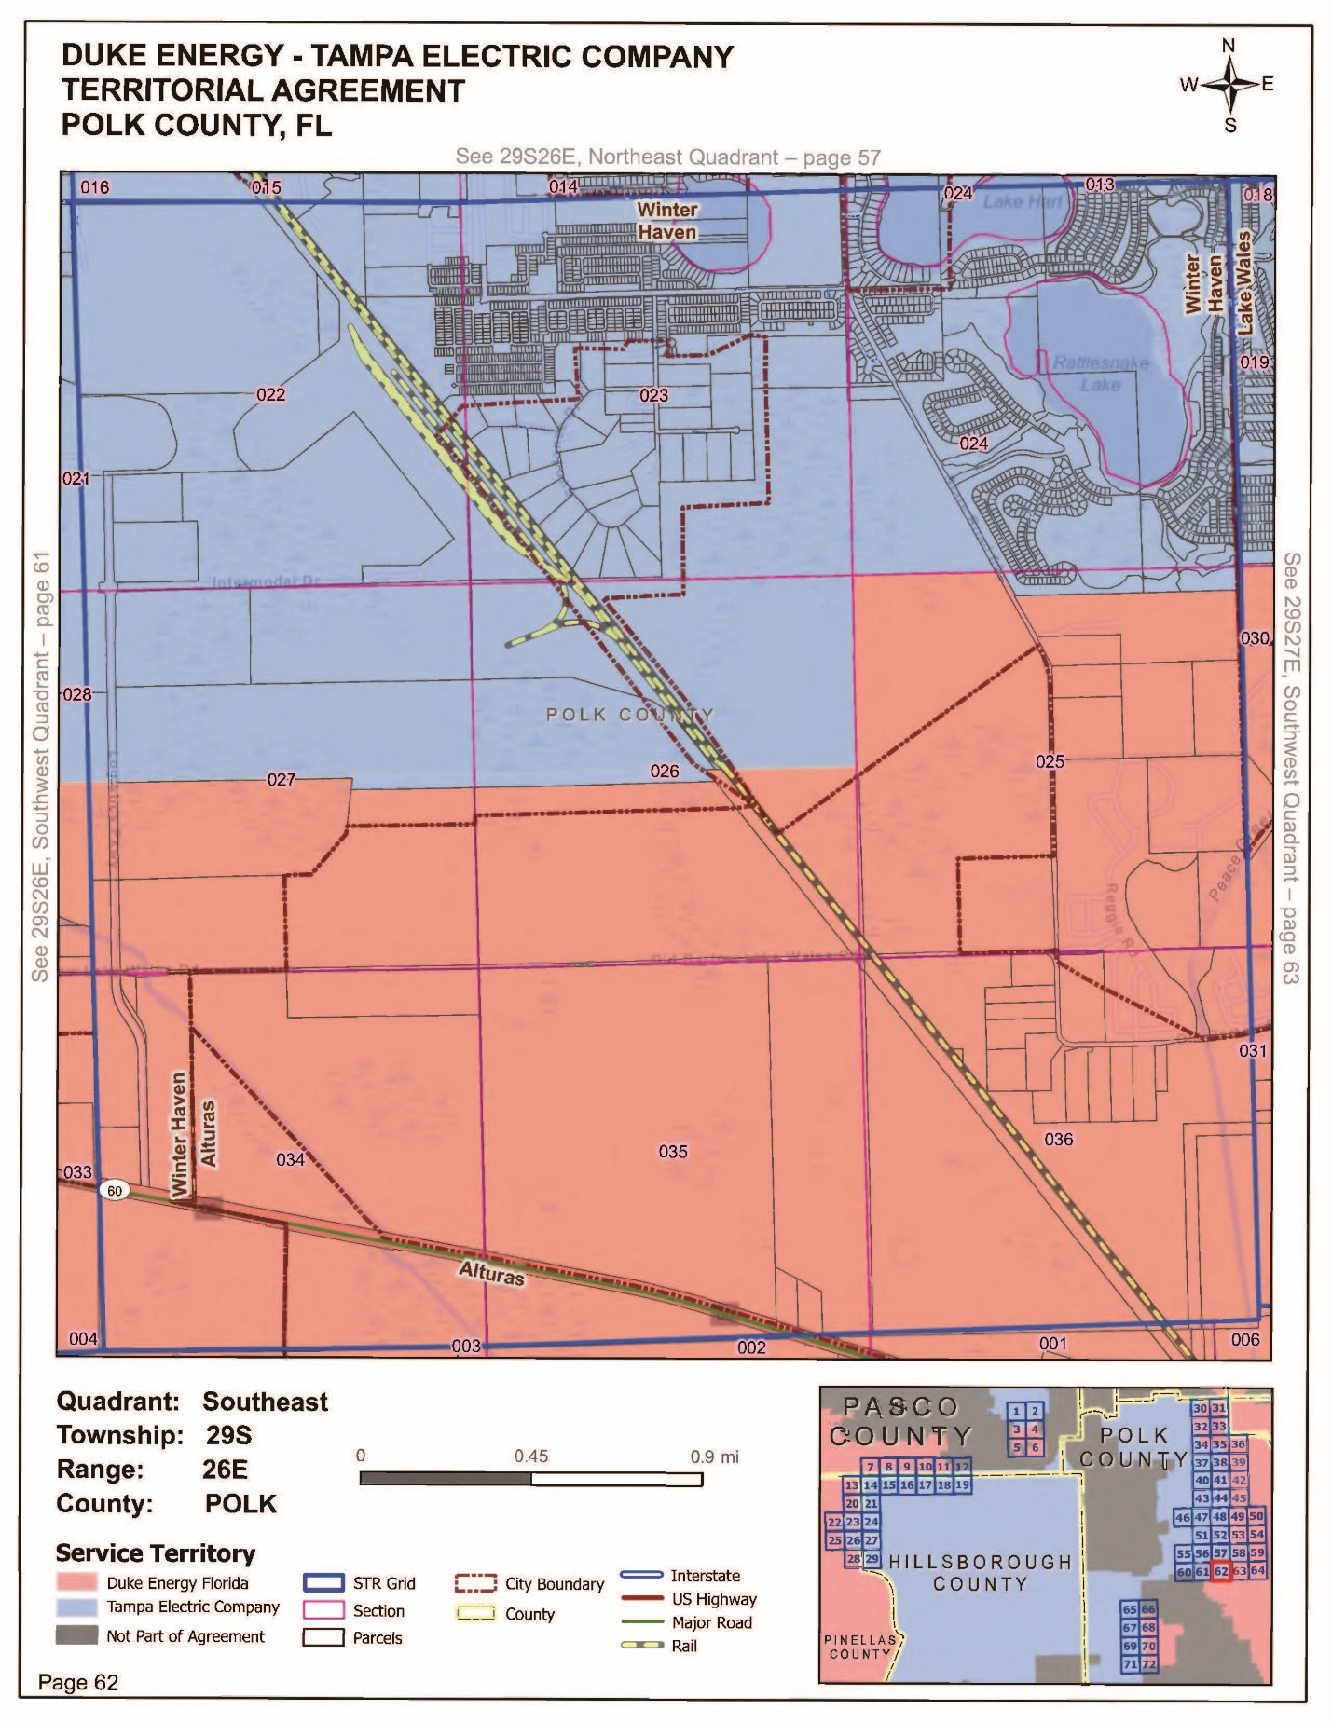

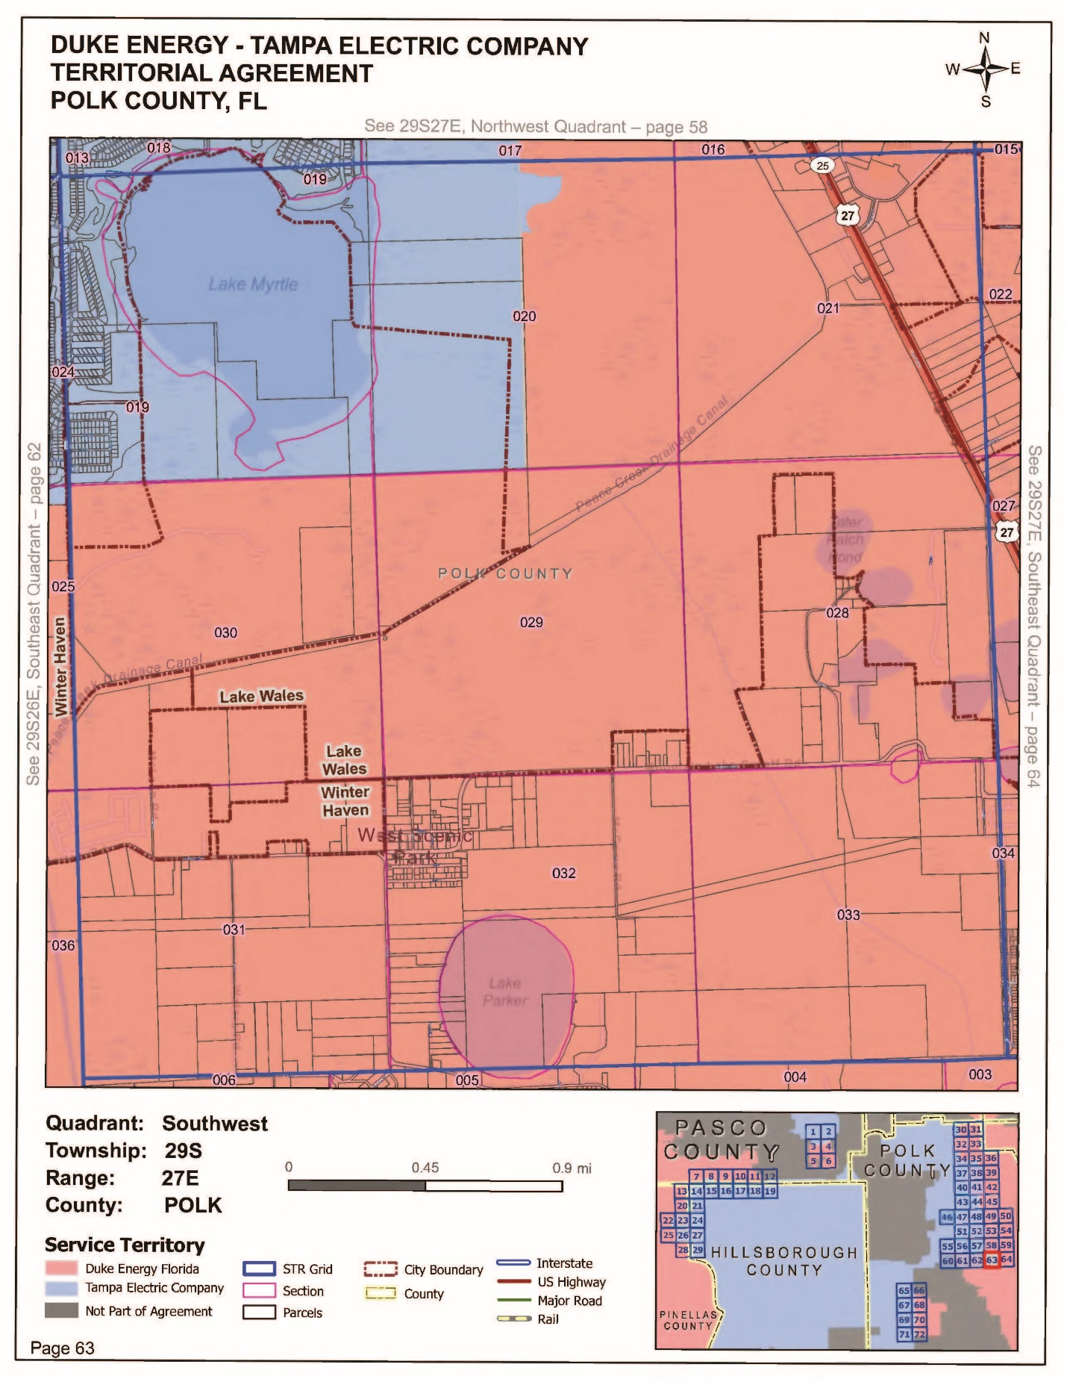

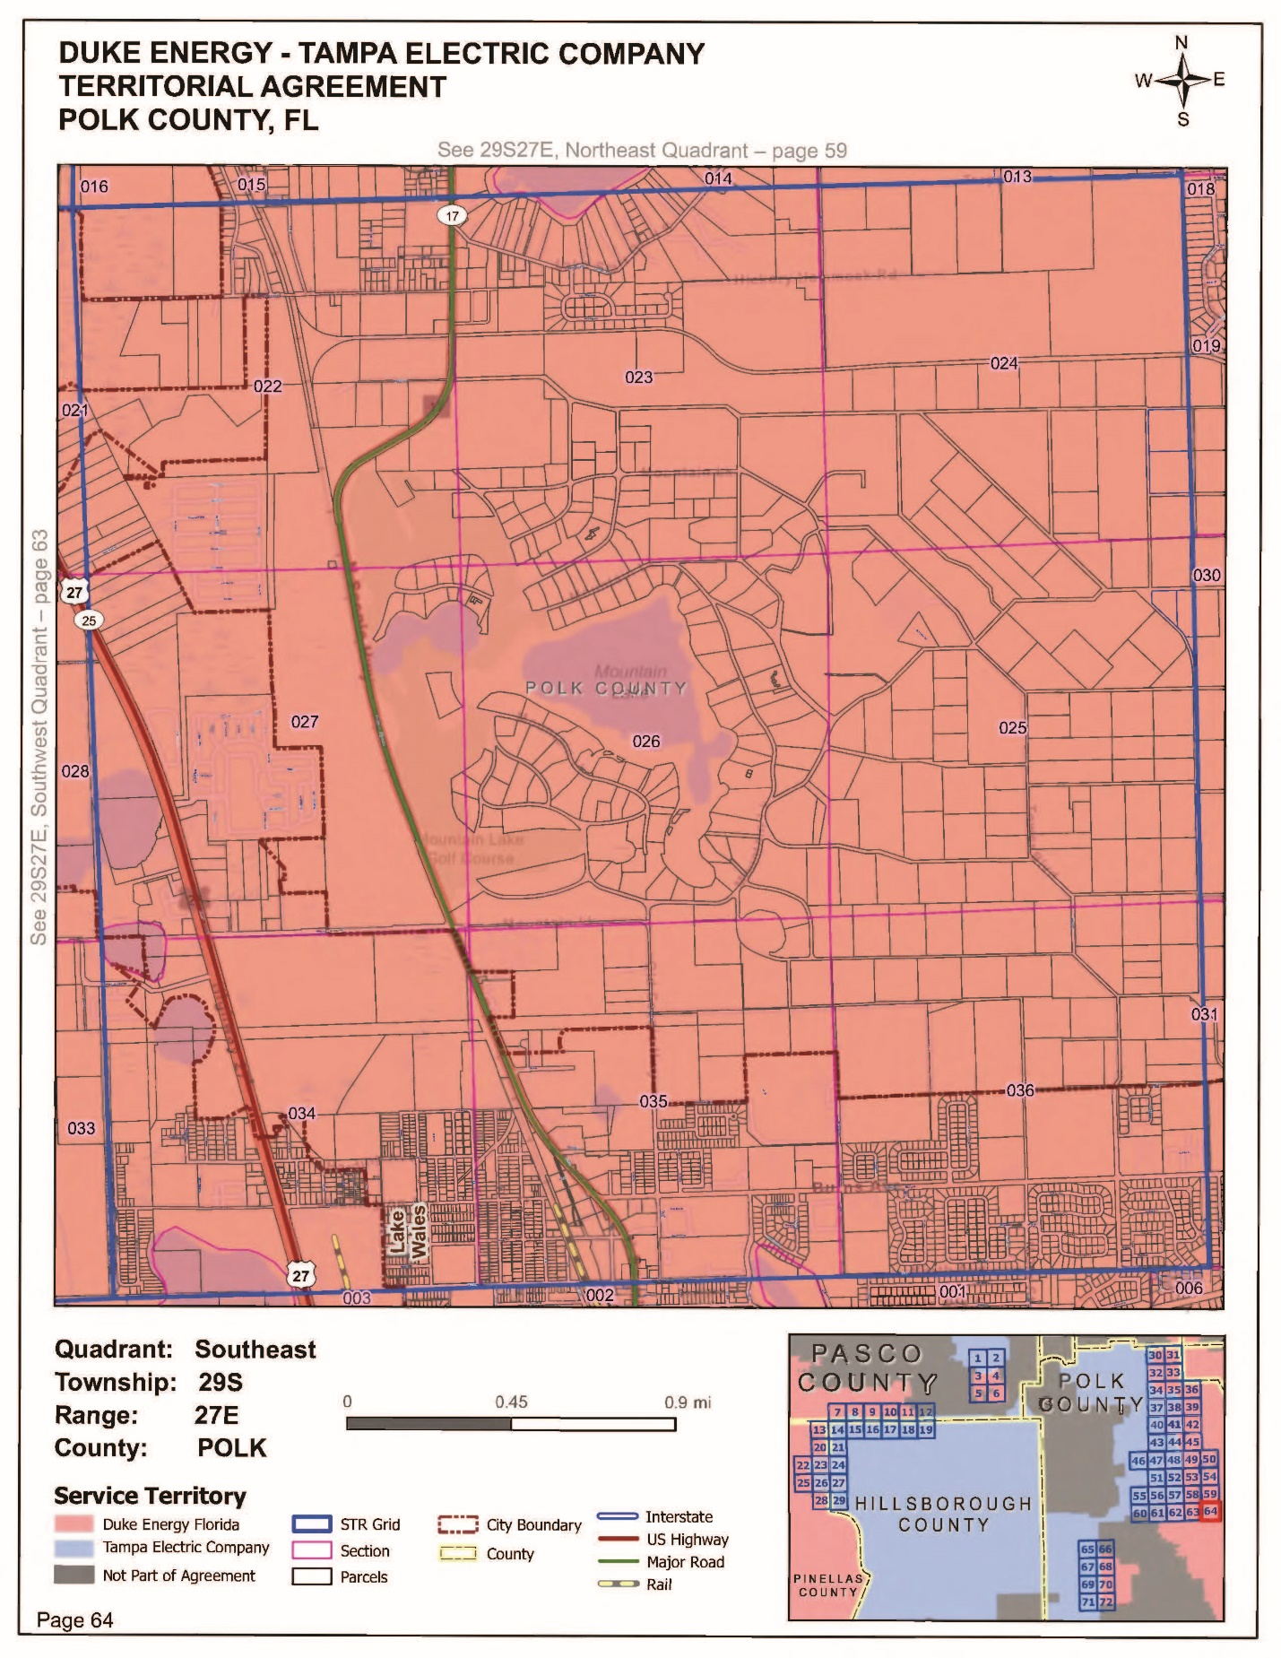

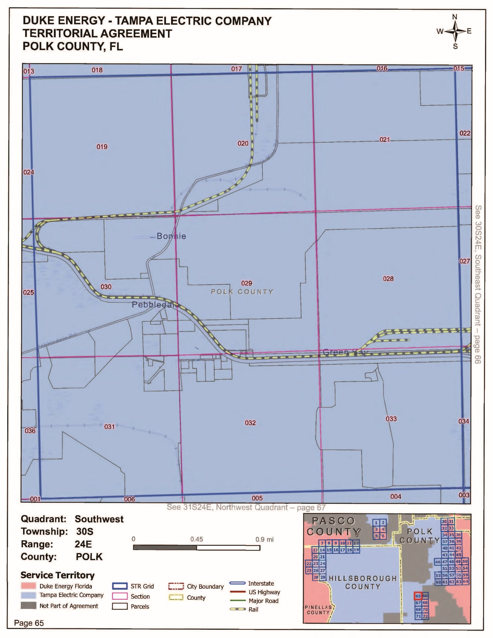

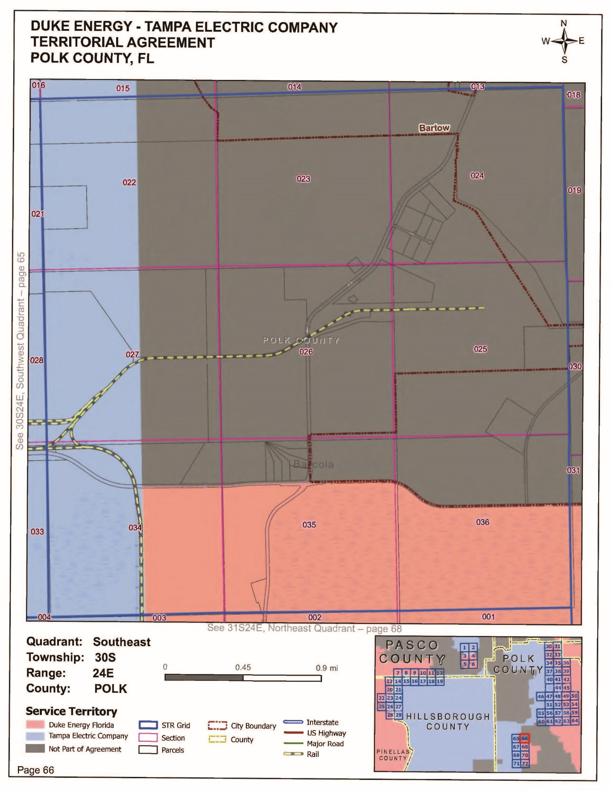

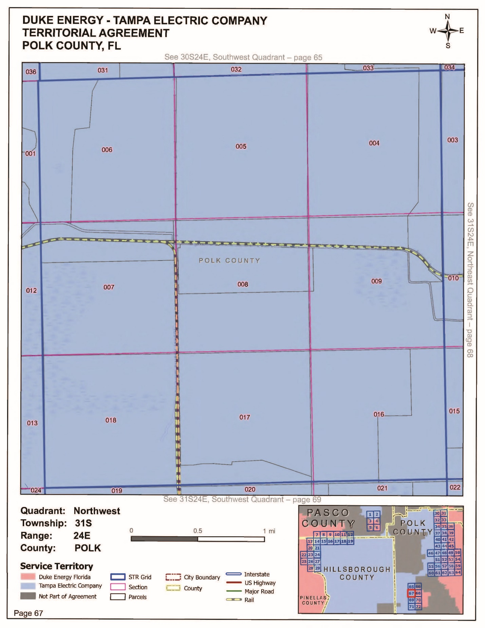

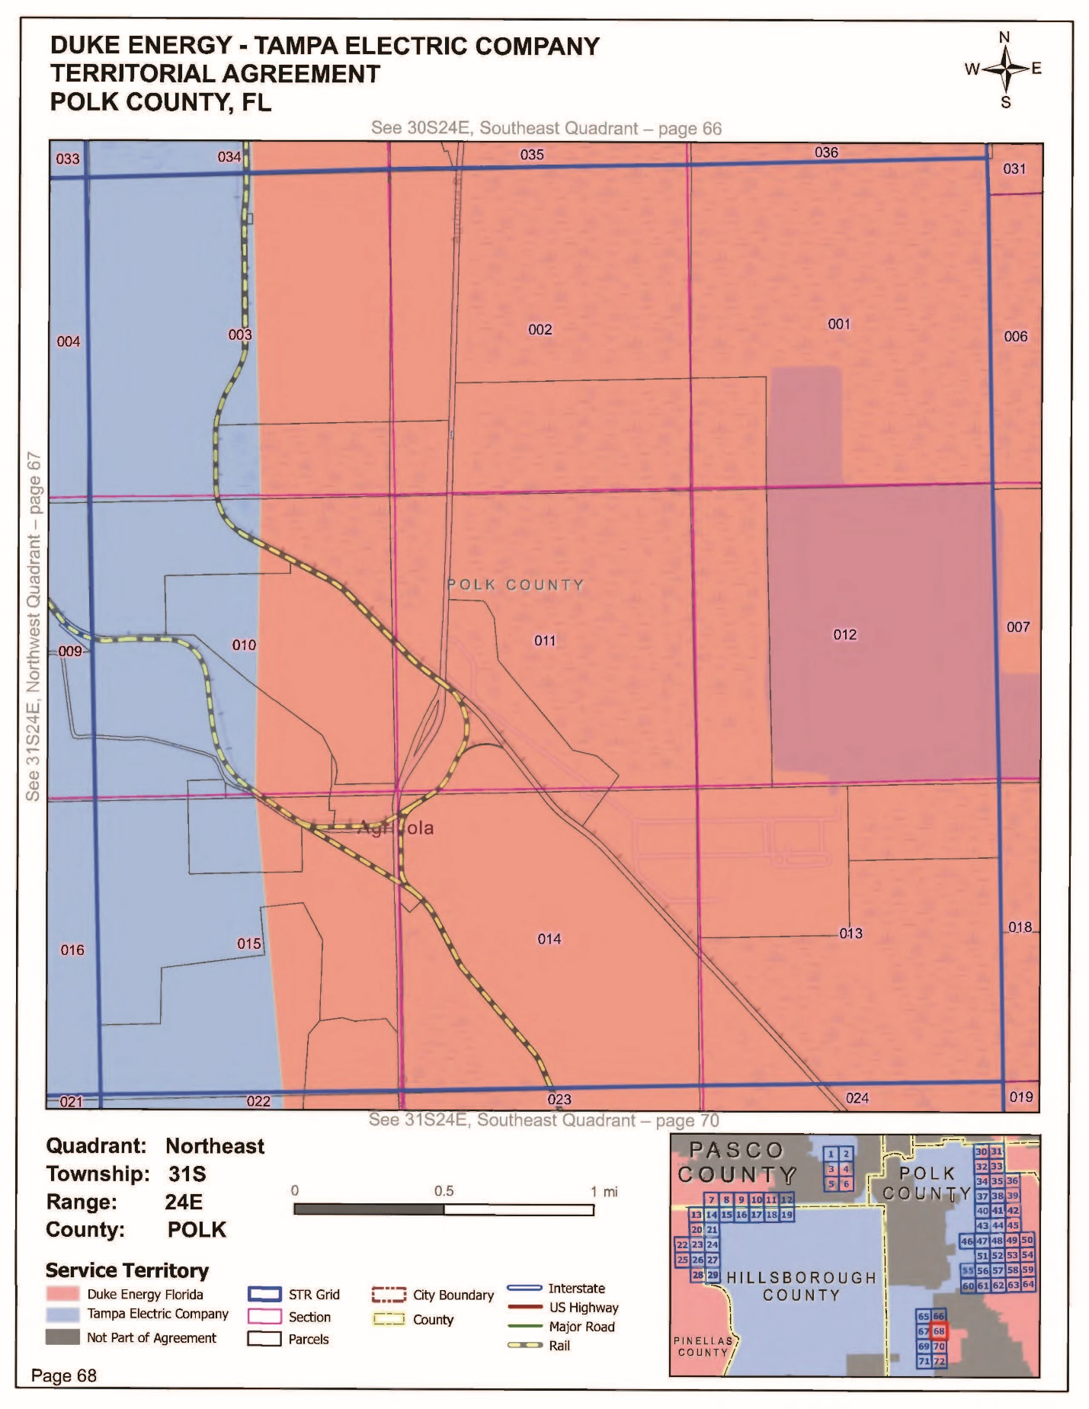

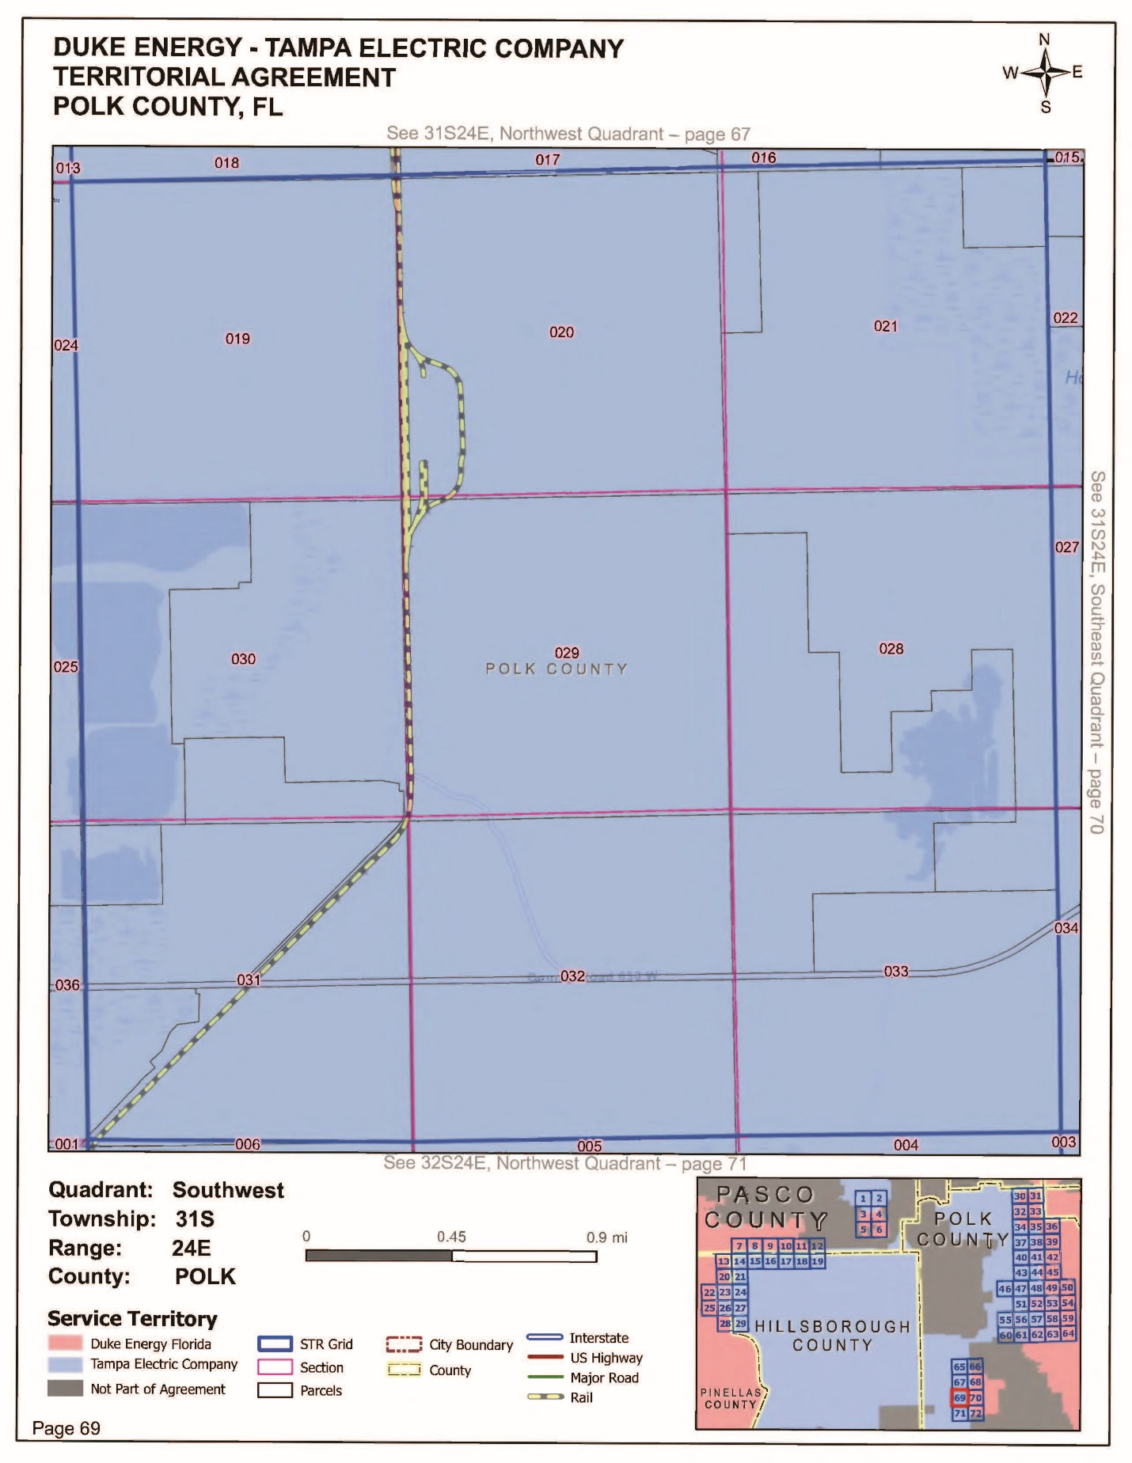

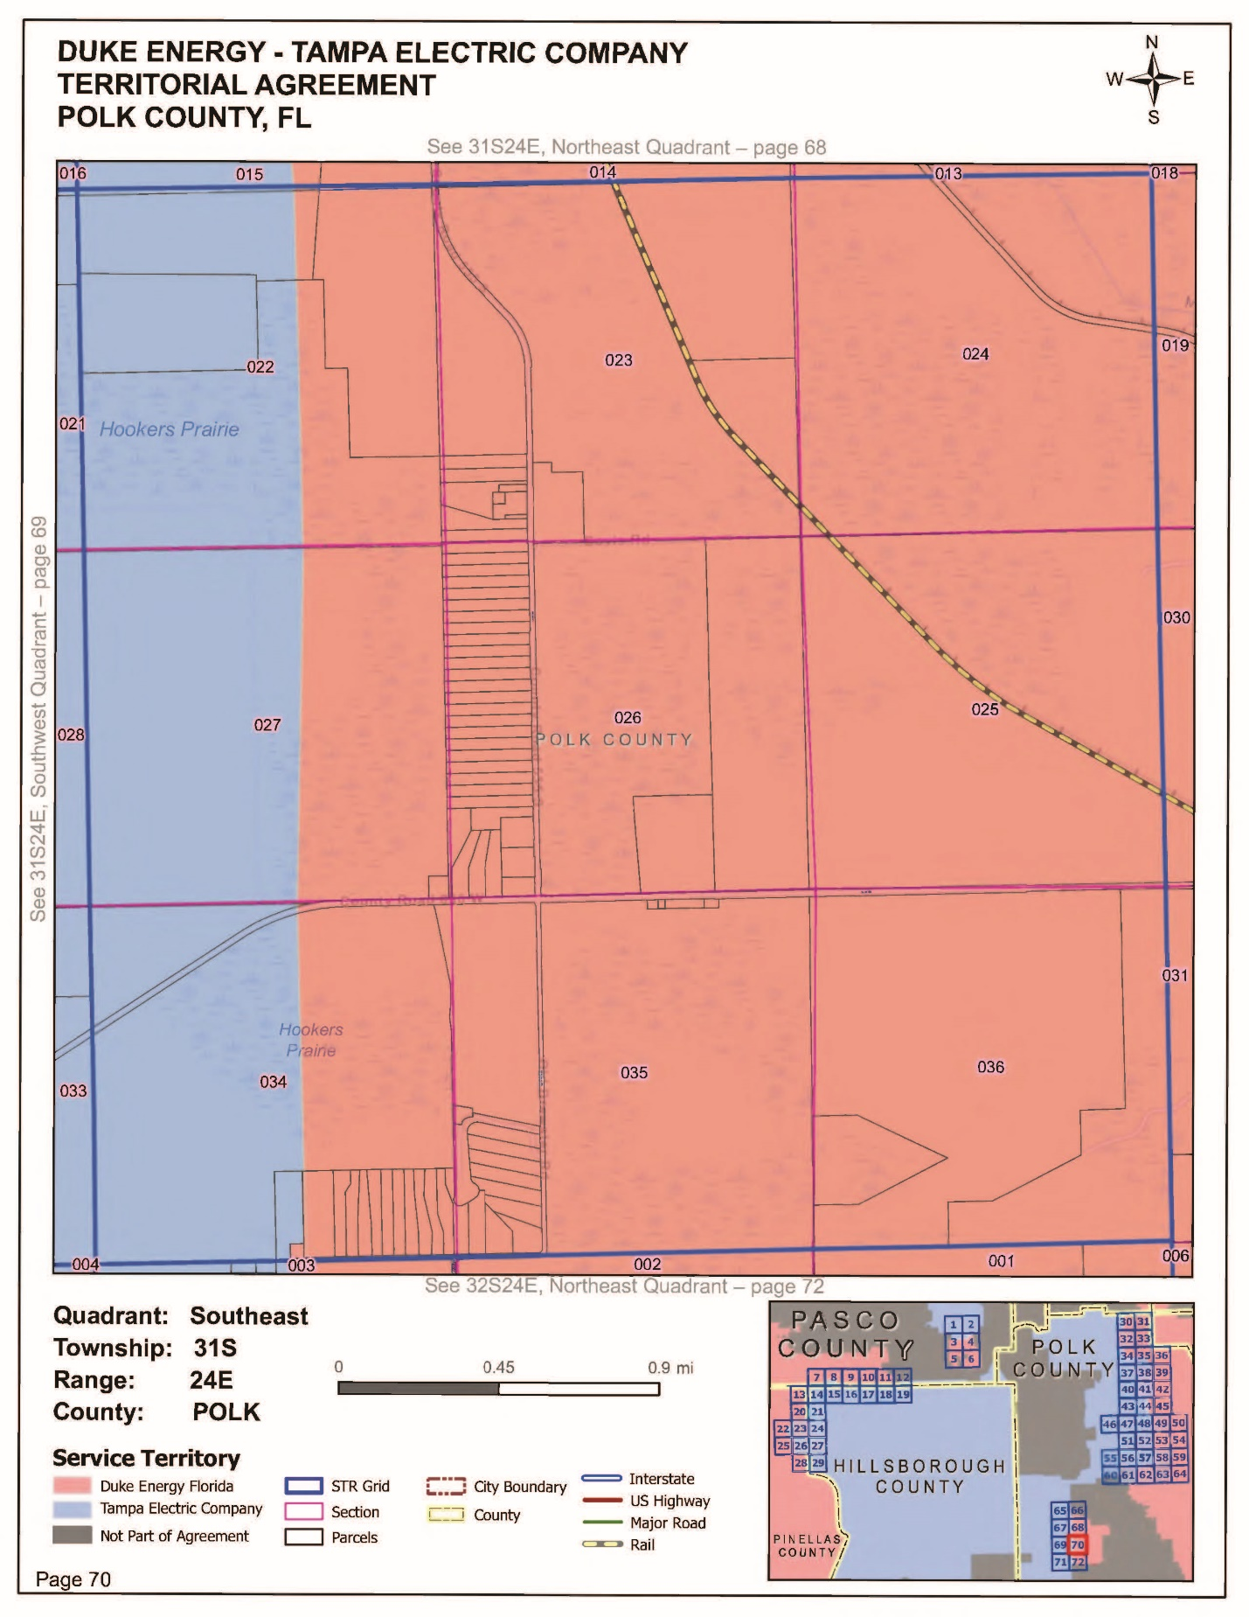

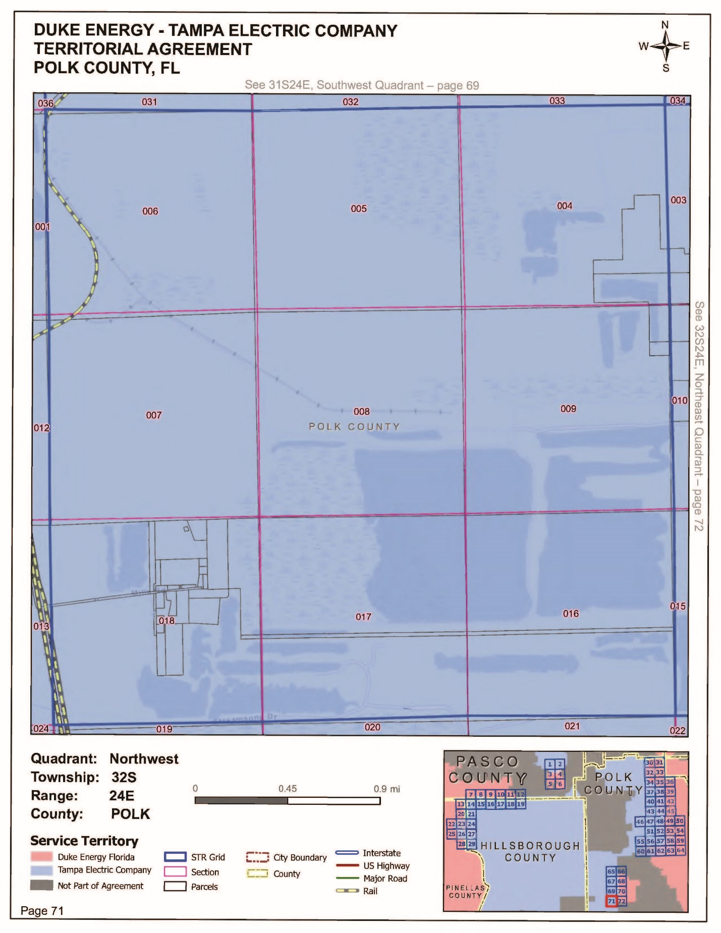

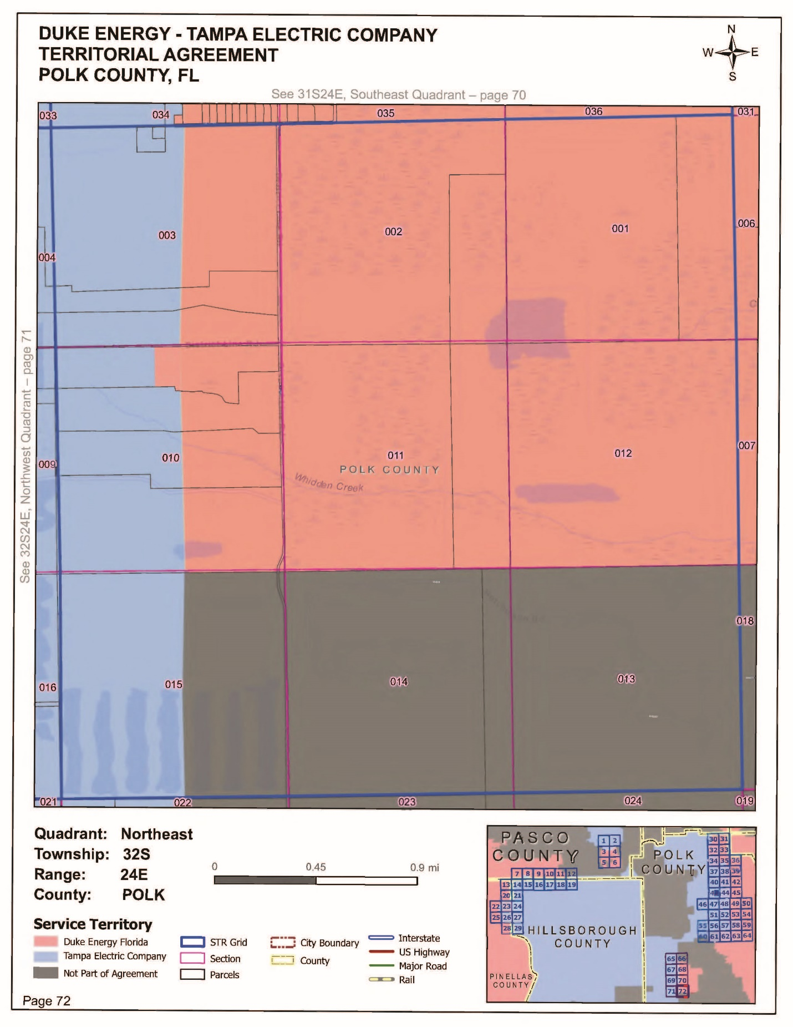

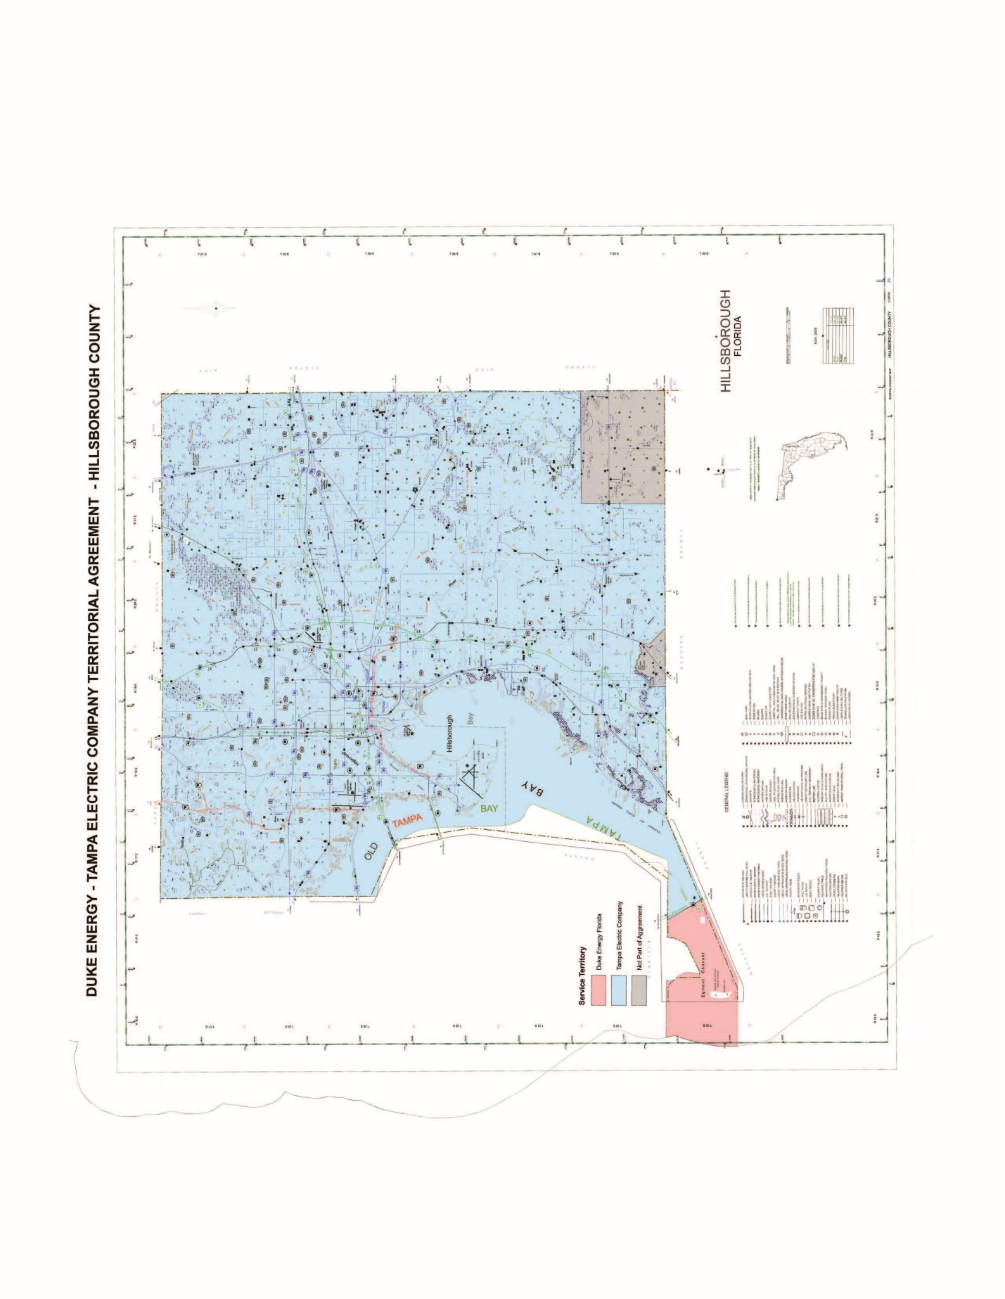

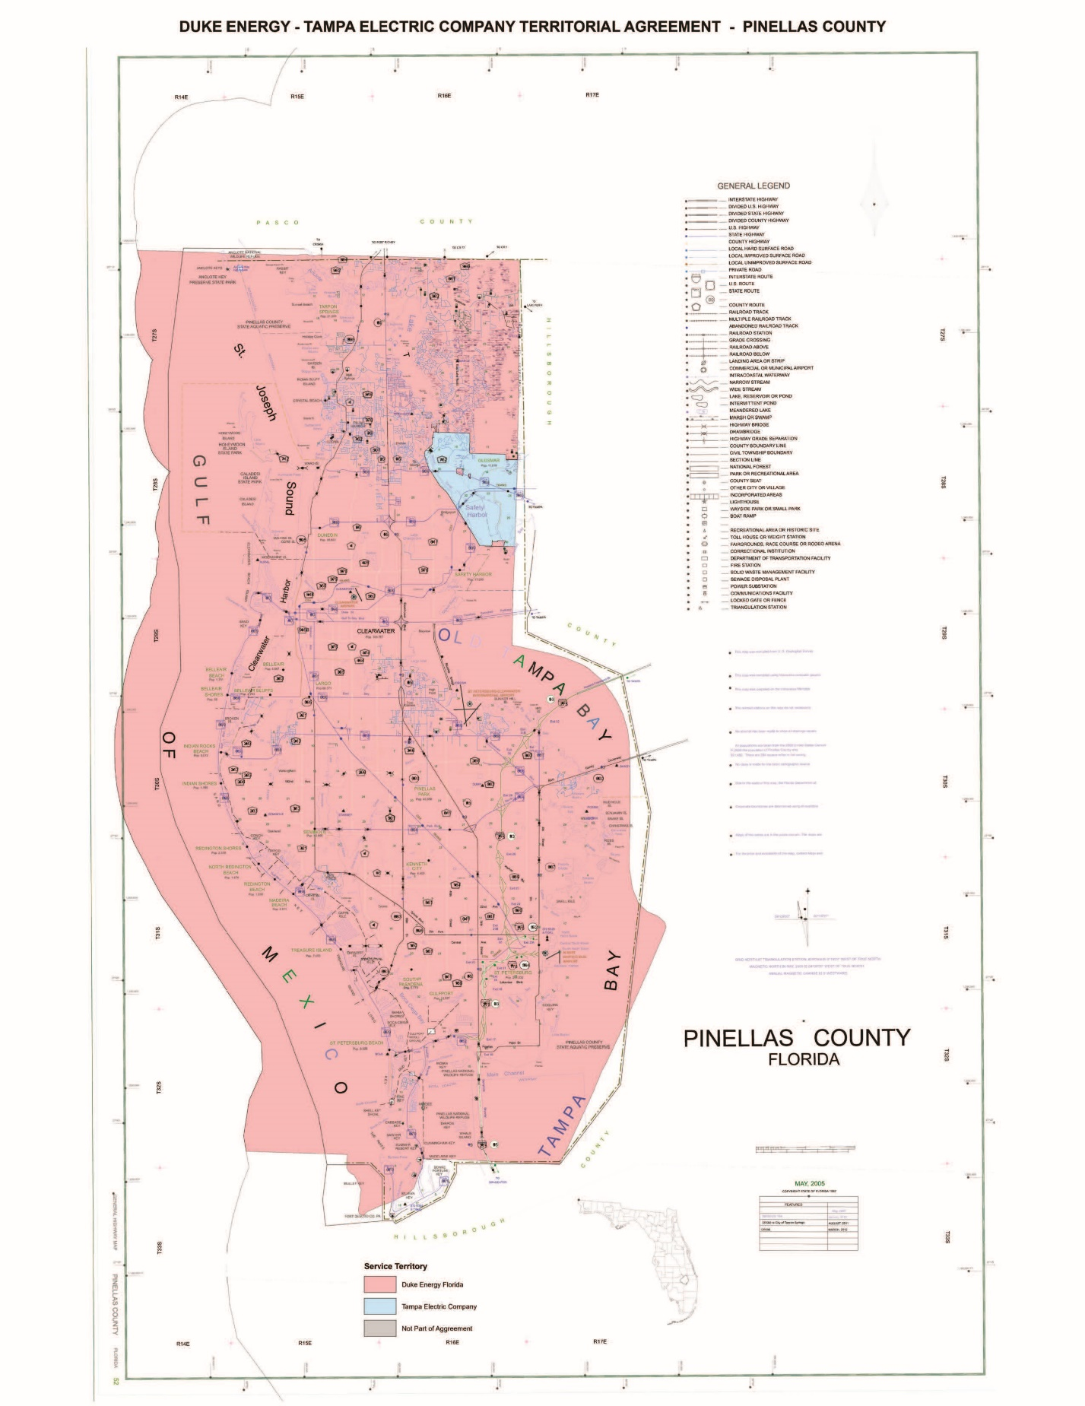

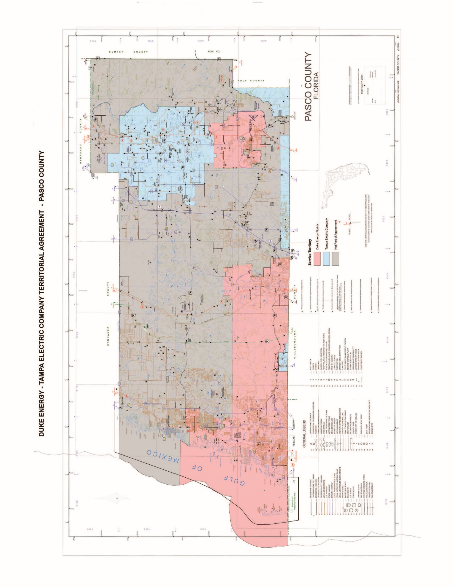

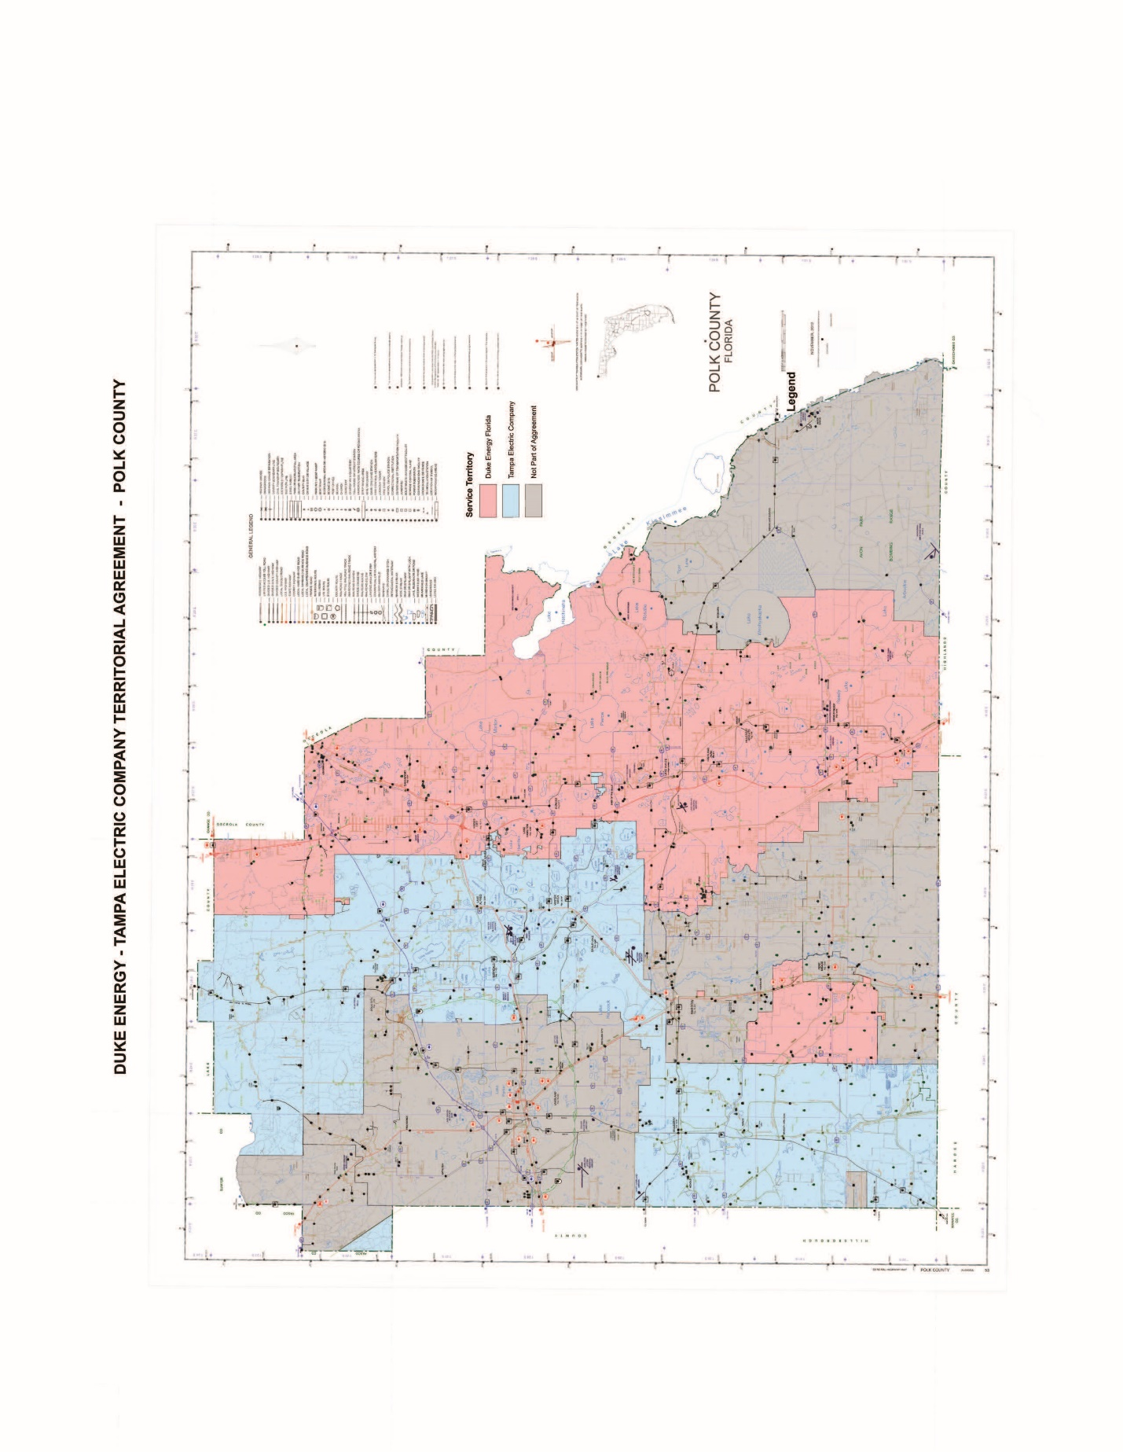

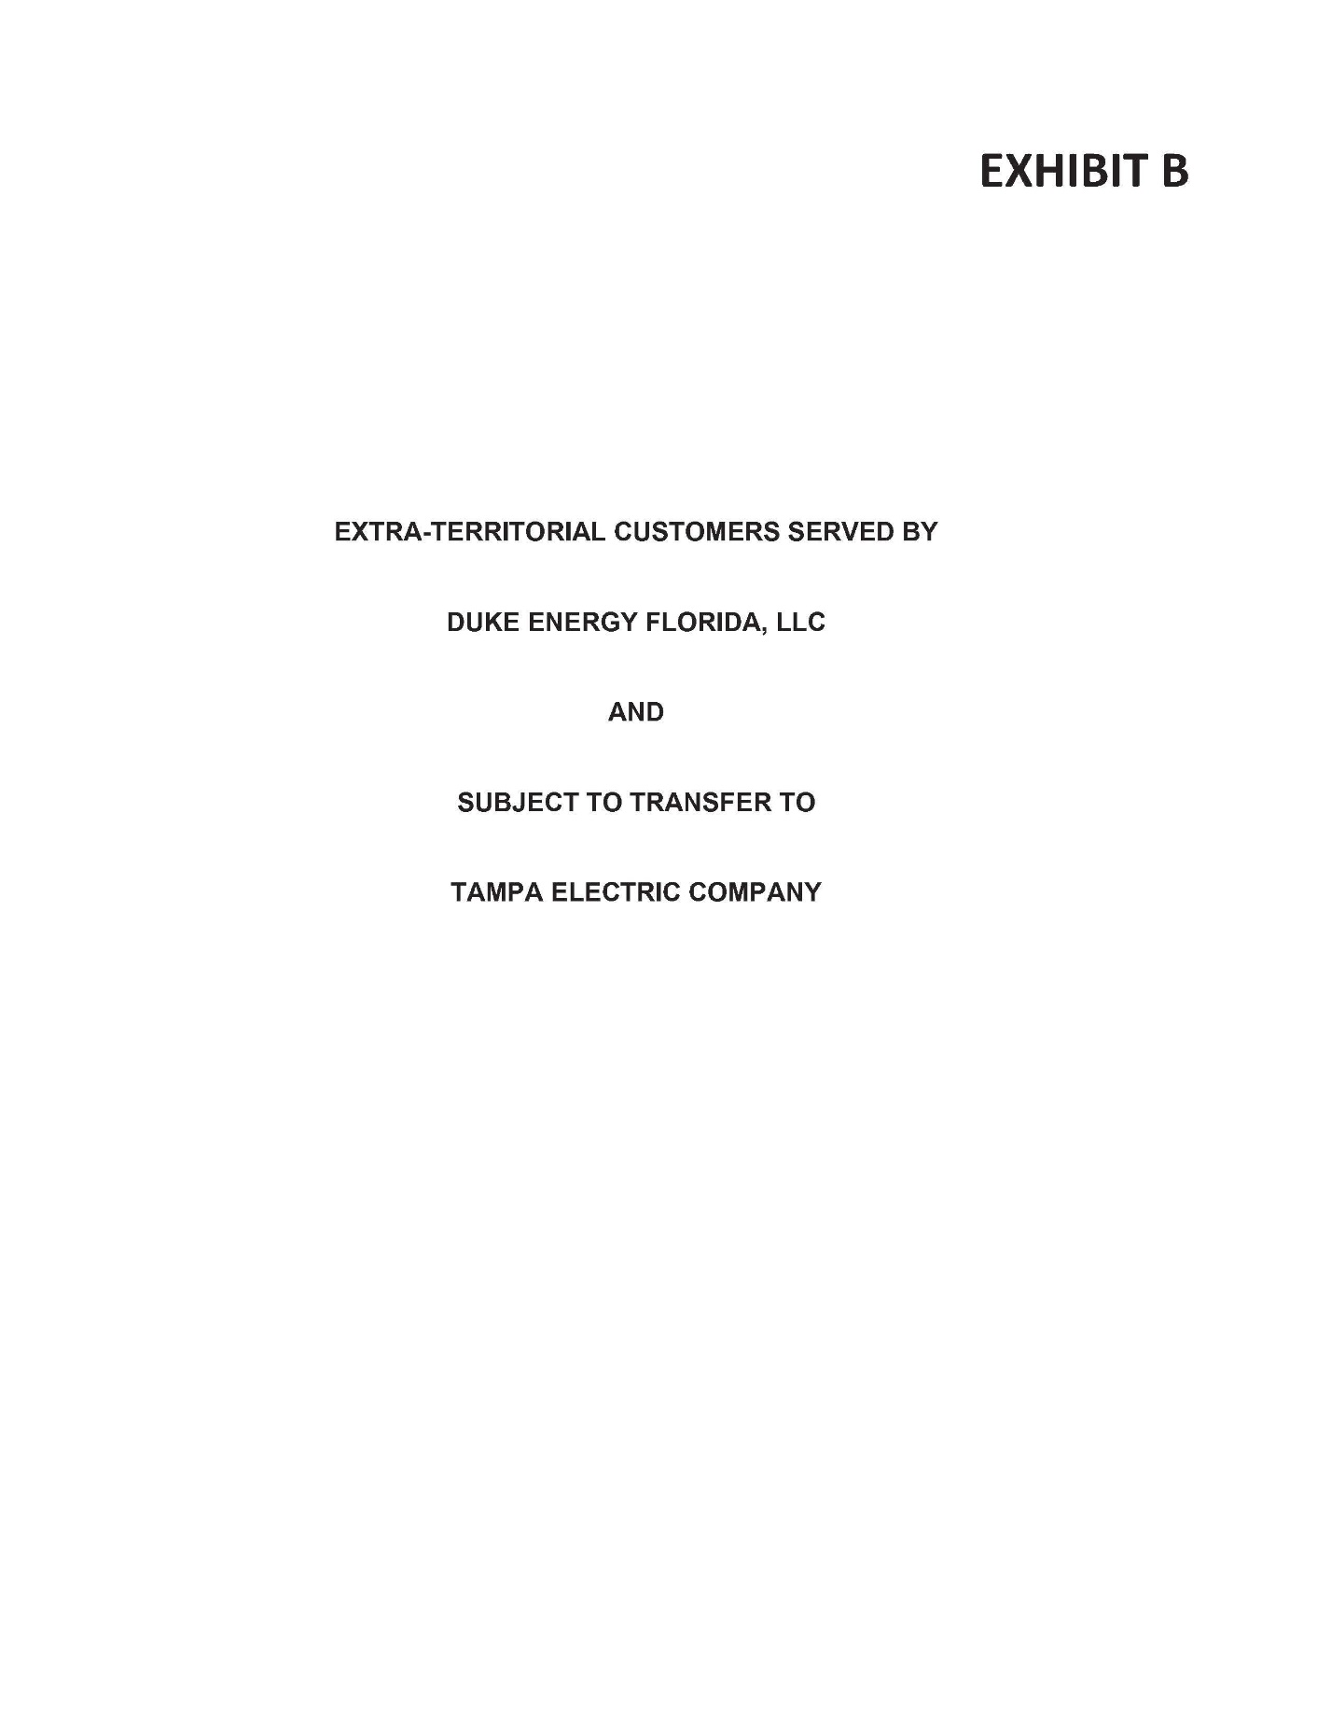

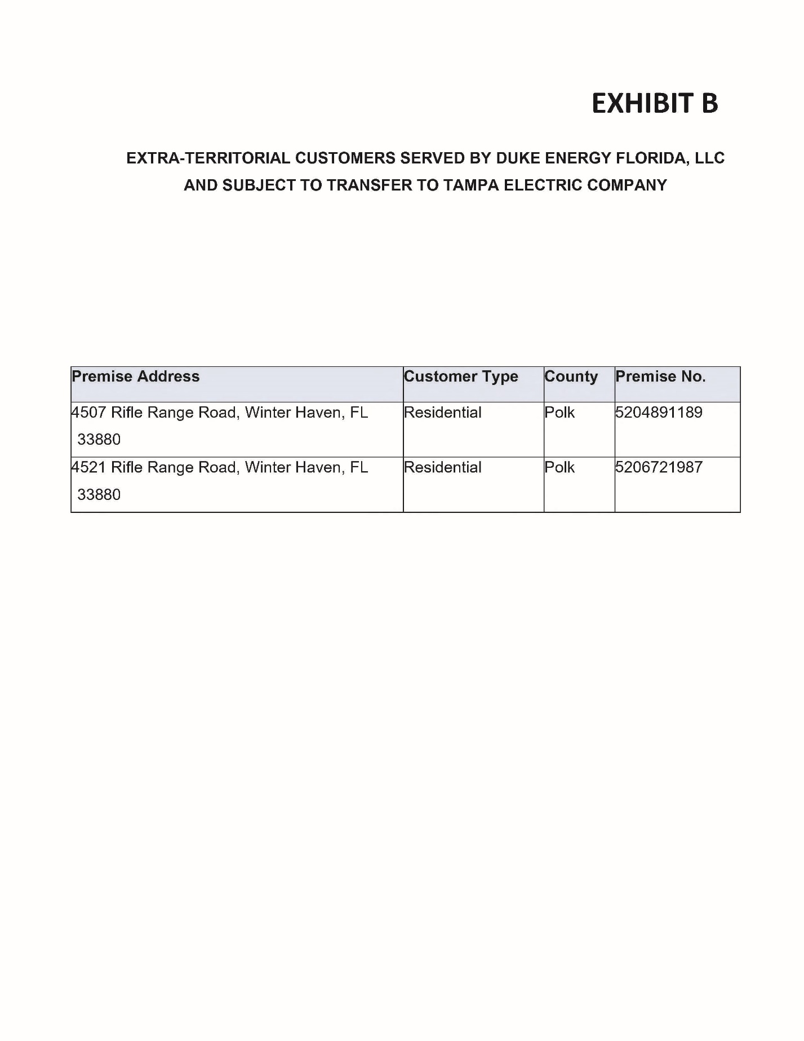

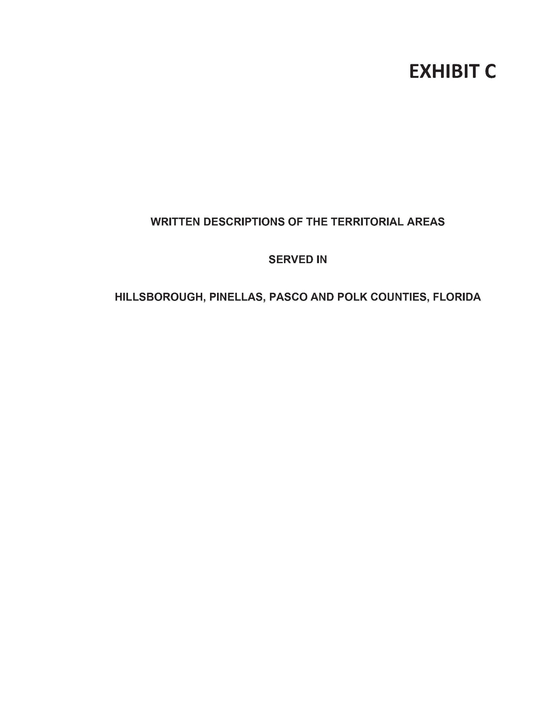

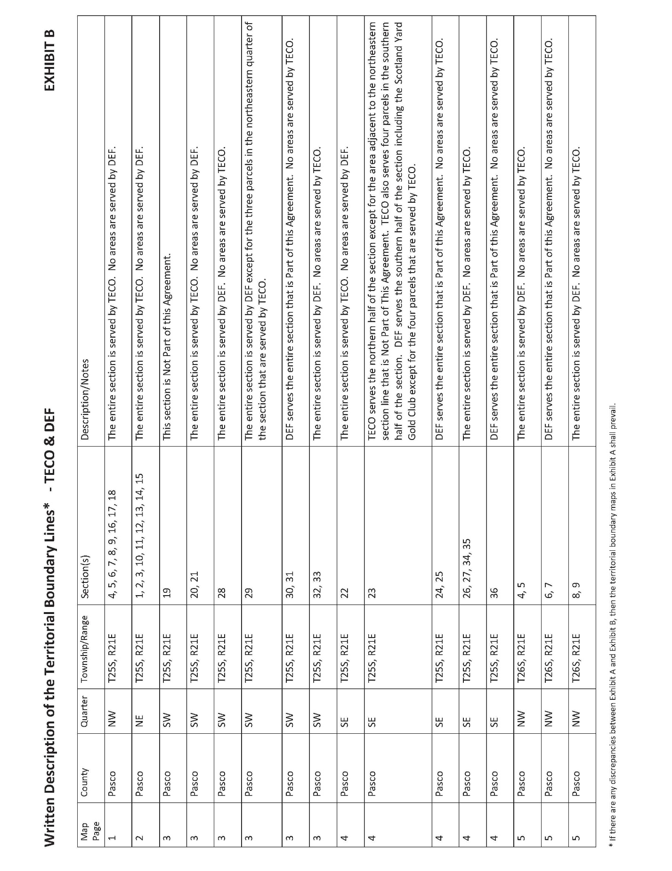

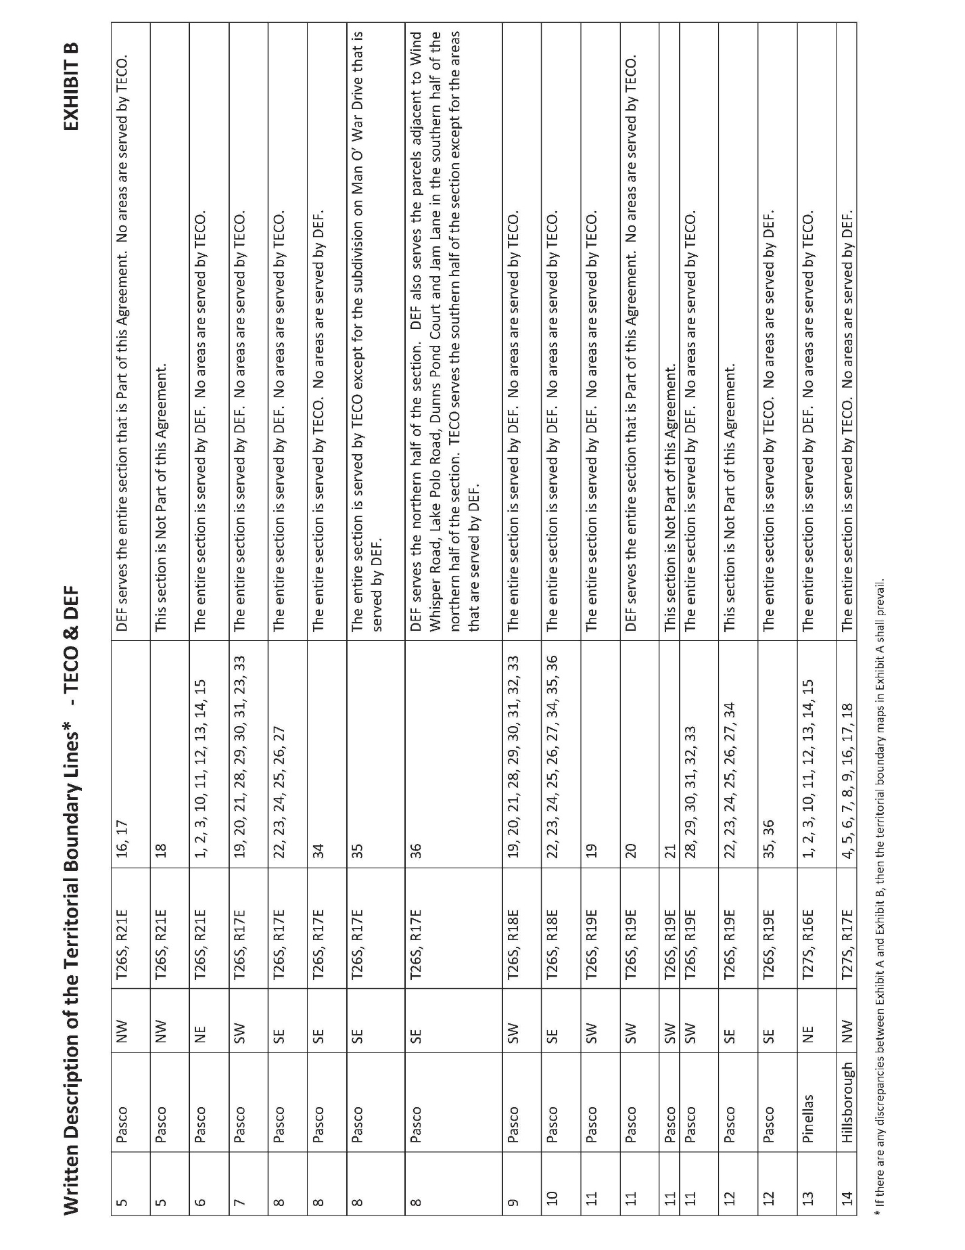

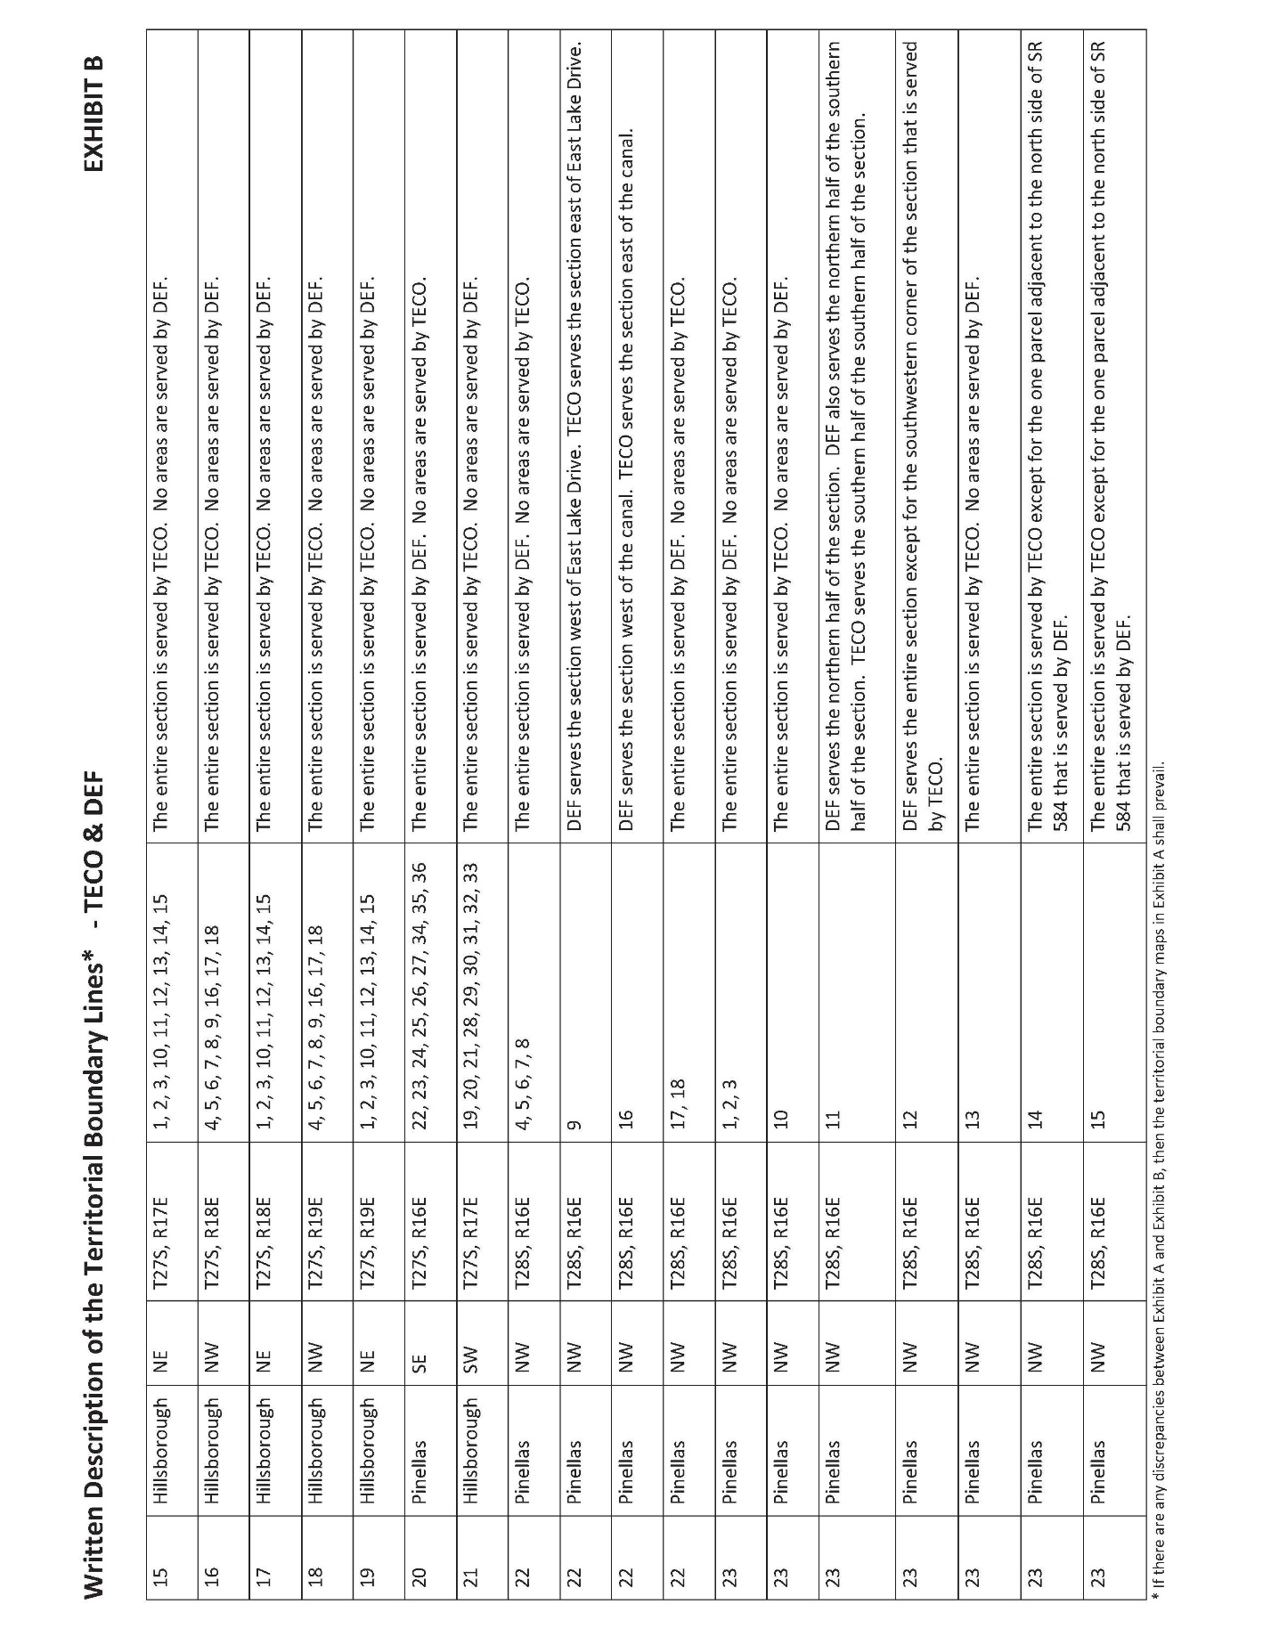

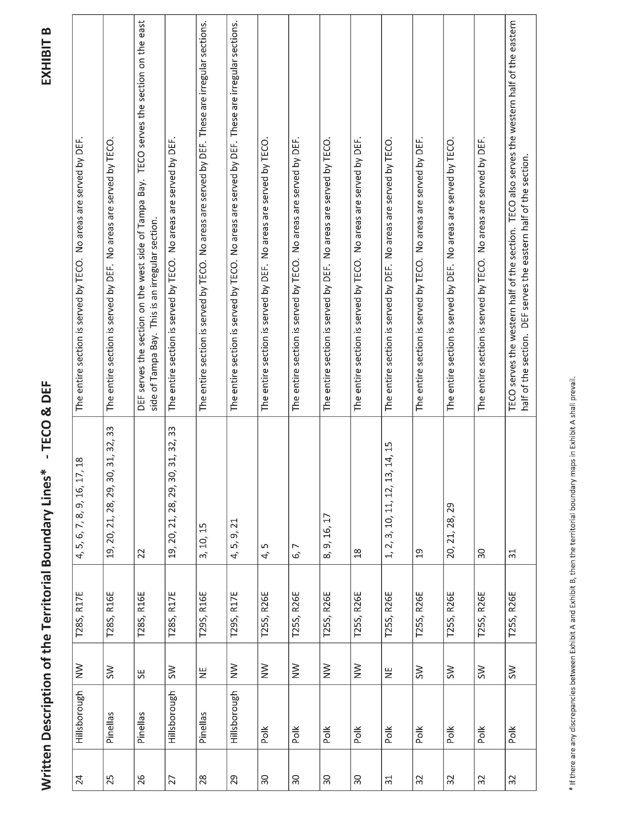

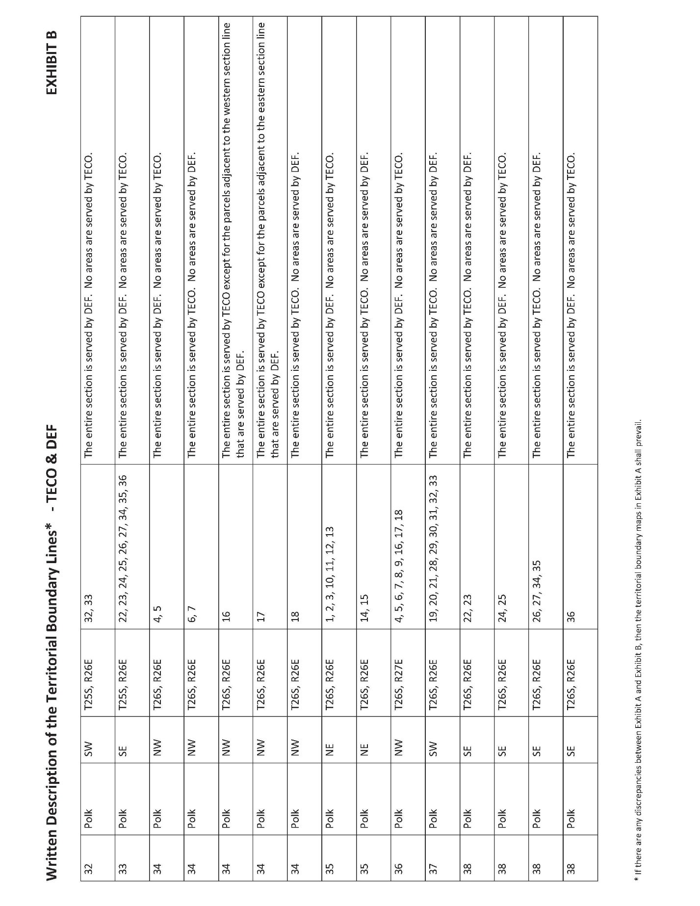

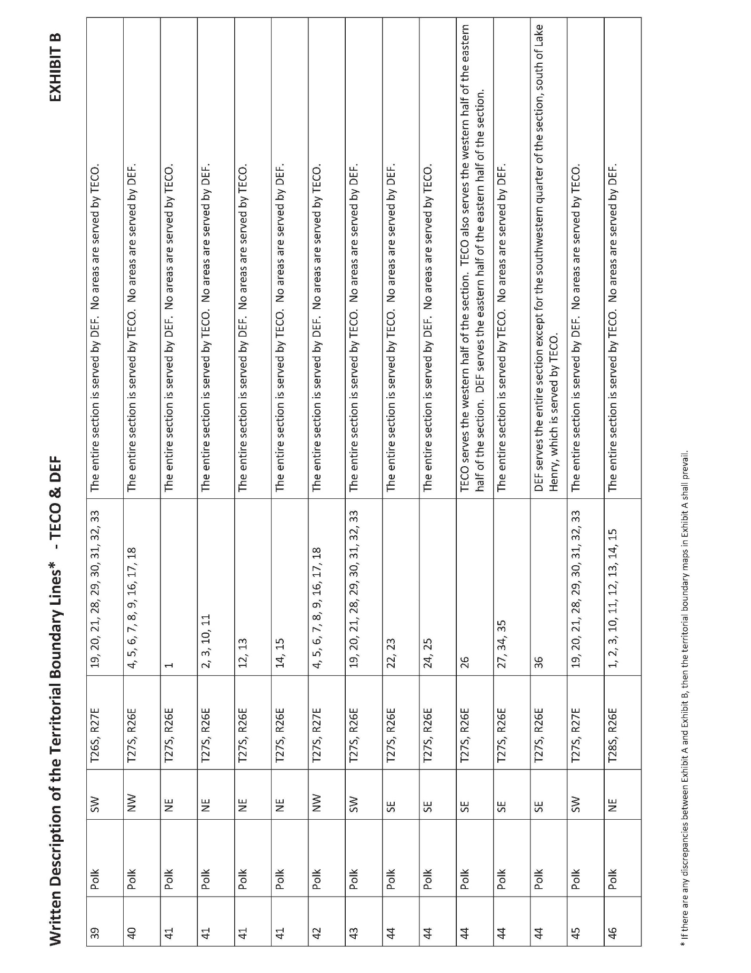

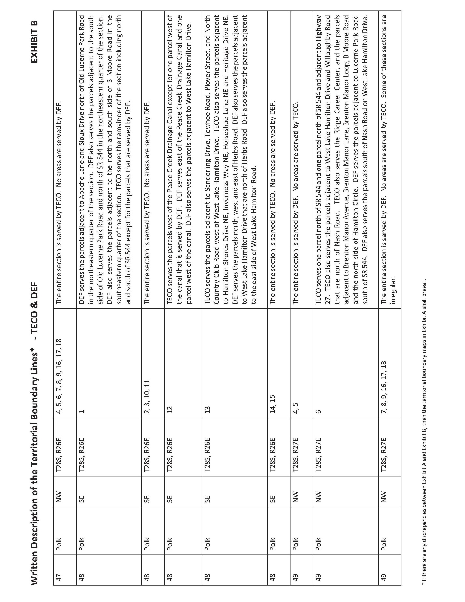

Document No. 00096-2026, filed January 7, 2026, in Docket No. 20260013-EU, In re: Joint petition for approval of Territorial Agreement [in Hillsborough, Pasco, Pinellas, and Polk Counties].
Order No. 24593, issued May 29, 1991, in Docket No. 910085-EU, In re: Joint petition for approval of Territorial Agreement between Tampa Electric Company and Florida Power Corporation.
Document No. 01120-2026, joint petitioners’ Response to Staff’s First Data Request, No. 5.
Document No. 01993-2026, joint petitioners’ Response to Staff’s Second Data Request, Nos. 4 and 5.
Utilities Commission of the City of New Smyrna Beach v. Florida Public Service Commission, 469 So. 2d 731 (Fla. 1985).
Document No. 01120-2026, joint petitioners’ Response to Staff’s First Data Request, No. 6.
Document No. 01120-2026, joint petitioners’ Response to Staff’s First Data Request, No. 5.
Document No. 01993-2026, joint petitioners’ Response to Staff’s Second Data Request, Nos. 4 and 5.
Document No. 00096-2026, joint petition for approval of territorial agreement, paragraph 4.
Document No. 01120-2026, joint petitioners’ Response to Staff’s First Data Request, No. 3.A. and No. 5.
Document No. 01120-2026, joint petitioners’ Response to Staff’s First Data Request, No. 3.A. and Document No. 01993-2026, joint petitioners’ Response to Staff’s Second Data Request, No. 3.C.
Document No. 01993-2026, joint petitioners’ Response to Staff’s Second Data Request, No. 3.C.
2026 Territorial Agreement, Article II – Retail Electric Service, Section 2.5.
2026 Territorial Agreement, Article II – Retail Electric Service, Section 2.3.
2026 Territorial Agreement, Exhibit B.
Document No. 01120-2026, joint petitioners’ Response to Staff’s First Data Request, No. 6.
2026 Territorial Agreement, Article III – Transfer of Customers and Facilities, Section 3.1.
Document No. 01120-2026, joint petitioners’ Response to Staff’s First Data Request, No. 1.A.
Document No. 01120-2026, joint petitioners’ Response to Staff’s First Data Request, No. 2.
Document No. 01120-2026, joint petitioners’ Response to Staff’s First Data Request, No. 6.
Document No. 01120-2026, joint petitioners’ Response to Staff’s First Data Request, No. 3.C.
Document No. 01993-2026, joint petitioners’ Response to Staff’s Second Data Request, No. 3 and 5.
Document No. 01120-2026, joint petitioners’ Response to Staff’s First Data Request, No. 3.B., Exhibit A, Attachment 10, Map Page 52.
2026 Territorial Agreement, Article II – Retail Electric Service.
Although we are cognizant of the rate impact on the customers, we have consistently adhered to the principle set forth in Storey v. Mayo, 217 So. 2d 304, 307-308 (Fla. 1968), and reaffirmed in Lee County Electric Cooperative v. Marks, 501 So. 2d 585 (Fla. 1987), that no person has a right to compel service from a particular utility simply because he believes it to be to his advantage.

