State of Florida   |  | Public Service Commission  Capital Circle Office Center ● 2540 Shumard Oak Boulevard  Tallahassee, Florida 32399-0850  -M-E-M-O-R-A-N-D-U-M-
DATE: | June 26, 2026
TO: | Office of Commission Clerk (Teitzman)
FROM: | Division of Accounting and Finance (Vogel, Gatlin, Holloway)  Division of Engineering (P. Buys, Thompson, Ramos)  Office of the General Counsel (Brownless, Crawford)
RE: | Docket No. 20240149-EI – Petition for limited proceeding for recovery of incremental storm restoration costs related to Hurricanes Debby, Helene, and Milton, by Florida Power & Light Company.
AGENDA: | 07/07/26 – Regular Agenda – Proposed Agency Action; Interested Persons May Participate
COMMISSIONERS ASSIGNED: |  |  | All Commissioners
PREHEARING OFFICER: |  |  | Ortega
CRITICAL DATES: |  |  | None
SPECIAL INSTRUCTIONS: |  |  | None

Case Background
On October 29, 2024, Florida Power & Light Company (FPL or Company) filed a petition for a limited proceeding seeking authority to implement an interim storm restoration recovery charge to recover $1.2 billion for the incremental restoration costs related to Hurricanes Debby, Helene, and Milton (the Storms), as well as the replenishment of its retail storm reserve. Included in the $1.2 billion is interest charged on the unrecovered balance of storm restoration costs resulting from the Storms. On December 17, 2024, the Commission approved Order No. PSC-2024-0503-PCO-EI, which authorized the Company to implement the interim storm restoration recovery charge subject to refund.
On August 13, 2025, FPL and the Office of Public Counsel (OPC) agreed that FPL would have PricewaterhouseCoopers (PwC) conduct an audit of the Company’s storm costs related to Hurricane Milton. The parties stated that the purpose of the third party audit is to reduce the need for discovery in the pending and future storm dockets. Additionally, the parties agreed that the third party audit in this docket would avoid the need for future similar audits as long as there are not any substantive material changes in procedures or the Commission’s rules and requirements. On October 20, 2025, an amended agreement was filed to substitute Deloitte & Touch LLP (Deloitte) as the third-party audit firm to conduct the independent examination of the Company’s storm costs associated with Hurricane Milton. On June 18, 2026, FPL and OPC filed Stipulations resolving potential issues in this docket, attached to this recommendation. Staff’s recommendation addresses these Stipulations (Issue 16), as well as the remaining issues needing resolution by the Commission.
The Commission has jurisdiction over this matter pursuant to Sections 366.04, 366.05, 366.06, and 366.076, Florida Statutes (F.S.).

Discussion of Issues

Issue 1:
Should the incremental cost and capitalization approach (ICCA) found in Rule 25-6.0143, Florida Administrative Code (F.A.C), be used to determine the reasonable and prudent amounts to be included in the restoration costs?

Recommendation:
Yes, the ICCA approach in Rule 25-6.0143, F.A.C., should be used to determine the reasonable and prudent amounts included in the storm restoration costs. (Holloway)

Staff Analysis:
Rule 25-6.0143, F.A.C., requires the ICCA methodology be used in determining the costs to be charged to cover storm related damages. Therefore, the ICCA approach should be used to determine the reasonable and prudent amounts included in the storm restoration costs.

Issue 2:
What is the reasonable and prudent amount of regular payroll expense to be included in the total storm related restoration costs?

Recommendation:
The reasonable and prudent amount of payroll expense to be included in the total storm restoration costs is $19.083 million. (Holloway)

Staff Analysis:
Rule 25-6.0143(1)(e)8., F.A.C., states that “overtime payroll and payroll related costs for the utility personnel included in storm restoration activities” are allowed to be charged to the reserve under the ICCA methodology. Staff believes that the full amounts calculated by FPL are allowable under Rule 25-6.0143, F.A.C.
As stated in FPL witness Mohomed’s testimony, the Company utilized multiple levels of review to ensure the reasonableness and prudence of each cost associated with the Storms. In preparation for the incoming storms, FPL sent email communications to all business units with pertinent information regarding the listing of all applicable Work Breakdown Structures (WBSs) by function and location, guidance on payroll, and guidance on the type of costs eligible to be charged to storm WBSs. In order to ensure procedural compliance and prudent spending for the duration of the storms, Finance Section Chiefs were assigned to each staging area and processing site. Additionally, FPL’s Human Resources Department was available at many sites to assist employees with their timesheets. Further, FPL had a storm controllership performed by each business unit, which was reviewed by FPL’s Accounting Department for reasonableness, and for classifying and recording each cost into the appropriate account: storm reserve, base Operations and Maintenance (O&M) expense, capital, and below-the-line expense.
Witness Mohomed testified that regular payroll and related payroll overheads for FPL employees represent time spent in direct support of storm restoration and exclude any bonuses and incentive compensation. The reasonable and prudent regular payroll expenses for each storm are listed below.

Table 2-1
Regular Payroll Expense
Storm | Amount (Million)
Debby | $3.018
Helene | 4.730
Milton | 11.335
Total | $19.083 Million
Source: Exhibits AM-1, AM-2, and AM-3

The Commission’s auditing staff reviewed Deloitte’s work papers and found that the scope, procedures, and conclusion were reasonable. The Company confirmed that costs and invoices for Hurricanes Debby and Helene were handled in the same manner as Hurricane Milton, which was the subject of the Deloitte audit. Therefore, staff recommends the costs for all of the hurricanes are reasonable and prudent.

The reasonable and prudent amount of regular payroll expense to be included in the total storm restoration costs is $19.083 million.
Issue 3:
What is the reasonable and prudent amount of overtime payroll expense to be included in the total storm related restoration costs?

Recommendation:
The reasonable and prudent amount of overtime payroll expenses to be included in the total storm restoration costs is $44.762 million. (Holloway)

Staff Analysis:
As discussed in Issue 2, the Company utilized multiple levels of review to ensure the reasonableness and prudence of each cost associated with the Storms.
Witness Mohomed also testified that the overtime payroll and related payroll tax overheads for FPL employees include time spent in direct support of storm restoration. The reasonable and prudent overtime payroll expenses for each storm are listed below.
Table 3-1
Overtime Payroll Expense
Storm | Amount (Million)
Debby | $8.650
Helene | 11.174
Milton | 24.938
Total | $44.762 Million
Source: Exhibits AM-1, AM-2, and AM-3

The Commission’s auditing staff reviewed Deloitte’s work papers and found that the scope, procedures, and conclusion were reasonable. The Company confirmed that costs and invoices for Hurricanes Debby and Helene were handled in the same manner as Hurricane Milton, which was the subject of the Deloitte audit. Therefore, staff recommends the costs for all of the hurricanes are reasonable and prudent.

The reasonable and prudent amount of overtime payroll expense to be included in the total storm restoration costs is $44.762 million.

Issue 4:
What is the reasonable and prudent amount of contractor costs to be included in the total storm related restoration costs?

Recommendation:
The reasonable and prudent amount of contractor costs to be included in total storm restoration costs is $624.764 million. (P. Buys)
Staff Analysis: Per FPL witness Jarro, contractor costs include costs related to external line contractors, mutual assistance utilities, FPL embedded contractors, and contractors performing overhead line patrols and environmental assessments. These costs also include mobilization and de-mobilization costs. Pursuant to Rule 25-6.0143(1)(e)1., F.A.C., contractor costs may be charged to the storm reserve under the ICCA methodology. FPL witness Mohomed explained that FPL determined the amount of non-incremental contractor costs by calculating the prior three-year average for the months in which storm restoration activities were incurred, and compared it to the actual contractor costs incurred in the month in which storm restoration work was performed.

When asked why the contractor costs were updated from the petition to witness Mohomed’s testimony, FPL stated that the changes reflect the normal and expected variances from the preliminary estimated costs to the final recorded costs after completion of restoration, invoice review, cost validation, and application of incremental costing and capitalization methodologies, as required by Rule 25-6.0143, F.A.C. The reasonable and prudent total contractor costs for each storm are listed below.

Table 4-1
Contractor Costs
Storm | Amount (Million)
Debby | $51.638
Helene | 101.605
Milton | 471.521
Total | $624.764 Million
Source: Exhibits AM-1, AM-2, and AM-3

The Commission’s auditing staff reviewed Deloitte’s work papers and found that the scope, procedures, and conclusion were reasonable. The Company confirmed that costs and invoices for Hurricanes Debby and Helene were handled in the same manner as Hurricane Milton, which was the subject of the Deloitte audit. Therefore, staff recommends the costs for all of the hurricanes are reasonable and prudent.

The reasonable and prudent amount of contractor costs to be included in total storm restoration costs is $624.764 million.

Issue 5:
What is the reasonable and prudent amount of line clearing costs to be included in the total storm related restoration costs?

Recommendation:
The reasonable and prudent amount of line clearing costs to be included in total storm restoration costs is $202.020 million. (P. Buys)

Staff Analysis:
Per FPL witness Jarro, line clearing costs consist of costs related to vegetation contractors, including mobilization and de-mobilization costs. FPL witness Mohomed explained that since FPL recovers all actual vegetation costs through the Storm Protection Plan Cost Recovery Clause, an ICCA adjustment under Rule 25-6.0143(1)(e)11., F.A.C., is not required. All vegetation management costs charged to the storm accounts are considered incremental.

When asked why the line clearing costs were updated from the petition to witness Mohomed’s testimony, FPL stated that the changes reflect the normal and expected variances from the preliminary estimated costs to the final recorded costs after completion of restoration, invoice review, cost validation, and applications of incremental costing and capitalization methodologies, as required by Rule 25-6.0143, F.A.C. The reasonable and prudent total line clearing costs for each storm are listed below.

Table 5-1
Line Clearing Costs
Storm | Amount (Million)
Debby | $23.066
Helene | 30.649
Milton | 148.305
Total | $202.020 Million
Source: Exhibits AM-1, AM-2, and AM-3

The Commission’s auditing staff reviewed Deloitte’s work papers and found that the scope, procedures, and conclusion were reasonable. The Company confirmed that costs and invoices for Hurricanes Debby and Helene were handled in the same manner as Hurricane Milton. Therefore, staff recommends the costs for all of the hurricanes are reasonable and prudent.

The reasonable and prudent amount of line clearing costs to be included in total storm restoration costs is $202.020 million.

Issue 6:
What is the reasonable and prudent amount of vehicle and fuel costs to be included in the total storm related restoration costs?

Recommendation:
The reasonable and prudent amount of vehicle and fuel costs to be included in total storm restoration costs is $32.417 million. (P. Buys)

Staff Analysis:
Per FPL witness Jarro, vehicle and fuel costs include vehicle utilization and fuel costs for FPL and contractor vehicles used during storm restoration efforts. FPL witness Mohomed explained that all FPL-owned vehicle costs charged to the storm reserve are considered non-incremental under the ICCA methodology. Pursuant to Rule 25-6.0143(1)(e)9., F.A.C., fuel costs may be charged to the storm reserve under the ICCA methodology. Witness Mohomed explained that FPL determined the amount of non-incremental fuel costs by calculating the prior three-year average for the months in which storm restoration activities were incurred, and compared it to the actual fuel costs incurred in the month in which storm restoration work was performed.

When asked why the vehicle and fuel costs were updated from the petition to witness Mohomed’s testimony, FPL stated that the changes reflect the normal and expected variances from the preliminary estimated costs to the final recorded costs after completion of restoration, invoice review, cost validation, and applications of incremental costing and capitalization methodologies, as required by Rule 25-6.0143, F.A.C. The reasonable and prudent total vehicle and fuel costs for each storm are listed below.

Table 6-1
Vehicle and Fuel Costs
Storm | Amount (Million)
Debby | $3.898
Helene | 6.456
Milton | 22.063
Total | $32.417 Million
Source: Exhibits AM-1, AM-2, and AM-3

The Commission’s auditing staff reviewed Deloitte’s work papers and found that the scope, procedures, and conclusion were reasonable. The Company confirmed that costs and invoices for Hurricanes Debby and Helene were handled in the same manner as Hurricane Milton. Therefore, staff recommends the costs for all of the hurricanes are reasonable and prudent.

The reasonable and prudent amount of vehicle and fuel costs to be included in total storm restoration costs is $32.417 million.

Issue 7:
What is the reasonable and prudent amount of materials and supplies expense to be included in the total storm related restoration costs?

Recommendation:
The reasonable and prudent amount of materials and supplies expense to be included in total storm restoration costs is $56.059 million. (P. Buys)

Staff Analysis:
Per FPL witness Jarro, materials and supplies expenses include items such as wire, transformers, poles, and other electrical equipment used during storm restoration efforts. As shown on Exhibits AM-1 through AM-3, there were no ICCA adjustments found to be made for materials and supplies costs.

When asked why the materials and supplies costs were updated from the petition to witness Jarro’s testimony, FPL stated that the changes reflect the normal and expected variances from the preliminary estimated costs to the final recorded costs after completion of restoration, invoice review, cost validation, and applications of incremental costing and capitalization methodologies, as required by Rule 25-6.0143, F.A.C. The reasonable and prudent total materials and supplies expenses for each storm are listed below.

Table 7-1
Materials and Supplies Expense
Storm | Amount (Million)
Debby | $3.111
Helene | 9.309
Milton | 43.639
Total | $56.059 Million
Source: Exhibits AM-1, AM-2, and AM-3

The Commission’s auditing staff reviewed Deloitte’s work papers and found that the scope, procedures, and conclusion were reasonable. The Company confirmed that costs and invoices for Hurricanes Debby and Helene were handled in the same manner as Hurricane Milton. Therefore, staff recommends the costs for all of the hurricanes are reasonable and prudent.

The reasonable and prudent amount of materials and supplies expense to be included in total storm restoration costs is $56.059 million.

Issue 8:
What is the reasonable and prudent amount of logistics costs to be included in the total storm related restoration costs?

Recommendation:
The reasonable and prudent amount of logistics costs to be included in total storm restoration costs is $182.369 million. (P. Buys)

Staff Analysis:
Per FPL witness Jarro, logistics costs include costs related to staging and processing sites, meals, lodging, buses, transportation, and rental equipment used by employees and contractors during storm restoration efforts. As shown on Exhibits AM-1 through AM-3, there were no ICCA adjustments found to be made for logistics costs.

When asked why the logistics costs were updated from the petition to witness Jarro’s testimony, FPL stated that the changes reflect the normal and expected variances from the preliminary estimated costs to the final recorded costs after completion of restoration, invoice review, cost validation, and applications of incremental costing and capitalization methodologies, as required by Rule 25-6.0143, F.A.C. The reasonable and prudent total logistics costs for each storm are listed below.

Table 8-1
Logistics Costs
Storm | Amount (Million)
Debby | $11.889
Helene | 25.771
Milton | 144.709
Total | $182.369 Million
Source: Exhibits AM-1, AM-2, and AM-3

The Commission’s auditing staff reviewed Deloitte’s work papers and found that the scope, procedures, and conclusion were reasonable. The Company confirmed that costs and invoices for Hurricanes Debby and Helene were handled in the same manner as Hurricane Milton. Therefore, staff recommends the costs for all of the hurricanes are reasonable and prudent.

The reasonable and prudent amount of logistics costs to be included in total storm restoration costs is $182.369 million.

Issue 9:
What is the reasonable and prudent amount of other costs to be included in the total storm related restoration costs?

Recommendation:
The reasonable and prudent amount of other costs to be included in the total storm restoration costs is $14.742 million. (Holloway)

Staff Analysis:

As stated previously, the Company utilized multiple levels of review to ensure the reasonableness and prudence of each cost associated with the Storms. Witness Mohomed stated that other costs included payroll and related overhead from affiliate personnel directly supporting storm restoration. Included in the other cost category is the cost for assistance provided to employees during the Storms labeled as employee assistance in the amounts of $58,000, $115,000, and $362,000, for Hurricanes Debby, Helene, and Milton, respectively. These costs are considered non-incremental under the ICCA methodology and the adjustments to remove these costs from the recoverable storm costs are reflected in Exhibits AM-1 through AM-3. The reasonable and prudent amount of other costs for each storm are listed below.
Table 9-1
Other Costs
Storm | Amount (Million)
Debby | $1.910
Helene | 3.227
Milton | 9.605
Total | $14.742 Million
Source: Exhibits AM-1, AM-2, and AM-3

The Commission’s auditing staff reviewed Deloitte’s work papers and found that the scope, procedures, and conclusion were reasonable. The Company confirmed that costs and invoices for Hurricanes Debby and Helene were handled in the same manner as Hurricane Milton. Therefore, staff recommends the costs for all of the hurricanes are reasonable and prudent.

The reasonable and prudent amount of other costs to be included in the total storm restoration costs is $14.742 million.

Issue 10:
What is the reasonable and prudent total amount of costs to be included in the total storm related restoration costs?

Recommendation:
The reasonable and prudent amount of total expenses to be included in the total storm restoration costs is $1,176 million ($1.176 billion). (Holloway)

Staff Analysis:

Based on staff’s recommendations in Issues 2 through 9, the reasonable and prudent amounts of incurred storm restoration costs for each storm are listed below.
Table 10-1
Total Expense
Storm | Amount (Million)
Debby | $107.180
Helene | 192.922
Milton | 876.115
Total | $1,176 Million
Source: Exhibits AM-1, AM-2, and AM-3

The reasonable and prudent amount of total expenses to be included in the total storm restoration costs is $1.176 billion.

Issue 11:
What is the reasonable and prudent amount of storm-related costs that should be capitalized?

Recommendation:
The reasonable and prudent amount of storm-related costs that should be capitalized is $131.091 million. (P. Buys)

Staff Analysis:

Pursuant to Rule 25-6.0143(1)(d), F.A.C., under the ICCA methodology, capital expenditures for storm-related facility damage must exclude the normal cost of removal, retirement, and replacement of those facilities in the absence of a storm. FPL witness Mohomed testified that, after accounting for the above-mentioned exclusion, FPL reclassified the remaining capitalizable amount by crediting FERC Account 186, Miscellaneous Deferred Debits, and debiting FERC Account 107, Construction Work in Progress.

When asked about the variance in total capitalizable costs from the petition to witness Mohomed’s testimony, FPL stated that the difference was a result of actual capitalizable costs differing from those originally estimated. The reasonable and prudent total costs that should be capitalized for each storm are listed below.
Table 11.1
Total Capitalizable Costs
Storm | Amount (Million)
Debby | $14.887
Helene | 22.006
Milton | 94.198
Total | $131.091 Million
Source: Exhibits AM-1, AM-2, and AM-3

The Commission’s auditing staff reviewed Deloitte’s work papers and found that the scope, procedures, and conclusion were reasonable. The Company confirmed that costs and invoices for Hurricanes Debby and Helene were handled in the same manner as Hurricane Milton.

Therefore, staff recommends the costs that were capitalized for all of the hurricanes are reasonable and prudent and the appropriate amount to capitalize is $131.091 million.

Issue 12:
What is the reasonable and prudent amount of storm-related costs that should be ICCA non-incremental O&M adjustments?

Recommendation:
The reasonable and prudent amount of storm-related costs that should be ICCA non-incremental O&M adjustments is $10.699 million. (Holloway)

Staff Analysis:
As stated in Rule 25-6.0143(1)(d), F.A.C.:

Under the ICCA methodology, the costs charged to cover storm-related damages must exclude those costs that normally would be charged to non-cost recovery clause operating expenses in the absence of a storm. Under the ICCA methodology for determining the allowable costs to be charged to cover storm-related damages, the utility will be allowed to charge Account No. 228.1 costs that are incremental to costs normally charged to non-costs recovery clause operating expenses in the absence of a storm.

Witness Mohomed testified that for regular payroll, overtime payroll, and contractors costs, the average of the costs for the prior three years for the months in which storm restoration activities were incurred, exceeded the costs charged to O&M in the months in which restoration work was performed. Therefore, based on the ICCA methodology, adjustments were made for the non-incremental amounts of the above mentioned categories. Fuel costs charged during the storm restoration activities were determined similarly. However, for Hurricanes Debby and Helene, the fuel costs did not exceed fuel costs charged to O&M in the months in which restoration work was performed. Therefore, based on the ICCA methodology, fuel costs were considered incremental and no adjustment was needed. However, as stated in response to staff’s fifth data request, the fuel costs for Hurricane Milton exceeded the fuel costs charged to O&M for the prior three years in the months which storm restoration activities incurred. Therefore, FPL removed the non-incremental portion of the fuel cost associated with Hurricane Milton.

Further, Witness Mohomed stated that line clearing costs are recovered through the Storm Protection Plan Cost Recovery Clause and therefore are considered incremental and do not require an adjustment under Rule 25-6.0143(1)(e)(11), F.A.C. Additionally, witness Mohomed verified that the vehicle utilization costs charged to the storm WBSs for FPL owned vehicles would be considered non-incremental under the ICCA methodology. The “other” category of storm restoration costs includes employee assistance which is considered non-incremental under the ICCA methodology. Pursuant to Rule 25-6.0143, F.A.C., the reasonable and prudent storm related costs that should be ICCA non-incremental O&M adjustments are listed below.

Table 12-1
ICCA Adjustments
ICCA Adjustments | Hurricane Debby | Hurricane Helene | Hurricane Milton
Regular Payroll | $753,000 | $698,000 | $618,000
Overtime Payroll | 142,000 | 210,000 | 44,000
Contractors | 1,305,000 | - | -
Vehicle Utilization | 1,332,000 | 1,453,000 | 3,526,000
Fuel | - | - | 82,000
Employee Assistance | 58,000 | 115,000 | 362,000
Total | $3,591,000 | $2,476,000 | $4,632,000
Source: Exhibits AM-1, AM-2, and AM-3

The Commission’s auditing staff reviewed Deloitte’s work papers and found that the scope, procedures, and conclusion were reasonable. The Company confirmed that costs and invoices for Hurricanes Debby and Helene were handled in the same manner as Hurricane Milton. Therefore, staff believes the adjustments for non-incremental costs are reasonable and prudent.

The reasonable and prudent amount of storm-related costs that should be ICCA non-incremental O&M adjustments is $10.699 million.

Issue 13:
What is the reasonable and prudent amount of retail recoverable storm costs?

Recommendation:
The reasonable and prudent amount of retail recoverable storm costs is $1,125 million ($1.125 billion). (Holloway)

Staff Analysis:

Based upon the previously stated storm restoration costs categories and adjustments, the reasonable and prudent retail recoverable storm costs are listed below.
Table 13-1
Retail Recoverable Storm Costs
Storm | Amount (Million)
Debby | $88.324
Helene | 167.613
Milton | 774.372
Storm Reserve Replenishment and Interest | 95.079
Total | $1,125 Million
Source: Exhibits AM-1, AM-2, AM-3, and AM-4

The reasonable and prudent amount of retail recoverable storm costs is $1,125 million ($1.125 billion).

Issue 14:
What is the amount that was recovered thorough the storm cost recovery surcharge?

Recommendation:
The amount recovered through the storm cost recovery surcharge is $1.205 billion. (Holloway)

Staff Analysis:
Based on FPL’s witness Anderson’s supplemental testimony, FPL collected $1.205 billion through the storm restoration recovery surcharge, during the recovery period of January 2025 through December 2025.

Issue 15:
If applicable, how should any under-recovery or over-recovery be handled?

Recommendation:
Any under-recovery or over-recovery should be recovered or refunded through an adjustment to the non-fuel energy charge. (Holloway)

Staff Analysis:
In FPL witness Mohomed’s testimony, the total retail recoverable storm cost requested is $1.125 billion. In FPL witness Anderson’s supplemental testimony, the reported amount recovered through the storm cost recovery surcharge totals $1.205 billion. Therefore, the recovery of the storm costs resulted in an over-recovery of approximately $80 million, plus interest.
Any under- or over-recovery should be addressed through an adjustment to the non-fuel energy charge. Interest should be applied to any excess or shortfalls at the 30-day commercial paper rate, consistent with Rule 25-6.109, F.A.C. The true-up rates should be structured in a manner consistent with the cost allocation methodology used for the interim storm charge rates approved in this docket. FPL should apply the true-up rates through the non-fuel energy charge on customers’ bills beginning on cycle day 1 of the first month that is more than 30 days after Commission approval.

Issue 16:
Should the Stipulations filed by OPC and FPL on June 18, 2026, be approved?

Recommendation:
Since the Stipulations are in agreement with Commission staff’s recommendations with regard to Issue Nos. 1, 13, 14, and 15, staff recommends that the Stipulations be approved if the Commission votes to accept staff’s recommendations on those issues. With regard to the FPL process issues, staff recommends that they be approved. (Brownless)

Staff Analysis:
On June 18, 2026, FPL and OPC filed Stipulations which addressed the following:
- Procedural issues regarding testimony, witness appearances, exhibits, and waiver of a request for hearing if the Stipulations are approved.
- Compliance with the terms of Order No. PSC-2019-0319-S-EI (Irma Settlement) and Order No. PSC-2024-0227-S-EI (Ian Stipulations). This conclusion is based on the Deloitte independent evaluation of Hurricane Milton costs and evaluation of discovery by OPC and Commission staff.
- Restoration costs for Hurricane Debby of $88.3 million; for Hurricane Helene of $167.6 million and Hurricane Milton of $774.4 million.
- FPL’s total retail recoverable storm costs of $1.125 billion.
- Compliance with the Incremental Cost and Capitalization Approach prescribed in Rule 25-6.0143, F.A.C.
- Actual revenues collected under the storm cost recovery surcharge is $1.205 billion.
- Refund of the storm cost surcharge over-recovery through the application of true-up rates administratively approved by Commission staff consistent with the Commission vote for a one-month period through the non-fuel energy charge starting on Cycle Day 1 after a final decision adopting the Stipulations.
- Notification of the one-time true-up to customers at least thirty days prior the rate change.
- There is no need for third party audits of storm costs in the future unless there is a substantial and material change in FPL’s processes/procedures or the Commission’s rules and requirements.
- FPL will continue to implement and update the process provisions of Sections 5 through 17 of the Irma Settlement. FPL may implement a cost per mile payment structure in its contracts that includes travel, meals, fuel and lodging. FPL will notify OPC of implementation of the cost per mile payment method.
- OPC and FPL agree that the Stipulations has no impact on the Commission’s statutory audit authority.
The Stipulations’ terms can be sorted into five basic areas: compliance with Rule 25-6.0143, F.A.C.; retail recoverable storm costs; actual revenues collected pursuant to the storm cost recovery surcharge; over-charge refund mechanism; and FPL’s processes. There is no provision in the Stipulations that the Commission must accept all of the terms.
Rule 25-6.0143, F.A.C.
With regard to compliance with Rule 25-6.0143, F.A.C., as discussed in Issue 1, staff agrees that Rule 25-6.0143’s ICCA approach should be used to determine the reasonable and prudent amounts included in the storm restoration costs.
Retail recoverable storm costs and actual revenues collected
Staff also agrees, as discussed in Issues 13 and 14, that the total retail recoverable storm costs for Hurricanes Debby, Helene and Milton is $1.125 billion and that the actual revenues collected pursuant to the storm cost recovery surcharge is $1.205 billion.
Over-charge refund mechanism
Staff further agrees, as discussed in Issue 15, that the refund of over-recovered storm costs should be accomplished by an adjustment to the non-fuel energy charge with interest applied to the excess at the 30-day commercial paper rate. Staff also agrees that the true-up rates through the non-fuel energy charge on customer’s bills should begin on cycle day 1 of the first month that is more than 30 days after Commission approval. Finally, staff agrees that it should be given administrative leave to review and approve the true-up rates that FPL will submit after the Commission’s decision in this case becomes final.
FPL processes
The process issues agreed to by the parties appear to be reasonable and practical modifications to the previous process and procedures approved in the Irma Settlement and Ian Stipulations. The agreement not to request a third-party audit in the future is specifically binding on the parties only, not the Commission.
Conclusion
Since the Stipulations are in agreement with Commission staff’s recommendations with regard to Issue Nos. 1, 13, 14 and 15, staff recommends that the Stipulations be approved if the Commission votes to accept staff’s recommendation on those issues. With regard to the FPL process issues, staff recommends that they be approved.

Issue 17:
Should this docket be closed?

Recommendation:
If no timely protest is received to the proposed agency action, a Consummating Order should be issued upon the expiration of the protest period, and this docket should be closed. (Brownless)

Staff Analysis:
If no timely protest is received to the proposed agency action, a Consummating Order should be issued upon the expiration of the protest period, and this docket should be closed.

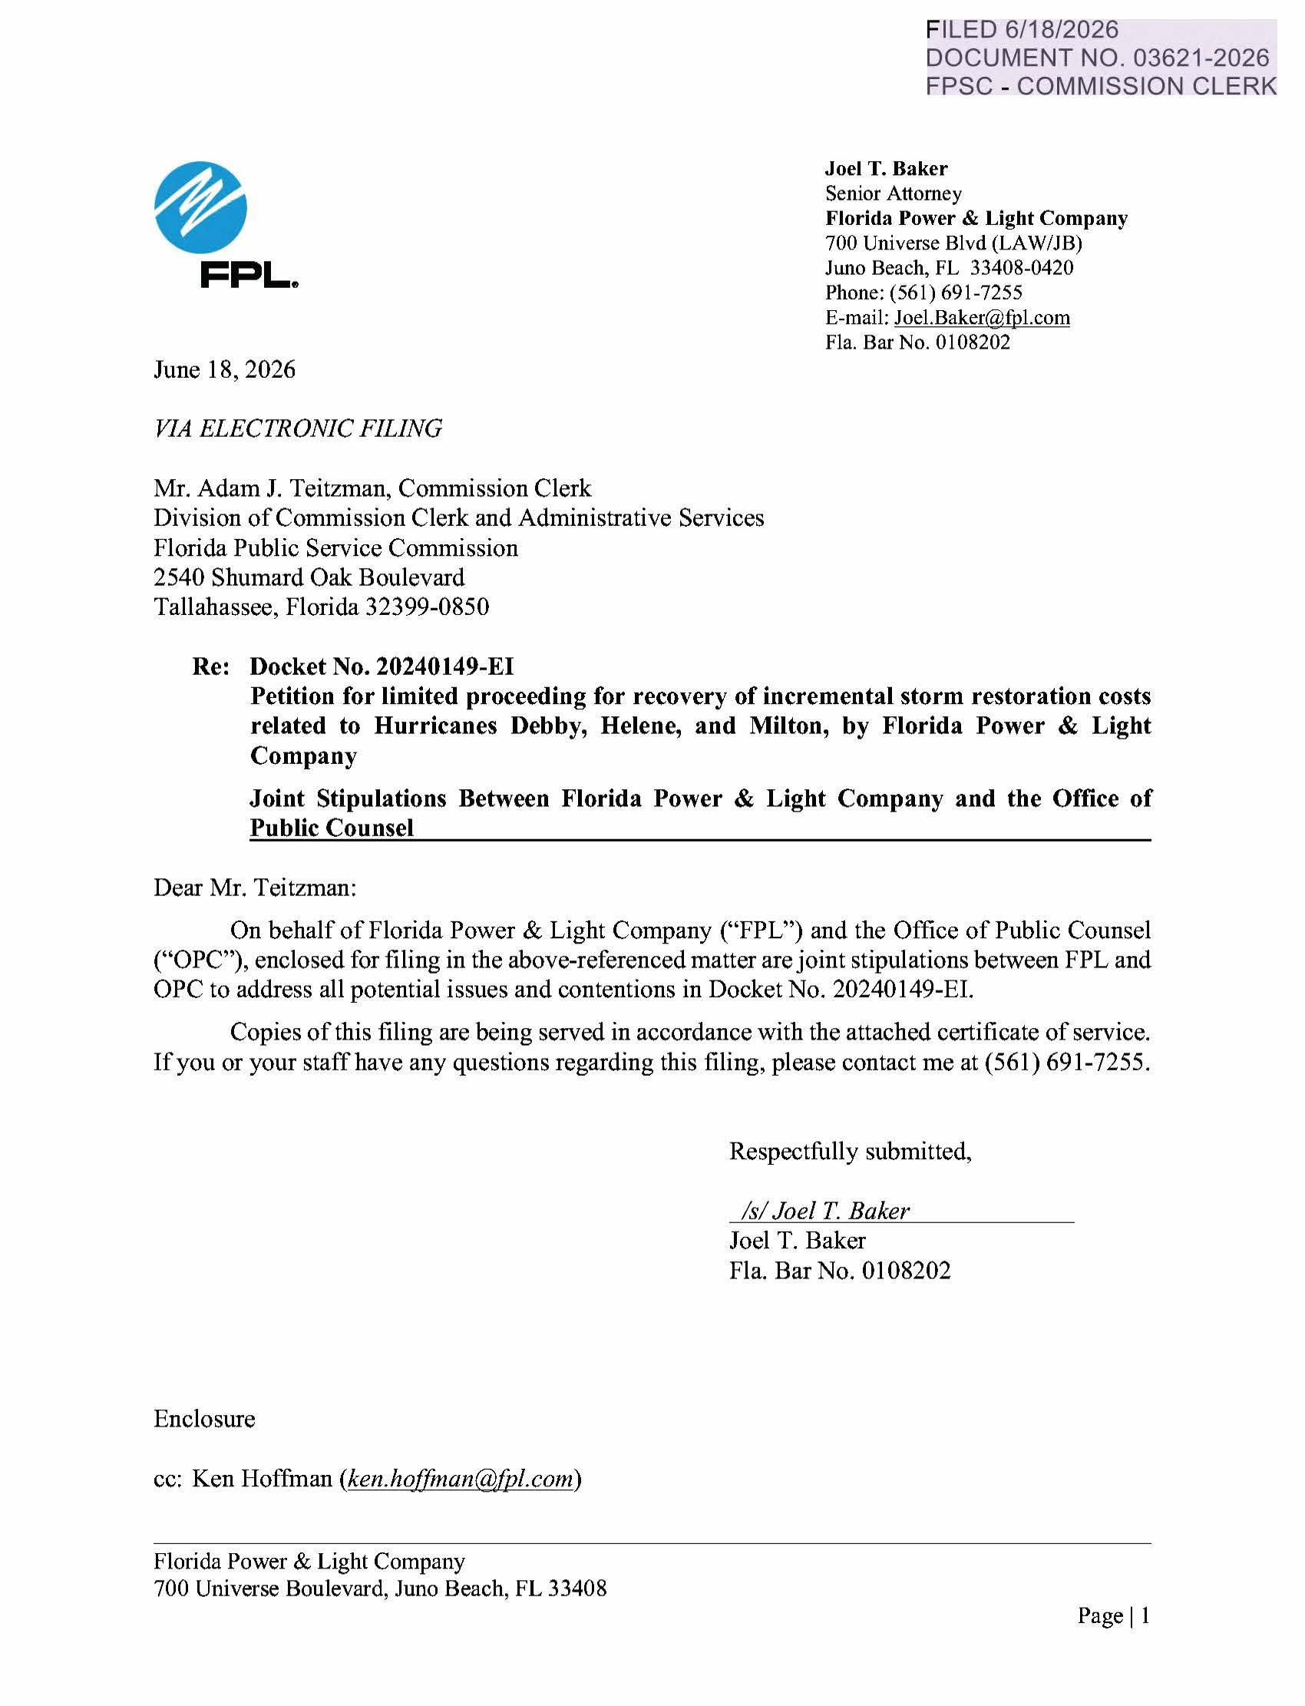
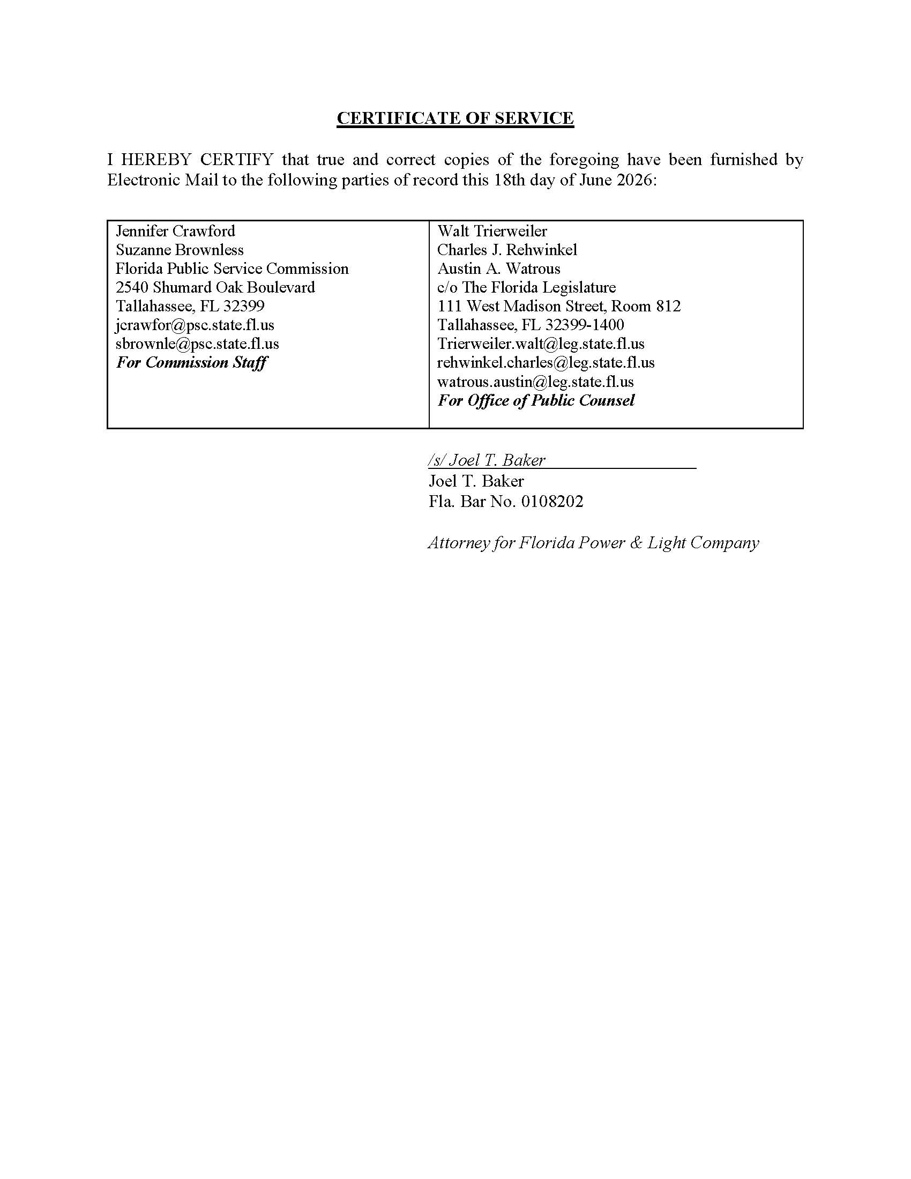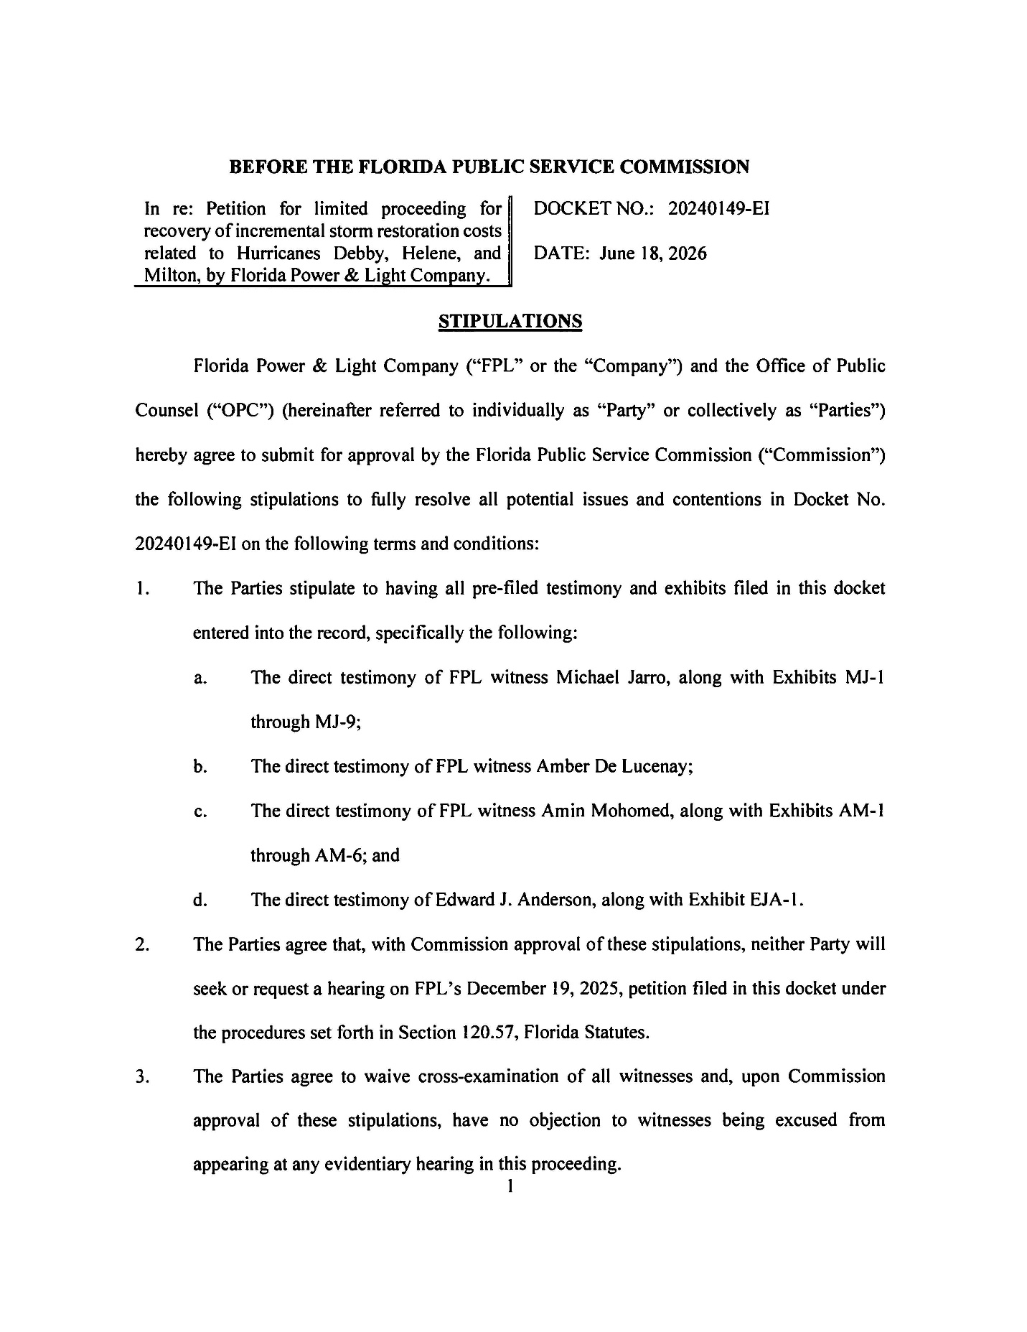

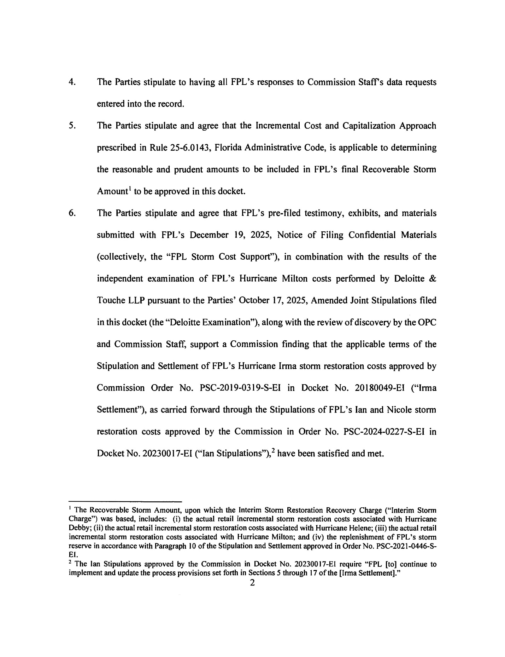
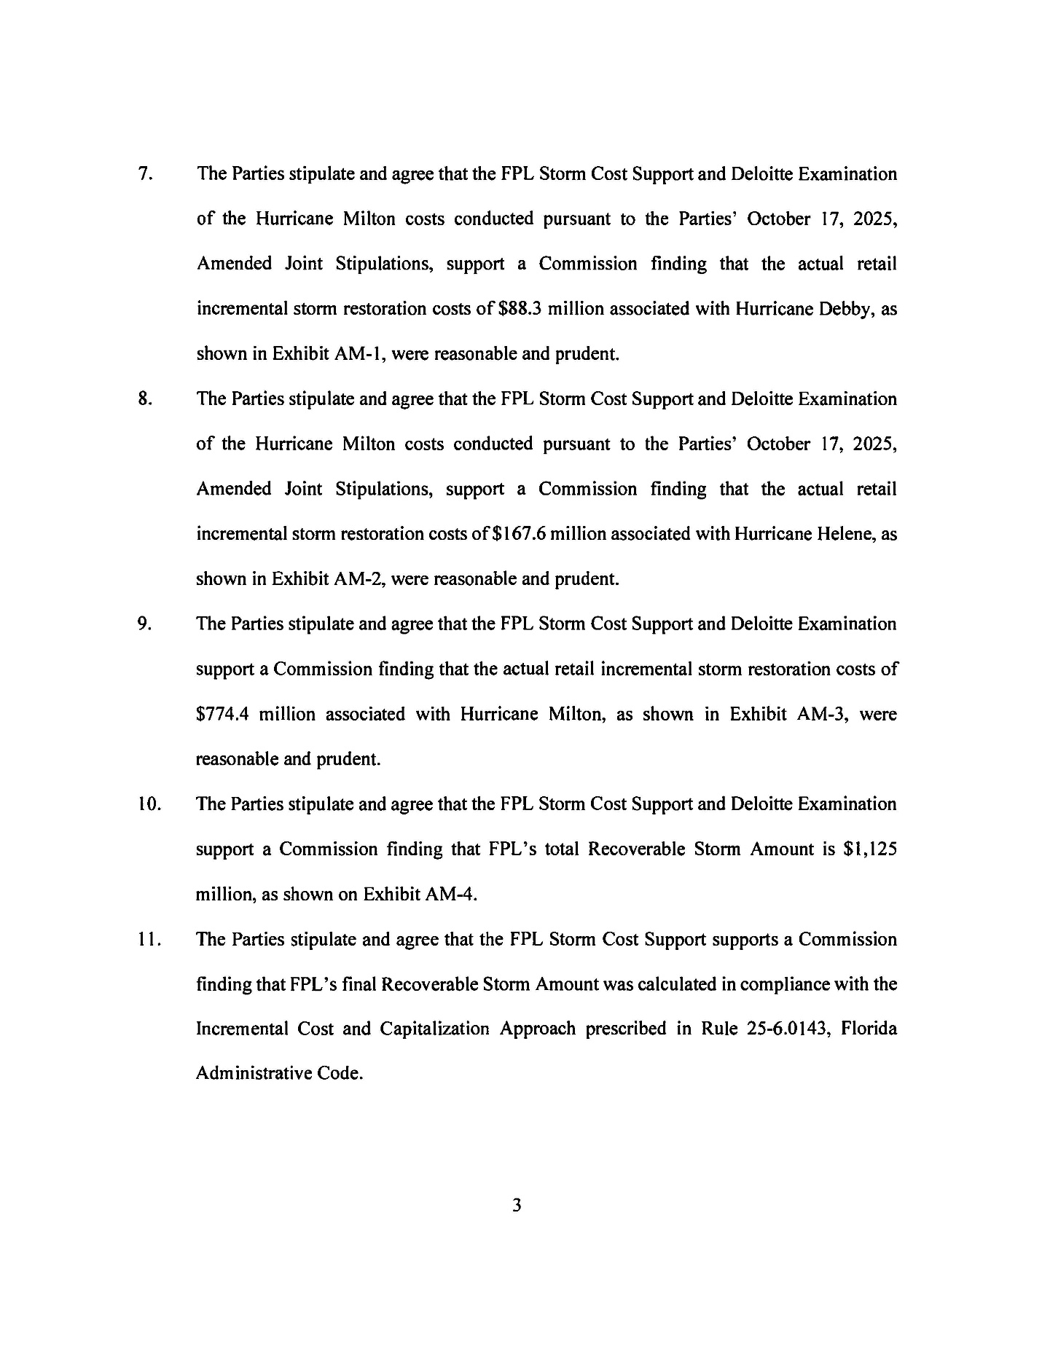
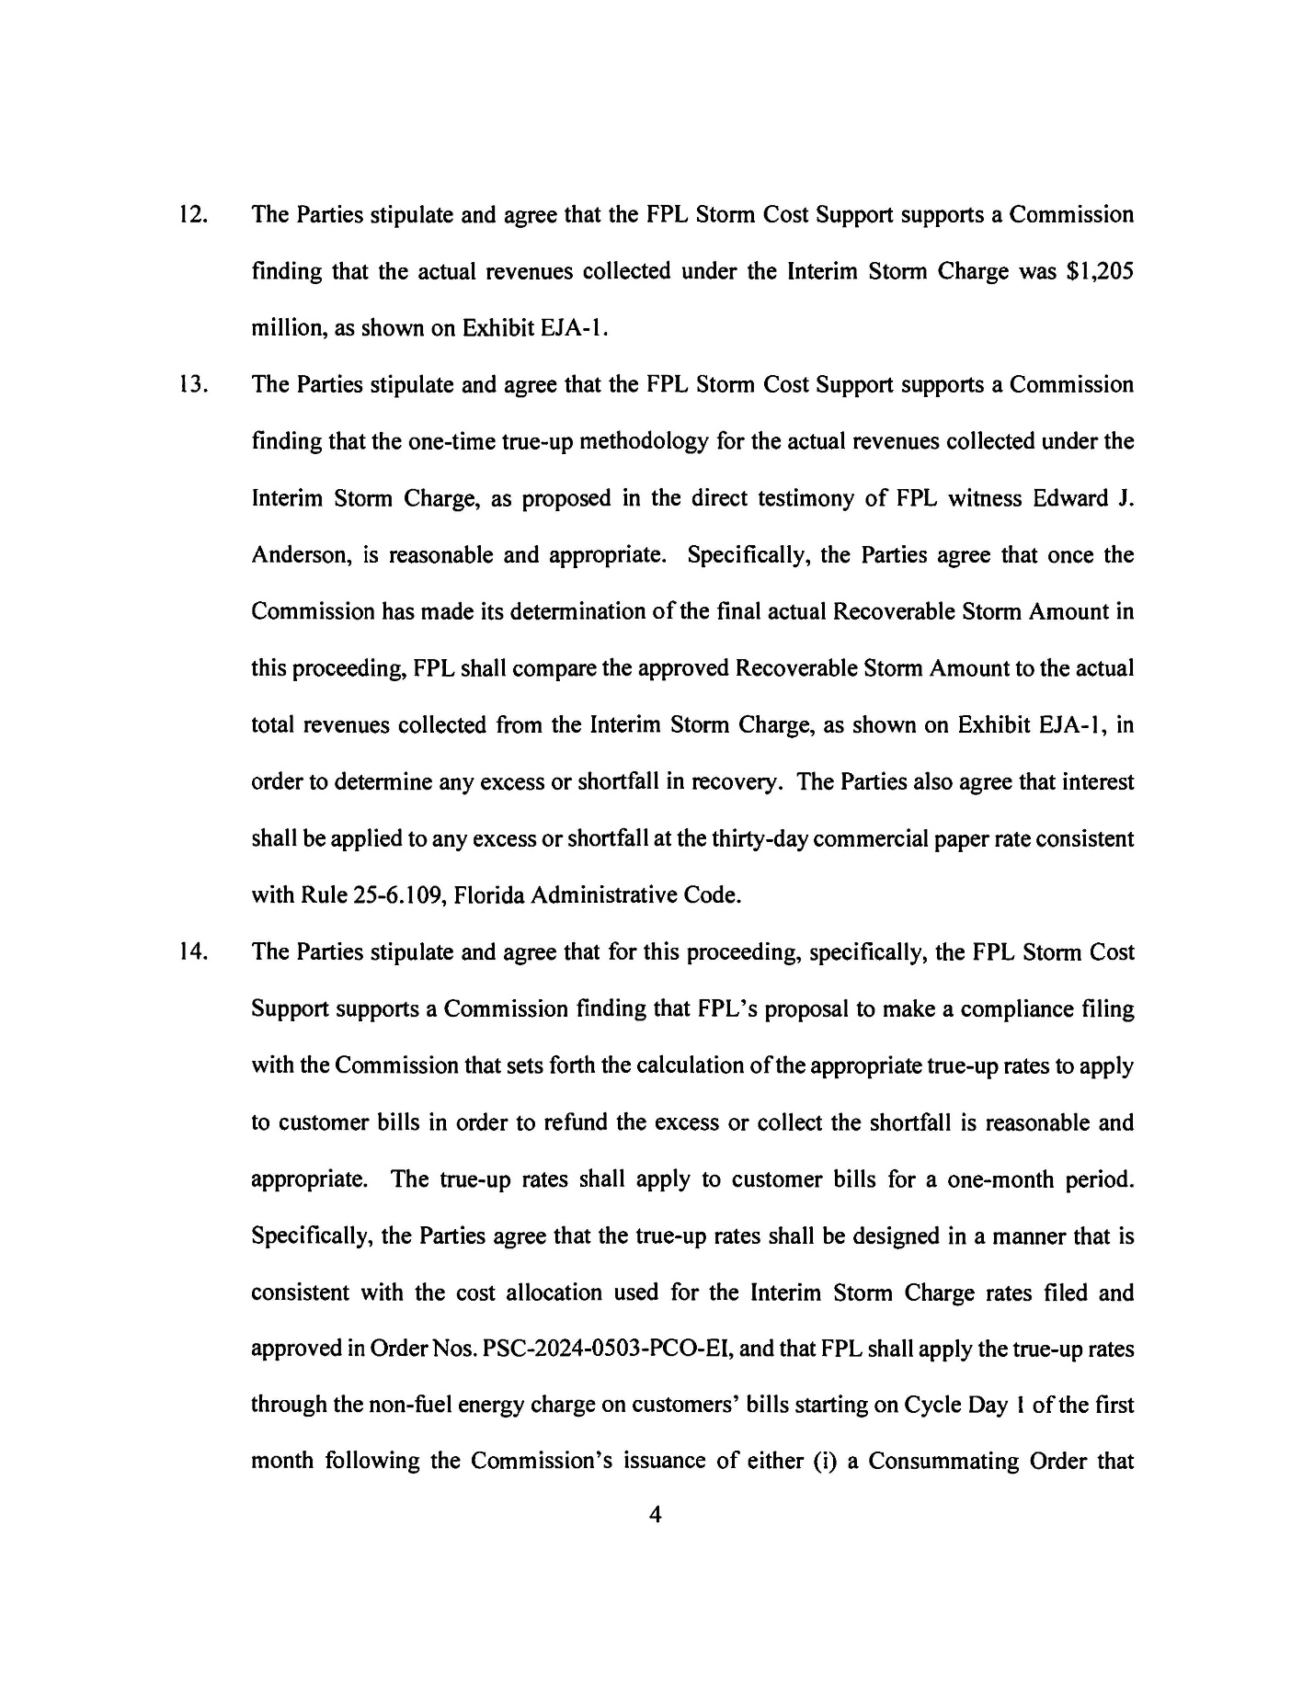
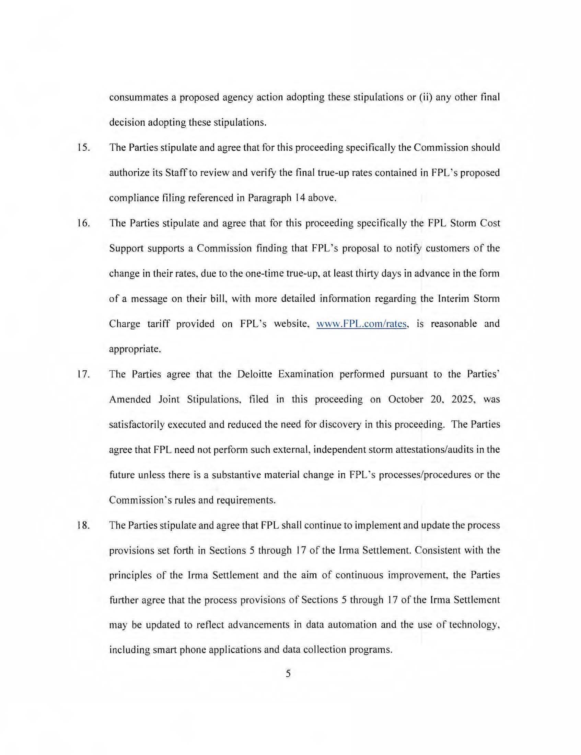
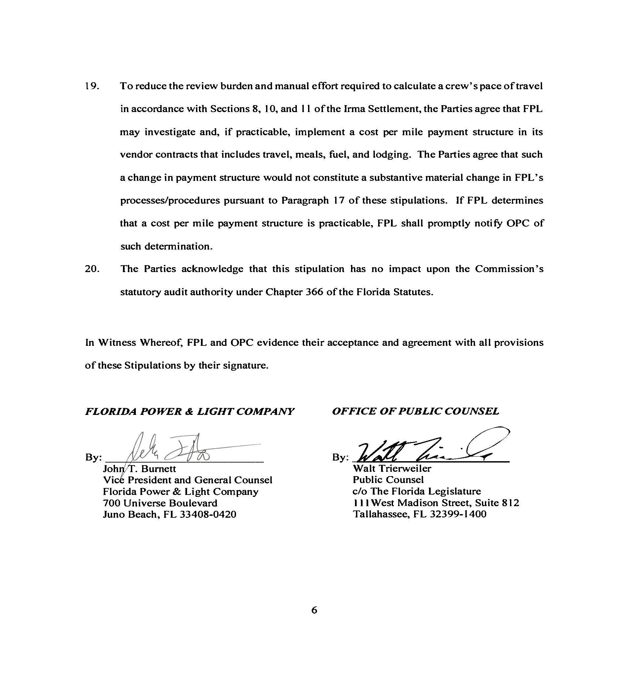

Document No. 07883-2025, Docket No. 20240149-EI
Document No. 14694-2025, Docket No. 20240149-EI
Document No. 15505-2025
Document No. 15506-2025
Document No. 03064-2026
Document No. 02783-2026
Document No. 15505-2025
Document No. 15506-2025
Document No. 03064-2026
Document No. 02783-2026
Document No. 15505-2025
Document No. 15506-2025
Document No. 03064-2026
Document No. 02783-2026
Document No. 15505-2025
Document No. 15506-2025
Document No. 03064-2026
Document No. 02783-2026
Document No. 15505-2025
Document No. 15506-2025
Document No. 03064-2026
Document No. 02783-2026
Document No. 15506-2025
Document No. 03089-2026

