BEFORE THE FLORIDA PUBLIC SERVICE COMMISSION

In re: Petition for approval of revised underground residential distribution tariffs, by Duke Energy Florida, LLC. | DOCKET NO. 20260046-EI  ORDER NO. PSC-2026-0256-TRF-EI  ISSUED: July 23, 2026

The following Commissioners participated in the disposition of this matter:

GABRIELLA PASSIDOMO SMITH, Chairman
GARY F. CLARK
MIKE LA ROSA
BOBBY PAYNE
ANA ORTEGA

ORDER APPROVING DUKE ENERGY FLORIDA, LLC’S REVISED
UNDERGROUND RESIDENTIAL DISTRIBUTION TARIFFS

BY THE COMMISSION:
BACKGROUND

On March 31, 2026, Duke Energy Florida, LLC (DEF or utility) filed a petition for approval of revisions to its underground residential distribution tariffs (URD) and associated charges (2026 Petition). These tariffs represent the estimated additional cost, if any, DEF incurs to provide underground service in place of overhead service in new residential subdivisions. The current URD tariffs and charges were approved in 2023.

Rule 25-6.078, Florida Administrative Code (F.A.C.), defines investor-owned utilities’ (IOU) responsibilities for filing updated URD tariffs. DEF has filed the instant petition pursuant to subsection (3) of the rule, which requires IOUs to file supporting data and analyses for updated URD tariffs if the cost differential, using current labor and material costs, varies from the Commission-approved differential by more than ten percent. Furthermore, subsection (3) of the rule also requires IOUs to file supporting data and analyses for updated URD tariffs at least once every three years. On October 7, 2025, pursuant to Rule 25-6.078(3), F.A.C., DEF filed its annual Overhead/Underground Residential Differential Cost Data (Form PSC/ECO 13-E).

On May 18, 2026, we suspended the proposed tariffs to allow our staff sufficient time to analyze the utility's filing. Staff issued its first data request on May 12, 2026, to which a response was provided on May 26, 2026.
The proposed URD tariffs are contained in this order as Attachment A. We have jurisdiction over this matter pursuant to Sections 366.03, 366.04, 366.05, and 366.06, Florida Statutes (F.S.).

DECISION

The URD tariffs provide charges for underground service in new residential subdivisions and represent the additional costs, if any, the utility incurs to provide underground service in place of overhead service. The cost of standard overhead construction is recovered through base rates from all ratepayers. In lieu of overhead construction, customers have the option of requesting underground facilities. Any additional cost is paid by the customer as a contribution-in-aid-of-construction (CIAC). Typically, the URD customer is the developer of a subdivision.

In prior URD filings, three standard model subdivision designs have been the basis upon which each IOU submits URD tariff changes for our approval: low density where there are one or more but less than six dwelling units per acre; high density where there are six or more dwelling units per acre; and a high density subdivision, where dwelling units take service at ganged meter pedestals (group of meters at the same physical location). While actual construction may differ from the model subdivisions, the model subdivisions are designed to reflect average overhead and underground subdivisions. In this petition, DEF did not provide a submission for high density ganged meter services, because DEF does not install services to ganged meter pedestals any longer. In DEF’s 2024 settlement agreement, installation to ganged meter pedestals was removed from Part 11.03 of the tariffs.

Costs for underground construction have historically been higher than costs for standard overhead construction, and the additional cost is paid by the customer as CIAC. However, DEF’s proposed URD differential charges remain $0 per lot for the low density and high-density subdivisions where DEF is supplying and installing the conduit. For the high-density subdivision where DEF is supplying and installing the conduit, the proposed differential decreases from the current $332 to $0 per lot. The decrease in the differential is attributable to the net present value of life cycle operational costs including storm restoration and pole attachment revenue causing an offset of any increase in cost differential since the last URD was approved for DEF in 2023.

Table 1 below compares the current and proposed URD differentials for the low density and high-density meter subdivisions for single-phase service as appears in Section IV, Part 11.03 of the current and proposed URD tariff. The charges shown are per-lot charges. The proposed URD differential for the high-density subdivision is decreasing due to the impact from Hurricanes Idalia, Debby, Helene and Milton in 2023 and 2024. These storms impacted overhead facilities more than underground facilities resulting in a 185 percent increase (from -$550 in 2023 to -$1565 in 2026) in the credit toward the differential.

Table 1
Comparison of URD Differential per Lot (Single-Phase Service)
Subdivision Designs | Current  URD Differential | Proposed  URD Differential
Low Density | $0 | $0
High Density | $332 | $0
Source: Order No. PSC-2023-0255-TRF-EI (Current) and DEF’s 2026 Petition (Proposed).

The calculations of the proposed URD charges include: (1) updated labor and material costs along with the associated loading factors and (2) operational costs. The costs are discussed below.

Updated Labor and Material Costs

The installation costs of both overhead and underground facilities include the labor and material costs to provide primary, secondary, and service distribution lines, as well as transformers. The costs of poles are specific to overhead service while the costs of trenching and backfilling are specific to underground service. The utilities are required by Rule 25-6.078(5), F.A.C., to use current labor and material costs.

DEF’s labor costs for overhead and underground construction are comprised of costs associated with work performed by both in-house employees and outside contractors. DEF’s contracted labor rates are based upon actual labor costs negotiated in bargaining unit contracts and labor rates with contractors. Table 2 shown below compares total 2023 and 2026 labor and material costs per lot for the two subdivision designs.

Table 2
Labor and Material Costs Per Lot for DEF Trench and Install Conduit
Subdivision Designs | 2023 Costs | 2026 Costs | Difference
Low Density
Underground Labor/Material Costs | $3,454 | $3,506 | $52
Overhead Labor/Material Costs | $2,749 | $3,231 | $482
Per Lot Differential | $705 | $275 | $(430)
High Density
Underground Labor/Material Costs | $3,003 | $3,553 | $550
Overhead Labor/Material Costs | $2,121 | $2,266 | $145
Per Lot Differential | $882 | $1,287 | $405
Source: Order No. PSC-2023-0255-TRF-EI (Current) and DEF’s 2026 Petition (Proposed).

As Table 2 shows, the majority of the proposed overhead and underground total labor and material costs have increased since the current URD charges were approved in 2023. As reflected, the 2026 costs for overhead and underground labor and materials are higher for both subdivision designs, although a greater increase has occurred for overhead, compared to underground. In a data request response, DEF stated overhead costs have escalated more rapidly than underground costs because underground costs have stabilized after a large increase during the 2020 to 2023 time period.

Updated Operational Costs

Rule 25-6.078(4), F.A.C., requires that the differences in net present value (NPV) of operational costs between overhead and underground systems, including average historical storm restoration costs over the life of the facilities, be included in the URD charge. The inclusion of the operational cost is intended to capture longer term costs and benefits of undergrounding.

Operational costs include operations and maintenance costs along with capital costs and represent the cost differential between maintaining and operating an underground versus an overhead system over the life of the facilities. The inclusion of the storm restoration cost in the URD calculations lowers the differential, since an underground distribution system generally incurs less damage than an overhead system as a result of a storm, and therefore, incurs less restoration costs when compared to an overhead system.

The utility used a 5-year average of historical, operational costs (2020-2024) for its calculations in this docket. The methodology used by DEF in this filing for calculating the NPV of operational costs was approved in Order No. PSC-12-0348-TRF-EI. Operational costs may vary among IOUs due to multiple factors, including differences in size of service territory, miles of coastline, regions subject to extreme winds, age of the distribution system, or construction standards.

Table 3 shown below presents information on costs that are reflected in the URD tariffs for the two subdivision designs. The table shows the result of adding the proposed 2026 overhead and underground labor and materials cost differentials, as found in Table 2, and the NPV of operational costs differentials, including storm costs, to calculate the proposed total cost differential for each design. The per lot differential costs appearing in parentheses are negative values, indicating the overhead costs exceed the underground costs.

Table 3
DEF Updated Overhead/Underground Cost Differential
Subdivision Design | 2026 Labor and Materials Differential  (A) | 2026 NPV of Operational  Costs Differential  (B) | Total Cost Differential Supporting Proposed URD  (C) = (A) + (B)
Low Density | $275 | $(2,051) | $(1,776)
High Density | $1,287 | $(1,565) | $(278)
Source: Exhibit C of DEF’s 2026 Petition.
Negative total cost differentials, as shown in 3 for both the low density and high-density designs, result in the proposed URD differential of $0, as shown in Table 1. For both designs, DEF’s positive labor and material cost differential is completely offset by their negative NPV of operational costs differential.

Other Proposed Tariff Changes

Tariff Sheet No. 4.113 of the utility’s proposed URD tariff includes the per foot charge for three-phase primary main or feeder mains that need to be installed underground. DEF states the cost for underground feeders decreased approximately 3 percent while overhead feeder costs increased by approximately 10 percent. The net result of this was a decrease in the per foot differential for three-phase primary main conduit provided and installed by DEF, which is proposed to change from $2.17 per foot to $0.

Tariff Sheet No. 4.114 of the utility’s proposed URD tariff includes the credits per each foot of trench for applicant provided trenching and backfilling for the use of the utility’s facilities in the case of both service laterals and primary or secondary systems. Increasing labor and material costs impacted the credits that are available to an applicant (customer) when the applicant provides the trenching and backfill for both primary and/or secondary systems and service laterals. Such credits are proposed to increase from $4.06 to $4.28 per foot of trench.

Section IV, Part 11.04 of the utility’s proposed URD tariff includes the charge for underground service laterals from existing secondary electric distribution systems. In the proposed URD tariff, there is a requested decrease in the charge for DEF supplied and installed conduit (service laterals, up to 80 feet) from $983 to $853. For customer supplied and installed conduit, the proposed decrease is $619 to $520.

Section IV, Part 11.05 of the utility’s proposed URD tariff includes the charge for underground service laterals replacing existing residential overhead services. The costs for this service have increased compared to costs approved in 2023. DEF states in response to Staff’s First Data Request that the cost to remove the existing overhead service and the remaining undepreciated value of the overhead service is higher. DEF proposes to increase its charge for installed conduit service lateral from $1,930 to $2,286 per service. The utility proposes to increase its customer installed conduit service lateral from $1,765 to $1,918 per service.

We have reviewed DEF’s proposed underground distribution tariffs and associated charges, its accompanying work papers, and the utility’s responses to Staff’s Data Request. Based on this review, we find that DEF’s proposed underground residential distribution tariffs as filed in the petition are cost-based and comply with Rule 25-6.078, F.A.C. Therefore, we approve DEF’s proposed underground residential distribution tariffs and associated charges as shown in Attachment A, effective on the date of our vote, July 7, 2026.

Based on the foregoing, it is

ORDERED by the Florida Public Service Commission that Duke Energy Florida, LLC’s proposed revised underground residential distribution tariffs, and associated charges, as discussed in the body of this Order, are hereby approved, effective July 7, 2026. It is further

ORDERED that if a protest is filed within 21 days of the issuance of this Order, the tariffs shall remain in effect, with any revenues held subject to refund, pending resolution of the protest. If no timely protest is filed, this docket should be closed upon the issuance of a Consummating Order.

By ORDER of the Florida Public Service Commission this 23rd day of July, 2026.

/s/ Adam J. Teitzman
ADAM TEITZMAN
Commission Clerk
Florida Public Service Commission
2540 Shumard Oak Boulevard
Tallahassee, Florida 32399
(850) 413-6770
www.floridapsc.com

Copies furnished: A copy of this document is provided to the parties of record at the time of issuance and, if applicable, interested persons.

SBr

NOTICE OF FURTHER PROCEEDINGS OR JUDICIAL REVIEW

The Florida Public Service Commission is required by Section 120.569(1), Florida Statutes, to notify parties of any administrative hearing that is available under Section 120.57, Florida Statutes, as well as the procedures and time limits that apply. This notice should not be construed to mean all requests for an administrative hearing will be granted or result in the relief sought.

Mediation may be available on a case-by-case basis. If mediation is conducted, it does not affect a substantially interested person's right to a hearing.

The action proposed herein is preliminary in nature. Any person whose substantial interests are affected by the action proposed by this order may file a petition for a formal proceeding, in the form provided by Rule 28-106.201, Florida Administrative Code. This petition must be received by the Office of Commission Clerk, 2540 Shumard Oak Boulevard, Tallahassee, Florida 32399-0850, by the close of business on August 13, 2026.

In the absence of such a petition, this order shall become final and effective upon the issuance of a Consummating Order.

Any objection or protest filed in this/these docket(s) before the issuance date of this order is considered abandoned unless it satisfies the foregoing conditions and is renewed within the specified protest period.

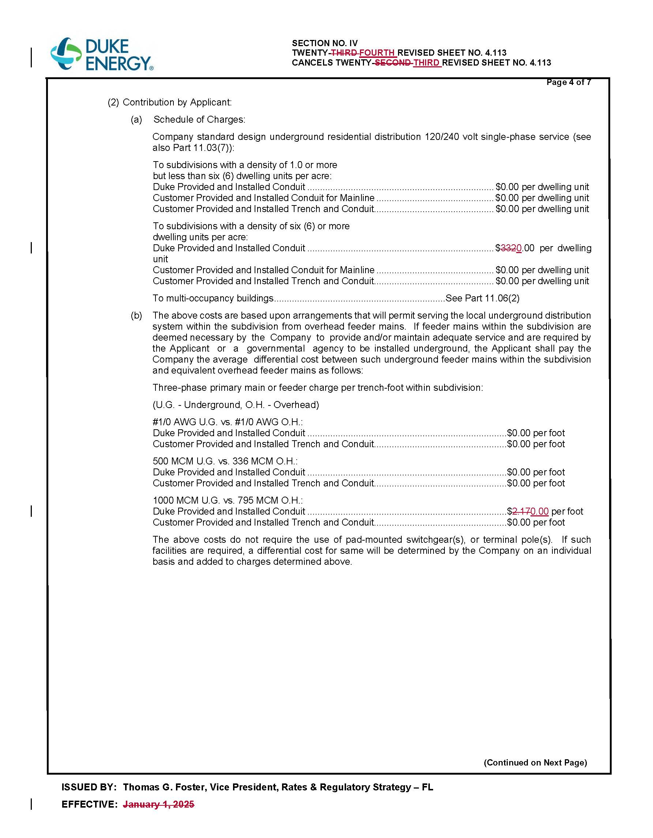

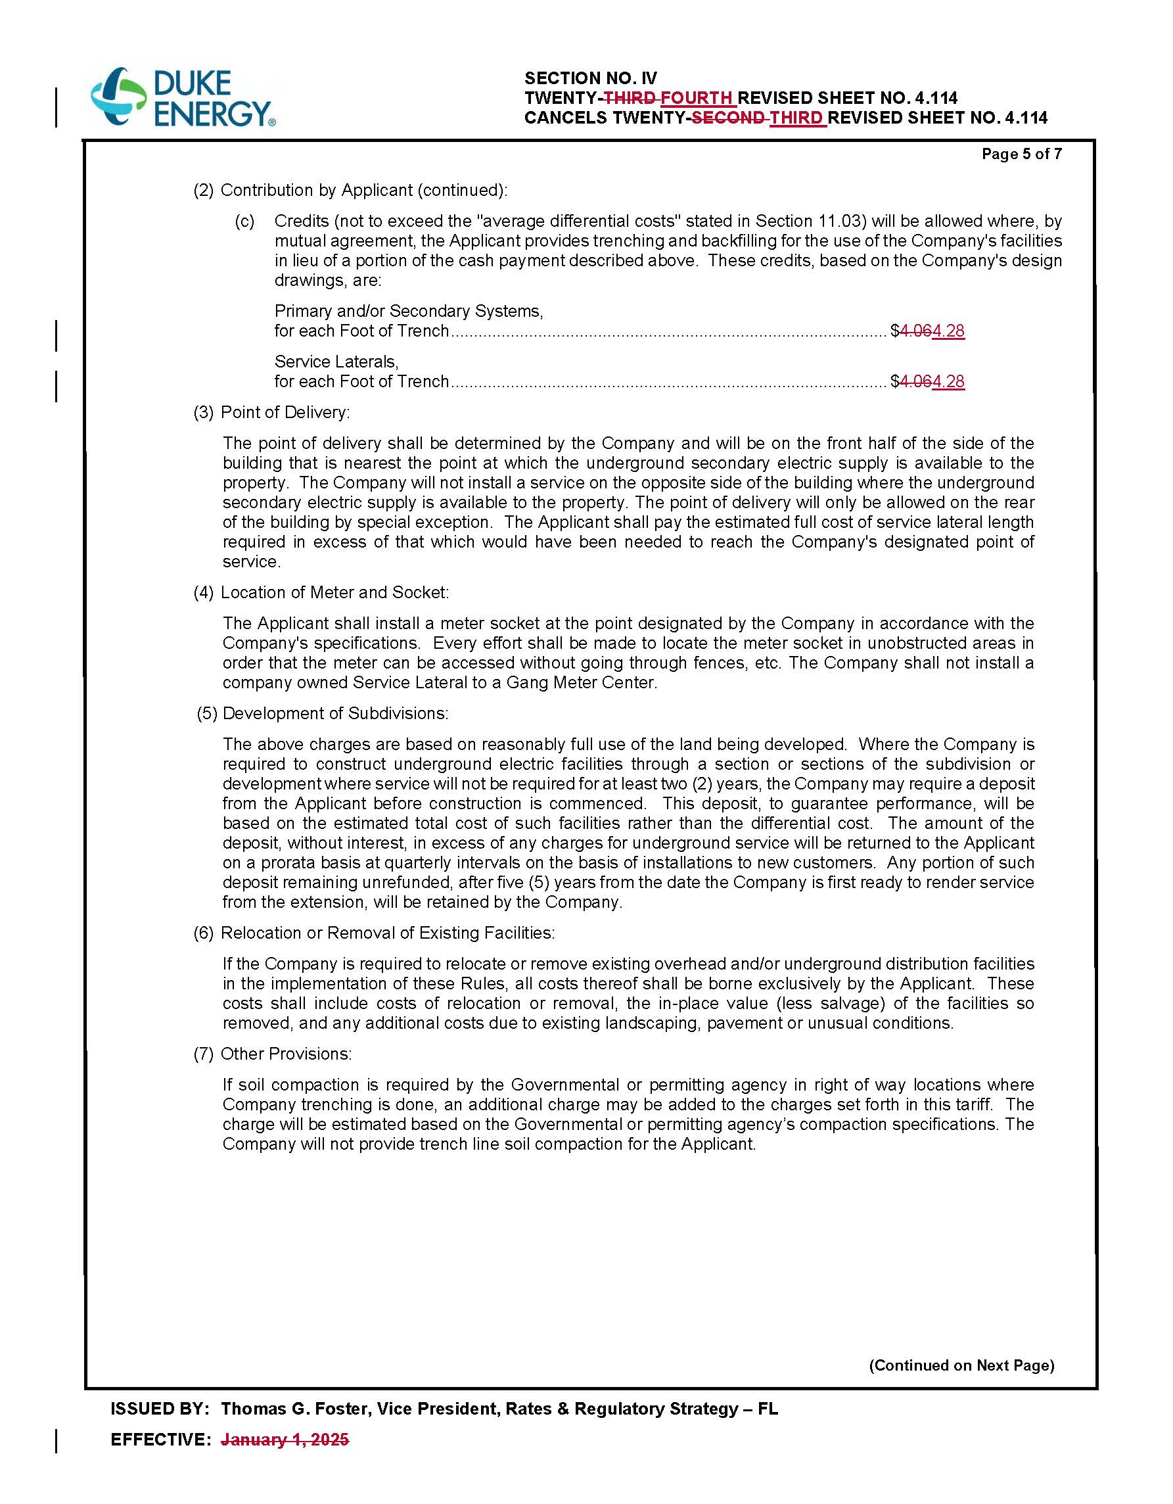

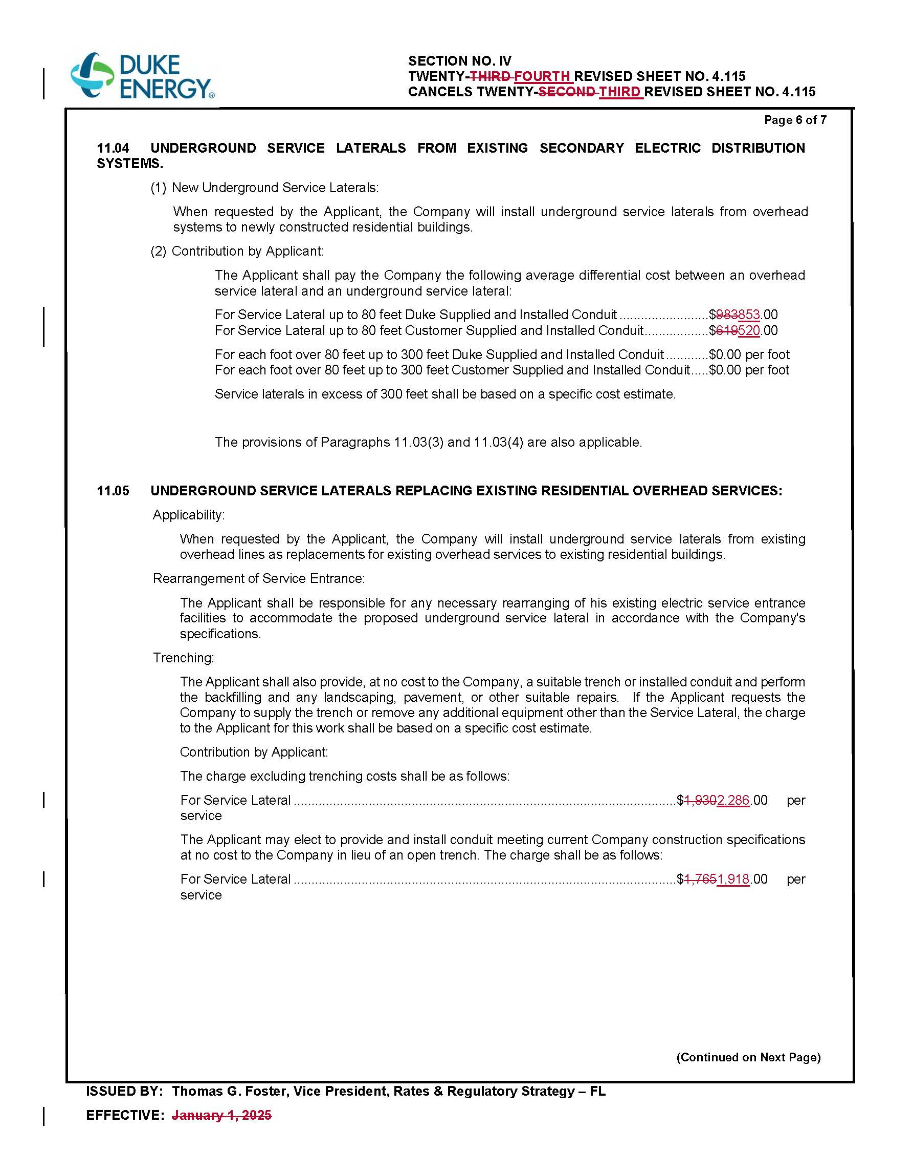

Order No. PSC-2023-0255-TRF-EI, issued August 21, 2023, in Docket No. 20230043-EI, In re: Petition for approval of revised underground residential distribution tariffs, by Duke Energy Florida, LLC.
Document No. 14343-2025, filed October 7, 2025.
Order No. PSC-2026-0154-PCO-EI, issued May 18, 2026, in Docket No. 20260046-EI, In re: Petition for approval of revised underground residential distribution tariffs, by Duke Energy Florida, LLC.
Document No. 03124-2026, filed May 26, 2026.
Order No. PSC-2024-0472-AS-EI, issued November 11, 2024, in Docket No. 20240025-EI, In re: Petition for rate increase by Duke Energy Florida, LLC.
DEF’s Response to Staff’s First Data Request, Response No. 3.
DEF’s Response to Staff’s First Data Request, Response No. 3.
DEF’s Response to Staff’s First Data Request, Response No. 1b.
Order No. PSC-12-0348-TRF-EI, issued July 5, 2012, in Docket No. 110293-EI, In re: Petition for approval of revised underground residential distribution tariffs, by Progress Energy Florida, Inc.
DEF’s Response to Staff’s First Data Request, Response No. 4.
DEF’s Response to Staff’s First Data Request, Response No. 6a.

