BEFORE THE FLORIDA PUBLIC SERVICE COMMISSION

In re: Application for rate increase by Florida City Gas. | DOCKET NO. 20260026-GU  ORDER NO. PSC-2026-0258-PCO-GU  ISSUED: July 24, 2026

The following Commissioners participated in the disposition of this matter:

GABRIELLA PASSIDOMO SMITH, Chairman
GARY F. CLARK
MIKE LA ROSA
BOBBY PAYNE
ANA ORTEGA

ORDER GRANTING INTERIM RATES

BY THE COMMISSION:

Background
On April 20, 2026, Florida City Gas (FCG or Company) filed a petition seeking our approval of a rate increase and associated request for interim rate relief. FCG is a natural gas local distribution company providing sales and transportation of natural gas and is a public utility subject to our regulatory jurisdiction under Section 366.02, Florida Statutes (F.S.). As a subsidiary of Chesapeake Utilities Corporation, FCG currently serves approximately 125,000 residential, commercial, and industrial natural gas customers in Miami-Dade, Broward, St. Lucie, Indian River, Brevard, Palm Beach, Hendry, and Martin counties. The Company’s last rate case was filed on May 31, 2022, and rates were last established by order on June 9, 2023, and as subsequently clarified on October 2, 2023.
FCG requested a total base revenue increase of $63.3 million based on a projected 2027 Test Year, which includes an incremental base rate revenue requirement of $46.9 million, and the reclassification of the Safety, Access, and Facility Enhancement program revenues in the amount of $16.4 million from surcharge recovery to base rates, which is ultimately revenue neutral. Pursuant to Sections 366.06(2) and (4), F.S., FCG requested that this rate case proceed under our hearing process.

On June 2, 2026, we suspended the proposed permanent increase in rates and charges to allow staff and the parties time to analyze the request and for us to conduct an administrative hearing.
This Order addresses FCG’s requested interim rate increase in its base rates and charges to generate $16,244,207 in additional gross revenues until the permanent rates become effective. The Company has based its interim request on a historical test year which ended December 31, 2025. In its petition, FCG stated that it will hold any revenues collected, subject to refund, with interest at a rate determined pursuant to Rule 25-7.040(3), Florida Administrative Code (F.A.C.), and that it be allowed to collect the interim increase subject to a corporate undertaking.

On February 20, 2026, we acknowledged the Office of Public Counsel’s (OPC) Notice of Intervention in this proceeding. In compliance with Section 366.06(2), F.S., an administrative hearing has been scheduled for September 28 – October 2, 2026.
We have jurisdiction over this request under Sections 366.06 and 367.071, F.S.

Decision
Interim Rate Base

In its filing, the Company proposed an interim year-end rate base to determine interim rates of $551,813,687 for the period ending on December 31, 2025. Pursuant to Section 366.071(5)(a), F.S., the Company is permitted to use either an average investment rate base or an end-of-period investment rate base for the purposes of setting interim rates. We reviewed the rate base adjustments made in the current interim filing for consistency with the approved adjustments in FCG’s last rate case proceeding, where appropriate, as well as other applicable dockets. Based on our review, it appears that the Company made applicable adjustments that are consistent with our prior orders.

As such, we find that $551,813,687 is the appropriate amount of rate base for the historical interim test year ended December 31, 2025. The calculations are shown on Attachment A.

Interim Return on Equity and Overall Cost of Capital

For purposes of its interim rate request, FCG used a weighted average cost of capital of 7.16 percent based on a return on equity (ROE) of 8.50 percent. Pursuant to Section 366.071(5)(b)3., F.S., the appropriate ROE for purposes of determining an interim rate increase is the minimum of the range of the Company’s last authorized ROE established in the most recent rate proceeding. In its last rate case, FCG’s ROE midpoint was set at 9.50 percent, with a range of plus or minus 100 basis points. FCG correctly reflected an ROE of 8.50 percent in its calculation of the overall rate of return.
Consistent with Section 366.071(5)(a), F.S., the Company used an end-of-year capital structure based on the most recent 12-month period ended December 31, 2025, to calculate the weighted average cost of capital as reflected in MFR Schedule F-8. In FCG’s most recent rate case proceeding in 2022, the capital structure was based on Florida Power & Light Company’s (FPL) capital structure. Since the last rate proceeding, FCG was purchased by Chesapeake Utilities Corporation (CUC) which has a different capital structure than FPL. FCG made adjustments to the capital structure to reflect the same ratio of total capital as that of CUC.
FCG’s calculation of the ROE and weighted average cost of capital for the purpose of setting interim rates is reasonable and consistent with Section 367.071, F.S. Therefore, we find that an ROE of 8.50 percent and an overall rate of return of 7.16 percent is appropriate for the purpose of determining interim rates. Attachment B details the calculations of the Company’s overall cost of capital.

Interim Test Year Net Operating Income

For the purposes of interim net operating income (NOI), FCG reflected $27,498,041 as the twelve-month amount for the historical interim test year ended December 31, 2025. On March 2, 2026, before the Company’s Minimum Filing Requirements (MFRs) were filed, OPC filed a letter requesting that we recognize a $500,000 reduction in depreciation expense in 2025 that we had previously approved. The Company made this adjustment to the depreciation expense, which was reflected on MFR Schedule F-5 at the time of filing. We reviewed the net operating income adjustments made in the current interim filing for consistency with the approved adjustments in the last rate case proceeding, as well as other applicable dockets.

We find that the appropriate net operating income amount for the interim test year is $27,498,041. The calculations are shown on Attachment A, attached to this Order.

Interim NOI Multiplier

On MFR Schedule F-6, FCG calculated an interim NOI multiplier of 1.3511, based on a revenue expansion factor of 74.01 percent, using a 21 percent federal income tax rate, a 5.5 percent state income tax rate, a 0.3597 percent bad debt rate, and a 0.5 percent factor for regulatory assessment fees. We have reviewed these rates and found them to be appropriate.
Therefore, we find that 1.3511 is the appropriate interim NOI multiplier. The calculations are shown in Table 1:

Table 1
Interim NOI Multiplier
Description
Revenue Requirement | 100.0000%
Regulatory Assessment Fee | -0.5000%
Bad Debt Rate | -0.3597%
Net Before Income Tax | 99.1403%
State and Income Tax @ 5.5% | -5.4527%
Federal Income Tax @ 21% | -19.6744%
Revenue Expansion Factor | 74.0132%
NOI Multiplier (100/74.0100) | 1.3511

Interim Revenue Increase

FCG requested interim rate relief of $16,244,207 for the historical test year ended December 31, 2025. The interim revenue increases would allow FCG an opportunity to earn an overall rate of return of 7.16 percent based on the minimum range of return on equity of 8.50 percent.
As such, we find that the appropriate revenue increase is $16,244,207 for the historical test year ended December 31, 2025. After a determination of the permanent rate increase has been made, the interim rate increase will be reviewed to determine if any portion should be refunded to customers. The calculation of interim rate relief is shown in Table 2:
Table 2
Interim Revenue Increase
Description
Jurisdictional Adjusted Rate Base | $ 551,813,687
Overall Rate of Return | 7.16%
Jurisdictional Net Operating Income | $39,520,896
Jurisdictional Adjusted Net Operating Income | ($27,498,041)
Revenue Deficiency | $12,022,856
Net Operating Income Multiplier | 1.3511
Interim Revenue Increase | $16,244,207
Base Rate Revenues | $86,770,676
Approved Percentage Increase Factor | 18.72%

As discussed in FCG witness Baugh’s direct testimony, the proposed interim rates were calculated using the methodology contained in Rule 25-7.040, F.A.C., which requires that any increase be applied evenly across the board to all rate classes based on their base rate revenues. As discussed previously, we find that an interim increase of $16,244,207 is appropriate. MFR schedule F-10 (Year-End), page 2, demonstrates the calculation of the interim percentage increase (18.72 percent) allocated to each rate class and the resulting proposed interim rates. The distribution charge for RS-100 customers would increase from $0.57421 per therm to $0.91507 per therm. The total monthly bill for residential customers using 14 therms per month would increase approximately $4.77, excluding taxes.
On May 21, 2026, FCG provided a draft customer notice for our staff’s review and approval. FCG’s proposed interim rates and associated tariffs, as shown in Attachment C, are hereby approved. The interim rates shall be effective for all meter readings made on or after July 20, 2026. Pursuant to Rule 25-22.0406(8), F.A.C., the Company shall provide notice to customers of the revised rates with the first bill containing the new rates.

Corporate Undertaking

Section 367.071(2)(a), F.S., requires that the difference between the interim rates and the previously authorized rates shall be collected under bond or corporate undertaking subject to refund with interest at a rate ordered by this Commission. The statute also states that we shall determine whether a corporate undertaking may be filed in lieu of a bond. FCG requested an annual interim revenue increase of $16,244,207 and to use a corporate undertaking to guarantee the maximum amount subject to refund during the period when interim rates are in effect.

The criteria for a corporate undertaking include sufficient liquidity, ownership equity, profitability, and interest coverage to guarantee any potential refund. Based on an estimated eleven-month collection period of interim rates, the maximum amount of revenues that may need to be protected is $15,144,143. We reviewed FCG’s three most recent annual reports (2025, 2024, and 2023) filed with us to determine if FCG can support a corporate undertaking in the amount requested.

Based on our analysis, FCG’s financial information demonstrates the Company does not have the financial capacity to support a corporate undertaking in the amount requested. FCG has acceptable levels of liquidity (working capital and current ratio), but inadequate levels of equity, interest coverage, and profitability. The maximum limit for a corporate undertaking is one-half of FCG’s most recent year-end net income. FCG’s 2025 net income is $5,169,000 as reported which is one-third of the Company’s requested interim increase. In addition, FCG’s average net income over the three-year period is also less than the requested corporate undertaking amount. Based on this analysis FCG does not qualify for a stand-alone corporate undertaking.

Alternatively, FCG could obtain and file a letter from its parent company, CUC, that guarantees the corporate undertaking amount on behalf of FCG. We reviewed CUC’s three most recent annual reports (2025, 2024, and 2023) filed with the Securities and Exchange Commission (SEC) and confirmed that CUC has the financial capacity to guarantee a corporate undertaking on behalf of FCG. On June 9, 2026, FCG filed a letter from CUC confirming CUC’s financial commitment to guarantee a corporate undertaking in an amount up to $15,144,143. This brief financial analysis is only appropriate for deciding if FCG can support a corporate undertaking in the amount requested and shall not be considered a finding regarding other issues in this proceeding.
Accordingly, we find that the appropriate security to guarantee the funds collected subject to refund is a corporate undertaking guaranteed by CUC of behalf of FCG.

Based on the foregoing, it is

ORDERED by the Florida Public Service Commission that Florida City Gas’ requested interim revenue requirement and rate increases are hereby approved as set forth in the body of this order. It is further

ORDERED that all funds collected subject to refund be secured by a corporate undertaking by Florida City Gas’ parent company, Chesapeake Utilities Corporation, to guarantee any potential refund of revenues collected under interim conditions as set forth herein. It is further

ORDERED that any interim revenue increase authorized shall be applied evenly across the board to all rate classes based on their base rate revenues, and shall be collected on a cents-per-therm basis. It is further

ORDERED that the interim rates shall be effective for all meter readings made on or after July 20, 2026. It is further

ORDERED that this docket shall remain open pending our final action on Florida City Gas’ requested rate increase.

By ORDER of the Florida Public Service Commission this 24th day of July, 2026.

/s/ Adam J. Teitzman
ADAM TEITZMAN
Commission Clerk
Florida Public Service Commission
2540 Shumard Oak Boulevard
Tallahassee, Florida 32399
(850) 413-6770
www.floridapsc.com

Copies furnished: A copy of this document is provided to the parties of record at the time of issuance and, if applicable, interested persons.

MRT

NOTICE OF FURTHER PROCEEDINGS OR JUDICIAL REVIEW

The Florida Public Service Commission is required by Section 120.569(1), Florida Statutes, to notify parties of any administrative hearing or judicial review of Commission orders that is available under Sections 120.57 or 120.68, Florida Statutes, as well as the procedures and time limits that apply. This notice should not be construed to mean all requests for an administrative hearing or judicial review will be granted or result in the relief sought.

Any party adversely affected by this order, which is non-final in nature, may request (1) reconsideration within 10 days pursuant to Rule 25-22.0376, Florida Administrative Code, or (2) judicial review by the Florida Supreme Court, in the case of an electric, gas or telephone utility, or the First District Court of Appeal, in the case of a water or wastewater utility. A motion for reconsideration shall be filed with the Office of Commission Clerk, in the form prescribed by Rule 25-22.0376, Florida Administrative Code. Citizens of the State of Florida v. Mayo, 316 So.2d 262 (Fla. 1975), states that an order on interim rates is not final or reviewable until a final order is issued. Such review may be requested from the appropriate court, as described above, pursuant to Rule 9.100, Florida Rules of Appellate Procedure.

Florida City Gas, INC.
Docket No. 20260026-GU
Interim Base Year
December 31, 2025
 |  | Historical Test | Commission | Adjusted Historical Test
 |  | Year Per Company | Adjustments | Year Per PSC
 | Rate Base
 | Plant in Service | $687,104,836 | - | $687,104,836
 | Common Plant Allocated | 4,170,712 | - | 4,170,712
 | Customer Advances | - | - | -
 | Acquisition Adjustment | 21,656,835 | - | 21,656,835
 | Accumulated Depreciation | (218,834,606) | - | (218,834,606)
 | Net Plant in Service | $494,097,777 | - | $494,097,777
 | Construction Work In Progress | 31,519,126 | - | 31,519,126
 | Net Utility Plant | $525,616,903 | - | $525,616,903
 | Working Capital Allowance | 26,196,785 | - | 26,196,785
 | Total Rate Base | $551,813,688 | - | $551,813,688
 |  |  |  | .
 | Income Statement
 | Total Operating Revenues | $96,370,576 | - | $96,370,576
 | Operations & Maintenance | $40,130,443 | - | $40,130,443
 | Depreciation | 17,176,614 | - | 17,176,614
 | Amortization | 314,757 | - | 314,757
 | Taxes Other Than Income | 7,702,347 | - | 7,702,347
 | Income Taxes - Federal | (5,852,708) | - | (5,852,708)
 | Income Taxes – State | 5,090,436 | - | 5,090,436
 | Deferred Income Taxes - Federal | 8,962,592 | - | 8,962,592
 | Deferred Income Taxes - State | (4,651,946) | - | (4,651,946)
 | Total Operating Expenses | $68,872,535 | - | $68,872,535
 | Net Operating Income | $27,498,041 | - | $27,498,041
 | Overall Rate of Return | 4.98% |  | 4.98%
 | Return on Equity | 8.50% |  | 8.50%

Florida City Gas, INC.
Docket No. 20260026-GU
Interim Base Year
December 31, 2025

 |  | Jurisdictional
 |  | Capital |  |  | Weighted
 | Capital Component | Structure | Ratio | Cost Rate | Cost Rate
 | Long-Term Debt | $23,101,485 | 4.19% | 4.47% | 0.19%
 | Long-Term Debt – FCG Direct | 216,511,807 | 39.24% | 6.67% | 2.62%
 | Short-Term Debt | 25,920,670 | 4.70% | 5.97% | 0.28%
 | Customer Deposits | 4,323,538 | 0.78% | 2.34% | 0.02%
 | Common Equity | 263,609,716 | 47.77% | 8.50% | 4.06%
 | Deferred Income Taxes | 10,304,257 | 1.87% | 0.00% | 0.00%
 | Other (FAS 109) | 8,042,215 | 1.46% | 0.00% | 0.00%
 | Total | $551,813,687 | 100.00% |  | 7.16%

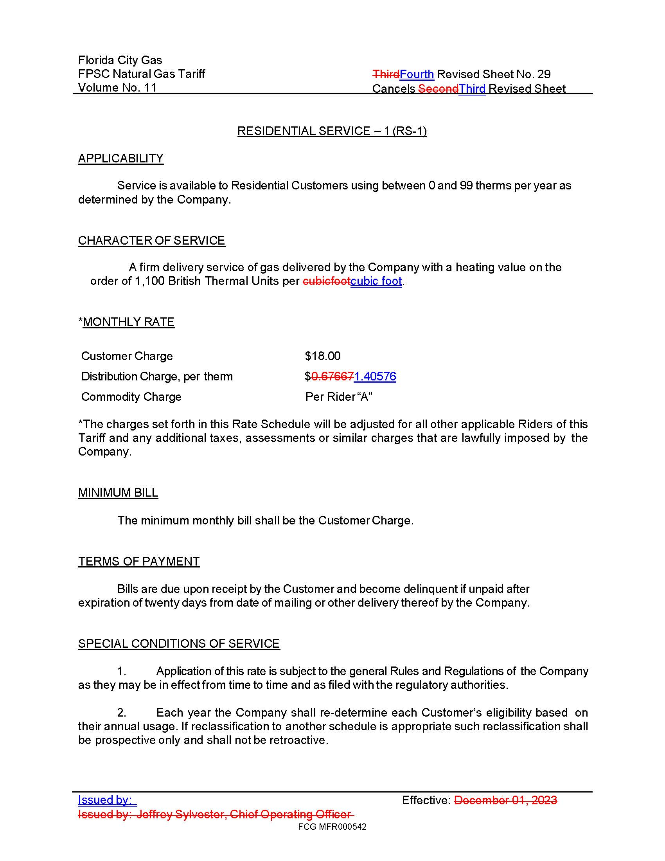

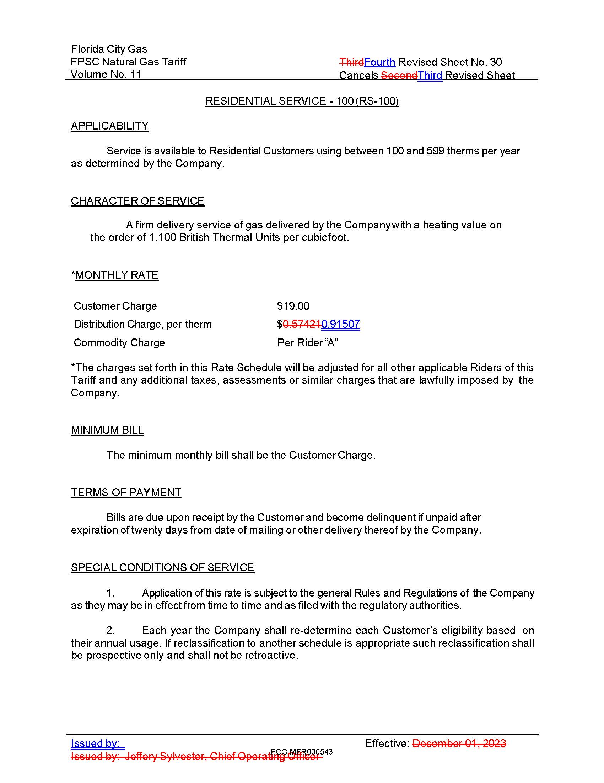

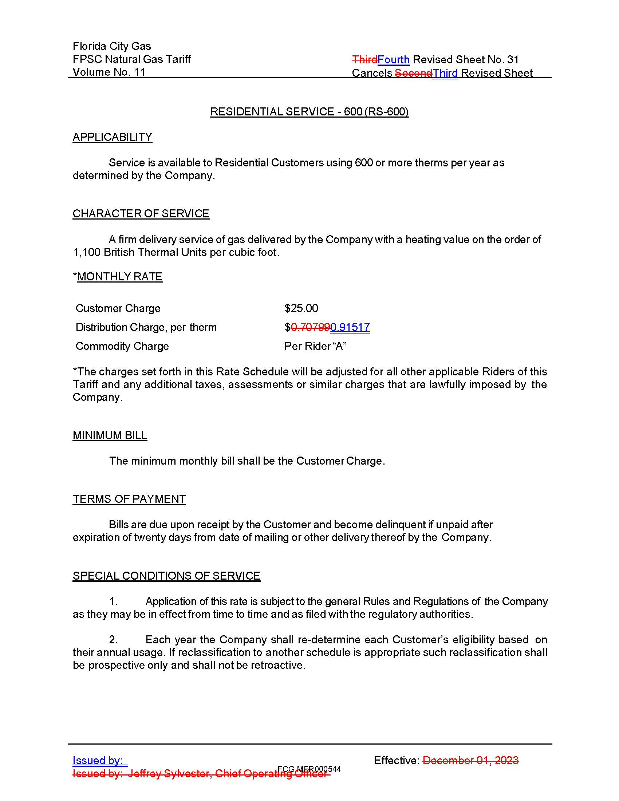

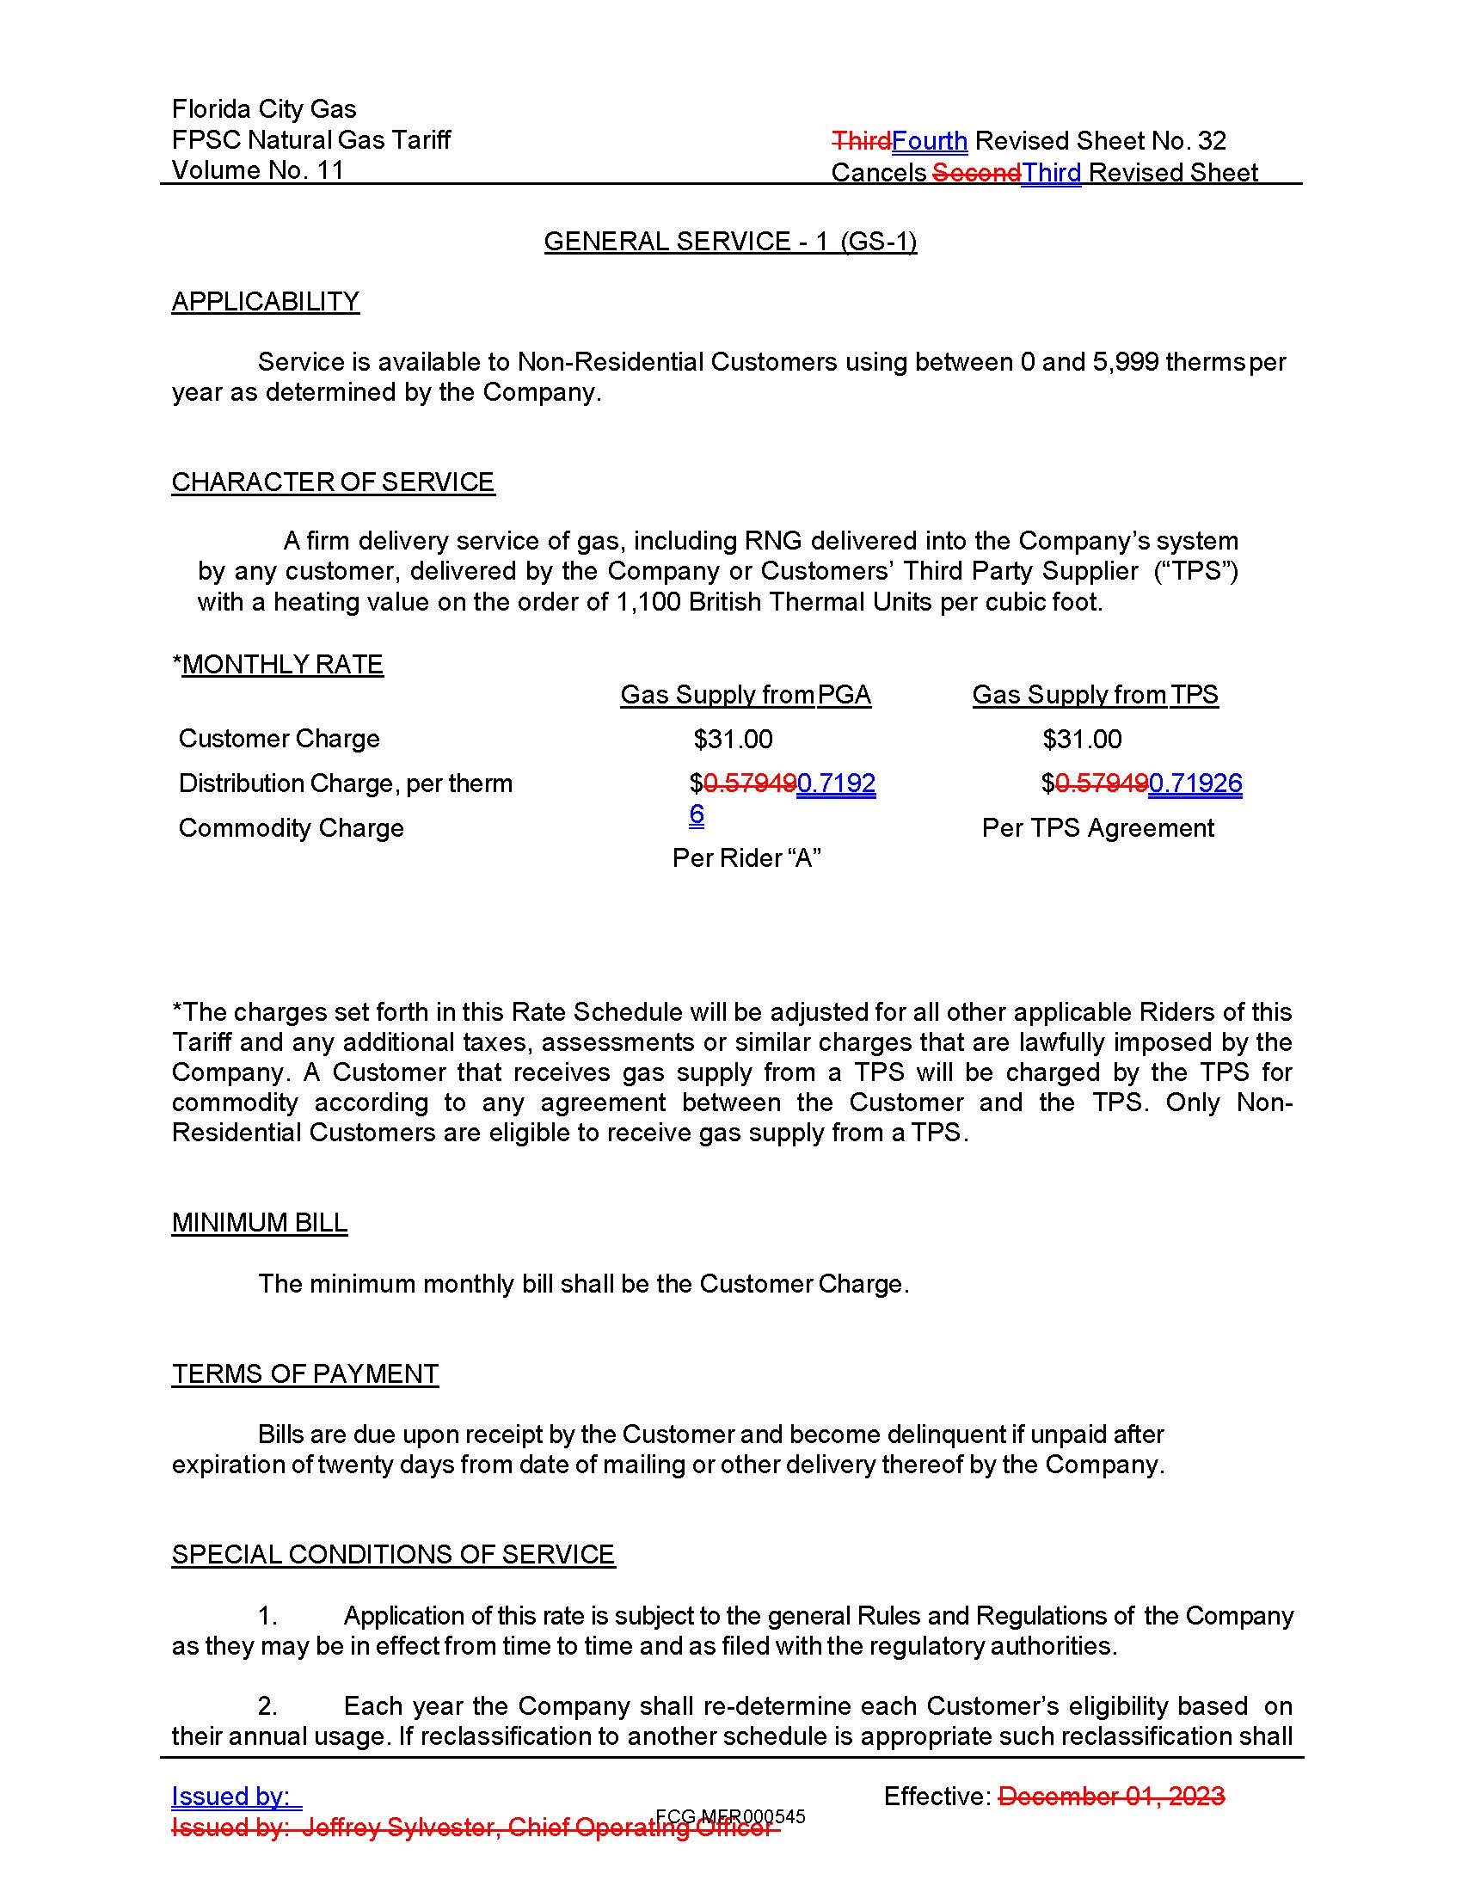

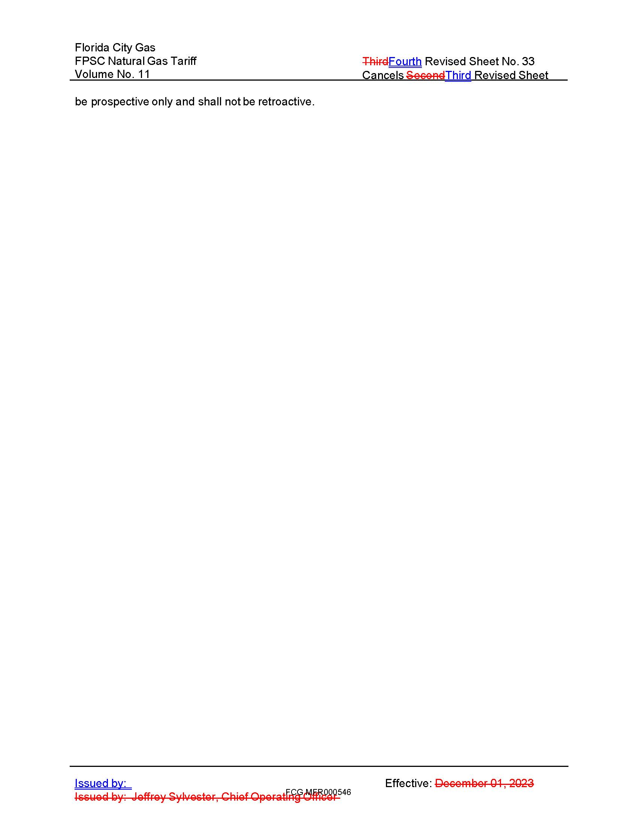

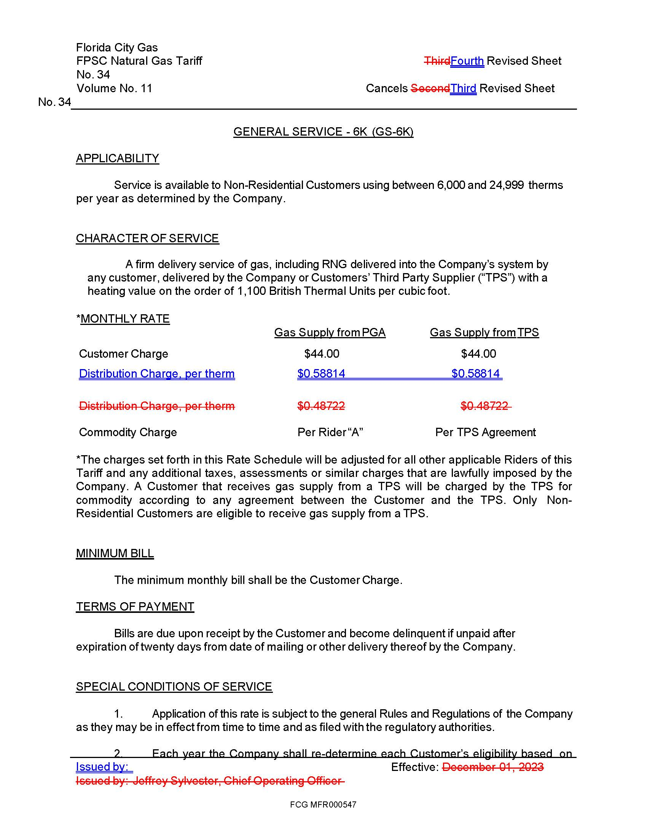

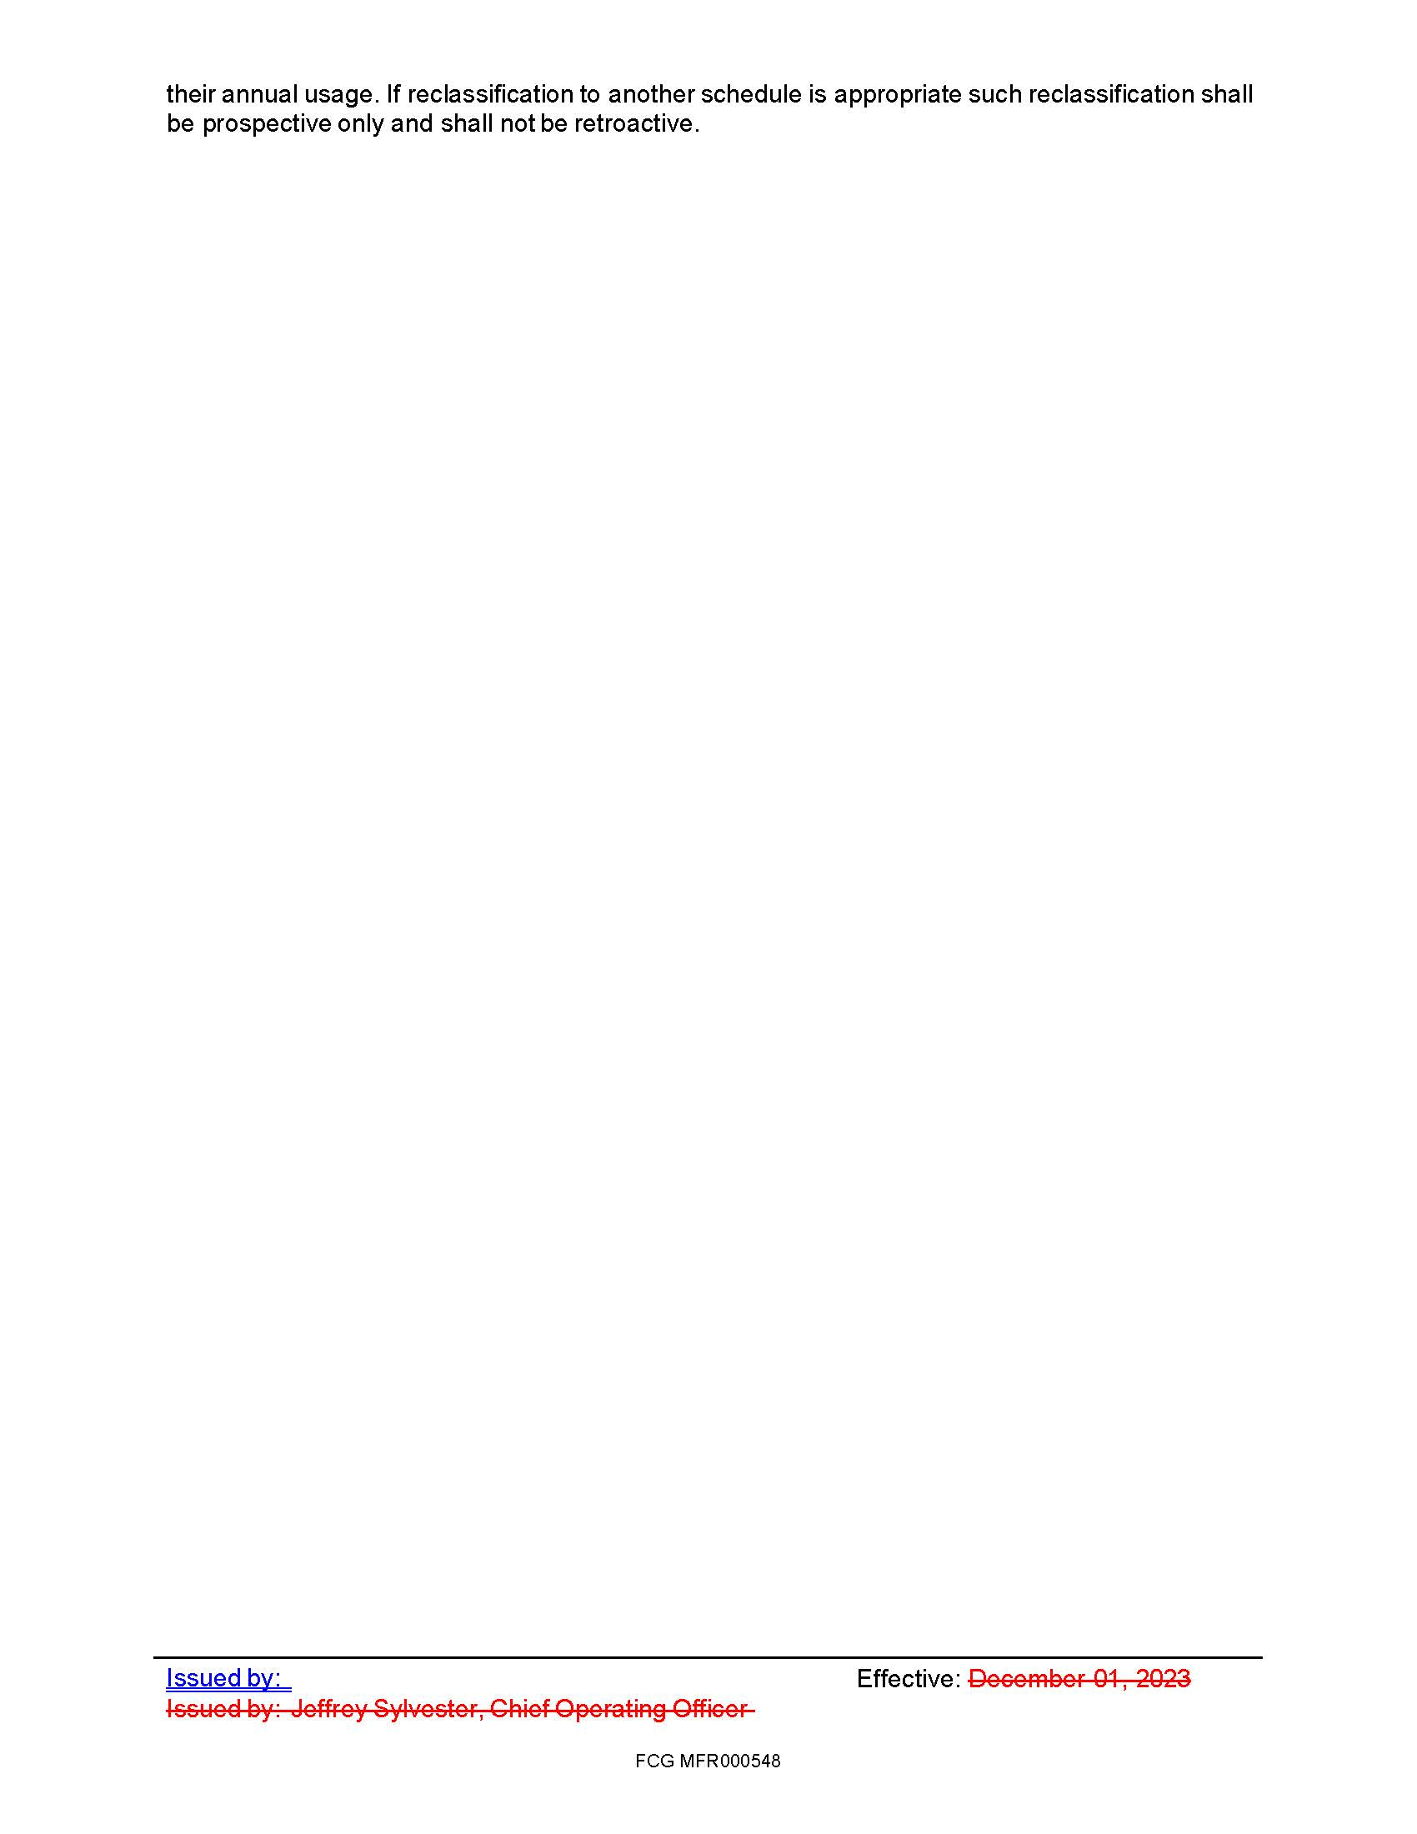

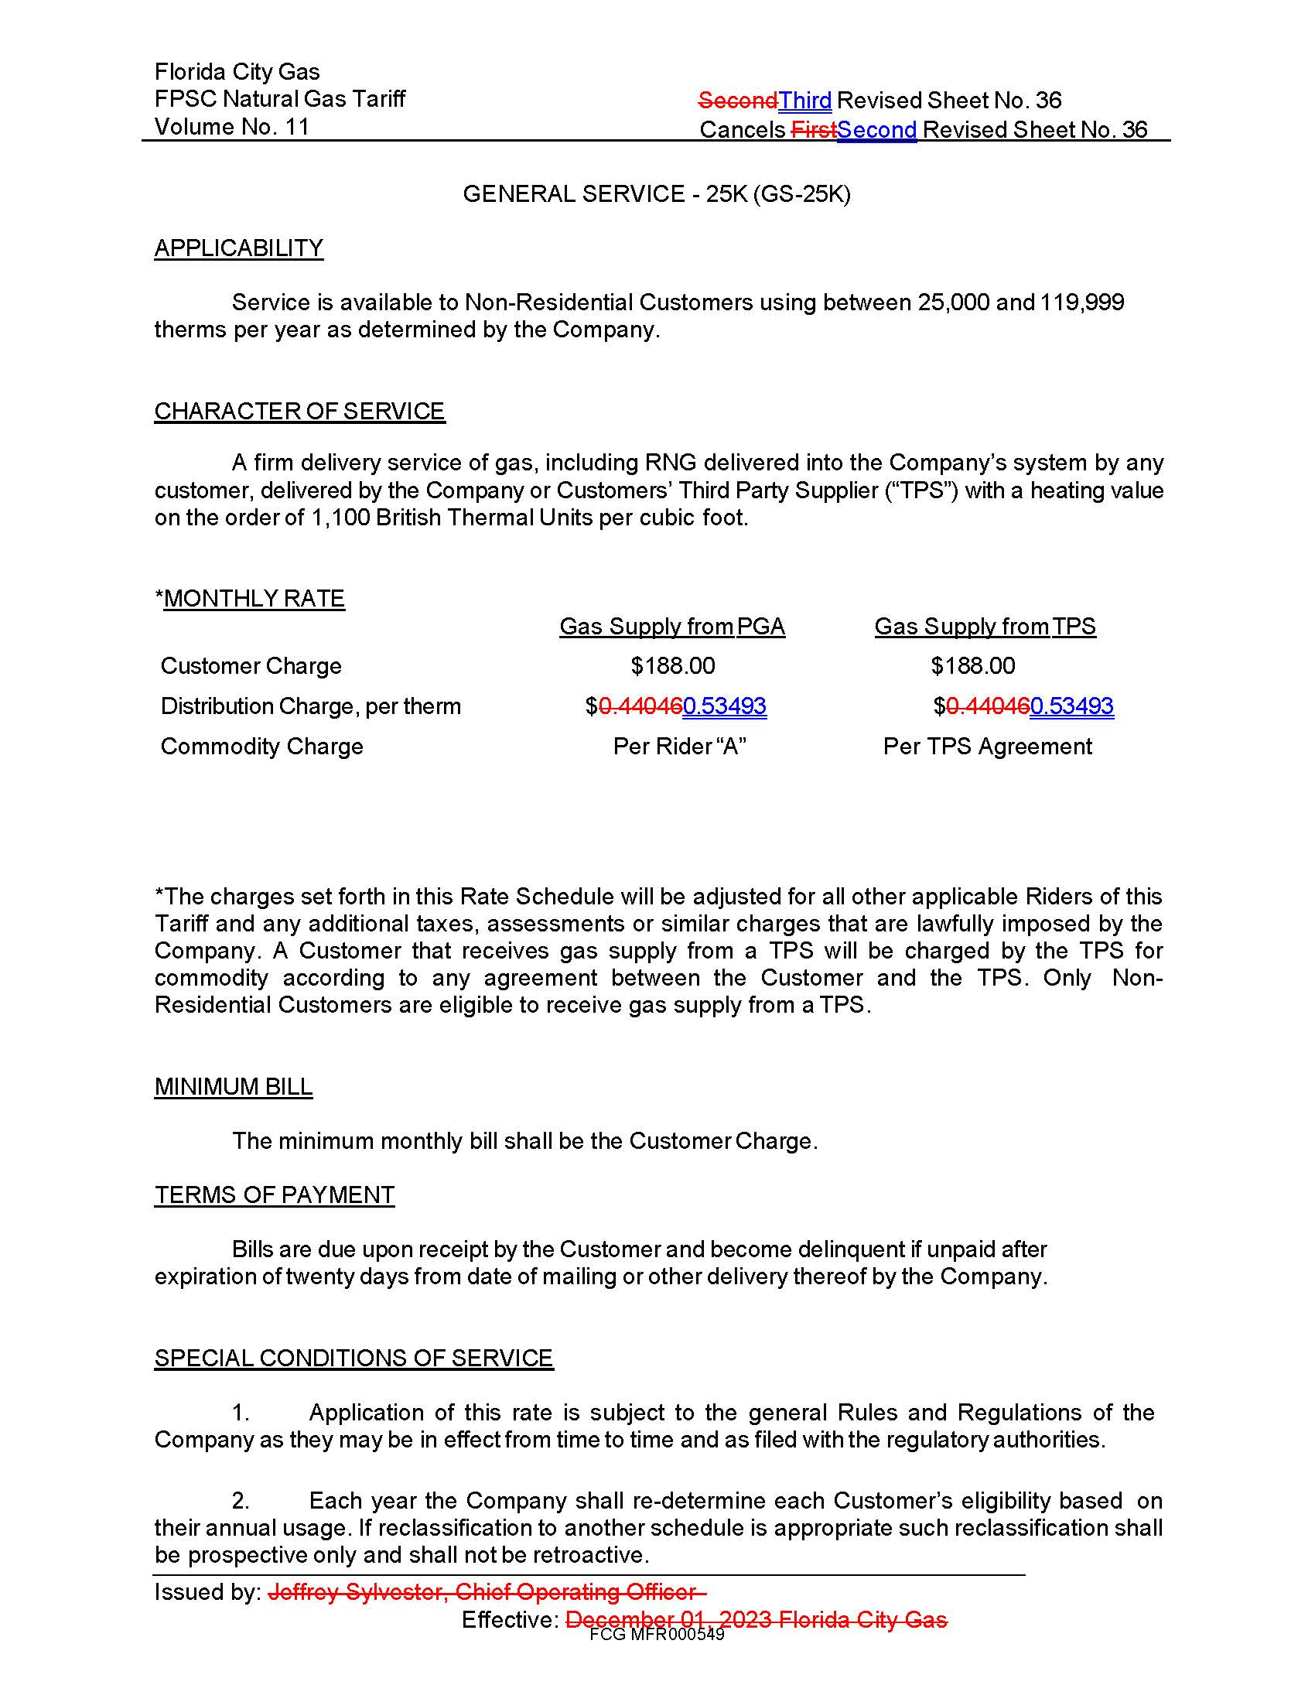

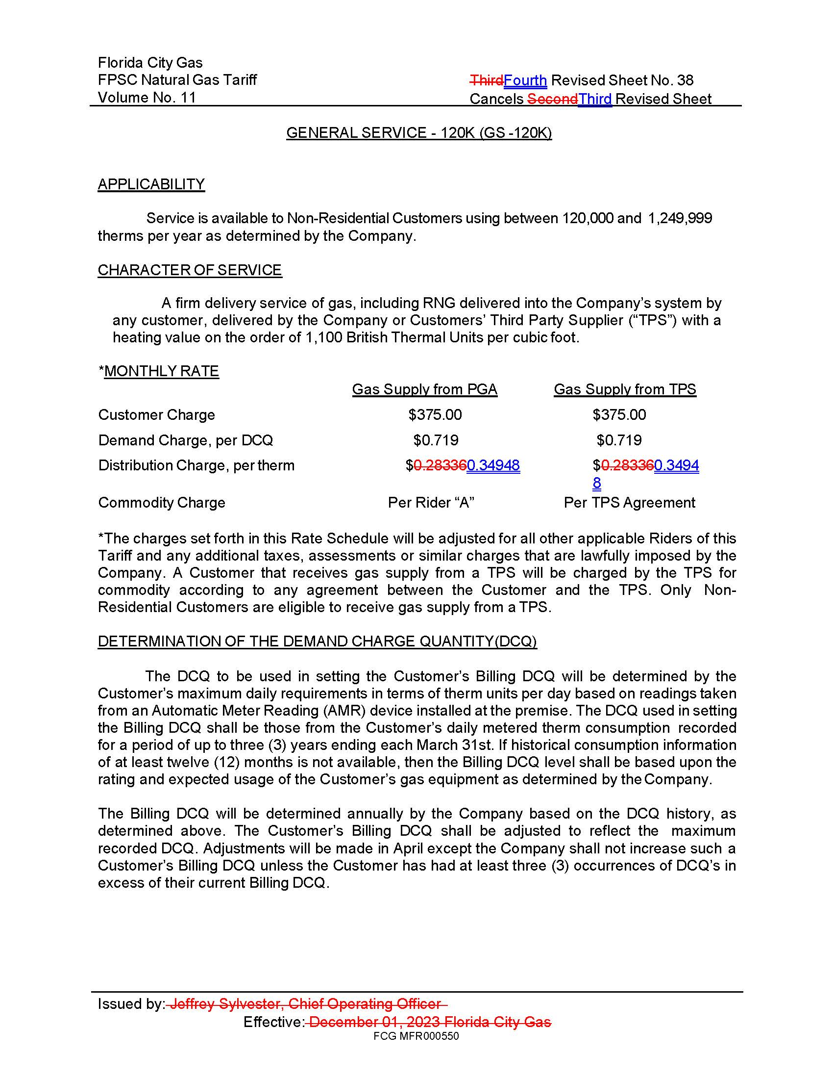

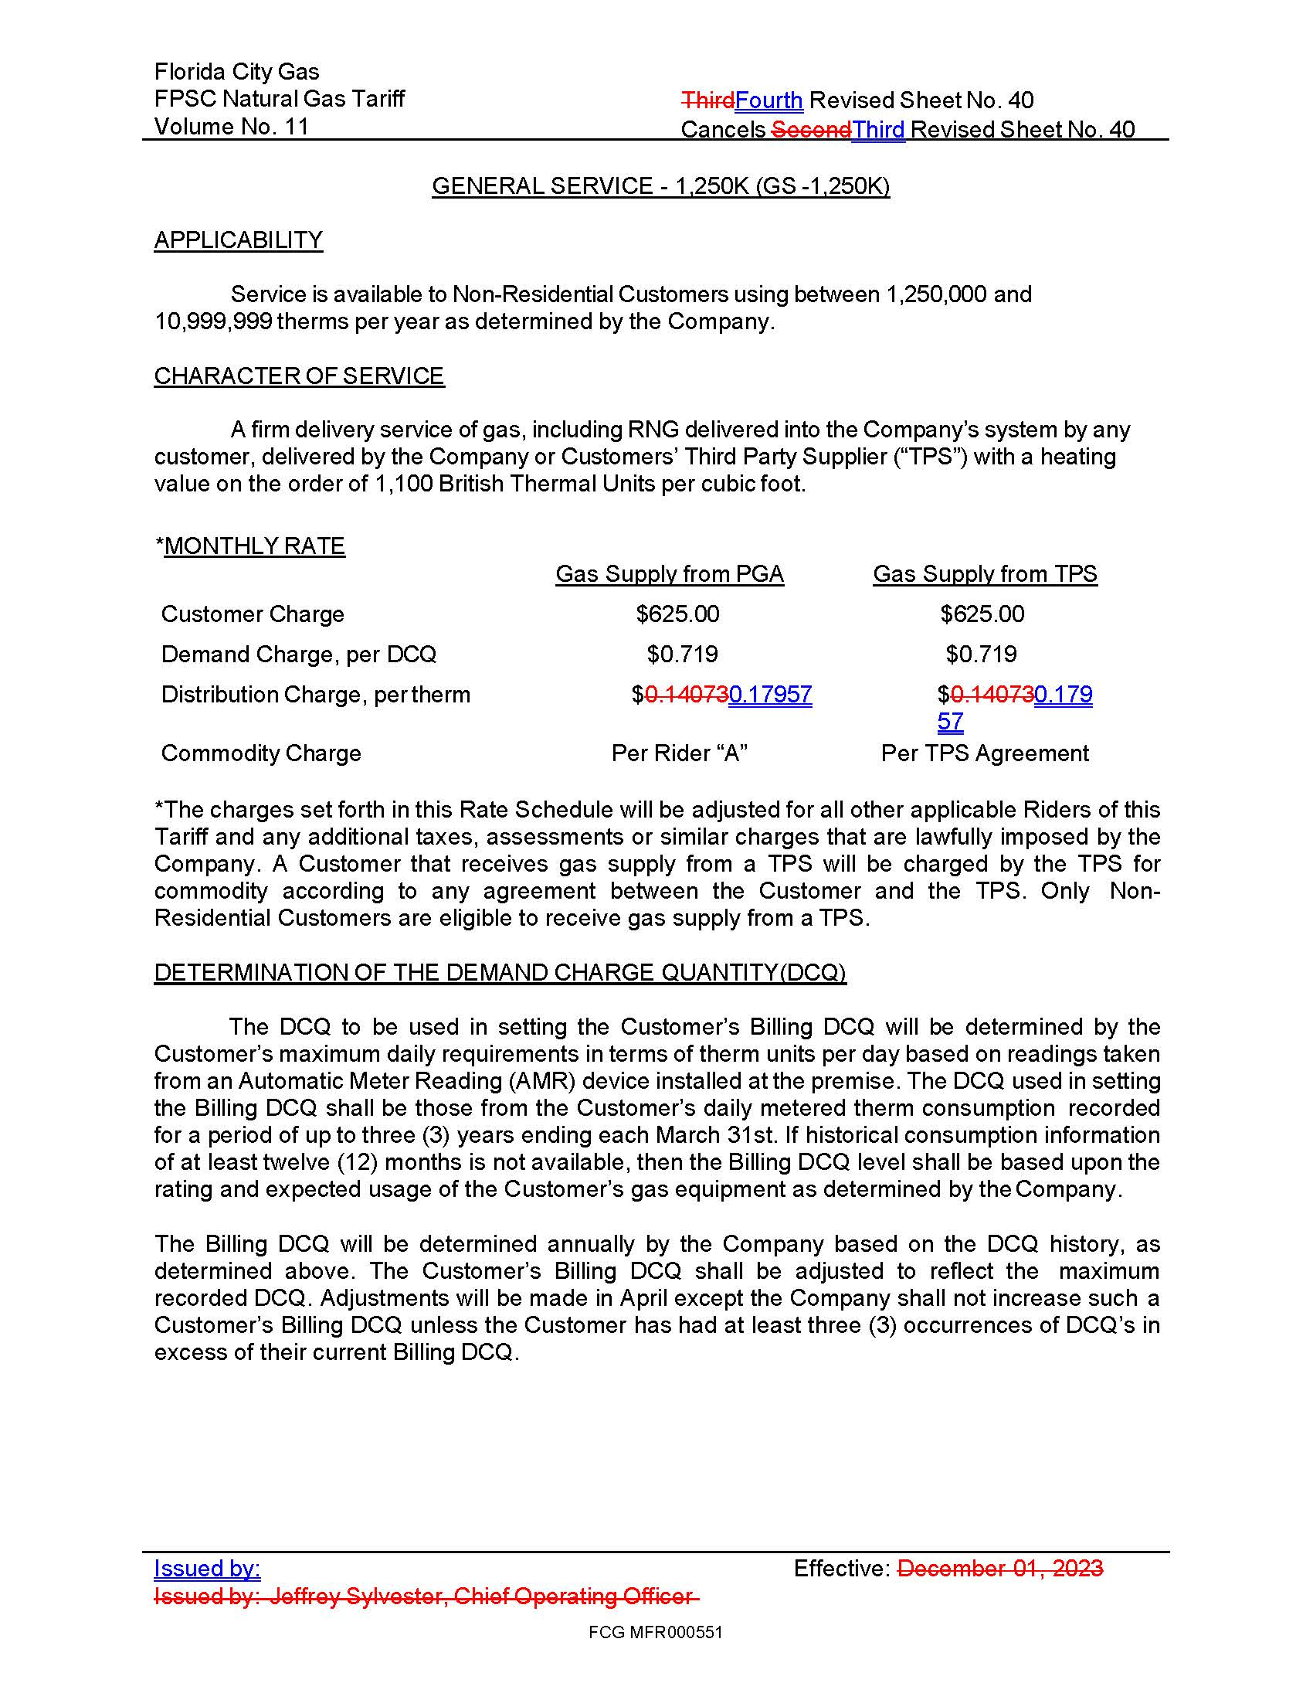

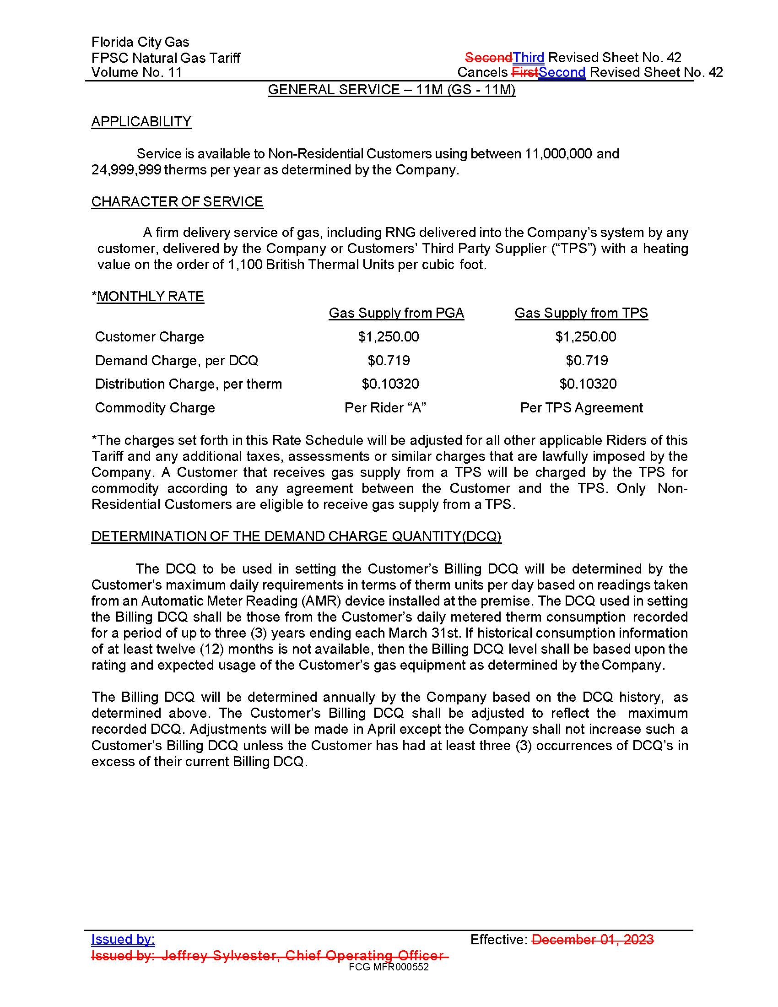

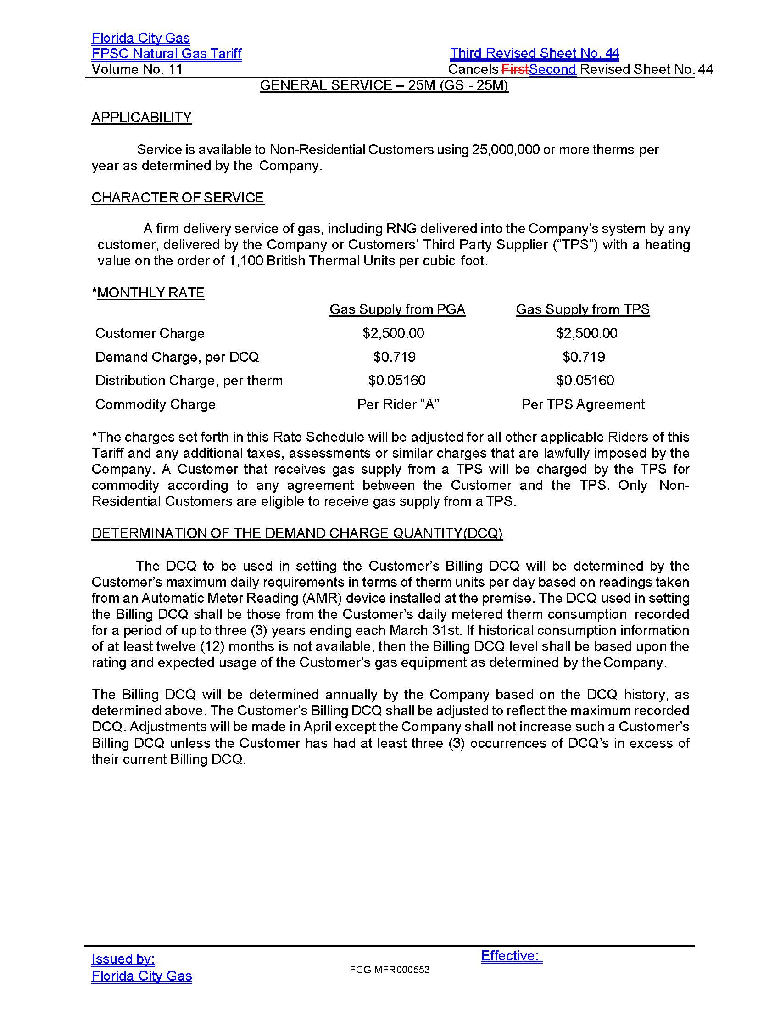

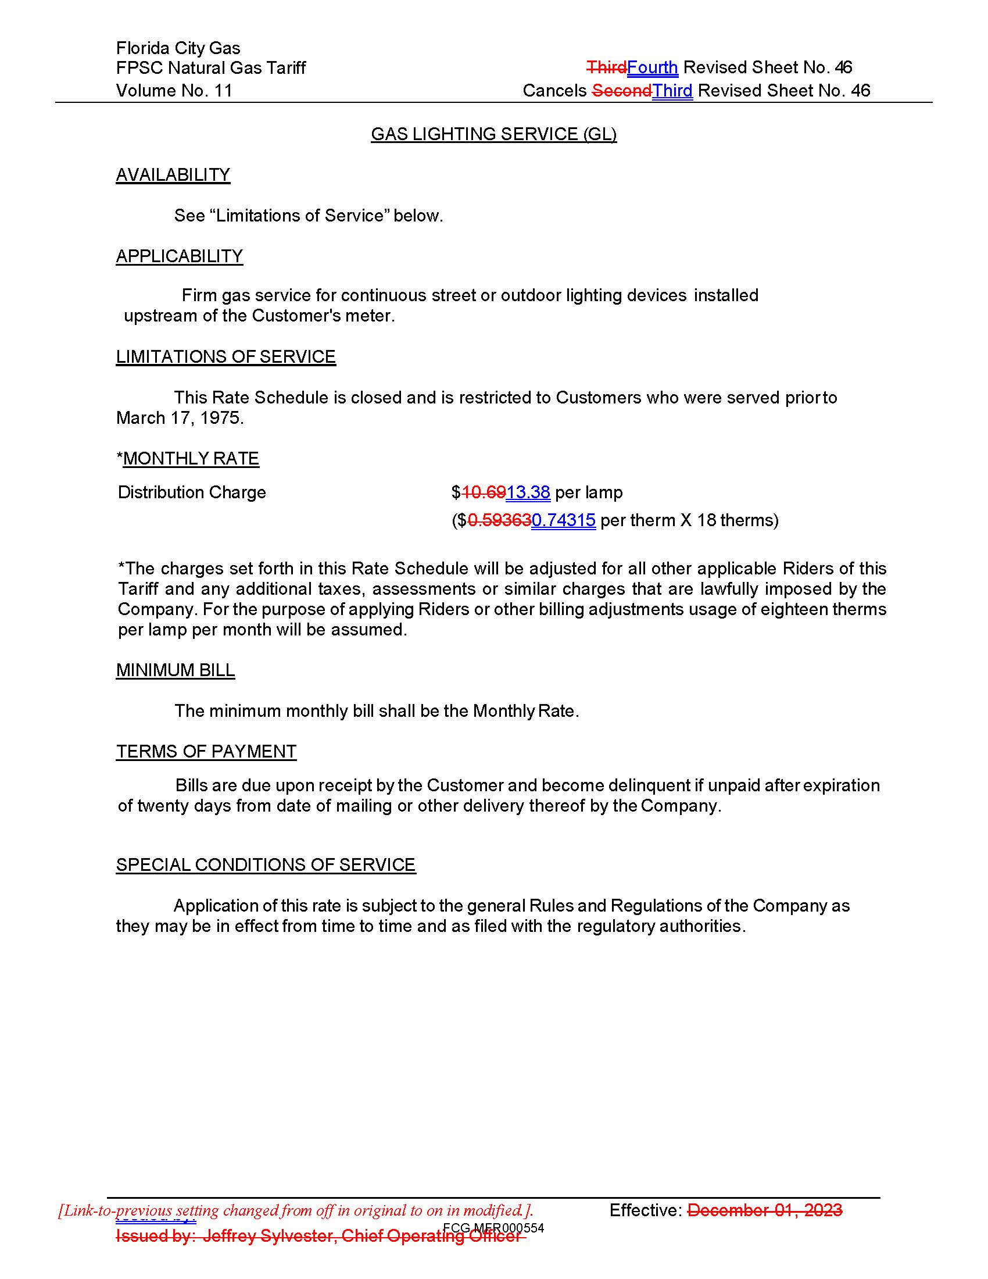

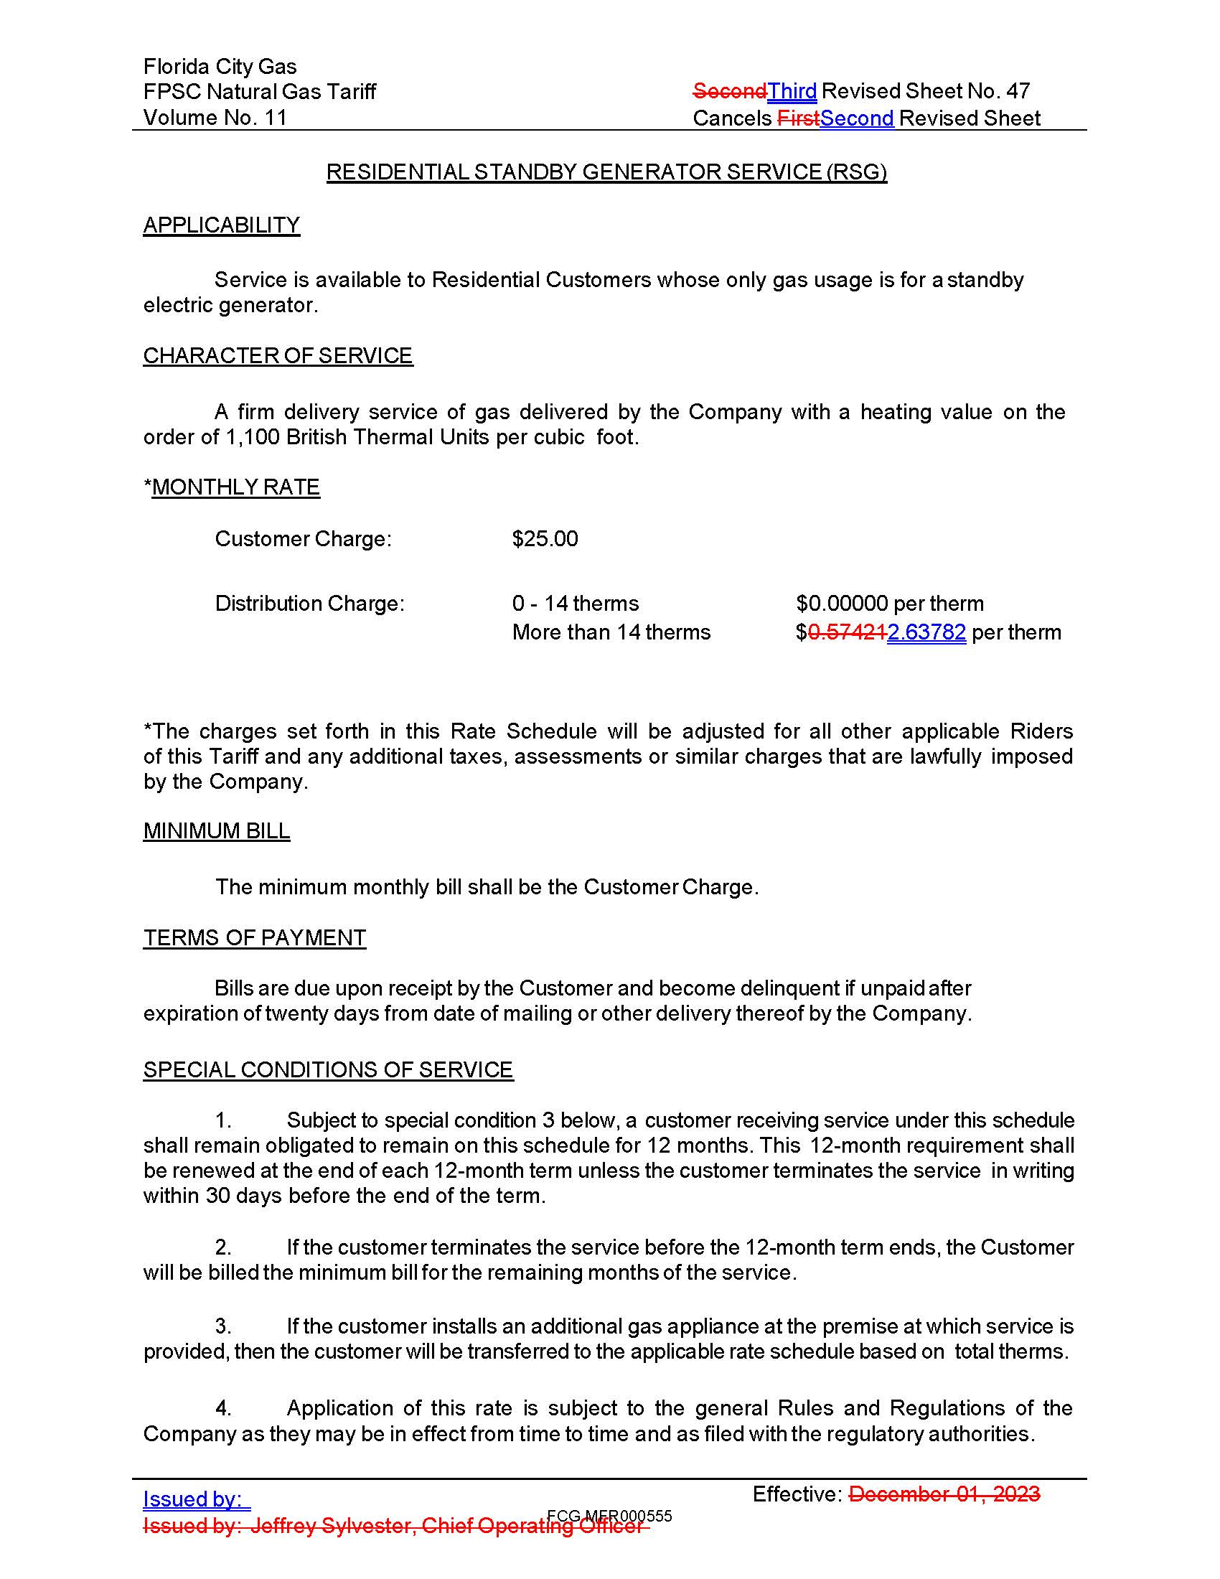

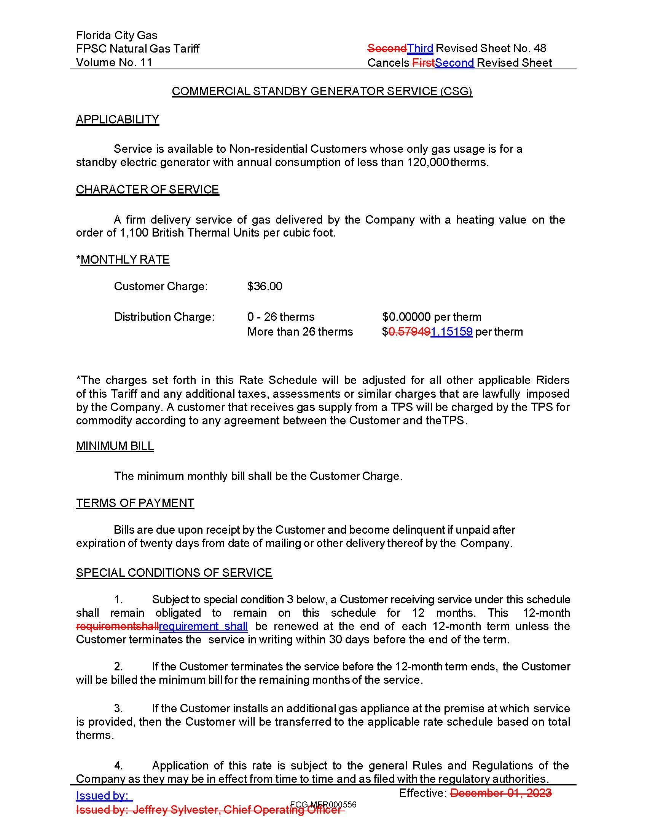

Order Nos. PSC-2023-0177-FOF-GU, issued June 9, 2023, and PSC-2023-0299-FOF-GU, issued October 2, 2023, in Docket No. 20220069-GU, In re: Petition for rate increase by Florida City Gas.
Order No. PSC-2026-0153-PCO-GU, issued May 15, 2026, in Docket No. 20260026-GU, In re: Petition for rate increase by Florida City Gas.
Order No. PSC-2026-0051-PCO-GU, issued February 20, 2026, in Docket No. 20260026-GU, In re: Petition for rate increase by Florida City Gas.
Order No. PSC-2023-0177-FOF-GU.
Order No. PSC-2023-0177-FOF-GU.
Id.
Order No. PSC-2023-0177-FOF-GU.
Document No. 03404-2026, filed on June 9, 2026.

