BEFORE THE FLORIDA PUBLIC SERVICE COMMISSION

In re: Commission approval of Florida Telecommunications Relay, Inc.'s fiscal year 2026/2027 proposed budget. | DOCKET NO. 20260042-TP  ORDER NO. PSC-2026-0262-PAA-TP  ISSUED: July 27, 2026

The following Commissioners participated in the disposition of this matter:

GABRIELLA PASSIDOMO SMITH, Chairman
GARY F. CLARK
MIKE LA ROSA
BOBBY PAYNE
ANA ORTEGA

NOTICE OF PROPOSED AGENCY ACTION
ORDER APPROVING FLORIDA TELECOMMUNICATIONS RELAY INC.’S
FISCAL YEAR 2026/2027 BUDGET

BY THE COMMISSION:

NOTICE is hereby given by the Florida Public Service Commission that the action discussed herein is preliminary in nature and will become final unless a person whose interests are substantially affected files a petition for a formal proceeding, pursuant to Rule 25-22.029, Florida Administrative Code (F.A.C.).

BY THE COMMISSION:

Background
The Telecommunications Access System Act of 1991 (TASA) established a statewide telecommunications relay system. Under TASA, the Florida Public Service Commission (Commission) must establish, implement, promote, and oversee the statewide telecommunications access system, which is intended to provide telecommunications service for deaf, hard of hearing, or speech impaired persons that is functionally equivalent to the service provided to hearing persons. TASA provides for the purchase and distribution of specialized telecommunications devices and specialized communications technology as defined in Chapter 427, Florida Statutes (F.S.).
TASA provides deaf or hard of hearing persons access to basic telecommunications services by using a specialized Communications Assistant that relays information between the deaf or hard of hearing person and the other party to the call. The primary function of the telecommunications access system is accomplished using a Telecommunications Device for the Deaf (TDD). The person using the TDD types a message to the Communications Assistant who in turn voices the message to the other party or types the message to a Captioned Telephone that displays real-time captions of the conversation.
In 2025, the Legislature amended Sections 427.702 through 427.706, F.S. relating to TASA. These statutory changes added newly defined specialized communications technology and requires us to set eligibility requirements for this distribution. Section 427.704(e), F.S. mandates that the eligibility requirements be based on income qualifications of no less than double, but no more than triple, the federal poverty level, or participation in other state or federal programs based on income. We adopted rules setting these eligibility criteria, which became effective on December 2, 2025. The eligibility requirements in the rule include income of less than 250 percent of the federal poverty level, or participation in the Supplemental Nutrition Assistance Program, Medicaid, Supplemental Security Income, the Section 8 Housing Choice Voucher Program, or receipt of either a Veterans Pension or Survivors Pension from the Department of Veterans Affairs.
Florida Telecommunications Relay, Inc. (FTRI), a nonprofit corporation formed by the local exchange telephone companies, was selected by us to serve as the telecommunications access system administrator. FTRI is primarily responsible for the purchase and distribution of specialized telecommunications equipment and specialized communications technology. As part of this process, FTRI contracts with other organizations to assist in the distribution of equipment and provide customer training on the proper use of the equipment and the relay service. FTRI also conducts marketing to raise awareness of available equipment and relay service. Finally, FTRI pays the Telecommunications Relay Service (TRS) provider, which is selected by us through a request for proposals process. The current TRS provider is T-Mobile USA, Inc. (T-Mobile).
FTRI is funded through the TRS surcharge, which local exchange telecommunications companies are required to collect and remit to FTRI. We have historically changed the surcharge to meet FTRI’s budgetary needs. The monthly surcharge is currently $0.08 per access line, for up to 25 lines per customer.
As part of our oversight responsibilities of the telecommunications access system, we review and approve a budget submitted by FTRI on an annual basis. On March 16, 2026, FTRI submitted its Fiscal Year 2026/2027 budget. On May 29, 2026, FTRI submitted responses to our staff’s first data request along with a revised budget for our consideration. This revised budget is appended hereto as Attachment A and is incorporated by this reference. FTRI provided a comparison of its proposed budget to our approved 2025/2026 budget, as well as its estimated revenue and expenses for the current fiscal year. FTRI estimated its revenue and expenses based on actual data from the first two quarters and estimated data for the remainder of the year.
On May 29, 2026, FTRI also filed third quarter financial information. With this updated information, we formulated an estimate of FTRI’s expenses for Fiscal Year 2025/2026. This estimate along with a comparison of FTRI’s proposed and approved budgets is contained in Attachment B, which is incorporated by this reference.

This Order addresses FTRI’s proposed budget and TRS surcharge for Fiscal Year 2026/2027. The TRS surcharge is the only rate we establish for telecommunications companies. The Commission is vested with jurisdiction over this matter pursuant to Chapter 427, F.S.

Analysis and Decision
- FTRI’s Fiscal Year 2026/2027 Proposed Budget is Approved

Traditional Telecommunications Relay Service

Traditional TRS cost as approved in the T-Mobile contract is currently $2.58 per session minute. T-Mobile’s projections indicate traditional TRS minutes of use during Fiscal Year 2026/2027 will be 297,506. By comparison, T-Mobile’s projections for traditional TRS minutes of use for Fiscal Year 2025/2026 was 467,554. Further, TRS usage totaled 510,081 actual minutes in Fiscal Year 2024/2025, representing a 14 percent decline from Fiscal Year 2023/2024 actual minutes.

Based on continued advancements in technology and the expansion of consumer choice, it is anticipated that TRS minutes of use will continue to decline. It has been observed that traditional TRS users are transitioning to the following services:

- IP Relay
- IP CTS
- Wireless Service

Florida Telecommunications Relay, Inc. Budget

Attachment A reflects FTRI’s Fiscal Year 2026/2027 proposed budget filed with the Commission, which was reviewed and adopted by FTRI’s Board of Directors. FTRI proposed maintaining the current $.08 surcharge per access line, which would result in total surcharge revenue of $1,565,015. FTRI projected $674,325 in interest income during Fiscal Year 2026/2027 through investments in its Investment Trust Money Market account and 3-month T-bills. As a result, FTRI’s total operating revenue was estimated to be $2,239,340. FTRI projected total expenses of $4,694,189 in its proposed budget. Based on FTRI’s projected revenue and expenses, it would need to transfer $2,454,849 from the Reserve Account to offset the shortfall. FTRI has a Reserve Account of approximately $19,723,369 million.

Analysis

The two primary factors contributing to FTRI’s proposed budget shortfall are continued declines in access lines, upon which the surcharge is assessed, and the increase in Category II - Equipment & Repairs expense related to distribution of specialized communications technology. Proposed surcharge revenue is projected to decline by $373,569 compared to last year’s approved budget because of continued declines in access lines. Expenses related to the distribution of specialized communications technology are projected to be $1,786,100. We developed an estimate of FTRI’s expenses for Fiscal Year 2025/2026, which is presented in Attachment B. We used actual data from the first three quarters and took an average of those three quarters to estimate the fourth. Our estimates were then used as one element in evaluating FTRI’s proposed budget, along with analyzing our past approved FTRI budgets to identify and evaluate ongoing cost reduction measures.

Below is our review of selected items from FTRI’s proposed budget expenses by category.

Category I – Relay Services

Category I captures TRS provider expenses for traditional TRS currently provided by T-Mobile. This Commission and FTRI have historically used the TRS provider’s minutes of use forecast to develop the budget for this category.

We approve using T-Mobile’s forecasted 297,506 minutes of use to calculate the TRS provider expense. At the contracted rate of $2.58 per minute, the proposed TRS provider expense is $767,564.

We approve $767,564 for relay services expense.

Category II – Equipment & Repairs

Category II expenses reflect the purchase of equipment to be distributed to clients and the repairs that FTRI must make to keep the equipment in working order. FTRI requested $1,978,503 for Fiscal Year 2026/2027, representing a $1,503,194 increase in expense from our current approved budget. The proposed increase is largely attributed to planned distribution of newly defined specialized communications technology authorized by amendments to Chapter 427, F.S., that were enacted by the Legislature in 2025.

The specialized communications technology line item proposes a $1,786,100 Fiscal Year 2026/2027 expenditure for iPhones, iPads, and ATOS electrolarynx devices. The ATOS electrolarynx device is designed to assist persons with total laryngectomy, which is the removal of the voice box to treat throat cancer. In addition to standard eligibility criteria related to hearing loss and speech disability, this equipment is only available to Florida residents whose income does not exceed 250 percent of the federal poverty level, or who participate in other income-based programs as described above.

FTRI’s Fiscal Year 2026/2027 proposed budget estimate is based on current unit cost and projected device distribution volumes, including assumptions on the size of the addressable client base. The current projection includes 705 iPhone devices at $1,620 per unit ($1,142,100), 470 large screen iPad devices at $1,300 per unit ($611,000), and 30 ATOS electrolarynx at $1,100 per unit, ($33,000).

In response to our staff’s data request, FTRI indicated that it relied on data from the Florida Coordinating Council for the Deaf and Hard of Hearing (FCCDHH) and other reputable organizations to develop its demand projections. FCCDHH is overseen by the Florida Department of Health. FTRI’s projected number of units starts with the identification of 900,000 residents who identify as Deaf, Hard of Hearing, or Speech Impaired, assumes that approximately 29 percent meet the income requirements, and estimates that 3 percent of those do not already have access to a wireless device that meets their needs. Applying FTRI’s logic yields 7,830 eligible Florida residents who may apply for equipment in any given year. FTRI anticipates 15 percent of this target population will submit a completed application in FY 2026/2027, resulting in 1,175 Apple units being distributed. The projected quantity of ATOS Emote devices to be distributed in Fiscal Year 2026/2027 is 30. This calculation is based on 10,000 people in the US living with total laryngectomy and 6.9 percent of the US population living in Florida. This equates to 690 Florida residents with total laryngectomy. Applying the same income assumptions as other wireless device projections, 200 Florida residents would qualify in any given year. Continuing with the conservative planning estimate of serving 15 percent of the target population, 30 units would be distributed in the upcoming fiscal year.

According to the 2025 FCCDHH Biennial Report, it is estimated that 3 to 4 million Floridians have significant hearing loss. FTRI also reported that of those, approximately 800,000 identify as Deaf or Hard of Hearing according to sources such as the Florida Department of State DLIS Deaf Literacy Center. According to the NIH National Institute on Deafness and Other Communication Disorders, approximately 7.2 percent of US children ages 3-17 have a disorder related to voice, speech, or language. Similarly, 7.6 percent of US adults report having a voice problem that lasted longer than 12 months. Given Florida’s population, this equates to over 1.7 million residents who have some form of speech-related disability. For the purposes of this initial projection, FTRI used a conservative estimate of approximately 100,000 residents who may identify as having a qualifying speech impairment, including 690 with total laryngectomy.

FTRI projected that approximately 12 percent of Florida residents live below the federal poverty level and 34 percent of households are classified as asset limited, income constrained and employed. Eligibility requirements are currently set at less than 250 percent of the federal poverty level and, as a result, FTRI estimates that 29 percent would satisfy program eligibility income requirements. Smartphones are common across income levels, with access to at least one device ranging from 79–98 percent based on income. Cellphone and Smartphone ownership for US adults with household income of $30,000-$69,900 is also 98 percent and 89 percent respectively. Considering these factors, FTRI used a conservative estimate of 3 percent of Florida residents who may not already have access to a wireless device that meets their needs.
In total, FTRI projects 1,205 units to be distributed at a total cost of $1,786,100 for Fiscal Year 2026/2027. We find that no adjustment to FTRI’s projections and budget request is needed. However, given FTRI’s reliance on demand assumptions, along with the potential for fraud, it is important that FTRI remain diligent. FTRI states that clients are required to adhere to the Conditions of Acceptance regarding the use of the devices. Condition of Acceptance five requires clients to return devices when no longer needed. In addition, FTRI shall require devices be returned when clients no longer meet income or program participation requirements. FTRI shall also implement a practice to verify client income and program eligibility when issuing replacement devices. We order FTRI to file monitoring reports on the distribution of iPhones and iPads as discussed in Section 2 of this Order.

We approve $1,978,503 for equipment and repairs expense.

Category III – Equipment Distribution & Training

Category III reflects the cost of distributing equipment and training consumers in the use of that equipment. FTRI’s proposed budget requests $149,554 for distribution and training, which reflects a $39,011 decrease from our current approved budget.

Expenses related to Regional Distribution Centers (RDCs) are the largest component of Category III expenses. FTRI’s proposed budget for RDCs is $109,504, which is $36,436 lower than our current approved budget. FTRI explained that some RDCs have not fully recovered from the impact of the COVID-19 shutdown. FTRI plans to continue exploring alternative partnerships to expand distribution services for selected equipment. However, FTRI will distribute the newly defined specialized communications technology devices using in-house resources and does not currently plan to use third parties. We support this approach considering the challenges related to initial implementation.

We approve FTRI’s proposed budget for Category III expenses of $149,554.

Category IV – Outreach

Outreach efforts are designed to promote FTRI’s equipment distribution services and to raise awareness about TRS. FTRI’s proposed Fiscal Year 2026/2027 Outreach budget increased by $19,028 over the 2025/2026 approved budget.

Factors contributing to the increase in Outreach Expense include the hiring of a Community Coordinator, travel expenses, and advertising price increases. FTRI employs various forms of communication in its outreach strategy. FTRI plans to expand outreach efforts, including continued advertising in newspapers using free-standing insert ads (flyers) and television. Expanded promotion may have additional value to inform qualifying relay customers about new types of equipment that are available.

We approve FTRI’s proposed budget of $653,309 for Outreach expenses.

Category V – General & Administrative

Category V reflects expenses associated with FTRI’s operations, such as office and furnishings, employee compensation, contracted services (auditing, legal, IT consulting), computers, and other operating expenses. FTRI is proposing $1,145,259 for Fiscal Year 2026/2027, which represents a $15,030 decrease from our current approved budget.

The amount budgeted for Fiscal Year 2026/2027 Insurance-Health/Life/Disability account shows a $39,302 increase from Fiscal Year 2025/2026 estimated expenditures. FTRI estimated a 10 percent increase in insurance premiums. It based this increase in consultation with its insurance company, along with historical costs over the past two years.

The proposed Employee Salaries budget for Fiscal Year 2026/2027 is $551,721, which is relatively unchanged from the 2025/2026 budget. Eight full-time employees were budgeted for both Fiscal Years.

We approve FTRI’s proposed budget for Category V expenses of $1,145,259.

Revenue Shortfall

FTRI’s Fiscal Year 2026/2027 budget has a shortfall of $2,454,849. FTRI shall draw upon the Reserve Account to cover the shortfall. FTRI’s Reserve Account is approximately $19,723,369 million.

Decision

We approve FTRI’s proposed budget expense of $4,694,189 for Fiscal Year 2026/2027, effective upon issuance of the consummating order. FTRI shall transfer $2,454,849 from the Reserve Account to offset the projected revenue shortfall.

- FTRI to file quarterly reports for Fiscal Year 2026/2027

As discussed in Section 1, based on FTRI’s reliance on demand assumptions, along with the potential for fraud and abuse, it is important that FTRI implement effective procedures. We presented questions to FTRI during the initial analysis of operating procedures, cost, and assumptions used to measure demand. We find that FTRI’s responses were reasonable. However, continued monitoring will be needed to validate assumptions and to collect data to address distribution issues as they arise.

The quarterly reports shall include the following information regarding specialized communications technology devices:
- Number of devices ordered by type.
- Number of devices distributed by type.
- Number of devices in inventory by type.
- Number of devices reported lost by type.
- Number of devices reported stolen by type.
- Number of devices returned damaged by type.
- Number of devices refurbished and returned to clients by type.
- Number returned by clients and taken out of service.
- Quarterly and year-to-date expenses.
- Any revisions to the methodology and/or assumptions used to identify the addressable client base.

We will evaluate the data throughout Fiscal Year 2026/2027 and make a finding on the need to continue the quarterly reporting during the analysis of FTRI’s Fiscal Year 2027/2028 budget filing.
We order FTRI to file quarterly reports for Fiscal Year 2026/2027 providing details on specialized communications technology device distribution.

- Telecommunications Relay Service (TRS) surcharge for Fiscal Year 2026/2027

FTRI has not requested a change in the TRS surcharge. We note that pursuant to the 2025 amendments to TASA, Section 427.704(4)(e), F.S., now prohibits us from increasing the surcharge when excess funds are available. We find the current TRS surcharge of $0.08 per line, per month is reasonable given the size of the Reserve Account identified in Section 1.

Based on the foregoing, it is

ORDERED by the Florida Public Service Commission that Florida Telecommunications Relay, Inc.’s proposed budget expense of $4,694,189 for Fiscal Year 2026/2027, is approved. It is further

ORDERED that Florida Telecommunications Relay, Inc. shall transfer $2,454,849 from the Reserve Account to offset the projected revenue shortfall. It is further

ORDERED that Florida Telecommunications Relay, Inc. shall file quarterly reports for Fiscal Year 2026/2027 providing details on specialized communications technology device distribution. It is further

ORDERED that the current Telecommunications Relay Service surcharge shall be $0.08 per line, per month for Fiscal Year 2026/2027. All local exchange companies shall continue billing the $0.08 TRS surcharge for Fiscal Year 2026/2027. It is further

ORDERED that if no person whose substantial interests are affected by the proposed agency action files a protest within 21 days of the issuance of the order, a consummating order shall be issued. This docket shall be placed in monitoring status during Fiscal Year 2026/2027 upon the issuance of a consummating order.

By ORDER of the Florida Public Service Commission this 27th day of July, 2026.

/s/ Adam J. Teitzman
ADAM TEITZMAN
Commission Clerk
Florida Public Service Commission
2540 Shumard Oak Boulevard
Tallahassee, Florida 32399
(850) 413-6770
www.floridapsc.com

Copies furnished: A copy of this document is provided to the parties of record at the time of issuance and, if applicable, interested persons.

JDI

NOTICE OF FURTHER PROCEEDINGS OR JUDICIAL REVIEW

The Florida Public Service Commission is required by Section 120.569(1), Florida Statutes, to notify parties of any administrative hearing that is available under Section 120.57, Florida Statutes, as well as the procedures and time limits that apply. This notice should not be construed to mean all requests for an administrative hearing will be granted or result in the relief sought.

Mediation may be available on a case-by-case basis. If mediation is conducted, it does not affect a substantially interested person's right to a hearing.

The action proposed herein is preliminary in nature. Any person whose substantial interests are affected by the action proposed by this order may file a petition for a formal proceeding, in the form provided by Rule 28-106.201, Florida Administrative Code. This petition must be received by the Office of Commission Clerk, 2540 Shumard Oak Boulevard, Tallahassee, Florida 32399-0850, by the close of business on August 17, 2026.

In the absence of such a petition, this order shall become final and effective upon the issuance of a Consummating Order.

Any objection or protest filed in this/these docket(s) before the issuance date of this order is considered abandoned unless it satisfies the foregoing conditions and is renewed within the specified protest period.

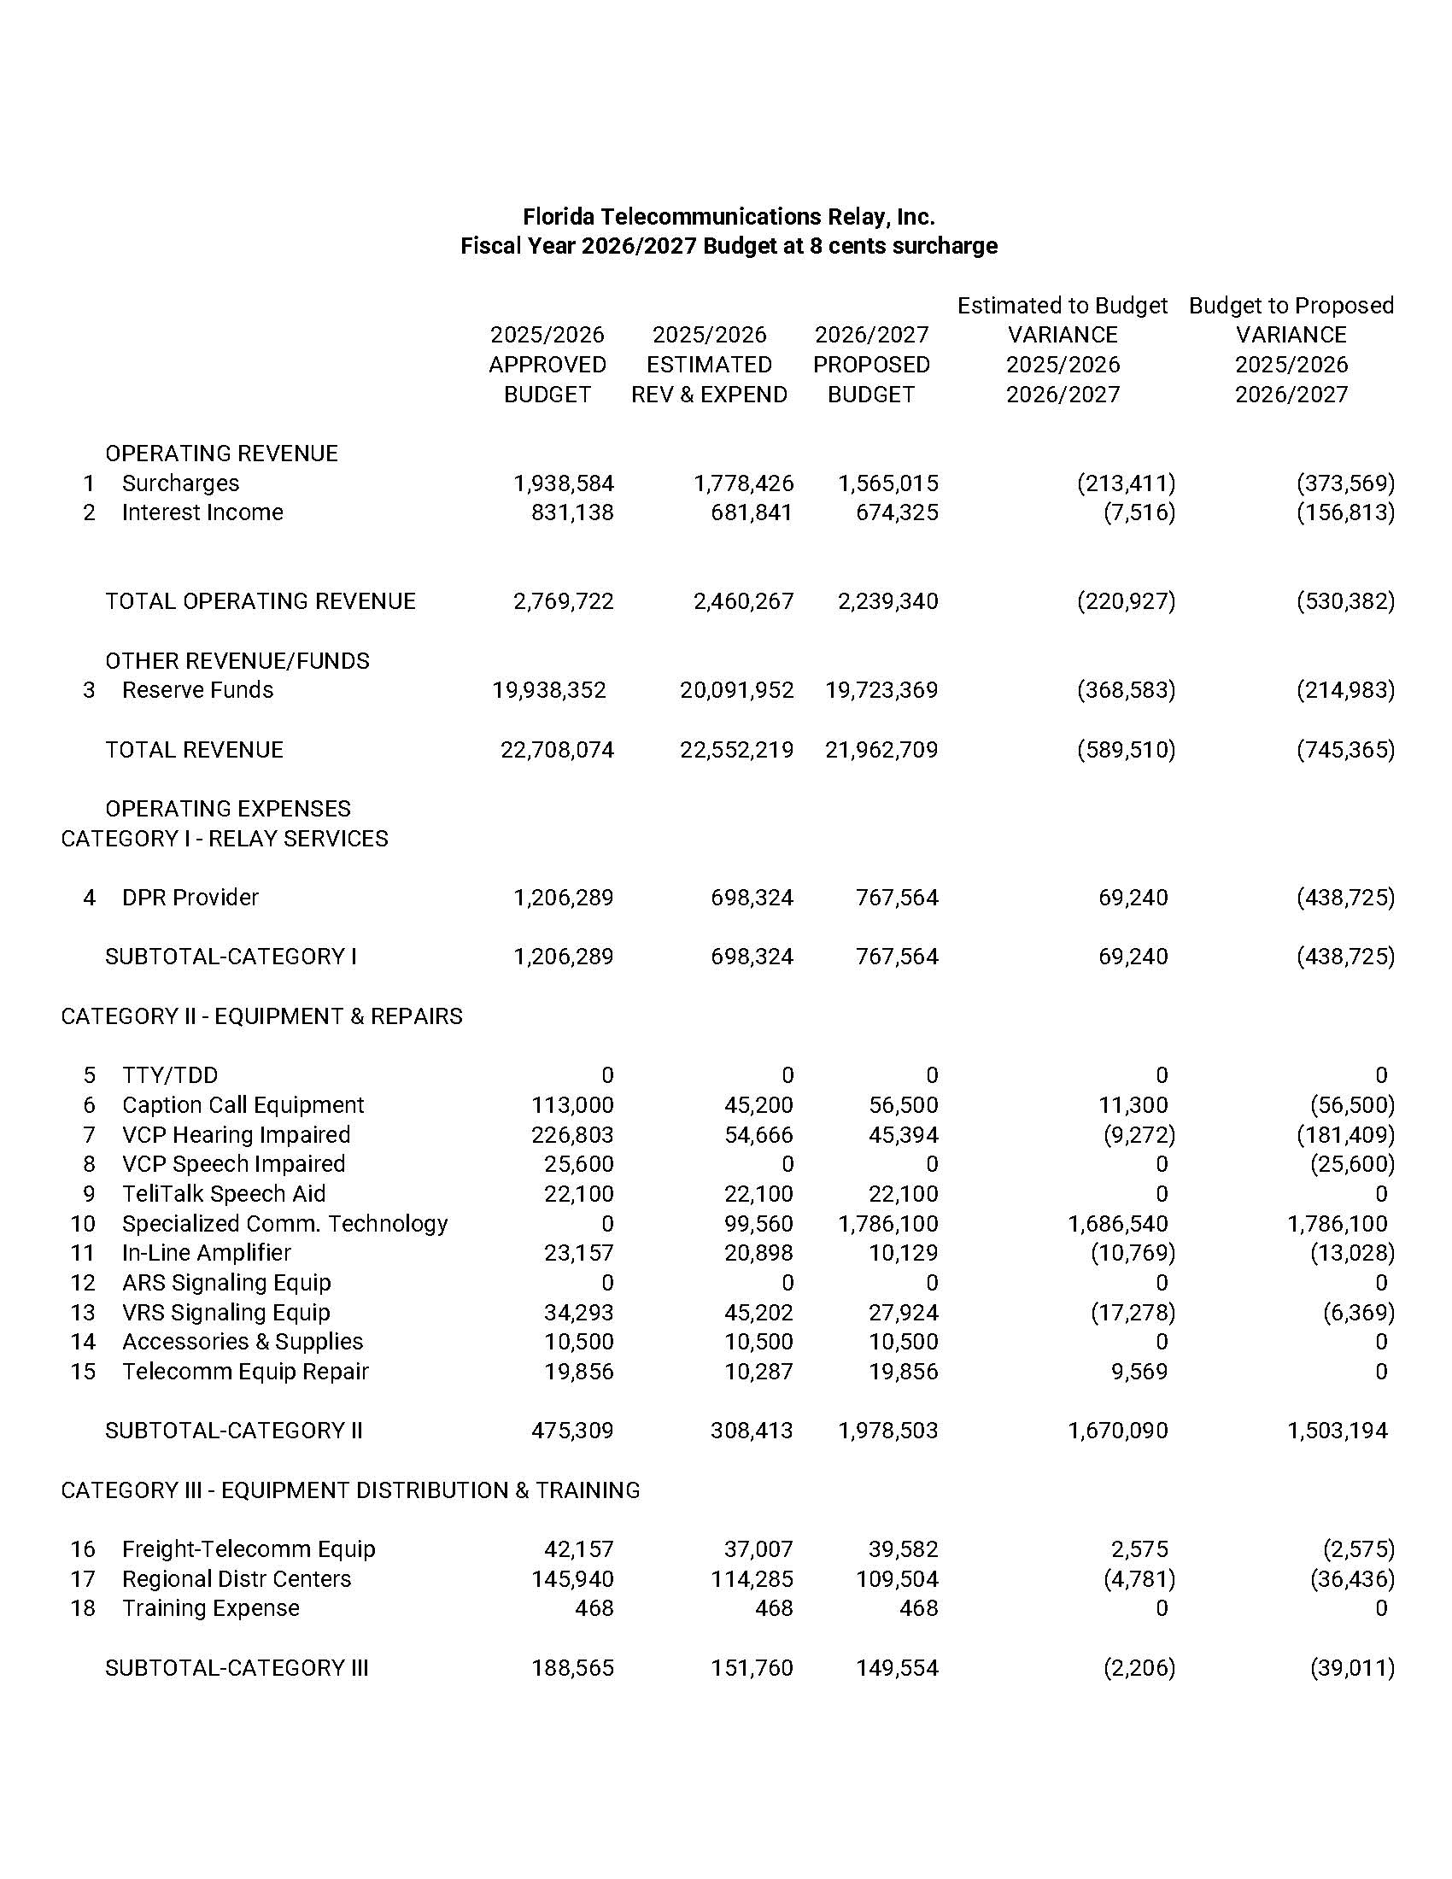

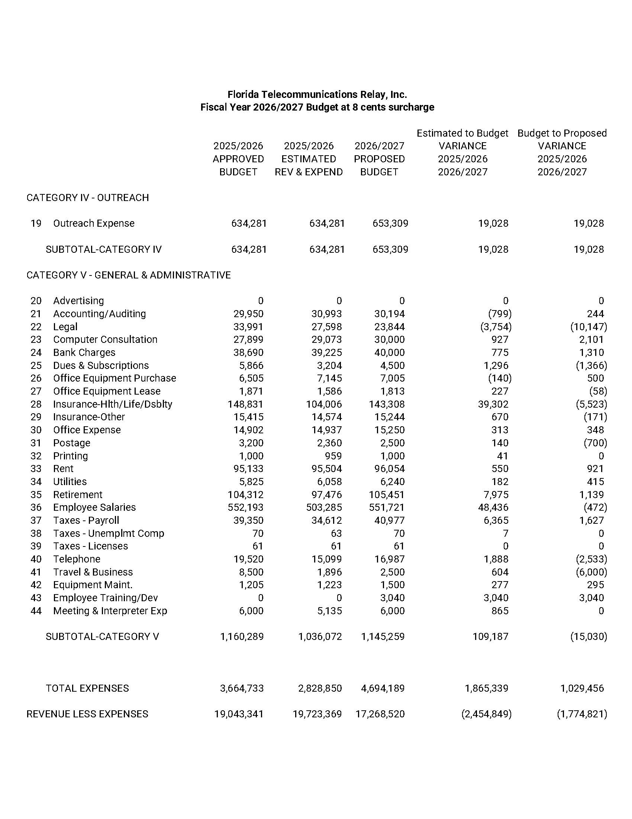

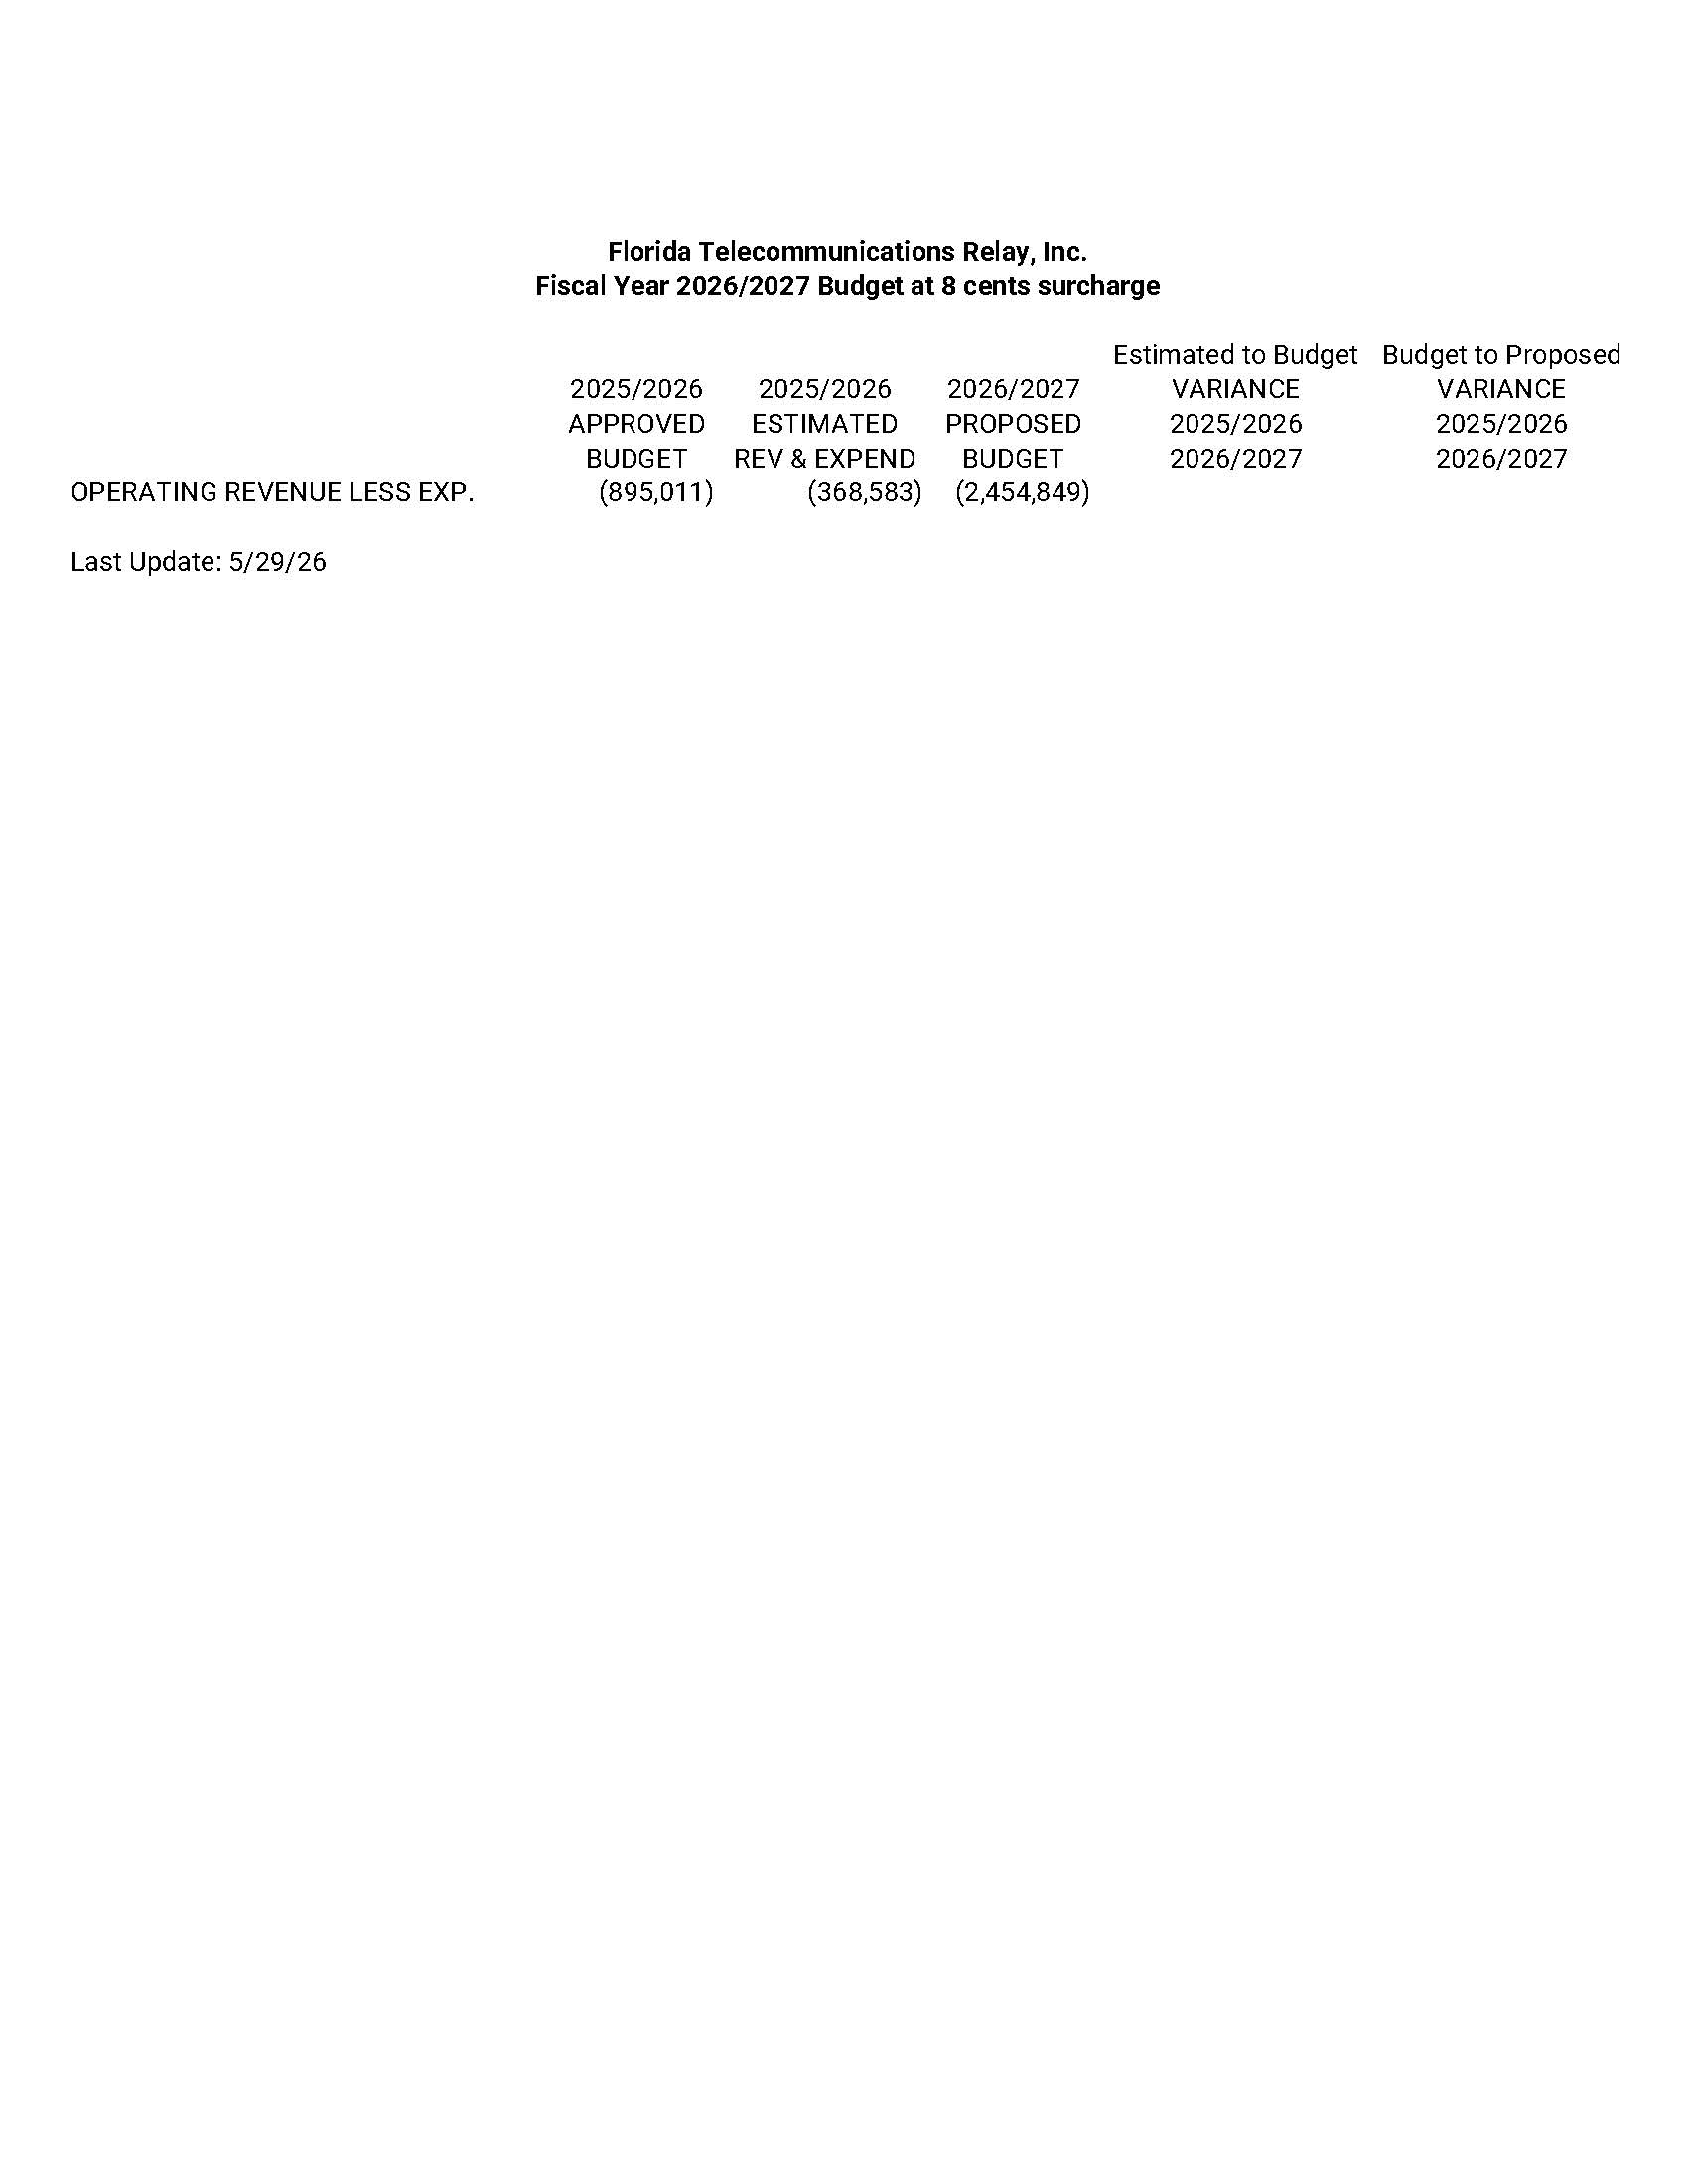

See Chapter 2025-148, Laws of Florida.

