BEFORE THE FLORIDA PUBLIC SERVICE COMMISSION

In re: Petition for approval of revisions to underground residential differential, underground commercial differential, and contribution-in-aid-of-construction tariffs, by Florida Power & Light Company. | DOCKET NO. 20260051-EI  ORDER NO. PSC-2026-0265-TRF-EI  ISSUED: July 28, 2026

The following Commissioners participated in the disposition of this matter:

GABRIELLA PASSIDOMO SMITH, Chairman
GARY F. CLARK
MIKE LA ROSA
BOBBY PAYNE
ANA ORTEGA

ORDER APPROVING 2026 REVISIONS TO UNDERGROUND RESIDENTIAL AND COMMERCIAL TARIFFS BY FLORIDA POWER & LIGHT COMPANY

BY THE COMMISSION:

Background
On April 1, 2026, Florida Power & Light Company (FPL or utility) filed a petition for revisions to its underground residential differential (URD), underground commercial differential (UCD), and contribution-in-aid-of-construction (CIAC) tariffs. The URD and UCD tariffs apply to new residential and commercial developments and represent the additional costs, if any, FPL incurs to provide underground distribution service in place of overhead service. The CIAC tariffs provide the terms for which a customer is required to cover the non-economic portion of that customer’s requested new or upgraded facilities. The petition was filed pursuant to Rule 25-6.078, Florida Administrative Code (F.A.C.), which requires utilities to file a URD tariff every three years. FPL’s current URD and UCD tariffs were approved by Order No. PSC-2023-0253-TRF-EI (2023 Order).
Based on current costs, including the net present value of long-term operational costs, FPL does not incur any additional costs to provide residential underground service; therefore, the proposed URD differentials are $0. The proposed (legislative version) URD and UCD tariffs are contained in Attachment A to this Order. The proposed revisions to FPL’s CIAC tariffs are also contained in Attachment A.
We suspended FPL’s proposed tariffs in Order No. PSC-2026-0155-PCO-EI. Our staff issued one data request for which responses were received on May 29, 2026. We have jurisdiction over this matter pursuant to Sections 366.03, 366.04, 366.05, and 366.06, Florida Statutes (F.S.).

Decision
- URD Tariff
The URD tariffs provide standard charges for underground service in new residential subdivisions and represent the additional costs, if any, the utility incurs to provide underground service in place of overhead service. The cost of standard overhead construction is recovered through base rates from all ratepayers. In lieu of overhead construction, customers have the option of requesting underground facilities. Typically, the developer of a new residential subdivision would be the utility customer utilizing the URD tariffs. FPL’s proposed URD tariffs are provided on pages 3 through 9 of Attachment A.
Traditionally, three standard model subdivision designs have been the basis upon which each investor-owned utility submits URD tariff changes for our approval: low density, high density, and a high density subdivision where dwelling units take service at ganged meter pedestals (groups of meters at the same physical location). Examples of this last subdivision type include mobile home and recreational vehicle parks. While actual construction may differ from the model subdivisions, the model subdivisions are designed to reflect average overhead and underground subdivisions.
In its petition, FPL updated its cost calculations and supporting documentation for the three subdivision models cost differentials. The currently approved cost differentials are $0.00 for all three subdivision models. As shown on Table 1, FPL’s proposed URD differential charges remain zero for all three subdivision models. A zero URD differential charge is typically the result of the avoided storm restoration costs associated with underground facilities, offsetting any higher labor and material costs associated with underground construction.
Table 1
Comparison of Differential per Service Lateral
Types of Subdivision | Current URD Differential | Proposed URD Differential
Low Density | $0 | $0
High Density | $0 | $0
Meter Pedestal | $0 | $0

Two primary factors impacted the calculation of FPL’s proposed URD charges which are discussed in greater detail below: (1) updated labor and material costs and (2) updated operational costs.

Updated Labor and Material Costs
The installation costs of both underground and overhead facilities include the labor and material costs to provide primary, secondary, and service distribution lines as well as transformers. The costs of poles are specific to overhead service while the costs of trenching and backfilling are specific to underground service. Table 2 compares the currently approved 2023 costs and 2026 costs for underground and overhead labor and material for the three subdivision models.
Table 2
Labor and Material Costs
Low Density | 2023 Costs | 2026 Costs | Difference
Underground Labor/Material Costs | $3,452.54 | $4,654.62 | $1,202.08
Overhead Labor/Material Costs | $2,543.92 | $3,561.73 | $1,017.81
Per Service Lateral Differential | $908.62 | $1,092.89 | $184.27
High Density
Underground Labor/Material Costs | $2,317.97 | $3,079.53 | $761.56
Overhead Labor/Material Costs | $1,921.50 | $2,424.31 | $502.81
Per Service Lateral Differential | $396.47 | $655.22 | $258.75
Meter Pedestal
Underground Labor/Material Costs | $1,485.47 | $2,045.92 | $560.45
Overhead Labor/Material Costs | $1,533.74 | $1,924.96 | $391.22
Per Service Lateral Differential | ($48.27) | $120.96 | $169.23

While both overhead and underground labor and material costs increased, underground costs increased at a higher rate, resulting in an increase in the differential. In response to staff’s data request, response no. 1, FPL explained that the higher overhead and underground construction costs are primarily driven by increased material costs and underground labor increasing more than overhead labor.

Updated Operational Costs
Rule 25-6.078(4), F.A.C., provides that the differences in net present value of operational costs between overhead and underground systems, including average historical storm restoration costs over the life of the facilities, be included in the URD charge. Operational costs include operations and maintenance costs and capital costs. The inclusion of the operational costs is intended to capture longer term costs and benefits of undergrounding. In response to staff’s data request, FPL stated that the current URD petition incorporates costs from hurricane events Idalia, Debby, Helene, and Milton. FPL’s methodology to calculate the operational costs was approved in Order No. PSC-08-0774-TRF-EI and remains the same in the instant docket.
Table 3 presents the pre-operational (shown in Table 2), non-storm operational, and the avoided storm restoration cost differentials between overhead and underground systems. The proposed differential is $0 when the calculation results in a negative number.
Table 3
Components of the URD Charges
Type of Subdivision | Pre-Operational Costs (A) | Non-Storm Operational Costs (B) | Avoided Storm Costs (C) | Proposed URD Differentials (A)+(B)+(C)
Low Density | $1,092.89 | ($1,757) | ($1,236) | $0
High Density | $655.22 | ($1,491) | ($1,236) | $0
Meter Pedestal | $120.96 | ($1,491) | ($1,236) | $0

Conclusion
We have reviewed FPL’s proposed changes to its URD tariffs and associated charges, the accompanying work papers, and responses to staff’s data request. We find that FPL’s proposed URD tariffs and associated charges as filed in the petition are cost-based and hereby approve the tariffs shown in Attachment A. The tariffs shall be made effective 30 days after our vote.

- UCD Tariff
Utilities are not required to file UCD tariffs pursuant to Rule 25-6.078, F.A.C.; however, as in prior URD petitions, FPL included proposed UCD tariffs in its petition. The UCD tariffs apply to small commercial or industrial customers (applicant) that request the installation of underground electric distribution facilities for a new building. The requested underground distribution facilities consist of underground service conductors, placed in conduit, and associated equipment that is installed from overhead feeder mains (or an overhead termination point) to the designed point of delivery (where the utility’s wires are connected to those of the customer). FPL’s proposed UCD tariffs are provided on pages 18 through 20 of Attachment A.
The UCD charges represent the differential costs for underground commercial facilities and their equivalent overhead design. The calculations provided by FPL in its petition employ FPL's standard engineering design criteria and are based on actual 2025 labor and material costs. Unlike the URD calculations, the UCD calculations do not include long term operational and avoided storm restoration costs. In addition, the UCD tariffs provide credits that apply if the applicant provides trenching, backfilling, or installs FPL provided conduit or a concrete pad for a pad-mounted transformer.
We reviewed FPL’s supporting documentation for the UCD charges and find that the charges are cost based and reasonable. The UCD tariffs and associated charges are hereby approved, effective 30 days after our vote.

- CIAC Tariff Provisions

Rule 25-6.064, F.A.C., provides the standard calculation for the CIAC to be paid by a customer. Under this formula, a customer’s CIAC is intended to cover the non-economic portion of that customer’s requested new or upgraded facilities. The non-economic portion of a customer’s requested new or upgraded facilities refers to the portion of the project cost not expected to be recovered from the customer’s estimated incremental base revenues recovered during the four years following the in-service date. The purpose of CIAC is to protect the general body of ratepayers from subsidizing customer-specific facilities that will not pay for themselves through the requesting customer’s own base revenues within that four-year period.

CIAC Tariff Modifications
In its petition, FPL stated that it is seeking our approval to modify its CIAC tariff provisions to more clearly state that, in addition to payment of the required CIAC, if facilities are requested or required by a governmental authority that are not usual and customary for the type of installation to be served, the customer shall also be responsible for the payment of the incremental cost of the requested facility in excess of the estimated cost of the utility’s standard design. FPL is proposing to incorporate this clarifying language into Tariff Sheet Numbers 6.020, 6.090, 6.100, 6.120, 6.130, 6.140, 6.199, 6.300, 6.330, and 6.500. FPL affirmed in its petition that this clarification will not change or otherwise modify FPL’s current CIAC calculation or application, but rather provides greater clarity to all customers seeking new or expanded service and mitigates potential confusion regarding cost responsibility for non-standard designs and facilities. These tariffs are provided on pages 1, 2, 4, 7, 9, 10, 11, 13, 15, and 16 of Attachment A, respectively.
Additionally, FPL is seeking approval of a revision to Tariff Sheet No. 6.020 to clarify that all CIAC shall be calculated pursuant to the rules and regulations of FPL’s Commission-approved tariffs. FPL asserts that this proposed modification to Tariff Sheet No. 6.020 will better reflect and remove ambiguity regarding the application of all FPL’s Commission-approved tariffs when determining a customer’s CIAC.
FPL is also seeking approval of a revision to Tariff Sheet No. 6.199 to provide greater guidance on the overhead to underground differential and credits used to calculate the CIAC for customers requesting underground service. Specifically, FPL is proposing to add language that clarifies to customers that the estimated differential cost and available credits for underground service are to be determined pursuant to the Commission-approved URD and UCD tariffs, and that in no event shall the CIAC for underground service be less than zero. FPL stated that this language is consistent with its current practice and is meant to provide better guidance to customers seeking underground service.
Next, FPL is seeking our approval to revise Tariff Sheet Nos. 6.090 and 6.510 to clarify that credits received by an applicant for the underground work the applicant performs shall, upon mutual agreement, be applied either as a reduction to the applicant’s CIAC or granted after the applicant’s work is completed, but in no event shall the credit exceed the CIAC amount due from the applicant. The utility stated that this clarification better reflects its current practice and preferences. Tariff Sheet No. 6.510 is provided on page 17 of Attachment A.
Finally, FPL is seeking our approval to update the deposit amounts required for a binding cost estimate under URD Tariff Sheet No. 6.200 and UCD Tariff Sheet No. 6.310. FPL stated that this update is appropriate to better reflect current costs for preparing a cost estimate for an applicant requesting underground service pursuant to the URD and UCD tariffs and to mitigate the potential risk of subsidization by the general body of ratepayers. Tariff Sheet Nos. 6.200 and 6.310 are provided on pages 12 and 14 of Attachment A, respectively.
In response to staff’s data request, response no. 9, FPL affirmed that the purpose of the proposed CIAC tariff revisions is to provide better transparency and clarity to customers or applicants requesting new or extended service. FPL additionally confirmed that the proposed changes are already in effect and in practice.

Conclusion
We reviewed FPL’s proposed modifications to its CIAC tariff and find that the modifications provide better clarity and transparency for its customers. We hereby approve of the proposed CIAC tariff modifications, effective 30 days after our vote.

Based on the foregoing, it is

ORDERED by the Florida Public Service Commission that Florida Power & Light Company’s proposed URD and UCD tariffs and associated charges as filed in the petition are hereby approved, effective 30 days after our vote on July 7, 2026. It is further

ORDERED that Florida Power & Light’s proposed modifications to its CIAC tariffs are hereby approved, effective 30 days after our vote. It is further

ORDERED that if a protest is filed within 21 days of the issuance of the order, the tariffs shall remain in effect, with any revenues held subject to refund, pending resolution of the protest. If no timely protest is filed, this docket should be closed upon the issuance of a consummating order.

By ORDER of the Florida Public Service Commission this 28th day of July, 2026.

/s/ Adam J. Teitzman
ADAM TEITZMAN
Commission Clerk
Florida Public Service Commission
2540 Shumard Oak Boulevard
Tallahassee, Florida 32399
(850) 413-6770
www.floridapsc.com

Copies furnished: A copy of this document is provided to the parties of record at the time of issuance and, if applicable, interested persons.

MRT

NOTICE OF FURTHER PROCEEDINGS

The Florida Public Service Commission is required by Section 120.569(1), Florida Statutes, to notify parties of any administrative hearing or judicial review of Commission orders that is available under Sections 120.57 or 120.68, Florida Statutes, as well as the procedures and time limits that apply. This notice should not be construed to mean all requests for an administrative hearing or judicial review will be granted or result in the relief sought.

Mediation may be available on a case-by-case basis. If mediation is conducted, it does not affect a substantially interested person's right to a hearing.

The Commission's decision on this tariff is interim in nature and will become final, unless a person whose substantial interests are affected by the proposed action files a petition for a formal proceeding, in the form provided by Rule 28-106.201, Florida Administrative Code. This petition must be received by the Office of Commission Clerk, 2540 Shumard Oak Boulevard, Tallahassee, Florida 32399-0850, by the close of business on August 18, 2026.

In the absence of such a petition, this Order shall become final and effective upon the issuance of a Consummating Order.

Any objection or protest filed in this docket before the issuance date of this order is considered abandoned unless it satisfies the foregoing conditions and is renewed within the specified protest period.

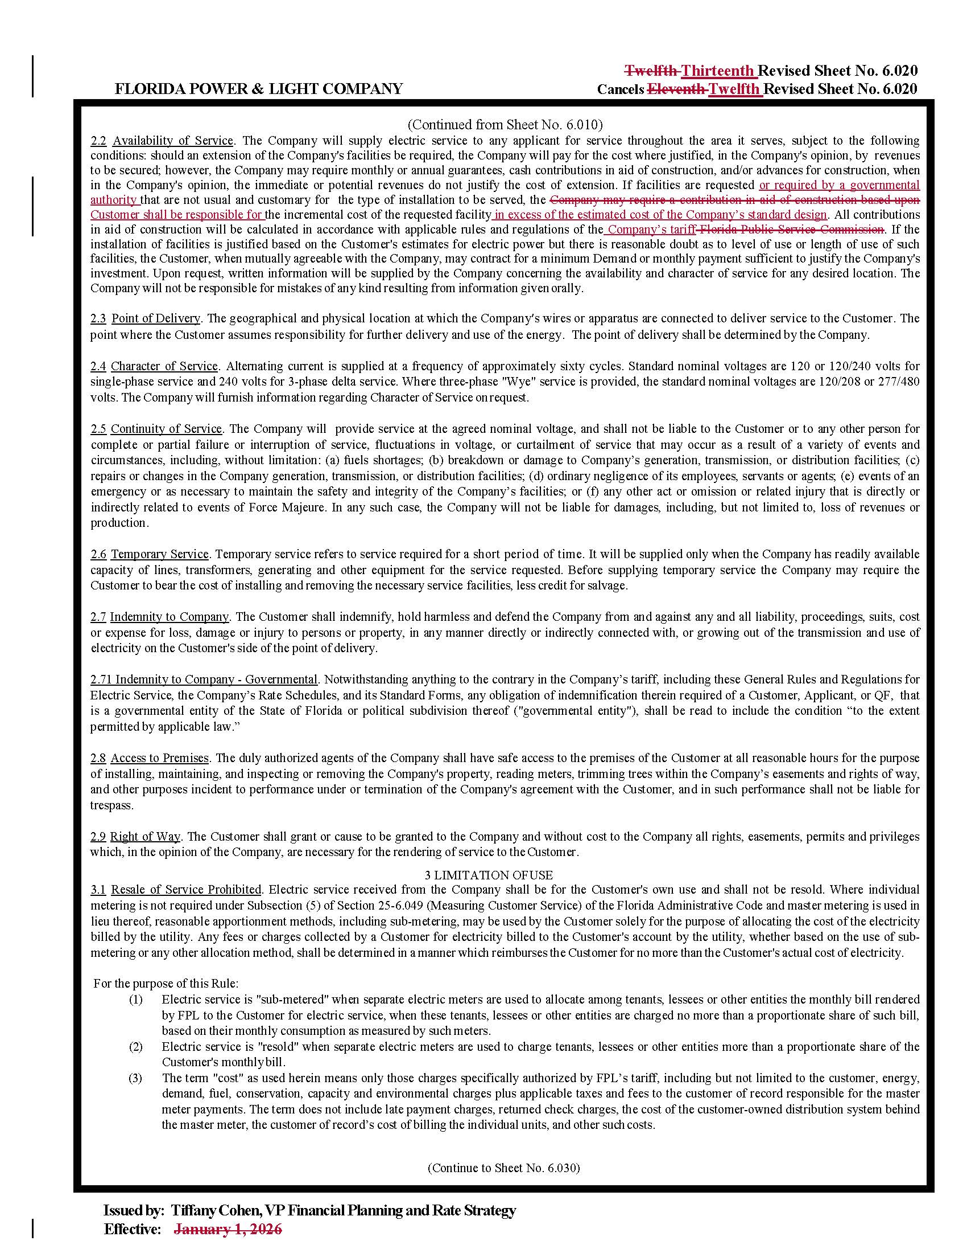

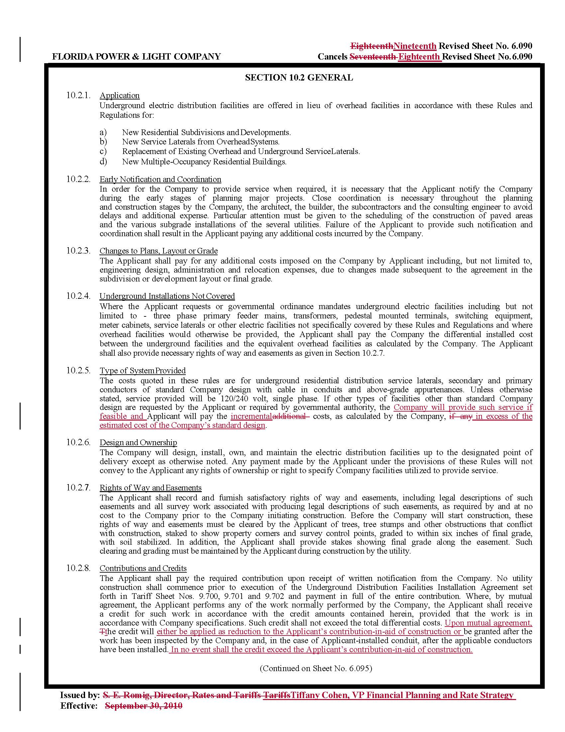

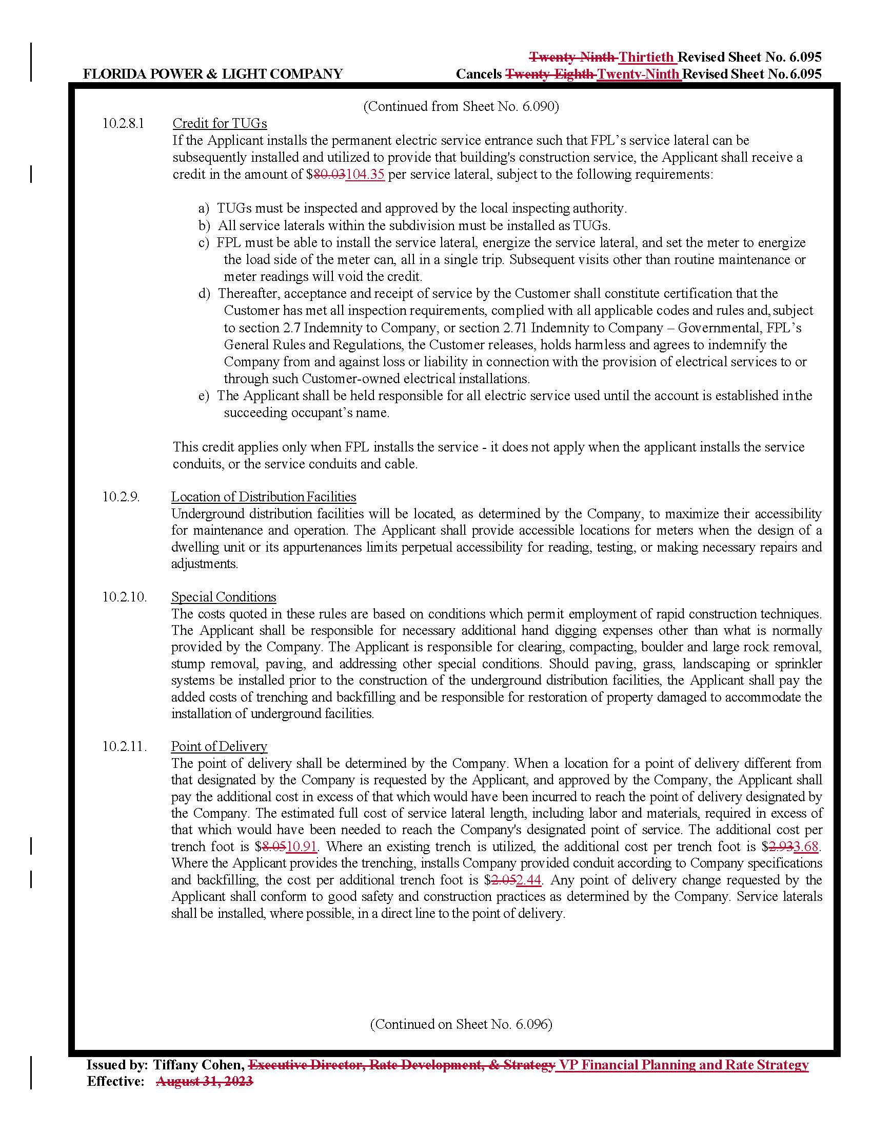

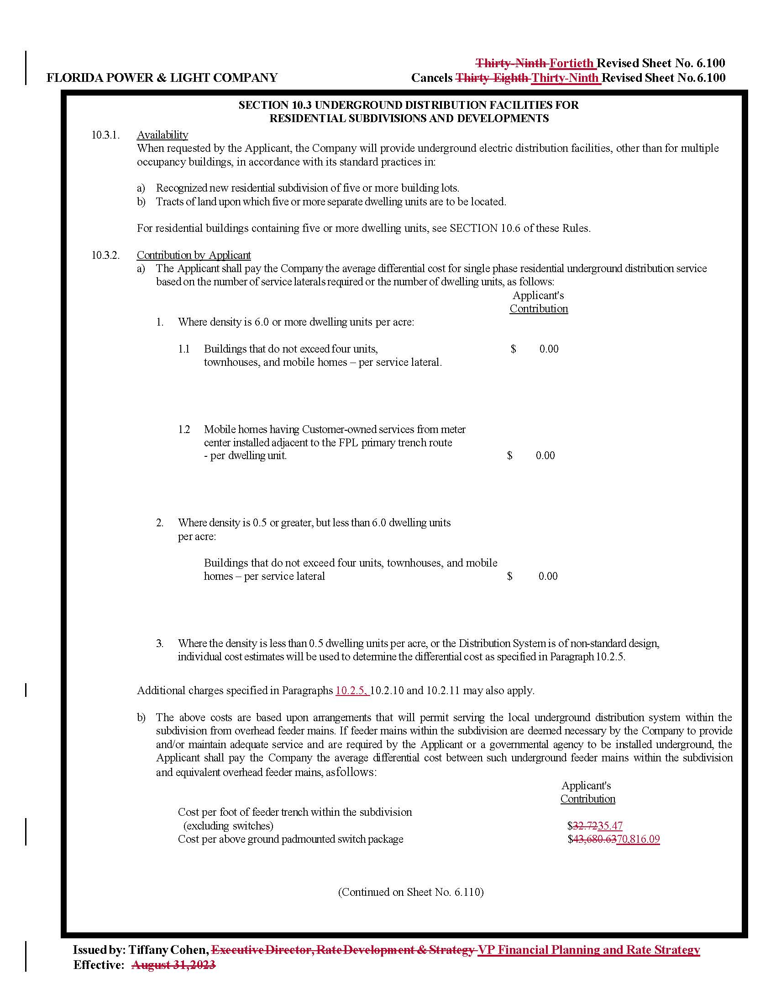

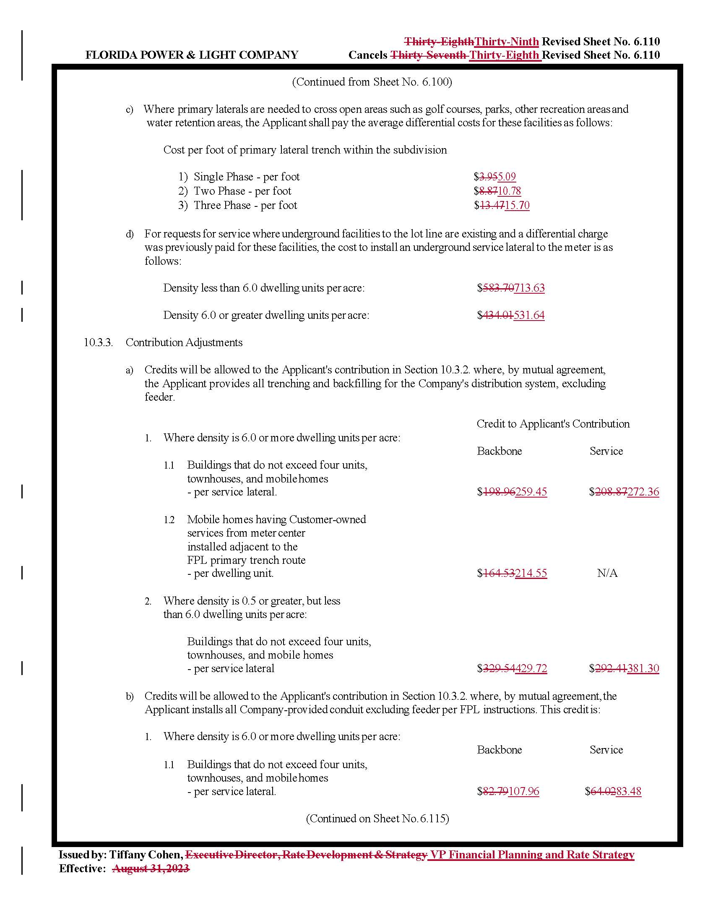

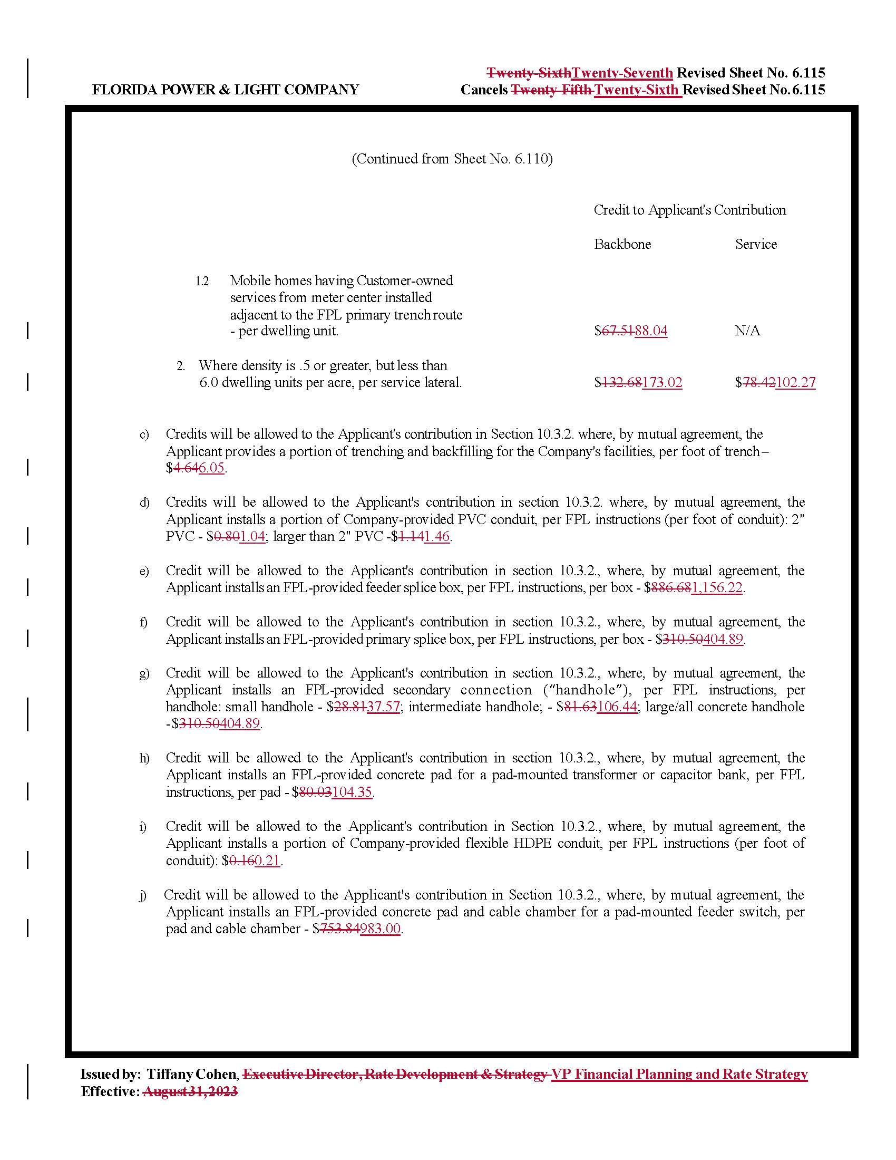

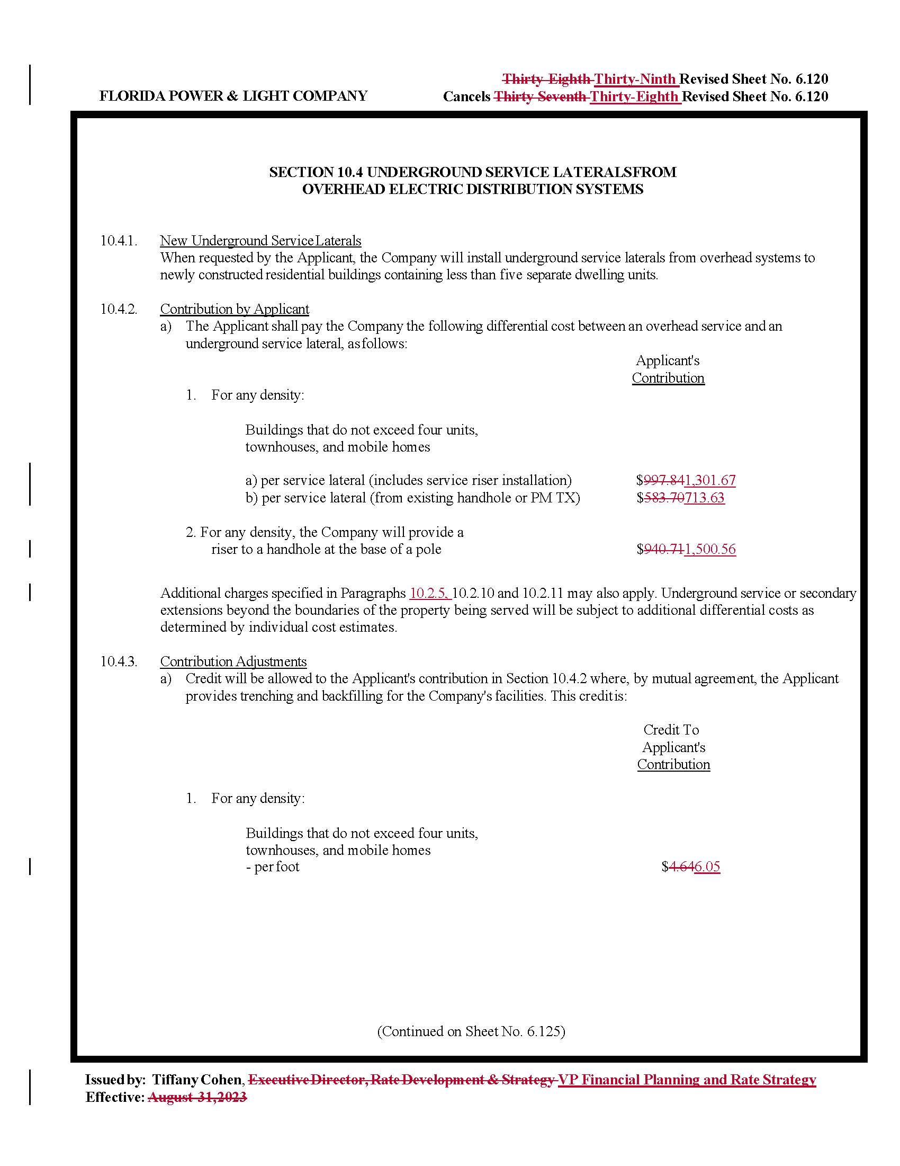

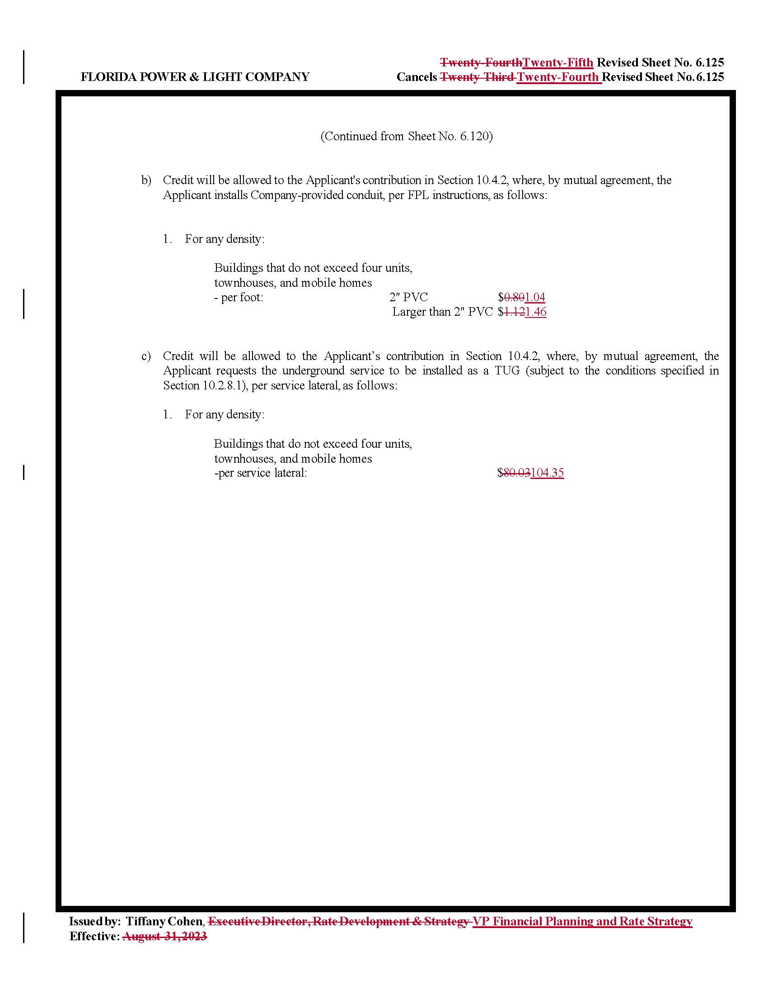

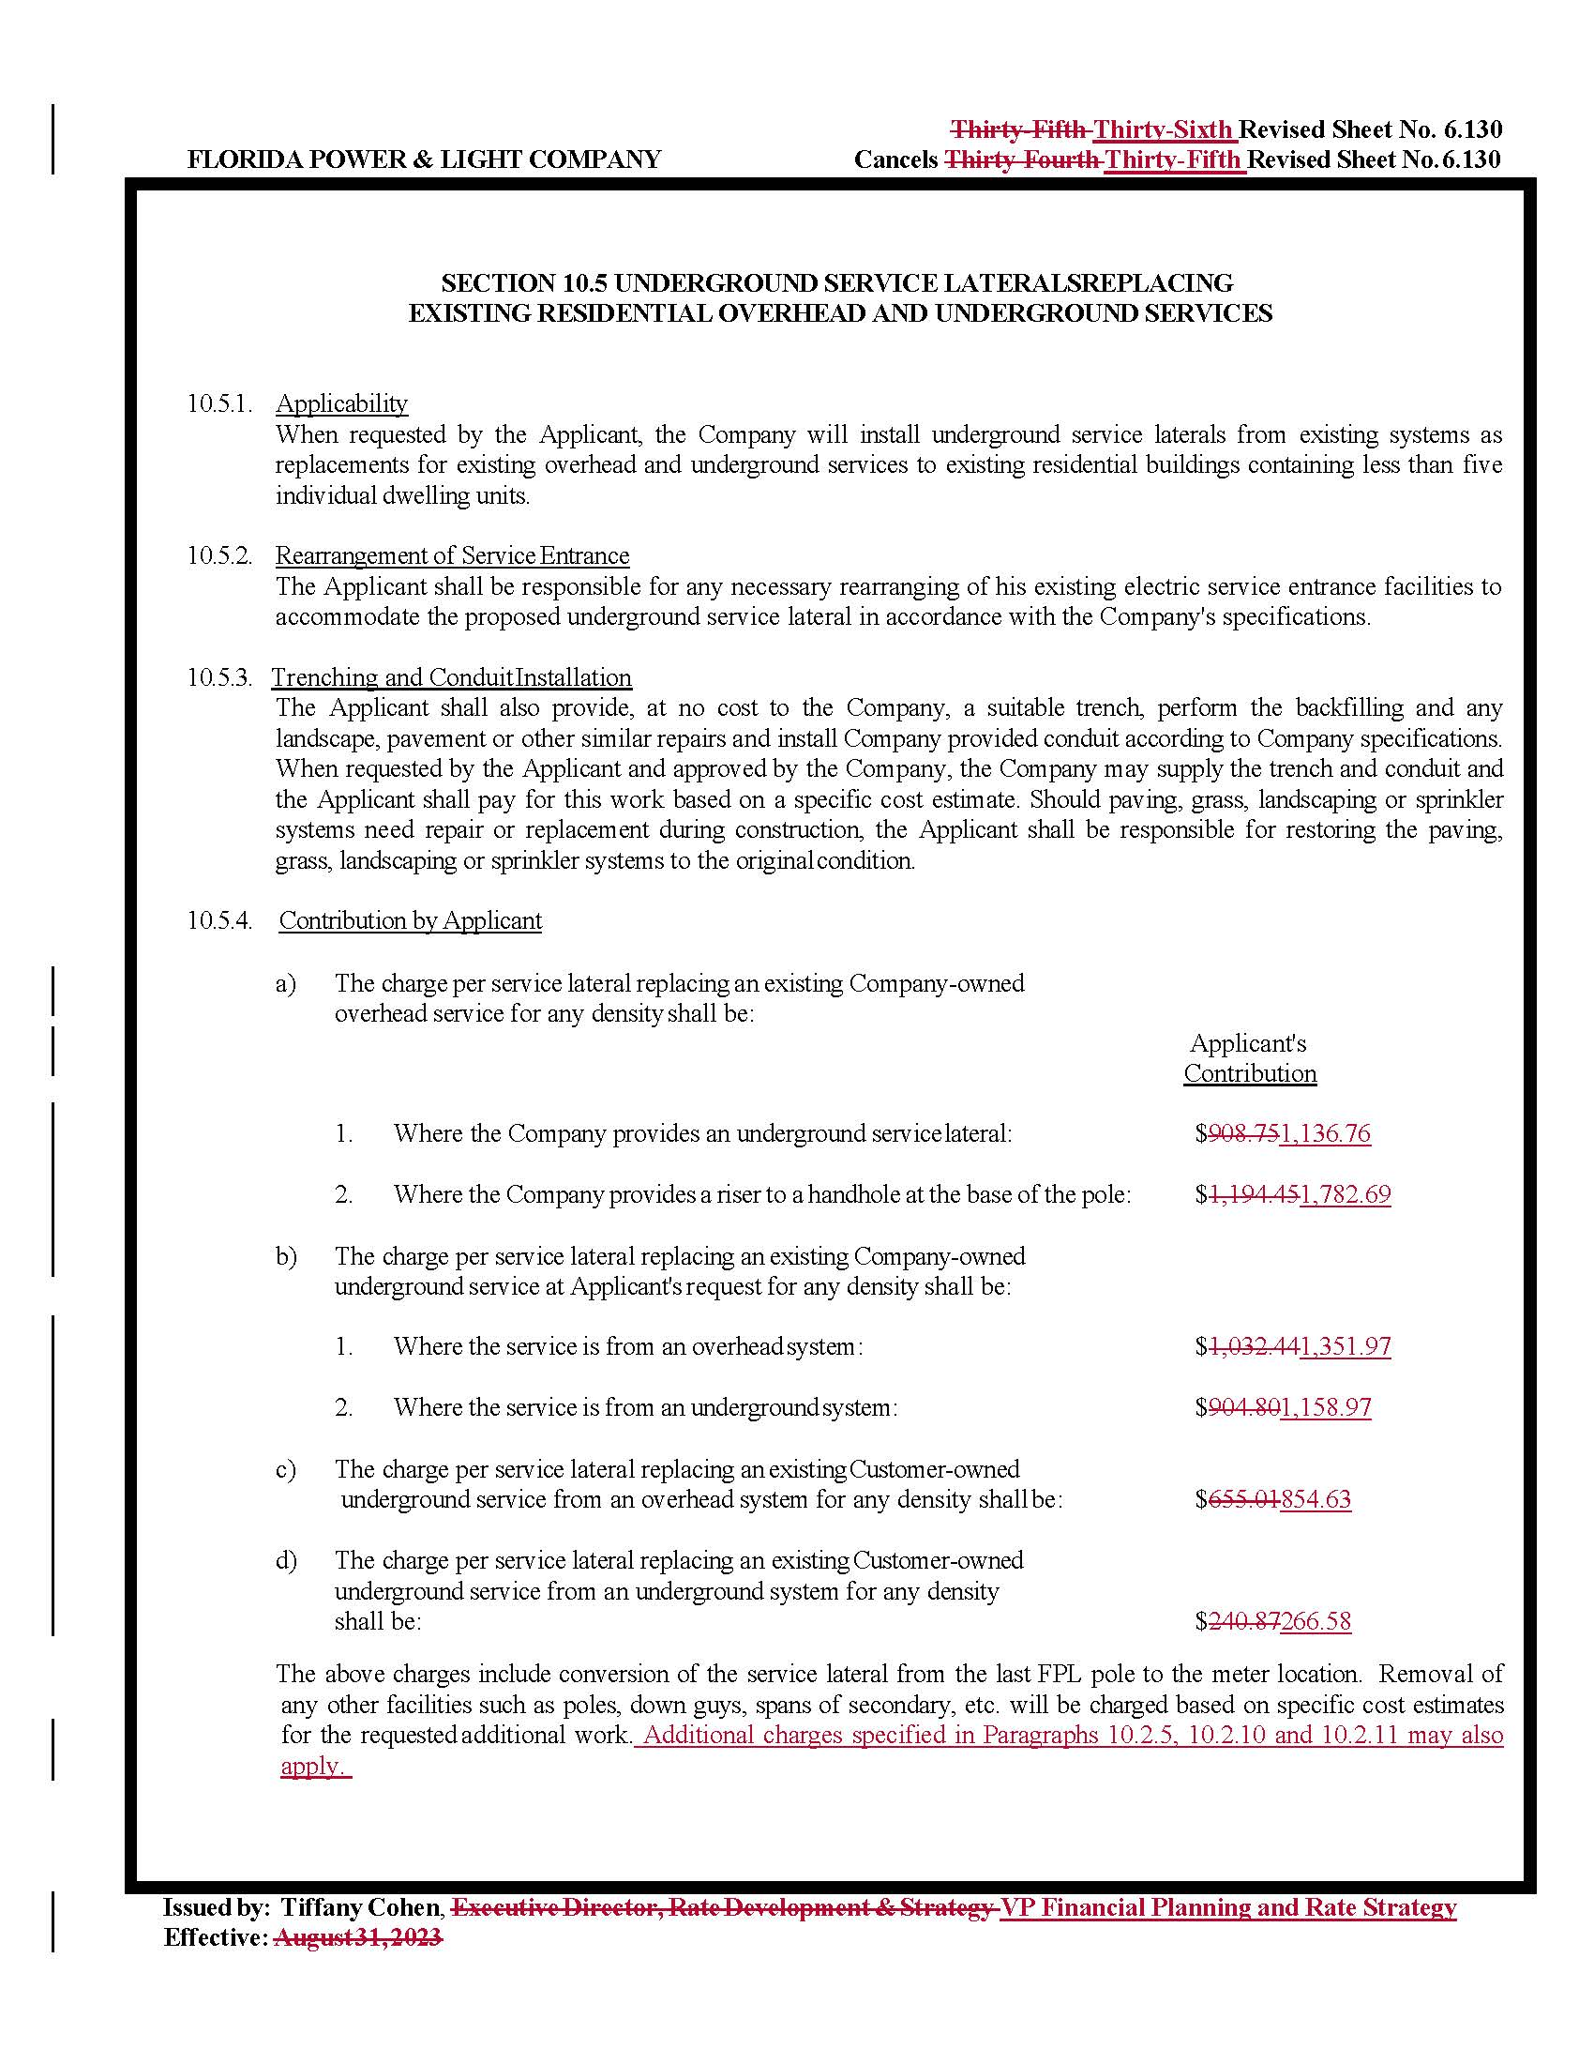

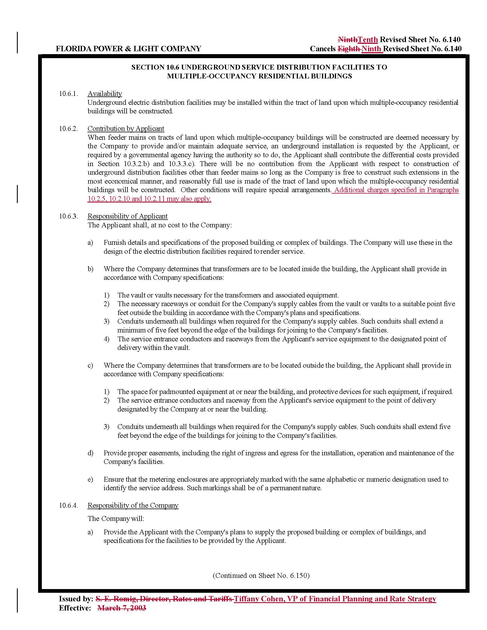

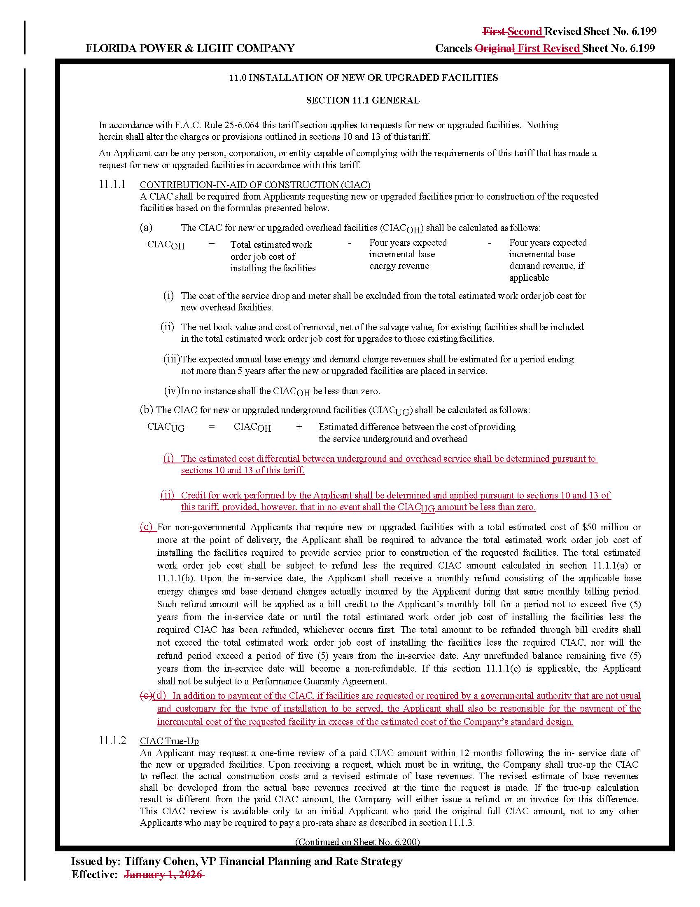

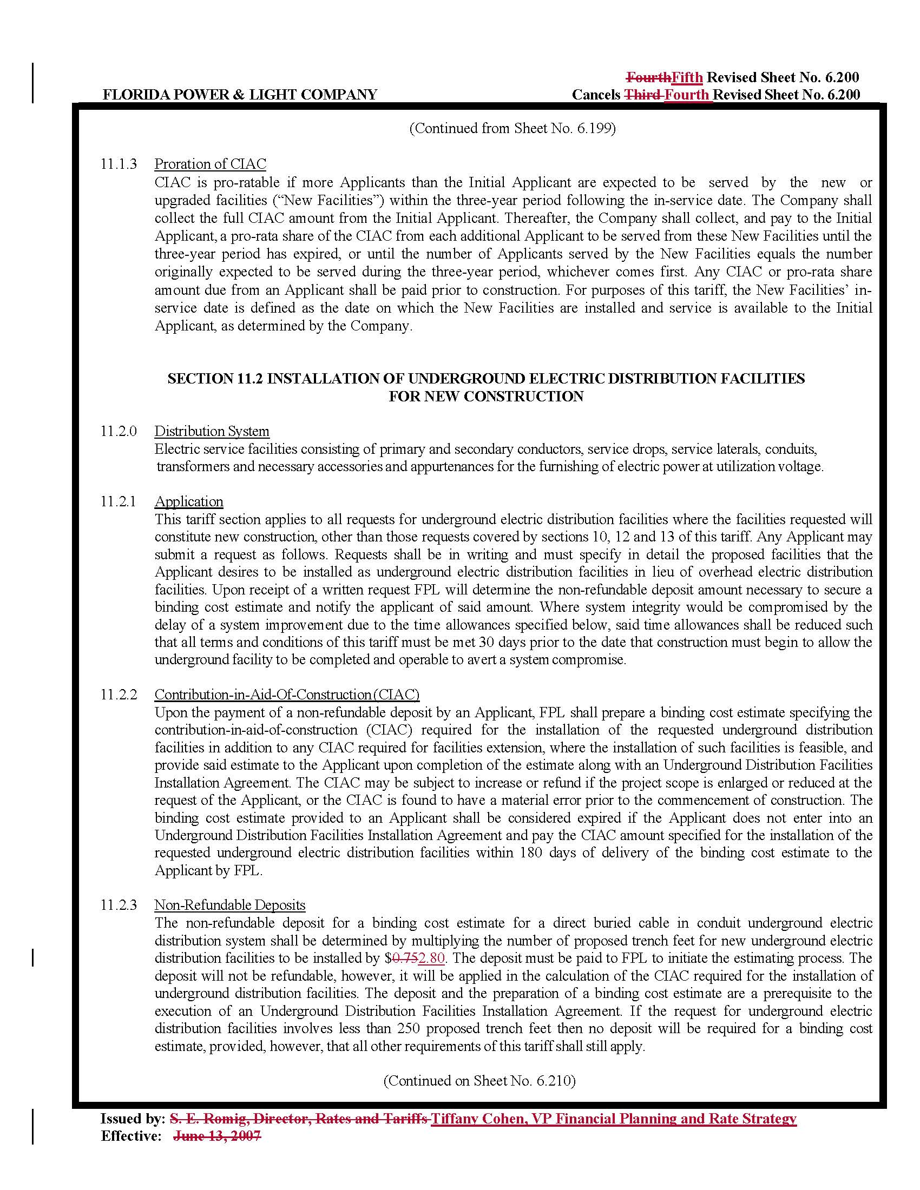

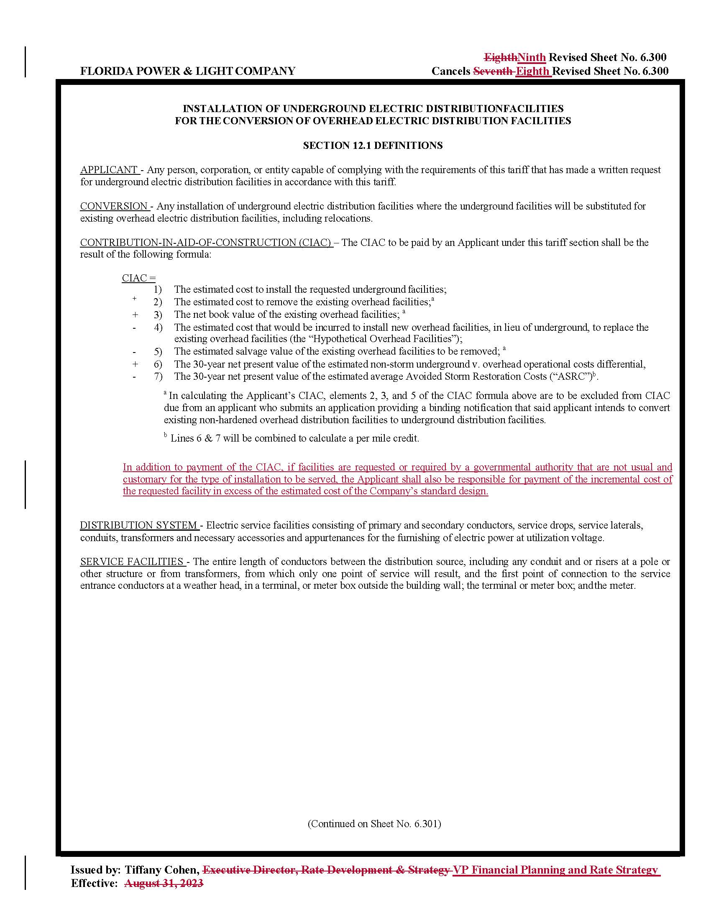

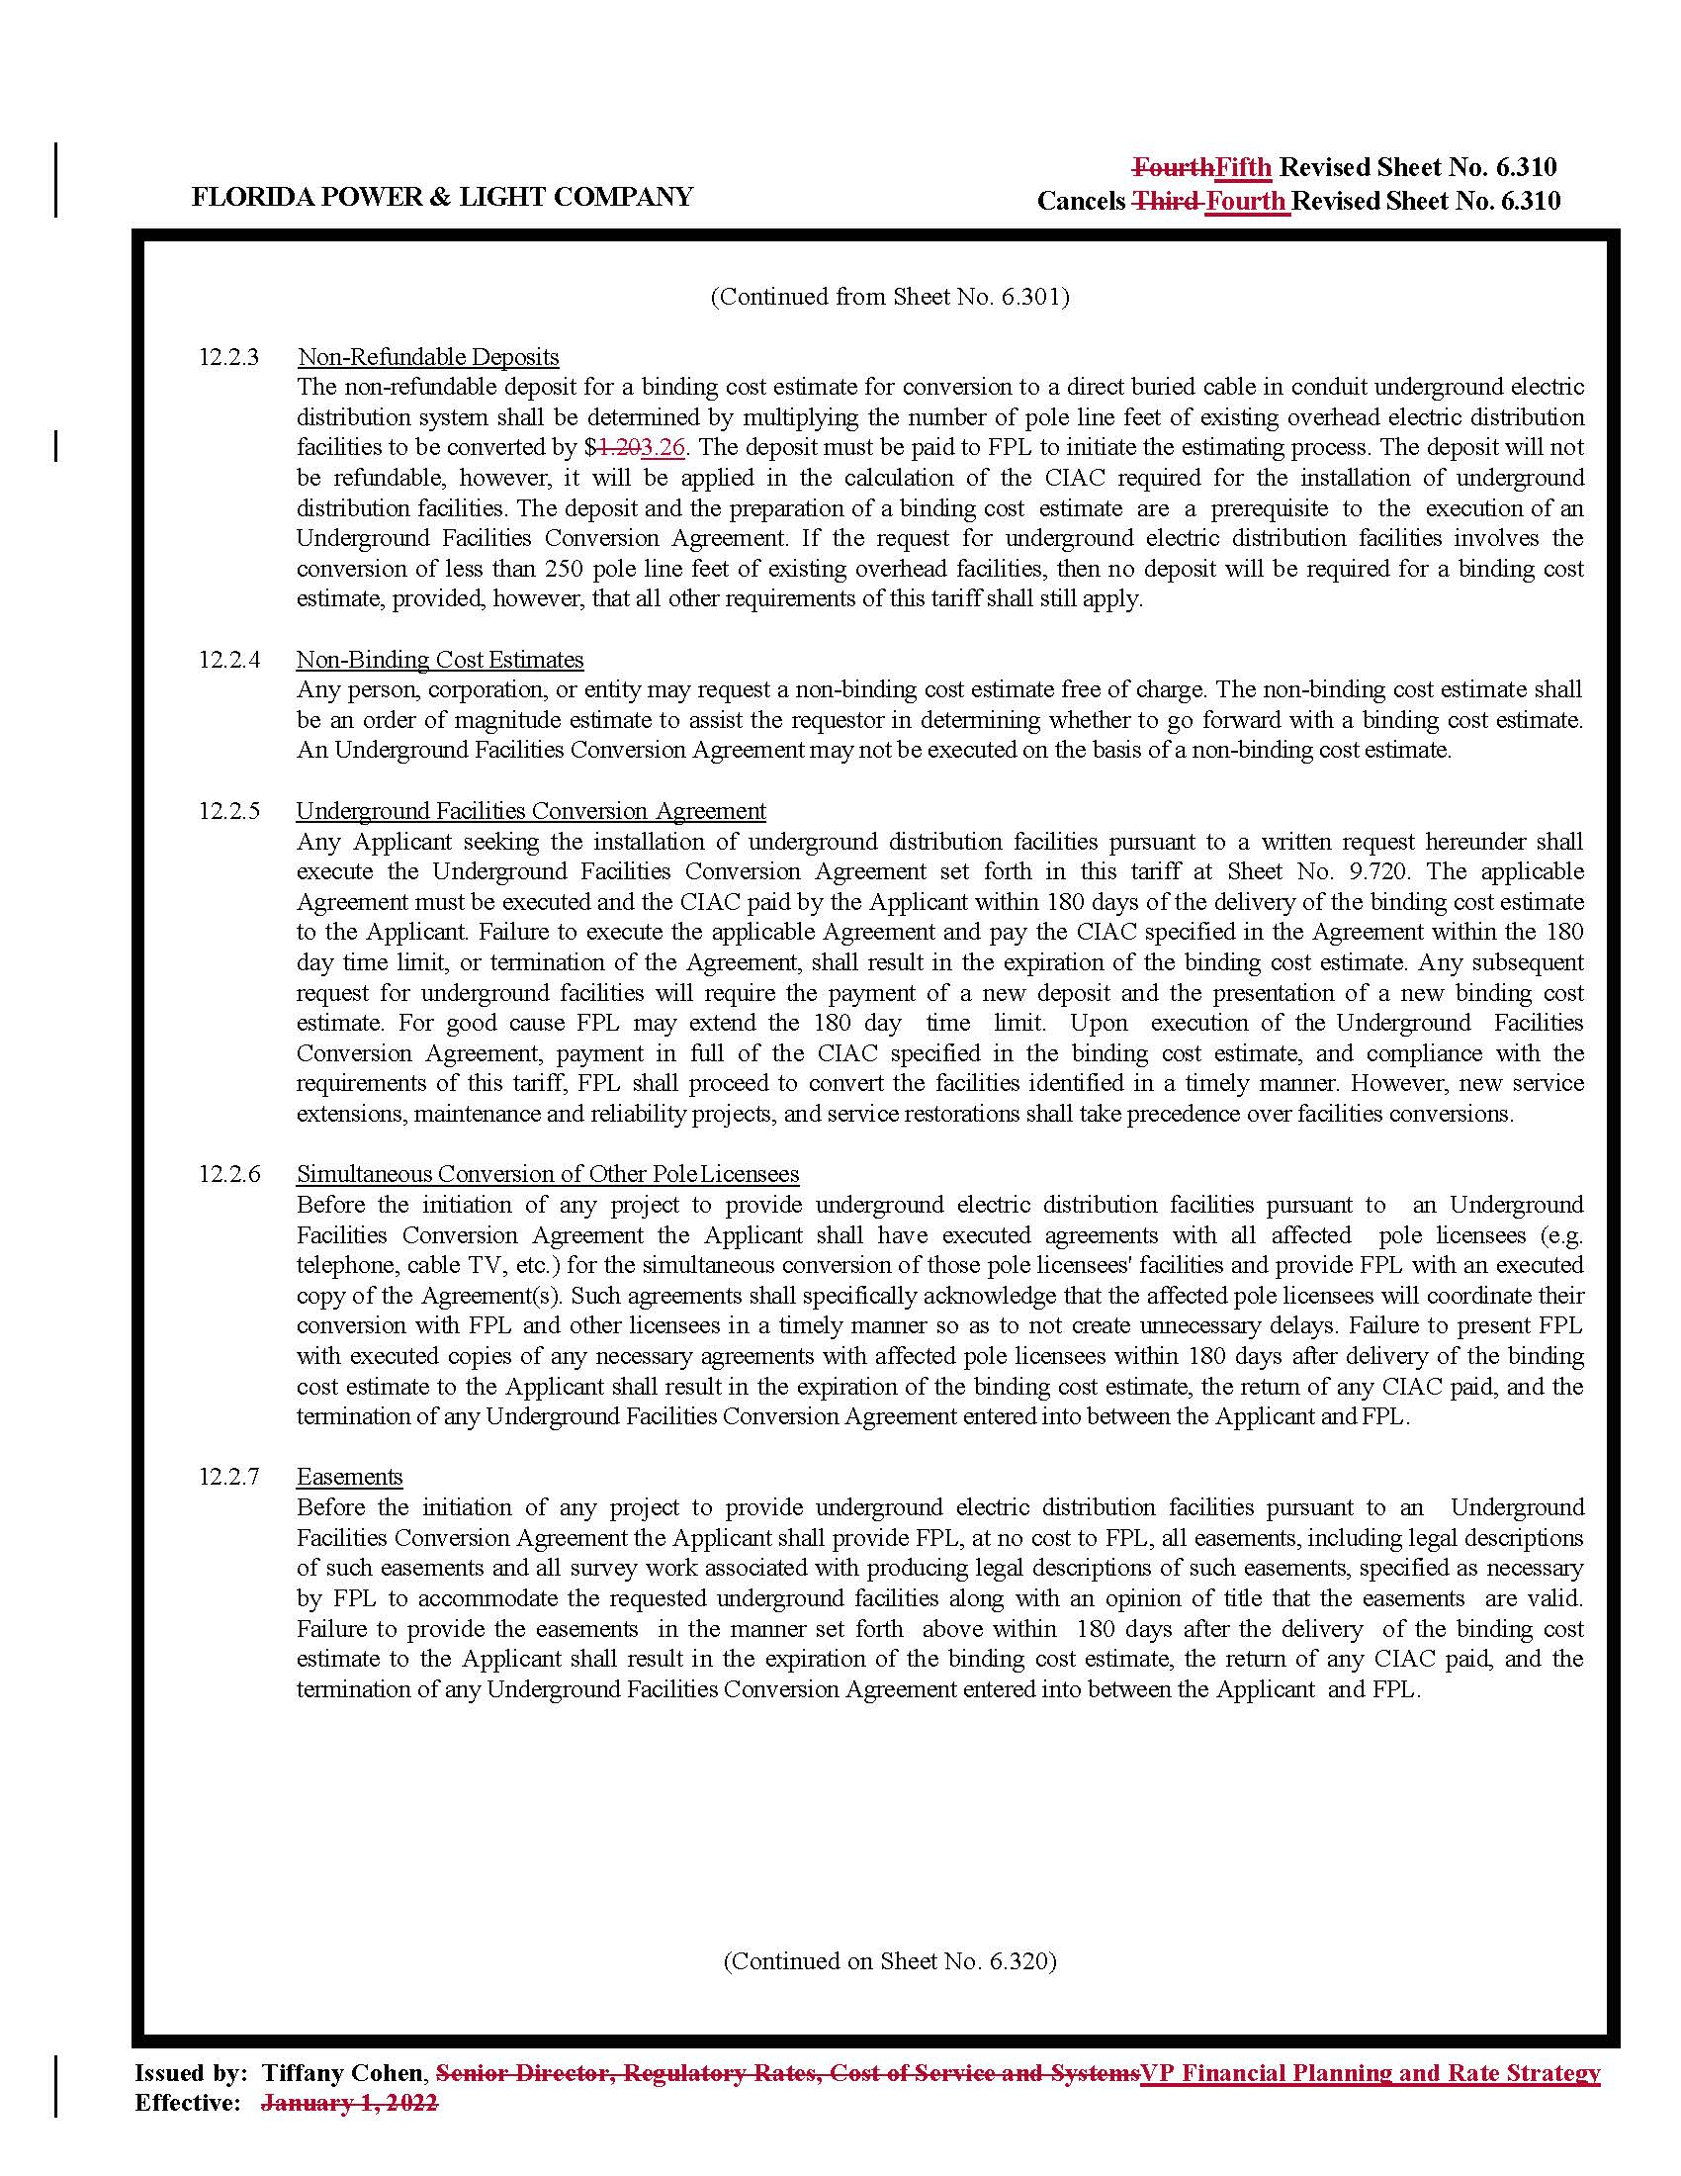

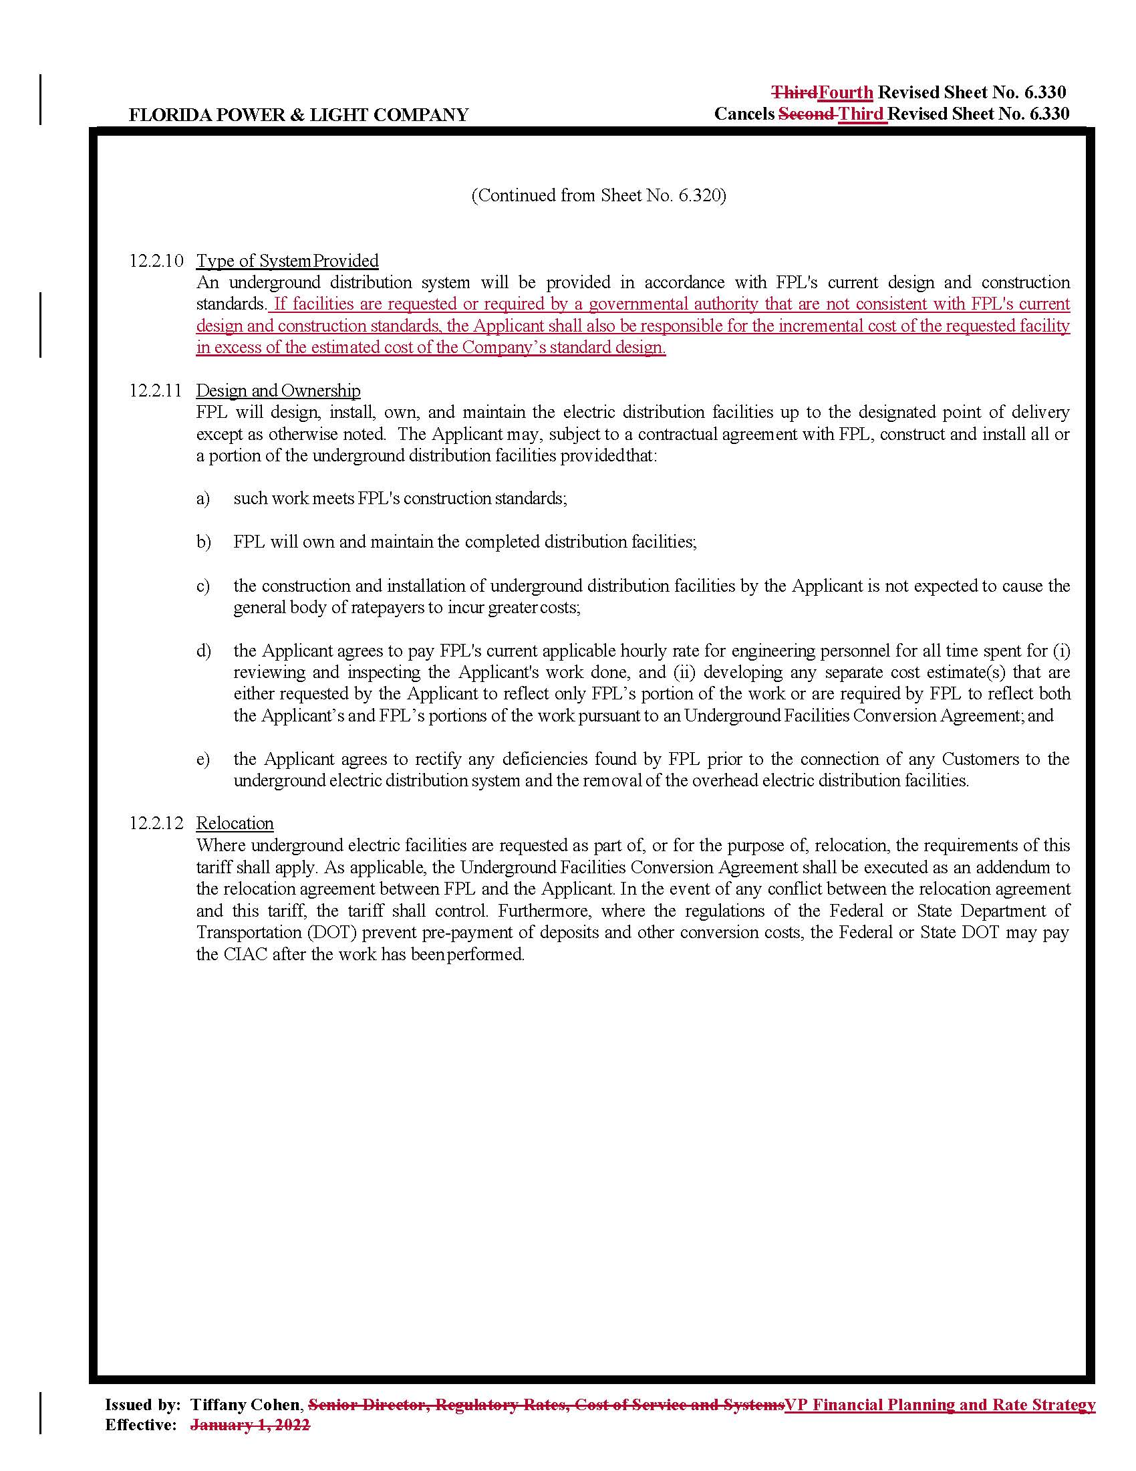

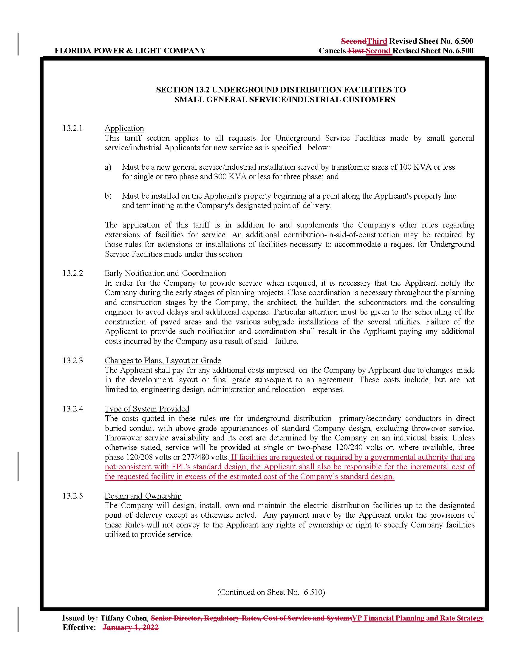

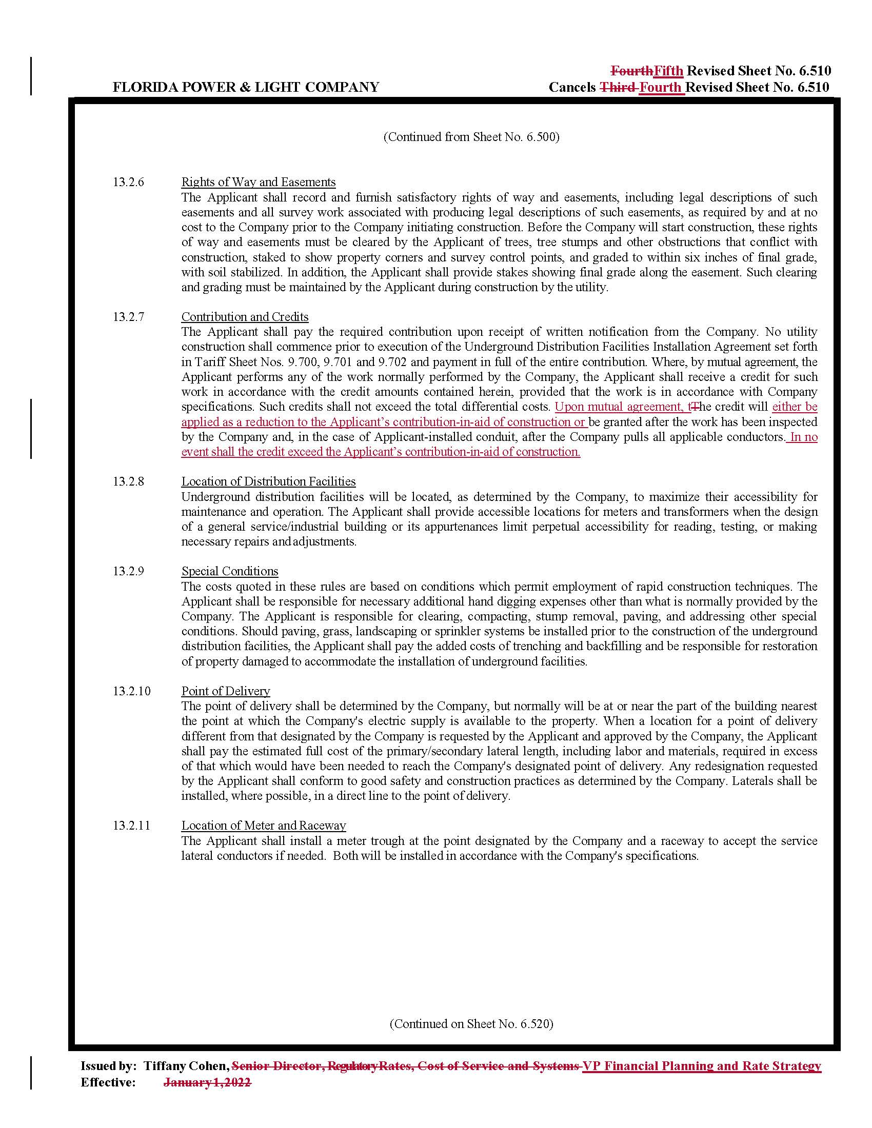

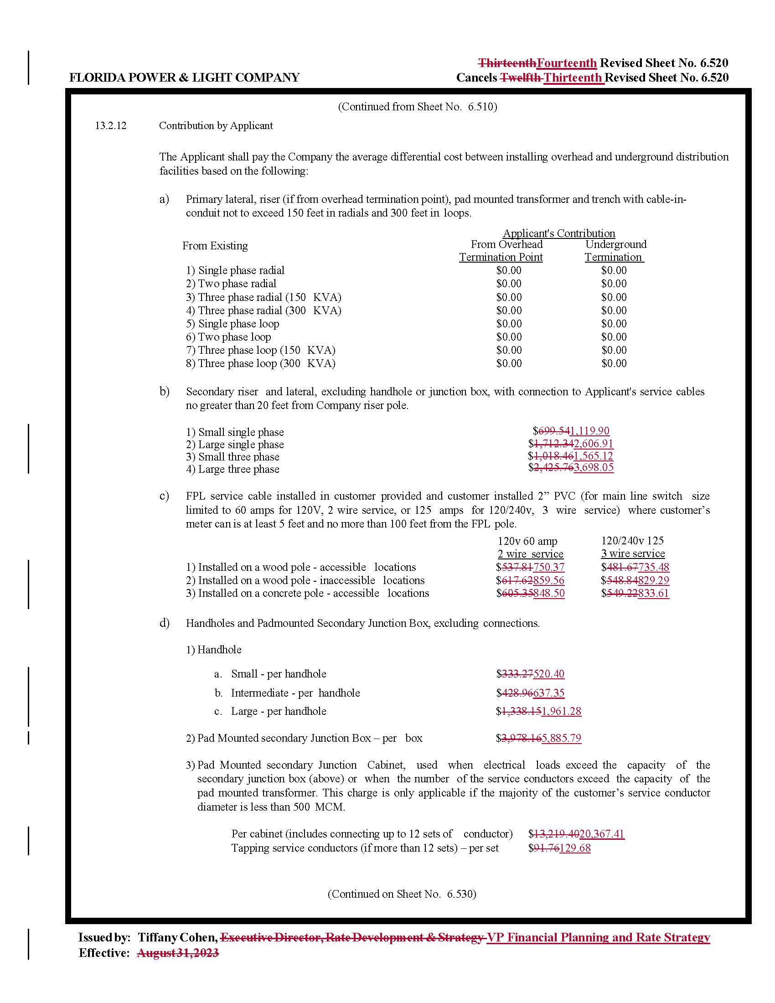

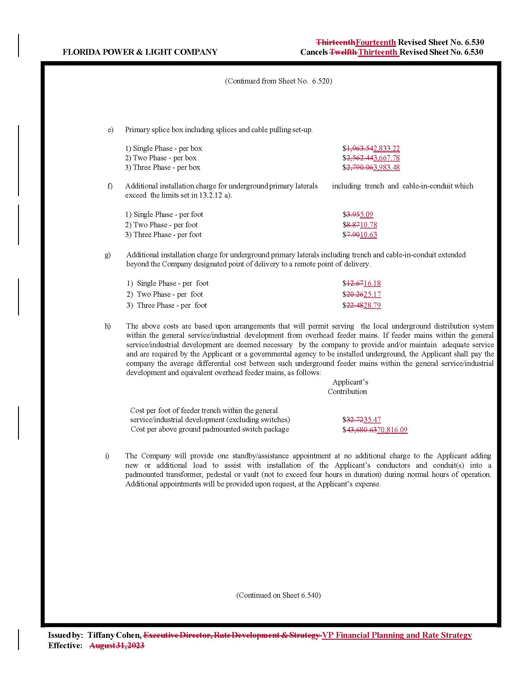

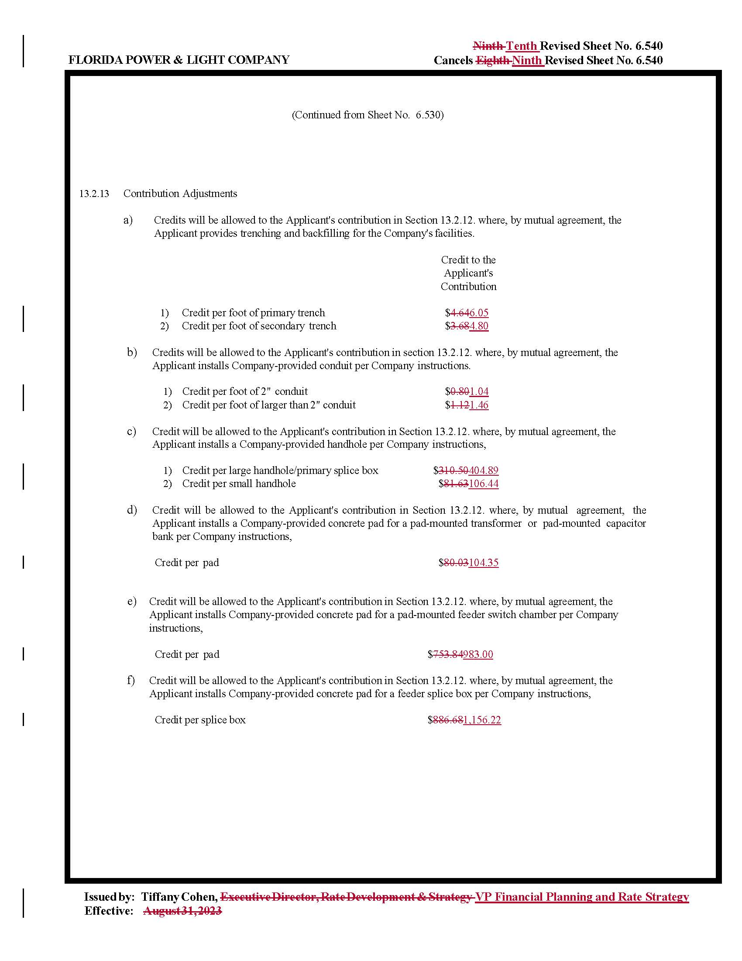

Order No. PSC-2023-0253-TRF-EI, issued August 21, 2023, in Docket No. 20230045-EI, In re: Petition for approval of revisions to underground residential tariff, underground commercial differential tariff, and overhead to underground conversion tariff, by Florida Power & Light Company.
Order No. PSC-2026-0155-PCO-EI, issued May 19, 2026, in Docket No. 20260051-EI, In re: Petition for approval of revisions to underground residential differential, underground commercial differential, and contribution-in-aid-of-construction tariffs, by Florida Power & Light Company.
Order No. PSC-08-0774-TRF-EI, issued November 24, 2008, in Docket No. 20070231-EI, In re: Petition for approval of 2007 revisions to underground residential and commercial distribution tariff, by Florida Power & Light Company.

